Original Research Article
Understanding Consumer Behaviour and Market-Level Constraints in Fish Markets of Hyderabad, Telangana

ABSTRACT
Aims: To analyze consumer behaviour in urban fish markets of Hyderabad by assessing purchasing patterns, species preferences, consumption attributes, and market-level constraints, and to suggest possible improvements in fish marketing infrastructure.
Study Design: Descriptive cross-sectional study.
Place and Duration of Study: Ram Nagar and Begum Bazaar fish markets, Hyderabad, Telangana.
Methodology: A total of 120 fish consumers were randomly selected from the two selected markets using purposive sampling. Data were collected through a structured interview schedule. The questionnaire included sections on socio-economic profile, frequency and quantity of fish purchase, consumer preferences, key consumption attributes, and perceived market constraints. Data were analyzed using descriptive statistics and the Rank-Based Quotient (RBQ) method to rank species preferences, attributes, and constraints.
Results: The majority of respondents were male (86.87%) and aged between 28-48 years. Most consumers purchased fish once a week, typically in quantities of 2-4 kg. Freshwater fish was overwhelmingly preferred, with Rohu, Catla, and Murrels ranked highest. Taste and health benefits were identified as the most influential factors in consumption decisions. The most commonly reported constraints included poor hygiene, limited vehicle parking, and market congestion.
Conclusion: The study highlights the need for targeted infrastructure improvements in urban fish markets. Enhancing hygiene, managing traffic flow, and providing adequate parking facilities could significantly improve the consumer experience and encourage more regular fish consumption in urban areas.
Keywords: Consumer behaviour; Fish markets; Fish consumption; Market constraints; Hyderabad.
1. INTRODUCTION
Fish is widely acknowledged as a vital part of a wholesome and balanced diet due to its rich composition of high-quality protein, essential fatty acids, and micronutrients like vitamins and minerals, all while being low in fat (Yaktine & Nesheim, 2007). With growing awareness of nutrition and health, fish has increasingly been recommended as part of healthier eating habits (Sidhu, 2003). A modest portion of fish about 150 grams can provide more than half of the daily protein requirement for an adult (FAO, 2014), emphasizing its importance in addressing nutritional deficiencies, particularly in developing regions. On a global scale, fish consumption per person averaged 20 kg in 2015 and is projected to rise to 21.2 kg by 2032 (FAO, 2016). In contrast, India’s fish consumption per capita remains comparatively low. Though it has improved significantly from 4.9 kg in 2005 to 8.89 kg in 2020, marking an 81.43% increase over 15 years (Padiyar et al., 2024) it still falls short of both the global average and the 12 kg per year benchmark recommended by the World Health Organisation (WHO). India currently ranks 129th out of 183 countries in terms of per capita fish availability (FAO, 2023), and fish contributes only about 2% to the total protein intake of the Indian population (Needham & Funge-Smith, 2015). Even with future projections estimating a rise to 6.6 kg per capita by 2030 (Kobayashi et al., 2015), consumption in India will remain below ideal levels. Fish consumption in India varies significantly by region. Coastal states like Kerala, where fish is an everyday staple, report substantially higher intake up to 30 kg per capita annually (Sajeev et al., 2019). In general, fish consumption is higher in rural areas compared to urban settlements (Mohan Dey et al., 2005). A range of barriers such as inadequate cold storage, limited infrastructure, volatile pricing, and unhygienic retail conditions are often cited as reasons for low consumption in many areas (Kumar et al., 2008).
Considering these issues, understanding consumer behaviour has become increasingly important. This encompasses the decisions and actions individuals or households take in selecting, using, and evaluating products and services (Schiffman & Kanuk, 2000). Identifying and analyzing consumer preferences, motivations, and constraints can guide producers, retailers, and policymakers to align supply with actual demand, improve marketing strategies, and design effective nutrition policies (Grunert et al., 2014). While earlier studies have explored fish marketing and consumption behaviour in states like Tripura, Madhya Pradesh, and Punjab (Chourey et al., 2014; Das et al., 2013; Datta et al., 2017). There is limited literature focusing on urban market-level consumer behaviour, especially in metropolitan settings like Hyderabad. This is noteworthy considering Telangana's per capita fish consumption stands at 8.7 kg, surpassing the national average of 6.31 kg (Handbook of Fisheries Statistics, 2022). Against this backdrop, the present study aims to assess consumer behaviour in the fish markets of Hyderabad, Telangana, with specific focus on purchasing patterns, species preferences, key attributes influencing buying decisions, constraints faced in the market environment, and suggestions for infrastructural and policy interventions to improve consumer experience and encourage fish consumption.
2. MATERIAL AND METHODS
This study was conducted in Hyderabad, the capital city of Telangana, a southern Indian state known for its high proportion of non-vegetarian population. A purposive random sampling technique was adopted for this study. Two major wholesale fish markets in Hyderabad namely Ram Nagar and Begum Bazaar fish markets were purposively selected based on their size, consumer footfall, and prominence as the largest fish markets in the city. These markets serve as key distribution and consumption centres for a wide range of fish species in Hyderabad. Within each selected market, fish consumers were selected randomly during different time intervals to ensure variability in responses. A total of 60 consumers from each market were interviewed, resulting in a sample size of 120 respondents. Data collection was conducted using a structured interview schedule administered through face-to-face interactions at the market sites during the period 2022-2023. The structured interview schedule used in this study included sections on the socio-economic profile of fish consumers, purchase behaviour (frequency, quantity, and expenditure), preferences between freshwater and marine fish, and species-wise preference. It also covered attributes influencing consumption, household consumption patterns, including decision-making, and constraints faced by consumers in the market.
The collected data were compiled and analyzed using Microsoft Excel. Simple descriptive statistics, such as frequencies and percentages, were used to interpret socio-economic characteristics and consumer behaviour patterns. To assess consumer preferences, consumption attributes, and constraints, the Rank-Based Quotient (RBQ) method, as proposed by Sabarathnam (1988) was applied. Respondents were asked to rank various species, attributes, and constraints according to their importance or severity. The RBQ values were then calculated to derive the relative importance of each item using the following formula:
$$RBQ= ​\frac{∑fi(n+1-i)}{N ×n}×100$$
Where:
- $fi$= Number of respondents assigning the i^{th} rank
- N = Total number of respondents
- n = Total number of items ranked
3. RESULTS & DISCUSSION
3.1. Socio-economic Profile of Fish Consumers
The socio-economic characteristics of the respondents (n = 120) are presented in Table 1. The majority of the fish consumers surveyed were male (80.83%), while females constituted only 19.16% of the sample. Similar findings were reported by Das et al. (2013) in Tripura and Sonanla et al. (2024) in Manipur, where a higher involvement of male consumers in fish purchasing was also observed. Age-wise distribution revealed that the predominant age group was 28–48 years, comprising 65.83% of respondents, followed by those below 28 years (19.16%) and those above 48 years (15.00%). In terms of educational attainment, a substantial proportion (46.66%) of respondents were graduates or had higher qualifications, while 22.50% had completed secondary education. A relatively smaller percentage had higher secondary education (18.33%), primary education (6.66%), or were illiterate (2.50%). The majority of the surveyed households (71.66%) had a family size of five or fewer members, whereas the remaining 28.33% had more than five members. Regarding family structure, 64.16% belonged to nuclear families, while 35.83% were part of joint families. Religious composition showed that the majority were Hindus (60.00%), followed by Muslims (25.00%) and Christians (15.00%). The occupational profile indicated that government employees (29.16%) formed the largest group among consumers, followed closely by private employees (26.66%), self-employed individuals (25.83%), and daily labourers (18.33%). Monthly household income data revealed that 40.00% of the respondents fell in the income bracket of ₹20,001–₹40,000, followed by 32.50% earning ₹40,001–₹60,000. About 14.16% reported monthly incomes above ₹60,000, while 13.33% had income levels below ₹20,000.

Table 1. Socio-economic Profile of Fish Consumers in Hyderabad
Variable | Overall (n=120)
Variable | Freq | %
Gender
Male | 97 | 80.83
Female | 23 | 19.16
Age (years)
<28 years | 23 | 19.16
28-48 years | 79 | 65.83
>48 years | 18 | 15.00
Education
Illiterate | 3 | 2.50
Primary Education | 8 | 6.66
Secondary Education | 27 | 22.50
Higher Secondary Education | 22 | 18.33
Graduate and above | 56 | 46.66
Family size
≤ 5 | 86 | 71.66
˃5 | 34 | 28.33
Family Type
Joint | 43 | 35.83
Nuclear | 77 | 64.16
Religion
Hindu | 72 | 60.00
Muslim | 30 | 25.00
Christian | 18 | 15.00
Occupation
Daily labourers | 22 | 18.33
Private Employees | 32 | 26.66
Government Employees | 35 | 29.16
Self-employed | 31 | 25.83
Income (Rs. / month)
<20000 | 16 | 13.33
20001-40000 | 48 | 40.00
40001-60000 | 39 | 32.50
>60000 | 17 | 14.16

3.2. Frequency and Quantity of Fish Purchase
The analysis of the frequency of fish purchase among consumers in Hyderabad revealed notable patterns (Fig 1). A significant proportion of respondents (45.83%) reported purchasing fish once a week, indicating a strong weekly buying habit. About 22.5% of consumers purchased fish fortnightly, while 19.16% visited the market twice a week for fish procurement. A smaller segment, accounting for 12.5%, reported buying fish only once a month.
The quantity of fish purchased during each visit by consumers in Hyderabad is presented in Figure 2. A vast majority of the respondents (82.5%) reported buying 2–4 kg of fish per visit, indicating this range as the most common household requirement. A smaller proportion (10.83%) purchased more than 4 kg per visit, likely reflecting larger family sizes or higher consumption preferences. Only 6.66% of the consumers purchased less than 2 kg of fish per visit. In comparison, Waghmare et al. (2023) found higher consumption frequency in Maharashtra’s Bhigwan market, where a larger share of consumers purchased fish multiple times a week. However, the quantity preference remained similar, with most opting for around 1–2 kg per visit, suggesting regional variation in purchase frequency while quantity per visit remains moderate across different markets.
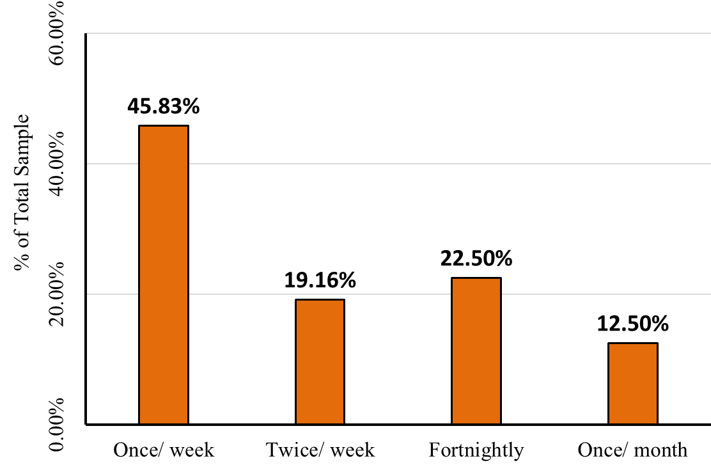
Fig 1. Frequency of Fish Purchase by Consumers in Hyderabad Fish Markets
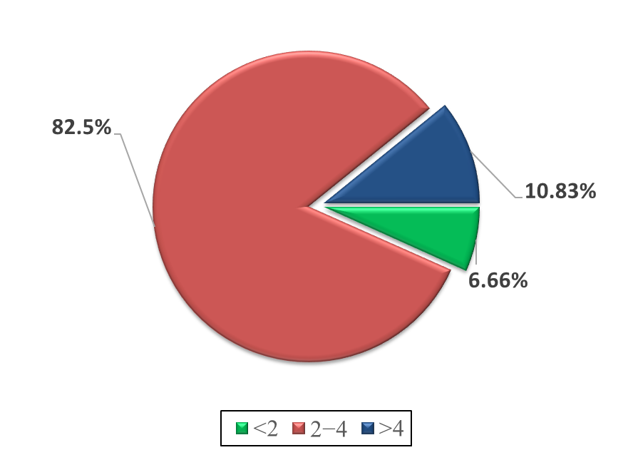
Fig 2. Quantity of Fish Purchased (Kg/ Visit) in by Consumers in Hyderabad
3.3. Average Monthly Expenditure on Food and Fish
The expenditure pattern of fish consumers in Hyderabad indicates significant allocation of household income towards food and non-vegetarian items. The average monthly expenditure on food was reported to be ₹11,508, out of which ₹5,439 was spent specifically on non-vegetarian items. Within this, the average expenditure on fish alone amounted to ₹1,752 per month. This suggests that fish constitutes a notable share of non-vegetarian expenditure, accounting for approximately 32.2% of the non-vegetarian budget and 15.2% of the total food expenditure.
3.4. Consumer Preferences for Fish Types and Species
An assessment of consumer preferences revealed that, among the 120 respondents surveyed, a vast majority (94.16%, n = 113) expressed a preference for freshwater fish, while only 5.83% (n = 7) favoured marine species.
Respondents were asked to rank different fish species based on their consumption preference, and the RBQ scores were calculated accordingly (Table 2). The results revealed that Rohu (RBQ score: 90.17) emerged as the most preferred species, securing the top rank among consumers in Hyderabad. This was followed by Catla (72.83) and Murrels (71.83), which occupied the second and third ranks, respectively. These findings are consistent with those of Das et al. (2013), who also reported Rohu and Catla as the top preferred species in Tripura. Prawns (63.50) and Tilapia (62.70) were also favoured, ranking fourth and fifth, indicating their popularity in urban fish markets. Species such as Common Carp (55.83) and Roopchand (28.00) occupied mid-level preference, whereas marine and lesser-consumed species like Mackerel (24.83), Pangasius (23.17), Wallugo attu (22.70), Anchovies (22.50), and Seer fish (22.17) were ranked lower in preference.
Table 2. Species-wise Preference of Fish Among Consumers
Species | RBQ Score | Rank
Rohu | 90.17 | I
Catla | 72.83 | II
Murrel | 71.83 | III
Prawn | 63.50 | IV
Tilapia | 62.70 | V
Common carp | 55.83 | VI
Roopchand | 28.00 | VII
Mackerel | 24.83 | VIII
Pangasius | 23.17 | IX
Wallugo attu | 22.70 | X
Anchovies | 22.50 | XI
Seer | 22.17 | XII

3.5. Determinants of Fish Consumption and Household Decision-Making Patterns
Among the attributes responsible for fish consumption, “Taste of fish” emerged as the most influential attribute, with the highest RBQ score of 83.70, securing the first rank (Table 3). This was closely followed by the perception that fish is healthy and nutritious, which ranked second with an RBQ score of 83.42. This aligns with the findings of Can et al. (2015), who also reported that health concerns play a significant role in shaping consumer preferences for fish. Other attributes such as the texture of fish meat (RBQ: 60.33), ease of digestion compared to other meats (38.16), and ease in cooking (34.00) were ranked third, fourth, and fifth, respectively.
In terms of household consumption patterns, most respondents (88.3%) reported that all family members consume fish, while a smaller proportion (11.6%) indicated that not all members were fish consumers. Regarding purchasing decisions, it was observed that in most households (66.6%), the head of the family makes the decision to purchase fish, whereas in 33.3% of cases, other family members were responsible.
Table 3. Attributes Influencing Fish Consumption
Attributes | RBQ Score | Rank
Taste of fish | 83.70 | I
Healthy and nutritious | 83.42 | II
Texture of fish meat | 60.33 | III
Easy digestion compared to other meats | 38.16 | IV
Ease in cooking | 34.00 | V

3.6. Constraints Faced by Fish Consumers
In total, seven key constraints were identified as challenges faced by fish consumers in Hyderabad, as assessed using the RBQ technique (Table 4). The analysis revealed that poor hygiene and sanitation facilities emerged as the most critical constraint, with the highest RBQ score of 84.30, indicating widespread concern among consumers regarding cleanliness in fish markets. The lack of vehicle parking facilities ranked second (RBQ: 72.40), reflecting a significant logistical challenge, particularly in congested urban areas. Market congestion was the third most reported issue (RBQ: 64.20), attributed to the high volume of consumers relative to the limited market space. Traffic chaos (RBQ: 40.10) was particularly noted during early morning hours and weekends, when heavy fish-loading vehicles congest the market vicinity, impeding consumer access and causing delays. Shyam et al. (2020) reported that fish markets in Kerala also face significant structural and functional limitations. Another major concern was price fluctuation (RBQ: 63.48), which respondents associated with the disruptions caused by the COVID-19 pandemic especially the lockdowns that impacted the fish supply chain and triggered volatility in market prices. Debnath et al. (2014) also highlighted high prices and frequent price fluctuations as key barriers to fish consumption, particularly affecting the choice of species. Other reported challenges included the lack of availability of fresh fish (RBQ: 50.93) and the inconvenience of markets being located at long distances (RBQ: 36.98), though these were relatively less significant in comparison to the top-ranked issues. This is in line with the findings of Shyam et al., (2019), who identified lack of fresh fish as the primary constraint in fish consumption, followed by high prices limiting access for many consumers.
Table 4. Constraints Faced by Fish Consumers in the Markets
Constraints | RBQ Score | Rank
Poor hygiene and sanitation facilities | 84.30 | I
Lack of vehicle parking facility | 72.40 | II
Market congestion | 64.20 | III
High price fluctuation due to covid | 63.48 | IV
Lack of fresh fish | 50.93 | V
Traffic chaos | 40.10 | VI
Long distantly located | 36.98 | VII

4. CONCLUSION
The study on consumer behaviour in fish markets of Hyderabad revealed that the majority of consumers preferred freshwater fish species, with Rohu, Catla, and Murrels ranking highest in preference based on RBQ analysis. Fish consumption was primarily driven by attributes such as taste and health benefits, and most households reported regular consumption by all members, with purchasing decisions largely made by the head of the family. However, several constraints were identified, the most critical being poor hygiene and sanitation, followed by lack of vehicle parking, market congestion, and price fluctuations. To address these issues, strategic infrastructure development is essential, particularly in improving waste management and drainage systems in markets. Redevelopment and proper planning can help mitigate problems like congestion and parking shortages. Enhanced fish market facilities will not only improve the consumer experience but also encourage higher market visitation and fish consumption.
DISCLAIMER (ARTIFICIAL INTELLIGENCE)
Author(s) hereby declare that ChatGPT was used only for editing and language refinement purposes. No direct AI-generated content has been used in the writing of the manuscript.

COMPETING INTERESTS DISCLAIMER:
Authors have declared that they have no known competing financial interests OR non-financial interests OR personal relationships that could have appeared to influence the work reported in this paper.

REFERENCES
Can, M. F., Günlü, A., & Can, H. Y. (2015). Fish consumption preferences and factors influencing it. Food Science and Technology, 35(2), 339–346.
Chourey, P., Meena, D., Varma, A., & Saxena, G. (2014). Fish marketing system in Bhopal (MP). Biological Forum, 6(1), 19-22.
Das, A., Kumar, N. R., Debnath, B., Barman, D., & Datta, M. (2013). Fish consumers’ behaviour at selected fish markets of Tripura, India.
Datta, S. N., Dhawan, A., & Singh, A. (2017). Trends of fish marketing strategy and trade in Punjab-A survey. Indian Journal of Ecology, 44(3), 637–643.
Debnath, B., Biradar, R. S., & Krishnan, M. (2014). Constraint analysis on fish consumption in Tripura. Indian Journal of Agricultural Marketing, 28(1), 36–44.
Department of Fisheries. (2022). Handbook of Fisheries Statistics 2022. Ministry of Fisheries, Animal Husbandry and Dairying, Government of India.
FAO. (2014). The State of World Fisheries and Aquaculture 2014: Opportunities and challenges. Rome: Food and Agriculture Organization of the United Nations.
FAO. (2016). The State of World Fisheries and Aquaculture 2016: Contributing to food security and nutrition for all. Rome: Food and Agriculture Organization of the United Nations.
FAO. (2023). The State of World Fisheries and Aquaculture 2022: Towards blue transformation. Rome: Food and Agriculture Organization of the United Nations.
Grunert, K. G., Hieke, S., & Wills, J. (2014). Sustainability labels on food products: Consumer motivation, understanding and use. Food Policy, 44, 177–189.
Kobayashi, M., Msangi, S., Batka, M., Vannuccini, S., Dey, M. M., & Anderson, J. L. (2015). Fish to 2030: The Role and Opportunity for Aquaculture. Aquaculture Economics & Management, 19(3), 282–300.
Kumar, B. G., Datta, K. K., Joshi, P. K., Katiha, P. K., Suresh, R., Ravisankar, T., Ravindranath, K., & Menon, M. (2008). Domestic fish marketing in India–changing structure, conduct, performance and policies. Agricultural Economics Research Review, 21(conf), 345–354.
Mohan Dey, M., Rab, M. A., Paraguas, F. J., Piumsombun, S., Bhatta, R., Ferdous Alam, M., & Ahmed, M. (2005). Fish consumption and food security: a disaggregated analysis by types of fish and classes of consumers in selected Asian countries. Aquaculture Economics & Management, 9(1-2), 89-111.
Needham, S., & Funge-Smith, S. (2015). The consumption of fish and fish products in the Asia-Pacific region based on household surveys.
Padiyar, A. P., Dubey, S. K., Bayan, B., Chadag, V. M., Belton, B., Jena, J., Murthy, L. N., Karthikeyan, M., & Murthy, C. K. (2024). Fish consumption in India: Patterns and trends.
Sabarathnam, V. E. (1988). Manuals of field experience training for ARS Scientists. NAARM, Hyderabad, 21.
Sajeev, M. V., Mohanty, A. K., Sajesh, V. K., & Rejula, K. (2019). A review of drivers and barriers to fish consumption based on theory of planned behaviour.
Schiffman, L. G., & Kanuk, L. (2000). Consumer behaviour. Upper Saddle River, NJ: Prentice Hall.
Shyam, S. S., Athira, N. R., Athira, P. R., Safeena, P. K., Rahman, M. R., Fernandez, R., Remya, R., & Rosey Xavier, S. (2019). Assessing demand drivers in augmenting fish consumption in Ernakulam. Indian Journal of Economics and Development, 7(5), 1–8.
Shyam, S. S., Monolisha, S., & Sunil, P. V. (2020). Fish Consumption: Gauging the determinants of consumption and buying patterns across Kerala markets. Journal of the Marine Biological Association of India, 62(1), 21–28.
Sidhu, K. S. (2003). Health benefits and potential risks related to consumption of fish or fish oil. Regulatory Toxicology and Pharmacology, 38(3), 336–344.
Sonanla, N. K., Rajakumar, M., Umamaheswari, T., Sujathkumar, N. V., Athithan, S., & Chimwar, W. (2024). Assessment of Fish Demand and Consumption Behaviour in Manipur, India.
Waghmare, S., Prakash, S., Sharma, A., Yadav, B. K., & Qureshi, N. (2023). Market analysis driven consumer behavior assessment of selected fish markets in Maharashtra, India. Journal of the Inland Fisheries Society of India, 55(3), 286–298.
Yaktine, A. L., & Nesheim, M. C. (2007). Seafood choices: Balancing benefits and risks. National Academies Press.

