**Original Research Article**

**Genetic Evaluation and Trait Association Analysis for Yield Enhancement in Soybean (Glycine max [L.] Merrill)**

**Abstract**

*Glycine max* [L.] Merrill is a internationally significant leguminous crop, appreciated for its high protein (~40%) and oil (~20%) content. Enhancing seed yield, a polygenic trait influenced by multiple agronomic characters, remains a major breeding objective. This investigation was conducted during *Kharif*, 2024 at the Research Farm, Zonal Agricultural Research Station, Morena, RVSKVV, Gwalior, M. P., India, using 60 genetically diverse genotypes laid out in a Randomized Block Design with two replications. Substantial genetic variability was observed for main yield attributing traits. Phenotypic coefficients of variation (PCV) exceeded genotypic coefficients (GCV), indicating environmental influence; however, small PCV-GCV differences for many traits suggested existence of a strong genetic basis. High heritability (>99%) and genetic advance as percentage of mean (GAM) were recorded for numbers of seeds per plant, biological and seed yield per plant signified that traits governed largely by additive gene action. Correlation analysis revealed significant positive associations of seed yield with numbers of seeds and pods per plant, biological yield, harvest index and hundred-seed weight. Path coefficient analysis identified biological yield as having the highest direct positive effect on seed yield, tracked by harvest index and numbers of seeds per plant. Whereas, negative direct effects of some traits were offset by strong indirect contributions *via* key yield contributing components. These findings highlighted that traits of high breeding value, offering essential guidance for selection indices in soybean improvement. Integrating these findings with molecular tools could accelerate the development of high-yielding, climate-resilient cultivars suitable to diverse agro-ecological zones.

**Keywords:** Correlation analysis, Genotypic coefficient of variation (GCV), Genetic advance, Genetic variability, Heritability, Phenotypic coefficient of variation (PCV), Phenotypic Path coefficient analysis, Soybean (*Glycine max)*.

**1. Introduction**

*Glycine max* [L.] Merrill stands as one of the most purposefully important leguminous crops cultivated worldwide, owing to its exceptional nutritional composition, broad industrial utility, and agronomic versatility (Upadhyay *et al.,* 2020). Its seeds contain around 40% high-quality protein and 20% oil, making soybean a vital component in human diets, animal feed formulations, and numerous industrial applications (Sharma *et al.,* 2021a; Mishra *et al.,* 2024a). Soy-derived protein, rich in essential amino acids, serves as a main alternative to animal protein in vegetarian and vegan diets. Instantaneously, soybean oil is extensively used in cooking, food processing, and non-food industries, including biodiesel, pharmaceuticals, cosmetics, lubricants and printing inks (Tripathi *et al.,* 2022; Sharma *et al.,* 2023; Mishra *et al.,* 2024b, Mishra *et al.,* 2024c). In livestock production, soybean meal produced after oil extraction aids as a high-protein feed ingredient that boosts productivity in poultry, cattle and aquaculture. Moreover, soybean products such as tofu, soy milk and textured vegetable protein are associated with health benefits like cholesterol reduction and improved heart health (Mishra *et al.,* 2025a). Agronomically, soybean subsidizes to environmental sustainability by fixing atmospheric nitrogen through symbiosis with *Rhizobium* bacteria, thereby reducing dependency on synthetic nitrogen fertilizers, improving soil fertility, and lowering production costs (Mishra *et al.,* 2021b; Nakei *et al.,* 2022; Hu *et al.,* 2023).

Its adaptability to diverse agro-climatic zones, short growing season, and compatibility with multiple cropping systems make soybean a crop of global relevance. The rising global demand-fueled by population growth, dietary transitions, livestock sector expansion and renewable energy needs has intensified the need for soybean yield enhancement under variable environmental conditions (Mishra *et al.,* 2021c; Malik *et al.,* 2024; Jia *et al.,* 2025). However, seed yield in soybean is a complex quantitative trait governed by multiple morphological, physiological and phenological factors, often influenced by genotype × environment interactions. Therefore, systematic genetic improvement through plant breeding remains critical. Understanding the extent of genetic variability, heritability and genetic advance is fundamental for devising efficient selection strategies that ensure sustainable genetic gains (Gnanasekaran *et al.,* 2024; Begna & Teressa, 2024). Simultaneously, assessing trait interrelationships through statistical tools such as correlation (Miller *et al.,* 1958) and path coefficient analyses (Wright, 1921), delivers insights into the direct and indirect effects of various yield attributing traits (Senthilnathan, 2019). Correlation analysis reveals the degree and direction of association among traits, while path analysis partitions these associations into direct and indirect effects, helping to identify key traits for selection (Skelly *et al.,* 2019; Reddy *et al.,* 2022). Together, these tactics offer a vigorous framework for trait prioritization and the development of high-yielding, climate-resilient cultivars tailored to specific agro-ecological conditions. Thus, present investigation was conducted to investigate a combined study on genetic variability, heritability, and genetic advance estimates and inter-trait relationships to achieve enhanced productivity, ecological resilience, and long-term food and nutritional security.

**2. Material & Methods**

**2.1 Experimental Site**

The field experiment was conducted during the *Kharif* season of 2024 at the Research Farm of the Department of Genetics and Plant Breeding, Zonal Agricultural Research Station, Morena, affiliated with Rajmata Vijayaraje Scindia Krishi Vishwa Vidyalaya (RVSKVV), Gwalior, Madhya Pradesh, India. Geographically, Morena is located at 26.5°N latitude and 78.0°E longitude, with an average elevation of 177 meters above mean sea level. The experimental site was characterized by uniform topography, medium-black soil and the absence of standing water, providing a suitable agro-ecological setting for soybean cultivation.

**2.2 Experimental Details**

The experiment was laid out in a Randomized Block Design (RBD) with two replications to ensure statistical accuracy and minimize environmental variability. A total of sixty soybean genotypes were evaluated for their performance under field conditions. Each genotype was sown in rows with a row-to-row spacing of 45 cm and plant-to-plant spacing of 15 cm, facilitating proper growth and aeration. The length of each row was 5 meters, providing adequate plot size for reliable phenotypic assessment. Standard agronomic practices were followed uniformly across the experimental field to ensure optimal crop establishment and to allow for the accurate evaluation of genetic potential.

**3. Result and discussion**

**3.1 Genetic variability, heritability and genetic advance**

The analysis of genetic variability, heritability and genetic advance among 60 soybean genotypes revealed substantial differences across investigated traits (Table 1). In all cases, phenotypic coefficients of variation (PCV) exceeded genotypic coefficients of variation (GCV), indicated environmental influence; nevertheless, the narrow gap between PCV and GCV for several traits suggested strong genetic control, supported the efficacy of phenotypic selection (Saicharan *et al.,* 2022; Chacko *et al.,* 2023).

High variability (>20%) was observed for numbers of seeds per plant (GCV: 31.25%; PCV: 31.26%), numbers of primary branches, harvest index, biological and seed yield, suggested for high selection potential. Moderate variability (10–20%) was addressed for 100-seed weight and plant height, while phenological traits *e.g*., days to flowering, podding and maturity demonstrated low variability (<10%) (Yimram *et al.,* 2009; Terfa & Gurmu, 2020).

Broad-sense heritability was found high for the most of the traits (75.74%–99.98%), with maximum values for numbers of pods, numbers of seeds per plant and days to maturity, indicated strong genetic determination as earlier mentioned by Toker (2004) and Akram *et al.,* (2016). Genetic advance as percentage of the mean (GAM) was recorded highest for numbers of seeds per plant (64.38%), tracked by numbers of branches, harvest index, biological and seed yield. This emphasized that these traits predominantly governed by additive gene action (Getnet *et al.,* 2018; Jayaprada *et al.,* 2021). Thus, traits like numbers of seeds per plant, biological yield and harvest index with high heritability and GAM emerged as prime candidates for selection in soybean improvement programmes targeting high-yielding and climate-resilient cultivars (Baraskar *et al.,* 2014; Nayak *et al.,* 2024).

Table 1: Grand Mean, range, coefficient of variation and heritability for different characters in soybean genotypes

|  |  |  |  |  |  |  |  |  |  |
| --- | --- | --- | --- | --- | --- | --- | --- | --- | --- |
| **Trait** | **Grand Mean** | **Range** | | **GCV** | **PCV**  **(%)** | **ECV**  **(%)** | **Heritability (%)** | **Genetic Advance**  **(%)** | **GA as % of Mean** |
| Maximum | Minimum | (%) |
| **Days to 50% flowering** | 40.292 | 47.000 | 33.000 | 7.339 | 7.349 | 0.386 | 99.72 | 6.083 | 15.098 |
| **Days to podding** | 53.175 | 62.000 | 47.000 | 7.527 | 7.533 | 0.292 | 99.85 | 8.239 | 15.494 |
| **Days to seed filling** | 64.558 | 75.000 | 54.000 | 6.726 | 6.730 | 0.241 | 99.87 | 8.939 | 13.846 |
| **Days to maturity** | 95.725 | 110.000 | 63.000 | 8.501 | 8.503 | 0.212 | 99.94 | 16.757 | 17.506 |
| **Plant height (cm)** | 37.500 | 56.333 | 28.000 | 14.484 | 14.517 | 0.976 | 99.55 | 11.164 | 29.770 |
| **Numbers of primary branches** | 4.294 | 7.333 | 2.000 | 27.924 | 28.218 | 4.063 | 97.93 | 2.445 | 56.924 |
| **Numbers of pods per plant** | 66.330 | 103.667 | 29.667 | 25.706 | 25.709 | 0.401 | 99.98 | 35.121 | 52.948 |
| **Numbers of seeds per pod** | 2.719 | 3.667 | 2.000 | 12.104 | 13.908 | 6.850 | 75.74 | 0.590 | 21.701 |
| **Numbers of seeds per plant** | 115.233 | 223.333 | 41.333 | 31.254 | 31.257 | 0.404 | 99.98 | 74.185 | 64.379 |
| **100-seed weight** | 9.173 | 13.465 | 5.176 | 16.770 | 19.067 | 9.072 | 77.36 | 2.787 | 30.386 |
| **Harvest index** | 41.406 | 64.251 | 22.360 | 27.727 | 28.120 | 4.681 | 97.23 | 23.320 | 56.321 |
| **Biological yield** | 25.884 | 41.407 | 11.231 | 27.090 | 27.177 | 2.174 | 99.36 | 14.398 | 55.627 |
| **Seed yield per plant** | 10.227 | 19.637 | 5.249 | 26.690 | 27.007 | 4.125 | 97.67 | 5.557 | 54.337 |

**Classes of Heritability (%): High** >70%, **Moderate** 50-70%, **Low <**50%

**Classes of GA as percentage of mean at 5%: High** >20%, **Moderate** 10-20%, **Low** <10%

**3.2** **Correlation coefficient analysis**

In the present investigation, genotypic and phenotypic correlation analysis were conducted to understand the interrelationships between seed yield per plant and various yield attributing traits in 60 soybean genotypes. At the genotypic level (Table 2; Fig. 1), seed yield per plant exhibited a highly significant and positive association with numbers of seeds per plant (0.729), numbers of pods per plant (0.505), biological yield (0.448), harvest index (0.386), and hundred-seed weight (0.265). These traits also displayed strong interrelationships, such as the high correlation between numbers of pods per plant and numbers of seeds per plant (0.637), and between harvest index and numbers of seeds per plant (0.376). This indicates that improvement in these traits may contribute significantly to enhance seed yield as earlier investigated by Bambodkar *et al.,* (2020) and Barpanda *et al.,* (2024). Traits such as days to flowering, days to podding, and days to maturity, generally demonstrated weak or non-significant correlations with seed yield. Some even exhibited negative associations with major yield traits, suggesting their limited direct role in yield enhancement under the investigated circumstances. For instance, days to podding had significant negative correlations with numbers of pods per plant and 100-seed weight at the genotypic level. Similar results also reported by Painkra *et al.,* (2018), Sharma *et al.,* (2021b) and Ragade *et al.,* (2025).

At the phenotypic level (Table 3; Fig. 2), the trends were consistent with the genotypic correlations. Seed yield per plant displayed significant positive correlations with numbers of seeds per plant (0.721), numbers of pods per plant (0.500), biological yield (0.444), harvest index (0.396), and hundred-seed weight (0.237). Numbers of primary branches also demonstrated a positive association with seed yield including several component traits in experiments of Guleria *et al.,* (2019) and Patil *et al.,* (2024), suggesting its importance as a secondary selection criterion. The negative correlation between biological yield and harvest index indicates a trade-off between total biomass production and resource allocation to seed formation (Chavan *et al.,* 2016; Amogne *et al.,* 2020). However, the strong positive association of biological yield with seed yield implies that genotypes with higher biomass, if coupled with a favourable harvest index, can be highly productive (Silva *et al.,* 2015; Sulistyo *et al.,* 2018; Miranda *et al.,* 2020). Similarly, the positive relationship between 100-seed weight and both harvest index and seed yield highlights the role of seed size in yield enhancement. The weak correlations of phenological traits such as days to flowering, podding, and maturity with seed yield suggested that delayed flowering or prolonged maturity may not contribute effectively to yield under rainfed *Kharif* conditions (Jain *et al.,* 2014; Karyawati & Puspitaningrum, 2021). These findings are likely influenced by environmental stresses such as irregular rainfall, drought, or waterlogging, which are common in the soybean-growing regions of India during this season (Nair *et al.,* 2024; Murali *et al.,* 2025). Overall, the results highlight the importance of selecting genotypes with higher numbers of pods and seeds per plant, better harvest index, and greater biological yield for improving soybean productivity. These traits can serve as reliable selection indices in soybean breeding programmes aim to yield enhancement under rainfed conditions (Borowska & Prusiński, 2021; Mishra *et al.,* 2025b).

Table 2: Estimates of correlation coefficient at genotypic level among different characters in soybean

|  |  |  |  |  |  |  |  |  |  |  |  |  |
| --- | --- | --- | --- | --- | --- | --- | --- | --- | --- | --- | --- | --- |
| **Days to 50% flowering** | **Days to podding** | **Days to seed filling** | **Days to maturity** | **Plant height (cm)** | **Numbers of primary branches** | **Numbers of pods per plant** | **Numbers of seeds per pod** | **Numbers of seed per plant** | **100- seed weight** | **Harvest index** | **Biological yield** | **Seed yield per plant** |
| **1.000** | 0.543 ** | 0.458 ** | 0.489 ** | -0.120 | 0.114 | -0.181 | 0.092 | -0.027 | -0.199 | -0.031 | 0.052 | 0.049 |
|  | **1.000** | 0.521 ** | 0.414 ** | -0.007 | -0.011 | -0.268 * | 0.027 | -0.058 | -0.255 * | -0.077 | -0.078 | -0.168 |
|  |  | **1.000** | 0.534 ** | -0.012 | 0.239 | -0.094 | -0.029 | -0.022 | -0.057 | -0.173 | 0.097 | -0.081 |
|  |  |  | **1.000** | -0.193 | 0.242 | -0.076 | -0.180 | -0.045 | 0.145 | -0.081 | 0.093 | -0.009 |
|  |  |  |  | **1.000** | 0.105 | 0.091 | 0.203 | 0.073 | -0.206 | -0.213 | 0.168 | -0.092 |
|  |  |  |  |  | **1.000** | 0.380 ** | 0.049 | 0.287 * | 0.249 | 0.004 | 0.198 | 0.197 |
|  |  |  |  |  |  | **1.000** | -0.030 | 0.637 ** | 0.070 | -0.007 | 0.503 ** | 0.505 ** |
|  |  |  |  |  |  |  | **1.000** | 0.258 * | 0.164 | 0.377 ** | -0.343 ** | -0.009 |
|  |  |  |  |  |  |  |  | **1.000** | 0.213 | 0.376 ** | 0.290 * | 0.729 ** |
|  |  |  |  |  |  |  |  |  | **1.000** | 0.442 ** | -0.176 | 0.265 * |
|  |  |  |  |  |  |  |  |  |  | **1.000** | -0.615 ** | 0.386 ** |
|  |  |  |  |  |  |  |  |  |  |  | **1.000** | 0.448 ** |
|  |  |  |  |  |  |  |  |  |  |  |  | **1.000** |

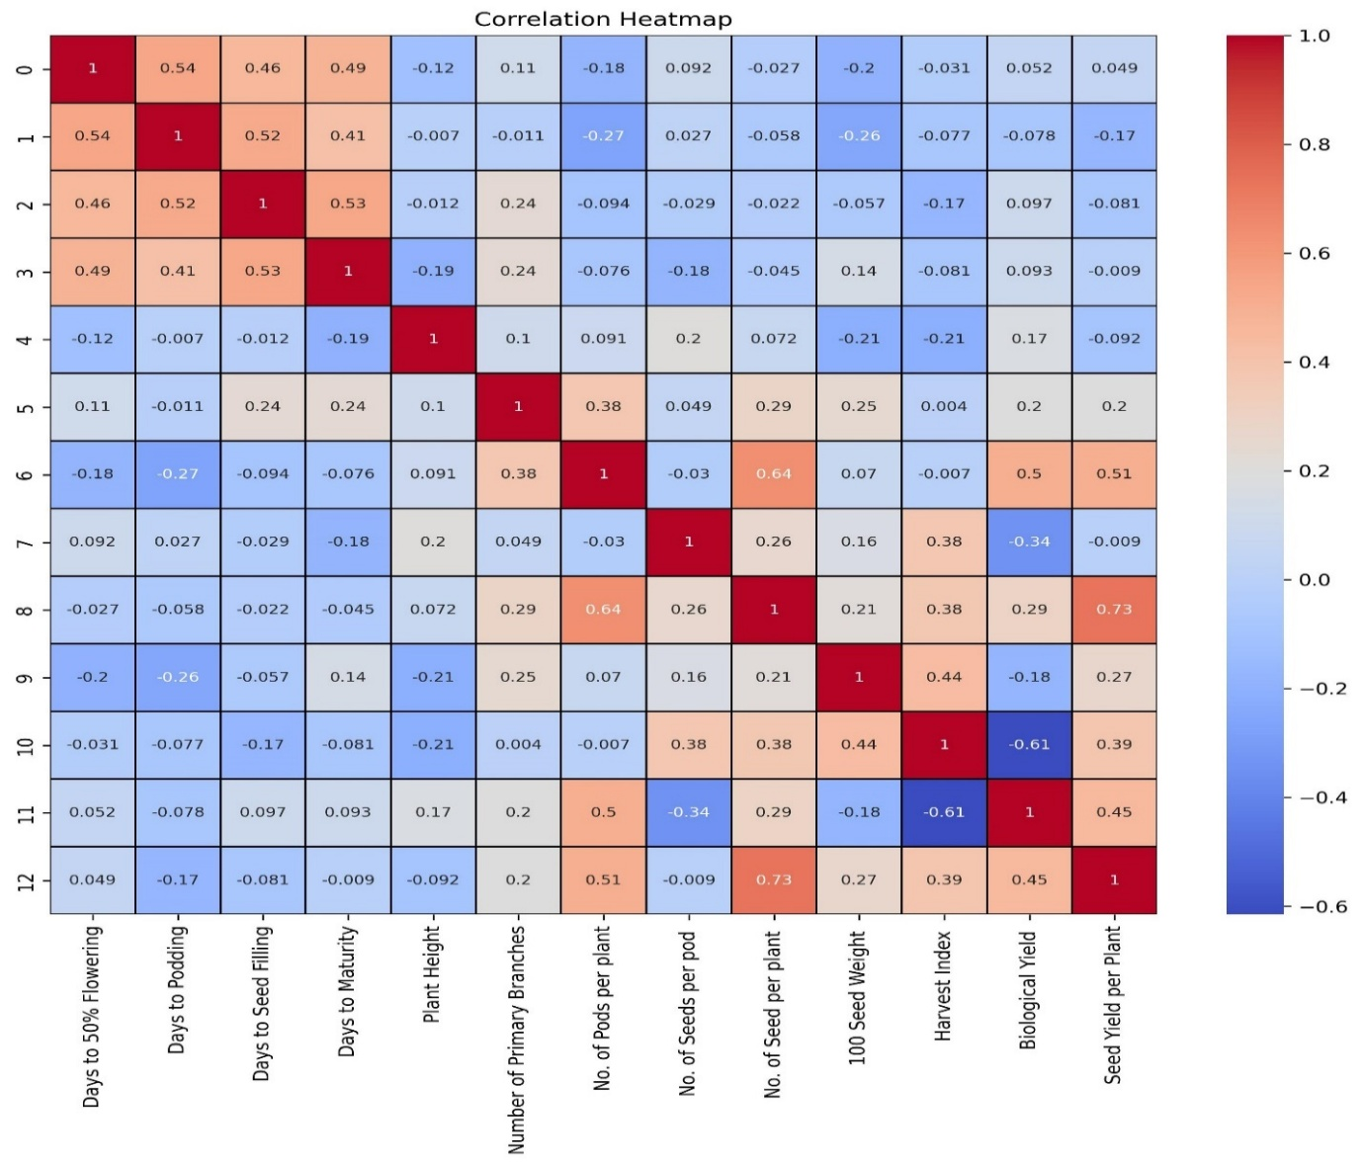

**Figure 1: Genotypic correlation heatmap for different traits in soybean**

**Table 3: Estimates of correlation coefficient for phenotypic level among different characters in soybean**

|  |  |  |  |  |  |  |  |  |  |  |  |  |
| --- | --- | --- | --- | --- | --- | --- | --- | --- | --- | --- | --- | --- |
| **Days to 50% flowering** | **Days to podding** | **Days to seed filling** | **Days to maturity** | **Plant height (cm)** | **Numbers of primary branches** | **Numbers of pods per plant** | **Numbers of seeds per pod** | **Numbers of seeds per plant** | **100-seed weight** | **Harvest index** | **Biological yield** | **Seed yield per plant** |
| **1.000** | 0.542 ** | 0.457 ** | 0.489 ** | -0.120 | 0.113 | -0.181 * | 0.081 | -0.027 | -0.167 | -0.031 | 0.051 | 0.048 |
|  | **1.000** | 0.521 ** | 0.413 ** | -0.007 | -0.012 | -0.267 ** | 0.027 | -0.058 | -0.224 * | -0.076 | -0.078 | -0.165 |
|  |  | **1.000** | 0.533 ** | -0.012 | 0.236 ** | -0.094 | -0.025 | -0.022 | -0.051 | -0.171 | 0.096 | -0.081 |
|  |  |  | **1.000** | -0.192 * | 0.239 ** | -0.076 | -0.160 | -0.045 | 0.127 | -0.080 | 0.093 | -0.010 |
|  |  |  |  | **1.000** | 0.104 | 0.091 | 0.174 | 0.072 | -0.181 * | -0.210 * | 0.168 | -0.090 |
|  |  |  |  |  | **1.000** | 0.376 ** | 0.042 | 0.283 ** | 0.220 * | 0.007 | 0.194 * | 0.195 * |
|  |  |  |  |  |  | **1.000** | -0.025 | 0.637 ** | 0.061 | -0.005 | 0.501 ** | 0.500 ** |
|  |  |  |  |  |  |  | **1.000** | 0.226 * | 0.138 | 0.329 ** | -0.297 ** | 0.000 |
|  |  |  |  |  |  |  |  | **1.000** | 0.186 * | 0.370 ** | 0.289 ** | 0.721 ** |
|  |  |  |  |  |  |  |  |  | **1.000** | 0.389 ** | -0.156 | 0.237 ** |
|  |  |  |  |  |  |  |  |  |  | **1.000** | -0.609 ** | 0.396 ** |
|  |  |  |  |  |  |  |  |  |  |  | **1.000** | 0.444 ** |
|  |  |  |  |  |  |  |  |  |  |  |  | **1.000** |

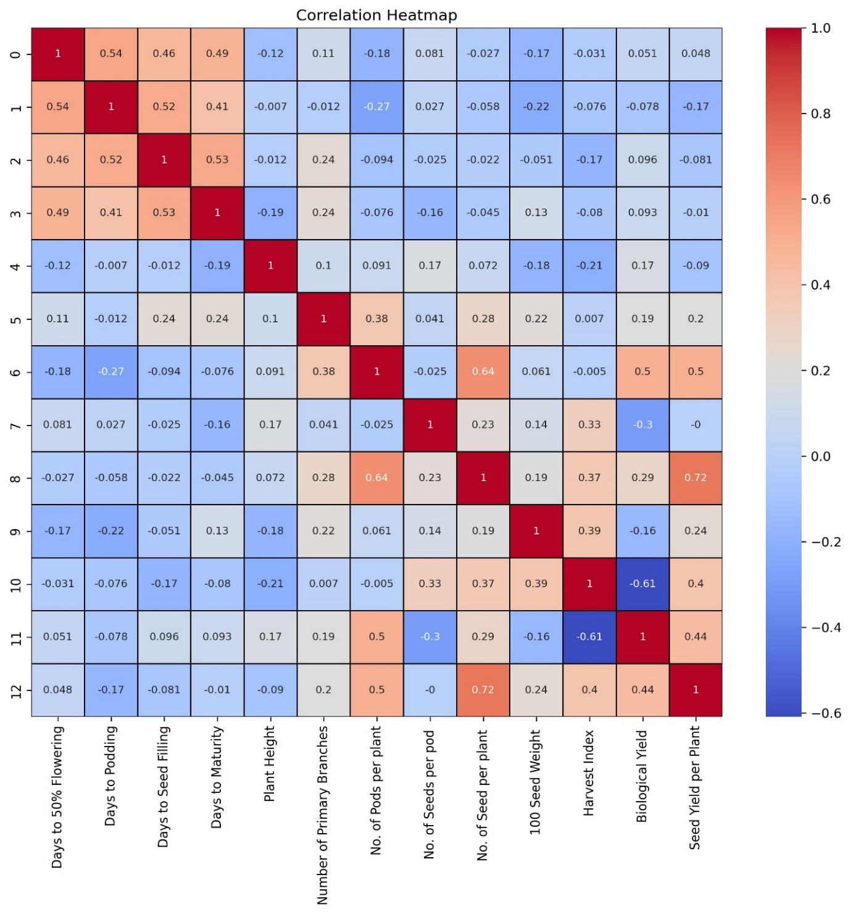

**Figure 2: Phenotypic correlation heatmap for different traits in soybean**

**3.3 Path Coefficient Analysis**

The path coefficient analysis conducted at both genotypic and phenotypic levels revealed detailed insights into the direct and indirect effects of various yield contributing traits on seed yield per plant in soybean (Table 4; Table 5). The results advised that biological yield per plant exhibited the highest positive direct effect on seed yield at both genotypic (0.999) and phenotypic (1.065) levels, tracked by harvest index and numbers of seeds per plant. This highlights the importance of these traits as primary contributors to seed yield enhancement as previously documented by Amogne *et al.,* (2020) and Patil *et al.,* (2024).

At the genotypic level, harvest index (0.992) and numbers of seeds per plant (0.127) also showed remarkable positive direct effects, whereas traits for instance days to maturity (-0.073), plant height (-0.051), numbers of pods per plant (-0.107), numbers of seeds per pod (-0.064), and days to podding (-0.031) had negative direct effects on seed yield. Similarly, at the phenotypic level, besides biological yield and harvest index, numbers of seeds per plant (0.120) contributed positively, while days to maturity (-0.068), plant height (-0.057), numbers of pods per plant (-0.105), and numbers of seeds per pod (-0.047) negatively influenced seed yield directly.

The indirect effects further elucidated complex interrelationships among traits. Markedly, biological yield exerted strong positive indirect effects *via* numbers of seeds per plant, numbers of seeds per pod, and phenological traits like days to flowering and podding, but was negatively influenced through harvest index, plant height, and numbers of pods per plant. Harvest index, while showed a strong direct effect, was influenced indirectly by traits such as numbers of seeds per plant, plant height, and days to maturity, while negatively impacted by biological yield and seed filling duration.

Traits such as numbers of pods per plant and numbers of seeds per pod, despite having negative direct effects, contributed positively to seed yield through their strong indirect effects *via* biological yield, numbers of seeds per plant, and harvest index. Days to maturity, plant height, and phenological traits generally had minimal or negative direct effects, yet their indirect contributions through key yield components were non-negligible.

These findings suggested that selection for high biological yield, efficient partitioning (harvest index), and greater seed numbers per plant can effectively increase seed yield in soybean. The predominance of biological yield as a central contributor to yield highlights the importance of biomass accumulation under field conditions (Sulistyo *et al.,* 2018; Ragade *et al.,* 2025). However, its negative association with harvest index designates a trade-off between vegetative growth and reproductive efficiency, necessitating a balanced selection approach. The positive direct and indirect effects of numbers of seeds per plant reaffirm its utility as a reliable yield predictor (Karyawati & Puspitaningrum, 2021; Nasir *et al.,* 2023). In contrast, traits like numbers of pods per plant and numbers of seeds per pod, though showing negative direct effects, may still be valuable through their interactions with other traits (Bisinotto *et al.,* 2017; Veeramani *et al.,* 2023). Moreover, the greater magnitude of both direct and indirect effects at the genotypic level compared to the phenotypic level suggests that genetic factors play a stronger role than environmental influences in determining these relationships, highlighting the potential of genetic improvement for yield enhancement (Obua *et al.,* 2024; Mishra *et al.,* 2025b).

**Conclusion**

The present investigation revealed significant genetic variability and robust interrelationships among yield and yield contributing traits in sixty soybean genotypes, offering valuable insights for crop improvement. Correlation and path coefficient analyses recognized key traits such as numbers of seeds per plant, biological yield, harvest index and seed yield per plant as critical determinants of yield. Remarkably, biological yield exhibited the highest positive direct effect on seed yield, followed by harvest index and numbers of seeds per plant, suggesting their prioritization in selection strategies. Although some traits like numbers of pods per plant and plant height displayed negative direct effects, their positive indirect effects accentuate the complexity of trait interactions and the need for balanced, multi-trait selection. The consistently higher phenotypic over genotypic coefficients of variation across traits indicated environmental influence; however, the narrow differences between them and the high heritability estimates for most traits advised predominant genetic control and the reliability of phenotypic selection. Moreover, high genetic advance for main characters implies additive gene action, making these characters ideal targets for genetic gain. Together, these findings establish a solid foundation for soybean breeding programmes. By integrating these insights with modern tools such as marker-assisted and genomic selection, breeders can accelerate the development of high-yielding, climate-resilient cultivars adapted to diverse agro-climatic conditions. This research strengthens the genetic base of soybean and contributes meaningfully to global food and nutritional security.

**Table 4: Path coefficient analysis showing the direct and indirect effect of 13 characters on the seed yield at phenotypic level**

|  |  |  |  |  |  |  |  |  |  |  |  |  |  |
| --- | --- | --- | --- | --- | --- | --- | --- | --- | --- | --- | --- | --- | --- |
| **Traits** | **Days to 50% flowering** | **Days to podding** | **Days to seed filling** | **Days to maturity** | **Plant height (cm)** | **Numbers of primary branches** | **Numbers of pods per plant** | **Numbers of seeds per pod** | **Numbers of seeds per plant** | **100- seed weight** | **Harvest index** | **Biological yield** | **Seed yield per plant** |
| **Days to 50% flowering** | **0.053** | -0.016 | 0.003 | -0.033 | 0.007 | 0.000 | 0.019 | -0.004 | -0.003 | -0.001 | -0.030 | 0.054 | 0.048 |
| **Days to podding** | 0.029 | **-0.029** | 0.003 | -0.028 | 0.000 | 0.000 | 0.028 | -0.001 | -0.007 | -0.002 | -0.075 | -0.083 | -0.165 |
| **Days to seed filling** | 0.024 | -0.015 | **0.005** | -0.036 | 0.001 | 0.000 | 0.010 | 0.001 | -0.003 | 0.000 | -0.171 | 0.103 | -0.081 |
| **Days to maturity** | 0.026 | -0.012 | 0.003 | **-0.068** | 0.011 | 0.000 | 0.008 | 0.008 | -0.006 | 0.001 | -0.080 | 0.099 | -0.010 |
| **Plant height (cm)** | -0.006 | 0.000 | 0.000 | 0.013 | **-0.057** | 0.000 | -0.010 | -0.008 | 0.009 | -0.002 | -0.209 | 0.179 | -0.090 |
| **Numbers of primary branches** | 0.006 | 0.000 | 0.001 | -0.016 | -0.006 | **0.001** | -0.039 | -0.002 | 0.034 | 0.002 | 0.007 | 0.207 | 0.1945 * |
| **Numbers of pods per plant** | -0.010 | 0.008 | -0.001 | 0.005 | -0.005 | 0.000 | **-0.105** | 0.001 | 0.077 | 0.001 | -0.005 | 0.534 | 0.5004 ** |
| **Numbers of seeds per pod** | 0.004 | -0.001 | 0.000 | 0.011 | -0.010 | 0.000 | 0.003 | **-0.047** | 0.027 | 0.001 | 0.328 | -0.316 | 0.000 |
| **Numbers of seed per plant** | -0.001 | 0.002 | 0.000 | 0.003 | -0.004 | 0.000 | -0.067 | -0.011 | **0.120** | 0.002 | 0.368 | 0.308 | 0.7205 ** |
| **100- seed weight** | -0.009 | 0.006 | 0.000 | -0.009 | 0.010 | 0.000 | -0.006 | -0.006 | 0.022 | **0.008** | 0.387 | -0.166 | 0.2374 ** |
| **Harvest index** | -0.002 | 0.002 | -0.001 | 0.006 | 0.012 | 0.000 | 0.001 | -0.015 | 0.044 | 0.003 | **0.996** | -0.649 | 0.3963 ** |
| **Biological yield** | 0.003 | 0.002 | 0.001 | -0.006 | -0.010 | 0.000 | -0.052 | 0.014 | 0.035 | -0.001 | -0.607 | **1.066** | 0.444 ** |

**Table 5: Path coefficient analysis showing the direct and indirect effect of 13 characters on the seed yield at genotypic level**

|  |  |  |  |  |  |  |  |  |  |  |  |  |  |
| --- | --- | --- | --- | --- | --- | --- | --- | --- | --- | --- | --- | --- | --- |
| **Traits** | **Days to 50% flowering** | **Days to podding** | **Days to seed filling** | **Days to maturity** | **Plant height (cm)** | **Numbers of primary branches** | **Numbers of pods per plant** | **Numbers of seeds per pod** | **Numbers of seeds per plant** | **100--seed weight** | **Harvest index** | **Biological yield** | **Seed yield per plant** |
| **Days to 50% flowering** | **0.058** | **-0.017** | **0.004** | **-0.036** | **0.006** | **0.000** | **0.019** | **-0.006** | **-0.003** | **-0.001** | **-0.031** | **0.056** | **0.049** |
| **Days to podding** | **0.032** | **-0.031** | **0.004** | **-0.030** | **0.000** | **0.000** | **0.029** | **-0.002** | **-0.007** | **-0.001** | **-0.078** | **-0.084** | **-0.168** |
| **Days to seed filling** | **0.027** | **-0.016** | **0.008** | **-0.039** | **0.001** | **0.000** | **0.010** | **0.002** | **-0.003** | **0.000** | **-0.174** | **0.103** | **-0.081** |
| **Days to maturity** | **0.029** | **-0.013** | **0.004** | **-0.073** | **0.010** | **0.000** | **0.008** | **0.012** | **-0.006** | **0.001** | **-0.081** | **0.100** | **-0.009** |
| **Plant height (cm)** | **-0.007** | **0.000** | **0.000** | **0.014** | **-0.051** | **0.000** | **-0.010** | **-0.013** | **0.009** | **-0.001** | **-0.213** | **0.179** | **-0.092** |
| **Numbers of primary branches** | **0.007** | **0.000** | **0.002** | **-0.018** | **-0.005** | **0.001** | **-0.041** | **-0.003** | **0.036** | **0.001** | **0.004** | **0.212** | **0.197** |
| **Numbers of pods per plant** | **-0.011** | **0.008** | **-0.001** | **0.006** | **-0.005** | **0.000** | **-0.107** | **0.002** | **0.081** | **0.000** | **-0.007** | **0.537** | **0.505 \*\*** |
| **Numbers of seeds per pod** | **0.005** | **-0.001** | **0.000** | **0.013** | **-0.010** | **0.000** | **0.003** | **-0.064** | **0.033** | **0.001** | **0.378** | **-0.367** | **-0.009** |
| **Numbers of seed per plant** | **-0.002** | **0.002** | **0.000** | **0.003** | **-0.004** | **0.000** | **-0.068** | **-0.017** | **0.127** | **0.001** | **0.376** | **0.310** | **0.7292 \*\*** |
| **100- Seed Weight** | **-0.012** | **0.008** | **0.000** | **-0.011** | **0.011** | **0.000** | **-0.008** | **-0.011** | **0.027** | **0.005** | **0.443** | **-0.188** | **0.265 \*** |
| **Harvest index** | **-0.002** | **0.002** | **-0.001** | **0.006** | **0.011** | **0.000** | **0.001** | **-0.024** | **0.048** | **0.002** | **0.992** | **-0.657** | **0.386 \*\*** |
| **Biological yield** | **0.003** | **0.002** | **0.001** | **-0.007** | **-0.009** | **0.000** | **-0.054** | **0.022** | **0.037** | **-0.001** | **-0.616** | **0.999** | **0.448 \*\*** |

**References**

1. Akram, S., Hussain, N. B. M., al Bari, Md. A., Burritt J. D., & Hossain, A. M. 2016. Genetic variability and association analysis of soybean (*Glycine max* (L.) Merrill) for yield and yield attributing traits. *Plant Gene and Trait*. <https://doi.org/10.5376/pgt.2016.07.0013>
2. Amogne, A., Atnaf, M., & Bantayehu, M. 2020. Correlation and path coefficient analysis in soybean [*Glycine max* (L.) Merrill] genotypes in dibate, North Western Ethiopia. *International Journal of Scientific Engineering and Science*, **4**(6): 1-5.
3. Bambodkar, P. P., Bisane, R. D., Maraskole, S. K., Pawar, V. S., & Kamdi, S. R. 2020. Correlation studies in F3 segregating generations of soybean. *International Journal of Current Microbiology and Applied Sciences*, **9**(12): 132–136. <https://doi.org/10.20546/ijcmas.2020.912.017>
4. Baraskar, V. V., Kachhadia, V. H., VachhanI, J. H., Barad, H. R., Patel, M. B., & Darwankar, M. S. 2014. Genetic variability, heritability and genetic advance in soybean [*Glycine max* (L.) Merrill]. *Electronic Journal of Plant Breeding*, **5**(4): 802-806.
5. Barpanda, T., Chavan, B. H., Katore, T. D., & Deshmukh, M. P. 2022. Correlation and path analysis studies in elite lines of soybean [*Glycine max* (L.) Merrill]. *Agricultural Science Digest - A Research Journal*. <https://doi.org/10.18805/ag.D-5538>
6. Begna, T., & Teressa, T. 2024. Genetic variability and its benefits in crop improvement: A review. *Middle East Journal of Agriculture Research*, **13**(1): 128–136. <https://doi.org/10.36632/mejar/2024.13.1.6>
7. Bisinotto, F. F., Hamawaki, O. T., Nogueira, A. P. O., Hamawaki, R. L., Glansenapp, J. S., & Hamawaki, C. L. 2017. Path analysis and traits correlation in soybean. [*Communications in Plant Science*s](https://www.researchgate.net/journal/Communications-in-Plant-Sciences-2237-4027?_tp=eyJjb250ZXh0Ijp7ImZpcnN0UGFnZSI6ImxvZ2luIiwicGFnZSI6InB1YmxpY2F0aW9uIiwicG9zaXRpb24iOiJwYWdlSGVhZGVyIn19), **7**(1-2):27-33.
8. Borowska, M., & Prusiński, J. 2021. Effect of soybean cultivars sowing dates on seed yield and its correlation with yield parameters. *Plant, Soil and Environment*, **67**(6): 360–366. <https://doi.org/10.17221/73/2021-PSE>
9. Chacko, A., Jayalekshmy, V. G., & Shahiba, A. M. 2023. Studies on PCV, GCV, heritability, and genetic advance in rice genotypes for yield and yield components. *International Journal of Plant & Soil Science*, **35**(16): 324–330. <https://doi.org/10.9734/ijpss/2023/v35i163266>
10. Chavan, B. H., Dahat, D. V., Rajput, H. J., Deshmukh, M. P., & Diwane, S. L. 2016. Correlation and path analysis in soybean. *International Research Journal of Multidisciplinary Studies*, **2**(9): 1-5.
11. Getnet, B. E. 2018. Genetic variability, heritability and expected genetic advance as indices for selection in soybean [*Glycine max* (L.) Merrill] varieties. *American Journal of Life Sciences*, **6**(4): 52-56. <https://doi.org/10.11648/j.ajls.20180604.11>
12. Gnanasekaran, M., Gunasekaran, M., Thiyagu, K., Muthuramu, S., Ramkumar, J., & Venudevan, B. 2024. Genetic variability, heritability, genetic advance and association studies in blackgram [*Vigna mungo* (L.) Hepper]. *Legume Research - An International Journal*. <https://doi.org/10.18805/LR-5203>
13. Guleria, H., Kumar, P., Jyoti, B., Kumar, A., Paliwal, A., & Paliwal, A. 2019. Genetic variability and correlation analysis in soybean (*Glycine max* (L.) Merrill) genotypes. *International Journal of Chemical Studies,* **7**(1): 1928-1932.
14. Hu, Y., Chen, Y., Yang, X., Deng, L., & Lu, X. 2023. Enhancing soybean yield: The synergy of sulfur and rhizobia inoculation. *Plants*, **12**(22): 3911. <https://doi.org/10.3390/plants12223911>
15. Jain, S., Srivastava, S. C., Singh, S. K., Indapurkar, Y. M., & Singh, B. K. 2015. Studies on genetic variability, character association and path analysis for yield and its contributing traits in soybean [*Glycine max* (L.) Merrill]. *Legume Research*, **38**(2): 182. <https://doi.org/10.5958/0976-0571.2015.00031.4>
16. Jayaprada, A., Lavanya, R., Babu, V. R., Krishna, C. N. S., & Reddy, T. S. 2021. Genetic variability, heritability and genetic advance for yield and yield contributing traits of green gram. *Journal of Agri Search*, **8**(2). <https://doi.org/10.21921/jas.v8i2.7289>
17. Jia, N., Yang, H., Lan, X., Li, Y., Song, Y., Zhang, Z., Song, W., Zhao, R., Ma, T., & Chen, R. 2025. Global soybean trade intensifies the impacts of dietary transition on human mobility. *IScience*, **28**(5), 112426. <https://doi.org/10.1016/j.isci.2025.112426>
18. Karyawati, A. S., & Puspitaningrum, E. S. V. 2021. Correlation and path analysis for agronomic traits contributing to yield in 30 genotypes of soybean. *Biodiversitas Journal of Biological Diversity*, **22**(3). <https://doi.org/10.13057/biodiv/d220309>
19. Malik, M. A. I., Zeeshan, S., Khubaib, M., Ikram, A., Hussain, F., Yassin, H., & Qazi, A. 2024. A review of major trends, opportunities, and technical challenges in biodiesel production from waste sources. *Energy Conversion and Management: X*, **23**: 100675. <https://doi.org/10.1016/j.ecmx.2024.100675>
20. Miller, P. A., Williams, J. C., Robinson, H. F., & Comstock, R. E. 1958. Estimation of genotypic and environmental variances and covariance in upland cotton and their implication in selection. *Agronomy Journal*, **50**: 126–131.
21. Miranda, C., Scaboo, A., Cober, E., Denwar, N., & Bilyeu, K. 2020. The effects and interaction of soybean maturity gene alleles controlling flowering time, maturity, and adaptation in tropical environments. *BMC Plant Biology*, **20**(1): 65. <https://doi.org/10.1186/s12870-020-2276-y>
22. Mishra, N., Tripathi, M.K., Tiwari, S., Tripathi, N., Sapre, S. & Ahuja, A. *et al*. 2021a. Cell suspension culture and *in vitro* screening for drought tolerance in soybean using poly-ethylene glycol. *Plants*, **10**(3):517. <https://doi.org/10.3390/plants10030517>
23. Mishra, N., Tripathi, M.K., Tiwari, S., Tripathi, N., Gupta, N., Sharma, A., & Solanki1 R.S. 2021b. Evaluation of diversity among soybean genotypes *via* yield attributing traits and SSR molecular markers. *Current Journal of Applied Science and Technology*, **40**, 21: 9-24.
24. Mishra, N., Tripathi, M.K., Tripathi, N., Tiwari, S., Gupta, N., & Sharma, A. 2021c. Validation of drought tolerance gene-linked microsatellite markers and their efficiency for diversity assessment in a set of soybean genotypes. *Current Journal of Applied Science and Technology*, **30**: 48–57. <https://doi.org/10.9734/cjast/2021/v40i2531515>
25. Mishra, R., Shrivastava, M.K., Amrate, P.K., Sharma, S., Singh, Y., &Tripathi, M.K. 2025a. Phenotypic diversity and trait analysis of soybean recombinant inbred lines. *Plant Cell Biotechnology and Molecular Biology*, **26**(7–8):32–52. <https://doi.org/10.56557/pcbmb/2025/v26i7-89345>
26. Mishra, R., Shrivastava, M.K., Tripathi, M.K., Amrate, P.K., Singh, Y. & Solanki R. *et al*. 2025b. Unravelling soybean yield potential: Exploring trait synergy, impact pathways, multidimensional patterns and biochemical insights. *Plant Science Today*. <https://doi.org/10.14719/pst.6401>
27. Mishra, R., Tripathi, M. K., Sikarwar, R. S., Singh, Y., & Tripathi, N. 2024a. Soybean (*Glycine max* L. Merrill): A multipurpose legume shaping our world. *Plant Cell Biotechnology and Molecular Biology*, **25**(3–4): 17–37. <https://doi.org/10.56557/pcbmb/2024/v25i3-48643>
28. Mishra, R., Tripathi, M., Tripathi, N., Singh, J. & Tiwari S. 2024b. Nutritional and anti-nutritional factors in soybean. *Acta Scientific Agriculture*. **8**(11): 46–63. <https://doi.org/10.31080/ASAG.2024.08.1432>
29. Mishra, R., Tripathi, M.K., Tripathi, N., Singh, J., Yadav, P.K. & Sikarwar, R.S. *et al.* 2024c. Breeding for major genes against drought stress in soybean. In: Tripathi MK, Tripathi N, editors. *Advances in Plant Biotechnology*. Cornous Publications LLP, Puducherry, India. p. 22–68. [https://doi.org/https://doi.org/10.37446/volbook032024/22-68](https://doi.org/https:/doi.org/10.37446/volbook032024/22-68)
30. Murali, R., George, A., Jolly, G. E., & Jincy, M. 2025. Impact and response of drought stress in pigeon pea (*Cajanus cajan* L.): A review. *Agricultural Reviews*, <https://doi.org/10.18805/ag.R-2713>
31. Nair, R. M., Chaudhari, S., Devi, N., Shivanna, A., Gowda, A., Boddepalli, V. N., Pradhan, H., Schafleitner, R., Jegadeesan, S., & Somta, P. 2024. Genetics, genomics, and breeding of black gram [*Vigna mungo* (L.) Hepper]. *Frontiers in Plant Science*, **14**. <https://doi.org/10.3389/fpls.2023.1273363>
32. Nakei, M. D., Venkataramana, P. B., & Ndakidemi, P. A. 2022. Soybean-nodulating rhizobia: ecology, characterization, diversity, and growth promoting functions. *Frontiers in Sustainable Food Systems*, ***6***. <https://doi.org/10.3389/fsufs.2022.824444>
33. Nasir, B., Razzaq, H., Sadaqat, H. A., Wahid, M. A., & Imtiaz, M. 2023. Correlation and path coefficient analysis in soybean under various levels of water and temperature at maturity stage. *Pak. J. Agri. Sci*., **60**(1): 107-115
34. Nayak, S., Meena, B., Sharma, S., Sachdeva, K., &. Himanshi. 2024. Genetic variability, heritability and genetic advance in soybean [*Glycine max* (L.) Merrill]. *International Journal of Advanced Biochemistry Research*, **8**(11S): 743–745. <https://doi.org/10.33545/26174693.2024.v8.i11Sj.3015>
35. Obua, T., Sserumaga, J. P., Tukamuhabwa, P., Namara, M., Awio, B., Mugarra, J., Tusiime, G., & Chigeza, G. 2024. Unravelling yield and yield-related traits in soybean using GGE biplot and path analysis. *Agronomy*, **14**(12): 2826. <https://doi.org/10.3390/agronomy14122826>
36. Painkra, P., Shrivatava, R., Nag, S. K., & Kute, I. 2018. Correlation analysis for seed yield and its attributing traits in soybean (*Glycine max* L. Merrill). *International Journal of Current Microbiology and Applied Sciences*, **7**(04), 2034–2040. <https://doi.org/10.20546/ijcmas.2018.704.234>
37. Patil, V. V., Girase, V., Ghule, S. K., Ghume, O. G., & Shaniware, Y. A. 2024. Correlation and path analysis studies in soybean [(*Glycine max* (L.) Merrill]. *International Journal of Advanced Biochemistry Research*, **8**(12S): 281–288. <https://doi.org/10.33545/26174693.2024.v8.i12Sd.3127>
38. Ragade, O., Deshmukh, M., Mahajan, S., Kale, S., Kumbhar, S., & MK, N. 2025. Correlation and path coefficient assessment for yield and yield contributing characters in soybean [*Glycine max* (L.) Merrill]. *International Journal of Agriculture and Food Science*, **7**(1): 185–188. <https://doi.org/10.33545/2664844X.2025.v7.i1c.256>
39. Reddy, S. G. M., Lal, G. M., Krishna, T. V., Reddy, Y. V. S., & Sandeep, N. 2022. Correlation and path coefficient analysis for grain yield components in maize (*Zea mays* L.). *International Journal of Plant & Soil Science*, 24–36. <https://doi.org/10.9734/ijpss/2022/v34i2331558>
40. Saicharan, G., Dhuppe, M. V., Rathod, S. T., Sargar, P. R., & Rao, M. V. 2022. Studies on genetic variability, heritability, and genetic advance for yield and yield contributing traits in soybean [*Glycine max* (L.) Merrill]. *The Pharma Innovation*, **11**(12): 3131-3133.
41. Senthilnathan, S. 2019. Usefulness of correlation analysis. *SSRN Electronic Journal*. <https://doi.org/10.2139/ssrn.3416918>
42. Sharma, A., Mishra, N., Tripathi, N., Nehra, S., Singh, J., & Tiwari S. *et al*. 2023. Qualitative trait based variability among soybean genotypes. *Acta Scientific Agriculture*. **1**: 02–13. <https://doi.org/10.31080/ASAG.2023.07.1212>
43. Sharma, A., Tripathi, M. K., Tiwari, S., Gupta, N., Tripathi, N., & Mishra, N. 2021a. Evaluation of soybean (*Glycine max* L.) genotypes on the basis of biochemical contents and anti-oxidant enzyme activities. *Legume Research,* <https://doi.org/10.18805/LR-4678>
44. Sharma, R., Mahla, H. R., Kumar, S., & Gaikwad, K. 2021b. Study of correlation, path coefficient and linkage of flower colour and hairiness with yield controlling quantitative traits in segregating population of cluster bean. *Current Plant Biology,* **26**: 100202. <https://doi.org/10.1016/j.cpb.2021.100202>
45. Silva, A. F., Sediyama, T., Silva, F. C. S., Bezerra, A. R. G., & Ferreira, L. V. 2015. Correlation and path analysis of soybean yield components. *International journal of plant, animal and environmental sciences*, **5**(1): 177-179.
46. Skelly, D. A., Raghupathy, N., Robledo, R. F., Graber, J. H., & Chesler, E. J. 2019. Reference trait analysis reveals correlations between gene expression and quantitative traits in disjoint samples. *Genetics*, **212**(3): 919–929. <https://doi.org/10.1534/genetics.118.301865>
47. Sulistyo, A., Purwantoro, & Sari, K. P. 2018. Correlation, path analysis and heritability estimation for agronomic traits contribute to yield on soybean. *IOP Conference Series: Earth and Environmental Science*, **102**: 012034. <https://doi.org/10.1088/1755-1315/102/1/012034>
48. Terfa, G. N., & Gurmu, G. N. 2020. Genetic variability, heritability and genetic advance in linseed (*Linum usitatissimum* L) genotypes for seed yield and other agronomic traits. *Oil Crop Science*, **5**(3): 156–160. <https://doi.org/10.1016/j.ocsci.2020.08.002>
49. Toker, C. 2004. Estimates of broad-sense heritability for seed yield and yield criteria in faba bean (*Vicia faba* L.). *Hereditas*, **140**(3): 222–225. <https://doi.org/10.1111/j.1601-5223.2004.01780.x>
50. Tripathi, N., Tripathi, M. K., Tiwari, S., & Payasi, D. K. 2022. Molecular breeding to overcome biotic stresses in soybean: update. Plants, **11**(15): 1967. <https://doi.org/10.3390/plants11151967>
51. Upadhyay, S., Singh, A.K., Tripathi, M.K., Tiwari, S., & Tripathi, N. 2020. Validation of simple sequence repeats markers for charcoal rot and Rhizoctonia root rot resistance in soybean genotypes. *I.J.A.B.R.* **10**(2):137-144.
52. Veeramani, P., Subrahmaniyan, K., & Manickam, S. 2023. Evaluation of high harvest index urdbean (*Vigna mungo* L.) varieties using path analysis in various crop spacing under rainfed conditions in Tamil Nadu. *Legume Research*. <https://doi.org/10.18805/LR-5129>
53. Wright, S. 1921. Correlation and causation. *Journal of Agricultural Research,* **20**: 557–585.
54. Yimram, T., Somta, P., & Srinives, P. 2009. Genetic variation in cultivated mungbean germplasm and its implication in breeding for high yield. *Field Crops Research*, **112**(2–3): 260–266. <https://doi.org/10.1016/j.fcr.2009.03.013>