# Original Research Article

# Block-Level Analysis of Rainfall and Temperature Trends and Variability Across Districts of Chhattisgarh

**Abstract**

Various rainfall and temperature patterns in 149 blocks of Chhattisgarh in India were analyzed for trends and variability from 1951 to 2020. Using Innovative Trend Analysis (ITA), the study considered four major climatic variables for five times: annual, winter, summer, southwest monsoon, and northeast monsoon. The variables under study are rainfall, the number of rainy days, maximum temperature, and minimum temperature. The study also concludes that climatic changes differ very much depending on location and the season. According to the studies, maximum temperatures have been increasing steadily across the state, while there has been a general decrease in annual rainfall and the number of rainy days. The findings provide insight into climatic variability in Chhattisgarh, which may influence agricultural practices and future planning concerning climate resilience.

**Keywords:** Rainfall variability, Temperature trends, Chhattisgarh, Innovative Trend Analysis, Climate change, Seasonal patterns, Agro-climatic zones

# Introduction

With long-enduring consequences for ecosystems, agriculture, water, and human livelihood, these issues have indeed been regarded at an international level. A proper attempt at adaptation and mitigation would call for an awareness of climatic changes at local and regional levels. Monsoon rains are the lifeblood of the agricultural operations of Chhattisgarh, placed between latitudes; a considerable part of the population cultivates through rain. The unique geographical diversity of the state consisting of plains, hills, and forests brings about conspicuous regional and temporal variations in climatic parameters, especially rainfall and temperature. Changes in the start and distribution of monsoon rainfall in Chhattisgarh in the last few decades also show the increasing trend in temperature. The socioeconomic stability of the region, agricultural yield, and water supply, however, are directly impacted by these changes. It is thus imperative to analyze climate trends at the district level to accentuate variation among these districts and formulate climate-resilient policies suited to a particular region. One of the reasons for climate change phenomena is the heating up of surface and atmospheric temperatures of the Earth, variations in rain, diminution in groundwater, soil erosion, draughty winds, floods, droughts, ocean level rise caused by ice melting, hailstorms, fog, cyclones, wind speed, earthquakes, and landslides. (Kumar et al., 2009).One definition of a trend is the general movement of a series over a long period of time, while another is the long-term change in the dependent variable. A correlation between two variables, such precipitation and time or temperature and time, establishes the trend (J. Sahu & Chaudhary, 2018). Because of increasing evaporation brought on by global warming, rainfall is changing or is predicted to change in terms of amount, shape, and timing, particularly in the tropics. Both the agricultural and non-agricultural sectors will be significantly impacted by this. Agriculture productivity has been declining due to climate instability, which has a detrimental impact on human health, livelihoods, and food security. Because they rely on agriculture for their food and livelihood, rural residents at increased risk from changes in the environment and fluctuations. People in the Hindu Kush region of the Himalayas, which includes parts of Bangladesh, Nepal, and India, are particularly vulnerable to climate change due to their high reliance on agriculture for a living, inadequate infrastructure, low productivity, physical isolation, and restricted access to international markets (T. Sahu et al., 2022). When it comes to the development of civilization, rainfall and all other natural circumstances should be considered essential. In the seasonally dry regions of the globe, rainfall is a critical agroclimatology component, and in India, its study is a necessary prerequisite for agricultural planning . Since India is a tropical nation, monsoon rainfall is crucial to the development of rainfall analysis because it determines agricultural planning and water use. Vennila et al., (2007) has examined the monthly, seasonal, and intensity variations of rainfall in the Vattamalaikarai subbasin in Tamil Nadu, India. In tropical nations, rainfall on various timescales and on a daily basis greatly influences meteorological phenomena and aids in determining the potential for hydrological studies and agricultural land usage. Im et al., (2017) examines the effects of extreme temperature indices on socioeconomic advancement, agriculture, and health in 10 western Odisha and five adjacent Chhattisgarh districts. Despite being industrialized, the people in these areas are sensitive to India's socioeconomic situations. The mean, daily maximum, and minimum Every year, we may anticipate a temperature increase of 0.017 °C, 0.012 °C, and 0.006 °C. Warm evenings have been happening more often and with more intensity; the tendency is most pronounced in Raigarh, Chhattisgarh. Cold days are becoming less common across all districts, while Sambalpur is seeing the biggest decline. Swain et al., (2019) This research examines precipitation and temperature fluctuations in Bilaspur District, Chhattisgarh, India, from 1901 to 2002. Results show rising precipitation patterns, with yearly rainfall increasing by 10.65% in 102 years. The average temperature rose 1.44% from 1901 to 2002, helping local stakeholders and policymakers understand climate variability for effective water management decisions. Verma et al., (2022) analyzed on rainfall and temperature in Chhattisgarh between 1901 and 2010. It found that rainfall decreased. The Jashpur district had the biggest drop each year. Other districts also saw large decreases. The results show that studying rainfall and temperature patterns can help forecast climate change. It can also help manage water resources in the area for the long term. Sinha et al., (2022) examined the impact of extreme weather events on hydraulic structures in Raipur City, India, using statistical trend analysis and change detection tests. Results show temperature as the primary cause of the changing rainfall pattern, and urbanization and industrial growth have significantly impacted the city's ecosystem and environment. Kurrey et al., (2023) conducted research on pre weather data of 1980-2020 period by the Department of Agrometeorology Indira Gandhi Agricultural University, Raipur. Agriculture univ. However, the state's monsoon season in this region, known as the southwest monsoon, which starts from June and continues through September, contributes to 87% of its annual rainfall. June and September display poorer consistency of the rainfall with coefficients of variation below 33% and around 30%, respectively. Variation of annual rainfall is lower compared to months receiving monsoon rains. District-wise minimum and maximum rainfall range between 14 and 37%, 22 and 37% & 14 and 37%, respectively in Wainganga basin. Dubey et al., (2023) The study examines long-term trends in climatic factors in Chhattisgarh, India, using non-parametric tests. Results show a decreasing trend in annual rainfall, increasing temperatures except for January, May, and June, and significant increases in September, October, and November. Homogeneous data may aid in water resource management and natural calamity response. Hailu et al., (2024) revealed that trend analysis showed significant changes both annually and seasonally with their timing. Anand et al., (2025) stated that spatial variability varies according to high and lower altitude districts.

# Research gap

Even though there has been a lot of study done on the patterns in temperature and rainfall in different Chhattisgarh districts, most of the studies that have been done so far have concentrated on specific areas or climatic characteristics throughout a range of time periods. The majority of studies are limited in their applicability for localized climate adaptation because they rely on broad regional data without including block-level or district-specific variability. Furthermore, while Sen's slope and Mann-Kendall are two popular tools for analyzing trends, there aren't many studies that connect these climatic trends to real-world applications in managing water resources, agriculture, and severe weather preparation. Comprehensive, district-by-district trend and variability study of Chhattisgarh's temperature and rainfall patterns using current data is still lacking, which might inform focused policy choices and climate-resilient tactics.

**Materials**

For the study, weather data was collected for a period of March 01, 2024 to March 31, 2025 as mentioned in Table 1. Four main meteorological factors will be included in the data: a total of rainy days, high and low temperatures in degrees Celsius, and the rainfall (in mm). 149 blocks from every district in Chhattisgarh would be included in the dataset. With an emphasis on winter, summer, the southwest and northeast monsoons, and the whole year, trend analysis will take into account both seasonal and yearly periods.

|  |  |  |
| --- | --- | --- |
| **Weather Parameter** | **Grid Size** | **Time Scale** |
| **Rainfall** | 0.25 x 0.25 | 01/03/2024 to 31/03/2025 |
| **Maximum Temperature** | 0.50 x 0.50 | 01/03/2024 to 31/03/2025 |
| **Minimum Temperature** | 0.50 x 0.50 | 01/03/2024 to 31/03/2025 |

**Table 1 Data sets used**

# Methodology

**Study Area**

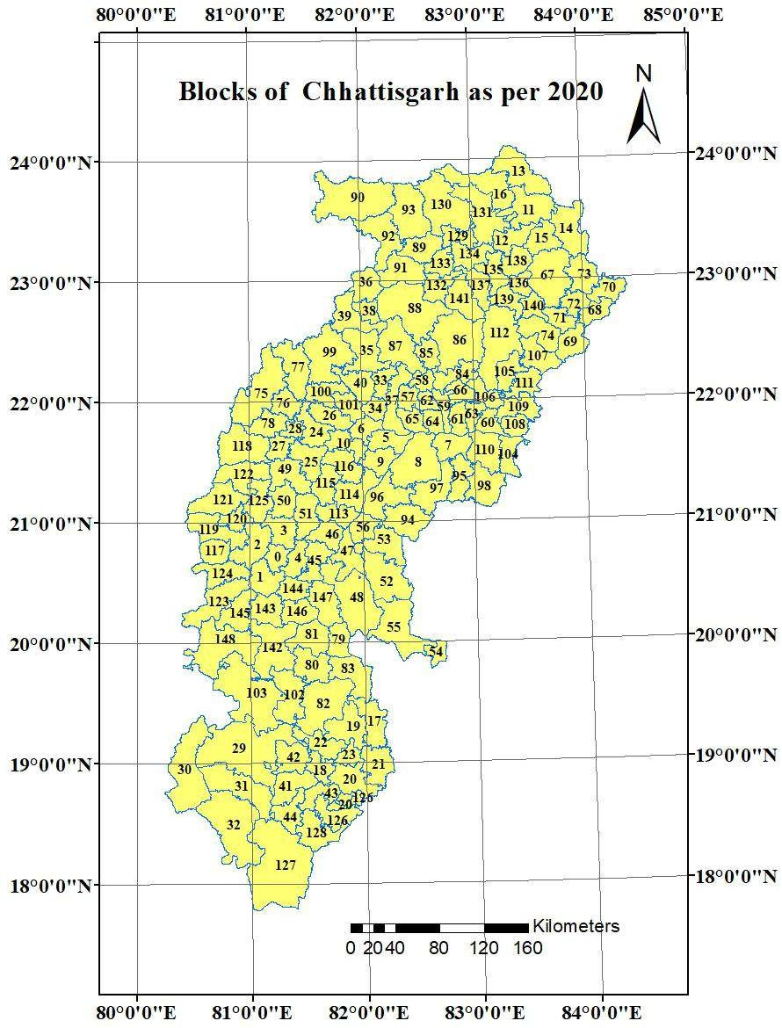Study area encompass block wise (Fig.1) trend and variability analysis a wide range of meteorological characteristics, making them ideal for studying patterns of rainfall and temperature change.

#### 

# Figure 1 Study Area - Block wise map of Chhattisgarh

# Analytical Method

The climatic variables' trend evaluation will be conducted using the Innovative Trend Analysis (ITA) method. ITA non-parametric method is reliable, is able to detect both linear and non- linear trends, and does not require a well distributed data. This method is particularly useful as it can cope with irregular datasets and missing values, so is suitable to study seasonal weather records.

# Trend Classification

Each ITA-identified trend will be categorized in terms of its significance. The trends will be classified by the direction of effects (increased, decreased or non significant) at 3 significant levels: 1% as very significant, 5% as moderately significant, and 10% as marginally or non-significant. Such classification will contribute to an in-depth analysis of climate variability and impacts at regional scale.

# Spatial and Temporal Analysis

District-wise and block level spatial analysis to find the spatial variation and shifts in climate behavior over the time. It will be much easier to determine whether observed variations are seasonal or yearly regular, when one employs seasonal distinction. A comprehensive understanding of the variations in weather patterns across Chhattisgarh at block level shall be made provision through a comparative analysis.

# Software and Tools Used

Data management would start with microsoft Excel, for cleaning and arranging the data. Spatial distributions between blocks and districts will be plotted and presented in GIS software. Furthermore, the ITA method is likely to be applied, and temperature-time graphs and charts will be generated, using custom scripts or standard statistical packages such as R or Python.

# Inclusion Criteria

In order to get a wider regional coverage, 149 blocks from various districts of Chhattisgarh were considered for the investigation. Data from March 2024 was incorporated in order to analyze seasonal trends. The four most important meteorological variables were precipitation, number of rainy days, high and low temperatures components kept at the end of the selection process. Winter, summer, the southwest and northeast monsoons, and the whole year were all included in the seasonal and yearly data analysis. The study only considered blocks with full and trustworthy data records.

# Exclusion Criteria

To ensure accuracy, blocks with significant gaps or missing data were not included. The study did not employ estimated or interpolated data. Non-standard techniques of data collection were not included. The research excluded variables unrelated to weather, such as land use or human activity.

# Result

**Study of the trend and variability of rainfall and temperatures in different districts of Chhattisgarh.**

Examination of four critical meteorological variables: total precipitation, frequency of precipitation, high and low temperatures, and the number of rainy days, was carried out at the block level. This analysis was performed utilizing the Innovative Trend Analysis method, covering a time span from March 1st, 2024 to March 31st, 2025.. The examination encompassed all seasons, including annual trends, as well as those specific to winter, southwest monsoon, and northeast monsoon periods.

# Annual Trends of rainfall, number of rainy days, maximum and minimum temperature

Rainfall, number of wet days, maximum and lowest temperatures, and yearly trends are shown in Figure 2. At the 1% level of significance, a general downward trend in yearly rainfall was noted over the whole state. Meshram et al. showed a significant growing trend at both the 1% and 5% significance levels in the Bastar Plateau Zone, which encompasses Bastar, Bijapur, Dantewada, and Sukma districts. in 2024. A similar increasing trend in annual rainfall was also identified in parts of the Balod district, Bemetara district, Durg district, Kabeerdham district, and Kanker district.

In terms of the number of rainy days, significant increasing trends at both the 1% and 5%levels of significance were only observed in Balod district, Durg district, and certain parts of Rajnandgaon district, Bastar district, and Sukma district. Conversely, the majority of the state experienced a decreasing trend in the number of rainy days at a high confidence level of 1%. These findings suggested that while the Bastar Plateau Zone experienced an overall increase in rainfall, the intensification of rainfall events was not uniform.

Collectively, the entire state showed a 1% annual increase in maximum temperature.

On the other side, the state-wide trend for lowest temperatures was a 1% decline. The districts of Koriya, Bilaspur, Rajnandgaon, Bijapur, Dantewada, Bastar, and Sukma, which are located

along the southern and western frontiers, showed an upward trend in the lowest temperature every year at the 1% and 5% significance levels, respectively. Roxy et al. reports similar findings (2017).

Winter rainfall trends, including total days of precipitation and extreme highs and lows, are displayed in Figure 3. The Bastar Plateau Zone and the Chhattisgarh Plain Zone both had a notable 1% increase in rainfall during the winter season. However, in districts like Dhamtari, Gariyaband, Janjgir-Champa, and certain parts of the Raigarh of the Chhattisgarh Plain Zone, along with the Northern Hill Zone, there was a significant 1% decreasing trend. This indicated that approximately two-thirds of the state witnessed an increase in winter rainfall.In contrast to the trend of rainfall, almost half of the state experienced a decreasing trend in the number of rainy days. Notably, the Bastar Plateau Zone and the southern parts of Rajnandgaon, Durg, and Balod districts exhibited an increasing trend at the 1% significance level. Regarding winter maximum temperature, there was a significant 1% increase observed across all the districts. However, when it came to the minimum temperature, the majority of districts experienced a 1% decreasing trend, with the exception of southern Bijapur district, Sukma district, Rajnandgaon district, and Surajpur district, where a 1% increasing trend was observed.

# Summer Trends of rainfall, number of rainy days, maximum and minimum temperature

Figure 4 shows the summertime temperature range, the number of wet days, and the total amount of precipitation. The districts of Koriya, Surguja, Surajpur, and Northern Balrampur in the western portion of the Northern Hill Zone and Sukma and Bastar in the eastern portion of the Bastar Plateau Zone, respectively, had a 1% increase in rainfall. The similar pattern was also seen in the rainfall in the Durg district and the southern Raigarh district. Additionally, nearby places did see an upward trend, although one that was not statistically significant. A decline trend at the 1% significant level was seen throughout the remainder of the state (Naidu et al., 2009). In the agro-climatic zones and districts stated before, there was a similar pattern of rising and falling rainy day counts. All of the state's districts saw a rising trend in maximum temperature, with a significance level of 1%. Minimum temperatures were found to be dropping across the state, with the exception of Surguja, Sukma, Rajnandgaon, and portions of Kanker and Kondagaon districts, which showed an upward trend at the 1% significance level.

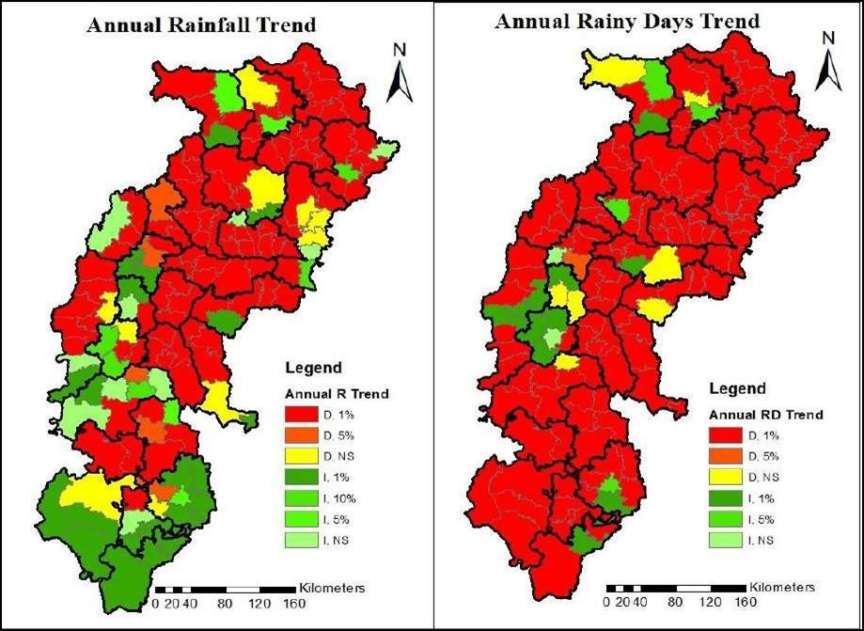

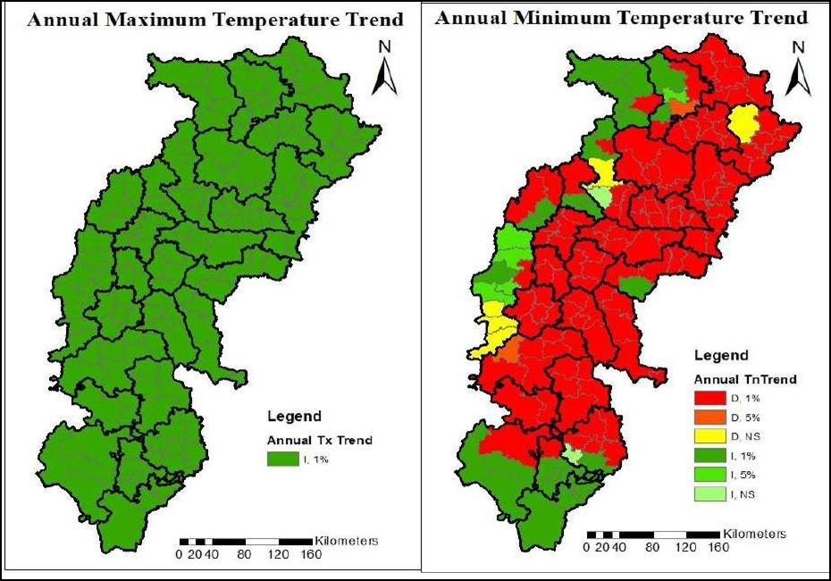

**Figure 2 Annual trends of Rainfall, Number of rainy days, Maximum and, Minimum Temperature**

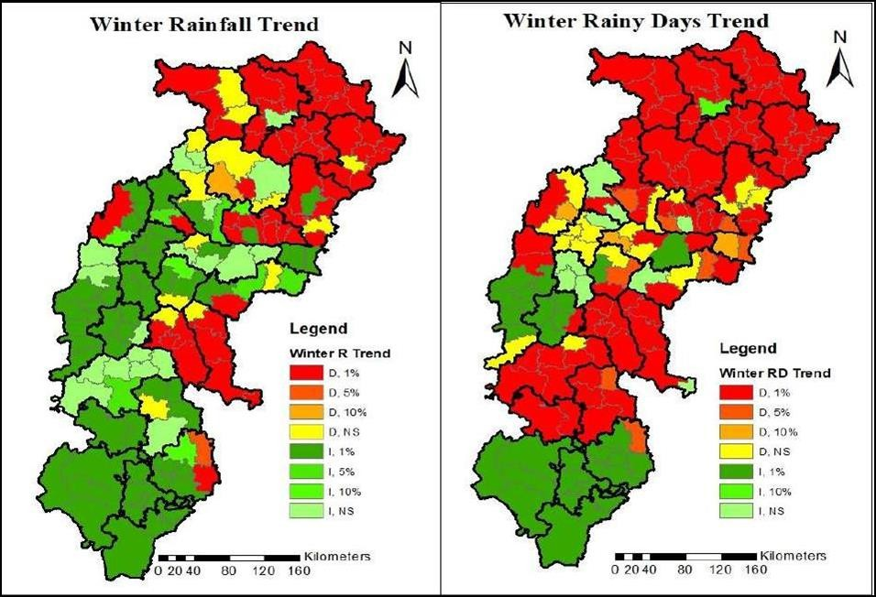

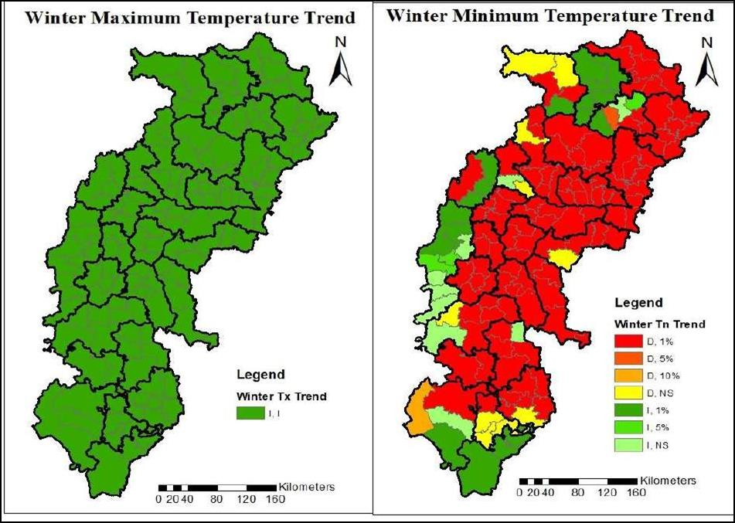

**Figure 3 Winter trend of Rainfall, Number of rainy days, Maximum and, Minimum Temperature**

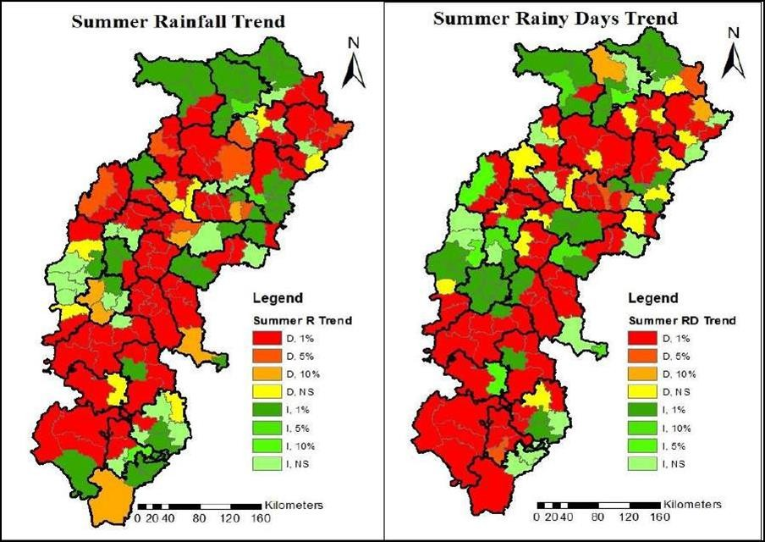

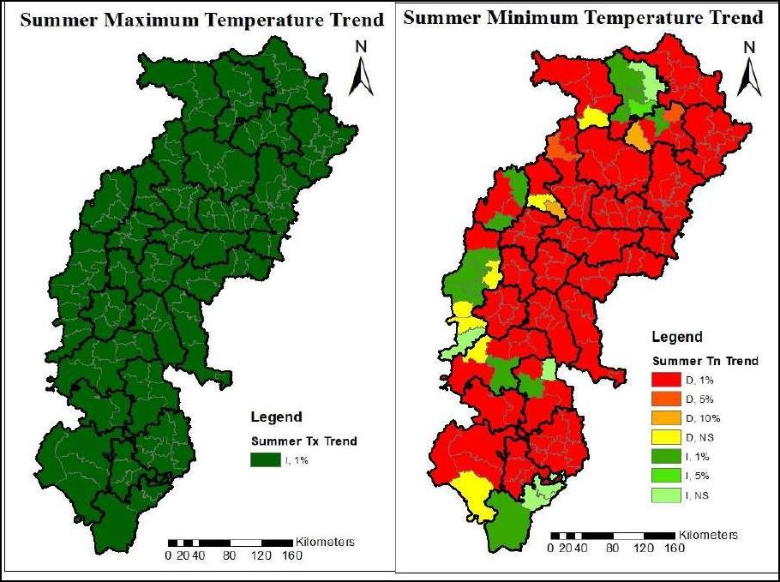

**Figure 4 Summer trends of Rainfall, Number of rainy days, Maximum and, Minimum Temperature**

# South-West Trends of rainfall, number of rainy days, maximum and minimum temperature

Figure 5 shows the pattern of rainfall, number of wet days, and maximum and lowest temperatures throughout the southwest monsoon season. Although this is the state's rainiest season, the Northern Hill Zone and the Chhattisgarh Plain Zone have not been seeing a good trend in rainfall. While rainfall decreased in these areas by a statistically significant margin of 1%, it increased in the Bastar Plateau Zone by the same margin. With respect to their agroclimatic zones, several districts, such as Durg, Kanker, and Kondagaon, had opposite trends of increase and decrease. An rising trend of 1% at non-significant levels was seen for the number of rainy days in just portions of the Bastar and Sukma districts. At the 1% level of significance, there was a growing tendency in the following districts within the Chhattisgarh Plain Zone: Rajnandgaon, Balod, Durg, portions of Bemetara, and Mahasamund. The districts of Koriya, Surajpur, and Balrampur in the Northern Hill Zone saw 1%, 5%, and non-significant increases, respectively. All of the state's districts saw a rising trend in maximum temperature, with a significance level of 1%. The state-wide trend for low temperatures was a 1% significant decrease, with the exception of the Southern Bijapur district, where there was a 1% significant increase.

# North-East Trends of rainfall, number of rainy days, maximum and minimum temperature

Figure 6 shows the average, maximum, and lowest temperatures, as well as the number of wet days during the northeast monsoon. Rainfall trended downward in nearly all districts in the Bastar Plateau Zone at the 1% significance level, although some areas in the Sukma and Bastar districts saw an increase. Rainfall in the eastern parts of Kabeerdham and Bemetara districts, as well as Rajnandgaon in the Chhattisgarh Plain Zone, decreased by 1% on average. Whereas, at the1%,5%, and 10% levels, the remaining locations showed a growing tendency that was neither statistically significant nor nonexistent. The districts included in the Northern Hill Zone had a notable increase in rainfall of 1%, 5%, and 10%. A declining trend at 1% significant levels was observed only in the northern regions of the Balrampur and Surguja districts. A tendency toward fewer rainy days was seen over the whole Bastar Plateau Zone at the 1% significance level, whereas a rising trend was observed in certain areas of the Kondagaon and Sukma districts. While the majority of the Chhattisgarh Plain Zone showed a statistically significant increase in the number of rainy days, the Korba district showed no such trend at the

1% or 5% significance levels. However, the number of rainy days decreased by 1% in Rajnandgaon district, 5% in Bemetara district, and 5% in Kanker district. A tendency of 1% increase in the frequency of rainy days was observed in the Northern Hill Zone. The highest temperature trended upward by 1% throughout the state's districts. Similarly, a 1% significant tendency toward higher minimum temperatures was also noted by most areas. The districts of Kanker, Surguja, Raigarh, Kabeerdham, and the northern portions of Mungeli all showed a declining trend at the 1% significance level.

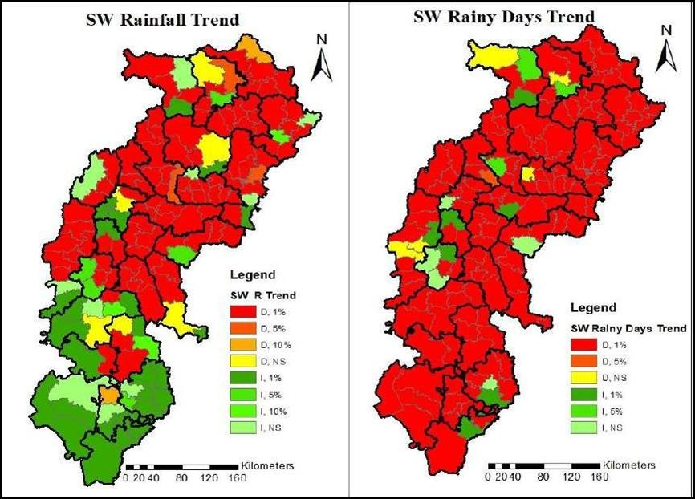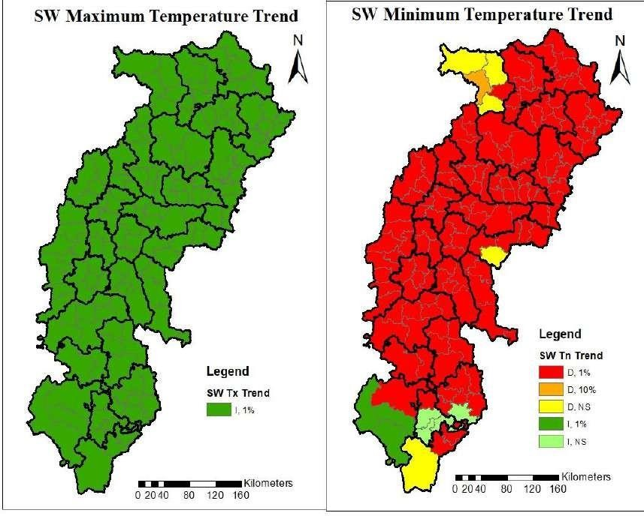

**Figure 5 Southwest monsoon season trend of Rainfall, Number of rainy days, Maximum and, Minimum Temperature**

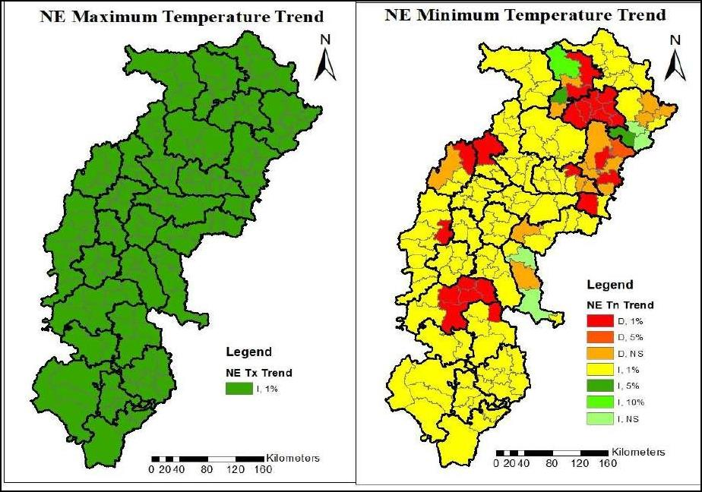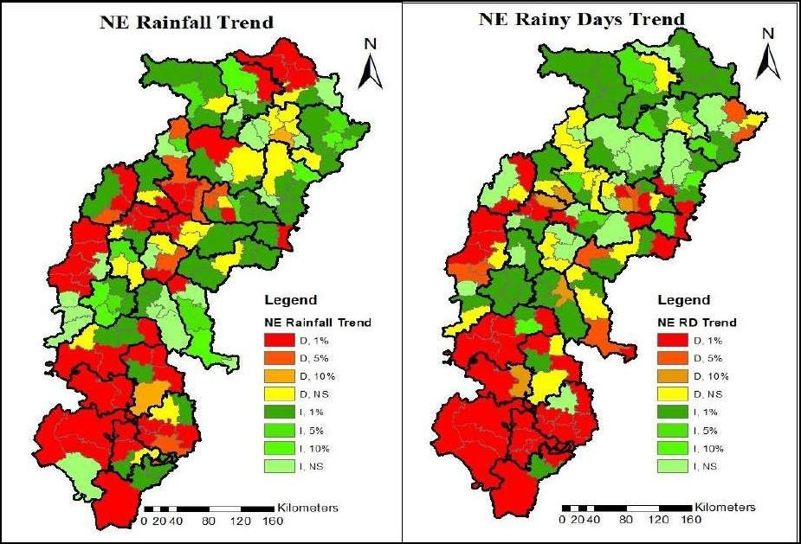

**Figure 6 Northeast monsoon season trends of Rainfall, Number of rainy days, Maximum and, Minimum Temperature**

# Overview of trends

Figure. 7 shows the result of rainfall trend. With reference to rainfall, out of 149 blocks, annually 108 blocks had observed a decreasing trend (S-95 & NS-95), and 41 blocks (S-31 & NS-10) had recorded an increasing trend. In the winter season, 70 blocks (S-56 & NS-14) and 79 blocks (S-60 & NS-19) noticed increasing and decreasing trends, respectively. During the summer season, 92 blocks (S-84 & NS-8) observed increasing trends, while 57 blocks (S-36 & NS-21) had decreasing trends. In the southwest monsoon season, 104 blocks (S-98 & NS-6) found a decreasing trend, and 45 blocks (S-35 & NS-10) noticed an increasing trend. Out of 149 blocks, 72 blocks (S-52 & NS-20) were experiencing increasing trends, and 77 blocks (S- 58 & NS-19) had decreasing trends during the northeast monsoon season. Fig 8 shows the result of trend of number of rainy days. For the number of rainy days, out of 149 blocks, 132 blocks reported a decreasing trend (S-45 & NS-7), and only 17 blocks showed an increasing trend (S-15 & NS-2). Almost similar results were also noted during the southwest monsoon season, with 134 blocks (S-129 & NS-5) experiencing a decreasing trend, and 15 blocks (S-10 & NS-5) observing an increasing trend. In the winter season, 111 blocks (S-94 & NS-17) observed a decreasing trend, and 38 blocks (S-30 & NS-8) found an increasing trend. In the summer season, 92 blocks (S-76 & NS-16) had decreasing trends, while 57 blocks (S-41 & NS- 16) observed increasing trends. During the northeast monsoon season, 73 blocks (S-52 & NS- 21) noticed a decreasing trend, and 76 blocks (S-54 & NS-22) observed increasing trends. Maximum temperature has unanimous significant trend in all the 149 blocks during annually, winter, SW and NE seasons. Figure 9 shows trend of maximum temperature. But in summer season only 11 blocks record decreasing trend (S-3 & NS-8) and remaining 138 blocks has shown increasing trends (S-133 & NS-5).

Figure 10 shows the result of trend of minimum temperature. In minimum temperature, out of 149 blocks, 118 blocks (S-113 & NS-5) observed a decreasing trend, and 31 blocks (S-29 & NS-2) noticed an increasing trend on an annual basis. Season-wise, during the winter season, 119 blocks (S-109 & NS-10) reported a decreasing trend, while 30 blocks (S-21 & NS-7) and 19 blocks (S-14 & NS-5) showed decreasing and increasing trends, respectively. In the SW monsoon season, 142 blocks (S-137 & NS-5) had a decreasing trend, and 7 blocks (S-3 & NS- 4) reported an increasing trend. In the NE monsoon season, 37 blocks (S-23 & NS-14) showed a decreasing trend, and 112 blocks (S-108 & NS-4) had an increasing trend.

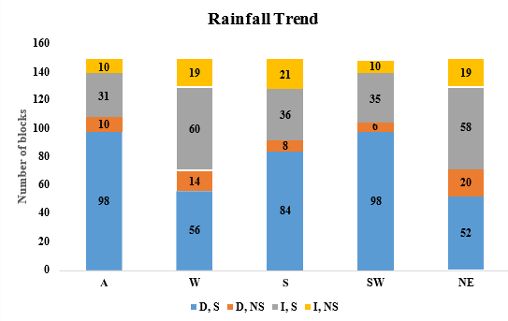

**Figure 7 Trend of rainfall at the block level**

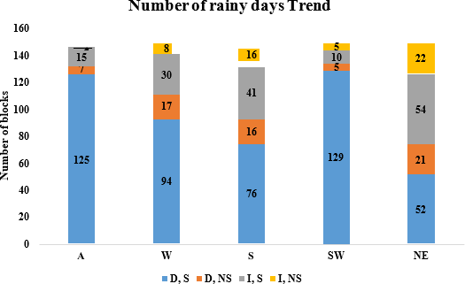

**Figure 8 Trend of number of rainy days at the block level**

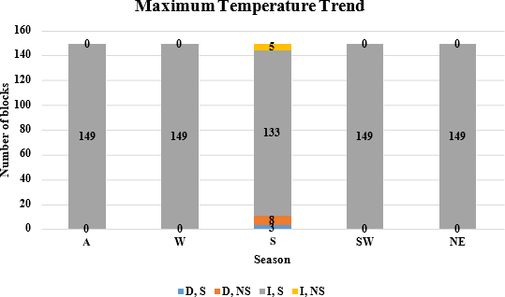

**Figure 9 Trend of maximum temperature at the block level**

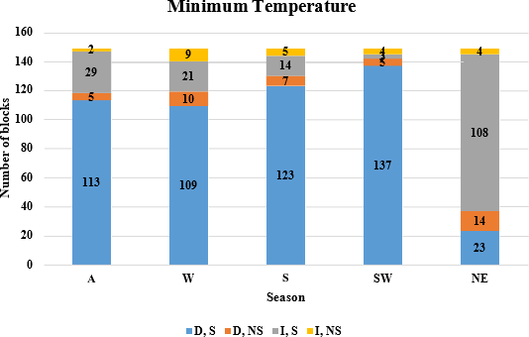

**Figure 10 Trend of minimum temperature at the block level**

# Discussion

The research shows considerable geographical and seasonal variability in Chhattisgarh. The broad reduction in yearly rainfall and wet days in most countries suggests shorter but more intense downpour events. Water availability and agriculture, particularly in rain-fed regions, might suffer. Maximum temperature rises across seasons and districts, indicating a regional warming trend, according to the research. Most places have yearly and seasonal decreases in minimum temperatures, however certain southern and western districts see rises. These changes may affect agricultural cycles, soil moisture, and biodiversity. Seasonal patterns show that certain places, like the Bastar Plateau Zone, have increased rainfall in winter and summer, while others, like the Northern Hill and Chhattisgarh Plain Zones, have decreased. This mismatch emphasizes the necessity for regional climate adaption measures rather than universal ones. Even with irregular data, the ITA approach captures linear and non-linear patterns. This facilitates its use in long-term climate research with variable data quality.

# Conclusion

Using the Innovative Trend Analysis (ITA) approach, the study looks at temperature and rainfall patterns over 149 blocks in Chhattisgarh from March 1st 2024 to Macrh 31st, 2025. The results show that there have been major shifts in the weather across the state's several agro-climatic zones, which makes it more susceptible to weather extremes and future climate change. Annual rainfall and rainy days have been declining across the country, according to the report. This is especially true in the Northern Hill Zone and the Chhattisgarh Plain Zone. This has the potential to influence agricultural output, surface water availability, and groundwater recharge. The report also notes that the highest temperature has been steadily climbing, which might mean that heat stress is getting worse. The research shows that governmental actions and targeted climate monitoring are necessary. You may find both little and large trends with the help of the ITA approach, which is great for long-term trend research. Climate trend analysis should be a part of development planning and resource management, according to the research.

# References

Anand, S., Aarti, & Singh, A. (2025). Investigation of the trends and variability in rainfall pattern in the Upper Kumaon Himalayan region. *Frontiers in Climate*, *7*, 1492260.

Dubey, V., Panigrahi, S., & Vidyarthi, V. K. (2023). Statistical trend analysis of major

climatic factors over Chhattisgarh State, India. *Earth Systems and Environment*, *7*(3), 629–648.

Hailu, D., Woldetsadik, M., & Ayal, D. Y. (2024). Trends and variability in annual and seasonal rainfall amount and timing in Wereilu district, Northeastern Highlands of Ethiopia. *Environmental Challenges*, *17*, 101055.

Im, E.-S., Pal, J. S., & Eltahir, E. A. B. (2017). Deadly heat waves projected in the densely populated agricultural regions of South Asia. *Science Advances*, *3*(8), e1603322.

Jagannadha Sarma, V. V. (2005). Rainfall pattern in the coastal zone of Krishna Godavary basin Andhra Pradesh India. *Journal of Applied Hydrology*, *18*(1&2), 1–11.

Krishnamurti, T. N., & Sikka, D. R. (1978). Some aspects of the life history, structure and movement of monsoon depressions. *Monsoon Dynamics*, 1501–1529.

Kumar, B., Hiremath, R. B., Balachandra, P., & Ravindranath, N. H. (2009). Bioenergy and food security: Indian context. *Energy for Sustainable Development*, *13*(4), 265–270.

https://doi.org/https://doi.org/10.1016/j.esd.2009.10.004

Kurrey, D. K., Pathak, H., & Choudhary, V. K. (n.d.). *Statistical analysis of mean maximum temperature and pattern of Chhattisgarh*.

Kurrey, D. K., Pathak, H., & Choudhary, V. K. (2023). Statistical Analysis of Rainfall

Pattern and Trend of Chhattisgarh State, India. *Int. J. Environ. Clim. Change*, *13*(7), 54– 61.

Puranik, H. V, & No, P. (n.d.). *Monthly and Inter-Seasonal Long Term Weather Variability Trend Analysis of Chhattisgarh Plain Zone*.

Sahu, J., & Chaudhary, J. L. (2018). Rainfall based crop planning in rainshadow districts of Chhattisgarh state by using rainfall and crop data. *Journal of Agricultural Issues*, 28.

Sahu, T., Chaoudhary, J., & Sahu, K. (2022). Analysis of Rainfall Probabilities and Crop Planning for Different Districts of Chhattisgarh. *International Journal of Environment and Climate Change*, *12*(10), 858–862.

Sinha, M. K., Baier, K., Azzam, R., Verma, M. K., & Kumar, S. (2022). Impacts of climate variability on urban rainfall extremes using statistical analysis of climatic variables for

change detection and trend analysis. In *Water Resources Management and Sustainability*

(pp. 333–387). Springer.

Swain, S., Dayal, D., Pandey, A., & Mishra, S. K. (2019). Trend analysis of precipitation and temperature for Bilaspur District, Chhattisgarh, India. *World Environmental and Water Resources Congress 2019*, 193–204.

Vennila, G., Subramani, T., & Elango, L. (2007). Rainfall variation analysis of

vattamalaikarai sub basin, Tamil Nadu. *Journal of Applied Hydrology*, *20*(3), 5059.

Verma, S., Prasad, A. D., & Verma, M. K. (2022). Trends of rainfall and temperature over Chhattisgarh during 1901–2010. *Advanced Modelling and Innovations in Water*

*Resources Engineering: Select Proceedings of AMIWRE 2021*, 3–19.