Bacillus mycoides protects archeological artifacts from fungal invasion: a possible mechanism as observed in ancient remains of Lal Masjid at Khasbalanda-Haroa

Abstract
Lal Masjid is located in Haroa area of North 24 Parganas, West Bengal, India in the territory of the ancient port city of Chandraketugarh, flourished long ago in between 600 BCE to 1250 CE, perhaps representing the Gangaridai of Greaco-Roman accounts. Originally it was a Buddhist Stupa, which was later, converted into a Masjid, popularly known as Lal Masjid. The ruins are neither protected nor under routine surveillance; however, is fungal invasion lacking. This initiates our quest to find out any persisting antifungal activity amongst the ruins. The surface materials of the artifacts in the ruins were collected with the help of sterile swabs on a bright sunny day. The swab culture revealed the presence of a rhizoid bacterium with creamy white colour opaque colony and further investigations with 16srRNA gene sequencing revealed the bacterium to be Bacillus mycoides strain S77.3 having anti-fungal property as reported earlier.
Key words
Bacillus mycoides, Lal Masjid, Antifungal activity, 16srRNA sequencing.

1.INTRODUCTION
All over the Indian subcontinent we still find remains of various ancient habitations with their glorified but forgotten histories which are yet to reveal from eternal darkness - the port city Chadraketugarh may demand further exploration in this regard. The Lal Masjid (Fig.1) lies in Haroagunj Khasbalanda village amongst the archeological ruins (latitude 22.606800, longitude 88.678596). There are several controversies regarding the Lal Masjid amongst the common people. Some people say it belongs to Hindus, some says it is a Buddhist Stupa and some people offer insights that it is a masjid belonging to the muslims (Chowdhury, 1999).
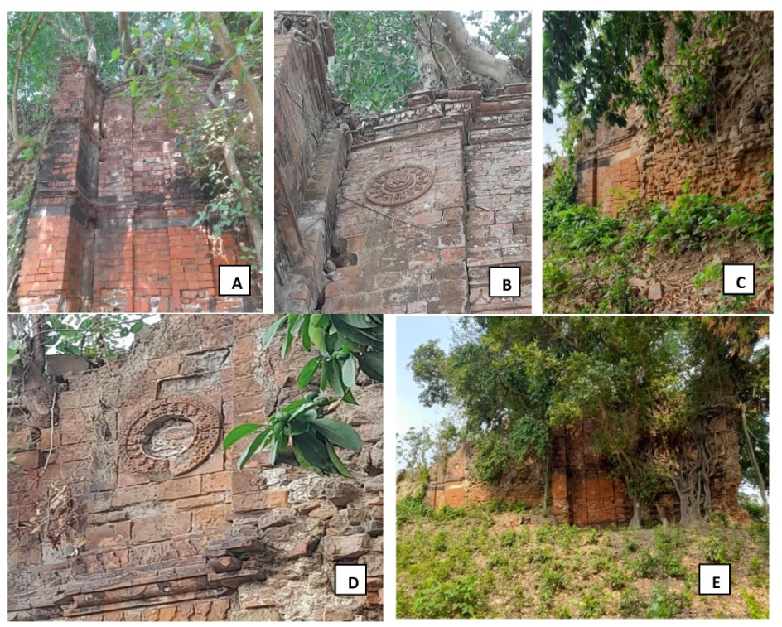
Fig. 1: Pictures of Lal Masjid from different sides representing A-E..
The then port city Chandraketugarh, 2500 years ago, was situated on the banks of the river Bidyadhari, which made economically connected the Gangaridai with the other parts of the different countries. Megasthenes mentioned Sandrocottus in his classical script Indica (302-298 BCE), the name has recently deciphered to be king Chandraketu of Chandraketugarh (Chakraborty, 2000).
Near the Berachampa and Haroa Road railhead, Chandraketugarh is situated next to the Bidyadhari River in North 24 Parganas, approximately 35 km northeast of Kolkata. Chandraketugarh was unintentionally found while building nearby highways (Das et al., 2019). The artefacts that unearthed drew the attention of a local doctor named Tarak Nath Ghosh in 1905, who corresponded with the British art historian and archaeologist Albert Henry Longhurst (1876 – 1955). It is reported that when renowned archaeologist Dr. Rakhaldas Banerji personally visited the site in 1909, he was astounded by the extraordinary quantity and variety of items he saw there. Ten years later, a report was released by Rao Bahadur Kashinath Narayan Dikshit (1889 – 1946) , the Archaeological Survey of India's the then-superintendent of the eastern circle (Das, et al., 2019). The historians and archaeologists of Ashutosh Museum of Art at Calcutta University took the initiative to begin excavations there in 1955. A vast post-Gupta temple complex was discovered at Khana Mihirer Dhipi, a five-meter-tall mound at Berachampa's northeast corner, as a result of extensive excavation work conducted there between 1955 and 1967. The results demonstrated the presence of a thriving prehistoric society that lasted six periods, from pre-Maurya to the Pala dynasty (Chattopadhyay et al., 2017). The Archaeological Survey of India, the West Bengal Heritage Commission, and the State's department of archaeology all reopened excavation in the year 2000. The area was designated as a heritage zone by the state government, and Chandraketugarh's 2,500-year history is protected by the Heritage Commission's efforts to get the city certified by UNESCO (Chattopadhyay et al., 2017).
Relics of Northern Black Polished Ware (NBPW), subsequent wares from roughly 400 BC to 100 BC, approximately contemporaneous with the Mauryan period, and more recent Kushanas and Gupta periods were found. Buddhist stupas and figures, Pala era artistic designs, Gupta and Kushana period coins, various types of beads, terracotta seals, bricks, and plaques with scenes from Jataka tales, as well as figurines from the Sunga, Maurya, Kushana, and Gupta periods are among the other discoveries. In order to conserve these unique antique artifacts, the state government has completed plans to establish a museum at Berachampa (Chowdhury, 1999). An unfinished mosque constructed at Haroa by Pir Gorachand and his adherents. According to historians, the mosque was constructed 1300 years ago on the site of a Buddhist Stupa. There is also a Pir Gorachand "dargah" close to the Haroa bus stop. Additionally, one can go to the Bidyadhari Bridge and Lal Masjid for a beautiful view of the river.
In the present study we have collected swab sample from the walls and crevices of Lal Masjid and wanted to study the predominant microorganism present over there.
2. MATERIALS AND METHODS
2.1 Collection of Sample:
The microbial remnants from the walls and crevices of the Lal Masjid were collected using sterile cotton swab sticks wearing sterile latex gloves. The swab sticks were rotated clockwise and anti-clockwise about 10 times within the crevices and stroked over the wall surfaces uni-directionally to collect the microbial populations.
2.2 Culturing of Micro-organisms:
The swab sticks were cultured on Columbia sheep blood agar and nutrient agar. After inoculation the plates were kept at 25ºC for growth for 72 hours. Thereafter, the plates were observed and pictures were taken.

2.3 Gram Staining of Micro-organisms:
After the soil samples were collected, possible presence of microorganisms was detected. To do this gram staining was done to those that showed distinct colonies. The protocol was followed for staining step wise, including smear preparation followed by heat fixation. Then crystal violet, iodine solution, decolourizer and safranin were added accordingly. Once the stains dried up it was observed under the microscope at 1000x magnification. This allowed us to suspect the rhizoid colony observed was of a bacterium is Bacillus mycoides.
2.4 16SrRNA gene Sequencing
DNA was isolated from the culture of the bacteria identified. The quality of the DNA was estimated by 1% agarose gel where a single band of the high molecular weight DNA has been observed. The fragment of the 16SrRNA was amplified using 16SrRNA-F and 16SrRNA-R primers. A discrete single band of amplicon of size 1500 bp was observed on agarose gel. This PCR band was purified from the gel to remove any contaminants. The forward and reverse DNA sequencing of the amplicon was done using using 16SrRNA-F and 16SrRNA-R primers by BDT v3.1 Cycle sequencing kit on ABI 3730xl Genetic Analyzer. The 16SrRNA gene sequence was determined by forward and reverse sequence data using aligner software. BLAST was carried out using ‘nr’ database of NCBI GenBank database of the 16S rRNA gene sequence. Determining the maximum identity score the first 10 sequences were chosen and it was aligned using the multiple aligning software Clustal W. The distant matrix and the phylogenetic tree was constructed using MEGA 10 software.

3. RESULTS
Cultural examination of the samples revealed growth of a bacterium with peculiar rhizoid colonies (Fig.2 A), in 100x magnification the colonies showed curved filamentous like growths (Fig. 2 C). After Gram’s staining they were Gram variable bacilli with occasional spores (Fig.2 B). Following 16srRNA sequencing ( Table 1, Fig. 3) the bacterium was identified as Bacillus mycoides which is well known to have strong antifungal activities.
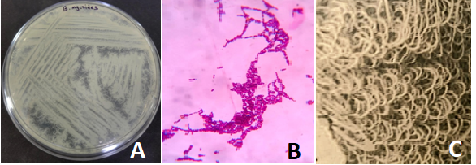
Fig.2: Rhizoid colonies of Bacillus mycoides (A), Gram’s stain showing Gram variable bacilli with occasional spores (B), rhizoid colony structure under magnification (100x) (C).
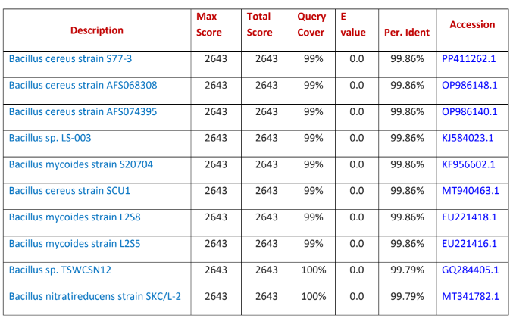
Table 1: Sequences producing significant alignments with the isolate.
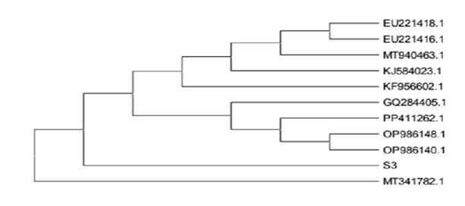
Fig 3: The strain has 99.86% homology with the bacteria Bacillus mycoides strain S77.3. The evolutionary history was referred by using the maximum likelihood method and Tamura-Nei model. The tree with the highest log likelihood (-2027.10) is shown. Initial tree(s) for the heuristic search were obtained automatically by applying Neighbor-Join and BioNJ algorithms to a matrix of pairwise distances estimated using the Tamura-Nei model, and then selecting the topology with superior log likelihood value. This analysis involved 11 nucleotide sequences. Codon positions included were 1st+2nd+3rd+Noncoding. There were a total of 1441 positions in the final dataset. Evolutionary analyses were conducted in MEGA11.
4. DISCUSSION
The absence of fungus around the artifacts in the ruins of Chandraketugarh made us curious about its reason. It was evident that despite the place being abandoned with moderate sunlight and moist surroundings, which are deemed ideal for the growth of fungus, there were none. This led us to dig deep into the reason and find out the agent that was acting as an effective antifungal. With gene isolation and sequencing of the samples collected from the ruins, we finally came across the presence of a microbe that has major antifungal activity. This was identified to be Bacillus mycoides from the family of B. cereus and an effective antifungal agent. It was due to the presence of this bacterium there may be no fungus was able to grow on the artifacts from the ruins.
Bacillus mycoides is phenotypically very much similar to Bacillus cereus. It is distinct due to its rhizoidal colonies and the bacterium is non-motile. The bacterium is facultatively anaerobic with maximum temperature for growth around 35 to 40ºC and the minimum temperature for growth is 10 - 15ºC. The colony characteristics is white to creamy colour and opaque rhizoidal colony (Fig1 A and C) (Andriani, et al., 2017).
Bacillus mycoides showed positive biochemical results for enzyme catalase, hydrolyses starch, casein, esculin, gelatin, can reduce nitrate to nitrite, positive result for Voges-Proskauer test, egg yolk reactivity, forms alkali in litmus milk test, produces acid from glucose, N-acetyl-D-glucosamine, glycerol, starch, trehalose and glycogen, arabinose, adonitol, D or L arabitol, dulcitol, erythritol, D or L fucose, beta gentibiose, meso-inositol, gluconate, inulin -2 or 5 keto gluconate, xylose, lactose, maltose, mannitol, D-mannose, alpha-metyl D manoside, melibiose, raffinose, rhamnose, sorbitol, xylose, xylitol, methyl-beta xyloside. The bacterium showed negative result for oxidase, produces gas from carbohydrates, causes deamination of phenylalanine (Di Franco, et al., 2002).
When studied about the plant growth promoting activities of the bacterium, isolated from the bamboo rhizosphere, Bacillus mycoides strain A3 (BmA3) demonstrated phosphate solubilisation and radical scavenging capabilities in addition to producing phytohormones such as gibberellic acid (GA) and indole-3-acetic acid (IAA) (Kurniawan et al., 2022; Turchi et al., 2012). BmA3-inoculated A. thaliana seedlings showed changed root architecture, including more lateral roots and root hairs. Likewise, the BmA3-treated seedlings showed increased plant size and fresh weight, as well as improved photosynthetic efficiency due to the deposition of larger quantities of starch and chlorophyll. By boosting the activities of catalase (CAT), guaiacol peroxidase (GPX), ascorbate peroxidase (APX), and phenylalanine ammonia-lyase (PAL), this bacterial inoculation activated the antioxidant defence system. Higher quantities of secondary metabolites, such as flavonoids, phenolic compounds, and glucosinolates, were produced in the plants treated with BmA3. An efficient and sustainable substitute for chemical pesticides is the biological management of soil-borne plant diseases through the use of beneficial bacteria and their active metabolites (Yi 2018; Nakamura et al., 1995). Bacterial strains from the genus Bacillus, including Bacillus subtilis, Bacillus velezensis, and Bacillus amyloliquefaciens, are among these helpful microorganisms that have been widely used for their capacity to treat soil-borne fungal illnesses (Khan et al., 2022, Blake et al., 2021, Hashem et al., 2019). Additionally, it has been found that Bacillus mycoides and B. amyloliquefaciens release volatile organic compounds (VOCs) that prevent the spore germination and mycelial growth of F. oxysporum and S. sclerotiorum (Mazzola, et al.,2017, Bonaterra, et al., 2022; Wu, 2020, Massawe, et al., 2018). Bacillus species produce these extracellular lipopeptides and volatile organic compounds (VOCs), which have the potential to be used as biopesticides to control soil-borne crop illnesses (Yuan et al., 2012; Everts et al., 2015).
5. CONCLUSION
The predominant microorganism is Bacillus mycoides Strain S77.3 which may be responsible for the absence of fungal invasion of the artifacts in the ruins.
ETHICALAPPROVAL
Not applicable.
ARTIFICIAL INTELLIGENCE
Author(s) hereby declare that NO generative AI technologies such as Large Language Models (ChatGPT, COPILOT, etc) and text-to-image generators have been used during writing or editing of this manuscript.
COMPETING INTERESTS
Authors have declared that no competing interests exist.

COMPETING INTERESTS DISCLAIMER:
Authors have declared that they have no known competing financial interests OR non-financial interests OR personal relationships that could have appeared to influence the work reported in this paper.

REFERENCES
Andriani, Y., Rochima, E., Safitri, R., Rahayuningsih, S. R. (2017). Characterization of Bacillus megaterium and Bacillus mycoides bacteria as probiotic bacteria in fish and shrimp feed. KnE Life Sciences, 127-135.
Di Franco, C., Beccari, E., Santini, T., Pisaneschi, G., Tecce, G. (2002). Colony shape as a genetic trait in the pattern-forming Bacillus mycoides. BMC microbiology, 2, 1-15.
Kurniawan, A., Chuang, H. W. (2022). Rhizobacterial Bacillus mycoides functions in stimulating the antioxidant defence system and multiple phytohormone signalling pathways to regulate plant growth and stress tolerance. Journal of applied microbiology, 132(2), 1260–1274. https://doi.org/10.1111/jam.15252
Turchi, L., Santini, T., Beccari, E., Di Franco, C. (2012). Localization of new peptidoglycan at poles in Bacillus mycoides, a member of the Bacillus cereus group. Archives of microbiology, 194, 887-892.
Yi, Y. (2018). Bacillus mycoides: novel tools for studying the mechanisms of its interaction with plants.
Nakamura, L. K., Jackson, M. A. (1995). Clarification of the taxonomy of Bacillus mycoides. International Journal of Systematic and Evolutionary Microbiology, 45(1), 46-49.
Chakraborty, S. (2000). Chandraketugarh--a cultural and archaeological study (500 BC to 500 AD). Bulletin of the Deccan College Research Institute, 60, 483-488.
Das, S., Srivastava, T. (2019). The Heritage of Chandraketugarh: A Report.
Chattopadhyay, S., Roy Chowdhury, A. (2017). Southern Bengal Delta—A Hub of ancient civilization and cultural assimilation: A case study of Chandraketugarh and allied sites. Heritage: Journal of Multidisciplinary Studies in Archaeology, 5, 283-299.
Chowdhury, S. R. (1999). A group of unique plaques from Chandraketugarh. East and West, 49(1/4), 293-296.
Khan, A. R., Mustafa, A., Hyder, S., Valipour, M., Rizvi, Z. F., Gondal, A. S., ... Daraz, U. (2022). Bacillus spp. as bioagents: uses and application for sustainable agriculture. Biology, 11(12), 1763.
Blake, C., Christensen, M. N., Kovács, Á. T. (2021). Molecular aspects of plant growth promotion and protection by Bacillus subtilis. Molecular Plant-Microbe Interactions, 34(1), 15-25.
Hashem, A., Tabassum, B., Abd_Allah, E. F. (2019). Bacillus subtilis: A plant-growth promoting rhizobacterium that also impacts biotic stress. Saudi journal of biological sciences, 26(6), 1291-1297.
Luo, L., Zhao, C., Wang, E., Raza, A., Yin, C. (2022). Bacillus amyloliquefaciens as an excellent agent for biofertilizer and biocontrol in agriculture: An overview for its mechanisms. Microbiological research, 259, 127016.
Mazzola, M., & Freilich, S. (2017). Prospects for biological soilborne disease control: application of indigenous versus synthetic microbiomes. Phytopathology, 107(3), 256-263.
Bonaterra, A., Badosa, E., Daranas, N., Francés, J., Roselló, G., & Montesinos, E. (2022). Bacteria as biological control agents of plant diseases. Microorganisms, 10(9), 1759.
Wu, J. J., Huang, J. W., Deng, W. L. (2020). Phenylacetic acid and methylphenyl acetate from the biocontrol bacterium Bacillus mycoides BM02 suppress spore germination in Fusarium oxysporum f. sp. lycopersici. Frontiers in microbiology, 11, 569263.
Massawe, V. C., Hanif, A., Farzand, A., Mburu, D. K., Ochola, S. O., Wu, L., ... & Gao, X. (2018). Volatile compounds of endophytic Bacillus spp. have biocontrol activity against Sclerotinia sclerotiorum. Phytopathology, 108(12), 1373-1385.
Yuan, J., Raza, W., Shen, Q., Huang, Q. (2012). Antifungal activity of Bacillus amyloliquefaciens NJN-6 volatile compounds against Fusarium oxysporum f. sp. cubense. Applied and environmental microbiology, 78(16), 5942-5944.
Everts, K. L., & Himmelstein, J. C. (2015). Fusarium wilt of watermelon: Towards sustainable management of a re-emerging plant disease. Crop Protection, 73, 93-99.

