Experimental study of a solar pumping system with supercapacitors in Burkina Faso.

|  |
| --- |
| **ABSTRACT**  On the basis of experimental results, the study demonstrated the ability of supercapacitors to provide the power required to initiate pump start-up during low solar irradiation. To this end, we first carried out an experimental study of the direct charging of supercapacitors by solar irradiation, and secondly, we experimented with the discharge of supercapacitors by direct supply to the solar pump. The results show that, for 7-minute fluctuations corresponding to a stored energy of 21.715Wh for a 180W pump, the supercapacitors correctly compensate for power variability by providing a continuous power supply to the pump. They can provide the power needed to start the pump in the event of low solar irradiation, or act as an energy source in the event of short-lived cloudy spells. This system can be used in agricultural production to obtain higher yields. |

Key words: supercapacitors, power, variability, irradiation, pump.

1. INTRODUCTION

The increasing consumption of fossil fuels, the problem of the availability of reserves and their high cost mean that solar energy has become a necessity with many advantages. Consequently, the production of electrical energy from clean, non-polluting and renewable sources is a necessity of both national and global interest in our society [10] [12]. In Burkina Faso, we have a significant solar resource ranging from 5.5 to 6 kWh/m2/dr, i.e. nearly 3,000 hours of sunshine per year [1][2]. This significant production of solar irradiation could be used for a variety of applications. In view of this energy potential, solar energy has played a key role in the country's energy policy for the past ten years [1][3][10][12]. As solar energy is intermittent, it needs to be stored to ensure continuity in certain applications. However, the storage of electrical energy is still very costly in today's renewable energy production systems. In photovoltaic applications, batteries are the most commonly used form of electrical energy storage. However, with technological advances, there are now modern energy storage systems such as supercapacitors, which have a higher number of charge and discharge cycles than batteries. The complementary use of supercapacitors and batteries makes it possible to improve power sources in power equipment [4], [5]. With this in mind, we investigated the problem of energy storage using supercapacitors to improve the efficiency of photovoltaic solar pumping in a country with high solar radiation potential, such as Burkina Faso.

The aim of this study is to propose a solution to improve solar pumping by boosting pump start-up during periods of low sunshine. Hence the need to propose solutions for determining the additional power required by supercapacitors to operate run-of-solar pumping systems in the Sahelian climate, due to variability in solar irradiance.

2. material and methods

**1.1. Experimental set-up**

The site defined for our experimental study is located within the grounds of the Joseph KI-ZERBO University at UFR/SEA (Unité de Formation et de Recherche en Sciences Exactes et Appliquées) in Ouagadougou, Burkina Faso, with the following geographical coordinates:

* Longitude 1o30’W
* Latitude 12o22’ N
* The experimental set-up consists of:
* two packs of six (06) 3000F/2.7V supercapacitors
* two 100Ah batteries
* a complete 180W submersible pump kit, nominal/maximum flow rate (0.8/2.7m3/h). pump height 520mm, outlet/diameter 25/75m
* two photovoltaic solar panels, 150W each.
* a pyranometer with a sensitivity of 7~14μV.m²/W; a spectral range of 0.3-3μm, a measurement range of 0-2000W/m², resolution 1W/m2
* current, voltage and power metersAltitude 291,96 m

**1.2 Supercapacitor characteristics**

Supercapacitors are electronic components used for direct electrostatic and electrochemical energy storage. Their high-power densities make them power sources [7][5]. The supercapacitors used in our experiment consist of two installation packs of six (06) supercapacitors (figure 1). Each supercapacitor is interconnected in series by printed circuit boards with voltage management circuits, buses, washers, rivets and fixing nuts. They are supplied by Maxwell Technologies [6] and each has a capacity of 3000F at 2.7V. Figure 1 shows the two supercapacitor packs studied. The principle of calculating maximum power and energy stored by a supercapacitor is expressed by formulae (1) and (2) respectively:

$P_{max }=\frac{V^{2}}{4. {ESR}_{DC}. mass}$ (1)

With : ESRDC: supercapacitor internal resistance in ohms

$E_{stockée }=\frac{\frac{1}{2}.C.V^{2}}{3600}$ (2)

Any variation in the energy of the supercapacitors corresponds to a variation in the voltage at their terminals. The maximum usable energy is calculated between the maximum voltage and the minimum operating voltage. The energy variation is expressed by the following formula (3):

$E_{pack}$ = $\frac{1}{2}C_{pack }$ ($V_{max}^{2}-V_{min}^{2}$) (3).

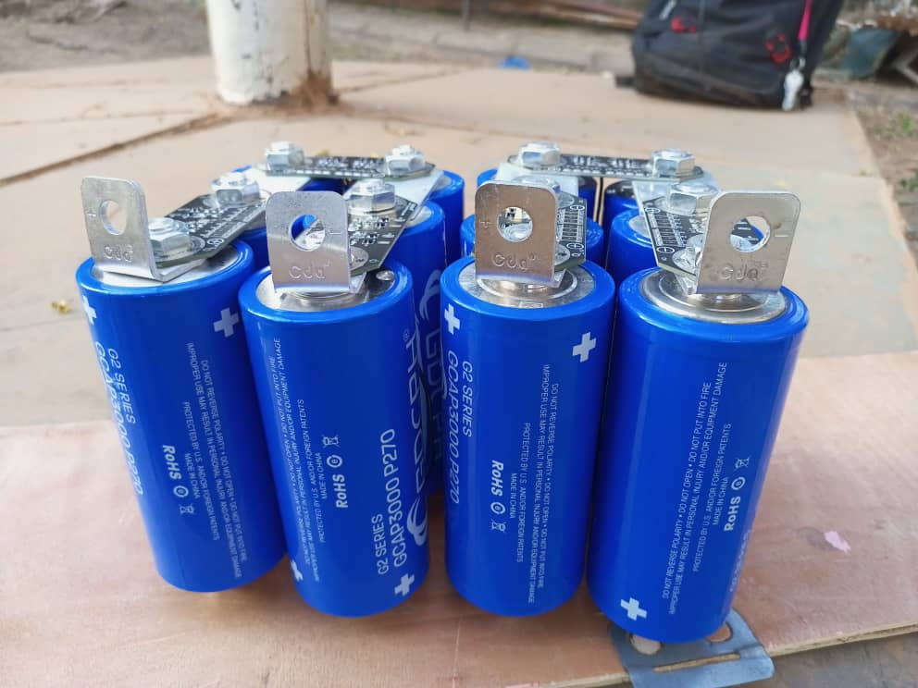

**Figure 1: 2 supercapacitor packs**

Figure 2 shows the experimental set-up consisting of the pump kit, two supercapacitor packs and batteries. Figure 3 shows the pyranometer and panel installation.

Control and command device

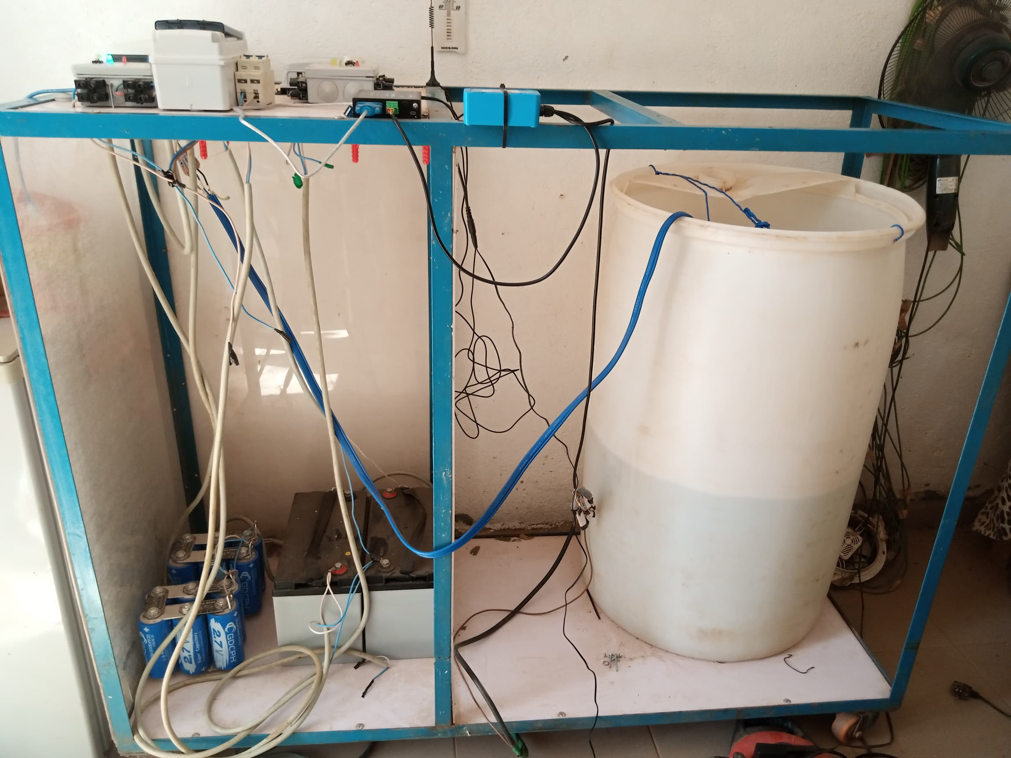

Supercapacitor

Batteries

Pumping system

**Figure 2: pump kit, supercapacitor packs and batteries**

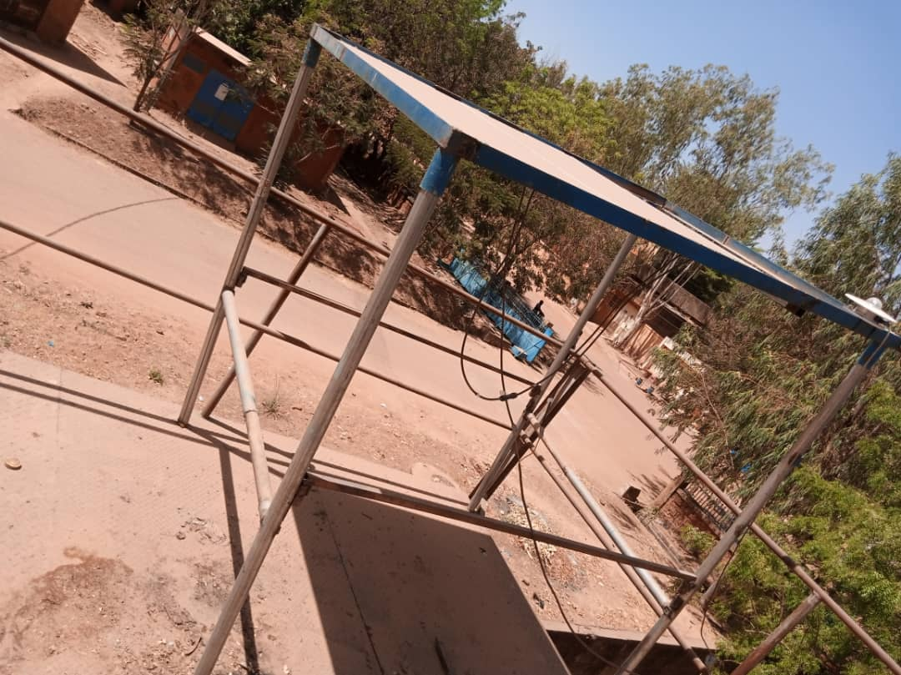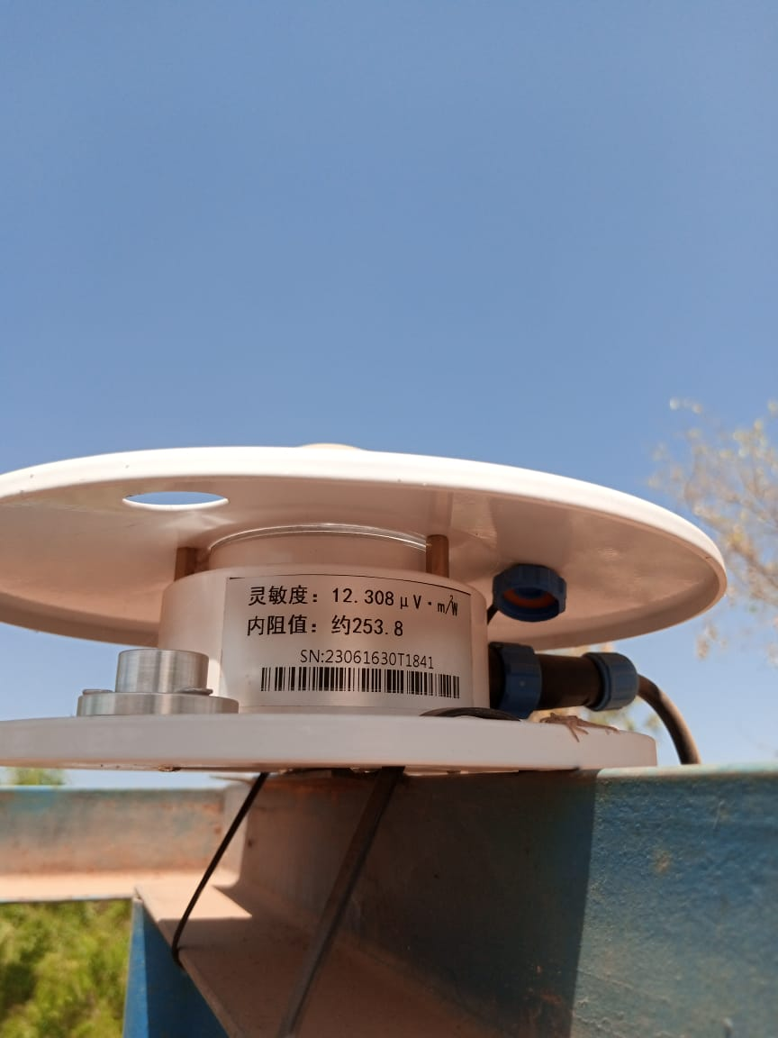

Pyranometer

Solar panel

**Figure 3: pyranometer and solar panels**

The experimental set-up consisting of the above-mentioned elements served as a framework for our experiment. The principle of the experiment was to record characteristic quantities every 10 seconds. We measured the solar system characteristics (irradiance) using a pyranometer. Voltage and current values at the output of the solar panels are measured using the MPPT controller. Pump characteristics (speed, current, voltage, power) are measured using the MPPT controller. As for the supercapacitors, voltage and current values are measured using a multimeter and a DC clamp ammeter respectively.

**1.3 Experimental measurements**

In the first instance, the experiment consisted of taking direct readings of the supercapacitor charge through solar radiation. Then, once charged, we proceeded to a direct discharge through the solar pump. The aim of the experiment is to run the pump directly over time. In the first case, when voltage dips prevent normal operation of the system, the supercapacitors are used to ensure operation during the period of the disturbance. In the second case, when irradiation is low, the supercapacitors are called upon again to boost pump start-up. To illustrate our experiment, we recorded the voltage and current values of the supercapacitors over the course of the solar irradiation. In the case of the discharge principle, the pump is powered via the supercapacitors. We recorded the voltage and discharge current of the supercapacitors. We also measured the characteristics of the motor pump. This experimental set-up is shown in a block diagram in figure 4, followed by a diagram of the experimental set-up in figure 5.

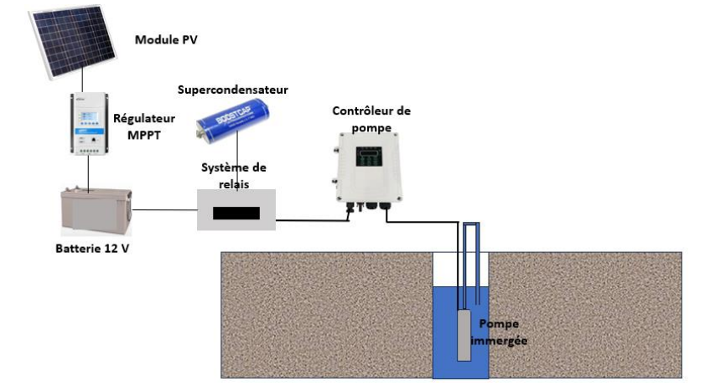

**Figure 4: schematic diagram of the experimental set-up**

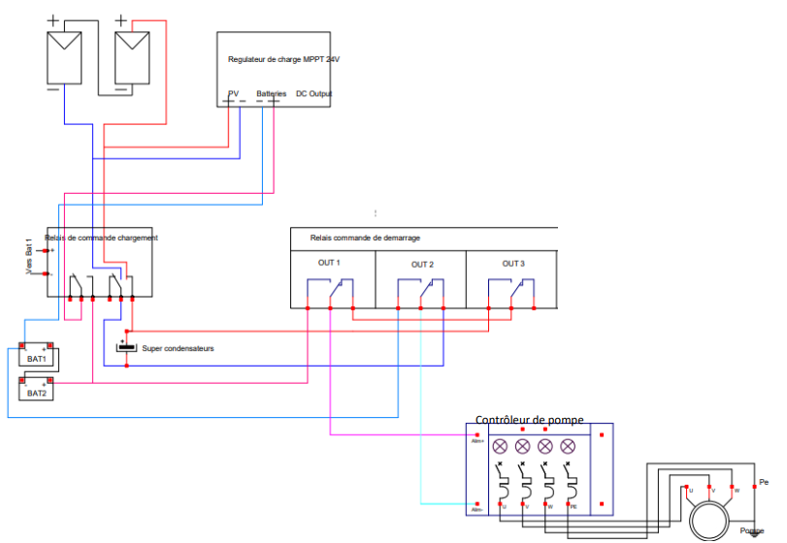

**Figure 5: experimental set-up diagram**

3. results and discussion

The results obtained enabled us to plot the following experimental curves for the day of January 30, 2025.

**Figure 6: Solar irradiance curve for the day of 30/01/2025**

Figure 6 above shows the evolution of solar irradiance during the day of 30/01/2025 in Burkina Faso. We can see a drop in solar irradiance. This is due to a cloudy spell during the measurement period.

Figure 7 shows the charging voltage and current profiles of the supercapacitors as a function of charging time. The current curve shows a high supercapacitor charge from the 1st second to the 650th second, corresponding to a charge time of 10 minutes 40 seconds. From this point onwards, a significant drop in charge occurs until the 960th second, due to low solar irradiation, when the supercapacitors reach their maximum charge at 980 seconds. This is justified by the fact that the harmattan clouds and dust attenuated the effect of solar irradiation for a duration of 310 seconds, or 5 minutes 10 seconds. The supercapacitors were able to power the pump during the period of reduced solar irradiance. This charge can be rapid for periods without fluctuating solar irradiance.

**Figure 7: Supercapacitor charge profile**

Figure 8 shows the profile of motor speed versus current I during daytime operation. At speeds below 3000 rpm, the pump flow rate is below the minimum pumping rate specified by the pump manufacturer (2.2*〖10〗^(-4) m^3/s). This flow rate varies with motor speed. Experimental results show that for an irradiation of 450W/ m^2, the motor rotation speed is of the order of 1750r/min corresponding to a flow rate of 2.12*〖10〗^(-4) m^3/s. For an irradiation of 934W/ m^2 with a motor rotation speed of 3350tr/min the flow rate is of the order of 3*〖10〗^(-4) m^3/s. The results obtained show that the higher the solar irradiation, the higher the motor rotation speed, resulting in a higher pumping flow rate.

Figure 8: Motor speed vs. current profile

Figure 9 shows the motor current profile as a function of pump power input during daytime operation. The results obtained show that for a pump power consumption of 115 W at a rotation speed of 3210 rpm, the pumping capacity is acceptable, i.e. less than 3350 rpm.

**Figure 9: Motor current profile as a function of power**

Figure 10 shows the motor speed vs. current profile when the supercapacitors are discharged. In contrast to feeding the pump directly from the sun, discharging the supercapacitors on the pump leads directly to its operation corresponding to a good flow at a rotation speed of over 3000 rpm.

**Figure 10: Motor speed vs. current profile**.

Figure 11 shows the profile of motor current versus power input during supercapacitor discharge operation. The current vs. power curve shows that between the maximum supercapacitor charge voltage of 32.4V and the threshold voltage of 19.6V, the pump receives the power required for operation.

**Figure 11: Motor current profile as a function of power**

Figure 12 shows the discharge voltage and current profiles of the supercapacitors as a function of charging time. The results obtained from this experiment give a discharge threshold value of 20 V. So, for a charging voltage of between 19.6V and 32.4V, corresponding to an energy of 21.715Wh, the supercapacitors supply the solar pump correctly. We can see that, despite the slight variations in current, the pump receives sufficient energy for operation. This discharge lasts 8 minutes 59 seconds. With reference to the charging system, we obtained a disturbance of 5 minutes 10 seconds due to fluctuations in solar irradiation against the supercapacitor discharge time. These results show that the supercapacitors can ensure continuity of supply to the load up to a maximum duration of 8 minutes.

**Figure 12: Discharge curve of supercapacitors through the load**

**. 3.DISCUSSION**

**3.1 Calculation of the mean solar power variability error**

For our study, we defined the mean power variability error in order to assess the evolution of pump output as a function of solar irradiation. Based on the experimental results, this error is the power deviation calculated between the pump's rated power of around 180W and the power absorbed by the pump as a function of solar irradiance over time.

- From 6:00 a.m. to 10:20 a.m. we observe low power production due to the absence or low irradiance of the sun. This low power production is characterized by an average power variability error of around 80.26.

- From 10 hours 20 minutes to 13 hours 20 minutes: we have high power generation due to high solar irradiance. This is characterized by an average power variability error of -27.742.

- From 1:20 pm to 1:50 pm (cloudy period): we see a drop in irradiance due to a significant cloudy period. This drop in solar production is characterized by an average power variability error of around 23.02.

- From 1:50 p.m. to 5:00 p.m.: drop in solar irradiance due to sunset. This significant drop in production is due to a reduction in solar irradiation corresponding to sunset. The average error of this drop in solar production is around 75.70**.**

**Figure 13 shows the results of calculating the average error in power variability as a function of time and solar irradiance.**

**Figure 13: profile of the average error in power variability as a function of time and solar irradiance.**

**3.2 Calculating the average error in power variability due to supercapacitor discharge**

Figure 14 shows a profile of supercapacitor charge vs. time. It shows a rapid increase in power as a function of time. The greater the power, the greater the average error in power variability due to supercapacitor charging. In the case of our study, particularly for the month of January with low solar irradiation, the supercapacitor charging time is 16 minutes**.**

**Figure 14: Supercapacitor charge vs. time profile**

**3.3 Calculating the average error in power variability due to supercapacitor discharge**

The average error in power variability due to supercapacitor discharge is defined by calculating the difference between the rated power of around 180W and the discharge power of the supercapacitor supplying the pump. For a charge voltage of between 19.6 V and 32.4 V, corresponding to an energy of 21.715 Wh, the supercapacitors ensure correct power supply to the solar pump. The curve representing the variability error is on the negative side and rising. This means that the energy stored by the supercapacitors provides the power required for the pump to operate correctly. The curves for power and power variability error are asymptotic with respect to the time axis.

Figure 15 shows the supercapacitor discharge profile as a function of time. The interval shown corresponds to a duration of 8 minutes 49 seconds. This corresponds to a pump supply phase. In our experiment, for two packs of 12 supercapacitors of 3000 Farad and 2.7 V terminal voltage each, the maximum discharge time is 9 minutes 30 seconds. The supercapacitors can compensate for the variability of solar irradiation from the 180W pump during this specified period. This discharge time can be increased depending on the number of supercapacitors. Both packs have an equivalent capacity of 250 Farad and a maximum voltage of 32.4V. This means that, in the event of dips or fluctuations in solar irradiation, clouds or wind movements on the solar panels, the supercapacitors can be discharged at any time, with durations of less than 9 minutes 30 seconds, continuity of power supply to the system could be ensured.

Figure 15: Supercapacitor discharge profile as a function of time.

Thanks to their high power density and rapid charging and discharging, supercapacitors can perfectly compensate for power fluctuations. They keep the pump running smoothly until the stored energy is exhausted. Supercapacitors are regarded as instantaneous storage devices with high specific power and low specific energy, covering the high-power demands of our pumping system. This shows that the profiles of the power variability error and the pump power are of the same order of magnitude.

**CONCLUSION**

We have concluded from this study that supercapacitors are capable of compensating for the 180W solar pump's power variability for a duration of at least 7 minutes to power the solar pumping system. Their ability to charge quickly even through weak solar radiation is one of the main advantages of this component over other energy sources (capacitor, battery). For + current electric motors (DC or AC) requiring a high starting current at high power during the transient starting phase, this phenomenon can be absorbed by supercapacitors (bicycles, cranes, motor vehicles) [8][9]. The same applies to temporary maintenance of the installation system, for less sunny periods of the day (early morning and sunset), and also for temporary grid disturbances. Supercapacitors help to better manage and improve the yield of agricultural production. This experiment will be approved by a numerical study.

**REFERENCES**

[1] Ahmed Ousmane Bagre. Optimization of the coupling of photovoltaic power plants to unstable public grids: application to the national grid of Burkina Faso. Electricity. University of Le Havre, 2014. French. NMT: 2014LEHA0017, Tel-01256023

[2] General Directorate of Meteorology of Burkina Faso (2015): Climatological data from weather stations. Standards and Reports, Government of Burkina Faso

[3] Ousmane Nikiema, Seydou Ouedraogo, Damgou Mani Kongnine, Emmanuel Nanema, Adekunlé Akim Salami. Analysis of the Complementarity Between Solar and Wind Energy in the Perspective of Installing a Hybrid System: Case Study in the Sahel of Burkina Faso. International Journal of Energy and Power Engineering. Vol. 12, No. 3, 2023, pp. 41-46. doi: 10.11648/j.ijepe.20231203.12 Received: July 16, 2023; Accepted: August 9, 2023; Published: August 22, 2023 page 41-42

[4] : BELHACHEMI Farid: Modeling and characterization of electric double layer supercapacitors used in power electronics, Institut National Polytechnique de Lorraine, 2001

[5] [4] Mohamed Ansoumane Camara. Modeling of photovoltaic energy storage by supercapacitors. Other. Université Paris-Est, 2011. French. NNT: 2011PEST1071, tel-00673218

[6] Maxwell Technologies, Maxwell K2series_DS_1015370-4-117973, www.maxwell.com

[7] Nathalie Devillers. Characterization and Modeling of Electrochemical and Electrostatic Storage Components. Other. University of Franche-Comté, 2012. French. NNT: 2012BESA2003. Tel 00838733

[8] Emmanuel Hoang, Bertrand Revol, Gilles Feld, Denis Pénard, Elements of Study of an "Electrical Energy" Storage System: The Supercapacitor. 3E.I Review, 2007, pp. 20hal-00533011 pages 7-8

[9] Nassim RIZOUG; Electrical and Energy Modeling of Supercapacitors and Characterization Method: Application to the Cycling of a Low-Voltage Supercapacitor Module at High Power

[10] Ministry of Energy, Mines and Quarries, Burkina Faso; National Rural Electrification Strategy (SNER 2024-2028), June 2024

[11] SONABEL (National Burkinabe Electricity Company), Renewable Energy Directorate, Photovoltaic Solar Power Plant Project. Technical Data Sheet, Government of Burkina Faso, Ouagadougou, Burkina Faso, 2022.