**Hydrodynamic and Thermal Propagation of Hydromagnetic Micropolar Nanofluid over an Expanding Stagnation-Point Surface**

**Abstract**

The current study investigates the transient stagnation-point flow and heat transfer characteristics of a magneto-micropolar nanofluid over an expanding surface under the influence of thermal radiation and boundary slip. The developed model incorporates the effects of micropolarity with weak concentration, external magnetic fields, and microscopic nanoparticles for enhanced thermal conductivity. The governing partial differential equations are formulated using boundary layer assumptions and transformed into a system of nonlinear ordinary differential equations through appropriate similarity transformations. These equations are solved numerically to analyze the effects of key parameters, with results presented in graphical and tabular forms. The findings reveal that increasing the magnetic parameter suppresses the velocity field while enhancing the thermal boundary layer thickness and temperature distribution. Additionally, thermal radiation significantly elevates the fluid temperature, indicating potential applications in thermal management and various energy systems. The results of this study contribute to the optimization of nanofluid-based technologies in transient, high-temperature environments.

**Keywords:** Unsteady flow**;** Micropolar nanofluid; Thermal radiation; Hydromagnetic flow; Stagnation-point flow

1. **Introduction**

The micropolar fluid model, classified under non-Newtonian fluids, was conceptualized by Eringen (1966) to account for the microstructure of fluids containing rigid, randomly oriented, and suspended particles within a viscous medium. These particles exhibit both translational and rotational motion. Unlike Newtonian fluids, micropolar fluids are characterized by a non-symmetric stress tensor, the inclusion of microrotation vector fields, the presence of couple stresses resulting from particle rotation, and a generalized form of the Navier–Stokes equations that incorporates angular momentum conservation [2–3]. This model has found broad applications in lubrication theory, biomechanical engineering (e.g., blood flow modeling), colloidal suspensions, liquid crystals, polymer suspensions, and flows through porous media [4–5]. These diverse applications have motivated numerous researchers to investigate the behavior of micropolar fluids under various configurations and geometries. For instance, Jalili et al. [6] analyzed the steady flow of micropolar fluid in a porous channel; Turkyilmazoglu [7] studied its flow over a porous extending surface; Maurya et al. [8] explored the flow over a porous cylinder under two distinct boundary conditions; while Guedri et al. [9] examined a micropolar-third grade fluid passing through an exponentially stretching device. However, to boost heat transfer phenomenon in today’s world, the micropolar fluid can be coupled with nanofluids.

Nanofluids are engineered colloidal suspensions of nanoparticles dispersed in conventional base fluids—such as water, ethylene glycol, or oil—to significantly enhance their thermal conductivity and heat transfer efficiency. These traditional fluids, by nature, possess low thermal conductivity and thus offer limited heat transfer performance, which falls short of the growing thermal demands in modern engineering and industrial applications. In response to these limitations, Choi and Eastman [10] introduced nanofluids and demonstrated their capacity to improve the thermal behavior of conventional fluids, making them ideal for advanced thermal management systems.

Owing to their superior heat transfer characteristics, nanofluids find applications in diverse sectors, including electronics cooling, renewable energy systems (e.g., solar collectors, photovoltaic cooling), the automotive industry (e.g., radiator coolants, brake, and exhaust systems), industrial heat exchangers, nuclear reactors, and biomedical engineering, [11-13]. These wide-ranging applications have spurred extensive research into the thermophysical behavior of nanofluids to maximize the thermal performance of conventional fluids. For instance, Alizadeh et al. [14] examined the MHD thermal radiative micropolar nanofluid flow between permeable walls, Fatunmbi et al. [15] analyzed a magnetohydrodynamic micropolar nanofluid passing through a vertical sheet under the influence of swimming microorganisms, and Panda et al. [16] investigated the impact of slip conditions on heat transfer in a micropolar nanoliquid system. Other aspects and key parameters of micropolar nanofluid have been investigated by some authors as found in Refs [17-20]. However, many of these studies have not considered this type of flow situation in a stagnation point in spite of various applications.

Stagnation-point flow describes the dynamics of fluid motion at a location where the flow velocity reduces to zero—typically occurring when a fluid impinges on a solid body. This phenomenon is pivotal in both theoretical and applied fluid mechanics, [21]. Key features of stagnation-point flow include: zero velocity at the surface, symmetry in the flow field near the impact point, and steep pressure gradients. These attributes make it highly applicable in diverse engineering and industrial contexts, including aerodynamic engineering (e.g., heat and mass transfer near leading edges of aircraft and turbine blades), nuclear reactors, electronic cooling systems (via fans), boundary layer flow separation, and biomedical engineering (e.g., blood flow at arterial bifurcations), [22-25]. Due to these broad applications, many researchers have investigated stagnation-point flow over various geometries and under diverse physical effects. For instance, Turkyilmazoglu [26] examined heat transfer and flow over stretchable surfaces and cylinders, demonstrating that material stretch dampens velocity and temperature profiles while enhancing heat transfer. Fatunmbi et al. [27] studied Williamson nanofluid flow with Joule heating and entropy generation over an elongated surface. Ghadikolaei et al. [28] explored hybrid nanofluid flow using $TiO₂–Cu$ nanoparticles near a stagnation point, considering shape factors and heat transfer. Khan et al. [30] investigated free convective transient flow with thermal radiation, chemical reaction, and activation energy over a stretching Riga plate. Salawu et al. [29] employed the Galerkin weighted residual method to analyze Maxwell nanofluid stagnation flow influenced by thermal radiation, magnetic fields, and chemical reactions, reporting that higher magnetic field strength compresses the velocity and momentum boundary layers. However, none of these studies have explored the unsteady flow phenomenon using micropolar nanofluids as the working medium, highlighting a significant gap in the literature and offering a promising direction for future research. An unsteady flow phenomenon occurs when, the fluid thermophysical properties changes with time and can be influenced by external factors such as varying boundary conditions, temperature gradients, or magnetic fields. This type of study is important for applications involving heat transfer, magnetic fields, and microfluidics, where time-dependent behaviour can significantly affect system performance, efficiency, and stability.

This study, therefore, investigates the flow and thermal propagation mechanisms of a hydromagnetic, chemically reactive micropolar fluid containing dispersed nanoparticles over a convectively heated, expanding stagnation-point surface. The heat transfer model incorporates the effects of viscous dissipation, velocity slip, thermophoresis, Brownian motion, and linear radiative heat flux. The findings of this research have important applications in various industrial, engineering, and technological fields. Notable application areas include polymer and metal processing, particularly in shaping materials with temperature-sensitive properties, aerospace and turbomachinery operations, where it aids in boundary layer control near stagnation zones such as turbine blades, aircraft noses, and rocket nozzles, as well as the cooling of electronic systems. The governing equations are solved numerically using the shooting method in combination with the Runge-Kutta-Fehlberg scheme, and the results are presented graphically and in tabular form.

**2.0 Assumptions for Problem Modeling**

An incompressible transient flow of hydromagnetic micropolar fluid is considered. It is assumed that the working fluid consists of minutes nanoparticles for an enhanced thermal transport. The flow is directed in the x direction while y axis is perpendicular to the flow route. The plate is heated from the bottom in a convective manner with the plate stretching at the rate of $U(x,t)=\frac{ax}{1-ζt}$, with t as the duration and $a>0,ζ≥0$ are constants). The wall temperature is denoted by $T_{w}$ while the nanoparticle concentration is signalled as $C_{w}$. It is assumed that the energy field is influenced by the thermal radiative heat flux, and viscous dissipation while there is influence of chemical reaction in the concentration field. The Bourgoin’s model is used for the nonfluid phenomenon which incorporates the Brownian and the thermophoresis influence in both the energy and concentration fields. The microrotation field id assumed to experience weak concentration of the micro-elements.

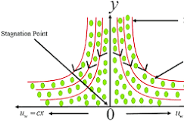

**Figure.1 Flow Configuration and Coordinate system**

**2.1 The Governing Equations**

Incorporating the assumptions highlighted above, and considering the boundary layer assumptions, the governing equations for the current problem are expressed below [30-32]

$\frac{∂U}{∂x}=-\frac{∂V}{∂y},$ (1)

$\frac{∂U}{∂t}+U\frac{∂U}{∂x}+V\frac{∂U}{∂y}-U_{e}\frac{dU}{dx}=\left(\frac{μ+r}{ρ}\right)\left(\frac{∂^{2}U}{{∂y}^{2}}\right)+\left(\frac{r}{ρ}\right)\frac{∂ω}{∂y}+\frac{σ{B_{0}}^{2}}{ρ}\left(U_{e}-U\right),$ (2)

$ρ_{j}\left[\frac{∂ω}{∂t}+U\frac{∂ω}{∂x}+V\frac{∂ω}{∂y}\right]-Ω\frac{∂^{2}ω}{{∂y}^{2}}=-r\left[2ω+\frac{∂U}{∂y}\right],$ (3)

$\begin{aligned}\frac{∂T}{∂t}+U\frac{∂T}{∂x}+V\frac{∂T}{∂y}-\left(\frac{κ}{ρCp}\right)\left(\frac{∂^{2}U}{{∂y}^{2}}\right)=\frac{ϑ}{Cp}\left(\frac{μ+r}{ρ}\right){\left(\frac{∂u}{∂y}\right)}^{2}-\frac{1}{ρc_{p}}\frac{∂q_{r}}{∂y}+τ\left[\left(D_{B}\frac{∂C}{∂y} \frac{∂T}{∂y} \right)+\frac{D_{T}}{T_{∞}} {\left(\frac{∂T}{∂y}\right)}^{2}\right] \\ \end{aligned}$ (4)

$\frac{∂C}{∂t}+U\frac{∂C}{∂x}+V\frac{∂C}{∂y}+K\left(C-C_{∞}\right)=$ $D_{B}\frac{∂^{2}C}{{∂y}^{2}}+\frac{D_{T}}{T_{∞}}\frac{∂^{2}T}{{∂y}^{2}}$ (5)

The boundary conditions are specified as:

$\begin{aligned}\begin{aligned} u=U_{w}\left(=\frac{ax}{1-ζt}\right)+J\left(\sqrt{1-ζt}\right)\frac{∂U}{∂y}, V=0, ω=-m\frac{∂U}{∂y}, -κ\frac{∂T}{∂y}=H_{f}\left(T_{w}-T\right), \\ D_{B}\frac{∂C}{∂y}+\frac{D_{T}}{T_{∞}}\frac{∂T}{∂y}=0, at y=0: \end{aligned} \\ U→U_{e}, \frac{∂U}{∂y}→0, ω→0, T→T_{∞}, C→C_{∞} as y→∞: .\end{aligned}$**(6)**

The symbols and letters used in the formulated governing equations (1-6) are $U, V, ω, Ω, C, T, B_{0}, r, μ, κ,$ are velocity components in $x$ direction, velocity component in $y$ direction, micropolar component, spin gradient viscosity, concentration of nano fluid, temperature of the fluid, magnetic field induction, vortex viscosity, dynamic viscosity, Heat convection transmission thermal conductivity. Similarly, $ρ$ is the density, $j$ is the micro inertial density, $q_{r}$ is the radiative heat flux, $τ$ connotes relative heat capacity between the nanoparticle material and the fluid. $ϑ$ is the kinematic viscosity, $D_{B}$ indicates random walk diffusivity, $K$ connotes the dimensionless reaction process parameter, $D_{T}$ defines the thermal migration coefficient, $σ$ is the fluid electrical conductivity, $C_{p}$ symbolizes the specific heat capacity at constant pressure, $T_{∞}$ defines the temperature at upstream, while $C_{∞}$ connotes the concentration of nanoparticles at far upstream and $H_{f}$ indicates the heat convection transmission.

**2.2 Similarity Transformation**

$\begin{aligned}\frac{η}{y}=\sqrt{\frac{α}{ϑ\left(1-ζt\right)}}, ψ=\sqrt{\frac{αϑ}{\left(1-ζt\right)}}xf\left(η\right), U_{e}=\frac{ax}{1-ζt}, U=\frac{c}{1-ζt}xf^{'}\left(η\right), \\ V=-\sqrt{\frac{αϑ}{\left(1-ζt\right)}}f\left(η\right), ω=\sqrt{\frac{α}{ϑ\left(1-λt\right)}}Cxg\left(η\right), T=T_{∞}+\frac{cx^{2}}{{\left(1-ζt\right)}^{2}}θ\left(η\right), \\ C=C_{∞}+\frac{ax^{2}}{{\left(1-ζt\right)}^{2}}ϕ\left(η\right), \end{aligned}$ (9)

Where $T_{w}=T_{∞}+\frac{cx^{2}}{{\left(1-ζt\right)}^{2}}θ\left(η\right), C_{w}=C_{∞}+\frac{ax^{2}}{{\left(1-ζt\right)}^{2}}∅\left(η\right), c$ and $a$ are constant.

By the virtue of equation (9), the partial differential equations governing the current problem are transformed into the following ordinary differential equations:

$\left(1+G\right)f^{'''}+ff^{''}-f^{'2}-H\left(f^{'}+\frac{η}{2}f^{''}\right)+Gg^{'}+γ^{2}+M\left(γ-f^{'}\right)=0$ (10)

$\left(1+\frac{G}{2}\right)g^{''}-G\left(2g+f^{''}\right)+fg^{'}-gf^{'}-H\left(g+\frac{η}{2}g^{'}\right)=0 ,$ (11)

$\left.\begin{aligned}\frac{1}{Pr}\left[1+R\right]θ^{''}-H\left(2θ+\frac{η}{2}θ^{'}\right)-2f^{'}θ+fθ^{'}+Nt {θ^{'}}^{2}+Nb θ^{'}ϕ'+ \\ \left(1+G\right)Ec{f^{''}}^{2}=0 \end{aligned}\right\},$ (12)

$ϕ^{''}-Sc\left[H\left(2ϕ+\frac{η}{2}ϕ^{'}\right)+2f^{'}ϕ-fϕ^{'}\right]+\frac{Nt}{Nb}θ^{''}-ScBϕ=0,$ (13)

The corresponding conditions at the boundary become:

$\begin{aligned}at η=0: f\left(0\right)=0, f^{'}\left(0\right)=1+sf^{''}\left(0\right) , θ^{'}\left(0\right)=-Bi\left(1-θ\left(0\right)\right), \\ Nb ϕ^{'}\left(0\right)+Nt θ^{'}\left(0\right)=0, \\ as η→∞, f^{'}\left(∞\right)=γ, f^{''}\left(∞\right)=0, θ\left(∞\right)=0, g\left(∞\right)=0, ϕ\left(∞\right)= 0\end{aligned}$ (14)

The dimensionless quantities found in the ordinary differential equations (11-14) are:

The material term $\left(G=\frac{r}{μ}\right), the$ unsteadiness $\left(H=\frac{ζ}{α}\right)$, the velocity ratio $\left(γ=\frac{b}{α}\right)$, the magnetic field parameter $\left(M=\frac{σ{B_{0}}^{2}}{αρ}\right)$ the Prandtl number $\left(Pr=\frac{μCp}{κ}\right)$, the Schmidt number $\left(Sc=\frac{ϑ}{D_{B}}\right),$ the Brownian motion parameter $\left(Nb=\frac{τD_{B} {(C}_{w}-C_{∞})}{ϑ}\right)$, the slip term $(s=J\sqrt{aϑ) },$ the thermophoresis parameter $\left(Nt=\frac{τD_{B} {(T}_{w}-T_{∞})}{ϑT_{∞}}\right)$, the thermal radiation term $\left(R=\frac{16σ^{*}{T_{∞}}^{3}}{{3k}^{*}Cpκ}\right)$, the Biot number $\left(Bi=\sqrt{ϑ/α} {H_{f}}/κ\right).$ the Eckert number $\left(Ec=\frac{U_{w}}{{bC}_{P}}\right)$.

The physical quantities of engineering interest are the skin friction coefficient and the Nusselt number which are respectively expressed as

$C_{f}=\frac{τ_{w}}{{{ρU}_{w}}^{2}},$ ${Nu}_{x}= \frac{xq_{w} }{κ\left(T_{w}-T_{∞}\right)}$ (15)

In equation (15) the wall shear stress and the surface heat flux are respectively denoted by $τ_{w}$, and $q_{w}$ and are expressed as

$q_{w}=κ{\left(\frac{∂T}{∂y}\right)}_{y=0 }, τ_{w}={\left(\left(\frac{μ+r}{ρ}\right)\left(\frac{∂u}{∂y}\right)+rω\right)}_{y=0 }$

Therefore, the dimensionless quantities of engineering interest are

$C_{f}{{Re}_{x}}^{1/2}=\left[1+H\left(1-m\right)f^{''}\left(0\right)\right],$ ${Nu}_{x}{{Re}_{x}}^{-1/2}=-θ^{'}\left(0\right),$ (16)

1. **Method of solution and validation of results**

Given the high nonlinearity of the problem under study, the coupled nonlinear system of differential equations (10) through (13), alongside the boundary conditions specified in equation (14), has been tackled through a robust numerical procedure. The numerical approach used the combined scheme of the Runge–Kutta–Fehlberg (RKF45) and the shooting technique, both of which are well-established for solving boundary value problems of this nature. Given the semi-infinite domain for the independent similarity variable $η$ an appropriate large but finite value, denoted as $η_{∞}$, is selected to truncate the domain to make the problem computationally integrated. This ensures that the asymptotic boundary conditions at infinity are sufficiently approximated within a finite domain. The system under consideration consists of a third-order nonlinear differential equation in velocity ($f''')$, and second-order in microrotation $(g^{''})$ and temperature $θ'')$ and concentration $ϕ'')$. To effectively apply the numerical method, the boundary value equations (10-14) is first transformed into a set of nine coupled first-order ordinary differential equations. This is necessary due to the fact that the Runge–Kutta-based schemes, are typically designed to handle systems of first-order equations. As soon as the system is expressed in first-order form, the shooting method is applied to convert the boundary value problem (BVP) into an initial value problem (IVP). This involves guessing the missing initial conditions and iteratively refining these guesses using techniques such as the Newton–Raphson method until the boundary conditions at $η_{∞}$ are valid within a specified tolerance. To do this, we assume that

$b_{1}=f, b_{2}=f^{'}, b_{3}=f^{''};b_{4}=g, b_{5}=g^{'}, b_{6}=θ, b_{7}=θ^{'};b_{8}=ϕ, b_{9}=ϕ^{'},$ (17)

$b_{3}^{'}=\frac{b_{2}^{2}-b_{1}b_{3}+G\left(b_{2}+\frac{η}{2}b_{3}\right)-βb_{5}-γ^{2}-M\left(γ-b_{2}\right)}{\left(1+β\right)},$ (18)

$b_{5}^{'}=\frac{G\left(b_{4}+\frac{η}{2}b_{5}\right)+H\left(2b_{4}+b_{3}\right)-b_{1b}+b_{2}b_{4 _{}}}{\left(1+\frac{H}{2}\right)},$ (19)

$b_{7}^{'}=\frac{Pr⁡[G\left(2b_{6}+\frac{η}{2}b_{7}\right)+2{b_{2}b_{6}-b_{1}b_{7}-Ntb_{7}^{2}-Nbb_{7}b_{9}-Ec\left(1+H\right)b_{3}^{2}]}^{ }}{(1+R)},$ (20)

$b_{9}^{'}=Sc\left[G\left(2b_{8}-\frac{η}{2}b_{9}\right)+2bb_{8}-b_{1}b_{9}\right]-\frac{Nt}{Nb}b_{7}^{'}+ScBb_{8},$ (21)

Subject to:

$\left.\begin{aligned}b_{1}\left(0\right)=0, b_{2}\left(0\right)=1, b_{3}\left(0\right)=c_{1};b_{4}\left(0\right)=-mb_{3}\left(0\right), b_{5}\left(0\right)=c_{2}, \\ b_{6}\left(0\right)=c_{3}, b_{7}\left(0\right)=-Bi\left(1-c_{3}\right);b_{8}\left(0\right)=c_{4}, b_{7}\left(0\right)=c_{4}. \\ b_{8}\left(0\right)=b_{5}, b_{9}\left(0\right)=b_{6}, Nbb_{9}\left(0\right)+Ntb_{7}\left(0\right)=0, \\ b_{2}\left(∞\right)→0, b_{4}\left(∞\right)→0, b_{6}\left(∞\right)→0, b_{8}\left(∞\right)→0.\end{aligned}\right\}$ (22)

The yet to be determined initial conditions ${ c}_{1}-c_{6}$ are assumed such that conditions at the boundary are valid. The final value of $η_{∞}$ is then chosen as the limit as $η→∞$. The symbolic algebra Maple 18 is used to carry out the numerical computation.

The current results compared favourably with previous studies in the limiting conditions as recorded in Tables 1 below. Thus, the current numerical code is judged to be accurate and correct.

**Table 1**. Comparison of the values of the skin friction coefficient $C_{f}{{Re}_{x}}^{1/2}$ as the wall slip parameter varies

|  |  |  |  |
| --- | --- | --- | --- |
| $$s$$ | Oyelakin et al. [33] | Sahoo and Do [34] | Current work |
| 0.0 | 1.000000 | 1.001154 | 1.000000 |
| 0.1 | 0.872083 | 0.871447 | 0.874071 |
| 0.3 | 0.701548 | 0.701738 | 0.702437 |
| 0.5 | 0.591195 | 0.591195 | 0.582309 |
| 1.0 | 0.430160 | 0.430450 | 0.433117 |
| 2.0 | 0.283979 | 0.283893 | 0.284005 |
| 3.0 | 0.214054 | 0.214314 | 0.215230 |
| 5.0 | 0.144714 | 0.144430 | 0.142125 |
| 10 | 0.080932 | 0.081091 | 0.0813137 |
| 20 | 0.043569 | 0.043748 | 0.0438167 |

1. **Results and discussion**

To further comprehend the influence of the key parameters on the dimensionless field, we have included various graphs under this section. Figures 2-5 display the impact of the unsteadiness parameter $(H)$ on the velocity, temperature, nanoparticles concentration, and microrotation profiles respectively. There is a decline in the velocity profiles, the temperature profiles and the concentration profiles as the unsteadiness term H magnifies. Both the thermal and hydrodynamic boundary layer shrunk with a rise in H as found in Figures 2, 3 and 4.

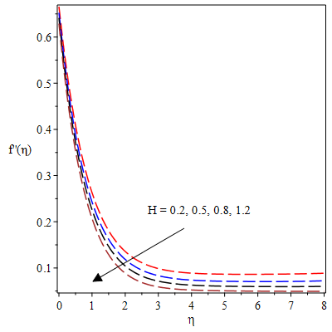

**Figure 2**. Velocity field for varying $H$

It can be affirmed from the governing equations that, a rise in the unsteadiness parameter often introduces additional time-derivative terms or alters similarity transformations. As a result, there is a damping effect and a reduce magnitude of both velocity and temperature profiles. These trends conform with physical intuition in that rapidly changing systems allow less time for fluid momentum and heat to propagate through the medium. As the unsteadiness parameter HH increases, the temperature profiles decline, indicating reduced heat propagation from the fluid surface into the interior. This trend is occasioned by a rise in $H$, which weakens thermal diffusion and diminishes the fluid’s ability to transport heat, thus to an overall drop in temperature within the boundary layer. However, the opposite trend is exhibited in the microrotation field as $H$ grows in magnitude as shown in Figure 5. A rise in the $H$ causes the microrotation profiles to magnify as found in figure 5. This can be attributed to a momentum lag in the system. In the flow of complex micropolar fluids, micro-elements react to translational and rotational effects and thus, a rise in $H$ causes lag in alignment between bulk fluid motion and microstructure rotation, leading to an enhanced microrotation profiles.

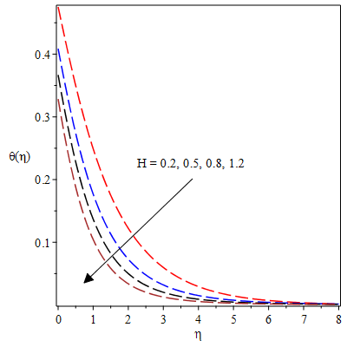

**Figure 3.** Thermal field for varying $H$

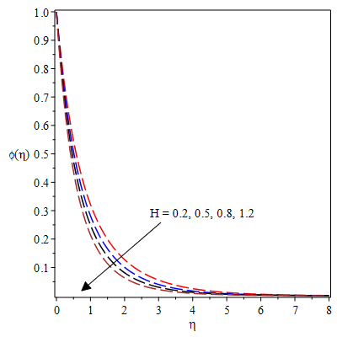

Fig. 4. Impact of $H$ in concentration profiles

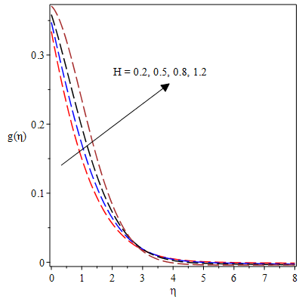

**Figure 5.** Microrotation profiles for variation in $H$

Figure 6 shows the velocity field versus η for variation in the material term (G). The velocity is a rising function of $G$. This trend depicts that the micropolar fluid's enhanced rotational effects, which contribute to sharper fluid motion and a fall in the dynamic viscosity of the fluid. The thermal boundary layer also thickens as G progresses in magnitude as showcase in figure 7. This is so because a rise in the micropolar term leads to higher internal rotation, an increased viscous dissipation, and reduced convective cooling, all of which propels the temperature profile in the boundary layer. However, the microrotation profiles dampens as $G$ enhances in magnitude as depicted in figure 8. In this case, growth in the micropolar parameter fosters a stronger coupling forcing the microrotation to align with zero or a very small value at the boundary, and as a result there is a reduction in the microrotation throughout the fluid.

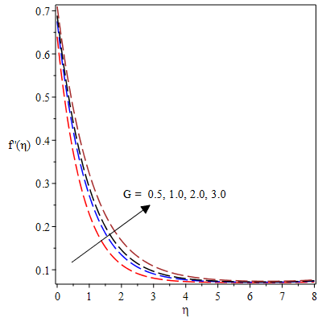

**Figure 6** Velocity profiles for variation in $G$

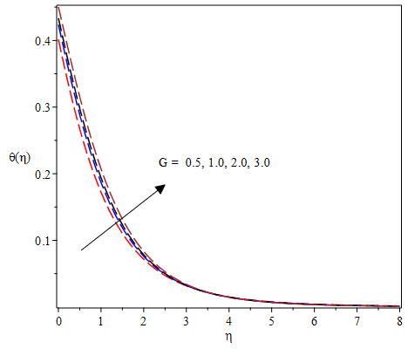

**Figure 7** Thermal profiles for variation in $G$

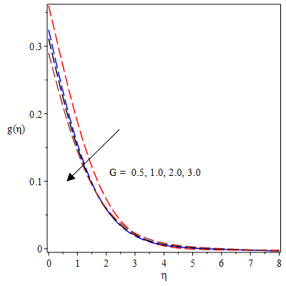

**Figure 8.** Impact of G on microrotation field

The impact of the magnetic parameter on velocity profiles is seen in Figure 9 as a decreasing function. As $M$ increases in strength, there is a corresponding rise in the Lorentz force, which operates as a drag force to resist the fluid motion. The hydrodynamic boundary layer shrinks as M grows which leads to the damping effect of the magnetic field on velocity profiles. This phenomenon finds applications in engineering, such as enhanced heat transfer in electrically conducting fluids and electromagnetic flow control. On the other hand, there is an enhanced thermal boundary layer as the magnetic field term progresses as depicted in figure 10. The temperature distribution progresses rapidly as the Lorentz force resist the fluid motion and thereby causes an increase in friction leading to heat generation. The drag-like force caused by the magnetic field dissipates kinetic energy as heat which in turn elevates the temperature within the fluid and thus, the temperature profile appreciates as $M$ increase. Likewise, the concentration profiles increase corresponding to a rise in $M$ as depicted in figure 11. This happens because growth in $M$ suppresses the velocity and consequently resisting convective mass transport. In view of this, solute particles accumulate more significantly within the boundary layer. This reduced convective loss allows for enhanced particle buildup, causing a rise in the concentration profiles as shown in this figure.

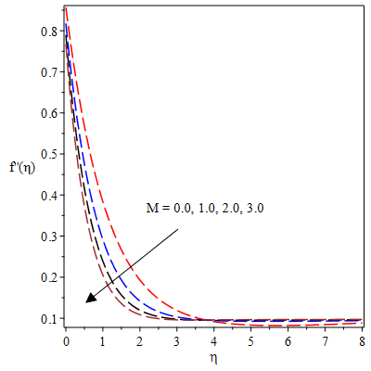

**Figure. 9**. Velocity profiles for variation in $M$

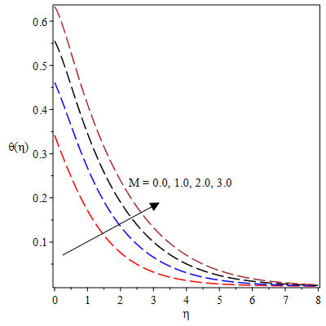

**Figure. 10**. Variation of $M$ on the thermal distribution

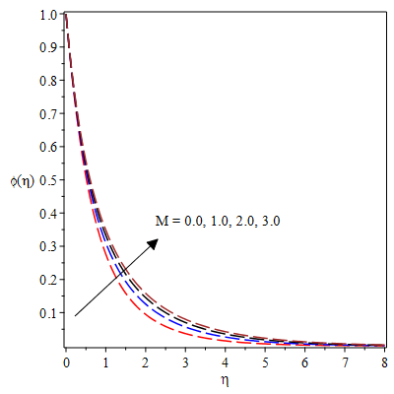

**Figure. 11**. Variation of $M$ on the concentration distribution

Figures 12 and 13 demonstrated the reaction of the velocity profiles for variation in the slip term (s). The presence of the slip parameter at the boundary indicates that the fluid is not fully dragged by the wall motion. Thus, a rise in this parameter connotes that the wall exerts less shear force on the fluid and as a result, there is a reduction of momentum transfer from the wall to the fluid such that the velocity profile decelerates as found in figure 12. In like manner, the microrotation profiles decline with a rise in the slip term as displayed in figure 13. In this figure, there is a weak coupling between the microstructure of the fluid and the boundary as the slip rises leading to a reduced profile of the microrotation.

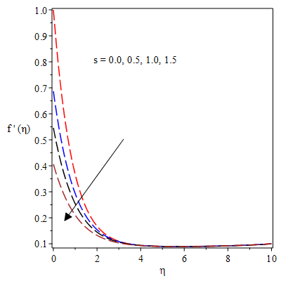

**Figure. 12**. Velocity field for variation in $s$ (slip term)

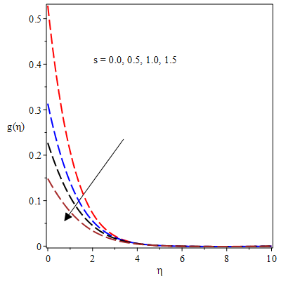

**Figure. 13**. Microrotation profiles for variation in $s$ (slip term)

Figures 14 and 15 reveal that as the thermophoresis parameter progresses in magnitude, both the temperature and concentration profiles magnify. This occurs due to enhanced thermophoretic motion, which drives nanoparticles away from hotter regions toward cooler ones. As a consequence, heat accumulation intensifies near the surface, reducing thermal loss and promoting greater thermal and solutal diffusion within the boundary layer.

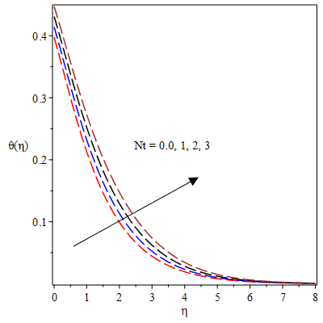

**Figure** 14. Impact of thermal distribution $θ\left(η\right)$ on $Nt$

.

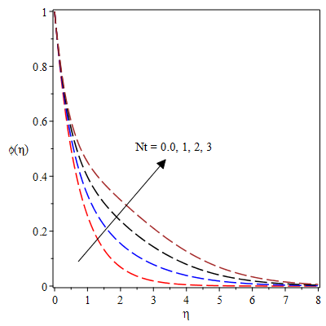

**Figure 15** Temperature profiles for variation in $Nt$

Figures 16 and 17 reveal the impact of the random motion $(Nb)$ of the nanoparticles on the thermal and concentration profiles respectively. In figure 16, a rise in $Nb$ causes the temperature profiles to increase but a reverse trend occurs in the concentration profiles as exhibited in figure 17. A rise in Nb fosters growth in thermal energy diffusion due to the irregular motion of nanoparticles, as a result, there is an increase in temperature across the fluid. However, with magnification of $Nb$ the solute nanoparticles spread out and consequently reduces concentration gradients, leading to lower local nanoparticle concentration in specific regions.

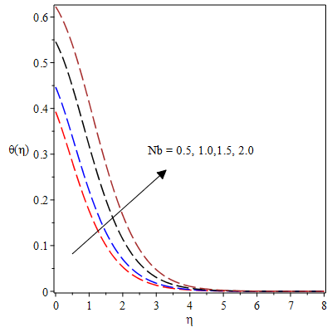

**Figure 16** Trend of thermal field for Nb

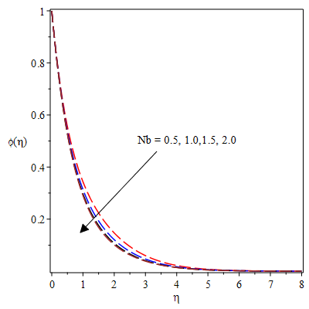

**Figure 17** Trend of concentration profiles for Nb

From table 2, the material micropolar term (G) causes a decrease in both the skin friction coefficient and the heat transfer across the surface. There is a rise in the wall drag phenomenon with a rise in M but the Nusselt number depreciates with this parameter. Both the wall drag force and the Nusselt number amplify with a rise in the unsteadiness parameter (H) as found in this table. The slip term (s) causes a decline in the viscous drag while slightly enhance the heat transfer in the system. The velocity ratio parameter $(γ)$ causes the skin friction coefficient to drop while increasing the heat transmission in the system.

**Table 2**: Calculated values of the friction factor ($-C_{f}{{Re}_{x}}^{0.5})$ and thermal conductance ( $-Nu{{Re}_{x}}^{-0.5})$ for variation in $β, M, A, a, He, Nt, K, Bi$

|  |  |  |  |  |  |  |
| --- | --- | --- | --- | --- | --- | --- |
| $$G$$ | $$M$$ | $$H$$ | $$α$$ | $$γ$$ | $$C_{f}{{Re}_{x}}^{0.5}$$ | $$-Nu{{Re}_{x}}^{-0.5}$$ |
| **0.0** | 0.5 | 0.3 | 0.5 | 0.1 | 0.9043146 | 0.1919817 |
| **0.5** | 0.8231173 | 0.1821531 |
| **1.0** | 0.7644645 | 0.1743034 |
| 0.5 | **0.0** |  |  |  | 0.7161634 | 0.2057179 |
| **1.0** | 0.8231173 | 0.1821531 |
| **2.0** | 0.9112337 | 0.1613267 |
|  | 0.5 | **0.2** |  |  | 0.8031604 | 0.1735170 |
| **0.7** | 0.8592939 | 0.1951361 |
| **1.2** | 0.8915178 | 0.2044716 |
|  |  | 0.3 | **0.0** |  | 1.1276881 | 0.2928806 |
| **1.0** | 0.6704956 | 0.3304481 |
| **1.5** | 0.4854719 | 0.3395099 |
|  |  |  |  | **0.1** | 0.8592939 | 0.1951361 |
| **0.3** | 0.7548330 | 0.2133270 |
| **0.5** | 0.6135143 | 0.2293193 |

1. **Conclusion**

This study analyzes magnetohydrodynamic micropolar fluid flow and heat transfer over an expanding stagnation-point surface under weak microelement concentration. The model incorporates thermophoresis, Brownian motion, viscous dissipation, velocity slip, and convective boundary conditions. Using the Runge-Kutta-Fehlberg method with shooting technique, the results show strong agreement with existing literature in limiting cases. Applications span nuclear reactors, MHD generators, aerospace surfaces, and biomedical microfluidics, where magnetic control and micro-rotational effects enhance thermal and flow efficiency at low nanoparticle concentrations. The following points are derived from this study:

* There is a fall in the hydrodynamic, thermal and solutal boundary layers with a rise in the unsteadiness term whereas an opposite trend occurs in the microrotation field.
* There is decline in the viscous drag, velocity and temperature profiles with higher values of the slip parameter slip term but slight increase occurs in the heat transfer phenomenon.
* The material micropolar parameter enhances the velocity and temperature profiles while reducing the viscous drag between the fluid and stretching plate. However, the microrotation profiles decline with a rise in the material term.
* There is thicker thermal boundary structure with higher thermophoresis and Brownian motion terms but the concentration profiles depreciate with the Brownian motion as velocity ratio parameter causes the skin friction coefficient to drop while increasing the heat transmission in the system.

**References**

Here is the list of references you requested formatted in the appropriate citation style:

1. Eringen, A. C. (1966). Theory of micropolar fluids. *Journal of Mathematics and Mechanics, 1*, 1-18.
2. Sheikholeslami, M., Hatami, M., & Ganji, D. D. (2014). Micropolar fluid flow and heat transfer in a permeable channel using analytical method. *Journal of Molecular Liquids, 194*, 30-36.
3. Fatunmbi, E. O., Okoya, S. S., & Makinde, O. D. (2020). Convective heat transfer analysis of hydromagnetic micropolar fluid flow past an inclined nonlinear stretching sheet with variable thermo-physical properties. *Diffusion Foundations, 26*, 63-77.
4. Reena, R., & Rana, U. S. (2009). Effect of dust particles on rotating micropolar fluid heated from below saturating a porous medium. *Applications and Applied Mathematics: An International Journal (AAM), 4*(1), 15.
5. Lukaszewicz, G. (1999). *Micropolar fluids: Theory and applications.* Springer Science & Business Media.
6. Jalili, B., Azar, A. A., Jalili, P., & Ganji, D. D. (2023). Analytical approach for micropolar fluid flow in a channel with porous walls. *Alexandria Engineering Journal, 79*, 196-226.
7. Turkyilmazoglu, M. (2016). Flow of a micropolar fluid due to a porous stretching sheet and heat transfer. *International Journal of Non-Linear Mechanics, 83*, 59-64.
8. Maurya, D. K., Deo, S., & Khanukaeva, D. Y. (2021). Analysis of Stokes flow of micropolar fluid through a porous cylinder. *Mathematical Methods in the Applied Sciences, 44*(8), 6647-6665.
9. Guedri, K., Ameer Ahammad, N., Nadeem, S., Tag-ElDin, E. M., Awan, A. U., & Yassen, M. F. (2022). Insight into the heat transfer of third-grade micropolar fluid over an exponentially stretched surface. *Scientific Reports, 12*(1), 15577.
10. Choi, S. U., & Eastman, J. A. (1995). Enhancing thermal conductivity of fluids with nanoparticles (No. ANL/MSD/CP-84938; CONF-951135-29). Argonne National Lab. (ANL), Argonne, IL (United States).
11. Choi, S. U. (2008). Nanofluids: A new field of scientific research and innovative applications. *Heat Transfer Engineering, 29*(5), 429-431.
12. Sivaraj, R., & Banerjee, S. (2021). Transport properties of non-Newtonian nanofluids and applications. *The European Physical Journal Special Topics, 230*(5), 1167-1171.
13. Bahiraei, M., Mazaheri, N., & Alighardashi, M. (2017). Development of chaotic advection in laminar flow of a non-Newtonian nanofluid: A novel application for efficient use of energy. *Applied Thermal Engineering, 124*, 1213-1223.
14. Alizadeh, M., Dogonchi, A. S., & Ganji, D. D. (2018). Micropolar nanofluid flow and heat transfer between penetrable walls in the presence of thermal radiation and magnetic field. *Case Studies in Thermal Engineering, 12*, 319-332.
15. Fatunmbi, E. O., Oke, A. S., & Salawu, S. O. (2023). Magnetohydrodynamic micropolar nanofluid flow over a vertically elongating sheet containing gyrotactic microorganisms with temperature-dependent viscosity. *Results in Materials, 19*, 100453.
16. Panda, S., Baithalu, R., Baag, S., & Mishra, S. R. (2024). Behaviour of effective heat transfer rate in radiating micropolar nanofluid over an expanding sheet with slip effects. *Partial Differential Equations in Applied Mathematics, 11*, 100851.
17. Hussain, S. M., Majeed, A., Ijaz, N., Omer, A. S., Khan, I., Medani, M., & Khedher, N. B. (2024). Heat transfer in three dimensional micropolar based nanofluid with electromagnetic waves in the presence of eukaryotic microbes. *Alexandria Engineering Journal, 94*, 339-353.
18. Shah, Z., Khan, A., Khan, W., Alam, M. K., Islam, S., Kumam, P., & Thounthong, P. (2020). Micropolar gold blood nanofluid flow and radiative heat transfer between permeable channels. *Computer Methods and Programs in Biomedicine, 186*, 105197.
19. Muhammad, F., Majeed, A., Ijaz, N., Barghout, K., & Abu-Libdeh, N. (2024). Exploration of heat transfer rate and chemically reactive bio-convection flow of micropolar nanofluid with gyrotactic microorganisms. *BioNanoScience, 14*(2), 1141-1156.
20. Mahabaleshwar, U. S., Maranna, T., Mishra, M., Hatami, M., & Sunden, B. (2024). Radiation effect on stagnation point flow of Casson nanofluid past a stretching plate/cylinder. *Scientific Reports, 14*(1), 1387.
21. Mathew, A., Areekara, S., Sabu, A. S., & Saleem, S. (2021). Significance of multiple slip and nanoparticle shape on stagnation point flow of silver-blood nanofluid in the presence of induced magnetic field. *Surfaces and Interfaces, 25*, 101267.
22. Suryakumar, V. S., Babbar, Y., Strganac, T. W., & Mangalam, A. S. (2016). Unsteady aerodynamic model based on the leading-edge stagnation point. *Journal of Aircraft, 53*(6), 1626-1637.
23. Mahmoud & Waheed, 20 K. (2013). Boundary layer stagnation-point flow of Casson fluid and heat transfer towards a shrinking/stretching sheet. *Frontiers in Heat and Mass Transfer (FHMT), 4*(2).
24. Khan, U., Mahmood, Z., Eldin, S. M., Makhdoum, B. M., Fadhl, B. M., & Alshehri, A. (2023). Mathematical analysis of heat and mass transfer on unsteady stagnation point flow of Riga plate with binary chemical reaction and thermal radiation effects. *Heliyon, 9*(3).
25. Islam, A., Mahmood, Z., & Khan, U. (2023). Double-diffusive stagnation point flow over a vertical surface with thermal radiation: assisting and opposing flows. *Science Progress, 106*(1), 00368504221149798.
26. Turkyilmazoglu, M. (2021). Stagnation-point flow and heat transfer over stretchable plates and cylinders with an oncoming flow: exact solutions. *Chemical Engineering Science, 238*, 116596.
27. Fatunmbi, E. O., Mabood, F., & Adeniyan, A. (2021). Stagnation-Point Flow of Magneto-Williamson Nanofluid over a Stretching Material with Ohmic Heating and Entropy Analysis. *International Journal of Mathematical Sciences and Optimization: Theory and Applications, 7*(1), 131-145.
28. Ghadikolaei, S. S., Yassari, M., Sadeghi, H., Hosseinzadeh, K., & Ganji, D. D. (2017). Investigation on thermophysical properties of TiO2–Cu/H2O hybrid nanofluid transport dependent on shape factor in MHD stagnation point flow. *Powder Technology, 322*, 428-438.
29. Salawu, S. O., Obalalu, A. M., Fatunmbi, E. O., & Disu, A. B. (2024). Tiny particles thermal motile in magnetized chemically reacting upper-convective Maxwell stagnation point fluid with radiation. *Results in Engineering, 23*, 102593.
30. Baag, S., Mishra, S. R., Dash, G. C., & Acharya, M. R. (2017). Numerical investigation on MHD micropolar fluid flow toward a stagnation point on a vertical surface with heat source and chemical reaction. *Journal of King Saud University-Engineering Sciences, 29*(1), 75-83.
31. Khan, U., Zaib, A., Pop, I., Abu Bakar, S., & Ishak, A. (2022). Stagnation point flow of a micropolar fluid filled with hybrid nanoparticles by considering various base fluids and nanoparticle shape factors. *International Journal of Numerical Methods for Heat & Fluid Flow, 32*(7), 2320-2344.
32. Mahmoud, M. A., & Waheed, S. E. (2012). MHD stagnation point flow of a micropolar fluid towards a moving surface with radiation. *Meccanica, 47*, 1119-1130.
33. Oyelakin, I. S., Mondal, S., & Sibanda, P. (2016). Unsteady Casson nanofluid flow over a stretching sheet with thermal radiation, convective and slip boundary conditions. *Alexandria Engineering Journal, 55*(2), 1025-1035.
34. Sahoo, B., & Do, Y. (2010). Effects of slip on sheet-driven flow and heat transfer of a third grade past a stretching sheet. *International Communications in Heat and Mass Transfer, 37*, 1064-1071. <https://doi.org/10.1016/j.icheatmasstransfer.2010.06.018>