**Review Article**

**Precision Gene Therapy: A Transformative Approach to Treat Age-Related Macular Degeneration (ARMD)**

**Abstract**

A new age of Precision gene therapy is the most futuristic, transformative, and alternative approach developed for treating Age-Related Macular Degeneration (ARMD). Globally, ARMD is a major contributor to severe, irreversible vision loss. It is a degenerative disease that results in central vision loss by affecting the choriocapillaris, photoreceptors, retinal pigment epithelium, and macula, thereby limiting the frequency of anti-VEGF (anti-vascular endothelial growth factor) injections as a standard treatment. Additionally, it involves creating techniques to ensure sustained delivery of a range of antiangiogenic proteins. These are repetitive intravitreal injections, which put the patient at high risk of infection, costly drugs, low compliance, disparities in access, healthcare burden, increase the doctor-patient conflict, and are hectic for the elderly population. Gene therapy has emerged as a promising substitute, an Innovative approach to treating ARMD by replacing faulty genes with healthy ones. Viral non-integrating Vectors, such as AAV, act as envelopes that carry encoded genetic messages without impacting native cellular DNA. It enhances patients' hope and quality of life. This Review aims to promote gene therapy for ARMD, providing the current status of ongoing research, awareness, and future innovative progression. With its vast and unlimited potential, gene therapy is poised to reshape the future of healthcare, offering new hope for patients with ARMD.

**Keywords:** Adeno-Associated Viral Vector, Age-Related Macular Degeneration, Gene Therapy, Precision Medicine, Vision Loss.

**1. Introduction**

Age-related macular degeneration ARMD), also known as senile macular degeneration, is a complex bilateral disorder characterised by the development of distinct, slightly raised, yellowish-white spots called Drusen (Voelker, 2024). These extracellular deposits form between the retinal pigment epithelium and Bruch's membrane. The risk is 1.3 times greater for women than for men. 10–20% of adults over 65 are suffering from Age-Related Macular Degeneration (ARMD), a major cause of severe, permanent loss of vision that will affect 200 million people by 2040 (Vyawahare & Shinde, n.d.). Current treatments, such as anti-VEGF injections, have limitations, including a high risk of infection, costly drugs, low compliance, substantial financial burden on the healthcare system, and poor patient adherence (Xu et al., 2022) ARMD is a multifactorial global disease that significantly impacts society. In ARMD, the Macula is affected, compromising the central vision, impairing a person's ability to see colours, and causing distorted and blurred vision. An individual will suffer from metamorphopsia with central scotoma, which might cause hallucinations and make facial recognition difficult (Chaudhuri et al., n.d.). ARMD exists in two main forms: Dry and wet. **Fig. 1**. Dry ARMD (Non-Exudative/Atrophic) is a slower-progressing form of ARMD characterised by the accumulation of waste material in the retina. New vessels are fragile and prone to breaking (Fernandes et al., 2022). Neovascularisation occurred in choroidal in choroidal membrane of the retina with enhanced oxygen flow to retinal tissue. Geographic atrophy, a progressive loss of the RPE and photoreceptors, is a sign of dry AMD (Di Staso et al., 2023). Exudative/neovascular wet ARMD is more severe, which involves the formation of new, fragile blood vessels beneath the retina. Deposition and pigmentation in the macula are marked by a decrease in macular thickness. Degeneration of photoreceptor, retinal pigment epithelium, and choriocapillaris of retina (Somasundaran et al., 2020).

This study introduces a visionary perspective on the application of precision gene therapy in the treatment of Age-related Macular Degeneration (ARMD), a major cause of visual impairment in ageing populations worldwide. Traditional therapies, namely anti-VEGF injections, offer temporary relief for neovascular ARMD; however, they are limited by high costs, the need for regular administration, a high risk of complications, and a limited impact on vision restoration. This approach advances beyond existing symptom-targeting methods by focusing on addressing the underlying genetic mechanisms that initiate ARMD development. This study differentiates itself through its focus on the evolving landscape of gene therapy technologies by using recombinant Adeno-Associated Viral (AAV) vectors and genome-editing tools like CRISPR-Cas9 to deliver therapeutic genes directly to the retinal tissues of individuals, which can provide permanent relief and eliminate the need for frequent anti-VEGF injections for at least five years due to the continuous expression of anti-angiogenic proteins in retinal cells. Furthermore, the study uniquely examines how gene therapy can target specific genetic risk factors such as variations in CFH, ARMS2, HTRA1, and other genes that contribute to oxidative stress, inflammation, and abnormal blood vessel formation in the retina.

Precision gene therapy plans are designed to work according with the eye’s immune system, reducing systemic side effects and improving treatment and patient adherence, and comfort. Recent advancements in the studies suggested that gene-editing technology could develop the scope of future therapeutic possibilities, along with the correction of hereditary mutations. Novelty lies in the condensed integration of genetic insights, clinical advancements to propose a long-lasting and patient-friendly alternative and a promising advancement to current ARMD treatments. This study not only boosts the current body of knowledge but also charts a new direction for precision medicine in ophthalmology for the treatment of ARMD.

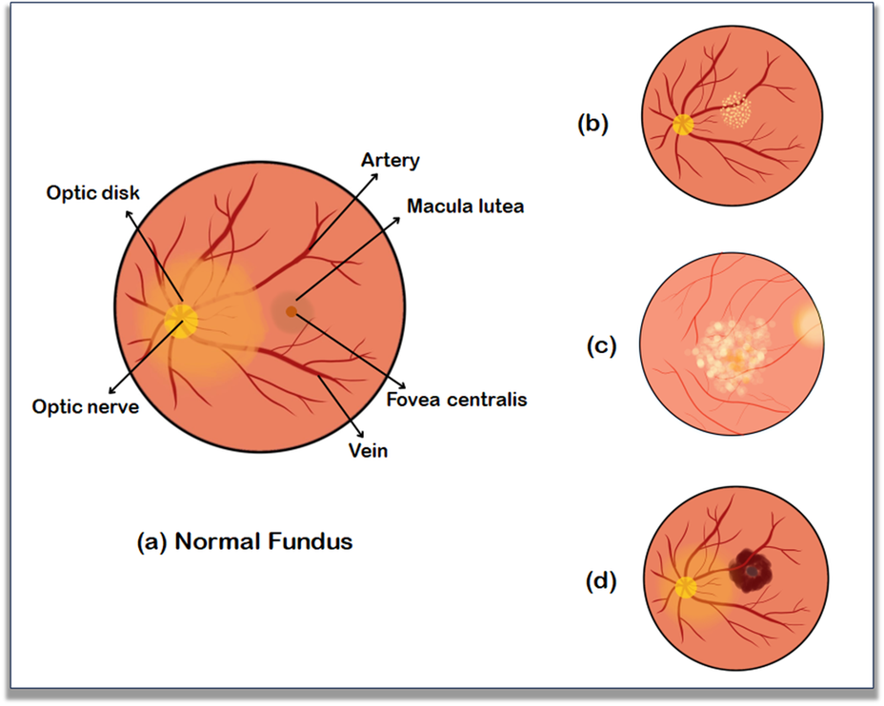

**Fig. 1.** Shows the Fundus Images Depicting Normal and Pathological Findings: (a) Normal fundus showing clearly defined optic disc, macula, fovea, and normal retinal vasculature. (b) Exudative Age-Related Macular Degeneration (ARMD): Fundus image showing lipid-rich deposits (exudates) localised in the macular region. (c) Fundus image illustrating cotton wool spots, indicative of localised retinal nerve fibre layer infarcts. (d) Non-Exudative ARMD: Fundus image showing subretinal haemorrhage without exudate accumulation.

**2. Age-Related Macular Degeneration Pathophysiology**

The pathophysiology of Age-related Macular Degeneration (ARMD) is a complex process involving multiple factors. It includes oxidative stress, ageing, environmental factors (smoking, UV exposure), poor diet, sedentary lifestyle, and genetic predisposition as key indicators. Lead to aggregation of reactive oxygen species (ROS), cellular damage and decline, and enablement of the immune response of the individual. Together, these processes contribute to the development of ARMD (Heesterbeek et al., 2020). As ARMD develops fully, a process called lipofuscinogenesis occurs, leading to the collection of waste products, such as lipofuscin, within retinal pigment epithelial (RPE) cells in the retina. Development leads to impaired RPE function, reduces nutrient supply to photoreceptors, and activates the release of pro-inflammatory cytokines (Mazzitello et al., 2009).

Chronic inflammation develops, further worsening the condition. In Wet AMD, the RPE detaches from Bruch's membrane, activates abnormal blood vessel growth from the choroid into the subretinal space (choroidal vascularisation), and leakage from new, fragile vessels of the retina. This process leads to the formation of a disciform scar, causing permanent, irreversible, and central vision loss (Bhutto & Lutty, 2012). The pathophysiology of age-related macular degeneration is shown in **Fig. 2**.  Several risk factors influence the progression of ARMD. It is primarily a disease of ageing, mostly affecting the older population. With the age above 50 years, the risk of ARMD increases significantly (Kulkarni et al., 2013). Environmental and genetic variables are important in determining an individual's risk of ARMD. Those with a family history of ARMD are at a higher risk (Mousavi & Armstrong, 2013). Certain systemic diseases, such as hypertension and cardiovascular diseases, can also influence the risk of ARMD. Sedentary lifestyle, smoking, and obesity might play an important part in increasing the risk of ARMD (Saigal et al., 2025).

**3. Gene Therapy Techniques**

The traditional method of therapy includes an anti-VEGF drug, which is injected into the affected eye. Patients need shots every four to six weeks to maintain the effect of the medicine. Vascular Endothelial Growth Factor (VEGF) is essential for vascular endothelial growth.(Pérez-Gutiérrez & Ferrara, 2023) Anti-Vascular Endothelial Growth Factor (Anti-VEGF) therapy is given to block vascular endothelial growth factors, which include antibodies such as bevacizumab, and also reduces the growth of abnormal blood vessels and reduces swelling. There is a necessity for the development of several innovative technologies and long-lasting therapies for treating Wet ARMD (Amarakoon et al., 2019).

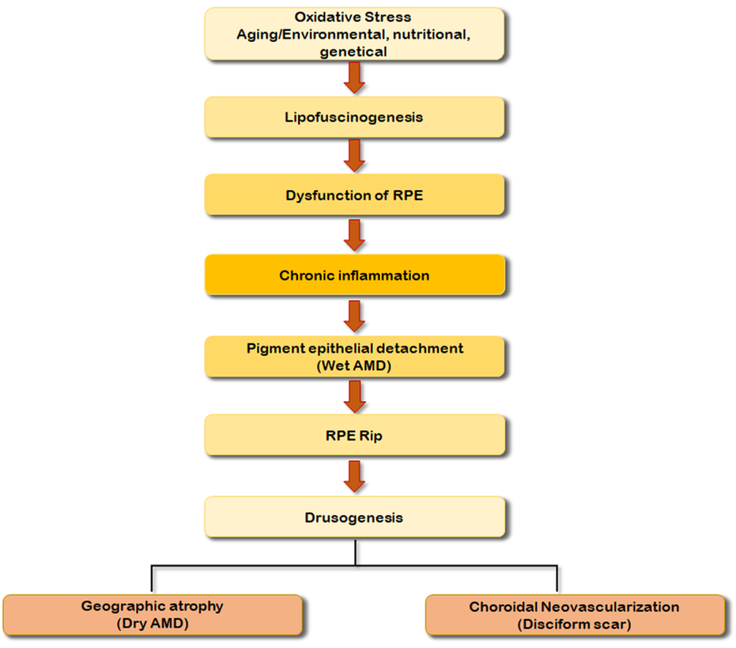

**Fig. 2.** The pathophysiology of age-related macular degeneration involves degeneration of the RPE and drusen accumulation, leading to geographic atrophy and choroidal neovascularisation and causing central vision loss.

Gene therapy itself is capable of continuously producing anti-VEGF proteins, without frequent invasive intravitreal injections. Gene Therapy is leading the way to a drastic change in the treatment of ARMD. The basic concept of gene therapy is the Genetic mutation of Cells having faulty genes through introducing healthy genes (Chung et al., 2021). The normal genes either replace the diseased cells/tissue physically or function severally at another point in the host genome, performing the normal gene-related activity of the cell. An altered DNA termed Recombinant DNA is formed by the process of Genetic Engineering; this process involves substituting a segment of the DNA of the virus with a therapeutic gene, integrated into the DNA strand of the virus, which is associated with proliferation/replication in the host cell (Rampersad & Tennant, 2018). When this Recombinant virus is delivered to diseased tissue then the proliferation of the therapeutic gene gets incorporated into host DNA, leading to the production of normal protein by the process of DNA expression (Gupta et al., 2016).

**4. The Viral Vector and the Eye**

For retinal gene replacement, the recombinant Adeno-Associated Viral (AAV) vector is ideal. Because of its several significant characteristics, the AAV vector is used for ocular gene therapy. AVV is a non-integrating type of vector (He et al., 2023). Due to risks involved while delivering the transgene in gene therapy, non-integrating vectors have been chosen in the present techniques and those that will be implemented soon. AAV is a small, single-stranded DNA genome. An icosahedral protein capsid and a single-stranded DNA (ssDNA) genome form an AAV. It comprises two inverted terminal repeats (ITRs) on either end of the genome that are T-shaped (Xiang & Hao, 2023). Although numerous other AAV serotypes have been discovered, AAV2, AAV5, and AAV8 have been the most extensively studied in ocular gene treatments (Issa et al., 2023). When humans are injected with AAV vectors, their antigen-specific T cells become activated. The reduced capacity of the parent virus to infect antigen-presenting cells results in a limited immune response (Ronzitti et al., 2020). Post-operation, a Broad range of immunosuppressants is prescribed to the patient as the body is at high risk. Recent strategies of gene therapy with AAV vectors have created the possibility of therapeutic gene manipulations with minimal concerns for inflammatory and immune reactions and with maximal efficacy. The limitation of AAV is that it cannot package a 4.8 kb longer DNA fragment (Naso et al., 2017; *Packaging Capacity of Adeno-Associated Virus Serotypes: Impact of Larger Genomes on Infectivity and Postentry Steps | Journal of Virology*, n.d.).

Dr Kiss helped design RGX-314 and ADVM-022, a Vector that works as a carrier for protein-coding genetic sequences. Sequences that allow the genetic material to take over the cellular machinery of the targeted cell, which is being transduced to make the desired protein, are the promoter, enhancer, and ITRs (Blasiak et al., 2024). The vector, also known as the capsid, is the shell of a virus; it binds to the receptors on the target cell and then injects its genetic content (Drouin & Agbandje-McKenna, 2013). Genetic material coding DNA – RGX-314 and ADVM-022 022, called cDNA, which enables precise gene delivery and expression (Hushmandi et al., 2025). Either end is are ITRs that facilitate the integration of therapeutic genes into the host cell’s genome. A promoter that defines the transcription start site determines the level of gene expression, and an Enhancer increases promoter activity. Transgene is the protein itself, which we are trying to make in the case of RGX-314 and ADVM-022; these are anti-VEGF(Buck & Wijnholds, 2020), as shown in **Fig. 3**. AVV vectors are small in size, having a broad cell type range, high cloning capacity, transduction capacity, low immunogenicity with long long-term expression. These are classified as first, second, and third generation viral vectors. First-generation viral vectors have limited use because they activate inflammatory responses, while the second generation of viral vectors is less immunogenic, and third-generation viral vectors are safest (Bulcha et al., 2021).



**Fig. 3.** Representing the genetic coding of adeno-associated virus. Cloning with the wild-type AAV genome. To insert a therapeutic gene, it deletes the original viral gene. Add promoter and enhancer, which control gene expression in a target cell as a regulatory element. Transfecting packaging cells involves introducing DNA into retinal cells that are packaged with rAAV Vector and purifying rAAV Vector.

**4.1 Genetic Background**

CFH is located on chromosome 1, while ARMS2 and HTRA1 are both on chromosome 10. The CHF version is primarily connected to the presence of drusen in the retina (Schmitz-Valckenberg et al., 2022). The ARMS2–HTRA1 variant correlates with the occurrence of subretinal or sub-RPE haemorrhages in the retina. Meanwhile, other genes, including MMP9, CETP, and TIMP3, have been linked to nAMD due to their roles in regulating extracellular matrix remodelling.(Pan & Iwata, 2024) FGD6, HTRA1, and CFH respond to oxidative stress and inflammation, contributing to the progression of nAMD (Asten et al., 2018). HIF-α (Hypoxia-inducible factor alpha) and VEGF-A produced by RPE cells lead to the degeneration of the RPE cells themselves and Bruch’s membrane (Botto et al., 2022). VEGF, VEGFR, PDGF, and PEGF are the primary targets for present gene therapy.(Guimaraes et al., 2021) Genetic modifications include single-nucleotide polymorphisms (SNPs), mitochondrial DNA mutations, and microRNA modifications. Gene editing techniques, such as gene splicing, allow for specific DNA alterations through gene cutting and nucleotide addition. The CRISPR-Cas9 technique enables efficient alteration and adjustment, including the insertion, replacement, or deletion of DNA within a living organism's genome, serving as a distinguished method for nuclear genome editing, with promising applications for mitochondrial genome editing as well (J. Y. Wang & Doudna, 2023). One limitation of gene editing is that it can cause genotoxicity, or damage to the genetic material itself, which may lead to coincidental and potentially harmful outcomes. Gene editing targets specific mutations that cause inherited diseases, aiming to make targeted changes to the genome to correct the underlying genetic defects, such as ARMD (Blattner et al., 2020),(Eghbalsaied et al., 2024).

**5. Routes of administration of ocular vector gene into the eye**

A crucial step in gene therapy is the delivery method of the vector, which can be administered via three routes: subretinal, intravitreal, or suprachoroidal, as given in **Fig. 4**. Subretinal administration is the standard and safest approach for ocular gene therapy, offering a little risk of immune response and less swelling in the patient's body (Kansara et al., 2020). According to Dr. Kokame, subretinal delivery of RGX-314 allows retinal cells to manufacture their anti-VEGF protein for a long time, effectively treating the state of ARMD lifelong. The subretinal delivery method involves a surgical vitrectomy, where the vitreous gel is removed from the eye, and RGX-314 is directly injected beneath the retina of a patient in a saline solution, forming a regional and concentrated bleb on the surface (Tripepi et al., 2023). Suprachoroidal delivery involves a slightly invasive procedure; in-office injection of the viral vector is given into the space behind the retina. It can effectively target specific cell types that are causing ARMD. Research has revealed this approach to be secure and well-tolerated, allowing for precise delivery of vectors to preferred tissues through different routes of administration (Planul & Dalkara, 2017). Protein production typically starts within a few weeks after injection. Bleb creation can lead to various complications like photoreceptor damage, cataracts, macular holes, retinal detachment, and increased intraocular pressure. To decrease these risks, intravitreal delivery via pars plana has been found as a less invasive alternative method for delivery. Suprachoroidal delivery offers a safer approach to delivering the gene by targeting the choroid and retinal pigment epithelium, consequently avoiding the surgical complications associated with vitrectomy (D. Wang et al., 2019).

**5.1 Mechanism of ocular gene therapy**

Gene therapy for retinal diseases can be administered via subretinal or intravitreal injections, with nanoparticles emerging as a promising delivery method for genome editing.(Ross & Ofri, 2021) These nanoparticles are designed to evade an individual’s immune system and diffuse through the ocular barrier to target retinal pigment epithelial (RPE) cells. Endocytosis occurs when the plasma membrane invaginates to surround the nanoparticle (N. J. Mehta & Mehta, 2024).

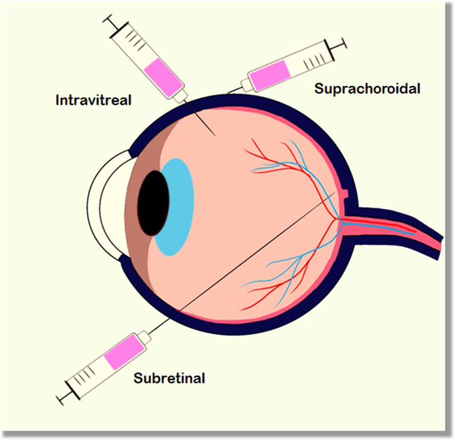

**Fig. 4.** Schematic representation of various ocular gene delivery routes, including intravitreal (injection into the vitreous humor), suprachoroidal (injection between the sclera and choroid), and subretinal (injection beneath the retina) administration.

Once inside the cell, the nanoparticles must escape the endosome and release their content, which can include mRNA, RNP, and pDNA, into the cytosol, referred to as Cargo Release (Brock et al., 2019). mRNA, RNP, and pDNA are transported into the nucleus, enabling further genome editing in the retinal nuclei and allowing for endogenous expression of a desired protein. Additionally, adenovirus-mediated delivery is used to introduce recombinant genetic material to host cells. The AAV virus binds with receptors present on the cell surface, followed by endocytosis, during which the nucleus releases the recombinant DNA. DNA transcription into mRNA and translation of mRNA begin to produce therapeutic proteins **Fig. 5** (Carvalho et al., 2023),(Rowe & Ciulla, 2024).



**Fig. 5.**Mechanism of ocular gene therapy via subretinal administration. The recombinant DNA can be delivered using nanoparticle-mediated or adeno-associated viral vectors.

**6. Gene Therapy: ARMD clinical trials**

**6.1. PEDF- Pigment epithelial-derived growth factor**

Serpin F1 is a glycoprotein that inhibits neovascularisation and promotes neuronal survival by blocking angiogenesis. In a study of 2006 Phase 1 trial explored the delivery of PEDF via a single intravitreal injection of gene therapy of AAV (adeno-associated virus) in 28 patients with neovascular age-related macular degeneration (nAMD) was explored (Campochiaro et al., 2006). The consequences of the study showed that patients who received a lower dose (< 108 particle units) encountered reduced visual acuity and increased size of lesion, whereas those who received a higher dose (at least 108 particle units) remained stable (Gehlbach et al., 2003). This study aimed to determine the optimal dosage rather than evaluating therapeutic efficacy.

**6.2. ADVM -022**

The phase 1 OPTIC is an open-label clinical trial. This trial assessed the safety, efficacy, and dose-finding of an office-based procedure for intravitreal gene therapy for treating ARMD (Khanani et al., 2020). This study utilised the AAV2.7 m8 capsid, an engineered form of capsid from AAV2, which encodes the cDNA for a protein similar to aflibercept, an anti-vascular endothelial growth factor (VEGF) agent (Cui et al., 2024). Adverum Biotechnology designed and started a Phase 1 trial study profile of intravitreal ADM-022. Trials were conducted on ARMD patients, previously controlled by frequent anti-VEGF injections, and who received high or low doses of ADVM-022 (ixoberogenesoroparvovec). The number of anti-VEGF injections was reduced by up to 98% in the high-dose population and 80% in the low-dose group. OPTIC study trial showed, injecting Ixo-vec encouraged steady points of intraocular aflibercept, best corrected visual acuity remained constant, and a remarkable decrease in anti-VEGF injections, replaced by a solo injection of the ixoberogene soroparvovec (Wojciechowski et al., 2025). The results revealed a significant yearly drop in anti-VEGF injections for ARMD, with a 94% decrease for the higher dose (2×1011 vg/eye) and a 90% decrease for the lower dose (6×1010 vg/eye), respectively, to an injection-free period of 85% and 68% (Dalkara et al., 2013).

**6.3. Endostatins and Angiostatins**

A lentiviral vector that encodes endostatin and Angiostatin, both are inhibitors of angiogenesis, helps to stop the formation of new blood vessels and is investigated as a therapeutic agent (Blaese et al., 1995). Retinostat (Oxford Biomedia) is an equine infectious vector; it showed good preclinical results on mice. Endostatin inhibits endothelial cell proliferation and migration, while angiostatin blocks endothelial cell proliferation and induces apoptosis (Campochiaro et al., 2017). The Phase 1 clinical trial enrolled 21 patients with advanced ARMD into 3 cohorts. Resulted in Gene therapy, which was safe, well tolerated, and generated a sustained expression of VEGF-neutralising protein. Ongoing Study and long-term effects are still not evaluated (Binley et al., 2012).

**6.4. RGX-314**

REGENXBIO, in collaboration with AbbVie, has developed a gene therapy, RGX-314, which utilises AAV8 to suppress neovascularisation by expressing a single clonal antibody fragment structure that binds to VEGF-A receptor. The gene is administered via subretinal and suprachoroidal routes, and RGX-314 has shown promise in treating age-related macular degeneration (AMD) (Liao et al., 2023). Presently, seven clinical trials have been registered to evaluate its safety and efficacy. This study involved around 46 patients; RGX-314 was well-tolerated, with minimal adverse effects, including inflammation, conjunctival haemorrhage, and retinal pigmentary changes have been seen. Patients who were treated with RGX-314 experienced a significant reduction in anti-VEGF treatment burden, with constant or enhanced best-corrected visual acuity and improved thickness of the central retina (Khanani et al., 2022).

**6.5. LUNA phase II trial**

This study evaluates the safety of Ixo-vec at two different dosages: 2× 1011 vg/eye and 6×1010 vg/eye. LUNA is an ongoing clinical trial. The result of this study revealed improved visual acuity and the anatomy of the fundus (Poulsen et al., 2025). Furthermore, the inflammatory profile was boosted with corticosteroid prophylaxis, compared to the previous OPTIC study. Findings of LUNA TRIAL-2 promote the potential for in-office intravitreal injections to revolutionise the treatment of nAMD (neovascular age-related macular degeneration). The clinical study revealed that Ixo-vec can provide sturdy, resilient, and effective cellular-based factories, reducing the rate of anti-VEGF injections (Khanani et al., 2023).

**7. Challenges and risk considerations**

Several risks and limitations are associated with Gene Therapy for ARMD; data on potential safety is unavailable. Optimal treatment targets remain controversial, as one route of delivery may consistently reach the target cell in the retina (Trincão-Marques et al., 2024). Each of these has its merits and demerits. The human body recognises a viral vector as a foreign entity, which poses a high risk for post-operative patients. Gene therapy can cause ocular inflammation by reacting to promoters and transgenes, as older cells may be less responsive. Fibrosis can diminish the effectiveness of gene therapy (Mallone et al., 2021). Older adults have compromised immune systems, which increases the risk of adverse reactions. Long waiting times for treatment and trials pose problems for older people, who have limited access due to high cost, limited awareness, and education (N. Mehta et al., 2021),(Zaiss et al., 2002).

**8. Future perspectives in precision gene therapy**

A new generation of precision gene therapy for ARMD, with editing of the DNA genome, unlocks the perception of a momentous enhancement in the lifetime comfort of patients (Schambach et al., 2024). Future research directions are likely to involve integrating and consolidating gene therapy with pharmacotherapy and CRISPR/Cas9 gene editing (Uddin et al., 2020). It permits precise modifications to DNA sequences with the possibility to prevent future vision loss, progress visual acuity, and improve patient quality of life (Ebrahimi et al., 2023). Future studies coming up with aim to develop therapeutic gene expression, including VEGF factors, with promising results (Finocchio et al., 2023a). Several factors require a superior consideration of the fundamental mechanisms of inflammation in ocular gene therapy for ARMD, with prolonged studies of follow-up required to fully assess efficacy, safety, and the body's immune response to gene therapy. It is estimated that over three to five years, gene therapy may substitute several anti-VEGF injections with only a dose of office-based administration and will change the current archetype of ARMD treatment by improving the patient’s quality of life (Finocchio et al., 2023b).

**Conclusion**

The review highlights the potential of gene therapy to overcome the burden of recurrent injections, improve patient outcomes, and revolutionise the management of nAMD. New generation therapies open an innovative purpose of “one and done” office-based treatment for dry and wet ARMD. Gene therapy is showing output in animal trials and initial phases of clinical trials, capable of producing Anti-VEGF protein at the therapeutic level for at least up to three years. It is essential to acknowledge the challenges that come with the progression and application of gene therapies for ARMD and implementing them into practice. Ongoing research and clinical trials for gene therapy are shaping the approach for patients who require additional therapies. Ocular route of administration for delivery of viral vector and potential immune responses, are related complications of gene therapy, accentuate the need for continued investigation and poise in this field. Safety concerns, optimal dosing schedule, long-term effects, and approachability to these innovative treatments necessitate additional research, and attention is required.

Gene therapy revolutionary method, promises to restore Retinal pigment epithelium function and improve visual acuity in both types of ARMD patients. Aims to slow ARMD progression by mutating targeted genes. The Phase 2 trial is carried out at Columbia University and New York-Presbyterian to test an investigational gene therapy for dry ARMD. In the United States, ARMD is a progressive, long-term eye disease without any cure and a leading cause of blindness. Phase 3 trial and regulatory approval (2025-2030) is ongoing research. In three to four years, gene therapy will be approved if this trial gives similar results to the Phase ½ trial. In the next 5 years, gene therapy trials will increase drastically, thus replacing injections of anti-VEGF with a solitary dose delivered office-based treatment. At present, several concerns need to be addressed in gene therapy. Future direction includes a combination of gene therapy and pharmacotherapy, and CRISPR/CAS9 gene editing.

**DISCLAIMER (ARTIFICIAL INTELLIGENCE)**

Authors hereby declare that NO generative AI technologies such as Large Language Models (ChatGPT, COPILOT, etc) and text-to-image generators have been used during writing or editing of manuscripts.

**References:**

Amarakoon, S., Martinez-Ciriano, J. P., van den Born, L. I., Baarsma, S., & Missotten, T. (2019). Bevacizumab in age-related macular degeneration: A randomized controlled trial on the effect of on-demand therapy every 4 or 8 weeks. *Acta Ophthalmologica*, *97*(1), 107–112. https://doi.org/10.1111/aos.13774

Asten, F. van, Simmons, M., Singhal, A., Keenan, T. D., Ratnapriya, R., Agrón, E., Clemons, T. E., Swaroop, A., Lu, Z., & Chew, E. Y. (2018). A Deep Phenotype Association Study Reveals Specific Phenotype Associations with Genetic Variants in Age-related Macular Degeneration: Age-Related Eye Disease Study 2 (AREDS2) Report No. 14. *Ophthalmology*, *125*(4), 559–568. https://doi.org/10.1016/j.ophtha.2017.09.023

Bhutto, I., & Lutty, G. (2012). Understanding age-related macular degeneration (AMD): Relationships between the photoreceptor/retinal pigment epithelium/Bruch’s membrane/choriocapillaris complex. *Molecular Aspects of Medicine*, *33*(4), 295–317. https://doi.org/10.1016/j.mam.2012.04.005

Binley, K., Widdowson, P. S., Kelleher, M., de Belin, J., Loader, J., Ferrige, G., Carlucci, M., Esapa, M., Chipchase, D., Angell-Manning, D., Ellis, S., Mitrophanous, K., Miskin, J., Bantseev, V., Nork, T. M., Miller, P., & Naylor, S. (2012). Safety and biodistribution of an equine infectious anemia virus-based gene therapy, RetinoStat(®), for age-related macular degeneration. *Human Gene Therapy*, *23*(9), 980–991. https://doi.org/10.1089/hum.2012.008

Blaese, R. M., Culver, K. W., Miller, A. D., Carter, C. S., Fleisher, T., Clerici, M., Shearer, G., Chang, L., Chiang, Y., Tolstoshev, P., Greenblatt, J. J., Rosenberg, S. A., Klein, H., Berger, M., Mullen, C. A., Ramsey, W. J., Muul, L., Morgan, R. A., & Anderson, W. F. (1995). T lymphocyte-directed gene therapy for ADA- SCID: Initial trial results after 4 years. *Science (New York, N.Y.)*, *270*(5235), 475–480. https://doi.org/10.1126/science.270.5235.475

Blasiak, J., Pawlowska, E., Ciupińska, J., Derwich, M., Szczepanska, J., & Kaarniranta, K. (2024). A New Generation of Gene Therapies as the Future of Wet AMD Treatment. *International Journal of Molecular Sciences*, *25*(4), 2386. https://doi.org/10.3390/ijms25042386

Blattner, G., Cavazza, A., Thrasher, A. J., & Turchiano, G. (2020). Gene Editing and Genotoxicity: Targeting the Off-Targets. *Frontiers in Genome Editing*, *2*, 613252. https://doi.org/10.3389/fgeed.2020.613252

Botto, C., Rucli, M., Tekinsoy, M. D., Pulman, J., Sahel, J.-A., & Dalkara, D. (2022). Early and late stage gene therapy interventions for inherited retinal degenerations. *Progress in Retinal and Eye Research*, *86*, 100975. https://doi.org/10.1016/j.preteyeres.2021.100975

Brock, D. J., Kondow-McConaghy, H. M., Hager, E. C., & Pellois, J.-P. (2019). Endosomal escape and cytosolic penetration of macromolecules mediated by synthetic delivery agents. *Bioconjugate Chemistry*, *30*(2), 293–304. https://doi.org/10.1021/acs.bioconjchem.8b00799

Buck, T. M., & Wijnholds, J. (2020). Recombinant Adeno-Associated Viral Vectors (rAAV)-Vector Elements in Ocular Gene Therapy Clinical Trials and Transgene Expression and Bioactivity Assays. *International Journal of Molecular Sciences*, *21*(12), 4197. https://doi.org/10.3390/ijms21124197

Bulcha, J. T., Wang, Y., Ma, H., Tai, P. W. L., & Gao, G. (2021). Viral vector platforms within the gene therapy landscape. *Signal Transduction and Targeted Therapy*, *6*(1), 1–24. https://doi.org/10.1038/s41392-021-00487-6

Campochiaro, P. A., Lauer, A. K., Sohn, E. H., Mir, T. A., Naylor, S., Anderton, M. C., Kelleher, M., Harrop, R., Ellis, S., & Mitrophanous, K. A. (2017). Lentiviral Vector Gene Transfer of Endostatin/Angiostatin for Macular Degeneration (GEM) Study. *Human Gene Therapy*, *28*(1), 99–111. https://doi.org/10.1089/hum.2016.117

Campochiaro, P. A., Nguyen, Q. D., Shah, S. M., Klein, M. L., Holz, E., Frank, R. N., Saperstein, D. A., Gupta, A., Stout, J. T., Macko, J., DiBartolomeo, R., & Wei, L. L. (2006). Adenoviral vector-delivered pigment epithelium-derived factor for neovascular age-related macular degeneration: Results of a phase I clinical trial. *Human Gene Therapy*, *17*(2), 167–176. https://doi.org/10.1089/hum.2006.17.167

Carvalho, C., Lemos, L., Antas, P., & Seabra, M. C. (2023). Gene therapy for inherited retinal diseases: Exploiting new tools in genome editing and nanotechnology. *Frontiers in Ophthalmology*, *3*, 1270561. https://doi.org/10.3389/fopht.2023.1270561

Chaudhuri, M., Hassan, Y., Bakka Vemana, P. P. S., Bellary Pattanashetty, M. S., Abdin, Z. U., & Siddiqui, H. F. (n.d.). Age-Related Macular Degeneration: An Exponentially Emerging Imminent Threat of Visual Impairment and Irreversible Blindness. *Cureus*, *15*(5), e39624. https://doi.org/10.7759/cureus.39624

Chung, S. H., Frick, S. L., & Yiu, G. (2021). Targeting vascular endothelial growth factor using retinal gene therapy. *Annals of Translational Medicine*, *9*(15), 1277. https://doi.org/10.21037/atm-20-4417

Cui, M., Su, Q., Yip, M., McGowan, J., Punzo, C., Gao, G., & Tai, P. W. L. (2024). The AAV2.7m8 capsid packages a higher degree of heterogeneous vector genomes than AAV2. *Gene Therapy*, *31*(9–10), 489–498. https://doi.org/10.1038/s41434-024-00477-7

Dalkara, D., Byrne, L. C., Klimczak, R. R., Visel, M., Yin, L., Merigan, W. H., Flannery, J. G., & Schaffer, D. V. (2013). In vivo-directed evolution of a new adeno-associated virus for therapeutic outer retinal gene delivery from the vitreous. *Science Translational Medicine*, *5*(189), 189ra76. https://doi.org/10.1126/scitranslmed.3005708

Di Staso, F., Di Pippo, M., & Abdolrahimzadeh, S. (2023). Choroidal Neovascular Membranes in Retinal and Choroidal Tumors: Origins, Mechanisms, and Effects. *International Journal of Molecular Sciences*, *24*(2), 1064. https://doi.org/10.3390/ijms24021064

Drouin, L. M., & Agbandje-McKenna, M. (2013). Adeno-associated virus structural biology as a tool in vector development. *Future Virology*, *8*(12), 1183. https://doi.org/10.2217/fvl.13.112

Ebrahimi, S., Khosravi, M. A., Raz, A., Karimipoor, M., & Parvizi, P. (2023). CRISPR-Cas Technology as a Revolutionary Genome Editing tool: Mechanisms and Biomedical Applications. *Iranian Biomedical Journal*, *27*(5), 219–246. https://doi.org/10.61186/ibj.27.5.219

Eghbalsaied, S., Lawler, C., Petersen, B., Hajiyev, R. A., Bischoff, S. R., & Frankenberg, S. (2024). CRISPR/Cas9-mediated base editors and their prospects for mitochondrial genome engineering. *Gene Therapy*, *31*(5–6), 209–223. https://doi.org/10.1038/s41434-023-00434-w

Fernandes, A. R., Zielińska, A., Sanchez-Lopez, E., dos Santos, T., Garcia, M. L., Silva, A. M., Karczewski, J., & Souto, E. B. (2022). Exudative versus Nonexudative Age-Related Macular Degeneration: Physiopathology and Treatment Options. *International Journal of Molecular Sciences*, *23*(5), 2592. https://doi.org/10.3390/ijms23052592

Finocchio, L., Zeppieri, M., Gabai, A., Toneatto, G., Spadea, L., & Salati, C. (2023a). Recent Developments in Gene Therapy for Neovascular Age-Related Macular Degeneration: A Review. *Biomedicines*, *11*(12), 3221. https://doi.org/10.3390/biomedicines11123221

Finocchio, L., Zeppieri, M., Gabai, A., Toneatto, G., Spadea, L., & Salati, C. (2023b). Recent Developments in Gene Therapy for Neovascular Age-Related Macular Degeneration: A Review. *Biomedicines*, *11*(12), Article 12. https://doi.org/10.3390/biomedicines11123221

Gehlbach, P., Demetriades, A. M., Yamamoto, S., Deering, T., Duh, E. J., Yang, H. S., Cingolani, C., Lai, H., Wei, L., & Campochiaro, P. A. (2003). Periocular injection of an adenoviral vector encoding pigment epithelium-derived factor inhibits choroidal neovascularization. *Gene Therapy*, *10*(8), 637–646. https://doi.org/10.1038/sj.gt.3301931

Guimaraes, T. A. C. de, Georgiou, M., Bainbridge, J. W. B., & Michaelides, M. (2021). Gene therapy for neovascular age-related macular degeneration: Rationale, clinical trials and future directions. *The British Journal of Ophthalmology*, *105*(2), 151–157. https://doi.org/10.1136/bjophthalmol-2020-316195

Gupta, V., Sengupta, M., Prakash, J., & Tripathy, B. C. (2016). Production of Recombinant Pharmaceutical Proteins. *Basic and Applied Aspects of Biotechnology*, 77–101. https://doi.org/10.1007/978-981-10-0875-7_4

He, X., Fu, Y., Ma, L., Yao, Y., Ge, S., Yang, Z., & Fan, X. (2023). AAV for Gene Therapy in Ocular Diseases: Progress and Prospects. *Research (Washington, D.C.)*, *6*, 0291. https://doi.org/10.34133/research.0291

Heesterbeek, T. J., Lorés‐Motta, L., Hoyng, C. B., Lechanteur, Y. T. E., & den Hollander, A. I. (2020). Risk factors for progression of age‐related macular degeneration. *Ophthalmic & Physiological Optics*, *40*(2), 140–170. https://doi.org/10.1111/opo.12675

Hushmandi, K., Lam, H. Y., Wong, W. M., Tan, W., Daryabari, S.-H., Reiter, R. J., Farahani, N., & Kumar, A. P. (2025). Gene therapy for age-related macular degeneration: A promising frontier in vision preservation. *Cell Communication and Signaling : CCS*, *23*, 233. https://doi.org/10.1186/s12964-025-02246-4

Issa, S. S., Shaimardanova, A. A., Solovyeva, V. V., & Rizvanov, A. A. (2023). Various AAV Serotypes and Their Applications in Gene Therapy: An Overview. *Cells*, *12*(5), 785. https://doi.org/10.3390/cells12050785

Kansara, V., Muya, L., Wan, C., & Ciulla, T. A. (2020). Suprachoroidal Delivery of Viral and Nonviral Gene Therapy for Retinal Diseases. *Journal of Ocular Pharmacology and Therapeutics*, *36*(6), 384–392. https://doi.org/10.1089/jop.2019.0126

Khanani, A. M., Boyer, D. S., Wykoff, C. C., Regillo, C. D., Busbee, B. G., Pieramici, D., Danzig, C. J., Joondeph, B. C., Major, J. C., Turpcu, A., & Kiss, S. (2023). Safety and efficacy of ixoberogene soroparvovec in neovascular age-related macular degeneration in the United States (OPTIC): A prospective, two-year, multicentre phase 1 study. *eClinicalMedicine*, *67*, 102394. https://doi.org/10.1016/j.eclinm.2023.102394

Khanani, A. M., Kiss, S., Turpcu, A., Hoang, C., & Osborne, A. (2020). Phase 1 Study of Intravitreal Gene Therapy ADVM-022 for neovascular AMD (OPTIC Trial). *Investigative Ophthalmology & Visual Science*, *61*(7), 1154.

Khanani, A. M., Thomas, M. J., Aziz, A. A., Weng, C. Y., Danzig, C. J., Yiu, G., Kiss, S., Waheed, N. K., & Kaiser, P. K. (2022). Review of gene therapies for age-related macular degeneration. *Eye (London, England)*, *36*(2), 303–311. https://doi.org/10.1038/s41433-021-01842-1

Kulkarni, S. R., Aghashe, S. R., Khandekar, R. B., & Deshpande, M. D. (2013). Prevalence and determinants of age-related macular degeneration in the 50 years and older population: A hospital based study in Maharashtra, India. *Indian Journal of Ophthalmology*, *61*(5), 196–201. https://doi.org/10.4103/0301-4738.99870

Liao, Y., Liu, H., & Spasić, I. (2023). Deep learning approaches to automatic radiology report generation: A systematic review. *Informatics in Medicine Unlocked*, *39*, 101273. https://doi.org/10.1016/j.imu.2023.101273

Mallone, F., Costi, R., Marenco, M., Plateroti, R., Minni, A., Attanasio, G., Artico, M., & Lambiase, A. (2021). Understanding Drivers of Ocular Fibrosis: Current and Future Therapeutic Perspectives. *International Journal of Molecular Sciences*, *22*(21), 11748. https://doi.org/10.3390/ijms222111748

Mazzitello, K. I., Arizmendi, C. M., Family, F., & Grossniklaus, H. E. (2009). Formation and growth of lipofuscin in the retinal pigment epithelium cells. *Physical Review. E, Statistical, Nonlinear, and Soft Matter Physics*, *80*(5 Pt 1), 051908. https://doi.org/10.1103/PhysRevE.80.051908

Mehta, N. J., & Mehta, S. N. (2024). Nanotechnology in Retinal Disease: Current Concepts and Future Directions. *Journal of Ocular Pharmacology and Therapeutics*, *40*(1), 3–12. https://doi.org/10.1089/jop.2023.0083

Mehta, N., Robbins, D. A., & Yiu, G. (2021). Ocular Inflammation and Treatment Emergent Adverse Events in Retinal Gene Therapy. *International Ophthalmology Clinics*, *61*(3), 151–177. https://doi.org/10.1097/IIO.0000000000000366

Mousavi, M., & Armstrong, R. A. (2013). Genetic risk factors and age-related macular degeneration (AMD). *Journal of Optometry*, *6*(4), 176–184. https://doi.org/10.1016/j.optom.2013.07.002

Naso, M. F., Tomkowicz, B., Perry, W. L., & Strohl, W. R. (2017). Adeno-Associated Virus (AAV) as a Vector for Gene Therapy. *Biodrugs*, *31*(4), 317–334. https://doi.org/10.1007/s40259-017-0234-5

*Packaging Capacity of Adeno-Associated Virus Serotypes: Impact of Larger Genomes on Infectivity and Postentry Steps | Journal of Virology*. (n.d.). https://journals.asm.org/doi/10.1128/jvi.79.15.9933-9944.2005

Pan, Y., & Iwata, T. (2024). Role of ARMS2/HTRA1 risk alleles in the pathogenesis of neovascular age-related macular degeneration. *Taiwan Journal of Ophthalmology*, *14*(4), 531–539. https://doi.org/10.4103/tjo.TJO-D-23-00152

Pérez-Gutiérrez, L., & Ferrara, N. (2023). Biology and therapeutic targeting of vascular endothelial growth factor A. *Nature Reviews Molecular Cell Biology*, *24*(11), 816–834. https://doi.org/10.1038/s41580-023-00631-w

Planul, A., & Dalkara, D. (2017). Vectors and Gene Delivery to the Retina. *Annual Review of Vision Science*, *3*, 121–140. https://doi.org/10.1146/annurev-vision-102016-061413

Poulsen, K., Hanna, K., Nieves, J., Nguyen, N., Sharma, P., Grishanin, R., Corbau, R., & Kiss, S. (2025). Nonclinical study of ixo-vec gene therapy for nAMD supports efficacy for a human dose of 6E10 vg/eye and staggered dosing of fellow eyes. *Molecular Therapy. Methods & Clinical Development*, *33*(1), 101430. https://doi.org/10.1016/j.omtm.2025.101430

Rampersad, S., & Tennant, P. (2018). Replication and Expression Strategies of Viruses. *Viruses*, 55–82. https://doi.org/10.1016/B978-0-12-811257-1.00003-6

Ronzitti, G., Gross, D.-A., & Mingozzi, F. (2020). Human Immune Responses to Adeno-Associated Virus (AAV) Vectors. *Frontiers in Immunology*, *11*, 670. https://doi.org/10.3389/fimmu.2020.00670

Ross, M., & Ofri, R. (2021). The future of retinal gene therapy: Evolving from subretinal to intravitreal vector delivery. *Neural Regeneration Research*, *16*(9), 1751–1759. https://doi.org/10.4103/1673-5374.306063

Rowe, L. W., & Ciulla, T. A. (2024). Gene Therapy for Non-Hereditary Retinal Disease: Age-Related Macular Degeneration, Diabetic Retinopathy, and Beyond. *Genes*, *15*(6), 720. https://doi.org/10.3390/genes15060720

Saigal, K., Salama, J. E., Pardo, A. A., Lopez, S. E., & Gregori, N. Z. (2025). Modifiable Lifestyle Risk Factors and Strategies for Slowing the Progression of Age-Related Macular Degeneration. *Vision*, *9*(1), 16. https://doi.org/10.3390/vision9010016

Schambach, A., Buchholz, C. J., Torres-Ruiz, R., Cichutek, K., Morgan, M., Trapani, I., & Büning, H. (2024). A new age of precision gene therapy. *The Lancet*, *403*(10426), 568–582. https://doi.org/10.1016/S0140-6736(23)01952-9

Schmitz-Valckenberg, S., Fleckenstein, M., Zouache, M. A., Pfau, M., Pappas, C., Hageman, J. L., Agrón, E., Malley, C., Keenan, T. D. L., Chew, E. Y., & Hageman, G. S. (2022). Progression of Age-Related Macular Degeneration Among Individuals Homozygous for Risk Alleles on Chromosome 1 (CFH-CFHR5) or Chromosome 10 (ARMS2/HTRA1) or Both. *JAMA Ophthalmology*, *140*(3), 252–260. https://doi.org/10.1001/jamaophthalmol.2021.6072

Somasundaran, S., Constable, I. J., Mellough, C. B., & Carvalho, L. S. (2020). Retinal pigment epithelium and age‐related macular degeneration: A review of major disease mechanisms. *Clinical & Experimental Ophthalmology*, *48*(8), 1043–1056. https://doi.org/10.1111/ceo.13834

Trincão-Marques, J., Ayton, L. N., Hickey, D. G., Marques-Neves, C., Guymer, R. H., Edwards, T. L., & Sousa, D. C. (2024). Gene and cell therapy for age-related macular degeneration: A review. *Survey of Ophthalmology*, *69*(5), 665–676. https://doi.org/10.1016/j.survophthal.2024.05.002

Tripepi, D., Jalil, A., Ally, N., Buzzi, M., Moussa, G., Rothschild, P.-R., Rossi, T., Ferrara, M., & Romano, M. R. (2023). The Role of Subretinal Injection in Ophthalmic Surgery: Therapeutic Agent Delivery and Other Indications. *International Journal of Molecular Sciences*, *24*(13), 10535. https://doi.org/10.3390/ijms241310535

Uddin, F., Rudin, C. M., & Sen, T. (2020). CRISPR Gene Therapy: Applications, Limitations, and Implications for the Future. *Frontiers in Oncology*, *10*, 1387. https://doi.org/10.3389/fonc.2020.01387

Voelker, R. (2024). What Is Age-Related Macular Degeneration? *JAMA*, *331*(24), 2142. https://doi.org/10.1001/jama.2024.4281

Vyawahare, H., & Shinde, P. (n.d.). Age-Related Macular Degeneration: Epidemiology, Pathophysiology, Diagnosis, and Treatment. *Cureus*, *14*(9), e29583. https://doi.org/10.7759/cureus.29583

Wang, D., Tai, P. W. L., & Gao, G. (2019). Adeno-associated virus vector as a platform for gene therapy delivery. *Nature Reviews. Drug Discovery*, *18*(5), 358–378. https://doi.org/10.1038/s41573-019-0012-9

Wang, J. Y., & Doudna, J. A. (2023). CRISPR technology: A decade of genome editing is only the beginning. *Science (New York, N.Y.)*, *379*(6629), eadd8643. https://doi.org/10.1126/science.add8643

Wojciechowski, P., Wdowiak, M., Panek, M., Lunk, I., Carrasco, J., Zhang, X., Wu, O., Korobelnik, J.-F., & Lanzetta, P. (2025). Efficacy, Safety, and Injection Frequency with Novel Aflibercept 8 mg in Neovascular Age-Related Macular Degeneration: A Comparison with Existing Anti-VEGF Regimens Using a Bayesian Network Meta-Analysis. *Ophthalmology and Therapy*, *14*(4), 733. https://doi.org/10.1007/s40123-025-01098-y

Xiang, Y. S., & Hao, G. G. (2023). Biophysical characterization of adeno-associated virus capsid through the viral transduction life cycle. *Journal of Genetic Engineering & Biotechnology*, *21*, 62. https://doi.org/10.1186/s43141-023-00518-5

Xu, M., Fan, R., Fan, X., Shao, Y., & Li, X. (2022). Progress and Challenges of Anti-VEGF Agents and Their Sustained-Release Strategies for Retinal Angiogenesis. *Drug Design, Development and Therapy*, *16*, 3241–3262. https://doi.org/10.2147/DDDT.S383101

Zaiss, A.-K., Liu, Q., Bowen, G. P., Wong, N. C. W., Bartlett, J. S., & Muruve, D. A. (2002). Differential activation of innate immune responses by adenovirus and adeno-associated virus vectors. *Journal of Virology*, *76*(9), 4580–4590. https://doi.org/10.1128/jvi.76.9.4580-4590.2002