# Original Research Article

# Outcomes of Trabeculectomy in Glaucoma Patients at a Tertiary Hospital, Northern Tanzania.

**ABSTRACT**

|  |
| --- |
| **Aim:** To evaluate long-term outcomes of trabeculectomy and associated factors for failure among adult glaucoma patients in northern Tanzania from January 2013 to December 2023.  **Study design:**  This was a hospital-based retrospective cohort study.  **Place and Duration of Study:** Department of Ophthalmology, Kilimanjaro Christian Medical Centre, Northern Tanzania between January 2013 and December 2023.  **Methodology:** This study included 286 eyes from 247 adult glaucoma patients aged ≥18 years who underwent primary trabeculectomy (TE), with or without cataract surgery. Data were consecutively extracted from medical records. Surgical success was defined as postoperative intraocular pressure (IOP) between 6 and 21 mmHg. Data were analyzed using STATA 17.  **Results:** The median (IQR) age at surgery was 63 years (range, 53–71). Mean (±SD) follow-up time was 11 (±1.4) months. The surgical success rate was 84.2% at 12 months. The median (IQR) IOP reduced from 30 (17-58) mmHg at baseline to 12 (7-31) mmHg, (P < 0.001) at 12-months post operatively. High baseline IOP (Hazard ratio = 1.72, P = 0.037) and older age at operation (Hazard ratio = 2.22, P = 0.008) were the only significant risk factor associated with higher likelihood of trabeculectomy the failure.  **Conclusion:** Trabeculectomy has shown higher rates of Trabeculectomy success within 12-months among adult glaucoma patients in northern Tanzania. Achieving favorable outcomes in lowering IOP and reducing number of medications. |

# Keywords

Trabeculectomy, Intraocular preassure, success rate, glaucoma patients

# 1. INTRODUCTION

Glaucoma refers to a group of optic neuropathies, characterized by excavation of the optic disc with corresponding progressive visual field loss. In 2013, there were 64.3million (3.54%) glaucoma cases worldwide, with Africa having about 13% these cases (1). Sub-Saharan Africa (SSA) have reported a prevalence of 5.02%, 6.8% and 4.16% in Nigeria, Ghana and Tanzania, respectively (2–4). Despite this high prevalence, early diagnosis and treatment is still the biggest challenge due to asymptomatic nature of a disease, low public knowledge and limited eye care services (5,6).

Glaucoma can be mainly classified according to anterior chamber angle morphology. Open angle glaucoma (OAG) being the most common globally, with African ancestry having a 2.8 times higher prevalence than Europeans. In SSA, OAG is approximately six times more prevalent than angle closure glaucoma (ACG). While ACG and normotensive glaucoma are more common in Asians (4,7).

Glaucoma is the second most common cause of visual impairment and the number one cause of irreversible blindness worldwide (8,9). If left untreated, can significantly reduce quality of life and placing a heavy burden on families and communities at large (10,11).

Intraocular pressure (IOP) is the only modifiable risk factor for glaucoma development and progression (7). Hence, lowering IOP is the optimal target of glaucoma treatment. First line therapy involves topical eyedrops, while incisional glaucoma surgeries remain as an option among those with medically uncontrolled glaucoma and even for the patients on antiglaucoma topical medications with IOP within the normal range but still have progressive visual field loss (12–14).

Trabeculectomy (TE) is the most commonly performed filtering glaucoma surgery worldwide and remains the standard surgical approach when medical or laser treatments fail to achieve adequate IOP reduction (15). It works by creating a continuous flow of aqueous humor from the anterior chamber to the subconjunctival space through a fistula that is created under a partial thickness sclera flap, thereby reducing the IOP (16,17). TE has demonstrated significant and sustained decreases in IOP, which is crucial for preserving optic nerve function and preventing further vision loss. Several studies have been done to evaluate the outcome of TE. However long-term outcome includes follow up time from one year post operatively (18). The success rate following primary TE varies from 38-98%, this effectiveness has been observed across diverse patient population, demographics and types of glaucoma, including OAG and ACG, highlighting its pivotal role in glaucoma management strategies globally. This has showed more significance in Africa as medical therapy has not been reliable because of unavailable, expensive glaucoma medication and poor medication adherence (19,20).

Given the scarcity of long-term comprehensive data on trabeculectomy outcome and surgical success rates, thus hindering our ability to evaluate its effectiveness and improving surgical techniques to promote glaucoma care in resource constrained environment. This study aims to evaluate the 12-month outcome of TE in reducing IOP and look in the predictive factors for surgical failure. Thus, offering valuable insights vital for guiding clinical practice and improving glaucoma care in underserved communities.

**2. MATERIAL AND METHODS**

**2.1 Study design and participants**

This hospital-based retrospective cohort study was conducted at Department of Ophthalmology, Kilimanjaro Christian Medical Centre, a tertiary zonal and a teaching hospital in northern Tanzania. Included eyes in patient aged 18 years and above, that underwent primary TE with or without combined cataract surgery between January 2013 and December 2023 and only cases that were performed by ophthalmologists. The exclusion criteria were; All eyes with a history of glaucoma laser treatment prior TE, normal tension glaucoma, decompensated cornea and cornea scars, less than 12 months follow-up period and all eyes with missing information such as baseline IOP, type of antimetabolite used and visual field test results.

**2.2 Study procedure**

A consecutive sampling method was used and cases were identified through theatre logbooks followed by a case-notes review for each file and then recorded to the data sheet.

Pre operative information on age at time of surgery, gender, visual acuity (VA), baseline IOP, lens status, cup disc ratio (CDR), type of glaucoma was first documented based on information found in the files as traumatic, neovascular, uveitic, primary open angle glaucoma (POAG), primary angle closure glaucoma (PACG) and other secondary glaucoma and then classified as OAG and ACG according to documented gonioscopy findings on peripheral anterior chamber angle morphology. The baseline IOP was defined as an average of two pre-operative IOP readings taken and recorded on patient's medical records on two consecutive visits just before surgery(21). Visual field parameters were extracted from Humphrey Field Analyzer model 740i S/N: 7401-17434.

Peri operatively; type of surgery done (Combine trabeculectomy with cataract extraction and Trabeculectomy alone) and type of antimetabolites used, were noted.

**2.3 Surgical technique**

All surgeries were done under retrobulbar anesthesia. A cornea traction suture was placed, followed by a fornix-based conjunctival flap. Corneal was covered with methylcelluce to prevent epithelial damage. Then placement of MMC (0.2-0.5mg/ml) or 5FU (25mg/ml) soaked sponges for 5min. After removal of the sponges and irrigation, a partial thickness scleral tunnel was created. In combined cases, cataract extraction using phacoemulsification or small incision cataract surgery (SICS) was performed with intraocular lens (IOL) implantation. Then TE was done from the posterior lip of the scleral tunnel using a Kelly's Descemet’s membrane punch, and an iridectomy was done. Then conjunctiva was closed using 10-0 monofilament nylon sutures.

Post operatively; follow-up time was 12 months. Information on VA, IOP, lens status, use of medication, number of medication, type of medications and post-operative intervention such as 5FU injection, needling, repeat trabeculectomy and CPC were recorded on the 1st day, 1 week,1 month, 3 months, 6 months and 12 months after surgery, according to the proposed time windows for follow-up visits as recommended by World Glaucoma Association (21).

**2.4 Outcome measures**

Surgical success was defined as maintaining postoperative IOP between 6 and 21 mmHg at follow-up time. Qualified success referred to achieving this target with glaucoma medication use, while complete success target IOP was achieved without medication. Surgical failure was defined as a postoperative IOP >21 mmHg or ≤5 mmHg on two consecutive follow-up visits, and the need for additional glaucoma intervention (e.g., needling, repeat trabeculectomy, or cyclophotocoagulation (CPC)) as complete failure (6,12,21).

**2.5 Data analysis**

Data was analyzed using STATA (Stata Corp LLC, College Station, Texas, USA) version 17. The distribution was skewed, descriptive statistics summarized categorical variables using frequency and percentages, and numeric variables using median with interquartile range (IQR). Wilcoxon signed rank test compared median difference in IOP during participants follow-up time. The Kaplan–Meier survival curves were used to show the success probability and the comparison of the surgical success time between different exposure groups, with the log rank test confirming the significance difference. A Poisson distribution regression model was used to assess the factors associated with the event. Significance in these tests was set at P-value of <0.05.

**3. RESULTS**

3.1 Social demographic and clinical characteristics of the participants

A total of 286 eyes from 247 patients who completed 12months follow-up were enrolled in this study. The mean (SD) follow-up period was 11 (±1.4) months. Of the 247 patients, 66.6% were males, 15.4% had diabetes mellitus, 20.6% had systemic hypertension and two third of the population had POAG as shown in table 1. Clinical characteristics of the 286 operated eyes are shown in Table 2. Majority (60.1%) were on two or more antiglaucoma medications, OAG contributed for 89.2% of all glaucoma cases that underwent surgery. TE alone was performed twice as frequently as combined TE with cataract extraction.

Table 1 : Social demographic characteristics of the study participant (N=247)

|  |  |  |
| --- | --- | --- |
| **Variable** | **Frequency** | **Percentage** |
| **Sex** |  |  |
| Male | 164 | 66.4 |
| Female | 83 | 33.6 |
| **Pre-existing DM** |  |  |
| No | 209 | 84.6 |
| Yes | 38 | 15.4 |
| **Pre-existing HTN** |  |  |
| No | 196 | 79.4 |
| Yes | 51 | 20.6 |
| **Type of glaucoma** |  |  |
| POAG | 189 | 76.5 |
| PACG | 25 | 10.1 |
| Neovascular glaucoma | 7 | 2.8 |
| Uveitic glaucoma | 8 | 3.3 |
| Other secondary glaucoma* | 18 | 7.3 |

*Traumatic, Pigment exfoliation syndrome, Angle recession, Phacomorphic and Phacolytic glauoma

Table 2: Clinical characteristics of the operated eyes (N=286)

|  |  |  |
| --- | --- | --- |
| **Variable** | **Frequency** | **Percentage** |
| **Age at time (years)** |  |  |
| <40 | 24 | 8.4 |
| 40-59 | 90 | 31.5 |
| 60+ | 172 | 60.1 |
| *Median (IQR)* | *63(53,71)* |  |
| **Operated eye** |  |  |
| Right Eye | 157 | 54.9 |
| Left Eye | 129 | 45.1 |
| **Baseline IOP (mmHg)** |  |  |
| ≤20 | 48 | 16.8 |
| 21-40 | 178 | 62.2 |
| >40 | 60 | 21 |
| *Median (IQR)* | *30 (24,38)* |  |
| **Use of pre operative eyedrops** |  |  |
| No | 21 | 7.3 |
| Yes | 265 | 92.7 |
| **Number of glaucoma medications** |  |  |
| <2 | 114 | 39.9 |
| 2+ | 172 | 60.1 |
| **Glaucoma stage at surgery** |  |  |
| Mild | 47 | 16.4 |
| Moderate | 43 | 15 |
| Advance | 44 | 15.4 |
| Severe | 152 | 53.1 |
| **Cup disc ratio pre operative** |  |  |
| <0.8 | 97 | 33.9 |
| ≥0.8 | 189 | 66.1 |
| **Pre operatively lens status** |  |  |
| Phakic | 259 | 90.6 |
| Aphakia | 2 | 0.7 |
| Pseudophakia | 25 | 8.7 |
| **Type of glaucoma** |  |  |
| OAG | 255 | 89.2 |
| ACG | 31 | 10.8 |
| **Type of surgery done** |  |  |
| Trabeculectomy | 189 | 66.1 |
| Trabeculectomy + SICS | 90 | 31.5 |
| Trabeculectomy + PHACO | 7 | 2.4 |
| **Antimetabolite type** |  |  |
| 5-FU | 134 | 46.9 |
| MMC | 152 | 53.1 |
| **Post operative Lens status** |  |  |
| Phakic | 160 | 55.9 |
| Pseudophakia | 120 | 42.0 |
| Aphakia | 6 | 2.1 |

**3.2 Trabeculectomy outcome**

Overall, 76.2% had surgical success at 12-months post operatively. Out of 286 eyes, 34 eyes had complete failure and among them 28 (9.8%) underwent needling, 4 (1.4%) eyes had repeat TE and only 2 (0.7%) eyes had CPC. Figure 1 shows the outcome of trabeculectomy surgery.

Figure 1: Outcome of Trabeculectomy surgery among participants eyes (N=286)

The surgical success rate for the participants’ eyes after TE from 3 months, 6 months to 12 months was 98.3%, 93.0%, and 84.2% respectively. The success probability showed significance difference by Age (P-value = 0.0141), and baseline IOP (P-value = 0.0351) as shown on figure 2.

Figure 2: Kaplan Meier survival curve showing the overall probability success on participants’ eyes after Trabeculectomy surgery (N=286) and the success probability among different participants’ characteristics after Trabeculectomy.

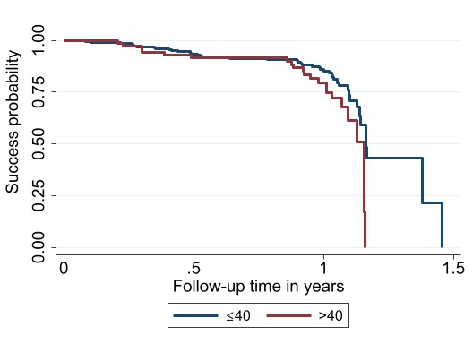

**P-value= 0.0351**

1. **Baseline IOP**

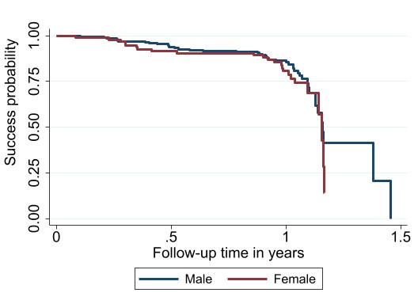

**P-value= 0.3561**

1. **Sex**

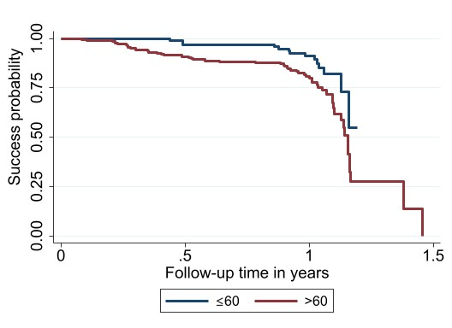

**P-value= 0.0141**

1. **Age**

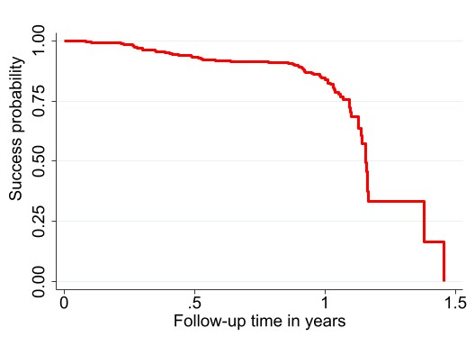

1. **Overall probability success**

In comparison to the median baseline IOP of 30 (17-58) mmHg, this study demonstrated a significant IOP reduction at 3 months 14 (6-39) mmHg, 6 months 14 (5.5-36.5) mmHg, and 12 months 12 (7-31) mmHg with a P-value of less than 0.001 as shown in Figure 3. Regarding number of glaucoma medications, we observed a significant reduction in mean number of medications, from 1.68 to 0.65 medications post-operative at month twelve (p<0.001). Notably; pre operatively 92.7% of eyes were using anti-glaucoma medications, whereas 12 months after surgery, about half (50.3%) of eyes were not using any IOP lowering medication.

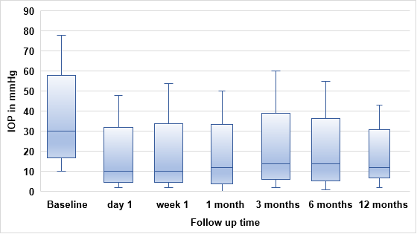

**P<0.001**

Figure 3: Box-plot illustration of IOP levels throughout a 12-month observation period: 25/75 (boxes), and median values (dark lines) and Dashes denote outliers.

Table 3 summarizes factors associated with TE surgical failure. In crude analysis older age at surgery of >60 years (CHR=2.19; 95%CI (1.21-3.94) P-value = 0.009) and high baseline IOP of >40 (CHR=1.66; 95%CI (1.01-2.74) P-value = 0.047) were factors that significantly associated with high risk of surgical failure. In multivariable analysis, age at surgery (CHR=2.21; 95%CI (1.23-3.98) P-value = 0.08) and baseline IOP (CHR=1.72; 95%CI (1.03-2.85) P-value = 0.037), remained significantly associated with TE surgical failure.

Table 3: Factors associated with surgical failure after trabeculectomy

|  |  |  |  |  |
| --- | --- | --- | --- | --- |
| **Variable** | **cHR(95%CI)** | **P-value** | **aHR(95%CI)** | **P-value** |
| **Age** |  |  |  |  |
| ≤60 | Ref |  | Ref |  |
| >60 | 2.19(1.21-3.94) | 0.009 | 2.21(1.23-3.98) | 0.008 |
| **Sex** |  |  |  |  |
| Male | Ref |  |  |  |
| Female | 1.14(0.69-1.87) | 0.610 | 1.04(0.63-1.71) | 0.884 |
| **Glaucoma type** |  |  |  |  |
| Open angle | Ref |  | Ref |  |
| Angle closure | 1.54(0.79-3.02) | 0.206 | 1.33(0.68-2.62) | 0.405 |
| **Pre operative IOP (mmHg)** |  |  |  |  |
| <40 | Ref |  | Ref |  |
| ≥40 | 1.66(1.01-2.74) | 0.047 | 1.72(1.03-2.85) | 0.037 |
| **Pre operative eyedrop use** |  |  |  |  |
| No | Ref |  |  |  |
| Yes | 2.68(0.66-10.97) | 0.168 |  |  |
| **Glaucoma stage at surgery** |  |  |  |  |
| Mild to moderate | Ref |  |  |  |
| Advanced | 1.04(0.62-1.73) | 0.893 |  |  |
| **Type of surgery** |  |  |  |  |
| Trabeculectomy | Ref |  |  |  |
| Combined TE | 0.97(0.59-1.61) | 0.927 |  |  |
| **Type ofAntimetabolite** |  |  |  |  |
| 5FU | Ref |  |  |  |
| MMC | 0.83(0.51-1.33) | 0.429 |  |  |
| **Post operative lens status** |  |  |  |  |
| Phakic | Ref |  |  |  |
| Pseudophakia/Phakic | 0.92(0.57-1.48) | 0.720 |  |  |

**4. DISCUSSION**

This study reported a high 12 months trabeculectomy success rate of 84.2%, which is comparable to the success rates observed in a Nigeria (79.4%) and Rwanda (90%) likely due to similar follow-up durations, patient population, and success criteria (IOP ≤21 mmHg). (16,20). However, the success rate in this study was lower than that in a Japanese study (94.9%), due to different success criteria (20% IOP reduction) and potential racial differences in wound healing, with higher macrophage and fibroblast activity in Black patients, leading to more aggressive scarring (12,22). Additionally, the success rate in this study was statistically higher than in the UK study (72%), that involved a a wider range of surgeons including trainees and different success criterion used of less than two-thirds pressure reduction from baseline (23).

IOP decreased significantly and consistently from a median baseline IOP of 30 mmHg to 12 mmHg at 12months post operatively. This is similar to retrospective studies done in the United Kingdom, USA, China and India to assess TE outcome among POAG, PACG, pigmentary glaucoma and juvenile open angle glaucoma patients, respectively, which showed a consistent IOP decrease (24–27). This similarity can be due to higher baseline IOP levels prior surgery, which increased the significant proportion of IOP decrease following surgery**.** As it has been previously reported by Yuasa et al., that better results in IOP reduction were observed in eyes with high IOP (12). On the other hand, a study from the USA that compared primary TE with phacoemulsification-TE revealed a slight increase in median IOP from the first post-operative month to the twelve months. Where by, about half of the population in their study (48.42%) had low pre-operative IOPs of <20 mmHg. On the contrary, the majority of eyes in our study (83.2%) had an IOP of ≥21 mmHg (28).

This study found that patients aged 61 and older had a higher risk of surgical failure after TE compared to younger patients, this could be attributed by severe stage of diseases in older age indicating advanced glaucoma, consistent with findings in Japan and India (29,30). Older age is also linked to poorer wound healing, which increase failure risk. Additionally, studies have shown that younger patients tend to have more localized, vascularized blebs compared to older patients thus increasing likelihood of failure (31). In contrast, studies from India and USA (25,26) reported that younger age was linked to higher failure rates. This discrepancy is likely due to differences in the study populations focusing on juvenile open-angle glaucoma aged 10-35 years in the Indian study and primary angle-closure glaucoma (PACG) in the USA study.

High preoperative IOP was significantly associated with an increased risk of TE failure, these findings are consistent with a study done in Japan by Sugimoto et al., likely due to greater risk of both intraoperative and postoperative complications (29). However, a study by song et al., reported a reduced risk of failure with higher preoperative IOP, which mainly focused on PACG patients with significant trabecular meshwork damage, where TE fistulas may more effectively reduce IOP in eyes with higher baseline IOPs (26). In contrast, our study included a broader range of glaucoma types, with 76% of participants having POAG.

Our study found no significant association between surgery type and surgical failure, similar to a USA study in which there was no statistical difference between patients undergoing TE and Combined TE (28). However, it differs from a Japanese study, which linked combined TE to higher failure risk. The difference may be due to the use of Small Incision Cataract Surgery (SICS) in this study, compared to Phacoemulsification in the Japanese study (29).

Due to its retrospective nature this study has few limitations; First, it was difficulty in accounting for variability in surgical techniques between different surgeons. Secondly, due to loss to follow-up, long-term follow-up beyond one year was not possible. Future studies should focus on developing a standardized follow-up protocol for all patients undergoing TE outlining specific assessment to be conducted at each visit, assessing bleb morphology and monitoring glaucoma progression through visual field and optic nerve imaging.

**5. CONCLUSION**

Trabeculectomy is highly effective in lowering intraocular pressure across diverse types of glaucoma, showing higher success rate in northern Tanzania particularly evident twelve months postoperatively. Additionally, nearly half of the patients remained medication-free, achieving favorable outcomes without requiring additional eye drops, thereby reducing the financial burden. Treatment should be tailored to individual patient characteristics, especially age and baseline IOP, as these factors affects surgical outcome. Personalized approaches are essential to optimize treatment efficacy and ensure long-term success in management of glaucoma.

***Ethical approval***

Ethical clearance was sought from the institutional review board of Kilimanjaro Christian Medical University College Research and Ethics Review Committee (KCMU-CRERC) and granted with No.PG 23/2023

COMPETING INTERESTS DISCLAIMER:

Authors have declared that they have no known competing financial interests OR non-financial interests OR personal relationships that could have appeared to influence the work reported in this paper.

# REFERENCES

1. Tham YC, Li X, Wong TY, Quigley HA, Aung T, Cheng CY. Global prevalence of glaucoma and projections of glaucoma burden through 2040: A systematic review and meta-analysis. Ophthalmology. 2014 Nov 1;121(11):2081–90.

2. Buhrmann RR, Quigley HA, Barron Y, West SK, Oliva MS, Mmbaga BBO. Prevalence of Glaucoma in a Rural East African Population. 2000;41(1):40–8.

3. Budenz DL, Barton K, Whiteside-De Vos J, Schiffman J, Bandi J, Nolan W, et al. Prevalence of glaucoma in an urban west african population: The tema eye survey. JAMA Ophthalmol. 2013 May;131(5):651–8.

4. Kyari F, Entekume G, Rabiu M, Spry P, Wormald R, Nolan W, et al. A Population-based survey of the prevalence and types of glaucoma in Nigeria: Results from the Nigeria National Blindness and Visual Impairment Survey. BMC Ophthalmol. 2015 Dec 12;15(1).

5. Gilmour-White JA, Shah P, Cross V, Makupa W, Philippin H. Glaucoma awareness and access to healthcare: Perceptions among glaucoma patients in Tanzania. Postgrad Med J. 2015 Jan 7;91(1077):373–8.

6. Murdoch I, Smith AF, Baker H, Shilio B, Dhalla K. The cost and quality of life impact of glaucoma in Tanzania: An observational study. PLoS One. 2020 Jun 1;15(6).

7. Schuster AK, Erb C, Hoffmann EM, Dietlein T, Pfeiffer N. The diagnosis and treatment of glaucoma. Dtsch Arztebl Int. 2020;117(13):225–34.

8. Cheng JW, Zong Y, Zeng YY, Wei RL. The prevalence of primary angle closure glaucoma in adult Asians: A systematic review and meta-analysis. Vol. 9, PLoS ONE. Public Library of Science; 2014.

9. Flaxman SR, Bourne RRA, Resnikoff S, Ackland P, Braithwaite T, Cicinelli M V., et al. Global causes of blindness and distance vision impairment 1990–2020: a systematic review and meta-analysis. Lancet Glob Heal. 2017;5(12):e1221–34.

10. Kolko M, Horwitz A, Thygesen J, Jeppesen J, Torp-Pedersen C. The prevalence and incidence of glaucoma in Denmark in a fifteen year period: A nationwide study. PLoS One. 2015 Jul 16;10(7).

11. Song P, Wang J, Bucan K, Theodoratou E, Rudan I, Chan KY. National and subnational prevalence and burden of glaucoma in China: A systematic analysis. J Glob Health. 2017 Dec 20;7(2).

12. Yuasa Y, Sugimoto Y, Hirooka K, Ohkubo S, Higashide T, Sugiyama K, et al. Effectiveness of trabeculectomy with mitomycin C for glaucomatous eyes with low intraocular pressure on treatment eye drops. Acta Ophthalmol. 2020;98(1):e81–7.

13. Kanda S, Fujishiro T, Omoto T, Fujino R, Arai T, Nomoto Y, et al. Comparison of effectiveness and complications in trabeculotomy with phacoemulsification between ab externo and ab interno using a spatula-shaped microhook. Sci Rep. 2021 Dec 1;11(1).

14. Sugihara K, Fukuda H, Omura T, Tanito M. Reasons for choice of glaucoma surgery in eyes not treated with anti-glaucoma medications. BMC Ophthalmol. 2022 Dec 1;22(1).

15. Arimura S, Miyake S, Iwasaki K, Gozawa M, Matsumura T, Takamura Y, et al. Randomised Clinical Trial for Postoperative Complications after Ex-PRESS Implantation versus Trabeculectomy with 2-Year Follow-Up. Sci Rep. 2018 Dec 1;8(1).

16. Ashaye AO, Komolafe OO. Post-operative complication of trabeculectomy in Ibadan, Nigeria: Outcome of 1-year follow-up. Eye. 2009;23(2):448–52.

17. Tanna AP, Boland M V., Giaconi JA, Krishnan C, Lin SC, Medeiros FA, et al. Glaucoma Basic and Clinical Science Course. New York Am Acad Opthalmology. 2020;3.

18. Ehrnrooth P, Lehto I, Puska P, Laatikainen L. Long-term outcome of trabeculectomy in terms of intraocular pressure. 2002;267–71.

19. Soatiana JE, Kpoghoumou M-A, Kalembo FW, Huyi Zhen H. Outcomes of Trabeculectomy in Africa. Open J Ophthalmol. 2013;03(03):76–86.

20. De Smedt SK, Fonteyne YS, Muragijimana F, Palmer K, Murdoch I. Glaucoma surgery outcome in Rwanda. J Glaucoma. 2016;25(8):698–703.

21. Shaarawy TM, Sherwood MB, Grehn F. Guidelines on Design and Reporting of.

22. Broadway D, Grierson I, Hitchings R. Racial differences in the results of glaucoma filtration surgery: Are racial differences in the conjunctival cell profile important? Br J Ophthalmol. 1994;78(6):466–75.

23. Kirwan JF, Lockwood AJ, Shah P, Macleod A, Broadway DC, King AJ, et al. Trabeculectomy in the 21st century: A multicenter analysis. Ophthalmology. 2013 Dec;120(12):2532–9.

24. Nesaratnam N, Sarkies N, Martin KR, Shahid H. Pre-operative intraocular pressure does not influence outcome of trabeculectomy surgery: A retrospective cohort study. BMC Ophthalmol. 2015 Dec 12;15(1).

25. Pathania D, Senthil S, Rao H, Mandal A, Garudadari C. Outcomes of trabeculectomy in juvenile open angle glaucoma. Indian J Ophthalmol. 2014 Feb;62(2):224–8.

26. Song BJ, Ramanathan M, Morales E, Law SK, Giaconi JA, Coleman AL, et al. Trabeculectomy and combined phacoemulsification-trabeculectomy: Outcomes and risk factors for failure in primary angle closure glaucoma. J Glaucoma. 2016;25(9):763–9.

27. Qing GP, Wang NL, Wang T, Chen H, Mou DP. Long-term efficacy of trabeculectomy on chinese patients with pigmentary glaucoma: A prospective case series observational study. Chin Med J (Engl). 2016 Jun 5;129(11):1268–72.

28. Davila JR, Singh K, Hernandez-Boussard T, Wang S. Outcomes of Primary Trabeculectomy versus Combined Phacoemulsification-Trabeculectomy Using Automated Electronic Health Record Data Extraction. Curr Eye Res. 2022;47(6):923–9.

29. Sugimoto Y, Mochizuki H, Ohkubo S, Higashide T, Sugiyama K, Kiuchi Y. Intraocular Pressure Outcomes and Risk Factors for Failure in the Collaborative Bleb-Related Infection Incidence and Treatment Study. Ophthalmology [Internet]. 2015 Nov 1;122(11):2223–33. Available from: https://doi.org/10.1016/j.ophtha.2015.06.038

30. Senthil S, Chary R, Ali MH, Cherukuri JR, RaniPK, Krishnamurthy R, Choudhari N, & Garudadri C (2021). Trabeculectomy for neovascular glaucoma in proliferative diabetic retinopathy, central retinal vein occlusion, and ocular ischemic syndrome: Surgical outcomes and prognostic factors for failure. *Indian Journal of Ophthalmology 2021;* 69:3341-8.

31. Hoang TKH, Kim YK, Jeoung JW, Park KH. Relationship between age and surgical success after trabeculectomy with adjunctive mitomycin C. Eye [Internet]. 2018;32(8):1321–8. Available from: http://dx.doi.org/10.1038/s41433-018-0071-x

**Abbreviations**

ACG-angle closure glaucoma

OAG-open angle glaucoma

TE-Trabeculectomy