Microbiological and Biochemical Characterization of plant based Vegan Curd

Abstract
Curd is a traditional food which is high in nutrition and helps in boosting immunity. Curd has-been consumed worldwide and has health gut bacteria that fights against harmful pathogenic bacteria. Curd is coagulated using milk. Since some people experience lactose intolerance, plant based curd is advised for their intake. In this study we will explore the good gut bacteria and other microorganisms present in the homemade vegan curd. This plant-based curd is made of peanut milk and rice milk and Green chilli pedicels are added for fermentation process that helps in curdling of milk. Peanuts are rich in antioxidants and they have health gut bacteria and fibres. Rice contains bacteria like Bacilli Green chillies consist of Lactobacilli and is also a starter for lactose fermentation. The homemade Vegan curd is rich in protein and carbohydrates. This research involved creating peanut curd from peanut milk using green chillies as a starter. Both the total bacterial count and the total yeast mold count were measured. Vegan curd, which serves as a plant-based substitute for dairy yogurt, has the potential to contain harmful microorganisms. Such contamination arises when undesirable bacteria and fungi proliferate in the product.
Keywords: Vegan curd, Rice milk, Lactose intolerance, Antioxidant, Probiotic bacteria
1.Introduction
Globally, plant-based or non-dairy milk is rapidly becoming a prominent category within the emerging market of functional and specialty beverages. Along with the suspended fats, these protein molecules refract light, so the milk appears to be white (Balamurugan, R. et.al, 2014). The regular consumption of curd produces a higher level of immunity boosting interferon as these bacteria cultures stimulate infection fighting white cells in blood stream with anti tumour effect (Maltock, 2007). It is widely consumed as a functional food due to its good taste and also acts a excellent vehicle to deliver probiotics(Reid et al, 2003).Many consumers are opting for alternatives to cow's milk due to allergic reactions, lactose intolerance, and concerns about calorie intake, high cholesterol levels, and a preference for vegan diets. Regular consumption of curd is thought to be beneficial in strengthening of immune system(Yadav, Jain, and Sinha, 2007).Alcohol fermentation converts one mole of glucose into two moles of ethanol(Arenvan Waarde,Maria Verhagen, 1993). The viability and reproducibility of observed results on a large scale for particular studies, as well as the viability and stability during use and storage, and, lastly, the capacity to survive in stomach acids and subsequently in the intestinal ecosystem, are among the issues raised in the scientific literature (Corthier G and Marteau P, 2011).Lactic acid strains are the common strains that has beneficial bacteria and curd is a very rich source of probiotics.They also have other bacterial species like Streptococci,Micrococcietc (Joshi, H. et al., 2023). Other bacteria are pathogenic to man and causes diseases if the milk is consumed untreated(Sharp et al 1985and Heeschen 1994.)lactic acid bacteria are (found in the gaserointestinal tract of animals,dairy products,seafood products,soil and on some plant surfaces (ring and Gatesoupe, 1998).These plant-based milk substitutes are gaining popularity and can serve as a cost-effective option for economically disadvantaged groups in developing nations and regions with limited cow's milk availability. Probiotics are monoculture or mixed 6 cultures of live microorganisms that might beneficially affect the host by improving the characteristics of indigenous microflorea(Hozapfel et al, 1998). Although a variety of innovative plant-derived beverages are being developed as substitutes for cow's milk, most encounter some form of technological challenge, whether in processing or preservation. Compared to cow's milk, these alternatives often lack nutritional balance. They also have a flavour inducing metabolite andit is called as diacetyl(Yadav et al 2007)Nonetheless, they contain bioactive components with health benefits that appeal to health-conscious individuals. Later they are used to find the lactic acid bacteria using the strains(G Klein et al 1998). Numerous species and strains of the genera lactobacillus and bifidobacterium have significant characteristics in practical settings (Giovanna E. Felis et al. 2007).This is applicable for the species like Lactobacillus acidophilus and Lactobacillus casei and Lactobacillus paracasei(Petra Habere, 2001) However, sensory acceptance, particularly with legume-based milk substitutes, can significantly limit their broader acceptance.
. The beverage known as vegan milk, often called plant milk, nut milk, or non-dairy milk, has been enjoyed all over the world for a long time. The human gut bacteria also plays an important role in nutritional processinthebody(R.Balamurugan,2014)Some individuals choose it for health reasons, such as lactose intolerance or allergies to dairy milk, while others appreciate its nutritional advantages. Rich in protein, calcium, nutrients, vitamin D, and B12, milk is a nutritious food that supports bone health. Consumption of fermented milk products are linked with several types of human health benefits partly because of their human benefits(Nurul Abduvan Choudary,2018) It is also considered a complete protein due to the fact that it includes all nine of the essential amino acids that the bodyneeds.Fermented milk products could me easily digestible foods for infants,children and adults even when gastrointestinal disturbances prevail(Van de Heijning, B.J et al., 2014). Peanut milk and its derivatives offer nutritional benefits due to their high content of protein, minerals, and essential fatty acids like linoleic and oleic acids, which are highly beneficial for human nutrition. The presence of pathogens indicator of higher deficiencies of colonies and counted them(Sivakumar N,2010) Approximately 400 generic names are applied to traditional and industrial products,including special fermented milk with health aspects attributed to probiotic microorganisms.Among the fermented foods those originating from eastern Europe and central asia(Joshi, H.,et al., 2023) Fermented diary products are increasingly investigated in view of their ability to exert health beneficts beyond their nutritional qualities(Gregory Pimental,2018)These products are advantageous for both young and old due to their richness in these nutrients (Isanga& Zhang, 2009). yoghurt and the starter clture is defined as an active microbial preparation deliberately added to initiate desirable changes during preparation of fermented products(Subrota Hati,2013). Given the potential of peanuts to help combat malnutrition, especially in developing countries, their consumption should be increased. Therefore, it is important to thoroughly explore the potential for processing peanuts into useful and edible products.Curd is produced through the bacterial fermentation of milk, where lactose is converted into lactic acid by certain probiotic bacteria. The specific bacteria involved in this fermentation process are influenced by environmental factors such as temperature and humidity, and may include species like Lactobacillus lactis, Streptococcus diacetylactis, Streptococcus bulgaricus, and Streptococcus thermophilus. Fermenting peanut milk is one approach that could boost the consumption of this valuable crop, thereby enhancing protein availability. Consequently, the current study aimed to optimize processing variables for creating an acceptable peanut milk-based curd and to develop mathematical models that describe its physicochemical and sensory properties. It has been suggested that the calyx of capsicum fruits, such as chili peppers, is often abundant in various lactobacilli. These natural bacteria act as a starter for the lacto-fermentation of milk. Additionally, capsaicin from chili peppers seems to enhance the metabolic activity of lactobacilli. Typically discarded as waste during food processing, the stalks (calyx) of chili peppers (Capsicum spp.) can be repurposed in milk curd production, transforming them from waste into a product of significant economic value, thus converting waste into wealth.Peanuts (Arachishypogaea) are great nourishment for newborn children experiencing different types of lack of healthy sustenance and for individuals with lactose narrow-mindedness sensitivities. Furthermore, peanut curd doesn't contain any lactose, making it reasonable for individuals with lactose narrow mindedness. Vegan curd, which serves as a plant-based substitute for dairy yogurt, has the potential to contain harmful microorganisms. Such contamination arises when undesirable bacteria and fungi proliferate in the product.

2. Materials and Methods
2.1 Preparation of Yoghurt Sample
A yogurt sample was prepared by adding Two hundred millilitres of water to soak one hundred gram of raw rice and one hundred gram of raw peanuts overnight. Following a thorough washing of the soaked peanuts, 200 millilitres of water are added and combined. There are two executions of this process. After blending, the mixture is filtered through a nut strain bag. After that, the peanut milk is separated and heated over a medium flame. Meanwhile, 125 gram of uncooked rice are thoroughly cleaned, combined, and the extract is then filtered. Rice milk is added to peanut milk and stirred continuously over medium heat. The milk is allowed to reheat to lukewarm after pasteurisation. The milk should be lukewarm to promote fermentation. When milk is cooked to a high temperature, fermentation does not occur. Top with green chilli pediceles once the milk is lukewarm. After that, the vessel is allowed to sit at room temperature for the entire day.
Fig. 1. Lukewarm milk topped with green chilli pediceles
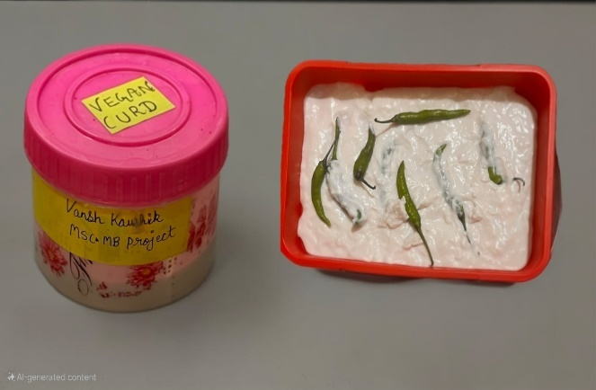

2.2 Media and Reagents
MacConkey agar (MCA), nutrient agar (NA), Mueller-Hinton agar (MHA), eosin methylene blue (EMB), nutrient broth, MacConkeybroth,Sabouraud dextrose agar(SDAandTrypticsoyAgar(TSA),Gram,s staining agents, ethanol, oil immersion, sugars for the biochemical test, and normal saline (diluents) were provided for the microbiological analysis.

2.3 Preparation of Culture Media

In this study, media such as Mueller-Hinton agar, Eosin methylene blue (EMB) agar, MacConkey agar (MCA), and MacConkey broth (MB) were used. Nutrient agar (NA), nutrient broth (NB), and MHA were made. Each media was weighed separately using an electronic weighing balance suspended in a different conical flask that contained 1000 millilitres of distilled water. The flasks were then covered with cotton plug, coated in aluminium foil, and autoclaved for 15 minutes at 121 degrees Celsius to sterilise them.

2.4 Microbiological Analysis/Test of Curd Samples

Either genotypic or phenotypic methods are the most reliable for identifying culture bacteria. Numerous methods are used to ascertain the initial microbial count, which is essential, both in the field and in the lab. a. The Methyl Red-VogesProskauer test (MR-VP), the standard plate count, the total coliform count, (indole and citrate tests) are tests that are commonly used to assess the quality of milk.
2.4.1. Serial dilution of the Standard Plate Count (SPC)
The serial dilution of curd is a process of reducing concentration of bacteria in curd sample By using a sequence of sequential dilutions, the proportion of bacteria in a yoghurt sample can be decreased. The spc of curd samples obtained from producers is a quantitative measure of total aerobic bacteria load present at the time of collection. Individual bacterial cells or small groupings such as clusters, chains, or clumps develop into visible colonies, which were subsequently enumerated. The bacterial load was quantified in terms of colony-forming units per millilitre (cfu/ml). By estimating the quantity of bacteria or colony-forming units (CFUs) in yoghurt, microbiologists can investigate the microbial makeup of food samples such as yoghurt.
Procedure:
Serial dilutions of curd sample were prepared up to 10⁻⁶ using sterile 0.1% buffered peptone water. For sterilisation, six petridishes and 100ml of pure water were autoclaved at 121 degrees celsius for 15 minutes at 15 lbs. Each test tube is labelled 10⁻¹ to 10⁻⁶ and contains 9 millilitres of distilled water. A 1000 ml micropipette is used to dilute the 1 ml of well-mixed curd that has been poured to the 10⁻¹ test tube to nine test tubes. In each of the nine test tubes, 1 millilitre of the solution is diluted, and the last 1 millilitre dilution is disposed of with a micropipette from the selected dilutions, 1ml was aseptically transferred into sterile petri dishes and overlaid with nutrient agar cooled to approx.45℃. The plates were subsequently incubated at 37℃ for 48 hours after incubation, the resulting colonies were counted and the microbial load was expressed as cfu/ml. Serial dilution is done to estimate the concentration or no of cells in a sample to obtain an incubate plate with easily countable number of colonies.

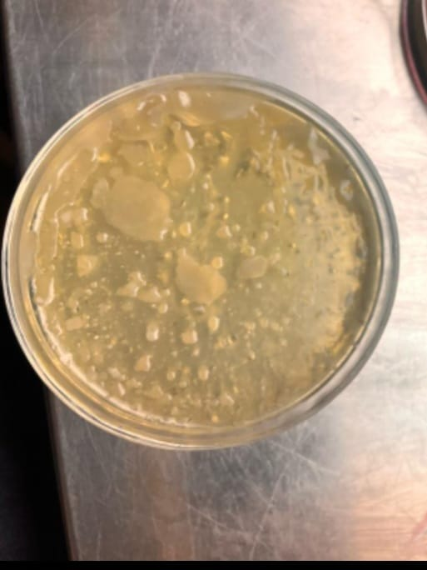

Fig. 2 Microbial analysis

2.4.2 Total Plate count:
This procedure outline a serial dilution technique commonly used in microbiology to determine the concentration of microorganisms in a sample. This method involves creating a series of dilutions, typically from 10-¹ to 10-⁶, to reduce the microbial population to a countable range. The use of sterile equipment and aseptic techniques throughout the process ensures the accuracy and reliability of the results. By plating dilutions from 10-³ to 10-⁵ on nutrient agar, researchers obtained a representative count of viable microorganisms. The incubation period of 48 hours at 37°C allows for the growth of visible colonies, which are then counted and expressed as colony-forming units per milliliter (CFU/ml). This standardized approach enables researchers to quantify and compare microbial populations across different samples or experimental conditions.
2.4.3. Total Coliform Count (TCC)

The Total Coliform Count (TCC) is a microbiological examination employed to determine the presence of coliform bacteria in water, food, or environmental samples. Coliforms are a category of Gram-negative, facultatively anaerobic, rod-shaped bacteria that are typically present in the environment, including soil, vegetation, and the intestines of warm-blooded animals. TCC is frequently utilized as an indicator of sanitation quality and potential fecal contamination. Although not all coliforms are harmful, their detection implies that other pathogenic microorganisms might also exist. The results of the count are usually reported in Most Probable Number (MPN) per 100 mL or Colony Forming Units (CFU) per mL/g, depending on the methodology employed and the type of sample being analyzed.blue and red colonies associated with gas bubbles are coliform bacteria.

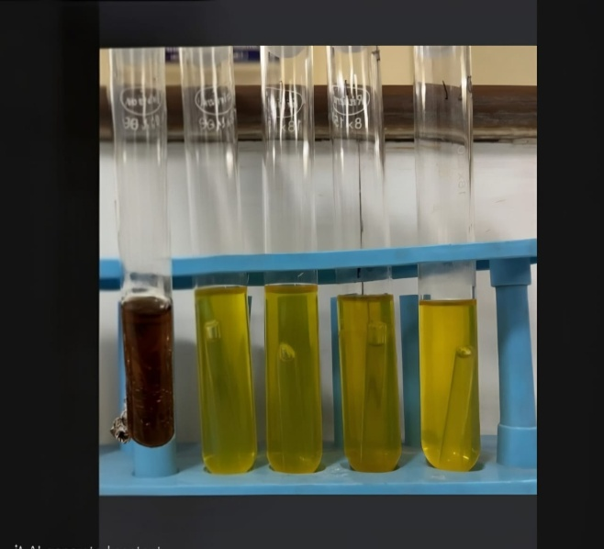

Fig. 3 Dilutions representing count of viable microorganisms.

3. Biochemical characterization of the isolated bacterial strain

The approaches as follows were used to identify the isolated bacteria as Lactobacillus species based on their morphological, cultural, physiological, and biochemical traits . Gram staining, capsule staining motility test, catalase production, indole, methyl red, Voges-Proskauer, citrate, starch hydrolysis, endospore test, and milk were among the tests conducted tests for phenol tolerance, NaCl, and coagulation activity.

3.1 Cirate Test
The use of the citrate test is a biochemical test that determines whether bacteria can use citrate as a carbon source Positive colour indicate bacterial growth, while strange colour changes from green to blue cause alkaline side effects of citrate metabolism. Negative results do not change in colour and bacterial growth does not grow.
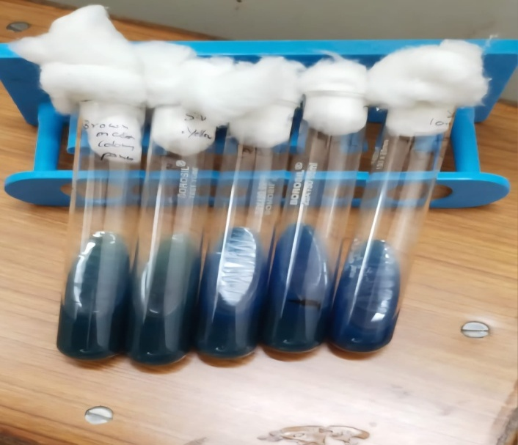

Fig. 4 Citrate test determining whether bacteria can use citrate as a carbon source

3.2 Catalase test
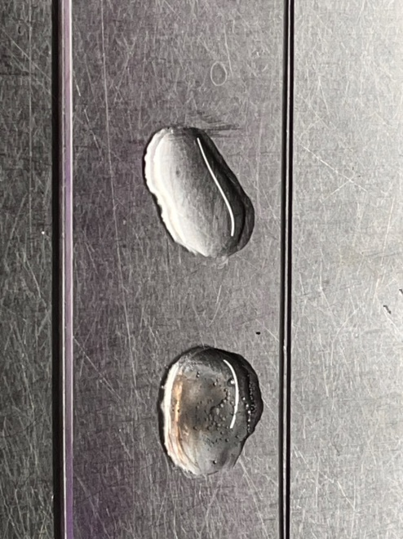
Catalase is an enzyme that decomposes hydrogen peroxide into water and oxygen. This assay is often employed to identify both gram-positive and gram-negative bacteria and to differentiate between aerobic and anaerobic organisms., a loopful of culture is retrieved using a wire loop, and 3 to 5% hydrogen peroxide is introduced while monitoring the reaction. the catalase test is used to differentiate between staphylococcus(cat+ve) and streptococcus(cat-ve)

3.3.Indole Production
A test tube was filled with 5 millilitres of tryptone broth, then culture was added.The test tube was inoculated for 24 hours, two drops of Kovac's reagent were added, and any reaction was monitored.

3.4 Gram Staining

Using structural differences in their cell walls, Gram staining is a basic laboratory technique in microbiology that separates bacterial species into two main groups: Gram-positive and Gram-negative

Fig. 5 Catalase test to identify both gram-positive and gram-negative bacteria
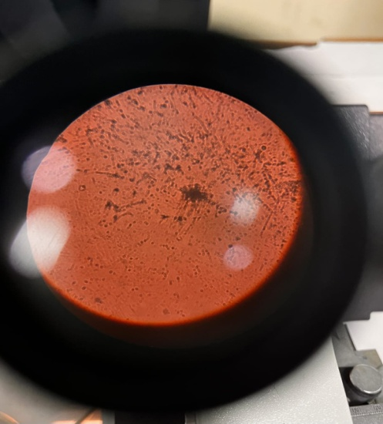

Fig. 6 Gram Staining separating bacterial species

4.RESULT AN DISCSUSSION
This study investigates the development of peanut curd as an alternative to dairy milk curd for individuals with lactose intolerance. The research underscores several key points:
1. Peanut Curd Preparation: The curd was formulated using peanut milk and green chili.
2. Sensory Analysis: - The organoleptic characteristics are detailed in Table 1.The curd exhibited a sour taste, indicative of fermentation. - Acidic flavor and aroma were detected, suggesting the growth of lactic acid bacteria.

4.1. Sensory Evolution
A sensory evaluation was conducted for the peanut curd by our friends to evaluate the sensory characteristics of curd samples (Yadav, D. N. et al.,2010). The sensory test was conducted in a laboratory under normal (daylight) illumination and ambient temperature. Panellists evaluated the sensory properties of the peanut curd. Samples based on their degree of like(Chhetri, A, 2021)The 9-point hedonic scale was used to evaluate appearance, taste, texture, aroma and overall acceptability, where nine (9) was "extremely like extremely," eight (8) was "like very much," seven (7) was "like moderately," six (6) was "like slightly," five (5) was neither like nor dislike, four (4) was "dislike slightly, “three (3) was disliked moderately, two (2) was disliked very much, and one (1) was extremely like. These total analyses were taken day by day for up to five days.

Table 1 shows the sensory results peanut curd up to 5 days

Name | colour | Taste | Smell | Texture | Overall acceptability
Anjali | 9 | 5 | 5 | 8 | 9
Saral | 9 | 7 | 5 | 6 | 8
Vishakha | 7 | 8 | 6 | 7 | 9
Arpita | 8 | 7 | 7 | 6 | 8
Isha | 9 | 5 | 5 | 8 | 9
Akshum | 9 | 8 | 6 | 7 | 7
Diksha | 7 | 7 | 5 | 8 | 8

4.2 Microbial Analysis
Standard Plate Count(SPC) and Total Yeast Mold Count (TYMC) were assessed in figure. These counts confirm the presence of prebiotic effects in the peanut curd.

The peanut curd sample was serially diluted and determined for the presence of microbial groups. The Figure 2 and Table 2 Table 3 showed the presence of good strength of microbes in the peanut curd sample.
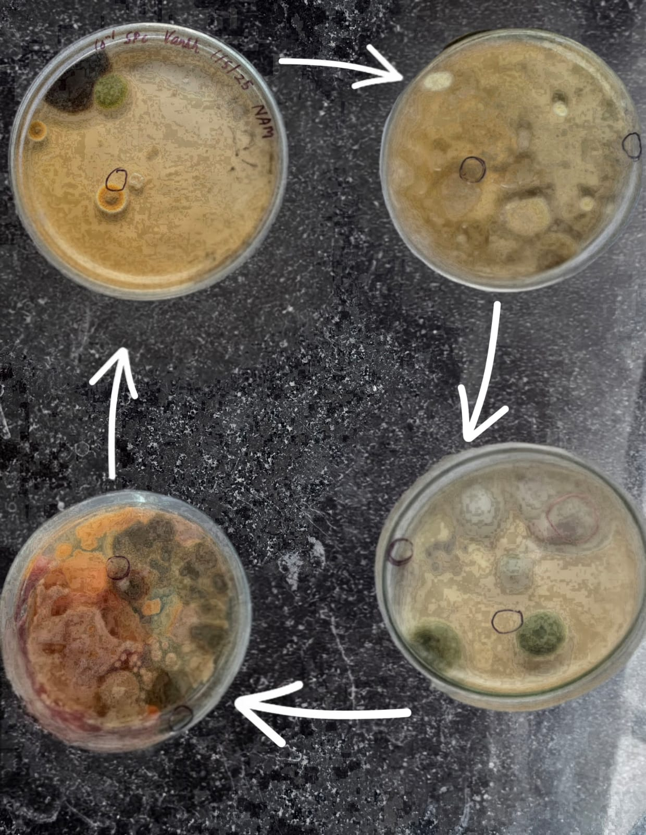

Fig.7 TYMC analysis of peanut curd

Table 2 shows total yeast mould count (TYMC) analysis of peanut curd.
Parameters | 10⁻¹ | 10⁻² | 10⁻³ | 10⁻⁴ | 10⁻⁵
TYMC | TNTC | TNTC | 107 | 58 | 12
Results cfu/ml. | TNTC | TNTC | 1.7x10⁶ | 5.8x10⁶ | 1.2x10⁷

Table:3 Characterization of Isolated Bacteria
Isolated Bacteria | Culture Characteristics | Colony Morphology | Gram Staining
Lactobacillus acidophilus | Small to medium grey colonies | Convex,small, rough occurs single,in pairs and in short chains | Positive, rod shaped
Bacillus Subtilis | Creamy white irregular, lobate, flat,dry/rough surface | Flat, circular to irregular | Positive, rod shaped
Micrococcus Luteus | Yellow,circular,entire,raised small, opaque, smooth | Circular, yellow, convex and smooth | Positive, cocci shaped
Staphylococcus Aureus | Circular, entire, smooth, opaque, medium size, golden yellow | Round, convex and golden yellow | Positive, Cocci
Lactobacillus Plantarum | Small, round, creamy white, smooth and raised, non pigmented and opaque | Rod shaped occurring in short chains or palisades or plump rods. | Positive, rod shaped
Listeria monocytogenes, | Small, round, smooth, slightly raised | White-grayish | Positive,  Short rods or coccobacilli
Escherichia coli, | Smooth, round, moist colonies; metallic green | round pink on MacConkey (lactose fermenter) | Negative  Small to medium rods (bacilli)
Serratia marcescens | Circular, smooth, moist; may have red pigment | Red pigment | Negative  Rods (bacilli)
Proteus spp. | Circular, smooth |  | Negative  Pleomorphic rods (bacilli), some long forms
  Colorless
  Fishy or unpleasant

4.3. Serial Dilution: The SPC is a well-established method used for assessing the microbiological quality of curd by quantifying the total number of viable aerobic bacteria. This evaluation plays a critical role in determining the milk’s freshness and its suitability for consumption. In our analysis, the spc values observed ranged from to colony forming unit per milliliter (cfu/ml), indicating that the curd was contaminated rendering the curd unsafe for consumption. The serial dilution is done to estimate the concentration or no. of cells in sample to obtain an incubated plate with easily countable number of colonies.

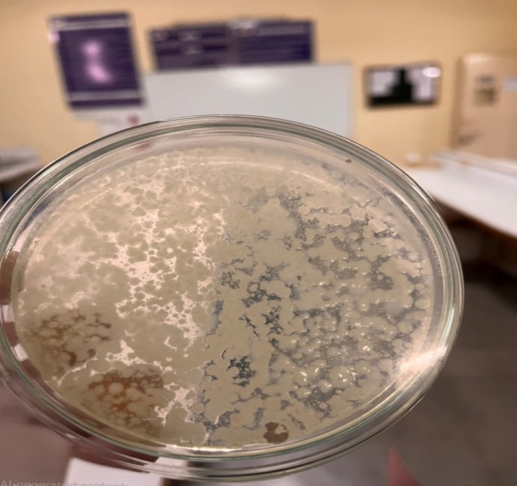
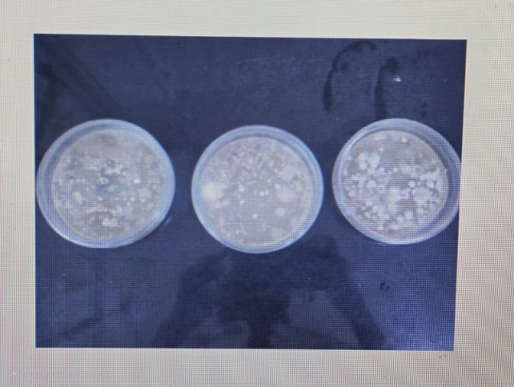

Fig. 8 & 9 Viable bacterial plate count

Table 4 shows Standard bacterial count and Total coliform count analysis of peanut curd
S.No | Sample | SPC(cfu/ml) | TCC(CFU/ml) | Optical Density
1. | Vegan curd | 7.2x10² cfu/ml | 1.0 x10²cfu/ml | 0.307
2. | Vegan curd | 7x10⁴ cfu/ml | 2.1x10² cfu/ml | 0.498
3. | Vegan curd | 8.3x10⁵ cfu/ml | 1.1x10¹ cfu/ml | 0.100
4. | Vegan curd | 8.9x10⁴cfu/ml | 2.0x10¹cfu/ml | 0.200
5. | Vegan curd | 5.6x10⁵cfu/ml | 1.0x10²cfu/ml | 0.500

The microbiological quality of five vegan curd samples was evaluated based on Standard Plate Count (SPC), Total Coliform Count (TCC), and optical density (OD). The SPC values ranged from 7.2 × 10² to 8.9× 10⁵ cfu/ml, indicating variability in total viable bacterial load among the samples. The lowest SPC (7.2 × 10² cfu/ml) was observed in Sample 1, while the highest (8.3 × 10⁵ cfu/ml) was noted in Sample 3. TCC values, which indicate the presence of coliform bacteria, remained relatively low across all samples, ranging from 1.1 × 10¹ to 2.1 × 10² cfu/ml, and suggesting limited fecal contamination. Interestingly, the optical density (OD) measurements, used as an indirect estimation of bacterial growth, did not always correlate with SPC values. For example, Sample 3 showed the highest SPC but the lowest OD (0.100), while Sample 5 had a high SPC (5.6 × 10⁵ cfu/ml) with a relatively high OD (0.500). These variations highlight the complexity of microbial growth behavior and emphasize the importance of using multiple parameters to assess the microbiological quality of vegan curd.
Coliform bacteria are indicators of possible pathogenic contamination and poor sanitation. A low TCC value is indicative of good curd hygiene and proper handling, whereas elevated levels suggest potential risks for curd-borne infections.
Chart 1. Graph indicating SPC, TCC and Optical Density across Five Samples
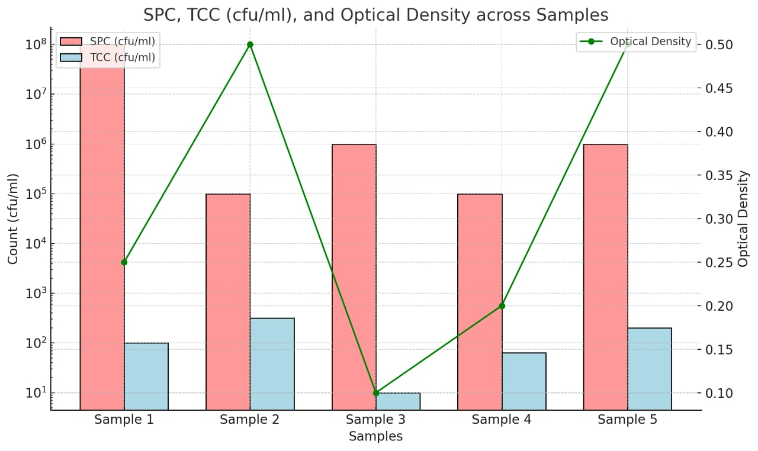

Table 5: Biochemical analysis of curd sample
Bacterial isolates | MR | VP | Indole | Citrate | Coagulase | Catalase
Lactobacillus acidophilus | - | + | – | – | – | –
Lactobacillus plantarum | + | - | – | – | – | –
Bacillus subtilis | _ | + | – | + | + | +
Micrococcus luteus | – | – | – | _ | – | +
Staphylococcus aureus | – | + | – | + | + (positive) | +
Listeria monocytogenes | + | – | – | _ | – | +
Escherichia coli | + | – | + (positive) | – | – | +
Serratia marcescens | _ | + | – | + | – | +
Proteus spp. | + | - | + | - | – | +

The following results were observed from biochemical testing of bacterial isolates from a curd sample using standard microbiological methods:

Lactobacillus acidophilus showed a negative result for MR, Indole, Citrate, Coagulase, and Catalase, but tested positive for VP. Lactobacillus plantarum showed a positive result for MR and a negative result for all other tests. Bacillus subtilis tested positive for MR, VP, Citrate, Coagulase, and Catalase, but was negative for Indole. Micrococcus luteus gave negative results for MR, VP, Indole, Citrate, and Coagulase, but was catalase positive. Staphylococcus aureus showed negative results for MR, VP, Indole, Citrate, and was positive for Coagulase and Catalase. Listeria monocytogenes showed a positive MR test and negative results for VP, Indole, Citrate, Coagulase, and Catalase. Escherichia coli tested positive for MR and Indole, and was noted as positive for Citrate (marked as "positive" in parentheses), while being negative for VP, Coagulase, and positive for Catalase. Serratia marcescens was MR and VP negative, Indole and Citrate positive, and negative for both Coagulase and Catalase. Lastly, Proteus spp. showed positive results for MR, Indole, and Catalase, but negative for VP, Citrate, and Coagulase.
The microbiological analysis of vegan curd reveals a complex ecosystem of both beneficial and potentially harmful bacteria. Beneficial bacteria like Lactobacillus acidophilus and Lactobacillus plantarum contribute to the fermentation process and may offer probiotic benefits. However, the presence of pathogenic bacteria such as Staphylococcus aureus, Listeria monocytogenes, Salmonella spp., and Escherichia coli raises concerns about food safety. These pathogens can cause foodborne illnesses if present in significant quantities. The detection of opportunistic pathogens like Serratia marcescens and Proteus further emphasizes the importance of maintaining strict hygiene standards during production. While some bacteria like Bacillus subtilis and Micrococcus luteus are generally considered non-pathogenic, their presence may indicate inadequate sanitation practices. This diverse microbial profile underscores the need for rigorous quality control measures in vegan curd production to ensure consumer safety while preserving the product's beneficial bacterial content.
Vegan curd, a plant-based alternative to dairy yogurt, can potentially harbour harmful microorganisms. This contamination occurs when unwanted bacteria, fungi, or other microbes grow in the product. Factors contributing to this issue may include:
1. Improper sanitation during production
2. Inadequate pasteurization of plant-based milk
3. Contaminated ingredients or equipment
4. Poor storage conditions
5. Insufficient fermentation process contamination can lead to spoilage, off-flavors, and potential health risks for consumers.
To ensure safety, manufacturers must implement strict hygiene practices, quality control measures, and proper storage guidelines throughout the production and distribution process.

Conclusion
Milk curd is full of nutrients, aids with digestion, and contains beneficial gut flora that fights against infections.They ferment to produce lactic acid bacteria.A small percentage of people are unable to eat milk curd.As an alternative, vegan curds are safe to eat and easy on the stomach.Lactobacillus acidophilus, and Bacillus subtilis are probiotic bacteria that are comparable in health and nutritional value to those found in milk curd and are found in vegan curd. To make this curd look and taste better, you can also add toppings and other flavours. There is no lactose sensitivity caused by vegan curd. This establishes that the vegan curd's high protein content, which is beneficial for the intestines and also strengthens immunity, and its microorganisms resist dangerous illness.

COMPETING INTERESTS DISCLAIMER:
Authors have declared that they have no known competing financial interests OR non-financial interests OR personal relationships that could have appeared to influence the work reported in this paper.

REFERENCES
1. R.Balamurugan 2014.Probiotic potential of lactic acid bacteria present in home made Curd in sourthern India.
2. Barbarous Ozer,2014.Microbiology and Biochemistry of Yoghurt and other fermented Milk products.Dairy microbiology and biochemistry pp;167-213.
3. Giovanna E Felis 2007.Taxonomy of Lactobacilli and Bifidobacteria.Current issues in Intestinal microbiology.Pp 44-61.
4. EstifanosHawaz 2014.Isolation and identification of probiotic lactic acid bacteria from Curd and in vitro evaluation of its growth inhibition activitie against pathogenic bacteria. 10.5897/ AJMR2014.6639.Vol 8(13).Pp 1419-1425.
5. R.Goyal,HarishDhingra,PratimaBajpal and Navneet Joshi 2012.African journal of Biotechnology.Characterization of the lactobacillus isolated from different curd Samples.10.5897/AJB11 31.Vol 11 (79) pp 14448-14452.
6. Lee Y-K,SalminenS.The coming age of probiotics.Trends food scitechnol 1995;6:241-5.
7. Mahmantesh M Patil, Ajay Pal,T.Anand and KV Ramana 2018.Isolation and Characterization of bacteria from curd and cucumber.Vol 9,April 2010,pp 166-172
8. Maria Kechagia ,Dimitriobasaulouis and Elenimariafakiri 2013.Health benefits of Probiotics.Microbiology department, sismanoglion general hospital of Athens.10.5042/481651 pp 161-195.
9. Mohsinshaik& Gaurav singh 2013.Determination of probiotic properties of lactic acid Bacteria from curd.G.J.B.A.H.S. Vol 2 (2) 2013; Pp 119-122.
10. Mjolkcentraein Aria 2010.Effect of fermentation of milk fat on milk fat products ad in Fermented milk products.Pp 105-46.
11.NurulAbduvanChoudary2012.Development of Fruit dahi fortified with Strawberry,orange and grapes juice.Pp 562-570.
12. Oskar Adolffson,SiminNikbinMeydani and Robert M Russell 2004,Yoghurt and gut Function,The American Journal of clinical nutrition vol 80 no 2.245-256.
13. Penders,J,Stobberign,E.E,Van den brandt,P.A and Thijis C.2007.The role of the Intestinal microbiota in the development of atopic disorders.Allergy 62;1223-36
14.RenzU,PuhanZ(1975),Beitragzutkennetnisvonfonktoren,DieBitterkeitinyoghurtbenningttenMilchwissenchaft 30;265-268.
15. PrathameshS.Kale 2014.Isolation and identification of bacteria from curd and its Application in probiotic chocolate.European journal of experimentl biology 2014(6);Pp 95-97
16. Sivakumar N 2010.Microbiological approach of curd samples collected from different Locations of Tamilnadu,India.

17. Yadav, D. N., Rajan, A., Sharma, G. K., & Bawa, A. S. (2010). Effect of fiber incorporation on rheological and chapati making quality of wheat flour. Journal of Food Science and Technology, 47, 166-173.
18. Chhetri, A. (2021). PREPARATION AND QUALITY EVALUATION OF PEANUT MILK INCORPORATED YOGHURT (Doctoral dissertation, Department of Food Technology Central Campus of Technology Institute of Science and Technology Tribhuvan University, Nepal 2023).

