QUANTITATIVE ANALYSIS OF TEA SOIL USING
TRICHODERMA AS BIOCONTROL AGENT

ABSTRACT
Tea is a popular drink which is made from the leaves of the Camellia sinensis plant. After water, it is the most widely consumed drink in the world. It is said to be likely started in northeast India, northern Myanmar, or southwest China. People in China have been drinking tea for over 5,000 years. Besides tasting good, tea is known to be healthy as it helps to reduce inflammation, works as an antioxidant, and may also help with weight loss.
Tea is known to grow best in tropical and subtropical regions with warm and humid weather conditions. The ideal temperature for tea is between 20°C and 30°C. Too much heat (over 35°C) or cold (below 10°C) is not preferable and it can harm the plants. Tea needs a lot of rain—about 150 to 300 cm a year—and it should be spread out through the year. Tea plants need slightly acidic soil with a pH ranging between 4.5 and 5.5. The soil should be fertile, well-drained, and not too sandy nor too clayey. A depth of at least 1.5 meters is preferable so that the roots can grow well. Shallow soil limits root development. Using too many chemical fertilizers and pesticides, along with growing only one type of crop for many years, can damage the soil and environment. That is why eco-friendly solutions are becoming more and more important.
Trichoderma is a type of helpful fungus which is used in farming. It fights harmful plant diseases, especially those present in soil, and it can also improve plant growth, help plants to absorb nutrients better, and reduce pollution caused by chemical use. It’s safe, affordable, and also good for the environment.
An experiment was been done using tea garden soil under three different treatments: Control – untreated soil, S+T – soil treated with Trichoderma, S+T+VC – soil treated with Trichoderma and vermicompost
A method called serial dilution was done to count the number of microorganisms like bacteria, fungi, and Trichoderma in the soil. The results showed that the highest growth of Trichoderma was found in the soil treated only with Trichoderma. Adding of vermicompost along with it led to slightly lower in growth.
This study shows that Trichoderma is very useful in tea farming. It helps to control diseases, improves plant growth, and supports healthy soil. However, combining it with vermicompost didn’t increase its growth, so more research is further needed in order to understand how to use both together most effectively.

Keywords: Tea, Trichoderma, Vermicompost

INTRODUCTION

Tea is perennial in nature and hence provides favorable micro as well as macroclimate for thriving of different insect pests and fungal diseases, which together cause enormous crop loss in terms of quantity and quality. Synthetic agrochemicals have been used for the management of these pests and diseases. Certainly, they provide efficient control for longer period; however, their frequent and injudicious application had definitely invited numerous other associated problems such as environmental pollution, development of pesticide resistance in insects, and unwanted pesticide residues in made tea [Roy et al., (2011)].

The biological control agents (BCAs) like the species of Trichoderma, Beauveria, and Metarhizium are reported to be safer and promising components of integrated pest and disease management (IPDM) strategies, which have been adopted in various crops including tea [Hall and Papierok (1982)]. Although research works have been carried out in this direction [Debnath 1996; Babu and Kumhar (2013, 2014)].

Trichoderma is an effective biocontrol agent for plants grown in greenhouse as well as fields, showing antifungal properties as well as promoting growth and inducing plant resistance against pathogenic microorganisms[Zhang FG et al., (2013)].

Adding Trichoderma to fumigated soil can prolong the fumigant’s control of soil-borne pathogens when populations increase over time, compared with fumigation alone which becomes ineffective against pathogens as concentrations decline over time[Cao AC et al., (2017)].

Soil, is the soul of infinite life that promotes diverse microflora. Soil bacteria viz., Bacillus, Pseudomonas and Streptomyces etc., are prolific producers of secondary metabolites which act against numerous co-existing phytopathogeic fungi and human pathogenic bacteria [Pathma et al.,( 2011b)]. Earthworms are popularly known as the “farmer’s friend” or “nature’s plowman”. Earthworm influences microbial community, physical and chemical properties of soil. They breakdown large soil particles and leaf litter and thereby increase the availability of organic matter for microbial degradation and transforms organic wastes into valuable vermicomposts by grinding and digesting them with the help of aerobic and anaerobic microbes [Maboeta and Van Rensburg(2003)]. Earthworms activity is found to enhance the beneficial microflora and suppress harmful pathogenic microbes. Soil wormcasts are rich source of micro and macro-nutrients, and microbial enzymes [Lavelle and Martin (1992)]. Vermicomposting is an efficient nutrient recycling process that involves harnessing earthworms as versatile natural bioreactors for organic matter decomposition.

Earthworm’s ability to increase plant nutrient availability is likely to be dependent on the activity of earthworm gut microflora. Earthworms indirectly influence the dynamics of soil chemical processes, by comminuting the litter and affecting the activity of the soil micro-flora [Petersen and Luxton (1982); Lee (1985); Edwards and Bohlen (1996)].

Earthworms increased the number of microorganisms in soi1 as much as five times and the number of bacteria and ‘actinomycetes’ contained in the ingested material increased upto 1,000 fold while passing through their gut [Edwards and Fletcher (1988)]. Similar increase was observed in plate counts of total bacteria, proteolytic bacteria and actinomycetes by passage through earthworms gut [ Devliegher and Verstraete (1995)].

REVIEW OF LITERATURE

Naghma Khan and Hasan Mukhtar in their paper titled “Tea and Health: Studies in Humans”in the year 2014, studied that,
Tea, next to water is the cheapest beverage humans consume. Drinking the beverage tea has been considered a health-promoting habit since ancient times. The modern medicinal research is providing a scientific basis for this belief. The evidence supporting the health benefits of tea drinking grows stronger with each new study that is published in the scientific literature. Tea plant Camellia sinensis has been cultivated for thousands of years and its leaves have been used for medicinal purposes. Tea is used as a popular beverage worldwide and its ingredients are now finding medicinal benefits.

Kishor Chand Kumhar et al., in their paper titled “Role of beneficial fungi in managing diseases and insect pests in tea plantation” in the year 2020, studied that,
The effectiveness of Trichoderma atroviride, T. asperellum, T. harzianum, against targeted tea disease causing pathogen, Fusarium solani (dieback), Beauveria bassiana against tea mosquito (Helopeltis theivora), and Metarhizium anisopliae against the red spider mite, Oligonychus coffeae Nietner, and the live wood eating termite (Microcerotermes beesoni Snyder), respectively were evaluated under laboratory and field conditions. The Trichoderma isolates showed effective control of F. solani (64.6 to 71.7%) under laboratory conditions, while the wettable powder (WP) formulation could reduce dieback disease incidence (57.1 to 77.7%) over control, under field conditions.

Hall and Papierok in their paper titled “Biological control agents of arthropods of agricultural and medical importance” in the year 1982, had studied that,
The biological control agents (BCAs) like the species of Trichoderma, Beauveria, and Metarhizium are reported to be safer and promising components of integrated pest and disease management (IPDM) strategies, which have been adopted in various crops including tea.

Jiajia wu et al., in their paper titled “Beneficial effect on the soil microenvironment of Trichoderma applied after fumigation for cucumber production” in the year 2022, studied that,
Biocontrol agents applied after fumigation play an important role to the soil microenvironment. We studied the effect of Trichoderma applied after dimethyl disulfide (DMDS) plus chloropicrin (PIC) fumigation on the cucumber growth, soil physicochemical properties, enzyme activity, taxonomic diversity, and yield through laboratory and field experiments. The results confirmed that Trichoderma applied after fumigation significantly improved soil physicochemical properties, cucumber growth, soil-borne pathogens, and soil enzyme activity. Genetic analysis indicated that Trichoderma applied after fumigation significantly increased the relative abundance of Pseudomonas, Humicola and Chaetomium, and significantly decreased the relative abundance of the pathogens Fusarium spp. and Gibberella spp., which may help to control pathogens and enhanced the ecological functions of the soil.

Zhang FG, Sridharan AP in their paper titled “Trichoderma harzianum T-E5 significantly affects cucumber root exudates and fungal community in the cucumber rhizosphere” in the year 2013, had studied that, Trichoderma is an effective biocontrol agent for plants grown in greenhouse as well as fields, showing antifungal properties as well as promoting growth and inducing plant resistance against pathogenic microorganisms. It is well documented that Trichoderma effectively controlled soil-borne pathogens such as Fusarium spp. and Phytophthora spp.

MATERIALS AND METHOD

MATERIALS REQUIRED:
- Sterile sample collection polythene bags
- Spatula
- Burner
- Pots
- Water sprayer
- Vermi compost
- Trichoderma
- Cotton
- Marker
- Alcohol
- Distilled water
- Glasswares:
- Petri plates
- Conical Flask
- Pipette
- Dilution bottles
- Measuring cylinder
- Funnel
- Instruments:
- Shaker
- Weighing machine
- Autoclave
- Laminar Air flow
- Hot air oven

- Media

PDA( Potato Dextrose Agar):
Potato Dextrose Agar (PDA) is used for the cultivation of fungi. Potato Dextrose Agar (PDA) is a general purpose medium for yeasts and molds that can be supplemented with acid or antibiotics to inhibit bacterial growth. It is recommended for plate count methods for foods, dairy products and testing cosmetics.
The nutritionally rich base (potato infusion) encourages mold sporulation and pigment production in some dermatophytes.

Composition:
- Potatoes peeled and dried - 200g
- D-glucose - 20g
- Agar - 15g
- Distilled water - 1L

- Sample:

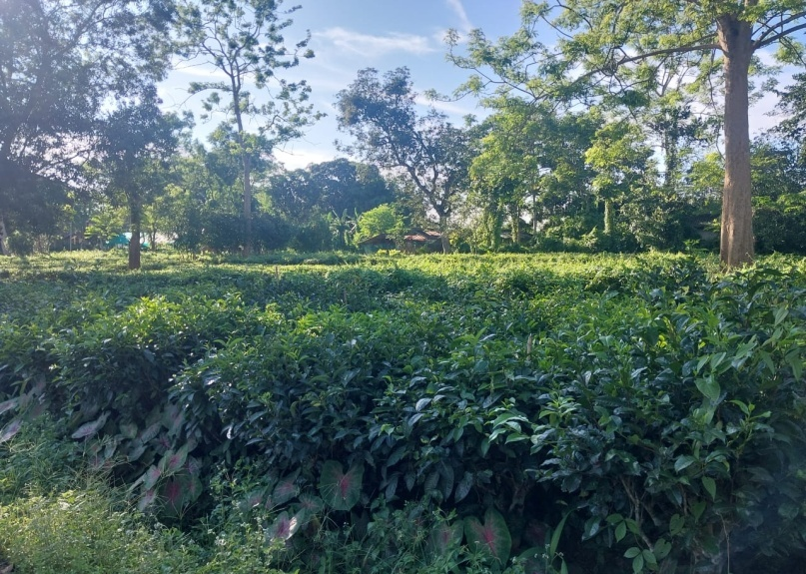

Picture 1 : Soil sample from tea garden(TTRI campus)

METHOD:

Collection of soil sample:
Tea soil was been collected from the garden in the campus itself.
- Keeping in mind the basic principles of microbiology, the collected soil sample was been sterilized using autoclavable bags in the autoclave at 121degree Celsius for around one hour.
- Then after sterilization is done the pot trial layout was been set up.Three set ups were made.
The first layout had only the sterilized soil sample i.e, Control (C).
The second layout had sterilized soil and Trichoderma i.e,( S+T)
The third layout had sterilized soil,trichoderma and vermi compost i.e, (S+T+VC)
- Triplicates of each individual layout was made.
- In the first layout, 2500g of only sterilized soil was weighed and divided equally into three pots.
- In the second layout, 2500g of sterilized soil was weighed and mixed with 125ml of Trichoderma and then again mixed well and equally divided into three pots.
- Similarly in the third layout, 2500g of sterilized soil and 125ml of trichoderma was weighed and mixed well with 125g of vermi compost and was equally divided among three pots.
- This set was kept in a clean environment without any hindrance for the study. Water was sprayed at regular intervals in order to keep the soil moistened. And the observations were taken in the 7th, 12th, 15th and 21st day of the samples.

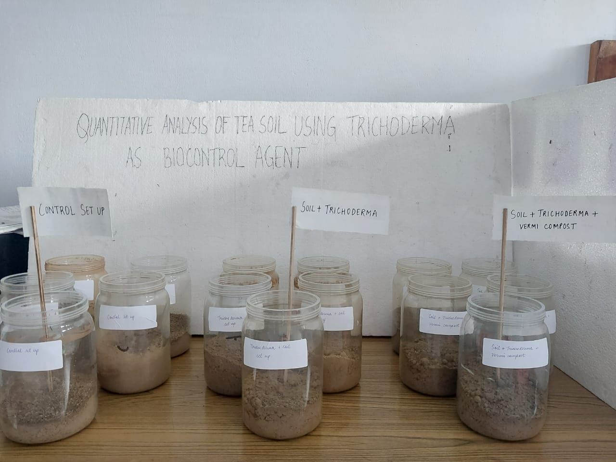
Picture 2 : Three set ups

PDA media preparation:
- First 200g of fresh cleaned and dried potatoes were taken and finely chopped into pieces.
- These were then taken in a vessel and to this 1L of distilled water is added and kept in a stove to boil for around an hour until the potatoes get cooked.
- Then the extract was collected in a measuring cylinder with the help of a funnel and muslin cloth. The remaining volume in the cylinder was filled upto 1000ml again by adding distilled water to it.
- As per convenience, the extract solution which was collected was been equally divided into two conical flasks (500ml in each).
- Then to one of the flask, 20g of D- glucose was measured and mixed into it. And to the other flask 15g of agar was measured and added.
- Both the flasks were heated in the flame until they dissolved evenly.
- These were then mixed together to form a homogeneous mixture.
- Then the media was been poured into small 250ml conical flasks, plugged with non absorbant cotton, covered with paper and tied with rubber bands and were labeled.
- Finally these flasks were autoclaved at 121 degree Celsius for around 1 hour for sterilization.

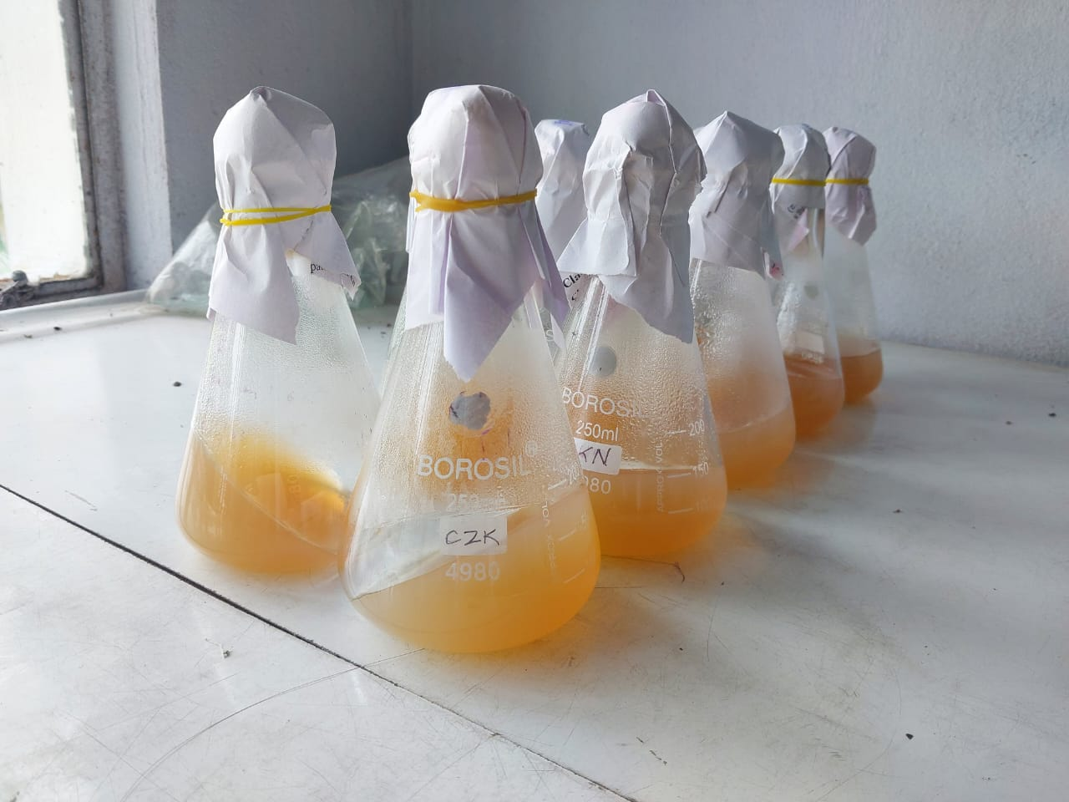
Picture 3 : Potato Dextrose Agar media (PDA)

For this work serial dilution technique was been used.

SERIAL DILUTION:

- A composite mixture of 10g of the soil of the triplicates from each layout was weighed in an electric meter and was taken in 100ml dilution bottle.
- The three 100ml dilution bottles along with 10g of weighed soil sample were placed in a shaker for around ½ hour, so that it gets homogenized and mixed well.
- Overall dilutions upto 10⁻⁷ was done.
- After the 100ml bottles were well shaken, 10ml from each bottle was been pipetted out and put in the dilution bottle of 90ml. Similarly the process was been carried out until 10^{-7th} dilution.
- For each layout one 100ml dilution bottle and seven 90ml bottles were used.
- Then after the dilution was done 1ml of dilution suspension from 10⁻¹, 10⁻⁵, 10⁻⁶ and 10⁻⁷ was been pipette out in the respective petri plates for each triplicate.
- For each individual layout again triplicates of each dilution was taken.
- Finally after serial dilution was done in all the plates, PDA( Potato Dextrose Agar) media was melted and poured into the plates.
- Then the petri plates were kept in a sterilized place for further observation.
- This process was been first done on the 7th day of set up then was again repeated in the following days of the set up- 12th, 15th and 21st day.

OBSERVATION AND RESULTS

Observation of Bacteria, Fungi and Trichoderma count in tea soil:

- For Sterilized soil(Control):

DAY | DILUTIONS |  | BACTERIA |  | FUNGI | TRICHODERMA
7th | 10⁻¹ |  | 1 |  | 0 | 5.5
7th | 10⁻⁵ |  | 0 |  | 41.3 | 41
7th | 10⁻⁶ |  | 0 |  | 18.3 | 19
7th | 10⁻⁷ |  | 2.6 |  | 10 | 9.6
12th | 10⁻¹ |  | 0 |  | 0 | 0
12th | 10⁻⁵ |  | 0 |  | 76.3 | 3.2
12th | 10⁻⁶ |  | 0 |  | 63 | 2.2
12th | 10⁻⁷ |  | 0 |  | 53.3 | 2.6
15th | 10⁻¹ |  | 0 |  | 0 | 0
15th | 10⁻⁵ |  | 100 |  | 104 | 3
15th | 10⁻⁶ |  | 74 |  | 78.3 | 6
15th | 10⁻⁷ |  | 59.3 |  | 62.3 | 6.3
21st | 10⁻¹ |  | 0 |  | 0 | 0
21st | 10⁻⁵ |  | 0 |  | 103 | 2.5
 |  | 10⁻⁶ |  | 0 | 77.3 | 7
 |  | 10⁻⁷ |  | 0 | 78.3 | 4.6

Table:1

From table 1: it can be said that the fungal count is high in comparison to bacterial and trichoderma count.

Taking the average of the values from table 1 a bar graph was plotted which is as follows:-

DAYS | BACTERIA | FUNGI | TRICHODERMA
7th | 0.9 | 18.7 | 18.7
12th | 0 | 48.2 | 2
15th | 58.3 | 61.1 | 3.8
21st | 0 | 64.6 | 3.5

Fig1: Graph for Control setup containing only sterilized soil

From the above fig it is clearly seen that the overall count for all the no. of days considered, the fungal count is more than bacteria and trichoderma.

- For sterilized soil and Trichoderma set up(S+T):

DAY | DILUTIONS |  | BACTERIA |  | FUNGI | TRICHODERMA
7th | 10⁻¹ |  | 0 |  | 0 | 0
7th | 10⁻⁵ |  | 0 |  | 0 | 11.3
7th | 10⁻⁶ |  | 0 |  | 0 | 13.3
7th | 10⁻⁷ |  | 0 |  | 0 | 10
12th | 10⁻¹ |  | 0 |  | 0 | 1.5
12th | 10⁻⁵ |  | 0 |  | 0 | 20.3
12th | 10⁻⁶ |  | 0 |  | 0 | 12.2
12th | 10⁻⁷ |  | 0 |  | 0 | 12.6
15th | 10⁻¹ |  | 0 |  | 0 | 0
15th | 10⁻⁵ |  | 3.6 |  | 0 | 14.6
15th | 10⁻⁶ |  | 3.5 |  | 3.5 | 13
15th | 10⁻⁷ |  | 0 |  | 7.6 | 9.6
21st | 10⁻¹ |  | 0 |  | 0 | 1.6
21st | 10⁻⁵ |  | 6.6 |  | 4.6 | 13.6
 |  | 10⁻⁶ |  | 6.3 | 5.5 | 7.2
 |  | 10⁻⁷ |  | 8.6 | 8.3 | 4.5
Table:2

From table 2: it can be seen that the trichoderma count is more in comparison to bacteria and fungus.

Taking the average of the values from table 2 a bar graph is plotted which is as follows:-

DAY | BACTERIA | FUNGI | TRICHODERMA
7th | 0 | 0 | 2.1
12th | 0 | 0 | 11.6
15th | 1.7 | 2.7 | 9.3
21st | 5.3 | 4.6 | 6.7

Fig2: Graph for S+T setup having only soil and trichoderma

From the above graph it can be clearly seen that the overall count of trichoderma considered for the no. of days is more compared to bacteria and fungus.
- For Sterilized soil, Trichoderma and Vermi compost set up:-

DAY | DILUTIONS |  | BACTERIA |  | FUNGI | TRICHODERMA
7th | 10⁻¹ |  | 0 |  | 0 | 0
7th | 10⁻⁵ |  | 38.8 |  | 0 | 1
7th | 10⁻⁶ |  | 52.1 |  | 0 | 5.3
7th | 10⁻⁷ |  | 58.8 |  | 0 | 8.3
12th | 10⁻¹ |  | 0 |  | 0 | 0
12th | 10⁻⁵ |  | 37.3 |  | 0 | 0
12th | 10⁻⁶ |  | 36.8 |  | 7 | 1
12th | 10⁻⁷ |  | 46.6 |  | 7.7 | 1
15th | 10⁻¹ |  | 0 |  | 0 | 0
15th | 10⁻⁵ |  | 71.3 |  | 0 | 16.6
15th | 10⁻⁶ |  | 35 |  | 0 | 33.6
15th | 10⁻⁷ |  | 36.6 |  | 2 | 18
21st | 10⁻¹ |  | 0 |  | 0 | 0
21st | 10⁻⁵ |  | 40.3 |  | 0 | 7.8
 |  | 10⁻⁶ |  | 14 | 0 | 8
 |  | 10⁻⁷ |  | 4.6 | 0 | 10.6

Table:3

From table 3: it can be seen that the bacterial microbes count is more as compared to the other two.

Taking the average of the values from table 3 a bar graph is plotted which is as follows:-

DAY | BACTERIA | FUNGI | TRICHODERMA
7th | 37.4 | 0 | 3.6
12th | 30.1 | 3.6 | 0.5
15th | 35.7 | 0.5 | 17
21st | 14.7 | 0 | 6.6

Fig3: Graph showing the S+T+VC setup having a mixture of soil, trichoderma and vermin compost

From the above fig it can be said that, the bacterial count considered for the no. of days is more than the trichoderma and fungal count.

Day wise comparison of Bacteria, Fungi and Trichoderma count from the aforesaid three set ups:-

- Bacterial count from all the three set ups:

- Fungal count from all three set ups:

- Trichoderma count from all the three set ups:

Plate 1 : PICTURES OF THE OBSERVATIONS TAKEN DAY WISE

- 12th Day-
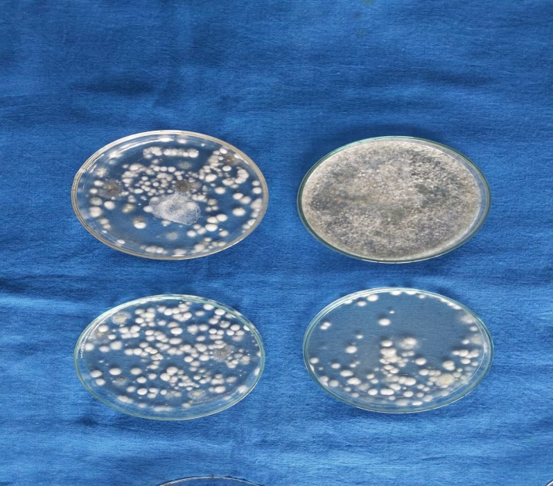
Soil

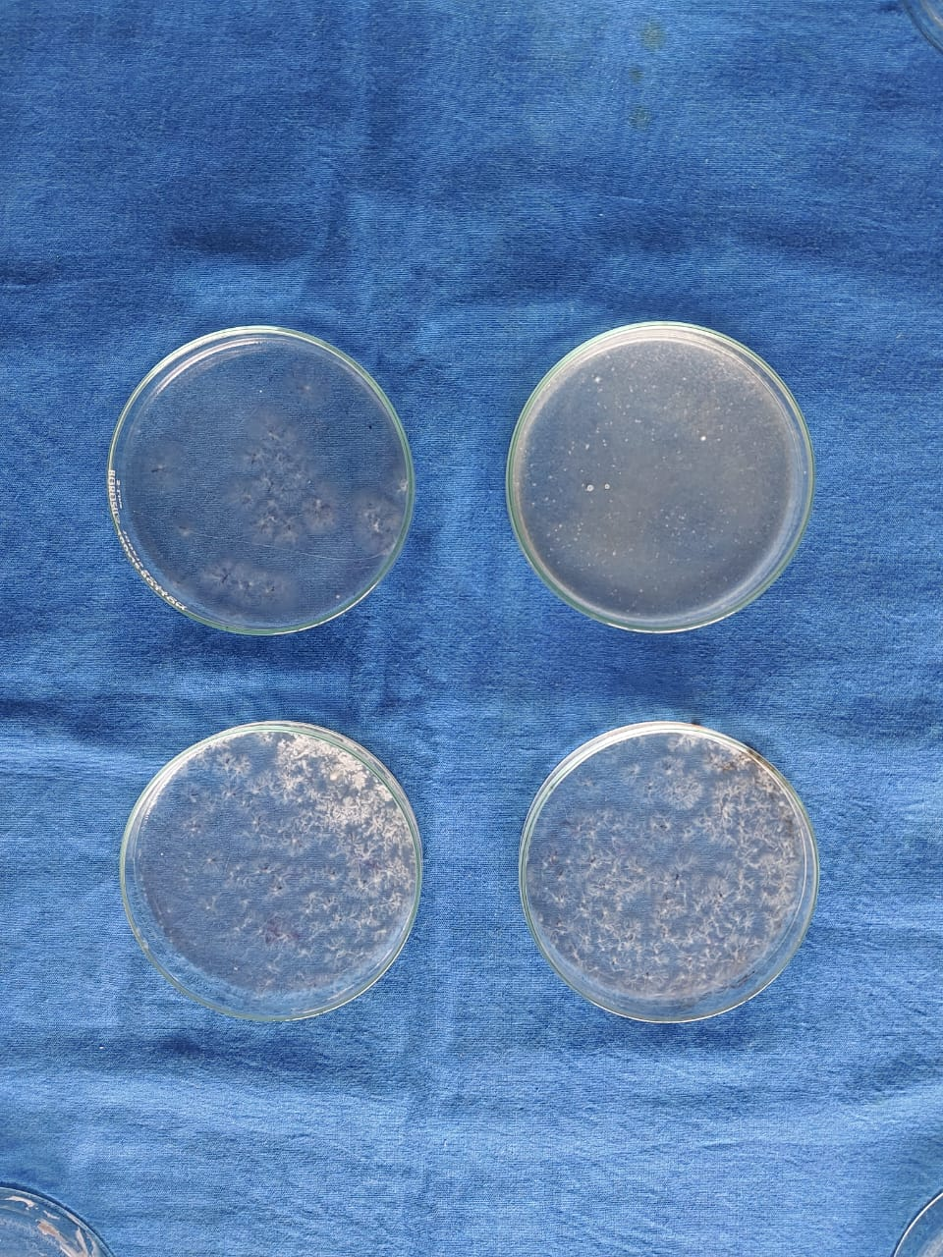
Soil and Trichoderma

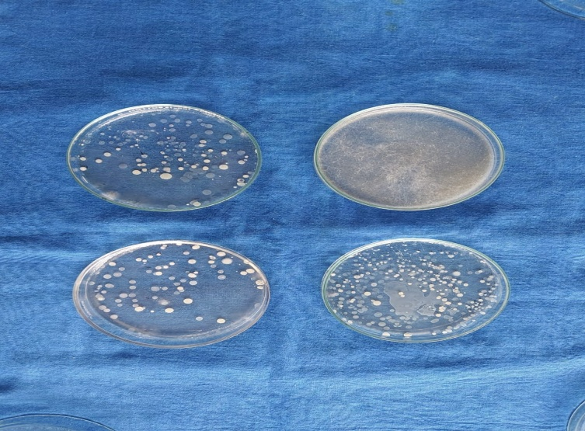
Soil, Trichoderma and Vermi compost

- 15th Day-
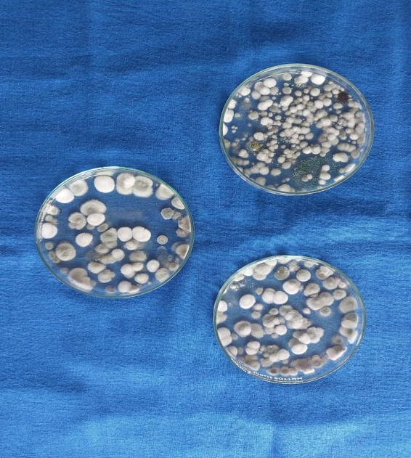
Soil
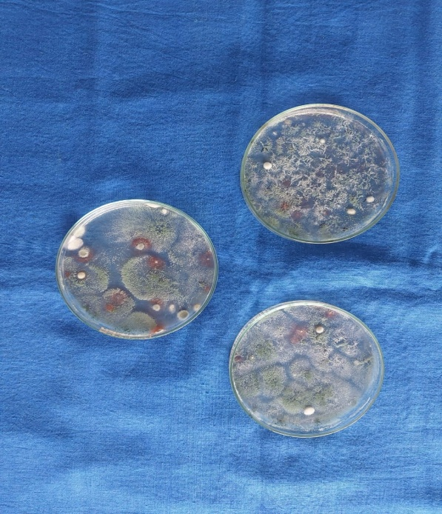
Soil and Trichoderma
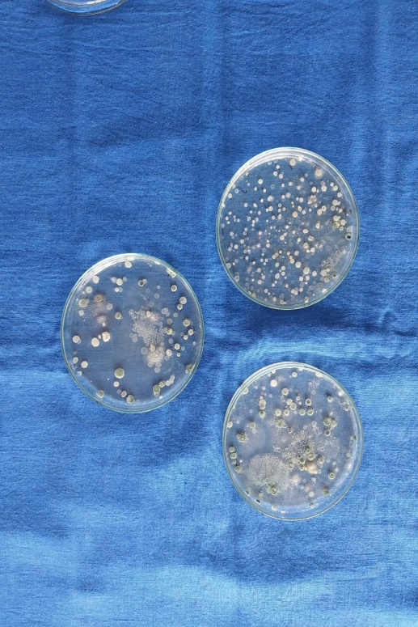
Soil, Trichoderma and Vermicompost

- 21st Day-

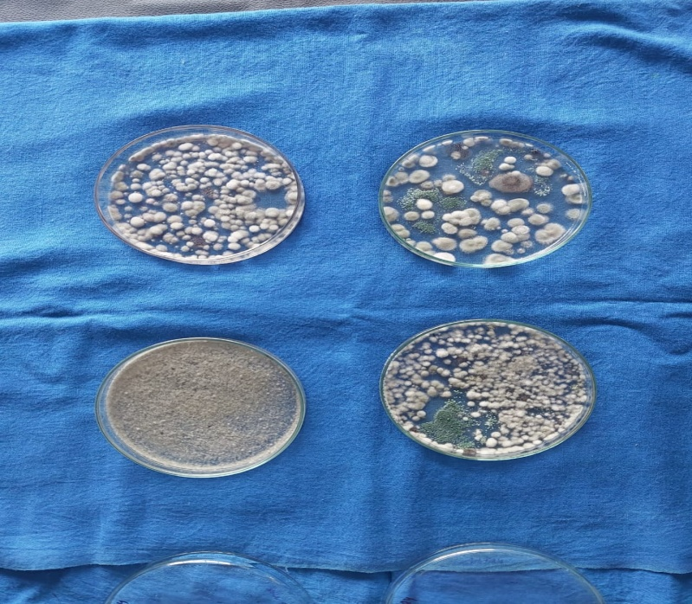

Soil

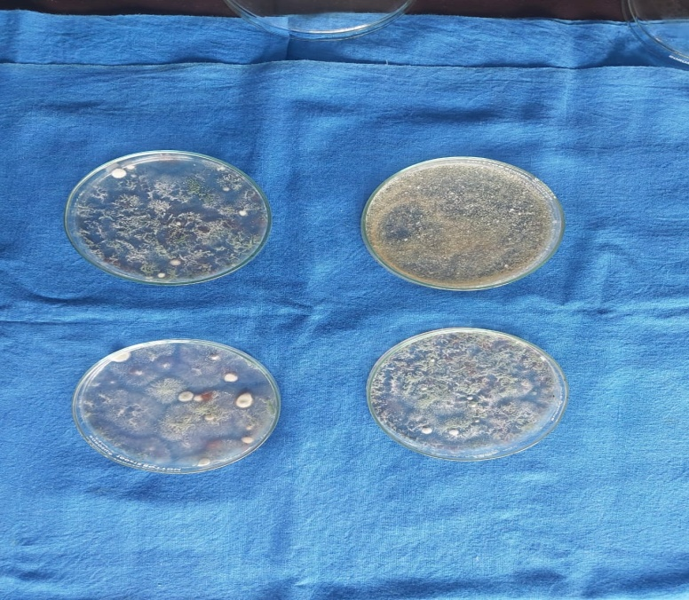

Soil and Trichoderma

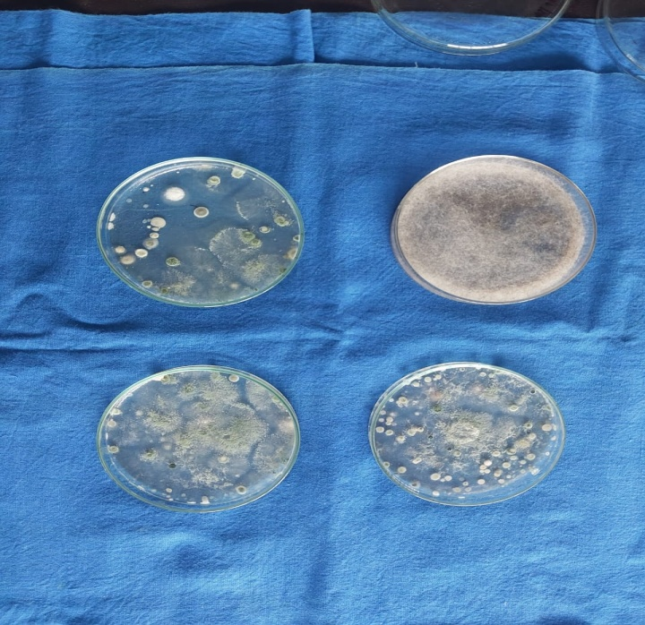
Soil, Trichoderma and Vermicompost

DISCUSSION

Tea, next to water is the cheapest beverage that humans consume. Drinking tea as a beverage has been considered a health-promoting habit since ancient times. The modern medicinal research is providing a scientific basis for this belief. As we all know the benefits of tea we should be able to maintain the soil in which tea is grown for its proper efficient growth. There are different kinds of microbes present in soil that gives positive impact on the growth of the plant.
Biocontrol agents applied after fumigation plays an important role to the soil microenvironment. Genetic analysis indicated that Trichoderma applied after fumigation significantly increased the relative abundance of Pseudomonas, Humicola and Chaetomium, and significantly decreased the relative abundance of the pathogens such as Fusarium spp. and Gibberella spp., which may help to control the pathogens and enhanced the ecological functions of the soil.
Trichoderma is an effective biocontrol agent for plants grown in greenhouse as well as fields, showing antifungal properties as well as promoting growth and inducing plant resistance against pathogenic microorganisms. It is well documented that Trichoderma effectively controlled soil-borne pathogens such as Fusarium spp. and Phytophthora spp. Adding Trichoderma to fumigated soil can prolong the fumigant’s control of soil-borne pathogens when populations increase over time, compared with fumigation alone which becomes ineffective against pathogens as concentrations decline over time.
Vermi composting has also proven to show some positive impact on plant growth using earthworms.Vermicompost is a finely divided, peat like material with high porosity, good aeration, drainage, water holding capacity, microbial activity, excellent nutrient status and buffering capacity thereby resulting the required physiochemical characters congenial for soil fertility and plant growth. Vermicompost enhances the soil biodiversity by promoting the beneficial microbes which in turn enhances plant growth directly by production of plant growth-regulating hormones and enzymes and indirectly by controlling plant pathogens, nematodes and other pests, thereby enhancing plant health and minimizing the yield loss.

CONCLUSION

Tea requires a moderately hot and humid climate. Climate influences yield, crop distribution and quality. Tea grows best on well-drained fertile acid soil on high lands. Tea grows well on high land well drained soils having a good depth, acidic pH in the range of 4.5 to 5.5 and more than 2% organic matter. Shallow and compact sub-soils limit root growth. Tea plants growing on such soils are liable to suffer from draught during dry period and water logging during the rainy months.
Different kinds of microbes such as Bacteria, Fungi, etc has both positive as well as negative impact on growth of the plant. In the traditional crop cultivation process, the excessive use of pesticides and chemical fertilizers, as well as the long-term large-scale planting of a single crop, has led to the destruction of the farmland. Trichoderma spp. also behaves as a safe, low-cost, effective, eco-friendly biocontrol agent for different crop species land ecological environment. Trichoderma is mainly used to control soil-borne diseases as well as some leaf and panicle diseases of various plants. Trichoderma can not only prevent diseases but also promotes plant growth, improves nutrient utilization efficiency, enhances plant resistance, and improves agrochemical pollution environment.
Vermicomposting is also an efficient way of growing healthy pesticide free crops.Vermicompost enhances soil biodiversity by promoting the beneficial microbes.
After undertaking the quantitative estimation of the trichodermal colony count from the tea soil taken from pot trial, it was observed that the trichodermal colony flourished maximum in the tea soil treated with only trichoderma than in the tea soil treated with trichoderma along with vermi compost.

REFERENCES

Babu A, Kumhar KC (2013) New record of two fungal pathogens of red slug caterpillar, vol 19. Tocklai News, Tea Research Association, Tocklai Experimental Station, Jorhat, pp 2–3

Babu A, Kumhar KC (2014) Pathogenicity of indigenous Beauveria bassiana (BKN 20) against tea mosquito and its compatibility with a few insecticides. Two and a Bud 61(1 & 2):64–67
Cao AC, Liu XM, Guo MX, Wang QX, Li Y, Ouyang CB, et al. Harm and control technology of crop soil-borne diseases. Plant Protection. 2017; 43(02): 6–16.

Edwards CA, Fletcher KE. Interaction between earthworms and microorganisms in organic matter breakdown. Agric Ecosyst Environ. 1988;20:235–249. doi: 10.1016/0167-8809(88)90069-2.

Hall RA, Papierok B (1982) Fungi as biological control agents of arthropods of agricultural and medical importance. Parasitol 84:205–240

Lavelle P, Martin A. Small-scale and large-scale effects of endogeic earthworms on soil organic matter dynamics in soils of the humid tropics. Soil Biol Biochem. 1992;12:1491–1498. doi: 10.1016/0038-0717(92)90138-N.

Lee KE. Earthworms: Their Ecology and Relationships with Soils and Land Use. Sydney: Academic Press; 1985.

Mukhtar H, Ahmad N. Tea polyphenols: prevention of cancer and optimizing health. Am J Clin Nutr. 2000;71:1698S–702S. discussion 1703S–4S

Pathma J, Rahul GR, Kamaraj Kennedy R, Subashri R, Sakthivel N. Secondary metabolite production by bacterial antagonists. Journal of Biological Control. 2011;25:165–181.
Petersen H, Luxton MA. A comparative analysis of soil fauna populations and their role in decomposition process. Oikos. 1982;39:287–388.

Roy S, Mukhopadhyay A, Gurusubramanian G (2011) Resistance to insecticides in field-collected population of tea mosquito bug (Helopeltis theivora Waterhouse) from the Dooars (North Bengal, India) tea cultivations. J Entomol Res Soc 13(2):37–44

Zhang FG, Zhu Z, Yang XM, Ran W, Shen QR. Trichoderma harzianum T-E5 significantly affects cucumber root exudates and fungal community in the cucumber rhizosphere. Appl Soil Ecol. 2013; 72: 41–48. 10.1016/j.apsoil.2013.05.016

