MAXILLARY ACTINOMYCOSIS IN A CROSS-BRED COW: DIAGNOSIS AND TREATMENT WITH LIMITED RESOURCES

Abstract
Bovine actinomycosis or lumpy jaw in cattle is caused by Actinomyces bovis which produces a chronic rarefying osteomyelitis of facial masticatory bones. A 3.5-year-old cross-bred cow with a history of gradually increasing swelling on the left maxillary region was presented for treatment at VCC, VCRI, Theni. Clinical examination revealed a hard, painless, immovable mass with no discharge. Hence, for diagnosis, fine needle aspiration biopsy (FNAB) was taken and the smear was stained with Gram staining. This revealed filamentous Gram-positive bacteria with surrounding Gram-negative club-shaped structures characteristic of actinomycosis. After confirming actinomycosis, the animal was treated with antibiotics, non-steroidal anti-inflammatory drugs and iodides. Along with this TissueAid bolus was advised for oral administration along with topical application with glycerine and magnesium sulphate. Symptomatic recovery was observed in the animal on subsequent visits.
Introduction
Actinomycosis is a less commonly reported bacterial infection, that affects the bones of the skull, especially the mandible and maxilla. Bovine actinomycosis, also called Lumpy Jaw, is primarily caused by a gram-positive, microaerophilic to anaerobic, filamentous bacterium called Actinomyces bovis (Willey et al., 2017). They are normal inhabitants of the oronasal, upper respiratory and digestive tracts (Roa et al., 2012). Animals are predisposed to actinomycosis either through the mucosal damage by sharp objects ingested along with feed, through oral ulcers induced by viral infections or due to dental problems. Following the entry and colonization of the bacteria, localized inflammation and tissue necrosis occur. This creates a conducive environment for bacterial proliferation and persistence, leading to chronic, granulomatous osteomyelitis. The lesion may also extend deep into the bony tissues and the adjacent soft tissue. Bovine actinomycosis is characterized by hard painful swelling, with fistulous tract discharging pus that resembles sulphur granules. The bacterium is also known to produce chronic nodular suppurative lesions in soft tissue at various anatomical sites (Gensa, 2018).
A tentative diagnosis of the disease is made based on the physical examination and clinical signs (Radostits et al., 2007). The preferred direct identification technique is gram staining of the pus or the biopsy samples, bacterial isolation can be attempted using anaerobic culture media, but it is challenging. Imaging techniques such as radiography and ultrasonography are useful in determining the extent of the lesion and its progression. However, bacterial isolation and imaging may not always be possible in resource-limited settings. We report a case of maxillary actinomycosis in a cross-breed cow, which was diagnosed based on clinical signs and gram staining in a basic veterinary facility.
Case presentation and diagnosis
A 3.5-year-old crossbred cow was presented to the Veterinary Clinical Complex, Veterinary College and Research Institute, Theni with a history of swelling in the left maxillary region for the past 6 months without any discharge. The vital parameters such as rectal temperature was 104.1⁰F and heart rate was 68 beats/ min. Clinical examination revealed a left distorted jaw carrying an asymmetrical hard mass. The mass felt firm, immovable and painful on palpation. The mass was irregularly polygonal, measuring 111.6 mm in length medially and 57.47 mm laterally. Its width ranged from 124.37 mm at the widest point to 116.05 mm at the narrowest region (Fig. 1). The animal remained alert with excessive lacrimation, salivation and enlarged left submandibular lymph node. Oral examination revealed the absence of any foreign body or feed impaction. The sample was collected using a fine needle by aspiration and sent for cell cytology and microbiological investigation.
Results
Cytology revealed the presence of mature neutrophils, mesenchymal and osteocytes. Gram staining of the smear from fine needle aspiration (FNAB) revealed the presence of Gram-positive, purple-coloured, long filaments and short V, Y and T-shaped structures (Fig. 2). They were surrounded by club-shaped structures which stained Gram-negative. This is characteristic of Actinomyces or ray fungus.
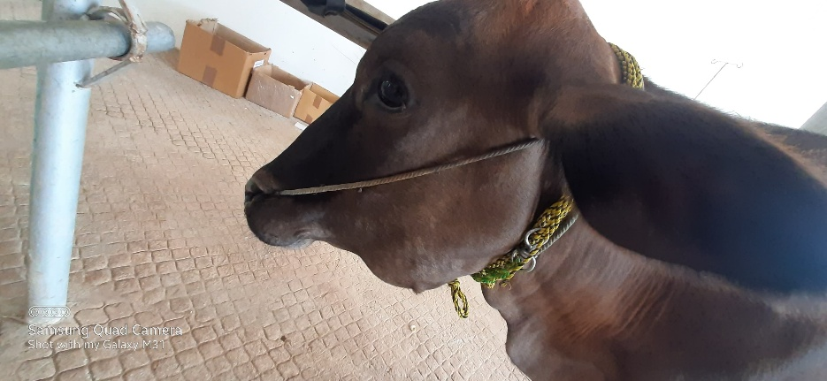 | 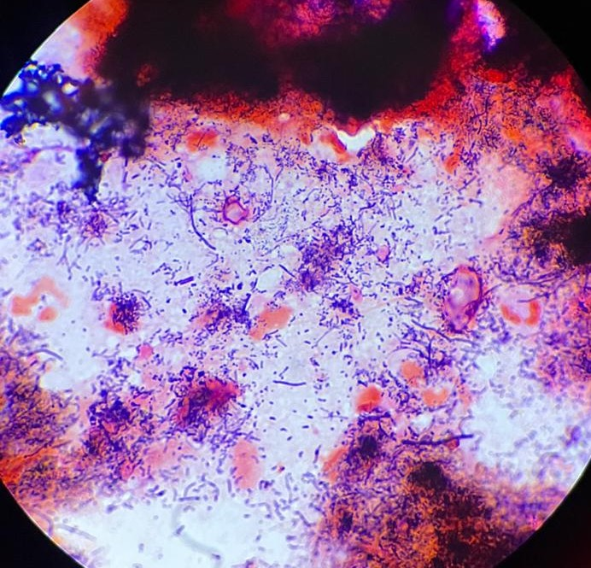
Fig. 1: 3.5-year-old cross bred cow showing hard mass in the left maxillary region. | Fig. 2: Gram staining of smear obtained through FNAB revealing long filaments and short V, Y and T shaped gram-positive bacteria with surrounding Gram-negative club shaped structures.

Treatment
The cow was administered with Inj. Benzathine penicillin @ 15 mg/kg body weight, Inj. Flunixin @ 2 mg/kg, Inj. Chlorpheniramine maleate @ 10 mg/kg intramuscularly for 5 days. Further orally, bolus Tissue Aid and bolus containing Meloxicam (100 mg) + Paracetamol (1800 mg) + Serratopeptidase (50 mg) @ 1 bolus/ day for 3 days were given. Along with this Potassium Iodide @10 gm daily for 10 days was given. Glycerine and Magnesium sulphate was advised for topical application.
Discussion
Lumpy jaw is a chronic rarefying osteomyelitis of the jaw bone in cattle caused by endogenous infection of commensal bacteria Actinomyces bovis. Actinomyces belongs to the family Actinomycetaceae under the order Actinomycetales which also includes Corynebacteriaceae, Mycobacteriaceae, and Nocardiaceae families. Most of the bacteria in this order have mycolic acid in their cell walls but the level varies making them to be acid-fast or non-acid-fast organisms. Actinomyces are non-acid-fast bacteria with less mycolic acid in their cell wall. They are Gram-positive, non-motile, non-spore-forming but filamentous bacteria that remain as a transitional form between bacteria and fungi.
Actinomyces bovis in cattle, Actinomyces israelii in humans rarely in pigs& cattle and A. viscosus in dogs are the most prevalent species (Könönen and Wade, 2015; Mohamed et al., 2011). Actinomycosis is sporadic in occurrence but common in cattle and has been reported worldwide, infrequently reported in pigs, dogs, horses, goats and humans. Common areas of infection in cattle are cheek muscles, mandible and maxillary bones. Whereas in pigs, the udder and in horses, wither and poll are commonly affected (Constable et al., 2017).
Actinomycosis of jaw bones may induce pain, further interfering with prehension, mastication, proper digestion and respiration. Eventually leading to dyspnoea, partial starvation, progressive loss of condition, weight loss with intermittent diarrhea, bloat etc. contributing to significant economic loss. The condition has to be differentiated from abscesses of the cheek muscles and throat region, actinobacillosis, neoplasm of bones, tooth infection, fractures of jaw bones and bone sinusitis (Radostits et al., 2007). In case of abscess or actinobacillosis, the mass is movable and generally localized in soft tissue. The consistency of the pus varies depending on the duration of infection. Whereas in the case of actinomycosis, the mass is immovable and the pus discharged is yellow resembling sulphur granules.
Actinomyces establish a chronic, suppurative, granulomatous infection. Unlike the classical pathogens, Actinomyces do not produce any exotoxins but they are capable of evading the host immune response by producing biofilms, cell-associated /extracellular polymers such as dextran, levan, N-acetylglucosamine-rich slime polysaccharides enabling them to attach to own or foreign surfaces (Gajdács and Urbán, 2020). Additionally, they possess certain types of fimbriae for adhesion and for co-aggregation with other bacteria in soft tissue lesions.
The most preferred samples for diagnosis of Actinomycosis are smears from aspiration biopsy and crushed pus. Fine needle aspiration biopsy (FNAB) is more safer, quicker, convenient, inexpensive and less invasive technique that can be performed with minimal facilities (Wong et al., 2011). Biopsy samples are generally more effective for diagnosing actinomycosis since the lesion is sterile in approximately 50% of cases, rendering swab samples less reliable. Diagnosis is based on clinical examination, Gram staining of the biopsy, microbial culture, cytology and imaging techniques. Among them, Gram staining is considered the gold standard test and a more sensitive test with most of clinical forms (Valour et al., 2014). The bacteria appear as Gram-positive tangled filaments surrounded by Gram-negative club-shaped structures which protect them from phagocytosis, thereby establishing a chronic infection (Wong et al., 2011).
Mandibular actinomycosis in bovines has been reported from various parts of India in recent years (Rajesh kumar and Archanakumari, 2017; Dhillon et al., 2020; Ganapathi et al., 2022). Renu Singh et al., (2017) reported a nasal form of actinomycosis. In most of the cases, diagnosis is based on clinical examination and staining characteristics.
Penicillin, Streptomycin, Oxytetracycline, Bacitracin, Cloxacin, Dicrystin-DS, and Isoniazid are effectively used for the treatment of actinomycosis in bovines (Ganapathi et al., 2022). In this case study Inj. Benzathine Penicillin along with Inj. Flunixin and Inj. Chlorpheniramine maleate were given intramuscularly for 5 days. Tissue Aid and Potassium iodide were also advised orally. Tissue Aid is a proprietary ayurvedic product that is known to reduce inflammation. Potassium iodide is considered as the treatment of choice for actinomycosis which is given until the animal develops iodism maximum for 10 days (Radostits et al., 2007). Glycerine and Magnesium sulphate was advised for topical application to reduce the swelling. Bovine actinomycosis was treated successfully by parenteral administration of Penicillin and Streptomycin along with oral administration of potassium iodide as reported by ( Pal et al., 2008 and Patel et al., 2016). Whereas Constable et al., 2017 and few others reported slow intravenous administration of 10% solution of sodium iodide @ 70mg/ Kg was also effective. Surgical debridement and Cryo- therapy using liquid nitrogen and be effective in advanced and poor responders.
Prompt treatment intervention is crucial for managing actinomycosis before the lesion progresses and becomes fibrosed. Early diagnosis and treatment are important, as the onset of the disease may not be readily apparent. The disease can be prevented by avoiding factors that can lead to oral lacerations, such as sharp objects or dental issues, as these predispose animals to the condition. Additionally, animals discharging pus discharge should be isolated, as this may lead to environmental contamination, even though the disease is generally considered non-contagious and is primarily associated with predisposing oral lacerations. Proper preventive measures and proactive management are key to addressing this challenging condition effectively. Examination of the animal on subsequent visits revealed the animal responded symptomatically well to the treatment.
Conclusion
Bovine actinomycosis or lumpy jaw occurs as a chronic, endogenous, suppurative infection affecting bones of mastication in cattle. It is an economically important disease, especially in dairy cattle because it interferes with prehension and mastication leading to reduced feed intake and production. The condition is effectively diagnosed based on the staining of pus or smears from samples obtained through FNAB. Fine needle aspiration biopsy is a more sensitive and cost-effective technique for diagnosing bovine actinomycosis. The disease is treated using a combination of antibiotics and iodides. Early diagnosis and treatment are crucial in actinomycosis management. The disease can be prevented by avoiding factors that can lead to oral lacerations.
References
Constable, P. D., Hinchcliff, K. W., Done, S. H., & Grünberg, W. (Eds.). (2017). Veterinary Medicine: A Textbook of the Diseases of Cattle, Horses, Sheep, Pigs, and Goats. W.B. Saunders Ltd. https://doi.org/10.1016/B978-0-7020-5246-0.00027-9
Dhillon, K. S., Kaur, S. J., & Khanmotra, A. (n.d.). Actinomycosis in a Holstein heifer: Diagnosis, treatment and management. Journal of Entomology and Zoology Studies.
Gajdács, M., & Urbán, E. (2020). The Pathogenic Role of Actinomyces spp. and Related Organisms in Genitourinary Infections: Discoveries in the New, Modern Diagnostic Era. Antibiotics, 9(8), 524. https://doi.org/10.3390/antibiotics9080524
Ganapathi, D. P., Hariharan, D. T., Subash, D. R., & Kavithaa, D. N. (n.d.). Treatment of bovine actinomycosis in crossbred cow: A case report.
Gensa, U. (2018). Review on Actinomycosis in Cattle. Journal of Biology, Agriculture and Healthcare, 8(13), 60.
Könönen, E., & Wade, W. G. (2015). Actinomyces and Related Organisms in Human Infections. Clinical Microbiology Reviews, 28(2), 419–442. https://doi.org/10.1128/CMR.00100-14
Mohamed, T., Al-Sobayil, F., Kurwasawa, T., Nakade, T., & Floeck, M. (2011). Computed tomographic findings in a calf with actinomycosis: A case report. Veterinární Medicína, 56(5), 255–259. https://doi.org/10.17221/1559-VETMED
Pal B, Prasad B, Mandeep S. Clinical Management of Actinomyces in cows. Indian Journal of Veterinary Medicine. 1994;14:49.
Pal B, Mandial RK, Wadhwa DR, Thakur YP, Dhar P. Actinomycosis in Cattle and its Clinical Management, 2008; 9:253-254.
Patel BR, Patel JS, Parmar SC. Clinico-Therapeutic Management of Actinomycosis in a Buffalo. Intas Polivet. 2016; 17:575-577.
Radostits OM, Gay CC, Blood DC, Hinchcliff KW. Veterinary Medicine, 9th ed, 2007, 1045-1046. London.W.B.Saunders.
Rao, J.U., Rash, B.A., Nobre, M.F., Da Costa, M.S., Rainey, F.A. and Moe, W.M., 2012. Actinomyces naturae sp. nov., the first Actinomyces sp. isolated from a non-human or animal source. Antonie Van Leeuwenhoek, 101(1), pp.155-168.
Renu Singh, G. A. C., Satbir Sharma, S. S., & Rath, A. P. (2017). Nasal Granuloma in Buffalo: An Unusual Case of Actinomycosis. International Journal of Current Microbiology and Applied Sciences, 6(4), 762–765. https://doi.org/10.20546/ijcmas.2017.604.094.
Rajesh Kumar and Archanakumari (2017) Clinical management of actinomycosis in bovines. Journal of Pharmacognosy and Phytochemistry 2017; SP1: 509-510.
Valour, F., Sénéchal, A., Dupieux, C., Karsenty, J., Lustig, S., Breton, P., Gleizal, A., Boussel, L., Laurent, F., Braun, E., Chidiac, C., Ader, F., & Ferry, T. (2014). Actinomycosis: Etiology, clinical features, diagnosis, treatment, and management. Infection and Drug Resistance, 7, 183–197. https://doi.org/10.2147/IDR.S39601
Willey, J. M., Sherwood, L., & Woolverton, C. J. (2017). Prescott’s Microbiology. McGraw-Hill Education.
Wong, V. K., Turmezei, T. D., & Weston, V. C. (2011). Actinomycosis. BMJ (Clinical Research Ed.), 343, d6099. https://doi.org/10.1136/bmj.d6099

