***Review Article***

**Signalling in plants under abiotic stress through root-shoot communication**

**Abstract**

A cordial communication between the root and shoot occurs for proper absorption of water and essential nutrients, which leads to plant growth and development. This communication may get altered when plants face an environmental stress such as water deficit, soil salinity, high/low temperature or shade, etc. This communication is maintained through various signals, including hormones, peptides, proteins, hydraulic signals, and metabolites, which are transported primarily through the vasculature (root) to distant tissues (above-ground plant parts). Root-localized stress signals trigger changes in xylem hydraulics, mobile peptides, reactive oxygen species (ROS), and Ca2+, which lead to remote effects and induce stomatal closure. The mobility of HY5 protein and its downstream targets via the phloem conveys shoot-sensed light and temperature information to affect both primary and lateral root growth. Shoot-derived sucrose loading/unloading in the phloem is highly responsive to environmental changes, and triggers signalling pathways that regulate root development. Developmental plasticity of the vasculature in response to abiotic stresses is key importance for long-distance transport of substances to assist plant stress resilience. How shoots and roots synchronize their response to environmental stress using mobile signals is an emerging field of research. We summarize recent studies on mobile signals regulating shoot stomatal movement and root development in response to specific environmental stresses.

**Key words:** abiotic stress, mobile signals, root vasculature plasticity, root growth, shoot–root communication, stomatal closure, ABA

**Introduction**

In higher plants, a clear division of labor exists between the shoot and root systems, each of which performs specialized and essential functions. The shoot system, located above ground, primarily captures solar energy through photosynthesis, allowing the plant to generate the carbohydrates necessary for growth and development. It also plays a central role in reproduction by producing flowers, fruits, and seeds. Conversely, the root system, which lies below ground, anchors the plant and absorbs water and vital mineral nutrients from the soil. Despite their spatial separation and distinct roles, the shoot and root systems must function in close coordination to ensure optimal growth, development, and survival, especially under fluctuating environmental conditions (Li et al., 2021).

This coordination is facilitated by a complex and dynamic exchange of information, often referred to as root–shoot communication. Central to this process is the plant vascular system, which consists of two main conducting tissues: xylem and phloem. While the xylem primarily transports water and dissolved minerals from the roots to the shoots, the phloem distributes photosynthates (such as sugars) from the photosynthetically active shoots to non-photosynthetic tissues, including the roots. However, in addition to transporting nutrients and water, these vascular tissues also function as conduits for various signaling molecules, including hormones (like auxins, cytokinins, and abscisic acid), peptides, RNAs, and secondary metabolites (Davier & Achard 2017). These signaling compounds allow the roots and shoots to sense and respond to internal physiological and environmental cues.

For instance, under drought stress, roots can detect falling soil moisture levels and respond by synthesizing abscisic acid (ABA), which is then transported via the xylem to the shoots. Upon arrival, ABA modulates shoot responses such as stomatal closure, thereby reducing water loss through transpiration (Takahashi et al., 2019). Conversely, shoot-derived signals, such as sugars or small RNAs, can travel through the phloem to influence root architecture or nutrient uptake processes based on the plant’s developmental needs or energy status. This two-way communication ensures that both the shoot and root systems operate as an integrated whole, enabling the plant to adapt effectively to both biotic and abiotic stressors (Thieme et al., 2015).

Fig .1 Root-shoot communication under stress conditions

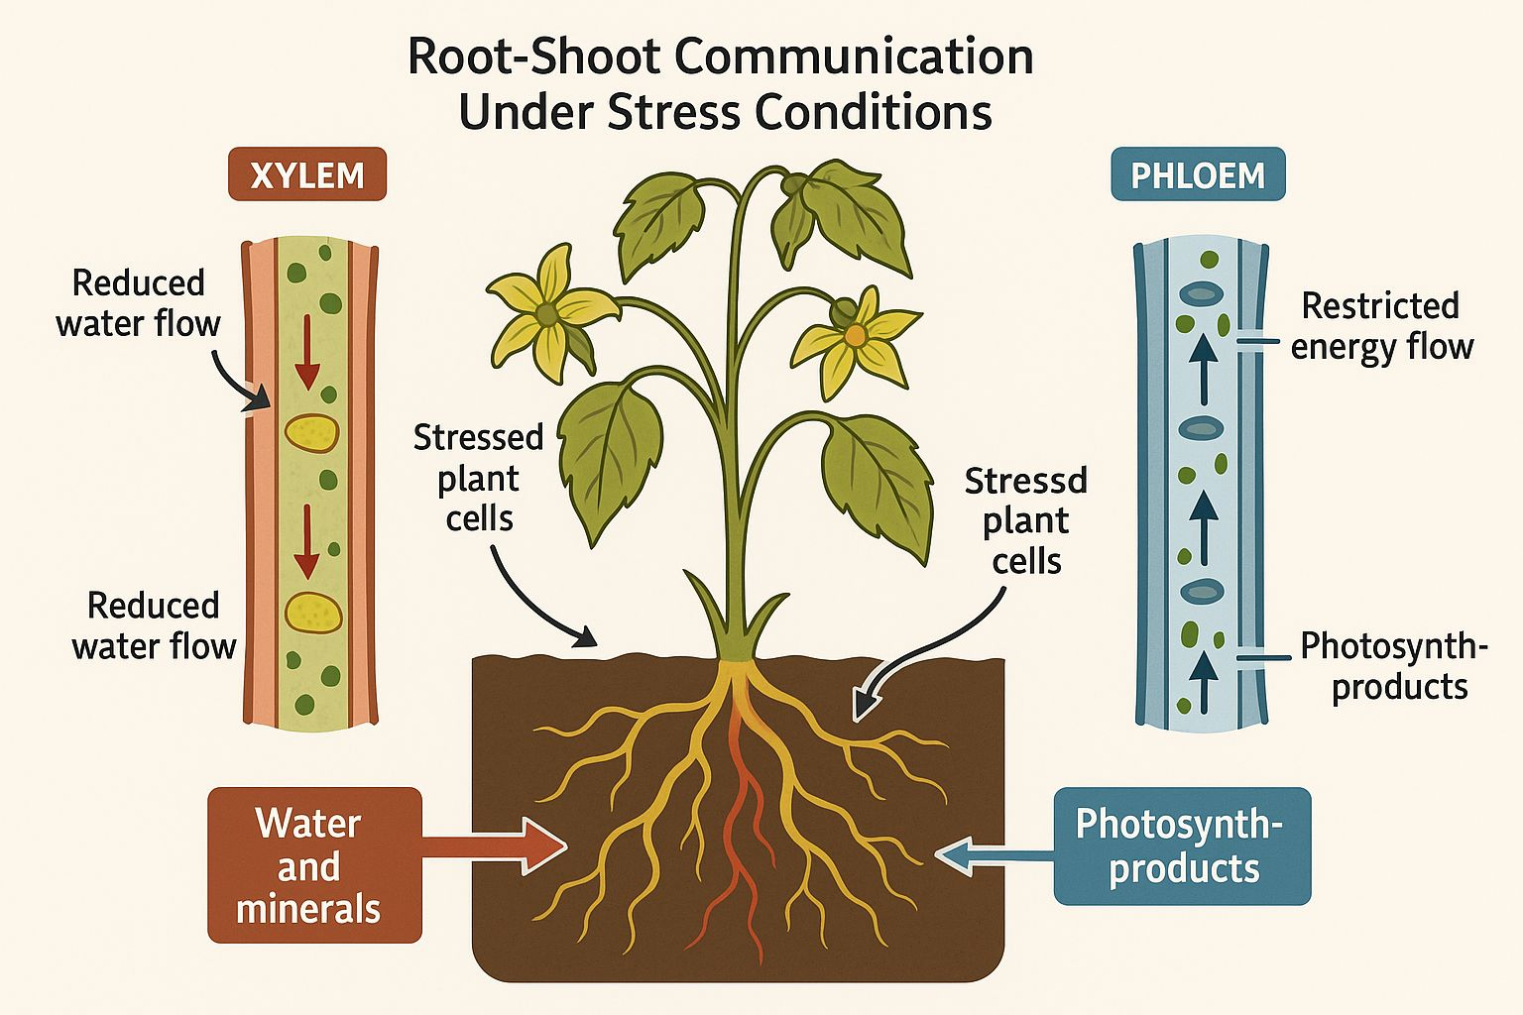

**Ways to communicate**

Water uptake in plants involves three primary pathways—apoplast, symplast, and transmembrane—that facilitate the movement of water from the soil through the root tissues to the xylem for upward transport to the shoot.

The **apoplast pathway** is the fastest route, where water moves through the cell walls and intercellular spaces without crossing any cell membranes. This passive diffusion continues until the endodermis, where the Casparian strip—a waxy, suberin-impregnated barrier—prevents water from entering the symplast. This selective barrier ensures that only essential solutes are absorbed, preventing the passive leakage of unwanted substances into the vascular system (Christmann et al 2013).

The **symplast pathway** involves water entering the root hair cells and moving from cell to cell through plasmodesmata, cytoplasmic channels that connect adjacent plant cells. This pathway is regulated by the selectively permeable plasma membranes of the root cells, allowing for controlled uptake of water and nutrients. Due to the selective filtration at each membrane, the symplast pathway is slower than the apoplast pathway.

The **transmembrane pathway** combines elements of both the apoplast and symplast pathways. Water crosses multiple plasma membranes and cytoplasm, exiting and re-entering cells. This pathway offers the most control and selectivity over ion and water uptake, allowing the plant to respond dynamically to environmental conditions (Christmann et al 2013).

Once water and minerals pass through the endodermis, they enter the xylem vessels, initiating upward transport to the shoot. Under stress conditions like drought or salinity, the rate and route of water uptake can change, triggering hormonal responses such as the production of abscisic acid (ABA). These hormones are transported to the shoot to mediate responses like stomatal closure, helping the plant conserve water and maintain homeostasis (Devireddy et al., 2018).

Fig 2: Three primary pathways of water uptake in plants

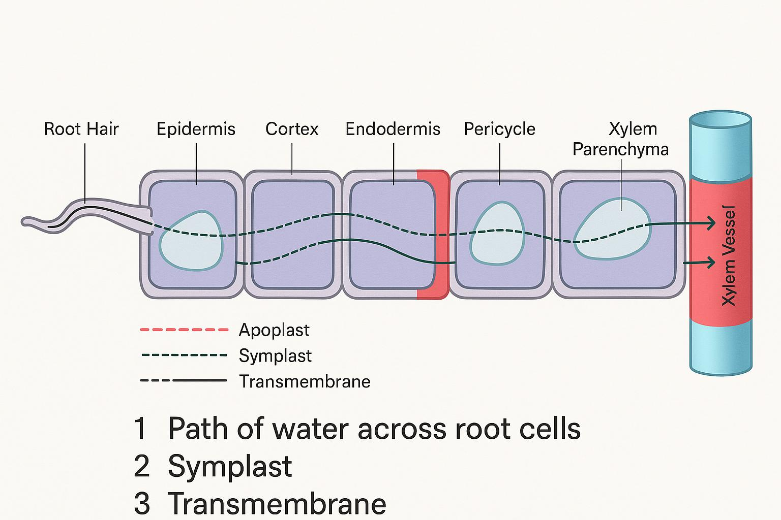

Another potential route is the vacuolar pathway, but this route is mostly restricted to water molecule movement. Here, water moves through the vacuoles of plant cells through osmosis. The mechanism is similar to the symplastic route, but instead of transport being limited to the cytosol, the water passes through the vacuoles. Further, vacuolar transport is facilitated by two proton pumps - ATPase and PPase - that energize the solute uptake. Vacuoles also comprise of specialized transport proteins - the aquaporins - that participate in the transport of water and solutes such as glucose and sucrose (Christmann *et al*., 2013).

**T.S. of Root and Shoot**

Microscopic examination of a young dicotyledonous stem reveals a well-organized internal anatomy tailored to support both physiological functions and mechanical stability. In a transverse section observed under low magnification (approximately 40x), the outermost tissue layer identified is the epidermis, which functions as a protective interface between the plant and its external environment. This layer is typically covered with a cuticular layer that serves to minimize transpirational water loss.

Beneath the epidermis lies the cortex, a broad region composed predominantly of parenchymatous cells. These cells, characterized by thin walls and large vacuoles, play a fundamental role in temporary food storage and also contribute to structural support. Delimiting the inner boundary of the cortex is the endodermis, a compact layer that regulates the selective movement of water and solutes into the central vascular tissue. Centrally positioned and often heavily stained in histological preparations, the primary xylem is readily identifiable; it is primarily involved in the acropetal transport of water and mineral nutrients absorbed by the roots.

Upon shifting to a longitudinal section at higher magnification (around 200x), greater resolution of internal tissue organization is evident. Just interior to the epidermis, collenchyma cells are observed, notable for their unevenly thickened primary cell walls. These cells impart tensile strength and flexibility, particularly in regions undergoing active growth. Proceeding inward, the primary phloem is located on the outer side of the vascular bundle and is specialized for the translocation of photoassimilates, chiefly sucrose, from source tissues such as leaves to sinks including roots and meristems.

Situated between the xylem and phloem is the vascular cambium—a lateral meristematic tissue responsible for secondary growth. Through periclinal divisions, the cambium produces secondary xylem toward the pith and secondary phloem toward the cortex, thereby contributing to the radial expansion of the stem. Additionally, scattered within the ground tissue are specialized cells containing calcium oxalate crystals, often classified as idioblasts or sclereids. These structures may serve multiple functions, including calcium regulation, deterrence of herbivory, and mechanical reinforcement. Collectively, the anatomical configuration evident in both radial and longitudinal perspectives underscores the functional complexity of dicotyledonous stems. The concentric arrangement of vascular bundles, coupled with the presence of a persistent cambial layer, is indicative of the stem’s capacity for both primary and secondary growth—hallmarks of dicot stem development.

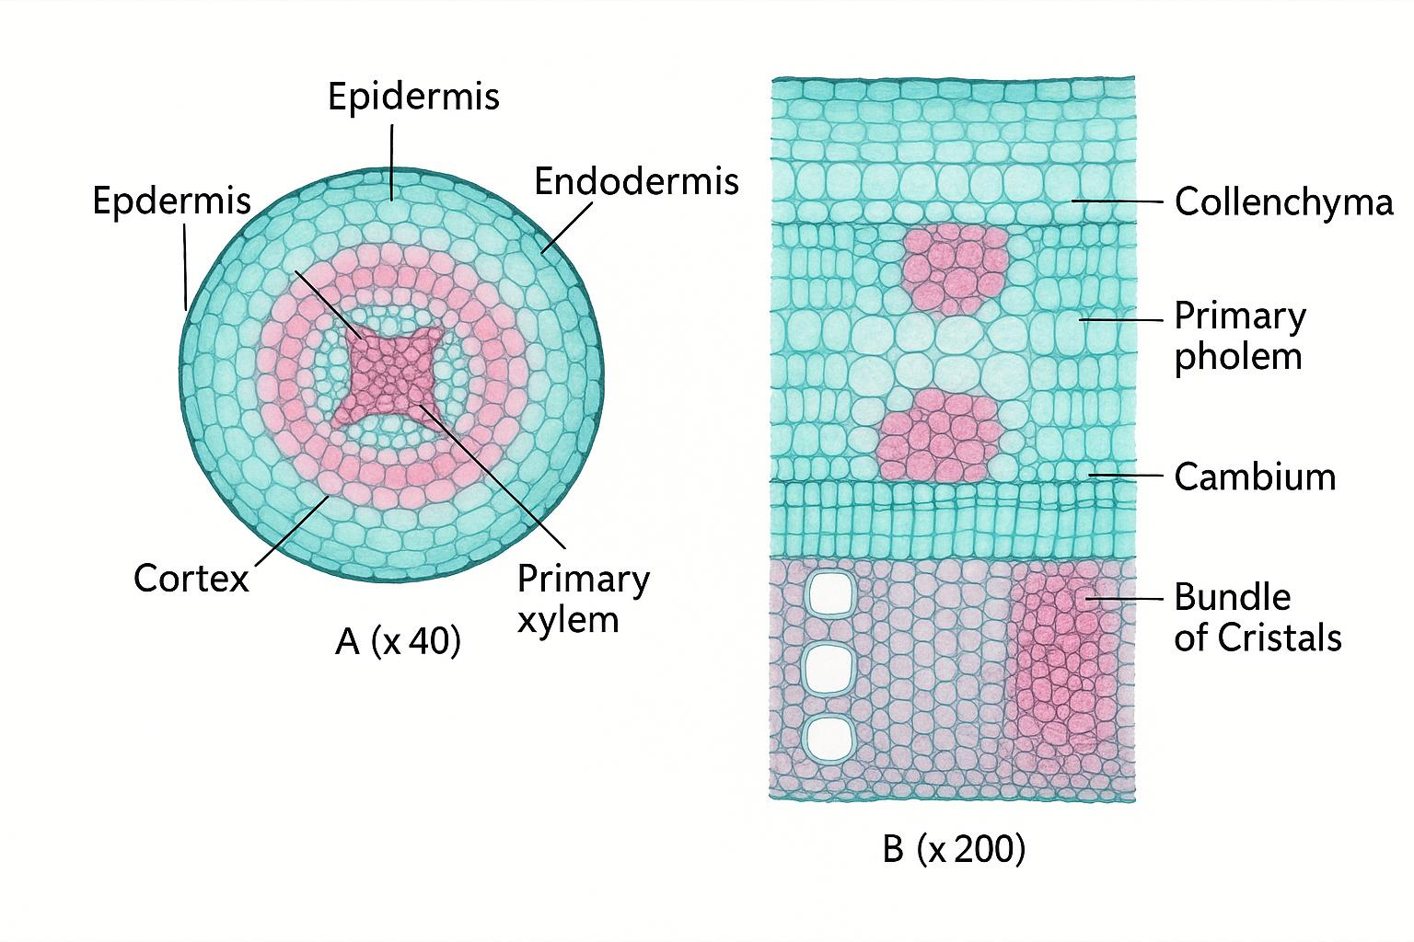

Fig .3 Transverse and longitudinal section of dicotyledonous stem

The transverse section of the upper shoot, as observed in the provided image, displays the characteristic internal structure of a dicotyledonous stem. At low magnification (×40), the stem appears circular in outline, with tissue layers arranged concentrically around a central pith. The vascular bundles form a distinct ring, a typical feature of dicot stems. At higher magnification (×200), the structural details become more evident. The outermost surface of the stem is covered by a protective cuticle, a waxy layer that minimizes water loss and acts as a barrier against external environmental stress. Emerging from the epidermis are non-glandular trichomes, or hair-like extensions, which further aid in reducing transpiration and provide physical defense. Beneath the epidermis lies the collenchyma tissue, made up of living cells with unevenly thickened walls. This tissue imparts mechanical strength and flexibility to the growing stem. Just below the collenchyma is a layer of sclerenchyma, composed of thick-walled, lignified cells that contribute to the rigidity and support of the stem. These supportive tissues ensure structural integrity, especially in the upper regions of the shoot.

Further inward, the vascular tissues are arranged in distinct bundles. The phloem, responsible for transporting the products of photosynthesis, lies toward the outer side of the bundle. Adjacent to it is the vascular cambium, a meristematic tissue that facilitates secondary growth by generating new layers of phloem and xylem. The xylem, located on the inner side of the bundle, is composed of thick-walled vessels that conduct water and minerals upward from the roots. At the center and surrounding the vascular bundles, large, thin-walled parenchyma cells occupy the pith region. These cells are primarily involved in storage, transport, and wound repair. Their loosely packed arrangement also aids in the diffusion of gases within the stem tissue. Altogether, this transverse section reveals a well-organized stem anatomy adapted for multiple essential functions—mechanical support, nutrient transport, water conduction, and secondary growth. The presence of a cuticle and trichomes reflects adaptations for reducing water loss, while the ringed vascular bundles and active cambium highlight the plant’s ability to grow and respond dynamically to its environment.

**Bottom-up approaches: stressed roots signal to shoots**

**Root-derived hydraulic signals mediate the plant shoot stress response**

Water limitation exerts a significant influence on plant growth and development by disrupting essential physiological processes. Water uptake from the soil proceeds radially towards the root xylem through multiple pathways, including the apoplastic route and the cell-to-cell pathways, which comprise transcellular transport and the symplastic pathway (Christmann et al 2013). Once water reaches the xylem, it is transported axially to the shoot following a gradient in water potential, with the lowest water potential typically found in the leaves, thereby driving upward movement. During periods of soil water deficit, root water potential decreases, leading to a rapid decline in the turgor pressure of leaf cells. This turgor loss can propagate from roots to shoots in the form of hydraulic signals (Vitali et al 2015). Notably, changes in root turgor pressure have been shown to activate local abscisic acid (ABA) signaling near the vascular bundles in the root, and also contribute to ABA accumulation in the shoot. This coordination plays a crucial role in regulating stomatal closure under water stress, suggesting a functional relationship between hydraulic signals and ABA-mediated responses. However, the precise mechanisms by which plants perceive root-derived hydraulic signals and integrate them into ABA signaling pathways remain poorly understood. Aquaporins, particularly those of the plasma membrane intrinsic protein (PIP) family, are integral membrane proteins that facilitate transcellular water transport across root cells, thereby playing a critical role in regulating root hydraulic conductivity (Lpr). Experimental evidence indicates that silencing of PIP aquaporins or treatment with aquaporin inhibitors significantly reduces Lpr, whereas overexpression of PIP-type aquaporins enhances root hydraulic conductivity. These findings highlight the importance of aquaporins in modulating water transport and signal transduction under conditions of water limitation (Postaire *et al.,* 2010; Li *et al*., 2021).

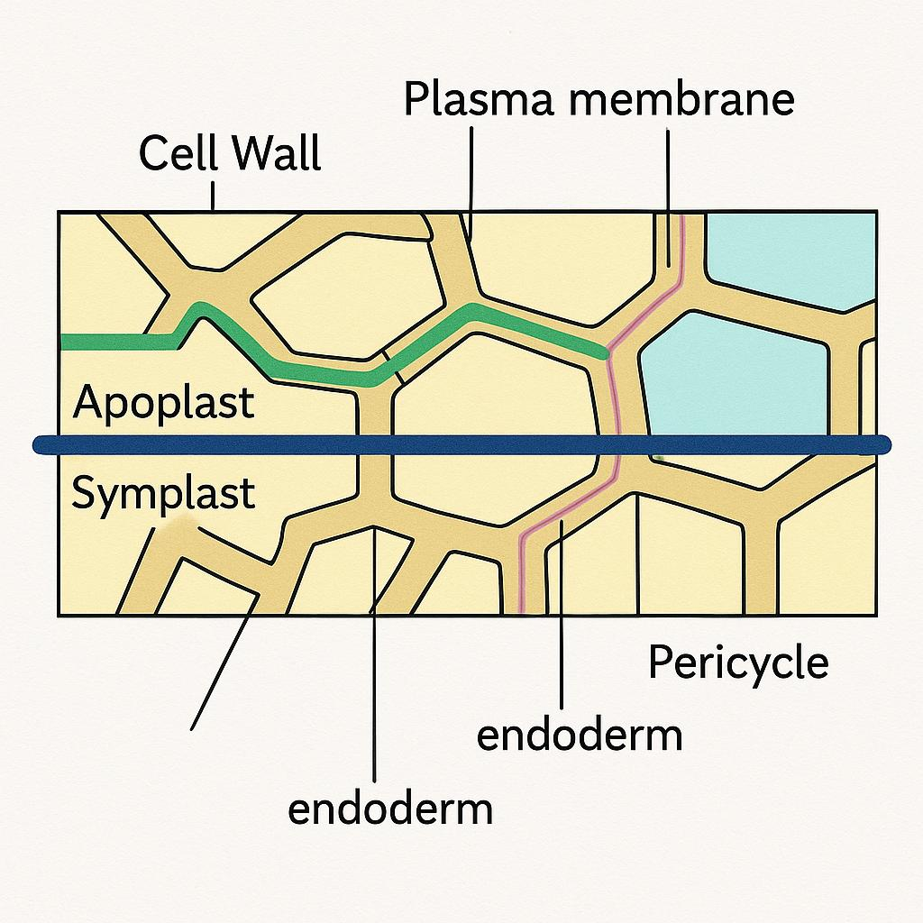

Fig .4: Pathways of Water Movement in Plant Roots: Apoplast and Symplast

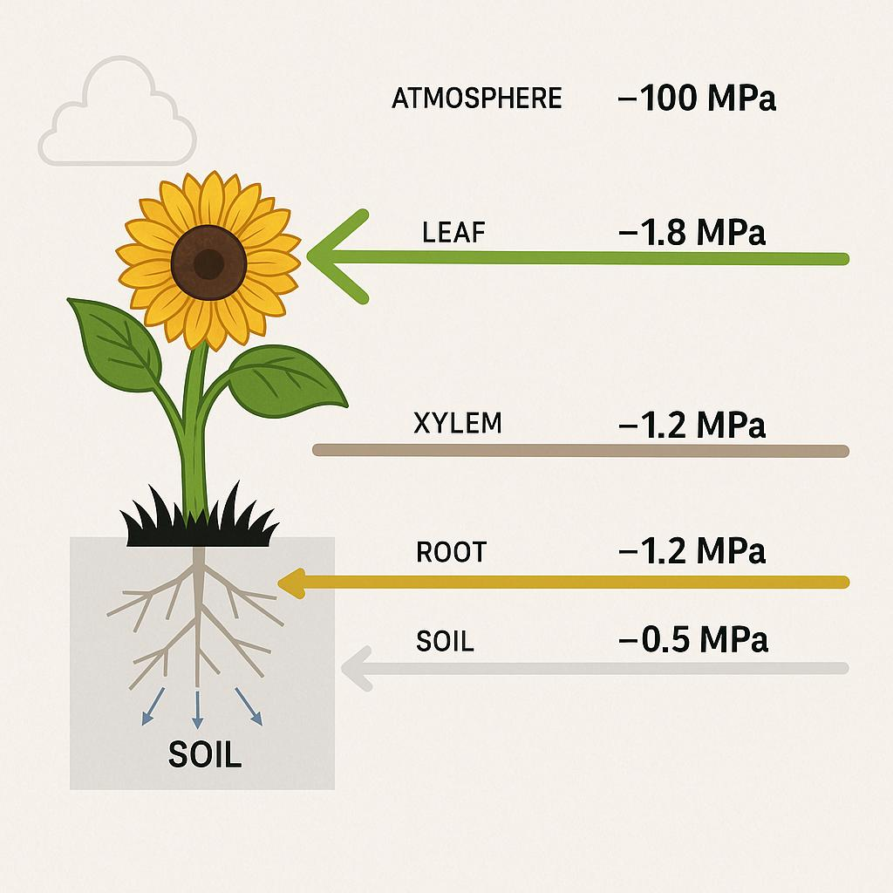

Fig .5: Water Potential Gradient in a Plant

**On the way: more mobile signals in the regulation of stomatal closure**

Abscisic acid (ABA) is a central phytohormone involved in plant responses to drought, primarily by regulating stomatal closure. Historically, ABA was believed to function as a long-distance signal produced in the roots and transported via the xylem to aerial tissues under water-deficit conditions. This was supported by observations of ABA accumulation in both roots and xylem sap during drought. However, recent grafting experiments using wild-type (WT) and ABA-deficient (aba2-1) Arabidopsis mutants have demonstrated that shoot-localized ABA biosynthesis is essential for stomatal closure (Zandainas et al 2020). Plants lacking ABA production in the shoot exhibited impaired stomatal responses, regardless of root-derived ABA, indicating that shoot-synthesized ABA is both necessary and sufficient for initiating drought responses (Postaire *et al.,* 2010).

Although root-derived ABA is not strictly required, root-to-shoot communication still plays a vital regulatory role via other mobile signals. One such signal is the peptide CLE25 (CLAVATA3/EMBRYO SURROUNDING REGION-RELATED 25), which is synthesized in roots during dehydration and transported to shoots. CLE25 induces the expression of NCED3 (NINE-CIS-EPOXYCAROTENOID DIOXYGENASE 3), a key gene in ABA biosynthesis, thereby promoting local ABA production in leaves (Li et al., 2021). Grafting studies revealed that WT roots could induce NCED3 expression in cle25 mutant shoots, while cle25 roots failed to elicit this response in WT shoots, confirming the root origin and shoot specificity of CLE25 signaling. The peptide is perceived in the shoot by receptor-like kinases BAM1 and BAM3 (BARELY ANY MERISTEM 1 and 3), and their functional loss prevents NCED3 induction. Notably, cle25 mutants show accelerated water loss under dehydration, despite normal leaf ABA levels, suggesting that CLE25 acts early and potentially in coordination with other signals to modulate stomatal behavior (Takahashi *et al*., 2019; Christmann, *et al.,* 2007).

Reactive oxygen species (ROS) and calcium ions (Ca²⁺) also serve as rapid systemic stress signals that interface with ABA signaling networks. ROS waves generated by NADPH oxidase RBOHD propagate across plant tissues and contribute to stomatal regulation under abiotic stress, such as high light or heat. Disruption of ROS production or Ca²⁺ signaling in these contexts prevents stomatal closure in non-stressed leaves, highlighting a tightly integrated ROS–Ca²⁺ response system (Evans et al., 2016). Similarly, salt stress triggers transient increases in cytosolic Ca²⁺ concentration (Ca²⁺), initiating calcium waves that travel from roots to shoots. Key proteins in this process include MOCA1 and OSCA1, which sense ionic and osmotic stress, respectively. The vacuolar channel TPC1, activated by Ca²⁺, is critical for the propagation of these waves and the activation of stress-responsive gene expression in aerial tissues. Mutants lacking RBOHD exhibit significantly slower calcium wave transmission, and modeling indicates that ROS-based signaling is essential to match observed propagation dynamics (Devireddy *et al.,* 2018).

Recently, HPCA1 (HYDROGEN PEROXIDE-INDUCED Ca²⁺ INCREASES 1), a leucine-rich repeat receptor-like kinase, has been identified as a sensor for extracellular hydrogen peroxide (eH₂O₂), facilitating ROS-induced calcium influx in guard cells. This response promotes stomatal closure via plasma membrane Ca²⁺ channels. Another receptor-like kinase, GHR1, interacts with CPK3 to activate anion channels, further enhancing closure in response to eH₂O₂. Additionally, drought stress increases sulfate transport to the shoot, and exogenous sulfate application induces stomatal closure and NCED3 expression, implicating sulfate as a potential root-to-shoot signal in drought signaling (Wu *et al*., 2020).

**Top-down organization: shoot to root signals**

**Mobile proteins transmit shoot-to-root light and temperature signals via phloem**

Plants rely on the coordination of environmental cues such as light and temperature across tissues to regulate growth, development, and circadian rhythms. Effective communication between above- and below-ground organs is essential for integrating these signals throughout the plant body. One key player in this systemic signaling is the transcription factor ELONGATED HYPOCOTYL 5 (HY5), which operates downstream of the photoreceptor-mediated light signaling pathway and plays a pivotal role in photomorphogenesis (Gangappa and Botto 2016). In Arabidopsis thaliana, the photoreceptor Phytochrome B (phyB) functions as a dual sensor of light and temperature, facilitating both the transcriptional activation and accumulation of HY5 protein in response to these stimuli (Legris et al., 2016). HY5 protein, primarily produced in the shoot, has been observed to translocate to the root, where it contributes to the promotion of primary root elongation under light conditions. This shoot-derived HY5 activates its own gene expression in root tissues and upregulates the expression of the high-affinity nitrate transporter NRT2.1, enhancing nitrogen uptake. Additionally, HY5 modulates shoot carbon metabolism by promoting the expression of SWEET11 and SWEET12, which encode sugar transporters involved in phloem loading and sucrose export. Through these mechanisms, HY5 integrates light-dependent cues to regulate both carbon and nitrogen allocation within the plant (Chen et al., 2012).

During shade-avoidance responses, far-red (FR) light detected in the shoot leads to the accumulation of HY5–YFP fusion protein in developing lateral root primordia. This accumulation negatively regulates lateral root formation by repressing the expression and activity of key auxin transporters such as PIN-FORMED 3 (PIN3) and LIKE-AUXIN TRANSPORTER 3 (LAX3), alongside the downregulation of the auxin response factor ARF19 (van Gelderen 2018). Interestingly, directly exposing roots to FR light did not reduce lateral root density, implying that the inhibitory signal originates in the shoot. Supporting this hypothesis, HY5 expression driven by either its native promoter or a phloem companion cell-specific promoter (SUC2) was sufficient to repress lateral root growth under shaded conditions, indicating that HY5 likely moves through the phloem to exert its effects. However, more recent investigations have raised questions about whether the physical translocation of HY5 is essential for its role in root elongation. A modified version of HY5 fused with an HA–YFP–HA (“DOF”) tag, which was detectable in shoots but not in roots, was still able to complement the short-root phenotype of hy5 mutants. This observation suggests that HY5 may activate a downstream mobile signal rather than traveling itself in detectable quantities, though low-level translocation of HY5 cannot be entirely excluded (Li et al., 2021).

In addition to HY5, the circadian clock component EARLY FLOWERING 4 (ELF4) has also been identified as a mobile factor capable of shoot-to-root movement. ELF4 regulates the rhythmic expression of core circadian genes in the root, including CIRCADIAN CLOCK ASSOCIATED 1 (CCA1), LATE ELONGATED HYPOCOTYL (LHY), and PSEUDO-RESPONSE REGULATORS (PRR7 and PRR9). This coordination enables the shoot circadian clock to modulate the root clock rhythmically. Interestingly, ELF4 mobility is modulated by temperature: low temperatures enhance its movement from shoot to root, whereas warm conditions restrict it. Consequently, under cool temperatures, ELF4 accumulation in roots intensifies repression of PRR9, resulting in a slower root clock rhythm. Additionally, elf4 mutants exhibit reduced lateral root density, implicating ELF4 in root developmental responses to temperature variation (Burko et al., 2020; Chen et al., 2020).

**Sugar signals regulate root growth via phloem loading and unloading**

Roots rely heavily on sucrose produced in the shoot as their primary energy source for growth and development. Under environmental stresses like drought or salinity, photosynthesis becomes less efficient, leading to reduced sucrose production and disrupted sugar allocation, which can negatively affect root development (Thalmann and Santelia 2017).

In Arabidopsis thaliana, sucrose is loaded into the phloem in the leaves by specific sugar transporters. The SWEET11 and SWEET12 proteins move sucrose from mesophyll cells into the apoplast (the cell wall space), after which the SUC2 transporter imports it into companion cells for long-distance transport to other parts of the plant. In roots, sucrose is unloaded either through apoplastic pathways (via SWEET or SUC transporters) or through symplastic pathways, which involve direct cell-to-cell cytoplasmic connections (Xu et al., 2020). Light-responsive transcription factors, particularly HY5, enhance the expression of SWEET11 and SWEET12, increasing sucrose export during the day. In potato, the mobile transcription factor StSP6A binds to the transporter StSWEET11 in stolons to reduce sucrose loss to the apoplast, instead directing more sucrose toward tubers via symplastic routes (Abelenda et al., 2019).

During drought, Arabidopsis increases the expression of SWEET11, SWEET12, and SUC2 to boost sucrose transport from shoots. However, the SUC1 transporter in roots, which helps unload sucrose, is downregulated during osmotic stress. This downregulation is controlled by ABA (abscisic acid), as ABA-responsive transcription factors like ABI5 and AREB3 suppress SUC1 expression, suggesting a mechanism by which ABA reduces carbon flow to roots under stress. Stress-induced reductions in carbon flow from shoots to roots can limit root growth. However, experiments show that supplying sucrose from cotyledons or extending light exposure can promote root elongation, emphasizing the vital role of shoot-derived carbon in root development. Drought conditions enhance sugar transporter expression to direct carbon flow toward deeper root zones, helping roots access water in lower soil layers (Durand et al., 2016; Durand et al., 2018).

This adaptive root development under stress involves the SnRK1–TOR signaling pathway, which links energy status with hormone responses. In salt-stressed roots, SnRK1 activates the transcription factors bZIP1 and bZIP53 to adjust carbohydrate metabolism, with bZIP53 acting in an ABA-dependent manner. SnRK1 also activates bZIP11, which stimulates the IAA3/SHY2 gene, reducing auxin transport to root tips and limiting primary root growth. In lateral roots, the transcription factor WOX7 inhibits root initiation by repressing CYCD6;1, a cell division gene, in a sucrose-dependent way. WOX7 works in concert with LBD16 and functions downstream of the auxin-regulated WOX11/12 pathway to control lateral root formation (Hu & Xu 2016).

**Tuning the communication channels: vasculature developmental plasticity in response to stress**

During abiotic stress, the vascular system plays a vital role in facilitating the transport of water, energy sources, and mobile signaling molecules between plant organs. Because of this central function, stress-induced modifications in vascular structure are crucial for maintaining transport efficiency. Root vascular patterning begins during embryogenesis and continues post-embryonically in the root apical meristem. Importantly, root vascular architecture exhibits considerable plasticity under environmental stress (Li et al., 2021).

**Xylem Remodeling Under Stress**

Under water deficit, Arabidopsis thaliana forms additional protoxylem strands and cellular files to enhance its water transport capacity. Similar adaptive changes also occur in other species: trees produce extra xylem vessels to prevent cavitation, and soybean roots increase the number of metaxylem vessels to improve water uptake during drought (Augusti & Blazguez 2020). Larger xylem conduit diameters correlate with increased root hydraulic conductance (Lpr) and redistribution, potentially explaining the enhanced drought resistance observed in xnd1 mutants, which exhibit expanded xylem areas. Under salt stress conditions, proper regulation of xylem structure is equally essential. ACAULIS5 (ACL5) mutants, which display abnormal xylem proliferation due to altered spermine biosynthesis, are hypersensitive to salinity and accumulate excessive sodium, suggesting that excessive xylem development can lead to unregulated ion transport (Ishikawa & Shabala 2019). ABA signaling plays a central role in xylem adaptation. During drought, endodermal ABA promotes the expression of miR165a/166b, which suppresses the HD-ZIP III transcription factor PHABULOSA (PHB), resulting in increased protoxylem formation. ABA also downregulates PHB directly at both the transcript and protein levels. Furthermore, secondary cell wall (SCW) formation, which affects xylem water permeability, is regulated by a transcriptional network involving VND7, ERF139, LBD15, and MYB86. VND7 responds to both ABA and salt stress, while LBD15 and MYB86 are upregulated by drought and salinity, indicating coordinated control of xylem differentiation and SCW deposition in stress conditions (Roy et al., 2014; Ingram et al., 2011).

**Phloem Development and Stress Responses**

Phloem also plays a crucial role during stress by transporting signaling molecules and nutrients from shoots to roots. Mutations that hinder phloem development often lead to starch buildup in shoots and disrupted auxin transport, affecting root architecture. SMXL3, SMXL4, and SMXL5 are essential regulators of early phloem development, with SMXL4 expression responding to ABA and salt stress. smxl4 mutants exhibit hypersensitivity to drought and salinity, showing reduced root growth under stress. SMXL3 is regulated by PEAR2, a transcription factor that promotes procambial cell division, a process opposed by HD-ZIP III proteins. During drought, ABA suppresses HD-ZIP III activity, indicating that the PEAR2–SMXL3 module may contribute to stress-responsive vascular development (Miyashima et al., 2019; Rodriguez-Villalon et al 2014).

Several additional regulators of phloem formation also integrate with stress signaling. The plasma membrane protein BRX is essential for protophloem sieve element development and interacts with auxin, brassinosteroid (BR), and ABA signaling. brx1 mutants show disrupted root phloem and increased ABA sensitivity. CLE peptides, such as CLE45 and CLE26, suppress protophloem differentiation and inhibit primary root growth, and are upregulated by environmental cues (Graeff et al., 2020). CLE45 is perceived by BAM3 and RLK2 receptors, which control phloem identity and maintain developmental plasticity in the root meristem. Interestingly, CLE45 signaling is opposed by local BR perception, which promotes phloem differentiation and potentially activates a mobile signal to rescue patterning defects in BR-insensitive mutants. Other stress-responsive phloem regulators include JUL1 (an E3 ubiquitin ligase) and NAC020, both of which respond to salinity and other abiotic factors (Czyzewicz et al., 2015).

**Conclusion**

Recent studies have revealed that mobile signals—such as proteins, RNAs, sugars, peptides, ROS, and Ca²⁺—enable tight coordination between shoots and roots under abiotic stress. These signals help balance growth and stress responses across the whole plant. Advances in single-cell sequencing and ‘omics’ technologies have improved our ability to identify these signals and understand vascular plasticity. However, much remains unknown about how vascular development and signaling adapt under stress. Future research should focus on uncovering the regulatory networks that shape vascular structure and function, ultimately enhancing plant resilience in challenging environments. Environmental stresses, such as drought and salinity, prompt significant remodeling of the plant vascular system. In the xylem, stress-induced ABA signaling and specific transcriptional networks modulate xylem vessel number, diameter, and secondary cell wall formation to improve water transport. In the phloem, development is regulated by a suite of transcription factors and peptides (e.g., SMXLs, PEAR2, BRX, CLE45) whose expression is often stress-responsive. Although phloem plasticity under stress remains less understood than xylem adaptation, emerging evidence suggests that environmental signals influence both phloem structure and function, ensuring proper root growth and survival during adverse conditions.

**References**

Abelenda, J. A., Bergonzi, S., Oortwijn, M., Sonnewald, S., Du, M., Visser, R. G., Sonnewald, U & Bachem, C. W. (2019). Source-sink regulation is mediated by interaction of an FT homolog with a SWEET protein in potato. *Current Biology*, *29*(7), 1178-1186.

Agusti, J. and Blazquez, M.A. (2020) Plant vascular development: mechanisms and environmental regulation. Cell. Mol. Life Sci. 77, 3711–3728

Aroca, R. (2012). Plant responses to drought stress. *From morphological to molecular features*, 1-5.

Burko, Y., Gaillochet, C., Seluzicki, A., Chory, J., & Busch, W. (2020). Local HY5 activity mediates hypocotyl growth and shoot-to-root communication. *Plant communications*, *1*(5).

Chen, L. Q., Qu, X. Q., Hou, B. H., Sosso, D., Osorio, S., Fernie, A. R., & Frommer, W. B. (2012). Sucrose efflux mediated by SWEET proteins as a key step for phloem transport. *Science*, *335*(6065), 207-211.

Chen, W. W., Takahashi, N., Hirata, Y., Ronald, J., Porco, S., Davis, S. J., Nusinow, D.A., Kay, S.A. & Mas, P. (2020). A mobile ELF4 delivers circadian temperature information from shoots to roots. *Nature plants*, *6*(4), 416-426.

Christmann, A., Grill, E., & Huang, J. (2013). Hydraulic signals in long-distance signaling. *Current opinion in plant biology*, *16*(3), 293-300.

Christmann, A., Weiler, E. W., Steudle, E., & Grill, E. (2007). A hydraulic signal in root‐to‐shoot signalling of water shortage. *The Plant Journal*, *52*(1), 167-174.

Davière, JM., Achard, P. Organ communication: Cytokinins on the move. *Nature Plants* **3**, 17116 (2017). <https://doi.org/10.1038/nplants.2017.116>

**Devireddy, A. R., Zandalinas, S. I., Gómez‑Cadenas, A., Blumwald, E., & Mittler, R. (2018).**  
Coordinating the overall stomatal response of plants: Rapid leaf‑to‑leaf communication during light stress. *Science Signaling,11*(518), eaam9514.

Durand, M., Mainson, D., Porcheron, B., Maurousset, L., Lemoine, R., & Pourtau, N. (2018). Carbon source–sink relationship in Arabidopsis thaliana: the role of sucrose transporters. *Planta*, *247*, 587-611.

Durand, M., Porcheron, B., Hennion, N., Maurousset, L., Lemoine, R., & Pourtau, N. (2016). Water deficit enhances C export to the roots in Arabidopsis thaliana plants with contribution of sucrose transporters in both shoot and roots. *Plant physiology*, *170*(3), 1460-1479.

Evans, M. J., Choi, W. G., Gilroy, S., & Morris, R. J. (2016). A ROS-assisted calcium wave dependent on the AtRBOHD NADPH oxidase and TPC1 cation channel propagates the systemic response to salt stress. Plant Physiology, 171(3), 1771-1784.

Gangappa, S. N., & Botto, J. F. (2016). The multifaceted roles of HY5 in plant growth and development. *Molecular plant*, *9*(10), 1353-1365.

Graeff, M., Rana, S., Marhava, P., Moret, B., & Hardtke, C. S. (2020). Local and systemic effects of brassinosteroid perception in developing phloem. *Current Biology*, *30*(9), 1626-1638.

Hu, X., & Xu, L. (2016). Transcription factors WOX11/12 directly activate WOX5/7 to promote root primordia initiation and organogenesis. *Plant Physiology*, *172*(4), 2363-2373.

Ingram, P., Dettmer, J., Helariutta, Y., & Malamy, J. E. (2011). Arabidopsis Lateral Root Development 3 is essential for early phloem development and function, and hence for normal root system development. *The Plant Journal*, *68*(3), 455-467.

Ishikawa, T., & Shabala, S. (2019). Control of xylem Na+ loading and transport to the shoot in rice and barley as a determinant of differential salinity stress tolerance. *Physiologia Plantarum*, *165*(3), 619-631.

Legris, M., Klose, C., Burgie, E. S., Rojas, C. C. R., Neme, M., Hiltbrunner, A., ... & Casal, J. J. (2016). Phytochrome B integrates light and temperature signals in Arabidopsis. *Science*, *354*(6314), 897-900.

Li, H., Testerink, C. & Zhang, Y. (2021). How roots and shoots communicate through stressful times. *Trends in Plant Science*.

Miyashima, S., Roszak, P., Sevilem, I., Toyokura, K., Blob, B., Heo, J. O., & Helariutta, Y. (2019). Mobile PEAR transcription factors integrate positional cues to prime cambial growth. *Nature*, *565*(7740), 490-494.

Osterlund, M. T., Hardtke, C. S., Wei, N., & Deng, X. W. (2000). Targeted destabilization of HY5 during light-regulated development of Arabidopsis. *Nature*, *405*(6785), 462-466.

Postaire, O., Tournaire-Roux, C., Grondin, A., Boursiac, Y., Morillon, R., Schäffner, A. R., & Maurel, C. (2010). A PIP1 aquaporin contributes to hydrostatic pressure-induced water transport in both the root and rosette of Arabidopsis. *Plant physiology*, *152*(3), 1418-1430.

Rodriguez-Villalon, A., Gujas, B., Kang, Y. H., Breda, A. S., Cattaneo, P., Depuydt, S., & Hardtke, C. S. (2014). Molecular genetic framework for protophloem formation. *Proceedings of the National Academy of Sciences*, *111*(31), 11551-11556.

Takahashi, F., and Shinozaki, K. (2019)**.** Long‑distance signaling in plant stress response. *Current Opinion in Plant Biology, 47*, 106–111.

Thalmann, M., & Santelia, D. (2017). Starch as a determinant of plant fitness under abiotic stress. *New phytologist*, *214*(3), 943-951.

van Gelderen, K., Kang, C., Paalman, R., Keuskamp, D., Hayes, S., & Pierik, R. (2018). Far-red light detection in the shoot regulates lateral root development through the HY5 transcription factor. *The Plant Cell*, *30*(1), 101-116.

Vitali, V., Bellati, J., Soto, G., Ayub, N. D., and Amodeo, G. **(2015).**  
Root hydraulic conductivity and adjustments in stomatal conductance: Hydraulic strategy in response to salt stress in a halotolerant species. *AoB Plants, 7*, plv136.

Wessels, B., Seyfferth, C., Escamez, S., Vain, T., Antos, K., Vahala, J., Delhomme, N., Kangasjarvi, J., Eder, M., Felten, J & Tuominen, H. (2019). An AP 2/ERF transcription factor ERF 139 coordinates xylem cell expansion and secondary cell wall deposition. *New Phytologist*, *224*(4), 1585-1599.

Wu, F., Chi, Y., Jiang, Z., Xu, Y., Xie, L., Huang, F., ... & Pei, Z. M. (2020). Hydrogen peroxide sensor HPCA1 is an LRR receptor kinase in Arabidopsis. *Nature*, *578*(7796), 577-581.

Xu, Q., Yin, S., Ma, Y., Song, M., Song, Y., Mu, S., Li, Y., Ren, Y., Gao, C & Liesche, J. (2020). Carbon export from leaves is controlled via ubiquitination and phosphorylation of sucrose transporter SUC2. *Proceedings of the National Academy of Sciences*, *117*(11), 6223-6230.

Zandalinas, S. I., Fichman, Y., Devireddy, A. R., Sengupta, S., Azad, R. K., & Mittler, R. (2020). Systemic signaling during abiotic stress combination in plants. *Proceedings of the National Academy of Sciences*, *117*(24), 13810-13820.