Original Research Article

“Dryland Despair to Hope: Constraints and Suggestions Expressed by Groundnut Growers in Central Dry-Zone of Karnataka”

ABSTRACT
Groundnut is the most important crop among the oilseed crops grown in the country. Groundnut is considered as the world’s fourth largest source of edible oil and third most important source of vegetable protein. It is also a major oilseed legume crop in India and meets about 30 per cent of the edible oil requirements in the country. Present study was conducted in Chitradurga district of Karnataka state to identify the constraints in adoption of groundnut production technology. 60 groundnut growers were selected among them 30 small farm growers and 30 big farm growers were selected randomly. The data were collected through interview schedule. Results indicates that high wage rates, uneven distribution of rainfall, disease and pest incidence, price fluctuation and non-availability of quality inputs like seeds fertilizers and seeds at right time with mean score of 3.00 were major constraints faced by small and big farm groundnut growers and also groundnut growers expressed some suggestions like provide seeds and fertilizer at reasonable cost and at a right time, soil and water conservation technologies, incentives and subsidies for inputs and providing minimum support prices for the produce.
Keywords: Groundnut growers, Constraints, Oilseeds.
- INTRODUCTION
Groundnut (Arachis hypogaea L.), also known as peanut or monkey nut, belongs to the family Papilionaceae, the largest and most important of the three subfamilies under Leguminaceae. It is one of the most significant oilseed crops cultivated in India, playing a vital role in the livelihoods of millions of small and marginal farmers. Karnataka is among the leading groundnut-producing states in the country, particularly in its semi-arid regions. The Central Dry Zone of Karnataka, which includes districts such as Tumkur, Chitradurga, and parts of Davanagere, is a prominent groundnut-growing region due to its favorable agro-climatic conditions and suitable soil types. However, despite its potential, groundnut cultivation in this region faces numerous challenges that hamper both productivity and profitability.
At the national level, groundnut is cultivated on approximately 5.74 million hectares, producing 10.13 million tonnes with an average productivity of 1,777 kg/ha. In Karnataka, groundnut covers about 0.56 million hectares, yielding approximately 0.48 million tonnes, with a comparatively low productivity of 846 kg/ha. In the Chitradurga district specifically, groundnut is cultivated on 0.16 million hectares, producing 0.14 million tonnes with a productivity of 849 kg/ha (Anonymous, 2021).
Despite groundnut being a key crop for the Central Dry Zone of Karnataka, its cultivation is significantly constrained by multiple agronomic, socio-economic, and institutional factors. Farmers face issues such as erratic rainfall, poor soil fertility, low adoption of improved technologies, high input costs, limited access to quality seeds, pest and disease outbreaks, and insufficient market support. These constraints have collectively led to low productivity and reduced profitability, thereby threatening the sustainability of groundnut cultivation in the region. Addressing these challenges through research, policy intervention, and farmer-centric solutions is crucial to enhance production, income, and livelihood security of groundnut growers in the Central Dry Zone.
Objective of the study
- To identify the major constraints in groundnut production and to seek suggestions from groundnut growers

- METHODOLOGY
The study was conducted in Chitradurga district of Karnataka, during the year 2023-24. Out of six taluks, Hiriyur, Challakere and Molkalmur were purposively selected for the study since these taluks have major areas under groundnut cultivation compared to other taluks. from each taluk 20 groundnut growers were selected among them 10 small farm growers and 10 big farm growers were selected randomly. Thus, 30 small groundnut farm growers and 30 big groundnut farm growers were selected. Which constitutes a total sample size of 60 from three taluks.
The personal interview schedule was prepared in light of the decided objectives and variables undertaken. Constraints and suggestions were measured by close-ended responses of the respondents with the help of a pre-tested schedule developed for the purpose. The data were collected through personal interviews with the help of a survey schedule. The data were analyzed and find out the percentage, mean and rank order. An ex-post facto research design with simple random sampling technique was adopted to carry out the study.

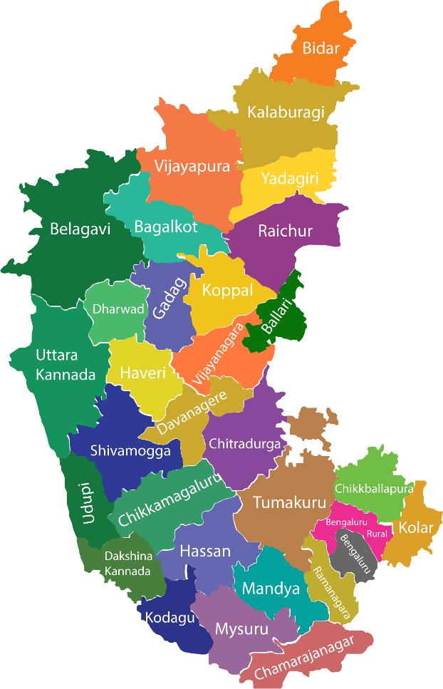

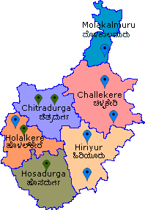

Karnataka state
Fig. 1: Map of the study area
- RESULTS AND DISCUSSION
The constraints faced by groundnut growers which had 4 components like production constraints, marketing constraints, technical constraints and financial constraints which were expressed by the groundnut growers.
  - Production constraints perceived by groundnut growers
Table 1 depicts that, both small and big farm growers expressed high wage rates, uneven distribution of rainfall, disease and pest incidence as the most significant production constraints with a mean score of 3.00. These issues are critical as they directly impact the ability of farmers to manage labour costs, deal with climatic variability and maintain healthy crops. The outcomes were consistent with the findings of Kiran (2014) and Manohar et al., (2020).
In case of small farm growers, high wages, uneven rainfall and pest and disease issues are particularly challenging due to their limited resources. The limited availability of family labour ranks fourth with mean score of 2.47 reflecting the dependency on family members for farm work which can become a bottleneck during peak agricultural periods. Financial limitations also play a significant role as limited access to financial resources ranks fifth with mean score of 2.27. Other notable constraints include intercropping challenges, which hinder mechanization (ranked sixth) with the mean score of 1.93 and a lack of awareness about recommended cropping sequences (ranked seventh) with the mean score of 1.90.
Among Big farm growers share the same top production constraints as small farmers, but they face additional challenges. The scarcity of family labour ranked fourth with mean score of 2.50 is a significant issue highlight the need for additional hired labour or mechanization. Intercropping issues that complicate mechanization are also a concern ranked fifth with mean score of 2.03. Limited availability of financial source, though less severe than for small farmers, still ranks as a notable constraint (ranked sixth) with mean score of 1.97.
Table 1: Production constraints perceived by groundnut growers
(n=60)
Sl.  No. | Constraints | Small farm growers  (n_{a} =30) |  | Big farm growers  (n_{b}=30) |  | Total  (n=60)
Sl.  No. | Constraints | Mean  score | Rank | Mean  score | Rank | Mean  score | Rank
1 | Wage rates are high | 3.00 | I | 3.00 | I | 3.00 | I
2 | Limited access to financial resources | 2.27 | V | 1.97 | VI | 2.12 | V
3 | Lack of awareness about recommended cropping sequences | 1.90 | VII | 1.80 | VII | 1.85 | VII
4 | Intercropping-come in the way of mechanization | 1.93 | VI | 2.03 | V | 1.98 | VI
5 | Limited availability of family labour | 2.47 | IV | 2.50 | IV | 2.48 | IV
6 | Uneven distribution of rainfall | 3.00 | I | 3.00 | I | 3.00 | I
7 | Disease and pest incidence | 3.00 | I | 3.00 | I | 3.00 | I
3.2 Marketing Constraints perceived by groundnut growers
From Table 2 depicts Price fluctuation is the top marketing constraint for both small and big farm growers with a mean score of 3.00. This issue creates financial instability and makes it difficult for farmers to predict and secure adequate income from their produce.
Among small farm growers, addition to price fluctuations small farm growers face significant marketing challenges due to low price for their produce (ranked first) with mean score of 3.00 and exploitation by middlemen (ranked third) with mean score of 2.47. The lack of storage facilities (ranked fourth) with mean score of 1.93 and the absence of timely market information (ranked fifth) with mean score of 1.77. Further exacerbate their difficulties in securing fair returns for their crops.
In case of big farm growers, price fluctuation ranks top marketing constraint (mean score 3.00) and low price for their produce (ranked second) with mean score of 2.97. However, the exploitation by middlemen (ranked third) with mean score of 2.73 is also a significant concern indicating that even larger-scale operations are not immune to unfair market practices. Additional challenges include lack of storage facilities (ranked fourth) with mean score of 1.93 and transportation difficulties (ranked fifth) with mean score of 1.90 which complicate the logistics of managing larger volumes of produce. This investigation result is in line with findings of Meghana (2023) and Mutteppa et al., (2024).

Table 2: Marketing Constraints perceived by groundnut growers
(n=60)
Sl.  No. | Constraints | Small farm growers  (n_{a} =30) |  | Big farm growers  (n_{b}=30) |  | Total  (n=60)
Sl.  No. | Constraints | Mean  score | Rank | Mean  score | Rank | Mean  score | Rank
1 | Lack of storage facility | 1.93 | IV | 1.93 | IV | 1.93 | IV
2 | Lack of timely market information | 1.77 | V | 1.53 | VI | 1.65 | VI
3 | Lack of transportation | 1.63 | VI | 1.90 | V | 1.77 | V
4 | Price fluctuation | 3.00 | I | 3.00 | I | 3.00 | I
5 | Low price for the produce | 3.00 | I | 2.97 | II | 2.98 | II
6 | Exploitation by middlemen in the market | 2.47 | III | 2.73 | III | 2.60 | III
3.3 Technical Constraints perceived by groundnut growers
Table 3 indicates that non-availability of quality inputs such as seeds, pesticides and insecticides at right time ranks a top technical constraint for both small and big growers with mean score of 3.00. This challenge is critical as it directly affects crop productivity and quality. The investigation results in line with Meghana (2023).
In case of small farm growers, lack of technical guidance about production techniques (ranked second) with mean score of 1.87 and the unavailability of relevant literature in the local language (ranked third) with mean score of 1.60. These issues indicate a need for improved access to technical support and educational resources that are both timely and understandable.
Among big farm growers, non-availability of quality inputs as their most significant technical constraint. They face challenges with a lack of technical guidance (ranked second) with mean score of 1.90 and the absence of relevant literature in the local language (ranked third) with mean score of 1.47. These issues underscore the need for better technical resources that can support larger-scale farming operations.

Table 3: Technical Constraints perceived by groundnut growers
(n=60)
Sl.  No. | Constraints | Small farm growers  (n_{a} =30) |  | Big farm growers  (n_{b}=30) |  | Total  (n=60)
Sl.  No. | Constraints | Mean  score | Rank | Mean  score | Rank | Mean  score | Rank
1 | Non-availability of quality inputs like seeds, pesticides and insecticides at right time | 3.00 | I | 3.00 | I | 3.00 | I
2 | Lack of technical guidance about production techniques | 1.87 | II | 1.90 | II | 1.88 | II
3 | Lack of relevant literature in local language | 1.60 | III | 1.47 | III | 1.53 | III

3.4 Financial Constraints perceived by groundnut growers
Financial constraints are a significant challenge for both small and big farm growers with high cost of production being a critical issue especially for small farm growers.
Among small farm growers, high cost of production ranks first with mean score of 3.00, insufficient incentives and subsidies (ranked second) with mean score of 2.97 and lack of credit availability (ranked third) with mean score of 2.43 creates financial barriers that limit their ability to invest in and scale their operations. The results are aligned with Vijayraj (2019).
Big farm growers were particularly burdened by the high cost of production ranks first with mean score of 2.97. This is a major concern given the scale of their operations and the associated expenses. The lack of incentives and subsidies also ranks high (raked second) with mean score of 2.90 highlight the need for more substantial policy support. While the lack of credit availability (ranked third) with mean score of 2.33 is less of a concern for big farm growers compared to small ones it still represents a significant financial constraint.
Groundnut growers face a range of constraints that span across production, marketing, technical and financial dimensions. While high wages, uneven distribution of rainfall, pest and disease incidence, non-availability of quality inputs like seeds, pesticides, insecticides at right time and price fluctuations were recognized as major challenges the specific impact of these constraints varies between small and big farm growers. Small farm growers are more affected by high cost of production, financial limitations, lack of technical guidance and market access issues, while big farm growers are heavily burdened by labour scarcity and challenges related to mechanization. Addressing these constraints requires a comprehensive approach that includes targeted financial support, improved market access, better technical resources and enhanced infrastructure to ensure the sustainability and profitability of groundnut farming across different scales. This investigation result is in line with Preethi (2021).

Table 4: Financial Constraints perceived by groundnut growers
(n=60)
Sl.  No. | Constraints | Small farm growers  (n_{a} =30) |  | Big farm growers  (n_{b}=30) |  | Total  (n=60)
Sl.  No. | Constraints | Mean  score | Rank | Mean  score | Rank | Mean  score | Rank
1 | Lack of credit availability | 2.43 | III | 2.33 | III | 2.38 | III
2 | High cost of production | 3.00 | I | 2.97 | I | 2.98 | I
3 | Lack of incentives and subsidies | 2.97 | II | 2.90 | II | 2.93 | II
3.5 Suggestions expressed by groundnut growers to overcome constraints
From Table 5 indicates that small farm groundnut growers, the top priorities, are the provision of a Minimum Support Price (MSP), access to seeds and fertilizers at reasonable costs and timely availability, and incentives and subsidies for inputs. Following these, there is significant interest in training on the latest improved technologies (70.00 %) and promoting soil and moisture conservation technologies (66.66 %). Skill teaching about seed treatment with insecticides and Trichoderma (46.67 %) and creating awareness about the importance of potash and gypsum (33.33 %) are less prioritized but still noted as important.
Among big groundnut farmers, the highest priorities are the Minimum Support Price (MSP), access to affordable inputs, and incentives and subsidies, each supported by cent per cent of the growers. Big farm growers also show strong interest in promoting soil and moisture conservation technologies (83.33 %) and training on the latest improved technologies (76.66 %). Additionally, they place a higher emphasis on creating awareness about the importance of potash and gypsum (70.00 %) and skill teaching about seed treatment (63.33 %) compared to small farmers.
When considering groundnut growers combined, the unanimous top priorities are the provision of a Minimum Support Price (MSP), access to seeds and fertilizers at reasonable costs and timely availability, and incentives and subsidies for inputs. These are followed by a strong collective interest in promoting soil and moisture conservation technologies (75.00 %) and training on the latest improved technologies (73.33 %). Skill teaching about seed treatment with insecticides and Trichoderma (55.00 %) and raising awareness about the importance of potash and gypsum (51.67 %) are recognized as important suggestions. The results are conformity with the study conducted by Preethi (2021).
Table 5: Suggestions expressed by the groundnut growers to overcome the constraints
(n=60)
Sl.  No. | Suggestions | Small farm growers  (n_{a} =30) |  | Big farm growers  (n_{b}=30) |  | Total  (n=60)
Sl.  No. | Suggestions | No. | % | No. | % | No. | %
1 | Providing minimum support price | 30 | 100.00 | 30 | 100.00 | 60 | 100.00
2 | Skill teaching about seed treatment with insecticide and Trichoderma | 14 | 46.67 | 19 | 63.33 | 33 | 55.00
3 | Promote soil and moisture conservation technologies | 20 | 66.66 | 25 | 83.33 | 45 | 75.00
4 | Training on latest improved technologies | 21 | 70.00 | 23 | 76.66 | 44 | 73.33
5 | Provide seeds and fertilizer at reasonable cost and at a right time | 30 | 100.00 | 30 | 100.00 | 60 | 100.00
6 | Create awareness about importance of potash and gypsum | 10 | 33.33 | 21 | 70.00 | 31 | 51.67
7 | Incentives and subsidies for inputs | 30 | 100.00 | 30 | 100.00 | 60 | 100.00

POLICY IMPLICATIONS
- Most of the oil seed growers sell their produce immediately after harvest to local traders to meet their financial needs. Thus, it's essential to strengthen institutional support by offering credit facilities at right time at reasonable interest rate and motivating farmers to sell their produce through APMCs for higher prices or through the creation of farmer interest groups.
- Constraints like high wage rates, incidence of pests & diseases, uneven rainfall, low price for the produce and price fluctuations are major problems faced by growers in production and marketing. Hence, appropriate policies may be formulated for safeguarding the interests of farmers. Soil and moisture conserving technologies, remunerative minimum support price for produce and market intelligence facilities are to be ensured for the growers.
- Availability of the required amount of inputs at right time at reasonable cost is to be made available to farmers through Raitha Samparka Kendras and societies during cropping seasons.
CONCLUSION
The present study briefed about the constraints faced by respondents in the study area. It was found that greater extent of groundnut growers were practicing all operations in groundnut cultivation practices, but expressed high wages rate, uneven rainfall, low market price and lack of quality inputs as major constraints faced by them so there is need to furnish low cost technologies, soil and moisture conserving technologies and availability of the required amount of inputs at right time at reasonable cost is to be made available to farmers through Raitha Samparka Kendras and societies during cropping seasons.
REFERENCE
ANONYMOUS., 2021, Ministry of agriculture, cooperation and Farmers welfare, Govt. of India. https://www.indiastatagri.com, 2020-2021.
KIRAN, R., 2014, Economics of groundnut based cropping systems in Pavagada taluk of Tumkur district. M. Sc. Thesis (Unpub.), Univ. Agric. Sci., Bangalore.
MANOHAR, K. N., BELLI, R. B., GOTYAL, S. H. AND CHAVAN, S. S., 2020, Constraints faced by the sericulture farmers in adoption of recommended sericulture cultivation practices in Northern Karnataka. Agric. Update., 15 (4): 289-292.
MEGHANA, N., 2023, Performance of farmers practicing groundnut based cropping systems in Tumakur district. M. Sc. Thesis (Unpub.), Univ. Agric. Sci. Bangalore.
MUTTEPPA CHIGADOLLI., SHIVALINGAIAH, Y. N. AND VEERSHETTY., 2024, Navigating challenges and solutions: Insights into improved turmeric cultivation practices in Karnataka. Int. J. Agric. Ext. Soc. Dev., 7 (10): 475-482.
PREETHI, Y. H., 2021, Performance and marketing behavior of areca growers of totautpannagala marata shankara sangha niyamith (TUMCOS) in Davanagere district. M. Sc. (Agri.) Thesis (Unpub), Univ. Agric. Sci., Bangalore.
VIJAYRAJ, D. M., 2019, An analysis of yield gap, technological gap and constraints in sunflower production of Chamarajanagar district. M. Sc. (Agri.) Thesis (Unpub.), Univ. Agric. Sci., Bangalore.

