DEVELOPMENT AND EVALUATION OF AUTOMATIC INTER AND INTRA-ROW WEEDER FOR WIDE SPACED CROPS

Abstract:
A tractor-mounted automatic inter and intra-row weeder was developed to address the challenges of labour-intensive weed management in wide-spaced crops such as cotton. The machine integrated a pivoting arm, rotary blades, ultrasonic sensors, and a microcontroller-based control system for precision weeding. The intra-row blade was actuated by a geared DC motor, while the inter-row blade was driven using the tractor power take-off (PTO). Field experiments were conducted at Dr. NTR College of Agricultural Engineering, Bapatla, on sandy loam soil with three plant spacings (45, 50, and 60 cm), three tractor forward speeds (1.5, 2.0, and 2.5 km/h), and three blade rotational speeds (180, 220, and 260 rpm). Performance was evaluated based on weeding efficiency, plant damage, and field capacity. The highest weeding efficiency (85%) was observed at 60 cm spacing with a speed-blade combination of S1B3 (1.5 km/h and 260 rpm), while the lowest plant damage (8%) occurred with S1B1 (1.5 km/h and 180 rpm). Wider plant spacings consistently resulted in better performance due to improved manoeuvrability and reduced crop interference. The results demonstrated that the developed prototype could significantly enhance weed control with minimal crop damage and improved operational efficiency, making it a viable solution for precision agriculture in wide-row cropping systems.
Keywords: Automatic, Field Capacity, Microcontroller, Ultrasonic Sensors, Weeding Efficiency.
1. INTRODUCTION
In Indian agriculture, weed management is the very important aspect in the production of crops with high yield and quality. Weeds used to compete with the crops for the nutrients, water and light reduce the yield of crop. In traditional weeding methods like manual weeding is very time consumptive, high labor requirement and labor wages are also very high. Weeds spread randomly throughout the crop field and compete with the primary crops for water, nutrients, and sunlight, which causes a sharp decline in the quantity and quality of production, (Berge et al., 2008, Slaughter et al., 2008, and Hamuda et al., 2016). The weed management in India, with an expense of Rs 4000 ha⁻¹ for winter (Rabi) season crops and Rs 6000 ha⁻¹ for rainy (Kharif) season crops representing, respectively, 33 % and 22 % of the entire production cost (Yaduraju and Mishra 2018). For years, Indian farmers relied on manual weeding using simple tools like sickles and hoes. These methods while effective were labor intensive and limited in scope. The Green Revolution of the 1960s and 1970s brought significant changes to Indian agriculture, including the introduction of high-yield crop varieties and pesticides, chemical fertilizers, during this period, herbicides became a popular method for controlling weeds. However, herbicides can have several negatives side effects on soil, impacting its physical properties, microbial communities and long-term health. Plants that are equidistant from their neighbours should do better than plants bunched together in widely spaced rows due to reduced inter plant competition, interception, and less evaporation of water from the soil surface, maximum light (Anderson and Garlinge, 2000). So, the wide spacing of the crops in an order gives better yield compared to other methods.
Implementing wide-spaced crops combined with advanced inter and intra-row weeding technologies offer several advantages lead to more effective weed management, which is crucial for maximizing crop yields. The increased space minimizes the risk of damaging crops during weeding operations ensuring healthier plant growth. Modern weeding technologies can operate more efficiently in wide-spaced rows, reducing labour and cost of operation. Better weed control with minimal herbicide use supports environmentally friendly farming practices. Overall, wide-spaced crops, when combined with advanced weeding technologies, can significantly improve the effectiveness of weed management in agricultural practices, efficiency leading to healthier crops and potentially higher yields. The perfect row spacing is the spacing between the plant to plant in the row equal to the distance between the rows (Fischer and Miles, 1973).
Mechanical inter-row weeders are often simple tools with blades or tines that are manually operated or pulled by animals. Weeders can be mechanical or powered, depend on the scale of operation and available resources. Powered inter-row weeders are tractor-mounted or self-propelled which can cover large areas with high efficiencies. In many instances, the success of these implements depends on dry weather conditions and workable soil (Rueda-Ayala et al., 2010). On the other hand, the targeted weeds grow with in the crop rows. These weeds are more complex and they must be navigated around the crop plants and those weeds are removed with the usage of high quality of sensors and technology without damaging the main crop. Intra-row weeding technology is advanced significantly, incorporating features like machine learning algorithms, and robotic systems, cameras to improve precision and efficiency.
The intra-row weeder is used to reduce the weeds in between the plant to plant in a row with the attachment of spacing sensor. These weeders help in maintaining a weed-free environment and reducing competition for resources. Manual weeding is labor-intensive and time-consuming while inter and intra-row weeders significantly reduce the labor required for weed management, allowing farmers to allocate their time and effort to other important farming activities. There by design and development of the inter and intra row weeder is focused on controlling weeds with the following objectives.
- To develop intra-row weeding mechanism using mechatronics principles for wide row planting.
- To optimize operational parameters for inter and intra row weeding for the wide row planting.
2.REVIEW OF LITERATURE
Inter-row and intra-row weeders are designed to target weeds between crop rows and within the crop rows, respectively. Inter-row weeders, such as tine, sweep, and disc weeders, operate between rows without disturbing the crop. Intra-row weeders like torsion, finger, and brush weeders work closer to the plant base, removing weeds without harming the crop. Some advanced tools, like powered rotary weeders and sensor-based systems, can handle both inter- and intra-row weeding with greater precision. The choice of weeder depends on crop spacing, soil type, and weed density.
Kumar et al. (2024) developed an intra-row weeding unit and tested under controlled conditions. This unit used ultrasonic sensors, fuzzy logic, a four-bar linkage mechanism, and a microcontroller circuit. The unit was evaluated at different depths, speeds and cone index values. The average plant damage varied from 0.66% to 8.66% across all tested parameters. This newly developed intra-row weeding unit could be integrated with existing tractor-mounted inter-row weeders for weeding between rows during a single pass of the tractor.
Chandel et al. (2021) designed and developed inter and intra row weeder. It consisted of active rotary tines for intra-row weeding rotate in unform manner to target weeds growing close to the crops without damaging the crops. Passive tines for inter-row weeding were provided to operate between the rows of crop. The developed system underwent rigorous testing in soil bin experiments to determine the optimal operational configurations. Field evaluations were conducted over maize (Zea mays L.) and pigeon pea (Cajanus cajan (L.) Millsp.) crops. The range of 0.8–1.3 for the ratio of intra-row tine rotational speed to forward speed produced the greatest results.
Perez-Ruiz et al. (2014) developed and tested an automatic, hoe-based weeding co-robot system, which uses real-time pneumatic hoe actuation controlled by precise odometry sensing. In this system, the co-robot actuator mechanically controlled weeds by automatically positioning a pair of small hoes within the intra-row zone between crop plants. The developed machine was tested on a precision-transplanted row crop and the design was also potentially applicable to direct-seeded crops.
Ahmad et al. (2012) developed inter and intra row weeders, which increase the effectiveness of the weeding process in comparison to conventional operations. It was mentioned that research into alternative weed management techniques has been spurred by environmental concerns and herbicide-resistant weeds. The limits of modern intra-row weeders and the inability of mechanical instruments to weed near crops are common. A revolving tine weeder driven by a brushless DC motor, a servo motor, and a belt system were all integrated in the developed intra-row weeder. Weeds in the same rows and in the spaces between plants were managed with this method.
3.METHODOLOGY
3.1 EXPERMENTAL STUDY AREA
The fabrication and testing of the inter and intra-row weeder were carried out at Dr. NTR College of Agricultural Engineering, Bapatla, Andhra Pradesh, India. The soil texture at the experimental site is sandy loamy soils.
3.2 DEVELOPMENT OF A TRACTOR-MOUNTED AUTOMATIC INTER AND INTRA-ROW WEEDER
Among various agricultural tasks, inter and intra-row weeding requires the highest energy input. Different techniques are used for weed removal between rows, while intra-row weeding is typically performed manually. Currently, no equipment has been developed in India that can operate effectively between plants within a row. To address this gap, an automatic inter and intra-row weeder was designed to control weeds in widely spaced crops such as cotton.
3.2.1 Circuit Design of Automatic Inter and Intra Row Weeder
The electrical circuit developed for the automated inter and intra-row weeder is shown in Fig. 1. In this system, an ultrasonic sensor (3 to 450 cm range, UART inference, IP67 rated) is integrated with an Arduino microcontroller to enable plant detection and distance measurement. The sensor trigger pin is connected to digital pin 2 of the Arduino, while the echo pin is linked to digital pin 3. The sensor draws power from the Arduino, with its VCC and GND terminals connected to the 5V and GND pins, respectively. Both the Arduino and the ultrasonic sensor are supplied by a 12V battery, which ensures consistent operation in field conditions.
To move the intra-row cutting blade in to and fro motion a motor driver module is employed. This component acts as an interface between the Arduino (which operates at low voltage and current) and the DC motors (which require higher voltage and current). The motor driver prevents direct loading of the Arduino by isolating the high-power section. The motor driver receives control signals from the Arduino through digital pins 5 and 6, allowing precise regulation of motor speed and direction as per the programmed logic. This configuration enables reliable control of the weeder active components while protecting the microcontroller from electrical stresses associated with motor operation.
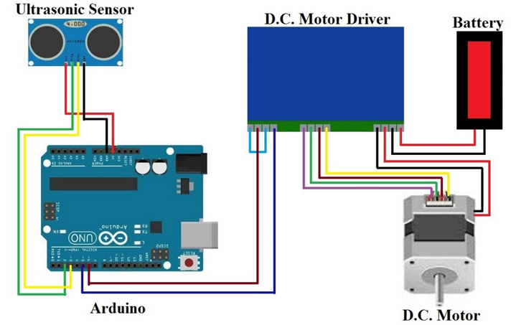

Fig. 1 Circuit diagram of automatic inter and intra row weeder
3.2.2 Prototype Design
A prototype of the weeder was modelled using CAD software to determine component dimensions and assess the feasibility of part movements. SolidWorks 2022 was used for this design process. The system dimensions were carefully set, with the overall unit having a maximum length of 1500 mm, a width of 1000 mm, and a height of 700 mm. Fig. 2 the CAD representation of the automated inter and intra row weeder was shown in top view of the prototype model and in Fig..3 is isometric view of the developed inter and intra row weeder. And Fig. 4 shown the front view of the implement.
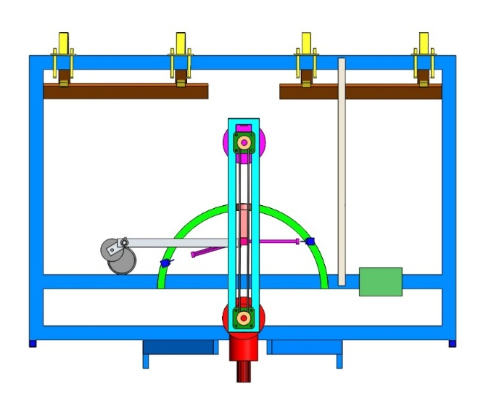
Fig..2 CAD representation of prototype, (Top view)
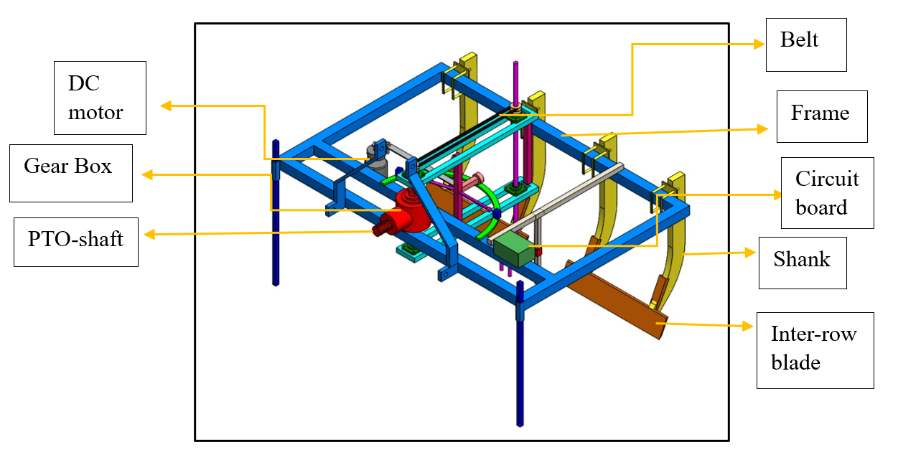
Fig..3 CAD representation of prototype, (Isometric view)

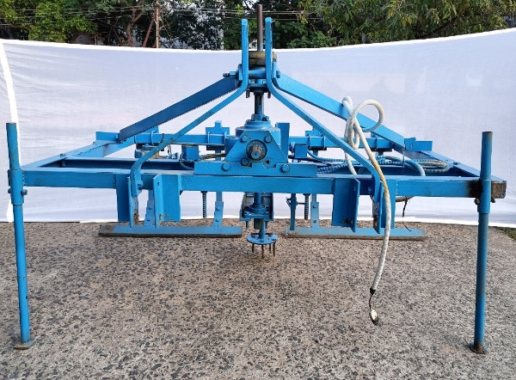
Fig. 4 Front view of developed inter and intra row weeder
3.2.3 MATERIAL OF CONSTRUCTION
Various materials were utilized in the fabrication of the tractor-operated automated inter and intra-row weeder, including L-channel of different sizes, spring steel blade, mild steel (MS) flat, MS rod, galvanized iron (GI) pipe, MS sheets, bushings. These components were selected to ensure durability and efficient performance of the weeder. A summary of the specifications of the developed automated inter and intra-row weeder is provided in Table.1.
Table. 1 Specifications of the developed automatic inter and intra row weeder
S. No. | Components | Specifications
1. | Frame | Mild Steel L-section frame having size 50 mm × 50 mm × 4 mm and frame dimensions 1500 mm × 1000 mm; 50 mm × 5 mm flat for three-point hitch.
2. | Shank | Shank was fabricated from 20 mm thick mild steel flat with a length of 600 mm. Its top end was provided with four 18 mm holes for bolting to the main frame. The design allowed for easy adjustment of row spacing by shifting the shank position.
3. | Inter row blade | Inter-row blade was fabricated using high carbon steel material having size 650 mm length and 10 mm thickness with a bevelled edge up to 20 mm. Spacing between two blades was maintained at 200 mm.
4. | Intra row blade | Intra row blade was made from MS of 5 mm thickness and 150 mm diameter.
5. | Ultrasonic Sensor | The A02YYUW Waterproof Ultrasonic Sensor (3–450 cm range, UART interface, IP67-rated) was used.
6. | D.C. Motor | A 12 V DC gear motor with a rated power of 250 W and a no-load speed of 3300 rpm was used to drive the intra-row blade mechanism, ensuring reliable performance during weeding operations.
7. | Microcontroller | Arduino Nano was used for control the movement of D.C. motor.
8. | Battery | A 12 V lead- acid tractor battery was used as the power source to operate the DC gear motor and microcontroller system.
9. | Sensor holder | Ultrasonic sensor was fixed on a sensor holder. Sensor holder was made from MS flat and MS square pipe.
10. | Voltage Regulator | LM7805 used to regulate 12V input to stable 5V for microcontroller operation
11. | Motor controller | Model A (DC12–30V, 10A) used to regulate blade movement speed via PWM control
12. | Dual channel relay | Robocraze 2-Channel 5V Relay Module with Optocoupler 5V Relay Module compatible with Arduino

As shown in Fig..5, tractor PTO power was transmitted through a universal-jointed shaft to a bevel gearbox, then via a belt–pulley to a vertical shaft that spins the bladed disc for intra-row weeding. As shown in Fig. 6 flowchart the ultrasonic sensor first spotted a plant and judged its height, if it was under 30 cm, the motor swung the intra-row blade left and briefly halted scanning until the blade returned.
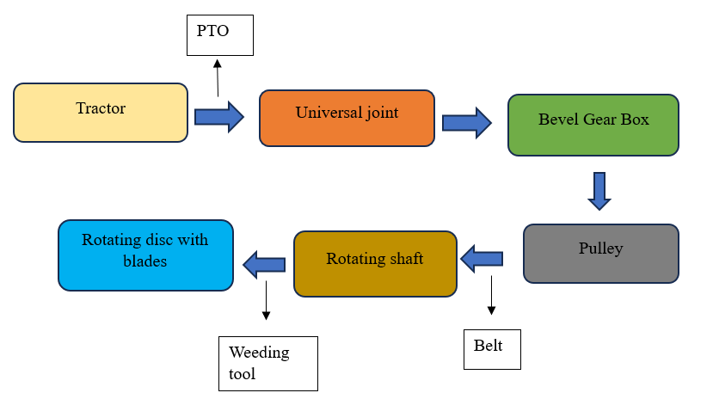
Fig. 5 Power transmission from tractor PTO to weeding tool (intra row)
Start

Ultrasonic sensor (detects plant)

yes
No
Plant height <30cm plant)

Intra blade moves left (via motor)

Detection stops

Intra blade returns to original position

Intra blade in original position

End

Fig..6 Flow chart of plant detection and intra- row blade actuation mechanism in automatic weeder
3.2.4 Pivoting Arm Design Requirements
An automatic inter and intra-row weeder was developed to achieve efficient and precise weed management in row crops through fully controlled mechanical operations. The system integrates a fixed-path pivoting arm and a rotary blade assembly, both coordinated by an electronic control unit. The heart of the system is a pivoting arm mounted on a fixed axis within the main frame as shown in Fig. 7. This arm supports the weeding mechanism and moves in a defined arc, enabling side-to-side coverage of the crop canopy area. The movement range of the arm is predetermined based on the row spacing and canopy width, ensuring the tool operates consistently within the intended weeding zone. The pivot is powered by a torque-efficient transmission system designed to move the arm smoothly and reliably across its fixed path.
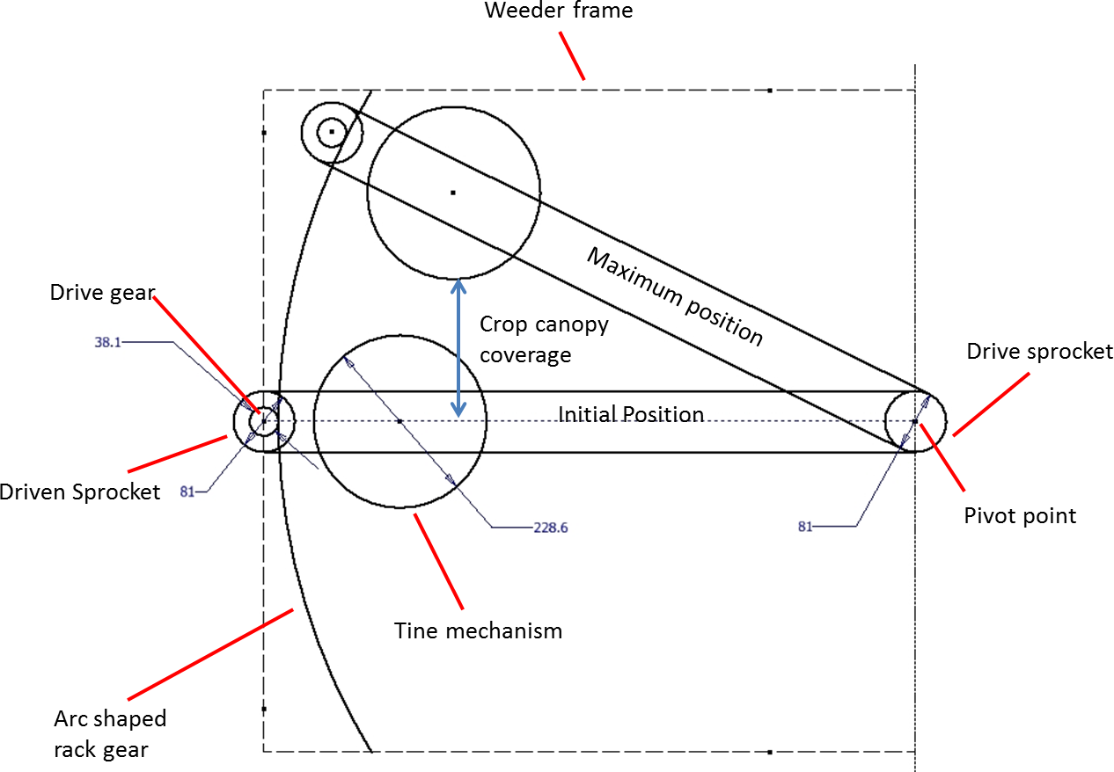
The intra-row blade is actuated by a compact geared DC motor, which is controlled electronically. This motor drives the blade in a continuous rotational motion, displacing or covering weeds between plants. As the blade rotates, it directs soil toward the crop row, forming a shallow ridge that buries small weeds while contributing to moisture retention and root aeration. The blade design allows it to work effectively in one direction, reducing complexity in the drive system. The entire weeding process is governed by an automated control system. This system can incorporate plant detection through sensors technology to coordinate the timing of blade engagement and arm movement with the position of crop plants. By synchronizing these actions, the system achieves accurate weed removal with minimal crop disturbance. The supporting frame structure is designed to house all mechanical and electronic components securely. It accommodates the pivot shaft, gearbox, weeding mechanism, and the necessary bearings to handle rotational forces and structural loads. The dimensions of the frame are optimized for field deployment while ensuring stability and ease of maintenance.

Fig. 7 Automatic pivoting- arm inter and intra row weeder.
I. Tine kinematic model
The time t, in seconds, taken for the tine to move forward at a certain travel speed is given by
$$t=\frac{d}{v}$$
Where,
d = Travel distance, m
v = Forward speed of the weeder, m s⁻¹.
At the same time, the tine will move in an angular distance, 𝜑, in radians, given by

𝜑 = 𝜔𝑡
where,
ω= the angular velocity, rad s⁻¹
To define the working zone for a specific number of rotating tines, predefined values were applied to the relevant equations. A weeding mechanism equipped with six tines was tested at three different travel speeds 1.5 km h⁻¹, 2 km h⁻¹ and 2.5 km h⁻¹ as shown in Table. 2. The objective was to determine the minimum angular velocity required for the tine weeding mechanism to ensure an effective working zone. This was achieved the tines either overlapped or made contact with each other, allowing for optimal weed removal efficiency.
Table 2 Different levels of plant spacing, speed of travel, blade speed
Factors | First level | Second level | Third level
Plant to plant spacing, cm | 45 | 50 | 60
Travel speed, km h⁻¹ | 1.5 | 2.0 | 2.5
Blade rotational speed, rpm | 180 | 220 | 260

3.2.5 Experimental Details
The intra-row blade rotates in a fixed direction, enabling effective weed removal by cutting or uprooting weeds between the crop plants. This rotational action helps to maintain clean intra-row spacing without disturbing the crop. The performance of the weeder in this mode is influenced by the forward speed of the machine and the rotational speed of the blade. The technical specifications of both the inter-row and intra-row weeder are provided in Table 3.
To evaluate the effectiveness of this mechanism, Kishore, 2023 conducted tests using different spike configurations 2 spikes at intra blade level, and 4 and 6 spikes in subsequent trials. Among these, the configuration with 6 spikes demonstrated the highest weeding efficiency along with minimal plant damage. The increased number of spikes allowed for better soil agitation and more uniform coverage of weeds, enhancing the overall soil covering action. Additionally, this setup improved the consistency of ridge formation, contributing to more effective weed suppression and reduced manual intervention. Based on these results, the 6-spike configuration was selected for all subsequent experiments to ensure optimal performance in terms of weeding efficiency.

Table 3 Specifications of tractor drawn inter and intra weeder
S. No | Particular | Specification
1. | Name of machine | Inter and intra row weeder
2. | Make | ANGRAU
3. | Model | Prototype
4. | Type of machine | Tractor operated
6. | Overall width of machine, mm | 1000
7. | Overall length of machine, mm | 1500
7. | Overall height of machine, mm | 700
8. | No. of rows covered | 1 (intra) 2 (inter)
9. | Type of transmission system | Bevel gear box
10. | No. of flange bearings | 4
11. | Diameter of rotary disc, mm | 150
12. | No. of linkages | 3- point linkage

3.2.6 Type of Power Unit for Weeder
A 45 HP tractor was selected as the power source for this project, and the weeder was specifically designed to operate efficiently with this tractor. The intra row blade were tested at three different rotational speeds 180, 220 and 260 rpm to evaluate performance under varying conditions. The choice of a 45 HP tractor ensured sufficient power delivery and stable operation across all tested speeds. This configuration provided consistent torque and reliable functioning of the implement, making it suitable for field conditions where effective soil engagement and weed removal are critical.
3.3 CROP CULTIVATION
Cotton was grown following the recommended agronomic practices. A 45 m × 16 m plot. The soil in the experimental field belongs to the sandy loam soil group. To achieve a well-prepared seedbed, the land was tilled using two passes of a rotavator. This tillage method ensured proper soil tilth for successful crop establishment.
3.3.1 Cotton
Cotton was sown directly in the field using a row to row spacing of 105 cm, with three different plants to plant spacings of 45 cm, 50 cm and 60 cm to evaluate the effect of intra-row spacing on crop growth and yield. The field was thoroughly prepared to ensure a fine tilth for better seed germination and establishment. Weeding operations were carried with developed weeder in cotton at 30 DAS.
3.3.2 Forward Speed of Operation
The tractor was operated at three different forward speeds 1.5 km h⁻¹, 2.0 km h⁻¹ and 2.5 km h⁻¹ to determine the optimal speed for efficient performance of the intra-row weeding equipment. These speeds were selected to evaluate their impact on weeding effectiveness, soil disturbance and overall field efficiency.

3.3.3 Plant to Plant Distance
For crops with wider row spacing, the distance between rows typically ranges from 90 to 120 cm, while the spacing between plants within a row varies from 45 to 60 cm. To determine the optimal performance of the intra-row weeder, three plant-to-plant spacing levels 45 cm, 50 cm and 60 cm were selected for evaluation.
3.3.4 Depth of operation
In dryland agriculture, weeding equipment is typically operated at a depth ranging from 2 to 6 cm to ensure effective weed removal and adequate soil pulverization. Therefore, all subsequent weeding operations were carried out at 6 cm depth to maximize weed removal and ensure effective soil disturbance throughout the study.
3.3.5 Rotational Speed of Cutting Blade
The tractor PTO was operated at 540 rpm, and three different intra-row blade speeds were achieved using a pulley and belt system between the gearbox and blade unit to enhance soil churning. To identify the best working conditions for the automatic weeder, various combinations of engine throttle settings (1800, 2000 and 2200 rpm) and load gears (LG1, LG2, and LG3) were tested. Each setup was replicated three times, and blade speeds were recorded using a tachometer. Results showed that blade speed and forward speed both increased with higher throttle and gear settings. Blade speed rise from 181 rpm to 254 rpm under LG1, while forward speed ranged from 1.52 to 2.63 km h⁻¹ across all settings. These trials helped determine optimal parameters for effective weeding with minimal crop disturbance.
3.3.6 Levels of variables
To evaluate the influence of different operational settings on the performance of the developed weeder, field trials were conducted 30 days after sowing (30 DAS). In all treatments, the working depth was maintained constant to isolate the effects of other variables. The primary focus was on analyzing the interaction between the forward travel speed of the machine and the rotational speed of the intra-row cutting blade. The specific levels of these parameters used during the trials are presented in Table 4.
Table.4 Details of experimental field
S. No. | Variables | Parameters | Levels
1 | Independent  Parameters | Forward speed, (S) | S₁ S₂ S₃
1 | Independent  Parameters | Cutting blade speed, (B) | B₁ B₂ B₃
1 | Independent  Parameters | Plant to plant spacing, (P) | P₁ P₂ P₃
2. | Dependent Parameters | Weeding efficiency (%)  Plant damage (%)  Field efficiency (%)

3.3.7 Experimental Layout
The field layout shown in Fig. 8 shows a 45 m × 16 m test plot arranged to compare the weeder’s performance at three cotton row widths. The strip was split length-wise into left, centre and right zones for 45 cm, 50 cm and 60 cm rows, keeping soil and moisture conditions alike across the site. Within each zone. Laid three parallel rows (R1, R2, R3) and each row was further broken into three marked treatment strips, giving nine plots per spacing and 27 in total. Headlands at both ends let the tractor turn without trampling the trials. This neat, grid-like layout let us shift smoothly from one plot to the next, confident that any difference in weed control or crop injury came from machine settings rather than field variability.
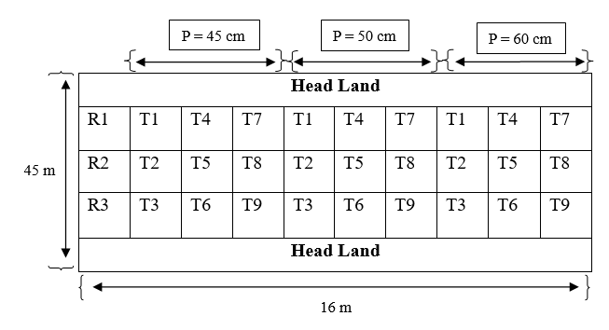
Fig. 8 Layout of experimental plot
3.3.8 Optimization of Variables
Fine-tuned the machine settings to balance peak weed removal with minimal crop injury and acceptable fuel use. After comparing all 27 speed-and-spacing combinations, one setup stood out for delivering the best mix of high weeding efficiency and low plant damage.
Theoretical field capacity
The theoretical field capacity was calculated using the formula provided by
$$Theoretical field capacity, ha h^{-1}= \frac{S ×W}{10}$$
Where,
TFC = Theoretical field capacity, ha h⁻¹
S = Forward speed, km h⁻¹
W = Width of coverage, m
Effective field capacity
Effective field capacity represents the actual average area covered by the machine over time, taking into account the total time spent in the field. This was calculated as per the method described by.
$$Effective field capacity, EFC= \frac{A}{T}$$
Where,
${ Efc}_{ }$= Effective field capacity, ha h⁻¹
A = Field coverage, ha
T = Actual time of operation, h
Field Efficiency
Field efficiency is the percentage ratio of the effective field capacity to the theoretical field capacity. It indicates how efficiently the machine performs in actual field conditions. The field efficiency was calculated using the following formula.
$$Field efficiency, E_{f}=\frac{EFC}{TFC}×100$$
Where,
${ E}_{f }$= Field efficiency, %
EFC = Effective field capacity, ha h⁻¹
TFC = Theoretical field capacity, ha h⁻¹
Weeding Efficiency (%)
Weeding efficiency refers to the percentage of weeds successfully removed by a weeder compared to the total number of weeds originally present in a given area. To measure this, the number of weeds was counted both before and after each test. These observations were repeated three times, and the average values were taken. The tests were conducted at different forward speeds 1.5, 2.0 and 2.5 km h⁻¹ in a cotton crop.
The weeding efficiency is calculated using the following equation:
$$Weeding efficiency \left(\%\right)=\left\{\frac{W_{1}-W_{2}}{W_{1}}\right\}×100$$
Where,
W₁ = Number of weeds before weeding
W₂ = Number of weeds after weeding
Plant Damage (%)
Plant damage was gauged by counting the cotton plants in a 15 m row before and after each pass, then expressing the losses as a proportion of the original stand. Counts were done in triplicate for accuracy and averaged. Assessments covered forward speeds of 1.5, 2.0 and 2.5 km h⁻¹.
The calculation is performed using the following equation:
$$Plant damage \left(\%\right)=\{1-\frac{q}{p}\}×100$$
Where,
q = Number of plants left in a 15 m row length after weeding
p = Number of plants in a 15 m row length before weeding
Table.5 showed that T3 had the highest weeding efficiency (84.33% at 60 cm) with moderate plant damage. T9 resulted in the highest plant damage (18.00%), indicating over-aggressive settings. T1 gave a balanced performance with moderate weeding efficiency and the lowest plant damage (9.33%). T7 showed the lowest weeding efficiency and was less effective overall. Treatments with different superscript letters were significantly different at the 5% level
Table 5 Treatments for 40, 50 and 60cm weeding efficiency and plant damage
Treatment | WE-45cm | WE-50cm | WE-60cm | PD-45cm | PD-50cm | PD-60cm
1 | 74.00 | 76.67 | 79.67 | 11.33 | 10.67 | 9.33
1 | (8.631^{cde}) | (8.784^{bc}) | (8.953^{bc}) | (3.437e) | (3.336e) | (3.132e)
2 | 77.00 | 79.00 | 82.00 | 12.33 | 12.00 | 11.00
2 | (8.803^{abc}) | (8.916ª) | (9.083ª) | (3.578de) | (3.534de) | (3.389de)
3 | 79.67 | 82.00 | 84.33 | 13.33 | 13.00 | 12.67
3 | (8.953ª) | -9.083 | -9.21 | (3.716^{cde}) | (3.669^{d}) | (3.624^{bcd})
4 | 72.67 | 74.67 | 77.00 | 13.33 | 12.67 | 11.67
4 | (8.553de) | (8.670^{cde}) | (8.803de) | (3.719^{cde}) | (3.624de) | (3.483^{cde})
5 | 75.00 | 77.00 | 80.00 | 14.33 | 14.00 | 13.67
5 | (8.689^{bcd}) | (8.803^{ab}) | (8.972^{b}) | (3.848^{bcd}) | (3.806^{cd}) | (3.763^{bc})
6 | 77.67 | 79.00 | 81.33 | 15.67 | 15.33 | 15.33
6 | (8.841^{ab}) | (8.916ª) | (9.046^{ab}) | (4.018^{abc}) | (3.977^{bc}) | (3.973^{ab})
7 | 68.00 | 73.00 | 74.00 | 16.33 | 15.67 | 13.67
7 | (8.276^{f}) | (8.573e) | (8.631^{f}) | (4.101^{ab}) | (4.018^{abc}) | (3.760^{bc})
8 | 71.33 | 74.00 | 76.00 | 17.00 | 17.00 | 15.33
8 | (8.475e) | (8.631de) | (8.746e) | (4.182ª) | (4.182^{ab}) | (3.971^{ab})
9 | 73.33 | 76.00 | 78.00 | 18.00 | 18.00 | 17.67
9 | (8.592de) | (8.746^{bcd}) | (8.860^{cd}) | (4.297ª) | (4.300ª) | (4.260ª)
Note: 1. The means with different Letters as superscripts are significant (P < 0.05).
2.The means with same letters or having common letter(s) are not significantly different
3.The values kept in brackets are square root transformed data

- RESULTS AND DISCUSSION
Table 6 illustrated the effect of different treatment combinations on maximum weeding efficiency at three intra-row spacings i.e: 45 cm, 50 cm and 60 cm. The treatment combinations are denoted by varying tractor speeds (S₁, S₂ and S₃) and intra-row blade speeds (B₁, B₂ and B₃). At 45 cm spacing, the highest weeding efficiency of 81% was achieved with the combination S₁B₃, while the other two combinations, S₂B₃ and S₁B₂, both resulted in 79% efficiency. At 50 cm spacing, S₁B₃ again provided the maximum efficiency of 83%, followed by S₁B₂ and S₂B₃ at 80%. The highest weeding efficiency was observed at 60 cm spacing, with S₁B₃ achieving 85%, S₁B₂ 83% and S₂B₃ 82%. These results indicate a consistent trend where the S₁B₃ combination outperforms others across all spacings and weeding efficiency improves as intra-row spacing increases. The bar graph further supports these findings by visually demonstrating that the highest weeding efficiencies correspond to the widest plant spacing (60 cm) across all selected treatments. This suggests that increased spacing enhances the operation of the intra-row weeder, allowing better access and movement between plants, thereby reducing interference and improving overall performance. In Fig. 9 the graphical representation of the weeding efficiency in 3 different spacing of plants are shown.

Table 6 Best treatment combination for maximum weeding efficiency
Intra row spacing | Best treatment combination | Maximum weeding efficiency (%)
 | T3- S1 B3 | 81
45 cm | T6- S2 B3 | 79
 | T2- S1 B2 | 79
 | T3- S1 B3 | 83
50 cm | T2- S1 B2 | 80
 | T6- S2 B3 | 80
 | T3- S1 B3 | 85
60cm | T2- S1 B2 | 83
 | T6- S2 B3 | 82

Fig. 9 Weeding efficiency at 40, 50 and 60 cm spacing
Table 7 presented the best treatment combinations for minimum plant damage across three intra-row spacings (45 cm, 50 cm and 60 cm). The lowest plant damage was observed at 60 cm spacing with combination S₁B₁ (8%). In general, S₁B₁ consistently showed minimal damage across all spacings, indicating that lower tractor speed (S₁) and lowest blade speed (B₁₎ are most effective in reducing plant injury. The bar graph visually supports these findings, showing decreasing plant damage percentages as spacing increases, with the lowest values observed at 60 cm. Treatments T₁ (S₁B₁), T₂ (S₁B₂) and T₄ (S₂B₁) show higher damage at narrower spacings and lower damage at wider spacings. Plant damage and it was shown in the bar chart of Fig. 10 for better treatments in plant damage of 3 different spacing of plants.
Table 7 Best treatment combination for minimum plant damage
Intra-row spacing | Best treatment combination | Minimum plant damage (%)
 | T1- S1 B1 | 10
45 cm | T2- S1 B2 | 11
 | T4- S2 B1 | 12
 | T1- S1 B1 | 9
50 cm | T2- S1 B2 | 11
 | T4- S2 B1 | 11
 | T1- S1 B1 | 8
60cm | T2- S1 B2 | 10
 | T4- S2 B1 | 10

Fig. 10 Plant damage at 40, 50 and 60 cm spacing
Actual Field Capacity of Best Performance Treatments Based on Weeding Efficiency
Fig. 11 shown how actual field capacity varies with plant spacing for three treatments are T2, T3, and T6. As plant spacing increases from 45 cm, 50 cm and 60 cm, actual field capacity also increases slightly across all treatments. This trend suggests that wider plant spacing may allow for smoother operation of the equipment, resulting in better coverage and higher field capacity. Among the treatments, T6 consistently delivers the highest actual field capacity at each spacing level, indicating it is the most efficient treatment in terms of area covered per hour. T2 and T3 show moderate and comparable field capacity values, with a gradual upward trend as plant spacing widens.

Fig. 11 Actual Field capacity at 40, 50 and 60 cm spacing
Field Efficiency of Best Performance Treatments Based on Weeding Efficiency
Fig. 12 presented the field efficiency of the same three treatments across different plant spacings. Field efficiency is highest at 45 cm spacing and decreases slightly as spacing increases to 60 cm. Treatment T3 stands out by consistently achieving the highest field efficiency at all spacing levels, suggesting it reduces time losses and improves operational accuracy. T2 and T6 show lower and similar efficiency values, with a noticeable drop at wider spacings. This implies that while wider spacing helps improve capacity, it might slightly reduce field efficiency due to possible increases in non-productive movement or machine overlap.

Fig. 12 Field Efficiency at 40, 50 and 60 cm spacing
Actual Field Capacity of Best Performance Treatments Based on Plant Damage
Fig. 13 showed that actual field capacity increased with plant spacing across all treatments. T4 had the highest field capacity at all spacings, while T1 and T2 had the lowest. This indicated that wider spacing and the T4 setup allowed for more efficient field coverage.

Fig. 13 Actual Field capacity at 40, 50 and 60 cm spacing
Field Efficiency of Best Performance Treatments Based on Plant Damage
Fig. 14 showed that field efficiency increased from 45 cm to 50 cm spacing but slightly decreased or remained stable at 60 cm for T1, T2 and T4 maintained the highest efficiency throughout, indicating better performance under that treatment.

Fig. 14 Field Efficiency at 40, 50 and 60 cm spacing

- CONCLUSION
In sum, the prototype tractor-mounted inter and intra-row weeder proved both practical and precise. By pairing a PTO-driven rotary blade with a sensor-guided pivot arm, it reliably distinguished weeds from cotton plants across a range of row widths, travel speeds, and blade rpms tested on sandy-loam fields at Bapatla. The machine consistently cleared weeds while sparing the crop, cutting labor needs and boosting field efficiency. These outcomes show that sensor-assisted, PTO-powered weeding can be a viable solution for wide-row crops, offering farmers a dependable tool for precision weed management.

REFERENCES
Berge, T.W., Aastveit, A.H and Fykse, H. 2008. Evaluation of an algorithm for automatic detection of broad-leaved weeds in spring cereals. Precision Agriculture. 9: 391-405.
Slaughter, D.C., Giles, D.K and Downey, D. 2008. Autonomous robotic weed control systems: A review. Computers and electronics in agriculture. 61(1): 63-78.
Hamuda, E., Glavin, M and Jones, E. 2016. A survey of image processing techniques for plant extraction and segmentation in the field. Computers and electronics in agriculture. 125: 184-199.
Yaduraju, N.T and Mishra, J.S. 2018. Smart weed management: A small step towards doubling farmers’ income. Indian Journal of Weed Science. 50(1): 1–5.
Anderson, W.K and Garlinge, J.R. 2000. The wheat book: principles and practice.
Weide, R. Y. V. D., Bleeker, P. O., Achten, V. T. J. M., Lotz, L. A. P., Fogelberg, F and Melander, B. 2008. Innovation in mechanical weed control in crop rows. Weed Research. 48 (3): 215-224.
Fischer, R.A and Miles, R.E. 1973. The role of spatial pattern in the competition between crop plants and weeds. A theoretical analysis. Mathematical Biosciences. 18(3-4): 335-350.
Rueda-Ayala, V., Rasmussen, J and Gerhards, R. 2010. Mechanical weed control. In Precision crop protection-the challenge and use of heterogeneity. 279-294.
Kumar, S.P., Tewari, V.K., Chandel, A.K., Mehta, C.R., Nare, B., CR, C., Pareek, C.M and Mundhada, K. 2024. Automated Prototype Intra Row Weeding System. Journal of scientific & industrial research. 83: 362-374.
Chandel, N.S., Chandel, A.K., Roul, A.K., Solanke, K.R and Mehta, C.R. 2021. An integrated inter-and intra-row weeding system for row crops. Crop Protection. 145: 105642.
Perez-Ruiz, M., Slaughter, D.C., Fathallah, F.A., Gliever, C.J and Miller, B.J. 2014. Co-robotic intra-row weed control system. Biosystems engineering. 126: 45-55.
Ahmad, M.T. 2012. Development of an Automated Mechanical Intra-Row Weeder for Vegetable Crops. Graduate Theses and Dissertations. 12278. Iowa State University.

