In vitro evaluation of different botanicals against the Colletotrichum gloeosporioides Penz. and Sacc.

ABSTRACT

In vitro experiment was carried out to evaluate the efficacy of botanical extract against mango anthracnose in PG Research laboratory of Department of Plant Pathology, N. M. College of Agriculture, Navsari Agricultural University, Navsari during 2023-24. The seven botanical treatments were tested at two concentrations (5% and 10%) to assess their potential against C. gloeosporioides under in vitro conditions by employing Complete Randomized Design. The efficacy was assessed based on per cent growth inhibition (PGI) and mean colony diameter (mm) at two concentrations (5% and 10%). Among the botanicals tested, garlic extract exhibited the superior performance and achieving 39.63 per cent and 45.93 per cent mycelial growth inhibition at 5 and 10 per cent concentrations, respectively. Novel plus ranked second in effectiveness, with inhibition rates of 32.63 per cent and 40.74 per cent at 5 and 10 per cent concentration. Eucalyptus extract showed moderate efficacy, followed by ginger extract. The remaining botanical treatments demonstrated comparatively lower inhibitory effects against mango anthracnose (C. gloeosporioides). Under laboratory conditions, garlic extract showed the highest inhibition activity which indicating effective against C. gloeosporioides.

Keywords: Mango, Anthracnose, C. gloeosporioides, Botanicals, Management, In vitro

1. INTRODUCTION

The mango (Mangifera indica Linnaeus) is the world’s most popular and enduring tropical fruit and is known as the “King” of all fruits. Mangos are universally grown in India and are members of the Anacardiaceae family. The “Mango” comes from the Tamil word “Mangkay”. It is known as one of the most significant and well-known Asian fruits. As per the National Horticulture Board (NHB), mango is growing on 2291 thousand hectares of area and produces 20,444 thousand MT in India. Uttar Pradesh, Andhra Pradesh, Karnataka, Bihar, Gujarat, Tamil Nadu and Telangana are the major mango-producing states in India.
Mango is affected by number of diseases at all the stages of its development right from nursery to the storage or transit conditions. Pre-harvest and post-harvest infections can impair fruit quality and result in significant losses. In the pre-harvest condition, it is prone to many fungal diseases like anthracnose [Colletotrichum gloeosporioides (Penz.) Penz. & Sacc.], dieback [Lasiodiplodia theobromae (Pat.)], sooty mould (Capnodium spp.), malformation (Fusarium mangiferae) and powdery mildew (Oidium mangiferae Berthet), leading to heavy yield loss.
It has been discovered that synthetic fungicides are effective in controlling anthracnose disease. However, their indiscriminate use has led to the development of resistance in fungus species. Excessive usage of synthetic fungicides leads to various toxicological and environmental issues as well as health issues. Therefore, it is needs to find an alternative solution for disease control. Some plant products are utilized as green pesticides, and organic fungicides are becoming more popular worldwide. It is known that using plants for managing plant diseases is an alternative in place of synthetic fungicides. Numerous compounds exhibited varying degrees of antimicrobial action against a variety of bacterial and fungal pathogens, and they successfully decreased the severity of important fruit crop diseases (Kumar and Kudachikar, 2020).
Botanical extracts, such as garlic, ginger, tulsi, lantana and eucalyptus, have antifungal activity against the C. gloeosporioides that cause mango anthracnose, making them a potential and eco-friendly solution against mango anthracnose disease (Kolase et al., 2014; De Guzman and Mangoba, 2020). Therefore, the present investigation was initiated to find out the most effective and economical management practices of anthracnose of mango.

2. materialS and methods
2.1 Experimental details
The present investigation was carried out to evaluate the efficacy of seven botanical extract against mango anthracnose in PG Research laboratory of Department of Plant Pathology, N. M. College of Agriculture, Navsari Agricultural University, Navsari during 2023-24.
2.2 Extract preparation
To prepare botanical extract, samples of different plant parts (leaf, Rhizome, suspension and cloves) were collected. Fifty grams (50 g) of each sample was taken in an electric blender and 50 ml of distilled water was added. The content was macerated and a suspension was prepared. The suspension was filtered through muslin cloth. The clean suspension filtrate at the bottom and this suspension.
The 5 per cent and 10 per cent extract solutions were prepared from the filtered botanical suspension. For the 5 per cent solution, 5 ml of the suspension was diluted with 95 ml of distilled water to make a total volume of 100 ml. Similarly, for the 10 per cent solution, 10 ml of the suspension was mixed with 90 ml of distilled water to achieve a total volume of 100 ml. These solutions were used for further experiments.
Table 1: Treatment details of botanicals and their concentration for in vitro evaluation
Tr. No. | Treatments | Plant parts used | Concentration (%)
T₁ | Eucalyptus (Eucalyptus globulus) | Leaves | 5 | 10
T₂ | Ginger (Zingiber officinale) | Rhizome | 5 | 10
T₃ | Lantana (Lantana camara) | Leaves | 5 | 10
T₄ | Garlic (Allium sativum) | Cloves | 5 | 10
T₅ | Turmeric (Curcuma longa) | Rhizome | 5 | 10
T₆ | Tulsi (Ocimum sanctum) | Leaves | 5 | 10
T₇ | Novel Plus | suspension | 5 | 10
T₈ | Control |  | - | -

2.3 Procedure
Total eight treatments of botanicals with control (Table 1) were assessed by Poison food technique (Grover and Moore, 1962). Sterilized PDA media was mixed with the botanical extract solutions (5 and 10%), and 20 ml was poured into sterilized Petri dishes, allowing it to solidify. After solidification, each plate was inoculated with the culture of test pathogen. The Petri dishes were incubated at 27 ± 2℃ in BOD incubator and the observations were recorded after incubation period.
2.4 Observations
The efficacy of botanicals was assessed based on per cent growth inhibition (PGI) and mean colony diameter (mm) at two concentrations (5% and 10%) after 7 days of incubation. The per cent growth inhibition (PGI) of pathogen in each treatment was calculated according to formula given by Vincent (1947).
$$PGI=\frac{DC-DT}{DC}×100$$
Where,
PGI = Per cent growth inhibition
DC = Average diameter of mycelial colony from control set (mm)
DT = Average diameter of mycelial colony from treated set (mm
2.4 Statistical analysis
The experiment was conducted using a Complete Randomized Design (CRD) with 8 treatments and 3 repetitions to evaluate the efficacy of different botanicals on C. gloeosporioides. The data were subjected to rigorous statistical analysis using the analysis of variance (ANOVA) technique, as outlined by Panse and Sukhatme (1985).
3. results and discussion
The results presented in Table 2 and depicted in Fig. 1 & 2 revealed significant differences in the efficacy of seven different botanical extracts tested against C. gloeosporioides under in vitro conditions.
3.1 Colony diameter (mm)
Among the tested botanicals, garlic extract showed the highest antifungal activity by recording the lowest colony diameters of 54.33 mm and 48.67 mm at 5 and 10 per cent concentrations, respectively. This was followed by novel plus, which recorded mean colony diameters of 60.67 mm and 53.33 mm at both concentrations. Eucalyptus and ginger extracts also exhibited moderate antifungal activity. Eucalyptus showed mean colony diameters of 65.67 mm and 58.00 mm, respectively. Ginger extract followed closely with colony diameters of 69.33 mm and 60.67 mm at 5 and 10 per cent concentrations, respectively. Conversely, lantana, tulsi and turmeric extracts showed comparatively lower antifungal activity and recorded higher mycelial growth of C. gloeosporioides at 5 per cent (80.67 mm, 78.67 mm and 75.33 mm, respectively) and 10 per cent (72.67 mm, 72.33 mm and 69.67 mm, respectively). The control treatment, without any botanical extract, showed the maximum colony diameter (90 mm) at both concentrations, confirming the effectiveness of the botanical treatments in suppressing the growth of C. gloeosporioides.
3.2 Per cent Growth Inhibition (PGI)
Among the tested botanicals, garlic extract showed the highest antifungal activity, recording a PGI of 39.63 per cent and 45.93 per cent at 5 and 10 per cent concentrations, respectively. This was followed by novel plus which recorded a PGI of 32.59 per cent (5%) and 40.74 per

Table 2 : In vitro efficacy of different botanicals against C. gloeosporioides
Tr.  No. | Treatments | Plant part used | Mean colony diameter (mm) |  | PGI (%)
Tr.  No. | Treatments | Plant part used | Concentration (%) |  | Concentration (%)
Tr.  No. | Treatments | Plant part used | 5 | 10 | 5 | 10
T1 | Eucalyptus (Eucalyptus globulus) | Leaves | 65.67 | 58.00 | 27.04 (31.33) | 35.56 (36.60)
T2 | Ginger (Zingiber officinale) | Rhizome | 69.33 | 60.67 | 22.96 (28.63) | 32.59 (34.81)
T3 | Lantana (Lantana Camara) | Leaves | 80.67 | 72.67 | 10.37 (18.78) | 19.26 (26.03)
T4 | Garlic (Allium sativum) | Cloves | 54.33 | 48.67 | 39.63 (39.01) | 45.93 (42.66)
T5 | Turmeric (Curcuma longa) | Rhizome | 75.33 | 69.67 | 16.30 (23.81) | 22.59 (28.38)
T6 | Tulsi (Ocimum sanctum) | Leaves | 78.67 | 72.33 | 12.59 (20.78) | 19.63 (26.29)
T7 | Novel Plus | Suspension | 60.67 | 53.33 | 32.59 (34.81) | 40.74 (39.66)
T8 | Control | - | 90.00 | 90.00 | 0.00 (0.00) | 0.00 (0.00)
S.Em.± |  |  | - | - | 0.29 | 0.43
CD at 5% |  |  | - | - | 0.87 | 1.29
CV% |  |  | - | - | 2.05 | 2.55
Note: Data in parentheses are arcsine transformed values and data outside parentheses are original values.

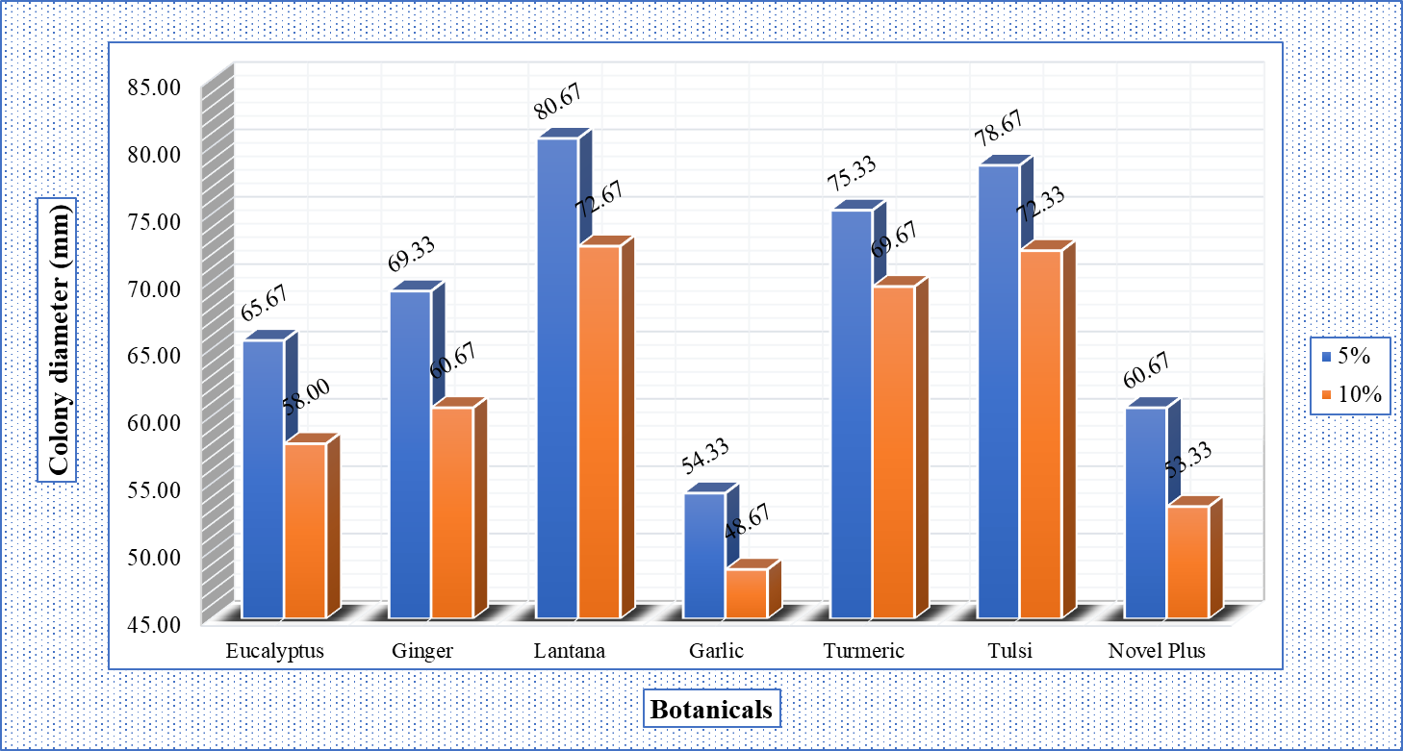
Fig. 1: In vitro effect of different botanicals on mean colony diameter of C. gloeosporioides

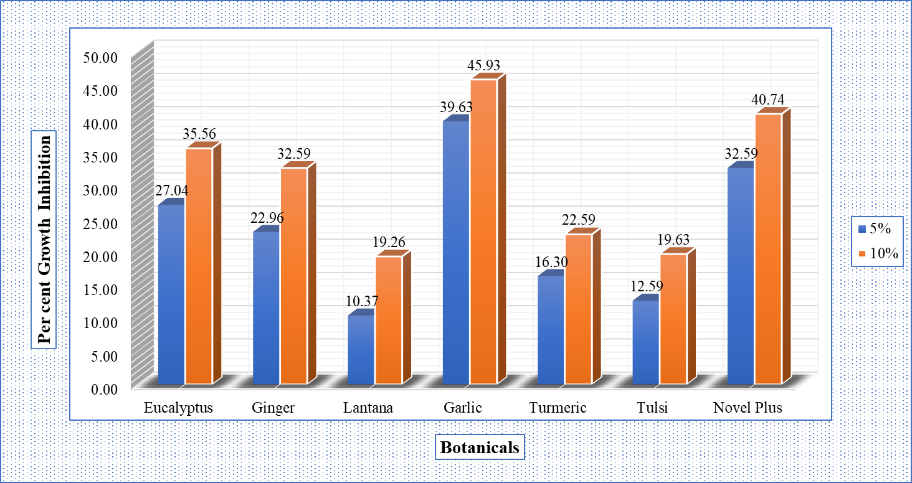
Fig. 2: In vitro effect of different botanicals on per cent growth inhibition of C. gloeosporioides

cent (10%). Eucalyptus and ginger extracts exhibited moderate antifungal activity against C. gloeosporioides. Eucalyptus showed PGI values of 27.04 per cent (5%) and 35.56 per cent (10%). Ginger extract followed closely with PGI values of 22.96 per cent and 32.59 per cent for 5% and 10% concentrations, respectively. On the other hand, lantana, tulsi and turmeric extracts showed comparatively lower per cent growth inhibition of C. gloeosporioides at 5 per cent (10.37%, 12.59% and 16.30%, respectively) and 10 per cent (19.26%, 19.63% and 22.59%, respectively). The overall trend indicates that increasing the concentration of botanical extracts from 5 to 10 per cent improved the efficacy of all treatments, as reflected by increased PGI and reduced colony diameters. The superior performance of garlic extract may be due to the presence of sulfur-containing compounds such as allicin, which have well-documented antifungal properties (Iram et al., 2019). These findings suggest that garlic extract and novel plus hold potential for managing C. gloeosporioides under laboratory conditions and could be explored further under field conditions.
The results of present investigation are more or less similar to Kolase et al. (2014), who noted that Neem leaves (35.21%) was effective in inhibiting the mycelial growth at 5 per cent concentration which was significantly superior over all other plant extracts and this was followed by ginger rhizome (18.32%), tulsi leaves (15.44%), garlic clove (11.57%) and onion bulb extract (10.35%) which were least effective in inhibiting the mycelial growth of C. gloeosporioides. The findings of this study align closely with those of Bashir et al. (2019), who revealed that methanolic fruit extract of lantana at 5 per cent exhibited maximum inhibition (66.00%) and at other concentrations (1, 2, 3 and 4%) also significantly reduced the growth of C. gloeosporioides up to 32-63 per cent. The current findings validate previous research outcomes of De Guzman and Mangoba (2020), who observed that Allium longicuspis extracts (ALE) completely inhibited the growth of mango anthracnose (C. gloeosporioides). Similarly, Gahlot et al. (2021) evaluated the efficacy of seven phyto-extracts against C. gloeosporioides and found that Garlic clove was spotted most effective at all three concentrations (5.0, 10.0 and 15.0%) with 100 per cent inhibition of C. gloeosporioides mycelial growth.
4. Conclusion

The results clearly demonstrated that garlic extract exhibited the highest antifungal activity against mango anthracnose (C. gloeosporioides), followed by novel plus, eucalyptus, and ginger extracts. The findings suggest that these botanical extracts, particularly garlic extract, hold potential for managing C. gloeosporioides under laboratory conditions and could be explored further for field applications. The results also highlight the importance of concentration, with increased efficacy observed at higher concentrations (10%) compared to lower concentrations (5%).

References

Bashir, S., Jabeen, K., Iqbal, S., Javed, S. & Naeem, A. (2019). Lantana camara: phytochemical analysis and antifungal prospective. Planta Daninha, 37, e019193526
De Guzman Alvindia, D. & Mangoba, M. A. A. (2020). Bioactivities of Allium longicuspis Regel against anthracnose of mango caused by Colletotrichum gloeosporioides (Penz.). Scientific Reports, 10 (1), 11367.
Gahlot, D., Meena, N. L., Trivedi, A. & Kumar, S. (2021). In vitro efficacy of fungicides and phyto-extracts against Colletotrichum gloeosporioides causing anthracnose of mango. Annals of Plant Protection Sciences, 29 (3), 217-221.
Grover, R. K. & Moore, J. D. (1962). Toximetric studies of fungicides against the brown rot organisms, Sclerotinia fructicola and S. laxa. Phytopathology, 52 (9), 876-880.
Iram, S., Laraib, H., Ahmad, K. S. & Jaffri, S. B. (2019). Sustainable management of Mangifera indica pre-and post-harvest diseases mediated by botanical extracts via foliar and fruit application. Journal of Plant Diseases and Protection, 126 (4), 367-372.
Kolase, S. V., Kamble, T. M. & Musmade, N. A. (2014). Efficacy of different fungicides and botanicals against blossom blight of mango caused by Colletotrichum gloeosporioides. International Journal of Plant Protection, 7 (2), 444-447.
Kumar, A. & Kudachikar, V. (2020). Efficacy of aroma compounds for postharvest management of mango anthracnose. Journal of Plant Diseases and Protection, 127, 245-256.
Panse, V. G. & P. V. Sukhatme. (1985). Statistical Methods for Agriculture Workers, ICAR, Publ. New Delhi, 4th Edn., Pp. 87-89.
Vincent, J. M. (1947). The esters of 4-hydroxybenzoic acid and related compound. Part 1. Method for the study of their fungistatic properties. Journal of the Society of Chemical Industry, 66 (5), 149-155.

