A RETROSPECTIVE STUDY ON FIBROUS OSTEODYSTROPHY (FOD) IN GOATS

ABSTRACT
Aim: To know the occurrence of Fibrous Osteodystrophy (FOD) in goats in and around Hyderabad and to study the clinical signs and management of the FOD.
Study design: The goats that were presented to C.V.Sc, Rjendranagar and referred from various dispensaries in and around Hyderabad with bilateral maxillary or mandibular swelling formed the material for the study. The occurrence of FOD based on breed, age and gender was analyzed.
Place and Duration of Study: The present study was conducted on goats presented to Veterinary Clinical Complex (VCC), College of Veterinary Science, Rajendranagar, Hyderabad during the period from April 2024 to September 2024.
Methodology: All the suspected goats were screened for FOD. They were subjected for hemato-biochemical, FNAC and Radiography. Feed analysis of the feed offered to these affected goats were also carried out.
Results: Out of 552 goats screened, 14 were diagnosed with FOD. Male animals aged below 1 year and Malabari breed goats were most commonly affected. The major clinical sings recorded were difficulty in prehension and mastication, protrusion of tongue, dyspnea, bilateral maxillary & mandibular swelling. Clinical examination findings were unremarkable. Serum biochemical examination revealed hypocalcemia and hyperphosphatemia with elevation of ALP levels. FNAC of affected bones revealed osteoclasts, chondrocytes and occasional fibroblasts. Radiographic findings in affected goats were radiolucent and decreased bone density at maxillary and mandibular areas. The nutritional origin of the disease was confirmed through reduced Ca:P ratio in the diet. Group I goats received treatment with 23% CBG, injection of Vitamin AD3E (once weekly), syrup Aluminium Hydroxide as a phosphate binder, and fluid therapy. In addition to the Group I protocol, Group II goats were also administered Inj. Nandrolone weekly. Notably, Group II goats showed marked clinical improvement compared to those in Group I.
Conclusion: High phosphorus and low calcium containing diets are attributed to FOD. Nandrolone decanoate can be used as novel therapy to promote bone mineralization and to increase bone density in FOD cases along with dietary correction.
Key words: FOD, Goats, Nandrolene, Aluminium hydroxide
1.INTRODUCTION
Fibrous osteodystrophy (FOD) or Osteodystrophia fibrosa or Osteitis fibrosa cystica is a metabolic disorder characterized by secondary calcium deficiency due to chronic consumption of excess dietary phosphorous leading to demineralization, extensive bone resorption, and replacement of bones by the fibrous connective tissue. This condition is principally a disease of horses but can also seen in porcine, caprine, feline, canine, and other species [15,4,3]. All breeds and ages of goats are susceptible after weaning [21]. In FOD, there is a decreased concentration of serum ionized calcium and increased synthesis and secretion of PTH [18]. Paratharmone (PTH) is polypeptide hormone produced from parathyroid gland was responsible for maintaining calcium homeostasis in blood after Vitamin D and calcitonin. An imbalance in mineral-hormonal metabolism, i.e., nutritional secondary hyperparathyroidism, due to excessive dietary phosphorus intake, is suggested as the prominent etiology in goats and the reduced Ca:P ratio is considered as prominent marker of FOD [26].The major clinical manifestations include bone deformities and enlargements, enhanced susceptibility to fractures, and locomotion or postural disturbances[18].
2.MATERIALS AND METHODS
The present study was conducted on goats presented and referred from various veterinary dispensaries of Hyderabad to Veterinary Clinical Complex (VCC), College of Veterinary Science, Rajendranagar, Hyderabad during the period from April 2024 to September 2024. The data pertaining to breed, age and sex was recorded. Necessary information regarding managemental practices such as deworming and vaccination status, feed and water intake, defecation and urination were documented. In affected animals, history of feeding with pea husk, wheat bran, rice bran, sorghum and red gram chunni and were confined to stall. Feed samples from household were collected for laboratory analysis. Detailed physical and clinical examination was done and observations were recorded. Blood and serum samples were collected from goats in a sterile vials with and without EDTA and subjected to further analysis. Fine needle aspiration cytology was performed under sterile conditions using 22 G needle (Figure1). Affected animals were subjected to radiography to detect pathological abnormalities of bones. Six apparently healthy animals were taken as a control.
Goats affected with FOD were divided into two groups (n=7 per group) for therapeutic evaluation.
Group I received the following treatment regimen:
- Intravenous administration of 23% CBG (CALBOROL) at a dose of 1 mL/kg body weight for 5 consecutive days.
- Inj. Vitamin AD₃E as a source of Vitamin D₃ at 4400 IU/kg body weight, administered once weekly.
- Syrup Aluminium Hydroxide (OMEFER) at 35 mg/kg body weight orally, twice daily, as a phosphate binder.
- Supportive fluid therapy.
Group II received the same treatment as Group I, with the addition of:
- Inj. Nandrolone (DECA-INSTABOLIN 50) at 1 mg/kg body weight, administered once weekly.
Following the 5-day intravenous calcium therapy, both groups were transitioned to oral Calcium Gluconate at 80 mg/kg body weight once daily for a duration of three months. Therapeutic monitoring was evaluated based on clinical improvement and biochemical parameters.
3.RESULTS
A total 14 out of 552 goats are found to be affected with fibrous osteodystrophy due to dietary imbalance and occurence of FOD was found to be 2.53% (Figure-2). Among the affected goats eight were below 1 year of age and six were above 1 year of age. Male animals (70%) were most commonly affected when compared to female animals (30%). Affected breeds include Malabari (6/14), Jamunapari (1/14), Barbari (1/14),osmanabadi (2/14) and Non -descript goats (4/14).Clinical sings recorded were anorexia (7/14), inappetence (7/14), salivation (4/14), difficulty in prehension and mastication (14/14), protrusion of tongue (11/14), dyspnea (11/14), bilateral maxillary &mandibular swelling (10/14), maxillary swelling (4/14), exophthalmos (4/14), postural abnormalities like out ward deviation of forelimb (3/14), loosening of teeth (2/14). However, out of which difficulty in prehension and mastication, protrusion of tongue, dyspnea, bilateral maxillary & mandibular swelling were the most common manifestations recorded in FOD Goats (Figure-3). On physical examination pain on palpation of swollen areas (maxillary, mandibular or both) was evident. On clinical examination vitals were within normal range. Hematological findings were unremarkable. Blood smear examination got negative for hemoprotozoa. On coprological examination no parasitic ova detected.

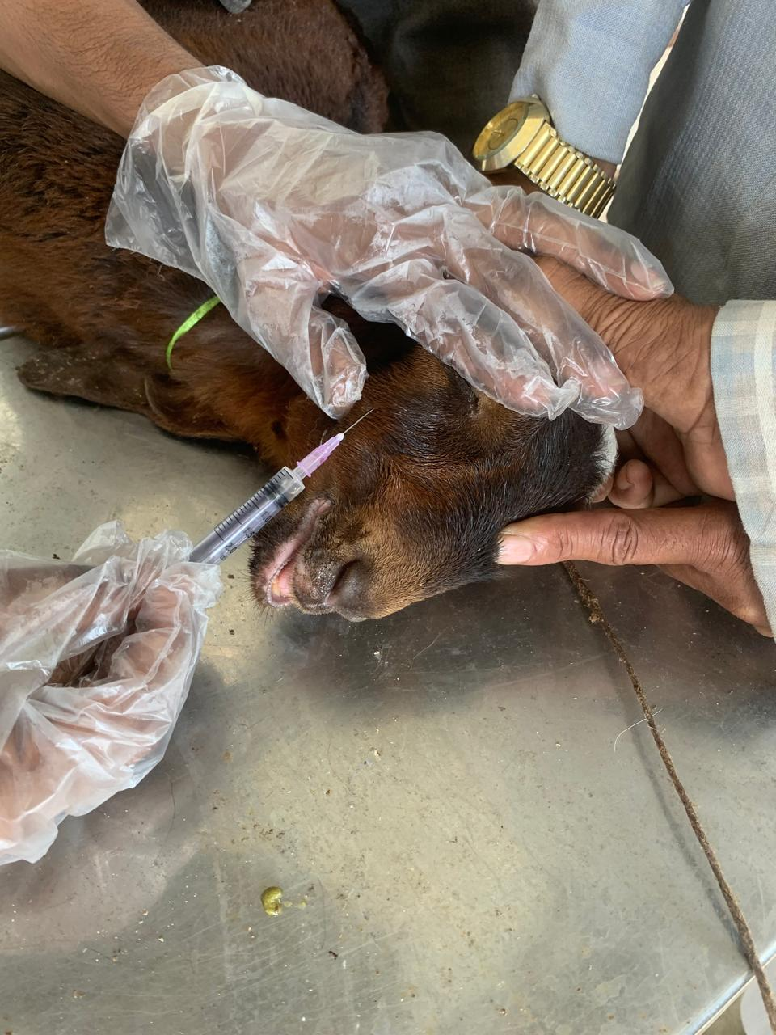
Figure-1 Collection of FNAC from FOD affected goat. Figure-2 Occurrence of FOD in Goats

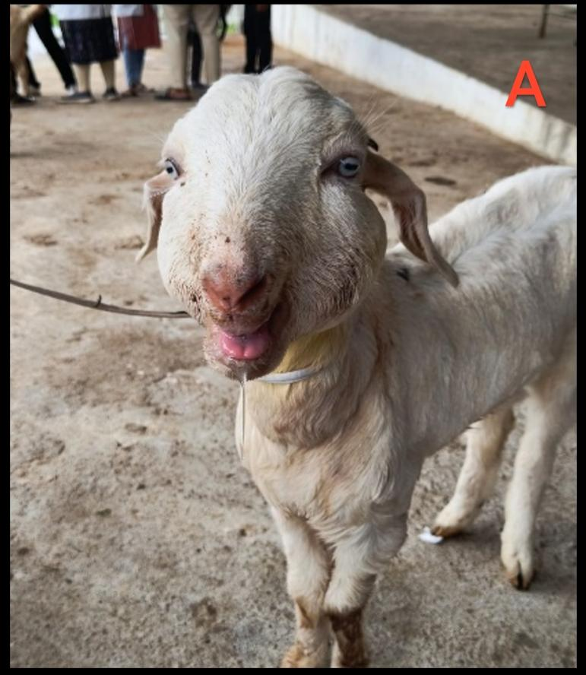 | 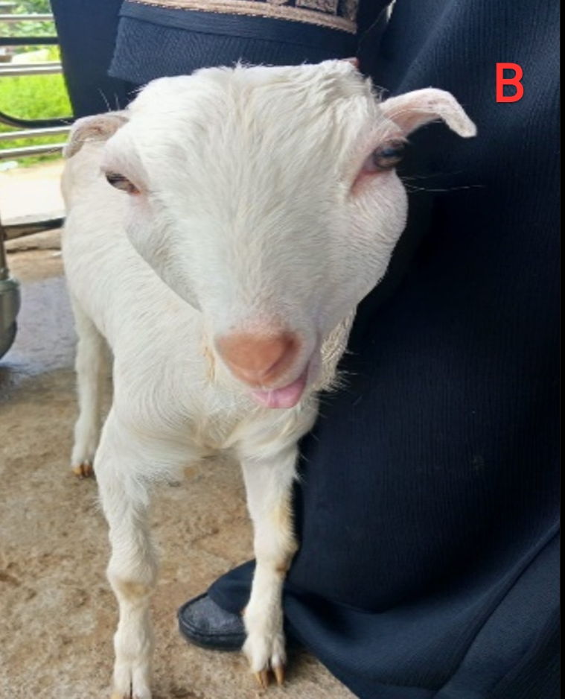 | 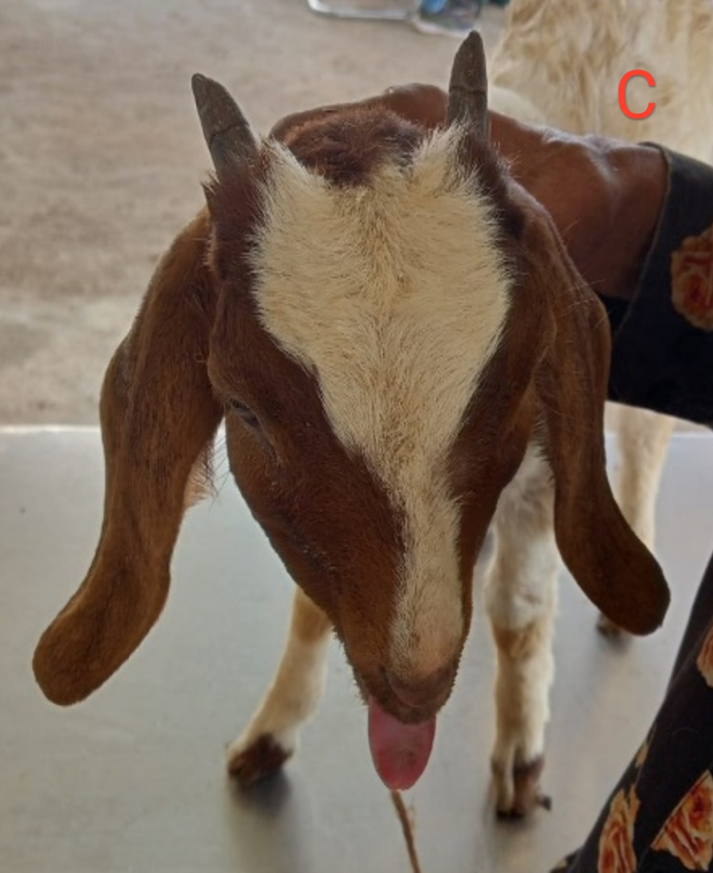
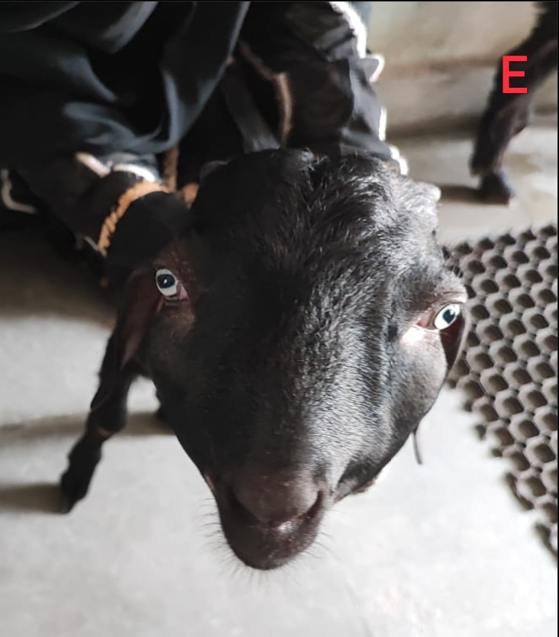
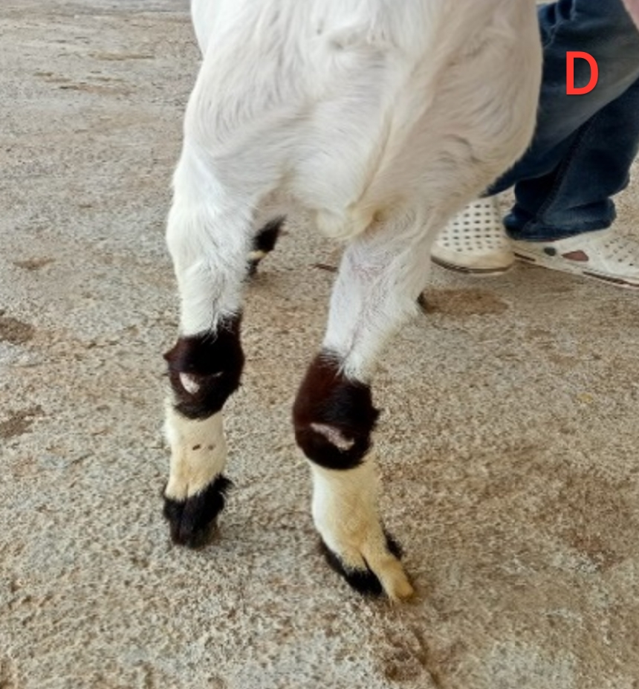
Figure 3: Clinical signs exhibited by FOD affected goats A) Bilateral maxillary & Mandibular swelling B) Bilateral maxillary swelling C) Protrusion of tongue D) Deviation of fore limb
E) Exopthalmos

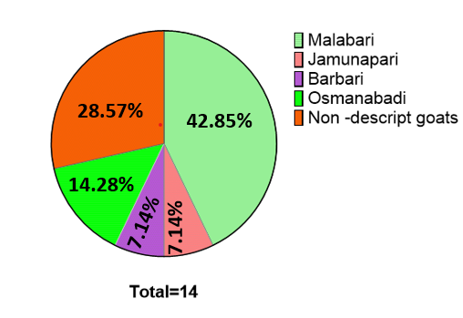
Figure:4 Breed wise incidence of FOD in goats(n=14)

Serum biochemical examination of the affected goats revealed hypocalcemia (5.87±0.29) and hyperphosphatemia (9.34±0.18) with significant elevation (P< 0.05) of ALP (593±18.74) levels (Table1). Radiographic findings recorded were increased soft tissue opacity at maxillary and mandibular areas (50%), radiolucent decreased bone density at maxillary and mandibular regions (35.71%) and Irregular teeth (14.28%) (Figure-5). FNAC of affected bones revealed osteoclasts (57.14%), chondrocytes (35.71%) and occasional fibroblasts (28.57%) (Figure-6).

Table: 1 Mean ±SE values of biochemical values in FOD affected goats
Parameter | Healthy goats (n=6) | FOD affected goats (n=14)
ALT (U/L) | 15.19±7.04ª | 14.19±7.04ª
AST (U/L) | 184.87±9.22ª | 185.20±9.61ª
ALP (U/L) | 195.12±12.5ª | 593.78±18.74^{b}
Total bilirubin (mg/dl) | 0.07±0.01ª | 0.1±0.15ª
Total protein (g/dl) | 6.83±0.15ª | 6.57±0.29ª
Creatinine (mg/dl) | 1.01±0.01ª | 1.05±0.06ª
BUN (mg/dl) | 14.87±2.22ª | 15.20±9.61ª
Calcium (mg/dl) | 9.33±0.15ª | 5.87±0.29^{b}
Phosphorous (mg/dl) | 4.08±0.10ª | 9.34±0.18^{b}

Values bearing different superscripts in a row differ significantly (P< 0.05) or (P< 0.01)
Values bearing similar superscripts in a row did not differ significantly (P >0.05)

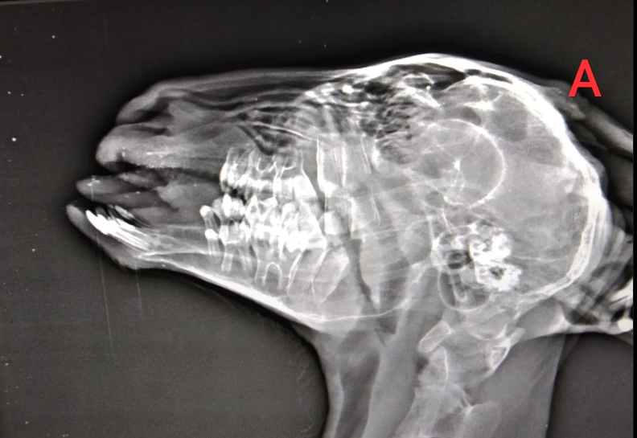 | 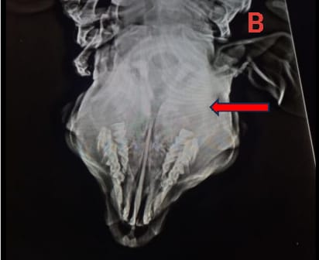 | 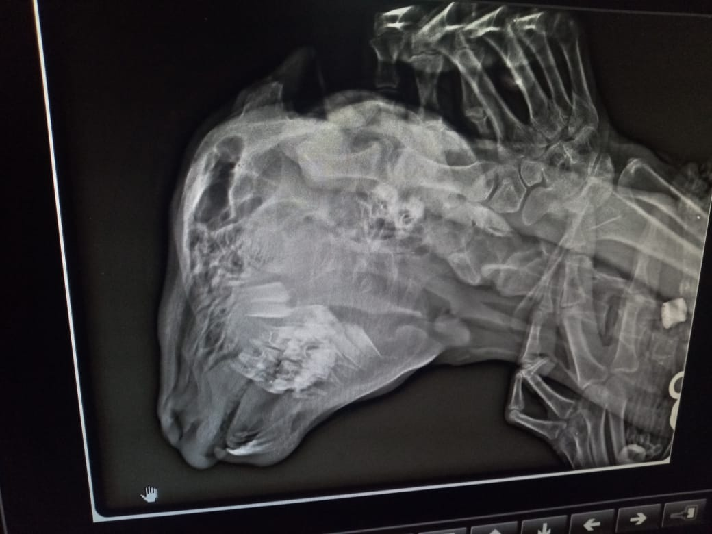
Figure -5:
A) Radiograph of skull, lateral view showing radiolucent & decreased bone density at maxillary and mandibular regions.
B) Radiograph of skull, ventro-dorsal view showing increased soft tissue opacity at maxillary and mandibular regions.
C) Radiograph of skull lateral view showing irregular teeth and increased bone density at maxillary and mandibular regions.

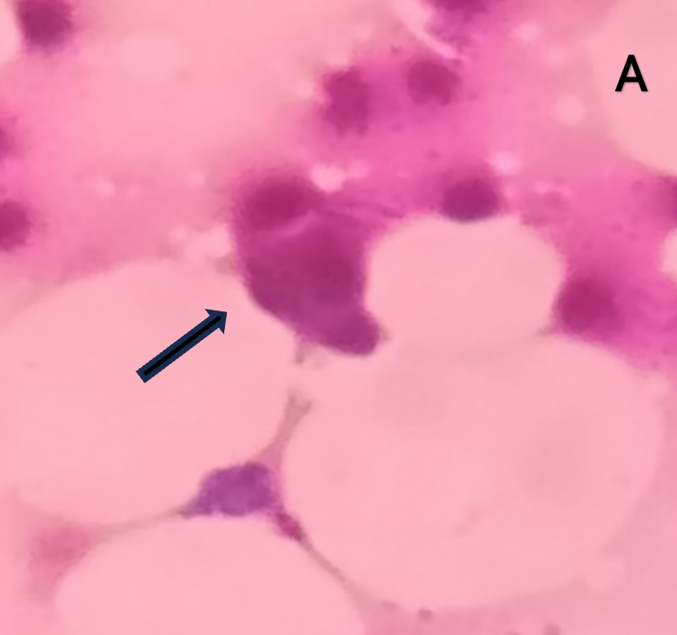 | 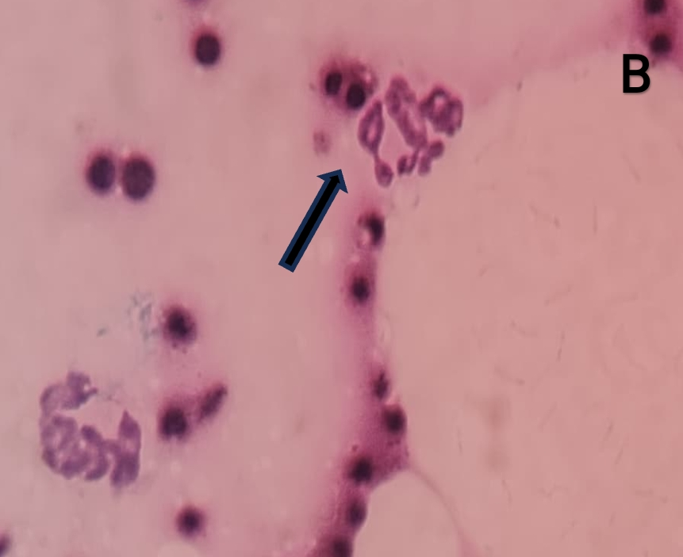 | 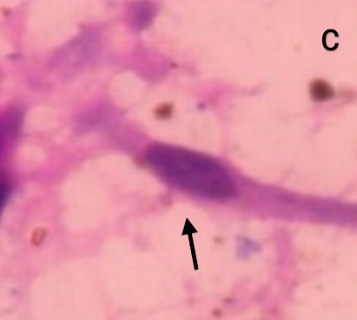
Figure-6: FNAC of FOD affected goats showing A) Multinucleated osteoclast B) Chondrocytes C) Fibroblast; Field stain ,100x magnification

Feed analysis of dietary samples that was fed to the affected goats revealed average calcium (Ca) and phosphorus (P) contents of 1.17 and 3.39 %, respectively (Ca:P ratio,1:2.89) (table:2). After one month of therapy, therapeutic monitoring was done by evaluating biochemical parameters. Group II goats showed marked clinical improvement in facial morphology and there is significant (P< 0.05) increase in serum calcium levels (10.87±0.28), significant decrease (P< 0.01) in phosphorous (4.36 ±0.11) and ALP levels (153.12±10.45) when compared to Group I goats (Table 3).

Table:2 Dietary Ca & P content in feed of affected goats
Feed sample | Calcium* (%) Phosphorous* (%)  Test value Ref. value Test value Ref. value
Pea husk | 0.32 0.49 0.41 0.27
Wheat bran | 0.10 0.20 1.29 1.23
Sorghum | 0.42 0.50 0.11 0.2
Rice bran  Red gram chunni | 0.13 0.1 1.28 1.3  0.2 0.5 0.40 0.3
*Percentage on Dry Matter (DM) basis

Table: 3 Mean ±SE values of biochemical values in FOD affected goats (After therapy)

Parameter | Before Therapy | After Therapy
Parameter | Before Therapy | Group I  (n=7) | Group II  (n=7)
Calcium(mg/dl) | 5.87±0.19ª | 8.95±0.16^{b} | 10.87±0.28^{c}
Phosphorous (mg/dl) | 9.34±0.18^{c} | 6.34±0.12^{b} | 4.36±0.11ª
ALP (U/L) | 593.78±21.74^{c} | 293.78±13.56 ^{b} | 153.12±10.45ª
Values bearing different superscripts in a row differ significantly (P< 0.05) or (P< 0.01)
Values bearing similar superscripts in a row did not differ significantly (P >0.05)

4.DISCUSSION
Fibrous osteodystrophy is a metabolic disorder characterized by extensive bone resorption, proliferation of fibrous connective tissues, and insufficient mineralization of the bone tissues [1].In present study young animals (< 1 year, 60%) were most commonly affected when compared to adult animals (>1 year, 30%).Generally in young growing animals; the daily requirement of calcium is met by the consumption of dam’s milk but reduced intake of dietary calcium during growing phase of animals leads to compensatory reabsorption of calcium from its innate reserve, i.e. bone, due to the effect of parathormone [12]. The increased occurrence of fibrous osteodystrophy in male kids was also reported by Gangadharan et al. [9] and Tejaswini et al. [25] which could be attributed to requirement of more calcium by male goat kids due to their increased growth rate [20,2]. In current study Malabari breed goats were most commonly affected when compared to other breeds.
Typical clinical signs of disease like maxillary and mandibular swelling usually develop fast in young animals due to their high rates of bone formation and remodelling which support the present study [27]. Dyspnea observed in affected goats could be attributed to enlargement of the maxillary bones which invaded the nasal cavity which in turn hindered the air flow. Difficulty in prehension and mastication observed in the affected goats might be due to the changes in mandible, maxilla and teeth. In FOD affected goats increased activity of alkaline phosphatase was associated with bone pathology [28]. The serum ALP is higher in young animals when compared to adults which is associated with the increased osteoblast function of growing bone [21]. Increased numbers of multinucleated osteoclasts on FNAC of affected bones were suggestive of active processes of bone resorption [24] and presence of fibroblasts indicates proliferation of fibrous tissue. The nutritional origin of the disease was confirmed through reduced Ca:P ratio in the diet as shown in table 2. Thompson [24] reported that the disease develops in herbivores feeding a diet of Ca:P ratio of 0.8 or lower but the desirable ratio should be 2:1[18]. Bandarra et al. [1] documented that in most of the naturally-occurred or experimentally-induced cases of osteodystrophia fibrosa in goats are reported to be the sequelae of chronic dietary intake of low Ca:P ratio consequent to stall feeding.
The chronic consumption of excessive dietary phosphorus and consequently increased intestinal absorption of phosphorus leads to hyperphosphatemia, which indirectly stimulates the parathyroid glands to produce PTH by producing hypocalcemia. The increase in the parathormone (PTH) levels in the plasma might be due to primary or secondary hyperparathyroidism [24]. Primary hyperparathyroidism is rare in domestic animals which could be attributed to parathyroid tumours (adenoma and carcinoma) or idiopathic bilateral parathyroid hyperplasia whereas secondary hyperparathyroidism occurs sporadically and could be attributed to nutritional imbalances or chronic renal disease [28]. Compensatory increase in the synthesis and secretion of PTH, which acts on bones, kidneys, and intestines increases calcium absorption and promotes bone resorption [19].
The standard therapeutic protocol suggested for fibrous osteodystrophy includes administration of calcium, vitamin D3 along with phosphate binders. Secondary calcium deficiency due to excess of dietary phosphorous in affected goats can be corrected by giving IV calcium followed by oral calcium supplements [23]. The purpose of usage of Vitamin D3 in present study was owing to its osteoblastic-promoting activity [27] and also helps in Ca absorption from the intestines [18]. Clinical cure for FOD can be achieved by including measures such as sunlight therapy to increase lowered Vitamin-D levels [5]. In current study, Aluminium hydroxide was used as a phosphate binder to reduce intestinal phosphorous absorption. Nimi and Bini [13] stated that clinical improvement was noticed in FOD affected goat kid when aluminium hydroxide is used as a phosphate binder along with calcium and vitamin D3 injections.
In present study, usage of Nandrolone decanoate (Group II) has shown to be beneficial for regaining normal facial appearance and to promote clinical cure in FOD affected goats when compared to standard therapy ( Group I). There is adequate clinical evidence in the literature suggesting the usage of nandrolone for improving bone mineral density and as a potent therapeutic drug for FOD [16,6]. Nandrolone decanoate is an anabolic steroid which is conventionally used in clinical cases of osteomalacia and osteoporosis in humans was beneficial in improving bone mineralization and bone density in affected goats [8,17]. Nandrolone, as an anabolic agent inhibits catabolic pathways, curbs osteoclastic migration to bones, promotes osteoblastic activity, increases bone mineral content and also promotes bone remodelling [7,11,22]. The beneficial effects of nandrolone were more predominant in increasing bone mineral density when compared to Vitamin D derivatives [10]. This study concluded that Ca and Vit. ADE, Nandrolene and phosphate binder combination can be used as standard protocol for treatment of FOD affected goats. However, success of the treatment depends upon severity of clinical signs [14] and recovery period extends up to 4-5 months.
5.CONCLUSION
High phosphorus and low calcium containing diets are attributed to FOD. Nandrolone decanoate can be used as novel therapy to promote bone mineralization and to increase bone density in FOD cases. Early recognition of disease, correction of Ca:p (2:1) ratio in the diet or use of phosphorus binders or avoiding diets containing calcium chelators are suggested prophylactic measures.

REFERENCES
- Bandarra PM, Pavarini SP, Santos AS, Antoniassi NAB, Cruz CE, Driemeier D (2011) Nutritional fibrous osteodystrophy in goats. Pesquisa Veterinaria Brasileira 31:875–878.
- Belay S, Gebru G, Godifey G, Brhane M, Zenebe M, Hagos H, Teame T (2014) Reproductive performance of Abergelle goats and growth rate of their crosses with Boer goats. Livestock Research Rural Devlopment 26(1):5
- Bharti D, Ajith Y, Madhesh E, Verma NK, Singh M, Kalaiselvan E, Raghuvaran R, Soni S, Mandal KD, Mukherjee R, Dimri U (2021) Nutritional secondary hyperparathyroidism–induced facial osteo dystrophy in a Labrador puppy. Comparitive Clinical Pathology 30:101–106.
- Constable PD, Hinchcliff KW, Done SH, Grünberg W (2016) Veterinary medicine: a textbook of the Diseases of cattle, horses, sheep, pigs and goats, 11th edn. Saunders Ltd, USA
- Dhanasree G, Pillai UN, Ambily VR (2019) Management of osteo dystrophia fibrosa in stall confined caprine kids. Intas Polivet 20(1):113–114
- Frisoli A Jr, Chaves PH, Pinheiro MM, Szejnfeld VL (2005) The effect of nandrolone decanoate on bone mineral density, muscle mass, and hemoglobin levels in elderly women with osteopo rosis: a double-blind, randomized, placebo-controlled clinical trial. Journal of Gerontology A Biological Sciences and Medical Sciences 60(5):648–653.
- Geusens P, Dequeker J (1986) Long-term effect of nandrolone decano ate, 1 alpha-hydroxyvitamin D3 or intermittent calcium infusion therapy on bone mineral content, bone remodeling and fracture rate in symptomatic osteoporosis: a double-blind controlled study. Journal of Bone and Mineral research 1(4):347–357.
- Geusens P (1995) Nandrolone decanoate: pharmacological properties and therapeutic use in osteoporosis. Clinical Rheumatology 14:32–39.
- Gangadharan B, Abraham MJ, Ramachandran KM, Rajan A (1997) Incidence and pathology of osteodystrophia fibrosa in kids. Indian Journal of Animal Sciences 67(8):685–686.
- Lyritis GP, Androulakis C, Magiasis B, Charalambaki Z, Tsakala kos N (1994) Effect of nandrolone decanoate and 1-α-hydroxy calciferol on patients with vertebral osteoporotic collapse. A double-blind clinical trial. Journal of Bone and Mineral research 27(3):209–217.
- Li X, Takahashi M, Kushida K, Shimizu S, Hoshino H, Suzuki M, Inoue T (2000) The effects of nandrolone decanoate on bone mass and metabolism in ovariectomized rats with osteopenia. Journal of Bone Mineral Metabolism 18:258–263.
- Lofrese JJ, Basit H, Lappin SL (2022) Physiology, parathyroid. In: StatPearls [Internet] StatPearls Publishing LLC, Florida
- Nimi PS, Bini J (2022) Nutritional fibrous osteodystrophy in goats report of two cases. Journal of Indian Veterinary Association 20(2):85–88.
- Özmen Ö, Şahinduran S, Aydoğan A, Sevgisunar NS, Haligür M (2017) Clinical and pathological studies on nutritional fibrousosteodystrophy in goats. Veteriner Fakultesi Dergisi 64(1):55–59.
- Palmer NC (1968) Osteodystrophia fibrosa in cats. Australian Veterinary Journal 44(4):151–155.
- Passeri M, Pedrazzoni M, Pioli G, Butturini L, Ruys AHC, Cortenraad MGG (1993) Effects of nandrolone decanoate on bone mass in established osteoporosis. Maturitas 17(3):211–219.
- Patanè FG, Liberto A, Maria Maglitto AN, Malandrino P, Esposito M, Amico F, Cocimano G, Rosi GL, Condorelli D, Nunno ND, Mon tana A (2020) Nandrolone decanoate: use, abuse and side effects. Medicina 56(11):606.
- Radostits O.M., Gay C.C., Hinchcliff K.W. & Constable P.D. 2007. Veterinary Medicine: A textbook of the diseases of cattle, horses, sheep, pigs, and goats. 10th ed. Saunders, London, p.633-634.
- Rosol T.J. & Capen C.C. 2008. Calcium-Regulating Hormones and Diseases of Abnormal Mineral Metabolism, p.650-652. In: Kaneko J.J., Harvey J.W. & Bruss M.L. (Eds), Clinical Biochemistry of Domestic Animals. 6th ed. Academic Press, San Diego.
- Soliman GZ (2005) Comparison of chemical and mineral content of milk from human, cow, buffalo, camel and goat in Egypt. Egyptian Journal of Hospital Medicine 21(1):116–130.
- Smith MC, Sherman DM. Goat medicine. 2nd ed. John Wiley & Sons. 2011; p. 88
- Schalch TD, Ferrari RAM, Souza NHC, Albarello PM, França CM, Bussadori SK, Martins MD, Fernandes KPS (2013) Effect of ste roid nandrolone decanoate on osteoblast-like cells. Medical Science and Technology 54(1):107–111.
- Mathews Mevin S, Ajith Y, Sasi Adithya, Amal V, Athira N, Sonaa M, Raj Siji S, Ancy T.Therapeutic management of osteodystrophia fibrosa in early weaned Malabari male goat kids Veterinary Research Communications (2024) 48:1271–1278.
- Thompson K. 2007. Bones and Joints, p.82-88. In: Maxie M.G. (Ed.), Jubb, Kennedy, and Palmer´s Pathology of Domestic Animals. Vol.1. 5th ed. El sevier, Philadelphia
- Tejaswini KG, Pillai UN, Madhavan UN, Nair SS (2018) Osteodystro phia fibrosa in a goat-a case report. Indian Journal of Veterinary Science and Biotechnology 14(2):64–65.
- Varshney JP, Kumar G, Singh SK (2018) Evaluation of promis ing biochemical markers of nutritional osteodystrophy in goats. Small Ruminant Research 169:86–89.
- Van de Peppel J, Franceschi RT, Li Y, van der Eerden BC (2018) Vita min D regulation of osteoblast function. In: Feldman D (ed) Vita min D, 4th edn. Academic Press, Cambridge, pp 295–308.
- Weisbrode S.W. 2007. Bone and joints, p.1075-1076. In: McGavin M.D. & Zachary J.F. (Eds), Pathologic Basis of Veterinary Disease. 4th ed. Mosby, St Louis.

