Field-Based Disease Indexing of Soybean Genotypes Against Yellow Mosaic Virus

Abstract
Yellow Mosaic Virus (YMV) is a major biotic constraint to soybean (Glycine max L. Merrill) production in India, significantly reducing yield and productivity. To identify resistant sources and characterize genetic variability for YMV resistance, a field experiment was conducted during the Kharif 2023 season at the experimental field, Department of Genetics and Plant Breeding, College of Agriculture, RVSKVV, Gwalior, Madhya Pradesh. The experimental site is located in a semi-arid agro-climatic zone and experienced an average rainfall of 907.7 mm during the cropping season. Ninety-two diverse soybean genotypes, including three checks viz., JS 20-98, JS20-34 and RVSM 2011-35, were evaluated under natural epiphytotic conditions using a Randomized Block Design with two replications. Spreader rows of the highly susceptible variety JS335 were also planted to ensure uniform YMV inoculum pressure. Disease severity was scored based on a standardized 0–5 scale, wherein lower scores indicated higher resistance. Substantial variability was observed in disease response, with genotypes categorized as highly resistant, resistant, moderately resistant, moderately susceptible, susceptible, or highly susceptible. Genotypes such as RVS 23-1, RVS 23-8, JS 20-98, PS 1693 and PS 1696 exhibited high levels of resistance, remaining asymptomatic or showing negligible symptoms. In contrast, JS335 and RVS2001-4 displayed high susceptibility, validating their role as spreader lines. The identification of genotypes with moderate to high resistance highlights their potential utility in breeding programmes. These findings provide a valuable foundation for the development of YMV-resistant soybean cultivars. Future integration with molecular markers and gene expression studies will accelerate resistance breeding and contribute to sustainable soybean cultivation in YMV-endemic regions.
Keywords: Crop improvement, Disease indexing, Disease resistance, Soybean (Glycine max), Yellow mosaic virus (YMV)

Introduction
Soybean (Glycine max L. Merill), originated from East Asia, has become a globally important crop. It contributes around 25% of the world’s edible oil and nearly two-thirds of livestock protein concentrate [1]. These have commonly gained the moniker “Golden bean” “Cow of the field”, and is a versatile oilseed and leguminous food crop valued for its high quality protein, substantial oil content and presence of bioactive compounds beneficial to human health [2,3]. Owing to its significant economic and nutritional value these play a crucial role in scientific research. Its seeds are rich in protein (40%), oil (20%) and health promoting phytonutrients. Additionally, soybeans are a valuable source of essential amino acids, vitamins and minerals such as isoflavons, tocopherol, linoleic acid, Vitamin B complex, Potassium, sodium, magnesium etc. [4]. A diverse range of soybean-based products has been developed to enhance its culinary and nutritional applications. These include soymilk, roasted soybean, soy mayonnaise, boiled soybeans, miso, soy yoghurt, soy cheese, soy sauce, tempeh, tamari tofu, textured soy protein and textured vegetable protein [5,6]. Over the past century, soybean has emerged as a major global crop, with Brazil, US and Argentina leading production in 2021-22. India also contributed significantly, with Madhya Pradesh, Maharashtra and Rajasthan being the top producing states during kharif 2023. These states collectively reported high sowing areas and yields, highlighting soybean’s growing importance in Indian agriculture [7]. Despite its agronomic and economic importance, soybean productivity is frequently constrained by a range of biotic stresses, among which Yellow Mosaic Virus (YMV) poses a major threat in tropical and subtropical regions, particularly in South and Southeast Asia [8].
Yellow Mosaic Virus, primarily transmitted by the whitefly (Bemisia tabaci), is one of the most devastating viral diseases affecting soybean [9]. The disease is characterised by the appearance of yellow patches or mosaics on leaves, reduced photosynthetic efficiency, stunted growth and ultimately significant yield losses [10,11]. The growing challenges posed by YMV are further exacerbated by climate change, which influences the epidemiology of vector-borne diseases through increased temperatures, erratic rainfall patterns and extended growing seasons [12,13,14]. Such environmental changes are known to enhance the population dynamics and geographical distribution of insect vectors, thereby intensifying disease incidence and severity in previously less-affected regions [15,16]. The absence of effective chemical control measures for viral pathogens further highlights the need for identifying and utilizing host-plant resistance as a sustainable management strategy [17,18].
Field based evaluation under natural epiphytotic conditions remains a reliable approach for screening and characterizing genotypic resistance to YMV. Such assessment facilitates the identification of resistant germplasm line(s), which can serve as a critical resource for resistance breeding programmes to develop YMV-tolerant/resistant cultivars. The present investigation was undertaken to evaluate a diverse set of soybean genotypes for their reaction to YMV under natural field conditions and to categorize them based on disease severity. This study aims to contribute to the ongoing efforts in enhancing YMV resistance through genetic improvement, thereby supporting stable soybean production in endemic regions.
2. Materials & Method

2.1 Experimental Site
The present investigation was conducted during the Kharif season of 2023 at the experimental field, Department of Genetics and Plant Breeding, College of Agriculture, RVSKVV, Gwalior, Madhya Pradesh, India. The experimental site is characterized by a semi-arid climate with extreme temperature variations. June is typically the hottest month, with maximum temperatures rising up to 48°C, while the winter season records minimum temperatures as low as 4°C. During the crop growth period (July to October 2023), normal weather conditions prevailed, with an average maximum and minimum temperature of 35.2°C and 24.5°C, respectively. A total of 907.7 mm of rainfall was received during this period, although its distribution was scanty and uneven. The region receives an average annual rainfall of 750–800 mm, primarily between late June and the end of September.
2.2 Experimental Material and Design
A total of 92 diverse soybean [Glycine max (L.) Merrill] genotypes, including three check varieties viz., JS20-98, JS20-34 and RVSM2011-35 were evaluated in this study. The genotypes were acquired from RAK College of Agriculture, Sehore, under the jurisdiction of Rajmata Vijayaraje Scindia Krishi Vishwavidyalaya (RVSKVV), Gwalior, Madhya Pradesh. The experiment was laid out in a Randomized Block Design (RBD) with two replications. Each genotype was sown in three-meter-long rows, maintaining a spacing of 30 cm between rows and 5–7 cm between plants. Standard agronomic practices were followed throughout the crop season to ensure proper crop establishment and growth.
2.3 Screening of Genotypes against Yellow Mosaic Virus (YMV) Disease
To evaluate the putative resistance of genotypes against Yellow Mosaic Virus (YMV) under natural field conditions, the experiment incorporated spreader rows of the highly susceptible variety JS335 along the borders of the experimental plots. This was done to facilitate uniform disease pressure across the experimental area. The scoring for disease incidence was conducted only after the border spreader genotype JS335 exhibited full-blown YMV symptoms. Visual observations of symptoms on leaves and overall plant growth were recorded (Fig.1), and disease reactions were scored based on the 0–5 scale as suggested by Lal et al. [19] (Table 1).
Table 1 Yellow Vein Mosaic Virus Disease severity rating scale (0-5)
Scale | Description | Disease Reaction
0 | No symptoms on plant | Highly resistant (HR)
1 | 1-5 % plants exhibiting mottling of leaves symptom | Resistant (R)
2 | 5-15 % plants exhibiting mottling and yellow discolouration symptoms | Moderately resistant (MR)
3 | 15-25 % plants exhibiting mottling and yellow discolouration symptoms | Moderately Susceptible (MS)
4 | 25-50 % plants exhibiting mottling and yellow discolouration symptoms | Susceptible (S)
5 | >50 % plants exhibiting mottling and yellow discolouration reduced flowers and pods | Highly Susceptible (HS)
For the purpose of this study, genotypes with scores of 0, 1, and 2 were categorized as resistant, while those scoring 3 to 5 were considered susceptible.
3. Result
Screening of soybean genotypes under natural field conditions during Kharif, 2023 revealed considerable variability in resistance responses to Yellow Mosaic Virus (YMV) and presented in Table 2. Disease severity was assessed based on a standardized 0–5 scale, wherein lower scores indicated greater levels of resistance. A wide spectrum of reactions was observed among the genotypes, ranging from highly resistant to highly susceptible.

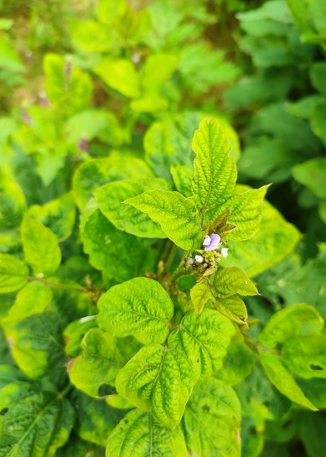 | 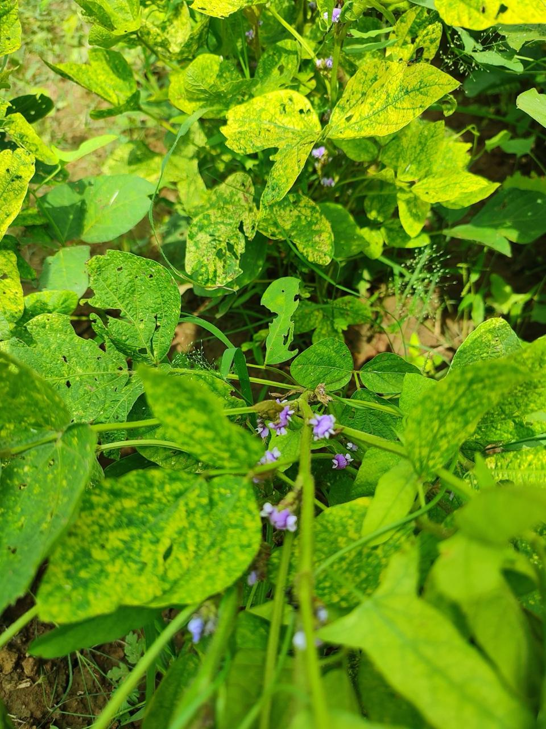 | 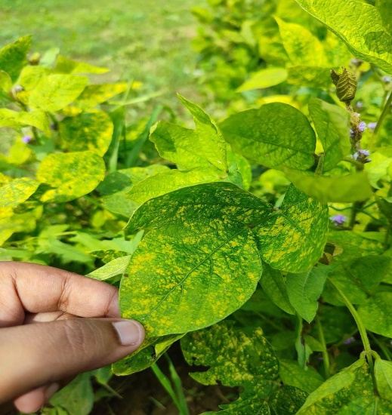
Highly Resistant | Resistant | Moderately Resistant
 | 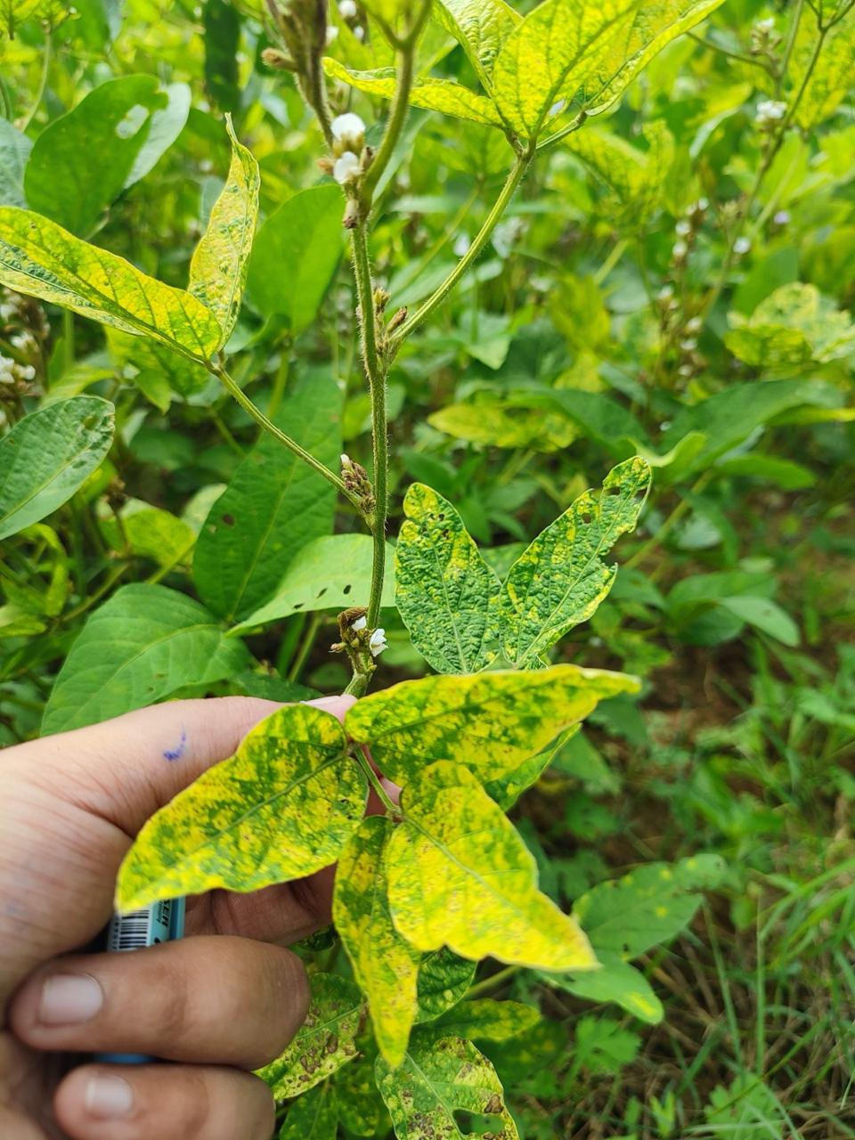 | 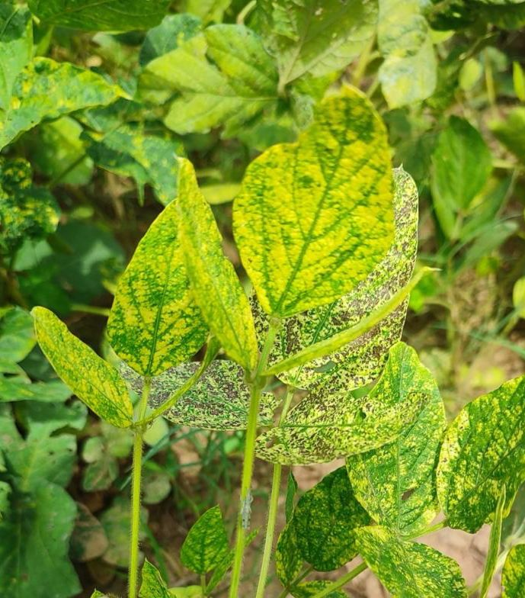
Moderately Susceptible | Susceptible | Highly Susceptible
Figure 1: Disease screening of Yellow Vein Mosaic Virus disease under field condition
The genotypes JS335 and RVS2001-4 exhibited the highest level of disease susceptibility, characterized by pronounced symptom expression and poor plant vigour. In addition, genotypes such as RVS 23-13, RVS 23-15, NRC253, TS-156, NRC254, VLS105, and AS34 showed susceptible reactions, indicating a lack of effective resistance mechanisms against YMV. A moderate level of susceptibility was recorded in several genotypes including RVS 23-10, RVS 23-14, RVS 23-16, RVS 23-17, JS 20-34, JS 93-05, MACS 1756 and others, which displayed intermediate symptom expression and reduced growth parameters.
Conversely, a substantial number of genotypes exhibited moderate resistance, showing limited symptom development and relatively better plant health under field conditions. These included genotypes such as RVS23-4, RVS23-7, RVS23-12, RVSM35, VLS104 and Pusa Sipani BS-9 among others. Further, a notable proportion of genotypes demonstrated resistant responses, characterized by mild or no visible symptoms and normal growth, suggesting effective inherent resistance. Genotypes such as JS 20-116, Raj Soya24, Lok Soya 2 and RVSM 2011-35 consistently maintained resistance under natural infection pressure.
Remarkably, the minimum level of disease incidence was recorded in genotypes RVS 23-1, RVS23-8, RVS23-24, JS20-98, Raj Soya 18, PS1693 and PS 1696, which were classified as highly resistant. These genotypes remained asymptomatic or exhibited only negligible signs of infection, indicating strong resistance potential and making them promising candidates for incorporation into YMV-resistance breeding programmes.
Table 2 Response of soybean genotypes for yellow mosaic disease screening during Kharif, 2023
S. No. | Genotypes | Disease Score | Disease Response
1 | RVS 23-1 | 0 | HR
2 | RVS 23-2 | 1 | R
3 | RVS 23-3 | 1 | R
4 | RVS 23-4 | 2 | MR
5 | RVS 23-5 | 1 | R
6 | RVS 23-6 | 1 | R
7 | RVS 23-7 | 2 | MR
8 | RVS 23-8 | 0 | HR
9 | RVS 23-9 | 1 | R
10 | RVS 23-10 | 3 | MS
11 | RVS 23-11 | 1 | R
12 | RVS 23-12 | 2 | MR
13 | RVS 23-13 | 4 | S
14 | RVS 23-14 | 3 | MS
15 | RVS 23-15 | 4 | S
16 | RVS 23-16 | 3 | MS
17 | RVS 23-17 | 3 | MS
18 | RVS 23-18 | 2 | MR
19 | RVS 23-19 | 2 | MR
20 | RVS 23-20 | 1 | R
21 | RVS 23-21 | 2 | MR
22 | RVS 23-22 | 2 | MR
23 | RVS 23-23 | 1 | R
24 | RVS 23-24 | 0 | HR
25 | RVS 23-25 | 2 | MR
26 | RVS 23-26 | 1 | R
27 | RVSM 35 | 2 | MR
28 | JS 20-34 | 3 | MS
29 | JS 93-05 | 3 | MS
30 | JS 95-60 | 1 | R
31 | JS 335 | 5 | HS
32 | JS 20-116 | 1 | R
33 | JS 20-69 | 1 | R
34 | JS 20-98 | 0 | HR
35 | RVS 76 | 1 | R
36 | RVS 2001-4 | 5 | HS
37 | Raj Soya 24 | 1 | R
38 | Raj Soya 18 | 0 | HR
39 | JS 20-29 | 1 | R
40 | VLS 104 | 2 | MR
41 | NRCSL 5 | 2 | MR
42 | JS 24-26 | 1 | R
43 | NRCSL 7 | 1 | R
44 | SKAUS 3 | 1 | R
45 | RVS 12-8 | 1 | R
46 | KDS 1203 | 1 | R
47 | NRC 253 | 4 | S
48 | MACS 1756 | 3 | MS
49 | Lok Soya 2 | 1 | R
50 | AMS 2021-3 | 2 | MR
51 | Himso 1695 | 2 | MR
52 | TS-156 | 4 | S
53 | NRCSL-8 | 1 | R
54 | JS 24-34 | 1 | R
55 | RSC 10-52 | 3 | MS
56 | DS 1510 | 2 | MR
57 | KSS 213 | 1 | R
58 | MAUS 824 | 2 | MR
59 | NRC 254 | 4 | S
60 | AMS 2021-4 | 3 | MS
61 | Himso 1696 | 2 | MR
62 | DS 1529 | 2 | MR
63 | KDS 1188 | 1 | R
64 | MACS 1745 | 2 | MR
65 | NRC 255 | 2 | MR
66 | Asb 93 | 3 | MS
67 | VLS 105 | 4 | S
68 | NRCSL 4 | 2 | MR
69 | NRC 257 | 1 | R
70 | MAUS 814 | 2 | MR
71 | SL 1311 | 1 | R
72 | Asb 85 | 3 | MS
73 | PS 1693 | 0 | HR
74 | NRC 256 | 1 | R
75 | RSC 1165 | 2 | MR
76 | BAUS 124 | 2 | MR
77 | DLSB 40 | 2 | MR
78 | NRC 258 | 1 | R
79 | Pusa Sipani BS-9 | 2 | MR
80 | PS 1696 | 0 | HR
81 | CAUMS 3 | 3 | MS
82 | AUKS 212 | 2 | MR
83 | RVSM 12-21 | 1 | R
84 | NRC 259 | 2 | MR
85 | AS 34 | 4 | S
86 | RVSM 2011-35 | 1 | R
87 | RSC 1172 | 3 | MS
88 | AS 55 | 2 | MR
89 | TS-208 | 3 | MS
90 | NRC-260 | 2 | MR
91 | NRC-196 | 3 | MS
92 | Pusa Sipani SPS-433 | 2 | MR
4. Discussion
The differential response of soybean genotypes to Yellow Mosaic Virus (YMV) infection observed in the present investigations highlights the existence of substantial genetic variability for disease resistance within the evaluated material. The identification of genotypes exhibiting varying degrees of resistance-from highly susceptible to highly resistant-under natural field conditions provide critical insights for breeding programmes to enhance YMV resistance. Similar studies have also been conducted by [20], [21] and [22].
The highly susceptible reaction recorded in genotypes such as JS335 and RVS2001-4, which are known for their vulnerability to YMV, confirms their utility as effective spreader and indicator lines. These genotypes facilitate uniform disease pressure across the experimental field, ensuring the reliability of resistance screening. Similarly, the susceptible and moderately susceptible genotypes identified in this study are likely to possess either incomplete or no genetic resistance, rendering them unsuitable for cultivation in YMV-prone regions [5, 23, 24].
Moderately resistant genotypes demonstrated partial resistance, which may be attributed to the presence of quantitative trait loci (QTLs) governing disease tolerance. These lines, although not entirely free from symptom expression, demonstrated significantly lower disease incidence and could serve as valuable sources of polygenic resistance. Their inclusion in breeding programmes may enhance the durability of resistance by reducing the selection pressure on the virus, thereby delaying the emergence of virulent strains [25,26,27].
Of particular importance are the genotypes categorized as resistant or highly resistant. The consistent performance of genotypes such as JS20-98, PS1693, PS1696, and Raj Soya 18 under natural YMV inoculum pressure suggests the presence of strong genetic resistance, possibly governed by dominant resistance genes. These genotypes exhibited either negligible or no visible disease symptoms, indicating their potential for direct use in YMV-endemic areas and their suitability as parental lines in resistance breeding efforts. Their resistance may be attributed to restricted virus replication or movement, enhanced expression of defense-related genes, or a combination of both [28, 29, 30].
The observed resistance among diverse genotypes also highlights the importance of maintaining genetic diversity in soybean germplasm collections [31]. Such variability not only facilitates the identification of resistance sources but also supports long-term resistance management strategies. Furthermore, the integration of these findings with molecular marker analysis and gene expression studies could enhance our understanding of the underlying resistance mechanisms and enable marker-assisted selection for durable YMV resistance [32-35].
Conclusion
The present investigation effectively elucidated the variability in resistance responses of soybean genotypes to Yellow Mosaic Virus (YMV) under natural field conditions during the Kharif 2023 season. A diverse range of reactions-ranging from high susceptibility to complete resistance-was observed, reflecting the rich genetic diversity within the tested material. The identification of genotypes exhibiting high levels of resistance, such as JS 20-98, Raj Soya 18, PS1693, and PS1696, is particularly noteworthy, as these lines consistently displayed negligible or no disease symptoms and maintained robust plant health. These highly resistant genotypes offer promising potential as parents in breeding programmes focused on enhancing YMV resistance. In addition, moderately resistant genotypes may serve as valuable sources of quantitative resistance, contributing to durable resistance through polygenic inheritance. Conversely, the identification of highly susceptible genotypes emphasizes the need to avoid their deployment in YMV-endemic areas unless used strategically in resistance introgression efforts. The outcomes of this study underscore the importance of field-based screening under natural disease pressure as a reliable and efficient approach for identifying resistant genotypes. Continued evaluation and validation of resistant lines across diverse environments, coupled with molecular characterization, may proof instrumental in accelerating the development of YMV-resistant cultivars, thereby contributing to sustainable soybean production and improved crop resilience against viral threats.
Disclaimer (artificial intelligence)
Author(s) hereby declare that NO generative AI technologies such as Large Language Models (ChatGPT, COPILOT, etc.) and text-to-image generators have been used during the writing or editing of this manuscript.
References
- Mishra R, Tripathi MK, Sikarwar RS, Singh Y, Tripathi N. Soybean (Glycine max L. Merrill): A Multipurpose Legume Shaping Our World. Plant Cell Biotechnology and Molecular Biology. 2024 Apr 15;25(3–4):17–37. https://doi.org/10.56557/pcbmb/2024/v25i3-48643
- Mishra R, Shrivastava MK, Amrate PK, Sharma S, Singh Y, Tripathi MK. Phenotypic Diversity and Trait Analysis of Soybean Recombinant Inbred Lines. Plant Cell Biotechnology and Molecular Biology. 2025 May 17;26(7–8):32–52. https://doi.org/10.56557/pcbmb/2025/v26i7-89345
- Mishra N, Tripathi MK, Tiwari S, Tripathi N, Sapre S, Ahuja A, et al. Cell Suspension Culture and In Vitro Screening for Drought Tolerance in Soybean Using Poly-Ethylene Glycol. Plants. 2021 Mar 10;10(3):517. https://doi.org/10.3390/plants10030517
- Mishra R, Shrivastava MK, Tripathi MK, Amrate PK, Singh Y, Solanki R, et al. Unravelling soybean yield potential: Exploring trait synergy, impact pathways, multidimensional patterns and biochemical insights. Plant Science Today. 2025 May 17. https://doi.org/10.14719/pst.6401
- Mishra N, Tripathi MK, Tiwari S, Tripathi N, Trivedi HK. Morphological and Molecular Screening of Soybean Genotypes against Yellow Mosaic Virus Disease. Legume Research - An International Journal. 2020 Aug 31. https://doi.org/10.18805/LR-4240
- Sharma A, Tripathi MK, Tiwari S, Gupta N, Tripathi N, Mishra N. Evaluation of Soybean (Glycine max L.) Genotypes on the Basis of Biochemical Contents and Anti-oxidant Enzyme Activities. Legume Research-An International Journal. 2021 Aug 7. https://doi.org/10.18805/LR-4678
- Mishra R, Tripathi M, Tripathi N, Singh J, Tiwari S. Nutritional and Anti-Nutritional Factors in Soybean. Acta Scientific Agriculture. 2024 Nov 3;8(11):46–63. https://doi.org/10.31080/ASAG.2024.08.1432
- Mishra R, Tripathi MK, Tripathi N, Singh J, Yadav PK, Sikarwar RS, et al. Breeding for Major Genes against Drought Stress in Soybean. In: Tripathi MK, Tripathi N, editors. Advances in Plant Biotechnology. Cornous Publications LLP, Puducherry, India; 2024. p. 22–68. https://doi.org/https://doi.org/10.37446/volbook032024/22-68
- Amrate PK, Shrivastava MK, Borah M, Routhu GK, Sharma S, Nataraj V, et al. Molecular characterization of soybean yellow mosaic virus isolates and identification of stable resistance sources in central India. Australasian Plant Pathology. 2023 May 9;52(3):165–79. https://doi.org/10.1007/s13313-022-00902-8
- Rahman SU, Raza G, Naqvi RZ, McCoy E, Hammad M, LaFayette P, et al. A source of resistance against yellow mosaic disease in soybeans correlates with a novel mutation in a resistance gene. Frontiers in Plant Science. 2023 Nov 24;14. https://doi.org/10.3389/fpls.2023.1230559
- Mishra GP, Dikshit HK, S. V. R, Tripathi K, Kumar RR, Aski M, et al. Yellow Mosaic Disease (YMD) of Mungbean (Vigna radiata (L.) Wilczek): Current Status and Management Opportunities. Frontiers in Plant Science. 2020 Jun 24;11. https://doi.org/10.3389/fpls.2020.00918
- Amrate PK, Shrivastava MK, Pancheshwar DK, Sharma S. Charcoal Rot and Yellow Mosaic Virus Diseases of Soybean Under Hot Spot Condition: Symptoms, Incidence and Resistance Characterization. International Journal of Bio-resource and Stress Management. 2020 Jun 30;11(3):268–73. https://doi.org/10.23910/1.2020.2104
- Swathi M, Gaur N, Singh K. Virus Vector Relationship of Yellow Mosaic Virus and Whitefly, Bemisia tabaci (Gennadius) in Soybean. Legume Research - An International Journal. 2021 Mar 3. https://doi.org/10.18805/LR-4479
- Caminade C, McIntyre KM, Jones AE. Impact of recent and future climate change on vector‐borne diseases. Annals of the New York Academy of Sciences. 2019 Jan 18;1436(1):157–73. https://doi.org/10.1111/nyas.13950
- Rocklöv J, Dubrow R. Climate change: an enduring challenge for vector-borne disease prevention and control. Nature Immunology. 2020 May 1;21(5):479–83. https://doi.org/10.1038/s41590-020-0648-y
- Abbasi E. Climate Change and Vector-Borne Disease Transmission: The Role of Insect Behavioral and Physiological Adaptations. Integrative Organismal Biology. 2025 Jan 21;7(1). https://doi.org/10.1093/iob/obaf011
- Subedi B, Poudel A, Aryal S. The impact of climate change on insect pest biology and ecology: Implications for pest management strategies, crop production, and food security. Journal of Agriculture and Food Research. 2023 Dec; 14:100733. https://doi.org/10.1016/j.jafr.2023.100733
- Krenz B, Niehl A, Krczal G. Emerging strategies in plant virus disease control: insights from the 56th meeting of the DPG working group “Viruskrankheiten der Pflanzen.” Journal of Plant Diseases and Protection. 2024 Dec 12;131(6):1761–8. https://doi.org/10.1007/s41348-024-00992-0
- Lal SK, Rana VKS, Sapra RL, Singh KP. Screening and utilization of soybean germplasm for breeding resistance against Mungbean yellow mosaic virus. Soyb Genet Newsl. 2005, 32.
- Magar SG, Jadhav P v, Vaidya ER, Moharil MP, Ghawade RS, Shinde UD, et al. Assessment of soybean genotypes for charcoal rot disease resistance and agronomic performance. International Journal of Advanced Biochemistry Research. 2024 Jan 1;8(6):309–13. https://doi.org/10.33545/26174693.2024.v8.i6d.1327
- Naveesh YB, Prameela HA, Basavaraj S, Rangaswamy KT. Screening of Soybean Genotypes to Soybean Yellow Mosaic Virus Disease. International Journal of Current Microbiology and Applied Sciences. 2020 Mar 20;9(3):2070–6. https://doi.org/10.20546/ijcmas.2020.903.237
- Amrate PK, Shrivastava MK, Pancheshwar DK, Sharma S. Charcoal Rot and Yellow Mosaic Virus Diseases of Soybean Under Hot Spot Condition: Symptoms, Incidence and Resistance Characterization. International Journal of Bio-resource and Stress Management. 2020 Jun 30;11(3):268–73. https://doi.org/10.23910/1.2020.2104
- Kumari N, Aski MS, Mishra GP, Roy A, Dikshit HK, Saxena S, et al. Development of infectious clones of mungbean yellow mosaic India virus (MYMIV, Begomovirus Vigna radiate indiaense) infecting mungbean [Vigna radiata (L.) R. Wilczek] and evaluation of a RIL population for MYMIV resistance. PLOS ONE. 2024 Oct 22;19(10): e0310003. https://doi.org/10.1371/journal.pone.0310003
- Amrate PK, Nataraj V, Shivakumar M, Shrivastava MK, Rajput LS, Mohare S, et al. Best linear unbiased prediction (BLUP)-based models aided in selection of high yielding charcoal rot and yellow mosaic resistant soybean genotypes. Genetic Resources and Crop Evolution. 2024 Dec 11. https://doi.org/10.1007/s10722-024-02289-5
- Mishra N, Tripathi MK, Tripathi N, Tiwari S, Gupta N, Sharma A. Validation of Drought Tolerance Gene-linked Microsatellite Markers and Their Efficiency for Diversity Assessment in a Set of Soybean Genotypes. Current Journal of Applied Science and Technology. 2021 Sep 30;48–57. https://doi.org/10.9734/cjast/2021/v40i2531515
- Hoque N, Haque MdA. Detection of yellow mosaic virus resistance in Soybean (Glycine max L.) genotypes for yield and related traits. F1000Research. 2024 Aug 30; 13:982. https://doi.org/10.12688/f1000research.150924.1
- Gai Y, Liu S, Zhang Z, Wei J, Wang H, Liu L, et al. Integrative Approaches to Soybean Resilience, Productivity, and Utility: A Review of Genomics, Computational Modeling, and Economic Viability. Plants. 2025 Feb 21;14(5):671. https://doi.org/10.3390/plants14050671
- Roy G, Afandi F, Vishnuvardhannaidu K, Raut RN, Amir M. A comprehensive review of genomics assisted breeding and mutation strategies for Yellow Vein Mosaic Virus resistance in mung bean. International Journal of Research in Agronomy. 2025 May 1;8(5):176–86. https://doi.org/10.33545/2618060X.2025.v8.i5c.2885
- Bag MK, Gautam NK, Prasad TV, Pandey S, Dutta M, Roy A. Evaluation of an Indian collection of black gram germplasm and identification of resistance sources to Mungbean yellow mosaic virus. Crop Protection. 2014 Jul; 61:92–101. https://doi.org/10.1016/J.CROPRO.2014.03.021
- Usovsky M, Chen P, Li D, Wang A, Shi A, Zheng C, et al. Decades of Genetic Research on Soybean mosaic virus Resistance in Soybean. Viruses. 2022 May 24;14(6):1122. https://doi.org/10.3390/v14061122
- Mishra R, Tripathi MK, Shrivastava MK, Amrate PK. Genetic diversity in crop improvement: A cornerstone for sustainable agriculture and global food security. In: Tripathi MK, Tripathi N, editors. Advances in Plant Biotechnology. Cornous Publications LLP; 2024. p. 1–21. https://doi.org/https://doi.org/10.37446/volbook032024/1-21
- Sharma A, Mishra N, Tripathi N, Nehra S, Singh J, Tiwari S, et al. Qualitative Trait Based Variability Among Soybean Genotypes. Acta Scientific Agriculture. 2023 Jan 1;02–13. https://doi.org/10.31080/ASAG.2023.07.1212
- Yamin D, Uskoković V, Wakil A, Goni M, Shamsuddin S, Mustafa F, et al. Current and Future Technologies for the Detection of Antibiotic-Resistant Bacteria. Diagnostics. 2023 Oct 18;13(20):3246. https://doi.org/10.3390/diagnostics13203246
- Deng Y, Ning Y, Yang DL, Zhai K, Wang GL, He Z. Molecular Basis of Disease Resistance and Perspectives on Breeding Strategies for Resistance Improvement in Crops. Molecular Plant. 2020 Oct;13(10):1402–19. https://doi.org/10.1016/j.molp.2020.09.018
- Michaelis C, Grohmann E. Horizontal Gene Transfer of Antibiotic Resistance Genes in Biofilms. Antibiotics. 2023 Feb 4;12(2):328. https://doi.org/10.3390/antibiotics12020328

