Original Research Article

Sustainable Spray Technology: A Battery-Powered Shielded Sprayer for Chilly Crop for Drift Reduction

____________________________________________________________________________
ABSTRACT

The study tackles low mechanization and pesticide drift in India’s small‐scale farming by designing, evaluating, and conducting a cost analysis of a battery-powered, shielded inter-row sprayer to improve pest control efficiency and minimize environmental impact. It was designed with a DC motor, Li-ion battery, nozzle-equipped adjustable boom, and shield to minimize drift. The sprayer uses interchangeable nozzles (hollow cone, flat fan) with a discharge rate of 900–1000 ml/min and a spray angle of 70–80. Powered by a 0.5 hp DC motor and guided by an Atmega16 controller, it includes rubber wheels and shielded nozzles for precise, drift-free spraying in chilly crop. Performance evaluation included laboratory tests per IS standards and field trials on 54 plots using different speeds, nozzle types, and heights. Spray parameters like droplet density, Volume Median Diameter (VMD), Number Median Diameter (NMD), Homogeneity Factor (HF), spray deposition, application rate, effective field capacity, field efficiency and ergonomic parameters like heart rate and comfort rating were analyzed for chilly crop. Field experiments indicated that droplet density decreased as with increase in spray height and increase in forward speed for changes nozzle type. Maximum droplet density was found at hollow cone nozzle, 0.4 m/s forward speed and 0.4 m height of nozzle (57.47 no./cm²) for chilly crop. Most uniform droplet size was found at hollow cone nozzle,0.7m/s forward speed and 0.4 height of nozzle as HF was closer to one (1.58), for chilly crop. The highest total deposition was observed in N1S2H2 (85.17%), while the lowest was found in N1S3H1 (82.44%). The maximum EFC was observed in N1S3H3 (0.328 ha/h), indicating higher speed improves field coverage efficiency, while the highest field efficiency was recorded in N2S1H1 (67.28%) and the lowest in N2S3H2 (51.34%). Heart rate increased with increased forward speeds, while the comfort rating was highest at low forward speed. Plant damage was highest (4.30%) in N1S2H1, with no damage in N1S1H3, showing that optimized sprayer settings reduce plant damage. The developed sprayer significantly reduced time, covering one hectare in only 4.40 hours compared to 11.62 hours with a battery-operated manual knapsack sprayer. This research provides compact design, effective field performance, and ergonomic operation make it ideal for improving weed and pest control in row crops like chilly.

Keywords: Shielded sprayer, chilly, droplet analysis, VMD, NMD, HF and Deposition.

1. INTRODUCTION

Agriculture remains vital to India's economy, supporting over 42% of the population and contributing significantly to GDP, despite facing challenges like small landholdings and declining farm sizes. Mechanization is increasingly essential due to labor shortages and the need for increased productivity and efficiency in farm operations. However, mechanization in India varies widely, with low adoption in some practices like plant protection and weeding.
Farm mechanization, including the use of equipment for pesticide application, plays a vital role in improving agricultural productivity. Spraying pesticides, though essential for pest control, is a process fraught with risks. The widespread use of pesticides and herbicides in Indian agriculture is crucial for crop protection but is often inefficient, leading to environmental pollution and health hazards due to drift and misapplication. Uniform and targeted application, especially for herbicides, is necessary to improve effectiveness and minimize damage.
Weed management is particularly critical as it can cause crop yield losses ranging from 10% to 100%. Traditional manual weeding is labor-intensive and expensive, making herbicides a preferred option. However, herbicide drift poses risks to surrounding crops and ecosystems. Shielded sprayers can mitigate this drift but are limited in availability and adoption, especially among small and marginal farmers who lack access to large machinery.
Chilly (Capsicum frutescens L.) is a spices crop; the hallmark of Indian cuisine is the use of spices and chilies. Indians themselves consider chilies as an integral part of their food. Prior to the arrival of chilies, the two main ingredients used to spice up Indian food were the long pepper (grown in Bengal in East India) and black pepper (grown along the Western Coast, in particular Malabar in Kerala). In Gujarat, chili occupies 0.12 lakh ha area with a production of 0.23 lakh MT in 2020-21 (Directorate of Agriculture, 2021).
With the dominance of small-scale farmers in India, affordable and efficient solutions like battery-operated shielded sprayers are essential. These sprayers not only reduce labor and energy costs but are also more environmentally friendly. Therefore, the study aims with below objectives to develop and evaluate a battery-powered shielded sprayer for herbicide and pesticide application for effective and sustainable crop protection.
- To standardize operational parameters of shielded spraying for chilly crop.
- To evaluate the techno-economic feasibility of shielded sprayer.

2. MATERIALS AND METHOD

2.1 Study Site and Crops
Location: Development and lab work at CAET, AAU Godhra; field trials at the college’s instructional farm in Kankanpur (22°56′ N, 72°53′ E).
Crops: Chilly (Capsicum frutescens L., var. VNR 332), selected for 500–600 mm row spacing. Crop parameters (age, canopy dimensions, inter-plant/row spacing) were measured to inform machine design.
2.2 Design & Fabrication of Battery-Operated Shielded Sprayer
The sprayer was developed with objectives an easy in-row operation, low cost, locally maintainable, time/labor saving, drift-reducing shield. The developed sprayer includes an adjustable MS frame with dimensions ranging from 1000–1400 mm in length and 460–1350 mm in width, weighing 60 kg when loaded. It features a 40-liter PVC tank, a 12V diaphragm pump, and lithium-ion batteries (12V, 25Ah & 15Ah). The sprayer uses interchangeable nozzles (hollow cone, flat fan) with a discharge rate of 800–1000 ml/min and a spray angle of 70–80°. Powered by a 0.5 hp DC motor and guided by an Atmega16 controller, it includes rubber wheels and shielded nozzles for precise, drift-free spraying in row crops.

2.3 Laboratory study
The tests were conducted to assess the nozzle parameter selection different parameters such as spray angle and width, nozzle discharge and spray pattern. The optimum values of those are important to ascertain the working of sprayer in the field condition. Measured spray angle and width, discharge (l/min), and distribution uniformity using a 41-channel patternator at 1–2.5 kg/cm², heights 400–600 mm of ranging.
2.4 Field performance study
The field studies were conducted to assess the performance of the developed shielded sprayer in real agricultural conditions, focusing on factors like; nozzle type (hollow cone, flat fan), forward speed (0.40, 0.55, 0.70 m/s), nozzle height (0.40, 0.50, 0.60 m). It was conducted on chilly crop. Factorial RBD with 3 parameters like; nozzle type (hollow cone, flat fan), forward speed (0.40, 0.55, 0.70 m/s), nozzle height (0.40, 0.50, 0.60 m) in 18 treatments × 3 replications = 54 plots (3168 m²) in 2025. The evaluation of developed sprayer performance involved analyzing Spray and field parameters like droplet density, Volume Median Diameter (VMD), Number Median Diameter (NMD), Homogeneity Factor (HF), spray deposition, application rate, effective field capacity, field efficiency and ergonomical parameters like heart rate and comfort rating were analyzed for chilly crop are as follows:
2.4.1 Spray parameter (Droplet size analysis)
Droplet size analysis included finding of droplet density, NMD, VMD, HF and deposition. For which (strips of known spread factor 1.16) glossy paper strip was put on upper and lower side of the leaf at top and middle of the plant and one strip was put on ground in rows. The open-source ImageJ software was used for further analysis of the strip.
Droplet Density: Number of droplets deposited per cm².
$$Droplet density(droplets/{cm}^{2})=\frac{Total number of droplets in selected image area }{Selected Image area}$$
Number Median Diameter (NMD): Diameter dividing droplets into two equal parts by number.
Volume Median Diameter (VMD): Mid-way droplet size when accumulated volume of smaller droplets accounts for 50% of sprayed liquid.
Homogeneity Factor (HF): Ratio of VMD to NMD, indicating droplet formation homogeneity.
Deposition: The droplet deposition is the volume deposited per cm² area or percentage. It was calculated by following equation.
$$Deposition (μl/{cm}^{2})=\frac{Total volume of all droplets on the selected area of strip }{selected area of strip }$$
2.4.2 Field evaluation and ergonomical parameters
Field evaluation parameters comprised theoretical field capacity (TFC), effective field capacity (EFC), field efficiency (FE), application rate & ergonomical parameters like heart rate, comfort rating was found by using standard formulas.
2.4.3 Experimental procedures
The shielded sprayer specific calibration followed the same procedures as the laboratory experiment. A methylene blue dye solution was prepared and filled into the sprayer tank. Glossy paper strips were then installed at various positions on the plants to capture spray data. The experimental procedure involved developed sprayer over the marked plot according to the designated treatment combinations. The time taken to cover the length and area was recorded, and the volume of liquid sprayed/consumed was measured. The strips were removed for analysis after each pass and placed new for subsequent trials. Each treatment was replicated thrice within a single day to ensure data reliability.
2.5 Techno-economical Evaluation
The parameters like operational Cost (fixed and variable costs) were taken into consideration to estimate the cost of operations by using IS: 9164-1979 test code, payback period and B:C ratio was calculated by using standard method and formulas.

3. RESULTS AND DISCUSSION
3.1 Effect of independent variables on droplet density
An experiment was conducted to know the effect of type of nozzle(N), forward speed(S) and height of nozzle(H) on the droplet density. The ANOVA given in Table 1 and Fig.1 shows that the effect of type of nozzle(N), forward speed(S), km/h and height of nozzle(H), m and their NS & SH interactions on the droplet density was found of significant at 5% level of significance.

Table 1: Analysis of variance for Droplet density (chilly)  Source of Variation DF S S M S F-Cal. S Em Test  N 1 4.785 4.785 49.78 0.060 *  S 2 1008.9 504.4 5248.3 0.073 *  N * S 2 0.740 0.370 3.85 0.103 *  H 2 70.935 35.468 368.97 0.073 *  N * H 2 0.544 0.272 2.83 0.103 NS  S * H 4 6.556 1.639 17.05 0.127 *  N *S*H 4 0.241 0.060 0.63 0.179 NS  Error 34 3.268 0.096  Total 53 1096.54 C V %: 0.62  (N: Type of Nozzles, S: Forward speed, H: Height of Nozzle *= P<0.05) | 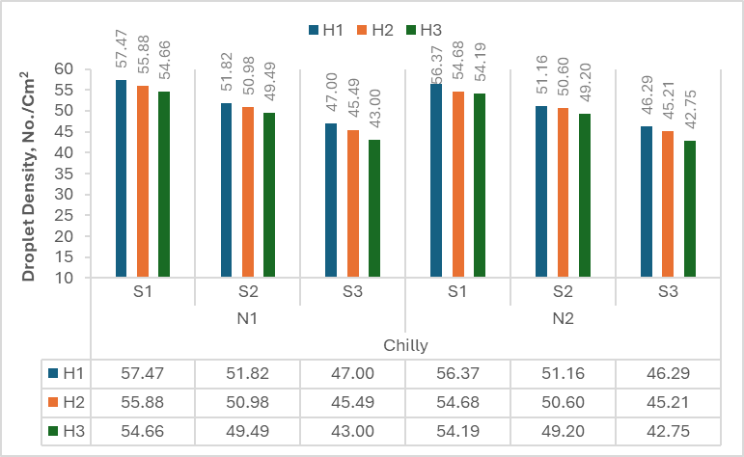  Fig. 1Effect of nozzle type (N), forward speed(S) and height of nozzle(H) on droplet density
3.2 Effect of independent variables on Homogeneity Factor
The experiment was conducted to know the effect of independent variables i.e., type of nozzle(N), forward speed(S) and height of nozzle(H) on the HF at chilly crop. The homogeneity factor (HF) is the ratio of the VMD to NMD. The ANOVA given in Table 2 and Fig.2 shows that effect of types of nozzles, forward speed(S) and height of nozzle (H) and their interaction on the HF was found significant at 5% level of significance.

Table 2: Analysis of variance for HF (Chilly)  Source of Variation DF S S M S F-Cal. S Em Test  N 1 0.301 0.301 165.90 0.008 *  S 2 0.015 0.007 4.09 0.010 *  N * S 2 0.085 0.043 23.49 0.014 *  H 2 0.119 0.060 32.84 0.010 *  N * H 2 0.223 0.111 61.40 0.014 *  S * H 4 0.056 0.014 7.70 0.017 *  N *S*H 4 0.069 0.017 9.47 0.025 *  Error 34 0.062 0.002  Total 53 0.929 C V %: 2.38  (N: Type of Nozzles, S: Forward speed, H: Height of Nozzle *= P<0.05) | 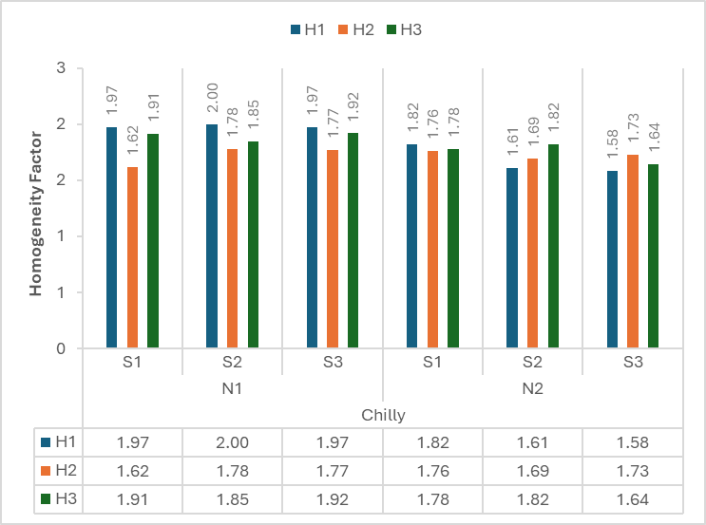  Fig. 2 Effect of nozzle type (N), forward speed(S) and height of nozzle(H) on HF

3.3 Effect of independent variables on Deposition
An experiment was conducted to know the effect of type of nozzle(N), forward speed(S) and nozzle height(H) on the deposition of chilly crop. The ANOVA given in Table 3 and Fig.3 indicates the percentage of other losses, which is the spray that does not reach the target and deposition losses away. Comparing the heights of nozzle, H2 generally exhibits the highest deposition percentages at various locations, while H1 & H3 tends to have the lowest deposition percentages for chilly crop.

Table 3 Average deposition for individual variables  Variables Deposition, %  H1 H2 H3  Top Upper 38.15 38.84 37.29  Top Lower 5.23 4.73 4.38  Middle Upper 15.01 20.17 23.67  Middle Lower 5.20 5.20 4.35  Bottom 19.12 19.12 13.75  Total on plants 82.71 85.01 83.44  Other losses 17.29 14.99 16.56 | 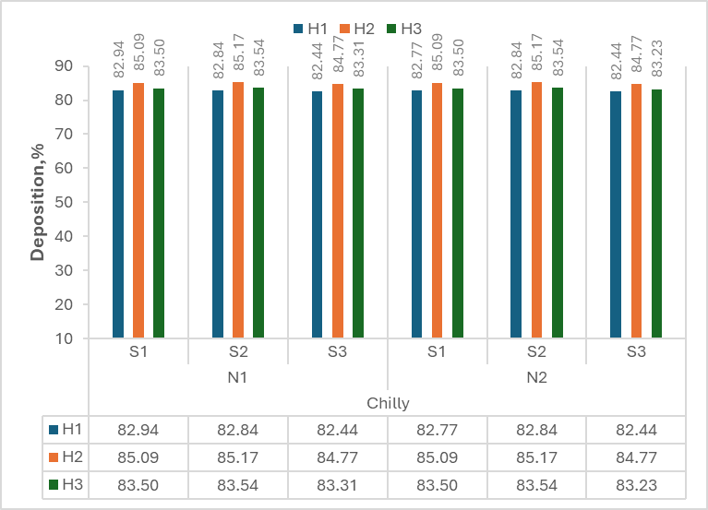  Fig. 3 Effect of nozzle type (N), forward speed(S) and height of nozzle(H) on deposition
3.4 Effect of independent variables on EFC
An experiment was conducted to know the effect of type of nozzle(N), forward speed(S) and nozzle height, on the Effective field capacity (EFC) of chilly crop. The ANOVA given in Table 4 and Fig.4 indicates the effect of height of nozzle(H) and forward speed(S) & interaction of NH found significant at 5% level of significance whereas their interaction on the EFC and effect of types of nozzles was found non-significant and the interaction of height of nozzle(H) and forward speed(S) was also found non-significant.

Table 4: Analysis of variance for EFC (Chilly)  Source of Variation DF S S M S F-Cal. S Em Test  N 1 0.000 0.000 0.04 0.001 NS  S 2 0.076 0.038 1230.17 0.001 *  N * S 2 0.000 0.000 0.19 0.002 *  H 2 0.000 0.000 3.81 0.001 *  N * H 2 0.000 0.000 4.33 0.002 *  S * H 4 0.000 0.000 2.44 0.002 NS  N *S*H 4 0.000 0.000 2.49 0.003 NS  Error 34 0.001 0.000  Total 53 0.079 C V %: 2.07  (N: Type of Nozzles, S: Forward speed, H: Height of Nozzle *= P<0.05) | 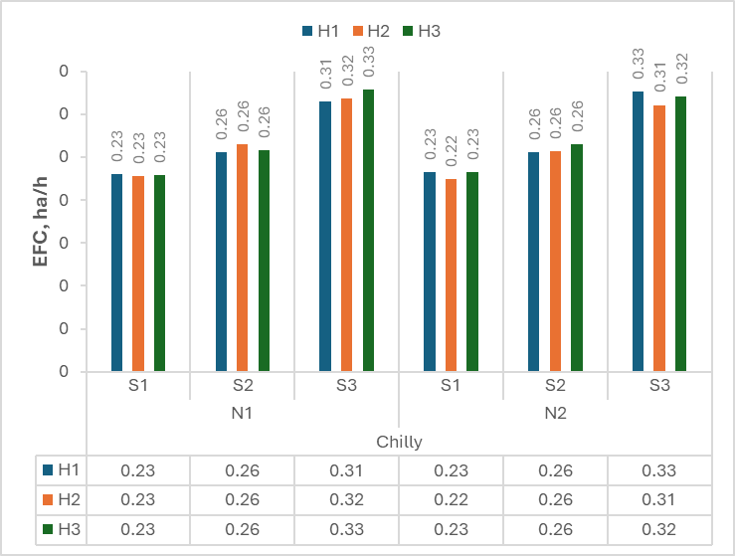Fig. 4 Effect of nozzle type (N), forward speed(S) and height of nozzle(H) on EFC

3.5 Effect of independent variables on Plant damage
An experiment was conducted to know the effect of type of nozzle (N), forward speed(S) and height of nozzle (H) on the plant damage. The ANOVA given in Table 5 and Fig.5 indicates that the effect of type of nozzle(N), forward speed(S), km/h and height of nozzle(H), m on the plant damage was found of significant at 5% level of significance and their interactions was found of non-significant due to crop parameters may be affect.
Table 5: Analysis of variance for Plant damage (Chilly)  Source of Variation DF S S M S F-Cal. S Em Test  N 1 0.685 0.685 0.25 0.029 *  S 2 7.852 3.926 1.44 0.036 *  N * S 2 2.507 1.253 0.46 0.051 NS  H 2 12.720 6.360 2.33 0.036 *  N * H 2 3.014 1.507 0.55 0.051 NS  S * H 4 9.480 2.370 0.87 0.062 *  N *S*H 4 14.447 3.612 1.32 0.088 NS  Error 34 92.805 2.730  Total 53 146.446 C V %: 104.17  (N: Type of Nozzles, S: Forward speed, H: Height of Nozzle *= P<0.05) | 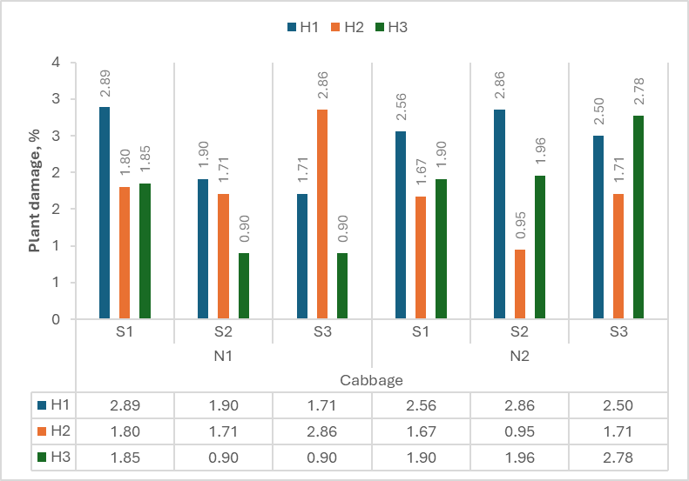Fig.5 Effect of nozzle type (N), forward speed(S) and height of nozzle(H) on plant damage
3.6 Effect of independent variables on Heart rate (HR)
An experiment was conducted to know the effect of type of nozzle(N), forward speed(S) and height of nozzle(H) on the heart rate (HR). The ANOVA given in Table 6 and Fig.6 indicates the effect of type of nozzle (N), forward speed(S) and height of nozzle (H) and their interactions on the heart rate was found of significant at 5% level of significance.

Table 6: Analysis of variance for HR (Chilly)  Source of Variation DF S S M S S Em Test  N 1 0.000 0.000 0.000 *  S 2 729.333 364.667 0.000 *  N * S 2 0.000 0.000 0.000 *  H 2 49.333 24.667 0.000 *  N * H 2 0.000 0.000 0.000 *  S * H 4 22.667 5.667 0.000 *  N *S*H 4 0.000 0.000 0.000 *  Error 34 0.000 0.000  Total 53 945.333 C V %: 0.00  (N: Type of Nozzles, S: Forward speed, H: Height of Nozzle *= P<0.05) | 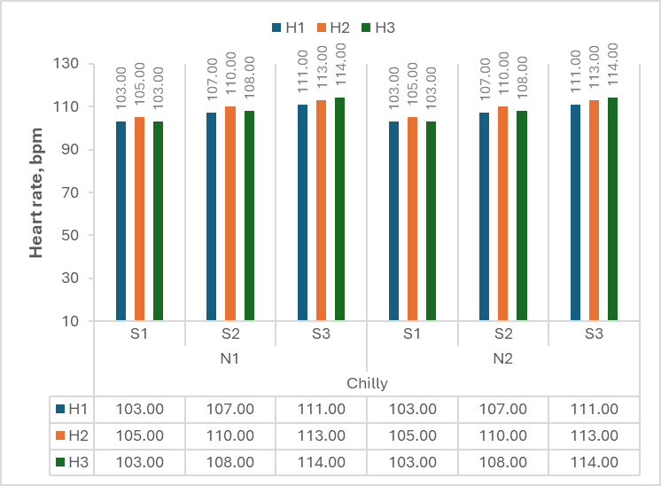  Fig. 6 Effect of nozzle type (N), forward speed(S) and height of nozzle(H) on HR
3.7 Effect of independent variables on Comfort rating (CR)
An experiment was conducted to know the effect of type of nozzle(N), forward speed(S) and height of nozzle(H) on the comfort rating (CR). The ANOVA given in Table 7 and Fig.7 shows that the effect of type of nozzle (N) and forward speed(S) was found of significant at 5% level of significance and height of nozzle (H) and all interactions on the CR was found of non-significant.

Table 7: Analysis of variance for CR (Chilly)  Source of Variation DF S S M S F-Cal. S Em Test  N 1 0.667 0.667 6.88 0.060 *  S 2 34.037 17.019 175.54 0.073 *  N * S 2 0.111 0.056 0.57 0.104 NS  H 2 0.481 0.241 2.48 0.073 NS  N * H 2 0.111 0.056 0.57 0.104 NS  S * H 4 0.519 0.130 1.34 0.127 NS  N *S*H 4 0.444 0.111 1.15 0.180 NS  Error 34 3.296 0.097  Total 53 39.704 C V % : 7.64  (N: Type of Nozzles, S: Forward speed, H: Height of Nozzle *= P<0.05) | 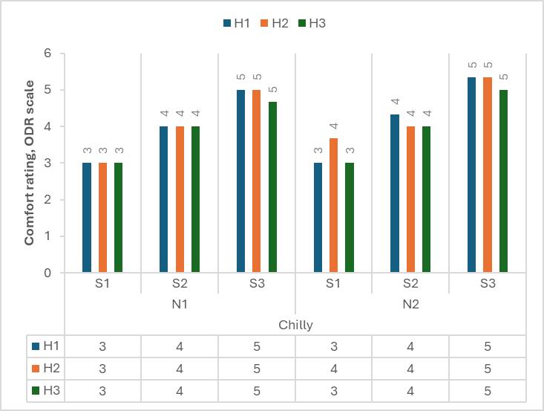  Fig. 7 Effect of nozzle type (N), forward speed(S) and height of nozzle(H) on CR

4. CONCLUSIONS

From the study, following conclusions were drawn.
- Droplet density declined with increasing spray height and speed across nozzle types, peaking at 57.47 no./cm² with a hollow cone nozzle at 0.4 m/s and 0.4 m height.
- The most uniform droplet size (HF = 1.58) was also at this nozzle type and 0.7 m/s speed.
- Maximum field capacity (0.328 ha/h) occurred in N1S3H3, while field efficiency ranged from 67.28% (N2S1H1) to 51.34% (N2S3H2).
- Total deposition varied slightly, highest in N1S2H2 (85.17%) and lowest in N1S3H1 (82.44%).
- Heart rate and comfort rating changed with speed from 103 bpm & 3 (S1) to 114 bpm & 5 (S3). Plant damage was highest (4.30%) in N1S2H1 and absent in N1S1H3, confirming optimized settings reduce damage.
- The developed sprayer operates at ₹74.65/h (₹329/ha) and requires 4.40 man-hours per hectare. It offers a net benefit of ₹53.87/h, with a payback achieved at ₹1024.29 or 232.36 ha.
- Benefit: Cost ratio is 3.13, demonstrating strong economic viability for small and marginal farmers.
- Compared to the knapsack sprayer, which costs ₹626/ha and takes 11.62 hours per hectare, the developed sprayer is nearly twice as cost-effective and 2.5 times faster.

The developed battery-operated shielded sprayer proved to be technically efficient (uniform droplet size, low drift), ergonomically safe (lower heart rate, higher comfort), economically viable (low cost, fast payback), and environmentally friendly (battery-powered, low emissions). It is especially suited for small and marginal farmers, supporting precision agriculture, timely field operations, and sustainable mechanization.

5. REFERENCES
Anibude, E. C., Jahun, R. F., & Abubakar, M. S. (2016). Development of an animal drawn hydraulic boom sprayer. American Journal of Engineering Research, 5 (2), 222-228.
Babasaheb, G., & Kushwah, O. (2015). Comparative performance of tractor operated boom type field sprayers on cotton crop. International Journal of Agricultural Engineering, 8 (1), 85-91.
Bhan, V. M., Kumar, S., & Raghuwanshi, M. S. (1999). Weed Management in India. Indian Journal of Plant Protection, (17), 71-202.
Chauhan, S. (2015). Motor torque calculations for electric vehicle. International Journal of Scientific & Technology Research, 4 (8): ISSN 2277-8616.
Corlett, E.N., & Bishop, R. P. (1976). A technique for assessing postural discomfort. Ergonomics, 19(2), 175-82.
Directorate of Agriculture (2021). Government of Gujarat. https://doh.gujarat.gov.in /Images/directorofhorticulture/pdf/statistics/Yearwise-Comparative-up-to-20-21.pdf
Gholap, B., & Mathur, R. (2013). Field evaluation of tractor operated boom sprayer of cotton crop. International Journal of Agricultural Engineering, 6 (2), 372-374.
Gupta, P., Sirohi, N. P. S., & Kashyap, P. S. (2011). Effect of nozzle pressure, air speed, leaf area density and forward speed on spray deposition in simulated crop canopy. Annals of Horticulture, 4 (1), 72-77.
IS: 11313 (2007). Test procedure for power sprayers. Indian Standards Institution. Government of India, New Delhi.1-16.
IS: 9164 (1979). Guide for estimating cost of farm machinery operation. Indian Standards Institution. Government of India, New Delhi. 1-17.
Kepner, R.A., Bainer, R. & Barger, E. L. (2005). Principles of farm machinery. AVI Publishing (4th), INC, Westport.
Ozkan, H. E., Miralles, A., Sinfort, C., Zhu, H., & Fox, R. D. (1997). Shields to reduce spray drift. Journal of Agricultural Engineering Research, 67, 311-322.
Singh, S. K., Dixit, A. K., Singh, S., & Rohinisb, K. (2010). Development of field evaluation of tractor mounted air assisted sprayer for cotton. Agricultural Mechanization in Asia, Africa & Latin America, 41 (4), 49-54.
Saha, P. N., Datta, S. R., Banergy, P. K., & Narayane, G. (1979). An acceptable workload from a modified scale of perceived exertion. Ergonomics, 37, 485-491.
Sidahmed, M. M., Awadalla, H. H., & Haidar, M. A. (2004). Symmetrical multi-foil shields for reducing spray drift. Biosystems Engineering, 88, 305-312.
Zhu, H., Masoud, S., & Robert, D. F. (2011). A portable scanning system for evaluation of spray deposit distribution. Computers & Electronics in Agriculture, 76 (2), 38-43.

***********

