Original Research Article

**Multivariate analysis in chickpea (*Cicer arietinum* L.) cultivars**

.

ABSTRACT

|  |
| --- |
| The study evaluated 36 chickpea genotypes, including one check variety, at SHUATS, Prayagraj, during Rabi 2021 using a randomized block design with three replications. Data on 13 traits were analyzed for genetic variability, heritability, correlation, and path analysis. ICC 2300 was identified as the best genotype for seed yield per plant. Significant variation was observed for all traits, with high heritability in days to maturity, number of primary branches, days to 50% flowering, and seed yield per plant. High genetic advance was recorded for plant height, number of branches, biological yield, and seeds per plant. Seed yield per plant showed positive correlations with the number of seeds per plant, pods per plant, and 100-seed weight. Principal component analysis explained 29.36% variance, and cluster analysis grouped 35 genotypes into six clusters. These findings aid in refining selection criteria for developing high-yielding chickpea varieties. |

*Keywords: Heritability, Variability, Genetic Advance, Correlation Analysis, PCA and D2 analysis*

1. INTRODUCTION

Chick pea (*Cicer arietinum)* ranks as the third most widely consumed legume globally with its origin tracked back to the Western Asia. The crop exists in two primary forms *viz:* the small, angular “desi type” and large, round “Kabuli type”. It serves as a valuable a protein supplement in cereal-based diets, particularly benefitting populations in developing countries. Chickpea seeds provide rich source of protein (14-15%), carbohydrates (44%), fat (4.5%), minerals, amino acids and vitamins. (Arunkumar et al., 1998, Sivakumar and Muthiah, 2001). Although studies on chickpea diversity exist, they often focus on a limited range of germplasm lines. Genetic variability is fundamental for any crop improvement effort, as it provides the foundation for selecting superior traits. Since yield is a complex quantitative trait, direct selection based solely on yield performance is often ineffective. Instead, selecting for highly heritable and interrelated traits can indirectly enhance yield potential. Heritability and genetic advance are crucial parameters in selection, as they help predict potential genetic gain. However, high heritability alone does not necessarily ensure significant genetic progress, making it essential to consider both factors together for effective selection of superior varieties. (Hamid & Cheema, 1997). Correlation and path analysis play a key role in understanding the relationship between yield and its contributing traits. These analyses not only assess the degree of association between traits but also help breeders determine the direct and indirect effects of different characteristics on grain yield. (Garcia de Moral et al., 2005). This information is essential for devising efficient breeding strategies aimed at yield enhancement Wright (1921). Genetic diversity is another crucial factor in crop improvement programme aiding in the development of superior recombinants. Mahalanobis’s D2 statistics is frequently utilized across various crops to identify genetically diverse parents for hybridization programs. This statistical approach effectively quantifies genetic divergence and establishes clustering patterns in relation to geographical origin (Kuldeep et al., 2015). Additionally Principal component score (PCS) method has been applied to select accessions that best represent maximum genetic diversity within given collection (Noirot et al., 1996; Gireesh et al., 2017). PCS analysis has proven valuable in evaluating germplasm and understanding trait relationships in various crops (Zafar et al., 2008). This study aims to assess genetic variability, diversity and trait associations in chickpea to facilitate yield improvement. Furthermore, it seeks to identify a subset of chickpea accessions that encapsulate maximum genetic diversity using the PCS strategy, thereby contributing to future breeding programs.

2. material and methods

Thirty-five Chickpea genotypes including one check variety (PUSA-362) depicted in the table 1 obtained from ICRISAT were sown at Field Experimentation Centre, Department of Genetics and Plant Breeding, Naini Agricultural Institute, Sam Higginbottom University of Agriculture, Technology & Sciences, Prayagraj, Uttar Pradesh. during rabi 2021.

Mean data were recorded for thirteen quantitative characters at the appropriate growth stage of the plant. The traits evaluated included days to 50% flowering, days to 50% pod setting, days to maturity, number of primary branches per plant, number of secondary branches per plant, plant height (cm), number of seeds per plant, number of pods per plant, number of seeds per pod, biological yield per plant, seed yield per plant (g), 100 seed weight (g) and harvest index. The computed mean data for each trait were subjected to analysis of variance following standard methods by Panse and Sukhatme (1985). Correlation coefficients were calculated using the formulae suggested by Falconer (1964), path analysis by Dewey and Lu (1959) and regression analysis through excel. Principal component analysis (PCA) and principal component score were derived using XLSTAT software to elucidate relationships among traits, additionally D2 analysis was performed using INDOSTAT software

**Table: 1 List of genotypes**

|  |  |  |  |  |  |  |  |
| --- | --- | --- | --- | --- | --- | --- | --- |
| 1 | ICC 86 | 10 | ICC 2411 | 19 | ICC 12007 | 28 | IPC 0459 |
| 2 | ICC 448 | 11 | ICC 3002 | 20 | ICC 12360 | 29 | IPC – 05-62 |
| 3 | ICC 768 | 12 | ICC 3230 | 21 | ICC 1202 | 30 | JG-14 |
| 4 | ICC 1204 | 13 | ICC 313 | 22 | BGD-72 | 31 | King ganesh |
| 5 | ICC 2198 | 14 | ICC 1248 | 23 | IPC-08-103 | 32 | Vaibhav |
| 6 | ICC 2211 | 15 | ICC 3018 | 24 | JG-16 | 33 | GNG-1958 |
| 7 | ICC 2233 | 16 | ICC 3115 | 25 | IPC-0528 | 34 | NBEG-49 |
| 8 | ICC 2300 | 17 | ICC 3488 | 26 | IPCK-1185 | 35 | IPC 57 29 |
| 9 | ICC 2355 | 18 | ICC 6068 | 27 | IPC 0566 | 36 | Pusa 362 |

3. results and discussion

**3.1 Genetic variability**

In this study, analysis of variance revealed significant differences among the accessions for all the thirteen traits evaluated. The mean performance of days to 50% flowering ranged from 91 days to 109 days with overall mean of 99 days. The genotype ICC 6068 (91 days) was the earliest to reach days to 50% flowering while JG-16 (109 days) took the longest. The mean performance for days to 50% pod setting was varied from 63 days to 95 days. The genotype BGD-72 (63 days) was earliest to reach days to 50% pod setting where as Vaibhav required the maximum time (95 days). The mean performance for days to maturity ranged from 123 days to 132 days with a grand mean of 128 days. The genotype ICC 6068 (123 days) was earliest in terms of days to maturity followed by ICC 2198 (123 days). The genotype JG-14(132 days) was identified late maturing among all accessions. Plant height exhibited a mean performance ranging from 43 cm to 75 cm with the grand mean of 58 cm. The shortest genotype was IPC 0528 (43 cm) closely followed by Vaibhav (44 cm) while ICC 2355 (75 cm) was the tallest. The mean performance for number of primary branches ranged from1.67 to 3.20 with grand mean of 2.45. The genotype ICC2411 (1.67) recorded fewest primary branches followed by ICC 2355 (2.00) and ICC 2211(2.20). In contrast ICC 3013(3.20) has shown maximum number of primary branches. For secondary branches the mean performance ranged from 5.52 to 9.73 with overall mean of 6.87. The genotype ICC3002 (5.52) has lowest number of secondary branches followed by ICC 12360 (5.53) and BGD-72 (5.93). The maximum number of secondary branches was recorded by IPC -0566 (9.73) followed by IPCK -1185 (9.20). The average of number of seeds per plant ranged from 38 to 70 with grand mean of 51. The genotype IPCK 1185 (70.13) has highest number of seeds per plant followed by ICC 2233 (70) and ICC 3002 (67) while the genotype ICC 2198 (38) has fewest number of seeds per plant followed by Vaibhav (37). The mean performance of number of pods per plant ranged from 22 to 80 with grand mean of 58. The genotype ICC12007 (80) has maximum number of pods per plant, while genotype JG-14(22) has minimum number of pods per plant. For number of seeds per pod the mean ranged from 1.0 to 2.0 with overall mean of 1.48. The genotype ICC2198 (2.0) and ICC2355 (2.0) has maximum number of seeds per pod whereas ICC 1204 (1.0) recorded minimum number of seeds per pod followed by ICC2411(1.20). The biological yield ranged from 9.33g to 45.33g with grand mean of 21.23 g. The harvest index ranged from20.17% to 72.32%with a grand mean of 45.70%. The genotype ICC2300 (72.32%) had highest harvest index followed by IPC-05-62 (65.10%). The ICC 3013 (20.17%) had lowest harvest index followed by ICC 764(21.22%).

**3.2 Correlation analysis**

Correlation analysis among yield and its attributing traits depicted through correlogram in the fig 1, revealed that seed yield per plant had significant positive correlation with number of secondary branches (0.36), number of seeds per plant (0.52), biological yield (0.44) and 100 seed weight (0.71). While significant negative association with number of primary branches, plant height, days to 50 % flowering, days to 50% pod setting and harvest index.

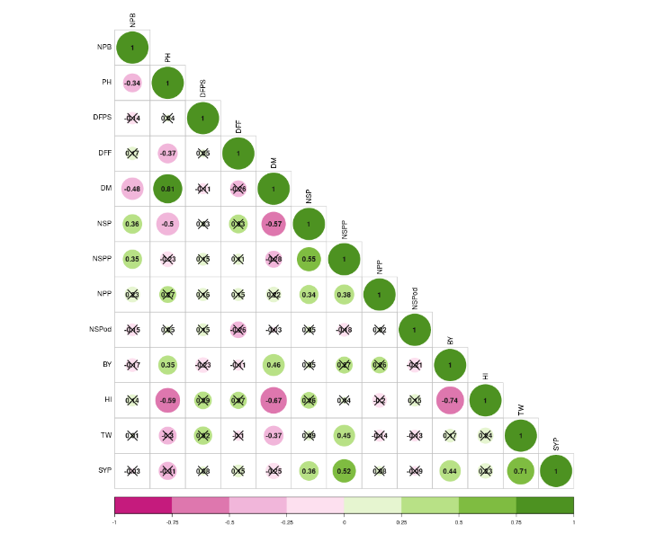

**Fig. 1. Correlogram representing the correlation between variables**

**3.3 Principal component analysis**

The primary objective of principal component analysis is to reduce the dimensionality of a large dataset, enhancing interpretability while minimizing the loss of information. The Eigen values, percentage of variance and cumulative percentage are summarized in Table 2. In this analysis, 5 principal components had Eigen values greater than 1. The eigen values for PCA 1, 2, 3, 4, and 5 had were 3.816, 2.507, 1.725,1.396 and 1.059 respectively. The percentage explained by these components was 29.35%, 19.28%, 13.26%, 10.73% and 8.14% respectively. Collectively these components accounted for 80.76 % of the total variability observed in the genotypes analysed diversity.

**Table 2: Eigen values**

|  |  |  |  |
| --- | --- | --- | --- |
| **Principal component** | **Eigen value** | **Percentage of variance** | **Cumulative percentage of variance** |
| PC1 | 3.816 | 29.357 | 29.357 |
| PC2 | 2.507 | 19.282 | 48.639 |
| PC3 | 1.725 | 13.267 | 61.906 |
| PC4 | 1.396 | 10.736 | 72.642 |
| PC5 | 1.059 | 8.147 | 80.789 |
| PC6 | 0.9 | 6.919 | 87.708 |
| PC7 | 0.46 | 3.535 | 91.243 |
| PC8 | 0.402 | 3.09 | 94.333 |
| PC9 | 0.291 | 2.235 | 96.568 |
| PC10 | 0.205 | 1.574 | 98.141 |
| PC11 | 0.152 | 1.167 | 99.308 |
| PC12 | 0.07 | 0.541 | 99.848 |
| PC13 | 0.02 | 0.152 | 100 |

Principal component Analysis revelated a wide distribution of the scores for the 13 quantitative traits, indicating substantial diversity. The analysis summarized the variance structure using a few linear combinations of the variables, representing the proportion og variability. Thus, on the basis of factor loading, it was possible to identify an exact picture of the specific traits contributing most to the observed variability. Understanding genetic diversity is crucial for developing effective breeding strategies, forming heterotic groups and predicting the performance of future hybrids.

A scree plot is a graphical representation that arranges eigen values in descending order, illustration the percentage of variability explained by each principal component (PC). PC 1 showed highest variability 29.35% with an eigen value of 3.816, followed by a gradual decline for subsequent components. The plot with fig.no. 2 exhibited a steep curve initially followed by a bend and then a levelling off, highlighting the significant contribution of PC1 to the overall variability. The biplot between PC1 and PC2 explained the distribution and the nature of diversity among variables and the genotypes. The loading plot revealed high degree of variation across most genotypes and traits. The biplot clearly demonstrated significant variability among the genotypes and parameters. This study offers valuable insights into identifying parameters contributing to variability aiding in selection of suitable genotypes for breeding programs and crop improvement efforts focused on yield related traits.

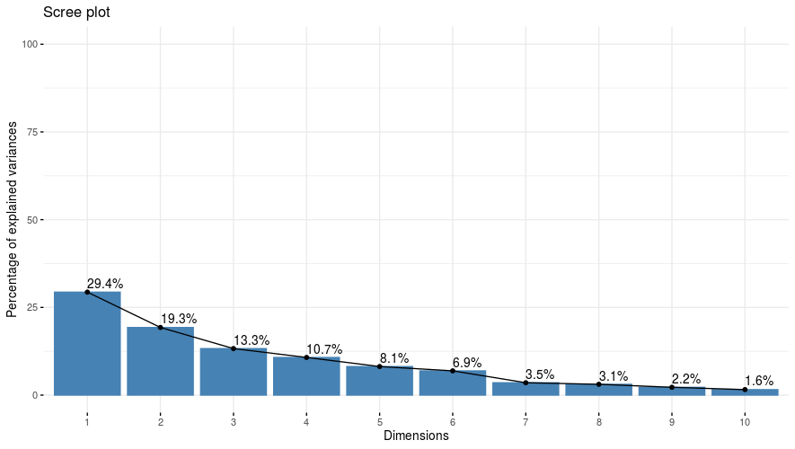

**Fig. No. 2 Screen plot constructed based on thirteen principal component and their Eigen values**

**3.4 Biplot Analysis**

A biplot was generated and depicted in fig 3 to explore the relationships among variables and samples in a multivariate dataset using principal component analysis (PCA). The biplot depicts the first two principal components (PC1 and PC2), which together capture a significant proportion of the variance in the dataset. **PC1** appears to represent the primary dimension of variability in the dataset, explaining the majority of variance. **PC2** adds a secondary layer of differentiation, orthogonal to PC1, contributing additional variability. Variables such as by number of seed per plant, biological yield and days to fifty percent flowering which are pointing in the same direction have a stronger influence on the variability captured by PC1 and PC2. Whereas days to maturity and number of seeds per pod are pointing in opposite directions are negatively correlated the position of accessions highlights their association with specific variables. Genotypes ICC 1248, ICC 2211, ICC 3002, ICC2300, ICC 86 are highly influenced by number for seed per plant and number of seed per pod. Variables like number of seed per plant, number of seed per pod and biological yield are the dominant contribution for PC1 and PC2 due to wide spread point. The spread of points across PC1 and PC2 reflect significant variability in data set

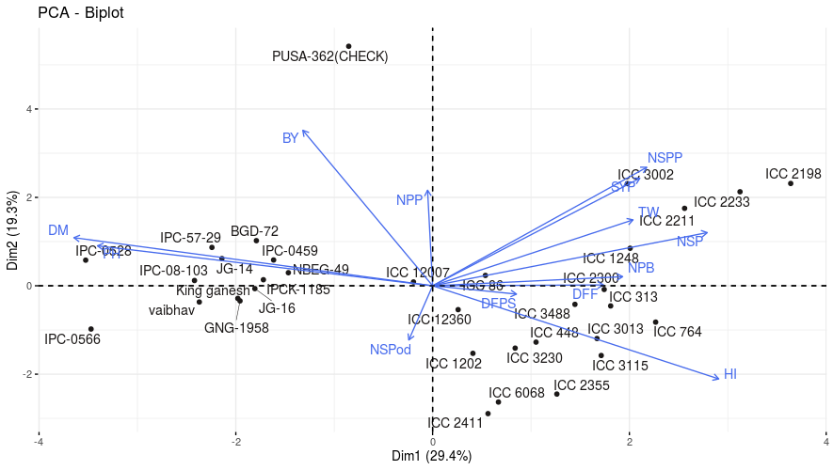

**Fig. No. 3 Distribution of 35 chickpea genotypes based on principal component PC1and PC2**

**3.5 Cluster analysis**

Cluster analysis is a valuable method for classifying the data, enabling the division of the genetic material into distinct homogenous groupings. It helps categorize genotypes based on their morpho-genetic traits. This technique works by reducing variance within each group, while maximizing the variance between different groups, making it useful for identifying outliers. In the present study 35 accessions were classified into six clusters based on D2 values using the Tocher method. The distribution of accessions across the clusters varied are summarized in the table 3. Among six clusters, Cluster II was the largest comprising of 11 accessions followed by Cluster V with 10 accessions. Cluster VI included had 6 accessions, while Cluster IV contained 3 accessions, Cluster I Comprised 2 accessions and Cluster III had only 1 accession represented in form of dendrogram in (Fig. No.4).

**Table 3: Genotypes included under different Clusters.**

|  |  |
| --- | --- |
| **Clusters** | **Genotypes included in the cluster** |
| **Cluster I** | JG-16, BGD-72 |
| **Cluster II** | Vaibhav, JG-14, IPC-0528, IPCK-1185, IPC-0459, IPC-57-29, NBEG-49, IPG-08-103, GNG-1958, King Ganesh, IPC-0566 |
| **Cluster III** | ICC-12007 |
| **Cluster IV** | ICC 2300, ICC 12360, ICC 2411 |
| **Cluster V** | ICC 764, ICC 3115, ICC 313, ICC 448, ICC 2355, ICC 3013, ICC 2211, ICC 1248, ICC 3488, ICC 86, ICC 1202 |
| **Cluster VI** | ICC 3002, ICC 2198, ICC 2233, ICC 3230, ICC 6068, PUSA-362 |

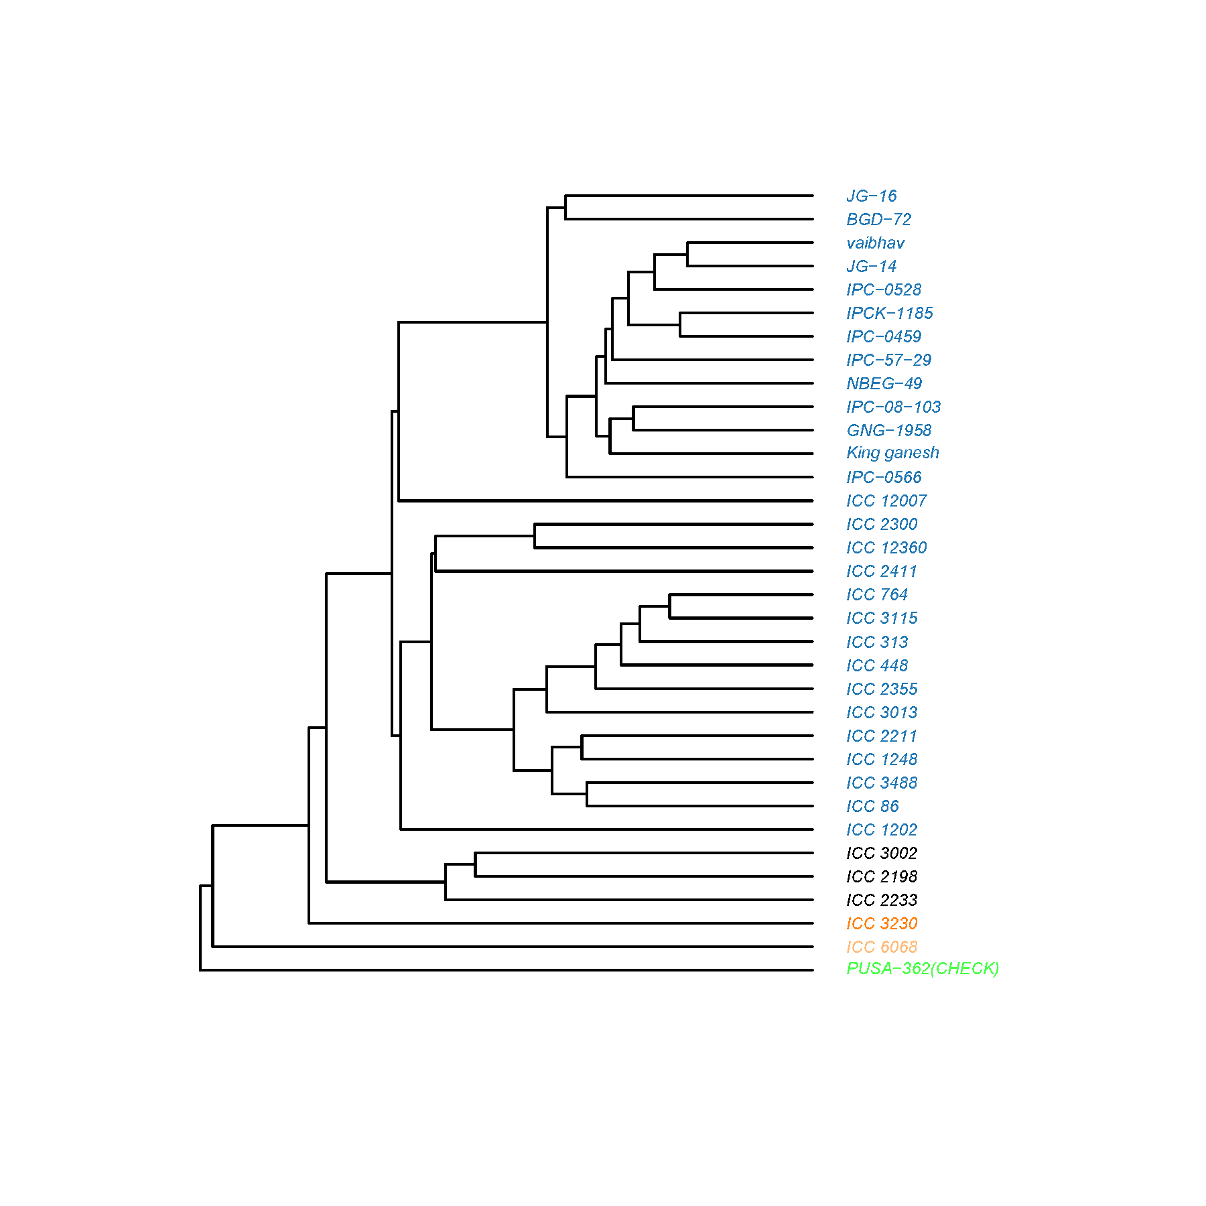

**Fig. No. 4 Distribution of 35 chickpea genotypes in the dendrogram**

4. Conclusion

The results of this study provide a comprehensive analysis of the genetic variability, diversity, and trait associations in chickpea, offering valuable insights for future breeding programs aimed at improving yield. Significant genetic variation was observed across the 35 chickpea genotypes for various agronomic traits, with promising candidates identified for key traits such as seed yield, number of seeds per plant, biological yield, and harvest index. The positive correlations between seed yield and traits like biological yield and 100 seed weight underscore their potential as selection criteria in breeding programs.

Principal component analysis and cluster analysis confirmed substantial genetic diversity among the genotypes, which can be leveraged for developing high-yielding and adaptive chickpea varieties. The results emphasize the importance of selecting traits with high heritability and genetic gain, such as the number of seeds per plant and biological yield, for improving chickpea productivity By utilizing these findings, breeders can make informed decisions to enhance chickpea production, particularly in regions where it serves as a crucial protein source for the population.

References

encouragement, and sacrifices, which have been a constant source of motivation throughout this research journey.

**Reference**

Aarif, M., Rastogi, N. K., Johnson, P. L. and Chandrakar, P. K., 2014**.** “Genetic analysis of seed yield and its attributing traits in chickpea (Cicer *arietinum L*.)”. *Journal of Food legumes*, **27** (1): 24-2

Anand Kumar, Kumar, A., Ravi, R. K., Kumar, S., Satyendra, Kumari, R. and Singh, P. K. 2019. Principal component analysis of agro-morphogenetic traits in Desi chickpea (*Cicer arietinum L*.). *International Journal of Chemical Studies*. SP6: 362-365.

Anita, B., Andey, S. and Singh, R. 2015. Genetic studies on chickpea genotypes grown in late sown under rice fallow conditions of Madhya Pradesh. *Electronic Journal of Plant Breeding*. **6**(3): 738-748.

Arunkumar, A Kumar, and Krishna, R. 1998. Heritability and genetic advance in gram (*Cicer arietinum L*.) genotypes of diverse origin*. Indian Journal of Agricultural Science*. 68: 747–749.

Dewey, J. R., and Lu, K. H., 1959. Correlation and path coefficient analysis of components of crested wheat grass seed production. *Agronomy Journal.* 51: 515–518.

Falconer, D. S. 1964. Introduction to Quantitative Genetics, vol. 1. New York: Ronald Press, p. 365.

Garcia de Moral, L. F., Rharrabti Y., Villegas, D. and Royo C. 2003. Evaluation of grain yield and its components in durum wheat under Mediterranean conditions: An oncogenic approach. *Agronomy journal*. 95: 266-274

Gediya, L. N., Patel, D. A., Kumar, S., Kumar, D., Parmar, D. J., and Patel, S.S. 2019. Phenotypic variability, path analysis and molecular diversity analysis in chickpea (*Cicer arietinum L.* ). *Vegetos*, 1-14.

Ghafoor, A., Sharif, A., Ahmad, Z., Zahid, M. A. and Rabbani, M. A. 2001. Genetic diversity in black gram [*Vigna mungo L. Hepper*]. *Field Crops Research*. 69: 183-190.

Hamid, A. and Cheema, N. M. 1997. Genetic analysis of plant characters in chickpea. *Journal of Agricultural Research*. **35**(3): 205-213.

Hasan, M. T. and Deb, A. C. 2017.Assessment of genetic variability, heritability, character association and selection indexes in chickpea (*Cicer arietinum L.*). *Tropical Research*, **1**(2): 65-72.

Jayalakshmi, V., Ronald, R. G. and Lakshmanna, K. 2014. Diversity analysis of chickpea germplasm in scarce rainfall zone of Andhra Pradesh, India. *Legume Research*. 37: 682 684.

Jida, Z., and Alemu, S. 2019. Genetic Diversity Analysis of Ethiopian Elite Chickpea (*Cicer arietinum L.*) Varieties Based on Agronomic Characters. *Journal of Plant Breeding and Crop Science*. 11(3), PP. 80-86.

Kuldeep, R., Pandey, S., Babbar, A. and Prakash, V. 2015. Genetic diversity analysis in chickpea grown under heat stress conditions of Madhya Pradesh. *Electronic Journal of Plant Breeding*. **6**(2): 424-433

Malik, S. R., Bakhsh, A., Asif, M. A., Iqbal, U. and Iqbal, S. M., 2010. Assessment of genetic variability and interrelationship among some agronomic traits in chickpea. *International Journal of Agriculture and Biology*. 12:81-85.

Malik, S. R., Shabbir, G., Zubur, M., Iqbal, S. M. and Ali, A. 2014. Genetic diversity analysis of morpho-genetic traits in Desi chickpea (*Cicer arietinum L.).* *International Journal of Agriculture and Biology*. 16: 956-960.

Noirot, M., Hamon, S. and Anthony, F. 1996. The Principal Component Scoring: a new method of constituting a core collection using quantitative data. *Genetic Resources and Crop Evolution.* 43: 1–6.

Panse, V. G. and Sukhatme, P. V. 1985. Statistical Methods for Agriculture Workers. New Delhi: *Indian council of Agricultural Research Publication*. pp. 87–89.

Shedge, P. J., Patil, D. K. and Misal, M. R., 2019. Assessment of Genetic Variability in Chickpea (*Cicer arietinum L*.). *International Journal of Current Microbiology and Applied Sciences*. 8 (7) : 1339-1344.

Shivwanshi, R. and Babbar, A. 2017. Principal component analysis of chickpea (*Cicer arietinum L.*) germpasm. *International Journal of Current Microbiology and Applied Sciences*. **6**: 166-173.

Singh, V., Singh, P., Kumar, A., and Nath, S. 2018. “Estimation of genetic variability parameters in chickpea (*Cicer arietinum L*. ) germplasm”. *Journal of Pharmacognosy and Phytochemistry*. **7** (2) :1204-1206.

Sivakumar, S. and Muthiah 2001. Genetic divergence in chickpea germplasm. Madras. *Agricultural Journal.* 87: 48–50.

Vishnu, B., Jayalakshmi, V. and Sudha Rani, M. 2020. Genetic diversity studies among chickpea (*Cicer arietinum L*.) genotypes under rainfed and irrigated conditions for yield attributing and traits related to mechanical harvesting. *Legume Research*. 43: 190-194.

Wright, S. 1921. Correlation and causation. *Journal of Agricultural Research*. 20: 557-565.

Zafar, I., Arshad, M., Ashraf, M., Mahmood, T. and Abdul, W. 2008. Evaluation of soybean (Glycine max (L.)) Merrill germplasm for some important morphological traits using multivariate analysis. *Pakistan Journal of Botany* 40: 2323–2328.