Original Research Article

FODDER PRODUCTIVITY, QUALITY CHARACTERISTICS AND PROFITABILITY OF SWEET CORN BASED VEGETABLE LEGUME INTERCROPPING SYSTEM DURING RABI UNDER SOUTHERN TRANSITION ZONE O F KARNATAKA

ABSTRACT
A field experiment was conducted during rabi season of 2023 at Keladi Shivappa Nayaka University of Agricultural and Horticultural Sciences, Shivamogga to evaluate the effect of different vegetable legumes as intercrops on fodder productivity, quality characteristics and profitability of sweet corn. It was laid out in randomized complete block design with ten treatments replicated thrice. The treatments consisted of sweet corn intercropping with french bean, vegetable cowpea and field bean at 2:2 and 3:2 row proportion compared with their sole cropping for their productivity. Sole sweet corn recorded significantly higher plant height (225.53 cm), leaf area (95.51 dm² plant⁻¹), dry matter accumulation (226.33 g plant⁻¹), cob yield (201 q ha⁻¹) and stover yield (287 q ha⁻¹). Among the intercropping systems, sweet corn + field bean (2:2) recorded significantly higher plant height (209.9 cm), leaf area (72.19 dm² plant⁻¹), dry matter accumulation (180 g plant⁻¹), cob yield (125 q ha⁻¹) and stover yield (179 q ha⁻¹) followed by sweet corn + vegetable cowpea (2:2). The fodder quality parameters of sweet corn viz., nitrogen content, crude protein, crude fiber, neutral detergent fiber and acid detergent fiber were influenced significantly and favourably with inclusion of legumes. Among the intercropping systems, sweet corn + vegetable cowpea (2:2) and sweet corn + field bean (2:2) were better over sole sweet corn. The nitrogen content, crude protein and crude fiber were maximum in sole sweet corn (0.84, 5.25 and 30.74 %, respectively). The neutral detergent fiber and acid detergent fiber were minimum in sweet corn + vegetable cowpea (2:2) (60.50 and 28.06 %, respectively). In terms of economics of different treatments, the highest net return (3,68,733 ₹. ha⁻¹) and BC ratio (4.06) were recorded with sweet corn + field bean (2:2) intercropping systems. Therefore, sweet corn intercropped with field bean at 2:2 row proportions found most compatible and remunerative intercropping system.
Key words: intercropping, sweet corn, field bean, vegetable cowpea, yield, quality parameters, fodder

- INTRODUCTION
The current trend in global agriculture is to search for highly productive, sustainable and eco-friendly cropping system. Intercropping of cereals with legumes is a recognized practice for economizing the use of nitrogenous fertilizers and increasing the productivity, quality and profitability. In our country 70% population mainly depends on agriculture and our country possess huge livestock population which plays an important role for nutritional and livelihood security of small and marginal farmers. The total livestock production in India during 2019 census was 535.78 million showing an increase of 4.63% over 2012 livestock census. This increased livestock population demands higher fodder in the country. In our country 77 per cent land area is subjected to natural calamities and 68 per cent net sown area is drought prone. Presently, our country faces a net shortfall of 35.6 per cent green fodder, 10.5 per cent dry fodder and 44 per cent of concentrated feed ingredients (Singh et al., 2022). Thus, availability of green fodder with improved quality is the key success of dairy enterprises.
Spatial row arrangement in the intercropping system is one of the most important factors for better yield advantage in order to avoid limitation of reduced plant population of base crop under traditional intercropping system (Pandey et al., 1999). Because of limited horizontal expansion of space, intercropping could help enhance vegetable yield. Sweet corn, as a wider-spaced plant, allows some component crops to grow without incurring a financial loss, while sacrificing a lower sweet corn yield in exchange for increased production in terms of land and time. Sweet corn intercropping with vegetable legumes produces a successful system. Apart from the above-mentioned benefits, the ability to generate short-term money from the sale of green pods is a major factor driving the adoption of sweet corn + vegetable legume intercropping.
Quality forage production and availability of green fodder with improved quality to animals is the key to success of dairy enterprises. Both quality and quantity of fodder are influenced due to plant species, stage of growth and agronomic practices. The growing of fodder crops in mixture with legumes enhanced fodder palatability and digestibility. It is well established fact that livestock feed should contain enough protein to maintain their health. A minimum protein content of 5–6% is required for maintenance and 14% for productive purposes. When legumes are used as intercrops, they provide beneficial effect on soil fertility by fixing atmospheric nitrogen, increasing forage protein content, quality, palatability and profitability, best utilization of nutrients, moisture, space, solar energy per unit area and time (Ginwal et al. 2019).
Specialty corns (viz., sweet corn, popcorn, baby corn, and high oil corn etc.) assume tremendous market potential not only in India but also in international market. These specialty corns with their high market value are perfectly suitable to peri-urban agriculture. Thus, they promise higher income to maize growers (Hugar and Salakinkop, 2022). Out of the various specialty corns, sweet corn (Zea mays L. saccharata) has big market potential. Sweet corn is an early maturing crop with 80-85 days duration and it has been bred to have higher levels of natural sugar (12%), which makes it very popular as it is rich source of Vitamin C, Vitamin A, niacin, beta-carotene, dietary fiber, antioxidant elements like calcium, potassium etc. The higher content of water-soluble polysaccharide in the kernel of sweet corn adds sweetness in addition to texture and quality. Hence, it is called “Sugar corn” (Venkatesh et al., 2003). After the harvest of corn, its lush green, soft, succulent, highly palatable fodder gives additional income to its growers and also sustains livestock. Whenever exclusive fodder maize is grown, sweet corn can be a potential alternative owing to its dual use for human consumption and fodder.
Therefore, in order to get best results, a rational approach is required for agronomic information on appropriate row proportion. It is time for India to switch to multiple and intensive vegetable cropping in order to increase income per unit area. Hence, the objective of the experiment is to evaluate the effect of different vegetable legumes as intercrops on fodder productivity, quality characteristics and economics of sweet corn.
- MATERIAL AND METHODS
A field experiment was conducted during rabi season of 2023 at Keladi Shivappa Nayaka University of Agricultural and Horticultural Sciences, Shivamogga. It lies under 13º 58’N latitude, 75º 34’ E longitude with an altitude of 650 m above the mean sea level in Southern Transition Zone of Karnataka. The prevailed weather conditions during the cropping period provided favorable circumstances for the growth and yield of sweet corn and intercrops (Fig 1). The crop received rainfall of 113.2 mm during the cropping period. The mean maximum and minimum air temperature of 34.58°C and 30.81 °C was recorded. The experiment was laid out in randomized complete block design with ten treatments replicated thrice. Treatments comprised of intercropping different vegetable legumes viz., French bean, Vegetable cowpea and Field bean with Sweet corn at 2:2 (T₁ to T₃) and 3:2 (T₄ to T₆) row proportions and sole planting (T₇ to T₁₀) of each crops for comparative studies. The experiment was conducted in replacement series of intercropping system and their design is represented in Fig 2 and 3. The soil of the experimental site was sandy loam in texture, neutral in soil reaction (6.73) with low inorganic carbon content (4.66 g kg⁻¹) and available nitrogen (175.92 kg ha⁻¹) but medium in available phosphorus (40.83 kg ha⁻¹) and potassium (191.25 kg ha⁻¹).
The hybrid and varieties used were MITHAS 12 of sweet corn, Arka Komal of french bean, Arka Samruddhi of vegetable cowpea and Hebbal Avre-3 of field bean. The duration of the crops was 80-85 days, 70 days and 70-75 days for sweet corn, french bean and vegetable cowpea and field bean, respectively. The seed rate used was 10 kg ha⁻¹ for sweet corn, 40 kg ha⁻¹ for french bean, 15 kg ha⁻¹ for vegetable cowpea and 37.5 kg ha⁻¹ for field bean. All the intercrops were sown along with the main crop by following line sowing method. The spacing followed was 45 cm × 30 cm for sweet corn and 45 cm × 20 cm for intercrops. Plant population accommodated per hectare in 2:2 row proportions was 37,037 and 55,555 for sweet corn and intercrops, respectively whereas in 3:2 row proportions 44,444 was the population per hectare for both sweet corn and intercrops. The recommended dose of fertilizers (Sweet corn: 100:50:25; French bean: 63:100:75; Vegetable cowpea: 25:75:60; and field bean: 25:50:25; kg N, P₂O₅ and K₂O ha⁻¹) was applied in the form of urea, DAP and MOP. Fertilizer was applied based on plant population for both main as well as component crop in the intercropping system and was placed 5 cm away from the crop row and covered with soil. For sweet corn, half of recommended nitrogen was given as basal dose and remaining nitrogen was top dressed at 30 days after sowing, while entire dose was applied at the time of sowing for all the legumes grown as intercrop.
The other management practices were done as per the recommended package of practices for both main and intercrops. Growth components of sweet corn were recorded at 20, 40, 60 DAS and at harvest. Leaf area was worked out by length x breadth method (Montgomery, 1911) which was multiplied by factor 0.74 and number of leaves per plant and expressed in dm²plant⁻¹. The cob yield and stover yields were recorded as per standard procedure and harvest index was worked out by dividing economic yield of crops by biological yield of respective crops. Samples were collected from each of the experimental plot and dried samples were ground to pass through 1 mm sieve and used for chemical analysis. Finally, milled samples were analysed for nitrogen content (Jackson, 1973), crude protein (it was was worked out by multiplying the nitrogen percentage with factor 6.25), crude fiber (Sadasivam and Manickam, 1992), neutral detergent fiber and acid detergent fibre (Van Soest, 1963). The economics of each treatment combination were calculated by taking all the detailed farm expenses (Cost of cultivation), cumulative income (Gross return), profit (Net return) and the benefit cost ratio. Statistical analysis was done by using analysis of variance (ANOVA) and the standard error of means (S. Em±) and critical difference at 5% (Gomez and Gomez, 1984).
- RESULTS AND DISCUSSION:
3.1 Growth components of sweet corn
Sole sweet corn recorded significantly higher growth components viz., plant height, number of leaves per plant, leaf area and total dry matter accumulation (Table 1). This might be due to the absence of intercrops, which did not offer competition in terms of water, nutrients and light. Manpreet et al. (2016) also reported higher plant height, cobs per plant and grains per cob in sole maize compared to maize in intercropping with rajmasha. Marer (2007) also reported higher plant height, leaf area per plant, grain weight per plant and test weight in sole maize. Shridhar et al. (2019) also found that sole maize recorded significantly higher leaf area per plant, cob girth, grain weight per cob, kernel yield and stover yield compared to its intercropping systems. Among the different intercropping system, sweet corn + field bean (2:2) recorded higher growth components, followed by sweet corn + vegetable cowpea (2:2) (Table 1). This might be due to better spatial complementarity of the component crops that led to better utilization of growth resources and field bean did not offer competition to sweet corn at any stage of their growth and also increased nodulation which helped nitrogen fixation in soil, this gained advantage and consequently resulted in higher growth and development. It might also be due to higher photosynthetic ability, utilization pattern of photosynthate for subsequent growth and translocation and increased light transmission, which could have helped towards higher photosynthesis, dry matter accumulation and translocation to reproductive parts. These results were collaborated with the findings of Kithan and Longkumer (2017b) in maize and soybean intercropping system. Singh and Singh (1993) observed that the growth and yield were generally decreased when two or more crops grown together in intercropping system compared to respective sole cropping, but the combined yield was higher than either of sole crops due to higher total productivity, which indicates better compatibility between the component crops with suitable cropping geometry.
3.2 Yield
Sole sweet corn recorded significantly higher cob yield and stover yield than it is grown in combination with vegetable legumes, viz., french bean, vegetable cowpea and field bean under different row proportions (Table 2). This was due to competition free environment for growth resources viz., light, soil moisture, air, nutrients and better agronomic practices which helped the crop to exhibit their full production potential. Since the experiment was conducted in replacement series the decrease in cob yield and stover yield was 37.8 and 37.6 per cent, respectively in sweet corn + field bean (2:2) compared to sole sweet corn (Fig 4). The results are similar with the findings of Kour et al. (2016) and Marer (2007). Among intercropping systems, sweet corn + field bean (2:2) has recorded higher cob yield, which was on par with sweet corn + vegetable cowpea (2:2) (Table 1). The higher cob yield and stover yield was mainly due complimentary relationship between the crops and optimum spacing leading to reduced competition for the resources like light, air, moisture, and nutrients (Hugar and Salakinkop, 2022). Similar results were found with the findings of Jan et al. (2016) and Kithan and Longkumer (2017a).
3.3 Quality characteristics
Quality forage production and availability of green fodder with improved quality to animals is the key to successful dairy enterprises. Both quality and quantity of fodder are influenced due to plant species, stage of growth and agronomic practices. The growing of fodder crops in mixture with legumes enhanced fodder palatability and digestibility. Higher the nutrient content and digestibility, improve the forage quality. When legumes are used as intercrops, they helps to enhance the nutritive value of the fodder like crude protein, crude fibre and digestibility.
Crude protein content of sweet corn varied from 4.06 to 5.25 per cent due to fluctuations in N content of herbage. However, sole sweet corn recorded significantly higher crude protein content (Table 3) due to higher amount of nitrogen content in sweet corn. Among the intercrops tested sweet corn + field bean (2:2) followed by sweet corn + vegetable cowpea (2:2) recorded significantly higher crude protein content (Table 3). This is mainly the result of higher amount of nitrogen content in sweet corn and also the component crops are synergistic in effect. These findings are in conformity with the results obtained by Ramankumar and Bhanumurthy (2001), who also reported that legume intercrops were able to grow better, fixing greater amount of atmospheric nitrogen, some part of it might have become available to cereal crop. This might be the possible reason for obtaining higher crude protein content of intercropping system. Similar results of higher crude protein in fodder maize when intercropped with legumes were earlier reported by Ram (2008).
Crude fibre content in sweet corn was significantly influenced by different intercropping system. The highest crude fibre content was observed in sole sweet corn (30.74 %) over different intercropping system (Table 3). This might be due to higher dry matter accumulation in sole sweet corn as compared to different intercropping system. The photosynthate, during its partitioning, might have been stored as cell wall contents, which is the possible reason for higher crude fibre content in sole sweet corn. Lower crude fibre content values were recorded in sweet corn + vegetable cowpea (2:2) followed by sweet corn + field bean (2:2). Sweet corn along with legumes, might have availed better nitrogen nutrition. This higher nitrogen under intercropped condition could have made the sweet corn more succulent and also higher synthesis of carbohydrates and synthesize carbohydrate partly converted into protein and protoplasm and only small portion of carbohydrate converted into components such as cellulose and hemicelluloses. These cell wall components are major constituent of fibre. Hence, decrease of these constituents the fibre per cent is reduced in intercropping (Ramankumar and Bhanumurthy, 2001). These findings are in conformity with Ginwal et al. (2019).
Neutral detergent fibre (NDF) content is important in ration formulation as it reflects bulkiness of the forage. Because forage fibre is bulky there is a limit to amount of NDF that will fit into a cow’s rumen. As NDF per cent increases, dry matter intake generally decreases (Javanmard et al., 2009). Acid detergent fibre (ADF) is energy content of a forage and is expressed as total digestible nutrients. The maximum value of total digestible nutrients (TDN) content might be due to minimum value of ADF contents in the respective treatments. TDN content in forage is inversely related with ADF concentration in feed therefore, as the concentration of ADF increases there is a decline in TDN content which limits an animal’s ability to utilize the nutrients that are present in forage (Carmi et al., 2006).
Intercropping of sweet corn with legumes significantly affected the NDF and ADF content (Table 3). Significantly higher NDF and ADF was observed in sole sweet corn. Among intercropping system significantly lower NDF and ADF was observed in sweet corn + vegetable cowpea (2:2) followed by sweet corn + field bean (2:2). Cereal crop grown along with legumes might have availed better nitrogen nutrition. This higher nitrogen under intercropped situation could have made the cereal component more succulent. Also, legumes provide more nitrogen which ultimately led to higher vegetative growth and reduced fibre fraction (Arif et al., 2022). Hence, NDF and ADF content significantly reduced with introduction of intercropping system compared to sole maize thus increasing the digestibility of forage. These findings are in conformity with Ginwal et al. (2019b).
3.4 Economics
By adopting diverse crops in the field at a time, the income earned by farmers can be increased and thus, risk can be minimized. Significantly higher gross, net returns and B-C ratio were observed in intercropping systems compared to sole crop of either sweet corn or intercrops (Table 4).
Sweet corn intercropped with field bean at 2:2 row proportion recorded significantly higher net returns and B: C (Table 4). It was due to better yield and market price of field bean. The next best intercropping system was sweet corn intercropped with vegetable cowpea (2:2) and field bean (3:2). There was 32 per cent increase in net return when sweet corn was intercropped with field bean compared to sole sweet corn. These findings are in conformity with Gargi et al. (1997) and Shankar and Devaiah (2002) where, significantly higher net returns and B: C ratio were recorded in mulberry and legume inter-cropping system compared to sole mulberry. This is also in line with Vilhekar et al. (2014) where, significantly higher net returns and B: C ratio were recorded in sweet corn + coriander and sweet corn + spinach inter-cropping system compared to sole sweet corn.

CONCLUSION
Based on the above results, it could be inferred that, intercropping of sweet corn with field bean in 2:2 row proportion proved most compatible, productive, remunerative and superior to their sole planting which recorded significantly higher sweet corn yield and fodder yield. The quality parameters such as nitrogen content, crude protein, crude fiber, neutral detergent fiber and acid detergent fiber were influenced significantly and favourably with inclusion of legumes. Profitability in terms of gross, net returns and B-C ratio were observed in intercropping systems compared to sole crop of either sweet corn or intercrops.
REFERENCE
- Arif M, Kumar A, Pourouchottamane R, Gupta DL, Singh MK, Rai B. Effect of intercropping row ratios on yield and nutritive value of maize and cowpea fodder. Range Management and Agroforestry. 2022;43(2): 292-298.
- Carmi A, Aharoni Y, Edelstein M, Umiel N, Hagiladi A, Yosef E, Nikbachat M, Zenou A, Miron J. Effects of irrigation and plant density on yield, composition and in vitro digestibility of a new forage sorghum variety, Tal at two maturity stages. Animal Feed Science and Technology. 2006;131: 120-132.
- Dahmardeh M, Ghanbari A, Syasar B, Ramroudi M. The role of intercropping maize (Zea mays L.) and cowpea (Vigna unguiculata L.) on yield and soil chemical properties. African Journal of Agriculture Research. 2010;5: 631-636.
- Egbe OM, Alibo SE, Nwueze, I. Evaluation of some extra-early maturity cowpea varieties for intercropping with maize in Southern Guinea Savanna of Nigeria. Agriculture and Biology Journal North America. 2010;1: 845-858.
- Gargi R, Shukla D, Kumar R, Pandey RK. Inter-cropping for profitable sericulture in Purvanchal. Indian Silk. 1997;34: 31-3
- Ginwal DS, Kumar R, Ram H, Dutta S, Arjun M, Hindoriya PS. Fodder productivity and profitability of different maize and legume intercropping systems. Indian Journal of Agricultural Science. 2019a ;89(9): 1451-1455.
- Ginwal DS, Kumar R, Ram H, Dutta S, Arjun M, Hindoriya PS. Quality characteristics and nutrient yields of maize and legume forages under changing intercropping row ratios. Indian Journal of Agricultural Science. 2019b;89(3): 281-286.
- Ginwal DS, Kumar R, Ram H, Meena RK, Kumar U. Quality characteristics and nutrient yields of maize and legume forages under changing intercropping row ratios. Indian Journal of Agricultural Science. 2019;89(3): 281-286.
- Gomez KA, Gomez AA. Statistical procedures for Agricultural research, Edition 2, John Willey, New York, 1984; 693.
- Hugar A, Salakinkop SR. Evaluation of sweet corn (Zea mays convar. Saccharata L.) based intercropping system with vegetable legumes during winter season. Journal of Farm Science. 2022;35(1): 85-89.
- JACKSON, M. L., 1973, Soil chemical analysis. Prentice Hall of India Pvt. Ltd., New Delhi. Pp: 498.
- Jan R, Saxena A, Jan R, Khanday MUD, Jan R. Intercropping indices and yield attributes of maize and black cowpea under various planting patterns. The Bioscan. 2016 ;11(2): 1-5.
- Javanmard A, Nasab ADM, Javanshir A, Moghaddam M, Janmohammadi H. Forage yield and quality in intercropping of maize with different legumes as double cropped. Journal of Agriculture, Food and Environment. 2009;7(1): 163-166.
- Kithan L, Longkumer T. Economics of maize (Zea mays L.) and soybean (Glycine max (L.) Merrill) intercropping. International Journal of Bio-resource and Stress Management. 2017a; 8(3): 401-404.
- Kithan L, Longkumer T. Production potential of maize (Zea mays L.) based intercropping systems under foothill condition of Nagaland. International Journal of Bio-resource and Stress Management. 2017b;8(5): 628-634.
- Kour M, Thakur NP, Kumar P, Charak AS. Productivity and profitability of maize (Zea mays) as influenced by intercropping of rajmah (Phaseolus vulgaris) and nutrient management techniques under sub alpine conditions of Jammu. Legume Research. 2016;39 (6): 970- 975.
- Manasa P, Maitra S, Barman S. Effect of summer maize – legume intercropping system on growth, productivity and competitive ability of crops. International Journal of Management Technology and Engineering. 2018;8(12): 2871-2875.
- Manasa P, Maitra S, Barman S. Yield attributes, yield and competitive ability and economics of summer maize – legume intercropping system. International Journal of Agriculture Environment and Biotechnology. 2020;13(1): 33-38.
- Marer SB, Lingrajju BS, Shashidhra GB. Productivity and economics of maize and pigeonpea intercropping under rainfed condition in northern transitional zone of Karnataka. Karnataka Journal of Agriculture Science. 2007;20 (1): 1-3.
- Manpreet K, Thakur NP, Kumar P, Charak AS. Productivity and profitability of maize (Zea mays L.) as influenced by intercropping of rajmash (Phaseolus vulgaris) and nutrient management techniques under sub alpine conditions of Jammu. Indian Journal of Legume Research. 2016;39(6): 970-975.
- Montgomery EG. Correlation studies in corn. Neberaska Agricultural Experiment Station Annual. Report. 1911;24:108-159.
- Panda SK, Maitra S, Panda P, Shankar T, Pal A, Sairam M, Praharaj S. Productivity and competitive ability of rabi maize and legume intercropping system. Crop Research. 2021;56(3&4): 98-104.
- Pandey AK, Prakash V, Singh RD, Mani VP. Effect of intercropping pattern of maize and soybean on yield and economic under mid hills of N-W Himalayas. Annals of Agricultural Research. 1999;20(3): 354-359.
- Parimaladevi C, Ramanathan SP, Kumar SN, Suresh S. Evaluation of maize based intercropping systems in Thamirabarani basin of Tamil Nadu. Journal of Pharamacognosy and Phytochemistry. 2019;8(3): 4051-4056.
- Ram SN. Productivity and quality of pasture as influenced by planting pattern and harvest intervals under semiarid conditions. Indian Journal of Agricultural Science. 2008;42(2): 38-41.
- Ramanakumar K, Bhanumurthy VB. Effect of staggered sowing and relative proportion of cowpea on the performance of maize + cowpea. Forage Research. 2001;27(2): 105-110.
- Saban Y, Mehmt A, Mustafa E. Identification of advantages of maize legume intercropping over solitary cropping through competition indices in the East Mediterranean region. Turkish Journal of Agriculture and Forestry. 2007;32: 111-119.
- Sadasivam S, Manickam A. Biochemical methods for agricultural sciences,Wiley Eastern Ltd., New Delhi. 1992;pp:246.
- Shankar MA, Devaiah MC. Intercropping in rainfed mulberry. Phd. Thesis University of Agricultural Science. Bangalore, 2002;pp: 69-71.
- Shridhara HS, Salakinkop SR, Harlapur SI. Effect of leguminous intercrops on maize productivity and economics. Journal of Farm Science., 2019;32(4): 190-193.
- Singh G, Singh OP. Intercropping compatibility of different crops with winter maize. Indian Journal of Agronomy., 1993;38(4): 519-522.
- Singh DN, Bohra JS, Tyagi V, Singh V, Gaurendra TRB. A review of India’s fodder production status and opportunities. Grass Forage Science. 2022;77(1): 1-10.
- Vansoest PJ. Use of detergents in the analysis of fibrous feeds. Ⅱ A rapid method for the determination of fiber and lignin. Journal of the Association Official Analytical Chemists. 1963;46:829.
- Venkatesh S, Sanjay R, Shekhar JC. Sweet corn. Speciality corn technical series 1, Directorate of Maize Research, New Delhi. 2003: 1-3.
- Vilhekar SC, Badole KK, Ghanbahadur MR. Yield and economics of sweet corn-based cropping systems in rainfed condition. Annals of Plant Soil Research. 2014;16(4): 316-318.
Table 1: Effect of intercropping of vegetable legumes on plant height, number of leaves per plant, leaf area and total dry matter accumulation of sweet corn at harvest
Treatment | Plant height (cm) | Number of leaves per plant | Leaf area per plant (dm² plant⁻¹) | Dry matter accumulation (g plant⁻¹)
T₁: Sweet corn + French bean (2:2) | 182.45 | 12.53 | 58.05 | 165.33
T₂: Sweet corn + Vegetable cowpea (2:2) | 199.91 | 12.67 | 63.79 | 172.56
T₃: Sweet corn + Field bean (2:2) | 209.90 | 12.80 | 72.19 | 180.00
T₄: Sweet corn + French bean (3:2) | 182.03 | 12.27 | 56.73 | 163.67
T₅: Sweet corn + Vegetable cowpea (3:2) | 185.45 | 12.60 | 60.76 | 165.78
T₆: Sweet corn + Field bean (3:2) | 185.63 | 12.60 | 63.58 | 167.67
T₇: Sole Sweet corn | 225.53 | 13.20 | 95.51 | 226.33
S. Em. ± | 9.39 | 0.76 | 3.48 | 9.18
C.D at 5% | 28.93 | NS | 10.72 | 28.28
NS – Non significant
DAS - Days after sowing

Table 2: Effect of intercropping of vegetable legumes on yield of sweet corn, intercrops and harvest index
Treatment | Yield (q ha⁻¹) |  |  | Harvest index (%)
Treatment | Sweet corn | Stover | Intercrops | Harvest index (%)
T₁: Sweet corn + French bean (2:2) | 107 | 138 | 60 | 43.44
T₂: Sweet corn + Vegetable cowpea (2:2) | 114 | 168 | 82 | 40.52
T₃: Sweet corn + Field bean (2:2) | 125 | 179 | 57 | 41.20
T₄: Sweet corn + French bean (3:2) | 99 | 124 | 46 | 44.01
T₅: Sweet corn + Vegetable cowpea (3:2) | 108 | 152 | 64 | 41.74
T₆: Sweet corn + Field bean (3:2) | 110 | 161 | 46 | 40.75
T₇: Sole Sweet corn | 201 | 287 | 0.00 | 41.43
T₈: Sole French bean | - | - | 119 | -
T₉: Sole Vegetable cowpea | - | - | 153 | -
T₁₀: Sole Field bean | - | - | 95 | -
S. Em. ± | 7.03 | 9.53 | 3.9 | 1.97
C.D at 5% | 21.66 | 29.37 | 11.54 | NS

Table 3: Effect of intercropping of vegetable legumes on fodder quality of sweet corn at harvest
Treatment | N content  (%) | Crude protein  (%) | Crude fibre  (%) | NDF (%) | ADF (%)
T₁: Sweet corn + French bean (2:2) | 0.68 | 4.25 | 23.30 | 70.19 | 39.08
T₂: Sweet corn + Vegetable cowpea (2:2) | 0.78 | 4.88 | 21.30 | 60.50 | 28.06
T₃: Sweet corn + Field bean (2:2) | 0.80 | 5.00 | 21.70 | 63.05 | 30.70
T₄: Sweet corn + French bean (3:2) | 0.65 | 4.06 | 24.20 | 74.60 | 40.21
T₅: Sweet corn + Vegetable cowpea (3:2) | 0.73 | 4.56 | 22.50 | 65.71 | 33.45
T₆: Sweet corn + Field bean (3:2) | 0.76 | 4.75 | 22.10 | 68.82 | 33.89
T₇: Sole Sweet corn | 0.84 | 5.25 | 30.74 | 79.30 | 44.80
S. Em. ± | 0.03 | 0.24 | 1.37 | 3.55 | 2.61
C.D at 5% | 0.11 | 0.74 | 4.22 | 10.94 | 8.05

Table 4: Economics as influenced by sweet corn based intercropping system
T | COC (₹. ha⁻¹) |  |  | Gross returns (₹. ha⁻¹) |  |  | Net returns (₹. ha⁻¹) |  |  | B:C
T | Sweet corn | Legumes | Total | Sweet corn | Legumes | Total | Sweet corn | Legumes | Total | B:C
T₁ | 61,383 | 55,195 | 1,16,578 | 2,14,000 | 1,80,000 | 3,94,000 | 1,52,617 | 1,24,805 | 2,77,422 | 3.37
T₂ | 61,383 | 51,168 | 1,12,551 | 2,28,000 | 1,64,000 | 3,92,000 | 1,66,617 | 1,12,832 | 2,79,449 | 3.48
T₃ | 61,383 | 58,884 | 1,20,267 | 2,50,000 | 2,39,000 | 4,89,000 | 1,88,617 | 1,80,116 | 3,68,733 | 4.06
T₄ | 73,665 | 44,156 | 117821 | 1,98,000 | 1,38,000 | 3,36,000 | 1,24,335 | 82,805 | 2,07,140 | 2.85
T₅ | 73,665 | 40,934 | 114599 | 2,16,000 | 1,28,000 | 3,44,000 | 1,42,335 | 76,832 | 2,19,167 | 3.00
T₆ | 73,665 | 47,107 | 120772 | 2,20,000 | 1,93,000 | 4,13,000 | 1,46,335 | 1,34,116 | 2,80,451 | 3.41
T₇ | 1,22,776 | 0 | 1,22,776 | 4,02,000 | 0 | 4,02,000 | 2,79,224 | 0 | 2,79,224 | 3.27
T₈ |  | 1,10,390 | 1,10,390 |  | 3,57,000 | 3,57,000 |  | 2,46,610 | 2,46,610 | 3.23
T₉ |  | 1,02,337 | 1,02,337 |  | 3,06,000 | 3,06,000 |  | 2,03,663 | 2,03,663 | 2.99
T₁₀ |  | 1,17,769 | 1,17,769 |  | 3,99,000 | 3,99,000 |  | 2,81,231 | 2,81,231 | 3.38
T- Treatment
COC- cost of cultivation
Note: Treatment details are provided in materials and methods
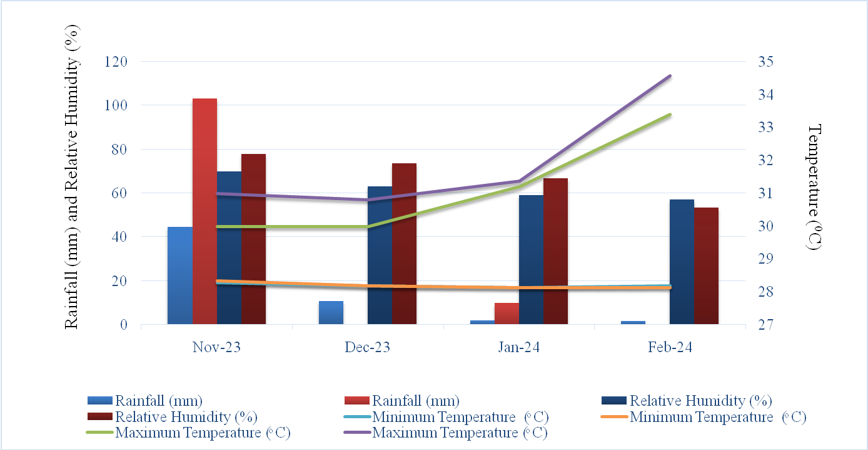
Fig 1: Meteorological data indicating monthly normal and actual rainfall, relative humidity, maximum and minimum temperature during the cropping period at ZAHRS, Shivamogga
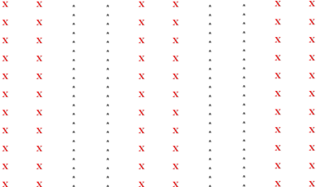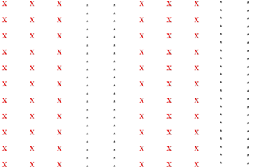
Fig 2: Sweet corn-based vegetable legume intercropping system in 2:2 row proportion

Fig 3: Sweet corn-based vegetable legume intercropping system in 3:2 row proportion

Where, X - sweet corn, * - intercrops
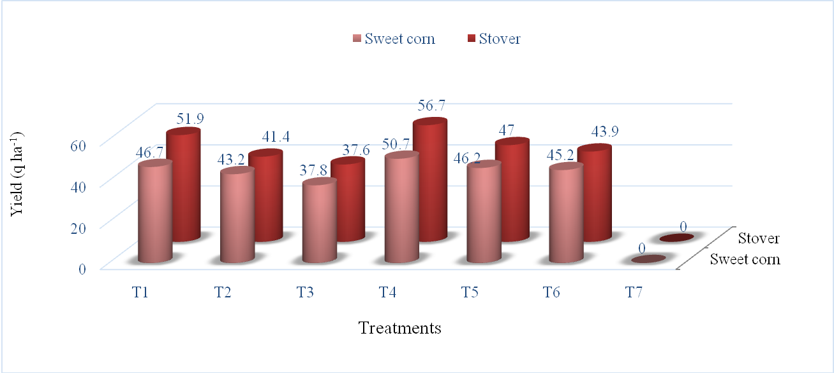
Fig 4: Per cent decrease in yield of sweet corn as influenced by intercropping different vegetable legumes
Note: Treatment details are provided in materials and methods

