**Women’s Acceptance of Training in Clean Milk Production and Milk Processing**

**Abstract**

Milk production and processing play a vital role in the livelihood of rural households, especially in agrarian economies. Women, being primary contributors in dairy farming and milk handling, are key stakeholders in ensuring the quality and safety of milk. Training programs on clean milk production and milk processing are essential to enhance their knowledge and skills, leading to improved milk quality, reduced contamination, and increased income opportunities. However, the success of such initiatives largely depends on the acceptability and willingness of women to participate and apply the knowledge gained. Understanding the factors influencing women’s acceptance of training is crucial for designing effective capacity-building programs that empower them, promote hygienic practices, and ultimately contribute to sustainable dairy development. This study focuses on assessing the acceptability of training on clean milk production and milk processing among women, exploring their perceptions, challenges, and motivation to adopt improved practices.

### Introduction

Rural women play a critical role in India's livestock sector, particularly in dairy farming, which has become a major livelihood activity for millions of households. Livestock and dairy farming play a vital role in the Indian economy and have the highest potential for generating income and employment by augmenting the productivity of dairy animals (Nath, 2022; Vijayalakshmy et al., 2023; Rani, 2021). The Women empowerment in the livestock sector has been emerged globally for assessing empowerment to promote sustainable development (Hira et al., 2025; Keba et al., 2025; Krishna et al., 2021). According to the **National Sample Survey Office (NSSO, 2013),** over 75% of rural women are involved in animal husbandry and related tasks, underscoring their indispensable contribution to the dairy economy. In states like Haryana, women are actively engaged in activities such as feeding, milking, cleaning of sheds, and basic animal healthcare. The increasing diversification of the rural economy has further highlighted the relevance of dairy as a sustainable income-generating activity for rural and tribal women.

**India remains the largest producer of milk in the world, with production reaching 132.4 million tonnes in 2012–13** (Department of Animal Husbandry, Dairying and Fisheries, 2013). Unlike seasonal crops, dairy farming ensures a steady and daily cash flow, making it a reliable source of livelihood for small and marginal farmers. As a result, the contribution of the dairy sector to rural incomes and nutritional security has been growing steadily.

To strengthen this sector, the **National Dairy Development Board (NDDB),** in collaboration with the **Government of India and the World Bank**, initiated the **National Dairy Plan Phase I (2012–2017),** aiming to enhance the productivity of milch animals and improve market access for rural milk producers (NDDB, 2014). With an investment exceeding ₹2,000 crore, the plan has emphasized infrastructure development, breed improvement, and training of dairy farmers, particularly women.

In this scenario, training and awareness about clean milk production and value addition through milk processing become crucial. However, effective communication and knowledge transfer are key challenges. The role of mass media, mobile-based advisories, and agricultural extension services has grown significantly in bridging the knowledge gap. As highlighted by **Singh and Meena (2015),** mass media and ICT tools have become vital in disseminating need-based, scientific information to rural women, thereby empowering them to make informed decisions.

Given this background, the present study was conducted in the **Udham Singh Nagar district of Uttarakhand,** focusing on **tribal women.** The study aimed to assess the **acceptability and impact of training on clean milk production and milk processing,** with an emphasis on how knowledge, attitudes, and practices are influenced by such capacity-building initiatives. This research is particularly relevant in regions where tribal women have limited access to formal education and extension services but remain central to dairy-based livelihood systems.

### ****Methodology****

The present study was conducted to examine the socio-economic profile and basic dairy farming practices of tribal dairy farmers in Udham Singh Nagar district of Uttarakhand. A descriptive research design was employed to gather accurate and meaningful insights from the selected respondents. The study was carried out in Sitarganj block, which has a significant tribal population engaged in agriculture and allied activities. Two villages: Jaganpuri, Garadpur, and Sadhunagar, Sitarganj were purposively selected based on the concentration of tribal households and the prevalence of dairy farming practices in these areas.

A multistage purposive sampling technique was adopted for the selection of respondents. From the selected villages, a total of 100 tribal dairy farmers were randomly chosen, ensuring fair representation from each village. Only those respondents who belonged to recognized Scheduled Tribes and were actively involved in dairy farming were included in the sample.

Primary data were collected using a well-structured and pre-tested interview schedule, which comprised two sections—socio-economic characteristics (such as age, education, occupation, landholding, family type, income, etc.) and Knowledge test of tribal women. The interviews were conducted in Hindi, the local language, to ensure clarity and comfort for the respondents.

The collected data were tabulated and analyzed using simple descriptive statistics such as frequency and percentage. The findings were systematically presented through tables to draw meaningful conclusions. Though every effort was made to ensure accuracy, the study was confined to selected villages of one block and based on self-reported responses, which may have limitations in terms of generalizability and objectivity.

**Table 1: Socio-Economic Characteristics of Tribal Dairy Farmers (N = 100)**

|  |  |  |  |  |
| --- | --- | --- | --- | --- |
| **S. No.** | **Characteristics** | **Category** | **Number (N)** | **Percentage (%)** |
| 1 | Age Group | Young (18–35 years) | 22 | 22 |
|  |  | Middle (36–50 years) | 58 | 58 |
|  |  | Old (Above 50 years) | 20 | 20 |
| 2 | Caste Category | Tribal | 100 | 100 |
| 3 | Education Level | Illiterate | 18 | 18 |
|  |  | Primary | 32 | 32 |
|  |  | Secondary | 28 | 28 |
|  |  | Higher Secondary and Above | 22 | 22 |
| 4 | Family Type | Nuclear | 38 | 38 |
|  |  | Joint | 62 | 62 |
| 5 | Land Holding Size | Marginal (<1 ha) | 28 | 28 |
|  |  | Small (1–2 ha) | 52 | 52 |
|  |  | Medium and Above (>2 ha) | 20 | 20 |
| 6 | Main Occupation | Agriculture + Dairy + Labour | 64 | 64 |
|  |  | Only Agriculture + Dairy | 26 | 26 |
|  |  | Others | 10 | 10 |
| 7 | Annual Income from All Sources | Low (<₹50,000) | 20 | 20 |
|  |  | Medium (₹50,000–₹1,00,000) | 55 | 55 |
|  |  | High (>₹1,00,000) | 25 | 25 |

**Results and Discussion**

**Age Group:** The analysis of age distribution among respondents revealed that a majority (58%) belonged to the middle age group of 36–50 years. This was followed by 22% of respondents in the young age group (18–35 years) and 20% in the old age group (above 50 years). The dominance of middle-aged women indicates that this group is the most actively involved in dairy and milk processing activities. Their age bracket is generally considered to be productive and responsible, contributing significantly to household income and livelihood activities.

**Caste Category:** All the respondents in the study (100%) belonged to the tribal community. This is consistent with the objectives of the program, which focused on the empowerment and capacity building of tribal women through dairy-based livelihoods. The homogeneity in caste category also implies that any interventions or findings are specifically relevant and tailored for tribal populations.

**Education Level:** The educational background of the respondents showed that 32% had primary education, 28% had completed secondary education, and 22% had education up to higher secondary and above, while 18% were illiterate. This indicates that a significant number of tribal women have access to basic education, although a portion of them still remain illiterate. The educational level of the majority provides a foundation for training and skill development in dairy processing, though there remains a need for simplified and visually oriented training methods for those with limited literacy.

**Family Type:** With respect to family structure, 62% of the respondents were from joint families while 38% belonged to nuclear families. Joint families can be advantageous for managing dairy activities, as labor is often shared among family members. However, decision-making in joint families may be influenced by elders, which could sometimes limit women’s autonomy in implementing new practices learned through training programs.

**Land Holding Size:** The data revealed that 52% of the respondents were small landholders with 1–2 hectares of land, 28% were marginal landholders with less than 1 hectare, and 20% had medium or above landholdings. This implies that the majority of respondents operate on small and marginal landholdings, which is typical in tribal regions. The limited landholding size also highlights the importance of dairy as a supplementary source of income and livelihood diversification.

**Main Occupation:** The main occupation of 64% of respondents included agriculture, dairy, and labor work. Around 26% were engaged in agriculture and dairy only, while 10% were involved in other occupations. This reflects that dairy is an essential component of the livelihood strategy for tribal women, often combined with other forms of labor to sustain household income. The integration of agriculture and dairy provides resilience against income fluctuations due to seasonal farming.

**Annual Income from All Sources:** In terms of annual income, 55% of the respondents were in the medium-income category earning between ₹50,000 to ₹1,00,000, 25% had a high income of over ₹1,00,000, and 20% had low income below ₹50,000. This suggests that a majority of families manage to earn a modest income, though a significant portion still lives with financial constraints. Dairy-based entrepreneurship and value-added milk processing activities could play a crucial role in enhancing income levels and improving the economic condition of these families.

Overall, the socio-economic profile of the respondents shows that most tribal women are engaged in agriculture and dairy-based livelihoods, with a reasonable level of literacy and land ownership. These characteristics make them suitable beneficiaries for training programs aimed at clean milk production, value addition, and marketing. The findings underline the importance of empowering tribal women through targeted interventions that build skills, increase productivity, and ultimately contribute to economic development.

**Table 2: Knowledge Test of Respondents on Value-Added Milk Products and Their Marketing (N=100)**

|  |  |  |  |  |  |
| --- | --- | --- | --- | --- | --- |
| **S. No.** | **Topic** | **Yes (f)** | **No (f)** | **Yes (%)** | **No (%)** |
| 1. | Knowledge of milk-based value-added products (paneer, ghee, curd, etc.) | 38 | 62 | 38% | 62% |
| 2. | Understanding of the milk processing methods | 34 | 66 | 34% | 66% |
| 3. | Knowledge of hygienic practices in milk product preparation | 42 | 58 | 42% | 58% |
| 4. | Awareness of shelf-life and preservation techniques for dairy products | 39 | 61 | 39% | 61% |
| 5. | Understanding of packaging and labelling techniques for dairy products | 37 | 63 | 37% | 63% |
| 6. | Awareness of government schemes for dairy entrepreneurs | 33 | 67 | 33% | 67% |
| 7. | Knowledge of milk chilling and storage facilities | 40 | 60 | 40% | 60% |
| 8. | Familiarity with local market demand for milk-based products | 36 | 64 | 36% | 64% |
| 9. | Awareness of pricing and cost calculation in dairy-based entrepreneurship | 35 | 65 | 35% | 65% |
| 10. | Knowledge of branding and promotion of milk-based value-added products | 32 | 68 | 32% | 68% |

**Interpretation and Description:**

Table 1 presents the knowledge levels of 100 respondents from the tribal community regarding various aspects of value-added milk products and their marketing. The findings indicate significant gaps in awareness and technical knowledge across all key areas:

1. **Knowledge of Milk-Based Value-Added Products**: Only 38% of the respondents had awareness of common dairy products such as paneer, ghee, curd, and khoa. The remaining 62% were unaware, indicating the need for basic orientation on milk product diversification.
2. **Milk Processing Methods**: About 34% of respondents had some understanding of milk processing techniques like pasteurization and fermentation, while 66% lacked knowledge, reflecting a critical need for technical training.
3. **Hygienic Practices**: While 42% of the participants were familiar with hygienic practices in milk product preparation, a significant 58% lacked this knowledge. This raises concerns about food safety and the need for hygiene education.
4. **Preservation Techniques**: Awareness of shelf-life and preservation methods such as refrigeration and the use of natural preservatives was reported by only 39%, whereas 61% lacked this crucial information.
5. **Packaging and Labelling**: Just 37% of respondents had any knowledge of proper packaging and labeling practices, which are essential for consumer appeal and compliance with food safety regulations.
6. **Government Schemes**: Only 33% were aware of schemes like the Dairy Entrepreneurship Development Scheme (DEDS) or NABARD support, while 67% had no awareness. This highlights a gap in knowledge about financial and policy support.
7. **Chilling and Storage Facilities**: Knowledge about the importance of chilling milk and cold storage was reported by 40%, with 60% lacking this understanding, which can directly impact product shelf-life and quality.
8. **Market Demand**: Only 36% had any familiarity with consumer preferences or demand for dairy products in local markets. This indicates the need for market exposure and training in consumer analysis.
9. **Pricing and Costing**: About 35% understood basic costing and pricing strategies. However, 65% had no knowledge of these entrepreneurial skills, which are vital for sustainable business planning.
10. **Branding and Promotion**: Just 32% were familiar with branding, packaging aesthetics, and promotional strategies, leaving 68% with no exposure to marketing literacy.

Overall, the table demonstrates that a majority of the tribal respondents lack essential knowledge and skills required to effectively engage in milk-based value-added product entrepreneurship. It underlines the importance of structured capacity-building programs focusing on technical know-how, marketing, hygiene, and awareness of government schemes.

Fig .1 Knowledge and awareness in milk-based value-added products

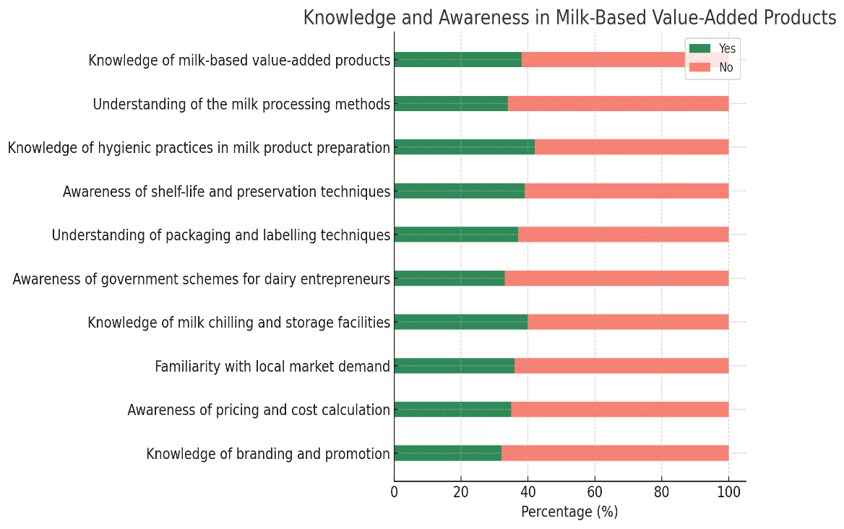

**Table 3: Weighted Mean Score (WMS) Analysis of Knowledge on Milk-Based Value-Added Products and Dairy Entrepreneurship among Respondents**

|  |  |  |
| --- | --- | --- |
| **S.No** | **Topic** | **WMS** |
| 1 | Knowledge of milk-based value-added products | 1.38 |
| 2 | Understanding of milk processing methods | 1.34 |
| 3 | Knowledge of hygienic practices in milk product preparation | 1.42 |
| 4 | Awareness of shelf-life and preservation techniques | 1.39 |
| 5 | Understanding of packaging and labelling techniques | 1.37 |
| 6 | Awareness of government schemes for dairy entrepreneurs | 1.33 |
| 7 | Knowledge of milk chilling and storage facilities | 1.40 |
| 8 | Familiarity with local market demand for milk-based products | 1.36 |
| 9 | Awareness of pricing and cost calculation in dairy entrepreneurship | 1.35 |
| 10 | Knowledge of branding and promotion of milk-based value-added products | 1.32 |

The Weighted Mean Scores (WMS) for the 10 knowledge items related to milk-based value-added products and dairy entrepreneurship range from 1.32 to 1.42 on a scale of 1 to 2, where:

* **1** represents the absence of knowledge (No response),

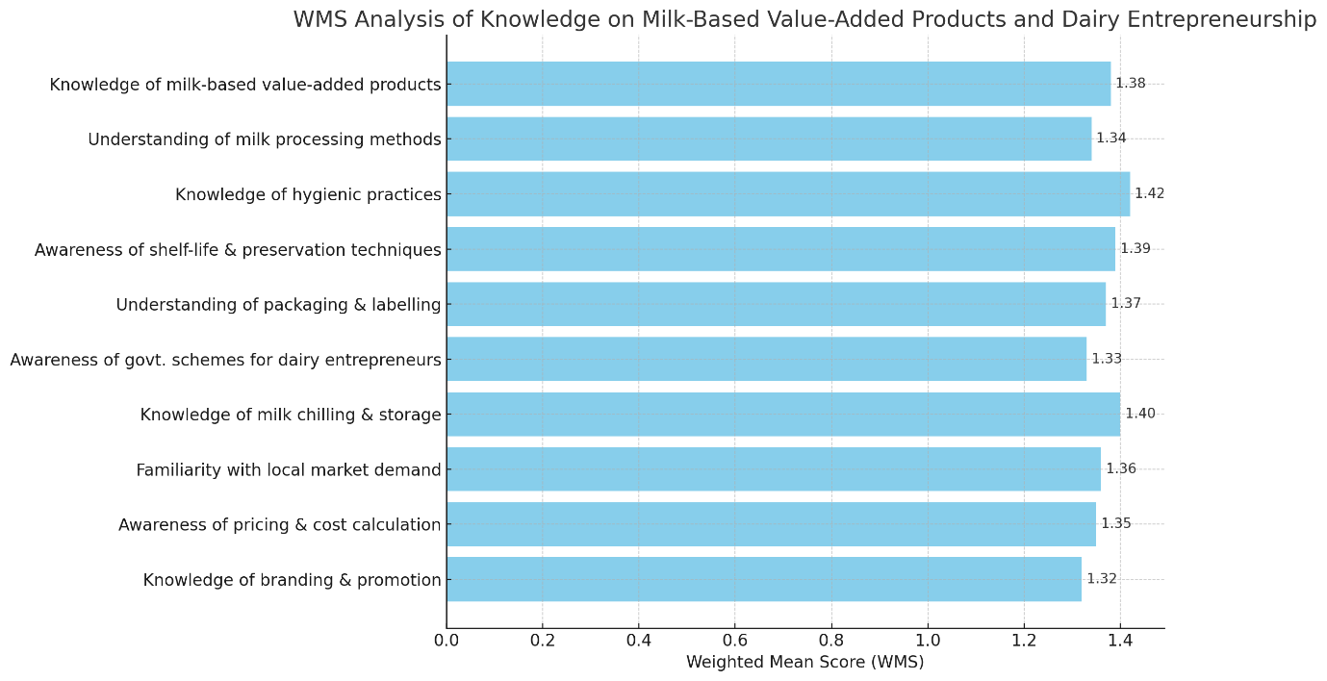fig .2 WMS analysis of knowledge on milk-based value-added products and dairy entrepreneurship

* **2** represents the presence of knowledge (Yes response).

This range indicates an overall low to moderate level of knowledge among respondents across all the topics assessed. Specifically:

* The highest WMS (1.42) was observed in Knowledge of hygienic practices in milk product preparation, suggesting this is the area where respondents showed comparatively better understanding.
* The lowest WMS (1.32) was for Knowledge of branding and promotion of milk-based value-added products, indicating this topic has the least awareness or understanding among respondents.
* Other topics such as shelf-life and preservation techniques (1.39), milk chilling and storage facilities (1.40), and knowledge of milk-based products (1.38) also showed moderate knowledge levels.
* The consistent range of scores around 1.3 to 1.4 implies a need for enhanced training and awareness programs to improve knowledge on various aspects of milk processing, packaging, government schemes, market demand, and entrepreneurship-related skills.

In summary, while some knowledge exists in the group, there is considerable scope for capacity building to strengthen understanding and practical skills in milk-based value addition and dairy entrepreneurship.

**Conclusion**

The study clearly highlights the pivotal role played by tribal women in dairy farming and emphasizes the importance of enhancing their knowledge and skills through targeted training in clean milk production and milk processing. The socio-economic profile of the respondents indicates that a majority of the women are in their productive age group, possess basic education, and are primarily engaged in agriculture and dairy-related activities. These attributes make them well-positioned to benefit from structured training interventions. However, the knowledge test reveals significant gaps in awareness and understanding related to milk-based value-added products, hygienic processing techniques, packaging, branding, and marketing. This underlines the urgent need for capacity-building programs that are context-specific, culturally appropriate, and designed to address the literacy and accessibility challenges faced by tribal women. Despite limited prior knowledge in several technical areas, the enthusiasm and involvement of women in dairy farming suggest a strong potential for the acceptance and adoption of improved practices—provided they receive consistent support, hands-on training, and post-training follow-up. Integrating information and communication technologies (ICTs), community-based extension services, and government schemes can further enhance the outreach and effectiveness of these programs.

In conclusion, empowering tribal women through training in clean milk production and value addition is not only crucial for improving milk quality and food safety but also offers a viable pathway for income enhancement, self-reliance, and rural development. Policymakers, extension agencies, and non-governmental organizations must work collaboratively to scale up such initiatives and ensure inclusive growth of the dairy sector.

**References**

1. Department of Animal Husbandry, Dairying and Fisheries. (2013). *Annual Report 2012–13*. Ministry of Agriculture, Government of India.
2. National Dairy Development Board (NDDB). (2014). *National Dairy Plan Phase I: Annual Report 2013–14*. Anand: NDDB.
3. National Sample Survey Office (NSSO). (2013). *Key Indicators of Employment and Unemployment in India 2011–12 (NSS 68th Round)*. Ministry of Statistics and Programme Implementation, Government of India.
4. Singh, A. K., & Meena, M. S. (2015). Role of ICTs in empowering rural women: A review. *Indian Research Journal of Extension Education*, 15(2), 1–5.
5. Nath, P. K. (2022). Collective Dairy Farming, Women Empowerment and Social Inclusion: A Village-Level Study from Bihar, India. *Global Business Review*, 09721509221121701.
6. Vijayalakshmy, K., Chakraborty, S., Biswal, J., & Rahman, H. (2023). The role of rural Indian women in livestock production. *European Journal of Humanities and Social Sciences*, *3*(1), 91-98.
7. Rani, A. (2021). Women’s Participation in Agricultural Activities: A Study of Haryana, India. *Interdisciplinary Journal of Economics and Business Law*, *10*(3), 57-77.
8. Hira, F. T. Z., Alam, M. J., & Begum, I. A. (2025). Women’s empowerment in livestock sector as a tool to enhance child’s nutrition: a review. *Discover Sustainability*, *6*(1), 1-13.
9. Keba, A., Tola, A., Kaylegian, K. E., Kebede, M., & Zewdu, A. (2025). Impact of hygienic milk production training on knowledge, attitudes and practices of women farmers in the central highlands of Ethiopia. *Frontiers in Sustainable Food Systems*, *8*, 1539559.
10. Krishna, N. L., Anitha, A., Rao, S. J., & Muralidhar, M. (2021). Livestock Holding and Time Spent by Farm Women in Dairying Activities in Andhra Pradesh. *Asian Journal of Agricultural Extension, Economics & Sociology*, *39*(12), 70–76.