Efficacy of Moisture Content on Frictional Properties of Food Grains

**ABSTRACT**

The frictional properties depend on moisture content of food grains are important to design sowing and post-harvest equipment. Frictional properties are important in many problems associated with the design of machines and the analysis of the behaviour of the product during seed sowing and agricultural process operations such as handling, harvesting, threshing, cleaning and sorting etc. In the current study, average frictional properties of sample of grains were carried out at five different moisture content level 10%, 13%, 16%, 19% and 22% (w.b.). To carry out the frictional property of grains at different moisture level apparatus are developed and fabricated. Four grain samples are selected for the experiment wheat (*Triticum aestivum*), paddy (*Oryza sativa*), gram (*Cicer arietinum*) and pea (*Pisum sativum*). Wheat’s angle of repose, angle of internal friction, angle of external friction on GI sheet and angle of external friction on plywood varies between 27-31°, 23-29°, 12-16° and 14-16° respectively. Paddy grains angle of repose, angle of internal friction, angle of external friction on GI sheet and angle of external friction on plywood varies between 27-32°, 24-31°, 19-23° and 21-23° respectively. Gram grains angle of repose, angle of internal friction, angle of external friction on GI sheet and angle of external friction on plywood varies between 22-27°, 30-32°, 15-19°,18-21° respectively. Pea grains angle of repose, angle of internal friction, angle of external friction on GI sheet and angle of external friction on plywood varies between 17-22°, 20-24°, 11-14° and 15-17° respectively. After analysis of all attributes pertaining to frictional parameter, it was found that the angle of repose, angle of external friction and angle of internal friction increased with increases the moisture content in food grains i.e., wheat, paddy, gram and pea.

**Keywords:** Frictional property ; food grains ; angle of repose ; angle of internal friction ; angle of external friction etc.

**1. INTRODUCTION**

India is an agriculture-based country. The country is slated to witness record food grains production of estimated 316.06 million tonnes as per the second advance estimates of production of major crops for the year 2021-22 released by the Ministry of Agriculture and Farmers Welfare. As for as food grains production, in India production of wheat during 2021-22 is estimated at record 111.32 million tonnes, similarly total production of paddy during 2021-22 is estimated at record 127.93 million tonnes, total production of gram during 2021-22 is estimated at record 13.12 million tonnes. total production of pea during 2019-20 is estimated at record 15.24 lakh tones (Anon2023a). There is so much wastage of grains due to improper storage techniques and systems. As the data collected by the govt institution, every year the wastage of grain is 40% of the total productions of the grains (Anon2023b). This data is reducing every year by enhancing the storage technique but the rate of reduction of the percentage of grain is not much satisfactory as to be happened.

In some areas the food production is too much low; it causes the food crises at that place. This can be resolved by reducing the wastage of grains and provides it to them for their survivals. The wastage of food grains can be stopped by studying the different type of properties of food grains at different moisture level which enhance to design an elaborated storage structure.

In the engineering properties of food grains, the frictional property is one of the most important properties of the designing of a seed drill, storage structure and the analysis of the behaviour of the food grains during agricultural process operation such as handling, harvesting, threshing cleaning sorting and drying. The frictional properties such as coefficient of friction and angle of repose are important in designing of hoppers, chutes, pneumatic conveying system, screw conveyors, threshers and seed metering devices etc. The moisture content of grains varies at the time of sowing, harvesting, storage and processing. Therefore, to design different equipment for handling, processing and storage of grains, the information regarding physical properties at different moisture contents is very important. The data of frictional property of that food grains at different level of moisture content makes us very helpful for the agricultural equipment design and operations, because the food grains change its frictional properties at different moisture level and different type material surface. That’s why the collection of data of the frictional property of that food grains at different moisture level is needed for the designing of the enhanced food grain agricultural process machines and structures. It is necessary to have some knowledge of the physical characteristics of grains in order to construct grain storage structures, sowing equipment, materials handling equipment, and processing machinery correctly and successfully. Known Size, shape, particle orientation, and moisture content are among the factors that have a significant impact on some of these properties, such as the internal coefficient of friction, coefficient of friction, and angle of repose.

The work carried to determine the effect of moisture content on angle of repose, coefficient of internal friction and coefficient of friction with aluminium, concrete, galvanized steel, hardboard, and plywood surfaces. The grains used were beans, maize, peanuts, rough rice, soybeans and wheat. Four levels of moisture content were considered: 10, 15, 20 and 25% wet basis. In general, the coefficients of friction indicated a tendency to increase with increasing moisture content the internal coefficient of friction also showed a similar tendency. The galvanized steel surface showed lower coefficients of friction while the concrete surfaces presented higher ones. The angle of repose increased with increasing moisture content for maize, rough rice, soybeans and wheat. (Benedito and Jorge, 1990)

The angle of repose or angle with a horizontal surface formed when free-flowing grain comes to rest can be used to estimate the height or width of grain piles. Angle of repose depends on properties like size and shape of kernels, moisture content, fines and foreign material content, presence of mold, and submerging, pouring, pilling or emptying method, and can vary greatly

The various physical properties determined of hempseed as a function of moisture content ranged between 8.62 to 20.88% dry basis. The sphericity, surface area, thousand seed mass, static and dynamic coefficients of friction were increased with increase in M.C. The bulk density, true density and porosity were decreased with increase in moisture content. (Sacilik et al., 2003)

The angle of repose or critical angle of repose of a granular material is the steepest angle of descent or dip relative to the horizontal plane to which a material can be piled without slumping at this angle, the material on the slope face is on the verge of sliding. Smooth, rounded grains cannot be piled as steeply as can rough, interlocking sands. If a small amount of water is able to bridge the gaps between particles, electrostatics attraction of the water to mineral surface will increase (Anon2023c).

**2. MATERIALS AND METHODS**

**2.1 Grain Sample**

Four varieties of grains viz. Wheat (PBW-502) 10kg, paddy (6444 GOLD) 10kg, gram (KPG-59) 10kg and pea (GS-10) 10kg was procured from local market in Shiv baba and rural villagers, Akbarpur, Ambedkar Nagar. The samples were manually cleaned to remove foreign matter, dust, dirt, broken and immature grains.

Grains samples of different varieties at five different moisture contents of 10%, 13%, 16%, 19% and 22% were prepared using mass balance method as shown in Fig 1 described by Coskun et al., 2005. Following equation by Mohsenin, (1970) was used to calculate weight of the water added or removed at desired moisture content given as eqn (i).

$Q=\frac{Wi(Mf-Mi)}{100-Mf}$……………. (i)

Where

Q = the weight of water added or removed in kg.

Wi = the initial weight of sample in kg.

Mi and Mf = initial and final moisture content of the sample on wet basis.

The grain samples at 10% moisture content (wb) were prepared by drying the grain in sun dryer while samples at 13%, 16%, 19% and 22% m.c. were prepared by adding calculated amount of distilled water. The samples were then transferred to separate polythene bags and the bags were sealed tightly. The samples were kept for 3 h to enable the moisture to be distributed uniformly throughout the sample. All physical properties were assed at these five moisture levels.

**2.2 Development of Experimental Setup**

Development of CAD model of inclined plane apparatus and angle of repose apparatus using “NX10” software as shown in fig 2 & fig.5 and fabricated an experimental setup to determine the frictional property of food grains at different material surface (plywood & GI sheet).

**2.3 Experimental Procedure**

***2.3.1 Angle of Repose***

The angle of repose of grains is obtained through an angle of repose apparatus. The value of the angle of repose is affected by various factors, including grain shape and size distribution, moisture content, and surface friction (Al-Hashemi et al).

The grains are poured through a funnel and placed on a base sheet, forming a cone as shown in Fig 3. When the predetermined height or the predetermined width of the base is reached, the pouring of grains is stopped. In this scenario, the angle between the sloping side of the cone formed by the grains and the horizontal plane is measured as the angle of repose. During the measurement process, the height of the funnel increases slowly and steadily with the help of an adjustable nut, gradually reducing the impact of the falling grains on the measurement results. The angle of repose was calculated as given in eqn (ii):

$α=\tan^{-1}{\frac{2H}{D}}$………………. (ii)

Where

$$α= angle of repose$$

H = height of grains cone

D = diameter of base of grains cone

***2.3.2 Angle of External Friction***

The angle of external friction was determined using a table provided with changeable surfaces, as per the method suggested by Richard, W.D. (1954). The experimental setup is shown in Fig 4. A box of size 90mm × 90mm × 90mm was tied by a cord passing over a pulley, and a pan was attached to this cord. Subsequently, the box was filled with sample material, and again weights were added to cause sliding of the box. Weights were added to the pan until the box started to slide on the desired surface (GI sheet and plywood).

These weights (P) were also noted. The coefficient of external friction was calculated as given in eqn (iii).

$μe=\frac{P-(W\sin{θ)}}{W\cos{θ}}$………………(iii)

Where,

μe = coefficient of the external friction

P = weight in pan

W = weight of grains in box

$θ$ = angle of tabletop

**Angle of external friction $(θ$**) = $\tan^{-1}{μe}$

The experiment was performed on two surfaces: plywood and galvanized iron sheet.

***2.3.3 Angle of Internal Friction***

The angle of internal friction was determined using the method suggested by Richard, W.D. (1954). The experimental setup is depicted in Fig 11. A layer of grains was placed on an inclined base to measure the friction between grain-to-grain surfaces. The weight of the grain sample and the box, which was sized 90mm × 90mm × 90mm, was placed on the inclined

base. Subsequently, the box was filled with the sample material and tied with a cord passing over a pulley attached to a pan. The box was then pulled upward slowly until the lower surface of the box left a layer of grains on the inclined base shown in fig 6. The weights (P) required to cause the sliding of the box were noted. The angle of internal friction was calculated as given in eqn (iv):

$μi=\frac{P-(W\sin{θ)}}{W\cos{θ}}$………………...(iv)

Where:

μi = coefficient of the internal friction

P = weight in pan

W = weight of grains in box

$θ$ = angle of tabletop

**Angle of internal friction $(∅$**) = $\tan^{-1}{μi}$

**3. RESULT AND DISCUSSION**

The effect of moisture content on frictional properties of different grains viz. wheat, paddy, gram, and pea were determined using standard method discussed in material and method. The frictional properties of grains at different moisture content (10%, 13%, 16%, 19% and 22%) w.b. were determined. The results are discussed below.

**3.1 Angle of Repose**

The data obtained on angle of repose of grains is presented in Table-1. The angle of repose of the wheat, paddy, gram and pea grains varied between 27.7-31.2°, 27.6-32.1°, 22.6-27.7° and 17.3-22.6° respectively as the moisture content increased from 10%, to 22% w.b.

The angle of repose exhibited a linear increase with the rise in moisture content. Regression analysis was performed to establish an equation for predicting the angle of repose at any moisture level. The findings are illustrated in fig 7.

**3.2 Angle of Internal Friction of Grains**

The data obtained on angle of internal friction of grains is presented in Table-2. The angle of internal friction of the wheat, paddy, gram and pea grains varied between 23.17 -29.60°, 24.04-30.80°, 29.92-32.24° and 20.74-24.11° respectively as the moisture content increased from 10%, to 22% w.b.

The angle for internal friction demonstrated a linear increase with the elevation in moisture content. Regression analysis was carried out to formulate an equation for predicting the angle of internal friction at any moisture level. The outcomes are showcased in fig 8. Top of Form

**3.3 Angle of External Friction of Wheat on Plywood**

The data obtained on angle of external friction on plywood of grains is presented in Table-3 The angle of external friction on plywood of the wheat, paddy, gram and pea grains varied from 14.33-16.35°, 21.56-23.45°, 18.09-20.07° and 15.02-17.22° respectively as the moisture content increased from 10% to 22% w.b.

The angle of external friction linearly increased with increase in moisture content. The regression analysis was conducted to develop equation for predicting angle of external friction at any moisture level. The results are presented in fig 9. As per the plywood surface, the value of external friction is higher than that of the GI sheet surface.

**3.3 Angle of External Friction of Wheat on G.I Sheet**

The data obtained on angle of external friction on G.I sheet of grains is presented in Table-4. The angle of external friction on G.I sheet of the wheat, paddy, gram and pea grain varied from 12.73-16.13°, 19.64-23.72°, 15.46-18.77° and 11.60-14.06° respectively as the moisture content increased from 10%, 13%, 16%, 19% and 22% w.b.

The angle pertaining to external friction linearly increased with the rise in moisture content. Regression analysis was undertaken to formulate an equation for forecasting the angle of external friction at any moisture level. The findings are displayed in fig 10. The angle of external friction will increase on both surface with an increase in the moisture content of the grains.

**4. CONCLUSIONS**

The following conclusions were drawn from the investigation on frictional properties of different food grains for moisture content range of 10%, 13%, 16%, 19% and 22% w.b. The samples were manually cleaned to remove foreign matter, dust, dirt, broken and immature grains. The initial moisture content of the samples was determined using hot air oven method set at 130±5°c for 3h. Grains samples at five different moisture contents were prepared using mass balance method. Angle of external friction observed on two surfaces namely (plywood and G.I. sheet). The various properties measured will serve as a useful tool in process and equipment design.

The value of frictional properties of wheat grains varies from 27.7 to 31.2° (angle of repose), 23 to 29° (angle of internal friction), 12 to 16° (angle of external friction on GI sheet) and 14.33 to 16.35° angle of external friction on plywood at different moisture contents 10% to 22%.

The value of frictional properties of paddy grains is varies from 27.7 to 32.12°(angle of repose),24 to 30°(angle of internal friction), 19 to 23° (angle of external friction on GI sheet and 21.56 to 23.45° angle of external friction on plywood at five different moisture contents (10% to 22%)

The value of frictional properties of gram grains is varies from 22 to 27°(angle of repose),29 to 32° (angle of internal friction), 15 to 18° (angle of external friction on GI sheet and 18.09 to 20.07° angle of external friction on plywood at five different moisture contents (10%, 13%, 16%, 19% and 22%)

The value of frictional properties of pea grains is varies from 17.7 to 22.2°(angle of repose),20 to 24° (angle of internal friction), 11 to 14° (angle of external friction on GI sheet and 15.02 to 17.22° angle of external friction on plywood at five different moisture contents (10%, 13%, 16%, 19% and 22%)

After analysis of all attributes pertaining to frictional parameter, it was found that the angle of repose, angle of internal friction and angle of external friction increases with the increase of the moisture content in food grains i.e., wheat, paddy, gram and pea. Now-a-days all developed and developing countries are boosting the production of grains. Despite of advanced application in handling and processing, only little is known about the basic frictional properties of food grains. This all needs better understanding of the properties.

**CONFLICT OF INTEREST**

The authors declare no conflict of interest.

**DATA AVAILABILITY STATEMENT**

No data was used for the research described in the article.

**REFERENCES**

**Al-Hashemi, Hamzah M. Beakawi, and Omar S. Baghabra Al-Amoudi.** "A review on the angle of repose of granular materials." Powder technology 330 (2018): 397-417.

**Anonymous 2023a**. A website <http://dpd.gov.in> is visited on date 01/05/2023.

**Anonymous 2023b** A website <http://static.pib.gov.in> is visited on date 01/05/2023.

**Anonymous 2023c** A website

[https://en.wikipedia.org](https://en.wikipedia.org  is visited on date 01/05/2023.)[is visited on date 01/05/2023.](https://en.wikipedia.org  is visited on date 01/05/2023.)

**Benedito CB and Jorge JT 1990**. Effect of moisture content on coefficient of friction sand angle of repose for different types of grains. *International working conference on stored product protection, Bordeaux France 9- 14 Sept.*

**Coskun, M.B., Yalcin, I. and Ozarslan, C. 2005**. Physical properties of sweet corn seed (Zea mays saccharata Sturt*.*) *J. Fd. Engg*., 74(4): 523-528.

**Mohsenin, N.N. 1970**. Physical properties of Plant and Animal Materials. *Gordon and Breach Science Publishers*, *New York*.

**Richard, W.D. 1954**. Friction coefficient of some agricultural material. Agri. Engg., 35(6): 411-414.

**Sacilik, K., Ozturk, R. and Keskin, R. 2003**. Some physical properties of hemp seed. Biosystems Engineering, 86(2): 191-198.

**TABLES**

**Table 1 Angle of repose at different moisture level**

|  |  |  |  |  |
| --- | --- | --- | --- | --- |
| **Moisture Level** | **Wheat** | **Paddy** | **Gram** | **Pea** |
| 10% | 27.76 | 27.65 | 22.62 | 17.35 |
| 13% | 28.39 | 28.81 | 23.50 | 18.43 |
| 16% | 29.74 | 30.74 | 25.46 | 19.65 |
| 19% | 30.47 | 31.43 | 26.57 | 21.04 |
| 22% | 31.22 | 32.15 | 27.76 | 22.62 |

**Table 2 Angle of internal friction of grains**

|  |  |  |  |  |
| --- | --- | --- | --- | --- |
| **Moisture Level** | **Wheat** | **Paddy** | **Gram** | **Pea** |
| 10% | 23.17 | 24.04 | 29.92 | 20.74 |
| 13% | 24.77 | 25.25 | 30.62 | 21.73 |
| 16% | 26.65 | 26.14 | 31.80 | 22.64 |
| 19% | 27.14 | 27.83 | 31.94 | 23.43 |
| 22% | 29.60 | 30.80 | 32.24 | 24.11 |

**Table 3 Angle of external friction of grains on plywood**

|  |  |  |  |  |
| --- | --- | --- | --- | --- |
| **Moisture Level** | **Wheat** | **Paddy** | **Gram** | **Pea** |
| 10% | 14.33 | 21.56 | 18.09 | 15.02 |
| 13% | 14.65 | 21.92 | 18.77 | 15.88 |
| 16% | 15.27 | 22.22 | 19.47 | 16.55 |
| 19% | 15.93 | 23.00 | 19.60 | 16.83 |
| 22% | 16.35 | 23.45 | 20.07 | 17.22 |

**Table 4 Angle of external friction on G.I. sheet**

|  |  |  |  |  |
| --- | --- | --- | --- | --- |
| **Moisture Level** | **Wheat** | **Paddy** | **Gram** | **Pea** |
| 10% | 12.73 | 19.64 | 15.46 | 11.60 |
| 13% | 13.24 | 21.47 | 16.73 | 12.33 |
| 16% | 13.91 | 22.18 | 17.81 | 12.83 |
| 19% | 14.63 | 22.56 | 18.32 | 13.53 |
| 22% | 16.13 | 23.72 | 18.77 | 14.06 |

**FIGURES**

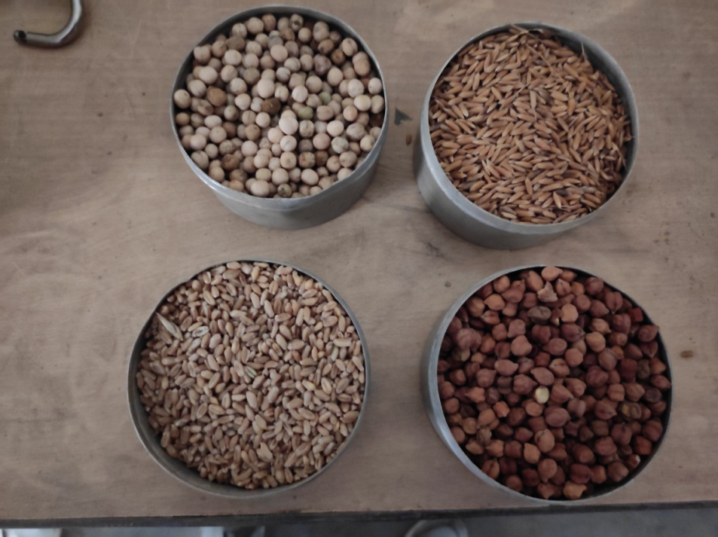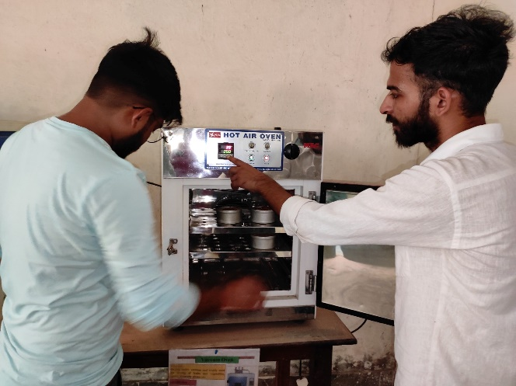

**Fig. 1 Grains sample**

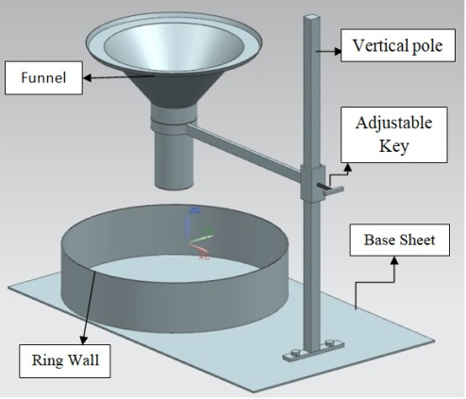

**Fig .2 CAD model of angle of repose apparatus**

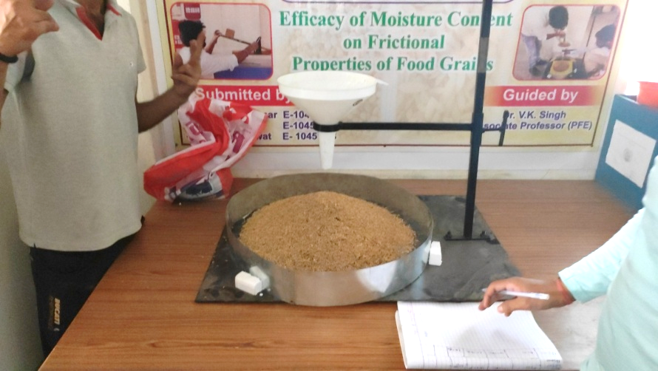

**Fig. .3 Experimental setup of Ange of repose apparatus**

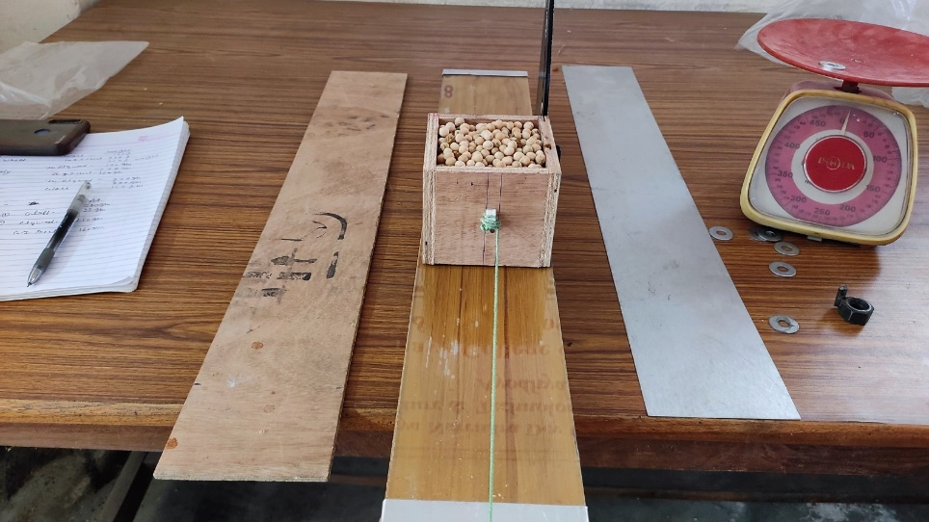

**Fig. 4 Experimental setup of inclined apparatuses**

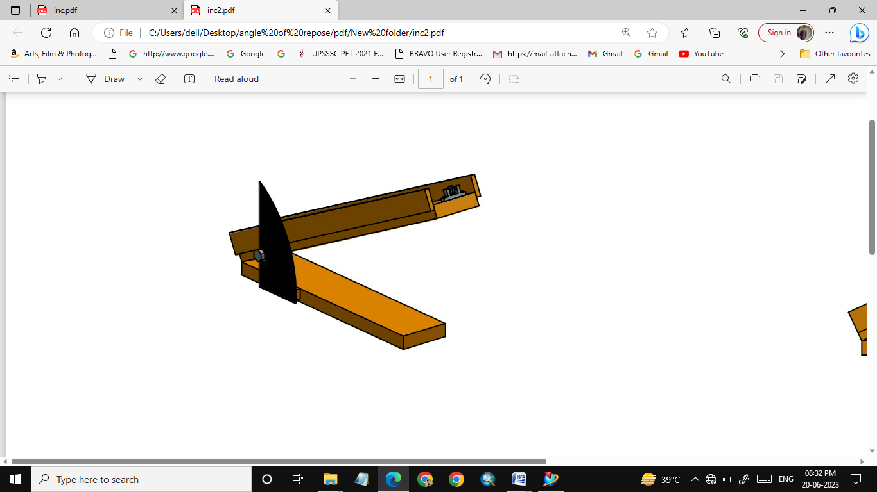

**Fig. 5 CAD model of inclined apparatus**

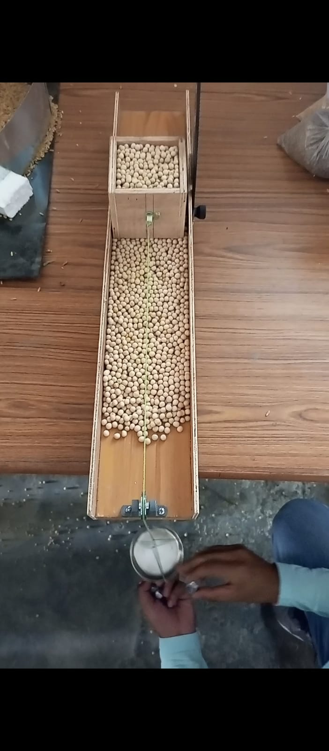

**Fig. 6 A view of experiment**

**Fig. 7 Graphical representation of moisture effect on angle of repose**

**Fig. 8 Graphical representation of moisture effect on angle of internal friction**

**Fig. 9 Graphical representation of moisture effect on angle of external friction (plywood)**

**Fig. 10 Graphical representation of moisture effect on angle of external friction (GI sheet)**