**Preparation and Performance Evaluation of Liquid Hand Wash**

**Abstract**

The study focused on the preparation and performance evaluation of liquid hand wash formulations (F-I and F-II) to develop effective, safe, and environmentally friendly hand hygiene solutions. Conducted during 2015–16 in Dharwad, Karnataka, the research involved the laboratory development of liquid hand wash, followed by quality characteristics assessment and antimicrobial analysis. The formulations were prepared using Sodium Lauryl Sulphate (83%) as the primary surfactant for effective foaming and cleaning, along with Ethylene Glycol Mono Sulphate (17%) as a secondary surfactant to enhance cleaning efficiency and skin-conditioning benefits. Perfume and color were added in sufficient quantities to improve sensory attributes.

Quality analysis revealed that both formulations exhibited favorable physical and chemical properties, including a neutral pH (7.0–7.2), good solubility in water and organic solvents, consistent surface tension (0.10 dynes), and stable foam height (0.25 cm), indicating effective cleansing and foaming capabilities. The stability tests showed that the formulations remained stable over three months, with no adverse effects observed under hard water conditions. Both formulations demonstrated good cleaning action and nil alcohol insoluble matter, confirming the absence of harmful residues.

Antimicrobial analysis highlighted the strong antibacterial properties of both formulations against common pathogens, ***Staphylococcus aureus*** and ***Escherichia coli***. The minimum inhibitory concentrations (MICs) were 1.56 µl for ***Staphylococcus aureus*** and 6.25 µl for ***Escherichia coli***, demonstrating effective microbial reduction. The study concluded that the developed liquid hand washes possess excellent quality characteristics and antimicrobial efficacy, making them suitable for daily hygiene use. These findings contribute to the advancement of safe, efficient, and sustainable hand hygiene products, addressing both health and environmental concerns.

**Keywords:** Liquid Hand Wash, Formulation, Antimicrobial Analysis, Sodium Lauryl Sulphate, Cleaning Action, Hygiene.

**Introduction:**

Household chemicals are non-food substances commonly used for cleaning, pest control, and maintaining hygiene within homes. These consumer goods, such as soaps, detergents, and household cleaners, are essential for health and disease prevention (Winer, 1986; Farn, 2006). They are categorized into personal cleansing products, laundry detergents, dishwashing products, and household cleaners, each designed to serve specific purposes in daily life. The widespread use of these chemicals has raised concerns about their potential adverse effects on human health and the environment, especially when improperly used or disposed of.

Marketing plays a crucial role in the distribution of household chemicals, acting as a bridge between producers and consumers. It involves strategies like attractive packaging, advertising, and competitive pricing to influence consumer choices (Seetharaman & Sethi, 2011). In a competitive market, manufacturers strive to balance product performance, safety, cost-efficiency, and environmental impact. The growing demand for eco-friendly products has led to varying definitions of "green" household cleaners, as companies aim to meet consumer expectations while adhering to environmental standards (Davis et al., 1992). This dynamic landscape reflects the evolving priorities of both consumers and manufacturers in the household chemical industry.

Liquid hand wash is a cleansing product designed to remove dirt, germs, and bacteria from the hands, promoting hygiene and preventing the spread of infections. Unlike bar soaps, liquid hand washes are typically formulated with moisturizing agents, antibacterial ingredients, and skin-friendly compounds to ensure effective cleaning without drying out the skin. They are commonly used in homes, workplaces, and public facilities due to their convenience, ease of use, and reduced risk of cross-contamination. Liquid hand washes come in various formulations, including antibacterial, moisturizing, and fragrance-infused varieties, catering to different skin types and user preferences. Their popularity has grown significantly, driven by increased awareness of hygiene practices and the need for effective hand hygiene in preventing the spread of diseases.

The development of an effective liquid hand wash requires careful consideration of its formulation to ensure it meets performance expectations while being safe for users and environmentally friendly. This investigation focuses on (i) formulating a liquid hand wash with optimal properties and (ii) assessing its cleaning efficacy and user safety. Through this study, the goal is to contribute to the advancement of effective and sustainable hand hygiene solutions for everyday use.

**Material and methods**

The present study was conducted during the year 2015-16 in Dharwad city of Dharwad district of Karnataka state. The experimental research involved development of Liquid hand wash under laboratory condition and assessment of quality characteristics testing with different parameters. The raw materials and chemical composition is maintained as per the process developed and standardized under SRP, Department of Family Resource Management (2014-15). The developed Liquid hand wash were sent for quality characteristics with different parameters was tested under Chemistry Laboratory of JSS College, Dharwad and antimicrobial study was tested under BioGenics Research and Training Centre in Biotechnology, Hubli.

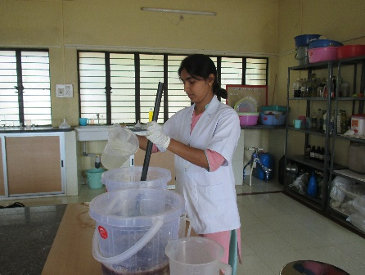 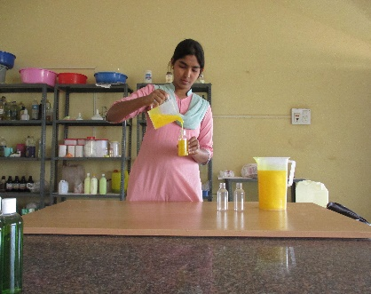 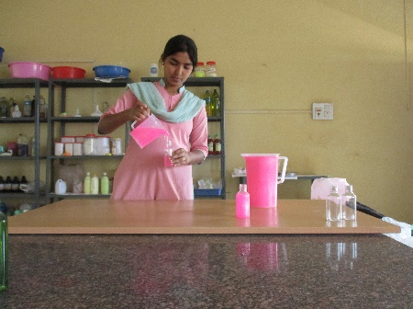 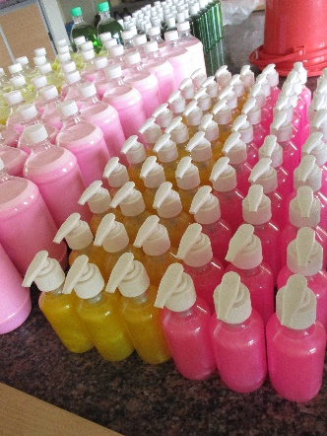 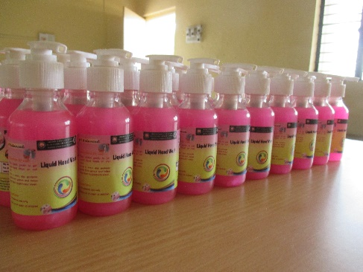  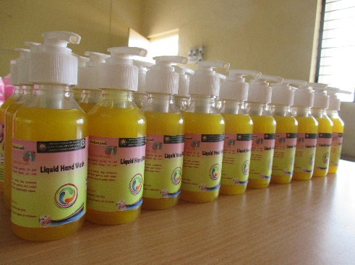

**Plate 1. Development of Liquid hand wash under laboratory**

**Results and discussion**

**Table 1: Development of Liquid hand wash for experimental research**

|  |  |  |
| --- | --- | --- |
|  | **Chemical Composition**  **(Raw materials)** | **Quantity in terms of percentage** |
| **Liquid hand wash**  **(F-I)** | Sodium Lauryl Sulphate | 83 % |
| Ethylene Glycol Mono Sulphate | 17 % |
| Perfume | q.s |
| Colour | q.s |
| **Liquid hand wash**  **(F-II)** | Sodium Lauryl Sulphate | 83 % |
| Ethylene Glycol Mono Sulphate | 17 % |
| Perfume | q.s |
| Colour | q.s |

qs- quantity sufficient

(F-I) – Formula-I and (F-II) – Formula-II

The development of the liquid hand wash for experimental research was detailed in Table 1. The chemical compositions used in the formulation of the liquid hand wash included Sodium Lauryl Sulphate (83%), which served as the primary surfactant to provide effective foaming and cleaning properties. Ethylene Glycol Mono Sulphate (17%) was included as a secondary surfactant to enhance the product’s cleaning efficiency and improve foam stability while offering skin-conditioning benefits. Additionally, Perfume and Color were added in quantity sufficient (q.s.) to provide a pleasant fragrance and an appealing appearance to the product. This combination of ingredients was designed to create an effective, gentle, and visually appealing liquid hand wash suitable for daily hygiene use.

The formulation of liquid hand wash has been extensively studied to enhance cleaning efficiency and skin safety. Debnath *et al*. (2011) focused on liquid soaps, highlighting the role of surfactants like Sodium Lauryl Sulphate (SLS) and skin-conditioning agents for effective cleansing without causing dryness. Building on this, Shah *et al.* (2014) explored herbal hand wash gels, emphasizing the use of natural ingredients like aloe vera and tea tree oil for their antimicrobial and skin-soothing properties. These studies reflect the ongoing evolution of liquid hand wash formulations, balancing effectiveness, skin safety, and consumer preference for natural, eco-friendly products.

**Table 2: Analysis for quality characteristics of developed Liquid hand wash under laboratory**

|  |  |  |  |
| --- | --- | --- | --- |
| **Parameters** | | **Liquid hand wash (F-I)** | **Liquid hand wash (F-II)** |
| **Physical parameters** | **Colour** | Pink | Yellow |
| **Fragrance** | Life buoy | Dettol Original |
| **Chemical parameters** | **pH** | 7.0-7.2 | 7.0-7.1 |
| **Solubility** | Soluble in H2O & Organic solvents | Soluble in H2O & Organic solvents |
| **Surface tension** | 0.10 dynes | 0.10 dynes |
| **Foam Height** | 0.25 cm | 0.25 cm |
| **Stability test** | 3 Months | 3 Months |
| **Hard water test** | Not affected | Not affected |
| **Cleaning action** | Good | Good |
| **Alcohol Insoluble Matter** | Nil | Nil |

(F-I) – Formula-I and (F-II) – Formula-II

Table 2 presented the analysis of quality characteristics for the developed liquid hand wash samples, Formula-I (F-I) and Formula-II (F-II), under laboratory conditions. The physical parameters showed that F-I had a pink color with a Life Buoy fragrance, while F-II was yellow with a Dettol Original fragrance, indicating variations in sensory attributes. For chemical parameters, both formulations exhibited a pH range of 7.0–7.2 for F-I and 7.0–7.1 for F-II, suggesting neutral pH levels suitable for skin use. They were both soluble in water and organic solvents, ensuring ease of use and formulation stability. The surface tension was consistent at 0.10 dynes for both, indicating effective foaming properties. Foam height was also the same at 0.25 cm, reflecting similar foaming capacity. Both formulations passed the stability test for 3 months, showing good shelf life. They were not affected by hard water, indicating reliable performance in various water conditions. The cleaning action of both samples was rated as good, and alcohol insoluble matter was nil, confirming the absence of undesirable residues.

This analysis demonstrated that both formulations met the required quality standards for effective and safe hand hygiene. Parallel observations were reported by **Joshi *et al*. (2008)** and **Shah *et al*. (2014),** who evaluated the performance characteristics of herbal hand wash gels, focusing on parameters like pH, foam height, surface tension, cleaning capacity and alcohol insoluble matter. These studies highlight the importance of these parameters in determining the efficacy and safety of liquid hand washes. The present study aligns with these findings, demonstrating that both formulations meet essential quality standards, including neutral pH, effective foaming, and strong cleaning action. This emphasizes the critical role of formulation components in achieving optimal hand hygiene performance.

Bacterial number

**Fig 1: Anti-bacterial analysis of the developed Liquid hand wash**

|  |  |  |
| --- | --- | --- |
| **Liquid hand wash (F-I)** |  |  |
|  | **Plate 2 (a): *Staphylococcus aureus*** | **Plate 2 (b): *Escherichia coli*** |
| **Liquid hand wash (F-II)** |  |  |
|  | **Plate 2 (a): *Staphylococcus aureus*** | **Plate 2 (b): *Escherichia coli*** |

**Figure 1** illustrated the antibacterial analysis of the developed liquid hand wash, showcasing its effectiveness against common bacterial strains. This analysis involved assessing the zone of inhibition, which indicated the hand wash's ability to prevent bacterial growth, with larger zones suggesting stronger antibacterial activity. The study compared the performance of different formulations (e.g., F-I and F-II) against standard bacterial cultures, highlighting variations in their antimicrobial properties. An antimicrobial study revealed that ***Staphylococcus aureus*** showed bacterial death in both Gram-positive and Gram-negative strains at a minimum concentration of **6.25 µl,** with a Minimum Inhibitory Concentration (MIC) of **1.56 µl**. Similarly, for ***Escherichia coli***, bacterial death occurred at a minimum concentration of **6.25 µl**, with an MIC of **6.25 µl.** This analysis confirmed the effective antibacterial properties of the liquid hand wash, demonstrating its potential for maintaining hand hygiene and preventing the spread of infections.

The antibacterial analysis of the developed liquid hand wash demonstrated strong antimicrobial activity against common bacterial strains. Similar observations were reported by **Joshi *et al*. (2008)** and **Shah *et al.* (2014)**, who evaluated herbal hand wash gels based on antimicrobial count. This study confirmed that the developed liquid hand wash effectively reduced bacterial growth, highlighting its potential for maintaining hand hygiene and preventing the spread of infections.

**Conclusion**

The study successfully developed and evaluated two formulations of liquid hand wash (F-I and F-II) for their quality characteristics and antibacterial efficacy. The formulations were crafted using Sodium Lauryl Sulphate (83%) as the primary surfactant and Ethylene Glycol Mono Sulphate (17%) as a secondary surfactant, aiming to deliver optimal cleaning performance while ensuring skin safety. Both formulations exhibited favorable physical and chemical properties, including neutral pH levels (7.0–7.2), good solubility in water and organic solvents, consistent surface tension (0.10 dynes), and stable foam height (0.25 cm), indicating effective foaming and cleansing capabilities.

The stability tests confirmed that both formulations maintained their quality over a period of three months, with no adverse effects observed in hard water conditions. Additionally, the alcohol insoluble matter was nil, ensuring the absence of undesirable residues, which is critical for maintaining skin health. The cleaning action of both formulations was rated as good, highlighting their efficacy in removing dirt, germs, and contaminants.

The antibacterial analysis further demonstrated strong antimicrobial properties against common pathogens, ***Staphylococcus aureus*** and ***Escherichia coli,*** with effective zones of inhibition and low Minimum Inhibitory Concentrations (MICs), particularly for ***S. aureus.*** These findings underscore the potential of the developed liquid hand washes to reduce microbial load effectively, promoting better hand hygiene and preventing the spread of infections. This study contributes valuable insights into the formulation of safe, efficient, and environmentally friendly liquid hand wash products, aligning with consumer health needs and sustainability goals.

**References**

Davis G A, Dickey P, Duxbury D, Griffith B, Oakley B and Cornell K, 1992, Household cleaners: environmental evaluation and proposed standards for general purpose household cleaners. *University of Tennessee Centre for Clean Products and Clean Technologies,* 12(2): 231-248.

Debnath S, Babu N M, Dega M, Bharathi K, Jyothsna T, Revathi D and Kishore T S, 2011, Formulation and evaluation of liquid soap containing herbal antimicrobial agent. Andhra Pradesh, *Research Journal of Pharmacy and Phytochemistry,* 3(5): 225-231.

Farn R J, 2006, Chemistry and technology of surfactants. *Blackwell Publishing Limited,* New Delhi, India, 29(1) pp:112.

Joshi, M. G., Kamat, D. V. and Kamat, S. D., 2008, Evaluation of herbal hand wash formulation. Mumbai, *National product radiance*, 7(3): 34-38.

Seetharaman and Sethi., 2011, Consumerism strategies and tactics. *CBS Publishers and Distribution Private Limited.* New Delhi, India,pp:131.

Shah, M. A., Natarajan, S. B. and Gousuddin, M., 2014, Formulation, evaluation and antibacterial efficiency of herbal hand wash gel. Malaysia, *International Journal of Pharmaceutical Sciences Review and Research,* 25(2): 120-124.

Winer, R., 1986, Household cleaning products. *Journal Consumer Research,* 13(1): 250-256.