**Microsponges enriched gel for enhanced anti-microbial potential of Shikalkin: Development and Characterization**

**Abstract**

**Objective:** Modern science has gone a long way in elucidating the beguiling properties attributed to the roots of Arnebia nobilis (Boraginaceae) containing Shikalkin (SHK). This compound holds promise as a powerful anti-microbial agent, addressing the persistent problem of microbial resistance stemming from imprudent use of antibiotics. The study aims to overcome these challenges by developing a microsponge-based topical gel containing SHK, after its successful extraction from roots of Arnebia nobilis.

**Methods:** The encapsulation of extracted SHK within the core of microsponges was confirmed through various techniques viz. UV spectrophotometry, ATR analysis, Differential Scanning Colorimetry (DSC), and Scanning Electron Microscopy (SEM). Subsequently, microsponges were integrated into a gel matrix, and the resultant gel underwent comprehensive characterization to assess its thixotropic and rheological attributes.

**Results:** The optimized SHK microsponge-based gel exhibited good thixotropic and texture properties. In-vitro anti-microbial studies conducted on prevalent pathogens such as Staphylococcus aureus, Escherichia coli, and Candida albicans warrant expediting its use in treating several kinds of microbial infections while imparting photostability to the encapsulated SHK.

**Conclusion:** The development of a microsponge-based topical gel containing SHK offers a promising solution to enhance the effectiveness of SHK as an anti-microbial agent, overcoming its limitations of photostability and poor aqueous solubility. This pioneering formulation harbors immense potential in addressing microbial infections with heightened precision, thus advancing the forefront of our efforts against the looming specter of antibiotic resistance.

**Keywords**: Shikalkin, microsponges, anti-microbial, MRSA, Candida albicans, Escherichia coli

1. **Introduction**

The global surge in microbial infections presents a critical health challenge, particularly in Asian countries like India, where strong infectivity and high rates of mortality are observed. The prevalence of multi-antibiotic resistant pathogens further complicates the combat against infections (Fair & Tor 2014). The escalating resistance among microbes at such an alarming rate has attracting global attention, prompting scientists to seek innovative alternatives to replace currently available antibiotics. A study by Lancet provides a comprehensive assessment of the global burden of antimicrobial resistance estimating a staggering 4.95 million deaths in 2019, emphasizing the need for a coordinated global action plan (Laxminarayan & Bhutta 2016). Microbial infections often lead to sepsis in immunocompromised and at-risk patients, with key resistant pathogens including *Staphylococcus aureus*, *Escherichia coli*, *Candida albicans*, Methicillin-resistant *Staphylococcus aureus* (MRSA) etc. While these micro-organisms form a part of the human microbiota, their pathogenic forms have been implicated in severe conditions such as blood and urinary tract infections, gastroenteritis, endocarditis, super infection of burn wounds, soft tissue infections and organ malfunction resulting in bacteremia or multiple organ dysfunctions (Tawara et al., 1996).

For past few decades, silver containing products including silver sulphadiazine and silver nitrate have been considered as gold standards to be used as anti-microbial agents in burn wound therapy apart from other topical antibiotics combined with corticosteroids. Having received widespread acceptance to control bactericidal infections as well healing indolent wounds; the use of silver ion has not received clinical success as anticipated due to its cost, serious side effects and microbial resistance (Atiyeh et al., 2007; Jadhav et al., 2016). Further, the nitrate moiety in silver nitrate exhibits tissue toxicity impairing re-epithelialization resulting in delayed wound healing. Most importantly, multidrug resistance among bacterial pathogens due to use of several antibiotics has threatened the efficient treatments of microbial infections.Thus, researchers are in continuous quest to shift their area of interest and replace the currently available antibiotics with plant extracts that are an attractive alternative to synthetic chemicals.

Among ancient civilizations, India and China stand out as rich repositories of medicinal plants, with a historical tradition of employing plant extracts to treat various ailments. Various secondary metabolites derived from plant extracts have emerged as alternative sources to currently available antibiotics, drawing interest from investigators across diverse disciplines. Alkanin/Shikonin (A/S) and their derivatives, obtained from *Lithospermum erythrorhizon* (Boraginaceae), a Chinese medicinal herb, demonstrate significant potential as potent anti-microbial agents. Besides their use as coloring pigments in the food industry, these naturally occurring naphthoquinones possess antioxidant, anti-inflammatory and anti-cancer properties (Papageorgiou e al., 1999; Chen et al., 2002). Shikalkin (SHK) is renowned for its remarkable anti-microbial activity against major opportunistic pathogens like MRSA, *C. albicans*, *E. coli*, *Streptococcus pneumonia*, etc. Various reported studies have elucidated the mechanism of C. albicans inhibition, primarily involving the intracellular reactive oxygen species (ROS) and depolarization of mitochondrial membrane potential. Cellular changes, including a reduction in ergosterol content and the upregulation of thioredoxin reductase related gene (TRR 1), NADPH oxidoreductase related gene (EBP 1), and the mitochondrial respiration electron transport chain related gene (MRF 1), along with endogenous ROS activation, contribute to DNA damage eventually leading to cell death (Papageorgiou et al., 2008). SHK targets another prevalent Gram-positive microbe associated with nosocomial infections i.e. *S. aureus* by binding with peptidoglycan in its cell wall, leading to cytoplasmic membrane disruption and leakage of intracellular components (Lee et al., 2015).

Poor aqueous solubility and photosensitivity of SHK has resulted in exploration of various unified approaches and methods to address this pressing issue related to its delivery. The conventional topical formulations intend to produce local effect wherein the rapid absorption of released active ingredient after application results in highly concentrated layer in epidermis often accompanied with irritation and allergic reactions. In addition to these limitations, uncontrolled evaporation of the active pharmaceutical ingredient from skin surface and reduced patient compliance are also considered as their major drawbacks (Vishwakarma & Choudhary 2019).

In the recent past, significant advances have been made in drug delivery systems employing various carrier systems in order to circumvent the aforementioned problems and improve efficacy, safety and patient compliance (Hu et al., 2007).Despite targeted and controlled release of drugs, microparticles and nanoparticles exhibit some limitations. Among these, liposomes are efficient but have limited chemical stability and are susceptible to microbial contamination (Shu et al., 2022).Furthermore, the microspheres are reported to be incapable of controlling the rate of drug release owing to rupture of outer wall of the system. On the other hand, nano-formulations easily permeate the blood stream either by injection or inhalation; therefore, result in systemic toxicity (Devrim & Canefe 2006). Advancements in this field have led to unveiling innovative delivery systems such as microsponges, composed of porous microspheres. This system consists of multiple interconnecting voids within a porous, non- collapsible structure, with a size generally in the range of 2-300um and a surface area from 20-500m2/g. Microsponges offer controlled release of pharmaceutical active ingredients, boasting functionalities such as high drug payload, free flow, increased stability, self-sterilization, biocompatibility, reduced irritation, and improved patient compliance. This technology seems to possess a high potential to be exploited for the delivery of poorly water-soluble drugs like SHK, simultaneously enhancing their dermal localization with a concomitant reduction in their side effects (PB et al., 2015).

The present study thus aims to isolate SHK from roots of *Arnebia nobilis* and its subsequent entrapment in microsponges. Fabrication of microsponges by quasi-emulsion solvent diffusion method ensures high drug loading efficiency of lipophilic drugs besides providing controlled and targeted release kinetics (Jyothi et al., 2019). The dermatological potential of SHK was further enhanced by loading these microsponges in a suitable carrier like gel to yield a more useful, versatile and effective therapeutic product.

**2 Materials and methods**

**2.1 Materials**

The roots of *Arnebia nobilis* were procured from the local market. Ethyl cellulose and polyvinyl alcohol were procured from Sigma-Aldrich Pvt. Ltd. Dichloromethane was procured on demand from Finar Chemicals Ltd. whereas methanol from REAL® Chemsys Products Pvt. Ltd. Silica gel 60-120 mesh and 100-120 mesh were purchased from Spectrochem Pvt. Ltd. Mumbai, India and Acme Synthetic Chemicals Ltd. respectively. Silica gel GF254 and TLC silica gel 60 F254 were made available by Spectrochem Pvt Ltd. India and Merck Life Sciences Pvt. Ltd. For microbial studies, Muller Hinton medium and Sabouraud dextrose agar media were procured from HiMedia Laboratories. Agar used was purchased from Sigma-Aldrich Chemicals Pvt. Ltd. Throughout experiments, triple distilled water (Rions India Lab Water Systems Pvt. Ltd., New Delhi) was used. All the ingredients used were of analytical grade and were used as procured.

**2.2 Methods**

**2.2.1 Extraction and Isolation of SHK**

Roots of *Arnebia nobilis* (100g) were macerated with chloroform until residue left no trace of red colored naphthoquinone pigment. The obtained extract was concentrated after filtration under reduced pressure at 40 °C using Rota evaporator (IKA, RV 10, India Pvt. Ltd.). The dried extract was then subjected to column chromatography and various fractions were isolated. From the isolated fractions, the most potent fraction containing SHK was optimized based on anti-microbial (agar well diffusion) assay and anti-oxidant assay.

***Anti-microbial Assay***

Agar well diffusion method was used to ascertain the anti-microbial activity of various isolated fractions against three pathogenic micro-organisms mainly consorted with infectious diseases namely *Staphylococcus aureus* (MTCC 740)*, Escherichia coli* (MTCC 119)and *Candida albicans* (MTCC 227)*.* Prior to assay *Staphylococcus aureus* (MTCC 740) and *Escherichia coli* (MTCC 119) were inoculated on Muller-Hinton Agar medium at 37°C for 18 hrs adjusted to 106 cfu/ml in saline whereas *Candida albicans* (MTCC 227) was inoculated on Sabouraud dextrose agar medium at 27°C for 24hrs with 106 cfu/ml in saline. After swabbing plates with 100µl inoculum of the test microorganisms, 20μl sample solution was dispensed in 8 mm wells. All plates were inoculated for 24hrs at 37°C and for 48hrs at 27°C for growth of bacteria and fungi, respectively. The positive control was ciprofloxacin (5ug/ml) for Gram positive bacteria, gentamicin (5ug/ml) for Gram negative bacteria and nystatin (5ug/ml) for fungi while dimethyl sulfoxide (DMSO) was used as negative control. The diameter of zone of inhibition was used as a measure of antibacterial activity of the active molecules (Vidhya et al., 2020).

***Anti-Oxidant Assay***

The free radical scavenging activity of various isolated fractions was determined by using DPPH (2, 2 –diphenyl -1- picrylhydrazyl) assay. 0.1ml aliquot of fraction was added to 3.9 ml of DPPH (6 X 105M) methanolic solution. The DPPH methanolic solution and methanol was used as control and solution of quercetin as positive control. The samples were incubated for 30 min at room temperature in the dark and absorbance was measured at 518 nm to determine the reduction in DPPH free radical (Coklar & Akbulut 2017). Low absorbance of the mixture indicated higher free radical scavenging activity and was calculated as per the equation (i):

$\% I = \left[\frac{ADPPH-AP}{ADPPH}\right]×100$ (i)

Where, ADPPH and AP are the absorbance of the DPPH solutions containing methanol and potent optimized fraction, respectively.

***Isolation of SHK from the potent fraction***

Fraction with maximum anti-microbial activity and anti-oxidant activity was further subjected to column chromatography and SHK was identified as major component, confirmed from comparison with standard shikonin procured from Sigma-Aldrich Pvt. Ltd. In order to get desired quantity of SHK, esters of SHK in crude extract was hydrolyzed using sodium hydroxide (5% *w/v* NaOH) with continuous stirring for about 4 hrs. This mixture was then acidified with hydrochloric acid (10 % *v/v*) till the color transformed from blue to red. The resultant solution was extracted using petroleum ether to obtain crude SHK that was further subjected to column chromatography that yielded pure SHK.

**2.2.2 Identification and Analysis of SHK**

To ascertain the structure and purity of isolated compound, various identification tests to check its appearance, solubility and melting point were performed and it was subsequently subjected to High Performance Liquid Chromatography (HPLC), Attenuated total reflectance (ATR) and X-Ray Diffraction (XRD) analysis.

***High Performance Liquid Chromatography (HPLC)***

Isolated SHK was identified using High performance liquid chromatography (HPLC) (Nexera X2, Shimadzu, Japan) equipped with Column-18G; 4.6 mm × 250 mm; 5µm width analytical column and column oven saturated at an optimum temperature of 25 ºC. The mobile phase consisting of acetonitrile: water: formic acid (75:24.5:0.5), filtered via vacuum filter and sonicated prior to analysis was run at a flow rate of 0.8 mL/min. The detection was carried out by SPD-20A photodiode array detector at 518 nm.

***Attenuated Total Reflectance (ATR)***

ATR is an important complementary tool for the characterization of isolated SHK. The spectrum was recorded on the ATR spectrophotometer (Cary ATR, Agilent Technologies, USA) over a range of 4000-400 cm-1. The spectrum shows various absorbance peaks for different functional groups present in it. The IR spectrum obtained was compared with standard spectrum of Shikonin (Kumar & Ghosh 2017).

***X-Ray Diffraction (XRD)***

To further boot the identification of isolated SHK, X-ray diffraction (XRD) technique was used. Crystallinity of isolated compound was unveiled by XRD analysis. Powder XRD using Bruker D8 Focus X-ray Diffractometer, Germany, further furnished the information regarding the thermal stability of the compound wherein the sample was pulverized to homogenous powder using XRD-Mill McCrone prior to analysis (Bhatia & Saini 2018).

**2.2.3 Minimum Inhibitory Concentration for dose optimization**

Dose selection is a prerequisite for the preparation of formulation. Dose selection is mainly based on minimum inhibitory concentration (MIC). The MIC values of SHK against above mentioned microbes were determined which further help in optimization of dose of SHK in microsponges (Londonkar & Hugar 2017; Jyothi et al., 2019).

**2.2.4 Selection and Screening of Excipients for Microsponges**

**Selection of type of internal phase and optimization of process variables**

Choosing an appropriate polymer and solvent for the preparation of optimized organic phase is a crucial factor. The internal phase exerts its significance by affecting the particle size, porosity and release characteristics of the drug delivery system. Preliminary trial batches of blank microsponges were formulated using polyvinyl alcohol (PVA) as external phase. Internal phase optimization was carried out using different types of polymers (Ethyl cellulose (EC), Eudragit RS and Eudragit S100) and different solvents (dichloromethane, ethanol, methanol, acetone, DCM + ethanol, DCM + methanol and DCM + acetone) at constant stirring speed of 600 rpm.

Further, the developed batches were characterized for percent yield, particle size and polydispersity index. SHK was incorporated into the selected batches which were further screened for drug loading capacity. The formulation with high drug content was selected as the optimized formulation. Optimization of the various process variables such as varying polymer concentration, internal phase volume, ratio of internal phase, surfactant concentration, external phase volume and stirring speed as shown in Table 1, were done on the final selected batch with good SHK loading. The batch with high percentage yield, adequate particle size and polydispersity index was taken further for characterizations.

**Table 1:** Formulation design for trial batches for SHK loaded microsponges

| **Batch** | **Polymer conc.** | **Type of Internal phase** | **Volume of**  **Internal phase** | **Volume of**  **External phase** | **Conc. of PVA** | **Stirringspeed (rpm)** | **Stirring**  **time (min)** |
| --- | --- | --- | --- | --- | --- | --- | --- |
| **Selection of polymer concentration** | | | | | | | |
| **M1** | 1% | DCM: Met(5:1) | 30ml | 100ml | 1% | 600 | 120 |
| **M2** | 1.5% | DCM: Met(5:1) | 30ml | 100ml | 1% | 600 | 120 |
| **M3** | 2% | DCM: Met(5:1) | 30ml | 100ml | 1% | 600 | 120 |
| **M4** | 2.5% | DCM: Met(5:1) | 30ml | 100ml | 1% | 600 | 120 |
| **M5** | 3% | DCM: Met(5:1) | 30ml | 100ml | 1% | 600 | 120 |
| **Selection of volume of internal phase** | | | | | | | |
| **M6** | 2.5% | DCM: Met(5:1) | 15ml | 100ml | 1% | 600 | 120 |
| **M7** | 2.5% | DCM: Met(5:1) | 30ml | 100ml | 1% | 600 | 120 |
| **M8** | 2.5% | DCM: Met(5:1) | 45ml | 100ml | 1% | 600 | 120 |
| **M9** | 2.5% | DCM: Met(5:1) | 60ml | 100ml | 1% | 600 | 120 |
| **Selection of ratio of internal phase** | | | | | | | |
| **M10** | 2.5% | DCM: Met(1:1) | 30ml | 100ml | 1% | 600 | 120 |
| **M11** | 2.5% | DCM: Met(2:1) | 30ml | 100ml | 1% | 600 | 120 |
| **M12** | 2.5% | DCM: Met(3:1) | 30ml | 100ml | 1% | 600 | 120 |
| **M13** | 2.5% | DCM: Met(4:1) | 30ml | 100ml | 1% | 600 | 120 |
| **M14** | 2.5% | DCM: Met(5:1) | 30ml | 100ml | 1% | 600 | 120 |
| **Selection of concentration of PVA** | | | | | | | |
| **M15** | 2.5% | DCM: Met(5:1) | 30ml | 100ml | 0.5% | 600 | 120 |
| **M16** | 2.5% | DCM: Met(5:1) | 30ml | 100ml | 1% | 600 | 120 |
| **M17** | 2.5% | DCM: Met(5:1) | 30ml | 100ml | 1.5% | 600 | 120 |
| **M18** | 2.5% | DCM: Met(5:1) | 30ml | 100ml | 2% | 600 | 120 |
| **Selection of volume of external phase** | | | | | | | |
| **M19** | 2.5% | DCM: Met(5:1) | 30ml | 50ml | 0.5% | 600 | 120 |
| **M20** | 2.5% | DCM: Met(5:1) | 30ml | 100ml | 0.5% | 600 | 120 |
| **M21** | 2.5% | DCM: Met(5:1) | 30ml | 150ml | 0.5% | 600 | 120 |
| **M22** | 2.5% | DCM: Met(5:1) | 30ml | 200ml | 0.5% | 600 | 120 |
| **Selection of stirring speed** | | | | | | | |
| **M23** | 2.5% | DCM: Met(5:1) | 30ml | 100ml | 0.5% | 600 | 120 |
| **M24** | 2.5% | DCM: Met(5:1) | 30ml | 100ml | 0.5% | 1200 | 120 |
| **M25** | 2.5% | DCM: Met(5:1) | 30ml | 100ml | 0.5% | 1500 | 120 |
| **M26** | 2.5% | DCM: Met(5:1) | 30ml | 100ml | 0.5% | 2000 | 120 |

**2.2.5 Preparation of SHK loaded microsponges**

Microsponges were prepared by quasi-emulsion solvent diffusion by preparing internal organic phase composed of ethyl cellulose (2.5% *w/v*) dissolved in dichloromethane: methanol (30 mL). SHK (100ug/ml) was incorporated into above optimized organic phase. Dose selection was based on the minimum inhibitory concentration (MIC) values of SHK against various pathogens prevalent in nosocomial infections such as *Staphylococcus aureus* (MTCC 740), *Escherichia coli* (MTCC 119) and *Candida albicans* (MTCC 227) (Shen et al., 2002).The aqueous phase was prepared by dissolving polyvinyl alcohol in distilled water (0.5% *w/v*). Drop wise addition of organic phase to aqueous phase with continuous stirring on homogenizer (REMI RQ 124 A/D Direct drive stirrer, India) for 2 hrs led to the evaporation of organic solvent. A solution containing microsponges was obtained which was subjected to filtration. The formed microsponges retained on the Whatmann filter paper (0.45 µm) were washed twice with distilled water and dried at a temperature not exceeding 40˚C for 12 hrs (Wadhwa et al., 2019).

**2.2.6 Characterization of microsponges**

***Dynamic light scattering (DLS) analysis***

Shape, size, polydispersity index (PDI) and zeta potential of prepared microsponges was measured through Malvern Zeta Sizer series (Zetasizer Nano ZS-90). The sample was placed in 10 mm × 10 mm transparent cuvette at a scattering angle of 90º at room temperature. The data interpretation was carried out in Malvern Zeta Sizer Software. Moreover, the particle size of microsponges was determined by particle size analyzer using dry assembly (Moin et al., 2016).

***Drug excipient interactions***

ATR spectral analysis of potent optimized fraction containing SHK, physical mixture, polyvinyl alcohol, ethyl cellulose and SHK loaded microsponges was performed on the ATR spectrophotometer (Cary ATR, Agilent Technologies, USA) over a wavelength range of 4000-400 cm-1 with a resolution of 4cm-1 and a 64 scan signal at atmospheric temperature. The spectrum shows various absorbance peaks for different functional groups present in structure of each compound and compared with the spectrum of SHK loaded microsponges to examine any possible drug excipient interactions (Vidhya et al., 2020).

***Scanning electron microscopy***

Morphology and surface topography of prepared microsponges was investigated using Scanning electron microscope (Ultra Plus, Carl Zeiss, Germany). The samples were mounted on metal stubs and were coated with silver in coating sputter under high vacuum. The scanning electron micrographs at different magnifications were studied to determine morphological characteristics of the microsponges (Vidhya et al., 2020).

***X-Ray diffraction (XRD) Analysis***

X-ray diffraction patterns of optimized fraction, ethyl cellulose and developed microsponges were recorded using X-ray diffractometer being operated at a continuous scan range from 5-50˚ at an angle of 2θ with an angular increment of 4˚/min; using copper line as source of radiation at the voltage of 40.0 (kV) and 30.0(mA) current. The analysis of X-ray diffractogram was done using origin software (Dantas et al., 2016).

***Total SHK Content and entrapment efficiency (EE)***

The prepared microsponges were precisely weighed (10mg) and dispersed in 10 ml of acetonitrile with proper stirring. 1ml of above solution was diluted further and analyzed using HPLC assay. The drug content and entrapment efficiency was calculated using ii and iii, respectively (Jamadar &Shaikh 2017).

$\%Drug content=\frac{Actual amount of drug in microsponges}{Weighed quantity of microsponges}×100$ (ii)

$\%Entrapment efficiency=\frac{Actual drug content}{Theoretical drug content}×100$ (iii)

***Micromeritics properties***

Prepared microsponges were evaluated for their free-flowing behavior by calculating their bulk density, tapped density, angle of repose, compressibility index and Hausner’s ratio (Malik & Kaur 2018).

***Porosity studies***

BET (Brunauer- Emmett- Teller) and Langmuir surface area analysis was performed to determine porosity and surface topography of the prepared microsponges using BET analyzer (Quantachrome, Austria). For physio-sorption studies, the sample was placed in the sample tube which was degassed at 90°C for 100 min. The system was allowed to cool for 30-40 min and transferred to analysis port. Prior to initiation of analysis, Dewar flask was filled with liquid nitrogen and operated for the period of 5-6 hrs. The various parameters such as total surface area, pore size and pore volume were measured (Dantas et al., 2016).

***Photostability studies***

The photo-degradation studies of SHK and SHK loaded microsponges were performed under UV lamp. The SHK and SHK loaded microsponges were kept at a distance of 10 cm from the lamp for 1 hr and samples were withdrawn at 15 min. intervals(Wadhwa et al., 2019). The samples were dissolved in acetonitrile and analyzed quantitatively by UV-visible spectrophotometer (Systronics, AU-2701, India).

**2.2.7 Preparation and evaluation of microsponges based gel**

Optimized SHK microsponges formulation was loaded into various concentrations of chitosan gel (0.5%, 1%, 1.5% and 2%) prepared in glacial acetic acid solution (1%*v/v*) (Moin et al., 2016).

***Visual inspection, pH determination, spreadibility and viscoelastic properties***

Visual inspection of gel was done to determine the organoleptic properties of the gel such as color, odor, texture, homogeneity, consistency and physical appearance(Dantas et al., 2016). pH of the formulation was determined using digital pH meter by preparing a sample solution (1g gel in 10 mL phosphate buffer (pH 7.4) or ethanol) (Jamadar & Shaikh 2017). Spreadibility test helps in assuring the uniform application of gel to the skin thereby,the prepared gels must have a good spreadibility and satisfy ideal quality in topical application (Malik & Kaur 2018).

$S=ML/T$ (iv)

Where, ‘S’ is Spreadibility, ‘M’ represents Weight (gm) attached to upper slide, ‘L’ is Length of glass slide and ‘T’ is Time taken to separate glass slides in equation (iv)

Spreadibility of formed gel is the net result of a combination of rheological contributions namely viscosity, yield stress and thixotropy assessed by cup and bob rheometer. Thixotropic behavior describes the recovery strength of the gels into its initial state after been subjected to an applied stress. The viscoelastic properties of an optimized gel formulation were measured at a constant shear rate (40 s-1) and at variable shear rate (0-50 s-1) by analyzing 20g of formulation in a cup of rheometer and bob was fixed at 37±2˚C (Malik & Kaur 2018).

***Tube extrudability***

Extrudability indicates amount of gel that extrudes out of the tube when pressure is applied. The prepared gel was filled in collapsible aluminium tube with 5mm nasal tip opening and the pressure was applied on tube by placing 1kg weight on the crimped end of tube. The percent amount of gel extruded was calculated (70% extrudability: Fair, 80% extrudability: Good, 90% extrudability: Excellent) (Malik & Kaur 2018).

***In vitro occlusion test***

The different gel formulations were evaluated for the occlusivity by measuring the percent water loss. Accurately weighed distilled water (25 g) was placed in a beaker (100 mL) covered with Whatmann filter paper. Thin film of each gel formulation was spread uniformly on the filter paper. The beaker containing double distilled water and covered with filter paper without applied sample was used as the reference. Beakers were maintained at 30±2˚C, 60±5% RH for a period of 48 hrs, after which all the formulations were then weighed to determine the water loss due to evaporation through filter paper (Vidhya et al., 2020).

$Occulsion factor=\frac{A-B}{A}×100$ ( v)

Where, ‘A’ represents water loss without sample (reference) and ‘B’ is water loss with sample (equation (v))

***In vitro anti-microbial activity of SHK loaded microsponges based gel***

Agar well diffusion assay was performed as described under Section 2.2.3 (a) in order to evaluate the prepared optimized gel for its anti-microbial activity against common pathogens viz. *S. aureus*, *E.coli* and *C. albicans* (Nasrollahzadeh et al., 2020).

**2.3 Statistical Analysis**

Results are presented as mean of three independent experiments ± standard deviation. The statistical analysis was performed using One-way ANOVA on GraphPad Prism (GraphPad Software, USA) to determine differences between groups. P values less than 0.05 were considered to be significant.

1. **Results**

**3.1 Extraction and Isolation of SHK**

The extract obtained after maceration of root bark powder with chloroform was concentrated under reduced pressure, at 40℃ on rota evaporator (IKA, RV 10, India) and subjected to column chromatography using gradient system with mobile phase consisting of hexane:ethyl acetate yielding sixteen fractions (FI-FXVI) which were further subjected to evaluation for their anti-microbial and anti-oxidant activity. The highest anti-microbial effect in the extract was exhibited by fraction XVI against all the tested microbial strains with maximum zone of inhibition of 17.7±0.15mm thereby exhibiting good inhibitory action on growth of these pathogens. It further possessed lowest IC50 amongst all the tested fractions, thus possessing highest free radical scavenging potential indicating presence of some compound responsible for this high antioxidant activity. Hence, SHK was isolated from the chosen fraction and analyzed by HPLC and XRD.

The diameter of zone of inhibition and % activity of isolated fractions are summarized in Table 2 and Figure 1.

**Table 2:** Zones of inhibition and percent inhibition of various isolated fractions against common pathogens

|  |  |  |  |  |  |  |
| --- | --- | --- | --- | --- | --- | --- |
| **Microbial Strains** | ***Escherichia coli***  **(MTCC 119)** | | ***Staphylococcus***  ***aureus* (MTCC 740)** | | ***Candida albicans* (MTCC 227)** | |
| **Fractions** | **Zone of Inhibition**  **(mm)** | **% Inhibition**  **Activity** | **Zone of inhibition**  **(mm)** | **% Inhibition**  **Activity** | **Zone of Inhibition**  **(mm)** | **% Inhibition Activity** |
| **I** | - | - | - | - | - | - |
| **II** | 12.7±0.15 | 59.91 | - | - | 2.7±0.06 | 12.44 |
| **III** | 4.6±0.25 | 21.69 | - | - | 1.6±0.15 | 7.37 |
| **IV** | 12.4±0.30 | 58.49 | 2.5±0.05 | 10.96 | 2.8±0.05 | 12.90 |
| **V** | 8.6±0.15 | 40.56 | 3.9±0.11 | 17.10 | 3.8±0.10 | 17.51 |
| **VI** | 7.7±0.26 | 36.32 | 4.2±0.21 | 18.42 | 3.5±0.05 | 16.12 |
| **VII** | 3.7±0.15 | 17.45 | 3.6±0.21 | 15.78 | 2.8±0.10 | 12.91 |
| **VIII** | 13.5±0.26 | 63.67 | 13.7±0.20 | 60.08 | 12.4±0.15 | 57.14 |
| **IX** | - | - | 3.8±0.11 | 16.66 | - | - |
| **X** | - | - | - | - | 2.8±0.1 | 12.90 |
| **XI** | - | - | 4.7±0.15 | 20.61 | 5.3±0.05 | 24.42 |
| **XII** | - | - | - | - | 4.7±0.15 | 21.65 |
| **XIII** | - | - | 5.2±0.21 | 22.81 | 7.3±0.15 | 34.10 |
| **XIV** | 4.2±0.15 | 19.81 | - | - | - | - |
| **XV** | 3.5±0.15 | 16.51 | 6.5±0.15 | 28.51 | 7.4±0.11 | 34.12 |
| **XVI** | **15.8±0.25** | **74.52** | **15.3±0.15** | **67.10** | **16.7±0.11** | **76.95** |
| **Ciprofloxacin (5µg/ml)** | 21.2±0.15 |  | - |  | - |  |
| **Gentamicin (5µg/ml)** | - |  | 22.8±0.06 |  | - |  |
| **Nystatin (5µg/ml)** | - |  | - |  | 21.7±0.10 |  |
| The tests were performed in triplicates and results are expressed as mean ± SD | | | | | | |

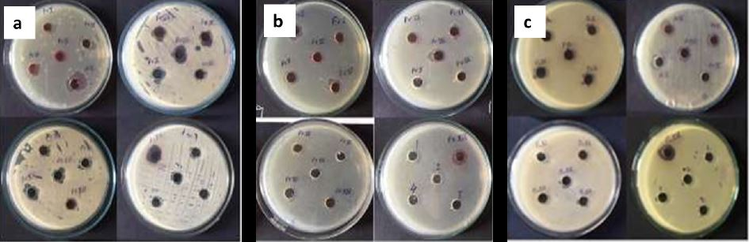

**Figure 1**: Zones of inhibition of isolated fractions (I-XVI) against *Candida albicans, Escherichia coli* and *Staphylococcus aureus*

***Anti-oxidant activity***

The results demonstrated that fraction XVI was having significantly lowest IC50 value (p<0.0001) as shown in Figure 2.

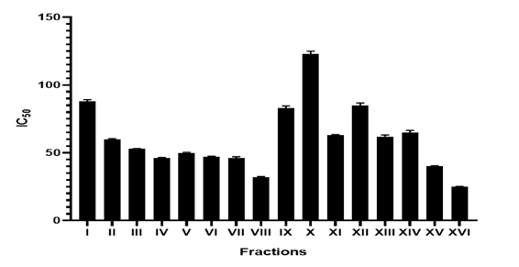

**Figure 2**: Anti-oxidant potential of various isolated fractions by comparison of IC50 values (mean ± SD, n=3)

*Isolation of SHK from potent fraction*

Fraction XVI was subjected to sub column chromatography with 5% ethyl acetate which showed four distinct bands and one prominent band. Consequently, Thin Layer Chromatography (TLC) analysis of fraction XVI was performed using hexane: ethyl acetate (7:3) solvent system revealing the presence of distinct spots with visual, short UV and long UV. Further, TLC of hydrolyzed extract resulted in a distinct spot and its comparison with reference SHK accentuated isolation of SHK in its purest form (97% pure). A sub column of the hydrolyzed extract of fraction (FXVI) was then maintained to obtain higher yield of SHK (20 mg from 100 g roots).Identification of potent fraction is a vital step prior to proceeding with the formulation development.

**3.2 Identification and analysis of isolated SHK**

Isolated SHK (red powder) was freely soluble in chloroform, methanol and acetonitrile (10 mg soluble in > 1 mL) and insoluble in water (10 mg insoluble in > 100 mL). It exhibited a sharp melting point at 146 ℃.

HPLC chromatogram of SHK was recorded in order to determine its purity. Representative chromatogram of SHK was monitored at 518 nm and the SHK retention time was found to be 4.308 (Figure 3 a). In addition, the X-ray pattern of potent fraction showed sharp peaks at 9° and 21° at the 2θ scale which signifies crystalline nature of isolated compound (Figure 3 b).

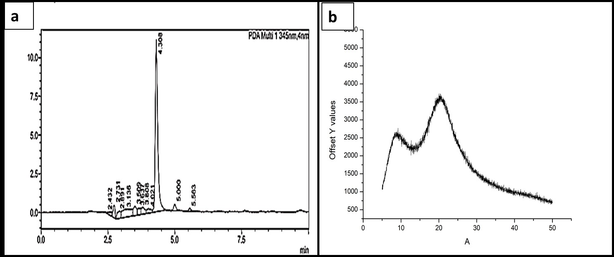

**Figure 3 a**: HPLC chromatogram of isolated SHK **b:** X-ray diffractogram of isolated SHK

**3.3 Preliminary selection screening of excipients for microsponges and the optimization of formulation and process variables**

The results of the preliminary studies are summarized in Table 3. On the basis of percent yield, particle size and polydispersity index of developed batches, formulations F6, F8, F13 and F19 were selected for evaluation of SHK loading capacity. Formulation F6 containing ethyl cellulose as polymer and dichloromethane: methanol (5:1) mixture as solvent was selected as it showed significantly higher SHK content (p<0.0001) of 90.11±0.92 µg/ml. Moreover, the rate of diffusion of this solvent mixture was found to be highest as compared to other solvents. SHK was freely soluble in the solvent providing better entrapment and imparting better microsponge characteristics.

**Table 3:** Preliminary screening on the basis of percentage yield, particle size and PDI

|  |  |  |  |  |  |
| --- | --- | --- | --- | --- | --- |
| **Formulations** | **Internal phase** | **Percentage yield** | **Particle size (um)** | | **PDI** |
| **F1** | EC + DCM | 47.53±0.55 | 2.46±0.15 | | 0.67±0.05 |
| **F2** | EC + Ethanol | - | - | | - |
| **F3** | EC + Methanol | - | - | | - |
| **F4** | EC + Acetone | - | - | | - |
| **F5** | EC + DCM: Ethanol | 18.78±0.29 | 2.71±0.22 | | 0.74±0.03 |
| **F6** | EC + DCM: Methanol | 88.87±0.62 | 5.89±0.19 | | 0.47±0.05 |
| **F7** | EC + DCM: Acetone | 36.61±0.68 | 3.02±0.21 | | 0.57±0.05 |
| **F8** | EuS100 + DCM | 75.73±0.57 | 2.43±0.35 | | 0.65±0.05 |
| **F9** | EuS100 + Ethanol | - | - | | - |
| **F10** | EuS100 +Methanol | - | - | | - |
| **F11** | EuS100 +Acetone | 12.99±0.47 | 1.32±0.25 | | 0.86±0.06 |
| **F12** | EuS100 + DCM: Ethanol | 82.77±0.78 | 1.86±0.62 | | 0.57±0.04 |
| **F13** | EuS100 + DCM: Methanol | 83.96±0.71 | 4.69±0.53 | | 0.63±0.06 |
| **F14** | EuS100 + DCM: Acetone | 56.72±0.43 | 2.57±0.33 | | 0.97±0.04 |
| **F15** | EuRS100 + DCM | 19.39±0.52 | 2.21±0.31 | | 0.67±0.03 |
| **F16** | EuRS100 + Ethanol | - | - | | - |
| **F17** | EuRS100 +Methanol | 26.71±0.29 | 4.57±0.26 | | 0.76±0.02 |
| **F18** | EuRS100 +Acetone | - | - | | - |
| **F19** | EuRS100 + DCM: Ethanol | 82.64±0.61 | 4.89±0.23 | | 0.49±0.03 |
| **F20** | EuRS100 + DCM: Methanol | - | - | | - |
| **F21** | EuRS100 + DCM: Acetone | - | - | | - |
| **Formulations** | **Internal phase** | | | **% Drug loading** | | |
| **F6** | EC + DCM: Methanol | | | 90.11±0.92 | | |
| **F8** | EuS100 + DCM | | | 85.43±0.97 | | |
| **F13** | EuS100 + DCM: Methanol | | | 56.86±1.35 | | |
| **F19** | EuRS100 + DCM: Ethanol | | | 71.32±0.98 | | |

(Mean ± SD, n=3)

Preliminary trials undertaken to establish the effect of polymer concentration, internal phase volume, ratio of internal phase, surfactant concentration, external phase volume and stirring speed on the varied characteristics of microsponges which aids better perception in controlling the process parameters during the development microsponges.

***Effect of various process variables on the particle size***-

Increase in polymer concentration led to significant increase (p<0.0001) in particle size of microsponges (Figure 4.a). that can be attributed to increased viscosity of the internal phase which resulted in more rigid and compact polymer coat (Çomoğlu et al., 2003; Abdelmalak and El-Menshawe 2012; Arya & Pathak 2014). An increase in the volume of solvent (dichloromethane: methanol) in the internal phase led to decreased particle size of the microsponges (p<0.002) owing to lesser concentration of the SHK in high volume of solvent. Nokhodchi et al. reported similar results about the influence of volume of internal phase on the particle size of microsponges (Nokhodchi et al., 2007). Moreover, high volume of internal phase ruptured the sponges resulting in irregular shaped and smaller microsponges whereas the lesser volume of internal phase increased the viscosity of internal phase leading to formation of larger droplets that need more energy to be divided when added to external aqueous phase (Obiedallah et al., 2018).

The ratio of solvents in the organic phase had a prominent effect on the size of microsponges. Increase in amount of dichloromethane in the solvent mixture significantly increased (p<0.0001) the particle size of microsponges. Concentration of emulsifying agent seems preponderant in controlling the particle size of microsponges with a proportionate effect. Increase in surfactant concentration significantly decreases interfacial tension (p<0.0001) resulting in reduced particle size. It has been established that increased differences in the viscosities of internal and external phase results in increased mean particle size of microsponges (Perumal 2001). Increase in volume of external phase also significantly increased the particle size (p<0.0001).

Furthermore, stirring speed was also observed to have a crucial impact on the particle size of developed microsponges. A significant decrease in the size of microsponges (p<0.0001) with increase in stirring speed can be attributed to turbulence effect at the high speed, probably related to constant, dynamic and increased mechanical shear at higher mixing resulting in rapid dispersion of formed droplets which may have less chances of coalescing into larger droplets (Salah et al., 2018). An optimum stirring speed of 600 rpm was thus selected which yielded spherical and uniform particles.

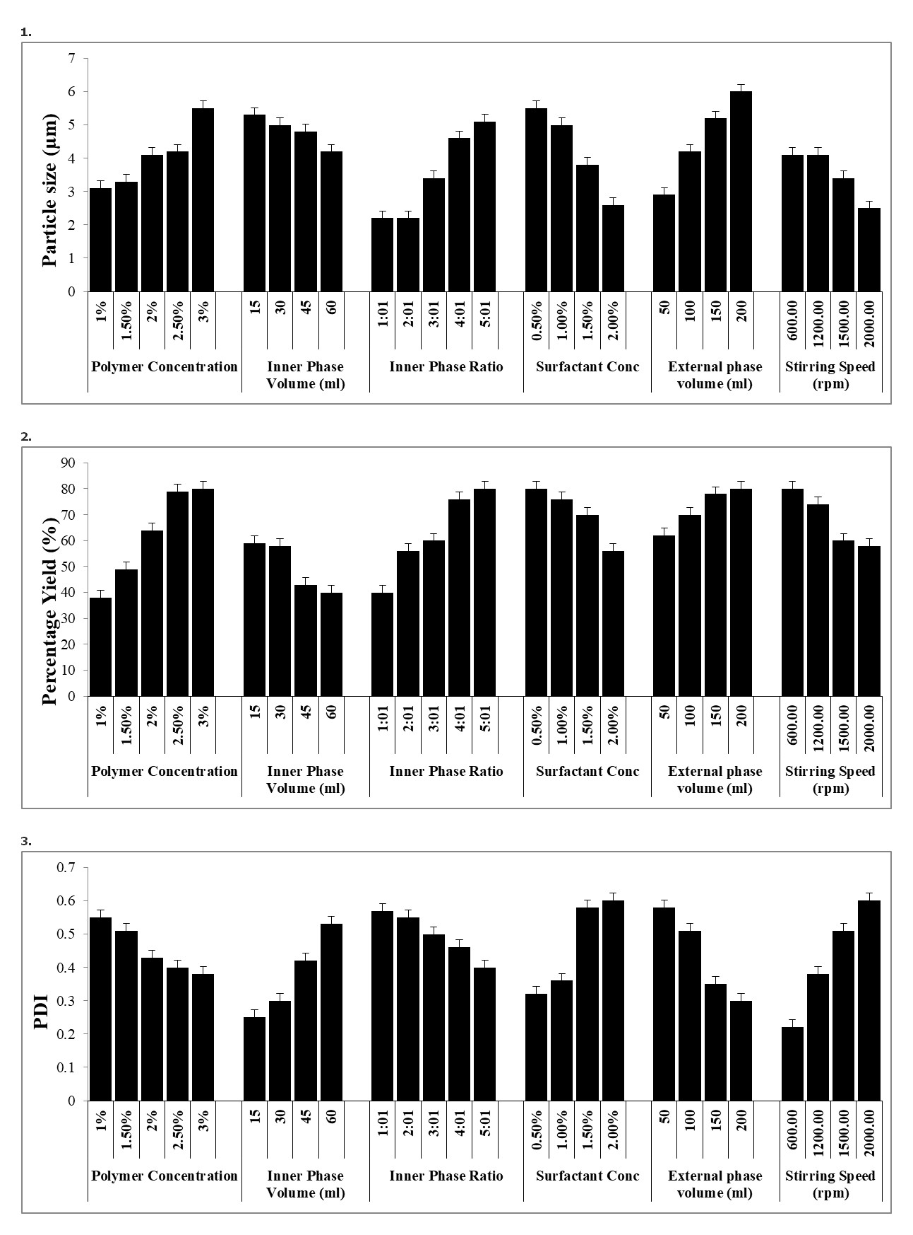

**a**

**Figure 4 a:** Effect of formulation and process variables on particle size of microsponges (Mean ± S.D., n=3)

***Effect of various process variables on percentage yield-*** Increase in the polymer concentration, inner phase ratio, and external phase volume resulted in higher percentage yield of microsponges (p<0.0001), attributed to increased amount of polymer available for SHK encapsulation (Figure 4 b). On the contrary, increase in the volume of internal phase, surfactant concentration and stirring speed decreased the production yield with a rationale that turbulence created within the external phase at higher stirring rates adhered polymer to the paddle resulting in decrease in the production yield. Studies of Perumal et al. reported similar conclusion about the influence of stirring rates on the percentage yield of microsponges. [34]

**b**

**Figure 4 b:** Effect of formulation and process variables on percentage yield of microsponges (Mean ± S.D., n=3).

***Effect of various process variables on the polydispersity index-*** With an increase in the amount of organic solvent in the internal phase or the surfactant concentration, the polydispersity of particles was found to increase significantly (p<0.0001) whereas increased volume of external phase led to a decrease in the polydispersity index (p<0.0001) due to availability of larger amount of external phase upon addition of internal phase for droplet formation. As the content of DCM in the internal phase was increased, the polydispersity index reduced significantly (p<0.0001) attributable to quick diffusion of internal phase owing to low boiling point of DCM, thus eventually causing all the dispersed phase containing the polymer and SHK to be converted into solid microsponges (Cheng et al., 1995). An increase in surfactant (PVA) concentration imparts a confirmation to the microsponge where the diffusion of DCM is slow, thus leaving particles of varying diameters behind (p<0.0001). A surge in stirring rate increases the polydispersity (p<0.0001) of particles due to greater mechanical strength (Figure 4 c).



**C**

**Figure 4 c:** Effect of formulation and process variables on polydispersity index of microsponges (Mean ± S.D., n=3).

**3.4 Characterization of developed microsponges**

***Dynamic light scattering (DLS)***

Droplet size is a crucial factor in the formation of microsponges as it determines the rate and extent of drug release as well as drug absorption. The optimized SHK loaded microsponges showed polydispersity index (PDI) of 0.187 indicating uniformity in the particle size (Figure 5 a). One of the fundamental parameters known to affect physical stability of microparticulate system is zeta potential since it reflects the degree of repulsion between particles. The zeta potential of optimized SHK loaded microsponges was found to be -2.40mv (Figure 5 b).

C:\Users\Erica\Desktop\Figures\Figure S3.tif

**Figure 5 a:** Figure representing the data of particle size and PDI of optimized microsponges **b:** representing the data of zeta potential of optimized microsponges.

***Drug-excipient interaction***

FTIR spectral analysis of potent fraction, physical mixture, polyvinyl alcohol, ethyl cellulose and SHK loaded microsponges is shown in Figure 6. The spectrum of SHK containing potent fraction showed characteristic peaks at 3429 cm-1 (O-H stretching), 2922 cm-1 (C-H stretching), 1722 cm-1 (C=O stretching),1610 cm-1 (C=C stretching), 1058 cm-1 (C-O stretching) and 775 cm-1 (C-H bending). The EC spectrum exhibited bands at 3459 cm-1, 1729 cm-1 and 1379 cm-1 whereas the characteristic peaks detected in PVA spectrum were at 1416 cm-1 and 1319 cm-1. However, the spectrum of SHK loaded microsponges depicted signals at 3459 cm-1, 1744 cm-1, 1446 cm-1 and 1371 cm-1. These characteristic peaks of SHK were also identified in the physical mixture as well as in SHK-loaded microsponges with no appreciable changes in frequencies.

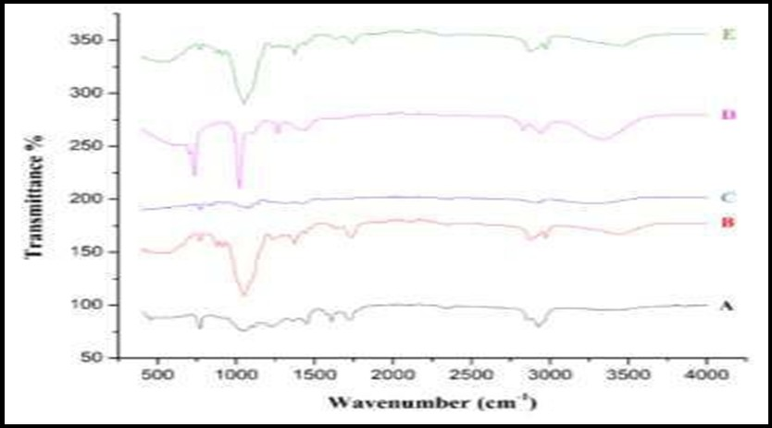

**Figure 6:** FTIR Spectra of **A)** optimized fraction of *Arnebia nobilis* containing SHK **B)** Ethyl cellulose **C)** Polyvinylalcohol **D)** Physical Mixture **E)** SHK loaded microsponges.

*S****canning electron microscopy (SEM)***

SEM images of optimized SHK loaded microsponges formulation providing evidence that microsponges were uniform and spherical in shape with highly porous nature as represents in Figure 7.

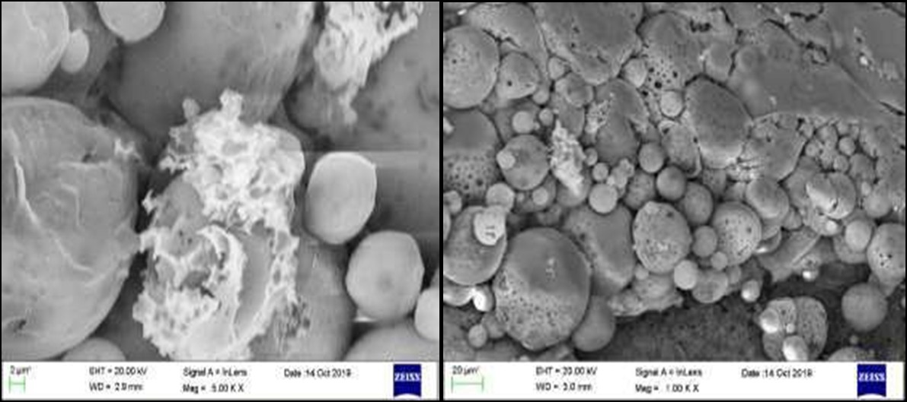

**Figure 7**: Scanning Electron Microscope images of optimized SHK loaded microsponges

***X-Ray Diffraction Analysis (XRD)***

The XRD pattern of SHK loaded fraction showed sharp peaks at 21°and 24° at the 2-theta scale which reveals the crystalline nature of the drug as shown in Figure 8. The X-ray diffractogram of ethyl cellulose is typical of amorphous materials with no sharp peaks.

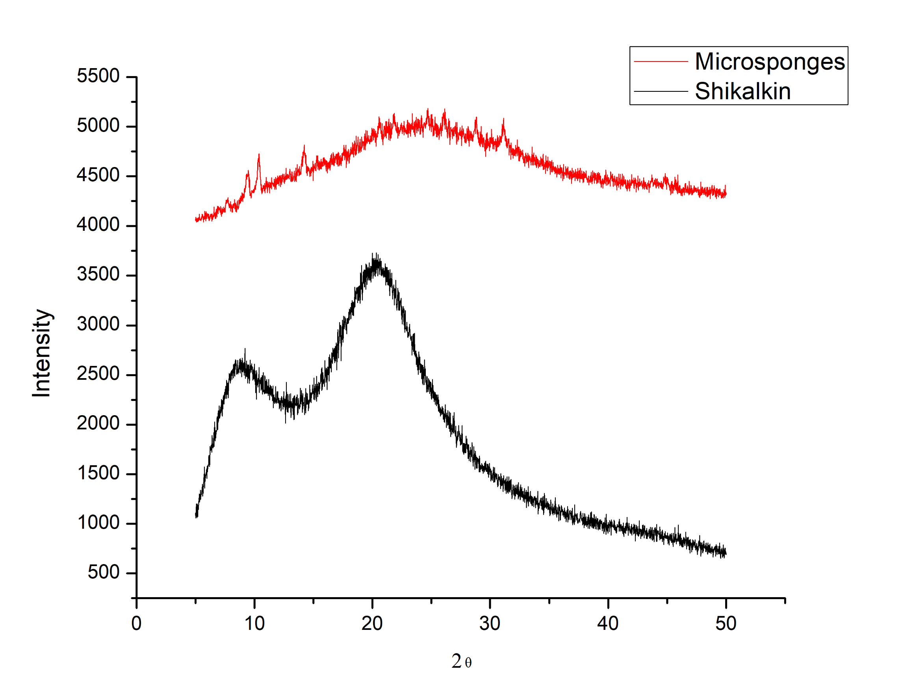

**Figure 8:** X-Ray diffraction peaks of **A)** Potent fraction of *Arnebia nobilis* containing SHK **B)** SHK loaded micropsonges

***Total drug content and entrapment efficiency***

The total SHK content and entrapment efficiency of optimized microsponges was found to be 95.5% and 81.35±1.3%, respectively, hence indicating uniform distribution of SHK in the microsponges.

***Micromeritics properties***

The bulk density, tapped density, angle of repose, compressibility index, Hausner’s ratio of optimized microsponges were 79.36 g/ml, 94.33 g/ml, 28.6°, 15.86 and 1.18, respectively. The increase in the tapped density indicated the presence of pores in the microsponges. However, the present values of angle of repose, Hausner’s ratio and Compressibility index reveals free flowing nature of microsponges.

***Porosity studies***

The quasi-emulsion diffusion method of microsponges preparation has been established to produce particles with high porosity. The blank microsponges possessed average surface area of 72.63 m2 /g , average pore volume of 0.141 cc/g and average pore diameter of 0.24µm indicating the presence of numerous pores. However, SHK loaded microsponges showed an average surface area of 3.09 m2/g, pore volume of 0.027 cc/g and average pore diameter of 0.19 µm. This substantial decrease in the surface area, pore volume and pore diameter is attributable to encapsulation of SHK within the pores of microsponges.

***Photostability studies***

SHK gets absorbed in the UV region displaying a peak around 518 nm, whose intensity retarded upon UVA irradiation (Figure 9).



**Figure 9:** Photostability study of pure shikonin and SHK loaded microsponges at 518 nm

**3.5 Optimization of SHK loaded microsponges based gel**

**Visual inspection, pH, spreadability, tube extrudability, occlusivity and viscoelastic properties**

The results of visual inspection of blank gels prepared by taking different chitosan concentration are given in Table 4. Chitosan was selected as gelling agent in concentration range of 0.5-2.5% *w/v*, discerning 2% *w/v* chitosan gel as homogenous and viscous as compared to other gel formulations. Further, to the selected concentration of chitosan gel microsponges were incorporated and the gels were evaluated for pH, % drug content, spreadability, extrudability and occlusivity. Results revealed that 2%*w/v* chitosan gel exhibiting highest SHK content with optimum pH 6.7 ± 0.1, indicated suitability of gel formulation to pass the threat of irritation to the skin on application. Moreover, its spreadibility was found to be 10.3 cm signifying its ease of spread by little shear while maintaining a good contact time when applied to the site of application. The percentage extrudability was found to be 80.69% indicating its suitability for application. A 2% *w/v* chitosan gel showed maximum occlusivity (Table 5).

Rheological characterization for the optimization of gel concentration for microsponges performed using Cup and Bob Rheometer depicted that no change in the viscosity was observed with constant shear and with increasing time, (Table 6 and Figure 10 a) whereas the varying shear rate resulted in decreased viscosity of the chitosan gel (Figure 10 b). 2% *w/v* chitosan gel showed higher viscosity at zero shear rate. Viscosity of gels decreased with an increase in the shear rate and became constant at higher shear rate. Further, the gel formulations were also evaluated for thixotropic analysis which showed shear thinning or pseudo plastic behavior (Figure 11). From rheological characterization, it can be concluded that 2%*w/v* chitosan gel was optimum owing to its homogeneity, viscosity and stability. Based on the results, gel containing 2%*w/v* chitosan was considered as the final optimized gel concentration for further microsponge incorporation.

**Table 4:** Physical characterization of various concentrations of blank chitosan gels

|  |  |  |  |  |  |
| --- | --- | --- | --- | --- | --- |
| **Property** | **0.5% w/v** | **1% w/v** | **1.5% w/v** | **2 % w/v** | **2.5% w/v** |
| **Color** | Colorless | Colorless | Colorless | Colorless | Colorless |
| **Appearance** | Transparent | Transparent | Transparent | Transparent | Transparent |
| **Odor** | Odorless | Odorless | Odorless | Odorless | Odorless |
| **After feel** | Watery | Emollient | Emollient | Emollient | Emollient |
| **Flow** | Free flowing | Free flowing | Thick | Thick | Sticky |
| **Phase separation** | Yes | Yes | Yes | No | No |
| **Consistency** | Poor | Poor | Good | Very good | Extreme |
| **Removal** | Easy | Easy | Easy | Easy | Difficult |

**Table 5**: Evaluation of different concentration of SHK loaded microscope based chitosan gels.

|  |  |  |  |  |  |
| --- | --- | --- | --- | --- | --- |
| **Concentration of chitosan gel** | **pH** | **% Drug Content** | **Spreadability (g.cm/s)** | **Extrudability**  **(%)** | **Occlusivity (%)** |
| 1% | 6.3±0.2 | 96.24 ±0.767 | 13.8±0.2 | 93.17±0.2 | 69.8±0.3 |
| 1.5% | 6.6±0.2 | 98.13 ±0.874 | 11.5±0.3 | 89.11±0.2 | 75.7±0.1 |
| 2% | 6.7±0.1 | 98.79 ±0.543 | 10.3±0.1 | 80.69±0.1 | 83.9±0.2 |

**(mean ±SD, n=3)**

**Table 6:** Table representing values of constant shear rate, varying shear rate, yield and flux used for evaluating various concentrations of SHK loaded microsponges based chitosan gel.

|  |  |  |  |  |
| --- | --- | --- | --- | --- |
| **Chitosan gel (*w/v*)** | **Constant shear rate (s-`1)** | **Variable shear rate (s-`1)** | **Yield** | **Flux**  **(mg cm-2 h-1)** |
| 1% | 0.38 | 5630.42-0.764 | 0.811±0.61 | 0.861-0.81 |
| 1.5% | 0.79 | 5706.12-2.37 | 41.99±2.79 | 4.18-3.64 |
| 2% | 2.23 | 5582.41-12.21 | 13.13±7.66 | 21.03-18.9 |

**(mean±SD, n=3)**

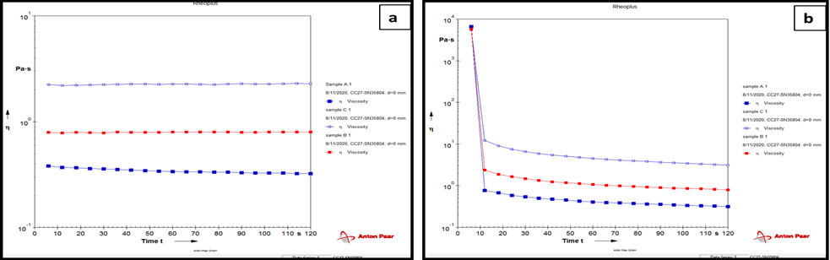

**Figure 10 a:** Comparison of viscosities of various concentrations of SHK loaded microsponges based chitosan gel with constant shear rate **A)** 1% *w/v* **B)** 1.5% *w/v* and **C)** 2% *w/v* **b:** Comparison of viscosities of various concentrations of SHK loaded microsponges based chitosan gel with varying shear rate **A)** 1% *w/v* B**)** 1.5% w*/v* and **C)** 2% *w/v*

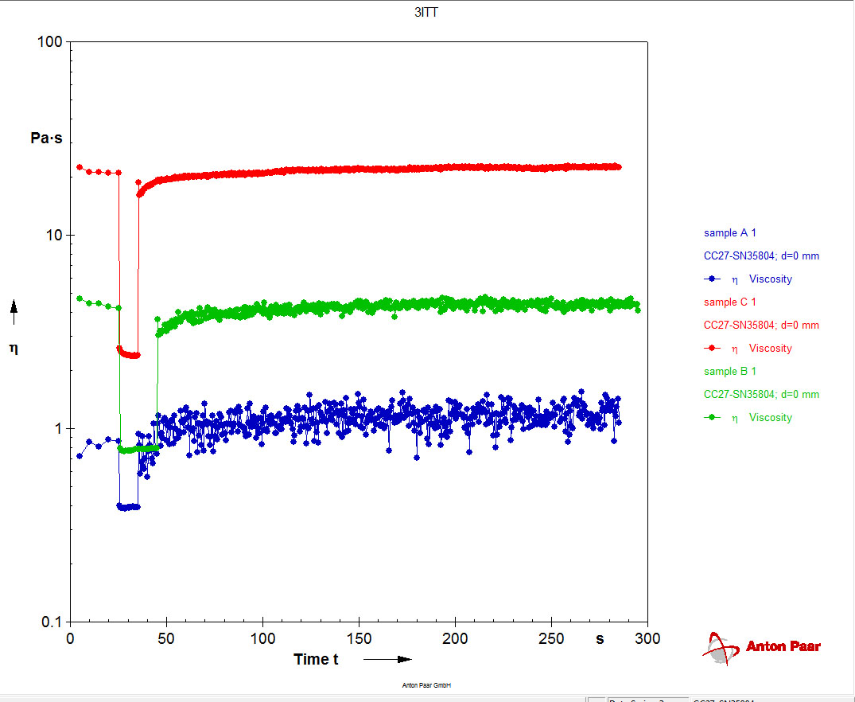

**Figure 11**: Comparison of thixotrophy of various concentrations of SHK loaded microsponges based chitosan gel **A)** 1% *w/v* **B)** 1.5% *w/v* and **C)** 2% *w/v*

**3.6 *In vitro* anti-microbial activity of SHK loaded microsponges based gel**

Agar well diffusion assay demonstrated that Placebo gel was found to exhibit slight antimicrobial property which might be due to presence of chitosan with known anti-microbial potential. Also, SHK suspension gel showed activity attributing to some water soluble entities in the potent fraction. However, maximum zone of inhibition (more than 15mm) was observed in SHK loaded microsponges based gel (Table 7, Figure 12 a, Figure 12 b).

**Table 7:** Table representing the zone of inhibition of placebo gel, suspension gel and SHK loaded MSPs based gel against burn pathogens (Mean±S.D).

|  |  |  |  |
| --- | --- | --- | --- |
| **Formulation** | **Zone of Inhibition (mm)** | | |
| ***Staphylococcus aureus* (MTCC 740)** | ***Escherichia coli* (MTCC119)** | ***Candida albicans***  **(MTCC 227)** |
| **Placebo gel** | 1.6±0.11 | 2.8±0.11 | **-** |
| **SHK Suspension gel** | 3.5±0.21 | - | - |
| **SHK**  **loaded Microsponge gel** | 19.7±0.13 | 20.6±0.25 | 18.1±0.13 |
| **Ciprofloxacin (5µg/ml)** | - | 23.9±0.15 | - |
| **Gentamicin (5µg/ml)** | 22.6±0.05 | - | - |
| **Nystatin (5µg/ml)** | - | - | 21.4±0.10 |



**Figure 12 a:** Zone of inhibition of placebo gel, suspension gel and SHK loaded gel against common pathogens **b:** Graph representing % activity of SHK loaded Microsponges based gel against common pathogen

**4. Discussion**

Phytoconstituents derived from Lithospermum family are often tormented by an issue of photostability. Micropsponge technology seems to bastion these constituents and aid in their successful delivery at the desired location. Hence, upon successful isolation and confirmation by sophisticated techniques, photosensitive SHK was loaded into microsponges prepared using ethyl cellulose as polymer and dichloromethane: methanol (5:1) as solvent. The proposed mechanism of microsponge formation highlights that upon addition of internal phase to external phase, the instant mixing of DCM: methanol and water at the interface of the droplets induced precipitation of ethyl cellulose forming a shell enclosing SHK and organic solvents. Further, the counter diffusion of organic solvents and water induces precipitation of SHK into the core of solidified microsponges.

Characterization of prepared microsponge system reveals particle size of microsponges to be directly proportional to the apparent viscosity of dispersed phase. Furthermore, larger the difference between apparent viscosity of internal and external phase with higher viscosity of the internal phase, the globules of the formed emulsion leads to formation of bigger droplets. Higher values of z-potential specify high electric charge on the surface aggregation of the microsponges which develops strong repellent forces between particles thereby preventing of the particles. Furthermore, it was noticed that blank microsponges had lower zeta-potential values than SHK loaded microsponges. The presence of SHK in microsponges tends to increase zeta potential values indicating that drug loading leads to significant changes in the orientation and surface structure of particles. In addition, the negative value of zeta potential indicates the stability of microsponges against aggregation potential. Additionally, FTIR spectra analysis depicted absence of new peak, or disappearance of existing peaks thereby eliminating probability of any chemical interaction between drug and excipients (Figure 6). Hence, the study indicated that SHK was compatible with excipients as well as confirming the encapsulation and stability of SHK in the prepared porous microsponges.

Surface topography of microsponges contained tiny pores which were induced by diffusion of volatile solvent from core to the surface of microsponges. However, no sharp peaks were detected in SHK loaded microsponges which confirmed transformation of SHK into amorphous form due to complete pore confinement and entanglement with the polymer matrix. Diameter of microsponge is attributable to encapsulation of SHK within the pores of microsponges. Entrapment Efficiency was found to not only depend on the SHK-ethyl cellulose interactions but was also influenced by the diffusion rate and further evaporation of the solvent (DCM and methanol) which caused precipitation and further entrapment of drug.

The reduction in intensity of SHK indicated photolysis of pure Shikonin as seen during the photostability studies. Underlying mechanism of photo-oxidation has been postulated as addition of molecular oxygen at C-13 position and subsequent detachment of allylic hydroperoxide (Schenck reaction) which further undergoes chemical degradation (Cheng et al., 1995). Results of photodegradation studies ascertained that SHK loaded microsponges were more photostable than pure SHK which could be attributed to its effective encapsulation within the microsponges. The microsponges provided an effective barrier against UV induced degradation, resulting in its enhanced photosability.

Further, incorporation of the microsponges in the chitosan gel helped in obtaining a suitable product for application with better spreadibility, extrudability and occlusivity indicating its property of retaining hydration in skin thereby preventing adverse drug reactions such as itching, dryness etc. In-vitro anti-microbial analysis further proved microsponges based gel to be an effective system against burn pathogens attributable to synergistic effect of chitosan as well as SHK loaded potent fraction with excellent anti-microbial potential.

**5. Conclusion**

Microsponges based delivery system has been investigated as one of the key technologies displaying a strong rationale in order to enhance the therapeutic performance of active moieties, with improved patient compliance. In the present study, we described the preparation and successful optimization of SHK loaded cellulosic microsponges gel and assessment of its anti-microbial activity against common pathogens, conferring its ability to treat microbial infections in the near future. Photostability studies of prepared microsponges system reveals microsponges to become a new burgeoning drug delivery matrix for SHK holding promise as a novel and efficient delivery system to treat several microbial infections caused by drug resistant pathogens consequently protecting it from photodegradation. Effective encapsulation of SHK into the microsponges with no possible interaction has helped in masking the shortcomings associated with this compound. We envision that the versatility of this developed system could open new frontiers and provide promising and excellent opportunities for broad application in myriad fields to treat microbial infections.

**Disclaimer (Artificial intelligence)**

Author(s) hereby declare that generative AI technologies such as Large Language Models (ChatGPT, COPILOT, etc) and text-to-image generators are not being used during writing or editing the manuscript.

**Consent**

Not applicable

**Ethical Approval**

Not applicable

**Abbreviations**

Attenuated total reflectance - ATR

Deoxyribose nucleic acid - DNA

Dichloromethane - DCM

Dimethyl sulfoxide - DMSO

2,2-Diphenyl-1-picrylhydazyl - DPPH

Dynamic light scattering - DLS

Entrapment efficiency- EE

Ethyl Cellulose - EC

High Performance Liquid Chromatography - HPLC

Methicillin-resistant Staphylococcus aureus – MRSA

Minimum inhibitory concentration – MIC

Mitochondrial respiration electron transport chain related gene - MRF 1

Nicotinamide Adenine Dinucleotide Phosphate - NADPH

Polydispersity index - PDI

Polyvinyl alcohol- PVA

Reactive oxygen species – ROS

Scanning electron microscopy – SEM

Shikalkin - SHK

Thin Layer Chromatography - TLC

Thioredoxin reductase related gene - TRR 1

X-Ray Diffraction - XRD

**References**

Abdelmalak, N. S., & El-Menshawe, S. F. (2012). A new topical fluconazole microsponge loaded hydrogel: preparation and characterization*. Journal of Pharmacy and Pharmaceutical Sciences*, 4(1), 460-468.

Arya, P., & Pathak, K. (2014). Assessing the viability of microsponges as gastro retentive drug delivery system of curcumin: optimization and pharmacokinetics. *International Journal of Pharmaceutics*, 460(1-2), 1-12.

Atiyeh, B. S., Costagliola, M., Hayek, S. N., & Dibo, S. A. (2007). Effect of silver on burn wound infection control and healing: review of the literature. *Burns*, 33(2), 139-148.

Bhatia, M., & Saini, M. (2018). Formulation and evaluation of curcumin microsponges for oral and topical drug delivery. *Progress in Biomaterials*, 7, 239-248.

Chen, G., Ushida, T., & Tateishi, T. (2002). Scaffold design for tissue engineering. *Macromolecular Bioscience*, *2*(2), 67-77.

Cheng, H. W., Chen, F. A., Hsu, H. C., & Chen, C.Y. (1995). Photochemical decomposition of alkannin/shikonin enantiomers. *International Journal of Pharmaceutics*, 120(2), 137-144.

Coklar, H., & Akbulut, M. (2017). Anthocyanins and phenolic compounds of Mahonia aquifolium berries and their contributions to antioxidant activity. *Journal of Functional Foods*, 35, 166-174.

Çomoğlu, T., Gönül, N., & Baykara, T. (2003). Preparation and in vitro evaluation of modified release ketoprofen microsponges*. II farmaco*, 58(2), 101-106.

Dantas, M. G. B., Reis, S. A. G. B., Damasceno, C. M. D., Rolim, L. A., Rolim-Neto, P. J., Carvalho, F. O. et al. (2016). Development and evaluation of stability of a gel formulation containing the monoterpene borneol*. Scientific World Journal*, 1-5.

Devrim, B., & Canefe, K. (2006). Preparation and evaluation of modified release ibuprofen microspheres with acrylic polymers (Eudragit) by quasi emulsion solvent diffusion method: effect of variables*. Acta Poloniae Pharmaceutica - Drug Research*, 63(6), 521-4.

Fair, R. J., & Tor, Y. (2014). Antibiotics and bacterial resistance in the 21st century. *Perspectives in Medicinal Chemistry*, 6, 25-64.

Hu, S. H., Liu, T. Y., Liu, D. M., & Chen, S. Y. (2007). Nano-ferrosponges for controlled drug release. *Journal of Control Release*, 121(3), 181-189.

Jadhav, K., Dhamecha, D., Bhattacharya, D., & Patil, M. (2016). Green and ecofriendly synthesis of silver nanoparticles: characterization, biocompatibility studies and gel formulation for treatment of infections in burns. *Journal of Photochemistry and Photobiology B: Biology*, 155, 109-115.

Jamadar, M. J. & Shaikh, R.H. (2017). Preparation and evaluation of herbal gel formulation. *Journal of Pharmaceutical Research and Education*, 1(2), 201-24.

Jyothi, K. N., Kumar, P. D., Arshad, P., Karthik, M., & Panneerselvam, T. (2019). Microsponges: a promising novel drug delivery system. J*ournal of Drug Delivery and Therapeutics*, 9(5-s), 188-194.

Kumar, P. M., & Ghosh, A. (2017). Development and evaluation of silver sulfadiazine loaded microsponge based gel for partial thickness (second degree) burn wounds. *European Journal of Pharmaceutical Sciences*, 96, 243-254.

Laxminarayan, R., & Bhutta, Z. A. (2016). Antimicrobial resistance—a threat to neonate survival. *The Lancet Global Health*, 4(10), e676-e677.

Lee, Y. S., Lee, D. Y., Kim, Y. B., Lee, S. W., Cha, S. W., Park, H. W. et al. (2015). The mechanism underlying the antibacterial activity of shikonin against methicillin‐resistant Staphylococcus aureus. *Evidence‐Based Complementary and Alternative Medicine*, *2015*(1), 520578.

Londonkar, R. L., & Hugar, A. L. (2017). Physicochemical, phytochemical profiling and antimicrobial activity of Pterocarpus marsupium. *International Journal of Pharmaceutical Sciences and Research*, 8(5), 2177.

Malik, D.S., & Kaur, G. (2018). Nanostructured gel for topical delivery of azelaic acid: Designing, characterization, and in-vitro evaluation. *Journal of Drug Delivery Science and Technology*, 47, 123-136.

Moin, T. K., Deb, R. A. M., Osmani, R. R., Moin, A., Deb, T. K., Osmani, R. A. M. et al. (2016). Fabrication, characterization, and evaluation of microsponge delivery system for facilitated fungal therapy. *Journal of Basic and Clinical Pharmacy*, 7(2), 39.

Nasrollahzadeh Sabet, M., Biglari, S., Khorram Khorshid, H. R., & Esmaeilzadeh, E. (2020). Shikonin ameliorates experimental autoimmune encephalomyelitis (EAE) via immunomodulatory, anti-apoptotic and antioxidative activity. *Journal of Pharmacy and Pharmacol*ogy, 72(12), 1970-1976.

Nokhodchi, A., Jelvehgari, M., Siahi, M. R., & Mozafari, M. R. (2007). Factors affecting the morphology of benzoyl peroxide microsponges. *Micron*, 38(8), 834-840.

Obiedallah, M. M., Abdel-Mageed, A. M., & Elfaham, T.H. (2018). Ocular administration of acetazolamide microsponges in situ gel formulations. *Saudi Pharmaceutical Journal*, 26(7), 909-920.

Papageorgiou, V. P., Assimopoulou, A. N., Couladouros, E. A., Hepworth, D., & Nicolaou, K. C. (1999). The chemistry and biology of alkannin, shikonin, and related naphthazarin natural products. *Angewandte Chemie International Edition*, 38(3), 270-301.

Papageorgiou, V. P., Assimopoulou, A. N., & Ballis, A. C. (2008). Alkannins and shikonins: a new class of wound healing agents. *Current Medicinal Chemistry*, 15(30), 3248-3267.

Perumal, D. (2001). Microencapsulation of ibuprofen and Eudragit® RS 100 by the emulsion solvent diffusion technique. *International Journal of Pharmaceutics*, 218, 1-11.

PB, M., SG, K., VS, H., & YOGITA, S. (2015). Recent advances in microsponges drug delivery system. *Journal of Critical Reviews*, 3(1), 2016.

Salah, S., Awad, G. E., & Makhlouf, A. I. (2018). Improved vaginal retention and enhanced antifungal activity of miconazole microsponges gel: Formulation development and in vivo therapeutic efficacy in rats. *European Journal of Pharmaceutical Sciences*, 114, 255-266.

Shen, C. C., Syu, W. J., Li, S. Y., Lin, C. H., Lee, G. H., & Sun, C. M. (2002). Antimicrobial activities of naphthazarins from arnebia e uchroma*. Journal of Natural Products*, 65(12), 1857-1862.

Shu, G., Xu, D., Zhang, W., Zhao, X., Li, H., Xu, F. et al. (2022). Preparation of shikonin liposome and evaluation of its in vitro antibacterial and in vivo infected wound healing activity. *Phytomedicine,* 99, 154035.

Tawara, Y., Honma, K., & Naito, Y. (1996). Methicillin-resistant Staphylococcus aureus and Candida albicans on denture surfaces. *Bulletin of Tokyo Dental College*, 37(3), 119-128.

Vidhya, E., Vijayakumar, S., Rajalakshmi, S., Kalaiselvi, S., & Pandiyan, P. (2020). Antimicrobial activity and phytochemical screening of Ocimum americanum L extracts against pathogenic microorganisms. *Acta Ecologica Sinica*, 40(3), 214-220.

Vishwakarma, P., & Choudhary, R. (2019). Microsponges: A novel strategy to control the delivery rate of active agents with reduced skin irritancy*. Journal of Drug Delivery & Therapeutics*, 9(6), 238-247.

Wadhwa, G., Kumar, S., Mittal, V., & Rao, R. (2019). Encapsulation of babchi essential oil into microsponges: Physicochemical properties, cytotoxic evaluation and anti-microbial activity. *Journal of Food and Drug Analysis*, 27(1), 60-70.