**HERBAL COSMETICS AND COSMECEUTICALS: A NATURAL APPROACH TO SKIN, HAIR, AND ORAL CARE**

**ABSTRACT**

The demand for beauty and personal care products has increased therefore consumers look towards alternatives in recent years, thereby increasing the popularity of herbal cosmeceuticals arise because they are safe and natural. Herbal extracts are infused with cosmetics or bases which serve the dual purpose of enhancing beauty while providing therapeutic benefits and devoid of the side effects that come with chemicals. This review analyzes the various types of herbal cosmetic products available for skin care, hair care, oral hygiene, and other applications of beauty. It also focuses on some important herbs and their scientifically proven methods of action, such as turmeric for psoriasis, aloe-vera for eczema, tea tree oil for acne, and licorice for hyperpigmentation. Furthermore, this paper draws attention to the value of herbal medicine in several skin diseases by highlighting the product features of these medicines, such as anti-inflammatory, antimicrobial, antioxidant, and healing properties. Also, the review discusses the advantages of the herbal cosmetics, like hypoallergenic, cruelty-free, eco-friendly, and nutrient-rich and yet are associated with cons like lack of a legal framework and unwarranted standardization as well as allergen potential. An analysis of the global and Indian herbal market trends indicates increasing demand and economic usefulness of these products. Moreover, the document describes global and domestic measures aimed at controlling the quality, safety, and effectiveness of herbal cosmetics. In the end, the patents highlight developments and active studies in this field. This review draws attention to the neglected body of scientific cosmeceuticals based on herbs and emphasizes the need for further research to substantiate claims on safety and efficacy, alongside enhanced regulatory frameworks to safeguard user trust and ensure product reliability.

**Keywords:** Herbal Cosmetics, Regulation, Extracts, Diseases, Treatment

**INTRODUCTION**

Herbal cosmetics are defined as products that use cosmetic ingredients to form a base, in which one or more herbal ingredients are incorporated to treat different skin ailments and for beautification purposes. [1]

Herbal cosmetics like creams, perfumes, and lotions enhance beauty and protect the skin without causing harm. The word "cosmetic" has its roots in the Greek term "kosmtikos," which signifies decorating skills and power. [1,2]

Herbalists today emphasize achieving better health through natural methods. When incorporated into daily routines, herbs initiate a gentle cleansing process, aiding the body in detoxification. Unlike synthetic drugs, which may cause various side effects, herbs work by naturally strengthening the body's defences and fostering harmony with nature. While not providing immediate results, they support the body’s natural healing processes. For millennia, herbs have been used in diverse ways—enhancing culinary flavours, creating perfumes, disinfecting, protecting against germs, and serving as remedies for illnesses**.[1]**

The U.S. FDA points out that the term "cosmeceuticals" has no legal definition, and products are classified as drugs, cosmetics, or both. Although these products undergo safety testing, manufacturers are not required to prove that their claims about ingredient effectiveness are accurate. While herbal cosmetics may include vitamins, botanical extracts, and oils, producers cannot claim these products penetrate beyond the skin’s surface or have therapeutic effects. To ensure consumer trust and product reliability, thorough testing and strict quality assurance are critical.[2]

**ADVANTAGES OF HERBAL COSMETICS**

* **Natural Products:** Free from harmful synthetic chemicals, containing beneficial nutrients like Vitamin E, Aloe vera, and coconut oil.
* **Safe to Use:** Hypoallergenic, dermatologist-tested, and free from harmful chemicals like BHA and BHT, ensuring no skin irritations or allergic reactions.[13]
* **Compatible with All Skin Types:** Suitable for all skin tones and types, with safer natural colours compared to coal tar-derived ones.
* **Wide Selection:** Variety of naturally formulated beauty products, including foundation, eye shadow, lipstick, blush, mascara, and concealer.
* **Fits Your Budget:** Often more affordable than synthetic products, with discounted prices during sales.
* **Not Tested on Animals:** Laboratory-tested without involving animals, ensuring ethical practices.
* **No Side Effects:** Free from parabens and harsh chemicals, preventing skin irritation, pimples, and other issues.
* **Nutrition Rich:** Contains essential fatty acids and antioxidants from ingredients like cocoa butter, apricots, green tea, pomegranate seeds, and grapes, helping nourish and protect the skin. [3,4]

**DISADVANTAGES OF HERBAL COSMETICS**

* The interest in herbal tablets is growing comparatively slower than allopathic medicines.[9]
* Masking the taste and odor is difficult, and the availability of herbal tablets is limited.
* Manufacturing procedures are tedious and complex.
* No pharmacopeia defines a specific technique or ingredients to be utilized by any of the natural beautifying dealers.[9]
* One of the disadvantages of natural cosmetics is that sometimes they do not contain the exact substances that are needed for a particular type of skin.
* The manufacturers of organic cosmetics must conduct further research to find the substances that will give their customers the best results.
* Many people have sensitive skin, and fragrances can cause allergic reactions.[9]

**STATISTICS**

The herbal market has experienced an upsurge due to the growing demand for natural alternative medicines. Worldwide demand for herbal products has been increasing at an annual rate of 10% - 15%. The trade of medicinal plants in India alone is approximated at Rs. 5.5 billion. The World Health Organization (WHO) has predicted that the global market for herbal products is expected to be valued at $5 trillion by the year 2050. The global sales of herbal products are anticipated to reach $26.2 billion by 2007. Europe and the United States represent the two largest markets for herbal products worldwide, accounting for a market share of 41 percent and 20 percent, respectively.[6]

Indian Herbal Products Market Growth (2014–2024F): Regional Breakdown (Fig [1]) [7]

* The total market size has shown steady growth from around ₹4 billion in 2014 to a projected ₹8.5+ billion by 2024.
* South India dominates the market consistently throughout the years, contributing the largest share.
* North India holds the second-largest market share, showing moderate and steady growth.
* West and East India have smaller contributions but are gradually increasing their market presence.

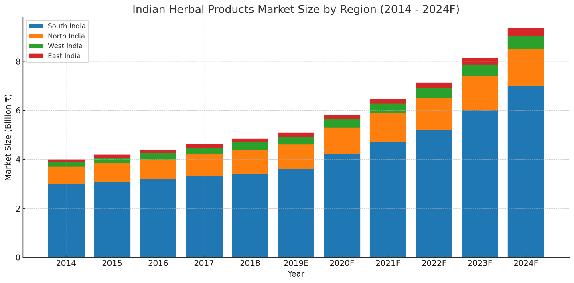

*Fig [1] Indian Herbal Products Market Size By Region (2014 – 2024F)*

**REGULATORY STATUS OF HERBAL PRODUCTS**

The **WHO guidelines** emphasize shared responsibility between manufacturers and regulatory bodies to ensure the quality of herbal products.

Regulatory authorities must establish guidelines for quality assurance, data evaluation, and compliance with Good Manufacturing Practice (GMP) standards. Manufacturers must adhere to good agricultural and collection practices (GACP), GMP, and Good Laboratory Practice (GLP) standards, maintaining thorough documentation. Incentives for GACP implementation can include technical and logistic support. Quality control departments ensure adherence to official pharmacopoeia and monographs, employing various analytical techniques.

Detailed product information, including ingredients, manufacturing details, and usage instructions, is essential for registration. Pharmacovigilance centres monitor the safety and efficacy of herbal products.[5]

**REGULATORY PROVISIONS IN INDIA**

The herbal drug market in India is regulated by AYUSH, under the Ministry of Ayurveda, Naturopathy, Yoga, Siddha, Homeopathy, and Unani systems. The **Drugs and Cosmetic Act (C&D) 1940** and the **rules of 1945** set the regulations. Manufacturers must follow AYUSH guidelines for composition, formulation, labelling, manufacturing, and packing. **Schedule-T** outlines Good Manufacturing Practices (GMP) established in 2016. [8,10]

some of the regulatory bodies are shown in the Fig [2]

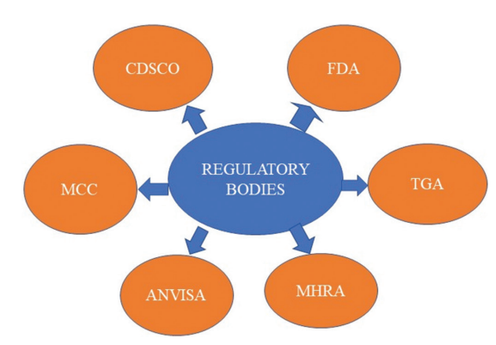

*Fig [2] Different regulatory bodies in worldwide*

**CLASSIFICATION OF HERBAL COSMECEUTICAL PRODUCTS**

Herbal cosmetics are products formulated using natural ingredients derived from plants, minerals, and occasionally animal sources. These products are designed to enhance and maintain the health and appearance of various body parts. Herbal cosmetics can be divided into 4 categories based on the part of the body to be applied for.[9] (Fig [3])

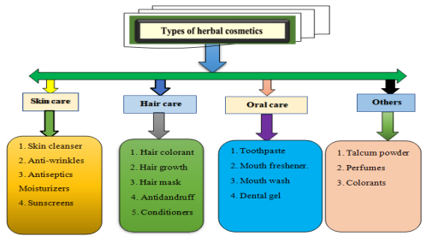Fig [3] Types Of Herbal Cosmetics

**A. HERBAL COSMETICS FOR SKIN**

These products aim to cleanse, nourish and protect the skin using natural ingredients. [11,12]

* **Powders**: Herbal powders such as face powders and talcum powders, often contain ingredients like sandalwood and turmeric, known for their aromatic and skin-beneficial properties.
* **Creams:** Herbal creams, including cold creams and vanishing creams, are emulsions designed to moisturize and protect the skin. They may incorporate plant-based ingredients that offer cosmetic benefits.

***Ingredients:*** Aloe Vera, Tulsi, Neem, and Bees Wax.

* **Deodorants**: Herbal deodorants utilize natural extracts to neutralize body odour and may include essential oils for fragrance.
* **Lotions**: Herbal lotions are liquid emulsions applied to the skin for hydration and nourishment, often containing plant extracts known for their skin-conditioning properties.

***Ingredients:*** Psoralea polyfolia (Babchi oil), Aloe barbadensis (Aloe Vera leaves), Osmium sanctum (Tulsi leaves), Azadirachta indica (Neem leaves), Curcuma longa (Turmeric rhizomes)

* **Bath and Cleansing Products:** These include soaps and body washes formulated with herbal ingredients to cleanse the skin while providing additional benefits like moisturization and soothing effects.
* ***Ingredients:*** Multani Mitti, Turmeric, Aloe Vera, Sandalwood, Lemon Peel, Rose Petal Powder, Manjistha, Lodhra, and Gram Flour.

**HERBAL TREATMENTS FOR SKIN DISEASES**

1. **Psoriasis**

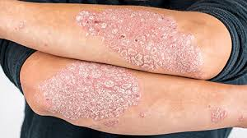Psoriasis is marked by flaky red skin patches covered with silver scales that typically appear on the elbows, knees, and lower back, and it can be uncomfortable or painful and sore. It negatively affects their quality of life. Patients with psoriasis often undergo episodes of little or no symptoms. Numerous herbs can aid in alleviating psoriasis symptoms by diminishing inflammation or slowing skin cell proliferation. Fig [4]

Fig [4] Psoriasis showing flaky red patches with silver scales

**Herb:** *Curcumin longa*

Curcumin (Fig [5]), a compound from turmeric, treats psoriasis via several mechanisms:

1. 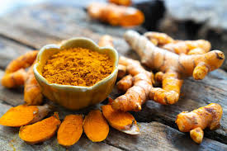**TNF-α Suppression**: Inhibits TNF-α production, binds its receptors to block NF-κB activation, and modulates TLRs to reduce inflammation.

Fig [5] Curcumin

1. **Phosphorylase Kinase (PhK) Inhibition**: Acts as a non-competitive PhK inhibitor, reducing keratinocyte-related issues and T-cell density in psoriatic plaques.
2. **Potassium Channel (Kv1.3) Modulation**: Inhibits Kv1.3 channels in T cells, lowering inflammation.[14]
3. **Cytokine Regulation**: Reduces pro-inflammatory cytokines (e.g., IL-17, TNF-α), curbing inflammation and keratinocyte overgrowth.
4. **Eczema**

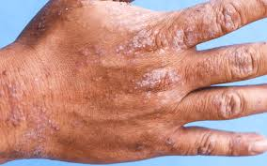Atopic eczema (Fig [6]) is a long-lasting, recurrent, inflammatory skin disorder linked to dysfunction of the epidermal barrier that leads to inflammation, redness, and itching. It can impact individuals of all ages, although it frequently starts in childhood.

Fig [6] Atopic eczema marked by inflamed, itchy, and red skin

**Herb:** *Aloe vera* (Fig [7]) [15]

1. 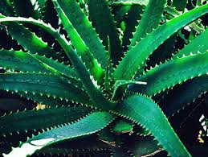Healing Properties

Fig [7] Aloe vera

1. UV and Gamma Radiation Protection
2. Anti-inflammatory Action
3. Immune Effects
4. Laxative Effects
5. Antiviral & Antitumor Activity
6. Moisturizing & Anti-aging
7. Antiseptic Properties
8. **Vitiligo**

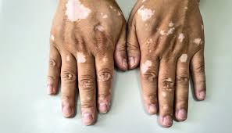Vitiligo is a persistent skin disorder marked by the disappearance of pigment-producing cells known as melanocytes. This leads to the emergence of white patches on the skin. The patches may occur on different areas of the body, such as the face, hands, arms, legs, and even within the mouth or on the hair, resulting in white pigmentation in the affected regions. Fig [8]  
The precise cause is not completely understood, but it is thought to involve a mix of genetic, autoimmune, and environmental influences. In certain situations, the immune system erroneously targets melanocytes, resulting in their damage.

Fig [8] Vitiligo characterized by white skin patches

**Herb:** *Ginkgo biloba*

*Ginkgo biloba* (Fig [9]) aids vitiligo treatment through:

1. 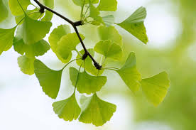**Oxidative Stress Reduction**: Neutralizes reactive oxygen species (ROS), protecting melanocytes from damage.[16]

Fig [9] *Ginkgo biloba*

1. **Immunomodulatory Effects**: Regulates the immune system, potentially preventing autoimmune attacks on melanocytes.
2. **Anti-inflammatory Properties**: Reduces inflammation, supporting melanocyte survival and repigmentation.
3. **Repigmentation Support**: Helps halt depigmentation and promotes skin repigmentation.
4. **Clinical Improvement**: Improves depigmentation scores (e.g., VASI), showing significant results in studies.
5. **Acne vulgaris**

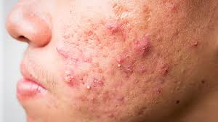Acne vulgaris is a prevalent skin disorder marked by the occurrence of different types of lesions, such as comedones (whiteheads and blackheads), papules, pustules, and in more serious instances, nodules and cysts. It primarily affects the face, back, and shoulders, particularly in adolescents and young adults, although it can persist into adulthood. Fig [10]

Fig [10] Acne vulgaris showing comedones, papules, and pustules.

**Herb:** Tea tree

Tea tree oil, (Fig [11]) derived from the leaves of the *Melaleuca alternifolia* plant, has several mechanisms of action that contribute to its effectiveness in the treatment of acne vulgaris:[17]

1. 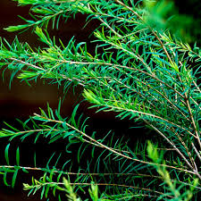**Antimicrobial Properties**: Tea tree oil possesses broad-spectrum antimicrobial activity. It is effective against *Propionibacterium acnes*, the bacterium commonly associated with acne. By inhibiting the growth of this bacterium, tea tree oil helps to reduce the inflammatory response and the severe manifestations of acne lesions.[18]

Fig [11] Tea tree

1. **Anti-inflammatory Effects**: The components of tea tree oil, particularly terpinen-4-ol, have been shown to possess anti-inflammatory properties. This can help in reducing the redness and swelling associated with acne lesions, leading to a decrease in the severity of inflammatory acne.
2. **Reduction of Sebum Production**: Although less directly documented, it is believed that tea tree oil may help regulate sebum production (the oil that clogs pores), which is a contributing factor in the development of acne.
3. **Promotion of Wound Healing**: Tea tree oil has been suggested to facilitate the healing process of the skin and minimize post-acne scarring. This can be beneficial for patients dealing with acne-related skin damage.
4. **Hyperpigmentation**

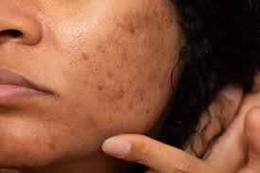Hyperpigmentation (Fig [12]) is a skin condition characterized by dark patches or spots on the skin, which occur when an excess of melanin (the pigment that gives skin its colour) is produced. This can happen for various reasons, including Sun Exposure, Hormonal Changes, Post-Inflammatory, Hyperpigmentation and Age.

**Herb:** Liquorice

Fig [12] Hyperpigmentation resulting from excessive melanin production

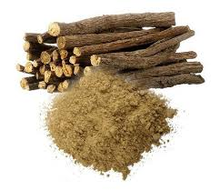Licorice (Fig [13]) extract reduces hyperpigmentation by distributing the melanin, blocking melanin production, and reducing cyclooxygenase activity, which consequently lowers free radical generation. Glabridin, a polyphenolic flavonoid, is the primary ingredient in licorice extract. Research has demonstrated that glabridin inhibits Ultraviolet B (UVB) induced pigmentation and provides anti -inflammatory benefits by suppressing superoxide anion and cyclooxygenase activity.[19]

Fig [13] Liquorice

**B. HERBAL COSMETICS FOR HAIR**

Hair Care Products Hair serves as a particularly significant and unique aspect that plays an integral role in self-image. To a degree, it conveys our identity and who we are. Hair is among the few physical traits we can easily alter. We can change its length, color, and shape to create various styles. These different styles can be employed for seduction, conformity, or to make a statement. Despite hair lacking a vital function, its immense significance is often harshly realized by individuals dealing with alopecia. Hair loss is a widespread issue for many men and women. Numerous factors can contribute to hair loss, including genetics, vitamin deficiencies, and hormonal changes. Some medical conditions, like thyroid disease, may also lead to hair thinning or loss. Plants have served as a source of food and medicine for an extended period. An extensive variety of plant oils is utilized in cosmetic and toiletry formulations. Hair is a crucial part of the body, mirroring a person’s personality. For a lengthy duration, plant materials have been employed for hair care. A multitude of cosmetics is available for hair care.[20]

* Hair Oil
* Hair Colorant
* Hair Cream
* Shampoo

**Hair Oils:** Hair oils, also known as hair tonics, consist of herbal extracts blended with a carrier oil base. Some hair oils contain a combination of multiple herbs and carrier oils. Carefully weigh all dried and fresh herbs such as Amla, Almond oil, coconut oil, castor oil, Olive oil, Nirgundi, Bringaraj, Jatamansi, Neem, Gambhari, Aprajita, Shankpusphi, Brahmi, Kapur, and Pudina, grind them together in a mixture, and combine them with 63% Til oil.

**Hair Colorants:** From ancient days various materials from plants like Henna, Chamomile, Indigo, etc. are used to dye the grey hair to get natural black colour. The leaves of Henna, Indigo, Brahmi, Tea and Bhringraj, fruits of Amla, Shoeflowers, and Cinnamon bark were collected from different places and dried in shade. They were made into powders and used for the preparation of hair colorant. The dried aqueous herbal extracts of Jatamansi rhizome (Nardostachys jatamansi), Gudhal leaves (Hibiscus rosa-sinensis), Kuth roots (Saussurea lappa), Amla dried fruit (Embelica officinalis), Kattha (Acacia catechu) were prepared. Coffee powder (Coffea arabica) and Henna powder (Lowsonia inermis), Beet root, Herbal hair colorants were produced from these dried aqueous herbal extracts and powders.[21]

**Herbal Shampoo:** Shampoos made with natural minerals and plants are widely used in traditional hair care preparations. The mineral soap bentonite powder is one of them to make shampoo preparations with cosmetic values for hair cleansing and formulation thickening properties. Natural coconut oil and sesame oil were selected to make herbal shampoo formulations. Shampoos gained prominence as a product category with the introduction of synthetic detergents. In the present study, herbal shampoo was formulated containing suitable ingredient such as Hibiscus rosa-sinensis. There are anti dandruff shampoos in which ingredients like Neem, Kapoor (naphthalene), Behada, Henna, and Hirda are used.

**HAIR CONDITIONS THAT CAN BE TREATED WITH HERBAL INGREDIENTS**

1. 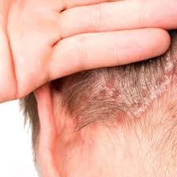**Scalp psoriasis**

Psoriasis is a long-lasting condition that causes a dry, itchy buildup of skin cells that may crack and bleed. It makes your skin flake, and you can have it on different parts of your body. About half of all people with it have it on their scalp. Fig [14]

Fig [14] Scalp psoriasis featuring dry, flaky skin

***Herb: Mahonia aquifolium***

* The flowering plant *Mahonia aquifolium* is derived from the **mahonia shrub**.
* **Oregon grape** is another name for it. This herb has been used to treat inflammatory disorders like psoriasis in the past.
* **Berberine**, found in *Mahonia aquifolium*, may help to reduce some of the irritation caused by psoriasis.
* 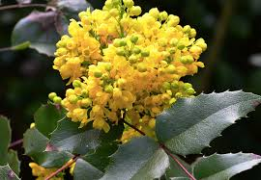The plant also contains antiproliferative properties, which means it can halt the growth of cells.

Fig [15] Mahonia aquifolium

* *Mahonia aquifolium* (Fig [15]) has one of the strongest evidentiary bases, according to the National Center for Complementary and Integrative Health (NCCIH). [22]

1. **Dandruff**

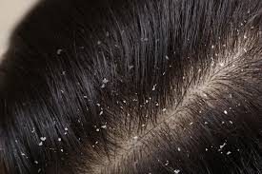Small pieces of skin can “flake” off your scalp and leave a telltale sprinkling of white on your shoulders. Overly dry -- or oily -- skin can cause it, as can certain illnesses, like HIV or Parkinson’s disease. It also can be a reaction to certain soaps or shampoos or to a fungus on your scalp. Fig [16]

Fig [16] Dandruff

***Herb: Rosmarinus officinalis***

Rosemary (Fig [17] is a powerful herb known for its numerous benefits in hair and scalp care. It has been widely used in traditional medicine for centuries to improve scalp health, promote hair growth, and reduce dandruff. Its natural antifungal, anti-inflammatory, and antioxidant properties make it an excellent remedy for maintaining a healthy scalp.[23]

* 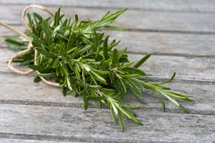**Antifungal Action:** Inhibits *Malassezia* fungus, reducing dandruff.

Fig [17] Rosemary

* **Soothes Inflammation:** Relieves redness, itching, and irritation.
* **Boosts Circulation:** Enhances blood flow for a healthier scalp.
* **Balances Sebum:** Prevents excessive dryness or oiliness.
* **Cleanses Scalp:** Removes buildup, dirt, and excess oil to prevent dandruff recurrence.

1. **Scalp Ringworm**

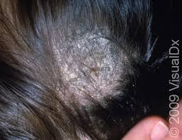Despite the name, no worms are involved in this condition. It’s a fungus that can infect your skin or scalp and cause itchy, scaly, bald patches on your head. It’s easy to get it from someone else, and it’s common in toddlers and children. Fig [18]

Fig [18] Scalp ringworm presenting as itchy, scaly bald patches

***Herb: Tea tree oil***

* 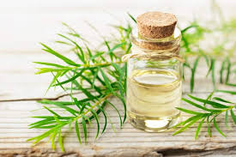Tea tree oil (Fig [19]) is one of the most effective natural remedies for ringworm due to its potent antifungal, antibacterial, and anti-inflammatory properties. It helps kill the fungus (Tinea) responsible for ringworm while soothing itching and inflammation.

Fig [19] Tea tree oil

* Antifungal Action – Tea tree oil contains terpinen-4-ol, a compound known to destroy fungi, including those causing ringworm.
* Reduces Inflammation – It soothes redness, irritation, and swelling, providing relief from itching.
* Prevents Spread – Its antimicrobial properties help prevent secondary infections and stop the fungus from spreading to other areas.
* Speeds Up Healing – It promotes skin regeneration, helping affected areas heal faster.

1. **Alopecia areata**

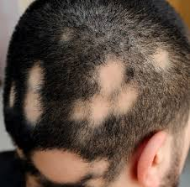Alopecia areata is an autoimmune condition where the immune system attacks hair follicles, causing patchy hair loss on the scalp and other body parts. It can occur at any age and may be triggered by stress, genetics, or other immune disorders. While hair may regrow on its own herbal remedies such as onion juice and rosemary oil can help stimulate regrowth. Fig [20]

Fig [20] Alopecia areata with patchy hair loss

***Herb: Allium cepa*** (Fig [21])

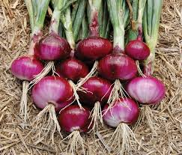Onion juice is a powerful natural remedy for hair loss, particularly Alopecia Areata. Rich in essential nutrients, it stimulates hair follicles, reduces inflammation, and strengthens hair strands.

Fig [21] Onion

* **Sulfur for hair strength** – Supports keratin production, boosts blood flow, and aids collagen formation for new hair growth.
* **Enhances Blood Circulation** – Dilates blood vessels, delivering oxygen and nutrients to dormant follicles, promoting regrowth.
* **Antimicrobial & Antifungal** – Fights infections, maintaining a healthy scalp environment for stronger hair.
* **Anti-Inflammatory & Antioxidant** – Rich in quercetin, reducing scalp inflammation and oxidative stress that cause hair thinning.
* **Blocks Hair Loss Hormones** – Inhibits DHT, preventing follicle shrinkage and hair loss.[24]

**C. HERBAL COSMETICS FOR TEETH AND MOUTH**

Aimed at maintaining oral hygiene and freshness using natural substances. Oral health is vital to general well-being as it can cause significant pain and discomfort if neglected. Using natural herbs in dental care can promote and maintain oral health with minimal side effects. These herbs, either alone or in combination, are effective in managing various oral issues like halitosis, bleeding gums, mouth ulcers, and dental caries. Unlike many over-the-counter products, herbal items are typically free from alcohol and sugar, reducing gum inflammation, rebuilding and healing gum tissue, and eliminating bad breath. Essential oils and extracts such as Red Thyme, Cinnamon Bark, Eucalyptus, Lavender, and Peppermint, along with organically grown Echinacea and Gotu Kola, are valued for their antibacterial, anti-inflammatory, antimicrobial, and antifungal properties. When combined, they reduce oral bacteria and gum inflammation, heal tissues, and freshen breath. Common herbal oral care products include toothpaste, dental cream, and mouthwash.

**Herbal Toothpaste:** Herbal toothpaste addresses issues like bad breath, tooth decay, gum disease, sensitivity, calculus, dental caries, and plaque by cleaning teeth surfaces, remove food particles, reduce plaque, polish teeth, and refresh breath.

***Ingredients***

Clove, Neem, Sunthi, Mentha, Aloe Vera, Kapoor, Babul, tulsi, mango, bay.[25]

**Herbal Mouthwash:** Herbal mouthwash, an aqueous solution often used to control plaque, eliminates oral pathogens through swishing. These natural herbs, with no reported side effects, help control dental plaque and gingivitis and are used as adjuncts to brushing and flossing.

***Ingredients***

Eucalyptus Oil, Clove oil, Neem oil, Tea tree oil, Wintergreen oil, Peppermint oil, Guava, Aloe vera, Curcumin, Tulsi oil, Pineapple, Grape seed extract, and Cardamomum oil have anti-inflammatory effects and prevent bleeding, contributing to better oral hygiene and health.[26]

**DENTAL CONDITIONS THAT CAN BE TREATED WITH HERBAL INGREDIENTS**

1. **Periodontitis**

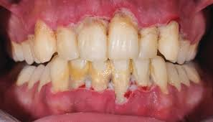If gingivitis is left untreated, it can progress to periodontitis (Fig [22]), a more severe form of gum disease. Periodontitis damages the soft tissue and bone supporting the teeth, potentially leading to tooth loss.​ [27]

Fig [22] Periodontitis showing receding gums and tooth instability

**Symptoms:** Receding gums, Formation of deep pockets between teeth and gums, Loose or shifting teeth, Persistent bad breath​

**Herb:** Azadirachta indica

Neem's (Fig [23]) multifaceted properties make it a valuable agent in the prevention and treatment of dental disorders:​

* 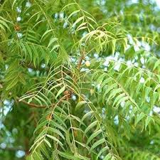**Antimicrobial**: Targets and inhibits periodontal pathogens.

Fig [23] Neem

* **Anti-inflammatory**: Reduces gum inflammation and bleeding.
* **Antioxidant**: Protects oral tissues from oxidative stress.
* **Clinical Validation**: Proven efficacy in clinical settings comparable to standard treatments.

1. **Dental Caries**

**Dental caries**, (Fig [24]) commonly known as **tooth decay** or **cavities**, is a widespread chronic disease that damages the hard tissues of the teeth. It occurs when bacteria in the mouth metabolize 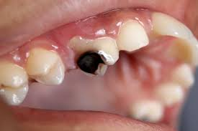sugars from food and drinks, producing acids that erode the tooth enamel over time. If left untreated, this process can lead to holes in the teeth, pain, infection, and even tooth loss. [27]

Fig [24] Dental caries

**Herb:** Psidium guajava (Fig [25])

**Antimicrobial Activity:** 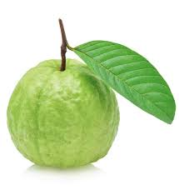Inhibits growth of *Streptococcus mutans* and *Lactobacillus acidophilus.* Reduces risk of enamel demineralization and cavity formation

Fig [25] Psidium guajava

**Biofilm Inhibition**: Prevents formation and adherence of bacterial biofilms on teeth. Limits acid production and bacterial colonization

**Rich Phytochemical Composition**: Contains quercetin, guaijaverin, and other flavonoids. Provides antimicrobial, anti-inflammatory, and healing benefits for oral tissues

**D. OTHER HERBAL PRODUCTS**

**Perfumes:** Natural fragrances are aromas made from elements found in nature, encompassing trees, plants, and those obtained from animals. The floral and musky fragrances you enjoy are frequently sourced from these natural elements.

Nevertheless, natural scents have a shorter duration. There are numerous cost-effective and easy natural methods to maintain body odor without relying on daily showers, such as eating antioxidant-rich food, Wear Natural Fabrics, Use Essential Oils, Use Shampoos and Moisturizers with Natural Scents, Drink Plenty of Water Musk, Civet, Ambergris, Castoreum, etc. [28]

Ingredients: Eugenol, Farnesal, Rose oxide, Citral, Limonene, Rose and Jasmine, Citrus, Oriental, Fruity, etc.

**Talcum Powder-** Herbal powders, rich in vitamins, are believed to benefit the skin in many ways.These powders are utilized in soaps and cosmetics not only for their advantages but also to safely and naturally provide color. Activated Charcoal. Activated Charcoal. For instance, herbal powders such as khus, peppermint, lavender, chamomile, rose, marigold, etc. can be applied in both food and skincare.[11]

**Other coloring agents**- "Natural Colors" are typically obtained from fruits, vegetables, and minerals. Unlike FDandC colors, they do not require batch certification. However, only a limited number of ingredients have been approved by the FDA for use as colorants in food. With one of the largest collections of FDA-approved natural food colors, IFC Solutions can assist you in obtaining the natural food coloring options you require for your products. Our custom blending offers even more possibilities to satisfy your production requirements.[11]

**PATENTED PRODUCTS**

**Table 1 : Herbal Cosmetics (Patented) in International Market [2]**

|  |  |  |
| --- | --- | --- |
| Product | Patent number | Country |
| Herbal cream (*Aloe vera, Allium sativum, Gymnema syllvestra, Tridax procumbens, Gum olibanum)* | US6200570 B1 | USA |
| Herbal preparation(*Bacopa monnieri, Camellia sinensis, Curcuma longa, Silybum marianum, Withania somnifera)* | EP1825845 A1 | EUROPE |
| Herbal cosmetic compositions containing herbs in mixture of surfactants, essential oils etc. Herbs are selected from chamomile, rosemary, mint, sage, lavender, citron, bergamot, juniper, rose, lime (linden), stinging nettle and witch-hazel. | DE4133085 A1 | GERMANY |
| Dry herbal, cleaning compositions ( *Bassica malabarica, cocoa nucifera sapindus trifoliatus, hibiscus rosa sinesis, trigonella foenum graeceum*) | EP0908171 A1 | EUROPE |
| Cosmetic or dermatologic composition containing at least one saponin of the ginsenoside type, and its applications particularly to hair care | WO1994006402 A2 | WORLD INTELLECTUAL PROPERTY ORGANISATION (WIPO) |

**CONCLUSION**

The combination of classical herbal medicine and modern science is evident in herbal cosmeceuticals, which provide safe and effective environmental alternatives to personal care products. And although these products have the potential to enhance skin, hair, and oral health, issues of scientific validation, standardization, and regulatory frameworks continue to add challenges. The capabilities of herbal cosmetics can be leveraged through further scientific research, supportive policies, and stringent quality regulations. Given the increasing awareness and consumption of natural products herbal medicine promises, herbal cosmeceuticals are set to transform the future of the beauty and wellness industries.

**REFERENCES**

1. Bijauliya RK, Alok S, Kumar M, Chanchal DK, Yadav S. A comprehensive review on herbal cosmetics. Int J Pharm Sci Res. 2017;8(12):4930–4949.
2. Joshi LS, Pawar HA. Herbal cosmetics and cosmeceuticals: an overview. Nat Prod Chem Res. 2015;3(2):170–178.
3. Fatima A, Alok S, Agarwal P, Singh PP, Verma A. Benefits of herbal extracts in cosmetics: a review. Int J Pharm Sci Res. 2013;4(10):3746–3760.
4. Pal M, Pushpendra, Saxena R, et al. A detailed analysis of herbal cosmetics. NeuroQuantology. 2022;20(15):6367–6381.
5. Sindhura SDK, Jain V. Challenges in formulating herbal cosmetics. Int J Appl Pharm. 2018;10(6):47–53.
6. Ashawat MS, Banchhor M, Saraf S, Saraf S. Herbal cosmetics: trends in skin care formulation. Phcog Rev. 2009;3(5):82–89.
7. Polshettiwar SA, Sawant DH, Abhale NB, et al. Regulation of herbal products used as medicine across the globe: a case study on turmeric—golden medicine. Biomed Pharmacol J. 2022;15(3):1227–1237.
8. Singh A, Saharan VA, Kharb V, Bhandari A. Current status of regulations for herbal medicines in Europe, United States and India. J Nat Conscient. 2011;2(3):406–422.
9. Suman, Saddam, Alok S. An overview of herbal cosmetics and their applications. Int J Pharm Sci Res. 2023;14(5):2214–2226.
10. Sahane MB, Basarkar GD. A review of herbal regulations and approval process in India and Europe. Int J Drug Regul Aff. 2023;11(4):25–33.
11. Chandini V, Kumar NU, Rani TM, Yadav KJ, Siva M, Babu MK. Herbal cosmetics and cosmeceuticals—a review in new technology of cosmetology. World J Pharm Pharm Sci. 2023;12(4):930–951.
12. Nidhi S, Yogita B, Archana R, Deepika J, Bhavna S. Usage of natural plants in herbal cosmetics. JOJ Dermatol Cosmet. 2021;4(2):555635.
13. Arora R, Aggarwal G, Dhingra GA, Nagpal M. Herbal active ingredients used in skin cosmetics. Asian J Pharm Sci. 2019;12(9):7–15.
14. Bahraini P, Rajabi M, Mansouri P, Sarafian G, Chalangari R, Azizian Z. Turmeric tonic as a treatment in scalp psoriasis: a randomized placebo-control clinical trial. J Cosmet Dermatol. 2018;17(3):461–466.
15. Zhao C, Wu S, Wang H. Medicinal plant extracts targeting UV-induced skin damage: molecular mechanisms and therapeutic potential. Int J Mol Sci. 2025;26(5):2278.
16. Mulianto N, Kariosentono H, Purwanto B, Indarto D, Soetrisno S. The effect of Ginkgo biloba extract on oxidative stress, anti-inflammatory and antiapoptotic in vitiligo treated with topical desoxymethasone. Evol Stud Imaginative Cult. 2024;8(2):1580–1590.
17. Enshaieh S, Jooya A, Siadat AH, Iraji F. The efficacy of 5% topical tea tree oil gel in mild to moderate acne vulgaris: a randomized, double-blind placebo-controlled study. Indian J Dermatol Venereol Leprol. 2007;73(1):22–50.
18. Carson CF, Hammer KA, Riley TV. Melaleuca alternifolia (tea tree) oil: a review of antimicrobial and other medicinal properties. Clin Microbiol Rev. 2006;19(1):50–62.
19. Simmler C, Pauli GF, Chen SN. Phytochemistry and biological properties of glabridin. Fitoterapia. 2013;90:160–184.
20. Bhalerao P, Jadhav B, Gulave D, Jangle M. Hair structure and care: a review of herbal hair care cosmetics. Int J Pharm Sci. 2024;2(10):1676–1686.
21. Singh A, Duggal S. Indian medicinal plants used in hair care cosmetics: a short review. Pharmacogn J. 2010;2(10):361–364.
22. Janeczek M, Moy L, Lake EP, Swan J. Review of the efficacy and safety of topical Mahonia aquifolium for the treatment of psoriasis and atopic dermatitis. J Clin Aesthet Dermatol. 2018;11(12):42–47.
23. Head & Shoulders. Can rosemary oil help in getting rid of dandruff? [Internet]. [cited 2025 Apr 28]. Available from: <https://www.headandshoulders.co.in/en-in/healthy-hair-and-scalp/dandruff/dandruff-home-remedies/rosemary-oil-for-dandruff>
24. Madani S, Shapiro J. Onion juice (Allium cepa L.), a new topical treatment for alopecia areata. J Dermatol. 2002;204(4):268–269.
25. Wadhwa S, Sethiya S. Preparation and evaluation of herbal toothpaste. Asian J Pharm Res Dev. 2016;4(1):1–5.
26. Shahidulla SM, Ghori MD, Saleh M. Herbal mouthwash: an innovative approach. Int J Pharm Sci Med. 2022;7(11):51–58.
27. Chandra Shekar BR, Nagarajappa R, Suma S, Thakur R. Herbal extracts in oral health care—a review of the current scenario and its future needs. Pharmacogn Rev. 2015;9(18):87–92.
28. Jellinek P. Perfume materials reminiscent of human body odor. In: The Psychological Basis of Perfumery. Dordrecht, The Netherlands: Springer; 1997:40–45
29. Latest Technology Advances in Cosmaceuticals
30. Nageen Arora, Shilpi Agarwal,
31. Latest Technology Advances in Cosmaceuticals
32. Nageen Arora, Shilpi Agarwal,
33. Latest Technology Advances in Cosmaceuticals
34. Nageen Arora, Shilpi Agarwal,
35. Latest Technology Advances in Cosmaceuticals
36. Nageen Arora, Shilpi Agarwal,
37. Latest Technology Advances in Cosmaceuticals
38. Nageen Arora, Shilpi Agarwal,
39. Latest Technology Advances in Cosmaceuticals
40. Nageen Arora, Shilpi Agarwal,
41. Latest Technology Advances in Cosmaceuticals
42. Nageen Arora, Shilpi Agarwal,
43. Latest Technology Advances in Cosmaceuticals
44. Nageen Arora, Shilpi Agarwa
45. Latest Technology Advances in Cosmaceuticals
46. Nageen Arora, Shilpi Agarwa