***Original Research Article***

**Nose-to-Brain Delivery of Naringenin loaded cubosomal *In-Situ* Gel: Formulation and *In vitro/In vivo* Evaluation**

**Abstract**

The main aim of this study was to develop naringenin-loaded cubosomes for intranasal administration, with a focus on assessing pharmacokinetics in animal models.The cubosomes were developed using the top-down method and were optimized using CCD. This method involves breaking down larger cubic phases into smaller nanoparticles, suitable for drug delivery applications.They are subjected to physicochemical analysis, *In vitro* release studies. From the studies cubosomal *in-situ* gel formulation (Gellan gum 0.45% w/v, Locust bean gum 1.58% and 3.0% w/v, PEG6000 2% w/v) showed significantly higher release compared to free naringenin. Pharmacodynamic studies confirms that the nasal administration group showed a delayed onset of action when compared to the oral administration group, suggesting a targeted effect.

Key words: Naringenin, cubosomes, *in-situ* gel, brain target drug delivery

**Introduction**

The BBB barrier, which restricts drugs from entering the brain, makes the central nervous system one of the most complex systems in the human body [**1].** Epilepsy is a serious emergency neurological disorder characterized by seizers [**2].** Though there are many causes for occurring of seizers, but the main cause of epilepsy is unknown. One of the potential processes in the pathophysiology of epilepsy is oxidative stress. Statusepilepsy alters redox potential and lowers ATP levels, which leads to a collapse in brain energy supply. Number of strategies are employed to target drugs to brain includes disruption of BBB either by osmotic or biochemical, manipulation of drug moieties (pro drugs, carrier or receptor mediated drug delivery) and modification in route of administration (intra cerebral,intra ventricular, olfactory routes) [**3,4]**.

Citrus fruits, such as oranges and grapes, naturally contain the inactive flavonoid naringenin (NRG).The naringenin is converted to active aglycone form naringenin (5,7,4’-trihydroxy flavones)by intestinal bacterial enzymes [**5].** This intriguing dietary flavonoid demonstrates numerous pharmacological activities like anti inflammatory, hepatoprotective, anti carcinogenic and antioxidant [**6]**.Additionally naringenin’s neuroprotective effects have been documented in animal models of forgetfulness, alzheimer’s and Parkinson’s diseases [**7]**. It is also shown that naringenin supplementation restore the cholin acetyl transferase enzyme results in improved learning and memory [**8]**.Naringenin has many reports regarding the therapeutical and food applications but it has hampered research due to the poor solubility and low bioavailability [**9]**. Therefore, increasing its bioavailability is crucial for its effective use.

In comparison to oral administration, nasal administration of naringenin improves drug dispersion to brain. Both peripheral and central drug transport is possible. Nasal drug administration has advantages like low cost, low dose, fast onset of action,patient compliance and self administration. Contrarily, some drawbacks like mucociliary clearance, small fluid volume for drug dissolution and low absorption of hydrophilic and large chemical moieties [**10]**. So the formulation of drug loaded *in-situ* cubosomal can address these issues.

Cubosomes are the nano carriers composed of amphiphilic polar lipid. Above critical micelle concentration, the amphiphilic molecules self assemble to form micelle structure. The generated micelles are compelled to form cubic structures at increasing concentrations. Numerous advantages of cubosomes include their high entrapment efficiency, biocompatibility, controlled release of drug and thermodynamic stability [**11].**

The central composite design (CCD) is a useful statistical experimental design for analysing the main effects of experimental components and their interaction factors, in comparison to the full factorial design. CCD requires only three levels of each factor, yet it covers a wide range of combinations. To create the optimal formulation, CCD can be used to forecast and optimise the responses [**12]**.

Based on literature the present work cubosomes imbibed intra nasal gel of naringeninto examine the brain targeting capacity was planned. This novel formulation aims to combine the advantages of in-situ gelling technologies, like the ease of intra-nasal administration, more retention time and prolonged drug release with cubosomes such as high drug entrapment efficiency.

**Materials and methods**

Naringenin was purchased from Sigma Aldrich, Mumbai, India, Gellan gum was a gift sample from Marine Colloids, Cochin, locust bean gum, glycerol, oleic acid, poloxamer 407, PEG6000 are purchased from Sigma Aldrich, Mumbai, India.

**Experimental design**

A three-factor, three-level (3) central composite design (CCD) was employed in a statistical optimization study to improve the formulation variables of 15 distinct formulations. Five iterations of the centre point formulation (F8) were included in each formulation. Design-Expert software (version 7, Stat-Ease Inc., MN, USA) was employed for this analysis. The key independent variables were Oleic acid (X1), Glycerol (X2), and Poloxamer 407 (X3), with three levels of each factor (-1, 0, and +1). The actual values for the compositions of the formulations can be found in (Table 1). The study assessed three dependent variables: particle size (PS) [Y1], entrapment efficiency percent (EE%) [Y2] and *in-vitro* t1/2 [Y3]. Additionally, the polydispersity index (PDI) and zeta potential (ZP) were determined for all the prepared formulations. Desirability values were calculated using the data collected from response surface analysis. These numbers played a crucial role in determining the most suitable combination with the most desired qualities.

**Table 1** Independent and dependent variables in central composite design

|  |  |
| --- | --- |
|  | Levels  -α -1 0 +1 +α |
| Independent variables  X1=Oleic acid (%v/v)  X2=Glycerol (%v/v)  X3=Poloxamer 407 (%w/v) | 0.97 2.0 3.5 5.0 6.02  -0.02 1.0 2.5 4.0 5.02  -0.02 1.0 2.5 4.0 5.02 |
| Dependent variables  Y1= Particle size (nm)  Y2= Entrapment efficiency (%)  Y3= t1/2 (h) | **Constraints**  Optimum (100-500)  Maximum  Optimum(6-8) |

**Calculation of theoretical drug release profile**

The *in-situ* gel's total NRG dosage was determined using the Robinson Erikson equation based on the accessible pharmacokinetic data. This total dosage, denoted as Dt, consists of two components: the immediate dose, Di, and the maintenance dose, Dm, where Dt = Di + Dm. The elimination rate constant, K, is calculated as 0.693/t1/2, which is 2.5 hours, resulting in K = 0.2772 mg/h. The availability rate, R, is determined as the product of K and the usual drug dose, D, which is 150 mg, resulting in R = KD = 41.58 mg/h. The maintenance dose, Dm, is calculated as Rh, where Rh is 498.96 mg, and h represents the desired sustained action duration, which is 12 hours. The immediate dose, Di, is determined as D-RTp, where D is 150 mg, R is 41.58 mg/h, and Tp is the time required to achieve peak plasma levels. The total dosage, Dt, is established as 500 mg. Therefore, according to the Robinson Erikson equation, the formulation should include a 500 mg dose [**13].**

**Preparation of NRG cubosomes**

Two distinct mixtures were prepared: the first involved a blend of oleic acid and glycerol, which was melted and combined over a water bath at 60°C, resulting in the formation of glycerol mono oleate. The second mixture consisted of poloxamer and water, which was melted and mixed at 70°C. The first mixture was mixed with the drug solution added first, and then the second solution was gradually added while stirring continuously. The combined solution was left undisturbed for a 24-hour period to reach equilibrium. After 24 hours, two separate phases formed, a mechanical stirrer was employed at a speed of 2500 rpm for two hours. Subsequently, the entire system was homogenized for an additional two hours at the same speed. The resulting liquid dispersion of cubosomes was stored at room temperature[**14].**

**Preparation of NRG *in-situ* cubo gels (NCG)**

The cubosomes mentioned above were optimized using a Central Composite Design (CCD), and *in-situ* gels containing the optimized formulation were developedaccording to the specifications outlined in (Table 2). The following method was used to prepare the *in-situ* gel: First, gellan gum and LBG solutions were individually developed by dispersing a precisely measured amount of gellan gum in warmed distilled water for approximately 20 minutes, utilizing a magnetic stirrer at 60°C. The gellan gum solution was continuously stirred, and the NRG cubosomal dispersion was gradually added once it had fully dispersed. While the gum solution was allowed to cool to 40°C, an excipient solution was prepared by combining the appropriate quantities of PEG6000 and benzalkonium chloride in a sufficient amount of water.The excipient solution was then steadily mixed into the gum solution and topped up with distilled water to attain the desired volume. The resulting mixtures were transferred into Rubber-stopped glass vials in an amber hue and stored for subsequent evaluation**[15]**.

**Table 2** Formulation of NCG

|  |  |  |
| --- | --- | --- |
| **Excipients** | **Quantity** | |
| NCG1 | NCG2 |
| **Gellan gum** | 0.45%w/v | 0.45%w/v |
| **Locust bean gum** | 1.58%w/v | 3.0%w/v |
| **PEG6000** | 2%v/v | 2%v/v |
| **Benzalkonium chloride** | 0.05%w/v | 0.05%w/v |
| **Oleic acid** | 3.5%v/v | 3.5%v/v |
| **Glycerol** | 2.5%v/v | 2.5%v/v |
| **Poloxamer 407** | 2.5%v/v | 2.5%v/v |
| **Drug(NRG)=500mg/ml** | | |

**Characterization of the NRG cubosomes**

**Shape analysis**

Transmission electron microscopy (TEM) using a JXA-840 instrument from JEOL in Tokyo, Japan, and Phase contrast microscopy were employed to analyze the morphology of the cubosomal dispersions. After the cubosomes were added to a carbon-coated copper grid, their existence was determined using high-resolutionTEM (HR-TEM) in bright-field mode, operated at 200 Kv [**16].**

**Particle size and zeta potential**

The Horiba ZetaSizer was utilized to ascertain the zeta potential and particle size of the produced NRG cubosomes. The dispersion was appropriately diluted with water before analysis.

**Entrapment efficiency**

Centrifugation was carried out to the cubosomal dispersion for 15 minutes at 10,000 rpm. Then, the liquid supernatant was mixed with the pH 6.4 phosphate buffer that had been appropriately diluted. Using a UV spectrophotometer, the absorbance of the resultant solution was determined at 220 nm and this measurement was compared to a blank solution containing only the phosphate buffer. By using a specific formula, the drug entrapment efficiency of the prepared cubosomal formulations was determined [**17]**.

% Entrapment efficiency= $\frac{Entraped drug}{Total drug}x100$

***In-vitro* drug release**

*In-vitro* drug release studies were conducted usinga modified Franz diffusion cell. The dialysis membrane was immersed in a pH 6.4 phosphate buffer for 12 hours prior to being attached to the diffusion cell in order to set up the system. The donor compartment contained a drug formulation equivalent to 500 mg, while the receptor compartment received approximately 50 ml of PBS at pH 6.4. To mimic physiological conditions, the temperature at 37°C and the stirring speed at 50 rpm were kept constant throughout the experiment.In order to maintain sink conditions, we periodically withdrew a certain volume of the sample from the system and replaced it with the same amount of fresh simulated nasal fluid (SNF). The withdrawn material was appropriately diluted and then analyzed at a wavelength of 220 nm using a UV spectrophotometer[**18].**

**Characterization of NCGs**

**Homogeneity, clarity studiesandmeasurement of pH**

Visual inspection was employed to assess the uniformity and transparency of each formulation under black and white backgrounds, examining their appearance and the possible presence of particles. A standard pH meter was used to measure the pH.

**Evaluation of Gel Properties**

**Gelation time**

Gelation time is the period of time required for a liquid to go from a solution to a gel-like condition. In an experiment, 2 ml of various formulations were added to a 10 ml transparent container with a little amount of simulated nasal fluid (SNF), an aqueous solution, present with specific concentrations of NaCl (8.77 mg/ml), KCl (2.98 mg/ml), and CaCl2 (0.59 mg/ml) per litre. At a constant temperature, the container was set up on a magnetic stirrer of 37±0.5oC. The gelling time represents the duration during which the magnetic bead stirring was paused due to the formation of a gel.

**Gel strength**

The assessment of gel viscosity in physiological settings is determined through its gel strength, a characteristic that depends on time. To evaluate a 5g of *in-situ* gel, one needs to consider the time it takes for a 3.5-gram weight to permeate to a depth of approximately 3 centimetres.

**Viscosity Studies**

Viscosity studies were carried out to ensure the formulation's quality and consistency.For every composition, viscosity was measured before and after gelation using a digital Brookfield viscometer with an S-63 spindle spinning at 100 rpm**[19].**

**Spreadability**

The objective of the experiment was to assess the gel's homogeneous diffusion over the physiological membrane. This was accomplished by assembling two slides with an extra 0.7 g of gel and securing a 20 g weight to the upper slide. For five minutes, a 100 g weight was applied to the upper slide to guarantee that the sample was distributed evenly. After that, any extra gel was carefully scraped away using a tissue along the margins. The spreadability (S) was determined using the formula S = (W * L) / T, where W represents the weight attached to the upper slide, L is the length of the slide (7.5 cm), and T corresponds to the time it took for the upper slide to detach from the lower slide immediately after the removal of the 100 g weight **[20].**

***In-vitro* Mucoadhesion Strength**

A specialised physical balance was used to assess the mucoadhesive strength in vitro. Sheep's nasal mucosa served as the study's test subject. One 1.33 cm2 piece of nasal mucosa was attached to one side of the balance, and another 1.33 cm2 piece was attached to the outside of a beaker so that the two mucosae could face each other. A 50 mg sample was applied to the beaker's mucosa and allowed to come into contact for a short while. The opposing side of the balance kept moving in the same direction until the two mucosae finally parted. The mucoadhesive strength's potency was determined using the equation: dynes/cm2 = mg/A, where "m" represents the weight in grams required to detach the mucosae, "g" corresponds to the gravitational acceleration, and "A" represents the area of the mucosa **[21].**

***In-vitro* drug release of NCGs**

An altered Franz diffusion cell was used to perform *in-vitro* drug release tests with NCGs. The dialysis membrane was pre-soaked in a pH 6.4 phosphate buffer for 12 hours before being inserted into the diffusion cell. An *in-situ* gel corresponding to 500 mg of NRG was placed into the donor compartment, while around 50 cc of SNF was present in the receptor compartment. Throughout the experiment, the temperature and agitation rate were kept constant at 37°C and 100 rpm to replicate biological circumstances. To maintain sink conditions, a predetermined amount of the sample was removed and concurrently replaced with the same volume of SNF. The extracted sample was appropriately diluted before being subjected to UV spectrophotometer analysis at a wavelength of 220 nm [**22].**

***Ex-vivo* studies**

Sheep nasal mucosa, which was positioned between the donor and receptor compartments, was used for the ex-vivo investigations. 50 ml of simulated nasal fluid (SNF) have been added to the receptor compartment. The drug was allowed to incubate for around 20 minutes before 500 mg of it was added to the donor compartment. The temperature, RPM (revolutions per minute), and sampling intervals were held constant for the in-vitro drug release study.Using the following formula, Papp=Q/Act, the apparent permeability coefficient (in cm/h) was determined, where Q represents the total amount of drug permeated during incubation (in grams), A signifies the area of the diffusion cell, c denotes the initial drug concentration in the donor compartment, and t indicates the total time for complete drug release. The graph depicted the cumulative percentage of drug penetration over time [**23].**

**Differential scanning calorimetry (DSC)**

Using (Mettler Toledo, Japan), DSC measurements were carried out on the pure drug and the physical combination of the drug and excipients (stored at 37°C with a relative humidity of 75%). The sample, which weighed around 10 mg, was heated between 30 and 300°C for the drug and physical mixture at a rate of 10°C per minute in aluminium pans.

**Pharmacodynamic studies**

The institutional Animals Ethics committee (CPCSEA/1677/SPMVV/IAEC/I-03) approved the study, and all of the experiments were carried out in accordance with the CPCSEA protocol.The study investigated the pharmacodynamic effects of an *in-situ* nasal gel using pentylenetetrazol (PTZ)-induced seizures. The research took place between 10 and 13 hours of the light cycle. Five animals in each of the three groups were fasted the night before and brought to the laboratory one hour before the study initiation. In Group 1, PTZ was administered as a control group. Group 2 received NRG suspension orally at a dose of 50 mg/kg per animal. Group 3 involved the administration of the NCG formulation. Before administering the *in-situ* gel to the animals in Group 3, they were anesthetized with ether. The nasal administration dosage was equivalent to 50 mg/kg per animal. PTZ was administered to Groups 2 and 3 intraperitoneally (i.p.) at doses of 60 mg/kg, leading to the onset of clonic convulsions. These convulsions were confirmed at 0.5 and 1 hour after drug administration**[24].**

**Stability studies**

The aim of performing stability investigations is to furnish data on the changes in drug formulation quality as time progresses, taking into account factors like temperature, humidity, and light exposure. These studies help establish the formulation's durability and endorse recommended storage conditions. In the case of *in-situ* gel, A stability study was carried out  in accordance with the International Council for Harmonization's (ICH) guidelines. Samples collected to evaluate drug concentration, drug release, in-vitro gelation duration, clarity, and particle size at predetermined intervals of 0, 3, and 6 months [**25].**

**Results and discussion**

**Fourier Transform Infra Red Spectroscopy (FT-IR) and Differential scanning calorimetry (DSC) Studies**

The FT-IR spectra depicted in (Fig. 1), the chemical composition of the drug and excipients appears compatible, as evidenced by the FT-IR spectra showing no significant changes in functional groups. The DSC thermograms as shown in (Fig. 2),the formulation maintains its physical stability despite the appearance of additional peaks in the DSC thermograms, implying altered thermal behaviour due to the presence of excipients.Overall, these findings suggest that the formulation remains chemically stable and retains physical stability, while also highlighting the influence of excipients on thermal properties.

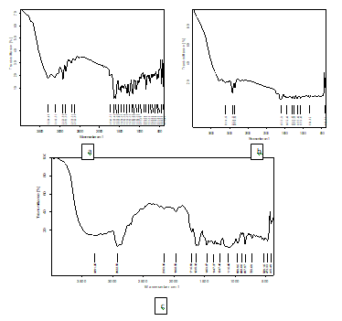

**Fig.1**FT-IR spectrum of (a) NRG, (b) NRG cubosomes, (c) physical mixture of NRG, RG cubosomes and Gellan gum, LBG

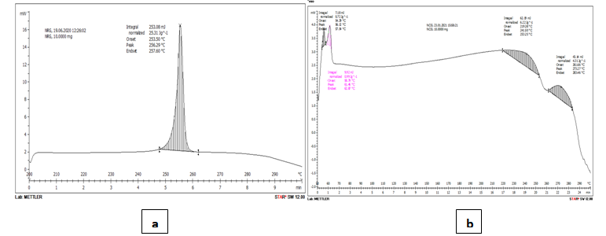

**Fig.2**DSC Thermogram of a) Pure drug NRG b) Physical mixture (NRG cubosomes+GG+LBG+PEG 6000)

**Experimental design**

As indicated in (Table 3), the three selected dependent variables exhibited varying distinctions across all 16 batches. By accounting for the coefficients magnitude and direction, polynomial equations were employed to draw the final conclusions.

**Table 3** Results of particle size, EE and t50%

|  |  |  |  |  |  |  |
| --- | --- | --- | --- | --- | --- | --- |
| **Formulation** | **X1:  Oleic acid** | **X2: Glycerol** | **X3: Poloxamer** | **Y1:Particle size**(mean±SD, n=3) | **Y2: Entrapment efficiency**(mean±SD, n=3) | **Y3: t50%** |
|  | %v/v | %v/v | %w/v | nm | % | H |
| NC1 | 2 | 1 | 1 | 917.7±5.64 | 34.44±4.72 | 8.5 |
| NC 2 | 2 | 4 | 1 | 983.9±6.43 | 28.02±5.92 | 7.5 |
| NC 3 | 3.5 | 2.5 | -0.02 | 1959.5±6.37 | 24.68±6.55 | 0 |
| NC 4 | 3.5 | 2.5 | 5.02 | 661±5.91 | 53.47±8.56 | 5.5 |
| NC 5 | 3.5 | 2.5 | 2.5 | 191±4.67 | 92.28±6.23 | 6 |
| NC 6 | 6.02 | 2.5 | 2.5 | 253.3±7.74 | 58.61±5.59 | 5 |
| NC 7 | 2 | 1 | 4 | 919±5.90 | 16.96±6.23 | 0 |
| NC 8 | 0.97 | 2.5 | 2.5 | 2085.7±6.49 | 28.02±5.97 | 0 |
| NC 9 | 3.5 | 2.5 | 2.5 | 191±7.40 | 92.28±5.23 | 6 |
| NC 10 | 3.5 | 5.02 | 2.5 | 684±5.59 | 42.42±4.41 | 6 |
| NC 11 | 5 | 1 | 1 | 1705.8±6.94 | 19.02±6.34 | 0 |
| NC 12 | 5 | 4 | 4 | 1551.5±7.39 | 46.53±4.01 | 0 |
| NC 13 | 2 | 4 | 4 | 1206.7±6.33 | 46.27±7.17 | 0 |
| NC 14 | 5 | 1 | 4 | 28.6±5.62 | 48.07±4.90 | 9 |
| NC 15 | 3.5 | -0.02 | 2.5 | 1450±5.85 | 26.73±5.72 | 0 |
| NC 16 | 5 | 4 | 1 | 641.1±6.01 | 26.22±6.23 | 10 |

0 in t50% implies that atleast half of the drug concentration does not release in 12 h

**Particle size (PS) and zeta potential (ZP):**

The results of the multiple regression analysis showed that there is a negative correlation between the response variable Y1 and the coefficients β1, β2, and β3. This implies that a decrease in particle size is caused by a rise in the amounts of lipid, surfactant, and copolymer. The fitted model for the response variable Y1 in respect to the transformation factor is shown in the following equation.

Y1==+199.01-544.78X1 -227.73X2 -386.05X3+13.04 X1X2-123.86 X1X3 +351.14X2X3 +293.60X12 +257.36 X22 +343.36X32 +295.76 X1X2X3+329.25 X12X2 +318.21X12X3 +532.24 X1X22

The cubosomes that were developed exhibit particle sizes (PS) ranging from 28.6 to 2085.7 nm. This range falls within the acceptable parameters for brain targeting. A strong correlation is observed with a high correlation coefficient (0.9761) between Y1 for all. The ANOVA analysis indicates that the concentration of lipid, surfactant, and copolymer significantly influences the PS, as evidenced by a low P value of 0.0009 (P<0.05). The inclusion of the polymeric surfactant, poloxamer 407, plays a crucial role in stabilizing cubosomes, effectively dispersing their crystalline structure, and providing steric stability to the system. Furthermore, a decrease in surface tension brought on by a rise in poloxamer concentration encourages the formation of cubosomes with smaller PS. When the concentration of GMO, a polar amphiphilic lipid, exceeds the critical micelle concentration (CMC), micelles form. Cubosomes, on the other hand, are formed when the GMO concentration exceeds this level. Increasing GMO concentration initially results in an increase in PS, but only up to a certain point, after which it levels off, as illustrated in(Fig. 3).

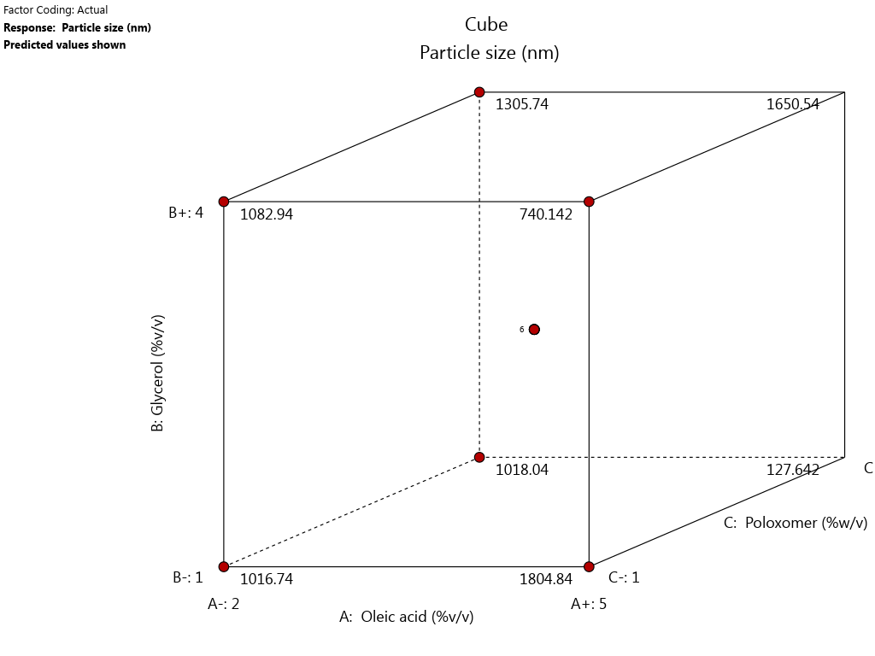

**Fig. 3** Cubic plot for the response Y1

The Zeta Potential (ZP) serves as an indicator of the stability of nanoparticles, reflecting their tendency to aggregate. The Polydispersity Index (PDI) measures the homogeneity of PS distribution, with higher values indicating greater variability (polydispersity) and lower values suggesting a more uniform distribution (monodispersity). An increase in ZP signifies a stronger repulsive force that prevents particle aggregation. In (Fig. 4), the optimized formulation demonstrates a PDI of 0.407 and a ZP of -17.6. These values indicate a low PDI and a high ZP, reflecting a state of reduced polydispersity and decreased particle aggregation.

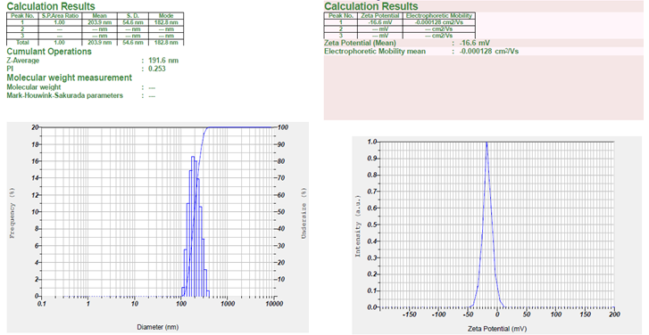

**Fig. 4** Particle size distribution & Zeta potential of optimized formulation of NRG cubosomes

**Entrapment efficiency (EE):**

The results of the multiple regression analysis showed that there is a positive association between the response Y2 and the coefficients β1, β2, and β3. This suggests that the EE rises in tandem with increases in GMO and poloxamer 407 concentrations. The simulated relationship between the transformation factor and the response Y2 is shown in the following equation.

Y2=92.36+9.09 X1+4.66 X2 +8.56 X3-2.51X1X2+6.07X1X3 +3.37X2X3 -17.85X12 -20.94 X22 -19.35X32 -5.56X1X2X3-1.10X12X2 -2.29X12X3 -7.33 X1X22

The correlation coefficient between the response Y2 and all the runs F1-F16 was 0.9987, indicating a strong relationship. The p-value for the variables is highly significant, with a value less than 0.0001. This suggests that each of the three factors, X1, X2, and X3, has a substantial influence on the response Y2. The impact of these factors on the response is visually evident in (Fig 5).

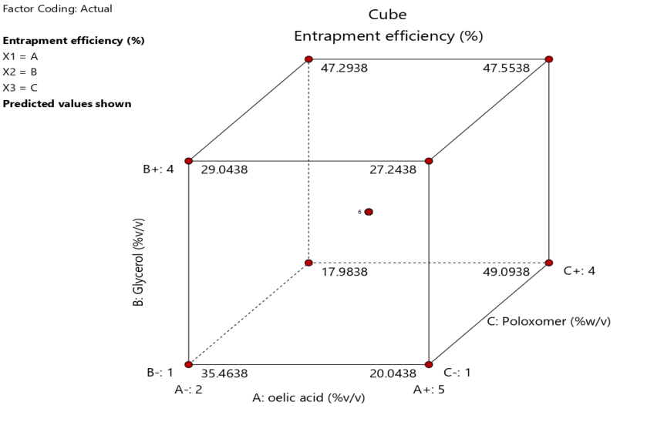

**Fig.5**Cubic plot for the response Y2

GMO, a lipid with both polar and amphiphilic properties, has the ability to independently form bicontinuous cubic structures in an aqueous environment. This resulting cubic structure exhibits a strong capacity to encase various drugs with differing molecular weights and polarities. The percentage of poloxamer had a significant influence on the encapsulation efficiency (EE%). The non-ionic triblock copolymer, poloxamer, possesses an HLB value of 22. In this particular design, poloxamerfulfils multiple roles, such as facilitating drug solubilization, providing stability to the cubosomes, and acting as a gelling agent. Poloxamer can enhance the water solubility of poorly soluble drugs and promote the entrapment of drugs within the water channels of cubosomes. Moreover, it can also serve to stabilize drug-containing cubosomes by forming a protective coating around them, potentially preventing the release of excessive energy.Top of Form

***In-vitro* drug release and T50%:**

The duration required for the drug concentration to decrease to 50% is referred to as t50%. The results of the multiple regression analysis for response Y3 indicated that all the coefficients β1, β2, and β3 displayed positive values. The equation below represents the derived formula for response Y3 in relation to the transformation factor.

Y3=5.94+1.49 X1+1.78 X2 +1.64 X3+0.25X1X2+1.88X1X3 -2.25X2X3 -0.85X12 -0.67 X22 -0.76X32 –2.50X1X2X3-1.78X12X2 -3.76X12X3 -1.11 X1X22

The correlation coefficient between the response variable Y3 and the runs F1-F16 was determined to be 0.9547. The P-value associated with the variables is 0.0053, indicating a significant influence of factors X1, X2, and X3 on the t50% parameter. Likewise, the drug release exhibits a parallel increase with higher concentrations of GMO, PF407, and EE. The cubic graphs depicted in (Fig.6) visually illustrate this connection.

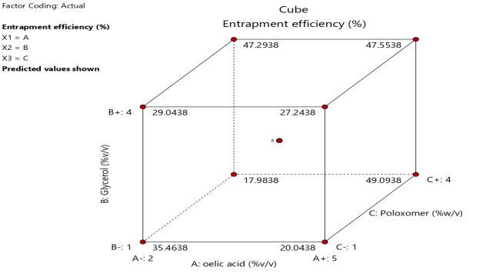

**Fig.6**Cubic plot for the response Y3

(Fig.7) illustrates the release of NRG from various cubosomal formulations. These formulations clearly demonstrate that NRG cubosomes can provide a more extensive release of NRG with better-controlled characteristics. This enhanced release is attributed to the presence of poloxamer on the cubosomal structure and the migration of the drug from the oil phase to the aqueous phase, resulting in a delayed and prolonged drug release. The amphiphilic copolymer PF407 acts as a pore-forming agent that enhances drug release. In the drug release studies, which extended up to 12 hours, the NC5 and NC9 formulations exhibited an approximately 78% NRG release.

**Fig.7**Drug release profile of NRG Cubosomes and pure drug

**Optimization:**

The desirability function played a pivotal role in advancing the formulation development process. In order to develop a formulation with the desired attributes, it was imperative to integrate the responses during the optimization of the formulation. The key characteristics sought in an efficient cubosomal formulation encompassed particle size within the range of 100-500 nm, achieving the utmost entrapment efficiency, and minimizing the time required for 50% drug release (t50%). The desirability function was employed to select the most favourable batch among the various cubosomal formulations. Remarkably, the formulation consists of 3.5% v/v oleic acid, 2.5% v/v glycerol, and 2.5% v/v poloxamer 407 exhibited the highest overall desirability score of 1.0. Consequently, the values of the independent variables in this particular batch were considered the optimal parameters for developing NRG cubosomes, rendering it the ultimate choice among all batches. Subsequently, the ideal formulation was devised, and it became evident that there was generally strong agreement between the predicted and observed values in each instance, as indicated by the low relative error values. This validation underscored the model's viability and confirmed the functionality of the reduced polynomial equation. Furthermore, it solidified the understanding of how oleic acid, glycerol, and poloxamer 407 influenced the dependent variables in the formulation.

**Shape analysis**

Phase contrast and TEM techniques were employed to assess the morphology of optimized cubosomes. In both (Fig.8, a, b) the morphology appears to range from cubic to spherical. However, upon drug loading, a noticeable change in both shape and texture becomes evident. Large-diameter particles exhibit uneven or irregular forms, whereas smaller diameter particles (less than 100nm) maintain a structure somewhat resembling cubic shapes. This preference for NRG, a hydrophobic drug, is to partition into the hydrophobic domain of the cubic phase. At low concentrations, the drug's molecule is believed to have a minimal impact on the lipid bilayer. As the drug dosage increases, the capacity for drug loading rises, and the molecule transitions from its normal cubic structure to a more spherical one. In (Fig.8 (b)), the particles display irregular structural boundaries and nearly spherical shapes without aggregation.Top of Form

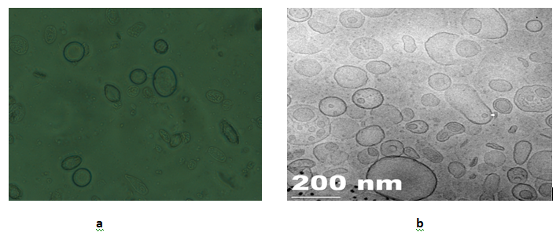

**Fig.8**a) Phase contrast image of NRG cubosomesb) TEM image of NRG cubosomes

**Evaluation of homogeneity, clarity, pH, gelation time, gel strength, Spreadability, viscosity and *in-vitro*mucoadhesive strength of NRG cubo*in-situ* gels**

The (Table 4) provides a comprehensive overview of the physicochemical characteristics of the NCGs. Notably, these gels NCG1 and NCG2 exhibit no coalescence in their sol form, maintained their structural integrity. The pH levels of both NCG1 and NCG2 gels fall within the range of 5.9 to 6.2, which is ideal for nasal application, ensuring comfort and compatibility with nasal mucosa. The gelation period for NCG1 is 9 seconds, while NCG2 takes 12 seconds to achieve gelation. This variation in gelation time is attributed to the interaction between the gum content and nasal secretions, with a noticeable increase in gelation time as the LBG content increases. This aspect is particularly significant in the development of *in-situ* nasal gels, as gel strength plays a pivotal role. Regarding gel strength, both NCG1 and NCG2 formulations demonstrate effective gel strength, enabling easy administration of droplets from their containers and extending the post-nasal drip. NCG1 exhibits a gel strength of 8 seconds, while NCG2 has a gel strength of 9 seconds. Furthermore, the spreadability of both formulations, measuring at 18.75±7.92 for NCG1 and 23.80±6.64 for NCG2, is favourable and conducive to extending the residence time. Viscosity was assessed in both the sol and gel states, revealing an increase in viscosity with higher gum concentrations in both states. In addition to these characteristics, both NCG1 and NCG2 display *in-vitro* mucoadhesive strengths of 3538.8±8.59 and 2722.2±7.77 dynes/cm2, respectively. Notably, the mucoadhesive strength increases with higher gum concentrations, indicating the formulation's ability to adhere effectively to mucosal surfaces.

**Table 4** Pysicochemical properties of NCGs

(mean±SD, n=3)

|  |  |  |
| --- | --- | --- |
| **Evaluation Parameter** | **Formulation** | |
| **NCG1** | **NCG2** |
| Homogeneity and clarity | Homogenate & clear | Homogenate & clear |
| pH Measurement | 6.2±6.49 | 5.9±5.53 |
| Gelation time (s) | 9±4.92 | 12±5.57 |
| Gel strength (s) | 8±6.91 | 9±7.79 |
| Syringeability | Pass | Pass |
| Spreadability (s) | 18.75±7.92 | 23.80±6.64 |
| Viscosity Studies (cps) |  |  |
| Sol | 34.17±5.17 | 51.62±4.17 |
| Gel | 142±4.41 | 174±3.19 |
| *In-vitro* Mucoadhesion Strength (dynes/cm2) | 2722.2±7.77 | 3538.8±8.59 |
| Drug content (%) | 84.34±4.32 | 79.61±5.01 |

***In-vitro*drug release and drug release kinetics of NCGs**

As depicted in (Fig.9), both formulations NCGs exhibited sustained drug release for up to 12 hours, with NCG1 achieving a release of 97.22% and NCG2 reaching 94.88%. Notably, NCG1 outperformed NCG2 in terms of drug release while maintaining a lower concentration of LBG. The challenge of achieving sustained drug release intensifies as the gum concentration increases. Both formulations follow to first-order kinetics with a diffusion model.

**Fig.9***In-vitro* drug release profile of NCGs

***Ex- vivo* study of NCGs**

The ex-vivo testing was conducted for both NCG1 and NCG2 formulations, revealing a slight variation in the CDR compared to the *in-vitro* results. As depicted in (Fig. 10), NCG1 exhibited a drug release of 91.47±5.17% after 12 hours, while NCG2 demonstrated a release of 82.09±4.58%. The apparent permeability coefficient (Papp) for NCG1 and NCG2 formulations was determined to be 0.023 and 0.021 cm/s, respectively.

**Fig.10** *Ex-vivo* drug release profile of NCGs

**Choosing the promised NCG formula**

After analyzing the previous *in-vitro* findings, the NCG1 formulation was chosen for the upcoming pharmacodynamic evaluations.

**Pharmacodynamic study**

In contrast to the control group with the disease, both treatment groups (1 and 2) exhibited a significantly quicker onset of seizures, as indicated by P<0.05, a finding that is explicitly presented in (Fig. 11). Notably, the nasal administration group showed a delayed onset of action when compared to the oral administration group, suggesting a targeted effect. The duration of seizure activity was noticeably shorter in the treatment groups (P<0.05). Furthermore, it is worth noting that the nasal group exhibited a shorter duration of effect compared to the oral group, indicating its specificity for the intended site of action.

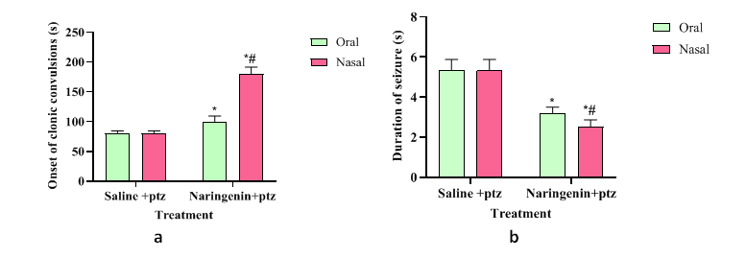* p <0.05 compared to diseased control, # p <0.05 compared to treatment 1 (pure drug 50 mg/kg/oral.)

**Fig. 11** Effect of NRG suspension and NCG on PTZ induced a) onset of seizures b) duration of seizures in rats

**Stability study**

The enhanced NCG formulation underwent for stability testing, and the findings from these stability studies can be found in (Table 5)**.** The results indicated that there have been minimal alterations in parameters such as clarity, gelation time, pH, PS, drug content, and drug release. Notably, the formulation's zeta potential measured at -16.6, indicating its stability as particle aggregation is absent. In conclusion, based on this NCG stability study, the formulation showed good stability for a period of upto six months.

**Table 5** Stability study data of NCG

|  |  |  |  |
| --- | --- | --- | --- |
| **Stability study of NCG at accelerated condition (25±2oC, 60±5% RH)** | | | |
| **Parameter** | **Initial** | **3 Months** | **6 Months** |
| Clarity | Clear | Clear | Clear |
| Gelation time (S)  pH | 7±3.7  6.1±4.2 | 7±5.3  6.1±3.36 | 7.5±1.04  6.2±2.73 |
| Particle size (nm)  Drug content (%) | 196±6.93  82.6±5.92 | 196.5±5.38  82.2±5.37 | 199±5.02  81.6±3.96 |
| Drug release at 12th h (%) | 92.9±6.42 | 92.47±5.39 | 92.34±4.01 |
| **Stability study of NCG *in-situ* gel under refrigeration (2-8oC)** | | | |
| Gelation time (S)  pH  Particle size (nm) | 7±3.7  6.1±4.2  192.5±6.93 | 7±0.97  6.1±2.20  192±2.28 | 7±0.95  6.1±1.97  194.6±3.56 |
| Drug content (%) | 82.6±5.92 | 82.4±3.04 | 82.12±2.95 |
| Drug release at 12th h (%) | 92.9±6.42 | 92.6±3.74 | 92.2±3.94 |

**References**

1. Nabeshima, S., Reese, T. S., Landis, D. M., & Brightman, M. W (1975) Junctions in the meninges and marginal glia. *Journal of comparative neurology*, *164*(2):127-169.

[**https://doi.org/10.1002/cne.901640202**](https://doi.org/10.1002/cne.901640202)

1. Acharya, S. P., Pundarikakshudu, K., Panchal, A., & Lalwani, A (2013) Preparation and evaluation of transnasal microemulsion of carbamazepine. *Asian Journal of Pharmaceutical Sciences*, *8*(1):64-70.

<https://doi.org/10.1016/j.ajps.2013.07.008>

1. Liang, L. P., & Patel, M (2006) Seizure-induced changes in mitochondrial redox status. *Free Radical Biology and Medicine*, *40*(2):316-322. <https://doi.org/10.1016/j.freeradbiomed.2005.08.026>
2. Gabathuler, R (2010) Approaches to transport therapeutic drugs across the blood–brain barrier to treat brain diseases. *Neurobiology of disease*, *37*(1):48-57. <https://doi.org/10.1016/j.nbd.2009.07.028>
3. Lee, Y. S., & Reidenberg, M. M (1998) A method for measuring naringenin in biological fluids and its disposition from grapefruit juice by man. *Pharmacology*, *56*(6):314-317. <https://doi.org/10.1159/000028215>
4. Renugadevi, J., & Prabu, S. M (2009) Naringenin protects against cadmium-induced oxidative renal dysfunction in rats. *Toxicology*, *256*(1-2):128-134. <https://doi.org/10.1016/j.tox.2008.11.012>
5. HL, M (2000) Radical scavenging by dietary flavonoids. A kinetic study of antioxidant efficiencies. *Eur Food Res Technol*, *211*:240-246.
6. Muthaiah, V. P. K., Venkitasamy, L., Michael, F. M., Chandrasekar, K., & Venkatachalam, S (2013) Neuroprotective role of naringenin on carbaryl induced neurotoxicity in mouse neuroblastoma cells. *Journal of pharmacology & pharmacotherapeutics*, *4*(3):192. [10.4103/0976-500X.114599](https://doi.org/10.4103%2F0976-500X.114599)
7. Yu, J., Wang, L., Walzem, R. L., Miller, E. G., Pike, L. M., & Patil, B. S (2005) Antioxidant activity of citrus limonoids, flavonoids, and coumarins. *Journal of agricultural and food chemistry*, *53*(6):2009-2014. <https://doi.org/10.1021/jf0484632>
8. Chhajed, S., Sangale, S., & Barhate, S. D (2011) Advantageous nasal drug delivery system: a review. *International Journal of Pharmaceutical Sciences and Research*, *2*(6):1322.
9. Kaur, S. D., Singh, G., Singh, G., Singhal, K., Kant, S., & Bedi, N (2021) Cubosomes as potential nanocarrier for drug delivery: a comprehensive review. *Journal of pharmaceutical research international*, *33*(31B):118-135. <https://doi.org/10.9734/jpri/2021/v33i31B31698>
10. Alam, P., Shakeel, F., Foudah, A. I., Alshehri, S., Salfi, R., Alqarni, M. H., & Aljarba, T. M (2022) Central composite design (CCD) for the Optimisation of Ethosomal Gel Formulation of Punica granatum extract: in vitro and in vivo evaluations. *Gels*, *8*(8):511. [**https://doi.org/10.3390/gels8080511**](https://doi.org/10.3390/gels8080511)
11. Robinson, J., & Eriksen, S. P (1966) Theoretical formulation of sustained‐release dosage forms. *Journal of pharmaceutical sciences*, *55*(11):1254-1263.

[**https://doi.org/10.1002/jps.2600551118**](https://doi.org/10.1002/jps.2600551118)

1. Kurangi, B., Jalalpure, S., & Jagwani, S (2021) Formulation and evaluation of resveratrol loaded cubosomal nanoformulation for topical delivery. *Current Drug Delivery*, *18*(5):607-619. <https://doi.org/10.2174/1567201817666200902150646>
2. Desai, G. N., Dandagi, P. M., & Kazi, T. M (2023) Nanosized intranasal delivery of novel self-assembled cubic liquid crystals: formulation and evaluation. *Journal of Pharmaceutical Innovation*, *18*(3):934-951.
3. Hosny, K. M (2020) Nanosized cubosomal thermogelling dispersion loaded with saquinavir mesylate to improve its bioavailability: preparation, optimization, in vitro and in vivo evaluation. *International journal of nanomedicine*, 5113-5129.
4. Wu, H., Li, J., Zhang, Q., Yan, X., Guo, L., Gao, X., ... & Chen, H (2012) A novel small Odorranalectin-bearing cubosomes: preparation, brain delivery and pharmacodynamic study on amyloid-β25–35-treated rats following intranasal administration. *European journal of pharmaceutics and biopharmaceutics*, *80*(2):368-378. <https://doi.org/10.1016/j.ejpb.2011.10.012>
5. Nasr, M., Younes, H., & Abdel-Rashid, R. S (2020) Formulation and evaluation of cubosomes containing colchicine for transdermal delivery. *Drug delivery and translational research*, *10*:1302-1313.
6. Raval, M., & Bagada, H (2021) Formulation and evaluation of cyclodextrin-based thermosensitive in situ gel of azithromycin for periodontal delivery. *Journal of Pharmaceutical Innovation*, *16*:67-84.
7. Hosny, K. M., & Banjar, Z. M (2013) The formulation of a nasal nanoemulsion zaleplon in situ gel for the treatment of insomnia. *Expert opinion on drug delivery*, *10*(8):1033-1041. <https://doi.org/10.1517/17425247.2013.812069>
8. Mahajan, Hitendra S (2012) Thermally reversible xyloglucan gels as vehicles for nasal drug delivery. Drug Delivery 19.5:270-276
9. Garala, K., Joshi, P., Shah, M., Ramkishan, A., & Patel, J (2013) Formulation and evaluation of periodontal in situ gel. *International journal of pharmaceutical investigation*, *3*(1):29.

[10.4103/2230-973X.108961](https://doi.org/10.4103%2F2230-973X.108961)

1. Harish, N. M., Prabhu, P., Charyulu, R. N., Gulzar, M. A., & Subrahmanyam, E. V. S (2009) Formulation and evaluation of in situ gels containing clotrimazole for oral candidiasis. *Indian Journal of Pharmaceutical Sci.* [10.4103/0250-474X.57291](https://doi.org/10.4103%2F0250-474X.57291)
2. Chen, Y., He, X., Sun, Q., Fang, Z., & Zhou, L (2017) Effect of lamotrigine on seizure development in a rat pentylenetetrazole kindling model. *Brain and Behavior*, *7*(7):e00727.

[**https://doi.org/10.1002/brb3.727**](https://doi.org/10.1002/brb3.727)

1. González-González, O., Ramirez, I. O., Ramirez, B. I., O’Connell, P., Ballesteros, M. P., Torrado, J. J., & Serrano, D. R (2022) Drug stability: ICH versus accelerated predictive stability studies. *Pharmaceutics*, *14*(11):2324. [**https://doi.org/10.3390/pharmaceutics14112324**](https://doi.org/10.3390/pharmaceutics14112324)