**DEVELOPMENT OF EFFECTIVE DIETARY INTERVENTIONS FOR PROMOTING HEALTHY AGING AND RELATED DISEASES: A BRIEF OVERVIEW**

**ABSTRACT**

Attention-Deficit/Hyperactivity Disorder (ADHD) is a prevalent neurodevelopmental condition characterized by persistent patterns of inattention, hyperactivity, and impulsivity that interfere with functioning or development. Affecting approximately 5–7% of children and 2.5% of adults worldwide, ADHD is associated with significant academic, occupational, and social impairments. Although the disorder typically manifests in childhood, it often persists into adolescence and adulthood, with varying symptom presentation across the lifespan.

**KEYWORDS**:-

Attention-Deficit/Hyperactivity Disorder , Cognitive Function , Dietary Interventions, Healthy Aging, Neurodevelopmental Disorders, Nutritional Supplements, Mild Cognitive Impairment, Oppositional Defiant Disorder, Executive Function, Neuroinflammation, Psychopharmacology, Herbal Medicine

**INTRODUCTION**

Attention hyperactivity disorder (ADHD) is a psychiatric condition that has long been recognized as affecting children’s ability to function. Individuals suffering from this disorder show patterns of developmentally inappropriate levels of inattentiveness, hyperactivity, or impulsivity. Although there used to be two different diagnoses of Attention Deficit Disorder vs. Attention Deficit Hyperactivity Disorder, the DSM IV combined this into one disorder with three subtypes: predominantly inattentive, predominantly hyperactive, or combined type.

The symptoms begin at a young age and usually include lack of attention, lack of concentration, disorganization, difficulty completing tasks, being forgetful, and losing things. These symptoms should be present before the age of 12, have lasted six months, and interfere with daily life activities in order to be labelled as ‘ADHD.’ This must be present in more than one setting (i.e., at home, school, or after-school activities).

ADHD must be considered within the context of what is developmentally and culturally appropriate for a person. It is considered a dysfunction of executive functioning, predominantly a frontal lobe activity. Therefore, patients with ADHD show disability not only in attention and focus but also in decision making and emotional regulation. Children with ADHD can have difficulty with social interactions, can be easily frustrated, and can be impulsive. They are often labelled as “troublemakers.”

Fig 1- Evidence of inflammation in ADHD

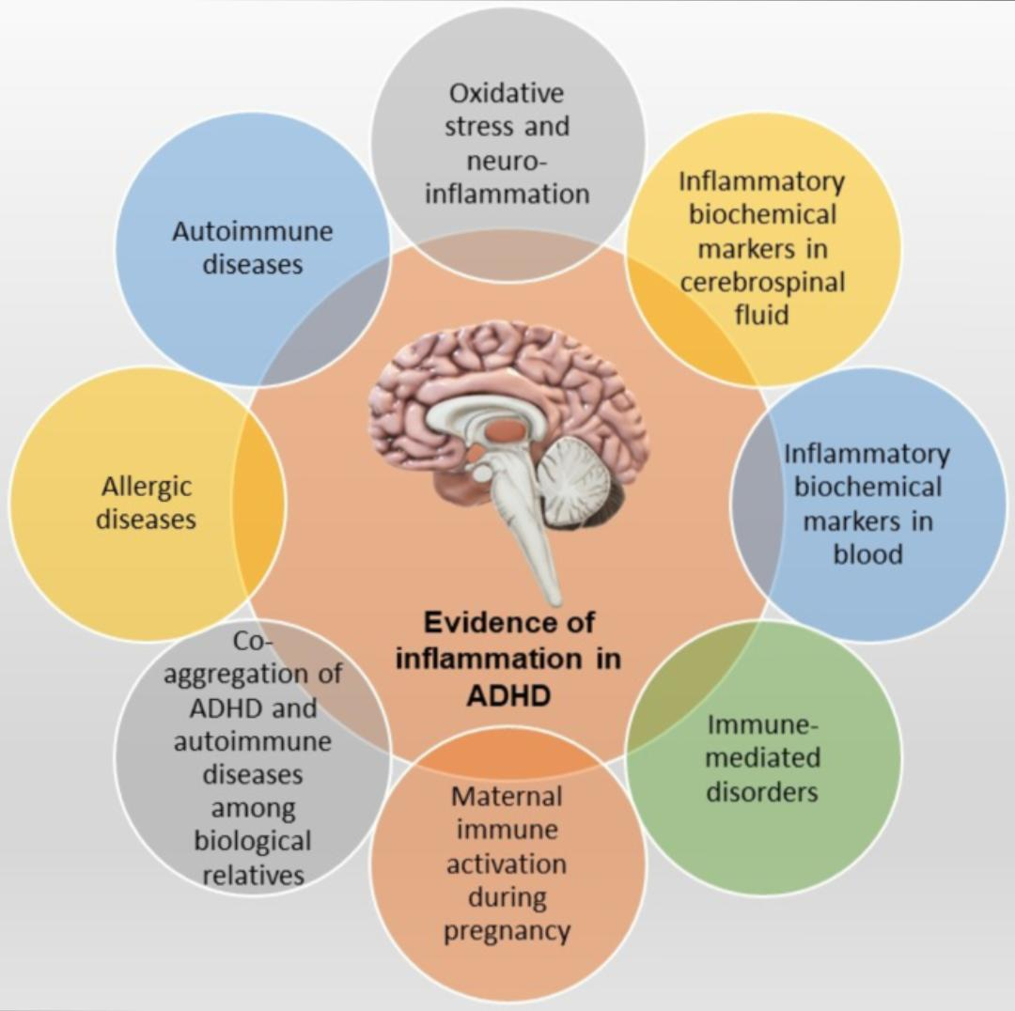ADHD is not a new condition and has been called different names throughout history. It was labelled as ‘minimal brain dysfunction’ in the 1930s and has ever since changed names to ADD and ADHD, respectively.[1] Its prevalence has increased over time, with a seeming spike in the 1950s as school became more standardized for children.

DSM 5: Types of ADHD

• Predominantly inattentive

• Predominantly impulsive or hyperactive

• Combination of the above

• The onset is usually before age 12

• Symptoms present at school, work, or home

• The disturbance causes significant impairment in social, occupational, and academic functioning.

• The disorder is not accounted for by any other behaviour disorder.

**ETIOLOGY**

The Etiology of ADHD is related to a variety of factors that include both a genetic and an environmental component. It is one of the most heritable conditions in terms of psychiatric disorders. There is a much greater concordance in monozygotic twins than dizygotic. Siblings have twice the risk of having ADHD than the general population. Similarly, viral infections, smoking during pregnancy, nutritional deficiency, and alcohol exposure in the fetes have also been explored as possible causes of the disorder. There are no consistent findings on brain imaging of patients with ADHD. The number of dopaminergic receptors has also been implicated in the development of the disorder, whereby research has shown that the receptors are decreased in the frontal lobes in individuals with ADHD.[3][1] There is also evidence for the role of noradrenergic receptor involvement in ADHD.

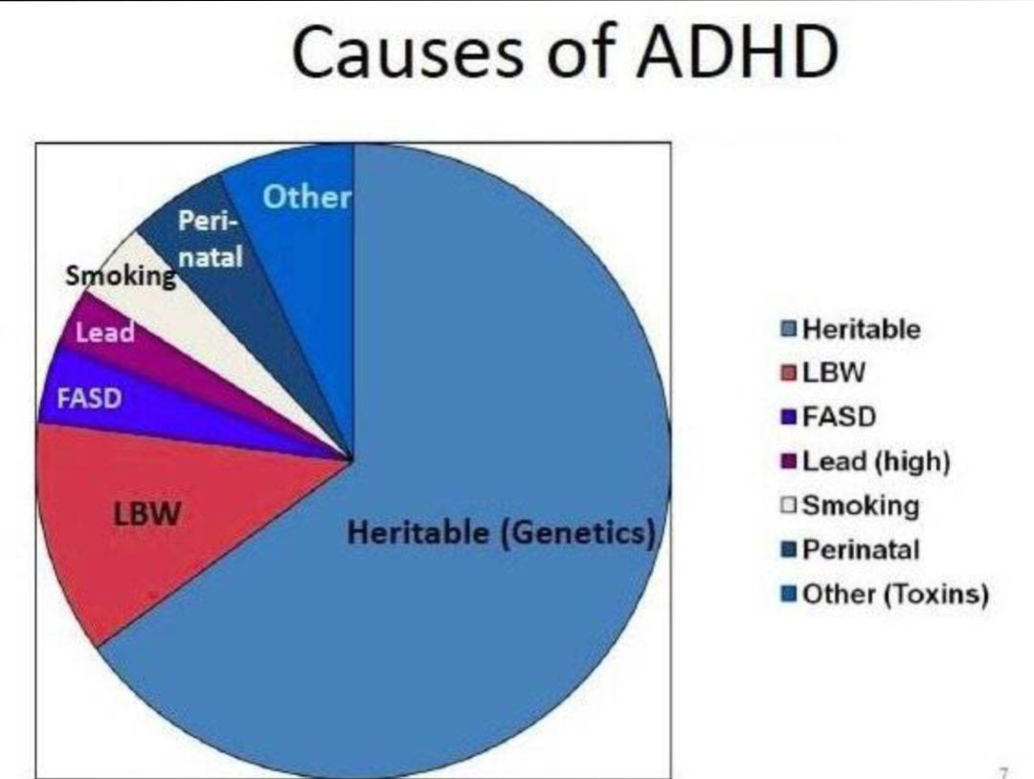

**Fig 2- causes of ADHD**

**EPIDEMIOLOGY**

The subtypes of attention deficit disorders are found to have different rates of prevalence in a group of individuals suffering from the disorders. It is found that the inattentive subtype is prevalent in about 18.3% of the total patients, while hyperactive/impulsive and combined represent 8.3% and 70%, respectively. It is also found that the inattentive subtype is more common among the female population. The disorders (collectively) are found in a 2:1 male-to-female ratio as per different research.[4] It is prevalent in around 3%-6% of the adult population.[5] It is one of the most prevalent disorders found in childhood. There is some evidence that ADHD is more prevalent in the United States than in other developed countries.

**PATHOPHYSIOLOGY**

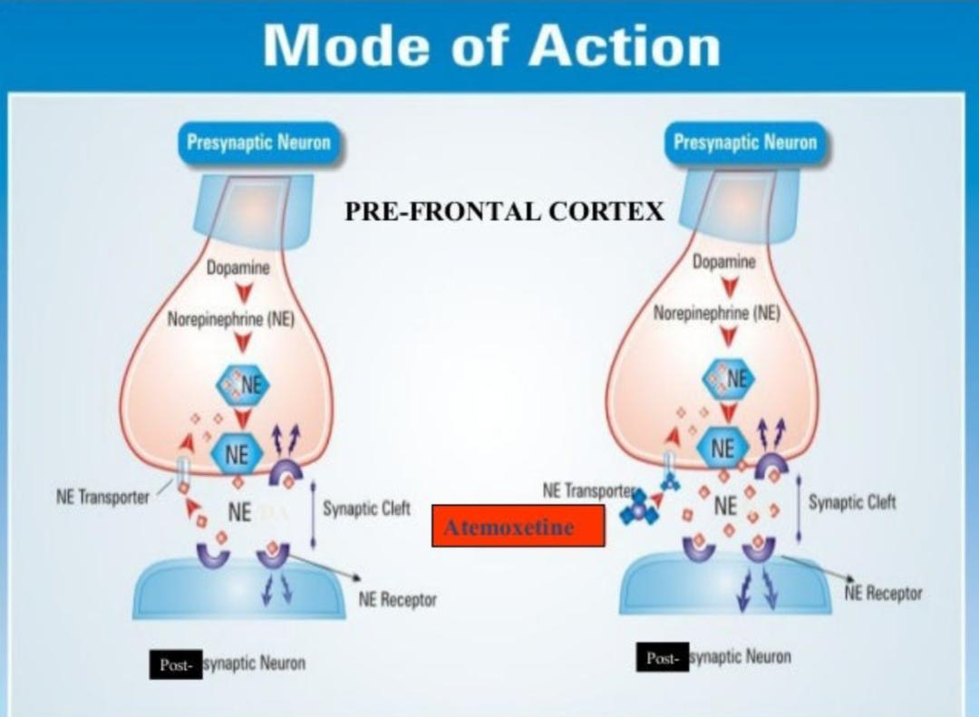

Fig 3- Mode of action

ADHD is associated with cognitive and functional deficits that relate to diffuse abnormalities in the brain. The anterior cingulate gyrus and dorsolateral prefrontal cortex (DLFPC) are found to be small in individuals who are suffering from ADHD. It is thought that these changes account for the deficits in goal-directed behaviour. Moreover, activity in the front striatal region is also reduced in these individuals as measured by fMRI. It is important to understand these pathophysiological mechanisms so that pharmacotherapy is directed toward them.[6] It is important to remember that ADHD is a clinical diagnosis. There are no standard laboratory or imaging results among patients with ADHD.

**TREATMENT**

Pharmacological therapy remains the mainstay of treatment for patients who have ADHD. It is divided into two major categories, which fall into stimulants or non-stimulants. Stimulants are further broken into amphetamines and methylphenidates. Both types of stimulants block the reuptake of dopamine at the presynaptic membranes and postsynaptic membranes. Amphetamines also directly release dopamine. Stimulants are the mainstay of treatment for ADHD. They are effective in about 70% of patients. There is a number needed to treat of There are multiple formulations of each subtype of stimulant, including immediate-release and extended-release, long-acting, or sustained release. Side effects of stimulants include changes in blood pressure, decreased appetite and sleep, and risk of dependency. However, there is an increased risk of substance use in patients with ADHD, and studies show treating with a stimulant decreases their overall lifetime risk of substance abuse. Because stimulants are controlled substances, providers often are hesitant to use them. However, repeated evidence has shown how imperative it is to try stimulants in ADHD.

There have been concerns regarding stimulant use in patients with seizures. However, recent studies showed that stimulant use for ADHD is safe in epilepsy.[7 , 8]

There can be an increase in the frequency of tics in patients with ADHD and Tic disorders. Adding alpha agonists may help to reduce tics.[2]

Of the non-stimulant option, there are also two types: antidepressants and alpha agonists. Within the antidepressant category, atomoxetine is the best known and works as a selective norepinephrine reuptake inhibitor. It is known to be effective in many trials as a treatment option for ADHD, though not nearly as effective as stimulants. It also has minimal antidepressant effects. It is often used in children who don’t tolerate stimulants or have anxiety. Other antidepressants include bupropion, which targets dopamine and norepinephrine, and TCAs, which are the last-choice options. These work by targeting norepinephrine.

Lastly, alpha agonists such as clonidine and guanfacine can be used as an effective treatment for ADHD. However, these are associated with multiple cardiovascular effects like lowering blood pressure, sedation (clonidine more than guanfacine), weight gain, dizziness, etc. They are found to be more effective in younger children than adults.[6]

Psychosocial treatment is the other form of treatment that is used for individuals suffering from the disorder. This form of treatment includes psycho-education for the family and patient and cognitive-behavioural training programs designed specifically for the patient to achieve short and long-term goals. Research has found that these training programs prove to be very effective when used along with pharmacotherapy. However, unlike other psychiatric disorders, there is strong evidence for medication management without therapy as being the most efficacious.[9][10][11]

The FDA has just approved the trigeminal nerve stimulation system for children not on medications. The device generates a low-level electrical pulse, which suppresses hyperactivity.

**RELATED DISEASES:**

1. **OPPOSITIONAL DEFIANT DISORDER**

Oppositional defiant disorder is a type of disruptive behavior disorder that primarily involves difficulties with managing emotions and behaviors. This condition is most often diagnosed and treated in childhood, but it may also be detected in adults.[12]

**ETIOLOGY**:

The exact etiology of oppositional defiant disorder is complex and likely results from an interplay between genetic, environmental, and psychosocial factors. Several models of oppositional defiant disorder exist, with 2 of the most prominent outlined in the DSM-5-TR.

**Bifactor model**: Irritable and defiant/headIrritable [13]

**Trifactor model**: Irritable, defiant/headstrong, and vindictive/hurtful [14]

**EPIDEMIOLOGY**:

According to the DSM-5-TR, the prevalence of oppositional defiant disorder is 3.3%. In the literature, the prevalence of oppositional defiant disorder in children and adolescents is between 28% and 65% in clinical samples and 2.6% and 15.6% in community samples.[15] Most community sample estimates range between 3% and 6%, and this rate does not vary greatly internationally. The variance in prevalence between nations was found to be related to methodological differences. The data for adult populations are severely limited. The relative risk of developing oppositional defiant disorder in male individuals compared to female individuals is roughly 1.6.[16] However, studies on whether this gender difference persists into late childhood have produced conflicting results. Notably, the prevalence of oppositional defiant disorder tends to decrease with age.

**PATHOPHYSIOLOGY**

Deficits in punishment processing and reward sensitivity have been identified in disruptive behaviour disorders such as oppositional defiant disorder and conduct disorder, correlating with skin conductance and mediated by autonomic nervous system functioning. The deficit in punishment processing is linked to a lack of fear conditioning, which may be associated with problems in serotonin, norepinephrine, and cortisol functioning. Studies indicate that male patients with disruptive behavioural disorders have low basal cortisol. In contrast, research shows mixed findings for either increased or decreased basal cortisol in female individuals with oppositional defiant disorder. These changes may be due to repeated exposures to stress, given the environmental risk factors for the condition.

Poor punishment sensitivity leads to response perseveration and problems with set switching, with weak evidence for deficits in other cool executive functions.[17] Patients with oppositional defiant disorder also have difficulty recognizing anger in other people’s faces. Poor early-life fear conditioning predicts later aggression and criminal behaviour.

**TREATMENT**

Treatment for oppositional defiant disorder is multimodal and should involve the patient, family, school, and community. Healthcare professionals should identify and treat comorbidities and modifiable risk factors, such as bullying and parenting techniques. Patients should be assessed regularly for depression, anxiety, and substance use, as patients with oppositional defiant disorder are predisposed to developing these conditions. Treatment modalities include parent management training (PMT), school-based interventions, individual child therapy, and family therapy.

1. **MILD** **COGNITIVE** **IMPAIRMENT**

Memory loss is a common complaint among older adults, and cognitive decline can present in various ways. It is a part of the normal aging process, subjective cognitive impairment (symptomatic complaints with normal neurocognitive test results), mild cognitive impairment, or dementia.

Fig 4.Mild Cognitive Impairment

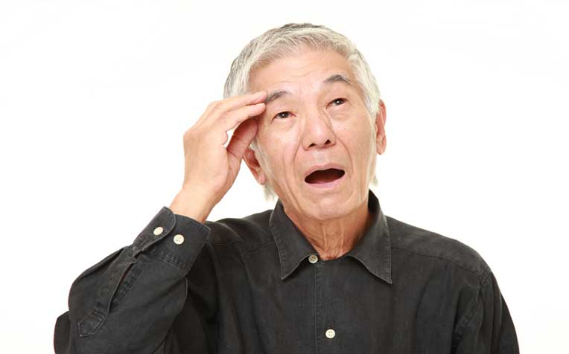**ETIOLOGY**

Advancing age is the strongest risk factor for MCI. Other risk factors include male sex, family history of cognitive impairment, and the presence of the Apo lipoprotein E (APOE) allele.[18] The APOE ε4 allele is the most frequent genetic risk factor associated with the progression of MCI to Alzheimer dementia. Some studies have reported an increased risk of progression to Alzheimer dementia in both carriers and homozygotes for APOE ε4 allele, while other studies have not found any association. Hence, the clinical utility of using the APOE genotype is limited.[19]

**PATHOPHYSIOLOGY**

In have several outcomes, with the most important being the progression to dementia. Other cases may revert to normal or remain stable in the MCI stage.

A meta-analysis demonstrated that the cumulative incidence of dementia development was 14.9% for MCI patients older than 65 years who were followed for 2 years. The relative risk for all types of dementia was 3.3 at 2 to 5 years in a cohort of MCI patients and age-matched controls, while the relative risk for the development of Alzheimer Disease was 3.0. People with MCI are at a higher risk of progressing to dementia than age-matched controls. The annual progression rate can be 12% in the general population and up to 20% in high-risk populations.[19] The risk factors for the development of MCI are not consistently associated with progression to dementia. Markers of cerebral dysfunction and those indicating the severity of underlying pathology are more consistently related to the risk of progressing to dementia.[20] More significant functional impairment, neuropsychiatric symptoms at the time of MCI diagnosis, lower neuropsychological test scores, and abnormalities on structural magnetic resonance imaging (hippocampal atrophy) are associated with a greater risk of conversion to dementia.[20]

**TREATMENT**

Treatment of reversible causes should be prioritized; conditions such as OSA, depression, hypothyroidism, vitamin deficiency, and polypharmacy are easily treated and may lead to the reversal of cognitive impairment. Vascular risk factors such as hyperlipidemia, hypertension, diabetes mellitus, atrial fibrillation, and tobacco and alcohol use should be addressed to slow down ischemic damage.

Currently, there are no FDA-approved agents for the treatment of MCI. Several pharmacological agents have been studied for efficacy in treating MCI. These include acetylcholine esterase inhibitors donepezil, galantamine, and rivastigmine, homocysteine-lowering B vitamins, flavonoid-containing drinks, vitamin E, vitamin C, transdermal nicotine patch, piribedil, rofecoxib, tesamorelin injections

**DIETARY SUPPLEMENTS**

1. **Ashwagandha** : Ashwagandha (Withania somnifera), also known as Indian ginseng or winter cherry, is a prominent herb in Ayurvedic medicine. Ashwagandha has antioxidant properties. It contains several bioactive compounds, including withanolides, alkaloids, and sitoindosides,

Fig 5- Ashwagandha (*Withania somnifera*)

**Dosage**: 300-600 mg/day

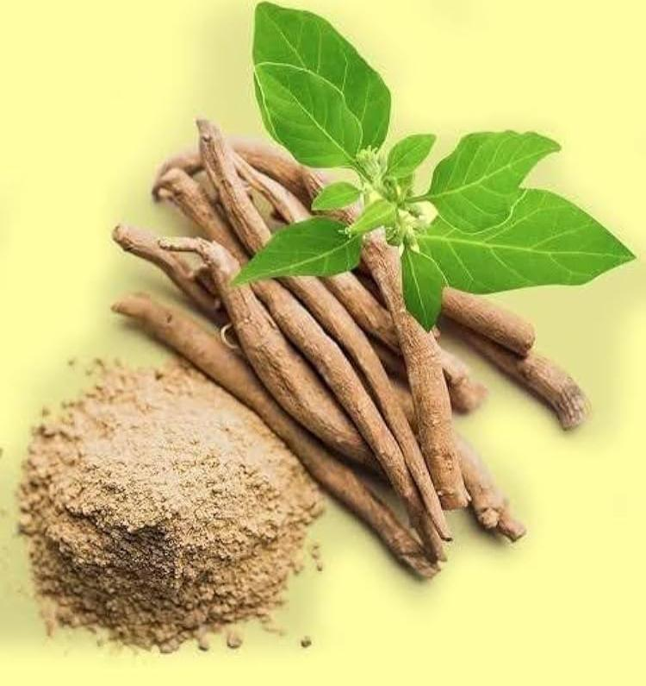**Benefit**: Reduces stress hormones (cortisol), promotes calmness

**Possible side effects**: drowsiness, GI upset, or allergic reactions.

Not recommended for pregnant women, people with autoimmune diseases, or those on certain medications unless advised by a doctor.

**Note**: Use root extract (KSM-66 or Sensoril): safe for long-term use

**Brand name**:-Dr. Botanical Health Ashwagandha

**B. Passionflower**: Passionflower (genus Passiflora) is a plant known for its calming effects, commonly used in traditional medicine and modern herbal supplements. The most frequently used species for medicinal purposes is Passiflora incarnata. It has an antioxidant properties .

Fig 6- Passionflower (genus Passiflora)

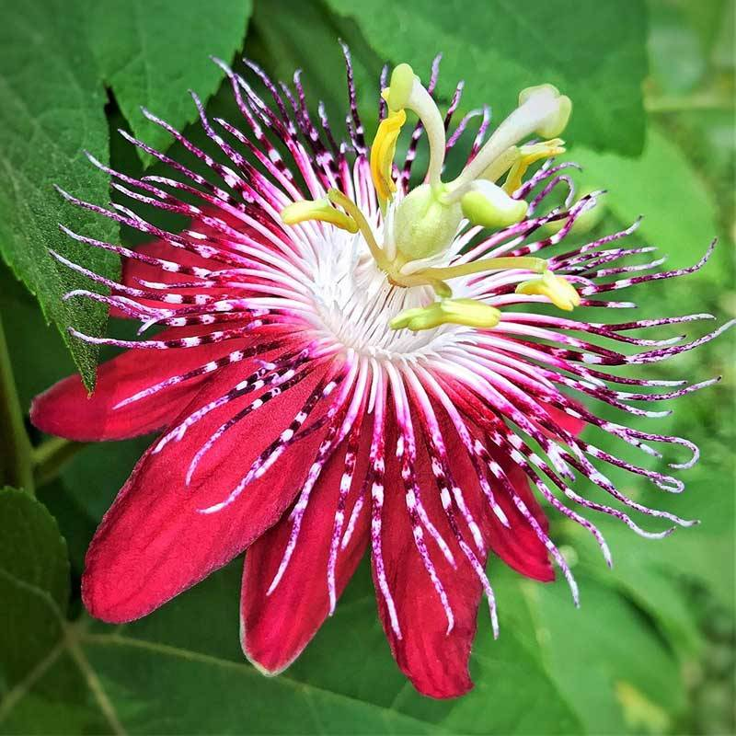**Dosage**: 250-500 mg/day

**Benefit**: Calms the nervous system, reduces restlessness

**Interactions**: Chamomile may interact with blood thinners (e.g., warfarin) due to its mild anticoagulant effects.

**Note**: Often used in tea or capsules; may be mildly sedative

**Brand name**-Nature’s Way Passionflower

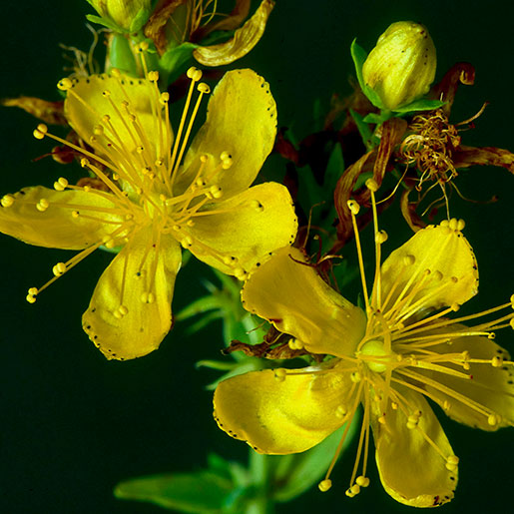

**Fig 7-:** St. John’s Wort (*Hypericum perforatum*)

**C.St. John’s Wort**: St. John’s Wort (Hypericum perforatum) is a flowering plant widely used in herbal medicine, primarily for its

antidepressant and neuroprotective effects.

**Dosage**: 300 mg three times/day

**Benefit**: Improves mood by increasing serotonin levels

**Note**: Standardized to 0.3% hypericin; interacts with many medications

**Brand name**:-Blossom Nature’s St. John’s Wort

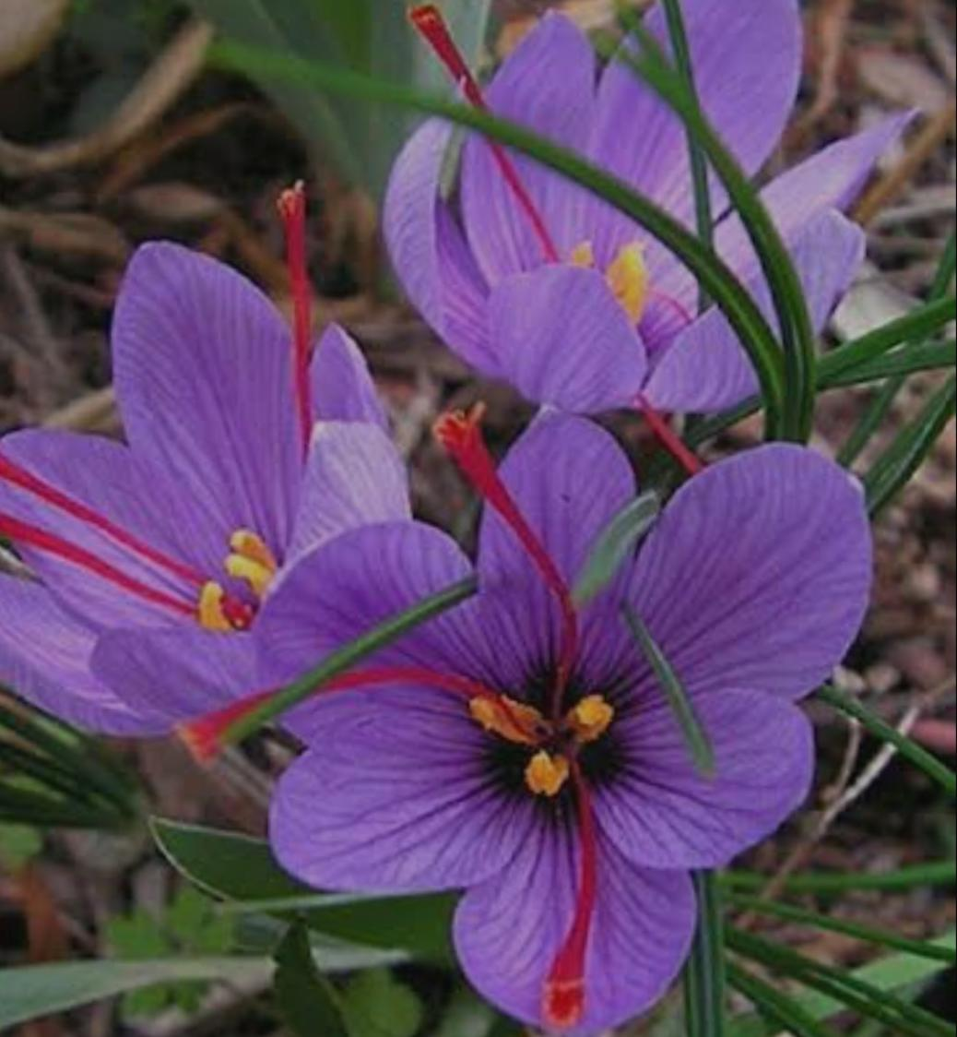

**Fig 8-** Saffron (*Crocus sativus*)

**D. Saffron**: Saffron (Crocus sativus) is a well-known spice with a rich history in culinary and medicinal uses. It is valued for its antioxidant, anti-inflammatory, and neuroprotective properties.

**Dosage**: 30 mg/day (15 mg twice daily)

**Benefit**: Enhances mood and emotional balance

**Note**: Use standardized extract; results seen in 4-6 weeks

**Brand name**: himaliyan Elevation and Zaffrus

Omega-3 (from flaxseed oil)

**Dosage**: 1000-2000 mg/day (ALA form)

**Benefit**: Improves mood regulation and reduces aggression

**Note**: Plant-based omega-3 (ALA) helps support brain function

**Brand name:**- TrueBasics Omega-3, WOW Life Science

**E. Ginkgo Biloba:** Ginkgo biloba is one of the most well-researched medicinal plants, traditionally used to enhance cognitive function and circulation. It also exhibits antioxidant and anti-inflammatory properties that contribute to its neuroprotective and therapeutic effects

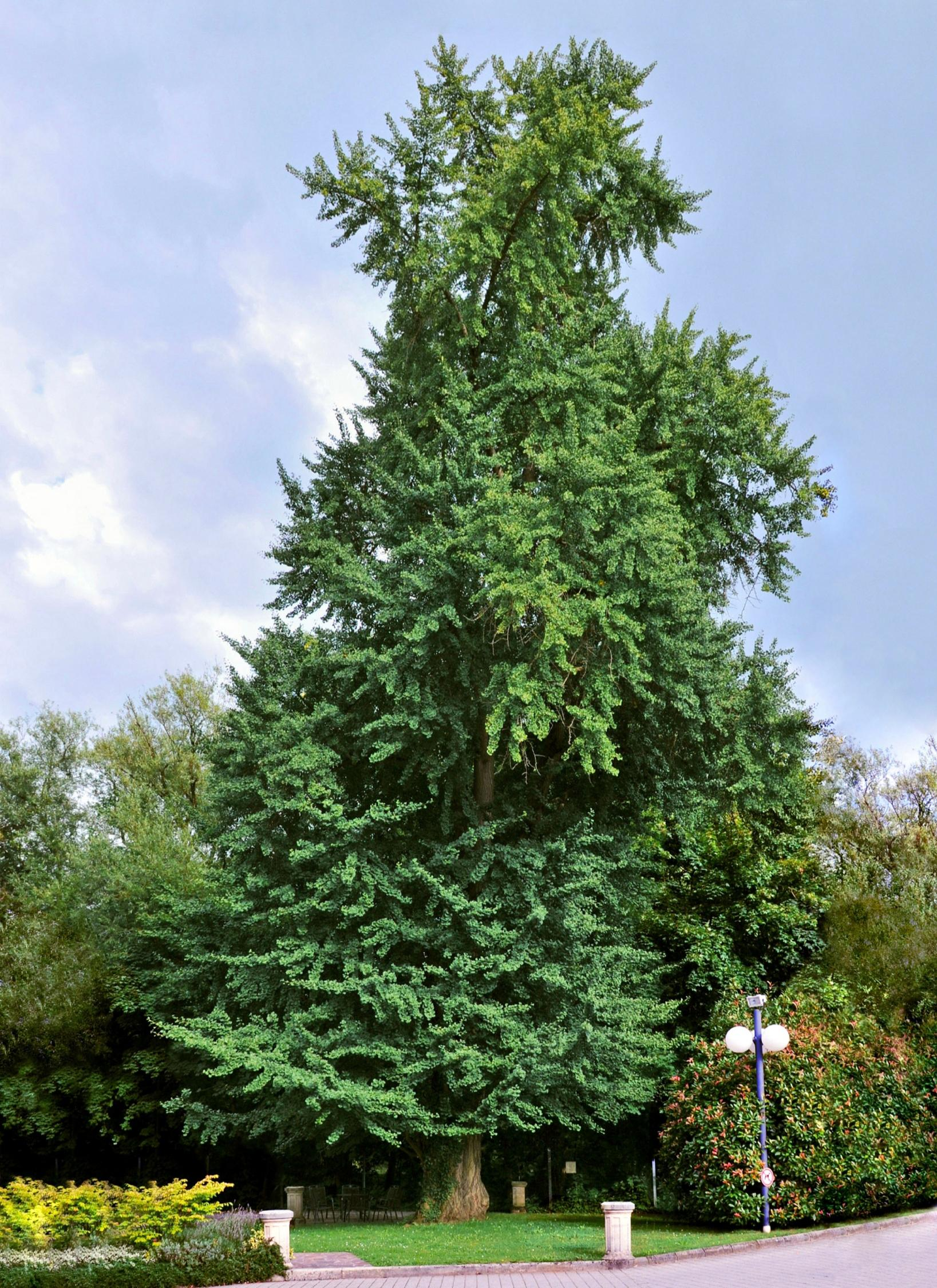

**Fig 9-** Ginkgo Biloba

**Dosage**: 120-240 mg/day

**Benefit**: Enhances cognitive function and behavioral control

**Note**: Use extract with 24% flavone glycosides

**Brand name:-**Himalaya Ginkgo, Ginkgold

**F. Chamomile** : Chamomile (Matricaria chamomilla or Chamaemelum nobile) is a widely used herb with a long history in traditional medicine, known for its calming, anti-inflammatory, and antioxidant properties.



**Fig 10-** **Chamomile (*Matricaria chamomilla*)**

**Dosage**: 300-500 mg/day (or 2-3 cups of tea)

**Benefit**: Calms agitation and supports emotional regulation

**Note**: Useful for anxiety-linked behavioral outbursts

**CONCLUSION**:

The intersection of Attention-Deficit/Hyperactivity Disorder (ADHD) and aging is an emerging field of interest, especially as more individuals are now being diagnosed and living with ADHD well into older adulthood. Developing effective dietary interventions for ADHD not only holds promise for improving core symptoms—such as inattention, impulsivity, and hyperactivity—but may also contribute meaningfully to promoting healthy aging. Nutritional strategies that target neuroinflammation, oxidative stress, and neurotransmitter regulation are particularly relevant, as these mechanisms are common to both ADHD pathology and age-related cognitive decline.

Current research highlights several promising dietary components, including omega-3 fatty acids, iron, zinc, magnesium, and polyphenol-rich foods. These nutrients may enhance executive function, support dopaminergic activity, and reduce systemic inflammation—factors that are crucial for both ADHD symptom management and maintaining cognitive health over time. Moreover, adherence to balanced dietary patterns, such as the Mediterranean or DASH diets, may offer broader benefits by supporting metabolic health, reducing cardiovascular risk, and potentially delaying neurodegenerative processes.

However, despite the encouraging evidence, challenges remain. Individual variability in nutritional needs, coexisting health conditions, and the lack of standardized dietary guidelines for adults with ADHD require a personalized and multidisciplinary approach.

In conclusion, dietary interventions for ADHD should be integrated into a comprehensive, life-course approach that emphasizes brain health, psychological well-being, and physiological resilience. When strategically developed and personalized, nutrition-based therapies have the potential to not only improve ADHD outcomes but also to contribute significantly to healthy aging trajectories.

**REFERENCE**

1.Matas M. Approach to attention deficit disorder in adults. Can Fam Physician. 2006 Aug;52(8):961-4.

2. Pary R, Lewis S, Matuschka PR, Rudzinskiy P, Safi M, Lippmann S. Attention deficit disorder in adults. Ann Clin Psychiatry. 2002 Jun;14(2):105-11.

3. Millichap JG. Etiologic classification of attention-deficit/hyperactivity disorder. Pediatrics. 2008 Feb;121(2):e358-65.

4. Salvi V, Migliarese G, Venturi V, Rossi F, Torriero S, Viganò V, Cerveri G, Mencacci C. ADHD in adults: clinical subtypes and associated characteristics. Riv Psichiatr. 2019 Mar-Apr;54(2):84-89.

5. Kates N. Attention deficit disorder in adults. Management in primary care. Can Fam Physician. 2005 Jan;51(1):53-9.

6.Wilens TE, Spencer TJ. Understanding attention-deficit/hyperactivity disorder from childhood to adulthood. Postgrad Med. 2010 Sep;122(5):97-109.

7. Brikell I, Chen Q, Kuja-Halkola R, D’Onofrio BM, Wiggs KK, Lichtenstein P, Almqvist C, Quinn PD, Chang Z, Larsson H. Medication treatment for attention-deficit/hyperactivity disorder and the risk of acute seizures in individuals with epilepsy. Epilepsia. 2019 Feb;60(2):284-293.

8.Fosi T, Lax-Pericall MT, Scott RC, Neville BG, Aylett SE. Methylphenidate treatment of attention deficit hyperactivity disorder in young people with learning disability and difficult-to-treat epilepsy: evidence of clinical benefit. Epilepsia. 2013 Dec;54(12):2071-81.

9.Osland ST, Steeves TD, Pringsheim T. Pharmacological treatment for attention deficit hyperactivity disorder (ADHD) in children with comorbid tic disorders. Cochrane Database Syst Rev. 2018 Jun 26;6(6):CD007990.

10.Geffen J, Forster K. Treatment of adult ADHD: a clinical perspective. Ther Adv Psychopharmacol. 2018 Jan;8(1):25-32.

11.Han DH, McDuff D, Thompson D, Hitchcock ME, Reardon CL, Hainline B. Attention-deficit/hyperactivity disorder in elite athletes: a narrative review. Br J Sports Med. 2019 Jun;53(12):741-745.

12.Hawes DJ, Gardner F, Dadds MR, Frick PJ, Kimonis ER, Burke JD, Fairchild G. Oppositional defiant disorder. Nat Rev Dis Primers. 2023 Jun 22;9(1):31.

13.Burke JD, Boylan K, Rowe R, Duku E, Stepp SD, Hipwell AE, Waldman ID. Identifying the irritability dimension of ODD: Application of a modified bifactor model across five large community samples of children. J Abnorm Psychol. 2014 Nov;123(4):841-51.

14.Stringaris A, Goodman R. Three dimensions of oppositionality in youth. J Child Psychol Psychiatry. 2009 Mar;50(3):216-23.

15.Boylan K, Vaillancourt T, Boyle M, Szatmari P. Comorbidity of internalizing disorders in children with oppositional defiant disorder. Eur Child Adolesc Psychiatry. 2007 Dec;16(8):484-94.

16.Demmer DH, Hooley M, Sheen J, McGillivray JA, Lum JA. Sex Differences in the Prevalence of Oppositional Defiant Disorder During Middle Childhood: a Meta-Analysis. J Abnorm Child Psychol. 2017 Feb;45(2):313-325.

17.Matthys W, van Goozen SH, Snoek H, van Engeland H. Response perseveration and sensitivity to reward and punishment in boys with oppositional defiant disorder. Eur Child Adolesc Psychiatry. 2004 Dec;13(6):362-4.

18.Sanford AM. Mild Cognitive Impairment. Clin Geriatr Med. 2017 Aug;33(3):325-337.

19.Ghosh S, Libon D, Lippa C. Mild Cognitive Impairment: A Brief Review and Suggested Clinical Algorithm. Am J Alzheimers Dis Other Demen. 2014 Jun;29(4):293-302.

20.Roberts R, Knopman DS. Classification and epidemiology of MCI. Clin Geriatr Med. 2013 Nov;29(4):753-72.