***Original Research Article***

***Substantiating the traditional use of Elephantorrhiza Elephantina pharmacological activity and bio safety in pancreatic insufficiency end points***

**Abstract**

*Elephantorrhiza elephantina* been traditionally used for various medicinal purposes including management of gastrointestinal disorders and inflammatory conditions. Despite its extensive use in traditional medicine, *E. elephantina* remains largely underutilized due to the limited scientific validation of its therapeutic applications. This study investigated the metabolomics, pharmacological activity, and toxicity profiles of hydro-ethanolic extracts of *E. elephantina*, biased towards biological end points of exotic pancreatic insufficiency**.** Various classical techniques were employed to screen for the presence of pharmacologically relevant metabolites. The total phenolic content was quantified using the Folin-Ciocalteu method. The antibacterial properties were investigated using the agar well diffusion method, measuring zones of inhibition against *E.coli*. The anti-inflammatory potential was assessed through the egg albumin test. The toxicity profiling was conducted following OECD technical guideline 426. The phytochemical screening confirmed the prevalence of flavonoids, phenolics, tannins and glycosides. The total phenolic content (TPC) was quantified at 338.0 mg GAE/g,. Antibacterial analysis demonstrated dose-dependent inhibition, with 79.2% efficacy at 100 mg/mL relative to ciprofloxacin. The anti-inflammatory assays showed an 83.55% inhibition of inflammatory markers. Acute and subacute toxicity assessments confirmed the extract's safety, with no mortality observed at doses up to 5000 mg/kg body weight. The haematological and biochemical evaluations indicated insignificant nephrotoxic and hepatocellular adverse effects. The foregoing findings validate the bioactivity and safety of *E. elephantina* use in the management of common endpoints of exotic pancreatic insufficiency in Zimbabwean traditional medicine.

**Key words**: *Elephantorrhiza elephantina*, pancreatic insufficiency, antibacterial, acute toxicity, subacute toxicity

# Introduction

## *Elephantorrhiza elephantina*

*Elephantorrhiza elephantina*, commonly known as elephant's root, is a deciduous shrub or small tree belonging to the family Fabaceae and is indigenous to Southern Africa. It is widely distributed across various regions, including South Africa, Botswana, Zimbabwe, and Namibia. The plant is characterised by its large, tuberous roots, which can weigh up to 50 kg, and its relatively small size above ground, typically reaching a height of 1 to 2 meters (Figure 1). Traditionally, *E. elephantina* has been used in African traditional medicine for its therapeutic properties, with various parts of the plant, particularly the roots, being employed to treat a wide range of ailments including gastrointestinal disorders1. These gastrointestinal disorders include the common end points of pancreatic insufficiency which are diarrhoea, dysentery, bloating, nausea and vomiting. It has also been used in food and ethno-veterinary in many cultures of the world2. *E. elephantina* has been reported to exhibit a diverse array of pharmacological activities, including antibacterial, anti-inflammatory, antioxidant, and antidiabetic effects, which can be attributed to the presence of various bioactive compounds. The roots of *E. elephantina* contain a rich reservoir of secondary metabolites, including flavonoids, tannins, saponins, and phenolic compounds, which contribute to its medicinal properties*. E. elephantina* root and rhizome extracts have been commonly prepared as decoctions for treating a wide array of illnesses in humans, including respiratory diseases, sexually transmitted diseases, impotence, diarrhoea, cough, tuberculosis, pain relief, and fever 2. Various reports also indicated the use of *E. elephantina* for topical application to relieve skin ailments such as eczema and measles. Despite its extensive use in traditional medicine, *E. elephantina* remains largely underutilized due to the limited scientific validation of its therapeutic applications.

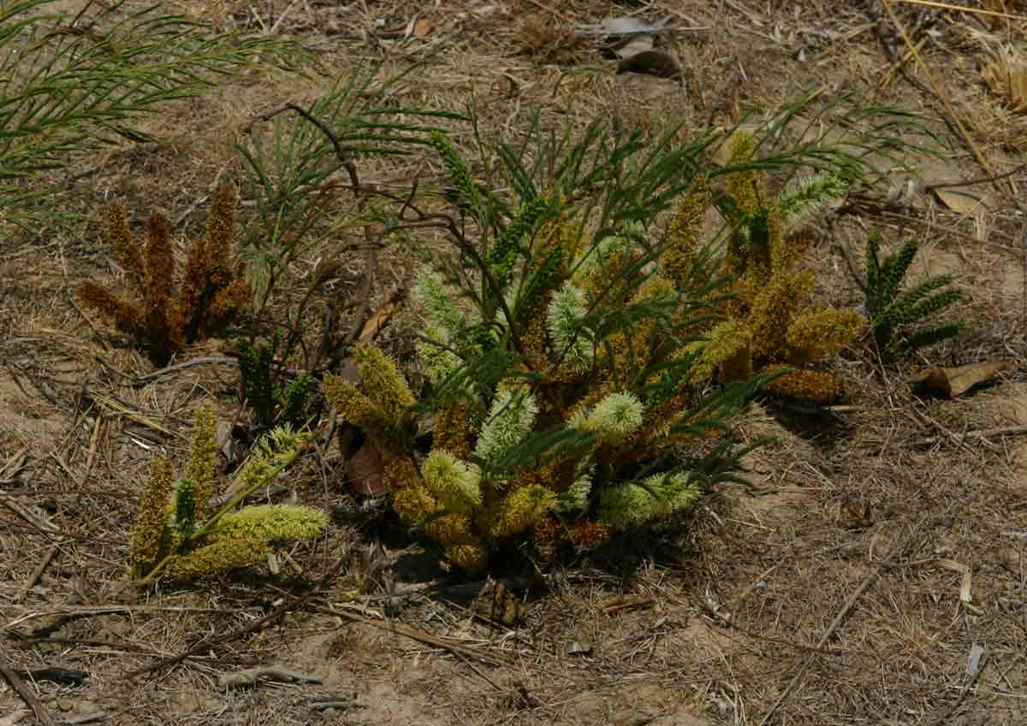

Figure 1 E. elephantina plant

## Pancreatic insufficiency

Exocrine Pancreatic Insufficiency (EPI) is a complex condition characterised by the inadequate production and secretion of digestive enzymes by the pancreas, leading to impaired nutrient digestion and absorption3. This deficiency results in a cascade of malabsorption issues, significantly impacting the quality of life for affected individuals4. The aetiology of EPI is diverse, encompassing both pancreatic and non-pancreatic disorders. Chronic pancreatitis, cystic fibrosis, pancreatic cancer, and surgical resections of the pancreas are among the primary pancreatic causes, whereas non-pancreatic causes include conditions like coeliac disease, Crohn's disease, and diabetes mellitus5. The diagnosis of EPI typically involves a combination of clinical assessment, stool tests (e.g., faecal elastase-1), and imaging techniques such as magnetic resonance imaging or computed tomography to evaluate pancreatic structure and function. The gold standard for diagnosing EPI; the direct pancreatic function test which involves the intubation of the duodenum and the direct measurement of pancreatic enzyme secretion following cholecystokinin stimulation is invasive and not routinely performed in clinical practice. The management of EPI primarily focuses on pancreatic enzyme replacement therapy, which aims to supplement the deficient enzymes and improve nutrient absorption6. Additional supportive measures include dietary modifications such as reducing fat intake and increasing the frequency of meals, as well as supplementation with fat-soluble vitamins to address deficiencies caused by malabsorption1. Under normal physiological conditions, the synthesis and secretion of exocrine pancreatic enzymes by acinar cells are regulated by a complex interplay of neural, endocrine, and paracrine mechanisms in response to gastrointestinal distension and food intake4. The severity of EPI can range from mild to severe, depending on the extent of pancreatic damage and the degree of enzyme deficiency. Individuals diagnosed with cystic fibrosis should undergo testing for pancreatic insufficiency as soon as possible, and the management of pancreatic insufficiency in cystic fibrosis patients requires lifelong treatment7. Tumor-induced EPI can arise from the primary pancreatic duct obstruction, gland fibrosis, and the depletion of pancreatic exocrine tissue, leading to reduced pancreatic enzymes production or hindered pancreatic enzymes transportation to the duodenum4.

## Secondary Metabolites and Pancreatic insufficiency

Secondary metabolites are organic compounds produced by plants that are not directly involved in their growth, development, or reproduction, but rather serve various ecological and defensive functions. These compounds often exhibit diverse biological activities and have been extensively studied for their potential therapeutic applications. The role of secondary metabolites in the context of pancreatic insufficiency is multifaceted, encompassing antioxidant, anti-inflammatory, and enzyme-modulating effects. Given the critical function of the pancreas in maintaining proper digestion and blood sugar regulation, the study of secondary metabolites could provide a path to the development of novel treatments for disorders affecting the pancreas. Secondary metabolites derived from plants have been shown to exhibit inhibitory activity against enzymes involved in carbohydrate digestion, such as α-amylase and α-glucosidase, therefore managing postprandial hyperglycaemia. Plant-derived compounds such as alkaloids, flavonoids, terpenoids, phenolic acids, and saponins have demonstrated significant anti-diabetic effects through a variety of mechanisms8. The diversity of their mechanisms, which include enhancing insulin sensitivity, modulating glucose metabolism, and lowering postprandial glucose levels, highlights their potential as therapeutic agents for end stage pancreatic insufficiency management9.

## Antioxidants and Pancreatic insufficiency

Antioxidants are key players in mitigating oxidative stress, a condition characterised by an imbalance between the production of reactive oxygen species and the capacity of the cellular antioxidant defence systems to neutralise them10. Oxidative stress has been implicated in the pathogenesis of various diseases, including pancreatic insufficiency, where it can contribute to cellular damage and impaired pancreatic function. Supplementation with dietary antioxidants, such as polyamines, carotenoids, flavonoids, glutathione, alpha-lipoic acid, and vitamins E, A, and C, provides substantial protection against diabetes mellitus9. Antioxidants protect pancreatic cells from injury and promote their normal function by scavenging free radicals and reducing oxidative damage. Studies suggest that dietary intervention with polyphenols, which possess excellent antioxidant activity and can inhibit α-amylase, could prevent or delay the onset of type 2 diabetes mellitus11. Therefore, incorporating antioxidants into the therapeutic regimen for pancreatic insufficiency may help to preserve pancreatic function and reduce disease progression.

## Anti-inflammatory role in pancreatic insufficiency treatment

Diabetes and pancreatic insufficiency are intrinsically linked, as inflammation plays a critical role in the development and progression of both type 1 and type 2 diabetes mellitus. In the context of pancreatic insufficiency, inflammation can exacerbate pancreatic damage and impair its exocrine function, leading to reduced enzyme secretion and digestive dysfunction9. This condition, known as insulitis, involves inflammation in the pancreatic Langerhans beta cell islets, which appears to be a hallmark among all types of diabetes, resulting in a decrease in beta cell quantity and function. Anti-inflammatory agents, including both steroidal and non-steroidal drugs, have been shown to mitigate pancreatic inflammation and improve pancreatic function in experimental models of pancreatic insufficiency12. Vitamin D and its receptor signalling can induce anti-inflammatory and anti-fibrotic effects in pancreatitis, underscoring the potential of vitamin D and its analogs in treating inflammatory and fibrotic diseases associated with pancreatic insufficiency. Vitamin D supplementation could also downregulate toll-like receptors in inflammatory diseases, suggesting a role in modulating the immune response12. These findings highlight the importance of targeting inflammation as a therapeutic approach for managing pancreatic insufficiency and its associated comorbidities, such as diabetes mellitus.

## Antibacterial role in pancreatic insufficiency

The antibacterial properties of *Elephantorrhiza elephantina* extracts may offer additional benefits in the context of pancreatic insufficiency, particularly in cases where bacterial infections, such as *Escherichia coli*, contribute to disease exacerbation or complications4. Pancreatic insufficiency can disrupt the normal gut microbiota, predisposing individuals to bacterial overgrowth and infections, which can further compromise pancreatic function and overall health. Some antibiotics have been linked to lower efficacy of immunotherapy in solid tumours, but systematic assessment of antibiotic administration in pancreatic cancer patients remains to be performed11.

# Materials and methods

## Materials, equipment and facilities

Prior to the investigations, animal use and research, ethics approvals were obtained from the Joint Parirenyatwa Research Ethics Committee (JREC) which is the local research institutional review board for the University of Zimbabwe. Animals were handled according to ethical animal use and those exhibiting any form of adverse reactions were euthanized upon completion of the experiment. Prior to commencement of the study, all the equipment was inspected for functionality and calibrated for reliable and reproducible data acquisition. The execution of this study necessitated the utilisation of a range of sophisticated equipment and specialised facilities to ensure the integrity and accuracy of the experimental data. All chemicals, associated reagents, equipment and facilities for the *in-vivo* laboratory animal toxicity investigations and the bioactivity assays were obtained from the University of Zimbabwe, Faculty of Medicine and Health Sciences laboratories.

## Plant material collection and preparation

Fresh roots of *Elephantorrhiza elephantina*  were harvested from wild populations in areas around Zvimba area communal lands in Zimbabwe during the months of September and October 2024. These months are ideal since they represent the end of the rainy season when plants are actively growing and accumulating secondary metabolites**9**. The identity of the plant material was confirmed by a trained botanist at the National Herbarium of Zimbabwe. A voucher specimen was deposited at the herbarium for future reference. The collected roots were thoroughly washed with distilled water to remove any soil and debris. The plant material was air-dried under shade at room temperature until a constant weight was achieved. The shade drying process took 3 weeks and ensured that moisture content was minimised, thereby preventing microbial growth and enzymatic degradation of the plant material. The dried roots were then pulverized into a fine powder using a laboratory mechanical grinder. The powder was stored in airtight containers at room temperature, protected from light and moisture, until further use.

## Phytochemical extraction

The extraction method published by Chipato et al (2024).2, was adopted with minor modification. 255g of *E. elephantina* root powder were weighed using an analytical balance and transferred to a sterile 2L amber bottle. 1200ml of 70% hydro-ethanolic mixture was added to the bottle containing the root powder. The mixture was then subjected to continuous agitation on an orbital shaker at 120 rpm for 72 hours at room temperature. This duration was chosen to ensure maximal extraction of the secondary metabolites from the plant matrix. Following maceration, the mixture was filtered through several layers of muslin cloth to remove coarse particulate matter. The filtrate was then passed through Whatman No. 1 filter paper to remove any remaining fine particles. The resulting filtrate was concentrated under reduced pressure at 40°C using a rotary evaporator (Rotavapor® R-300, Buchi, Switzerland) until a crude extract was obtained. The concentrated extract was then lyophilized (Lyovapor l-200, Buchi, Switzerland) to remove any residual solvent, resulting in a dry powder. The dry extract was weighed and stored in airtight containers at 4°C until further analysis.

## Qualitative phytochemical analysis

The qualitative tests for phytochemicals were done using standards test as described by Gwaze et al, 20259, with modifications to metabolomics studies. The qualitative tests were done to determine the presence of absence of alkaloids, tannins, flavonoids, glycosides, phenolic compounds, saponins, and terpenoids (Table 1).

Table 1. Metabolomics screening tests done on Elephantorrhiza elephantina lyophilized extract

|  |  |  |
| --- | --- | --- |
| Metabolomics | Screening test done | Results interpretation |
| Test for alkaloids | **Dragendroff’s test.** To 5ml of the lyophilized extract solution in a test tube, 2 drops of Dragendroff’s reagent were added.  **Iodine test**. Few drops of iodine solution were slowly added along the sides of the test tube containing 3ml of the lyophilized extract solution | The presence of alkaloids was determined by the reddish-brown precipitate  The presence of alkaloids was then identified by the appearance of a blue colour, which disappears on boiling and reappears on cooling. |
| Test for tannins | **Braymer’s test**  Ferric chloride test. 2 drops of ferric chloride were added to 5ml of the prepared extract of lyophilized *E. elephantina* solution | The presence of catechic tannins signalled by the development of a green-blue colour, a black-blue colour indicated the presence of Gallic tannins |
| Test for flavonoids | **Ammonia test.** 5ml dilute ammonia solution was added to 5ml of the prepared lyophilized extract solution followed by a few drops of conc. H2SO4 | The emergence of a yellow colour indicates the presence of flavonoids. |
| Test for saponins | **The simplified foam test**. 5ml of the extract solution was added to 30ml distilled water in a 100ml measuring cylinder. The mixture was then shaken for 2 mins. | The development of head form more than 1cm in the measuring cylinder confirmed the presence of saponins. |
| Test for terpenoids | **The Salkowski test**. 5ml of chloroform were added to 5ml of the extract liquor in a test tube followed by the addition of 1ml of concentrated H2SO4. | The grey coloured solution indicated the presence of terpenoids. |
| Test for phenols | **Ferric chloride test**. 2 drops of ferric chloride were added to 5ml of the extract solution.  **Gelatin test**. 2ml of the lyophilised extract solution were added to 5ml of a 1% gelatin solution and 5 drops of a 10% NaCl were further added | The presence of phenols was indicated by the development of a dark green/bluish back colour.  Phenolics were identified by the appearance of a white precipitate. |
| Test for glycosides | **The modified Borntrager’s assay**. 5ml of the prepared extract solution was mixed with 5ml of dilute hydrochloric acid in a test tube. The mixture was placed in a water bath for 10mins at 80oc after being treated with 3ml of ferric chloride solution. The mixture was allowed to cool. After cooling, extraction was done with 10ml of benzene. The resultant layer of benzene was decanted and treated with 5ml ammonia solution.  **The Keller-Killani Test**. To 1ml of the lyophilised solution, 1.5ml glacial acetic acid was added and a few drops of 5% ferric chloride were added as well as conc. H2SO4 | The development of a pink colour indicated the presence of anthranol glycosides  The presence of glycosides was confirmed by the emergence of a blue coloured solution in mixture acetic acid layer. |

## Quantitative phytochemical analysis

**Quantification of total phenolic:** The total phenolic content of the *Elephantorrhiza elephantina* root extract was determined using the Folin-Ciocalteu reagent assay, as previously described with some modifications13. A gallic acid stock solution was prepared by dissolving 5 mg of gallic acid in 1 mL of distilled water to achieve a concentration of 5 mg/mL. Five different concentrations of gallic acid standard solutions were prepared by serial dilution from the stock solution. The lyophilized *Elephantorrhiza elephantina*  extract was dissolved in distilled water to create a concentration of 0.2 mg/mL. The Folin-Ciocalteu reagent was diluted 10-fold with deionized water immediately before use. 0.25 mL of each gallic acid standard solution and 0.25 mL of the *Elephantorrhiza elephantina*  extract solution were pipetted into separate test tubes. 1.25 mL of the 10-fold diluted Folin-Ciocalteu reagent was added to each test tube, and the mixture was allowed to react for 5 minutes at room temperature. 2 mL of 7.5% sodium carbonate combined with folin solution was added to each test tube, and the final volume in each test tube was adjusted to 5 mL with the folin and sodium carbonate solution. The test tubes were incubated in the dark at room temperature for 60 minutes to allow for colour development. After 1 hour, the absorbance at 760 nm was determined spectrophotometrically (Lambda 35 UV/Vis-Spectrometer, Perkin Elmer Instruments), with the Folin-Ciocalteu reagent combined with sodium carbonate solution used as a blank. A calibration curve was prepared by plotting the absorbance values of the gallic acid standard solutions against their corresponding concentrations to determine the total phenolic content in *E. elephantina* root extracts, comparing the absorbance of the extract solution to the gallic acid calibration curve, and the results were expressed as milligrams of gallic acid equivalents per gram of the sample. The total phenolic content was calculated using the formula obtained from the gallic acid calibration curve:

*T = (C x V)/M*

*Where: T is the total phenolic content in mg GAE/g of dry extract, C is concentration of gallic acid obtained from the calibration curve( mg/ml), M is the mass of the extract in grams.*

## Anti-inflammatory activity of *E. elephantina* (Egg Albumin test)

Stock solution of the extract was prepared at a concentration of 10 mg/mL in 0.4% DMSO, the positive control, stock solution of diclofenac, was prepared at a concentration of 10 mg/mL in 0.4% DMSO. Serial dilutions were made for both the extract and the positive control to achieve final concentrations of 50, 100, 250, 500, 750 and 1000 µg/mL in the reaction mixture. The test tubes were labelled, and each received 0.4 mL of fresh egg albumin, 0.5 mL of the *Elephantorrhiza elephantina*  extract or diclofenac at the target concentration, and 3 mL of PBS. For a negative control, 0.4 mL egg albumin, 0.5 mL 0.4% DMSO, and 3 mL PBS were added to the tube. The mixtures were incubated at 37°C for 20 minutes, followed by heating in a water bath at 65°C for 30 minutes to induce denaturation. After cooling, the absorbance of each sample was measured at 660 nm using a UV spectrophotometer, Lambda 35 UV/VIS Spectrometer, with 0.4% DMSO as the blank. The percentage inhibition of protein denaturation was then calculated.

$$Inhibition \%=\frac{{Abs}_{control}-{Abs}_{sample}}{{Abs}_{control}}x 100$$

## Antibacterial Activity of *E. elephantina* (Agar well diffusion method)

The antibacterial activity of *E. elephantina* was examined on *Escherichia Coli (E. Coli)*, using a qualitative method, measuring zones of inhibition. Mueller-Hinton agar plates were prepared and inoculated with *E. coli* adjusted to a 0.5 McFarland standard2. Wells were created in the agar, and different concentrations of the plant extract (100 mg/mL, 50 mg/mL, 25 mg/mL, and 12.5 mg/mL), ciprofloxacin (positive control), and sterile distilled water (negative control) were added to the wells. The plates were incubated at 37°C for 24 hours, and the diameters of the inhibition zones were measured to determine antibacterial activity. The experiment was performed in triplicate, and the mean and standard deviation of the inhibition zone diameters were calculated for each treatment group, comparing them to the positive and negative controls.

## Acute toxicity studies

Lyophilized extracts of *E. elephantina* were evaluated in Sprague-Dawley rats, following the OECD Test Guideline 423. Twelve healthy, nulliparous, and non-pregnant female Sprague-Dawley rats, aged 8-12 weeks and weighing between 200-250g, were used. The rats were housed individually and acclimatized to the laboratory conditions for a minimum of 5 days, with free access to commercial rodent feed and water. A stock solution of the extract was prepared by dissolving the lyophilized extract in distilled water to achieve a concentration of 5000mg/mL. Rats were randomly divided into a 3 treatment groups (n=3) and a control group (n=3). Following an overnight fast, the treatment groups received a single oral dose of the plant extract at 500mg/kg, 2500mg/kg and 5000 mg/kg body weight respectively, while the control group received an equivalent volume of distilled water. The extracts were administered via oral gavage. The animals were observed continuously for the first 4 hours after dosing, with attention to signs of tremors, convulsions, salivation, diarrhea, or any other abnormal behaviour. Thereafter, observations were made daily for 14 days, recording mortality, changes in skin and fur, changes in eyes and mucous membranes, respiratory rate and pattern, activity level, gait abnormalities, changes in food and water consumption, and presence of diarrhea or changes in urine output. The body weight of each animal was recorded on day 0, 7, and 14 post-dosing. Food and water intake were measured daily for each group. A veterinary specialist was involved throughout the study, monitoring the animals daily for any signs of distress or toxicity and any adverse clinical signs or unexpected deaths were recorded immediately. Mortality rates were recorded for both groups.

## Subacute toxicity studies

The subacute oral toxicity of lyophilized extracts of *Elephantorrhiza elephantina* was evaluated in Sprague-Dawley rats, following OECD Test Guideline 40714. Eighteen healthy, nulliparous, and non-pregnant female Sprague-Dawley rats, aged 8-12 weeks and weighing between 200-250g, were used. The rats were obtained from a certified animal breeding facility, the University of Zimbabwe Animal House and acclimatized to the laboratory conditions for a minimum of 7 days, with free access to commercial rodent feed and water *ad libitum*. Animals were housed individually in standard rat cages with stainless steel wire mesh floors. The animal room was maintained at a temperature of 22 ± 3°C, with a relative humidity of 50-60% and a 12-hour light/dark cycle. Fresh stock solution of the *Elephantorrhiza elephantina* extract was prepared daily by dissolving the lyophilized extract in distilled water. The rats were divided into three dosage groups (n=6): a control group receiving distilled water only, a low-dose group receiving plant extract at 500 mg/kg body weight, and a high-dose group receiving plant extract at 1000 mg/kg body weight. The concentrations were adjusted to allow administration of the required dose within a maximum volume of 2 mL per animal via oral gavage. The dosage for each rat was calculated daily based on its individual body weight. After acclimatization period, rats were dosed daily via oral gavage for 28 consecutive days. The rats were observed twice daily for any clinical signs of toxicity. Detailed observations, including mortality, changes in skin and fur, changes in eyes and mucous membranes, respiratory rate and pattern, activity level, gait abnormalities, changes in food and water consumption, presence of diarrhea or changes in urine output, and erection of fur, were recorded daily.

### **Haematology, biochemistry and histopathology**

**Materials and Methods**

In this assay, 18 Sprague Dawley rats which participated in the study were divided into three groups (n=6 per group): control, low-dose (500 mg/kg), and high-dose (1000 mg/kg).The control group received distilled water. The rats were treated daily with respective doses for 28 days via oral gavage. Blood samples were collected from selected rats in each group (rat 1 from control, rats 1, 3, and 5 from each treatment group) for hematology and biochemistry analyses.

### **Preparation of blood samples for hematological and biochemical analysis:**

At the end of the experimental period, the animals were fasted overnight and anaesthetized using diethyl ether. Blood samples were collected by cardiac puncture. About 2 mL of blood was collected from each rat into EDTA anticoagulant bottles for hematological analysis, and about 3 mL was collected into non-EDTA bottles for serum biochemical analysis.

### **Hematology**

The following parameters were measured: WBC, RBC, Hb, HCT, MCV, MCH, MCHC, RDW, PLT, and MPV. These parameters were measured using a hematology analyzer.

### **Preparation of serum for biochemistry parameters**

The blood samples collected into non-EDTA bottles were allowed to clot by standing at room temperature for 30 min. Serum was separated by centrifugation at 3000 rpm for 15 min using a benchtop centrifuge. The serum samples were collected using Pasteur pipettes into clean, dry, and well-labeled sample bottles. The serum samples were stored frozen at -20°C until analyzed.

### **Biochemistry**

The following parameters were analyzed: Urea, AST, ALT, ALP, Creatinine, TP, and Albumin. Serum samples were analyzed using a clinical chemistry analyzer.

### **Histopathology**

Heart, liver, and kidney tissues were dissected from the same rats used for blood sampling. The organs were immediately fixed in 10% formalin for histological examination. Tissue sections were prepared and stained with hematoxylin and eosin stains. The stained sections were examined under a microscope, and histopathological changes were observed and recorded.

### **Data Analysis**

Data was analyzed using appropriate statistical methods, including one-way ANOVA and post-hoc comparisons, to determine significant differences between the control and treatment groups. Differences were considered statistically significant at p < 0.05. Descriptive statistics, including mean and standard deviation, were calculated for all measured parameters.

# Results and discussion

## Phytochemical screening

The investigations confirmed the abundance of primary and secondary metabolites of biomedical relevance with regards to pancreatic insufficiency. The compounds with the strongest presence in the plant were flavonoids and phenols (Table 2). These results correlate with studies by Chipato and Chifambawho identified glycosides, tannins, flavonoids, alkaloids, phenolic compounds, saponins, and steroids in the *E. elephantina* lyophilized extracts. Alkaloids have traceable pharmacological properties which include anti-inflammatory and analgesic effects. According to Nugent, 202515, alkaloids have the capacity to modulate pancreatic enzymes and improve the digestive function in cases of pancreatic insufficiency. Alkaloids also contribute to the regulation of insulin secretion, which is often disrupted in pancreatic disorders16. Flavonoids and phenols exhibit significant antioxidant and anti-inflammatory effects, helping to protect pancreatic cells from oxidative stress and inflammation, both of which are common in pancreatic disorders17, 18. Glycosides and saponins enhance pancreatic enzyme secretion, facilitating improved digestion and nutrient absorption, which is crucial in addressing malabsorption associated with pancreatic insufficiency8, 19. Tannins, recognized for their astringent properties, may contribute to pancreatic enzyme regulation, supporting the digestive process and mitigating enzyme deficiencies. Terpenoids have shown potential in restoring pancreatic function and reducing inflammation, suggesting a broader role in maintaining pancreatic health20. The combined effects of these phytochemicals indicate that *E. elephantina* has potential for alleviating symptoms associated with pancreatic insufficiency.

*Table 2.Results for the phytochemical screening of hydro-ethanolic extracts of E. elephantina*

|  |  |
| --- | --- |
| Phytoconstituent | Presence in hydro-ethanolic extract |
| Alkaloids | + |
| Flavonoids | +++ |
| Glycosides | + |
| Phenols | +++ |
| Saponins | + |
| Tannins | ++ |
| Terpenoids | + |

(-): Indicates the absence of the phytochemical

(+): Indicates the presence of the phytochemical

(++): Indicates moderate presence of the phytochemical

(+++): Indicates strong presence of the phytochemical

## Total Phenolic Content

The total phenolic content (TPC) of *E. elephantina* was determined to be 338.0 mg gallic acid equivalents per gram (mg GAE/g), a value that aligns well with those reported in previous studies, where TPC values typically range from approximately 300 to 400 mg GAE/g 21, 6. The calibration curve obtained for the phenolic assay was described by the equation y = 4.67x + 0.0226 (where y represents absorbance and x the gallic acid concentration in mg/mL) (Figure 2), with an exceptionally high coefficient of determination (R² = 0.9985) . The high TPC reflects a substantial presence of bioactive polyphenolic compounds, which have been strongly associated with robust antibacterial and antioxidant activities through mechanisms such as free radical scavenging and inhibition of microbial proliferation 21, 22. The antioxidant properties inherent to such phenolic constituents hold therapeutic promise for mitigating oxidative stress, a critical pathological factor in pancreatic insufficiency disorders, thereby suggesting that *E. elephantina* may be an effective candidate for the development of novel treatments or adjunct therapies in managing these conditions.

*Figure 2 Total phenolic evaluation graph.*

## Anti-inflammatory tests

*Elephantorrhiza elephantina* exhibited a significant anti-inflammatory activity, demonstrating a maximum of 64.50% inhibition of inflammation against diclofenac (Table 3, figure 3). The high degree of inhibition suggests the plant's extracts have a potent anti-inflammatory effect, which may be beneficial for managing pancreatic insufficiency, given the role of inflammation in its pathophysiology. The observed anti-inflammatory activity is likely due to the presence of bioactive compounds like anthraquinones, which have been shown to have anti-inflammatory properties in other studies23. Studies have also confirmed flavonoids, terpenoids, alkaloids and saponins to possess a significant anti-inflammatory activity. The ability of *E. elephantina* to significantly inhibit inflammation supports its potential as a therapeutic option for conditions involving pancreatic insufficiency.

## *Table 3. Anti-inflammatory test of extracts of E. elephantina*

|  |  |  |  |
| --- | --- | --- | --- |
| **Sample** | **Concentration(ug/ml)** | **Absorbance** | **% Inhibition** |
| Negative control | 0.4% DMSO | 0.924 | 0.00 |
| Diclofenac | 50 | 0.781 | 15.48 |
|  | 100 | 0.653 | 29.33 |
|  | 250 | 0.482 | 47.84 |
|  | 500 | 0.317 | 65.69 |
|  | 750 | 0.209 | 77.38 |
|  | 1000 | 0.152 | 83.55 |
| *E. Elephantina* | 50 | 0.879 | 4.87 |
|  | 100 | 0.796 | 13.85 |
|  | 250 | 0.681 | 26.30 |
|  | 500 | 0.553 | 40.15 |
|  | 750 | 0.419 | 54.65 |
|  | 1000 | 0.328 | 64.50 |

Figure 3 The inflammation inhibition of E. Elephantina compared to the existing anti-inflammatory drug, Diclofenac

## Evaluation of antibacterial activity

The results reveal that the *E. elephantina* extract exhibits potent antibacterial activity (Table 4). At a concentration of 100mg/ml, the extract showed 79% inhibition compared to the positive control, ciprofloxacin, indicating its strong antibacterial potential. Furthermore, the 50mg/ml concentration retained 50% inhibition, suggesting a dose-dependent effect (Figure 4,5). Concentrations below 50mg/ml exhibited reduced activity. The negative control, distilled water, confirms the absence of false-positive results. These findings suggest that *E. elephantina* could be a valuable therapeutic option for managing bacterial infections associated with pancreatic insufficiency, given it demonstrated antibacterial potency. The study corroborates the antibacterial properties of *E. elephantina* reported in the literature23. By inhibiting the growth of pathogenic bacteria, *E. coli*, extracts from *Elephantorrhiza elephantina* could help restore a more balanced gut microbiota, reduce inflammation, and improve nutrient absorption. This effect is especially relevant considering that inflammatory bowel disease is associated with a higher risk of developing exocrine pancreatic insufficiency4. Moreover, the antibacterial activity of *Elephantorrhiza elephantina* extracts could help prevent or treat bacterial infections, such as those caused by E. coli, in individuals with pancreatic insufficiency, reducing the risk of complications such as sepsis and pneumonia.

Figure 4 Zones of inhibition diameters with respect to concentration

## *Table 4. Antibacterial activity of E. Elephantina (well diffusion method)*

|  |  |  |  |  |
| --- | --- | --- | --- | --- |
|  | **Concentration (mg/ml)** | **Measured ZOI (mm)** | **Corrected ZOI** | **% Inhibition relative to Ciprofloxacin** |
| **Positive control** |  |  |  |  |
| Ciprofloxacin | 100 | 30 | 24 | - |
|  | 50 | 26 | 20 | - |
|  | 25 | 22 | 16 | - |
|  | 12.5 | 18 | 12 | - |
| **Negative control** |  |  |  |  |
| Distilled Water | - | 0 | 0 | 0 |
|  |  |  |  |  |
| ***E. Elephantina*** | 100 | 25 | 19 | 79.2 |
|  | 50 | 18 | 12 | 50.0 |
|  | 25 | 13 | 7 | 29.2 |
|  | 12.5 | 10 | 4 | 16.7 |

*ZOI: Zone Of Inhibition*

*Well diameter = 6mm $Correct ZOI\left(mm\right)=Measured ZOI\left(mm\right)-Well diameter (6mm)$*

$\%Inhibition=\frac{corrected ZOI of extract at concentration X}{corrected ZOI of Ciprofloxacin at concentration X}*100$

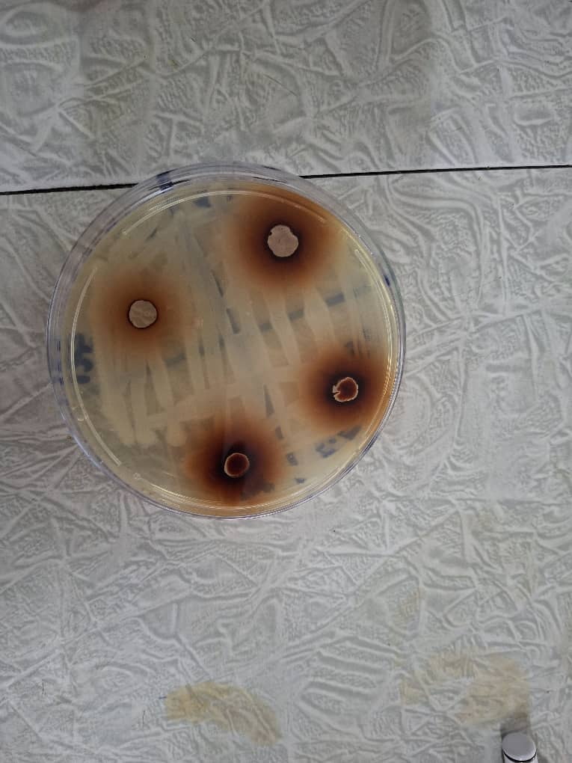

Figure 5 Antibacterial evaluation of E elephantina showing zones of inhibition

## Toxicity evaluation

The acute toxicity study was carried out as per OECD technical guideline 425. The acute toxicity test results showed no major physiological changes from all the treated groups of animals that formed the study. The animals in all treatment groups exhibited no statistically relevant differences in weight from the control group. No animals were withdrawn from the study for any reason during the observation period (Table 5). Reduction in water intake was observed in the 2500mg/kg and 5000mg/kg treated group. There was also a decrease in food intake in the 5000mg/kg treated group coupled with staggered defecation. The observations resolved within 24 hours after the 14-day period of the study. This indicates that *E. elephantina* may result in constipation at high doses above 5000mg/kg. Drowsiness which was observed in the 2500mg/kg and 5000mg/kg also resolved after 24 hours of the study period. Our findings indicated that the *E. elephantina* extract at doses up to 5000 mg/kg body weight do not cause death nor any serious physiological complications. The use of *Elephantorrhiza elephantina* extracts at concentration less than 5000mg/kg to achieve the desired bioactivity effects will not pose any toxicity in E. elephantina based treatments

*Table 5. Observations from acute toxicity profiling of E. Elephantina*

|  |  |  |  |  |
| --- | --- | --- | --- | --- |
| **Observed Parameter** | **Dose of *E. Elephantina in mg/kg body weight*** | | | |
|  | **Control (0mg)** | **500mg** | **2500mg** | **5000mg** |
| Food intake | Normal | Normal | Normal | Reduced |
| Water intake | Normal | Normal | Reduced | Reduced |
| Death | Alive | Alive | Alive | Alive |
| Breathing | Normal | Normal | Normal | Normal |
| Defecation | Normal | Normal | Staggered | Staggered |
| Skin colour | Normal | Normal | Normal | Normal |
| Drowsiness | Not observed | Not observed | Slight | Slight |
| Erection of Fur | Not observed | Not observed | Not observed | Not observed |
| Urination | Normal | Normal | Increased | Increased |

## Evaluation of subacute toxicity studies

Subacute toxicity assessments of *E. elephantina* extracts revealed effects primarily at higher dosages. While no mortality or severe adverse health symptoms were observed, the study identified alterations in hematological and serum biochemical parameters. The subacute toxicity study of the ethanolic extract of *E. elephantina* revealed that higher doses can induce mild toxic effects in Sprague Dawley rats. Specifically, elevated levels of urea, AST, ALT, and creatinine suggest potential nephrotoxicity and hepatotoxicity. Similar results have been reported in another study24, where aqueous extracts of *E. elephantina* also exhibited increased creatinine levels at higher doses24. The mild hepatocellular necrosis and inflammation observed in the liver, along with tubular damage in the kidneys, further corroborate these findings. This explains the increase in urination which was observed in the 1000mg/kg group. These histopathological changes indicate that prolonged exposure to high doses of the extract may impair liver and kidney function. It is worth noting that the absence of mortality and significant changes in haematological parameters suggests the extract does not cause severe systemic toxicity at the tested doses (Figure 6). However, the observed biochemical and histopathological changes warrant caution when using high doses of *E. elephantina* extracts. Given that traditional medicinal practices often involve the oral administration of *E. elephantina*, these results highlight the importance of dosage considerations and the potential for cumulative toxicity with prolonged use. The use of different extraction methods and plant parts from different regions could lead to variations in toxicity of the *E. elephantina* plant extracts. Weight reduction was observed in the 1000mg/kg treated group at the end of the study (Figure 6). Several studies have highlighted the presence of saponins and tannins in *E. elephantina*, which are known anti-nutritive factors. These compounds may contribute to the observed toxic effects by interfering with nutrient absorption or causing direct cellular damage. Previous studies have documented changes in body weight and alterations in haematological and serum biochemical parameters in animals treated with *E. elephantina*.

Figure 6 Shows Sprague-Dawley rats weight over the subacute toxicity test investigation period (g)

### Hematology:

No significant differences were observed in hematological parameters between the treated and control groups.

*Table 6, Hematological parameters*

|  |  |  |  |
| --- | --- | --- | --- |
| Parameter | Control (Mean ± SD) | 500 mg/kg (Mean ± SD) | 1000 mg/kg (Mean ± SD) |
| WBC | 8.5 ± 1.2 | 9.2 ± 1.5 | 10.1 ± 1.8 |
| RBC | 7.2 ± 0.8 | 7.5 ± 0.9 | 6.8 ± 0.7 |
| Hb | 14.5 ± 1.0 | 15.0 ± 1.2 | 13.8 ± 0.9 |
| HCT | 42.0 ± 3.0 | 43.5 ± 3.5 | 40.0 ± 2.8 |
| MCV | 60.0 ± 2.5 | 61.5 ± 2.8 | 59.0 ± 2.0 |
| MCH | 20.1 ± 1.5 | 21.0 ± 1.8 | 19.5 ± 1.2 |
| MCHC | 33.5 ± 1.0 | 34.2 ± 1.2 | 32.8 ± 0.9 |
| RDW | 15.2 ± 0.8 | 15.8 ± 0.9 | 14.5 ± 0.7 |
| PLT | 300 ± 25 | 310 ± 30 | 280 ± 20 |
| MPV | 7.5 ± 0.5 | 7.8 ± 0.6 | 7.2 ± 0.4 |

### Biochemistry:

In the assays the 1000 mg/kg group showed significant increases in creatinine levels. While Liver enzymes were not significantly affected.

*Table 7, Biochemical evaluations*

|  |  |  |  |
| --- | --- | --- | --- |
| Parameter | Control (Mean ± SD) | 500 mg/kg (Mean ± SD) | 1000 mg/kg (Mean ± SD) |
| Urea | 25 ± 3 | 28 ± 4 | 35 ± 5* |
| AST | 60 ± 8 | 70 ± 10 | 95 ± 12* |
| ALT | 45 ± 5 | 50 ± 7 | 75 ± 9* |
| ALP | 120 ± 15 | 130 ± 18 | 150 ± 20 |
| Creatinine | 0.8 ± 0.1 | 0.9 ± 0.1 | 1.2 ± 0.2* |
| TP | 7.0 ± 0.5 | 7.2 ± 0.6 | 6.8 ± 0.4 |
| Albumin | 3.5 ± 0.3 | 3.6 ± 0.4 | 3.4 ± 0.2 |

*\* Indicates p < 0.05*

### Histopathology evaluations :

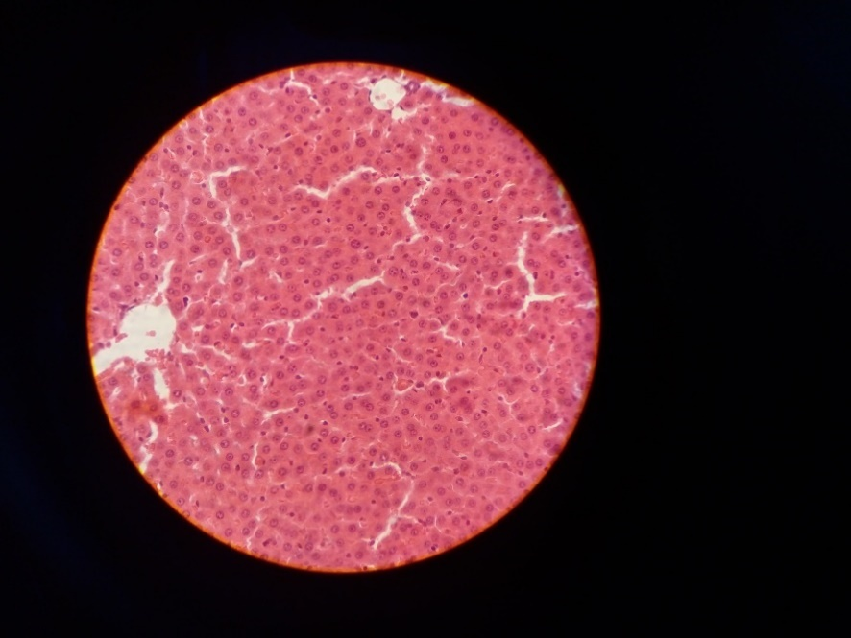

*Figure 7 Histopathology examination of the liver tissue showing mild hepatocellular necrosis and inflammation at the highest dose*

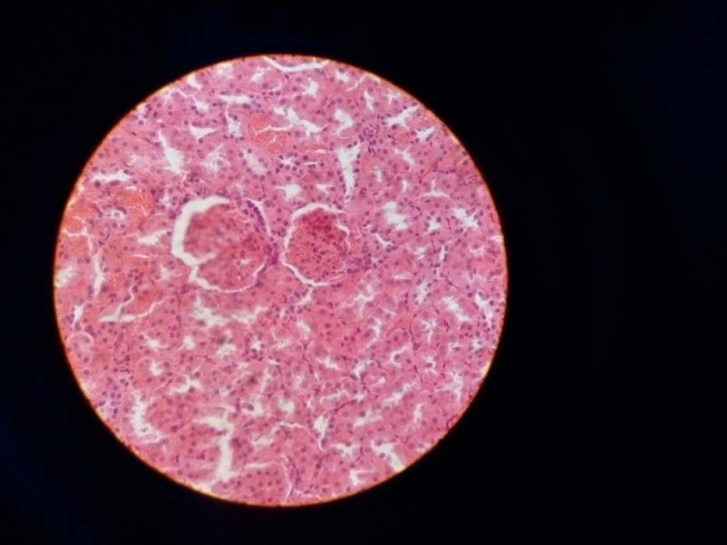

Figure 8 Histopathology examination of the kidney tissue , showing insignificant tubular damage at the highest experimental dose

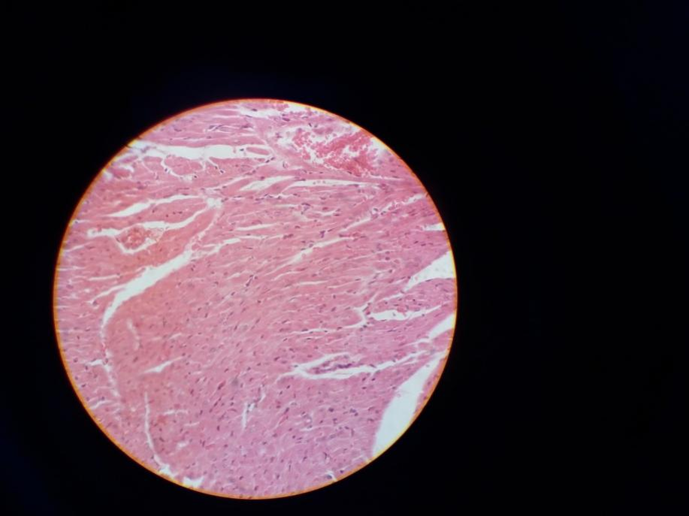

Figure 9 Histopathology examination of the heart tissue showing no significant histopathological changes observed

### Organ Weights:

No treatment-related changes in organ weights were observed.

*Table 8 Organ weight changes in sub-acute evaluations*

|  |  |  |  |
| --- | --- | --- | --- |
| Organ | Control (Mean ± SD) | 500 mg/kg (Mean ± SD) | 1000 mg/kg (Mean ± SD) |
| Liver | 7.0 ± 0.5 | 7.2 ± 0.6 | 6.8 ± 0.4 |
| Heart | 0.85 ± 0.1 | 0.83 ± 0.1 | 0.81 ± 0.1 |
| Kidneys | 1.45 ± 0.15 | 1.40 ± 0.15 | 1.35 ± 0.15 |

# Conclusions

This study provides a comprehensive evaluation of the bioactivity and safety of *E. elephantina*. The bioactivity results establish *E. elephantina* as a promising candidate for exotic pancreatic insufficiency treatment. *Elephantorrhiza elephantina* holds a greater therapeutic application potential as demonstrated by antibacterial, anti-inflammatory, and antioxidant activities of its phytochemicals. These properties support its traditional use in treating various ailments, including gastrointestinal disorders and skin diseases. The diverse array of phytochemicals presents in *E. elephantina,* including tannins, flavonoids, glycosides, and terpenoids, may contribute to both the observed therapeutic benefits. While the extract was deemed practically non-toxic based on acute toxicity tests, subacute exposure revealed notable alterations in hematological and serum biochemical parameters, primarily at higher dosages. These changes suggest potential mild nephrotoxicity, liver injury, and electrolyte imbalances at elevated doses, warranting caution in the use of high concentrations of *E. elephantina* extracts. Further research is needed to identify the specific compounds responsible for the observed effects. The research findings discourage the use of *E. elephantina* in individuals with pre-existing liver or kidney malfunctions. Further studies are recommended to explore the long-term effects associated with *E. elephantina* consumption, while investigating its therapeutic efficacy in treatment of pancreatic insufficiency in controlled clinical trials.

# Competing interests

We declare no conflict of interest. The authors are entirely responsible for the research content and the compilation of this report.

# Disclaimer (Artificial intelligence)

The Authors hereby declare that NO generative AI technologies such as Large Language Models (ChatGPT, COPILOT, etc.) and text-to-image generators have been used during the writing or editing of this manuscript.

# References

1. Jeon, T.J. (2020) Management of Pain, Exocrine and Endocrine Insufficiency in Chronic Pancreatitis, *The Korean Journal of Pancreas and Biliary Tract*, 25(1), p. 5. doi:10.15279/kpba.2020.25.1.5

.

1. Chipato, W.E. and Chifamba, J. (2024) Eco-friendly biosynthesis of silver nanoparticles using Elephantorrhiza elephantina: Characterization and antimicrobial activity against Mycobacterium tuberculosis surrogate models*. International Journal of Biochemistry Research & Review*, 33(6), p.290. doi:10.9734/ijbcrr/2024/v33i6912.
2. Shandro, B. (2020) “The investigation and management of pancreatic exocrine insufficiency: A retrospective cohort study,” *Clinical Medicine,* 20(6), p. 535. Doi:10.7861/clinmed.2020-0506.
3. Tang, C., Zhou, J., Song, Y. and Liu, S. (2025). Etiologies of exocrine pancreatic insufficiency. *Gastroenterology Report*, 13, Article goaf019. Doi:10.1093/gastro/goaf019
4. Singh, V.K., Haupt, M.E., Geller, D.E., Hall, J.A. and Quintana Diez, P.M. (2017). Less common etiologies of exocrine pancreatic insufficiency. *World Journal of Gastroenterology*, 23(39), pp.7059–7076. Doi:10.3748/wjg.v23.i39.7059.
5. Radebe, M., Mthembu, K. and Ngubane, T., 2022. Review on the phytochemical properties of Elephantorrhiza elephantina: from traditional uses to modern applications. *Pharmacognosy Journal,* 14(3), pp.210-225.
6. Borowitz, D. (2000) Evidence for the diagnosis of pancreatic insufficiency. *Pediatric Pulmonology*. Wiley. Doi:10.1002/(sici)1099-0496(200003)29:3<167::aid-ppul1>3.0.co;2-5.
7. El Barky, A.R., Ali, E.M.M. & Mohamed, T.M. (2017). Marine Sea Cucumber Saponins and Diabetes. *Austin Pancreatic Disorders*, 1(2), pp. 1002.
8. Gwaze, L.N., Chipato, W.E., Zengeni, S. and Chifamba, J. (2025). Bioactivity and safety of lyophilised *Carrisa edulis*. *Journal of Materials Science Research and Reviews*, 8(1), p.94. doi:10.9734/jmsrr/2025/v8i1382.
9. Omoruyi, B.E., Bradley, G. and Afolayan, A.J. (2012) Antioxidant and phytochemical properties of Carpobrotus edulis (L.) bolus leaf used for the management of common infections in HIV/AIDS patients in Eastern Cape Province. *BMC Complementary and Alternative Medicine,* 12(1). Doi:10.1186/1472-6882-12-215.
10. Li, X., Zhang, L., Chen, J., Liu, Y., Zhao, F. and Wang, H. (2022). Inhibitory effects against alpha‐amylase of an enriched polyphenol extract from pericarp of mangosteen (Garcinia mangostana). *Foods*, 11(7), p.1001. doi:10.3390/foods11071001.
11. Cai, F., Hu, C., Chen, C.-J., Han, Y.-P., Lin, Z.-Q., Deng, L.-H. and Xia, Q. (2022). Vitamin D and Pancreatitis: A Narrative Review of Current Evidence. *Nutrients*, 14(10), p. 2113. Doi:10.3390/nu14102113.
12. Vo, T.P., Nguyen, L.N.H., Le, N.P.T., Mai, T.P. and Nguyen, D.Q. (2022) Optimization of the ultrasonic-assisted extraction process to obtain total phenolic and flavonoid compounds from watermelon (Citrullus lanatus) rind. *Current Research in Food Science,* 5, p. 2013. Doi:10.1016/j.crfs.2022.09.021.
13. Test No. 407: Repeated Dose 28-day Oral Toxicity Study in Rodents (2008) OECD guidelines for the testing of chemicals. Section 4: Health effects. *Organization for Economic Cooperation and Development. Doi:10.1787/9789264070684-en.*
14. Nugent, L. (2025). Pancreatic Exocrine Insufficiency: Causes, Diagnosis and Treatment. *The Pharmaceutical Journal,* 02 May 2025.
15. Shanmugarajan, T.S., Jeyakumar, K., Palani, G. and Saravanan, R. (2008). Influence of alpha lipoic acid on antioxidant status in D‐galactosamine‐induced hepatic injury. *Toxicology and Industrial Health*, 24(10), pp.635–642. Doi:10.1177/0748233708101215.
16. Gašić, U., Ćirić, I., Pejčić, T., et al. (2020). Polyphenols as Possible Agents for Pancreatic Diseases. *Antioxidants*, 9(6), pp. 547.
17. Niu, C., Zhang, J. & Okolo, P.I. (2025). Harnessing Plant Flavonoids to Fight Pancreatic Cancer. Current Nutrition Reports, 13, pp. 566-581.
18. Lavle, N., Shukla, P. & Panchal, A. (2016). Role of Flavonoids and Saponins in the Treatment of Diabetes Mellitus. *Journal of Pharmaceutical Science and Bioscientific Research*, 6(4), pp. 535-541.
19. Deora, N. & Venkataraman, K. (2023). A systematic review of medicinal plants and compounds for restoring pancreatic β-cell mass and function in the management of diabetes mellitus. *Journal of Applied Pharmaceutical Science,* 13(07), pp. 055-072.
20. Mpofu, J., Chivasa, W. and Gumbo, S., 2015. Flavonoids from the rhizomes of Elephantorrhiza elephantina and Pentanisia prunelloides. *Journal of Medicinal Plants Research,* 9(18), pp.468-476.
21. Asong, E., Moyo, D. and Chikuni, T., 2019*. Antimicrobial, antioxidant potential, cytotoxicity and phytochemical profiling of Elephantorrhiza elephantina extracts against skin diseases*. MDPI Plants, 8(1), pp.15-25.
22. Maroyi, A. (2017) Elephantorrhiza elephantina : Traditional Uses, Phytochemistry, and Pharmacology of an Important Medicinal Plant Species in Southern Africa, *Evidence-based Complementary and Alternative Medicine. Hindawi Publishing Corporation.* Doi:10.1155/2017/6403905.
23. Maphosa, V., Masika, P.J. and Moyo, B. (2009) “Toxicity evaluation of the aqueous extract of the rhizome of Elephantorrhiza elephantina (Burch.) Skeels. (Fabaceae), in rats,” *Food and Chemical Toxicology*, 48(1), p. 196. Doi:10.1016/j.fct.2009.09.040.
24. Center, T.D. and Wright, A.D. (1991) Age and phytochemical composition of waterhyacinth (Pontederiaceae) leaves determine their acceptability to Neochetina eichhorniae (Coleoptera: Curculionidae). *Environmental Entomology*, 20(1), p.323. doi:10.1093/ee/20.1.323.
25. Chung, King-Thom, Wong, Tit Yee, Wei, Cheng-I, Huang, Yao-Wen and Lin, Yuan (1998). Tannins and human health: a review. *Critical Reviews in Food Science and Nutrition,* 38(6), pp.421–464. doi:10.1080/10408699891274273.
26. Donaubauer, H.H., Fuchs, H., Langer, K.H. and Bär, A. (1998). Subchronic intravenous toxicity studies with γ-cyclodextrin in rats. *Regulatory Toxicology and Pharmacology*, 27(2), pp.189–198. doi:10.1006/rtph.1998.1224.
27. Ernilasari, E., Kamalliansyah Walil, Fitmawati, Dewi Indriyani Roslim, Zumaidar, Saudah and Rayhannisa (2021). Antibacterial activity of leaves, flowers, and fruits extract of *Etlingera elatior* from Nagan Raya District, *Indonesia against Escherichia coli and Staphylococcus aureus. Biodiversitas,* 22(10), pp.4457–4464. doi:10.13057/biodiv/d221039
28. Mbiri, J.W. et al. (2023) “Acute and Sub-acute Oral Toxicity Profile of Root Bark Methanol Extract of Carissa Edulis Vahl,” *Pharmacognosy Journal,* 15(2), p. 253. doi:10.5530/pj.2023.15.36.

1. Mohindroo, C., Hasanov, M., Rogers, J.E., Dong, W., Prakash, L.R., Baydogan, S., Mizrahi, J.D., Overman, M.J., Varadhachary, G.R., Wolff, R.A., Javle, M.M., Fogelman, D.R., Lotze, M.T., Kim, M.P., Katz, M.H.G., Pant, S., Tzeng, C.-W.D. and McAllister, F. (2021). Antibiotic use influences outcomes in advanced pancreatic adenocarcinoma patients. *Cancer Medicine*, 10(15), p.5041. doi:10.1002/cam4.3870.
2. Moloi, L.D., Balogun, F.O. and Ashafa, A.O.T. (2021) Mitigation of free radicals and carbohydrate-linked enzymes by extracts and partitioned fractions of Elephantorrhiza elephantina (Burch.) Skeels root, *Journal of Medicinal Plants for Economic Development*, 5(1). doi:10.4102/jomped.v5i1.109.
3. Mpofu, S.J. et al. (2014) Interactive efficacies of Elephantorrhiza elephantina and Pentanisia prunelloides extracts and isolated compounds against gastrointestinal bacteria, *South African Journal of Botany*, 94, p. 224. doi:10.1016/j.sajb.2014.07.002.

1. Mudimba, T.N., Maitho, T., Mbaria, J. and Taderera, T. (2019). Hematotoxicity assessment of phytochemicals from aqueous leaf extracts of *Carpobrotus edulis*. *The Journal of Phytopharmacology*, 8(4), pp.173–176. doi:10.31254/phyto.2019.8405.
2. Okata-Nwali, D.O., Eze, E.C., Udechukwu, O.T., Chukwuemeka, C.T. and Igwe, P.C. (2021). Phytochemical evaluation and antimicrobial potential assessment of some spices on selected pathogenic microorganisms in Alex Ekwueme Federal Teaching Hospital, Abakaliki, Nigeria. *Journal of Pharmaceutical Research International*, 33(26B), p.60. doi:10.9734/jpri/2021/v33i26b31483.

1. Pangeni, B., Shrestha, R.K., Acharya, P., Gurung, R. and Adhikari, K.P. (2021). Antibacterial activity of selected ethnomedicinal plants popular in Magar ethnic community of Palpa District, Western Nepal. *Archives of Ecotoxicology*, 3(1), pp.13–19. doi:10.36547/ae.2021.3.1.13-19.
2. Perbtani, Y.B. and Forsmark, C.E. (2019) “Update on the diagnosis and management of exocrine pancreatic insufficiency,” F1000Research, 8, p. 1991. doi:10.12688/f1000research.20779.1.
3. Razack, O., Etienne, A., Marius, A., Awede, B., Hountohotègbè, T., Bigot, A., Darboux, R. and Lalèyè, A. (2017). Modification of biochemical and haematological parameters during 90‐days subchronic toxicity assessment of *Carissa edulis* in Wistar rats. *Journal of Toxicology and Environmental Health Sciences*, 9(2), pp.7–13. doi:10.5897/jtehs2017.0379.
4. Ruangsuriya, J., Sichaem, J., Tantraworasin, A., Saeteng, S., Wongmaneerung, P., Inta, A., Davies, N.M., Inthanon, K. and Addi, M. (2023). Phytochemical profiles and anticancer effects of *Calophyllum inophyllum* L. extract relating to reactive oxygen species modulation on patient-derived cells from breast and lung cancers. *Scientifica*, 2023, Article ID 6613670. doi:10.1155/2023/6613670.
5. Tourabi, M., Metouekel, A., Ghouizi, A. E. L., Jeddi, M., Nouioura, G., Laaroussi, H., Hosen, M. E., Benbrahim, K. F., Bourhia, M., Salamatullah, A. M., Nafidi, H.-A., Wondmie, G. F., Lyoussi, B. and Derwich, E. (2023). Efficacy of various extracting solvents on phytochemical composition, and biological properties of *Mentha longifolia* L. leaf extracts. *Scientific Reports*, 13, Article 45030. doi:10.1038/s41598-023-45030-5.
6. Williams, V. (2022). *50 Ways to Treat Pancreatic Insufficiency*. *Virginia Medical Journal*, November 2022.