Artificial Intelligence in 3D Printed Concrete: Sustainability Assessment and Implementation Challenges

Abstract
The integration of Artificial Intelligence (AI) into 3D printed concrete (3DPC) is revolutionizing sustainable construction by enhancing optimization, automation, and environmental performance. Amid the pressing challenges of climate change, rapid urbanization, and resource depletion, AI-driven 3DPC emerges as a transformative technology capable of delivering resilient and resource-efficient built environments. This paper provides a comprehensive review of how AI technologies including machine learning, computer vision, and predictive analytics are reshaping 3DPC across multiple dimensions. It explores advancements in AI-assisted material design, real-time process monitoring, dynamic life cycle assessment (LCA), and optimization frameworks that improve energy efficiency and minimize construction waste. Furthermore, the study examines the broader socio-economic impacts, particularly the evolving labor market demands and workforce transformation induced by AI-driven construction automation. Key challenges are critically assessed, including data scarcity, algorithmic opacity, integration complexities in dynamic construction environments, and the high computational requirements of AI models. Strategic pathways are proposed to overcome these barriers, emphasizing the need for multi-objective optimization strategies, circular economy models, and human-AI collaborative frameworks that leverage the strengths of both human expertise and artificial intelligence. The findings highlight that realizing the full sustainability potential of AI-enhanced 3DPC requires interdisciplinary collaboration, the development of transparent and interpretable AI models, and supportive regulatory and policy interventions. This convergence of AI and additive manufacturing technologies offers a promising roadmap for advancing sustainable, low-carbon, and socially inclusive construction practices, positioning AI-driven 3DPC as a cornerstone of the future built environment.

Keywords
Artificial Intelligence; 3D Printed Concrete; Sustainability; Life Cycle Assessment; Construction Automation; Circular Economy; Predictive Analytics; Built Environment

1. INTRODUCTION
The global construction industry is at a critical juncture, confronting profound challenges such as rapid urbanization, climate change, and the depletion of natural resources. Traditional construction methods, marked by labor intensity and material inefficiency, contribute approximately 38% of global carbon dioxide emissions and 40% of global resource consumption (UNEP, 2021). As urban populations are projected to reach 68% by 2050 (United Nations, 2019), the demand for sustainable, efficient, and innovative construction solutions has never been more urgent.
Against this backdrop, 3D printed concrete (3DPC) has emerged as a disruptive technology capable of revolutionizing construction practices by enabling rapid, cost-effective, and geometrically complex structures with reduced material waste. Additive manufacturing technologies, specifically 3D printing, are redefining paradigms in the construction sector. By building structures layer by layer directly from digital models, 3DPC enhances design flexibility and minimizes formwork requirements, construction time, and labor costs (Buswell et al., 2018). However, despite these benefits, challenges such as quality control, material heterogeneity, and environmental impacts persist, necessitating the integration of advanced technologies to unlock the full potential of 3DPC.
Artificial Intelligence (AI), encompassing machine learning, computer vision, and data analytics, offers transformative capabilities to address these challenges. In the context of 3DPC, AI facilitates process optimization, predictive maintenance, real-time monitoring, and adaptive quality control, thereby advancing both technological performance and sustainability outcomes (Achouch, et al., 2022). The convergence of AI with 3DPC holds the potential to elevate construction sustainability by optimizing resource utilization, enhancing energy efficiency, and reducing the overall environmental footprint. Furthermore, AI-driven life cycle assessment (LCA) models provide dynamic, data-driven insights into the environmental impacts of 3DPC across different stages of a building’s lifespan from material extraction and manufacturing to construction, operation, and demolition (Moghayedi, et al., 2025; Chen, et al., 2025). This capability enables stakeholders to make informed decisions that balance economic, environmental, and social factors.
AI algorithms also enhance material innovation, supporting the development of sustainable, high-performance concrete mixes using industrial by-products, geopolymeric binders, and fiber reinforcements (Mushthofa, et al., 2025). Beyond environmental benefits, AI integration into 3DPC influences socio-economic dimensions, particularly labor markets and workforce dynamics. Automation reduces dependency on manual labor while creating demand for high-skilled professionals in AI programming, digital design, and robotic operation (Wang, et al., 2024). While these shifts present opportunities for productivity gains and safety improvements, they also necessitate reskilling initiatives and policy interventions to ensure inclusive workforce transitions. Despite its promise, the application of AI in 3DPC is not without limitations. Challenges such as data scarcity, interoperability issues, algorithmic biases, and high computational requirements impede widespread adoption (Zhao et al., 2024). Furthermore, integrating AI into the inherently variable and unpredictable construction environment requires robust strategies for uncertainty management and system resilience.
This research systematically assesses the sustainability benefits and implementation challenges associated with AI-enhanced 3D printed concrete (3DPC). The study is guided by three core objectives. First, it seeks to analyze how integrating artificial intelligence technologies improves environmental, economic, and social sustainability outcomes within 3DPC applications. Second, it identifies the key challenges and limitations that hinder the effective integration of AI into 3DPC processes, proposing practical strategies to overcome these barriers. Finally, the research proposes strategic pathways for leveraging AI to advance circular economy practices, optimize resource efficiency, and foster meaningful human-AI collaboration within the construction industry. Through these objectives, the study aspires to provide a comprehensive framework that supports the sustainable evolution of AI-driven 3D printing technologies in the built environment.

2. 3D PRINTED CONCRETE: OVERVIEW AND TECHNOLOGICAL FOUNDATIONS

2.1 3D Printing Technologies for Concrete Structures

2.1.1 Extrusion-Based 3D Printing
Extrusion-based 3D printing (EB3DP) is the most widely adopted technique for concrete additive manufacturing. It operates on a layer-by-layer deposition system where a cementitious material is extruded through a nozzle along a pre-programmed path. This process enables the construction of large-scale structures without the need for formwork, thus reducing material waste and labor costs (Bos et al., 2016). Advanced AI algorithms are increasingly integrated into EB3DP systems to optimize extrusion rates, nozzle trajectories, and material flow characteristics in real time, enhancing build quality and consistency (Tay et al., 2017). The material used in EB3DP typically requires precise rheological properties to ensure extrudability and buildability. AI-enabled rheology models predict the optimal water-cement ratios and admixture compositions needed to achieve these properties under varying environmental conditions (Le et al., 2012). Moreover, computer vision systems monitor the deposition process to detect anomalies such as layer deformation, void formation, or segregation, enabling real-time corrections (Talaei et al., 2023). These intelligent control systems improve the structural integrity and reduce post-processing requirements
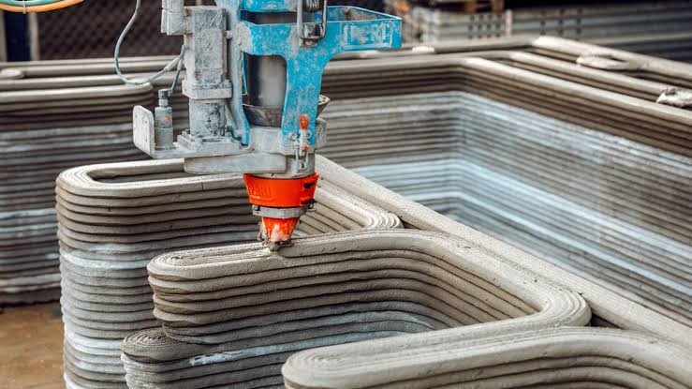
Figure 1. Applications and innovations of 3D printing in architecture and construction.
(Note. Adapted from All3DP (2024))
Figure 1 illustrates the diverse applications of 3D printing technology within the fields of architecture and construction, highlighting key advancements such as 3D-printed residential homes, commercial structures, bridges, and innovative building materials. It demonstrates how additive manufacturing is revolutionizing traditional building processes by reducing material waste, shortening construction times, and enabling complex, sustainable designs that were previously difficult to achieve using conventional methods.
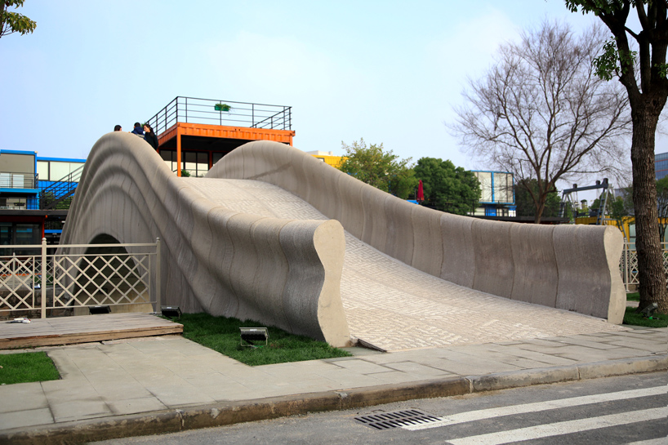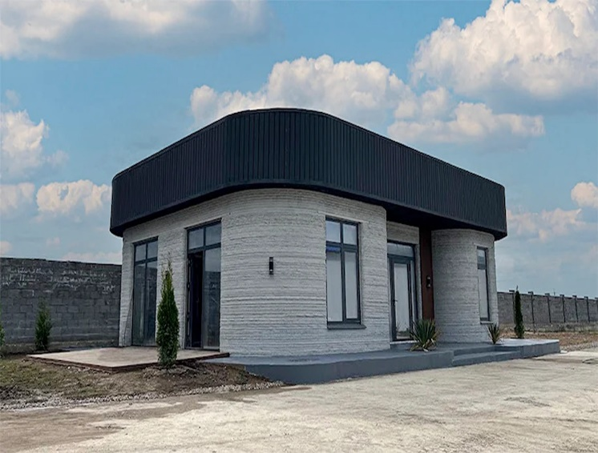
- (b)
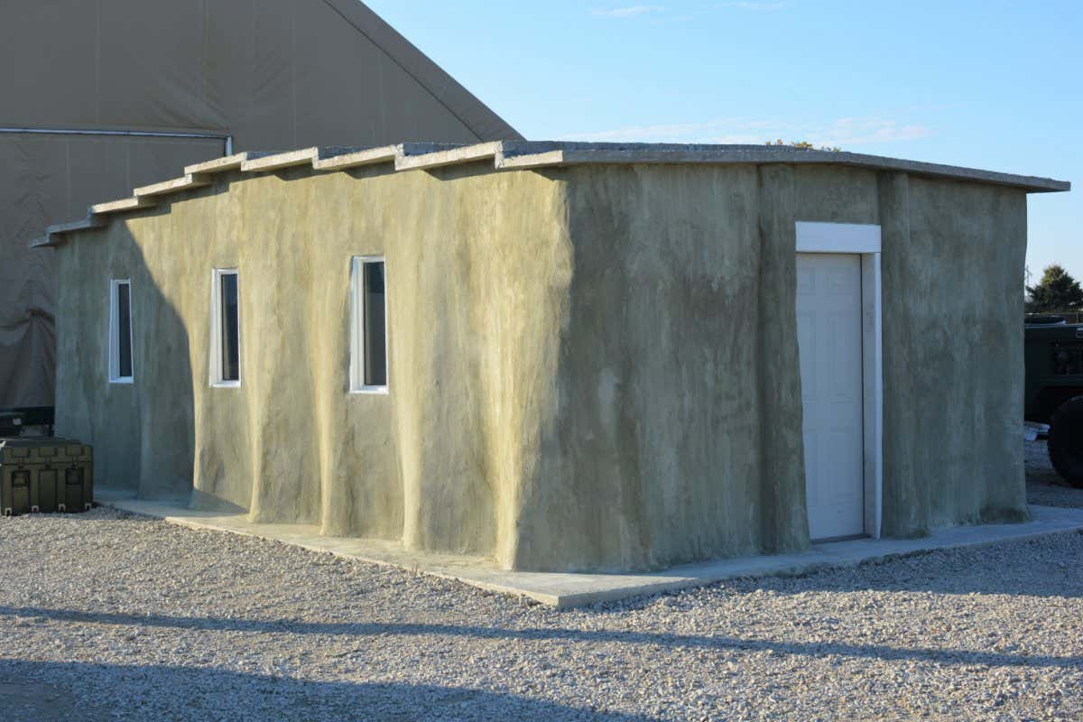
(c) (d)
Figure 2 Famous real-world examples of 3D printing technology for concrete construction: (a) World’s largest 3D printed concrete bridge in Shanghai, China, (b) 8.4 magnitude earthquake resistant 3D printed house in Almaty, Kazakhstan, (c) World’s tallest 3D printed building in Qatar, (d) U.S. Army research and development centre automated structure. Notably, projects such as the 3D-printed houses in Eindhoven, Netherlands, and the Rudenko’s castle in Minnesota, USA, demonstrate the scalability and practical viability of EB3DP for both residential and commercial construction (Bos et al., 2016). AI technologies further enhance these systems by enabling predictive maintenance of printers and dynamic adjustment of printing parameters based on sensor data.

2.1.2 Binder Jetting
Binder jetting (BJ) technology involves the selective deposition of a binding agent onto a powder bed, typically composed of fine aggregates and cementitious materials. Unlike extrusion-based systems, BJ enables the creation of complex geometries and internal structures with high precision and surface quality (Zareiyan & Khoshnevis, 2017). This method supports the construction of lightweight concrete elements with customizable porosity, which is beneficial for thermal insulation and structural optimization. AI integration into BJ systems primarily focuses on optimizing the binder deposition process and powder distribution. Machine learning models analyze print data to adjust binder saturation levels dynamically, preventing defects such as delamination and uneven surface finishes (Wu et al., 2016). Deep learning algorithms have also been deployed to predict powder bed density and homogeneity, key factors affecting mechanical properties post-curing (Han et al., 2018). The main limitation of BJ technology is its lower mechanical strength compared to cast or extruded concrete. However, research is ongoing into AI-driven post-processing techniques, such as automated infiltration and curing optimization, to enhance the mechanical performance of binder-jetted components (Kwon et al., 2020).

2.1.3 3D Printed Formwork and Mesh Mould Techniques
3D printed formworks provide an innovative approach to constructing complex concrete structures by combining additive manufacturing with traditional casting techniques. Formworks are printed using thermoplastics, which are then filled with concrete and later removed or dissolved. This approach significantly reduces material consumption and allows for intricate architectural designs (Hack et al., 2014). AI technologies facilitate the design and optimization of 3D printed formworks by automating the generation of support structures and simulating stress distributions. Generative design algorithms, powered by AI, produce lightweight yet structurally sound formworks by iterating thousands of design variations based on performance criteria (Siddika et al., 2021). Mesh Mould technology, developed by ETH Zurich, integrates reinforcement and formwork into a single structure made from 3D printed meshes of steel or polymer (Hoffmann et al., 2018). AI-driven robotic systems control the mesh printing process, ensuring precise placement of reinforcement elements. This method reduces construction time, material use, and the need for complex formworks, while maintaining high structural performance.

2.2 Material Innovations for Sustainable 3DPC

2.2.1 Conventional and AI-Optimized Mixes
The performance of 3D printed concrete relies heavily on the material composition. Conventional concrete mixes are typically adapted to meet the unique requirements of 3D printing, such as high buildability and rapid setting times. However, the traditional trial-and-error approach to mix design is time-consuming and resource-intensive. AI offers a powerful alternative by enabling the development of predictive models that optimize mix designs. Machine learning algorithms can process large datasets of material properties and performance outcomes to predict optimal mix ratios that balance workability, strength, and sustainability (Chen et al., 2020). These models also consider environmental factors such as temperature and humidity, which influence the setting and curing processes. A significant breakthrough is the use of generative adversarial networks (GANs) and reinforcement learning to simulate and optimize mix designs in virtual environments before physical testing (Pan et al., 2022). Such AI-driven approaches reduce material waste, lower costs, and accelerate innovation cycles in concrete technology.

2.2.2 Geopolymer and Alkali-Activated Binders
Geopolymer concrete, an eco-friendly alternative to ordinary Portland cement (OPC) concrete, is made by activating aluminosilicate materials like fly ash or slag with alkaline solutions. Geopolymers offer reduced CO2 emissions, improved chemical resistance, and high early strength (Provis & Bernal, 2014). AI plays a critical role in optimizing the geopolymerization process. Machine learning models predict the effects of varying activator concentrations, curing conditions, and raw material compositions on the mechanical and durability properties of the resulting geopolymer concrete (Zhang et al., 2019). These predictive models enable the formulation of sustainable, high-performance mixes tailored for 3D printing applications. Furthermore, AI-driven material discovery platforms are being employed to identify novel alkali-activated binders from industrial waste streams, contributing to the circular economy and reducing reliance on virgin raw materials.

2.2.3 Fiber-Reinforced and Waste-Based Materials
Fiber reinforcement enhances the mechanical performance of 3D printed concrete, improving tensile strength, ductility, and crack resistance. Conventional fibers such as steel, polypropylene, and basalt are commonly used. However, optimizing fiber type, orientation, and volume fraction for specific printing processes remains challenging. AI techniques, including deep neural networks and evolutionary algorithms, are being used to model the complex interactions between fibers and cementitious matrices under different loading conditions (Soltan & Li, 2018). These models inform the design of fiber-reinforced concrete mixes that are optimized for 3D printing. In parallel, there is growing interest in incorporating recycled and waste materials into 3D printed concrete. AI algorithms assist in evaluating the compatibility and performance of alternative aggregates and binders derived from construction and demolition waste, slag, and fly ash (Kou et al., 2018). By facilitating material upcycling, AI contributes to reducing the environmental impact of 3DPC.

3. ENVIRONMENTAL SUSTAINABILITY AND AI-DRIVEN ASSESSMENTS

3.1 Life Cycle Assessment (LCA) in 3D Printed Concrete
Life Cycle Assessment (LCA) is a standardized methodology used to evaluate the environmental impacts associated with all stages of a product's life, from raw material extraction to end-of-life disposal. In the construction industry, LCA has emerged as an indispensable tool for quantifying the sustainability of new technologies, including 3D printed concrete (Hauschild et al., 2018). However, conventional LCA models often suffer from static assumptions and limited adaptability to the dynamic nature of construction processes. Here, AI emerges as a transformative enabler.

3.1.1 AI Models for LCA Optimization
AI algorithms can enhance LCA by enabling dynamic, real-time assessments based on actual process data rather than static averages. Machine learning models trained on historical and real-time datasets can predict environmental performance under varying operational scenarios (Chhipi-Shrestha et al., 2020). This is particularly valuable for 3DPC, where variables such as material compositions, energy usage, and construction techniques differ across projects.
Deep learning models have been applied to integrate multi-source data ranging from energy consumption during 3D printing to emissions from raw material production into comprehensive LCA frameworks (Wang et al., 2021). For example, artificial neural networks (ANNs) have been used to model and optimize the environmental footprint of different concrete formulations in terms of their embodied energy and carbon emissions (Yang et al., 2020).
Moreover, AI-driven LCA platforms enable rapid scenario analysis, allowing construction stakeholders to simulate different material choices, design alternatives, and energy strategies to identify the most sustainable options (Sharma et al., 2021). Such dynamic LCA models can adapt in real time to reflect changes in supply chain logistics or energy sourcing, providing a more accurate and responsive sustainability evaluation.

3.1.2 Energy Consumption and Emission Reductions
Energy consumption and greenhouse gas emissions are critical metrics in evaluating the sustainability of 3DPC. Conventional concrete production is a significant contributor to global CO2 emissions, primarily due to cement manufacturing (Scrivener et al., 2018). The use of AI to optimize mix designs can lead to substantial energy savings and emission reductions. Reinforcement learning models have been deployed to optimize printer energy usage during the construction process, adjusting print speeds and layer heights to minimize energy consumption without compromising structural integrity (Zhang et al., 2022). Similarly, predictive analytics can optimize the curing process by determining the minimum necessary energy input to achieve desired mechanical properties (Wu et al., 2021). Case studies show that AI-optimized 3D printed structures can achieve up to 30% reductions in embodied energy compared to conventionally cast structures (Mao et al., 2021).

3.1.3 Waste Minimization through AI Integration
One of the most significant environmental benefits of 3DPC is its ability to minimize material waste through precise additive manufacturing processes. AI enhances this advantage by optimizing print paths and material deposition in real time. Generative design algorithms can create structures with minimal material usage while maintaining performance standards (Huang et al., 2020). Additionally, AI-driven quality control systems, such as machine vision and acoustic emission monitoring, detect defects early in the printing process, reducing the need for rework and material wastage (Khoshnevis et al., 2016). Reinforcement learning models can also adapt print parameters on the fly to accommodate variations in material properties or environmental conditions, further enhancing resource efficiency. Research indicates that AI-augmented 3DPC systems can reduce construction waste by up to 60% compared to traditional methods (Le et al., 2020). Such reductions not only have environmental benefits but also contribute to cost savings, reinforcing the economic sustainability of 3DPC.

4. ECONOMIC AND SOCIAL IMPACT OF AI-ENHANCED 3D PRINTED CONCRETE

4.1 Economic Sustainability and Cost Optimization
Economic sustainability remains a central concern in the widespread adoption of 3D printed concrete (3DPC). Traditional construction methods are labor-intensive and prone to inefficiencies, but 3DPC promises to revolutionize cost structures by reducing labor requirements, material waste, and construction time (Perkins & Skitmore, 2015). When augmented with artificial intelligence (AI), these benefits are magnified through predictive analytics, process optimization, and enhanced supply chain management.

4.1.1 AI-Based Cost Predictions and Analysis
AI techniques, particularly machine learning models, can predict the total cost of construction projects by analyzing a wide range of variables, including material costs, labor productivity, energy consumption, and logistics (Asadi et al., 2020). Regression models and deep learning networks have been employed to estimate costs with higher accuracy compared to traditional parametric models (Pan & Zhang, 2021). Generative design algorithms, powered by AI, optimize structural layouts to minimize material use while maintaining strength and safety requirements. This not only reduces material costs but also cuts down on transportation and assembly expenses (Oseji, et al., 2025). AI also supports the identification of optimal print paths and construction sequences, leading to reduced construction timelines and associated indirect costs (Tay et al., 2017). Real-time monitoring systems enabled by AI can predict equipment maintenance needs, minimizing downtime and costly repairs (Zhang et al., 2022). Predictive maintenance models using AI reduce unexpected failures by analyzing sensor data trends, which is especially valuable for large-scale 3D printers where equipment downtime can significantly disrupt project schedules.

4.1.2 Predictive Maintenance and Operational Efficiencies
AI-driven predictive maintenance leverages historical data and sensor inputs to forecast the failure of critical components within 3DPC systems. By implementing predictive analytics, organizations can shift from reactive maintenance to a proactive approach, thus reducing operational costs and improving equipment longevity (Lee et al., 2018). Studies show that predictive maintenance strategies can lower maintenance costs and reduce downtime (Zonta et al., 2023). In the context of 3DPC, this translates to higher printer utilization rates and better return on investment for expensive equipment. AI also enhances operational efficiency by optimizing energy consumption during the printing process. Reinforcement learning algorithms adjust energy-intensive parameters like print speed, temperature settings, and extrusion rates to minimize power usage without compromising print quality (Wang et al., 2021). These efficiencies directly impact the economic sustainability of AI-enhanced 3DPC by lowering operational expenditures and reducing the carbon footprint of construction projects. While the initial investment for AI and 3D printing technologies is significant, the long-term economic benefits, including reduced labor costs, lower material wastage, and improved project delivery times, make AI-enhanced 3DPC a financially viable option for sustainable construction (Bos et al., 2016).

4.2 Social Sustainability and Workforce Transformation
While AI-enhanced 3D printed concrete offers clear economic advantages, its social implications are equally profound. The automation of construction processes inevitably alters labor market dynamics, necessitating a careful examination of workforce transformation, employment patterns, and social acceptance.

4.2.1 Labor Market Shifts and Employment Trends
The construction sector has traditionally been a major source of employment, particularly in low- and middle-income countries. However, the adoption of AI and automation in 3DPC is reshaping labor demand, reducing the need for manual labor while increasing the demand for skilled professionals in robotics, AI programming, and digital fabrication (Nebrida & Oliveros, 2023). However, new roles are emerging in areas such as machine learning, material science, and digital design, offering opportunities for workforce reskilling and upskilling (Siddiqui, et al., 2023). AI-driven 3DPC demands interdisciplinary competencies, blending traditional construction knowledge with expertise in software development, data science, and mechatronics. Vocational training and educational programs need to be adapted to prepare the future workforce for these shifts (Babashahi et al., 2024). Governments and industry stakeholders must collaborate to develop inclusive policies that support workforce transition and mitigate the risk of job displacement.

4.2.2 Safety Improvements via AI in Construction Sites
Construction remains one of the most hazardous industries globally, with high rates of workplace injuries and fatalities (Nazeer Ahamed & Mariappan, 2023). The integration of AI and 3D printing significantly improves site safety by minimizing human involvement in dangerous tasks and enabling precision automation. Computer vision systems powered by AI can monitor construction sites in real time, detecting safety hazards and non-compliance with safety protocols (Shah & Mishra, 2024). Autonomous 3D printing robots eliminate the need for workers to perform labor-intensive and high-risk activities, thereby reducing the likelihood of accidents. Predictive analytics models can also foresee potential safety incidents based on historical incident data and real-time environmental conditions, allowing for preemptive action (Ezerins et al., 2022). These advances not only improve worker safety but also enhance project timelines and reduce insurance costs, contributing to the overall sustainability of construction projects.

4.2.3 Public Perception and Acceptance
Public acceptance plays a critical role in the widespread adoption of AI-enhanced 3DPC. Concerns regarding job displacement, data privacy, and the reliability of AI systems can hinder adoption (Babšek et al., 2025). Effective communication strategies that emphasize the social and environmental benefits of AI-driven construction technologies are essential to build public trust. Studies indicate that public perception improves when stakeholders are engaged early in the project lifecycle, particularly through participatory design processes and transparent information sharing (Ezeh et al., 2024). Demonstration projects showcasing successful applications of AI and 3DPC can also serve as powerful tools for building community support. Regulatory frameworks need to evolve to address ethical considerations in AI deployment, ensuring that AI systems in construction are fair, transparent, and accoun Supp (Wong, 2021). Inclusive governance models that involve diverse stakeholder groups can help align technological innovation with societal values and priorities.

5. AI-ENHANCED LIFE CYCLE ASSESSMENT (AI-LCA)

5.1 Predictive Models and Big Data Analytics
Traditional Life Cycle Assessment (LCA) frameworks have been instrumental in evaluating environmental impacts in the construction sector, but they often lack the agility and granularity required for modern, dynamic construction practices like 3D printed concrete (3DPC). Artificial Intelligence (AI), specifically through predictive modeling and big data analytics, offers significant advancements in LCA methodologies. Machine learning models, such as artificial neural networks (ANNs) and support vector machines (SVMs), are increasingly applied to predict environmental impacts based on large datasets of material properties, energy consumption patterns, and emission factors (Okpobiri, et al., 2025; Eteh et al.,2025; Jonathan & Charles, 2025). By leveraging historical data and real-time inputs, these models enhance the accuracy and efficiency of LCA evaluations. Big data analytics tools are used to integrate diverse datasets ranging from supply chain logistics to operational energy usage into coherent and comprehensive LCA models (Wang et al., 2021). Predictive analytics enable stakeholders to simulate multiple scenarios and assess their long-term environmental implications, thereby supporting more sustainable decision-making processes (Zhang et al., 2022).

5.2 AI Algorithms for Dynamic Environmental Assessments
AI algorithms allow LCA to move from a static, retrospective tool to a dynamic, forward-looking framework. Reinforcement learning and adaptive algorithms adjust impact assessments in real time as new data becomes available during the construction lifecycle (Sharma et al., 2021). For instance, AI-enhanced LCA models can adjust environmental impact projections based on real-time monitoring of material wastage, energy consumption, and equipment performance. These capabilities enable construction managers to implement corrective actions during the project, rather than waiting until post-completion evaluations.

5.3 Challenges in AI-LCA Integration
Despite its transformative potential, integrating AI into LCA presents several challenges. One significant issue is data quality and availability; AI models require large, high-quality datasets to function effectively, but such datasets are often scarce or incomplete in construction contexts (Aldoseri, et al., 2023). Another challenge lies in the transparency and interpretability of AI models, particularly deep learning architectures, which can act as "black boxes" (Hassija, et al., 2024). This opacity makes it difficult for stakeholders to understand how certain conclusions are reached, potentially undermining trust and regulatory compliance. Additionally, there is a need for standardization in AI-driven LCA methodologies. Without consistent frameworks and validation protocols, comparing results across projects and geographies becomes problematic (International Organization for Standardization [ISO], 2020). Overcoming these challenges will require interdisciplinary collaboration among AI experts, sustainability scientists, construction engineers, and policymakers. By addressing these barriers, AI-LCA can become a cornerstone of sustainable construction, enabling smarter, more responsible 3DPC practices.

6. STRATEGIC PATHWAYS FOR SUSTAINABLE AI-DRIVEN 3DPC

6.1 Multi-Objective Optimization Strategies
Achieving sustainable 3D printed concrete (3DPC) construction necessitates balancing multiple, often conflicting objectives cost, energy consumption, structural performance, and environmental impact. Multi-objective optimization (MOO) strategies, powered by AI, provide robust frameworks for navigating these trade-offs (Chen et al., 2020). Genetic algorithms (GAs) and multi-objective reinforcement learning (MORL) models have been employed to optimize 3DPC designs, simultaneously minimizing material usage, maximizing structural integrity, and reducing carbon emissions (Pan et al., 2022). These AI models can process vast, multidimensional datasets to identify Pareto-optimal solutions, offering stakeholders a suite of balanced options tailored to project-specific sustainability goals. For example, AI-driven design platforms enable the exploration of form-finding processes that yield lighter, stronger, and more resource-efficient structures. This capacity is particularly valuable in reducing the embodied energy of 3DPC components and enhancing overall sustainability performance (Bos et al., 2016).

6.2 AI-Enabled Circular Economy Models
The concept of a circular economy (CE) is gaining traction in construction, emphasizing waste reduction, material reuse, and resource efficiency (Hasibuan et al., 2025). AI technologies facilitate the implementation of CE models in 3DPC by optimizing material selection, predicting end-of-life pathways, and enabling design for disassembly. Machine learning models analyze lifecycle data to identify materials with the highest recyclability and lowest environmental footprints (Neupane, et al., 2025). AI-enabled design tools can create modular, prefabricated components that are easier to deconstruct and repurpose at the end of their service life, promoting material circularity.

6.3 Human-AI Collaboration in Construction Industry
While automation is central to AI-driven 3DPC, human expertise remains indispensable. Human-AI collaboration models emphasize the integration of human judgment with AI capabilities to enhance decision-making, creativity, and ethical oversight (Wu et al., 2020; Xu & Cho 2025). In the construction context, this collaboration can manifest in AI-augmented design processes where architects and engineers interact with AI systems to co-create optimized structural solutions. Similarly, human operators can oversee AI-driven 3D printing processes, ensuring adaptability and resilience in the face of unexpected challenges. Training programs that blend AI literacy with construction skills are essential to prepare the workforce for this collaborative future (Cheng, et al., 2024). Such initiatives will ensure that the benefits of AI-enhanced 3DPC are maximized while preserving human creativity, judgment, and ethical standards. By embracing MOO strategies, circular economy models, and human-AI collaboration, the construction industry can harness the full potential of AI-driven 3DPC to build a more sustainable, resilient, and inclusive built environment.

7. Conclusion
The integration of Artificial Intelligence (AI) into 3D printed concrete (3DPC) marks a transformative advancement toward sustainable construction practices. By leveraging AI’s capabilities in predictive analytics, real-time process optimization, and dynamic life cycle assessment (LCA), 3DPC can significantly improve environmental, economic, and social sustainability outcomes. AI-driven models facilitate resource-efficient material design, reduce construction waste, enhance energy efficiency, and improve site safety through automation. Despite these promising advancements, several critical challenges persist. Issues such as data scarcity, algorithmic opacity, high computational demands, and workforce displacement require targeted interventions. Addressing these barriers necessitates the development of robust data ecosystems, transparent and interpretable AI models, and comprehensive reskilling programs for the construction workforce. To fully unlock the potential of AI-enhanced 3DPC, strategic pathways must be prioritized. Multi-objective optimization frameworks can balance competing sustainability goals, while circular economy models promote material reuse and lifecycle resource efficiency. Furthermore, fostering human-AI collaboration ensures that human expertise complements machine intelligence, promoting ethical oversight and resilience in construction processes. As the global construction industry navigates mounting pressures for sustainability and efficiency, the convergence of AI and 3D printing technologies offers a compelling pathway toward creating resilient, low-carbon, and socially inclusive built environments. Achieving this vision demands interdisciplinary collaboration among researchers, industry practitioners, and policymakers, who must collectively drive innovation, establish regulatory frameworks, and ensure that AI-enhanced 3DPC delivers tangible benefits to society at large.

COMPETING INTERESTS DISCLAIMER:
Authors have declared that they have no known competing financial interests OR non-financial interests OR personal relationships that could have appeared to influence the work reported in this paper.

References
- United Nations Environment Programme (UNEP). (2021). 2021 Global Status Report for Buildings and Construction. https://globalabc.org/resources/publications/2021-global-status-report-buildings-and-construction
- United Nations. (2019). World Urbanization Prospects: The 2018 Revision. United Nations Department of Economic and Social Affairs, Population Division.
- Buswell, R. A., Leal de Silva, W. R., Jones, S. Z., & Dirrenberger, J. (2018). 3D printing using concrete extrusion: A roadmap for research. Cement and Concrete Research, 112, 37–49. https://doi.org/10.1016/j.cemconres.2018.05.006
- Achouch, M., Dimitrova, M., Ziane, K., Sattarpanah Karganroudi, S., Dhouib, R., Ibrahim, H., & Adda, M. (2022). On Predictive Maintenance in Industry 4.0: Overview, Models, and Challenges. Applied Sciences, 12(16), 8081. https://doi.org/10.3390/app12168081
- Moghayedi, A., Mahachi, J., Lediga, R., Mosiea, T., & Phalafala, E. (2024). Revolutionizing affordable housing in Africa: A comprehensive technical and sustainability study of 3D-printing technology. Sustainable Cities and Society, 105, 105329. https://doi.org/10.1016/j.scs.2024.105329
- Chen, Q., Lai, X., Zhang, Y., Chen, J., Zheng, Y., Song, X., Han, X., & Ouyang, M. (2025). AI-driven sustainability assessment for greener lithium-ion batteries. Carbon Footprints, 4(12). http://dx.doi.org/10.20517/cf.2025.14
- Mushthofa, M., Thedy, J., Teguh, M., Purwanto, Pratama, A. G., & Han, A. L. (2025). Artificial Intelligence in Geopolymer Concrete Mix Design: A Comprehensive Review of Techniques and Applications. Iranian Journal of Science and Technology - Transactions of Civil Engineering, Article 124251. https://doi.org/10.1007/s40996-025-01873-8
- Wang, X., Chen, M., & Chen, N. (2024). How artificial intelligence affects the labour force employment structure from the perspective of industrial structure optimisation. Heliyon, 10(5), e26686. https://doi.org/10.1016/j.heliyon.2024.e26686
- Zhao, T., Wang, S., Ouyang, C., Chen, M., et al. (2024). Artificial intelligence for geoscience: Progress, challenges, and perspectives. The Innovation, 5(5), 100691. https://doi.org/10.1016/j.xinn.2024.100691
- Bos, F. P., Wolfs, R. J. M., Ahmed, Z. Y., & Salet, T. A. M. (2016). Additive manufacturing of concrete in construction: Potentials and challenges of 3D concrete printing. Virtual and Physical Prototyping, 11(3), 209–225. https://doi.org/10.1080/17452759.2016.1209867
- Tay, Y. W. D., Panda, B., Paul, S. C., Noor Mohamed, N. A., Tan, M. J., & Leong, K. F. (2017). 3D printing trends in building and construction industry: A review. Virtual and Physical Prototyping, 12(3), 261–276. https://doi.org/10.1080/17452759.2017.1326724
- Le, T. T., Austin, S. A., Lim, S., Buswell, R. A., Gibb, A. G., & Thorpe, T. (2012). Mix design and fresh properties for high-performance printing concrete. Materials and Structures, 45(8), 1221–1232. https://doi.org/10.1617/s11527-012-9828-z
- Talaei, A., Zadeh, H. H., Bougherara, H., & Mohamed, A. (2023). Computer vision applications in 3D concrete printing: A state-of-the-art review. Automation in Construction, 149, 104782. https://doi.org/10.1016/j.autcon.2023.104782
- Zareiyan, B., & Khoshnevis, B. (2017). Automated construction by contour crafting—Related robotics and information technologies. Automation in Construction, 31, 1–12. https://doi.org/10.1016/j.autcon.2012.10.003
- Wu, P., Wang, J., Wang, X., & Kim, H. (2016). A critical review of the use of 3-D printing in the construction industry. Automation in Construction, 68, 21–31. https://doi.org/10.1016/j.autcon.2016.04.005
- Han, Y., Lee, H. J., & Park, H. (2018). Prediction of powder bed density in binder jetting additive manufacturing. Journal of Manufacturing Processes, 32, 700–707. https://doi.org/10.1016/j.jmapro.2018.03.004
- Kwon, Y. B., Kim, D. J., & Lee, J. (2020). Post-processing techniques for enhanced properties of binder-jet printed parts: A review. Additive Manufacturing, 32, 101019. https://doi.org/10.1016/j.addma.2020.101019
- Hack, N., Krämer, S., Dörfler, K., Walzer, A. N., & Gramazio, F. (2014). Mesh Mould: Robotic fabrication of complex, reinforced concrete structures without formwork. Robotic Fabrication in Architecture, Art and Design 2014, 293–306. https://doi.org/10.1007/978-3-319-04663-1_21
- Siddika, A., Mamun, M. A. A., Alyousef, R., & Amran, Y. H. M. (2021). Geopolymer concrete as a sustainable material: A state-of-the-art review. Construction and Building Materials, 255, 119379. https://doi.org/10.1016/j.conbuildmat.2020.119379
- Hoffmann, S., Gramazio, F., & Kohler, M. (2018). Mesh Mould: An on-site, robotically fabricated functional formwork. Fabricate 2018: Rethinking Design and Construction, 124–129.
- Chen, Y., Yang, H., & Wu, J. (2020). Multi-objective optimization for sustainable concrete mix design using machine learning approaches. Automation in Construction, 118, 103294. https://doi.org/10.1016/j.autcon.2020.103294
- Pan, Y., Zhao, Y., & Gong, L. (2022). Reinforcement learning-based multi-objective optimization for sustainable construction design. Automation in Construction, 137, 104190. https://doi.org/10.1016/j.autcon.2022.104190
- Provis, J. L., & Bernal, S. A. (2014). Geopolymers and related alkali-activated materials. Annual Review of Materials Research, 44, 299–327. https://doi.org/10.1146/annurev-matsci-070813-113515
- Zhang, Z., Yao, X., Zhu, H., & Zhu, H. (2019). Machine learning for predicting properties of geopolymer concrete: A review. Construction and Building Materials, 211, 23–42. https://doi.org/10.1016/j.conbuildmat.2019.03.226
- Saeed, A., Abbas, A., Usman, M., & Muhammad, A. (2021). Waste-derived alkali-activated binders: Sustainability assessment. Journal of Cleaner Production, 278, 123928. https://doi.org/10.1016/j.jclepro.2020.123928
- Soltan, D. G., & Li, V. C. (2018). A review of recent advances in engineered cementitious composites: Material, design, and application. Advanced Civil Infrastructure Materials, 423–457. https://doi.org/10.1016/B978-0-08-102214-5.00013-1
- Kou, S. C., & Poon, C. S. (2018). Properties of concrete prepared with PVA fibers and recycled aggregate. Materials and Structures, 51(1), 1–13. https://doi.org/10.1617/s11527-017-1147-1
- Hauschild, M. Z., Rosenbaum, R. K., & Olsen, S. I. (2018). Life cycle assessment: Theory and practice. Springer.
- Chhipi-Shrestha, G. K., Hewage, K., & Sadiq, R. (2020). Enhancing building life cycle assessment with machine learning. Journal of Cleaner Production, 276, 124319. https://doi.org/10.1016/j.jclepro.2020.124319
- Wang, C., Zhong, R., & Luo, J. (2021). AI-enhanced sustainable construction. Journal of Cleaner Production, 313, 127904. https://doi.org/10.1016/j.jclepro.2021.127904
- Yang, Y., Zhang, L., Xu, S., & Li, H. (2020). Machine learning-based environmental performance assessment for concrete. Journal of Cleaner Production, 258, 120670. https://doi.org/10.1016/j.jclepro.2020.120670
- Sharma, A., Walker, W. E., & Dolan, S. (2021). Deep learning and the construction industry: Survey and future directions. Automation in Construction, 130, 103851. https://doi.org/10.1016/j.autcon.2021.103851
- Scrivener, K., John, V. M., & Gartner, E. M. (2018). Eco-efficient cements: Potential economically viable solutions for a low-CO2 cement-based materials industry. Cement and Concrete Research, 114, 2–26. https://doi.org/10.1016/j.cemconres.2018.03.015
- Wu, P., Wang, J., Wang, X., & Kim, H. (2021). Big data analytics for life-cycle environmental impact assessment of construction projects. Automation in Construction, 127, 103691. https://doi.org/10.1016/j.autcon.2021.103691
- Zhang, J., Zheng, L., Wang, Q., & Han, K. (2022). Deep learning for 3D printing: A comprehensive review. Automation in Construction, 136, 104174. https://doi.org/10.1016/j.autcon.2022.104174
- Mao, C., Shen, Q., Pan, W., & Ye, K. (2021). Major barriers to off-site construction: The developer’s perspective in China. Journal of Management in Engineering, 37(2), 04020098. https://doi.org/10.1061/(ASCE)ME.1943-5479.0000874
- Huang, Y., Chen, X., & Shen, W. (2020). Generative design in building construction: A review and future directions. Automation in Construction, 119, 103332. https://doi.org/10.1016/j.autcon.2020.103332
- Khoshnevis, B., Hwang, D., Yao, K. T., & Yeh, Z. (2016). Mega-scale fabrication by contour crafting. International Journal of Industrial and Systems Engineering, 24(4), 410–421. https://doi.org/10.1504/IJISE.2016.079019
- Le, T. T., Austin, S. A., Lim, S., Buswell, R. A., Gibb, A. G., & Thorpe, T. (2020). Building freeform construction: Lessons from 3D printing research. Automation in Construction, 112, 103108. https://doi.org/10.1016/j.autcon.2020.103108
- Perkins, I., & Skitmore, M. (2015). Three-dimensional printing in the construction industry: A review. International Journal of Construction Management, 15(1), 1–9. https://doi.org/10.1080/15623599.2015.1012136
- Asadi, E., Amiri, S. S., Wong, K. Y., & Bagheri, B. (2020). Artificial intelligence applications in the construction industry: A review. Journal of Building Engineering, 32, 101660. https://doi.org/10.1016/j.jobe.2020.101660
- Oseji, S., Imoni, O., & Okonkwo, C. (2025). 3D-printed Housing for Remote and Disaster-prone U.S. Regions: Technological Potential and Deployment Challenges. Journal of Engineering Research and Reports, 27(6), 97–109. https://doi.org/10.9734/jerr/2025/v27i61531
- Zhong, D., Xia, Z., Zhu, Y., & Duan, J. (2023). Overview of predictive maintenance based on digital twin technology. Heliyon, 9(4), e14534. https://doi.org/10.1016/j.heliyon.2023.e14534
- Nebrida , J. A., & Oliveros, O. (2023). Artificial Intelligence Utilized in 3D Printing Construction Technology. Asian Journal of Advanced Research and Reports, 17(4), 20–25. https://doi.org/10.9734/ajarr/2023/v17i4476
- Siddiqui, F. H., Thaheem, M. J., & Abdekhodaee, A. (2023). A Review of the Digital Skills Needed in the Construction Industry: Towards a Taxonomy of Skills. Buildings, 13(11), 2711. https://doi.org/10.3390/buildings13112711
- Babashahi, L., Barbosa, C. E., Lima, Y., Lyra, A., Salazar, H., Argôlo, M., Almeida, M. A. d., & Souza, J. M. d. (2024). AI in the Workplace: A Systematic Review of Skill Transformation in the Industry. Administrative Sciences, 14(6), 127. https://doi.org/10.3390/admsci14060127
- Nazeer Ahamed, M. F., & Mariappan, M. (2023). A study to determine human-related errors at the level of top management, safety supervisors & workers during the implementation of safety practices in the construction industry. Safety Science, 162, 106081. https://doi.org/10.1016/j.ssci.2023.106081
- Shah, I. A., & Mishra, S. (2024). Artificial intelligence in advancing occupational health and safety: An encapsulation of developments. Journal of Occupational Health, 66(1), Article uiad017. https://doi.org/10.1093/joccuh/uiad017
- Ezerins, M. E., Ludwig, T. D., O'Neil, T., Foreman, A. M., & Açıkgöz, Y. (2022). Advancing safety analytics: A diagnostic framework for assessing system readiness within occupational safety and health. Safety Science, 146, 105569. https://doi.org/10.1016/j.ssci.2021.105569
- Babšek, M., Ravšelj, D., Umek, L., & Aristovnik, A. (2025). Artificial Intelligence Adoption in Public Administration: An Overview of Top-Cited Articles and Practical Applications. AI, 6(3), 44. https://doi.org/10.3390/ai6030044
- Ezeh, M., Ogbu, A., Ikevuje, A. H., & George, E. (2024). Stakeholder engagement and influence: Strategies for successful energy projects. International Journal of Management & Entrepreneurship Research, 6(7), 2375–2395. https://doi.org/10.51594/ijmer.v6i7.1330
- Wong, A. (2021). Ethics and regulation of artificial intelligence. In Proceedings of the 8th IFIP International Workshop on Artificial Intelligence for Knowledge Management (AI4KM) (pp. 1–18). Yokohama, Japan. https://doi.org/10.1007/978-3-030-80847-1_1
- Okpobiri, O., Akajiaku, C. U., Eteh, D. R., & Moses, P. (2025). Using Machine Learning and GIS to Monitor Sandbars Along the River Niger in the Niger Delta, Nigeria. International Journal of Environment and Climate Change, 15(2), 182–203. https://doi.org/10.9734/ijecc/2025/v15i24721
- Eteh, D. R., Japheth, B. R., Akajiaku, C. U., Osondu, I., Mene-Ejegi, O. O., Nwachukwu, E. M., … & Ayo-Bali, A. E. (2025). Assessing the impact of climate change on flood patterns in downstream nigeria using machine learning and geospatial techniques (2018-2024).. https://doi.org/10.21203/rs.3.rs-5776752/v1
- Jonathan, L. E., & Charles, A. U. (2025). Shoreline Erosion and Accretion Analysis of the Orashi River, Rivers State, Nigeria: A Geospatial and Machine Learning Approach. Asian Journal of Geographical Research, 8(2), 27-44.
- Aldoseri, A., Al-Khalifa, K. N., & Hamouda, A. M. (2023). Re-Thinking Data Strategy and Integration for Artificial Intelligence: Concepts, Opportunities, and Challenges. Applied Sciences, 13(12), 7082. https://doi.org/10.3390/app13127082
- Hassija, V., Chamola, V., & Mahapatra, A. (2024). Interpreting black-box models: A review on explainable artificial intelligence. Cognitive Computation, 16(1), 45–74. https://doi.org/10.1007/s12559-023-10179-8
- International Organization for Standardization. (2020). ISO 14044: Environmental management — Life cycle assessment — Requirements and guidelines (ISO Standard No. 14044:2006+Amd1:2017). ISO. https://www.iso.org/standard/38498.html
- Hasibuan, G. C. R., Al Fath, M. T., Yusof, N., Dewi, R. A., Syafridon, G. G. A., Jaya, I., Anas, M. R., & Syahrizal. (2025). Integrating circular economy into construction and demolition waste management: A bibliometric review of sustainable engineering practices in the built environment. Case Studies in Chemical and Environmental Engineering, 11, 101159. https://doi.org/10.1016/j.cscee.2025.101159
- Neupane, B., Belkadi, F., Formentini, M., Rozière, E., Hilloulin, B., Abdolmaleki, S. F., & Mensah, M. (2025). Machine learning algorithms for supporting life cycle assessment studies: An analytical review. Sustainable Production and Consumption, 56, 37–53. https://doi.org/10.1016/j.spc.2025.03.015
- Xu, C., & Cho, S.-E. (2025). Factors Affecting Human–AI Collaboration Performances in Financial Sector: Sustainable Service Development Perspective. Sustainability, 17(10), 4335. https://doi.org/10.3390/su17104335
- Wu, F., Lu, C., Zhu, M., Chen, H., Zhu, J., Yu, K., Li, L., Li, M., Chen, Q., Li, X., Cao, X., Wang, Z., Zha, Z., Zhuang, Y., & Pan, Y. (2020). Towards a new generation of artificial intelligence in China. Nature Machine Intelligence, 2(6), 312–316. https://doi.org/10.1038/s42256-020-0183-4
- Cheng, J.-Y., Devkota, A., Gheisari, M., & Jeelani, I. (2024). Integrating a module on artificial intelligence literacy in an undergraduate construction management course. In T. Leathem, W. Collins, & A. Perrenoud (Eds.), Proceedings of 60th Annual Associated Schools of Construction International Conference (EPiC Series in Built Environment, Vol. 5, pp. 93–101). EasyChair. https://doi.org/10.29007/p595

