***Original Research Article***

**Hydro-chemical Dynamics and Sustainability of Groundwater in Coastal Kasaragod: An Integrated Approach**

**Abstract**

Groundwater quality is a critical factor in the sustainable management of coastal water resources, particularly in regions prone to seawater intrusion and anthropogenic pressures. Using an integrated geochemical approach, this study investigates groundwater's hydrochemical dynamics in the coastal zones of Kasaragod, Kerala, India. Groundwater samples from key locations were analyzed using Piper, Schoeller, and Stiff diagrams, complemented by statistical techniques to assess spatial variability and hydrochemical facies. The study has found out that there is considerable intrusion of saltwater along the Kasaragod coast which indicates extensive groundwater extraction. These findings underline the necessity for sustainable groundwater management practices, including regular monitoring, regulation of extraction, and pollution control measures, to ensure the long-term viability of groundwater resources. This study offers a framework for addressing groundwater quality challenges in coastal environments, with regional and global implications for water sustainability.

**Keywords:** Groundwater, Hydro-chemical, Coastal Water, Piper Diagram, Schoeller Diagram, And Stiff Diagram.

1. **Introduction**

Though accounting only a fraction of Earth’s total water resources (0.06%) (UN Water, 2022), Groundwater accounts for 99% of liquid freshwater in Earth (Schwartz & Zhang, 2003). This hidden yet vital resource supports nearly half of the global population's drinking water needs, sustains agricultural irrigation, and supplies a significant portion of industrial water demand. Unlike surface water, groundwater is shielded from immediate environmental fluctuations, making it a more reliable source in times of drought or water scarcity. Billions of people live in coastal regions around the world accounting for about 38.1% of the world's population (Cosby et al., 2024) and groundwater is the primary source of water supply to the coastal regions. Coastal aquifers serve as the major water supply units to these regions (Ajami, 2021). Coastal areas experience very high population density and higher urbanisation especially in densely populated regions like Kerala coastal plains, India (Sajjad et al., 2021). This density and urbanization lead to large scale groundwater extraction, and it is necessary to maintain the quality of this groundwater to provide a healthy water supply for the coastal population.

Biological, physical as well as chemical characteristics of groundwater indicates its quality. The quality of groundwater is determined by chemical characteristics like ions of elements (CO3, HCO3, Cl, SO4, K, N etc…), physical factors like electrical conductivity and biological constituents like presence of coliform bacteria, oxygen demand and biological oxygen demand (Harter, 2003). Groundwater quality is influenced by both natural processes, such as rock-water interactions, mineral weathering, and soil composition, and anthropogenic factors, including agricultural runoff, industrial discharge, and domestic wastewater (Khatri & Tyagi, 2015). In coastal regions, the quality of groundwater is further impacted by the intrusion of seawater (Ajami, 2021), which alters the chemical composition by increasing salinity levels and introducing ions like sodium and chloride. Monitoring these parameters is essential to identify potential contamination sources and assess the overall health of aquifers. Poor water quality not only affects human health by increasing the risk of waterborne diseases but also reduces the suitability of groundwater for agricultural and industrial purposes. Regular groundwater quality assessments, using tools such as Piper, Schoeller, and Stiff diagrams, can help in visualizing spatial and temporal variations, providing critical insights for implementing targeted remediation and sustainable management strategies. Ensuring optimal water quality is pivotal to preserving the socioeconomic and environmental well-being of coastal communities.

Groundwater resources are in a much greater threat in coastal areas under great pressure from population growth, urbanization, and climate change (Kumar, 2012). Their sustainable management will demand the extraction options coupled with free recharges, accentuating the necessity for water conservation measures, controlled abstraction, and protection of recharge zones. The case gets even more complicated in coastal areas due to seawater intrusion into aquifers, affecting the quality and availability of fresh water. Assessment of groundwater quality is undoubtedly important for its sustainable management. A hydrochemical study provides understanding of all the interaction linkages derived as a result of natural processes, including rock-water dynamics together with anthropogenic activities, such as agricultural runoff and industrial pollution. Upon recognition of the various spatial and temporal changes in groundwater composition, the strategies to mitigate contaminations, prevent extraction, and counter salinity intrusion can be framed. Proper monitoring of groundwater quality provides a basis from which policy initiatives can be developed and public awareness can be raised that this precious resource can continue to sustain the needs of present and future generations in harmony with nature.

Kasaragod, the northernmost district of Kerala, is characterized by a narrow coastal plain flanked by lateritic uplands and the Arabian Sea. This unique geomorphological setting, combined with high population density and intensive agricultural activities, places immense stress on groundwater resources. A few studies have been conducted on parts of Kasaragod coast. Mamidi & Jafar, 2023 evaluated the hydrogeochemical aspects of a portion of unconfined aquifer in SW Kasaragod coast for assessing drinking and irrigation water quality employing water quality index to identify vulnerable regions of groundwater quality. Gopalan & Chikkamadaiah, 2015 assessed the impacts of saltwater intrusion on groundwater quality of the northern portion of Kasaragod coast utilizing Electrical conductivity values. This study employs statistical techniques and plots to examine the qualitative characteristics of groundwater by examining the hydrogeochemical facies of groundwater samples from the study area.

1. **Study Area**

Kasaragod is in the northern part of Kerala, which shares borders with Karnataka to the north and east, the Arabian Sea to the west, and Kannur district to the south. The Kasaragod district includes 12 coastal panchayaths which are Thrikkaripur, Valiyaparamba, Padne, Cheruvathur, Ajannur, Pallikkara, Uduma, Chemnad, Mogral Puthur, Kumbala, Mangalpady, Manjeswar and three municipalities include Kanhangad, Kasaragod and Nileswar has selected for the study. The length of the coastline of Kasaragod is 70km which extends from Manjeswar to Valiyaparamba. The coastal zone of Kasaragod is located between 12˚26’23” to12˚27’56” N latitudes and 74˚51’33” to 75˚10’36” East longitude. The coastal area is densely populated and major towns are located along the coastal stretch. The region experiences a tropical climate with an average annual rainfall of approximately 3000 mm. Laterite soils dominate the higher midland areas, whereas the western coastal regions are enriched with fertile, nutrient-rich loam. High temperatures are observed during the summer months, from March to May.

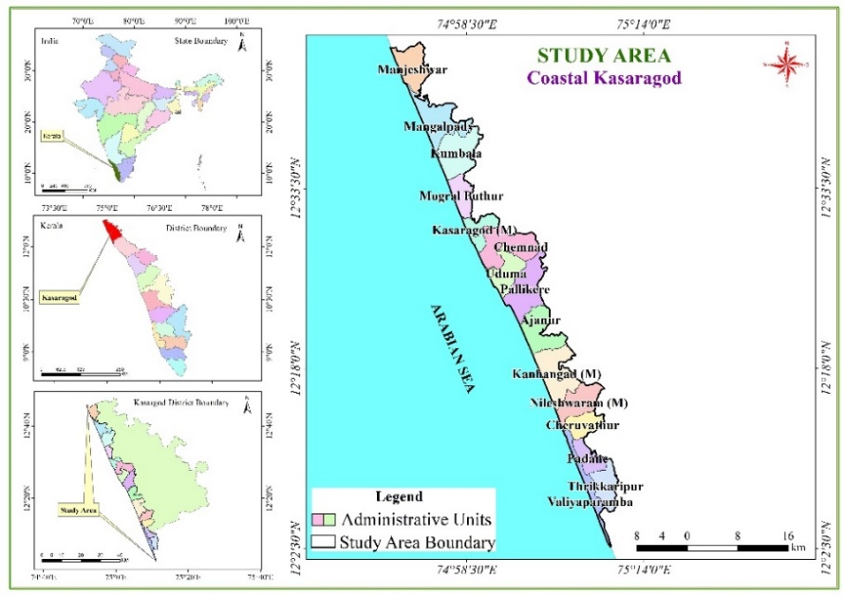

Fig.1: Location map of the Study area

1. **Materials and Methods**

This study primarily relies on secondary data collected from the India Water Resource Information System (IWRIS), the interactive water resource information platform of the Ministry of Jal Shakthi, Government of India. The data was supplemented with primary data collected from some sample locations across the Kasaragod coast. Hydrochemical data from 25 sampling locations dispersed along the length and breadth of the Kasaragod coast were collected and analyzed for the study. The sample locations are: Ajannur, Bekal, Chamundikunnu, Chowki, Elambachi, Kalikkadavu, Kanhangad, Kanhangad town, Kannadippara, Kasaragod, Kumbala, Mangalpady, Manjeshwar town, Manjeshwar, Mavungal, Melparamba, Mogral, Mogral town, Mogral Puthur, Nileshwar, Pullur, Thachangad, Trikkarippur, Udinur central, Uppala located across 15 coastal local self-governing bodies (Panchayats and Municipalities) in the study area.

Groundwater quality parameters analyzed in this study included bicarbonate (HCO3​), carbonate (CO3​), sulfate (SO4​), chloride (Cl), sodium (Na), calcium (Ca), magnesium (Mg), potassium (K), pH, total dissolved solids (TDS), and total hardness (TH). Descriptive statistical analyses, such as mean, minimum, maximum, and standard deviation, were employed to summarize the hydrochemical data and identify regional variability. Advanced geochemical analyses were conducted to understand groundwater dynamics. Piper diagrams were generated using Python programming, while Schoeller and Stiff plots were prepared using the open-source web application aquiferApp, developed by Hatari Labs. These visual tools provided insights into the study area's overall groundwater quality and hydrochemical facies, enabling a detailed assessment of spatial patterns and potential influences of natural and anthropogenic factors on groundwater quality. ArcGIS software was used to generate maps of the study area and sampling sites.

1. **Results and Discussions**
   1. **Hydro-chemical analysis of groundwater samples**
      1. **Piper plot**

The Piper plot, introduced by Arthur M. Piper in 1944, is a widely used graphical representation for the geochemical classification of water. This trilinear diagram is designed to visualize the major cationic (e.g., Ca2+, Mg2+, Na+, K+) and anionic (e.g., HCO3−​, SO2−​, Cl−) constituents of groundwater, along with their interactions. The plot consists of two triangular fields—one for cations and one for anions—combined with a central diamond field that provides a comprehensive overview of the hydrochemical facies. The Piper plot serves as a valuable tool in hydrochemical studies, enabling the identification of dominant water types, such as calcium bicarbonate or sodium chloride, as well as the characterization of salinity intrusion, mixing processes, and anthropogenic impacts. By comparing spatial and temporal variations in water composition, it helps to assess the factors influencing groundwater chemistry, such as rock-water interactions, seawater intrusion, and contamination.

Piper analysis (Fig.2) of the study area depicts that majority of samples (12 samples) have no dominant type in the catatonic triangle and a few samples lean towards sodium (8 samples - Ajannur, Kalikkadavu, Melparamba, Mangalpady, Pullur, Kanhangad town, Kasaragod and Kannadippara) and calcium dominant (5 Samples- Kumbala, Uppala, Kanhangad, Udinur central and Manjeshwar) sides. Even though most of the samples fall under no dominant cation side, there is a tendency of clustering towards the sodium side indicating mixing of saltwater due to seawater intrusion or anthropogenic activities.

On the anion triangle, the composition is equally divided between Calcium Magnesium carbonate type (12 samples) and Bicarbonate type (12 samples) one sample (Mogral Puthur) in no dominant type. This also denotes the probability of seawater intrusion. The water type is predominantly alkaline. Calcium and Bicarbonate types usually include water which interacts with limestone regions and carbonate rocks. However the terrain of the Kasaragod coast mostly consists of lateritic formations and is generally devoid of limestone formations (Prasad, 2018).

The groundwater in the study area generally belongs to two types of hydrochemical facies: Calcium magnesium bicarbonate (10 samples) and Sodium chloride (9 samples) based on the diamond diagram in piper plot. This indicates that most of the study area have undergone seawater intrusion and laterite weathering (Al-Khatib & Al-Najar, 2011).

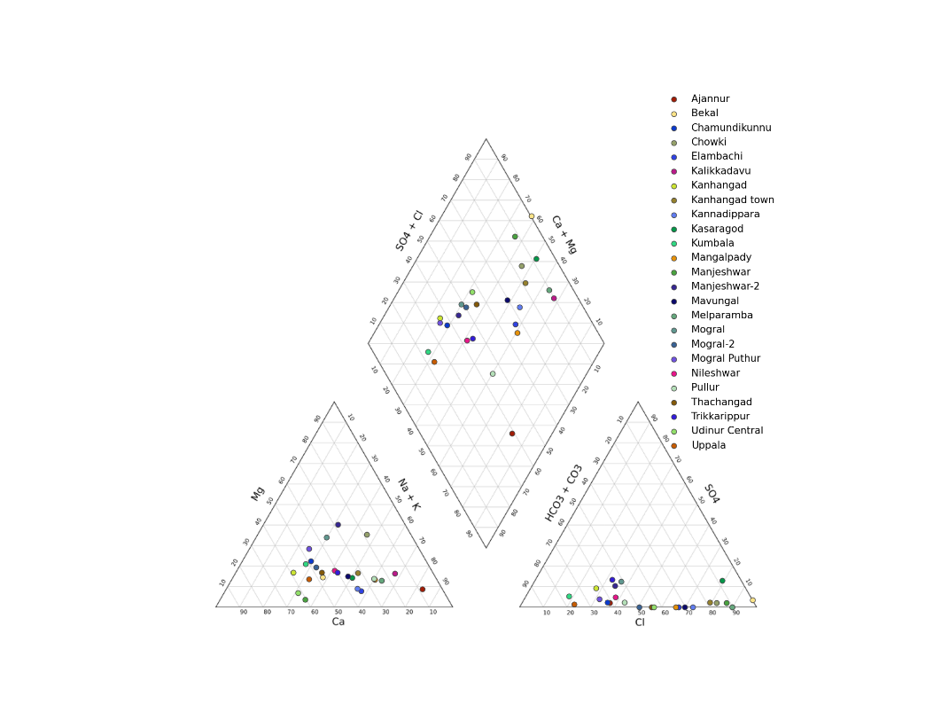

Fig.2: Piper plot

* + 1. **Schoeller** **Diagram**

The Schoeller diagram, first introduced by Helmut Schoeller in 1956, is a semi-logarithmic graphical representation widely used in hydrochemical studies to compare the ionic composition of water samples (Scholler, H., 1956). Unlike trilinear diagrams like the Piper plot, the Schoeller diagram provides a comprehensive visualization of the concentration of major ions across multiple samples in a single plot. The logarithmic scale allows for the identification of patterns, trends, and relative dominance of specific ions, making it particularly useful for evaluating spatial and temporal variations in groundwater chemistry. This tool is instrumental in detecting hydrochemical facies, salinity levels, and potential contamination sources. It also facilitates comparisons between water samples by plotting ionic concentrations along a vertical axis for each sample. A consistent pattern in the plotted lines reflects similar hydrochemical characteristics, while deviations may indicate processes such as rock-water interactions, seawater intrusion, or anthropogenic influences.

The Schoeller plot analysis (Fig.3) reinforces the findings from the Piper plot, highlighting significant hydrochemical processes governing groundwater quality in the Kasaragod coastal region. The dominant presence of calcium and sodium among cations, along with chloride and sulfate among anions, suggests a complex interaction between natural geochemical processes and anthropogenic influences. The high concentrations of calcium indicate substantial rock-water interaction. This signifies that groundwater recharge areas are primarily influenced by carbonate weathering. However, the elevated sodium levels in some locations point toward the possible influence of seawater intrusion, a prevalent issue in coastal aquifers where overextraction leads to the encroachment of saline water into freshwater zones. Additionally, cation exchange processes might contribute to increased sodium concentrations by replacing calcium and magnesium in clay-rich formations. Similarly, sulfate enrichment in select samples may be attributed to either natural gypsum dissolution or contamination from human activities such as the use of sulfate-based fertilizers and industrial effluents. the lower concentrations of magnesium observed in the Schoeller plot indicate limited contributions from silicate weathering or lesser influence of clay mineral dissolution. Potassium is usually retained in soil and clay minerals, making it less mobile in groundwater systems. Its lower concentration suggests minimal anthropogenic impact from agricultural fertilizers or industrial waste disposal. Similarly, the relatively lower levels of bicarbonate in some samples, despite its general dominance in freshwater systems, may indicate the dilution effect from seawater intrusion or reduced carbonate dissolution in certain areas. These hydrochemical trends indicate a dynamic groundwater system where freshwater and saline water interactions vary spatially. The implications of these findings are critical for groundwater management, as the presence of salinity ingress in certain zones suggests the need for immediate interventions, including controlled groundwater extraction and artificial recharge to prevent further salinization. Regular water quality monitoring is essential to assess the progression of seawater intrusion and detect pollution hotspots, thereby ensuring sustainable water resource management. Identifying freshwater recharge zones and protecting them from overextraction and contamination should be a key priority for long-term groundwater sustainability. In summary, the Schoeller plot confirms the hydrochemical variability and the need for strategic interventions to mitigate groundwater quality deterioration, making it essential to implement sustainable groundwater management practices to preserve the water resources of the Kasaragod coast.

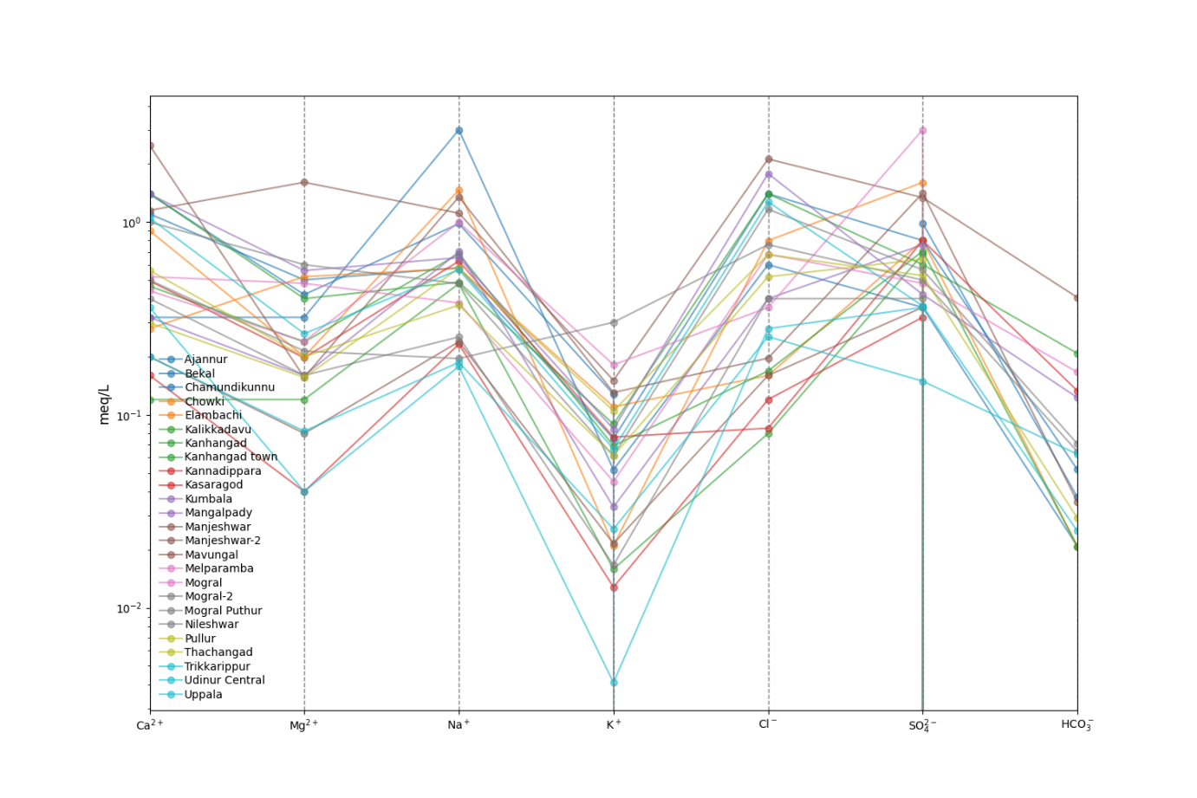

Fig.3: Schoeller diagram

* + 1. **Stiff** **Plot**

The Stiff plot, introduced by H.A. Stiff in 1951, is a graphical method used in hydrogeochemical studies to visualize and compare the major ionic composition of water samples. It provides a distinctive polygonal shape by plotting the concentrations of major cations (e.g., Ca²⁺, Mg²⁺, Na⁺ + K⁺) on the left and major anions (e.g., Cl⁻, SO₄²⁻, HCO₃⁻) on the right, measured in milliequivalents per litre (meq/L). The shape and width of the diagram provide a quick and intuitive way to identify water types, hydrochemical facies, and potential contamination sources.

The Stiff plot analysis (Fig.4) provides a comprehensive visualization of the groundwater chemistry across the Kasaragod coastal region, highlighting spatial variations in hydrochemical facies. Most samples exhibit either sodium-potassium-chloride (Na+K-Cl) facies or calcium-bicarbonate (Ca-HCO₃) facies, indicating distinct influences of both seawater intrusion and freshwater recharge processes. Locations such as Elambachi, Kalikkadavu, Kannadippara, and Kasaragod show a dominance of Na+K and Cl⁻, suggesting a strong marine influence, likely due to seawater intrusion caused by overextraction of groundwater in coastal areas. In contrast, Ajannur, Chamundimukk, Kumbala, and Mogral Puthur display HCO₃⁻ as the dominant anion, with Ca²⁺ and Mg²⁺, signifying freshwater recharge from natural as Manjeshwar town, Mogral, and Nileshwar, where both chloride and bicarbonate are prevalent, indicates transitional zones where saline and freshwater sources interact, altering the natural ionic balance.

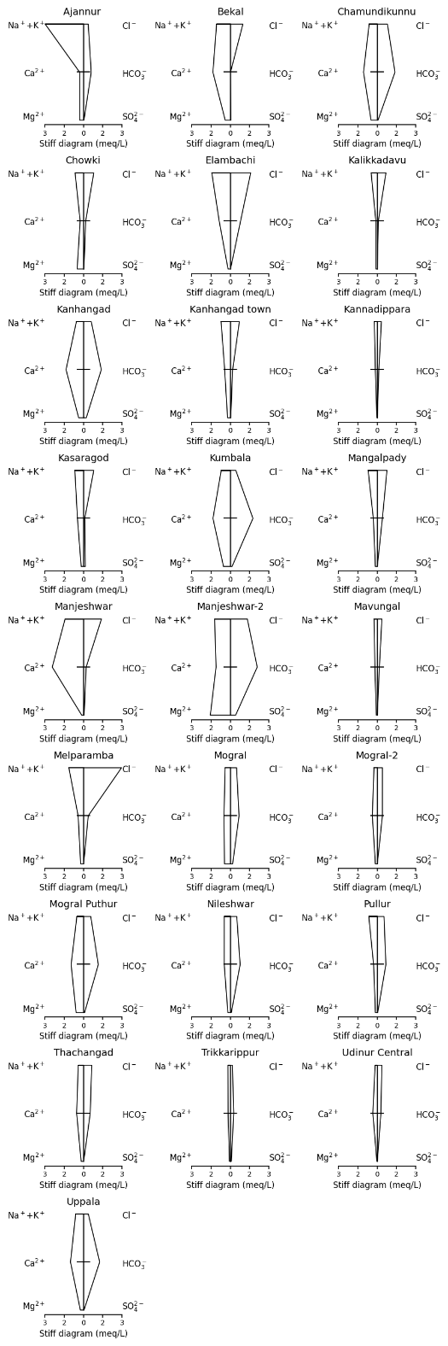

Fig.4: Stiff plot

The influence of anthropogenic activities, cation exchange, and carbonate dissolution is evident in certain locations. Elevated sulfate levels in select samples suggest potential contamination from fertilizers, industrial discharge, or wastewater infiltration, impacting water quality in specific areas such as Thachangad and Mogral 2. The variability in rock-water interactions and lateritic weathering. The presence of mixed water facies in locations such sodium and calcium concentrations also highlights ion exchange processes, particularly in regions where fresh groundwater interacts with saline sources. The Stiff diagram reveals that while some regions still retain good-quality freshwater, others are undergoing progressive salinization, emphasizing the need for targeted groundwater management strategies. Sustainable measures such as controlled groundwater extraction, artificial recharge, and regular hydrochemical monitoring are crucial to mitigating seawater intrusion and maintaining groundwater quality in the Kasaragod coastal aquifers.

1. **Conclusion**

The hydrochemical investigation of groundwater based on Piper, Schoeller and Stiff plots in the Kasaragod coastal region exhibits significant spatial variability, with two predominant hydrochemical facies: Calcium-Magnesium Bicarbonate (Ca-Mg-HCO₃) and Sodium-Potassium Chloride (Na+K-Cl). The presence of the Ca-Mg-HCO₃ facies in certain locations indicates freshwater recharge zones influenced by rock-water interactions. Prominence of Na+K-Cl facies in coastal areas points to intrusion of seawater caused by various reasons which may include excessive groundwater extraction. Apart from the intrusion of seawater, the potential for anthropogenic contamination of groundwater is highlighted through this study. Elevated sulfate concentrations in some samples suggest pollution from agricultural fertilizers, industrial effluents, or wastewater infiltration, which could further degrade water quality. Additionally, cation exchange processes observed in several locations indicate disruptions to the natural ionic balance, especially in areas where fresh and saline waters mix. The progressive salinization observed in coastal regions calls for urgent intervention through sustainable groundwater management strategies.

The study underscores the critical need for continuous groundwater monitoring to track the advancement of salinity and identify contamination hotspots. Implementing regulated groundwater extraction policies is essential to curb further seawater intrusion, while artificial recharge techniques such as managed aquifer recharge (MAR) should be promoted to restore freshwater balance in overexploited areas. Additionally, stricter pollution control measures must be enforced to prevent groundwater contamination from agricultural and industrial sources. This study provides a comprehensive hydrochemical framework for assessing groundwater quality in coastal regions, offering valuable insights for sustainable water resource management. Future research should focus on long-term monitoring trends, the impact of climate change on groundwater dynamics, and innovative aquifer protection strategies to ensure the long-term sustainability of groundwater resources in Kasaragod.

**Reference**

**Personal Author(s)**

1. A.O., T. (2016). The Suitability of Groundwater for Domestic and Irrigation Purposes: A Case Study of Ikere-Ekiti, SW-Nigeria. International Journal of Environment, Agriculture and Biotechnology, 2(1), 181–195. <https://doi.org/10.22161/ijeab/2.1.23>
2. Al-Khatib, M., & Al-Najar, H. (2011). Hydro-Geochemical Characteristics of Groundwater Beneath the Gaza Strip. Journal of Water Resource and Protection, 03(05), 341–348. <https://doi.org/10.4236/jwarp.2011.35043>
3. Cosby, A. G., Lebakula, V., Smith, C. N., Wanik, D. W., Bergene, K., Rose, A. N., Swanson, D., & Bloom, D. E. (2024). Accelerating growth of human coastal populations at the global and continent levels: 2000–2018. Scientific Reports, 14(1), 22489. <https://doi.org/10.1038/s41598-024-73287-x>
4. Gopalan, C. V., & Chikkamadaiah, K. (2015). Saltwater intrusion impacts and quality of groundwater along coastal area from Thalapady To Kumbala, Kasaragod District, Kerala, India. Earth Sci.
5. Harter, T. (2003). Groundwater Quality and Groundwater Pollution. University of California, Agriculture and Natural Resources. <https://doi.org/10.3733/ucanr.8084>
6. Khatri, N., & Tyagi, S. (2015). Influences of natural and anthropogenic factors on surface and groundwater quality in rural and urban areas. Frontiers in Life Science, 8(1), 23–39. <https://doi.org/10.1080/21553769.2014.933716>
7. Kumar, C. P. (2012). Climate Change and Its Impact on Groundwater Resources. International Journal of Engineering and Science, 1(5), 43–60.
8. Mamidi, K., & Jafar, M. (2023). Hydrogeochemical Evaluation of Groundwater Quality for Drinking and Irrigation: A Case Study from Unconfined Coastal Aquifers in S-W Kasaragod, India (SSRN Scholarly Paper 4517243). Social Science Research Network. <https://doi.org/10.2139/ssrn.4517243>
9. Piper, A.M. (1944). A graphic procedure in the geochemical interpretation of water‐analyses. Eos, Transactions American Geophysical Union, 25(6), 914–928. <https://doi.org/10.1029/TR025i006p00914>
10. Prasad, T. K. (2018). Landscape of Kannur: A geomorphological appraisal. Impact: IJRHAL, 6(7), 355–370.
11. Scholler, H. (1956). Géochimie des eaux souterraines: Application aux eaux de gisement de pétrole.
12. Schwartz, F. W., & Zhang, H. (2003). Fundamentals of ground water. Wiley.
13. Sajjad, H., Seenipandi, K., Rani, M., Rehman, S., & Kumar, P. (Eds.). (2021). Remote sensing of ocean and coastal environments. Elsevier.
14. UN Water (Ed.). (2022). Groundwater making the invisible visible. UNESCO.
15. Ajami, H. (2021). Geohydrology: Groundwater. In Encyclopedia of Geology (pp. 408–415). Elsevier. <https://doi.org/10.1016/B978-0-12-409548-9.12388-7>