EFFECTS OF FRESH WATER DEGRIDATION ON HUMAN ACTIVITIES: A CASE STUDY IN RIVER ATHI MACHAKOS COUNTY, KENYA.

ABSTRACT
Freshwater degradation resulting from human and industrial activities has become a major global concern, particularly for communities whose livelihoods rely heavily on water resources. In accordance with the principles outlined in the United Nations’ Agenda 21—which promotes the equitable and sustainable use of water for socio-economic development—this study examined the impact of freshwater degradation on human activities along River Athi in Machakos County, Kenya. The study specifically sought to: assess the effects of freshwater degradation on domestic water use; analyse its impact on agricultural activities; and determine its influence on fishing activities within the region. A descriptive research design incorporating both quantitative and qualitative approaches was employed. The study area was the Athi Catchment, located between latitude 1°0′ to 4.5° South and longitude 37°0′ to 40°0′ East. From a target population of approximately 2,000 individuals, a sample size of 160 respondents was determined using Yamane’s formula. Purposive sampling was utilized to select relevant stretches of the river. Data were collected using structured questionnaires and interview guides administered to local residents and key informants. Data analysis was conducted using SPSS version 21. Descriptive statistics such as frequencies, percentages, tables, and graphs summarized the findings, while Pearson’s correlation coefficient tested relationships between freshwater degradation and human activities. Results indicated statistically significant negative correlations between freshwater degradation and domestic use (r = 0.195, p = 0.028), fishing activities (r = 0.215, p = 0.015), and agricultural activities (r = 0.280, p < 0.05). The study concludes that the degradation of River Athi has adversely affected domestic, agricultural, and fishing activities, threatening the livelihoods and socio-economic well-being of the local population. These findings underscore the critical need for sustainable river management strategies to protect freshwater quality and support community resilience.

- INTRODUCTION
  - Background of the study
Freshwater degradation has become a critical environmental challenge of the 21st century. Globally, approximately 70% of freshwater resources are utilized for agricultural purposes, with the remaining 20% and 10% allocated to industrial and domestic uses, respectively. The demand for freshwater is increasing by an estimated 64 billion cubic meters annually (United Nations Educational, Scientific, and Cultural Organization [UNESCO], 2009). Freshwater degradation has adversely impacted human activities in areas dependent on these water resources, with most freshwater bodies—including rivers, lakes, and groundwater—now exhibiting signs of contamination.
Despite covering more than 70% of the Earth's surface, only about 2.7% of the world’s water is freshwater, with the remainder being saline (Ramakrishnaiah et al., 2009). Environmental experts widely regard pollution as the foremost challenge confronting the global water sector (UNESCO, 2009). In both developed and developing nations, agricultural practices are cited as the leading contributors to freshwater degradation, followed by contamination from human settlements and industrial discharges. These pollutants have significantly compromised inland water bodies, coastal areas, and aquifers worldwide (WHO/UNICEF, 2015).
Approximately 38% of water bodies in the European Union are polluted primarily due to agricultural activities (WHO/UNICEF, 2015). In the United States, agriculture is identified as the principal source of pollution in streams, wetlands, and lakes (US EPA, 2016). Similarly, nitrate contamination of groundwater in China is largely attributed to agricultural practices (FAO, 2013). A study on the Amazon River in South America found that increased freshwater degradation has disrupted the flora and fauna dependent on this ecosystem (IPCC, 2014). Habitat modification, overexploitation, and pollution of river ecosystems have adversely affected fish species, consequently threatening the livelihoods of communities reliant on these resources (Dugan et al., 2010).

In China’s Yellow River, pollution from heavy metals such as cadmium, lead, and mercury has reached alarming levels, largely due to rapid industrialization and population growth (Yue et al., 2014). These pollutants have caused significant ecological harm, diminishing water quality for domestic, agricultural, and fishing purposes, and negatively impacting human health and well-being (Li et al., 2013; Chen, 2010).
In Lesotho, efforts to promote industrialization, agriculture, and urbanization have inadvertently led to pollution of the Mohokare River, particularly in Maseru City (Hapazari et al., 2015). Industrial effluents and unsustainable farming practices have compromised the usability of the river’s water for drinking, cooking, and fishing, thus endangering the health and livelihoods of local populations (Walakari & Okot-Okumu, 2011; Singh et al., 2013).
In Kenya, environmental scholars have identified urbanization, industrialization, and agriculture as the primary sources of river pollution (Odha, 2024; Gikundi, 2014). According to (Mbui et al. 2016), Kenya’s pursuit of rapid industrial growth without adequate investment in waste management infrastructure, policies, and enforcement mechanisms has exacerbated water pollution. Major rivers such as the Nairobi, Athi, Kerio, Nzoia, and Nyando have all been affected by industrial discharges (Mbui et al., 2016).
Specifically, studies show that the Athi River is heavily polluted with toxic soluble metals and other hazardous pollutants originating from industrial activities, mining operations, fossil fuel combustion, and agricultural runoff within the river basin (Otieno et al., 2015). The accumulation of these contaminants has severely degraded water quality, rendering it unfit for human consumption, agriculture, and other livelihood activities in the surrounding areas (Mutia et al., 2015). Further research attributes this degradation to industrial effluents, poor waste management, unsustainable agricultural practices, and rapid urban population growth in cities such as Nairobi, Thika, and Mavoko along the Athi River’s course (Kiambi, 2016). Consequently, agricultural productivity, fisheries, and domestic water use have all been negatively affected, posing serious risks to the health and economic well-being of the local communities (Mustapha et al., 2013).
  - Statement of the problem
Water is essential for many human activities that are of economic value to the lives of people living in the environs of River Athi. Water degradation caused by both natural and human-induced pollutants in River Athi poses a significant problem for individuals and communities in the area because the water is relied upon by many people in the area of study for agricultural, domestic, and fishing activities. This has prompted research focusing on how water degradation has affected human activities such as agriculture, fishing, and domestic use of water as according to the objectives of the study.
  - Purpose of the study
The purpose of the study was to examine the effects of fresh water degradation on human activities focusing on River Athi in Machakos County.

  - Objective of the study
To analyse the effects of fresh water degradation on agricultural activities in Machakos County, Kenya.
  - Justification of the study
In the Kenyan context, water from River Athi is vital for communities in Machakos County, serving agricultural, domestic, and fishing needs. However, both natural processes and human activities have contributed to the degradation of this river, negatively impacting water quality and reducing its usability. The justification for this study aligns with Sustainable Development Goal 6 which aims to realize clean water and sanitation for all and access to safe water and sustainable management of water resources. The study supports the Machakos County Integrated Development Plan (CIDP), which emphasizes environmental conservation, improved public health, and promotion of sustainable livelihoods. By highlighting the impacts of water degradation, the study provides evidence that can guide local authorities such as the Machakos County Government and NEMA in developing targeted interventions to protect and restore River Athi, thus promoting sustainable development in the region.
  - Significance of the study
The research findings have provided important information to the Ministry of Water, Sanitation, and Environmental Resource Management. Policymakers might use the data in policy formulation to implement interventions to reduce or stop degradation of River Athi in Machakos County and other areas that may be experiencing similar challenges. The study may also assist the people who depend on water of River Athi for their economic activities devise alternative measures to acquire fresh water to continue with their activities.
  - Scope of the study
The study was conducted in Machakos County, specifically in areas where River Athi passes through and supports the livelihoods of surrounding communities. The research focused on assessing the effects of freshwater degradation in River Athi on selected human activities namely agriculture, domestic water use, and fishing.

- Literature review
Freshwater degradation has been shown to negatively impact crop production, leading to reduced food quality and posing health risks to human life (Khan & Ghouri, 2011). Research indicates a significant association between water pollution and public health problems, as disease-causing organisms present in contaminated water are easily transmitted to humans in affected areas (Kamble, 2014). Furthermore, water degradation compromises the quality of irrigation water. Ideal irrigation water must meet specific standards of acidity, salinity, solubility, and alkalinity. Salinity, in particular, measures the concentration of dissolved salts, while salinity hazard assesses the potential impact of this salinity on crop growth (Zörb et al., 2019).
Water degradation not only diminishes crop productivity but also renders food unsafe for consumption, thereby endangering human health (Khan & Ghouri, 2011). An estimated 10% of the
global population relies on food cultivated using polluted water (Corcoran et al., 2010). Consumption of such food is linked to diseases such as diarrhea and neurological disorders (Ullah et al., 2014). Moreover, nitrogen-based chemical contaminants in crops have been associated with serious health conditions, including cancer and blue baby syndrome (Khan & Ghouri, 2011).
In India, industrial waste discharged into surface and groundwater systems is a major source of pollution (Sharma et al., 2022). Common pollutants include heavy metals such as iron and mercury, petroleum products, chlorinated hydrocarbons, salts, and other organic compounds. These substances alter soil acidity and alkalinity, posing risks to human, plant, and animal health (Sharma et al., 2022). Studies have established a positive correlation between industrial water pollution and decreased rice yields in irrigated areas (Sekharan et al., 2022).
Research findings further reveal that rice and grain crops irrigated with polluted water suffer quality and yield losses. Wheat grown under such conditions shows reduced protein content, plant height, leaf area, and dry matter accumulation (Sekharan et al., 2022). In India, a decline in cultivated land has been observed in villages downstream of industrial centers such as Andhra Town (Kumar et al., 2024). Similar trends have been documented globally.

For example, in Hebei Province, China, wastewater irrigation has been linked to lower corn quality and yield (Wang et al., 2024). In Tho, Vietnam, farmlands irrigated with contaminated water have seen both yields and profits decline. Historical records indicate that industrial water pollution led to crop losses in Patancheru, Andhra Pradesh, India, sparking grassroots protests against industrial pollution during the 1980s (Murty & Kumar, 2011).
In Nigeria, oil exploration and related activities have caused widespread environmental pollution, degrading freshwater sources and threatening agriculture, fisheries, and domestic water supplies essential for local livelihoods (Ugwuanyi et al., 2012). It is estimated that 30% of Nigeria’s habitable land has been damaged by oil spills, resulting in the contamination of rivers and groundwater, reduced crop yields, and diminished land productivity (Ouncer & Hooverian, 2015).
In the study area—Athi River Basin—research indicates that during the dry season, water from the Athi River becomes highly contaminated with industrial effluents, elevated salinity, and total dissolved solids that hinder plant growth and alter the river's natural course (Kathuli et al., 2013). Pollution from Nairobi City and its environs is discharged into the Nairobi River, which subsequently flows into the Athi River, affecting irrigation activities downstream (Aywa, 2017; Kiithia & Mutua, 2006). These environmental concerns provided the motivation for this research, as no prior studies had comprehensively examined the effects of freshwater degradation on agricultural activities in this region.
- Research Methodology
The study was carried out along River Athi within Machakos County, Kenya, forming part of the larger Athi Catchment Area. The catchment lies between latitudes 1°00′ to 4°30′ South and longitudes 37°00′ to 40°00′ East, bordered by the Tana Catchment Area to the north, the Indian Ocean to the east, Tanzania to the south, and the Rift Valley Catchment Area to the west. Covering approximately 58,639 km², the basin spans several counties including Nairobi, Machakos, Makueni, Kiambu, and Kajiado. The river originates from the Ngong Hills and traverses diverse topography, from the Aberdare highlands through central plains to the coastal lowlands. Key springs such as Mzima, Kiku, Njorokubwa, Nolturesh, and Marere sustain the catchment’s hydrological regime.
The research study adopted a descriptive research design through which data was acquired from respondents using quantitative and qualitative procedures. Descriptive research design examined what, where and how an aspect under investigation needs and its current practices (Kothari & Garg, 2014). The study targeted 2,000 adults aged 18 years and above residing in Yatta, River Athi, and Mwala sub-counties along the River Athi in Machakos County, Kenya. The population primarily comprised farmers, livestock keepers, and fishers, alongside local county administrators, whose livelihoods depend on river-based resources. A stratified random sampling technique was employed to account for the population’s heterogeneity and to ensure representation from each subgroup, thereby reducing sampling bias and improving result accuracy.
A multistage sampling approach was used. Machakos County was purposively selected as the study site due to its location along the Athi River. From its eight sub-counties, three (Yatta, River Athi, and Mwala) were selected based on their proximity to the river. Using Yamane’s formula at a 95% confidence level (margin of error = 0.05), a sample size of 160 respondents was determined. Respondents were further selected based on accessibility within the riparian zones.
The study employed questionnaires and interview schedules as research instruments to collect data from the target population. Data collection involved direct interaction between the researcher and respondents, including residents, farmers, local traders, and county administrators. The questionnaires comprised both open-ended and closed-ended items. One section gathered demographic information, while the other focused on the effects of water degradation on human activities, as outlined in the study objectives. Closed-ended questions used a five-point Likert scale (strongly agree, agree, undecided, disagree, strongly disagree), while open-ended questions captured respondents’ opinions. Additionally, interviews and observations were conducted to supplement the data collected.

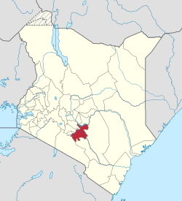

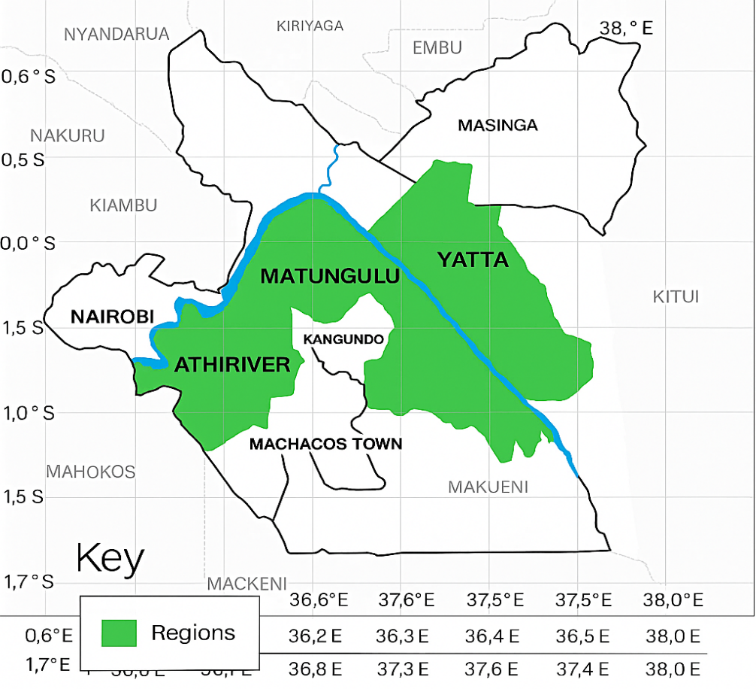
Fig. 1. Map of River Athi and Study Area (Best et al., 2024)

- RESULTS AND DISCUSIONS
The study assessed the impact of water degradation on agricultural activities among communities along River Athi. The majority of respondents (77.2%) agreed that degraded water had negatively affected agricultural practices. Specifically, 52.0% agreed and 21.3% strongly agreed that water degradation adversely influenced crop production.

Regarding livestock, 49.6% of respondents indicated that their animals were affected by poor water quality, while 26.8% were unsure of the extent of this impact, suggesting a lack of direct awareness or observation regarding livestock water-related health effects.
Additionally, 46.0% agreed and 31.0% strongly agreed that the use of degraded water increased the cost of crop production, highlighting the economic burden imposed by water quality deterioration. Furthermore, 46.8% of respondents strongly agreed that land under irrigation had reduced due to the declining quality of water from River Athi, signalling a constraint on agricultural expansion and productivity in the region.
Table 1 : Effects of Water Degradation on Agricultural Activities
 | Strongly Disagree | Disagree | Not Sure | Agree | Strongly Agree | Total
There are agricultural activities affected by degraded water | 0.0% | 11.8% | 1.6% | 77.2% | 9.4% | 100%
Crops have been affected by degraded water | 0.8% | 10.2% | 15.7% | 52.0% | 21.3% | 100%
Animals /livestock have been affected by degraded water | 0.8% | 14.2% | 26.8% | 49.6% | 8.7% | 100%
There is cost implication in crop production in the area due to use of degraded water | 0.0% | 8.7% | 14.3% | 46.0% | 31.0% | 100%
Land under irrigation using River Athi waters has reduced due to water degradation | 22.2% | 11.9% | 1.6% | 17.5% | 46.8% | 100%

A one-way Analysis of Variance (ANOVA) was conducted to determine whether significant differences existed in the effects of water degradation on agricultural activities across different sections of River Athi. The results revealed a statistically significant difference among the sections, F (2, 118) = 3.118, p = 0.048. This indicates that the impact of water degradation on agricultural activities varied significantly depending on the river section, suggesting localized variations in water quality and its influence on farming practices.

Table 2 Indicates effects of water degradation affected agricultural activities on different sections of the river.
Dependent Variable: Agricultural Effects
LSD
(I) Location | (J) Location | Mean Difference (I-J) | Std. Error | Sig. | 95% Confidence Interval
 |  |  |  |  | Lower Bound | Upper Bound
Athi-River | Mwala | -.11836 | .21061 | .575 | -.5354 | .2987
Athi-River | Yatta | -.37933 | .21784 | .034 | -.8107 | .0520
Mwala | Athi-River | .11836 | .21061 | .575 | -.2987 | .5354
Mwala | Yatta | -.26097* | .11546 | .026 | -.4896 | -.0323
Yatta | Athi-River | .37933 | .21784 | .034 | -.0520 | .8107
Yatta | Mwala | .26097* | .11546 | .026 | .0323 | .4896
*. The mean difference is significant at the 0.05 level.
A post hoc analysis was conducted following the significant ANOVA results to identify specific sections of River Athi where agricultural activities were most affected by water degradation. The results indicated that agricultural activities in Yatta were significantly more impacted compared to River Athi (p = 0.034) and Mwala (p = 0.026). However, no significant difference was observed between Mwala and River Athi sections (p = 0.575). The greater impact observed in Yatta may be attributed to the community's higher dependency on River Athi as the primary source of irrigation and water for agriculture, intensifying the consequences of water quality degradation in this area.
A one-way ANOVA test was conducted to determine whether there were significant differences in the effects of fresh degradation on agricultural activities across different age groups of respondents. The result, F (3, 117) = 0.378, p = 0.769, indicated no statistically significant differences among the age groups. This suggests that the impact of degradation on agricultural activities was similar regardless of age, implying that both younger and older individuals were affected in comparable ways.

Table 3 ANOVA Test on Age and Water Degradation on Agricultural Activities
ANOVA
Agricultural Effects
 | Sum of Squares | df | Mean Square | F | Sig.
Between Groups | .406 | 3 | .135 | .378 | .769
Within Groups | 41.931 | 117 | .358
Total | 42.337 | 120
Hypothesis Testing
This section presents the results of testing the first hypothesis, which was stated as follows:
Ha-1: There is an effect of freshwater degradation on agricultural activities.
A Pearson Correlation analysis was conducted at a 95% confidence level with an alpha value of 0.05 to test this hypothesis. As shown in Table4, the Pearson Correlation coefficient was r = 0.288, with a significance level of p = 0.001. These results indicate a statistically significant positive relationship between freshwater degradation and the extent of disturbances to agricultural activities.
The positive correlation implies that an increase in freshwater degradation corresponds to an increase in the level of disturbances experienced in agricultural activities along the river. Based on these findings, the study fails to reject the alternative hypothesis (Ha-1), confirming the existence of a significant statistical relationship between freshwater degradation and agricultural impacts.

Table 4Correlation between Water Degradation and Agricultural Effects
Correlations
 |  | Water Degradation | Agricultural Effects
Water Degradation | Pearson Correlation | 1 | .288**
Water Degradation | Sig. (2-tailed) |  | .001
Agricultural Effects | Pearson Correlation | .288** | 1
Agricultural Effects | Sig. (2-tailed) | .001
**. Correlation is significant at the 0.01 level (2-tailed).
1.1 Discussion
The results presented in Table 5 indicate that the effect of water degradation on agricultural activities was statistically significant (p = 0.001). The linear regression analysis produced the following equation:
A=2.345+0.345X1A = 2.345 + 0.345X_1A=2.345+0.345X1​
where A represents agricultural activities and X₁ denotes the extent of water degradation. According to this equation, when water degradation remains constant, the baseline level of agricultural activity disturbance is 2.345. The regression coefficient for water degradation was 0.345, with a p-value less than 0.05, indicating statistical significance. This implies that for every one-unit increase in water degradation, disturbances to agricultural activities increased by 0.345 units. These results demonstrate that water degradation has a direct, measurable negative impact on agricultural activities along the river.
This finding is consistent with the study by (Heath et al. 2009) on the Limpopo River in Lesotho, which reported that pollutants and contaminants originating from human activities rendered the river water unsuitable for both human and animal consumption.

Table 5 Regression Coefficients-Effect of Water Degradation on Agricultural Activities
Coefficientsª
Model |  | Unstandardized Coefficients |  | Standardized Coefficients | t | Sig.
 |  | B | Std. Error | Beta | t | Sig.
1 | (Constant) | 2.382 | .408 |  | 5.838 | .000
1 | water degradation | .345 | .103 | .288 | 3.363 | .001
a. Dependent Variable: Agricultural Effects
- CONCLUSIONS AND RECOMMENDATION
The research findings revealed that the water quality of River Athi has been significantly compromised. This degradation is primarily attributed to contamination from industrial effluents and the improper disposal of human waste, which emerged as the main agents of water pollution. In addition, the quality of the river water has been further reduced by soil erosion and rampant sand harvesting activities along various sections of the river.
The study established a positive correlation between water degradation and adverse effects on agricultural activities. Regression analysis confirmed a statistically significant relationship, indicating that increased water degradation corresponded with heightened disturbances to agricultural productivity along the river. This suggests that as the extent of water pollution increases, the negative impact on agricultural activities also intensifies.
Moreover, the research revealed notable variations in the extent of water degradation along different sections of River Athi. Certain sections were found to be more severely polluted than others. This disparity was largely attributed to differences in population density and the concentration of industrial activities and human waste disposal practices along the river course.

DISCLAIMER (ARTIFICIAL INTELLIGENCE)
Author(s) hereby declare that generative AI technology such as chat GPT, and spelling checker has been used during the writing or editing of the manuscript.
Details of the AI usage are given below
- Paraphrasing
- Grammar
- Summary
REFERENCES
Aywa, J. O. (2017). Suitability of Athi River water for irrigation within Athi River town and its environs (Doctoral dissertation).
Best, J., Darby, S., Esteves, L., & Wilson, C. (2024). The World Atlas of Rivers, estuaries, and deltas. https://doi.org/10.2307/jj.7855343
Corcoran E, Nellemann C, Baker E. (2010). The central role of wastewater sustainable development and rapid response Assessments. United National Environment programme
Dugan, P. J., Barlow, C., Agostinho, A. A., Baran, E., Cada, G. F., Chen, D., ... & Wine miller, K. O. (2010). Fish migration, dams, and loss of ecosystem services in the Mekong basin. Ambio, 39, 344-348.
Gikundi, J. (2014). Planning for sustainable utilization and conservation of urban river corridors in Kenya: A Case Study of the Nairobi River (Doctoral dissertation, University of Nairobi).
Hapazari, I., Ntuli, V., & Taele, B. M. (2015). Waste generation and Management in Lesotho and waste to clay brick recycling: A review. Br. J. Appl. Sci. Techno, 8(2), 148-161
Intergovernmental Panel on Climate Change (IPCC), (2014). Retrieved April, 29 2019.From www. Ippcc.ch

Kamble, S. M. (2014). Water pollution and public health issues in Kolhapur city in Maharashtra. International journal of scientific and research publications, 4(1), 1-6.
Kathuli, P. (2013). Diagnosis of source of Soil Salinization in selected irrigation schemes in semi – arid lands of Taita – Taveta County in Kenya: Joint proceedings of the 27th Soil science society of East Africa and the 6th African soil science society.
Khan, M. A., & Ghouri, A. M. (2011). Environmental pollution: its effects on life and its remedies. Researcher World: Journal of Arts, Science & Commerce, 2(2), 276-285.

Kiambi, M. M. (2016). Addressing Water Resources Degradation Through Improved Stakeholder Participation in the Upper Athi River Basin (Doctoral dissertation, University of Nairobi).
Kithiia, S. M., & Mutua, F. M. (2006). Impacts of land-use changes on sediment yields and water quality within the Nairobi River sub-basins, Kenya. Iahs publication, 306, 582.

Mbui, D., Chebet, E., Kamau, G., & Kibet, J. (2016). The state of water quality in Nairobi River, Kenya. Asian Journal of Research in Chemistry, 9(11), 579-586.
Murty MN, and Kumar S, (2011). Water pollution in India: An economic Appraisal in India infrastructure Report, India.
Mustapha, A., Aris, A. Z., Juahir, H., Ramli, M. F., & Kura, N. U. (2013). River water quality assessment using environmentric techniques: case study of Jakara River Basin. Environmental Science and Pollution Research, 20, 5630-5644.
Odha, G. A. (2024). Environmental Policy Implementation Effects on Prevention and Control of River Water Pollution in Kenya: A Case of Ngong River, Nairobi City County.
Ramakrishnaiah, C.R., Sadashivaiah, C. and Ranganna, G. (2009) Assessment of Water Quality Index for the Groundwater in Tumkur Taluk, Karnataka State, India. E-Journal of Chemistry, 6, 523-530. http://dx.doi.org/10.1155/2009/757424
Sekharan, S., Samal, D. R., Phuleria, H. C., Chandel, M. K., Gedam, S., Kumar, R., ... & Karmakar, S. (2022). River pollution monitoring over an industrial catchment in urban ecosystem: Challenges and proposed geospatial framework. Environmental Challenges, 7, 100496.
Sharma, R., Kumar, R., Sharma, D. K., Sarkar, M., Mishra, B. K., Puri, V., ... & Nhu, V. H. (2022). Water pollution examination through quality analysis of different rivers: a case study in India. Environment, Development and Sustainability, 24(6), 7471-7492.
Ugwuanyi, G.O (2012). The impacts of environmental pollution on Agricultural productivity in the Niger Delta: Journal of Environmental science and Resources Management Vol. 4. Cen resin Publishers, Nigeria.
Ullah, S., Javed, M. W., Shafique, M., & Khan, S. F. (2014). An integrated approach for quality assessment of drinking water using GIS: A case study of Lower Dir. Journal of Himalayan Earth Sciences, 47(2), 163-174.
UNESCO (2009). The United world water development Report 3: Water in a changing world. Paris /New York, UNESCO / Berghahu Books.
Wang, P., Ding, R., Shi, W., & Li, J. (2024). Potential Reductions in the Environmental Impacts of Agricultural Production in Hubei Province, China. Agriculture, 14(3), 439.
Walakira, P., & Okot-Okumu, J. (2011). Impact of industrial effluents on water quality of streams in Nakawa-Ntinda, Uganda. Journal of Applied Sciences and Environmental Management, 15(2).
WHO/UNICEF Joint Water Supply, & Sanitation Monitoring Programme. (2015). Progress on sanitation and drinking water: 2015 update and MDG assessment. World Health Organization.

