**Water Dynamics and Irrigation Demands for Food Crop Production in the Santa Agrarian Basin, Cameroon: A Spatio-Temporal Assessment of Surface and Groundwater Resources**

**Abstract**

The global water–food nexus is under increasing pressure as agricultural systems struggle with growing climate variability, unsustainable water extraction, and rising competition for limited water resources. Water is a vital input that influences every stage of food crop development, from germination to harvest. This paper investigates the spatio-temporal interplay of surface and groundwater resources on food crop production in the Santa Agrarian Basin. A mixed-methods approach was employed, combining secondary data from satellite imagery (ASTER, HydroSHEDS), climatic records (1980–2024), and agricultural statistics. Primary data were collected through 397 questionnaires, 12 key-informant interviews, and two focus group discussions conducted across 10 communities. Geospatial analysis using QGIS and ArcGIS quantified changes in surface and groundwater potential, while crop water requirements were calculated using the FAO CROPWAT 8.0 tool for tomato and Irish potato. Findings revealed a 50% decline in first-order stream length between 1980 and 2024, with groundwater emerging as the primary irrigation source after 2010. Crop water requirement analysis showed high irrigation dependencies: tomatoes (571.3 mm) and Irish potato **(**514.3 mm**),** with supplemental needs exceeding 40–50%. Crop output followed hydrological trends, with peak yields of water-intensive crops reaching 15,100 tons in 2007–2008, then falling to 6,000 tons by 2024 due to aquifer depletion. The paper recommends integrated water governance and the implementation of managed aquifer recharge in high-potential areas such as Pinyin and Mbu to promote water sustainability and agricultural resilience.

**Keywords:** Crop water requirements, Groundwater, Surface water, Water–food nexus.

**1. Introduction**

Agriculture is the largest consumer of freshwater globally, accounting for 70% of all withdrawals, with surface and groundwater serving as its primary sources (FAO, 2020). As the global population continues to rise, food demand is projected to increase by 60% by 2050 (IPCC, 2023). Surface water systems like rivers, lakes and reservoirs are highly susceptible to seasonal variability, climatic extremes and anthropogenic modifications such as damming, irrigation diversions and land-use changes (IPCC, 2021; Vörösmarty *et al.,* 2010). Groundwater, once considered a dependable buffer during dry periods, is facing a crisis of over-extraction, contamination and reduced recharge, especially in major agricultural belts like the Indo-Gangetic Plain, the North China Plain, and Central Valley of California (Wada *et al*., 2010; Taylor *et al*., 2013). The spatio-temporal disconnect between water availability and food crop demand has become a defining challenge for sustainable development and food security worldwide. Despite their importance, surface and groundwater systems are often studied and managed separately. This fragmented understanding hinders the development of integrated water management strategies that align with local agricultural calendars and crop water needs (Gowing *et al.,* 2009; Kimengsi *et al.,* 2022).

The Santa Agrarian Basin exemplifies a microcosm of water-agriculture nexus. The interplay between fractured basaltic aquifers and ephemeral streams creates a complex hydrological system. Groundwater recharge in this area is largely dependent on seasonal rainfall, and surface water availability fluctuates with topography and land use patterns. Both spatial and temporal variability strongly influence local crop choices, planting calendars and irrigation practices. The main objective of this paper is to identify and analyze the spatio-temporal variations in water potentials for food crop production in the Santa Agrarian Basin. This investigation is guided by the assumption that the quantity of water available for agriculture fluctuates significantly across seasons, largely in response to changing rainfall and temperature patterns. This paper takes an integrated analysis where fractured aquifers and ephemeral streams create unique water-crop feedback loops.

**2. Theoretical Construct**

This study is underpinned by the Integrated Water Resources Management (IWRM) framework, which emphasises the coordinated development and management of water, land, and related resources to maximise economic and social welfare without compromising the sustainability of vital ecosystems (GWP, 2000). IWRM advocates for a holistic approach to managing water resources by considering both surface and groundwater systems as interconnected components of a single hydrological cycle. This theoretical lens is particularly relevant for understanding the Santa Agrarian Basin, where groundwater and surface water interact in complex and seasonal ways.

By applying the IWRM framework, the study captures the multifaceted nature of water demand for food production. It highlights the need for data-driven, context-specific strategies that integrate climatic conditions, hydrological trends, crop water requirements, and community water governance systems. The framework supports the central hypothesis of this research: that sustainable food crop production in the Santa Basin hinges on the effective management of both surface and groundwater systems within their spatial and temporal contexts.

**3. Material and methodology**

Santa is one of the seven Sub Divisions in Mezam Division, North West Region, Cameroon. It is located between latitudes 5° 42´and 5° 53´ North of the Equator and longitudes 9° 58´ and 10° 18´ East of the Greenwich Meridian (Fig.1). About 90% of the population is dependent on agriculture, practicing either livestock or crop cultivation (Santa Rural Council Monographic Study, 2003). It covers some nine villages, namely, Mbei, Njong, Akum, Mbu (Baforchu), Alatening, Baba II, Awing, Baligham ,and Pinyin. Located in the in the Western Highlands of Cameroon. It covers a surface area of about 532.67km.

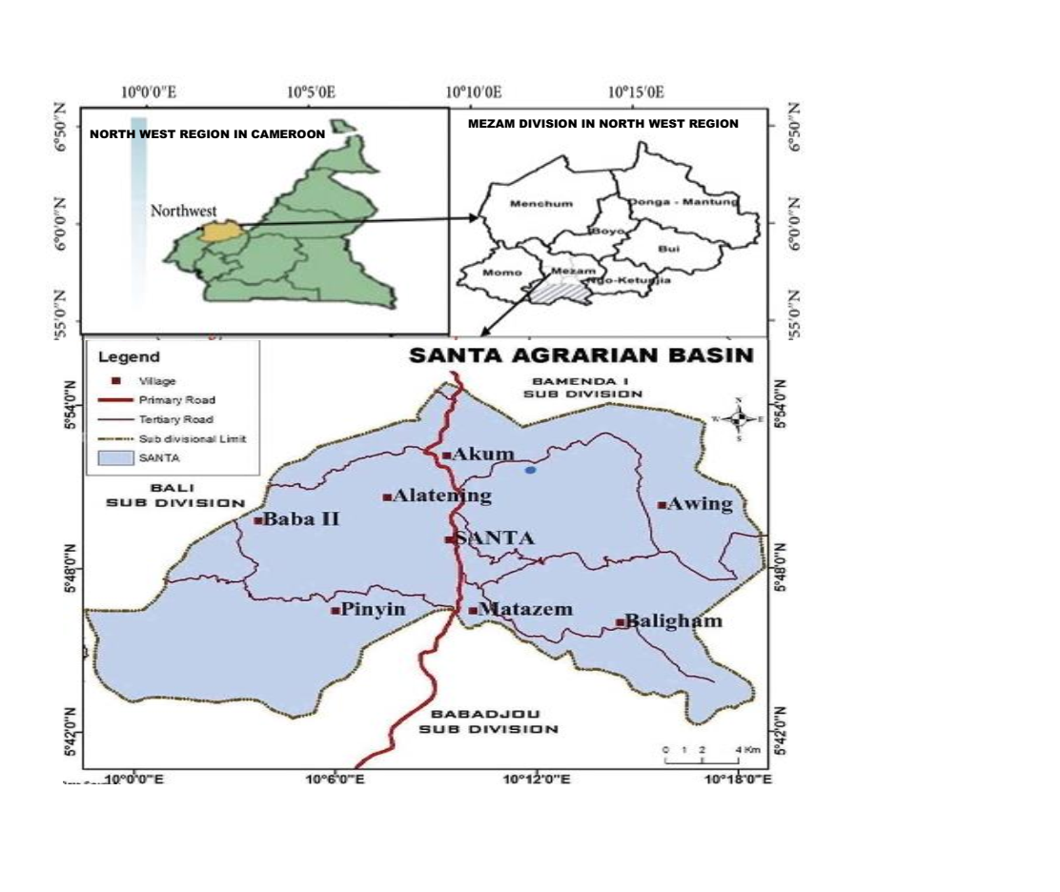

**Figure 1: Location of study area**

Source: NIS, 2017 and Field work, 2023

It is bordered to the North by Bamenda I Sub Division, to the West by Bali and Batibo Sub Divisions, to the South by Wabane, Babadjou and Mbouda and to the East by Galim. It lies some 20km from Bamenda and is disenclaved by the national road number 10, which links Bamenda to Bafoussam and the rest of the country.

This paper adopted a mixed-methods approach. Data were collected from both primary and secondary sources. Secondary data included satellite remote sensing imagery such as ASTER and HydroSHEDS to assess surface and groundwater changes between 1980 and 2024. Climatic data, including rainfall and temperature records were obtained from the Bamenda Meteorological Station. Data on crop yields, land use and irrigation practices were obtained from the Sub Divisional Delegation of Agriculture and Rural Development, and the Santa Council. These secondary sources provided baseline hydrological and food crop production information critical for long-term trend analysis.

Primary data collection involved the administration of 397 structured questionnaires to residents of 10 rural and urban communities within the basin. The communities were selected using stratified random sampling to capture the heterogeneity of the population. The questionnaire consisted of both closed-ended and open-ended items, capturing data perceptions of water scarcity, and the classification of water sources for crop cultivation. To complement quantitative data, qualitative information was gathered through field observations, semi-structured interviews with 12 key informants, and two focus group discussions involving 7 to 12 participants each. Key informants included agricultural officers, community leaders, and youth representatives with expert knowledge on local water governance and farming systems. This allowed for detailed computation of irrigation needs for major food crops in the area, including Irish potatoes, and tomatoes. These crops were selected due to their economic relevance and widespread cultivation across the region. Geospatial tools including QGIS and ArcGIS were used to synthesize and visualize spatial datasets. Decadal maps were generated to show changes in groundwater levels and surface water resources. Qualitative data from interviews and focus groups were transcribed and thematically coded umsing NVivo. Triangulation of data sources ensured validity and enhanced the reliability of results. The choice of the Santa Agrarian Basin is justified by its unique hydrological and agricultural characteristics. Santa is one of the most agriculturally active zones in the North West Region of Cameroon.

**4. Findings and Discussion**

**4.1 Findings**

**4.1.1 Spatio-Temporal Dynamics of Surface Water Potentials**

Surface water resources in the Santa Agrarian Basin have undergone profound transformations between 1980 and 2024 (Fig. 2). Between 1980 and 1990, the Santa Agrarian Basin experienced a period of relative surface water abundance, with widespread distribution of both perennial and seasonal streams. First-order streams dominated the hydrological network, representing 56.3% of the total area and extending 8.0 km in length. From 1991 to 2001, the basin showed signs of hydrological stress. While first-order streams remained dominant, their length significantly decreased to 4.1 km, with area coverage falling slightly to 53.1%. This decline reflected the emerging influence of environmental degradation, deforestation, expanding human settlements, and increasingly erratic rainfall. Though second-order streams showed a modest increase in area coverage, their length also decreased. Between 2002 and 2012, the decline in stream network density and continuity continued. First-order streams still accounted for the majority of the hydrological landscape at 55.7%, but their total length fell further, indicating a persistent contraction in surface water resources. Higher-order streams, such as fifth-order, nearly disappeared from the basin, covering just 0.2% of the area. Spatial disparities also became more pronounced, with southeastern and western parts of the basin experiencing marked reductions in perennial flows. From 2012 to 2024, surface water resources in the basin reached a critical stage. The cumulative effects of demographic growth, intensified agriculture, deforestation, and climate variability significantly stressed the hydrological system. Fieldwork highlighted an intensification of water scarcity, as seasonal streams became more dominant and reliable year-round water sources diminished.

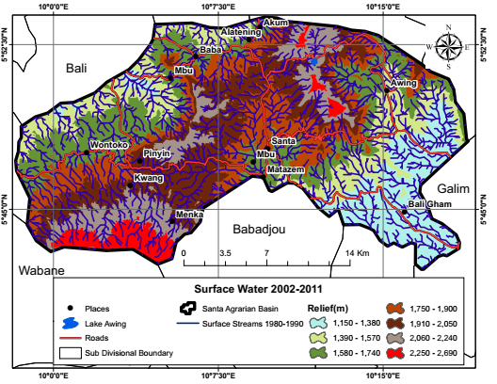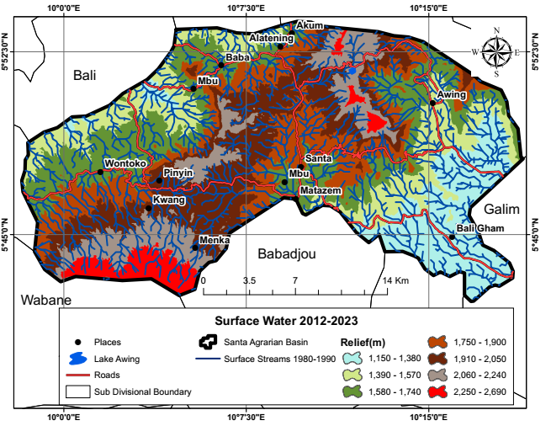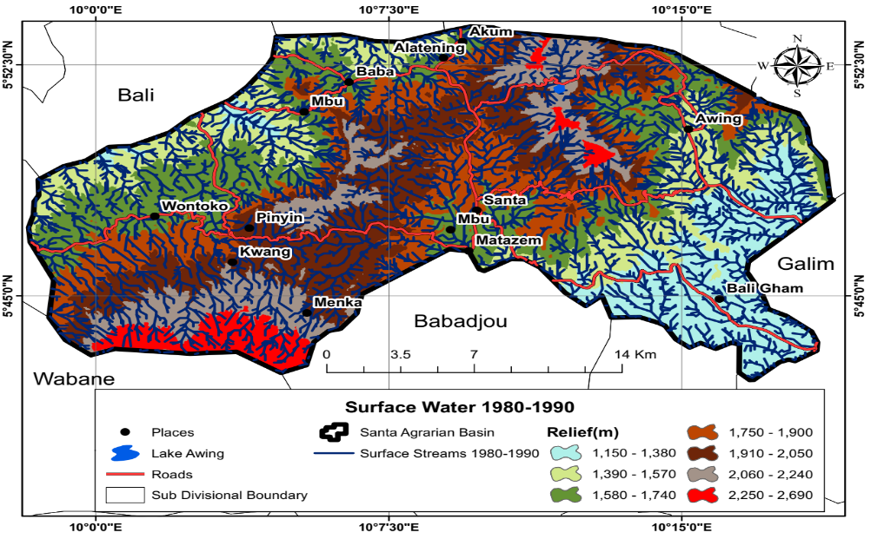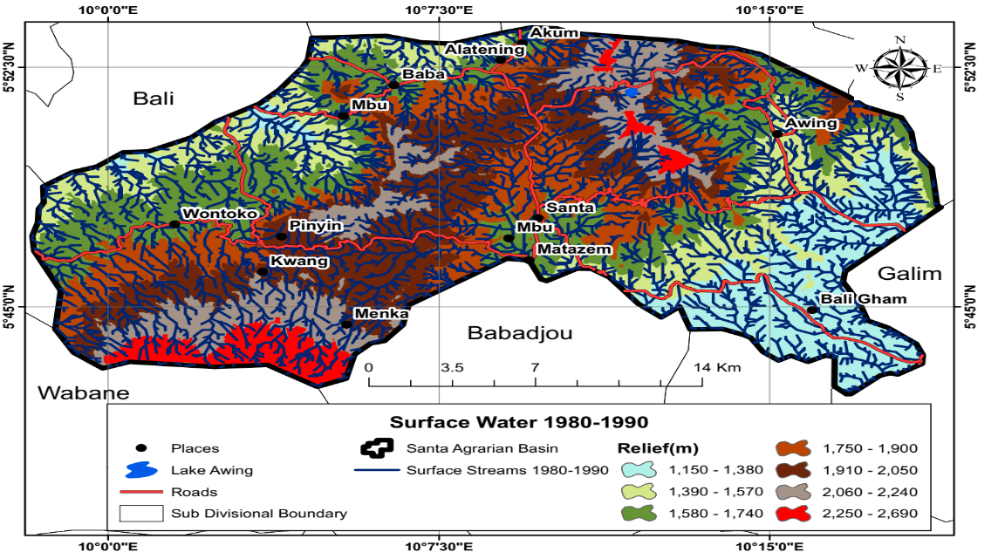

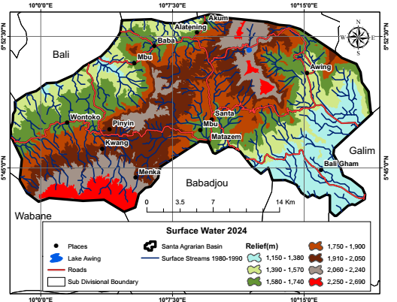

**Figure 2: Surface water potentials in the Santa Agrarian Basin (1980-2024)**

Source: ASTER Image (METI and NASA, 1980)

**4.1.2 Spatio-Temporal distribution of groundwater potentials**

Groundwater in the Santa Agrarian Basin has undergone a transformative evolution over the past four decades. In the1980s, the region entered what can be described as a “Silent Revolution” in groundwater use. Prior to this period, groundwater abstraction was limited, with reliance largely centered on surface water sources. However, between 1980 and 1990, increasing demand for agricultural water began to push communities toward alternative water sources, including shallow wells and hand-dug boreholes. Groundwater potential was highest in Awing, Santa, Mbu, and Kwang. Despite its growing importance, groundwater was often perceived as abundant and inexhaustible. This misperception, combined with a lack of technical knowledge regarding recharge rates and sustainable extraction, led to uncoordinated abstraction practices that would later impact water availability.

From 1991 to 2001, a marked intensification in groundwater abstraction occurred across the basin. This transformation was both spatial and technological. Areas experiencing surface water shortages, particularly in the northwest and eastern parts of the basin, saw increased reliance on groundwater sources. For instance, Wontoko emerged as a new zone of high groundwater concentration. This decade of intensified abstraction closely aligns with the decline observed in the surface water network. As surface streams contracted in both length and spatial coverage, particularly among first-order streams, groundwater became the default source for both domestic and agricultural uses.

Between 2002 and 2012, this pressure intensified further. The reduction in surface water resources, particularly in the southeastern and western regions of the basin, drove farmers toward deeper and more frequent groundwater abstraction. Boreholes and wells became common in agricultural zones, particularly in Awing, Pinyin and Alatening, where groundwater remained relatively accessible. These areas emerged as key agricultural zones, sustained in part by access to subsurface water. However, this rapid and often unregulated extraction led to visible consequences. Declines in water table levels became more frequent, especially during the dry season, and recovery times extended significantly. The basin began to exhibit signs of groundwater stress, particularly in lower recharge zones with less forest cover or unfavorable geological formations. This decade reflects a growing asymmetry in water resource availability. Surface water resources became increasingly fragmented and unreliable, while groundwater remained accessible in limited areas, albeit under growing stress.

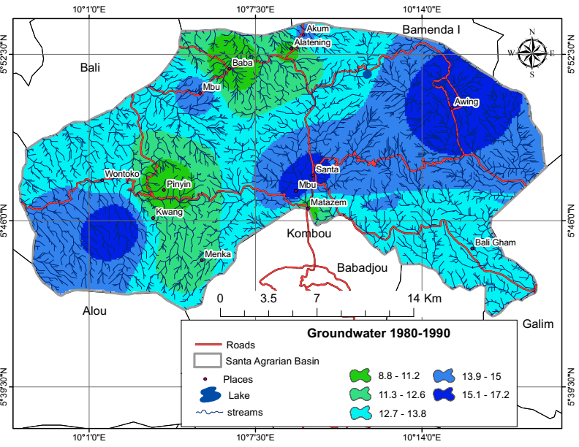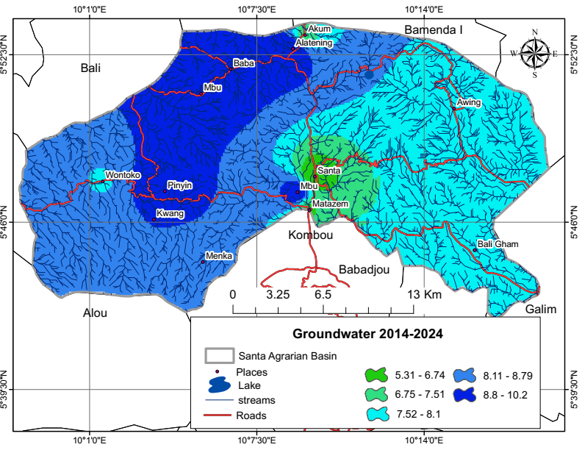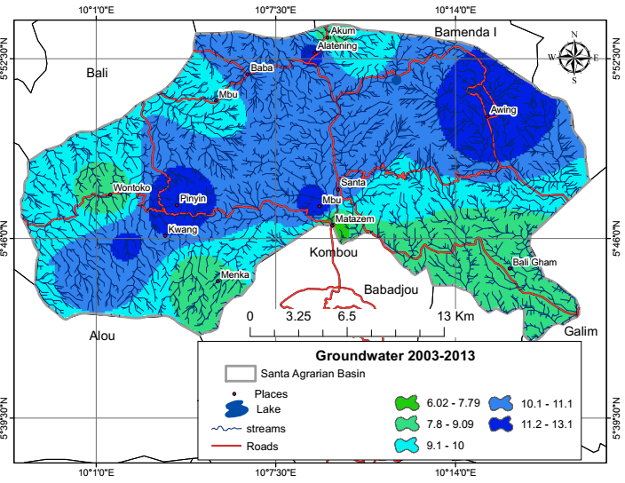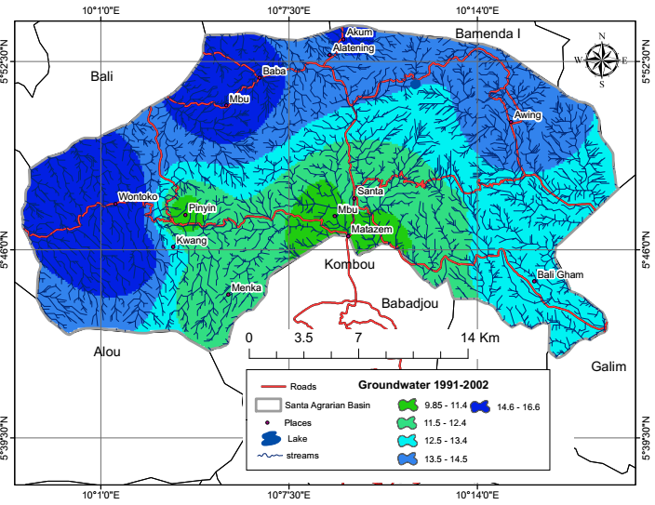

**Figure 3: Distribution of Groundwater resources in the Santa Agrarian Basin (1980-2024)**

Source:ASTER Image (METI and NASA, 1980, and Fieldwork, 2024)

From 2012 to 2024, the basin experienced a critical shift in groundwater distribution. While surface water resources continued to contract and fragment under demographic, agricultural, and climatic pressures, groundwater became indispensable. Farmers increasingly viewed groundwater not just as a supplement, but as the primary water source for sustaining year-round crop production. However, the spatial distribution of groundwater showed marked variation. Areas such as Pinyin, Mbu, and Baba emerged as high-potential zones due to favorable forest cover and geologic recharge conditions, while eastern regions, including Santa town itself, recorded significantly lower groundwater levels.

**4.1.3 Food Crop production trend in the basin in relation to surface and groundwater potential (1980-2024)**

The Food crop production trends of the Santa Agrarian Basin between 1980 and 2024 reveals that surface and groundwater resources are a key driver in the basin (Fig.4).

**Figure 4: Crop production trend in the Santa Agrarian Basin**

Source: Sub Divisional Delegation of Agriculture and Rural Development Santa

From 1980 to 1990, all three major food crops experienced steady increases in production. This growth closely followed the widespread availability of surface and groundwater water potential in the Santa Agrarian Basin. With surface water accounting for the majority of irrigation during this period, crops like tubers and cereals, which have higher water demands than vegetables, were particularly well sustained. Tubers increased from 12,000 to 13,400 tons, and cereals from 8,500 to 9,500 tons. The steady rise in these crops highlights the importance of perennial surface water sources, especially first- and second-order streams for consistent agricultural output. During the 1991–2001 decade, even as surface water began to decline due to deforestation and land conversion, groundwater emerged as a critical compensatory resource. This transition supported continued growth across all crops. Tubers increased from 13,300 to 14,470 tons and cereals from 9,400 to 10,210 tons, indicating that water-intensive crops still had sufficient water support through newly installed wells and boreholes. Vegetables, which are more adaptive to smaller-scale irrigation systems like shallow wells, also increased, but the contribution of groundwater to tuber and cereal irrigation was especially crucial during this decade. From 2002 to 2012, signs of hydrological stress became more visible, and the impact was **more severe on tubers and cereals.** Tubers initially reached a peak of 15,100 tons around 2007–2008, but began to decline thereafter, falling to 12,100 tons by 2009–2010. Cereals also plateaued and then dropped slightly. These crops' performance closely followed the contraction of both surface streams and declining groundwater recovery rates, especially in the southeastern parts of the basin. Farmers increasingly relied on groundwater, but over-extraction without recharge began to limit its availability, affecting tuber and cereal yields more dramatically than vegetables, due to their higher water dependency and longer growing cycles.

Between 2016 and 2019, crop production data is absent due to the sociopolitical crisis in the North West Region, which disrupted farming activities, data collection, and access to agricultural infrastructure. With partial stabilization beginning around 2019, production resumed but showed mixed results. In 2019–2020, cereals spiked to 14,000 tons, likely due to improved rainfall or temporary gains in groundwater availability after years of underuse. However, tuber and vegetable outputs were lower than historical highs, reflecting uneven recovery. In the following years, a downward trend set in again.

**4.1.4 Crop water Requirements in the Santa Agrarian Basin**

Plants require a specific amount of water to thrive and achieve optimal growth. When water is not distributed according to these requirements, significant water losses can occur, leading to insufficient irrigation across cultivated areas.

**4.1.4.1 Water Requirement of Tomatoes in the Santa Agrarian Basin**

Tomato (***Solanum lycopersicum***) is one of the most highly demanded market gardening crops within the basin and beyond. It serves as a staple in households, a raw material for agro-industries, and a key ingredient in culinary practices (Table 1).

**Table 1: Water Requirement for Tomatoes in the Santa Agrarian Basin**

|  |  |  |  |  |  |  |  |
| --- | --- | --- | --- | --- | --- | --- | --- |
| Month | Decade | Stage | Kc | Etc | Etc | Eff Rain | Irr. Req. |
|  |  |  | Coeff | mm/day | mm/dec | mm/dec | mm/dec |
| Dec | 3 | Init | 0.6 | 2.47 | 19.7 | 0.3 | 19.5 |
| Jan | 1 | Init | 0.6 | 2.5 | 25 | 1.4 | 23.6 |
| Jan | 2 | Init | 0.6 | 2.54 | 25.4 | 1.2 | 24.2 |
| Jan | 3 | Deve | 0.65 | 2.9 | 31.9 | 2.1 | 29.8 |
| Feb | 1 | Deve | 0.79 | 3.67 | 36.7 | 0.9 | 35.8 |
| Feb | 2 | Deve | 0.92 | 4.47 | 44.7 | 0.6 | 44.1 |
| Feb | 3 | Deve | 1.04 | 4.97 | 39.7 | 10.3 | 29.4 |
| Mar | 1 | Mid | 1.12 | 5.27 | 52.7 | 22.7 | 30 |
| Mar | 2 | Mid | 1.13 | 5.2 | 52 | 32 | 20 |
| Mar | 3 | Mid | 1.13 | 4.98 | 54.7 | 34.6 | 20.1 |
| Apr | 1 | Mid | 1.13 | 4.75 | 47.5 | 37 | 10.4 |
| Apr | 2 | Late | 1.12 | 4.49 | 44.9 | 40.7 | 4.3 |
| Apr | 3 | Late | 1.02 | 4.03 | 40.3 | 41.5 | 0 |
| May | 1 | Late | 0.9 | 3.48 | 34.8 | 42.1 | 0 |
| May | 2 | Late | 0.8 | 3.01 | 21.1 | 30.3 | 0 |
|  |  |  |  |  | **571.3** | **297.9** | **291.3** |

Source: CROPWAT 8.0 and Fieldwork, 2024

According Table 1, during the initial stage, the crop coefficient (Kc) is relatively low, indicating reduced water requirements as seedlings establish and focus on root development. As the plants progress into the development stage, their water needs increase significantly due to vigorous vegetative growth and fruit formation. Over the entire growing season, tomatoes require 571.3 mm of water. Effective rainfall contributes 297.9 mm, leaving 291.3 mm to be supplied through irrigation. The tomato crop takes 145 days from planting to harvesting.

**4.1.4.2 Water Requirement for Irish potatoes in the Santa Agrarian Basin**

Irish potatoe (Solanum tuberosum) is the most widely cultivated root crops in the Santa Basin. The water requirements of Irish potatoes vary significantly across their developmental stages (Table 2).

Table 2: Water Requirement for Irish potatoes in the Santa Agrarian Basin

|  |  |  |  |  |  |  |  |
| --- | --- | --- | --- | --- | --- | --- | --- |
| Month | Decade | Stage | Kc | ETc | ETc | Eff rain | Irr. Req. |
|  |  |  | Coeff | mm/day | mm/dec | mm/dec | mm/dec |
| Dec | 3 | Init | 0.5 | 2.05 | 16.4 | 0.3 | 16.2 |
| Jan | 1 | Init | 0.5 | 2.09 | 20.9 | 1.4 | 19.5 |
| Jan | 2 | Deve | 0.51 | 2.17 | 21.7 | 1.2 | 20.5 |
| Jan | 3 | Deve | 0.69 | 3.07 | 33.8 | 2.1 | 31.6 |
| Feb | 1 | Deve | 0.91 | 4.24 | 42.4 | 0.9 | 41.5 |
| Feb | 2 | Mid | 1.11 | 5.36 | 53.6 | 0.6 | 52.9 |
| Feb | 3 | Mid | 1.14 | 5.42 | 43.4 | 10.3 | 33 |
| Mar | 1 | Mid | 1.14 | 5.34 | 53.4 | 22.7 | 30.7 |
| Mar | 2 | Mid | 1.14 | 5.25 | 52.5 | 32 | 20.5 |
| Mar | 3 | Mid | 1.14 | 5.02 | 55.2 | 34.6 | 20.6 |
| Apr | 1 | Late | 1.09 | 4.58 | 45.8 | 37 | 8.7 |
| Apr | 2 | Late | 0.95 | 3.8 | 38 | 40.7 | 0 |
| Apr | 3 | Late | 0.81 | 3.17 | 31.7 | 41.5 | 0 |
| May | 1 | Late | 0.72 | 2.79 | 5.6 | 8.4 | 5.6 |
|  |  |  |  |  | 514.3 | 233.9 | 301.4 |

Source: CROPWAT 8.0 and Fieldwork, 2024

According to Table 2, during the initial stage that spans late December to the second decade of January, the crop is in its establishment phase. The crop coefficient (Kc) is low, ranging from 0.5 to 0.51, indicating modest water requirements. However, evapotranspiration (ETc) gradually increases from 16.4 mm/decade in December to 21.7 mm/decade in mid-January, driven by rising temperatures. Effective rainfall during this period is negligible, contributing between 0.3 mm and 1.4 mm/decade. As a result, irrigation plays a critical role, with requirements ranging from 16.2 mm to 20.5 mm/decade. This highlights the need for consistent water supply to support germination and initial root development. The development stage marks a period of rapid crop growth, characterized by a significant increase in water demand. The crop coefficient rises from 0.69 to 1.11, reflecting the plants' increasing water uptake. Correspondingly, evapotranspiration reaches as high as 53.6 mm/decade by mid-February. Effective rainfall remains low, varying from 0.6 mm to 2.1 mm/decade, which is insufficient to meet the crop's water requirements. Consequently, irrigation becomes critical, with peak demands reaching 52.9 mm/decade in mid-February. This stage underscores the importance of ensuring a steady and sufficient water supply to support vegetative growth and prepare the crop for tuber development.

The mid-season stage is the most water-intensive period of Irish potato cultivation. The crop coefficient stabilizes at 1.14, and evapotranspiration rates peak, with values such as 55.2 mm/decade recorded in late March. Effective rainfall increases notably during this stage, ranging from 10.3 mm/decade in late February to 34.6 mm/decade in late March. As a result, irrigation requirements gradually decline, from 33 mm/decade in late February to 20.6 mm/decade in late March. This phase is critical for tuber formation, and any water stress could lead to reduced yields and compromised tuber quality. In the late stage, as the crop approaches maturity, water demand begins to decrease. The crop coefficient declines from 1.09 to 0.72, and evapotranspiration drops from 45.8 mm/decade in early April to 2.79 mm/day in early May. Effective rainfall during this period (37–41.5 mm/decade) is sufficient to meet or even exceed the crop's water needs, effectively eliminating the need for irrigation in most decades. This natural reduction in water demand coincides with the final stages of tuber maturation and the onset of harvest, making it a less resource-intensive period for farmers.

**4.2 Classification of water sources for food crop cultivation**

Farmers in the Santa Agrarian Basin derive water for crop cultivation from a variety of sources, with each reflecting distinct patterns of access and utilization (Fig. 5). These sources are utilized differently depending on their availability, cost and accessibility, with clear disparities evident in rural and urban farming communities.

**Figure 5: Classification of water sources for crop cultivation in the Santa Agrarian Basin**

**Source: Fieldwork, 2024**

According to Figure 5, rainfall emerges as the most significant water source for crop cultivation in the Santa Agrarian Basin, with 43% of rural farmers depending on it compared to 32.5% in urban areas. This striking reliance indicates the dominance of natural rainfall in rural areas, where traditional farming practices are widespread, and irrigation infrastructure is scarce. Rural farmers’ dependence on rainfall stems from limited alternative water sources and the high cost of establishing irrigation systems. Conversely, urban farmers’ reduced reliance indicates greater access to alternative sources and more diversified water-use strategies. Surface water, including lake and streams, is highly relied upon by both rural and urban farmers, with each accounting for 24.7% of the water supply. This uniform distribution illuminates the importance of surface water as an accessible and cost-effective resource across the basin. The widespread availability of streams makes this source indispensable during the rainy season when streamflow is high. Even in Santa urban areas, where water systems are relatively more advanced, surface water serves as a critical supplement during dry spells or irrigation demands. Public taps are predominantly used by urban farmers, with 24.7% relying on them compared to only 13% in rural areas. This difference illustrates the uneven distribution of water supply infrastructure, as urban areas benefit from better-organized and accessible public systems, often developed through government initiatives. The lower percentage in rural areas indicates that such infrastructure is either unavailable or located too far from farming communities, limiting its practicality for agricultural use.

### ****5. Discussion of Findings****

This study aimed to explore the spatio-temporal dynamics of surface and groundwater potentials and their implications for food crop production in the Santa Agrarian Basin. The findings reveal important transformations in the area’s hydrology over the past four decades, which have directly impacted agricultural productivity and farmers’ water-use strategies. These findings are consistent with global and African patterns identified in previous studies.

The contraction in surface water resources between 1980 and 2024 reflects the increasing influence of environmental degradation, deforestation and climate variability in the Santa Agrarian Basin. The drastic reduction in first-order stream lengths, from 8.0 km to near disappearance, echoes global concerns that surface water bodies are becoming highly susceptible to seasonal variability and anthropogenic pressure (Vörösmarty et al., 2010; IPCC, 2021). These trends affirm the argument by Gowing et al. (2009) that fragmented and declining surface water systems hamper sustainable agricultural water planning, particularly in areas where irrigation systems are not fully developed.

In Africa, and particularly in semi-humid zones like the Santa Basin, rainfall variability and poor land-use practices have accelerated the fragmentation of surface hydrological systems. This supports Bonsor et al. (2018) and MacDonald et al. (2021), who emphasise that despite rainfall abundance in some parts of the continent, poor management and ecological stress often reduce the usable water available for agriculture.

The increasing reliance on groundwater since the 1990s, especially in zones like Awing, Pinyin, and Mbu, underscores a regional "groundwater revolution", similar to that observed in India’s Indo-Gangetic Plain and China’s North Plain (Wada et al., 2010). The findings show that while groundwater became an indispensable buffer, especially during the dry season, its exploitation was largely uncoordinated and inadequately regulated. This unregulated abstraction, paired with poor knowledge of recharge dynamics, aligns with the concerns of Taylor et al. (2013), who warned about declining groundwater sustainability in sub-Saharan Africa.

The study’s evidence of spatial disparities in aquifer potential also mirrors findings by MacDonald et al. (2012), who documented unequal groundwater accessibility due to underlying geological differences. Areas with basaltic fractures and forest cover, such as Pinyin and Baba, sustained groundwater potential, whereas deforested and rapidly urbanising zones like Santa town experienced alarming depletion. This highlights the need for spatially sensitive groundwater governance.

The direct correlation between water availability and crop yield trajectories further affirms the literature linking hydrological dynamics to food security (FAO, 2020; IPCC, 2021). Tubers and cereals, both water-demanding crops, peaked in output during periods of surface water stability (1980–2000) and began to decline in response to hydrological stress and aquifer depletion by 2012. These outcomes support the Integrated Water Resources Management (IWRM) framework’s premise that both surface and groundwater must be co-managed to sustain agricultural livelihoods.

The mid-2000s peak and subsequent drop in tuber yields from 15,100 to 12,100 tons reflect the limits of groundwater as a substitute for surface water when recharge rates are low. This phenomenon has been observed across sub-Saharan Africa, where shifting rain patterns and groundwater overuse create unsustainable water–food feedback loops (UNECA, 2020). The socio-political crisis that disrupted agricultural activity between 2016 and 2019 adds to the vulnerability of this alreyady fragile hydrological–agricultural system.

The CROPWAT 8.0 results demonstrate substantial irrigation needs for main crops such as tomato (571.3 mm) and Irish potato **(**514.3 mm**)**. These findings corroborate Gowing et al. (2009), who argue that crop-specific water management strategies are crucial in water-scarce contexts. Notably, the effective rainfall in all cases was insufficient to meet crop water demands, with supplemental irrigation needs exceeding 40–50%, a statistic that confirms the vulnerability of food crops to seasonal water shortfalls.

The variability in crop water needs across growing stages, rising sharply during development and peaking mid-season, emphasises the importance of aligning irrigation schedules with phenological phases. For instance, Irish potatoes showed late-season water reduction, suggesting that with proper irrigation timing, overall water use could be optimized, a principle central to the IWRM framework.

These insights also reinforce the argument of Altchenko and Villholth (2015) that adaptive water governance strategies must consider crop physiology and local hydrological realities. Without strategic irrigation planning, the risk of mid-season crop failure and reduced yields will persist. The classification of water sources reveals spatial and socio-economic disparities in water access. Rural farmers remain heavily dependent on rainfall (43%), whereas urban farmers are more depended on public taps and boreholes. These disparities align with findings by Kimengsi et al. (2022), who highlight infrastructural inequalities as important drivers of unsustainable water use in Cameroon’s agrarian zones.

The higher use of private taps in rural areas also suggests that wealthier households or cooperatives are able to buffer against water insecurity, creating potential equity gaps in agricultural outcomes. The limited use of boreholes and wells in rural areas despite groundwater potential further underscores infrastructural and technical limitations. This calls for targeted investments in community-scale water systems and farmer training on aquifer recharge management.

**Conclusion**

This paper investigated the complex and evolving dynamics of surface and groundwater resources in the Santa Agrarian Basin, emphasizing their role in sustaining food crop production. Over the past four decades, the basin has experienced a significant reduction in surface water availability, prompting increased dependence on groundwater, a trend that has directly influenced agricultural patterns and productivity. The marked decline of water-intensive crops since 2010 indicated the link between water resource health and the quantity of food crop production. The crop water requirement analysis revealed high irrigation demands, with key crops such as tomatoes, and Irish potatoes 40–50% water supplementation, well above global averages.

**References**

Altchenko, Y., & Villholth, K. G. (2015). Mapping irrigation potential from renewable groundwater in Africa: A quantitative hydrological approach. Hydrology and Earth System Sciences, 19(2), 1055–1067.

Bonsor, H. C., MacDonald, A. M., & Calow, R. C. (2018). Groundwater resilience to climate change in Africa. Nature Climate Change, 8(8), 869–872.

FAO (Food and Agriculture Organization). (2020). Crop water requirements and irrigation

Global Water Partnership (GWP). (2000). Integrated water resources management. TAC Background Papers No. 4. Stockholm: GWP. Retrieved from https://www.gwp.org/en/GWP-CEE/about/why/what-is-iwrm/

Gowing, J. W., Walker, D. J., & Parkin, G. (2009). Integrated water management in dryland agriculture. Agricultural Water Management, 96(10), 1413–1422.

IPCC (Intergovernmental Panel on Climate Change). (2021). Climate change 2021: The physical science basis. Cambridge University Press.

IPCC (Intergovernmental Panel on Climate Change). (2023). Climate change 2023: Impacts, adaptation, and vulnerability. Cambridge University Press.

Kimengsi, J. N., Balgah, R. A., & Buchenrieder, G. (2022). Water governance and agricultural productivity in sub-Saharan Africa: A review. Sustainability, 14(3), 1234.

MacDonald, A. M., Bonsor, H. C., Dochartaigh, B. É. Ó., & Taylor, R. G. (2012). Quantitative maps of groundwater resources in Africa. Environmental Research Letters, 7(2), 024009.

MacDonald, A. M., Lark, R. M., Taylor, R. G., & Calow, R. C. (2021). Groundwater and resilience to drought in Africa. Nature Communications, 12(1), 1–8.

NIS (National Institute of Statistics, Cameroon). (2017). Regional monographs of the North West Region. Yaoundé: NIS.

Santa Rural Council. (2003). Monographic study of Santa Sub Division. Santa: Santa Rural Council.

Taylor, R. G., Scanlon, B., Döll, P., & Rodell, M. (2013). Groundwater and climate change. Nature Climate Change, 3(4), 322–329.

UNECA (United Nations Economic Commission for Africa). (2020). Water security and agricultural resilience in the Sahel. Addis Ababa: UNECA.

Vörösmarty, C. J., McIntyre, P. B., Gessner, M. O., Dudgeon, D., Prusevich, A., Green, P., ... & Davies, P. M. (2010). Global threats to human water security and river biodiversity. Nature, 467(7315), 555–561.

Wada, Y., van Beek, L. P. H., & Bierkens, M. F. P. (2010). Modeling global water stress of the recent past: On the relative importance of trends in water demand and climate variability. Hydrology and Earth System Sciences, 14(12), 2415–2434.