**Original Research Article**

**Stability Analyses of Rock Slopes and Improvement Solutions: Case of Muğla/ Bakıcak**

**ABSTRACT**

This study evaluates the overall stability of the rock slopes in Muğla Bakıcak and discusses how these slopes can be made safer with specific measures. In this context, the stability of the rock slopes in Muğla Bakıcak was investigated using various analysis methods. In the study, the different processes affecting the instability of rock slopes and the effect of these processes on rock mass strength were examined in detail. In particular, the effect of discontinuity characteristics on rock slope stability is discussed in detail in the study. The rock material constituting the rock slopes, engineering properties of the rock mass, discontinuity properties, and orientations were determined in the analyses. The stability of rock slopes was investigated by limit equilibrium analysis, finite element method, and kinematic analysis. As a result of kinematic analysis, it was determined that planar, wedge, and overturning-type instabilities are possible.

**Key Words:** Rock slope stability, Rock mass strength, Kinematic analysis, Slope stability

**1. INTRODUCTION**

Slope stability issues are significant geoenvironmental hazards frequently encountered in construction projects (Stead & Wolter, 2015). Consequently, identifying and resolving slope instability problems has been a research focus for many years (Z. Chen, 1995; Uribe-Etxebarria et al., 2005; Pantelidis, 2009). The literature encompasses various approaches and solutions related to slope stability analyses (Chen et al., 1998; Nilsen, 2000, 2017; Hadjigeorgiou & Grenon, 2005; Li et al., 2006; Sun et al., 2011; Länsivaara & Poutanen, 2014; Stead & Wolter, 2015; Yang et al., 2015; Azarafza et al., 2021). Human interventions for engineering purposes or natural influences on soil and rock slopes often lead to instability and substantial material losses (Dorren, 2003; Akgün & Koçkar, 2004; Liu et al., 2021). Therefore, particular attention to stability analyses by design engineers is crucial during slope design or modification.

Different types of failures in rock slopes and the processes leading to these failures have been summarized by Brideau et al. (2009). The study highlights the effects of tectonism and discontinuity characteristics on rock mass strength reduction. Failures in rock slopes are often controlled by the intersection of complex discontinuities that facilitate kinematic failure. These discontinuities are commonly associated with folds, faults, shear zones, and bedding planes (Havaej & Stead, 2016). Instabilities near an active fault zone and rock masses are prone to failure due to various triggering factors (Bao et al., 2021; Hack et al., 2007; Jelínek & Žáček, 2018; Liu et al., 2014; Zhou & Cheng, 2014). Therefore, slope stability should be thoroughly assessed for static and dynamic conditions, considering different analysis methods for long and short-term evaluations. In this context, the most critical slip surface, safety factors, deformation damage modes, and deformation damage mechanisms must be addressed in slope stability analyses under the influences of earthquakes and groundwater.

This study encompasses general stability evaluations of rock slopes in Bakıcak, Muğla (Figure 1), and discusses the planned applications to enhance rock slope stability. Within the scope of the study, the engineering properties of the rock material and rock mass constituting the rock slopes in the study area are presented, and precautionary measures specific to critical slope sections are discussed. To identify potential hazards in rock slopes, traverse surveys covering the entire study area were conducted, and the discontinuity characteristics of the rock mass constituting the rock slopes were determined using the acquired data. Additionally, rock mass material properties, dominant orientations of slopes, and average slope angles and heights were determined to serve as a basis for rock slope stability analyses. In conclusion, this study examines the stability of rock slopes through limit equilibrium and finite element methods, as well as kinematic analyses. The findings from these assessments are used to propose solutions for controlling the identified hazards.

harita içeren bir resim

Açıklama otomatik olarak oluşturuldu

**Figure 1**. Location map of the study area.

**2. ROCK MASSES AND MATERIALS CONSTITUTING ROCK SLOPES**

**2.1. Discontinuity Characteristics of the Rock Mass**

The most crucial structural features that disrupt or alter the homogeneity of the rock mass are considered to be the discontinuities within the rock mass. Therefore, discontinuities are regarded as the most critical parameter affecting the stability of rock masses. Discontinuities vary in size from millimeters to meters, and their locations, orientations, and various features significantly influence several properties of rock masses, such as strength, deformation, permeability, etc. (Ulusay & Sönmez, 2002). Two standard methods, traverse surveys, and window mapping are widely used for measuring and identifying parameters related to discontinuities when determining the characteristics of the rock mass. In the study area, the discontinuity characteristics of the rock mass were examined using the traverse survey method recommended by ISRM (2007) at three locations, paying attention to points where rock slope characteristics vary and critical slope positions (Figure 2). The data obtained from the traverse surveys conducted at these two points, which are suitable for analysis of critical slopes, were evaluated separately for each analysis profile, determining the condition, type, spacing, aperture, continuity, infill material properties, degree of discontinuity weathering, surface roughness, and water conditions related to discontinuities in the study area.

metin, gün içeren bir resim

Açıklama otomatik olarak oluşturuldu

**Figure 2.** Images from traverse survey locations.

During the traverse surveys conducted at three different locations to reveal the discontinuity characteristics, the orientations of the discontinuities were measured and analyzed using Dips Version 8.003 (2021) software. The results obtained from the analyses were evaluated separately for the entire field and each location under consideration for critical slopes. According to the analysis, four dominant joint sets are in the study area, with orientations identified as 65/158, 83/253, 81/298, 76/016, and 77/329 (Figure 3). Additionally, as visible on the stereonet, randomly oriented joints will not be included in any cluster. In addition to determining the general conditions of discontinuities in the field, orientations within critical slopes were also identified and considered in stability analyses based on these data and the predominant orientation for the slope.

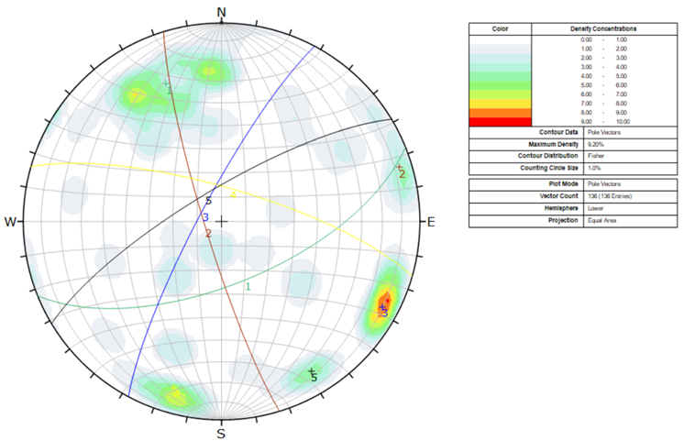

**Figure 3.** Dominant joint sets were identified for the entire field.

Upon the characterization of discontinuities in the rock units in the study area, measurements of discontinuity spacing were conducted by measuring distances up to the adjacent discontinuity perpendicular to the discontinuities. Statistical evaluation of the discontinuity spacing measurements conducted at three locations revealed the presence of discontinuities with spacings of 20-60 mm and 60-200 mm in the study area, with a significant portion of the discontinuity spacings ranging between 60-200 mm. When evaluating the discontinuity spacing values in the study area based on the criteria proposed by ISRM (2007), joint spacings varied from "Very close spacing" to "Close spacing," and the predominant feature in the field was considered "Close spacing." Measurements obtained from the traverse surveys were statistically evaluated, revealing an average aperture of 2 mm, with the smallest aperture being 0.1 mm and the largest aperture being 50 mm. Discontinuities in the locations generally do not contain infill material but may occasionally include weathered material. ISRM (2007) classified discontinuity apertures descriptively, as shown in Table 2. Accordingly, discontinuities range from "closed" to "open," with discontinuity apertures generally considered as "Open, fractured structure." Additionally, the rock mass in the field mainly exhibits a blocky structure, and discontinuities within the rock mass are intersected by one another. The continuity of joints measured in the rock units in the study area is mostly less than 1. When the continuity of measured joints in the rock units in the study area was classified using the continuity criteria recommended by ISRM (2007), the discontinuities in the rock mass were evaluated as "very low continuous."

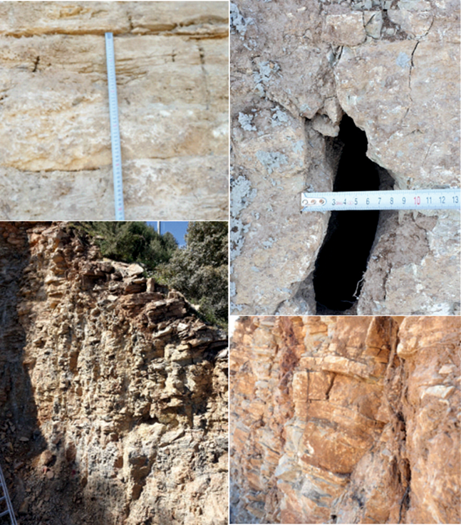

**Figure 4**. Images from the line survey locations.

Water seepage in rock masses develops along discontinuities (secondary permeability) associated with each other. The classification proposed by ISRM (Table 1) for the degree of leakage in unfilled discontinuities in rock masses can be utilized to assess the extent of seepage. Field observations indicate erosions in some samples due to the influence of water (Figure 5). According to the evaluation based on ISRM (2007), the degree of seepage is considered to be 3.

|  |  |
| --- | --- |
| dış mekan, jeoloji, kireç taşı, dip kaya içeren bir resim  Açıklama otomatik olarak oluşturuldu | dış mekan, gökyüzü, yer, dağ içeren bir resim  Açıklama otomatik olarak oluşturuldu |

**Figure 5.** Surface alterations observed in samples.

**Table 1.** Definition of seepage degree (ISRM 2007).

|  |  |
| --- | --- |
| **Seepage rating** | Description |
| I | The discontinuity is very tight and dry, water flow along it does not appear possible |
| II | The discontinuity is dry with no evidence of water flow. |
| III | The discontinuity is dry but shows evidence of water flow, i.e., rust staining, etc. |
| IV | The discontinuity is damp but no free water is present. |
| V | The discontinuity shows seepage, occasional drops of water, but no continuous flow. |
| VI | The discontinuity shows a continuous flow of water. ( Estimate l/min and describe pressure i.e. low,medium,high). |

To estimate the strength and degree of degradation of discontinuity surfaces, the Schmidt hammer test was conducted using the method proposed by Gokceoglu (1997), which relies on the number of rebounds of the Schmidt hammer (Table 3). With this method, fresh (Rf) and weathered (Rw) rebound values are obtained from locations and degraded discontinuity surfaces, and the weathering coefficient (Wc) can be determined using Equation 1. Schmidt hammer tests were performed at 3 locations in the study area, and the statistical average values are presented in Table 2. The obtained Wc value, along with Table 3, was used to classify the discontinuities as "Completely weathered" at locations 1 and 2 and "Moderately weathered" at location 3.

**Table 2.** Schmidt hammer test data.

|  |  |  |
| --- | --- | --- |
| **Location** | $$R_{f}$$ | $$R_{w}$$ |
| 1 | 50 | 23.8 |
| 2 | 51 | 22.2 |
| 3 | 44 | 26.4 |

$$W_{c1}=\frac{R_{f}}{R_{w}}=\frac{50.2}{13.2}=3.78 Equation 2$$

$$W_{c2}=\frac{R_{f}}{R_{w}}=\frac{51.2}{22.8}=2.24 Equation 2$$

$$W_{c3}=\frac{R_{f}}{R_{w}}=\frac{46.4}{27.9}=1.66 Equation 2$$

**Table 3.** Classification of discontinuity surfaces based on weathering index (Wc) (Gokceoglu, 1997).

|  |  |  |
| --- | --- | --- |
| Wc | Classification | Definition (ISRM 2007) |
| <1.1 | 1 | Intact (Fresh) |
| 1.1-1.5 | 2 | Slightly degraded |
| 1.5-2.0 | 3 | Moderately degraded |
| >2.0 | 4 | Completely degraded |

The Joint Roughness Coefficient (JRC) values for discontinuity surfaces were determined by tracing the roughness representative profile with the values provided by Barton and Choubey (1977), defining the JRC value as 10-12 (Figure 6). The Joint Wall Compressive Strength (JCS) properties of the discontinuity surfaces were determined in the field through Schmidt hammer test data, ranging from 29.5 MPa to 112 MPa (Figure 7) using the equation proposed by Barton and Choubey (1977).

$$logJCS=0.00088γR+1.01 Equation 2$$

JCS; Joint Wall Compressive Strength, γ; unit weight, R; Schmidt rebound value

Studies Were also conducted to determine the dimensions of rock blocks within the rock mass forming the rock slopes. The block size is a crucial feature controlling the behavior of rock masses. According to ISRM 2007, rock slopes can be described as irregularly blocky rock masses. The block size was defined based on the average size of typical blocks (block size index Ib) or the total number of observed discontinuities in a unit rock mass volume (volumetric joint count Jv). In this context, the rock masses in the study area were classified as "small blocks" according to ISRM 2007 Jv.

**2.2. Rock Material Strength**

The fundamental index and mechanical properties of rock material in the slopes of the project area have been extensively discussed in the Drilling-Based Soil Investigation Report prepared by Ege-Su Engineering in 2017 and were utilized in this study. According to the study, the strength of rock materials varies with depth, ranging from 149 kg/cm² to 319 kg/cm². Accordingly, the rock materials in the study area were classified as "very low-low" strength rocks according to Deere and Miller (1966) (Table 4).

|  |  |
| --- | --- |
| figure1 | açık hava, çayır, doğa, taş içeren bir resim  Açıklama otomatik olarak oluşturuldu |

**Figure 6.** Roughness profiles and the corresponding range of JRC (joint roughness coefficient) values (Barton & Choubey, 1977; ISRM, 2007).

**Table 4.** Deere and Miller (1966) rock strength class

|  |  |  |
| --- | --- | --- |
| Classification | Strength | **Uniaxial compressive strength (MPa)** |
| A | Very High | **>220** |
| B | High | **110-220** |
| C | Ota | **55-110** |
| D | Low | **27.5-55** |
| E | Very Low | **>27.5** |

**2.3. Rock Mass Classification (RMR)**

Rock slope stability analyses differ significantly from the behavior of soil in an excavated state, leading to the development and refinement of rock mass classifications for the evaluation of rock slope stability over time (Selby, 1980; Bieniawski, 1989; Haines et al., 1991; Romana, 1991; Singh & Goel, 1999). Rock mass classification systems are standardized methods to define and classify the characteristics of geological structures, rocks, and rock slopes. In this study, the classification of rock masses in the study area was conducted using the Rock Mass Rating (RMR) system, a rock mass classification system proposed by Bieniawski (1989).

This system is frequently employed in the planning and designing rock slopes, tunnels, mines, and other underground engineering projects (Bieniawski, 1993; Mateus et al., 2023; Adikusuma et al., 2023). In this classification system, points are assigned to factors such as rock mass strength, RQD value, discontinuity spacing, discontinuity conditions, and crack water conditions, and the overall condition of the rock mass is defined by obtaining a total score (Bieniawski, 1993). The evaluation based on these features assists in predicting the stability of a rock slope or tunnel. A higher RMR score signifies a more stable rock mass or tunnel, while a lower score may indicate a need for additional engineering precautions. According to the RMR classification system results, the rocks in the study area were classified as RMR IV class, "weak rock," under the worst conditions. Based on this data, rock mass strength parameters defined for weak rock will be used in all stability analyses.

**3. STABILITY ANALYSIS OF ROCK SLOPES IN THE STUDY AREA**

The stability of rock slopes is assessed through kinematic analyses, limit equilibrium analyses, numerical analyses, and Rock Mass Rating (SMR) classification systems (Hoek & Bray, 1981; Romana, 1991; Pantelidis, 2008b, a; Alejano et al., 2011). In kinematic analyses, the slope geometry and internal friction angle of discontinuities are used as input parameters, and this analysis method becomes crucial in cases where failures in rock slopes are controlled by discontinuities (Goodman, 1991; Kliche, 1999; Gurocak et al., 2007; Kulatilake et al., 2011; Cerri et al., 2018). This analysis method helps identify potential failure types in rock slopes (planar, wedge, and toppling failures).

If any failure risks are identified in kinematic analyses, potential hazards should be investigated using limit equilibrium analyses. Limit equilibrium analyses consider factors such as shear strength along the failure plane, pore water pressure, and maximum horizontal ground acceleration (Gurocak et al., 2007; Qi et al., 2015; Akram et al., 2019). Although limit equilibrium analyses are commonly used for evaluating slope stability, they may be insufficient when slopes are destabilized by complex mechanisms such as excavation damage and discontinuity orientations (Eberhardt, 2003; Stead et al., 2006). Advances in finite element programs allow for more representative rock slope stability results, provided rock mass properties are accurately reflected.

**3.1. Limit Equilibrium Analyses**

Considering the most critical slope geometry in the study area, limit equilibrium analyses were performed with Rocscience Slide 9 software and Rocscience RS2 using the Generalised Hooke Brown material model (Table 5), and it was observed that the safety factor of the slopes was 1.9 (Figure 7 a). Even though the slope is considered safe since the slope material in the study area contains discontinuities, the failures are considered to be discontinuity controlled, and the stability of the slopes should be evaluated by kinematic analyses, and evaluations should be made according to the results obtained. In addition to the limit equilibrium analyses, in order to determine the possible displacements, the stability of the slopes was also analyzed with Rocscience RS2 V.11 software using a two-dimensional hybrid element model called the finite element method geotechnical parameters (slope angle, uniaxial compressive strength, Poisson's ratio, geological strength index (GSI) of the rock unit, Hoek - Brown application, deformation modulus of rock material (Erm), friction angle, cohesion and direction of discontinuities and groundwater status) are taken into account in the Finite Element method. The slope geometry and material properties used in the limit equilibrium and stress-deformation analyses were performed with the Generalised Hooke-Brown material model. Plastic failures were investigated for all slopes. The numerical analyses did not consider seismic loads and triangular finite elements with three nodes were used. The total displacement, maximum shear strain, and strength factor obtained from the analyses are presented in Figures 7 b, c ,d.

**Table 5**. Material parameters used in slope stability analyses.

|  |  |
| --- | --- |
| Material Model | Generalized Hoke Brown |
| Unit | Limestone |
| GSI | 50 |
| mi | 25 |
| d | 0.7 |
| UCS (intact) | 15 Mpa |
| Slope Height | 12. m |
| Slope Angle | 860 |

|  |  |  |
| --- | --- | --- |
| **a** | | **b** |
| **c** | **d** | |

**Figure 7.** Strength Factor (a), Expected displacements on the slope (b), Total displacements (displacement arrows) (c), Total maximum shear strain (d).

**3.1. Kinematic Analyses**

The kinematic analysis method, initially defined by Hoek and Bray (1981), developed by Goodman (1991), and later revised by Wyllie and Mah (2004), is used for the investigation of planar, wedge, and toppling failures in jointed rock slopes. Kinematic analyses serve as a method before detailed analyses to distinguish potential slopes where instability problems could occur in rock masses where discontinuity systems control stability. Kinematic analyses are critical in slope stability studies where failures are expected under the control of discontinuities. The relationships between discontinuities and slope positions are input parameters for these analyses. In this method, planar, wedge, and toppling failures are examined, and the orientation of discontinuities and the internal friction angle (Ø) of the discontinuity surface are used as input parameters in the analyses. In this study, the internal friction of discontinuities was determined to be 25° using the RMR score and Rocdata 5.0 (2020) software (Figure 8). The critical slope parameters for three representative slopes in the study area and the discontinuity properties obtained from field surveys were used as input parameters in the analyses (Table 6). Kinematic analyses were conducted using Dips Version 8.003 software (rocscience 2021).

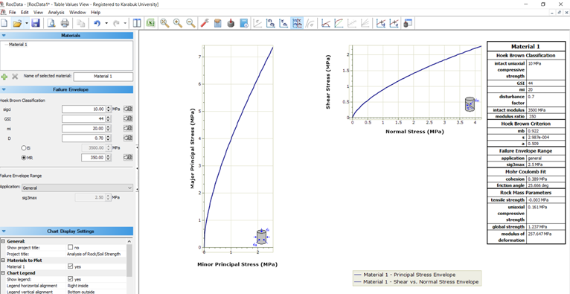

**Figure 8**. Discontinuity strengths.

**Table 6.** Slope parameters considered in kinematic analyses for Location 1.

|  |  |  |  |  |  |
| --- | --- | --- | --- | --- | --- |
| **Slope No** | **Approximate slope height** | **Slope Orientation**  **(Slope/Slope Direction)** | **Dominant Joint Orientation** | **Internal Friction Angle of Discontinuity Planes (ɸr)** | **Lithology** |
| S­_1 | 9.5 m | 80/320 | 66/179, 80/019, 80/293 | 250 | Weathered Andesite in places |
| S_2 | 13 m | 85/210 |
| S_3 | 6.5 m | 85/250 |

**3.1.1. Kinematic analysis results for slope 1**

For this slope, the ITRF96 538611/4108980 coordinate is representative, and the stone wall starting area opposite the construction site is representative (Figure 9 a). According to the kinematic analysis results, the probability of planar slip on the slope under the control of all joint systems was 9% (Figure 9 a). In support of the analysis results, planar slides were observed on the existing slope during the field study (Figure 9 b). The analysis of the wedge-type slip on this slope orientation is shown on the stereo net in Figure 9. It is determined that the failure may occur at the intersections of Set 1 and Set 3, Set 3 and Set 4, and Set 1 and Set 4; the probability is 21%. The analyses show that flexural overturning type failure (Figure 9) and block type failure are likely to occur on the slope with a high probability. (Figure 9).

|  |  |  |  |  |
| --- | --- | --- | --- | --- |
|  |  | |  | |
| b | | c | | d |

**Figure 9.** General view and planar failure analysis results for Slope 1( a). wedge failure analysis results for Slope 1 (b). flexural overturning type failure analysis for Slope 1 (c), block overturning type failure analysis for Slope 1 (d).

**3.1.2. Kinematic analysis results for Slope 2**

ITRF96 529096/4110026 is representative of this slope (Figure 10), and the steepest section of the approximately east-west orientated slopes in the study area in the middle section is analyzed within the scope of this slope.

|  |  |
| --- | --- |
|  |  |

**Figure 10.** Slope 2.

According to the kinematic analysis results, the possibility of planar slip on the slope under the control of joint systems was not detected (Figure 11a); the analysis of wedge-type slip on this slope orientation is shown on the stereo net given in Figure 11b, and it is determined that the failure may occur at the intersections of Set 3 and Set 4 and the probability is 11%. The analyses show the possibility of flexural overturning-type failure (Figure 11c) and block-type failure (Figure 11d) on the slope.

|  |  |
| --- | --- |
|  |  |
|  |  |

**Figure 11.** Planar failure analysis results for Slope 2 (a), wedge failure analysis results for Slope 2 (b), flexural failure analysis for Slope 2 (c), and block failure analysis for Slope 2 (d).

**3.1.3. Kinematic analysis results for Slope 3**

The coordinate ITRF96 529096/4110026 represents this location (Figure 12) and covers the eastern part of the slopes in the study area. According to the results of the kinematic analyses at this location, the probability of planar slip on the slope under the control of all joint systems was determined to be 0% (Figure 13a). The analysis of wedge-type slip on this slope orientation is shown on the stereonet in Figure 13b. It is determined that the probability is 9% and is determined to be at the intersection of Set 3 and Set 4. The analyses show a possibility of overturning on the slope, and the probability of bending overturning type failure is around 14% (Figure 13c). In comparison, block-type overturning will be taken under Set 2 control and has a probability of 12% (Figure 13d).

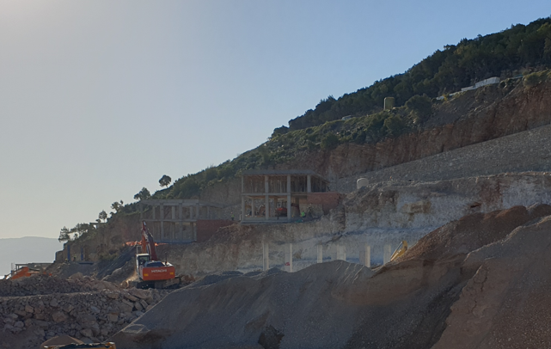

**Figure 12.** Location 3 discontinuity condition

|  |  |
| --- | --- |
|  |  |
|  |  |

**Figure 13**. Planar failure analysis results for Slope 3 (a), wedge failure analysis results for Slope 3 (b), flexural failure analysis for Slope 3 (c), and block failure analysis for Slope 3 (d).

The analyses revealed that planar, wedge and overturning-type failures are likely to occur on the slopes in the study area (Table 7).

**Table 7.** Possible kinematic instabilities on the identified slopes

|  |  |  |  |
| --- | --- | --- | --- |
| **Slope** | **Planar Shear** | **Wedge Shear** | **Overturning** |
| Slope 1 | √ | √ | √ |
| Slope 2 | √ | √ | √ |
| Slope 3 |  |  | √ |

**3.2. Numerical evaluation of kinematic analyses**

Within the scope of the study, numerical analyses of planar, wedge, and overturning type instabilities were performed with Rocsciences Swedge, Rocsciences RocPlan, and Rocsciences RocTopple software after kinematic analyses. Swedge (Rocsciences, 2021) software is an effective software used to evaluate the stability of surface wedges in rock slopes defined by two intersecting discontinuity planes, slope surface, and stress crack. RocTopple is a software used to perform overturning analysis and support the design of rock slopes. RocPlane is an interactive software tool for performing planar rock slope stability analysis and design. RocPlane makes it easy to create planar models quickly, visualize them in both 2D and 3D, and evaluate the results of the analyses. The analyses are based on the block-tipping method developed by Goodman and Bray (1976).

Considering the dominant joints in the study area and a representative slope profile, planar (Figure 14), wedge (Figure 15), and overturning type (Figure 16), slip probabilities were numerically evaluated. These analyses show that the probabilities revealed by kinematic controls are also available numerically, and the calculated safety factors for a slip at the critical limit are approximately 1.22, 1.28, and 1.67 for planar slip, 0.85, 1.22, and 0.92 for wedge slip, 0.84, 0.80 and 0.82 for overturning type slip, respectively.

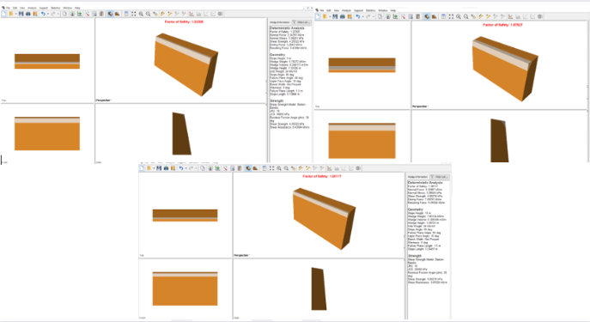

**Figure 14.** Planar shear analysis for critical slope

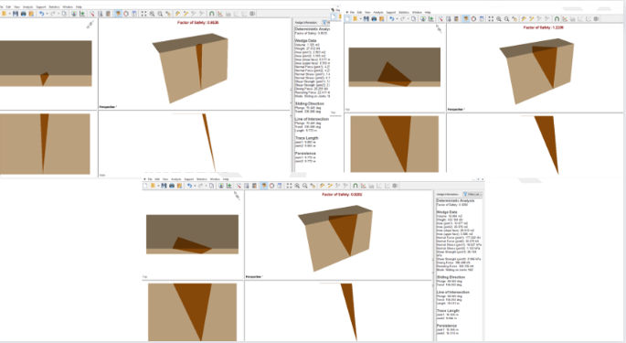

**Figure 15.** Wedge shear analysis for critical slope

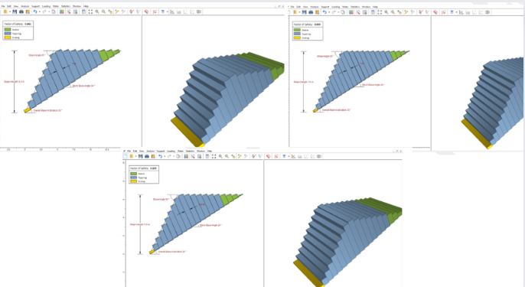

**Figure 16.** Slope 1 overturning analysis.

**4. PROPOSED STABILISATION METHOD FOR ROCK SLOPES IN THE STUDY AREA**

Stability analyses show that the rock slopes subject to the investigation are unsafe. There are different applications with different properties to increase the stability of rock slopes. However, these applications should be selected by evaluating land use and project requirements together. Considering the lack of large areas under the slope in the study area and the land constraints in the project area, it was evaluated that the most suitable stability enhancement method would be Rock Bolts and Steel Mesh + Shotcrete application to be applied on it. In this context, in the analyses made with Rocsciences Swedge, Rocsciences RocPlan, and Rocsciences RocTopple software, it was evaluated that the existing hazard could be avoided by using Rock bolts with a capacity of at least 150 kN (Figure 17). In addition, the planned prevention method was confirmed with Macro.2.0 software, and it was evaluated that the implementation of the application project as Ø32mm IBO Bolt + 2.7 mm Steel Mesh with 80x100 mesh opening + at least 10 cm Shotcrete with a minimum length of 4m and 1.70m*1.70m intervals will control the existing risk.

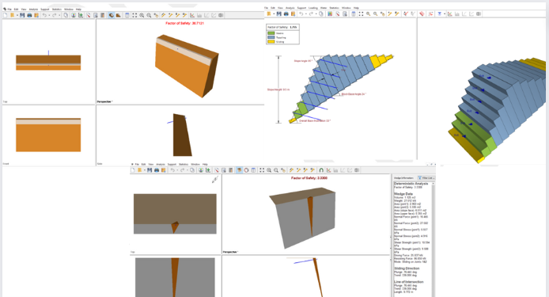

**Figure 17.** Stability enhancing blon application.

Drills for anchor holes should be made in the direction of pulling at an angle of at least 15° to the horizontal. Anchors should be mortared where the anchor head is in the horizontal position by inserting the anchors into the holes until the hole mouth coincides with the mark on the anchor. During the ibo bolt application, injection grout should be injected through the bolt to fill the gap between the bolt and the rock. An important parameter that increases the quality of the application is that the injection grout cements the weak points together from the fractured, cracked roads it finds during its return. For this reason, to stop the application process, the injection should be expected to come from the hole mouth opened for blon and to show continuity. The injection mixture design should be checked and approved by the employer. Test samples should be taken by the principles specified in AASHTO T 106 / ASTM C109 standards, not less than one set for each 100 m3 injection, and it should be checked whether it meets the standard by performing a compressive strength test.

Tensile tests should be performed to check the field behavior and service capacity of the bolts to be applied. In this context, one blog tensile test should be performed on 50 bolts randomly selected in the field, and the blog and its application should be tested. Tests should be carried out under gradually increasing loads and load levels; load increase times and displacements should be recorded and controlled. Tensile tests should be performed by ISRM Doc.2 Part 1 "Recommended Methods for Rock Bolt Tests" or ASTM D4435-08 "Standard Test Method for Rock Bolt Anchor Pull Test."

In addition, at some points with negative angles in the study area, slope trimming should be considered in the context of time stability as long as the terrain permits.

**5. CONCLUSION AND RECOMMENDATIONS**

As a result of the studies carried out on the rock slopes located in Muğla Province - Bodrum five dominant joint sets in 65/158, 83/253, 81/298, 76/016, and 77/329 orientations were identified in the investigation area. The blocks bounded by these discontinuities were defined as "small blocks" when classified according to ISRM 2007 Jv, and rock slope stability analyses were performed considering the discontinuity characteristics of these joint sets. When the rock masses are classified according to ISRM 2007 Jv, they are defined as "medium-sized blocks." Based on all these data, the following conclusions can be drawn.

* The joints' joint Roughness Coefficient (JRC) value was determined as 10-12, and Joint Wall Compressive Strength (JCS) was determined as 30 MPa by the Schmidt test. Rock materials were classified as "shallow" strength rock according to Deere and Miller 1966 and as "weak rock" according to ISRM 2007 field strength estimation criteria. In addition, considering that rock mass properties will be important in the study area, the rock mass was classified according to the RMR classification system and defined as "weak rock" mass.
* Limit equilibrium, finite element, and kinematic analyses examined the stability of the slopes in the study area. Although high safety was obtained in limit equilibrium analyses, kinematic analyses revealed that there may be kinematically controlled insensitivities in the slopes in the study area.
* In order to control the rock slope problems in the investigation area, it was evaluated that at least 4m long Ø32mm IBO Bolt with 1.70*170 intervals + 2.7 mm Steel Mesh with 80x100 mesh opening + at least 10 cm Shotcrete application would be appropriate. After the field grading is done for the production, it will be appropriate to tighten the blocks that are likely to be released after the field grading is made, with the approval of the expert geological engineer, with additional IBO Blons, or increase the blog length.
* In steel mesh applications, top and heel anchors increase the life of the steel mesh system. The steel nets should be covered in one piece as much as possible in the vertical plane. Steel nets that will come together horizontally should overlap at least two eyes, and these steel ropes and overlapping places should be sewn. In vertical directions, a 50 cm overlap should be made with C rings with a breaking strength of 1770 knt, and each frame should be connected with C clips both at the top and bottom. Alternatively, 50 cm overlapping kissing wires should be connected with 50 cm vertical binding wire every 40 cm.
* The time stability relationship is an essential factor in slope stability. For this reason, attention should also be paid to controlling the application in question in specific periods, determining the possible negativities, and making the necessary improvements in the process.

COMPETING INTERESTS DISCLAIMER:

Authors have declared that they have no known competing financial interests OR non-financial interests OR personal relationships that could have appeared to influence the work reported in this paper.

**REFERENCES**

Alejano, L.R., Ferrero, A.M., Oyanguren, P.R., Fernandes, M.I.A., 2011. Comparison of limit–equilibrium, numerical and physical models of wall slope stability. International Journal of Rock Mechanics and Mining Sciences, 48, 16–26.

Andrea L., Monica B., Daniele M., Daniele P., (2016). Maintenance and risk management of rockfall protection net fences through numerical study of deteriorations, Nat. Hazards Earth Syst. Sci. Discuss, 24 March <https://doi.org/10.5194/nhess-2016-78>.

Barton N, Choubey V (1977). The shear strength of rock joints in theory and practice. Rock Mech 10:1–54

Bieniawski, Z.T., 1975 “Point load in geotecnical practice”, Eng. Geol. 9: 1–11 (1975).

Deere D. & Miller R. (1966). “Engineering classification and index properties for intact rock” Tech. Report No AFWL - TR-65-116, Air Force Weapons Lab., Kirtland Air Base, New Mexico.

Dips Version 8.003 stereographic projection program for the analysis and presentation of orientation Co., Canada. www.rocscience.com), 2021.

Eberhardt, E.D., 2003. Rock slope stability analysis– utilization of advanced numerical techniques. Earth and Ocean Sciences at UBC. 4 p.

Ege-Su Mühendislik 2021, Muğla İli - Bodrum İlçesi - Gökçebel Mahallesi - Bakıcak Mevkii N18C12C1A Pafta - 577 Ada - 165 Parsel Geoteknik Rapor.

Goodman, R. E., (1989). Introduction to rock mechanics, Wiley New York, p.

Goodman, R. E. & Bray, J. W., (Boulder, CO: American Society of Civil Engineers.), 1976. Toppling of rock slopes, Proceedings of the specialty conference rock engineering for foundations and slopes, pp. 201–234.

Gökçeoğlu, C., 1997, Killi, yoğun süreksizlik içeren ve zayıf kaya kütlelerinin mühendislik sınıflamasında karşılaşılan güçlüklerin giderilmesine yönelik yaklaşımlar. Doktora Tezi, Hacettepe Üniversitesi, 214 s.

Gürocak, Z., Alemdag, S., Zaman, M.M., 2008. Rock slope stability and excavatability assessment of rocks at the Kapikaya dam site, Turkey. Engineering Geology, 96, 17–27.

Hoek, E. ve Bray, J., 1981, Rock Slope Engineering, The Institutional Of Mining and Metallurgy, London: 356h, p.

Hoek, E., (1999). Putting numbers to geology – an engineer’s viewpoint. Quarterly Journal of Engineering Geology, pp. 32, 1–19.

ISRM, (1981). International Society for Rock Mechanics, 1981, Rock Characterization, Testing, and Monitoring_ISRM Suggested Methods, ET Brown (ed.), Pergamon Press, Oxford.

ISRM, (2007). The complete ISRM Suggested Methods for Rock Characterization, Testing and Monitoring: 1974-2006. Suggested Methods Prepared by the Commission on Testing Methods, ISRM, R. Ulusay and J.A. Hudson (eds.), Compilations Arranged by the ISRM Turkısh National Group Ankara, Kozan ofset, Turkey, 628 p, 2007.

Kliche, C.A., (1999). Rock slope stability. SME, Littleton, CO.

Kıncal, C., Koca, M.Y., 2009. A proposed method for drawing the great circle representing dip angle and strike changes. Environmental and Engineering Geoscience, 15, 145–165.

Kulatilake, P.H.S.W., Wang, L., Tang, H., Liang, Y., 2011. Evaluation of rock slope stability for Yujian River dam site by kinematic and block theory analyses. Computers and Geotechnics, 38, 846–860.

Kulatilake, P.H.S.W., Wang, L., Tang, H., Liang, Y., 2011. Evaluation of rock slope stability for Yujian River dam site by kinematic and block theory analyses. Computers and Geotechnics, 38, 846–860.

Phase 2 2D 2021, Finite element program for calculating stresses and estimating support around underground excavations, Canada. www.rocscience.com, 2021

Slide 2D, 2021 limit equilibrium slope stability for soil and rock slopes, www.rocscience.com, 2021

Turner, A.K., Schuster, R.L., (2012). Rockfall characterization and control, Transportation Research Board, National Academy of Sciences, Washington D.C., 658 p. <https://doi.org/10.2113/gseegeosci.19.4.398>.

Ulusay, R., Gökçeoğlu, C., Sönmez, H., Tuncay, E., 2001. Causes, mechanism, and environmental impacts of instabilities at Himmetoğlu coal mine and possible remedial measures. Environmental Geology, 40 (6), 769–786.

Ulusay, R. ve Sönmez, H., 2002. Kaya Kütlelerinin Mühendislik Özellikleri. TMMOB Jeoloji Mühendisleri Odası Yayınları No. 60, 243 s. Ankara.

Wyllie, D.C., Norrish, N.I., (1996). Stabilization of rock slopes, Landslides investigation and mitigation, Keith Turner and Robert Schuster Ed., Transportation Research Board Special Report 247, pp. 474–506.

Wyllie, D. C. ve Mah, C., 2004, Rock Slope Engineering, Vancouver, Canada, CRC Press,

Taylor& Francis, p. 621.