The Development of a Groundnut Oil Expeller’s Kneader

ABSTRACT
A kneader for a groundnut oil expeller, based on the screw press principle, was designed, constructed, and evaluated through performance testing. The design of the machine was done using standard engineering equations and the components of the machine include feeding inlet, kneader shaft, rotating paddles, screw-type blades housed in a semi-cylindrical chamber, kneading cylinder, transmission belt, frame stand, pulleys, electric motor and oil outlet. In operation, the rotating paddles rotate at moderate speed of 40 rpm to mash and squeeze the groundnut paste, rupture more oil cells within the groundnut particles and promote the aggregation of small oil droplets into larger ones, making oil release easier. During kneading, frictional heat slightly increases the paste temperature, which further lowers oil viscosity and promotes flow. After 20 minutes of the kneading operation, the processed paste was discharged into the pressing chamber (screw press) for oil extraction. The machine was evaluated using 5 kg of groundnut paste. During testing, the maximum oil yield of 70% and an efficiency of 81% were attained under moderate processing parameters specifically, a feed rate of 10 kg/h, a rotational speed of 66.26 rpm, and a temperature of 96.89°C. Under these favorable conditions, oil loss was minimized to 19%. However, when the feed rate was increased beyond optimal levels, extraction losses rose sharply, peaking at 72%. Although the machine achieved its highest throughput at 20 kg/h, this came at the expense of extraction efficiency, which declined due to the shorter residence time of the paste in the chamber. This machine is recommended for small and medium groundnut oil processors since it is affordable, durable and has a low operating cost.
Keywords: kneader, groundnut paste, groundnut oil, oil yield, extraction efficiency, throughput capacity.

- INTRODUCTION
The groundnut, often known as the peanut (Arachis hypogaea), is a valuable legume that is grown all over the world because of its great nutritional value, oil yield, and economic significance. It makes a substantial contribution to human nutrition and animal feed by acting as a key source of protein and edible oil (Okello et al., 2022). The crop's agricultural, nutritional, and economic significance has been the subject of numerous studies, particularly in underdeveloped countries where it is an essential cash crop. Tropical and subtropical climates are ideal for groundnut growth, and China, Nigeria, and India are the top producers (Gaur et al., 2021). The process of extracting groundnut oil typically involves a series of steps such as shelling, roasting, milling, kneading and oil extraction (Kumar et al., 2023; Olatunde et al., 2024). Even with the increasing demand for groundnut oil in domestic and international markets, conventional oil extraction techniques are still mainly ineffective, particularly in small-scale and rural areas. The absence of an efficient kneading mechanism that can adequately condition the groundnut paste before to pressing is a major problem in these systems (Maduako et al., 2015). Low oil production, poor paste consistency, and higher extraction energy consumption are the outcomes of inadequate kneading (Hassan and Osunde, 2022). The majority of groundnut oil extractors on the market today either don't have a kneader at all or use manual mixing, which is time-consuming, labor-intensive, and uneven in its effectiveness. Furthermore, insufficient oil recovery from poorly kneaded paste frequently lowers overall productivity and financial returns for small-scale processors. A mechanical kneader must be added to the groundnut oil extraction system in order to increase the process's yield, consistency, and efficiency. By dissolving leftover oil cells, an efficient kneader improves oil discharge (Sulaiman et al., 2024), boosting the coalescence of oil droplets and expanding the surface area of groundnut particles. Higher oil recovery is ensured and the strain on the oil press is lessened thanks to this pre-processing phase. In addition to lowering manual work, mechanized kneading enhances hygiene and enables consistent heating and mixing—all of which are essential for producing high-quality oil (Olayinka et al., 2022). Small and medium-sized groundnut oil extractors can increase output, enhance oil quality, and increase their potential revenue by including a kneader. This is especially true in rural areas. Additionally, this kind of innovation promotes sustainable farming methods, strengthens local enterprises, and improves food security (Maduako et al., 2015).
Therefore, the purpose of this study was to developed and test the performance of a kneader integrated into a groundnut oil extractor system. The extractor is composed of several key components, including a supporting frame that serves as the machine’s base structure, a feeding mechanism, a kneading section, an oil extraction unit, and the power unit.
- MATERIALS AND METHODS
The design of the kneader for a groundnut oil expeller was intended to achieve the following: high oil yield, high extraction efficiency, high extraction capacity, low extraction loss, availability, simplicity, and low fabrication costs. Also, the need to design the cylindrical kneading unit to hold the necessary quantity of groundnut paste was considered. Designing the rotating paddles and screw press shaft to guarantee optimal groundnut paste feeding, crushing, squeezing, and pressing was also taken into consideration. To provide structural stability and a robust base for the machine, consideration was also given to the primary frame. The kneader was designed and fabricated using appropriate material in the Department of Agricultural and Environmental Engineering, Federal University of Technology Akure. All of the kneader’s components were made of stainless steel, which was fabricated with excellent quality control to enhance its appearance.
  - Machine Description
Figure 1a shows the isometric view of the groundnut oil expeller’s kneader. The feeding inlet makes up the feeding section; the rotating paddles, screw press shaft and kneading chamber make up the kneading and extraction segment; and belt, pulleys, and electric motor make up the power segment. The machine's frame functions as the support system for the other full segment that will be installed. The design concept is centered on the potential for high oil extraction efficiency, the accessibility of local resources, machine maintenance and operation simplicity, and low extraction costs. The machine is a basic groundnut paste oil extractor that simultaneously masticates, squeezes and extracts oil from the groundnut paste that are fed into it. Groundnut paste is compressed and crushed using a screw press against a static kneading chambers wall, allowing oil to pass through the screen and the chaff to be discharged through a different opening. The machine's main parts are the feeding inlet, kneader shaft, rotating paddles, screw-type blades housed in a semi-cylindrical chamber, kneading cylinder, transmission belt, frame stand, pulleys, electric motor and oil outlet (Figure 1b).
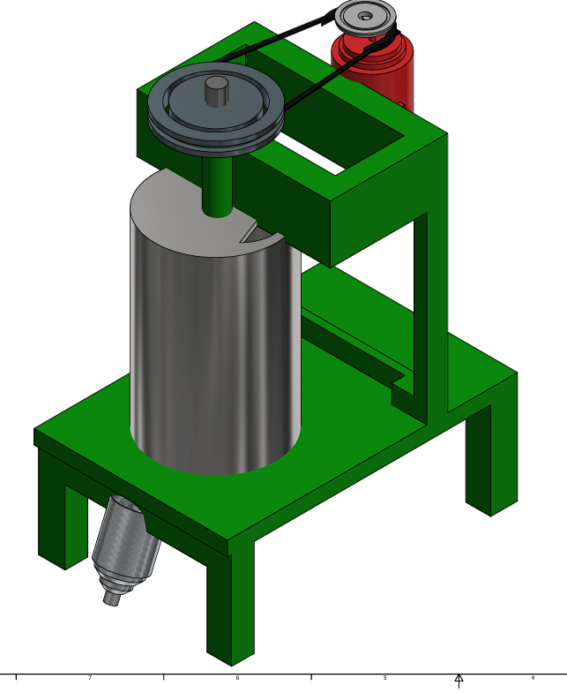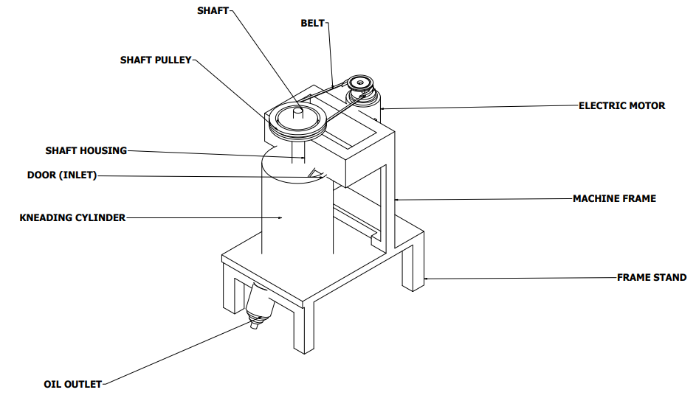
- (b)
Fig. 1. (a) Isometric view of the groundnut oil expeller’s kneader b) Part view of the groundnut oil expeller’s kneader

  - Design Analysis of the Groundnut Oil Expeller’s Kneader
The following criteria were key in the design of the groundnut oil expeller’s kneader: design of the cylindrical kneading chamber, force required for extraction, torque required to turn the shaft, power rating of the machine, rotating paddles, screw-type blades and shaft design.
    - Design of cylindrical kneading chamber
Internal diameter (d): 70 mm (0.07 m)
Wall thickness (t): 5 mm (0.005 m)
Internal pressure (P): 4.5 MPa (as per design considerations)
Hoop Stress (σ): Using the thin-walled cylinder formula:
σ = $\frac{P . d}{2t}$ (Khurmi and Gupta, 2004) (1)
σ = $\frac{4.5 × {10}^{6} ×0.07}{2 ×0.05}$
= 31.5 MPa
This stress is within the allowable limits for materials like stainless steel, which has a yield strength of approximately 215 MPa.
    - Force required for extraction
- Crushing force for groundnut paste: 23.1 kN/m²
- Number of paste processed simultaneously: 110
- Contact area per paste: 1 cm² (0.0001 m²)
Total Force (F):
F = Crushing force per paste $×$ Contact area $×$ Number of paste (2)
F =23.1$×$ 10³ $×$ 0.0001 $×$110 = 254.1N
    - Torque required to turn the shaft
- Mean radius of the screw (r): 0.03 m
- Coefficient of friction (μ): 0.3
- Lead angle (λ): 30°
Torque (T): Using the formula:
T = F $∙$ r $\left(\frac{\tan{λ + μ}}{1 - μ ∙ tan λ}\right)$ (Nnanna et al., 2018) (3)
tan 30° = 0.577
T = 254.1 $×$0.03 $× \left(\frac{0.577 + 0.3}{1 - 0.3 × 0.577}\right)$
≈ 10.15 Nm
    - Power rating of the machine
Torque (T): 10.15 Nm
Rotational speed (N): 60 rpm
Power (P):
P = $\frac{2πNT}{60}$ (Nnanna et al., 2018) (4)
P = $\frac{2π ×10 ×15}{60}$ ≈ 63.8W
Considering efficiency losses and startup loads, selecting a motor with a power rating of approximately 0.75 kW was advisable.
    - Design of rotating paddles and screw-type blades
Material: Stainless Steel (AISI 304)
Blade length: 100 mm
Blade width: 30 mm
Thickness: 5 mm
Shear Stress (τ): Assuming the blades experience a force equal to the extraction force:
τ = $\frac{F}{A}$ (Akerele, 2015) (5)
A = Blade width $×$Thickness = 0.03 $×$0.005 = 1.5 $×$10⁻⁴ m²
τ = $\frac{254 ×1}{1.5 {×10}^{-4}}$ ≈ 1.69 MPa
This shear stress is well below the shear strength of stainless steel (~215 MPa), indicating the design is safe.
    - Torque generated per paddle arm
T = F × r = 150 N × 0.05 m = 7.5 Nm
If multiple paddles are mounted on the shaft (e.g. 4 arms), total torque:
T_{total} = 4 × 7.5 = 30 Nm
    - Screw-type blade design
Let’s design the screw-type blade (like a single-flight auger) for moving and mixing the paste.
Outer diameter (D): 100 mm = 0.1 m
Inner diameter (shaft) (d): 20 mm = 0.02 m
Pitch (p): 80 mm = 0.08 m
Blade thickness: 4 mm
- Helix angle (α):
tan (α) = $\frac{Pitch}{π × Mean Diameter}$ = $\frac{0.08}{π × 0.06}$ = 0.424 ⇒ α ≈ 22.99º
Axial Force: Assume paste resistance = 200 N
Then, Torque needed to rotate:
T = F $∙$ r $\left(\frac{\tan{ α + μ}}{1 - μ ∙ tan α}\right)$ (Nnanna et al., 2018) (6)
Let μ (paste-stainless steel friction) = 0.35
T = 200 $×$ 0.05 $\left(\frac{0.424 + 0.35}{1 - 0.35 × 0.424}\right)$ = 10⋅0.91 ≈ 9.1 Nm
    - Shaft design
Torque (T): 10.15 Nm
Allowable shear stress (τ): 40 MPa
Shaft Diameter (d): Using the torsion formula in equation 7;
T = $\frac{πd^{3}τ}{16}$ (Khurmi and Gupta, 2005) (7)
Solving for d:
d = ${\left(\frac{16T}{πτ}\right)}^{1/3}$
d = ${\left(\frac{16 × 10.15}{π × 40 × {10}^{6}}\right)}^{1/3}$ ≈ 0.015 m = 15mm
Selecting a shaft diameter of 20 mm provides a safety margin.
  - Machine Testing
Each test was carried out based on a set of parameters, including the mass and volume of the extracted oil from the groundnut seed, the screw press speed, the barrel temperature, the barrel pressure, the pressing time, and the feed rate. The criteria taken into consideration for extraction are:
- Operating factors: This included feed rate (F) at four levels (F₁ = 5 kg/h, F₂ = 10 kg/h, F₃ = 15 kg/h, and F₄ = 20 kg/h), barrel temperature (T), of (55.89 – 118.12 0C), pressing time (t) of (6.29 – 25.55 min) and extraction speed (S) at (45.12 – 200.89 rpm, measured using a tachometer).
- Performance parameters: This include oil extraction yield, O_{Y} (%), extraction efficiency E_{E} (%), extraction losses, E_{L} (%), Throughput capacity, T_{C}.
According to the reports by Aviara et al. (2013), the machine was evaluated using the following indices: oil extraction yield (Equation 8), extraction efficiency (Equation 9), extraction loss, extraction efficiency as indices (Equation 10), and throughput capacity as indices (Equation 11):
Oil extraction yield, O_{Y} (%) = $\frac{M_{OP}}{M_{PF}}×$100 (8)
Extraction efficiency, E_{E} (%) = $\frac{ M_{OE}}{M_{OP}}×$100 (i.e 1$-$ $\frac{ M_{OTC}}{O_{JP}}×$100) (9)
Oil extraction loss = $M_{OP} -M_{OE}=M_{OTC}$
% Extraction loss, E_{L} (%) = $\frac{M_{OTC} }{M_{OP}}×$100 (10)
The throughput capacity, T_{C} (l/h) = $\frac{M_{PF}}{T}$ (11)
Where: M_{PF} is the mass of product fed (g), M_{OP} is the mass of oil in product (g), $M_{OE}$ is the mass of oil extracted (g), M_{PC} is the mass of product chaff collected (g), M_{OTC} is the mass of oil trapped in the chaff (g), T is the time taken for the machine to process the feed sample, and x is the oil constant of groundnut paste (decimal). The oil constant was obtained from the ratio of sum of masses of oil extracted and oil in chaff to the mass of product fed in.
x = $\frac{\{M_{OE}+M_{OTC }\}}{M_{PF}}$ (12)
- Results and Discussion
The pictorial view of the kneading machine of the modified groundnut oil expeller with a size of 1120 × 540 × 700 mm is presented in Plate 1. The rotating paddle, screw press shaft, kneading chamber, and collection unit were all made of stainless steel while other components were made up of mild steel. With the use of groundnut paste, the performance of the kneader was assessed. The oil yield ranged from 30% to 70%, with the highest yield (70%) recorded at a feed rate of 10 kg/h, screw press speed of 66.26 rpm, and a barrel temperature of 96.89°C. Fig. 2, illustrates how feed rate and screw speed affect extraction efficiency, with the lowest yield (30%) occurring at 20 kg/h feed rate and 145.46 rpm. These results are consistent with previous research by Olaoye et al. (2020), which highlighted the negative correlation between oil output and feed rate as a result of increasing material compactness that restricts oil evacuation. Depending on the processing parameters, the oil production varied considerably. With an efficiency of 81%, the maximum oil production of 70% was achieved at a barrel temperature of 96.89°C, a screw press speed of 66.26 rpm, and a feed rate of 10 kg/h (Fig. 2.).

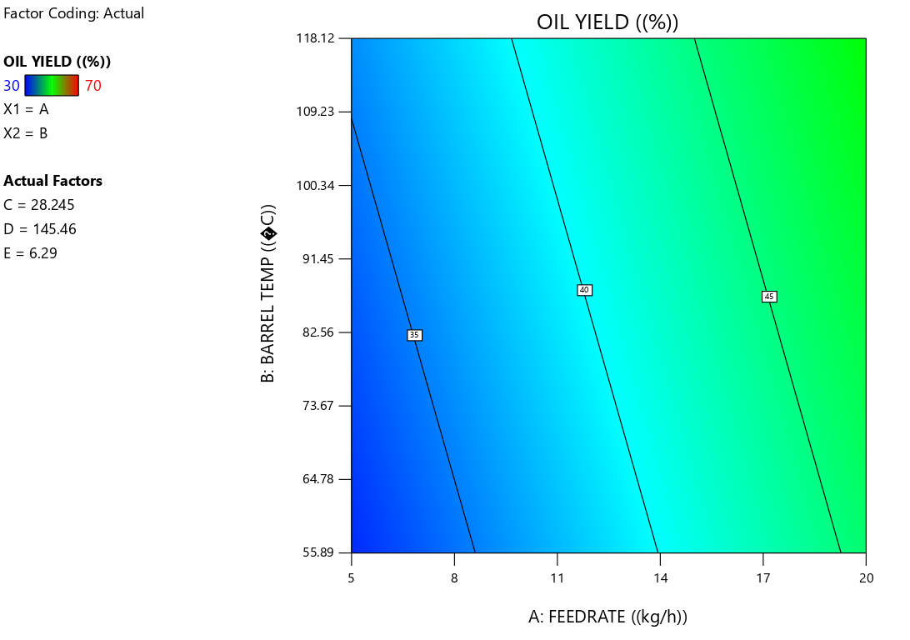
Fig. 2. Influence of feed rate and barrel temperature on the oil yield

Conversely, the lowest oil yield of 30% occurred at a feed rate of 20 kg/h, with a screw press speed of 145.46 rpm (Fig. 2.) and barrel temperature of 55.89°C, showing a corresponding efficiency of 40%. This indicates that lower feed rates and moderate screw press speeds favor higher oil yield and efficiency. Machine efficiency followed a similar trend to oil yield, with the highest efficiency (81%) observed under conditions of moderate feed rate (10 kg/h) and optimal barrel temperature (96.89°C) which is very significant with a R² of 0.9533 and 0.8444 for oil yield and efficiency respectively. The lowest efficiency (28%) occurred at the highest screw press speed (185.99 rpm), confirming that excessive speed reduces retention time and extraction efficiency (Fig. 2.).
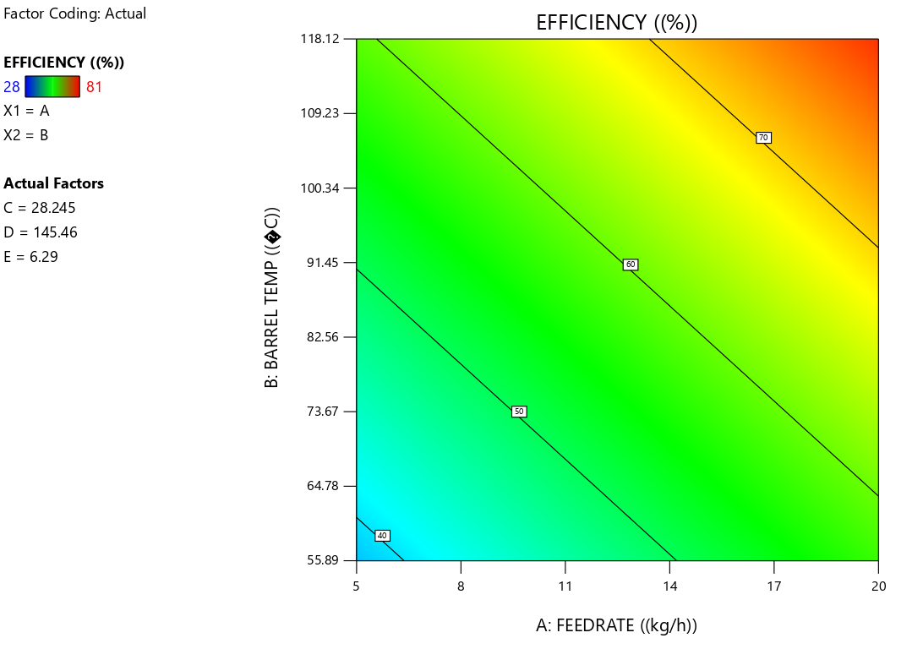
Fig. 3. Influence of feed rate and oil yield on the efficiency
In 2022 study by Hassan and Osunde developed a groundnut oil expeller with an oil yield of 35.9%, and an extraction efficiency of 80.6%. This machine operates by kneading groundnut paste using an electric motor, reducing manual labor and increasing oil production efficiency. These results is similar to the findings in this study. Oil extraction loss was minimized (19%) at 10 kg/h, 66.26 rpm, and 96.89°C, corroborating findings by (Olaoye et al., 2020), where lower feed rates improved oil recovery. Oil extraction loss varied significantly based on the feed rate, screw press speed, and barrel temperature.
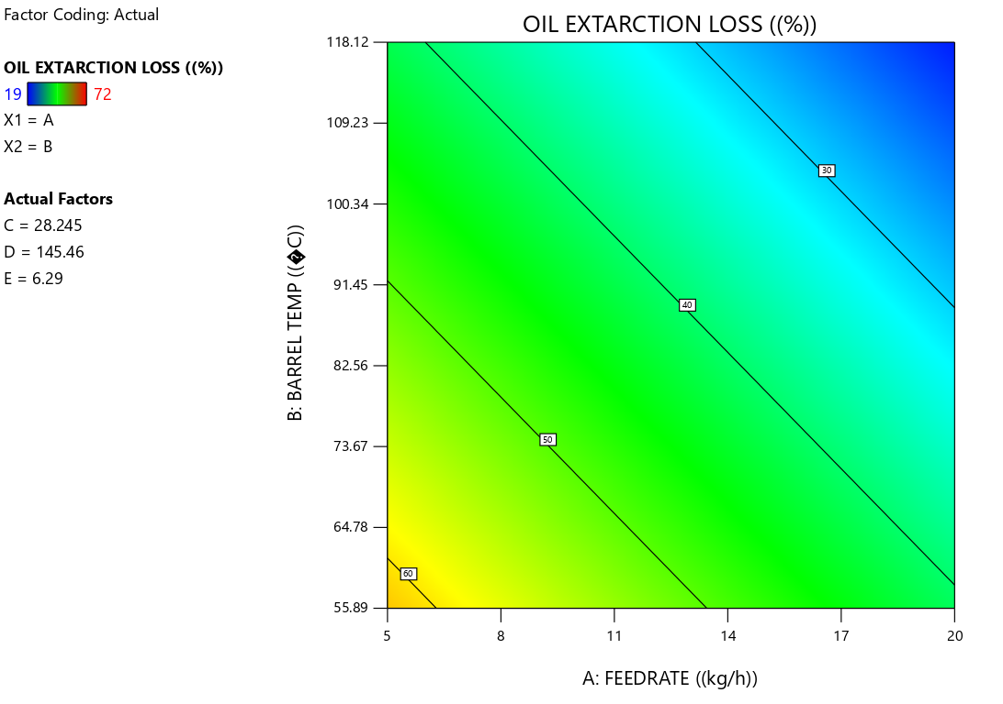
Fig. 4. Influence of feed rate and barrel temperature on the oil extraction loss

At a feed rate of 20 kg/h, screw press speed of 185.99 rpm, and barrel temperature of 59.40°C, the maximum oil loss (72%) was observed (Fig. 4.). This implies that high screw speeds and excessive feed rates shorten retention times, resulting in partial oil evacuation. On the other hand, the model is noteworthy with an R² of 0.5623; the lowest oil loss (19%) was noted at 10 kg/h feed rate, 66.26 rpm screw press speed, and 96.89°C barrel temperature. This is consistent with research by Aung et al. (2019), which shows that ideal barrel temperatures and moderate feed rates enhance oil recovery by facilitating improved oil-cell rupture and release. The findings imply that when the feed rate is increased above ideal levels, there is more residual oil in the cake as a result of inadequate residence time. This is in line with research by Atabani et al. (2013), which found that oil loss rose when throughput increased and pressing time was insufficient. This data is also consistent with research by Smith and Bolarinwa (2023), which showed that higher feed rates led to more oil loss because of insufficient press residence time.

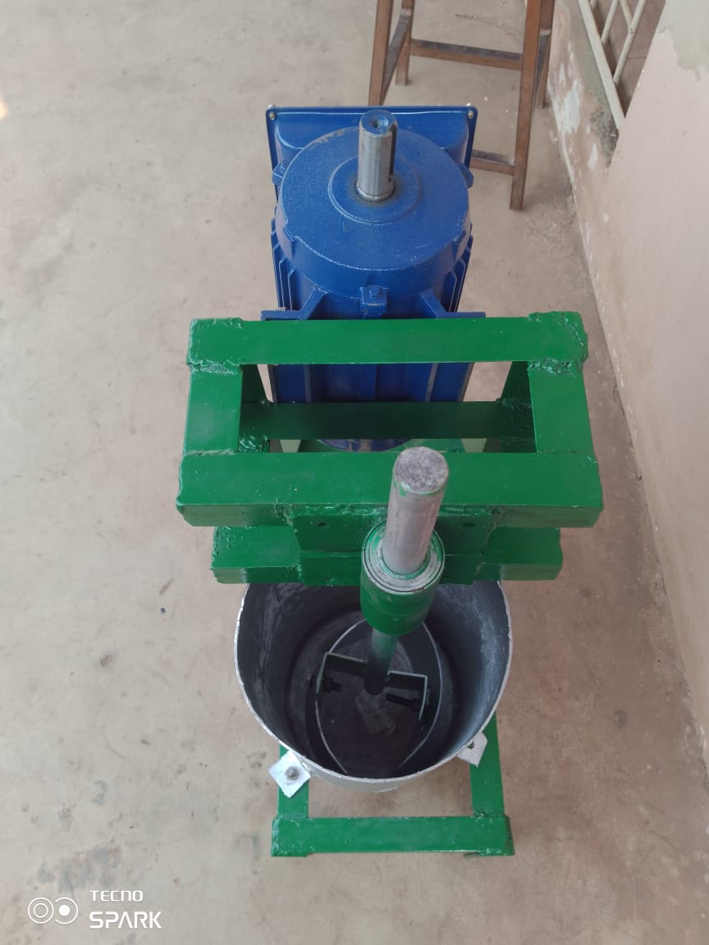
Blade
Oil outlet
Rotating paddle
Machine stand
Shaft
Kneading chamber
Frame
Motor
Plate 1: The developed groundnut oil expeller’s kneader

- CONCLUSION
A kneader that is portable, simple, effective, and less laborious incorporated into a modified groundnut oil expeller, has been developed for extraction of groundnut oil from groundnut paste. Materials that were both economical and locally sourced were employed in fabricating the machine. After the machine was tested, the highest oil yield (70%) and efficiency (81%) were achieved at moderate processing conditions (10 kg/h, 66.26 rpm, 96.89°C). Under favorable conditions, oil extraction losses were kept as low as 19%; however, when the feed rate was too high, the losses significantly increased, reaching up to 72%. The machine throughput was highest at 20 kg/h but resulted in lower extraction efficiency due to reduced residence time. Priced around ₦150,000 (approximately $100), it remains affordable for both rural and urban small-scale processors
REFERENCES
Akerele, O.V. (2015). Design and Construction of Groundnut Oil Expeller. International Journal of Engineering and Computer Science, 4(6), 12529-12538.
Atabani, A. E., Silitonga, A. S., Ong, H. C., Mahlia, T. M. I., Masjuki, H. H., Badruddin, I. A. and Fayaz, H (2013). Non-edible vegetable oils: a critical evaluation of oil extraction, fatty acid compositions, biodiesel production, characteristics, engine performance and emissions production. Renewable and sustainable energy reviews, 18, 211-245.
Aung, K., Chit, S. P., Hninsi, K. and Chan, Z.M (2019). Design and Stress Analysis of Screw Shaft for Peanut Oil Screw Press Expeller. International Journal of Progressive Sciences and Technologies, 16(1), 207-212.
Aviara, N. A., A. A. Lawal, D. S. Nyam, and J. Bamisaye. 2013. Development and performance evaluation of a multi-purpose juice extractor. Global Journal of Engineering, Design and Technology, 2 (2), 16 -21.
Gaur, P. M., Varshney, R. K., and Pandey, M. K. (2021). "Breeding for Climate-Resilient Groundnut Varieties: Progress and Prospects." Plant Breeding Reviews, 45(1), 67-88.
Hassan, U. B. and Osunde, Z. D. (2022). Development and Performance Evaluation of a Groundnut Oil Expeller. Journal of Inventive Engineering and Technology. Vol 2. No. 2.
Khurmi, R. S. and Gupta, J. K. (2005): A Textbook of Machine Design (S.I Units). Eurasia publishing house. (PVT.) Ltd.
Maduako, J. N; Mikailu, J. and Maunde, F. A. (2015). Development of a Motorized Kneader for Groundnut Oil Extraction. Nigerian Journal of Technology. Vol. 23 No. 1.
Nnanna, I., Okeahialam, S.I., and Okoro, H.O. (2018). Design and Fabrication of a Groundnut Oil Expelling Machine. American Journal of Engineering Research, 7(9), 46-57.
Okello, D., Biruma, M., and Ojok, A. (2022). "Advances in Biocontrol for Aflatoxin Management in Groundnuts." Journal of Agricultural Science and Technology, 27(1), 33-45.
Olaoye, I. O., Salako, Y. A. and Owolarafe, O. K. (2020). Development of Multi Seeds Oil Expeller. Arid Zone Journal of Engineering, Technology and Environment, 16(4), 699- 716.
Olatunde, O. B., Ajav, E. A., and Fatukasi, S. O. (2024). *Design and Fabrication of Groundnut (Arachis Hypogaea) Roaster cum Expeller*. Mechanical Engineering Department, Faculty of Technology, University of Ibadan.
Olayinka, A., Olumide, J., and Omotayo, F. (2022). "Energy Efficiency in Agricultural Machinery: The Case of Groundnut Oil Extractors." Renewable Energy in Agriculture, 11(1), 78-90.
Smith, R. T., and Bolarinwa, S. (2023). Energy Optimization in Groundnut Oil Extraction. Journal of Renewable Resources, 12(5), 330–345.
Sulaiman, M. E., Nalado, D. D., Shittu, S. K., and Katibi, K. K. (2024). Design, fabrication, and optimization studies of a groundnut kneader. *Sasakawa Africa Association, Nigeria; Department of Agricultural and Environmental Engineering, Bayero University, Kano, Kano State, Nigeria; Department of Food, Agricultural and Biological Engineering, Kwara State University, Ilorin, Kwara State, Nigeria*.

