Original Research Article

Study on the Effect of Tipping Paper Permeability on the Transfer Efficiency of Cooling Intensity Based on the Cell Membrane Method

.
ABSTRACT

In this study, a CHO-TRPM8 cell system expressing the TRPM8 receptor was employed in combination with FLIPR (Fluorescent Imaging Plate Reader) technology to monitor real-time intracellular calcium ion concentration changes. This approach enabled accurate determination of the relative cooling intensity values of tobacco filler and mainstream smoke with different tipping paper permeability, and calculation of the cooling transfer efficiency based on variations in cooling intensity. The results demonstrated that tipping paper permeability significantly affected the cooling transfer efficiency of mainstream cigarette smoke. A consistent decline in cooling delivery efficiency was observed with increasing tipping paper permeability, closely mirroring the migration patterns of six commonly used cigarette cooling agents: L-menthol, WS-23, menthone, WS-3, WS-5, and menthyl acetate. When these cooling agents were added to tobacco filler, the transfer rates of cooling compounds in mainstream smoke decreased by 44.33%, 49.21%, 52.92%, 43.59%, 42.91%, and 41.20%, respectively, at a permeability of 500 CU compared to 0 CU. Correspondingly, the cooling transfer efficiencies decreased by 44.08%, 45.38%, 50.11%, 41.94%, 42.11%, and 37.96%, respectively. Sensory evaluation revealed that as the tipping paper permeability increased from 0 CU to 150 CU, 300 CU, and 500 CU, sensory attributes such as smoothness, irritation, and aroma quality improved, while ratings for off-notes, aftertaste, and dryness first increased and then declined. Meanwhile, attributes such as smoke density, salivation, and aroma intensity showed a decreasing trend.

Keywords: Delivery efficiency; tipping paper permeability; L-menthol; high-throughput real-time fluorescence assay

1. INTRODUCTION

Tipping paper permeability significantly influences the transfer efficiency of cooling agents in cigarette smoke. Therefore, in modern tobacco manufacturing, optimizing tipping paper permeability is crucial for precisely formulating and adjusting the ratios of cooling flavorants, thereby ensuring consistent perceived cooling intensity across production batches (Tackett et al., 2023). Traditional evaluation methods for cooling intensity primarily depend on human sensory assessment, relying heavily on subjective ratings provided by professionally trained sensory panels. However, this approach presents notable limitations. First, genetic polymorphisms in human cooling receptors lead to considerable individual variability in perception (Ricci et al, 2024). Second, ambient environmental conditions such as temperature and humidity can significantly affect sensory outcomes. High temperature and humidity typically diminish the perception of cooling, while low temperature and dry conditions tend to exaggerate it (Hu et al., 2018; Liu et al., 2024). As a result of these factors, the results of sensory evaluations, particularly those used to estimate the transfer rates of cooling agents, are often subjective and lack reproducibility. This poses significant challenges to achieving the precision in formulation and the level of quality control required in modern tobacco production. In contrast, electronic tongue techniques are limited to detecting static ion concentrations and fail to capture receptor-mediated cascade responses. A more advanced and reliable approach involves the use of in vitro cellular models, particularly the CHO-TRPM8 system, which has been widely adopted in pharmaceutical screening. Applying this method to the analysis of cigarette tobacco and smoke offers significant potential for enhancing the accuracy and objectivity of cooling intensity evaluations (Frank et al., 2007).

In this study, a CHO-TRPM8 cell system expressing the TRPM8 receptor was utilized in conjunction with FLIPR (Fluorescent Imaging Plate Reader) technology to monitor real-time changes in intracellular calcium ion concentrations. This approach enabled precise quantification of cooling intensity in both tobacco filler and mainstream smoke, thereby establishing an objective evaluation system for assessing cooling sensation intensity (Becker et al., 2024; Behrendt et al., 2004). Subsequently, cigarette samples were produced with tipping papers of differing permeability levels (0 CU, 150 CU, 300 CU, and 500 CU) to simulate the cigarette combustion process. Gas chromatography was then employed to determine the transfer rates of cooling agents from the tobacco filler to the mainstream smoke (Feng et al., 2022; Havermans et al., 2024). By comparing the transfer rates of cooling compounds and the corresponding cooling intensity under varying tipping paper permeability, the study elucidates the impact of tipping paper permeability on variations in cooling intensity in mainstream smoke. These findings provide valuable insights for the evaluation of cigarette smoke and support the optimized application of cooling agents in tobacco product development.

2. material and methods

2.1 Main reagents and instruments
Blank cigarette samples were produced from Hongta Lao Tobacco Co., a subsidiary of Yunnan Tobacco Industrial Co., Ltd. Absolute ethanol and triacetin (chromatographic grade) were purchased from China National Pharmaceutical Group Chemical Reagent Co., Ltd. Phenethyl acetate (used as an internal standard, ≥99.0%, chromatographic grade) was also sourced from the same supplier. Cooling agents including L-menthol, menthone, menthyl acetate, N-ethyl-p-menthane-3-carboxamide (WS-3), N-(ethoxycarbonylmethyl)-p-menthane-3-carboxamide (WS-5), N,2,3-trimethyl-2-isopropylbutanamide (WS-23) were all obtained from China National Pharmaceutical Group Chemical Reagent Co., Ltd. The Fluor-8 calcium assay kit was purchased from AAT Bioquest (USA).

The instruments used in this study included a GC 6890-MS 5973N gas chromatography-mass spectrometry (GC-MS) system (Agilent Technologies, USA), 0.45 μm organic solvent-resistant syringe filters (Agilent Technologies, USA), an RM20H rotary smoking machine (Borgwaldt KC, Germany), an HY-2A variable-speed multipurpose oscillator (Kangmanji Electronics Technology Co., Ltd., Shanghai, China), and an AB265-S electronic analytical balance with a sensitivity of 0.00001 g (Mettler Toledo, Switzerland).

2.2 Preparation of cigarette samples with different tipping paper permeability

Experimental cigarette samples were designed based on Table 1 and prepared using commercially produced tobacco filler (LA1110925) from the Hongta brand, Laos factory, Yunnan Tobacco Industry Co., Ltd. The design parameters of the cigarettes were as follows: a length of 59 mm and a draw resistance of 1900 Pa. Cigarettes were produced with tipping paper permeability of 0 CU, 150 CU, 300 CU, and 500 CU. (Here, CU refers to the permeability unit measured by the Sheffield method according to ISO 5636-4-2005, defined as the volume of air (mL) passing through 1 cm² of cigarette paper per minute under a pressure differential of 1 kPa.) Cooling agents including L-menthol, menthone, menthyl acetate, WS-3, WS-5, or WS-23 were individually added to the tobacco filler at a concentration of 1.5 mg per cigarette. The cigarettes were then assembled under the specified conditions. Both blank cigarettes (without cooling agents) and those containing cooling agents were packaged into cigarette packs. All samples were sealed and stored under controlled environmental conditions (22 ± 2℃, 60 ± 5% relative humidity) for 30 days prior to analysis.

Table 1. Physical specifications of cigarette test samples

Sample ID | Cigarette type | Mass（g） | Draw resistance（Pa） | Length（mm） | Preparation Quantity（stick） | Ventilation（CU）
LA202401 | Standard | 0.844 | 1030 | 83.8 | 1 000 | 0
LA202402 | Standard | 0.848 | 950 | 83.8 | 1 000 | 150
LA202403 | Standard | 0.859 | 920 | 83.8 | 1 000 | 300
LA202404 | Standard | 0.840 | 830 | 83.8 | 1 000 | 500

2.3 Preparation of test solutions for cooling agent extraction from tobacco filler and mainstream smoke

2.3.1 Extraction of cooling agents from cigarette tobacco filler

Ten cigarettes were randomly selected, and the cigarette papers were carefully removed. The tobacco filler was collected and transferred into a 150 mL stoppered Erlenmeyer flask. Then, 40 mL of internal standard solution (0.1 mg/mL phenethyl acetate in absolute ethanol) was added. The mixture was subjected to ultrasonic extraction at room temperature for 30 min. After extraction, the tobacco filler was removed by filtration, and the residue was rinsed three times with 2 mL of absolute ethanol each time. The filtrates and washings were combined and diluted to a final volume of 50 mL with absolute ethanol. The resulting solution was filtered through a 0.45 μm organic-phase membrane filter to obtain the extract solution of cooling agents from the tobacco filler.

2.3.2 Extraction of cooling agents from mainstream cigarette smoke

Each cigarette was smoked using the RM20H rotary smoking machine following the GB/T 16450-2004 standard smoking regimen, which specifies a puff volume of 35 mL, a puff duration of 2 s, and a puff interval of 60 s. The experimental cigarettes containing cooling agents were smoked to collect mainstream smoke. The mainstream smoke was passed through a cold trap or adsorption tube to capture smoke condensates. The collected condensates were then dissolved in a pre-prepared artificial saliva buffer (pH=7.2), consisting of a phosphate buffer system containing 1.74 g/L sodium dihydrogen phosphate and 2.7 g/L disodium hydrogen phosphate. Exposure solutions containing cooling agent components were prepared at a ratio of 10 cigarettes to 10 mL of buffer. The resulting solutions were stored at 4℃ until further analysis.

2.4 Instrumental analysis

Samples prepared as described in Section 2.3 were loaded onto extraction columns and incubated at 70 ℃ for 30 min to separate volatile compounds. The resulting extracts were then analyzed using a GC 6890-MS 5973N system. The chromatographic conditions were as follows: an Agilent DB-5MS capillary column (30 m × 0.25 mm i.d. × 0.25 μm) was used. The oven temperature was initially set at 40℃ and held for 1 min， then ramped at 10 ℃/min to 200℃, followed by a further ramp at 30 ℃/min to 300℃, which was held for 5 min. The injector temperature was maintained at 280℃, and a sample volume of 1 μL was injected in split mode with a split ratio of 10 : 1. Helium was used as the carrier gas at a constant flow rate of 1.0 mL/min. The mass spectrometer detector temperature was set at 280℃.

2.5 Calculation of cooling agent transfer efficiency based on cooling intensity variation

Cigarettes containing 1.5 mg of cooling agent per stick were smoked used the method described above, and cambridge filter pads were used to collect the mainstream smoke condensates. Mainstream smoke from a single cigarette was extracted using absolute ethanol and diluted to a final volume of 15 mL. The cooling intensity of the extract was measured and compared with that of the corresponding tobacco filler extract, allowing calculation of the transfer efficiency (%) based on cooling intensity. The transfer rate of cooling agents in mainstream smoke (ZY₁, %) was calculated using the following formula: ZY₁=A₂/(A₁/A₀)×100%, Where 𝐴₁ is the mass fraction of cooling agent in the cigarette filler with added cooling agent (mg/stick), 𝐴0 is the mass fraction of cooling agent in the blank cigarette (mg/stick), 𝐴₂ is the mass fraction of cooling agent in the mainstream smoke (mg/stick). The cooling intensity transfer efficiency in mainstream smoke (ZY₂, %) was calculated using the following formula: ZY₂=B₂/(B₁/B₀)×100%, Where B₁ represents the relative cooling intensity value of the cigarette containing the added cooling agent, B₀ is the relative cooling intensity value of the blank cigarette, and B₂ is the relative cooling intensity value measured in the mainstream smoke.

2.6 Cell-based Trp receptor model for evaluating cooling intensity

The cooling intensity of test samples was evaluated using a cell-based assay involving the expression of TRP receptors. Chinese Hamster Ovary (CHO) cells were genetically modified to express cloned TRPA-1 and TRPM-8 receptors. The assay employed the Fluor-8 Calcium Assay Kit in conjunction with a high-throughput real-time fluorescent imaging system (FLIPR) equipped with a robotic arm and a high-sensitivity camera (Molecular Devices, USA). The FLIPR system enables real-time reagent addition, simultaneous signal detection, and whole-plate imaging, making it particularly effective for monitoring dynamic cellular processes involving ion channels and G protein-coupled receptors (GPCRs).

CHO cells (Chinese Hamster Ovary, ATCC, supplied by Shanghai Sentai Biotechnology) were stably transfected with TRPA-1 and TRPM-8 cDNAs and cultured in Ham’s F-12 medium supplemented with 10% fetal bovine serum under standard conditions.

For FLIPR analysis, CHO cells were seeded into 384-well flat-bottom microplates at a density of 2~3 × 10⁴ cells/well. The plates were incubated overnight at 37 ℃ in a humidified atmosphere containing 5% CO₂ and 95% humidity to ensure adequate cell adherence and growth. Prior to fluorescence analysis, the growth medium was removed. Cells were then incubated at 37 ℃ for 30 min with either 20 μL (for TRPA-1 analysis) or 40 μL (for TRPM-8 analysis) of HEPES-buffered physiological saline (HBPS) containing the Fluor-8 calcium indicator and Typan red. The HBPS solution consisted of 10 g/L HEPES, 16 g/L NaCl, 0.74 g/L KCl, 0.27 g/L Na₂HPO₄·2H₂O and 2.0 g/L dextrose.

During FLIPR analysis, 5 μL of the test solution or reference compound, prepared at 6× the final concentration in HBPS, was added to each well. Real-time changes in intracellular calcium levels were recorded using the FLIPR system (excitation/emission wavelengths: 470~495 nm/515~575 nm) and analyzed with FLIPR ScreenWorks 3.1 software. The main analytical workflow in FLIPR ScreenWorks 3.1 involved the following steps: 1) acquisition of fluorescence signals over time, 2) export of raw fluorescence data as time–fluorescence intensity curves, F(t), 3) baseline correction, where the average fluorescence intensity during the 10 s prior to stimulation was defined as F₀, 4) calculation of ΔF/F₀ using the formula ΔF/F₀ = (FF₀)/F₀, where F represents the post-stimulation fluorescence intensity, 5) automatic generation of dose-response curves and EC₅₀ determination based on ΔF/F₀ values using built-in algorithms, and 6) calculation of the cooling sensation transfer efficiency (η) using the formula: η= [ΔF/F₀ (mainstream smoke ) /ΔF/F₀ (tobacco filler )]×100%，where ΔF/F₀ represents the relative cooling response intensity.

If the Fluo-3 probe exhibits a fluorescence enhancement of 60~100 fold and the dynamic range of the ΔF/F₀ signal falls within the expected range for the probe, this indicates stable expression and functional activity of the receptor. Prior to the addition of the test solutions, a 10 s baseline was recorded. After addition, fluorescence was recorded for 50 s at 1 s intervals per sample, followed by an additional 4 min at 5 s intervals per sample. The agonistic effects of test compounds were evaluated in the absence of known agonist ligands. For assay validation, 100 μmol/L allyl isothiocyanate (AITC) was used as a positive control for TRPA-1 channel activation, and 10 μmol/L L-menthol was used as a positive control for TRPM-8 channel activation.

2.7 Sensory quality evaluation

A comparative evaluation of the prepared cigarette samples was performed in accordance with the tobacco industry standard YC/T 497-2014.

3. results and discussion

3.1 Effect of tipping paper permeability on the transfer rate of cooling agents in cigarettes

Based on the analysis of the transfer rates of cooling agents under four different tipping paper permeability levels, the variation trends in the transfer rates of six cooling agents directly added to cigarette tobacco filler were investigated. The results indicate that the transfer rates of each compound exhibited minor variations depending on the permeability of the tipping paper. These findings are illustrated in Figure 1.

As shown in Figure 1, the concentrations of six cooling agents in mainstream cigarette smoke decreased progressively with increasing tipping paper permeability. Specifically, when L-menthol, menthone, menthyl acetate, WS-3, WS-5, and WS-23 were added directly to the cigarette tobacco filler, their transfer rates at a tipping paper permeability of 500 CU decreased by 44.33%, 49.21%, 52.92%, 43.59%, 42.91%, and 41.20%, respectively, compared to those observed at 0 CU. Among these, menthyl acetate exhibited the most pronounced reduction in transfer rate as permeability increased. The increased permeability of the tipping paper facilitates greater air ingress into the cigarette’s combustion zone, leading to a dilution of the mainstream smoke. This dilution reduces the concentration of cooling agents in the smoke stream, thereby lowering their transfer efficiency into the particulate phase of mainstream smoke. This common dilution mechanism accounts for the overall decrease in transfer rates across all tested cooling agents, underscoring the critical influence of tipping paper permeability on the chemical composition of cigarette smoke (Feng et al., 2022; Havermans et al., 2024).

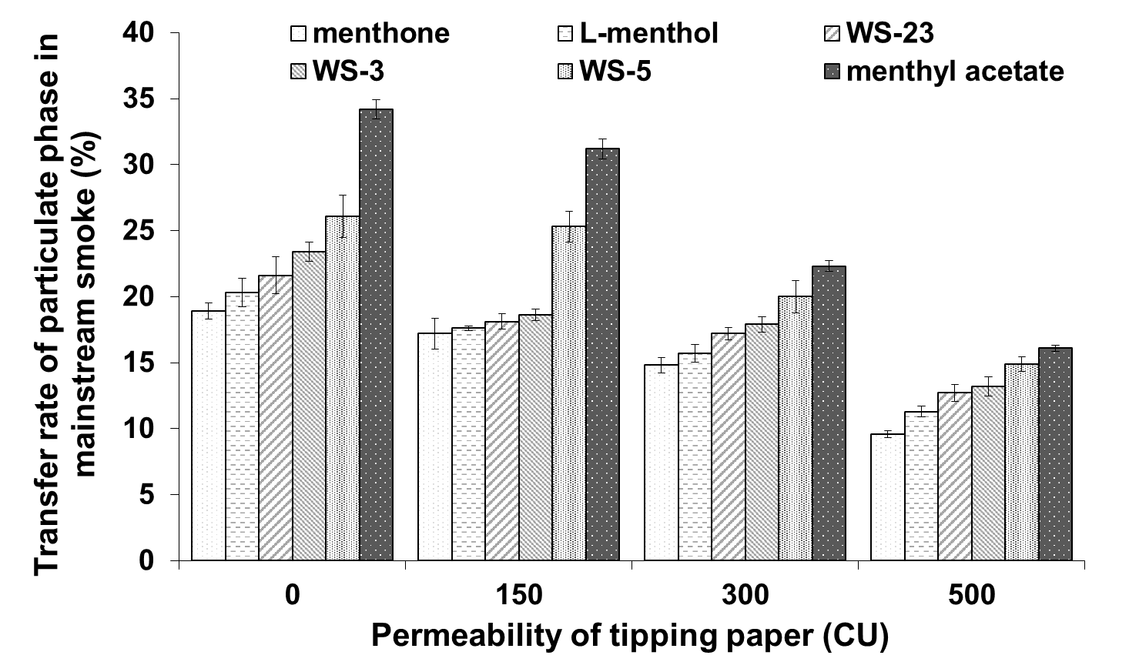

Fig. 1. Effect of tipping paper permeability on the transfer rates of cigarette cooling agents

3.2 Variation in cooling sensation intensity in cigarettes with different tipping paper permeability

By analyzing the cooling sensation intensity in mainstream smoke across four different tipping paper permeability levels, the variation trends in the transfer efficiency of six cooling agents added to the tobacco filler were identified. The results are presented in Figure 2.

As shown in Figure 2, the transfer efficiency of cooling sensation intensity in mainstream cigarette smoke decreased progressively with increasing tipping paper permeability. Specifically, when L-menthol, menthone, menthyl acetate, WS-3, WS-5, and WS-23 were added to the tobacco filler, their transfer efficiencies at a tipping paper permeability of 500 CU declined by 44.08%, 45.38%, 50.11%, 41.94%, 42.11%, and 37.96%, respectively, compared to those observed at 0 CU.

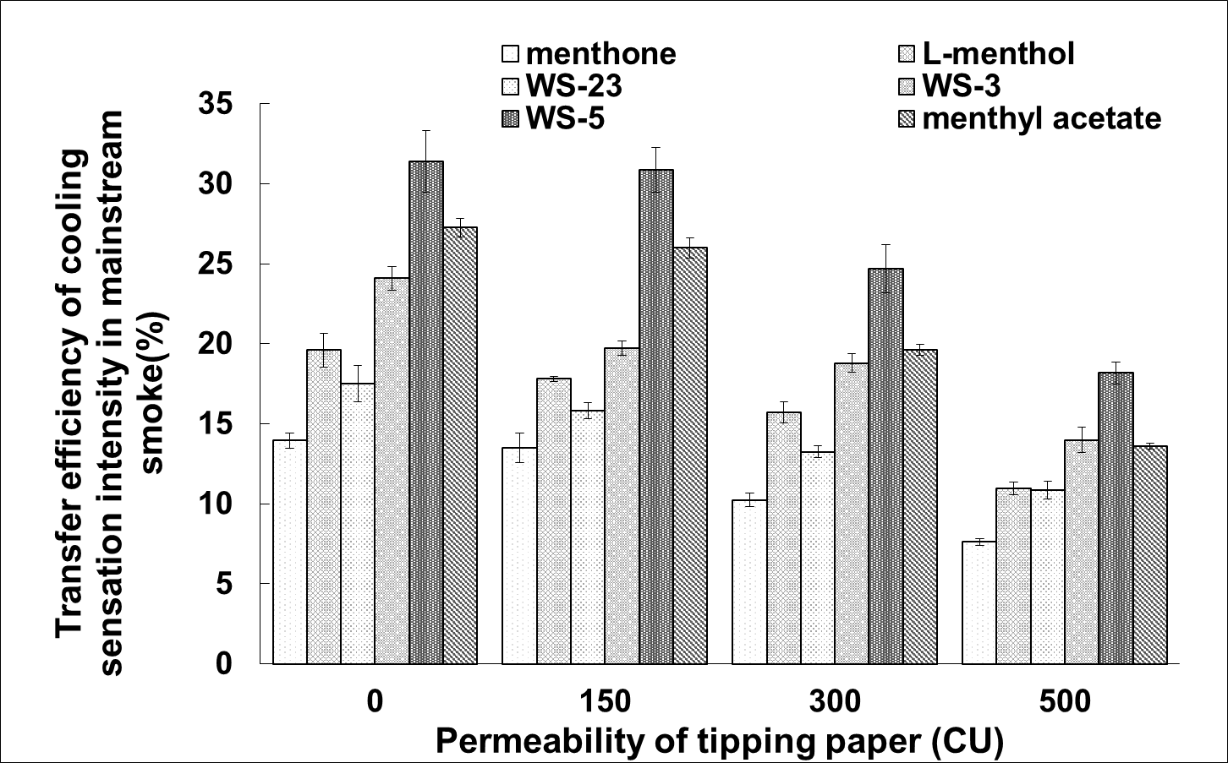

Fig. 2. Effect of tipping paper permeability on the transfer efficiency of cooling sensation in mainstream cigarette smoke

At a tipping paper permeability of 0 CU, menthyl acetate exhibited a transfer efficiency of 27.3%, which was relatively high among the tested cooling agents. It then steadily decreased to 26.0% at 150 CU, further declined to 19.6% at 300 CU, and reached 13.6% at 500 CU, indicating a substantial overall reduction. These results indicate that menthyl acetate is particularly sensitive to changes in tipping paper permeability. Its initially high transfer efficiency may be attributed to its molecular structure and volatility. However, as permeability increases, the introduction of greater amounts of air dilutes the mainstream smoke, significantly decreasing the compound’s effective transfer into the smoke aerosol (Stabbert et al., 2019).

In contrast, menthone showed the lowest initial transfer efficiency among the six cooling agents, with a value of 14.0% at 0 CU. This efficiency then steadily decreased to 13.5% at 150 CU, further dropped to 10.2% at 300 CU and 7.6% at 500 CU, showing a relatively large decrease. The notable reduction in transfer efficiency may be associated with menthone’s adsorption and diffusion behavior within the smoke aerosol. Increased tipping paper permeability leads to greater smoke dilution, thereby reducing the retention rate of menthone in the particulate phase. These findings highlight the importance of considering tipping paper permeability when incorporating menthone as a cooling agent in cigarette formulations. To avoid excessive weakening of the cooling sensation, combining menthone with other agents that are less sensitive to permeability changes may help optimize the overall cooling effect (O'Connor J et al., 2008; Tackett et al., 2023).

It is evident that the permeability of tipping paper is a precisely controllable parameter that significantly influences the transfer efficiency of cooling agents in cigarette products. To enhance the cooling sensation, low-permeability tipping papers can be employed; conversely, high-permeability tipping papers are preferable when a milder cooling effect is desired (Mimi et al., 2004; Wampler et al., 2012). Moreover, the trend in the transfer rate of cooling intensity generally corresponds to that of the transfer rate of cooling agent components, although the magnitude of change may differ. This discrepancy primarily arises from two factors: first, the relationship between the concentration of cooling agents and the perceived cooling intensity is not strictly linear. second, different cooling agents contribute variably to the overall cooling intensity in mainstream smoke, especially when considering the dynamic changes in transfer behavior observed across the upstream, midstream, and downstream regions of the simulated smoking system, which adds further complexity to the interpretation (Pauly et al., 1998; Ron et al., 2013). Therefore, the correlation between the transfer rate of cooling intensity and that of cooling agent components provides a valuable theoretical foundation for the development of cooling flavor bases and supports their practical application in product design (Wampler et al., 2012). For consumers who prefer a strong cooling sensation, tipping papers with permeability of 0 CU or 150 CU are effective in maintaining a high transfer efficiency of agents such as WS-5 and methyl acetate. In contrast, for consumers seeking a milder cooling experience, tipping paper with a permeability of 500 CU can substantially reduce the transfer efficiency of all cooling agents, thereby catering to individual sensory preferences.

3.3 Effect of different tipping paper permeability on the sensory quality of cigarettes

The sensory evaluation results of cigarettes with different tipping paper permeability are shown in Figure 3. As illustrated, the overall sensory quality of the cigarettes exhibits a trend of initial enhancement followed by a decline as permeability increases. Specifically, as the tipping paper permeability increases from 0 CU to 150 CU, 300 CU and finally 500 CU, the smoothness score increases, peaking at 7.4 at 300 CU and slightly increasing to 7.5 at 500 CU. A similar trend is observed for smoke irritation, which decreases as permeability increases, indicating enhanced smoothness up to a certain level. The aroma quality also reaches its maximum at 300 CU, with a score of 13.6. In contrast, negative sensory attributes such as off-notes, aftertaste, and dryness all exhibit a different trend, increasing initially and then declining at higher permeability levels.

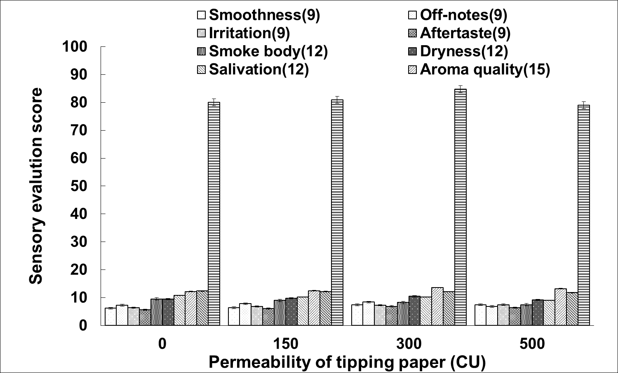

Fig. 3. Sensory quality evaluation results of cigarettes with different tipping paper permeability levels

The changes in the sensory quality indicators of mentholated cigarettes are primarily attributed to variations in tipping paper permeability. As permeability increases, the filter ventilation also rises, resulting in a higher proportion of air into the mainstream smoke. This increased air dilution reduces the concentration of smoke constituents, thereby decreasing irritation, enhancing smoothness, and improving aroma quality. However, when the tipping paper permeability becomes excessively high, the dilution effect intensifies to a degree that significantly weakens the delivery of aroma compounds. As a result, the perception of aroma and overall flavor intensity declines (Shaikh et al., 2002; Wasel et al., 2015).

4. Conclusion

The permeability of tipping paper has a significant influence on the transfer efficiency of cooling sensation intensity in mainstream cigarette smoke. As tipping paper permeability increases, the transfer efficiency of the cooling sensation consistently declines, closely mirroring the migration trends of six commonly used cigarette cooling agents (L-menthol, WS-23, menthone, WS-3, WS-5, and menthyl acetate). When these agents are added into cigarette tobacco, increasing the tipping paper permeability from 0 CU to 500 CU leads to substantial reductions in the transfer rates of these cooling agents in the mainstream smoke by 44.33%, 49.21%, 52.92%, 43.59%, 42.91%, and 41.20%, respectively. Correspondingly, the transfer efficiency of the cooling sensation decreases by 44.08%, 45.38%, 50.11%, 41.94%, 42.11%, and 37.96%, respectively.

In addition, increased tipping paper permeability affects various sensory quality indicators of cigarettes in different ways, generally exhibiting one of three patterns: a continuous increase, a continuous decrease, or an initial increase followed by a decline. As the permeability increases from 0 CU to 500 CU, attributes such as smoothness, irritation, and aroma quality tend to improve. In contrast, indicators such as smoke density, salivation, and aroma volume show a declining trend, reflecting a weakening of smoke richness and flavor delivery. These results indicate that the optimization of tipping paper permeability is critical for balancing positive and negative sensory attributes in cigarette design.

References

Becker, J., Ellerkmann, C. S., Schmelzer, H., Hermann, C., Lützel, K., Gudermann, T., et al. (2024). Optical control of TRPM8 channels with photoswitchable menthol. Angewandte Chemie, 137 (5), e202416549.
Behrendt, H. J., Germann, T., Gillen, C., Hatt, H., & Jostock, R. (2004). Characterization of the mouse cold-menthol receptor TRPM8 and vanilloid receptor type-1 VR1 using a fluorometric imaging plate reader (FLIPR) assay. British Journal of Pharmacology, 141 (4), 737-745.
Feng, Y. C., Zhang, Z., Feng, D. D., Guo, D. R., Ni, H. P., Huang, K., et al. (2022). Optimization of determination method of cooling agents in cigarette tipping paper by gas chromatography. LC GC North America, 40 (4), 180-185.
Frank, M., Grzegorz, O., Leen, V., Annelies, J., Humbert, D. S., Bernd, N., et al. (2007). TRPM8-independent menthol-induced Ca2+ release from endoplasmic reticulum and Golgi. The Journal of Biological Chemistry, 282 (5), 3325-3336.
Havermans, A., Pauwels, C. G. G. M., Hart, I. M. E. B., Fayokun, R., Nierop, L. E., Hellmich, I. M., et al. (2024). Across the world availability of flavour accessories for tobacco products. Tobacco Control.
Hu, R., Zhang, Q. L., Qian, B., Chang, L. L., & Zhou, Z. J. (2018). An effective soft-sensor method based on belief-rule-base and differential evolution for tipping paper permeability measurement. Complexity, 2018, 1-14.
Liu, A. H., Hootman, J., Li, D. M., & Xie, Z. D. (2024). Public perceptions of synthetic cooling agents in electronic cigarettes on Twitter. PloS one, 19 (3), e0292412.
Mimi, N., Mark, N., & David, V. S. (2004). Popular perceptions of tobacco products and patterns of use among male college students in India. Social Science & Medicine, 59 (2), 415-431.
O'Connor, R. J., Hammond, D., McNeill, A., King, B., Kozlowski, L T., Giovino, G A., et al. (2008). How do different cigarette design features influence the standard tar yields of popular cigarette brands sold in different countries? Tobacco Control, 17, i1-5.
Pauly, J. L., Lee, H. J., Hurley, E. L., Cummings, K M., Lesses, J. D., & Streck, R. J. (1998). Glass fiber contamination of cigarette filters: An additional health risk to the smoker? [J], Cancer Epidemiology Biomarkers & Prevention, 7 (11): 967-979.
Ricci, S., Kim, M. S., & Simons, C. T. (2024). The impact of temperature and a chemesthetic cooling agent on lingual roughness sensitivity. Chemical Senses, 49.
Ron, B., & Steven, S. (2013). Effects of stick design features on perceptions of characteristics of cigarettes. Tobacco Control, 22 (5), 331-337.
Shaikh, A. N., Negi, B. S., & Sadasivan, S. (2002). Characterization of Indian cigarette tobacco and its smoke aerosol by nuclear and allied techniques. Journal of Radioanalytical and Nuclear Chemistry, 253 (2), 231-234.
Stabbert, R., Ghosh, D., Clarke, A., Miller, J., Collard, J., Crooks, I., et al. (2019). Assessment of priority tobacco additives per the requirements in the EU Tobacco Products Directive (2014/40/EU): Part 2: Smoke chemistry and in vitro toxicology. Regulatory Toxicology and Pharmacology, 104, 163-199.
Tackett, A. P., Han D. H., Peraza, N., Whaley, R. C., Mason, T., Cahn, R, et al. (2023). Effects of 'Ice' flavoured e-cigarettes with synthetic cooling agent WS-23 or menthol on user-reported appeal and sensory attributes. Tobacco Control.
Wampler, D. A., Leiden, S. M., Nazaroff, W. W., Gadgil, A. J., Litvak, A., Mahanama, K. R. R., et al. (2012). Effectiveness of smokeless ashtrays. Journal of the Air & Waste Management Association, 45 (6), 494-500.
Wasel, J., Boll, M., Schulze, M., Mueller, D., Bundschuh, M., Groneberg, D. A., et al. (2015). Brand cigarillos: low price but high particulate matter levels—is their favorable taxation in the european union justified? International Journal of Environmental Research and Public Health, 12 (8), 9141-9153.

