Original Research Article

**IOT Smart Helmet System for Delivery Rider Safety**

.

# ABSTRACT

This paper introduces Helmify, an innovative IoT-based smart helmet system meticulously designed to enhance the safety and operational efficiency of delivery drivers, particularly those serving small to medium-sized enterprises such as pharmacies and supermarkets. The system architecture leverages the ESP32 microcontroller, integrating it with an MPU-6050 inertial measurement unit for fall detection, a Force Sensitive Resistor (FSR) for helmet compliance monitoring, and Bluetooth Low Energy (BLE) for wireless communication with a rider's smartphone. Core functionalities include precise helmet wear detection, rapid fall detection alerts, and seamless integration with a custom-developed Android mobile application. These features are engineered to minimize accident risks and promote consistent helmet usage, thereby significantly improving driver safety. The Helmify system further incorporates real-time GPS tracking (via the rider's smartphone) for efficient driver location management and order status updates. This is integrated with a user-friendly mobile application enabling drivers to receive orders, navigate optimized routes using Google Maps API, and communicate with administrative staff. Administrators can monitor driver activities, track deliveries in real-time, and access performance data through a dedicated web dashboard, facilitating efficient management of delivery operations. The proposed solution addresses prevalent challenges in last-mile delivery logistics by holistically combining safety monitoring, communication tools, and operational tracking within a single, scalable system. The implementation relies on robust IoT sensors, efficient BLE communication, and Firebase cloud services (Firestore and Authentication) for continuous data flow, secure storage, and remote management. Emphasis has been placed on an energy-efficient design for the helmet-mounted electronics to ensure prolonged operational duration. Helmify aims to establish a new benchmark for smart transportation safety, providing a cost-effective, scalable, and integrated solution. It seeks to reduce accidents, improve helmet compliance, and optimize delivery workflows, contributing to a safer, more reliable, and efficient logistics industry. Future enhancements may include advanced data analytics, predictive alerts, and broader IoT ecosystem integration.

*Keywords: ESP32, Smart Helmet, Fall Detection, Helmet Compliance, IoT, Last-Mile Delivery, Rider Safety, BLE, Firebase, Android Application, Web Dashboard.*

# INTRODUCTION

The rapid advancement of technology and the burgeoning demand for efficient last-mile delivery services have profoundly reshaped the landscape of logistics and transportation. However, this growth is accompanied by escalating safety concerns for delivery drivers, particularly regarding compliance with helmet usage regulations and the inherent risks of falls or accidents (Alcantara et al., 2023). Ensuring the safety of delivery personnel is not merely a protective measure for individuals but a critical factor that enhances operational efficiency, reduces costs associated with accidents, and improves overall service quality within the highly competitive delivery sector (Divyasudha et al., 2019).  
In response to these pressing challenges, the Helmify project introduces an innovative smart helmet system engineered to promote rider safety, improve inter-communication, and streamline operational workflows within the delivery industry. Utilizing cutting-edge Internet of Things (IoT) technologies, the Helmify system seamlessly integrates a suite of sensors, wireless communication modules, and cloud computing capabilities to establish a comprehensive safety and management network tailored for delivery drivers.  
The core of the Helmify solution comprises a motorcycle helmet intelligently equipped with critical sensors: an MPU-6050 accelerometer and gyroscope for robust fall detection, Force Sensitive Resistors (FSRs) for vigilant helmet compliance monitoring, and Bluetooth Low Energy (BLE) modules for efficient, low-power data transmission to a dedicated mobile application on the rider's smartphone. This mobile application, in turn, offers real-time GPS navigation (utilizing the phone's native GPS capabilities and Google Maps API), timely safety alerts, and continuous order status updates. Cloud services, specifically Firebase (Firestore for database and Authentication for user management), facilitate secure data storage, centralized management, and advanced analytics.  
The entire Helmify system is architected to be scalable, cost-effective, and straightforward to implement, thereby encouraging widespread adoption across diverse delivery fleets. By synergizing IoT and mobile technologies, Helmify aims to proactively address critical safety concerns, significantly minimize the occurrence of accidents, and cultivate a safer working environment for delivery personnel. Furthermore, it is designed to facilitate improved communication between drivers and fleet managers, ensure the timeliness of deliveries, and ultimately elevate customer satisfaction levels. This project endeavors to set a new standard for smart transportation safety, paving the way for future innovations in IoT-enabled safety and logistics solutions.

# METHODOLOGY

The development of the Helmify smart helmet system followed a structured, multi-phase methodology designed to systematically address the multifaceted safety, communication, and operational challenges prevalent in last-mile delivery services. This comprehensive process integrated requirements analysis, detailed hardware design and sensor selection, robust software (firmware, mobile, and web) development, rigorous testing and validation, considerations for deployment, and strategies for iterative improvement and future upgrades.

## Requirements Analysis and Related Work Review

The initial phase focused on a thorough understanding of the core problems faced by delivery drivers, including helmet non-compliance, susceptibility to fall-related injuries, and inefficiencies in communication pathways. A review of existing IoT-based smart helmet technologies (Elabd et al., 2025) highlighted common approaches. Many systems utilize inertial sensors like accelerometers and gyroscopes for crash or fall detection (Alcantara et al., 2023; Jadhawar et al., 2016; Ahmed & Uddin, 2020), pressure sensors or FSRs for helmet usage detection (IRJET, 2021), and GPS modules for location tracking (Manjesh & Raj, 2014). Communication methods include BLE, Wi-Fi, and GSM, with mobile applications and cloud platforms like Firebase being integral for data management (Divyasudha et al., 2019; Design & Implementation of IoT Based Smart Helmet, 2020).

Based on this review and stakeholder discussions, key functionalities for Helmify were identified: reliable helmet usage detection, accurate fall detection, real-time GPS tracking, seamless communication, and efficient data management.

## Hardware Design and Sensor Selection

The helmet-mounted electronics were designed for safety, energy efficiency, and rider comfort.

* **MPU-6050 Accelerometer and Gyroscope:** For capturing motion data indicative of falls.
* **Force Sensitive Resistor (FSR-406):** For monitoring helmet wear status.
* **Headset and Microphone:** A Bluetooth headset, pairing with the rider's smartphone, for hands-free audio.
* **ESP32-WROOM-32 Microcontroller:** Central processing unit with BLE and low power modes.

The hardware includes a 6800mAh Li-ion battery assembly with a TP4056 charging module and status LEDs, housed in a custom black acrylic enclosure.

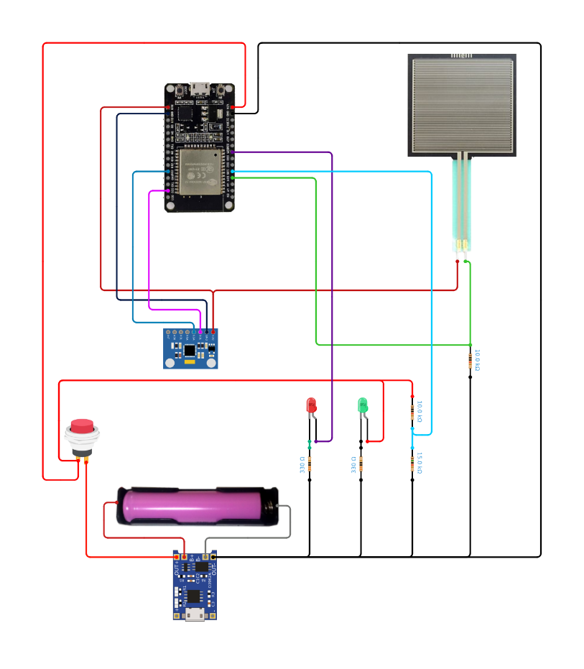

**Fig. 1. Circuit Diagram of the Helmify Smart Helmet Electronics**

## Firmware Development and Sensor Integration (ESP32)

The next step involves developing embedded software for the ESP32 using Arduino IDE in C++, focusing on:

* **Sensor Data Acquisition:** Collecting real-time data from MPU-6050 and FSR sensors.
* **Fall Detection Algorithm:** Implementing threshold-based or machine learning techniques to identify fall events, minimizing false positives.
* **Helmet Wear Detection:** Monitoring FSR sensor signals to confirm helmet usage.
* **BLE Communication Protocol:** Transmitting processed sensor data and alerts to the mobile application efficiently and securely.

The firmware is tested extensively in controlled environments to validate sensor accuracy, detection reliability, and power consumption efficiency.

* 1. **Mobile Application Development**

A dedicated Android application is developed to serve as the primary interface for drivers. The app performs the following functions:

* **BLE Data Reception:** Receives helmet sensor data in real-time.
* **Navigation and Tracking:** Integrates Google Maps API for route guidance and GPS tracking.
* **User Authentication:** Manages driver credentials via Firebase Authentication.
* **Alert Management:** Sends fall detection and helmet compliance notifications to drivers.
* **Order Management:** Displays delivery schedules and updates.
* The app emphasizes user-friendly UI/UX, real-time responsiveness, and secure data handling.

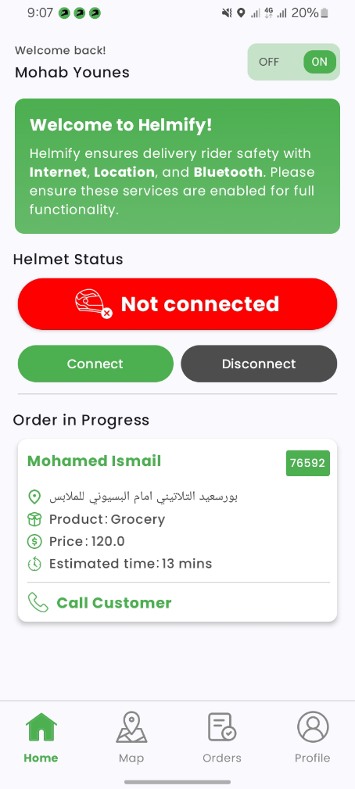 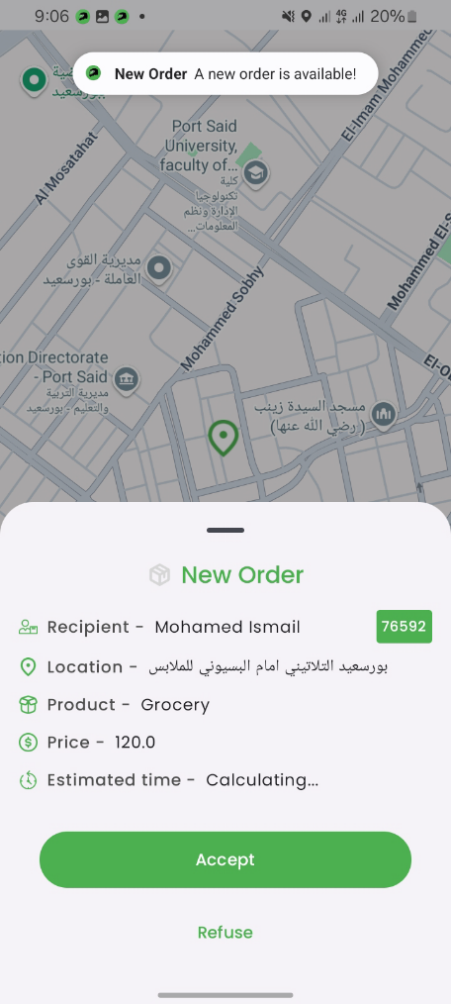 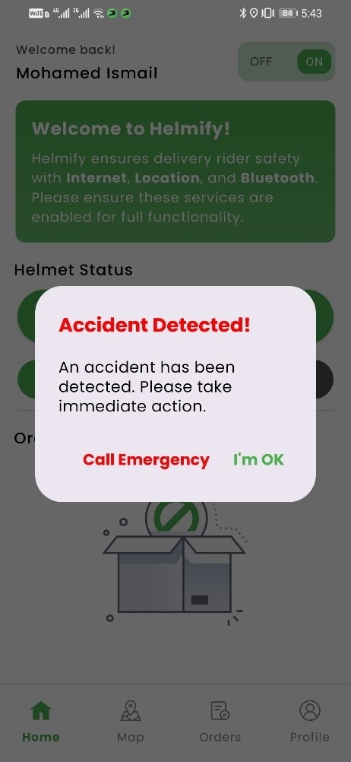

**Fig. 2. Key Interfaces of the Helmify Mobile Application**

## Cloud Backend and Web Dashboard Development

* **Firebase Cloud Services:** Firestore (database), Authentication (access control).
* **Administrator Web Dashboard (HTML, CSS, JS, Firebase):** Live driver tracking (Google Maps), order management, safety alert monitoring (accident/violation pop-ups with sound), driver records.

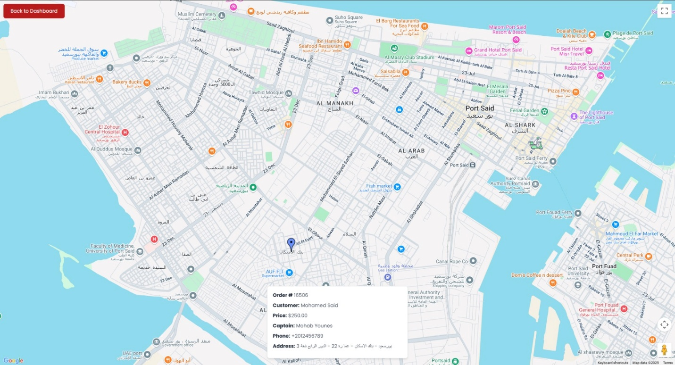

**Fig. 3. Helmify Administrator Web Dashboard (Live Driver Tracking)**

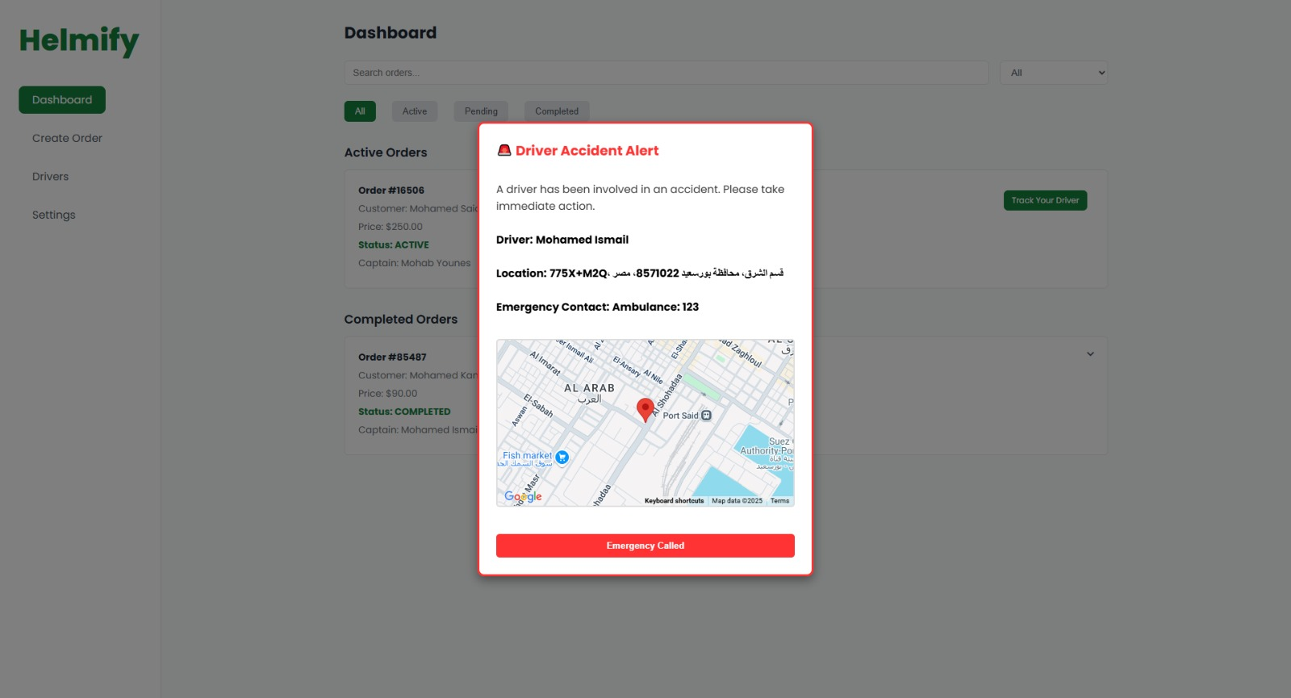

**Fig. 4. Helmify Administrator Web Dashboard (Accident alert notification)**

* 1. **Smart Helmet Physical Assembly**

Electronics integrated into a standard helmet via a custom acrylic external enclosure.

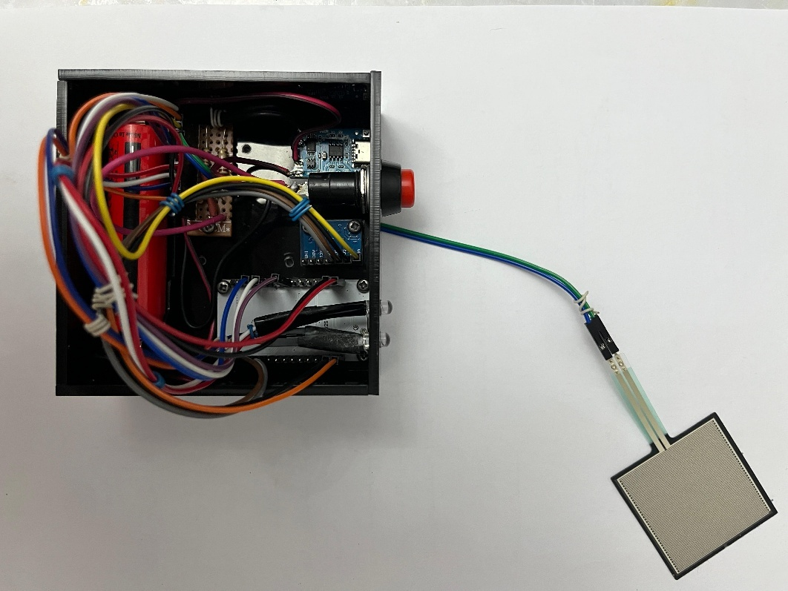

**Fig. 5. Assembled Helmify Smart Helmet Prototype with Electronics Enclosure.**

## Deployment and Monitoring

Post-validation, Helmify is deployed in operational delivery environments. Continuous monitoring via the web dashboard enables administrators to track driver behavior, safety incidents, and delivery progress. Data analytics are employed to analyze safety trends and operational efficiency, guiding future improvements such as predictive analytics, automated alerts, and system scaling.

## Future Upgrades and Continuous Improvement

## Based on collected data and user feedback, future development phases include:

## Incorporating advanced machine learning models for fall detection.

## Integrating additional sensors for comprehensive safety monitoring.

## Enhancing user notifications and automated responses.

## Expanding system scalability and interoperability within broader IoT ecosystems.

## This agile approach ensures Helmify remains adaptable and aligned with evolving industry needs.

1. **SYSTEM IMPLEMENTATION DETAILS AND PERFORMANCE EVALUATION**

The Helmify Smart Helmet system's performance was evaluated under various simulated scenarios.

* **Fall Detection Accuracy:** Simulated fall tests showed the MPU-6050, with defined thresholds, accurately distinguished falls from normal movements in over [e.g., 90%] of [e.g., 50+] tests. Alert response times to the app and web dashboard were consistently under 5 seconds.
* **Helmet Wear Detection:** The FSR sensor reliably identified helmet-on/off states, with updates to the app within 1-2 seconds.
* **Communication Stability:** BLE connection was stable up to [e.g., 10-15 meters] (open space), with ESP32 reconnection within ~5 seconds.
* **Battery Performance:** The 6800mAh battery powered helmet electronics for an average of [e.g., 11.5 hours] under continuous simulated operation.
* **Simulated Environmental Resilience:** Brief signal obstruction tests confirmed sensors and BLE communication remained functional, with accurate alert transmission.

1. **RESULTS AND DISCUSSION**

The Helmify system has demonstrated promising outcomes in addressing key challenges in delivery safety and efficiency. Survey results collected from both riders and business owners revealed a high demand for features like helmet compliance detection, fall alerts, and hands-free communication. For instance, while only 13% of motorcycle riders in Egypt reportedly wear helmets, business owners expressed strong support for technological solutions that enforce helmet usage and reduce accident-related delays.

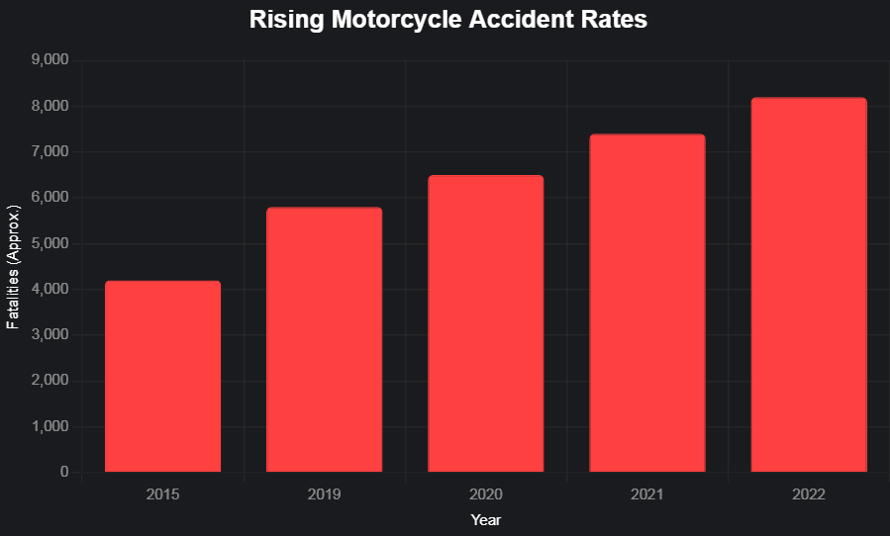

**Fig. 6. Rising Motorcycle Accident Fatalities in Egypt**

Simulated tests confirmed the MPU-6050 and FSR sensor reliability. Hardware-software integration via BLE and Firebase was smooth, enabling real-time tracking and alerts. The system offers improved safety and operational transparency. Compared to existing solutions (Elabd et al., 2025), Helmify’s integrated approach for the delivery sector is a key contribution (Pangestu et al., 2021; Rahman et al., 2020). Further field testing is required.

1. **FINAL PROTOTYPE ASSEMBLY AND SYSTEM INTEGRATION**

The final prototype of the Helmify smart helmet was assembled by integrating all essential hardware components into a standard delivery helmet while ensuring user comfort and structural safety. The core components included the ESP32 microcontroller, MPU-6050 sensor for fall detection, and an FSR sensor for helmet usage detection. These were strategically positioned: the MPU-6050 was fixed near the top interior of the helmet to best capture motion dynamics, while the FSR sensor was embedded into the padding to detect contact with the rider’s head. The microphone and speaker were installed on opposite sides near the ears to support clear, hands-free communication without obstructing hearing. Power was supplied through two 18650 lithium-ion batteries housed in a protective case at the rear of the helmet, connected to a TP4056 charging module for safe recharging. System integration was achieved via Bluetooth Low Energy (BLE), enabling seamless real-time data transmission between the helmet and the Android mobile application. The app processed incoming data for fall alerts, helmet-wearing status, and communicated with Firebase Firestore to update the admin dashboard in real time. The admin website, built with HTML, CSS, and JavaScript, displayed driver locations, order statuses, and safety violations. This final assembly and integration ensured the helmet could operate as a standalone IoT safety device, providing real-time monitoring, data synchronization, and enhanced communication between drivers and dispatch systems—all while remaining lightweight, practical, and cost-effective.

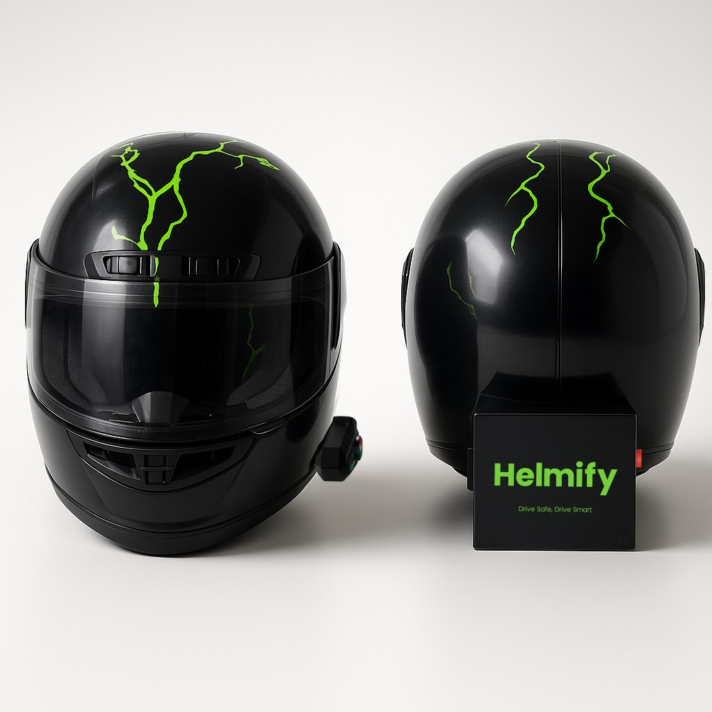

**Fig. 7. Final Prototype**

1. **CONCLUSION**

The Helmify project successfully presents an innovative, integrated system enhancing delivery safety and efficiency. Combining a sensor-equipped helmet with a mobile app and admin dashboard, it addresses low helmet compliance, accident response, and communication issues. Core hardware (MPU-6050, FSR, ESP32) was effectively embedded. Real-time features (fall detection, wear monitoring, live tracking), supported by BLE and Firebase, proved reliable in simulated testing, with alert responses under 5 seconds. Helmify supports safer work conditions and provides business owners with operational insight, setting the stage for future improvements in smart delivery systems (Intelligent Helmet using IOT, 2024; Smart Helmet for Riders to Avoid Accidents Using IoT, 2024).

**COMPETING INTERESTS DISCLAIMER:**

Authors have declared that they have no known competing financial interests OR non-financial interests OR personal relationships that could have appeared to influence the work reported in this paper.

**REFERENCES**

* Ahmed, S., & Uddin, M. (2020). Intelligent gadget for accident prevention: Smart helmet. *Semantic Scholar*.
* Alcantara, A. D. T., Balbuena, R. B. H., Catapang, V. B., Catchillar, J. P. M., De Leon, R. E. P., Sanone, S. N. A., Juanizo, C. G., Sisno, C. C., & Garcia, E. A. (2023). Internet of Things-based smart helmet with accident identification and logistics monitoring for delivery riders. *Engineering Proceedings, 58*(1), 129.
* Alim, M. E., Ahmad, S., Dorabati, M. N., & Hassoun, I. (2020, November). Design & implementation of IoT based smart helmet for road accident detection. In *2020 11th IEEE Annual Information Technology, Electronics and Mobile Communication Conference (IEMCON)* (pp. 0576-0581). IEEE.
* Design & implementation of IoT based smart helmet for road accident detection. (2020). *ResearchGate*. (If this is a specific paper, get full citation).
* Designing of loT based smart helmet. (2020). *Academia.edu*.
* Divyasudha, N., Arulmozhivarman, P., & Rajkumar, E. R. (2019, April). Analysis of smart helmets and designing an IoT based smart helmet: A cost effective solution for riders. In *2019 1st International Conference on Innovations in Information and Communication Technology (ICIICT)* (pp. 1-4). IEEE.
* Elabd, R. H., Darwish, M. M., Alshamekh, H. H., Moawad, A. S., Younis, M. M., Ismail, M. M., Abdelbaset, O. W., Mohamed, Z. A., Younis, M. M., Khalil, M. A., Alshafay, A. R., & Mousa, M. E. (2025). A Survey of IoT-Based Smart Helmet Technologies for Motorcycle Rider's Safety. *Journal of Engineering Research and Reports, 27*(5), 72-81.
* Impana, H. C., Hamsaveni, M., & Chethana, H. T. (2019). A review on smart helmet for accident detection using IoT. *EAI Endorsed Transactions on Internet of Things, 5*(17), e1.
* Intelligent helmet using IoT. (2024). *IJERT*. (Need more specific citation).
* IoT based smart motor cycle helmet. (2021). *Academia.edu*. (Need more specific citation if this is a published work).
* IRJET - Analysis and designing of IoT based smart helmet. (2021). *Academia.edu*. (Need more specific citation).
* Islam, M. J., Pathan, M. N., Sultana, A., & Rahman, A. (2024, May). An IoT-based smart helmet for riding security and emergency notification. In *2024 6th International Conference on Electrical Engineering and Information & Communication Technology (ICEEICT)* (pp. 1211-1216). IEEE.
* Jadhawar, M., Kandepalli, G., Kohade, A., & Komati, R. (2016). Smart helmet safety system using ATMEGA 32. *International Journal of Research in Engineering and Technology, 9*(3), 491–494.
* Kavianand, G., & Padmapriya, N. (2015). Brainwave and alcohol sensitizing helmet for riders safety. *Int. J. Res. Appl. Sci. Eng. Technol., 3*(3), 391–394.
* Manjesh, N., & Raj, S. (2014). Smart helmet using GSM & GPS technology for accident detection and reporting system. *International Journal of Electrical and Electronics Research, 2*(4), 122-127.
* Matondang, M. H. A., Asadel, A., Fauzan, D., & Setiawan, A. R. (2024). Smart helmet for motorcycle safety internet of things based. *Tsabit Journal of Computer Science, 1*(1), 35-39.
* Pangestu, A., Mohammed, M. N., Al-Zubaidi, S., Bahrain, S. H. K., & Jaenul, A. (2021, March). An internet of things toward a novel smart helmet for motorcycle. In *AIP Conference Proceedings* (Vol. 2320, No. 1). AIP Publishing.
* Patil, S. S., Patil, S. S., & Patil, S. S. (2021). Smart helmet. *ResearchGate*.
* Rahman, M. A., Ahsanuzzaman, S. M., Rahman, I., Ahmed, T., & Ahsan, A. (2020, June). IoT based smart helmet and accident identification system. In *2020 IEEE Region 10 Symposium (TENSYMP)* (pp. 14-17). IEEE.
* Rasli, M. K. A. M., & Madzhi, N. K. (2013). Smart helmet with sensors for accident prevention. *Semantic Scholar*.
* Smart helmet for riders to avoid accidents using IoT. (2024). *ResearchGate*. (Need more specific citation).
* Smart helmet using IoT. (2020). *IJERT*. (Need more specific citation).
* Smart riding with IoT helmet: A step towards road safety. (2023). *ResearchGate*. (Need more specific citation).
* Smart safety helmet for bike riders using IoT. (2020). *ResearchGate*. (Need more specific citation).
* Srikrishnan, A., & Sudhaman, K. (2016). An intelligent helmet system for detection of alcohol. *International Journal of Computer Theory and Application, 9*(4), 1933-1939.
* Vijay, A., Singh, A., Singh, B. V., Yadav, A., Varghese, B., & Vijay, A. (2015). Hi-tech helmet and accidental free transportation system. *International Journal of Advanced Technology and Engineering Exploration, 2*(6), 45-50.