A Study on the Application of Perspective in Ancient and Modern Architecture

Abstract
Perspective, as one of the most important visual tools in architecture, plays a fundamental role in spatial representation and the transmission of artistic and spatial concepts. This article provides a comparative study of perspective in Iranian architecture with Western viewpoints, particularly linear perspective and spatial Cubism, and introduces a new approach called Fraperspective (holistic perspective). The findings indicate that classical perspective methods have limitations in depicting the entirety of space, whereas Fraperspective, by expanding the field of view and employing multiple vanishing points, enables a more comprehensive representation of architectural space. This approach is applicable both from the standpoint of Iranian ontology and in alignment with contemporary design needs.
Keywords: Perspective, Fraperspective, Renaissance Era, Modern Art, Miniature Perspective, Pictorial Space.
Introduction
Perspective, as the visual language of architecture, is a tool that defines the relationship between the observer and the space. In traditional Iranian architecture, perspective has developed with a different approach from that of the Western world, where space is seen not only as a geometric structure but also as a spiritual and multidimensional entity. In contrast, linear perspective in the West, with its emphasis on a single, fixed vanishing point, was for a long time the standard method for representing space.
With the advent of modern transformations and the emergence of Cubism, this one-sided view was challenged, giving rise to more relative and multidimensional perspectives in art and architecture. This paper reviews these two historical approaches and introduces a new approach called "Fraperspective," which can overcome the limitations of classical vision and represent space in a comprehensive and holistic manner.

Materials and Methods
This research is a qualitative study that relates to multiple fields such as teaching perspective in architecture, the history and theory of perspective expression in architecture, and is considered an applied research in terms of its objective. For this purpose, a descriptive-analytical method has been used in this study. In the descriptive method, the goal is to describe the conditions and phenomena under investigation. Conducting this type of research helps the researcher to better understand existing conditions to make correct decisions (1). In the descriptive-analytical method, in addition to depicting what exists, the researcher also examines and explains the reasons behind the issue. Therefore, to reach logical analyses, strong bases of reasoning are needed, which are provided through a review of theoretical literature, prior research, and a proper understanding of the overall context such as relevant laws and theories. In descriptive-analytical research, the researcher logically examines the interrelations of the parts related to the research problem and arrives at findings and conclusions (2). Accordingly, this study investigates the spatial perspectives in the environment of painting on one hand, and the history and fundamental principles of perspective drawing on the other, with the expectation that by examining these spatial viewpoints and expanding them within a conceptual framework, it will be possible to study their development across different time periods.
Perspective and Intellectual Context
The intellectual context is a crucial factor in the use of metaphors within spatial domains. In fact, the intellectual framework emerges as a mental schema derived from human bodily experience regarding the positioning of objects. Levinson, an American linguist, demonstrates that language—even in core cognitive domains such as spatial thinking—influences how people conceptualize spatial relationships, directions, and consequently their mental representations and reasoning (Levinson, 2004). Across all studies in spatial cognition, the concept of a reference frame is fundamental. Humans employ multiple cognitive systems to understand space. Levinson argues that there are three distinct cognitive frames for representing spatial relations between objects in the world: viewer-centered frames, object-centered frames, and environment-centered frames.
- In the viewer-centered frame, objects are represented relative to the observer’s coordinate system, based on the observer’s viewpoint, either egocentric (eye-centered) or body-centered.
- In the object-centered frame, objects are coded according to their intrinsic axes.
- In the environment-centered frame, objects are located relative to prominent environmental features such as gravity or distinctive landmarks (Levinson, 2004).
These three frames of reference are also known as relative, intrinsic, and absolute frames, respectively. Each of these reference frames encompasses a complete family of semantically related yet distinct systems. Here, linguistic frames of reference are explained in a relatively abstract manner with details on linguistic variation. Initially, a set of basic geometric shapes is introduced to illustrate all the systems, some of which are depicted in Figure 1. These examples represent three common types of coordinate systems used by humans. Supporting the concept of selective reference frames, different human groups employ various mental maps, which lead to differences in many aspects of communicative behavior and culture (Levinson, 2004).

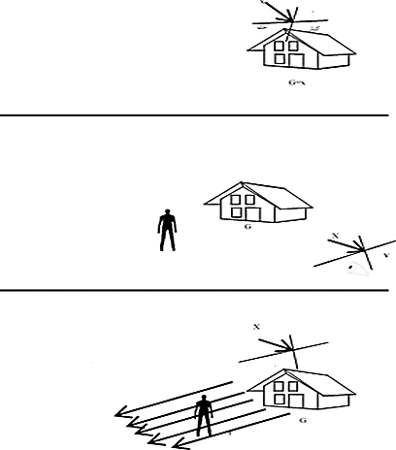
Figure 1. The main elements and the placement of a person next to a house are represented differently in each of the intrinsic, relative, and absolute reference frames
South
North
Absolute
he person is located north of the house, with the coordinate origin based on the geographical direction.
Inherent
A person is in front of the house.
The origin of the coordinate system is located on the house
Relative
The person is located on the left side of the house, with the coordinate origin at the viewer's position."
Rear
.

1. Intrinsic Perspective:
This concept refers to the inherent characteristics of space and the human eye. In other words, intrinsic perspective is related to the natural and physical methods the human eye uses to perceive depth and dimensions of objects. This perspective is based on the viewer's angle of vision and the eye’s innate features, such as distance and the size of objects in length and width.
2. Relative Perspective:
Relative perspective refers to the differences in the size and distance of objects depending on the viewer’s position or angle of vision. In this perspective, everything is relative and depends on the observer’s eye. For instance, when you look at a road, it appears wider near you and converges in the distance. These changes in size happen in a relative manner.
3. Absolute Perspective:
Absolute perspective refers to a fixed and standardized approach to representing depth and distance in painting and design. This type of perspective operates independently of the viewer’s position, based on consistent geometric rules and principles. In this method, distances and sizes are calculated in a fixed manner, regardless of the observer’s point of view.
In summary, these concepts help us use geometric principles and different viewpoints to create images that depict depth and dimension more realistically.
Considering the role of vision as a representational scheme, as mentioned in the previous section, this pattern can be understood within the framework of the well-known triadic model of reference frames.
Reference frames can be examined in two ways: relative to the object and observer (intrinsic), and relative to the object, observer, and a third element (relative). In the second case, a triadic relationship is established among the observer, the primary object, and the third object. Each of the relative and intrinsic modes, when compared to human visual experience and the horizon line, leads to three additional states—forming a total of six modes, as shown in Table 1.
The Emergence of Perspective in the Renaissance
The prioritization of the knowing subject, interpreted through the unified concept of subjectivism, marks a turning point in modern epistemology and the philosophy of art, where shared roots are evident in both domains. With a decisive break from predecessors, Descartes established his philosophy based on the certainty and confidence of the knowing subject, along with the use of precise, measurable methodologies drawn from mathematics. In this framework, the knowing subject must comprehend the object of knowledge according to their own rules—namely, the rules of mathematics—and dominate it. The aim of such knowledge is to create order and determine the position of known elements within the chain of human understanding (Beheshti, 2006).
Table 1. Perspective Schema
(Source: Mohammadi, 2014)
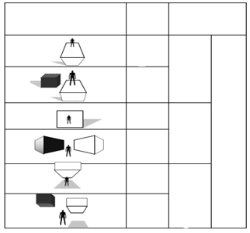
Relative
Inherent
Relative
Inherent
Relative
Inherent
The object is placed above the horizon line
Aligned with the horizon line
The object is located below the horizon line
Position of the observer
Reference frame
Conceptual space
Understanding basic spatial relationships is essential in architectural design

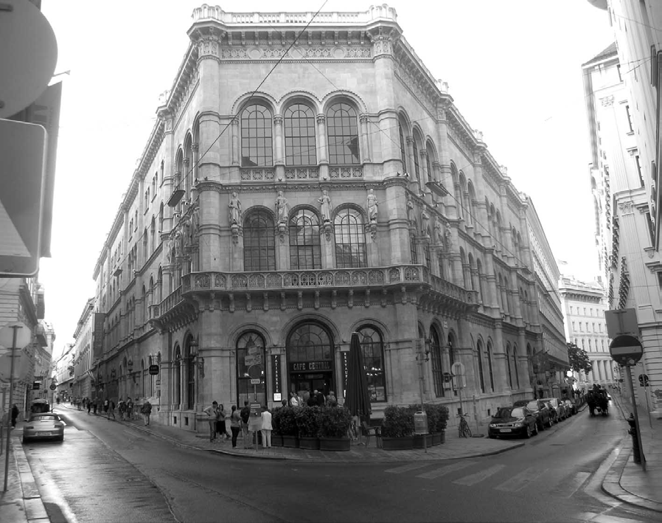
The rediscovery of perspective or "viewpoint" in Renaissance painting and architecture was likewise based on this understanding of human cognition. The role of the observer, along with the perspective of the painter or architect in the act of seeing, became central to the perception of objects and the space they inhabit. By standing still at a given moment and gazing toward the horizon and into the distance, the architect is able to depict the future sequence of events and the precise positioning of elements within space (see Figure 2).
Figure 2. Perspective illustration on the road to Vienna

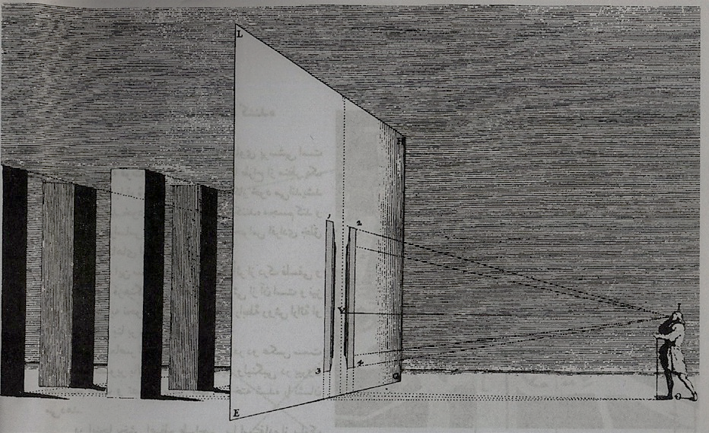
Janowski, on one hand, refers to this transformation as the objectification of mental matter through the transition from psychological and physiological space to mathematical space. On the other hand, he notes that this process can likewise be called the "subjectivization of the objective world," as it arranges and organizes all objects according to the viewer’s sight and perspective (Beheshti, 2006, p. 79). The Renaissance human perceived space within the framework of the new humanism of his era. With the period's emphasis on individual and personal experience, his mental imagery was deeply influenced by the new method of representation—namely, the scientific perspective. As a result, these images could both depict a pre-existing reality on the canvas and represent an imaginative conception of a contradictory three-dimensional space that existed in the designer’s mind (Bacon,1993, p. 30) (Figure 3).
Figure 3. Perspective in the Renaissance period (Source: Bacon, 1993. 30)

Considering the cognitive model mentioned in the previous section, perspective in the Renaissance era signifies the domain of space as time, where objects within the spatial domain are arranged and refined according to the observer’s viewpoint, and the temporal domain of the future is completely clear and predictable. The frame of reference is mostly relative and viewpoint-centered. Due to the humanistic thinking of this period, most perspectives were based on the human eye’s viewpoint and the horizon line (see Table 2).
Perspective in Miniature
The depiction of architectural space in miniature painting does not represent the world as it is in reality. Instead, it creates a new reality. Dianlu Konshu refers to paintings as old sources and documents, but the issue raised regarding these paintings is the level of realism they embody and the meanings expected from them. "Mian" in new aesthetics is used to describe those aspects and to extract artistic concepts and meanings that do not belong to the realm of representation, as discussed in semiotics and philosophy of art. The similarity between a painting or even a photograph and its subject is a matter of convention rather than existence (Foroutan, 1960/1389). One of the main features of Iranian painting is the absence of perspective. Space in these works is not viewed from a specific point or through human vision. This creates a fundamental difference between Iranian painting and Western painting, which has been famous since the Renaissance. From Gharami's viewpoint, as we no longer see it, things become smaller, whereas this is never the case in Iranian painting. After the Renaissance, the Western painter considers what disappears as a zero point, but the Iranian painter imagines himself as the zero point, which is a broader concept. For this reason, in Iranian painting, the courtyard floor, room, balcony, courtyard roof, and distant hills are all exposed to view. The Iranian narrative painter sees viewpoint in a hierarchy and does not suppress or ignore what disappears on a higher level to express the entirety of their vision (Dabiri, 2011).
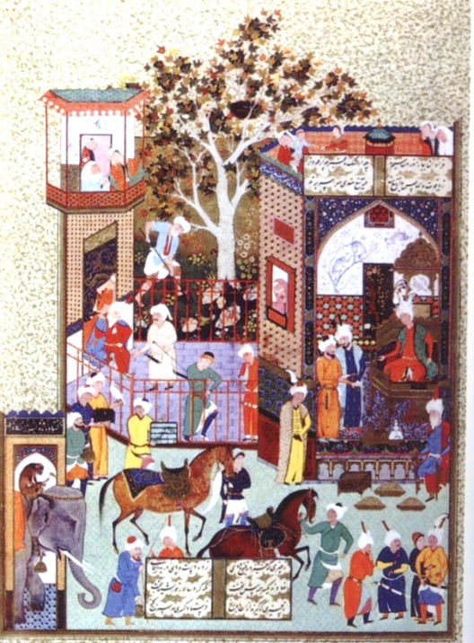
The sizes of near and far objects are the same, and what is more important is inevitably placed above the assembly. The depicted world is not only flat and two-dimensional like a piece of paper but also the inside and outside are not separate from each other; from this perspective, the inner entirety is just as real as the outer (Heydari, 1990).
Figure 4. The painter’s presentation of gifts from India to Khosrow in a miniature allows the viewer to observe events simultaneously from multiple angles (Source: Nazrani, 2011, p. 132). This includes the outer courtyard, the inner courtyard, the central courtyard of the royal palace, and the banquet all at the same time.

Representation in architecture | Reference frame | Time | space | Recognition
Point perspective in architecture | Relative and viewer-centered – aligned with the horizon line | Foresight | Object arrangement according to the viewer's viewpoint | Emphasis on epistemology and the knowing subject (subjectivism)
Table 2. Perspective Analysis in the Renaissance Era

Table 3. Perspective Analysis in the Modern Era
Representation in architecture | Reference frame | Time | space | Recognition
Anti-perspective  Spatial Cubism | Relative and viewer-centered – simultaneous use of multiple horizon lines | Simultaneity | Cubism Observer movement | Relation

In the imaginary spatial structure of the miniature, since the viewer is positioned at an infinite point or at all points simultaneously, the subjects sit side by side in a two-dimensional space with equal value. The narratives do not compete vertically with one another; rather, each scene is arranged horizontally and simultaneously with other events according to its own nature and world (Figure 4). The most important feature of this horizontal viewpoint is its view from above, very far away, and parallel to the world. This type of vision gives equal value to all components of the subject, which corresponds to the logic of horizontality and the importance of elements in their place. This presence in various locations implies multiplicity, which ultimately unites into a single artwork—many perspectives converge within one work to achieve unity (Eslami, 2011).
In another analysis regarding the language of Iranian architecture, reference can be made to the naming of spaces in traditional Iranian houses. Many space names in Iranian architecture are based on their placement relative to two horizontal and vertical axes: the horizontal axis being the ground and proximity to the central courtyard, and the vertical axis representing the sky. Examples include the front and back rooms of a house, the basement back room, the upper living space, and the lower house (Haeri, 2009). These two vertical and horizontal axes (Figure 5) organize an invisible spatial grid, where the placement of each space is not due to the viewer’s position but because of the intrinsic value created for each space (Figure 6).
This horizontal orientation also has precedents in Iranian cinema. In Kiarostami’s films, characters are all equal, like figures in a miniature painting; none have particular individuality and none are placed behind or in front. In reality, everyone in traditional society occupies their eternal and unchanging place, and consequently, they stand in respect to the audience at the same position (Mohammad Kashani, 2005). According to the cognitive model, spatial narratives act as a metaphor for the realm of time, where past, present, and future events are seen simultaneously, which generates qualities that produce gradations of time. From a mystical ontology perspective, where the viewer is still nothing more than a speck in the world, the distance or closeness of objects to the viewer is irrelevant; thus, the reference becomes an intrinsic metaphor.
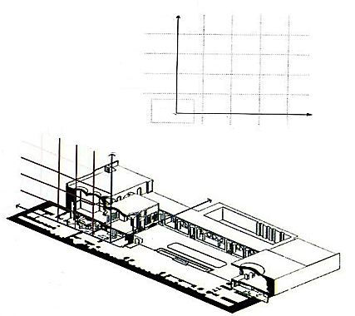
Figure 5. Representation of the two axes—sky and earth—in the invisible grid and their placement within the spatial organization of Saleh House, Kashan. (Source: Haeri, 2009)

Courtyard
Third floor
The second floo
The first floor
Section
First layer
Intermediate layer
Final layer
Plan
The first floor
Third floor
The second floo
Final layer
Intermediate layer
First layer
Courtyard
Section
Plan

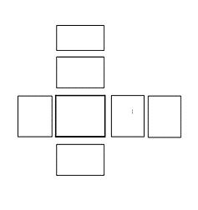
Figure 6. Naming of spaces based on the spatial grid. (Source: Haeri, 2009)

Beyond
the room

After the basement
Basement
Courtyard
Bedroom
Sitting room
Perspective in the Modern Era
A new viewpoint emerged in the modern era—with the advent of technological achievements in the early 20th century and the possibility of bodily movement and experiences enabled by machines—the understanding of the modern human also changed. The achievements of modern physics in the theory of relativity and the continuity of time and space transformed the Renaissance notions of absolute time and precise spatial measurement. This shift in the perception of modern humans and the emergence of the concept of time and space outside traditional frames of reference coincided with changes in visual arts. The fixed single-point perspective of the Renaissance was challenged by additional perspectives, such as spatial Cubism, which opposed the earlier view. Siegfried Gideon, a modern architectural theorist, believes that from one viewpoint, the authority of traditional perspective was lost due to profound spatial understanding arising from the optical revolution, which became fundamental to architecture and urban planning. During this period, perspective entered architecture from painting, but by the early 20th century, with Cubism’s introduction in painting, the principles of perspective that had dominated architecture and art for about four hundred years were liberated. The foundational idea of perspective—depicting an object from a single viewpoint—was challenged. (Ma’arian, 2005, p. 316)Cubism goes beyond the principles of Renaissance perspective. In this era, spatial perception is relative; in other words, the painter views the object from several different points and draws it. The painter’s view from each single point does not alone show the final shape of the object. Thus, the painter depicts the object in one image from all sides—above, below, inside, and outside. The painter’s brush moves around and penetrates the body. Therefore, the fourth dimension, time, was added to the spatial concept developed during the Renaissance. (Gideon, 2004, p. 363)
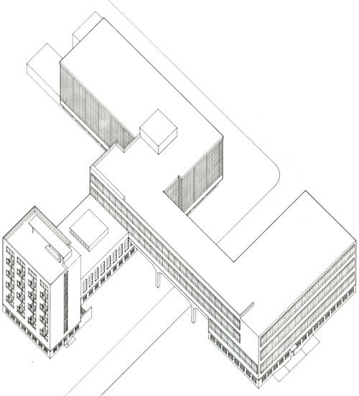
Cubism in architecture is associated with nonlinearity in form and emphasizes movement elements such as ramps and stairs to help the observer understand space dynamically. The movement of the observer through space provides various possibilities for perception. (Figure 7)

Figure 7. The Bauhaus School by Walter Gropius, designed based on anti-perspective architecture. Each facade of the building presents a different image. As the observer moves inside the building, through corridors and around it, a different perception is created.(Source: Archdaily, 2010)
Based on the cognitive model mentioned in the previous section, the perspective in the modernist era is an image in which objects exist within a spatial domain according to the observer’s movement across different horizons (above and below) and sometimes the concept of simultaneity. The frame of reference for representation in architecture is relative and anti-perspective. (Table 3).
Introduction to Meta-Perspective (Holistic Perspective)
Perfectionism in the level of perspective drawing can have a fully functional interpretation. In other words, if the functional weakness of traditional perspective lies in its inability to depict the true totality of space, then by introducing a drawing method that expands the field of view and increases the mapping range of the image, we can define the roots of perfectionism or a holistic worldview functionally in the form of a method called Meta-Perspective. Thus, Meta-Perspective can be considered a technique for enlarging the range of architectural space representation. It provides a way to realize the ideal of holistic depiction or "super-visualization" as opposed to the realistic representation of ordinary perspective, which focuses on architectural space details. Unlike conventional perspective, which is limited to displaying the observer's static cone of vision, the entirety of architectural space in Meta-Perspective is recorded from multiple viewpoints as separate segments, each with its own vanishing points and depth of field. By assembling these various perspectives together, a larger, more comprehensive perspective is achieved. To align these segmented perspectives with multiple vanishing points, it is necessary for the horizon line and perspective lines to change from Euclidean (straight) to non-Euclidean (curved) forms. The method for drawing this transformation is explained below. Converging perspectives define the observer's position relative to the subject through the horizon line and the location of the vanishing points on this line. In other words, as the observer moves, the distance between the horizon line and the vanishing points changes. All parallel lines in reality converge toward a single vanishing point according to the observer's changing position relative to the object and the angle between the line passing through the observer’s two eyes and each dimension of the object. The proximity or distance of vanishing points can increase accordingly.
However, every object is ultimately defined by three dimensions, each having its own vanishing point. Therefore, according to classical perspective principles, a maximum of three vanishing points are used to depict an object. The object is drawn relative to its own position in relation to the observer’s eye level (horizon line), and whether it is above or below this line depends on the observer’s height of view. The distance between the vanishing points on the horizon indicates the observer’s proximity or distance from the object. As shown in Figure 8, cubes that extend beyond the circular boundary drawn around the vanishing points exhibit distortion. This distortion mainly results from the acute angles formed where the paths of lines passing through the vanishing points intersect. The lines drawn from the vanishing points meet at right angles when they intersect on the diameter of this imaginary circle; however, as they move away from this circle, the angle between them decreases, which causes the perspective to skew.
Based on this, perspective drawing is limited to the area within this circular boundary. To increase the drawing space beyond this limit, there are only two options:
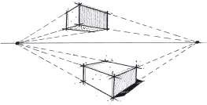
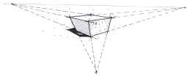
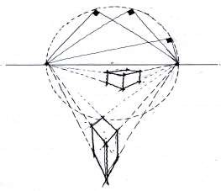
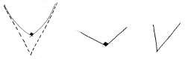
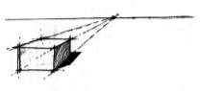
- Increase the distance between the vanishing points: This allows more objects to be included within the observer’s cone of vision by moving further away from the object. However, this does not change the intrinsic limitation of the field of view and is not always feasible in confined spaces such as a room.
- Change the angle between the lines: This approach involves altering the angles between the perspective lines themselves to overcome the spatial restrictions.
Thus, expanding the perspective drawing field requires either physically distancing the observer or modifying the geometric relationships of perspective lines beyond classical Euclidean constraints.
Figure 8. Show graphical problems in convergent perspectives

Therefore, if we consider the placement of four cubes in a room, classical perspective drawing can only depict part of the scene without distortion at best, while the rest of the scene will appear distorted, reducing the drawing’s value. The area marked by the circle represents the boundary within which perspective can be drawn without distortion. By changing the horizon line from a straight line to a curved one and aligning the drawn lines along the meridians of an imagined circle, it is possible to depict the four cubes without distortion and in a holistic manner (Figure 9).
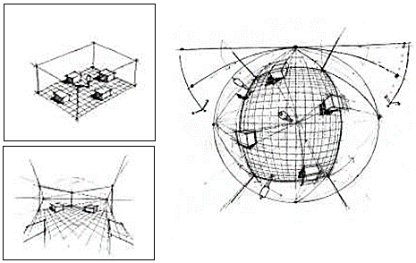
Figure 9: In the picture, we show how the angle can be corrected by deforming the lines from straight to curvature

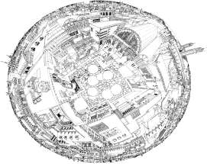
In Figure 10, a four-way (chahar-suq) space is depicted using this holistic perspective drawing method. By modifying the edges of the perspective and the vanishing points, the subject can be enclosed within a circle and a square, allowing different spatial dimensions to be composed within a single frame. As evident in the figure, the inverted plan of the ceiling is displayed alongside the perspective view of the corridors of the four-way space. Thus, this method enables us to represent all spatial dimensions on a two-dimensional surface.
Figure 10: Four-dimensional drawing with a holistic perspective
Discussion
Perspective, as a method of representing reality, has always reflected the cultural, scientific, and philosophical conditions of each historical period. In the modern era, the shift from single-point perspective to relative, multifaceted, and multidimensional viewpoints marks a fundamental change in how humans perceive time and space. However, presenting the entirety of a space within a single image remains a significant challenge. Fraperspective, with its emphasis on a holistic approach and expanded field of view, is an innovative attempt to address these limitations, enabling a more comprehensive and distortion-free representation of architectural space. Yet, its acceptance and application require changes in visual habits, teaching methods, and the perspectives of architects and designers. This approach calls for a reconsideration of traditional methods of drawing and spatial perception.
Moreover, balancing the need for detailed accuracy (detail-orientation) and maintaining a broad, comprehensive vision (holism) in architectural design remains a debated issue. Fraperspective offers an opportunity to explore and experiment with this balance. Ultimately, further research and broader practical applications are necessary to validate its effectiveness and feasibility.
Findings
- Classical Perspective and Its Limitations:
Western linear perspective, with a maximum of three vanishing points, realistically represents only a limited portion of space. When the field of view expands beyond this limit, visual distortions occur.
- Iranian View of Space:
In Iranian miniature art, space is depicted as two-dimensional and simultaneous, where each spatial element has its own unique value and spiritual significance. This viewpoint highlights simultaneity and multiplicity of perspectives within the space.
- Spatial Cubism:
By employing multiple vanishing points and simultaneous perspectives, spatial cubism enables a relative and dynamic perception of space, incorporating the fourth dimension—time.
- Fara-Perspective (Holistic Perspective):
This method increases the number of vanishing points and transforms the horizon line from linear to curved, allowing the representation of the entire architectural space without distortion. The architectural space is constructed from separate perspective segments, each with its own field of view and depth, which are combined to form a comprehensive image.
- Function in Contemporary Architecture:
Fara-perspective can serve as a valuable tool in architectural design for better spatial understanding and simultaneous display of spatial details. Moreover, it embodies a holistic worldview closely aligned with Iranian cultural perspectives.
Conclusion
Perspective in architecture is not only a technical tool for representing space but also reflects the philosophical and cultural viewpoints of each era. Comparing classical Western perspective with Iranian miniature painting reveals distinct differences in the perception of space, time, and cognition. The method of Fara-Perspective (Holistic Perspective), as a solution to expand the field of view, not only overcomes the limitations of classical perspective but also integrates the principles of perspective with traditional Iranian approaches. This makes it an effective tool for contemporary architectural education and design, enabling the representation of a holistic and multidimensional space. This method holds significance both ontologically and in enhancing the architectural design process.

COMPETING INTERESTS DISCLAIMER:
Authors have declared that they have no known competing financial interests OR non-financial interests OR personal relationships that could have appeared to influence the work reported in this paper.

References
Panofsky, E. (1997). Perspective and Renaissance art. Harper & Row.
Frampton, K. (2007). Modern architecture: A critical history. Thames & Hudson.
Hoffmann, W. (2010). The language of modern architecture. Wiley-Blackwell.
Arnheim, R. (1974). Art and visual perception: A psychology of the creative eye. University of California Press.
Eltis, K. (1993). Space in architecture: The evolution of spatial concepts. Routledge.
Kolarevic, B. (2003). Architecture in the digital age: Design and manufacturing. Taylor & Francis.
Giedion, S. (1967). Space, time and architecture: The growth of a new tradition. Harvard University Press.
Vidler, A. (1992). The architectural uncanny: Essays in the modern unhomely. MIT Press.
Norberg-Schulz, C. (1980). Genius loci: Towards a phenomenology of architecture. Rizzoli.
Tschumi, B. (1996). Event-cities. MIT Press.
Zumthor, P. (2006). Atmospheres: Architectural environments – Surrounding objects. Birkhäuser.
Merleau-Ponty, M. (2012). Phenomenology of perception (D. A. Landes, Trans.). Routledge. (Original work published 1945)
Akkach, Samer (2005). Cosmology and Architecture in Premodern Islam. State University of New York Press:New York.
Donato, Sandro (1990). IRAN, La Recostruzione Delle Aree Distrutte Dalla Guerra. Gangemi Editore, Roma: Reggio C.
Michell, George and Zebrowski, Mark (1999).Architecture and Art of the Deccan Sultanates. Cambridge University Press: Cambridge.

