Parametric Study of Drone-based Gas Pollution Monitoring System Integrating Internet of Things Technology

.

ABSTRACT

|  |
| --- |
| **This study presents the design, development, and testing of a drone-based gas pollution monitoring system integrated with Internet of Things (IoT) technology to investigate air pollution in the Niger Delta region of Nigeria. The design utilizes electrochemical sensors and non-dispersive infrared sensors to detect and measure various gas pollutants, including carbon monoxide, carbon dioxide. nitrogen dioxide, among other emitted gases. The design unique features include a drone-based sensor array, real-time data transmission via Wi-Fi (ESP8266 module) and cloud-based data presentation. After system integration and calibration, the sensors demonstrated high accuracy, with MQ-7 sensor achieving 97.14% accuracy for CO detection and the MQ-135 sensor exceeding 98% accuracy for the measurement. The system's performance was also evaluated in various environments; urban areas, industrial zones, and rural regions, showcasing its versatility and adaptability. The results highlight system's potential for reliable and efficient environmental monitoring with applications in air pollution trend quality identification, monitoring hard-to-reach areas and informing policy decisions. The real-time data transmission and cloud-based visualization enable immediate analysis and decision-making, which is crucial for timely interventions in air pollution management. While minor limitations were observed, such as restricted flight duration and dependency on Wi-Fi connectivity, these can be addressed in future study through advancement in battery technology and alternative communication protocols. The study demonstrates the viability of combining drones, IoT and real-time monitoring for modern environmental gas pollution detection, providing a scalable and flexible solution for gas pollution management. The system potential for large-scale deployment play a significant role in addressing air pollution challenges, thus, promoting sustainable development ethics. This research showcases the potential of drone-based gas pollution monitoring systems to revolutionize environmental monitoring and management, providing a valuable technique for protecting public health and the environment.** |

***Keywords****: Drone, gas sensor, IoT monitoring, pollution detection, wireless communication.*

1. INTRODUCTION

World Health Organization (WHO) defines air pollution as process when any chemical, physical or biological substance modifies the basic characteristics of the atmosphere and contaminates its interior or exterior surroundings [1][2]. Air pollutants, therefore can be classified into biological and air toxic pollutant, where carbon monoxide, carbon dioxide, ozone, nitrogen dioxide and sulfur dioxide are involved in this process [3][4]. Gas pollution is predominant in the area of Niger Delta, Nigeria due to large volume of oil and gas exploration and their related activities. The environment is often affected with flared gases which are harmful to man, aquatic life in the ocean, animals and natural environment. The effect of this gas exploration on the eco-system often led to extinction of aquatic live and hamper economic growth. Gas flaring and its activities are discussed in the studies [5][6] and the attending impacts are well documented. Natural environment and air pollution are of great concern to life and activities of people, plants and animals. Accordingly, [7][8][9] studies revealed that the immediate surrounding in which oil exploration facilities operate can be toxic. The toxicity nature of this area shows that air, water, land, flora and fauna, human beings, natural resources and the inter-relationship that exists between them are grossly polluted. Our environment determines the wellbeing and existence but man’s activities (air pollution) destroy the natural air quality of the environment (ecosystem), directly or indirectly. Air pollution occurs when there is contamination of air quality, that is, when air contains gasses, fumes, dust or odor in harmful quantity which can cause damage to ecosystem [10]. Air pollutants such as carbon monoxide (CO), carbon dioxide (CO2), sulphur, ozone, nitrate oxide, chlorofluorocarbons and unburned hydrocarbons, volatile organic compound and other heavy metals are not only toxic but can cause air pollution. The above highlights and its activities within the Niger Delta region of Nigeria necessitates air pollution study. Gas emission emanating from welding torch, cutting of metals, welding operations, periodic painting of oil and gas facilities, also contribute to air pollution. Thus, air pollution monitoring is a critical aspect for managing and preserving our natural resources within the Niger Delta region. Traditional methods of gas pollution data collection, such as ground-based surveys and satellite imaging [11][12][13], have limitations in terms of accessibility, resolution and cost. Recent advancements in technology have introduced unmanned aerial vehicle (UAV), commonly known as drone, as a viable and innovative solution to these challenges [14]. Drones offer several advantages, including the ability to cover large areas quickly, provide high-resolution data and access remote or hazardous areas [15[16]. Equipped with various sensors, drones can collect a wide range of data types, including multispectral and hyperspectral imaging, thermal sensing and light detection and ranging. The integration of drone with IoTs technology enables real-time wireless communication, data collection, transmission [17[18][19] and analysis; facilitating immediate decision-making and timely interventions in gas pollution management.

Gas pollution poses severe threat to environmental sustainability and public health, causing respiratory diseases, cardiovascular problem and premature deaths. Traditional gas pollution monitoring systems rely on stationary sensors, which are limited by their fixed locations, high installation costs and inability to provide real-time, dynamic data in hard-to-reach or rapidly changing environments. To address these challenges, this design aims at developing a drone-based gas pollution monitoring system integrated with IoT technology to provide real-time, mobile and high-resolution air quality data. This system enhanced gas pollution assessment, improve environmental management and support decision-making for mitigating gas pollution's impacts on health and ecosystems. The specific objectives of the study include developing a drone-based system capable of capturing gas pollution data, integrating various sensors to monitor environmental conditions and detect air pollutants (harmful gases), developing a communication system for real-time data collection and dissemination.

2. RESEARCH material and methodOLOGY

**2.1 Research Design and Location**

The design focused on equipping drones with lightweight, high-precision sensors capable of measuring key air pollutants, including particulate matter, carbon monoxide, nitrogen dioxide, ozone, and sulfur dioxide. The system leveraged on wireless communication technologies to transmit data to a central server or cloud platform for advanced analysis and visualization. By combining drone mobility with IoT capabilities, the project aims at delivering a scalable, cost-effective, and flexible solution for air quality monitoring, addressing the growing demand for dynamic pollution assessment and enabling informed environmental management and policymaking decision. Despite the potential benefits, the work acknowledges certain limitations, including the operational range and flight duration constraints due to battery capacity. In addition, adverse weather conditions affecting drone stability and sensor accuracy, potential interruptions or delays in wireless communication and the initial investment and maintenance costs are addressed. The research locations were Okoromboko and Okoroutip communities in Eastern Obolo Local Government Area of Akwa Ibom State, Nigeria.

* 1. **Gas Pollution Monitoring Methods and Technologies**

Gas pollution monitoring is a systematic process that involves collecting, analyzing and interpreting data from the natural environment and to understand gas pollution conditions, track changes over time and assess the impact of human activities alongside natural phenomena on ecosystems. Effective gas pollution monitoring is crucial for informed decision-making, policy development and sustainable resource management. Gas pollution monitoring serves several purposes, including assessing gas pollution conditions, detecting changes and trends, ensuring compliance with regulations, assessing and managing risks and promoting public awareness and education [20]. Various methods are employed to achieve these objectives, including remote sensing using satellites, drones, and aerial photography to provide large-scale and high-resolution data on land use, vegetation coverage, water bodies, and atmospheric conditions. In-situ monitoring involves direct measurement of gas pollution parameters at specific locations using sensors and instruments. Biological monitoring assesses the health and diversity of biological communities to infer ecosystem health. Technologies that facilitate effective gas pollution monitoring include geographic information systems (GIS) for integrating and analyzing spatial and temporal data, drones and UAVs equipped with sensors for high-resolution data collection, IoT devices and networks for real-time monitoring [21][22]. Machine learning and big data analytics for identifying patterns and predicting trends [23]. These methods and technologies collectively contribute to a comprehensive understanding of gas pollution conditions, enabling effective management and conservation of natural resources.

* 1. **Traditional Gas Pollution Monitoring Method and Drone-based Monitoring System**

Traditional gas pollution monitoring methods have long been used to gather data concerning various gas pollution parameters, including air and water quality, soil health, and biodiversity. However, these methods present several significant challenges and limitations in today’s rapidly changing gas pollution landscape. Traditional methods are often resource-intensive and costly, requiring substantial financial investments, human labor, and specialized equipment. They also lack the ability to cover large areas efficiently, with stationary sensors providing data from fixed points that may not represent wider gas pollution conditions. Additionally, traditional methods provide data at limited spatial resolution, leading to gaps in data and an incomplete understanding of gas pollution conditions. Furthermore, ground-based surveys and manual data collection are prone to human error, which can affect the accuracy and reliability of the data.

In contrast, drone-based monitoring systems offer several advantages. Drones equipped with advanced autonomous navigation systems can navigate complex environments without human intervention [23]. They can also capture high-resolution imagery and remote sensing data using multispectral, hyperspectral, and LiDAR sensors [24]. The integration of artificial intelligence and machine learning algorithms enables drones analyze data in real-time and make informed decisions autonomously. Advanced communication technologies, such as 5G networks and satellite communication systems [25][26], enable seamless data transmission between drones and ground stations. The advantages of using drones in gas pollution monitoring include flexibility and mobility, cost-effectiveness, rapid deployment, and high-resolution data acquisition. However, drone-based monitoring systems also face several challenges, including regulatory compliance, limited flight endurance, data processing and analysis, and potential environmental impacts [27]. Summarily, traditional gas pollution monitoring methods have significant limitations, and drone-based monitoring systems offer a promising solution. By leveraging advanced technologies, drones can provide high-resolution data, real-time monitoring, and cost-effective solutions for gas pollution monitoring. However, addressing the challenges and limitations of drone-based monitoring systems is crucial for their successful implementation.

* 1. **Drone System Components**

The drone system consists of hardware and software components. The hardware components include DC motors, electronic speed controller, sensors, communication system and frame structure.

**2.4.1 Frame Structure**

The frame design for drone system, is a crucial component of a quadcopter, providing structural support and withstanding significant tensile and compressive forces [28]. As the foundation for all other components, the frame's design determines the configuration and alignment of the motors, as well as the spacing between them, playing a vital role in the drone's overall stability and performance. Frame development for the drone system is presented in Figure 1.

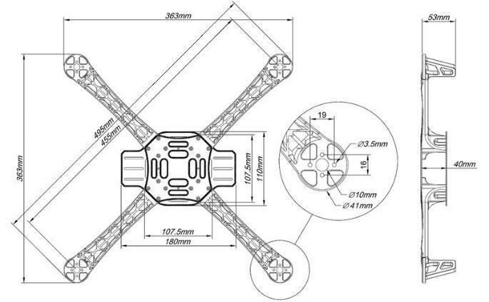

Figure 1: Frame design for drone system.

**2.4.2 Brushless DC Motor**

A brushless DC (BLDC) motor, is a synchronous motor that utilizes an electronic controller to switch DC currents to the motor windings, generating magnetic fields that rotate in space and cause the rotor to follow [29][30]. BLDC motors are renowned for their high efficiency, excellent controllability and power-saving advantages, making them an ideal choice for various applications. The BLDC motor operates through electronic commutation, eliminating the need for brushes. It consists of a rotor with permanent magnets and a stator with windings. The stator windings are energized in a specific sequence by an electronic controller, creating a rotating magnetic field that interacts with the rotor magnets and causes the rotor to spin. The controller synchronizes the energizing sequence using feedback from sensors or non-sensor techniques, ensuring smooth and efficient operation. Due to their efficiency and reliability, BLDC motors were selected for this project.

**2.4.3 Electronic Speed Controller (ESC)**

An Electronic Speed Controller (ESC), is a crucial drone component that regulates motor speed by translating flight controller signals into precise electrical pulses [31]. It ensures smooth acceleration, deceleration, and consistent motor operation, managing power delivery from the battery to the motors for efficient propulsion and stable flight. The ESC works by receiving control signals and adjusting power delivery to the motor. It converts DC power [32] from the battery into variable AC voltage for brushless motors, controlling speed by altering the duty cycle. Advanced ESCs feature thermal protection, feedback, active braking, and heat management for enhanced performance. Multiple ESCs are used in quadcopters, one for each motor, to ensure synchronized operation and responsiveness.

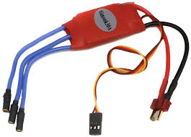

Figure 2: Electronic speed controller.

**2.4.4 GPS Module**

A GPS module, is a vital drone component that provides precise location and navigation data, enabling autonomous flight and waypoint navigation [33]. It communicates with satellites to determine the drone's real-time position, altitude, and speed, integrating with the flight controller for path planning and geofencing. The GPS module works by receiving signals from multiple satellites, calculating distances using time delays, and triangulating its precise position using at least four satellites. Advanced GPS modules feature enhanced signal processing and compatibility with multiple satellite systems, improving positioning precision and operational efficiency. This enables accurate and reliable performance in applications like mapping, surveying, and delivery.

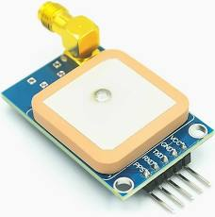

Figure 3:. GPS module.

**2.4.5 RC Controller and Radio Module**

The RC controller and radio module, facilitate drone operation, providing a communication link between the pilot and the drone. The RC controller sends command for movement, altitude adjustment, and other functions through joysticks and switches, which are transmitted via the radio module to the drone's onboard receiver. The radio module ensures a stable and responsive connection, even over long distances, allowing for precise control. Modern systems feature multiple channels, telemetry feedback, and secure communication protocols, enhancing reliability and user control. This setup provides real-time control for drones and other remote devices, enabling precise and responsive operation.

**2.4.6 Wireless Communication Module**

The ESP8266 module, is a low-cost, Wi-Fi-enabled microcontroller that enables seamless wireless communication [34] between drones and external devices, such as smartphones or cloud platforms. It facilitates real-time data transmission, remote monitoring, and control, making it ideal for IoT applications in drones. With its low power consumption, built-in TCP/IP stack, and compatibility with various sensors, the ESP8266 enhances drone connectivity and enables advanced functionalities like real-time telemetry and automation. Its versatility and affordability make it a popular choice for drone application.

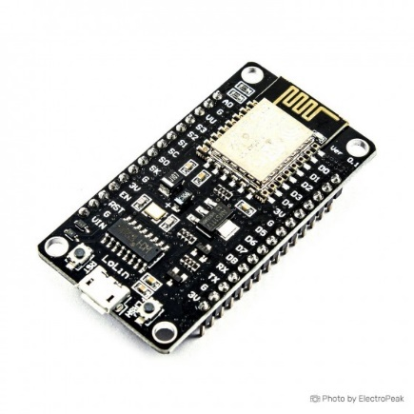

Figure 4: ESP8266 communication module.

**2.4.7 Gas Sensors**

MQ-7 and MQ-135 gas sensors are versatile and cost-effective devices that detect various gases, including methane, carbon monoxide, ammonia and hydrogen, by measuring changes in conductivity when exposed to target gases. They are widely used in drones for air quality monitoring and environmental assessment, providing real-time data on pollutant concentrations. MQ sensors are ideal for drone integration due to their lightweight design, high sensitivity, and compatibility with microcontrollers. Applications include industrial emission tracking, hazardous gas detection, and agricultural monitoring, making them suitable for environmental and safety applications.

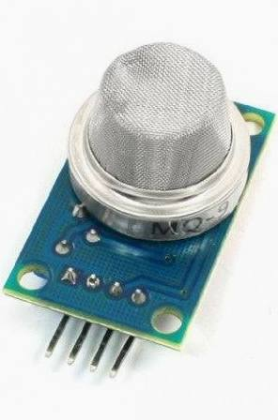

Figure 5: Gas sensor.

**2.4.8 Software and IOT Cloud System**

Ardupilot mission planner is an open-source ground control software for planning, monitoring, and analyzing drone missions. It enables users to create detailed flight paths, configure drone settings, and view real-time telemetry data. Advanced features like autonomous flight, data logging, and fail-safe mechanisms enhance mission reliability, making it a valuable technique for both hobbyists and professionals in aerial mapping, agricultural surveying, and environmental monitoring. Arduino is an open-source microcontroller. It was employed in this study for the development and controlling drone system. Its simplicity and flexibility allow users program and integrate sensors, motors, and communication modules. Arduino's extensive library support and compatibility with components like GPS modules and ESC makes it ideal for prototyping and developing customized drone solutions.

**2.5 Methodology**

The system block diagram illustrates the interconnected subsystems enabling its operation and functionality. Key components include flight controller (manages stability and navigation), power system (battery, ESCs, and voltage regulators), sensors (gyroscopes, accelerometers and GPS), propulsion system (motors and propellers) and communication module for real-time data transmission. These components work together to ensure efficient propulsion, stable flight and reliable communication, as depicted in Figure 6.

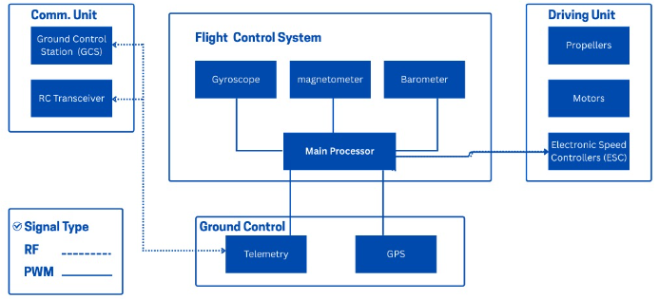

Figure 6: Block diagram of drone system

The system consists of gas sensors for detection, microcontroller (ESP8288, processes and calibrates data), power supply (LiPo battery and voltage regulators), communication module (ESP8266 Wi-Fi) transmits data to cloud platform and visualization interface (dashboard) and mobile app, displays real-time pollutant data. These components work together to detect pollutants, process data, and enable remote monitoring and decision-making. The block diagram of gas sensor and communication system is presented in Figure 7.

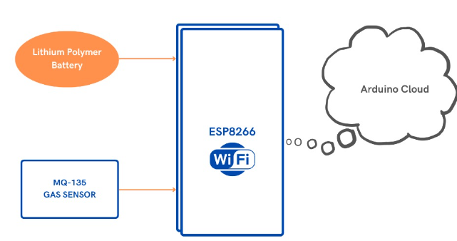

Figure 7: Block diagram of gas sensor and communication system.

The system integrates hardware and software components to function and detect, measure, and transmit air quality data in real-time. Key components include microcontroller (ESP8266), gas sensors (MQ-series), GPS module (tracks location), Wi-Fi module (wireless communication), power supply (7.4V Li-ion battery) and cloud platform (stores and visualizes data). The system is programmed using Arduino IDE, and sensor readings are transmitted to the cloud in JSON format. Data is displayed on a dashboard, showing pollutant levels and locations on a map. Sensor calibration was done using reference environments and equations to calculate pollutant concentrations. The microcontroller programming, data transmission and visualization use Arduino IDE to read sensor data, append GPS coordinates, transmit data via ESP8266 module to the cloud in JSON format using HTTP POST requests, and visualized on a dashboard. Figure 8, shows the gas monitoring sensor integration process.

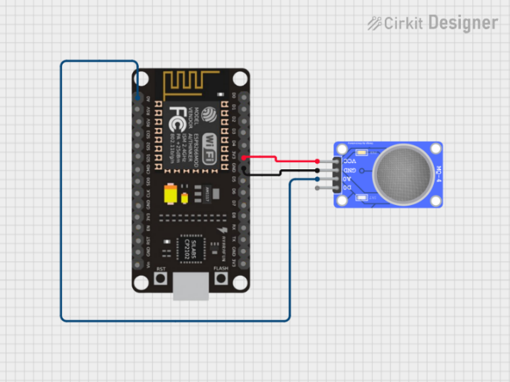

Figure 8: Gas monitoring sensor system.

From the above presentation, in this study, the sensor resistance (Rs) is calculated;

Rs (Ω) = [(Vs / Vout) – 1] × RL (1)

Where; Vs = supply voltage, Vout = sensor output voltage, and RL = load resistance.

The Drone rotational dynamics representation is given by [35][36];

$$Rxyz=⟦\begin{matrix}C_{∅}C_{θ} & C_{∅}C_{θ}C_{φ}-S_{∅}S_{φ} & C_{∅}S_{θ}C_{φ}-S_{∅}S_{φ} \\ C_{∅}S_{θ} & S_{∅}S_{θ}S_{φ}+C_{∅}C_{φ} & S_{∅}S_{θ}C_{φ}-C_{∅}S_{φ} \\ -S_{θ} & C_{∅}S_{φ} & C_{∅}C_{φ}\end{matrix}⟧ (2)$$

Where; R = matrix transformation, Sᶿ = Sin (θ); Sɸ = Sin (ɸ); and S ψ = Sin (ψ). Cᶿ = Cos (θ); Sɸ = Cos (ɸ); and S ψ = Cos (ψ). Applying the force and moment balance laws, the quadcopter motion equation [35][36];

$x=U_{1}\left(\cos{∅}\sin{θ}\cos{φ}+\sin{∅}\sin{φ}\right)-K1\dot{\frac{x}{m}} (3)$

$y=U_{1}\left(\sin{∅}\sin{θ}\cos{φ}-\cos{φ}\sin{θ}\right)-K2\dot{y/m}$ (4)

$$z=\left(\cos{∅}\cos{φ}\right)-g.\frac{K3}{m} (5)$$

Where, *K1* = drag coefficient (Assuming zero since drag is negligible at low speed).

3. results and discussion

This section discusses the procedure involved in the data capturing process. The sensors were calibrated to ensure accurate readings by exposing sensors to known gas concentrations and adjusting sensitivity. In this case, the process guaranteed reliable data collection during flight operation by the drone. Initial test flights assessed the drone's stability, communication module performance, and data transmission capabilities while performing pollution monitoring operation. Data collected during test flights was compared with traditional air quality monitoring stations to evaluate accuracy. Discrepancies were addressed through fine-tuning and software adjustments, ensuring reliable data processing and transmission. The gas pollution trend is revealed in Table 1. The mobility of the system is presented in Table 2 and the system power consumption analysis is presented in Table 3.Results for the air quality monitoring system is tabulated in Table 1. The MQ-135 and MQ-7 sensors were calibrated and tested for air quality monitoring, achieving MQ-7: 97.14% accuracy for CO detection in urban settings, and MQ-135: 98% accuracy for overall air quality in both industrial and rural areas respectively. Table 1, presents gas sensor readings.

Table 1. Sensor readings compared with reference values

|  |  |  |  |
| --- | --- | --- | --- |
| Test Location | Urban Area | Industrial Area | Rural Area |
| Pollutant | CO | CO | CO |
| Reference Value (PPM) | 10.50 | 30.00 | 15.00 |
| Sensor Reading (PPM) | 10.20 | 29.50 | 14.80 |
| Accuracy | 97.14 | 98.33 | 98.67 |

**3.1 Mobility and Coverage**

The drone’s ability to cover diverse terrains was tested by measuring pollutant levels over a 2km radius in an industrial area. The results in Table 2 demonstrate system’s capability to sustain communication link and provide data over a wide range, with minimal signal loss during flight operation. In this scenario, achievable results from the three investigated arears are presented. Given the fact that, air pollution in industrial zones are always of higher impact compared to the residential and rural arears. From Table 2, also, the rural area result shows moderately higher air pollution data. This is obvious as the studied communities are faced with air pollution challenges from the oil and gas production companies in this location. The residential arrears results are least affected from this finding.

Table 2: Mobility and coverage testing

|  |  |  |  |
| --- | --- | --- | --- |
| Test Area | Industrial Zone | Residential Area | Rural Area |
| Distance covered (m) | 2000.00 | 1800.00 | 2500.00 |
| Signal loss (%) | 5.00 | 2.00 | 3.00 |
| Average pollutant level (PPM) | 25.80 | 8.60 | 12.30 |

**3.2 Power Consumption Analysis**

The power consumption of the drone-based system was analyzed to determine operational efficiency. The results are presented in Table 3. The drone achieved an average flight time of 1500s per full battery charged.

Table 3: Power consumption Analysis

|  |  |  |
| --- | --- | --- |
| Component | Power Consumption  (W) | Duration (s) |
| Sensors | 2.5 | 1500 |
| Micro-controller | 1.8 | 1500 |
| Communication | 1.2 | 1500 |
| **Total** | 5.5 | 1500 |

Table 3, also present significant information concerning the measured parameters and their results during this investigation. Three different measured components; senor, micro-controller and communication parameters were employed in the study. The power consumption and duration of these components were also measured. It shows that the total power consumption for the test period of 1500s (second) is 5.5W (wat). This points to the fact that more research should be directed to improve duration time for similar operation.

**3.3 Discussions**

In this study, from the conceptual design, testing and application of drone-based gas pollution monitoring system, air pollution activities and its impacts generally could be assessed. The achievable results in this case demonstrate consistent outcomes as air pollution within the Niger Delta region has severe impact to man and its environs (eco-system) concerns, generally. The drone-based gas pollution monitoring system demonstrated exceptional performance in pursuit of this study. The drone has mobility advantage and capable of collecting gas pollution data over diverse terrains, covering distances up to 2.5km, which could have been difficult to achieve using the conventional approach of handheld gas detection system. The sensor measurements accuracy exceeded 95% reliability due to meticulous calibration of MQ-135 and MQ-7 sensors. The measurements captured by the sensors were effectively transmitted to the cloud with average transmission time of 1.2 seconds and success rate above 90% using ESP8266 wireless communication module. The sensor readings were interfaced for stakeholders to monitor and analyze air quality data, enabling identification of trends and pollution sources. However, some limitations encountered include minor discrepancies in extreme environmental conditions, restricted flight duration of approximately 1500s (seconds) per fully charged battery and dependency on Wi-Fi communication system with restricted distance. Plate 1, presents some pictures captured during the system calibration, integration and flight field test.

Plate 1: System Integration and field test.

|  |  |
| --- | --- |
| Plate 1 (a) System integration and calibration | Plate 1(b): System field test |
| Plate 1 (c): Field test and data capturing process | Plate 1 (d): System approach (landing). |

4. Conclusion

This project successfully developed a prototype drone-based gas pollution monitoring system integrated with IoT technology, providing real-time, accurate air quality data. Key achievements include high accuracy in pollutant detection, efficient data transmission and reliable performance, mobility to monitor remote or hard-to-reach areas, and geo-tagged air quality data for precise identification of pollution hotspots. Despite limitations such as dependency on Wi-Fi connectivity and restricted flight time, the system demonstrates the potential of combining drone and IoT for effective environmental monitoring. Future enhancement includes consideration of alternative communication technologies and advanced batteries or renewable energy sources. The project offers a scalable and efficient alternative to conventional methods, with potential applications in disaster response, urban planning and industrial compliance, contributing to global efforts to combat gas pollution and protect public health.

Definitions, Acronyms, Abbreviations

CO: Carbon monoxide

CO2: Carbon dioxide

ESP8266: Wi-Fi module for wireless communication

GPS: Global Positioning System

HTTP: Hypertext Transfer Protocol (data transmission format)

IoTs: Internet of Things

JSON: JavaScript Object Notation (data forma

RL: Load resistance

Rs: Sensor resistance

Rxyz: Rotation matrix (for drone dynamics)

Vout: Sensor output voltage

Vs: Supply voltage

reference

1. World Health Organization (2024). Air Pollution, WHO. <https://www.who.int/health-topics/air-pollution#tab=tab_1>
2. Rui Zhou, Tianjun Li, Keyi Tian, Lei Huang (2025). Exploration the effect of air pollution on the incidence of myasthenia gravis: An empirical study from Chengdu. Atmospheric Pollution Research, ScienceDirect, 16 (5). <https://doi.org/10.1016/j.apr.2025.102477>
3. Qiong Duan, Cheng Zhou, Haifeng Chen, Jie Zhang, Zhaohui Ruan, Hongfei Cao, Zixing Zhang, Xihai Xu, Xinyu Fang (2025). Long-term exposure to ambient air pollution and incident nephritis: A prospective cohort study in the UK Biobank. Atmospheric Pollution Research, ScienceDirect, 16 (7). <https://doi.org/10.1016/j.apr.2025.102524>
4. Department of Climate Change, Energy, the Environment and Water (DCCEEW), Australian Government (2024). Air Pollutants. <https://www.dcceew.gov.au/environment/protection/air-quality/air-pollutants>
5. F. I., Abam, B. B Okon, I. F Edem, M. C Ndukwu, E. B Ekpo, O. E. Diemuodeke, (2023). Environmental assessment and CO2 emissions of Brayton cycle configurations based on exergo-sustainability, economic and ecological efficiency using multi-criteria optimization technique. Future Technology, 3(1) pp. 1-12. DOI: 10.55670/fpll.futech.3.1.1
6. Abam, F.I., Okon, B.B., Ekwe, E. B., Isaac, J., Effiom, S. O., Ndukwu, M. C., Inah, O.I., Ubi, P.A., Oyedepo, S. and Ohunakin, O. S. (2022). Thermoeconomic and exergoenvironmental sustainability of a powercooling organic Rankine cycle with ejector system. E-Prime Advances in Electrical Engineering, Electronics and Energy, 2, 100064. pp. 1-16. <https://doi.org/10.1016/j.prime.2022.100064>
7. Okon, B. B, Okon, V. E. and Udom, E.J., (2020). Water Infrastructure Maintainability-issues and challenges in the costal regions of Akwa Ibom State, Nigerian Journal of Technology, 39(3), 953-961. [http://dx.doi.org/10.4314/njt.v38i4.16](https://dx.doi.org/10.4314/njt.v38i4.1)
8. Okon, B, Ekpo, S and Elhag, T. (2010). A Sustainable Engineering Infrastructure Model for the 21st Century. World Congress on Engineering (WCE). Volume II, London, United Kingdom.
9. Okon, B. B. and Okon, V. E. (2018). Building Services Equipment and Effective Maintenance Culture: The Experts’ Standpoint. Journal of Mechanics Engineering and Automation, Volume 8, pp. 35-24.
10. Esara, E. E. and Okon, B. B. (2016). Evaluation of Solid Waste towards Sustainable Facilities Management. World Journal of Environmental Engineering, 4, 1, 19-22.
11. Ekanem K, Ubom E and Ukommi U. (2022). Analysis of Rain Attenuation for Satellite Communication in Akwa Ibom State, Nigeria. The Nigerian Institute of Electrical and Electronic Engineering (NIEEE) Proceedings of the International Conference and Exhibition on Power and telecommunication (ICEPT 2022), 23-24.
12. Essien, A., Ukommi, U., & Ubom, E. (2024). Downlink Power Budget and Bit Error Analysis for LoRa-Based Sensor Node-to-Satellite Link in the Industrial, Scientific and Medical Frequency Bands. Signals and Communication Technology. Springer Nature, Switzerland. 143-152. <https://link.springer.com/chapter/10.1007/978-3-031-53935-0_14>
13. Ukommi, U, Ekanem, K, Ubom, E & Udofia, K, “Evaluation of Rainfall Rates and Rain-Induced Signal Attenuation for Satellite Communication in the South-South region of Nigeria’’. Nigerian Journal of Technology (NIJOTECH), Volume 42, Issue 4, 2023.
14. Zhang, Z., & Zhu, L. (2023). A Review on Unmanned Aerial Vehicle Remote Sensing: Platforms, Sensors, Data Processing Methods, and Applications. Drones, 7(6), 398. <https://doi.org/10.3390/drones7060398>
15. Uko, M, Ekpo, S., Ukommi, U., Iwok, U, and Alabi, S. (2025). Energy and Spectral Efficiency Analysis for UAV-to-UAV Communication in Dynamic Networks for Smart Cities. MDPI, Smart Cities, 8 (2), 1-27. <https://doi.org/10.3390/smartcities8020054>
16. E. C. Joseph, O. C. Onyebuchi, and O. R. Obinna (2022). A drone based crop monitoring system in precision agriculture using RF remote control. International Journal of Advances in Computer and Electronics Engineering,7(1), pp. 1–8.
17. U. Ukommi, Emmanuel Ubom and Idaraesit Abraham, “Outdoor 2.4 GHz Band Wifi Networks Performance Characterization”, International Journal of Engineering Research and Technology, Volume 9, Issue 8, August 2020.
18. Oduoye Israel Olufemi, Ubong Ukommi and Emmanuel Ubom (2023). Comparative Analysis of Transceiver Payload Size Impact on The Performance of LoRaBased Sensor Node Science and Technology Publishing (SCI & TECH), 7 (8), pp. 1559-1563.
19. Ukommi, U and Ubom, E (2023). Impact Assessment of Elevation Angles on Signal Propagation at VHF and UHF Frequencies for Improved Rural Telephony. ABUAD Journal of Engineering Research and Development (AJERD), 6(2), 136-142. <https://doi.org/10.53982/ajerd.2023.0602.13-j>
20. Mohammad Shahab-Deljoo, Bijan Medi, Monzure-Khoda Kazi and Mostafa Jafari (2023). A techno-economic review of gas flaring in Iran and its human and environmental impacts, Process Safety and Environmental Protection, Elsevier, 173, pp. 642-665. <https://doi.org/10.1016/j.psep.2023.03.051>
21. Y. Cao (2023). Design and Implementation of an Intelligent Machine Learning System Based on Artificial Intelligence Computing. 2nd International Conference on Data Analytics, Computing and Artificial Intelligence (ICDACAI), Zakopane, Poland, pp. 707-711, <https://ieeexplore.ieee.org/document/10361138>
22. O. Onwunah, R. Udoh and U. Ukommi (2022). Modelling of the Energy Level and Outage Analysis for Battery-powered IoT Sensor Node with Soar Energy Harvester. International Multilingual Journal of Science and Technology (IMJST), 7(10), pp. 5654-5668.
23. Olufemi, O.I. and Ukommi, U. (2024). Evaluation of Energy Consumption and Battery Life Span for LoRa IoT Multisensor Node for Precision Farming Application. Signals and Communication Technology. Springer Nature, Switzerland. 153-162. <https://link.springer.com/chapter/10.1007/978-3-031-53935-0_15>
24. Kruse, F. A., Kim, A., Runyon, S. C., Esterline, C. H., & other authors. (2014). Multispectral, hyperspectral, and LiDAR remote sensing and geographic information fusion for improved earthquake response. In Proceedings of SPIE - The International Society for Optical Engineering. <https://doi.org/10.1117/12.2049725>
25. M. C. Uko, S. C. Ekpo, U. Ukommi and R. Kharel (2015). Shadowing effect on Macro-Femto heterogeneous network for cell-edge users. 31st International Review of Progress in Applied Computational Electromagnetics (ACES), Williamsburg, USA, pp. 1-2.
26. Ogungbemi Emmanuel Oluropo, Ubong Ukomi and Regina Aniebiet Udoh (2022). Comparative coverage and horizon plane analysis for LEO, MEO, and GEO and HEO Satellites. Journal of Multidisciplinary Engineering Science and Research (JMESR), 1(2), pp. 54-56.
27. Sairul Safie and Raudhah Khairil (2025). Regulatory, technical, and safety considerations for UAV-based inspection in chemical process plants: A systematic review of current practice and future directions. Transportation Research Interdisciplinary Perspectives, Elsevier, Volume 30 (101343), <https://doi.org/10.1016/j.trip.2025.101343>
28. H. Nandwana, V. Kashyap, A. Chechani, P. Saraswat and A. Vijayvargiya (2021). Design analysis of payload carrying quadcopter using finite element analysis. Smart Technologies, Communication and Robotics (STCR), pp. 1-5, **DOI:**[10.1109/STCR51658.2021.9588990](https://doi.org/10.1109/STCR51658.2021.9588990)
29. J. A. Prakosa, D. V. Samokhvalov, G. R. V. Ponce and F. Sh. Al-Mahturi (2019). Speed Control of Brushless DC Motor for Quad Copter Drone Ground Test. IEEE Conference of Russian Young Researchers in Electrical and Electronic Engineering (EIConRus), Russia, 2019, pp. 644-648, **DOI:**[10.1109/EIConRus.2019.8656647](https://doi.org/10.1109/EIConRus.2019.8656647)
30. C. A. Ekim, I. O. Akwukwaegbu, A. Ubom, U. S. Ukommi, C. O. Jude-kennedy and C. K. Joe-Uzuegbu (2024). Design and Modelling of a Proportional Derivative Controller for a three-Phase Induction Motor Speed. Nigerian Journal of Technology (NIJOTECH), Vol. 43(2), pp. 338-344.
31. B. A. Malyshev, P. A. Troshin, S. Y. Zanegin and D. M. Shishov (2024). Research of Electronic Speed Controllers Designs and Functional for Unmanned Aerial Vehicles. IEEE 25th International Conference of Young Professionals in Electron Devices and Materials (EDM), Altai, Russian Federation, pp. 1150-1155, **DOI:**[10.1109/EDM61683.2024.10615216](https://doi.org/10.1109/EDM61683.2024.10615216)
32. Festus, U., Ukommi, U. and Ubom, E. (2023) Real-Time Control of Solar PV System by Adaptive Extremum Seeking Technique. International Multilingual Journal of Science and Technology (IMJST), vol. 8, no. 12, pp. 6903-6911.
33. H. Kang, K. -B. Bae, M. -H. Jung and S. -O. Park (2020). Measurement and Analysis of Radiation Leakage From a GPS Module for the Detection of Drones. IEEE Antennas and Wireless Propagation Letters, 19(9), pp. 1610-1614. **DOI:**[10.1109/LAWP.2020.3011851](https://doi.org/10.1109/LAWP.2020.3011851)
34. U. Ukommi, K. Kodikara Arachchi, Safak Dogan and A.M. Kondoz (2013). Content-Aware Bitrates Adaptation for Robust Mobile Video Services. IEEE International Symposium on Broadband Multimedia Systems and Broadcasting (BMSB), United Kingdom, 1-4. **DOI:**[10.1109/BMSB.2013.6621696](https://doi.org/10.1109/BMSB.2013.6621696)
35. Kaito Isogai, Ryo Inohara, Hideo Nakano and Hideaki Okazaki (2016). Modeling and Simulation of Motion of a Quadcopter. 2016 International Symposium on Nonlinear Theory and Its Applications. NOLTA2016, Yugawara, Japan, pp. 1-8.
36. M. A. Alsharif and M. S. Holzel (2016). Estimation of a drone's rotational dynamics with piloted Android flight data. IEEE 55th Conference on Decision and Control (CDC), Las Vegas, NV, USA, pp. 1199-1204. **DOI:**[10.1109/CDC.2016.7798429](https://doi.org/10.1109/CDC.2016.7798429)