Original Research Article

Energy and Carbon Performance Analysis in a Mixed Commercial-Office Building in Shenzhen Using EnergyPlus and LSTM

ABSTRACT

Energy conservation and carbon emission reduction in building have become key areas of research and practical application in China with the advancement of carbon neutrality. An energy consumption model was developed in this study based on a typical mixed-use commercial-office building in Shenzhen. EnergyPlus and Long Short-Term Memory (LSTM) neural network were introduced to optimize the simulated energy consumption. Model validation yielded high accuracy, with R² exceeding 0.96 for both total building energy consumption and HVAC energy consumption, and RMSE below 0.25. The characteristic bimodal fluctuation in annual energy use was observed with the maximum monthly variation reaching 741 MWh. Ambient temperature and customer traffic were identified as the primary external driving factors, both exhibiting a significant positive correlation with energy consumption. Based on the developed building energy model, a comprehensive carbon flow framework was constructed, which clearly illustrating the emission pathways and distribution across various internal systems and functional zones. Based on the constructed energy consumption model, a photovoltaic system was simulated, resulting in an annual energy reduction of 145 MWh and a carbon emissions reduction of 1487.1 tCO₂.

Keywords: Building Energy Consumption; Carbon Emission; EnergyPlus Simulation; LSTM Neural Network

INTRODUCTION

With the guidance of "carbon peaking" and "carbon neutrality" strategies, as a major contributor to energy consumption and carbon emissions, the building industry is receiving increasing transformation pressures^{[1]}. Carbon emission from both the building operation phase and the production of building materials have remained consistently increase, forming a distinct "dual-high" structural pattern^{[2, 3]}. This growth trend not only amplifies the complexity of achieving decarbonization but also raises significant barriers to the development of viable low-carbon transition pathways.
As typical high-energy-consuming structures in urban environments, commercial buildings exhibit significantly higher overall energy consumption levels compared to other building types. Among these system, HVAC typically represents the most energy-intensive component, contributing 40%-60% of total energy consumption^{[3]}. The frequent operation of lighting, elevators, and other equipment further elevates energy consumption intensity^{[4]}.
At present, building energy consumption modeling is primarily approached through two main technical methodologies. The first involves physics-based simulation methods, such as EnergyPlus, TRNSYS, and DeST, which accurately represent dynamic interactions among building structures, system equipment, thermal environments, and occupant behavior^{[5, 6]}. Yik proposed a simulation method using a database of cooling load curves for various building types, providing a pathway for complex energy demand forecasting ^{[7]}; Wang employed a lumped-parameter thermal network model to characterize thermal loads; while Pan calibrated and validated a building energy analysis approach for a high-rise commercial building^{[8]}.Despite strong predictive accuracy, these methods are often limited by narrow modeling scopes and high calibration costs, which restrict their generalizability across diverse building types^{[9, 10]}.
The second approach is data-driven prediction, which has gained increasing attention due to its effectiveness in capturing nonlinear and time-dependent patterns, especially with the rapid development of big data and artificial intelligence^{[11]}. Among these, the Long Short-Term Memory (LSTM) neural network has demonstrated strong accuracy across long-term temporal dependencies with incorporate external variables such as weather conditions, and occupant density^{[12]}. Chen introduced AI-based methods that incorporates crowd density as a dynamic factor into building energy and carbon assessments^{[13]}; Yildiz applied LSTM to achieve high-precision energy forecasting for office building power usage with a mean absolute error below 5%^{[14]}; Cheng integrated LSTM with Convolutional Neural Networks (CNNs) to simulate continuous load profiles dynamically in complex commercial buildings^{[15]}. However, most current studies focus on isolated building characteristics or generalized climate conditions, without fully capturing the dynamic energy-carbon interactions among subsystems at different hierarchical levels.
To address this gap, this study selects a mixed-use commercial-office building in Shenzhen as a case study. The building features diverse operational demands, with the shopping mall zone characterized by high cooling loads due to heavy customer traffic, and the office area exhibits clear diurnal variations. Based on the model framework combining EnergyPlus with LSTM time-series, an integrated data-driven approach was proposed to capture the dynamic performance on energy consumption and carbon emissions. Therefore, analyzing energy-carbon dynamics and supporting strategic decision-making in green building retrofits.

METHODOLOGY

2.1 Building overview
This building located in Shenzhen, Guangdong Province, occupies a site area of 6212 m² with a total gross floor area of 86577 m². The building comprises 24 stories and reaches a height of 67 meters, adopting a reinforced concrete frame structure with a shape coefficient of 0.099. Its spatial layout is functionally diverse: B2 to B4 are used for underground parking; B1 accommodates a large supermarket; Floors 1 to 6 consist of retail shops and public activity spaces; Floors 7 to 9 are allocated for conference rooms, dining, and entertainment; and Floors 10 to 20 are designated as office.

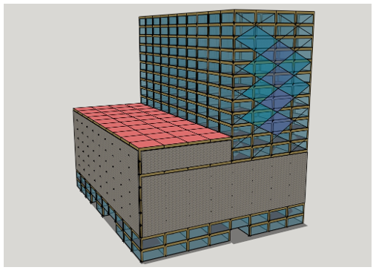

Figure 1. Building SketchUp model

Due to its complex mix of building functions, the customized HVAC systems were employed for different zones. Only fresh air is supplied for B4 to B2; all-air systems are installed from B1 to 6F to accommodate high ceilings and dense foot traffic in public areas; ceiling-mounted cabinet units with fresh air systems are used on Floors 7 to 9 to address the fluctuating demands of meetings and leisure activities; and from the 10th floor upward, as well as in auxiliary spaces with lower precision requirements for temperature and humidity control, fan coil units with independent fresh air systems (FCU + Fresh Air) offer flexible and energy-efficient climate regulation. Given subtropical climate in Shenzhen, the building operates a year-round cooling system to manage persistent thermal loads. During transitional seasons, only fresh air ventilation is used. The configuration details of the HVAC system are presented in Table 1.
Table1 HVAC system equipment configuration of the building
Device Designation | Technical Specification | Quantity
HVAC Unit | YORK-YSRZFZS55CNER | 2
Vertical Air Handling Unit | TAD210D H3RR4 | 11
Glycol Hydronic Pump | 1610-8E | 3
Chilled Water Pump | 1LE0002-2BB23-3AB4-Z | 3
Condenser Water Pump | 1LE0002-2BB23-3AB4-Z | 3
Crossflow Cooling Tower | HMK-800L | 2
HVAC Makeup Pump | YE2-160-M1-2 | 2
To ensure the scientific and representativeness of the energy consumption model, the thermal performance parameters of the building envelope and the operational settings were determined based on the 《Design Standard for Energy Efficiency of Public Buildings》(DGJ08-107-2015), as well as actual building project data. This allowed for the specification of design parameters for key rooms and the assignment of corresponding internal heat gains. The thermal performance parameters are detailed in Table 2.
Table 2. Thermal performance parameters of the baseline building
Thermal Boundary Element (TBE) | Thermal Transmittance K/[W/(m²·K)]
Roof Assembly | ≤0.60(Thermal Inertia D＞2.50)
Exterior Wall System (Including Opaque Curtain Wall) | ≤0.75(Thermal Inertia D＞2.50)
Glazed Curtain Wall | ≤ 1.80(SHGC ≤ 0.30; Visible Light Transmittance ≥ 0.40)
Fenestration System | 2.0(SHGC 0.35)
Meteorological data were drawn from a typical meteorological year dataset for Shenzhen, which was used to define the building's external climate boundary conditions. The building’s operational parameters—including per capita floor area, lighting power density, equipment power density, outdoor air ventilation rate per person, and daily operating hours of the HVAC and heating systems—were determined based on relevant building standards and actual project conditions. The dataset based on the annual energy consumption data in 2024 and includes the following:
(1) Energy data: hourly electricity consumption of the entire building and its subsystems (HVAC, lighting, elevators, etc.);
(2) Customer occupancy data: daily customer flow in commercial zones and office access records;
(3) Operational data: control settings, schedules, and automation parameters from the building management system (BMS).
All datasets were preprocessed through missing value imputation, outlier removal, and normalization before model training, the specific values are provided in Table 3.
Table 3. Operational parameters of the baseline building
Parameter Classification | Parameter Specification
Occupant Density | Shopping mall-10 m²/person  Office area-5 m²/person
Installed Lighting Load | 15 W/m²
Equipment Operating Load Density | Shopping mall-45 W/m²  Office area-30 W/m²
Minimum Fresh Air Volume | Shopping mall-18 m³/(h·person)  underground parking - 15 m³/(h·person)  Office area-24 m³/(h·person)
HVAC Daily Operation Period | 8:00~22:00

2.2 Building energy prediction model

2.2.1 Model framework
During the analysis of energy consumption data across various functional zones of the building, strong periodicity and clear temporal dependencies was observed. A hybrid modeling approach was developed that combines simulation-based and data-driven to account for the sequential characteristics of the data. EnergyPlus was employed to simulate baseline hourly energy consumption under standard operating conditions, providing high-resolution synthetic data for different zones, equipment types, and occupancy scenarios.
The Long Short-Term Memory (LSTM) network was introduced to optimize the energy consumption data, which is highly effective for time-series data processing^{[16]}. And the temporal attention mechanism was incorporated to probabilistically assign attention weights to different time steps in the historical sequence. By integrating physics-based simulation (EnergyPlus) with the attention-enhanced LSTM model, which combines deterministic and data-driven methods, resulting in more robust and adaptive predictions of energy use across different functional zones.
The LSTM network includes:
(1) Input layer: input features include energy consumption, temperature, humidity, passenger flow, etc. at several moments in the past;
(2) Double-layer LSTM hidden layer: each layer contains 64 units, and the activation function is tanh;
(3) Dropout layer (dropout rate is 0.2) to prevent overfitting;
(4) Output layer: a single neuron outputs the predicted energy consumption value for the next moment or the next day.
In this model: X_{T} (T ∈ [1，n]) represents the input sequence to the LSTM network; h_{T} (T ∈[1，n]) denotes the hidden layer outputs of the LSTM; α'_{T} (T ∈[1，n]) are the attention weights assigned to each time step by the is the final output of the LSTM network integrated with the temporal attention mechanism. The attention weight matrix α' and the feature vector representation v in the temporal attention mechanism are calculated as follows:
$$\begin{aligned}{\text{e}}_{\text{T}}^{\text{'}}\text{=}{\text{u}}_{\text{s}}\text{tanh}\left({\text{w}}_{\text{s}}{\text{h}}_{\text{T}}\text{+}{\text{b}}_{\text{s}}\right)\#(1)\end{aligned} \\ \begin{aligned}{\text{a}}_{\text{T}}^{\text{'}}\text{=}\frac{\text{exp}\left({\text{e}}_{\text{T}}^{\text{'}}\right)}{\sum_{\text{n=1}}^{\text{T}}{{\text{e}}_{\text{n}}^{\text{'}}}}\#(2)\end{aligned}$$
$$\begin{aligned}\text{v=}\sum_{\text{n=1}}^{\text{T}}{{\text{a}}_{\text{T}}^{\text{'}}{\text{h}}_{\text{T}}}\#(3)\end{aligned}$$
where e'_{T} refers to the normalized weight matrix；w_{s}、b_{s} and u_{s} are randomly initialized attention mechanism weight matrix, offset and time series matrix respectively.

2.2.2 Model training and evaluation metrics
The dataset was split into training (70%), validation (15%), and testing (15%) sets. The Adam optimizer was used with the Mean Squared Error (MSE) loss function:
$$\begin{aligned}\text{MSE=}\frac{\text{1}}{\text{n}}\sum_{\text{J=1}}^{\text{n}}{\text{(}{\text{C}}_{\text{p,j}}\text{-}{\text{C}}_{\text{a,j}}{\text{)}}^{\text{2}}}\#(4)\end{aligned}$$
To evaluate the accuracy of the prediction model over a specific period, this study uses two key performance metrics: the coefficient of determination (R²) and the Root Mean Square Error (RMSE). The mathematical expressions for these evaluation metrics are as follows:
$$\begin{aligned}{\text{R}}^{\text{2}}\text{=1-}\frac{\sum_{\text{J=1}}^{\text{n}}{\text{(}{\text{C}}_{\text{p,j}}\text{-}{\text{C}}_{\text{a,j}}{\text{)}}^{\text{2}}}}{\sum_{\text{J=1}}^{\text{n}}{\text{(}{\text{C}}_{\text{p,j}}\text{-}{\text{C}}_{\text{a,j}}{\text{)}}^{\text{2}}\text{+}\sum_{\text{J=1}}^{\text{n}}{\text{(}{\text{C}}_{\text{p,j}}\text{-}{\text{C}}_{\text{a,mean}}{\text{)}}^{\text{2}}}}}\#(5)\end{aligned}$$
$$\begin{aligned}\text{RMSE=}\sqrt{\frac{\sum_{\text{J=1}}^{\text{n}}{\text{(}{\text{C}}_{\text{p,j}}\text{-}{\text{C}}_{\text{a,j}}{\text{)}}^{\text{2}}}}{\text{n}}}\#(6)\end{aligned}$$
where n is the total number of energy consumption data points, J represents the time index, C_{a,j} is the actual energy consumption at time j, Cₚ,ⱼ is the predicted value, and C_{a,mean} is the mean of the actual energy consumption values.
Following model validation, the predicted time series data were analyzed to uncover usage patterns and quantify external driving factors.

2.3 Building carbon emission
The building carbon emission system was developed based on life cycle assessment principles, enabling systematic and comprehensive quantification of carbon emissions associated with both energy consumption and energy conversion processes during the operational period^{[17]}.

2.3.1 Carbon flow structure
This study proposes a refined decomposition framework based on a hierarchical energy-carbon flow architecture, delineated along the trajectory of primary energy- secondary energy- terminal equipment- functional end-use scenarios (Fig. 3), which enables multidimensional tracing and attribution of carbon emissions within the building’s operational lifecycle. The energy system within the building is disaggregated across four progressive layers, each corresponding to a specific stage in the energy transformation and utilization chain:
(1) Primary Energy Inputs: Denoting upstream fossil-based energy carriers such as coal, natural gas, and crude oil, which serve as the origin of energy conversion processes;
(2) Secondary Energy Carriers: Including electricity and district heating, representing the intermediary forms of energy as delivered for end-use;
(3) Terminal End-Use Devices: Encompassing key consumption nodes such as HVAC units, lighting systems, elevator drives, and fluid machinery (e.g., pumps, fans), each constituting a physical site of energy-to-work conversion;
(4) Functional Use Scenarios: Categorized by operational domains (e.g., lighting, ventilation, computing, transport), structured into seven major typologies reflective of commercial-building usage patterns.
This disaggregation paradigm forms the theoretical foundation for both spatial boundary definition (device-level emission localization) and functional boundary demarcation (usage-based carbon attribution).
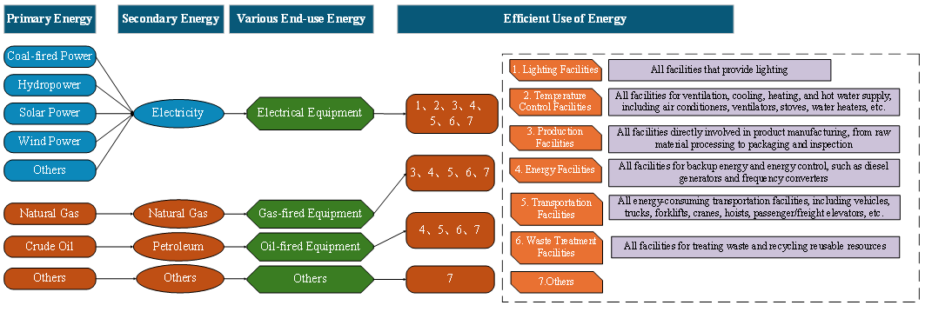
Figure 2. Carbon flow analysis framework of building

2.3.2 Carbon emissions calculation
A comprehensive carbon emissions accounting framework focused on operational energy consumption is established to systematically quantify the building’s carbon footprint. This approach assigns specific emission factors to each energy source or activity. Total carbon emissions are calculated as the sum of the products of energy consumption (or activity data) and the corresponding emission factors. The carbon accounting is performed based on the following general equation:
$$\begin{aligned}{\text{E}}_{\text{i}}\text{=}\sum_{\text{j}}{\left(\text{A}{\text{D}}_{\text{i,j}}\text{×E}{\text{F}}_{\text{i,j}}\text{×GWP}\right)}\#(7)\end{aligned}$$
where E_{i} is the emission of the i-th emission source, in tons of carbon dioxide equivalent (tCO₂e); AD_{i,j} is the activity data of class J fuel from the i-th emission source, in tons (t) or cubic meters (m) or megawatt hours (MWh), etc; EF_{i,j} is the emission factor of class J fuel from the i-th emission source, in units of tCO₂/t fuel or tCO₂/m³ fuel or tCO₂/MWh, etc; GWP-global warming potential, dimensionless, GWP adopts the latest GWP100 value of the assessment report published by IPCC.

2.4 Building energy-carbon structure
To address the complexity of carbon emissions during the operational phase of this building, a multi-stage system dynamics framework (figure4) that integrates energy consumption prediction, carbon emission modeling and data quality management was developed. The proposed methodology comprises three stages. First, a feature attention mechanism is applied to optimize input variable weights, enabling dynamic and high-accuracy time series prediction of operational energy consumption through an integrated LSTM-attention model. Second, a system-level decomposition constructs a carbon emission flow path from energy sources to end-use, with subsystem emissions quantified via the LCA method to achieve precise energy–carbon mapping. Third, a data quality governance mechanism ensures input validity and output reliability through standardized collection, validation, and feedback, supporting iterative model optimization and scalable energy–carbon assessment.
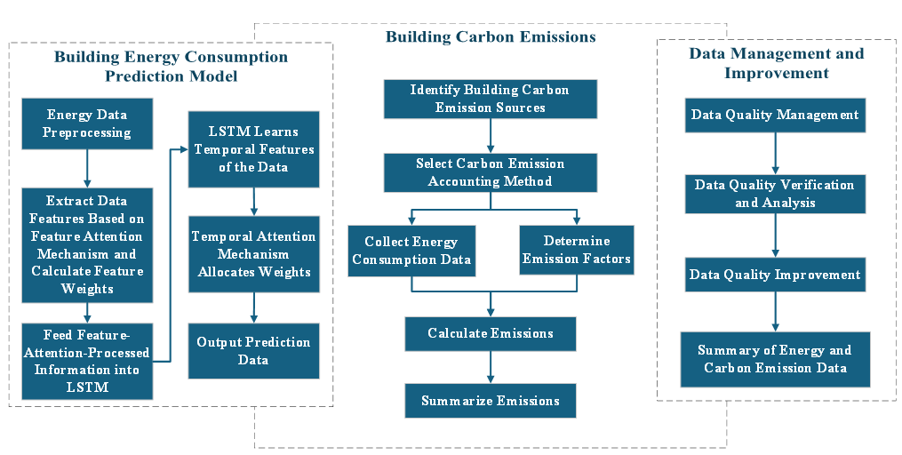
Fig. 3. System dynamics framework for building energy-carbon nexus analysis

RESULTS AND DISCUSSION

3.1 Validation of simulation results
To evaluate the accuracy and practical applicability of the developed energy consumption model, a representative operational period was selected for simulation. The model’s predicated energy consumption was compared with actual measured data for the target building, as shown in Figure 5. The analysis revealed a strong concordance between simulated and observed values. The coefficient of determination (R²) for total building energy consumption reached 0.969, while that for the HVAC system alone reached 0.986. Additionally, the RMSE was 0.22 for the total energy consumption and 0.108 for the HVAC system, indicating high fidelity at both the overall and subsystem level.
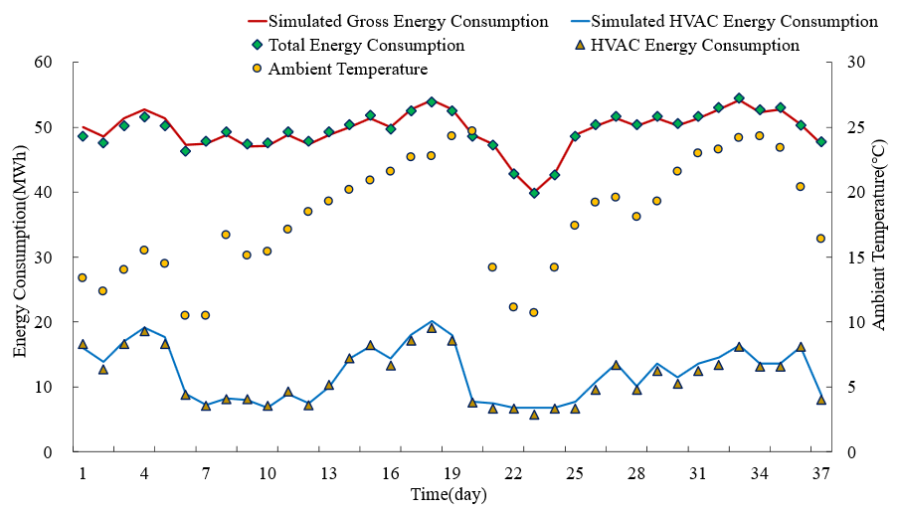
Figure 4. Comparative of simulated and observed energy data
Further analysis indicated a strong positive correlation between the energy load of HVAC system and the daily average ambient temperature. During the observation period, the maximum daily average energy consumption of the air-conditioning system reached 19062 kWh, occuring at an average ambient temperature of 22.8°C. While the minimum consumption was 5718.6 kWh, occurring at a temperature of 10.7°C. These findings underscore the temperature sensitivity of HVAC loads, affirming seasonal climatic variations as the dominant determinants of energy demand.

3.2 Analysis of Energy Consumption
The total annual electricity consumption is 21593 MWh, with the HVAC system accounting for 5645 MWh, approximately 26.1% of the total. Figure 6 illustrates a typical dual-peak energy consumption pattern during the summer and winter months of this building. The annual energy consumption curve exhibits a pronounced bimodal fluctuation, with a substantial difference of 741 MWh, reflecting seasonal variability primarily driven by HVAC operations. A significant positive correlation was observed between HVAC energy consumption and ambient temperature, with a coefficient of determination (R²) exceeding 0.92. Notably, when ambient temperature exceed 28°C, HVAC energy consumption increases at an accelerated rate, with an average growth gradient (ΔE/ΔT) of approximately 48 MWh/°C.
HVAC energy consumption displays nonlinear fluctuations during transitional seasons, attributed to the building's sensitivity to cooling load transitions and delayed response. The proportion of HVAC within total energy consumption follows a parabolic seasonal pattern, peaking at 33.6% in July and declining to 15.1% in December, indicative of a typical seasonal energy structure.
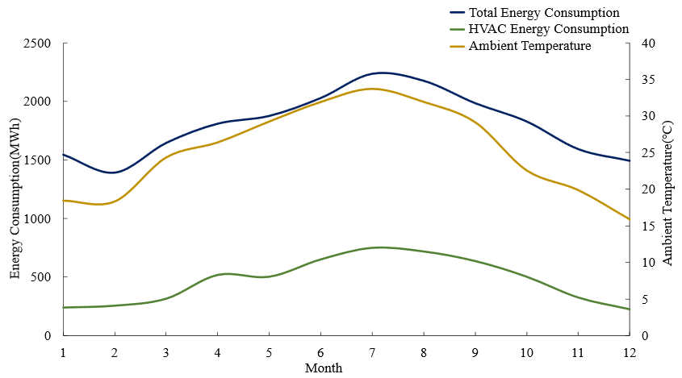
Figure 5. Annual energy consumption
From a temporal perspective, the monthly energy consumption displays a clear “rapid rise–gradual decline” inertia pattern. Between January and June, the growth rate of average month energy consumption reached 12.3%, peaking at 18.7% in June. From July to December, energy consumption decreased steadily, with an average monthly reduction of 9.4%. This trend reflects the influence of the building’s thermal inertia, with an estimated thermal time constant of approximately 22 days, indicating a significant hysteresis in the heat storage and release within the building envelope.

3.3 Carbon flow analysis
Figure 7 presents the dynamic carbon emission profile for the year 2024, systematically revealing carbon flow pathways across different spatial and system levels during the operational phase. The carbon emission profile is characterized by a strong dependence on electricity, regional concentration, and distinct system-level emission patterns. Total annual carbon emissions amounted to 21780.52 tons of CO₂ equivalent (tCO₂), of which electricity consumption accounted for 21765.07 tCO₂, or 99.91%, indicating that the carbon footprint of this type of commercial complex is almost entirely driven by the power system. In contrast, emissions from natural gas and gasoline combined contributed only 0.09%, highlighting their negligible impact.

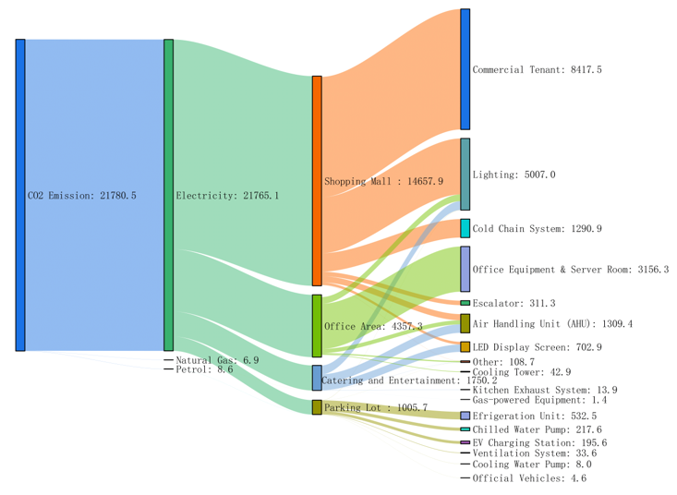
Figure 6. Building carbon flow (tCO₂)
At the primary emission unit level, the shopping mall emerged as the largest emitter, with 14657.9 tCO₂ annually (62.13% of the total), followed by the office area (4357.27 tCO₂, 23.22%), catering and entertainment zones (1750.2 tCO₂, 9.32%), and the underground parking garage (1005.7 tCO₂, 5.34%). This distribution corresponds closely with the operational intensity, floor area, and energy-use characteristics of each functional zone.
At the tertiary emission unit level, the lighting system was the largest single source of emissions, contributing 5007 tCO₂ annually (21.34%), followed by the air-conditioning system at 3448.73 tCO₂ (18.38%). Additional emissions were primarily distributed across elevators, cold-chain equipment, and office terminal devices. This structure highlights lighting and HVAC systems as core contributors to the building's operational carbon footprint due to their high energy intensity and usage frequency.

3.4 Energy-carbon prediction Analysis of Rooftop Photovoltaic retrofit
Building upon the validated simulation model and the detailed analysis of energy consumption patterns and carbon flow structures, a rooftop photovoltaic (PV) retrofit scenario was further explored using EnergyPlus to assess its potential impact on operational performance and emission mitigation. In this scenario, a 6,000 m² PV array was modeled on the building’s rooftop. Based on regional solar irradiance data for Shenzhen and standard PV system efficiency, the array is projected to generate approximately 1,500 MWh of electricity annually. The EnergyPlus model was carefully updated to reflect changes in the roof's thermal boundary conditions, incorporating both the renewable electricity contribution and the passive thermal insulation effect of the PV panels.

3.4.1 Energy- impact assessment
The simulation results indicate that the rooftop PV retrofit led to both direct and indirect reductions in energy consumption as depict in table 4. Grid electricity demand decreased by 1500 MWh, as this portion was directly supplied by the installed PV system. As a result, the total annual electricity consumption was slightly reduced to 21448 MWh, down from the baseline value of 21593 MWh.
Table 4 Pre- and Post-Retrofit Comparison
Indicator | Total Electricity Consumption (MWh) | Grid Electricity Consumption (MWh) | HVAC Electricity Consumption (MWh) | Total Carbon Emissions (tCO₂e)
Baseline | 21593 | 21593 | 5645 | 21780.5
PV Retrofit Scenario | 21448 | 20093 | 5500 | 20293.4
Reduction (%) | ↓ 0.67% | ↓ 6.95% | ↓ 2.6% | ↓ 7.49%
Figure 8 presents the simulated monthly HVAC energy consumption under baseline conditions and after the implementation of the rooftop PV retrofit. A clear seasonal pattern is observed, with consistently lower consumption in the PV scenario during the cooling-intensive months (May–September), especially in July and August. This reduction is mainly due to the passive shading and thermal insulation effects of the PV panels, which mitigate rooftop heat gain and cooling demand. In contrast, HVAC loads remain similar in cooler months due to minimal thermal influence. Overall, the PV retrofit achieved a 2.6% annual reduction in HVAC electricity consumption, from 5645 MWh to 5500 MWh, highlighting the dual benefit of rooftop PV in supplying clean energy and enhancing thermal performance.
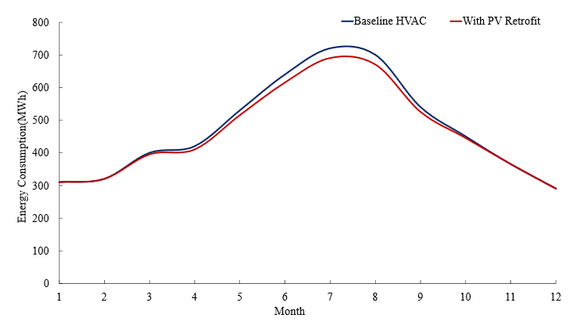
Figure 8. Monthly HVAC energy consumption: Pre- and Post-PV retrofit

3.4.2 Carbon emissions reduction
Following the rooftop PV retrofit, the building’s total annual carbon emissions decreased from 21780.5 tCO₂ to 20293.1 tCO₂, representing a 7.49% reduction. This reduction comprises 1487.1 tCO₂ offset through on-site renewable electricity generation and an additional 146.3 tCO₂ avoided due to reduced HVAC energy use resulting from the improved thermal insulation of the rooftop. These results directly respond to the emission structure outlined in Section 3.3, where electricity—particularly from HVAC and lighting systems—was identified as the dominant source of operational emissions. The findings underscore the dual benefits of rooftop PV integration: not only does it supply clean electricity, but it also passively reduces cooling-related energy demand, making it an effective and targeted strategy for carbon mitigation in high-energy-use commercial buildings. This is especially valuable in subtropical climates like Shenzhen, where cooling loads are a major contributor to peak electricity demand and carbon intensity.

CONCLUSIONS

This study developed a dynamic assessment framework by integrating the EnergyPlus simulation engine with LSTM neural network, capable of accurately capturing the operational energy consumption and carbon emission characteristics of a mixed-use commercial-office building in Shenzhen. The results reveal a distinct bimodal seasonal fluctuation in energy consumption, with peak monthly variation reaching 740.6 MWh. HVAC systems were identified as the primary energy consumers, accounting for up to 33.6% of total electricity use, followed by lighting and office equipment. Energy demand was found to be highly sensitive to both ambient temperature and occupant density, each exhibiting a strong positive correlation with the building’s load profile. The total annual carbon emissions reached 21,780.5 tCO₂e, of which 99.91% originated from electricity consumption, primarily attributed to HVAC and lighting systems. These subsystems were identified as the principal carbon sources, underscoring their strategic importance in future energy efficiency upgrades and emission reduction interventions. The integrated EnergyPlus–LSTM modeling approach demonstrated high predictive accuracy and strong adaptability in capturing real-time energy dynamics and climate–load interactions. Furthermore, based on the constructed energy consumption model, a rooftop photovoltaic system was simulated and evaluated. The results indicate that PV integration led to an annual energy savings of 145 MWh and a corresponding carbon emission reduction of 1487.1 tCO₂, highlighting its dual role in both providing on-site renewable electricity and passively mitigating cooling loads through rooftop thermal insulation.
These findings further demonstrate the effectiveness of combining advanced simulation techniques with renewable energy integration strategies to optimize energy use and facilitate low-carbon transitions in large-scale commercial buildings, while also enhancing the temporal resolution and reliability of building energy and carbon simulations.

REFERENCES

1. Tan J, Peng S, Liu E: Spatio-temporal distribution and peak prediction of energy consumption and carbon emissions of residential buildings in China. Applied Energy 2024, 376:124330.
2. Jiang Y, Yan D, Guo S, Hu S, Wei Q, Liu Y, Zhang Y, An J, Zhang Y, Guo SJBERCoTU: China building energy use 2018. 2018.
3. Lai JHK, Lu M: Carbon emission and maintenance cost of commercial buildings: Quantification, analysis and benchmarking. Journal of Cleaner Production 2024, 447.
4. Attia S: Chapter 7 - Energy Systems and Loads Operation. In: Net Zero Energy Buildings (NZEB). Edited by Attia S: Butterworth-Heinemann; 2018: 189-218.
5. Crawley DB, Lawrie LK, Winkelmann FC, Buhl WF, Huang YJ, Pedersen CO, Strand RK, Liesen RJ, Fisher DE, Witte MJ et al: EnergyPlus: creating a new-generation building energy simulation program. Energy and Buildings 2001, 33(4):319-331.
6. Zhao H-x, Magoulès F: A review on the prediction of building energy consumption. Renewable and Sustainable Energy Reviews 2012, 16(6):3586-3592.
7. Yik FWH, Burnett J, Prescott I: Predicting air-conditioning energy consumption of a group of buildings using different heat rejection methods. Energy and Buildings 2001, 33(2):151-166.
8. Pan Y, Huang Z, Wu G: Calibrated building energy simulation and its application in a high-rise commercial building in Shanghai. Energy and Buildings 2007, 39(6):651-657.
9. Krarti M: An Overview of Artificial Intelligence-Based Methods for Building Energy Systems. Journal of Solar Energy Engineering 2003, 125(3):331-342.
10. Dounis AI: Artificial intelligence for energy conservation in buildings. Advances in Building Energy Research 2010, 4(1):267-299.
11. Zhang C, Li J, Zhao Y, Li T, Chen Q, Zhang X: A hybrid deep learning-based method for short-term building energy load prediction combined with an interpretation process. Energy and Buildings 2020, 225:110301.
12. Hou G, Taherian H, Song Y, Jiang W, Chen D: A systematic review on optimal analysis of horizontal heat exchangers in ground source heat pump systems. Renewable and Sustainable Energy Reviews 2022, 154:111830.
13. Chen C-Y, Chai KK, Lau E: AI-Assisted approach for building energy and carbon footprint modeling. Energy and AI 2021, 5:100091.
14. Yildiz B, Bilbao JI, Sproul AB: A review and analysis of regression and machine learning models on commercial building electricity load forecasting. Renewable and Sustainable Energy Reviews 2017, 73:1104-1122.
15. Salemi S, Torabi M, Haghparast AK: Technoeconomical investigation of energy harvesting from MIDREX® process waste heat using Kalina cycle in direct reduction iron process. Energy 2022, 239:122322.
16. Hasan MW: Design of an IoT model for forecasting energy consumption of residential buildings based on improved long short-term memory (LSTM). Measurement: Energy 2025, 5:100033.
17. Shan Y, Liu J, Liu Z, Xu X, Shao S, Wang P, Guan D: New provincial CO2 emission inventories in China based on apparent energy consumption data and updated emission factors. Applied Energy 2016, 184:742-750.

