Production of coal from cotton shell using the carbonization process for the formulation of fuel briquette

**Abstract:** The production of coal using hydrothermal carbonization process for fuel briquette formulation had shown its efficiency as the flue gas produced during the combustion of briquette is low and the energy released is higher. Due to the complex hydrothermal conditions, the simple carbonization process had gained attention. The goal of this study was the valorization of cotton shell in the production of coal fuel briquette. To achieve this objective, coal was produced using the carbonization process following the Box Benken matrix. The coal was characterized and fuel briquettes were formulated by adding Arabic gum as binder. The results showed that, the optimum conditions to produce coal with higher fixed carbon were temperature at 500°C for a residence time of 30min and cotton shell mass of 26.5g. FTIR spectra of cotton coal cotton shell points −C═O groups of aliphatic carboxylic acids, carbonyl groups from the hydroxyl unsaturated aldehydes/ketones and aromatic rings. The thermogram of coal revealed water evaporation, the degradation of volatile matter and the transformation of fixed carbon to ash. The optimum conditions to formulate the coal fuel briquettes with an efficient degradation rate of briquette and the easy handle were 85.8% coal and 14.2% arabic gum.

**Keywords:** Cotton shell valorization, coal production, carbonization process, coal briquette.

**1 Introduction**

Cotton shell is produced in huge amount around 64 500 dry bone tons per year by SODECOTON which is a Cameroonian company located in the northern part(Onguene et al., 2024a). This waste can be an important energy sources to replace fossil energy as its energy potential is estimated at 1.30 GJ per year and thus solve the energy deficit faced by the population1. In fact, fossil fuel is responsible for global warming caused by the emissions of greenhouse gases (IPCC, 2007; Xu et al., 2020; Kim et al., 2017). Moreover, the deposits of fossil fuel needs millions of years to form, while these deposits are extracted rapidly (Cai et al., 2016; Park et al., 2018, 258, Quispe et al., 2016). Many methods to convert biomass into energy exist in the literature namely thermochemical, agrochemical, biochemical and physical (Samomssa et al., 2019). The biomass properties provide vital information in the selection of efficient thermal conversion technologies(Samomssa et al., 2022). Concerning the cotton shell properties from SODECOTON, the thermochemical and physical technologies seem to be an economic and a suitable way of conversion Onguene et al., 2024; Samomssa et al., 2022.

Among both of them, the physical method is appropriated for less developing countries such as Cameroon due to its low cost and easy implementation(Samomssa et al., 2021) as biomass is densified into solid fuel briquettes. However, some undesirable characteristics such as high moisture content, high alkali content, low heating value, low bulk density, poor grindability, and storage problems11-14 (Bach and Skreiberg, 2016; Acharya et al., 2015; Castellano et al., 2015; Nhuchhen et al., 2014) lead to a pretreatment before the densification. These pretreatment methods are drying, carbonization and AFEX (Ammonia Fiber Expansion)(Samomssa et al., 2024b; Samomssa et al., 2024c; Samomssa et al., 2019). AFEX pretreatment provides biomass ester linkages, facilitates the opening of cell wall structures, enhances enzyme accessibility and leads to a fivefold increase in sugar conversion. The efficient choice of the pretreating method depends on the biomass properties. In fact, AFEX method is more expensive due to the use of ammonia, while the drying method is suitable for biomass with low volatile matter, high lignin, high fixed carbon and higher heating value (HHV) content, whereas carbonization is appropriate for biomass with high volatile matter, cellulose and hemicellulose. More so, during drying, water is evaporated from the biomass while during carbonization, energies from cellulose, hemicellulose are released as volatile matter into flue gases, lignin and a part of cellulose are transformed into fixed carbon and carbon17-21 Gani and Naruse, 2007; Leng and Huang, 2018 Leng et al., 2020; Li et al., 2019; Xu et al., 2021). Hence, the carbonization pretreatment is suitable to limit flue gases and clean up the environment during its use in industries as well as in traditional kitchen. Moreover, for an efficient carbonization, the energy released in flue gases can be used to heat fournace (Samomssa et al., 2022) and the production of fuel briquette from coal needs binder to improve its handle and storage.

Literature reveals three main parameters which influence coal production namely temperature, residence time and feedstock mass(Sharma et al., 2015; White et al., 2011; Madhu et al., 2015). The optimum conditions to produce biochar vary from one biomass to another and it may be related to biomass properties and the interactions between the parameters(Madhu et al., 2018). At present, the preferred technology to produce coal from lignocellulosic wastes is hydrothermal carbonization which occurs at subcritical water conditions (180~250 °C) with residence time of several hours in a closed reactor, under self-generated pressures16,18,19,26 (Li et al., 2021; Samomssa et al., 2024c; Leng and Huang, 2018; Leng et al., 2020). The implementation of hydrothermal carbonization in low developing countries is difficult as it requires some complex conditions such as pressure and water reactor. The goal of this study is to assess the effect of temperature, mass and time on fixed carbon on coal and to formulate fuel briquette from cotton shell coal.

**2 Materials and Methods**

**2.1. Sampling**

Cotton shell was collected in SODECOTON and was conducted in the lab, dried at 50 °C until at constant mass and was ground into powder samples. The dried cotton shell was kept for future analysis. The compositional characteristics were carried out by Onguene *et al*., 2024a and are presented in Table 1.

**Table 1:** Compositional characteristics of cotton shell on dry basis1

|  |  |
| --- | --- |
| Parameters | Values |
| Structural analysis (%) | |
| Cellulose | 38.03 ± 0.50 |
| Lignin | 12.51 ± 0.09 |
| Hemicellulose | 23.09 ± 0.04 |
| Proximate analysis (%) | |
| Moisture Content % | 7.25 ±0.15 |
| Ash % | 3.63±0.07 |
| Volatile matter (VM) % | 70.00±1.00 |
| Fixed carbon (FC) % | 26.33±1.06 |
| Ultimate analysis (%) | |
| Carbon (C) % | 48.62±0.22 |
| Hydrogen (H) % | 5.70±0.01 |
| Oxygen (O) % | 41.32±0.15 |
| Nitrogen (N) % | 0.70±0.02 |
| Sulfur (S) % | 3.64±0.08 |
| C/H % | 8.52±0,05 |

**2.2. Optimization of coal production from cotton shell**

Experimental design was used to establish the mathematical model to obtain the optimum conditions to produce coal from cotton shell. This method requires the identification of parameters, responses, appropriate experimental design and studied intervals based on previous works and primary tests. Thus, from literature review, the most influencing parameters are carbonization temperature, cotton shell mass and carbonization residence time while, Box Benken design was applied to investigate the optimum conditions based on test matrix, modeling and iso-curve response. The studied response was fixed carbon and experiment matrix was displayed using statgraphics software with 18 experiments. The minimum, middle and maximum values of each variable are labeled as -1, 0 and +1 respectively. A1, B2 and C3 are attributed to temperature, residence time and mass respectively. The studied intervals and the mathematical model were given in Table 2 and by Eq (1) respectively.

**2.3 Carbonization process**

The carbonization process permits to convert biomass material into charcoal or char in an oxygen-limited environment which serves to partially combust the biomass under the required heat for the reaction to occur. During the process, cotton shell is gradually heated, and then dehydrated, degassed and the polycondensation which leads to the formation of carbonized material with a primary-pore structure formed. The charcoal obtained was then characterize to identify functional group and to predict combustion behavior.

Table 2. Studied intervals of temperature, residence time and mass.

|  |  |  |  |  |
| --- | --- | --- | --- | --- |
|  |  | Level | | |
|  |  | Low | Middle | High |
| Parameters | Coded value | (-1) | (0) | (+1) |
| Temperature (°C) | A1 | 300 | 400 | 500 |
| Residence time | B2 | 30 | 75 | 120 |
| Mass (g) | C3 | 5 | 17.5 | 30 |

|  |  |  |
| --- | --- | --- |
|  |  | (1) |

Where: Xi: Independant variable; a0: Constant; a1, a2, and a3 are linear coefficient; a12, a13 and a23, are second order interaction coefficient; a12, a22, and a32 are quadratic coefficient

**2.4 characterization of coal produced from cotton shell**

**2.4.1 Fourier Transform Infrared Spectroscopy** (**FTIR) analysis**

This analysis was done to identify the functional groups and the chemical bonds by the means of iS50 RAMAN. A mg of sample was put in a sample holder and placed into an analyzer chamber. The data displayed on the computer, were collected and treated using OMNIC software.

**2.4.2 Thermal analysis**

Thermal analysis was conducted by the means of thermal analyzer PerkinElmer instrument, Pyris Diamond. This analysis points out the mass loss of the sample with respect to temperature. Accordingly, 16 mg of the sample is distributed uniformly in an aluminum crucible and the second empty aluminum crucible serving as a reference is placed next to the first. The sample undergoes heat treatment from room temperature until 600 °C with a rising temperature programmed at 10 °C/min and the air flow of 125 mL/min

**2.5. Fuel briquette formulation**

The formulation of the fuel briquette was done following the scheffe mixture design with constraint. The studied parameters were coal from cotton shell (X1) and arabic gum (X2) fractions. The amount of arabic gum in the mixture must not be more than 20%. Studied response was degradation rate of briquette. The model is presented by the Eq. (2) revealing the absence of the constant. This can be explained by the fact that the sum of the proportions of each experiment has to be equal to 1, thus, leads to no middle experiment.

$Y= AX_{1}+BX_{2}+CX_{1}X_{2}+DX_{1}X_{2}\left(X_{1}-X_{2}\right)+E X_{1}X_{2}(X_{1}-X_{2})²$ Eq (2)

**2.6. Determination of responses**

The studied responses are fixed carbon (%) for optimization design (Box Benken matrix) and degradation rate of briquette for the mixture design. The fixed carbon was determined using ASTM methods (ASTM, 2006a; ASTM, 2006b; ASTM, 2007) while, the degradation rate of briquette (DRB) was determined according to the method described by Samomssaet al(2021). The known height (in centimeters) of briquette was placed above a Bunsen burner in a fume cupboard until a complete burn and the DRB was calculated by the ratio of the burned distance and residence time.

**2.7 Validation of the Model**

The validation of the obtained empirical models is vital in experimental design studies15. The statistical tools used for are absolute average deviation (AAD), Exactitude Factor (Af1) and bias factor (BF). They are determined using the equations (3) to (6). The conditions set are adjusted R2 must be more than 95%, absolute average deviation (AAD) has to be nearer to zero, exactitude factor (Af1) and bias factor (BF) have to be between 0.75 and 1.25. The analysis of variance (ANOVA) is used to investigate the effect and the degree of the signification of each factor (Samomssa et al., 2024b). By this way, the statistical significance of each effect is illustrated by comparing the mean squares with an evaluation of experimental error. The significance of each factor is evaluated by the fisher test.

|  |  |  |
| --- | --- | --- |
|  |  | (3) |

|  |  |  |
| --- | --- | --- |
|  |  | (4) |

|  |  |  |
| --- | --- | --- |
|  |  | (5) |

$R^{2}= \sum_{I=1}^{n}{\left(\frac{Y_{cal}}{Y_{exp}}\right)}$ (6)

Where: Yexp: experimental value; Ycal: calculated value; n: number of experiments.

**3 RESULTS AND DISCUSSION**

**3.1 Analyzing of test matrix of coal production**

Table 3 presents the test matrix of fixed carbon from box benken design revealing that, the response varies from 93% to 95%. This variation indicated that the studied parameters slightly influence fixed carbon in studied intervals set.

Table 3: Test matrix of coal production.

|  |  |  |  |  |  |
| --- | --- | --- | --- | --- | --- |
| Experiments | Temperature(°C) | | Time(min) | Mass (g) | Fixed Carbon (%) |
| 1 | 500 | 120 | | 30.0 | 94.6 |
| 2 | 500 | 30 | | 30.0 | 94.4 |
| 3 | 500 | 120 | | 5.0 | 95.3 |
| 4 | 500 | 30 | | 5.0 | 94.1 |
| 5 | 300 | 120 | | 30.0 | 93.9 |
| 6 | 300 | 30 | | 30.0 | 93.3 |
| 7 | 300 | 120 | | 5.0 | 93.8 |
| 8 | 300 | 30 | | 5.0 | 93.2 |
| 9 | 500 | 75 | | 17.5 | 94.8 |
| 10 | 300 | 75 | | 17.5 | 94.0 |
| 11 | 400 | 120 | | 17.5 | 94.9 |
| 12 | 400 | 30 | | 17.5 | 93.7 |
| 13 | 400 | 75 | | 30.0 | 93.5 |
| 14 | 400 | 75 | | 5.0 | 93.7 |
| 15 | 400 | 75 | | 17.5 | 94.1 |
| 16 | 400 | 75 | | 17.5 | 93.3 |
| 17 | 400 | 75 | | 17.5 | 93.4 |
| 18 | 400 | 75 | | 17.5 | 93.9 |

**3.2 Validation of model of fixed carbon**

The model was validated using the validation indicators. Thus, Samomssa et al (2024d) estimated that the model is validated if the exactitude and bias factors are ranged between 0.75 and 1.25. Samomssa et al (2025a) considered that a model can be validated if the model displays at least 80% at 90% of the variability of the response (adjusted R2). Samomssa et al (2025b) judged that a model is validated if the AAD varies from 0 to 0.3. From the results obtained in Table 4, it is evident that the model of fixed carbon with respect to temperature, residence time and mass is validated.

Table 4: Parameters to validate the model

|  |  |  |  |
| --- | --- | --- | --- |
| Validation indicator | Abreviation | Values | Condition of validation |
| adjusted *R*2 | R2 | 0.82 | R2 ≥ 0.80 |
| Absolute Average Deviation | AAD | 0.00 | AADM = 0 |
| Bias factor | B*f* | 1.00 | B*f =* 1 |
| Exactitude factor | A*f1* | 1.00 | A*f1 =* 1 |

**3.3 Modeling**

The model of fixed carbon with respect to temperature (A1), residence time (B2) and mass (C3) is illustrated by Eq (7). This equation points out that the singular effect of each parameter significantly influences the fixed carbon compared to quadratic and interaction effects. This influence in descending order is C3, A1 and B1. Eq (7) also reveals that quadratic effect of C3 is important compared to quadratic effects of A1 and B1. Thesingular and quadratic effects of C3 are negative. This observation can justify the vital role of mass C3 during carbonization process on fixed carbon of obtained coal. The negative effect of C3 can be explained by the fact that, the more the mass, the more the time to degrade the macromolecule such as cellulose and lignin into coal.

Fixed carbon (%) =97.379+0.0270*A1+0.01506B2*-0.136*C3+0.0001*A12+ 0.0001*A1B2-0.0001*A1C3+0.001*B22-0.0020*B2C3- 0.0030*C32  Eq (7)

With A1: Temperature; B2: residence time; C3: mass.

**3.4 Direct effect diagram**

Figure 1 shows the trend of the fixed carbon with respect to the combined effects for the studied parameters namely A1B2, A1C3 and B2C3. This figure displays that the combined effect of A1B2 increases the fixed carbon while the combined effect of B2C3 reduces the fixed carbon. This result is in agreement with Eq 7 which states that the combination of residence time and mass has a negative effect.



94.5

94

Fixed carbon (%)

95.5

95

93.5

93

B2C3

A1C3

A1B2

120

30

500

300

500

300

**Figure 1**: Interaction effect of temperature, residence time and mass on fixed carbon

**3.5 Optimization**

The response surface of fixed carbon with respect to temperature, residence time and mass is presented in Figure 2 showing that the optimum value of fixed carbon is found for the temperature of 500°C, mass of 26.5g and a residence time of 30min. This result is in agreement with the model which states that A1 and B2 tend to increase significantly the fixed carbon.

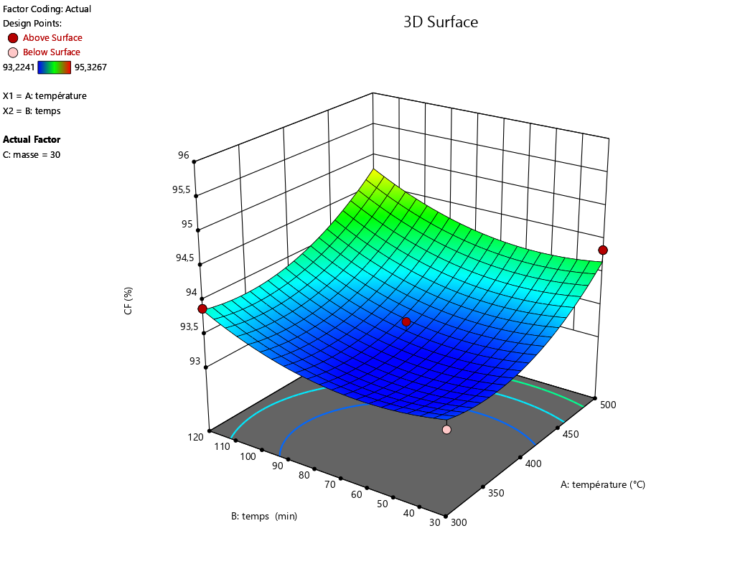

X3 : Mass=30g

X1 : Temperature

X2 : Time

Fixed carbon (%)

Time (min)

Temperature (°C)

**Figure 2 :** Response surface of fixed carbon with respect to temperature, residence time and mass

**3.6 Characterization of coal obtained at optimum conditions**

**3.6.1 FTIR of cotton shell and cotton shell coal**

FTIR spectra of cotton shell and coal cotton shell are presented in Figure 3 (a) and (b) respectively. Figure 3a shows five main groups while Figure 3b reveals three main adsorption bands explaining that certain groups of cotton shell such as cellulose and lignin have been transformed into coal during carbonization. The absorption bands from Figure 3a are between 3000 cm-1-3600 cm-1, 2700 cm-1-3000 cm-1, 1700 cm-1-1500 cm-1, 1000 cm-1 and 500 cm-1 while those from Figure 3b are 1559 cm-1, 1360cm-1, 1124 cm-1 combined with the absorption at 1225 cm-1. The absorption band range between 3000- 3600 cm-1 belongs to the elongation vibration of the bonded alcohol group OH, while those between 2700-3000 cm-1is attributed to the presence of C-H. Absorption bands between 1700-1500 cm-1 are characteristic of C-O elongation while those at 1000 cm-1 correspond to the C-C bond meanwhile adsorption at 500 cm-1 is assigned to mineral compounds such as PO4- and CO32-. The adsorption band at 1559 cm-1 is associated to −C═O groups of aliphatic carboxylic acids. Li *et al* (2021) justified that −C═O groups mainly originated from the dehydration of the carbohydrate fraction. The peak at 1360cm-1 corresponds to the stretching vibration of carbonyl groups from the hydroxyl unsaturated aldehydes/ketones while the band at 1124 cm-1 combined with the peak at 1225 cm-1 are characteristics toaromatic rings (Lang *et al*., 2018).



b)



**Figure 3 :** FTIR spectra of cotton shell (a), coal from cotton shell (b).

**3.6.2 Thermogram of cotton shell and cotton shell coal**

Figure 4 (a) and (b) illustrates the thermogram of cotton shell and coal cotton shell respectively. These figures show three plots namely red, blue and black. The blue plot points out the exothermic phenomena while the red plot illustrates the percentage of weight loss meanwhile the black plot shows endothermic phenomena. Figure 4a presents five temperature peaks at 68°C, 249°C, 310°C, between 423°C-434°C and 503°C with associated loss mass of 10.81%, 15.13%, 31.09%, 33.33% and 2.91% respectively. The peak at 68°C corresponds to the evaporation of water while the peak at 249°C and 310°Cischaracteristics by the degradation of hemicellulose, meanwhile the peakbetween 423°C-434°C is attributed to the degradation of cellulose and lignin. The last peak at 503°C is assigned to the degradation of the remaining lignin. Figure 4b reveals three temperature peaks at 69°C, 419°C with corresponding loss mass of 11.16% and 79.68% and 501°C without loss mass. These peaks are associated to water evaporation, the degradation of volatile matter and the transformation of fixed carbon to ash.

a)

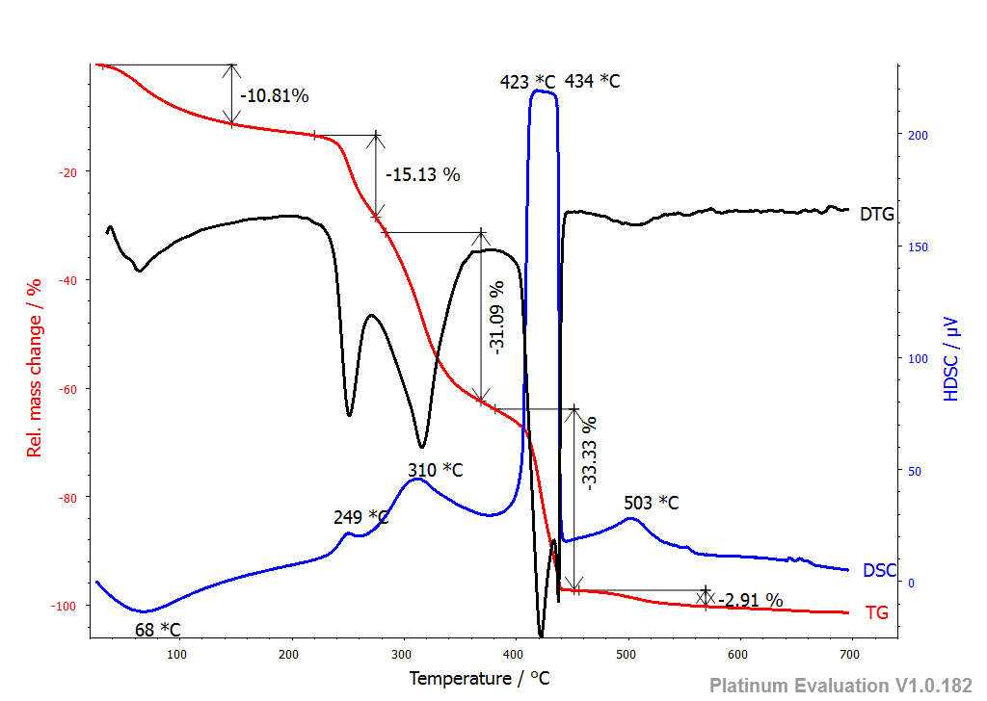

b)

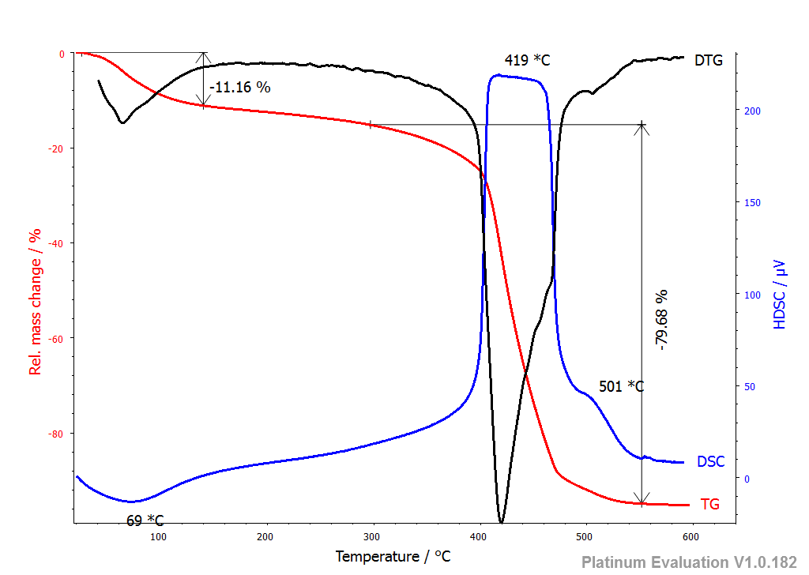

Figure 4 : Thermogram of cotton shell (a) cotton shell coal (b).

**3.7 Formulation of coal fuel briquette**

**3.7.1 Test matrix**

The briquettes produced from cotton shell coal is presented in Figure 5 and the test matrix is shown in Table 5 revealing the variation of the degradation rate of the briquette from 0.024 cm/min to 0.044 cm/min. This variation can be justified by the different properties of fuel coal briquette related to the different proportions of coal and arabic gum.

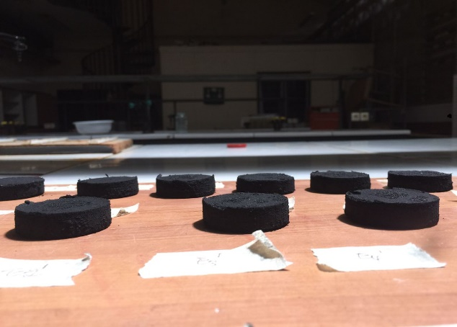

**Figure 5**:Fuel briquette from cotton shell coal

Table 5: Mixture test matrix of degradation rate of coal fuel briquette

|  |  |  |  |
| --- | --- | --- | --- |
| Experiments | Coal (g) | Arabic gum (g) | DRB Cm/min |
| 1 | 9.00 | 1.00 | 0.042 |
| 2 | 8.25 | 1.75 | 0.036 |
| 3 | 9.00 | 1.00 | 0.043 |
| 4 | 8.00 | 2.00 | 0.033 |
| 5 | 8.34 | 1.66 | 0.027 |
| 6 | 8.00 | 2.00 | 0.034 |
| 7 | 8.00 | 2.00 | 0.034 |
| 8 | 8.50 | 1.50 | 0.025 |
| 9 | 8.50 | 1.50 | 0.026 |
| 10 | 8.75 | 1.25 | 0.044 |
| 11 | 9.00 | 1.00 | 0.043 |
| 12 | 8.66 | 1.34 | 0.029 |
| 13 | 8.50 | 1.50 | 0.024 |

DRB : Degradation rate of briquette.

**3.7.2 Analyzing of validation indicators of degradation rate of coal briquette**

The model was validated using the validation indicators. Samomssa et al (2024d) estimated that a model is validated if the exactitude and bias factors are between 0.75 and 1.25. Samomssa et al (2025a) considered that a model can be validated if the model explains at least 80% of the variability of the response (adjusted R2). Samomssa et al (2025b

) judge a model is valid if the AAD is between 0 and 0.3. From the results obtained in Table 6, it is evident that the model of fixed carbon with respect to temperature, residence time and mass is validated.

Table 6 : Validation indicators of degradation rate of fuel briquette from coal cotton shell

|  |  |  |
| --- | --- | --- |
| Validation indicators | Values | Limit set |
| R2 | 0.84 | R2 ≥ 0.80 |
| AAD | 0.04 | AADM = 0 |
| B*f* | 1.00 | B*f =* 1 |
| A*f1* | 1.04 | A*f1 =* 1 |

**3.7.3 Modeling of degradation rate of coal briquette**

It appears from this equation that, the factors studied individually have a negative influence on the response, but the combined effect of the two factors tends to increase this response. The quadratic effect has a positive influence on the response.

$$DRB= -4.14 X_{1}-4893.42X_{2}+9246.15X_{1}X_{2}-6596.29X_{1}X_{2}\left(X_{1}-X_{2}\right)+2359.16 X_{1}X_{2}(X_{1}-X_{2})²$$

**3.7.4 Optimizing**

Figure 6 shows that the rate of degradation of the briquettes varies depending on the proportions of the mixture. Two hypothesis emerge from this figure: when the binder content is 10%, we observe that the rate of degradation of the briquette is high, varying between [0.042-0.043%], and for a binder content of 20%, a decrease in the rate of degradation is observed [0.033-0.034%]. This is explained by the fact that coal is more porous than dried cotton shell and therefore will tend to blend more, not facilitating the access to oxygen.

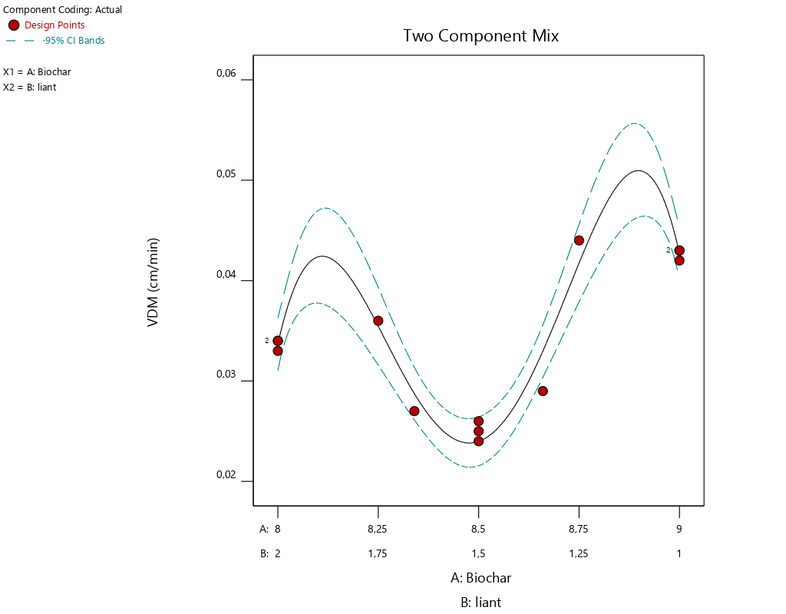

8.75

1.25

B : 2

9

1

B : 2

A : 8

B : 2

B : 2

8.25

1.75

B : 2

X1 : Coal

X2 : Arabic gum

B : 2

8.5

1.5

B : 2

0.02

DRB (Cm/min)

B : 2

0.03

0.04

0.05

0.06

**Figure 6**:Iso-curve response of DRB of fuel briquette from cotton shell coal

**Conclusion:**

The goal of this study was the valorization of cotton shell in the production of coal fuel briquette. The results showed that, the optimum conditions to produce coal with higher fixed carbon was temperature at 500°C for residence time of 30min and cotton shell mass of 26.5g with charcoal yield of 35%. FTIR spectra of cotton shell and coal cotton shell showed five and three main groups respectively, explaining that certain groups of cotton shell such as cellulose and lignin have been transformed into coal during carbonization. The functional groups present in coal are −C═O groups of aliphatic carboxylic acids, carbonyl groups from the hydroxyl unsaturated aldehydes/ketones and aromatic rings. The thermogram of coal reveals three temperature peaks at 69°C, 419°C and 501°C which were associated to water evaporation, the degradation of volatile matter and the transformation of fixed carbon to ash respectively. The optimum conditions to formulate coal fuel briquettes with an efficient degradation rate of the briquette and the easy handle were 85.8% coal and 14.1% arabic gum.

**References :**

Acharya, B., Dutta, A., Minaret, J. Review on comparative study of dry and wet  
torrefaction. Sustain. Energy Technol. 12 (2015) 26-37.

ASTM standards. Standard test method for ash in biomass. *Fuels*. 2007;E:1755–01.

ASTM standards. Standard test method for volatile matter in the analysis of particulate wood. Fuels. 2006b; (E): 872–882.

ASTM standards. Standard test method moisture analysis of particulate wood. *Fuels*. 2006a, (E), 1871–1882.

Bach, Q.V., Skreiberg, O. Upgrading biomass fuels via wet torrefaction: A review  
and comparison with dry torrefaction, Renew. Sustain. Energy Rev. 54 (2016)  
665-677.

Cai, J.X., Li, B., Chen, C.Y., Wang, J., Zhao, M., Zhang, K. Hydrothermal carbonization of tobacco stalk for fuel application. Bioresour. Technol. 2016, 220, 305–311.

Castellano, J.M., Gomez, M., Fernandez, M., Esteban, L.S., Carrasco, J.E. Study on the effect of raw materials composition and pelletization condition on the  
quality and properties of pellets obtained from different woody and non woody  
biomasses. Fuel 2015, 139, 629-636.

Gani, A., Naruse, I. Effect of cellulose and lignin content on pyrolysis and combustion characteristics for several types of biomass. Renew Energy 2007, 32, 649–661.

IPCC (Intergovernmental Panel on Climate Change), 2007. Climate change the  
physical science basis. In: Solomon, S., Qin, D., Manning, M., Marquis, M., Averyt,  
K., Tignor, M.M.B., Henry Le Roy Miller, J. (Eds.), Contribution of Working Group  
I to the Fourth Assessment Report of the Intergovernmental Panel on Climate  
Change. Intergovernmental Panel on Climate Change. Cambridge University  
Press, Cambridge, p. 212.

Kim, D., Park, S., Park, K.Y. Upgrading the fuel properties of sludge and low rank coal mixed fuel through hydrothermal carbonization. Energy. 2017, 141, 598–602.

Leng, L., Huang, H. An overview of the effect of pyrolysis process parameters on biochar stability. Bioresour. Technol. 270 (2018) 627–642. <https://doi.org/10.1016/j.biortech.2018.09.030>.

Leng, L., Yang, L., Chen, J., Leng, S., Li, H., Li, H., Yuan, X., Zhou, W., Huang, H. A review on pyrolysis of protein-rich biomass: Nitrogen transformation. Bioresour. Technol. 315 (2020) 123801. <https://doi.org/10.1016/j.biortech.2020.123801>.

Li, M., Vithanage, Q., Shu, Z., Mortaza, G., Xun, H., Xiangzhou, Y. Binoy, S., Ondrej, M., Yong, S. O. Co-hydrothermal carbonization of swine and chicken manure: Inﬂuence of cross-interaction on hydrochar and liquid characteristics. Sci. Total Environ. 786 (2021) 147381.

Li, Y., Liu, H., Xiao, K., Liu, X., Hu, H., Li, X., Yao, H. Correlations between the physicochemical properties of hydrochar and specific components of waste lettuce: Influence of moisture, carbohydrates, proteins and lipids. Bioresour. Technol. 2019, 272, 482–488. <https://doi.org/10.1016/j.biortech.2018.10.066>.

Madhu, P., Kanagasabapathy, H., Neethi, M.I. Conversion of cotton residues to bio-oil andchemicals through flash pyrolysis in a fluidised bedreactor. Int. J. Energy Technology and Policy. 2018, 14(1), 14P.

Madhu, P., Kanagasabapathy, H., Neethi, M.I. Cotton shell utilization as a source of biomass energy for bio-oil by flash pyrolysis on electrically heated fluidized bed reactor. J Mater Cycles Waste Manag. 2015, 10P, DOI 10.1007/s10163-014-0318-y

Nhuchhen, D.R., Basu, P., Acharya, B. A comprehensive review on biomass  
torrefaction, Int. J. Renew. Energy Biofuels. 2014, 1–56

Onguene, M. P.; Samomssa, I.; Domga, Richard.; Rodica, D.M.; Circiumaru, A. Prediction of Cotton Shell from Sodecoton Behavior in Thermal Conversion and Theoretical Energy Potential. EJ-ENG, 2024, 23-31.

Park, K.Y., Lee, K., Kim, D. Characterized hydrochar of algal biomass for producing solid fuel through hydrothermal carbonization. Bioresour. Technol. 2018, 258, 119–124.

Quispe, I., Navia, R., Ramzy, K. Energy potential from rice husk through direct combustion and fast pyrolysis: A review. Waste Manag xxx (2016) xxx–xxx.

Samomssa, I., Adjia Z.H, Domga R., Dili G., Kamga R. Optimizing of phophorus and potassium contents in cattle manure ash during combustion. Int. J. Environ. Sci. Technol. 2025a, 1-12.

Samomssa, I., Bisso, A., Kamga, R. The effect of co-combustion of cattle manure and sawdust on energy recovered. Therm. Sci. Eng. 2024c, 7(2), 5943, 1-13. https://doi.org/10.24294/tse.v7i2.5943

Samomssa, I., Domga R., Pahimi H., Lemougna P. N., SamitnaA. A., Uphie C. The effect of corn cob, cotton shell and rice straw mixture during carbonization on charcoal yield using mixture design. J. Indian Chem. Soc. 101, 2024d, 1-8.

Samomssa, I., Jiokap, N. Y., Tsamo, C., Rodica, M. D., Kamga, R. Influence of Physico-Chemical Parameters on Fuel Briquettes Properties Formulated with Mixture of Biomasses J. Environ. Sci. Pollut. Res. 2019, 5(2), 338–341.

Samomssa, I., Jiokap, N.Y, Cârâc, G., Gur˘au, G., Rodica, D.M., Kamga, R. Optimization of fuel briquette production from cassava peels, plantain peels and corn cobs. *J Mater Cycles Waste Manag*. 2021, 23, 1905–1917.

Samomssa, I., Oumarou, A. A., Djou, B., Kamga, R. Optimization of Pretreatment and Hydrolysis Steps and Estimation of Theoretical Bioethanol Potential from Cattle Manure. Sustain. Chem. Eng. 2024b, *5*, 550-566.https://doi.org/10.37256/sce.5220245278

Samomssa, Inna., Embolo A.R.N, MassaiH., Kamga R. Phosphorus recovery from beef slaughterhouse wastewater by electrocoagulation process. Sust. Chem. Environ. 10, 1-9.

Samomssa, I., Adjia, Z. H., Hassana, B., Tsamo, C., Geta, C., Mouangue, R., Rodica, D.M.,  Kamga, R. Compositional characteristics and theoretical energy potential of animal droppings from Adamawa region of Cameroon. Biomass Convers. Biorefin. 2022, 1-13. <https://doi.org/10.1007/s13399-022-03320-4>.

Sharma, A., Vishnu, P., Dongke, Z. Biomass pyrolysis-A review of modelling, process parameters and catalytic studies. Renew. Sustain. Energy Rev. 2015, 50, 1081–1096.

White, J.E., Catallo, W. J. Benjamin, L. Legendre Biomass pyrolysis kinetics: A comparative critical review with relevant agricultural residue case studies. J Anal Appl Pyrol. (2011) 91 1–33.

Xu, X., Tu, R., Sun, Y., Li, Z., Jiang, E. Influence of biomass pretreatment on upgrading of bio-oil: Comparison of dry and hydrothermal torrefaction. Bioresour.Technol. 2020, 262, 261–270.

Xu, Z., Renzhi, Q., Mengmeng, X., Daofang, Z., He, G., Weifang, C. Conversion of cotton textile waste to clean solid fuel via surfactant-assisted hydrothermal carbonization: Mechanisms and combustion behaviors. Bioresour. Technol. 2021, 321, 1-10, 124450.