**Improved Biomass Cook Stove with a Movable Combustion Chamber that Incorporates Top-Lit Up Draft and Rocket Principles for Continuous Operation**

**Abstract**

Currently, about 3 billion people in developing countries, especially Sub-Saharan Africa use traditional open fire methods to prepare their food, which is due to lack of access to clean energy for cooking. Solid biomass, such as wood, charcoal, agricultural wastes, cow dung, etc. are used as fuel in these cooking methods. These methods are inefficient in burning fuel, thereby emitting pollutants that are harmful to health. In Sierra Leone, majority of the population, especially those living in rural communities, prepare their food using three-stone fire stove, which is inefficient in terms of fuel use and with negative outcomes on the environment and users, especially women and children. A stove that is more efficient with less pollutants can help solve these issues. Thus, the essence of this study, which is to design and produce an improved solid biomass cook stove that can transfer heat more efficiently thereby using less fuel with minimum pollutants. The stove works on two principles; rocket and Top Lit Up-draft (TLUD) principles. It has a movable combustion chamber, which can be operated continuously and capable of burning different solid biomass fuels. Air supplied is through natural and forced draft, the latter supply is operated by a 12-volt fan. Performance of the stove was tested using Water Boiling Test. Thermal efficiency results for the rocket, natural draft and forced draft are 39.55%, 48.68% and 52.48% respectively. Burning rates for forced draft operation was 6.76g/s, while those for rocket and natural are 2.97g/s, 4.11g/s respectively. Specific fuel consumption for the three tests were 0.62 Kgwood/Kgwater, 0.72 Kgwood/Kgwater and 0.77 Kgwood/Kgwater. Time taken to boil water was lowest for the forced draft (6 minutes), which is due to the faster rate of air supplied to the fuel, but it consumed more fuel that the other two methods. These results show that an improved cookstove that is carefully designed is more efficient than traditional stoves, as it facilitates enhanced mixing of combustible gases and oxygen, promoting more efficient burning of fuel and ultimately lowering emissions, thus, better thermal efficiency and reduced fuel consumed will reflect favourably on the environment as less trees will be cut down.

Key words: Cookstove, combustion, thermal efficiency, heat transfer

**1. Introduction**

United Nations’ Sustainable Development Goal (SDG) 7 points out that modern clean household energy is central to achieving improved global health by 2030, and this energy must be safe and affordable (who, 2024). Furthermore, policies of governments should shift focus from improved biomass cookstoves to clean cooking fuels such as ethanol, LPG and electricity. Unfortunately, about 3 billion people lack access to modern forms of energy, and most of them live in developing countries with dependence on traditional biomass resources to meet their basic energy need (Stoner et al., 2021; IEA, 2023). Moreover, about 50% of cooking and heating food in developing countries are done through the use of open fires and inefficient stoves, which use biomass as fuel (Nyika et al., 2020; Das et al., 2021). Biomass being the world’s fourth largest cooking energy source (Tidze et al., 2016; Rasoulkhani et al., 2019). Globally, about three billion people prepare food using traditional three stone fire stove, which uses biomass fuel such as wood, agricultural residues, cow dung, charcoal, fruit shells and nuts to name a few (Teixeira et al., 2022; IEA, 2023). These sources of fuel contribute to greenhouse gas emissions, indoor air pollutions and health issues (Murray et al., 2019). Additionally, almost 3.8 million deaths per annum are associated with harmful emissions produced from inefficient traditional cookstoves (WHO, 2018; Samal et al., 2019). Women and children in rural communities are vulnerable to pollutants emitted by burning biomass in inefficient cook stoves, as they are mostly involved in food preparation (Masera et al., 2009). Improved cookstoves have shown to be more efficient than 3-stove fire stove in terms of burning fuel, which lead to less fuel usage (Cooke et al., 2008; Segun et al., 2024; Pope et al., 2021). Also, these cookstoves reduce cooking time, use less fuel and emits less CO and pollutants like PM2.5 (Wang et al., 2016; Ayaz et al., 2022). Although designs of improved biomass cook stoves have shown gradual improvement in thermal efficiency, yet deforestation has continued as wood is used as fuel in these stoves (Baqir et al., 2019; Abanikannda and Dantani, 2021). Worthy of note is that the more efficient these stoves becomes, the lesser the pressure on forest, thereby reducing the number of trees cut down. Therefore, better design methods of cook stoves are needed to help increase thermal efficiency, and to reduce, pollutants, health risks and fuel usage, hence the initiative for this study.

**2. Literature Review**

**2.1 Energy and Traditional forms of Cooking**

Energy is essential for every aspect of life from, leisure, education, engineering, medicine, food processing, lighting and space heating, to name few. it forms part of the basic building blocks of modern life (Floess et al., 2020). Currently, both renewable and non-renewable sources of energy are being utilised to produce the energy need for mankind. A country’s economic development can be traced through the path of its energy usage, which makes reliable and constant energy supply an important component in this development trajectory (Mirza et al., 2008). In Africa, especially sub-Saharan Africa, 80% of the population get their energy from biomass (Adem et al., 2019). Biomass is available globally and can be converted into different forms of energy. Plant biomass or Phyto-mass and zoo-mass or cattle excreta are subsumed under the general term biomass (Balat and Ayar, 2005). Generally, it is available in the form of solid state, for instance, crop residues and wastes such as animal, municipal, plant and forest (Ozokwelu et al., 2017).

**2.2. Traditional Forms of Cooking**

These stoves come in two types; three-stone fire and built-in mud stoves. Over the years, modifications have been made to these stoves as a result of cultural and food practices (Still et al., 2011). The traditional three-stone fire stove is made of three stones placed on the ground in a triangular format and fuel wood is placed between the stones as shown in figure 1. The pot is then placed on top of the stones. It is cheap and very simple to make with minimum skill required. It uses lots of fuel as air enters in all directions, loses heat through radiation as the stones are placed on the ground and produces lots of PM2.5 and CO. Thermal efficiency of this stove is up to 20%, one such reason is due to incomplete combustion (Still et al., 2011; Bailis, 2015). The design of the mud stove, on the other hand, is based on the three-stone fire stove, which is permanently built with mud, see figure 2. It requires more skills to build than the former stove. It is safer to use as the fire is enclosed and less heat is lost due to radiation. little fuel is added at a time, leading to less fuel use, thus its efficiency is higher is than the three-stone fire, about 29% (Jetter, 2009). Traditional forms of cooking are inefficient; consume more fuel and emit more pollutants, especially when used indoors, and inhalation of these pollutants leads to acute respiratory infection and obstructive pulmonary disease, and continuous inhalation can lead to death (Huangfu et al., 2014). Fine Particulate Matter (PM2.5) pollutant, which is 20 times smaller than the width of the human air, has shown to cause adverse health effect (Bailis, 2015; Murray et al., 2019). Therefore, with health consideration, it is relevant to understand the types of fuels and stoves that reduce HAP.

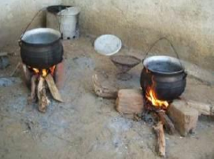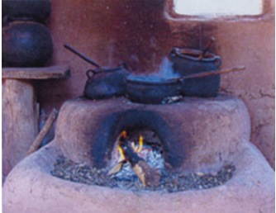

Figure1: 3-Stone fire stove Figure 2: Fixed Mud Stove

Source: Vitali (2011) Source: Ecolocalizer (2009)

Sierra Leone, which is a sub-Saharan Africa country, 90% of its inhabitants depend on biomass as a source of fuel that are used in traditional three stone fire stoves (Floess, 2023). These stoves consume more fuel as compared to improved biomass cookstoves (Global Alliance for Clean Cookstove, 2018). Wonder stove is widely used by city dwellers in Sierra Leone for cooking and heating food (Lahai et al., 2023), but coherent studies on its efficiency and pollutant emission are yet to be carried out, which requires an alternative form of cooking that is more efficient leading to less fuel use and low emissions. Studies have shown that more biomass fuel use is associated with more forest degradation as more trees are cut down (Bamwesigye et al., 2020; Baqir et al., 2019). However, better designs of these stoves lead to less fuel, which translate to less tree being cut down. Therefore, study is undertaken to help address these issues by designing a stove that uses solid biomass as fuel, but with better thermal efficiency and less pollution.

**2.3. Improved Cook Stoves Principles**

The objectives of the improved biomass stove are to make improvements on the traditional stoves by increasing safety and thermal efficiency but reducing fuel use and pollutants, keeping costs down and easy to use. Emission of pollutant can be reduced to 40% and 75% (MacCarty et al., 2008). Thermal efficiency of this stove is up to 20% (Still et al., 2011; Bailis, 2015). Combustion is the process of burning fuel with air to release the chemical energy contained in the fuel (Kshirsagar and Kalamkar, 2014). Due to pyrolysis and gasification, combustion of solid biomass fuel is more complex that burning gaseous and liquid fuel (Kumar et al., 2013). In cookstoves, combustion takes place in a container, that is, combustion chamber, in which air is supplied (Sutar et al., 2015). The two main designs of improved cook stoves are rocket elbow and top-lit up-draft (TLUD). In rocket design, the fuel is placed at 90 degrees to the combustion chamber, whilst in the TLUD, fuel is placed parallel to the combustion chamber. see figures 3 and 4.

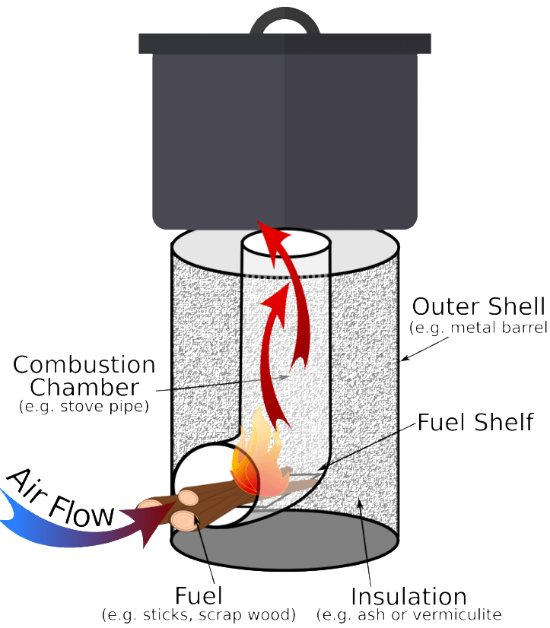 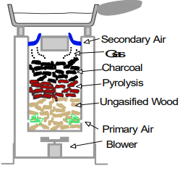

Figure 3: Rocket stove Figure 4: TLUD Stove

Source: Winiarski, 1996 Source: Anderson (2001)

Gasification and eventual combustion in stoves that work on the two principles just stated are far less polluting, given that combustion is complete in this stove. Air enters the combustion chamber in one direction and mixes with fuel to produce heat, which combust to produce fire/flame (Berrueta et al., 2008). The flue gas produced is further burnt to increase the temperature of the flame reaching the pot (Baldwin et al., 1985). TLUD stove works on the principle of mini gasification, with improved combustion technique. Gasification involves the conversion of carbonaceous materials, such as solid biomass, into hydrogen, carbon dioxide, carbon monoxide and methane, which is achieved at high temperature in the presence of limited amount of oxygen (Bryden et al., 2005).

Syngas or producer gas, which is a fuel, is produced in the process just described. In volumetric form, syngas produced from wood gasification contains these approximate values; 10 – 20% CO, 11 – 135 CO2, 15 – 21% of hydrogen, 1 -5% CH4, plus nitrogen (Dayton, 2002). Incomplete combustion of biomass releases CO, N2O CH4, which are harmful to health, whereas, complete combustion releases CO2 and water vapour, which are far less harmful to human health (Panwar, 2009). Nitrogen is the only incombustible gas in all the gases just stated. it is important to note that particle size, air-fuel ratio and fuel moisture content are relevant to the efficiency of gasifier cookstoves (huangfu et al., 2014).

**2.4. Methods of Air Supplied: Natural and Forced drafts**

Most of the biomass cookstoves used in homes work on the principle of free convection (natural draft), as they are easy and cheap to produce (Kar et al., 2012). These Natural draft biomass cookstoves do not need a fan for air supply, as it pulls the surrounding air needed for combustion. This leads to incomplete combustion given that gaseous fuel burns around the solid fuel, the result of which is increase emission (Kumar et al., 2013). Forced draft, on the contrary, uses a fan to transport air from the surrounding into the stove. The gaseous fuel released are burnt above the solid fuel, which leads to higher temperature and better heat transfer. Additionally, reduction of cooking time, improved combustion efficiency and reduction of pollutants. Forced draft stoves, on average, use 37% less fuel and a reduction of 80% of CO when compared with natural draught stoves (Still et al., 2011). Recently, forced draft models are employed in most gasifier stoves (Getahun, 2019; Suttar, 2022). Given that gasifier stoves are capable of producing combustible gas through pyrolysis, gasification and combustion (Roth, 2011).

**2.5. Performance of Improved biomass cookstoves**

Performance and thermal efficiency, including accompanying emissions from cookstoves, are predicated on several elements; design, combustion temperature and fuel feeding practice (Ojolo et al., 2012). During forced draft operation, it was observed that an increase in the amount of primary air into the fuel, due to the fan, leads to increase in smoke produced, which portrays a shift from gasification to combustion (Getahun et al., 2019). Careful design of these stoves, allows solid biomass fuels such as crop residues, animal dung, wood, shells and nuts to be burnt more efficiently with less pollutants (Suttar, 2022). Several studies by different researchers have reveals that a better designed biomass cookstove has positive relationship with thermal efficiency. Also, improved design lead to less fuel use and less harmful pollutants (Panwar, 2009; Dresen et al., 2014; Ojolo et al., 2012; Getahun, 2019; Baqir et al., 2019; Abanikannda and Dantani, 2021).

Studies on review and meta-analysis of 50 Household Air Pollutants (HAPs) were carried out to assess the effects of exposure to Particulate Matter 2.5mm (PM2.5) and carbon monoxide (CO) from clean fuels (electricity, ethanol and Liquified Petroleum Gas) and improved cooking stoves. The results show that improved biomass stoves reduced PM2.5 by 50%, while 85% reduction in PM2.5 was achieved by clean fuels technologies (Pope et al., 2021). During forced draft operation, it was observed that an increase in the amount of primary air into the fuel, due to the fan, leads to increase in smoke produced, which portrays a shift from gasification to combustion (Getahun et al., 2019). Worthy of note is that improved cook stoves are more efficient, use less fuel and emit less pollutants (Merklein et al., 2016; Getahun, 2019). Hence, heat transfer mechanism in improved cookstoves is more efficient as compared to traditional three-stone stove, in which air enters in different direction of the stove, leading to lower efficient and more usage of fuel wood (Pottmaier et al., 2015).

Through forced draft and batch feeding of fuel, biomass cookstoves can be more efficient in terms of fuel usage and heat transfer (Bryden et al., 2005). The reviewed literatures reveal that there is little or no study on cookstoves that use multiple fuels and operate on both TLUD and rocket principles. Moreover, there is a dearth of studies on using forced draft on these combined principles of fuel combustion. in this regard, this study was undertaken to help address the gap just mentioned in the literature. Therefore, design and fabrication of a stove that is durable, affordable, safer, reliable, efficient and produces low emissions is the aim of this study.

**3. Materials and Methods**

**3.1. Theoretical Design Methods**

This section deals with the designs and dimensions to aid reproduction of the stove. Design processes were done with the help of Automatic Computer Aided Design (AutoCAD) software, 2024 version. The software was used to produce both 2-Dimensional and 3-Dimensional drawings of the stove. The exploded views and important dimensions of the stove are shown in figures 5 and 6, whereas table 1 provides names of the parts. In figures 7 and 8, the Refuelling an operating position are shown

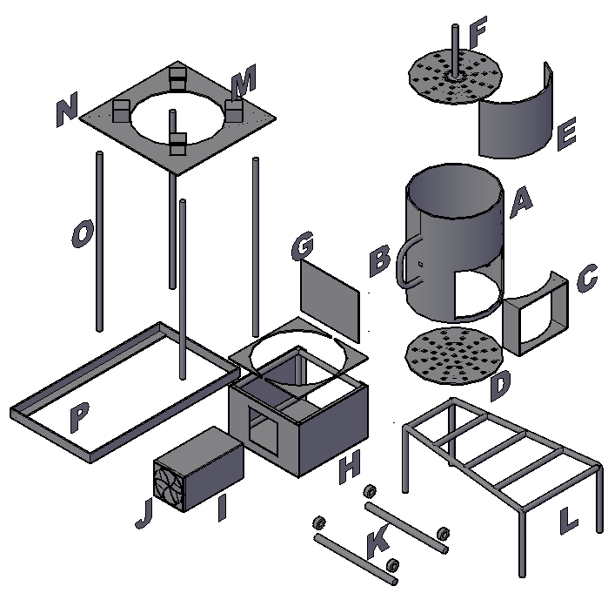 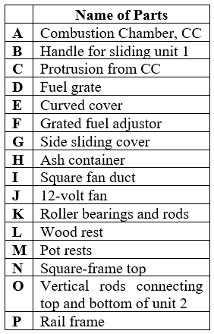

Figure 5: Exploded Parts of Stove Table 1: Names of Parts of Stove

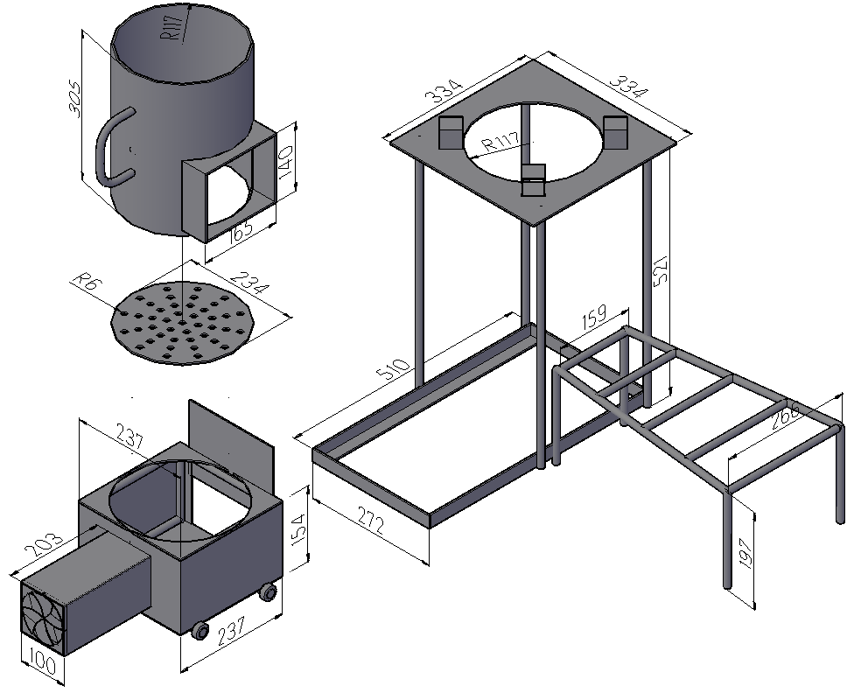 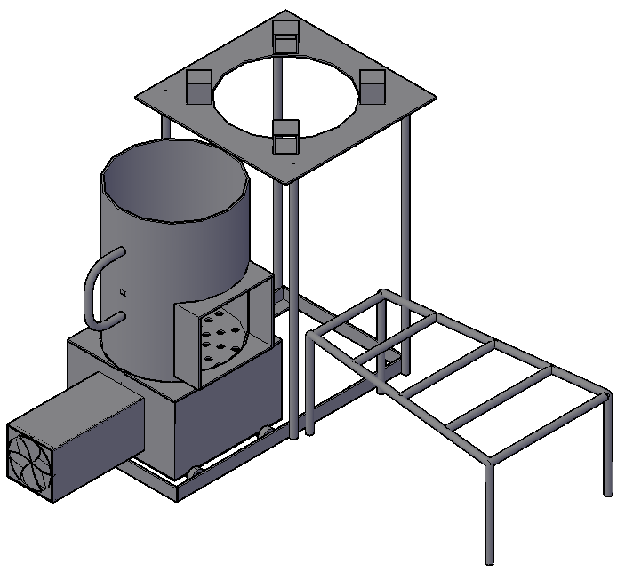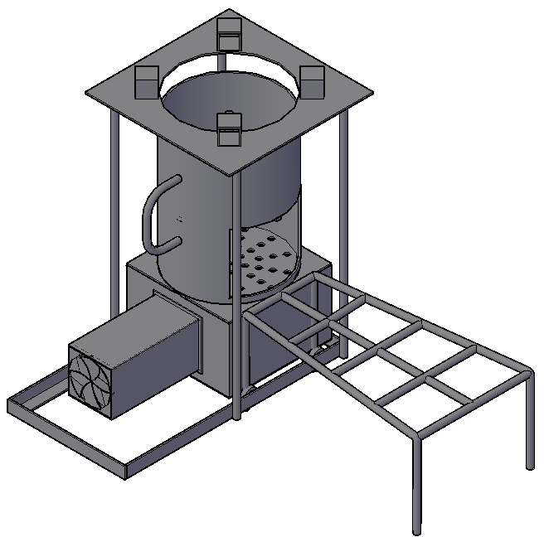

Figure 6: Important Dimensions **Figure 7: Refuelling Position Figure 8: Operating**

**3.2. Materials and Fabrication Methods**

All parts were made from mild steel, as it is cheap and widely available and can withstand heat of up to 900 degrees centigrade. Forced draft was produced by a 12-volt fan which was obtained from old power pack of a personal computer. The fan is powered by a 12-volt rechargeable battery. Combustion chamber, fuel grate and plate supporting pot rests are made from a 3mm thick plate. Right-angled iron, measuring 38mm by 38mm, was used as rails for moving the combustion chamber in and out of the frame. Ash container, made from 1.3 mm thick, is supported by 12mm rods on the inside, which is meant to increase strength and stability. Four used roller bearings were firmly attached to the ends of two 12 mm diameter rods, which are then welded to the bottom of the ash container. The wood stand was fabricated using 12 mm rods.Unit 1 of the stove was fabricated by welding the combustion chamber at the top of the ash container, Combustion chamber and its protrusion were welded on the top of the ash and charcoal container, see figure 9. Fan holder was welded on the left-hand side of the container, which forms unit 1 of the fabrication process, see figure 10.

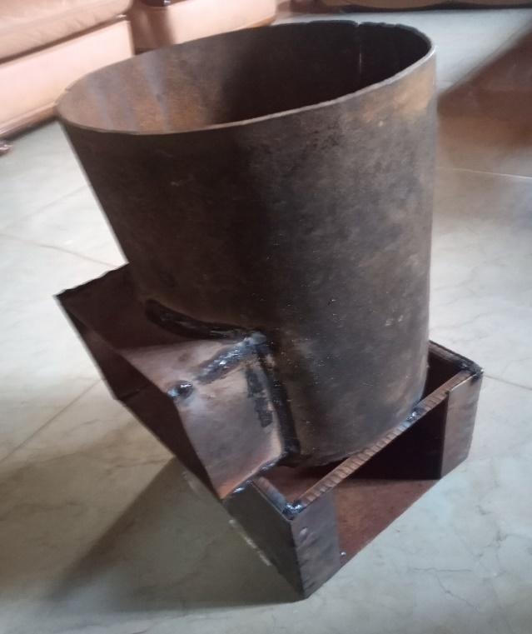 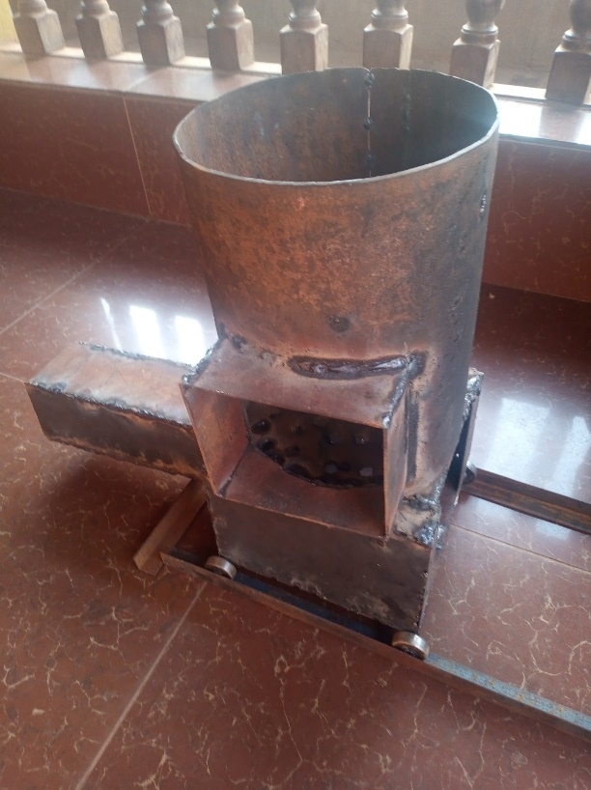

Figure 9: CC and ash container Figure 10: Unit 1 on rails

Four pot rests are welded to a 3mm thick plate, which is then welded to four vertical rods. The other ends of the rods are welded on the outer section of the rail, thereby forming unit 2 of the stove, see figure 7. Unit 1 is then slid on to the rail of 2. It can be seen that unit 1 rides on unit 2 with the help of the bearings. a curved 3mm thick plate is used on the wood entrance to switch from rocket elbow to TLUD operation, see figure 5, part E. The pot rests are positioned at a distance that will enable smaller diameter of pots to be used on the stove. The height and diameter of combustion chamber, including height of the pot rest were obtained through iteration and heuristic methods, the aim of which is to achieve maximum heat transfer from the fuel to the bottom of the pot before it spreads to the sides of the pot.

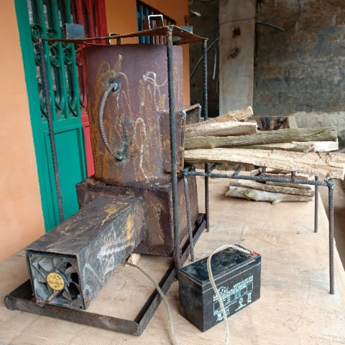 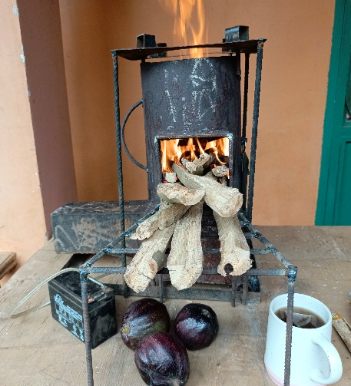

Figure 11a: Rocket operation, wood in CC Figure 11b: combustion process

During rocket operation, ignition was done on part of the wood that is inside the combustion chamber, and primary air for gasification enters parallel to the wood and moves up the combustion chamber to the bottom of the pot. See figures 11a and 11b. As regards TLUD operation, unit 1 is slid towards the left of the rail, thereby enabling fuel to be placed in the combustion chamber. Ignition takes place at the top of the fuel and draft (natural or forced) moves up the fuel to the pot. Wood stand is not used during TLUD operation, instead, a curved cover, part c, was placed at the opening of the combustion chamber to prevent primary air from entering and fuel from exiting the opening. see figures 12a and 12b.

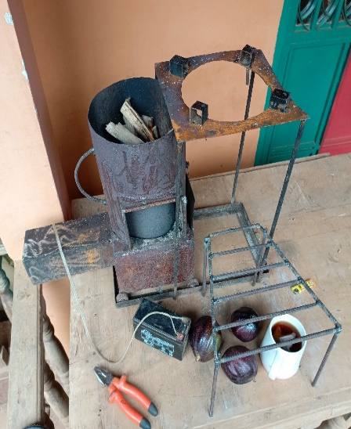 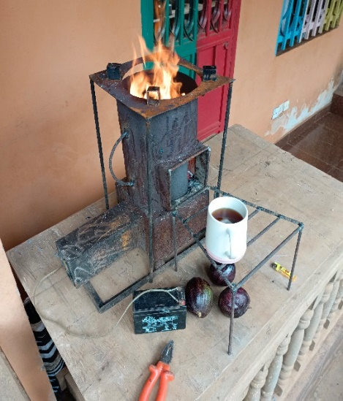

Figure 12a: TLUD operation, fuel in CC Figure 12b: Combustion Process

**3.3. Methods and Equations**

Thermal Performance metrics such as temperature, heat flow across combustion chamber, burning rate, specific fuel combustion, power consumed and thermal efficiency are the considered in the design process. Thus, formulae used to calculate these metrics are provided.

**3.3.1. Heat flow across the cylindrical wall of the combustion chamber**

Heat flow for a hollow cylinder is given as (Fourier’s law):

$Q_{r }= -KA\frac{dT}{dr}$ Equation 1

Where K is the thermal conductivity of the cylindrical material; A is the area of the walls of the cylinder or heating chamber across which heat transfer occur and; dT/dr is the radial temperature gradient across the walls. Tf and Ti are final and initial temperatures respectively. The subscripts ‘i’ and ‘o’ are the inside and outside surfaces of the cylinder respectively. From equation 1, $Q_{r }$ is independent of r and $T_{f}> T_{i}$. The equation can be integrated and rearranged to give:

$Q_{r }$**= $\frac{T_{f }–{ T}_{i}}{\frac{1}{2πKL}\ln\left(\frac{r_{o}}{r_{i}}\right)}$ = $\frac{T_{f }–{ T}_{i}}{\left\{\frac{\ln\left(\frac{r_{o}}{r_{i}}\right)}{2πKL}\right\}}$**  Equation 2

**3.3.2. Burning Rate**

Burning rate is the amount of fuel used in the experiment with respect to the time. It helps to show whether the stove is effective in utilising fuel. The formular for burning rate of wood is given as:

F = $\frac{1}{t}\left[\left(\frac{{100 X M}_{iW}}{100+ X}\right)-\left(\frac{M_{C}H_{C}}{H_{WD}}\right)\right]$ Equation 3

**3.3.3. Specific Fuel Consumption**

This is the amount of fuel consumed by the stove in bringing to boil the quantity of water required for the experiment. The specific fuel consumption (SFC) is expressed as:

SFC = $\left[\frac{M_{F}\left(1-X\right)-1.5M_{C}}{M_{iWT}}\right]$ Equation 4

**3.3.4.** Power Consumed for Boiling

This gives the energy used to boil the water used in the experiment. It expresses the rate at which the stove does its work. Formula is give in below.

PC = $\left[\frac{M_{F}\left(1-X\right)-1.5M_{C}}{60t}\right]C_{F}$ Equation 5

**3.3.6. Thermal efficiency of stove**

Efficiency is the ratio of the amount of energy given out with respect to the energy used (input) to obtained the output, expressed in percentage. It is expressed as, $η$ = Output/Input x100%

$η=\{\frac{S_{HW} x W_{i}\left(T_{f}-T_{i}\right)+L_{EW}\left(W_{i}-W_{f}\right)}{M_{f}C_{f}}\} x 100\%$ Equation 6

Performance of both rocket and TLUD operations were done using the standard water boiling test method (WBT), as it is the most popular test used to find out how effective and efficient a cook stove is in burning biomass fuel. Moisture content and weight of the bundle of wood used in the experiment were obtained using moisture content meter and mass scale respectively. clean water and cleaned pot, without a cover, were weighed and weights recorded. The experiment was carried out in an enclosed kitchen environment. the stove was ignited and pot placed on the pot rests only after a flame with constant temperature was obtained. The stove was ignited, and after a constant temperature of flame was obtained, pot was placed on pot rests. Experiment started at 10:30 in the morning at Gloucester, a village in Freetown, Sierra Leone. Initial temperature was recorded while final temperature was recorded after vigorous boiling of water in the pot. The pot and boiled water were taken off the stove and then weighed to find out the amount of water evaporated. Ash produced was weighed and flame of the unburnt wood was extinguished with sand to reduce burning after the experiment ended. Unburnt wood and charcoal were weighed after the pieces were shaken to remove sand used for putting out fire.

**4. Results and Discussions**

**4.1 Results Experimental Data**

This section presents calculations on burning rate, specific fuel consumption, power consumed for boiling and thermal efficiencies. It is important to note that water boiling test does not measure actual efficiency, but rather, it measures the thermal efficiency, which is vital, as heat transfer is essential in cookstoves. Parameters of the rocket and TLUD operations are presented in table 2. It is important to note that this stove has been used for the past two years since it was fabricated in February of 2023.

**4.1.1. Heat flow across the Cylindrical Wall of the Combustion Chamber, CC**

Fourier’s law was integrated and rearranged equation for heat flow for a hollow cylinder is given as:

$Q_{r }$**= $\frac{T_{f }–{ T}_{i}}{\left\{\frac{\ln\left(\frac{r_{o}}{r_{i}}\right)}{2πKL}\right\}}$** Equation 2

The combustion chamber is a cylindrical mild steel tube of internal radius 114mm and external radius 117mm (‘i’ and ‘o’ respectively), and a length of 308mm. Substitution of the associated parameters from table 2 into equation 1 gives:

Rocket design

$Q_{r }$ = $\frac{470-28}{\frac{1}{2*3.142*39*0.308}\ln\left(\frac{117}{114}\right)}$ = $\frac{442}{\frac{1}{75.483 }*0.0259}$ = $\frac{442}{\frac{0.0259 }{0.0132}}$ = $\frac{442}{1.962}$ = 225.280W

Natural draft

$Q_{r }$ = $\frac{520-28}{\frac{1}{2*3.142*39*0.308}\ln\left(\frac{117}{114}\right)}$ = $\frac{492}{\frac{1}{75.483 }*0.0259}$ = $\frac{492}{\frac{0.0259 }{0.0132}}$ = $\frac{492}{1.962}$ = 250.765W

Forced draft

$Q_{r }$ = $\frac{560-28}{\frac{1}{2*3.142*39*0.308}\ln\left(\frac{117}{114}\right)}$ = $\frac{552}{\frac{1}{75.483 }*0.0259}$ = $\frac{552}{\frac{0.0259 }{0.0132}}$ = $\frac{552}{1.962}$ = 281.345W

Calculations of heat flows across combustion chamber during forced draft was the highest, as this was due to higher rate of air flow into the fuel to produce fire required for combustion.

Table 2: Experimental and Fixed Parameters

|  |  |  |  |  |
| --- | --- | --- | --- | --- |
| No | **Experimental Parameter (Description)** | **Rocket** | **Natural draft** | **Forced draft** |
|  | **Maximum flame temperature** | 4700C | 5200C | 5600C |
| 1 | Initial mass of water, $M_{iwt}$ | 3kg | 3kg | 3kg |
| 2 | Final mass of water, $M_{fWT}$ | 2.7kg | 2.6kg | 2.25kg |
| 3 | Weight of water evaporated, MWEV | 0.3kg | 0.4kg | 0.75kg |
| 4 | Initial Temperature of water, | 280C | 280C | 280C |
| 5 | Final temperature of water, | 1000C | 1000C | 1000C |
| 6 | Mass of empty pot, $M_{P}$ | 2.5 Kg | 2.5 Kg | 2.5 Kg |
| 7 | Initial mass of fuel (wood), $M_{wfi}$ | 3kg | 3kg | 3kg |
| 8 | Mass of ash, $M_{A}$ | 0.1kg | 0.1kg | 0.07kg |
| 9 | Mass of charcoal, $M_{Ch}$ | $$0.6kg$$ | $$0.4kg$$ | 0.3 |
| 10 | Final mass of wood at the end, $M_{wff}$ | 1.7kg | 1.6kg | 1.43 |
| 11 | Mass of fuel wood consumed, $M_{WFB}$ | 0.6kg | 0.9kg | 1.2kg |
| 12 | Thermal efficiency | 39.55% | 48.68% | 52.48% |
| 13 | Moisture content of wood, X | 8% | 8% | 8% |
| 14 | Start-up time | 10 minutes | 8 minutes | 4 minutes |
| 15 | Time taken to boil | 11 minutes | 9 minutes | 6 minutes |
|  | **Fixed Parameters** | | | |
| 16 | Specific heat capacity of Charcoal, $C_{C}$ | 0.4 kcal/kg | 0.4 kcal/kg | 0.4 kcal/kg |
| 17 | Latent heat of evaporation of water, $L_{EW}$ | 2260 KJ/Kg | 2260 KJ/Kg | 2260 KJ/Kg |
| 18 | Thermal conductivity of mild steel, K | 39W/mK | 39W/mK | 39W/mK |
| 19 | Specific heat capacity of pot (Aluminium), $C_{P}$ | 0.9 KJ/Kg0C | 0.9 KJ/Kg0C | 0.9 KJ/Kg0C |
| 16 | Specific heat capacity of water, $C_{W}$ | 4.186 KJ/Kg0C | 4.186 KJ/Kg0C | 4.186 KJ/Kg0C |
| 20 | Calorific value of charcoal, CCH | 8000kcal/kg | 8000kcal/kg | 7500kcal/kg |
| 21 | Calorific value of fuel (wood), CWF | 4127.25 Kcal/Kg | 4127.25 Kcal/Kg | 4127.25 Kcal/Kg |

**4.1.2. Burning Rate**

Burining rate of wood is given as:

F = $\frac{1}{t}\left[\left(\frac{{100 X M}_{iWt}}{100+ X}\right)-\left(\frac{M_{Ch}C_{ch}}{C_{wf}}\right)\right]$ Equation 3

Substitution of the associated parameters from table 2 for rocket, natural and forced draft are carried out:

**Rocket design**

F = $\frac{1}{11 x 60}\left[\left(\frac{100 x 3}{100+ 0.08}\right)-\left(\frac{0.6 x 8000}{4127.25}\right)\right]$ = 0.00152[2.997 – 1.163] = 0.00279kg/s = 2.97g/s

**Natural draft**

F = $\frac{1}{9 x 60}\left[\left(\frac{100 x 3}{100+ 0.08}\right)-\left(\frac{0.4 x 8000}{4127.25}\right)\right]$ = 0.00185[2.997 – 0.775] = 0.00411kg/s = 4.11g/s

Forced draft

F = $\frac{1}{6 x 60}\left[\left(\frac{100 x 3}{100+ 0.08}\right)-\left(\frac{0.3 x 8000}{4127.25}\right)\right]$ = 0.0028[2.997 – 0.581] = 0.00676kg/s = 6.76g/s

Burning rate calculations show that the higher the time taken to burn fuel, the lower the burning rate. Also, higher charcoal yield resulted the lower burning rate. Thus, the rocket design has the lowest burning rate.

**4.1.3. Specific Fuel Consumption**

Substitution of the necessary data from table gives the following result.

SFC = $\left[\frac{M_{F}\left(1-X\right)-1.5M_{C}}{M_{iWT}}\right]$ Equation 4

Rocket design

SFC = $\left[\frac{3\left(1 - 0.08\right) - (1.5 x 0.6)}{3}\right]$ = $\left[\frac{2.76 - 0.9}{3}\right]$ = $\frac{1.86}{3}$ = 0.62 Kgwood/Kgwater

Natural draft

SFC = $\left[\frac{3\left(1 - 0.08\right) - (1.5 x 0.4)}{3}\right]$ = $\left[\frac{2.76 - 0.6}{3}\right]$ = $\frac{2.16}{3}$ = 0.72 Kgwood/Kgwater

Forced draft

SFC = $\left[\frac{3\left(1 - 0.08\right) - (1.5 x 0.3)}{3}\right]$ = $\left[\frac{2.76 - 0.45}{3}\right]$ = $\frac{2.31}{3}$ = 0.77 Kgwood/Kgwater

Specific fuel consumption varies with mass of charcoal; given that it is the only variable that changed in the three experiments. Thus, the higher the mass of charcoal produced, the lower the specific fuel consumption, as can be seen for the rocket design.

**4.1.4. Power Consumed for Boiling**

PC = $\left[\frac{M_{wfi}\left(1-X\right)-1.5M_{ch}}{60t}\right]C_{wf}$ Equation 5

The substitution of the associated parameters from table 3 gives:

Rocket design

PC = $\left[\frac{3\left(1 - 0.08\right) - 1.5*0.6}{60*11}\right]$*4127.25 = $\left\{\frac{2.76 - 0.9}{60 x 11}\right\}*4127.25$ = 0.00282( $4127.25)$ = 11.631W

PC (natural draft) = $\left[\frac{3\left(1 - 0.08\right) - 1.5*0.4}{60*9}\right]$*4127.25 = $\left\{\frac{2.16}{60 x 9}\right\}*4127.25$ = 0.004( $4127.25)$ = 16.51W

**PC (Forced draft) = $\left\{\frac{2.76 - 0.3 }{60 x 6}\right\} x 4127.25$**  = 0.00642 x $4127.25$ = 26.48W

The rocket design with the longest boiling time and highest charcoal production resulted in lower power consumed for boiling, in essence, these two factors contribute to power consumption.

**4.1.5. Thermal efficiency of stove**

$η= \frac{S_{HW} x W_{i}\left(T_{f}-T_{i}\right)+L_{EW}\left(W_{i}-W_{f}\right)}{M_{f}C_{f}}$ Equation 6

$η= \frac{C_{w} x M_{iWT} \left(T_{f}-T_{i}\right)+L_{EW}\left(M_{iWT} -M_{fWT}\right)}{M_{fwc}C_{wf}}$

When data from table 2 were substituted in equation 6, thermal efficiencies:

Rocket design

= $\frac{4.186 x 3\left(100 - 28\right) + 2260\left(3 - 2.7\right)}{0.6 x 4127.25}$ $= \frac{301.392 + 678}{2476.35}=\frac{979.392}{2476.35}$ = 39.55%

$Natural draft η$ = $\frac{4.186 x 3\left(100-28\right)+2260\left(3-2.6\right)}{0.9 x 4127.25}$ $= \frac{1808.176}{3714.525}$ = 48.68%

$Forced draft η=$ = $\frac{4.186 x 3\left(100-28\right)+2260\left(3-2.25\right)}{1.2 x 4127.25}$ = $\frac{2599.176}{4952.70}$ = 52.48%

Thermal efficiency is affected by mass of fuel used and mass of water evaporated; higher water evaporated and fuel used lead to higher thermal efficiency, as can be seen for the forced draft. On the contrary, the lower evaporation and lower fuel use result in lower efficiency for the rocket design.

Calculations show that thermal efficiencies of rocket, natural draft and forced draft were 39.55%, 48.68 % and 52.48% respectively. Forced draft has the highest efficiency, which is due to the velocity of the air entering the gasification phase of the process.

**4.2. Discussion**

Heat flows across combustion chamber during forced draft was the highest, which can be attributed to higher rate of air flow into the fuel to produce fire required for combustion. This finding is similar to finding obtained by the following researchers (Bryden et al., 2005; Roth, 2011). Burning rate from the forced draft recorded the highest, 6.76g/s, which can be associated with the volume of air flow rate in the combustion chamber, leading to the least time taken to boil, 6 minutes. This result runs parallel to the results obtained by Ayaz et al. (2022) in which they state that improved cookstove can lead to better burning rate and fuel efficiency. Careful design and fabrication of these stoves, allows solid biomass fuels to be burnt more efficiently with less pollutants (Panwar, 2009; Dresen et al., 2014; Ojolo et al., 2012; Getahun, 2019; Suttar, 2022). This study adopted cautious design methods including scientific principles, which led to better efficiency in terms of less fuel usage and better heat transfer. Results obtained by Pope et al. (2021) show that improved biomass stoves reduced PM2.5 by 50%. Though this study does not measure the amount of pollutants produced during operation, it can be suggested that, since efficiency and fuel usage were reduced, it means that pollutants are also reduced. Thermal efficiency of three-stone fire stove is up to 20% (Bailis, 2015), While that for mud stove is 29% (Still et al., 2011).For this study, the least thermal efficiency, which is that obtained for rocket stove, 39.55%, was higher than the efficiencies of both stoves just mentioned.

**5. Conclusion**

The improved biomass stove designed for this study was done to make improvements on the traditional and popular wonder stoves widely used in Sierra Leone by increasing safety and thermal efficiency but reducing fuel use and pollutants, leading to less cost on fuel. This stove works on both can be used as rocket and Top-Lit Up Draft principles of combustion, which makes it suitable for different solid biomass fuels to be used, and to continuous operation. The use of a stove equipped with a forced draft mechanism facilitates enhanced mixing of combustible gases and oxygen, promoting more efficient burning of fuel and ultimately lowering emissions, thus, smoke and other harmful emissions be cut down through better heat transfer leading to improved combustion efficiency, which will reduce the amount of fuel needed. Thermal efficiency and burning rate of this stove shows favourable results, which will reflect positively on both the environment and users, in the sense that, less trees would be cut down (a reduction in deforestation) and less money spent on purchasing solid biomass fuel. Better cookstoves design leads better thermal efficiency and less fuel consumption, therefore, the use of this stove can enhance lives of community dwellers as regards inhalation of less pollutants leading to better health. These results are reflective of the requirement of World Health Organisation regarding better access to clean cooking.

**References**

Abanikannda, J.O. and A. Dantani (2021). Fuel wood exploitation and sustainable forest management. J. Appl. Sci. Environ. Manage., 25: 987-993.

Adem, K. D. Ambie, D. A. Arnavat, M. P. et al. (2019). First injera baking biomass gasifier stove to reduce indoor air pollution, and fuel use. AIMS Energy, vol. 7, no. 2, pp. 227–245.

Anderson, Reed, and Wever (2007). “Micro-Gasification: What it is and why it works” http://www.hedon.info/docs/BP53-Anderson-14.pdf

Ayaz, A.; Sajid, J.; Ahmed, N. (2022). Performance Investigation of Novel Improved Cooking Stove Model for Cold Rural Populations. Eng. Proc. 2022, 12, 86. https://doi.org/10.3390/

Bailis R, Drigo R, Ghilardi A, Masera O. (2015). The carbon footprint of traditional woodfuels. Nature Clim Change; 5: 266–72.

Bailis, R. (2023). “Scaling Up Gas and Electric Cooking in Lowand Middle-Income Countries: Climate Threat or Mitigation Strategy with Cobenefits?” Environmental Research Letters 18(3), 034010. https://doi. org/10.1088/17489326/acb501.

Balat, M., Ayar, G. (2005). Biomass energy in the world, use of biomass and potential trends. Energy Sources 27, 931–940.

Baldwin, S., Geller, H., Dutt, G., Ravindranath, N. (1985). Improved wood burning cookstoves: signs of success. Ambio 14(4), 280–287.

Bamwesigye, D. Kupec, P. Chekuimo G. et al. (2020). Charcoal and wood biomass utilization in Uganda: the socioeconomic and environmental dynamics and implications. Sustainability, vol. 12, no. 20, p. 8337.

Baqir, M., R. Kothari and R.P. Singh (2019). Fuel wood consumption, and its influence on forest biomass carbon stock and emission of carbon dioxide. A case study of Kahinaur, District Mau, Uttar Pradesh, India. Biofuels, 10: 145-154.

Belonio, A.T.: Rice Husk Gas Stove Handbook. Bioenergylists.Org (2005)

Berrueta, V. M., Edwards, R. D., Masera, O. R. (2008). Energy performance of wood-burning cookstoves in Michoacan, Mexico. Renew. Energy 33(5), 859–870.

Bond TC, Doherty SJ, Fahey DW, et al. (2013). Bounding the role of black carbon in the climate system: A scientific assessment. Journal of Geophysical Research: Atmospheres 2013; 118: 5380–552. References Acknowledgments

Bryden, M., D. Still, P. Scott, G. Hoffa, D. Ogle, R. Bailis, K. Goyer, et al. (2005). Design principals for wood burning cook stoves, Aprovecho Research Center.

Cooke, P.; Kohlin, G.; Hyde, W.F. (2008). Fuelwood, forests and community management—Evidence from household studies. Environ. Dev. Econ. 2008, 13, 103–135

Das, B. J. Das, S. Boro, R. N. Bishal, P. B. and Ashim, K. (2021). Study and fabrication on heat efficient stove of low smoke emission. Journal of Ae Institution of Engineers (India), Series E.

Dayton, D. (2002). Review of the Literature on Catalytic Biomass Tar Destruction: Milestone Completion Report, December 2002

Ecolocalizer http://ecolocalizer.com/2009/04/29/black-soot-time-for-a-fair-discussion/ Accessed 16TH December, 2024

Getahun, Eshetu; Tessema, Dawit and Gabbiye, Nigus (2019). Design and Development of Household Gasifier Cooking Stoves: Natural Versus Forced Draft. Springer nature. https://doi.org/10.1007/978-3-030-15357-1_25

Flores, W.C.; Bustamante, B.; Pino, H.N.; Al-Sumaiti, A.; Rivera, S. (2020). A National Strategy Proposal for Improved Cooking Stove Adoption in Honduras: Energy Consumption and Cost-Beneﬁt Analysis. Energies 2020, 13, 921. [CrossRef]

Floess, E., Grieshop, A., Puzzolo, E., Pope, D., Leach, N., Smith, C. J., Gill-Wiehl, A., Landesman, K., Bailis, R. (2023). “Scaling Up Gas and Electric Cooking in Low- and Middle-Income Countries: Climate Threat or Mitigation Strategy with Co-beneﬁts?” Environmental Research Letters 18(3), 034010. https://doi.org/10.1088/17489326/acb501.

Global alliance for clean cookstove (2018). Handbook for Biomass Cookstove Research, Design, and Development, Practical Guide to Implementing Recent Advances. https://www.academia. edu/23874923/Design

Haines, A., A.J. McMichael, K.R. Smith, I. Roberts and J. Woodcock et al. (2009). Public health benefits of strategies to reduce greenhouse-gas emissions: Overview and implications for policy makers. Lancet, 374: 2104-2114.

Huangfu, Y., Li, H., Chen, X., Xue, C., Chen, C., Liu, G. (2014). Effects of moisture content in fuel on thermal performance and emission of biomass semi-gasified cookstove. Energy. Sustain. Dev. 21(1), 60–65 (2014)]

Jetter, K.P., 2009. JJ, Solid-fuel household cook stoves: Characterization of performance and emissions. Biomass-.-. Bioenergy 294–305.

International Energy Agency, IEA, IRENA, UNSD, World Bank, WHO. (2023). Tracking SDG 7: The Energy Progress Report. World Bank, Washington DC.

Janssen R. and Rutz, D. (2012). Bioenergy for Sustainable Development in Africa, Springer Science for Business Media B.V.

Kang, S.; Chaoliu, L.; Wang, Q.; Zhang, Q.; Cong, Z. (2009). Total suspended particulate matter and toxic elements indoors during cooking with yak dung. Atmos. Environ. 2009, 43, 4243–4246

Kar, A., Rehman, I.H., Burney, J., Puppala, S.P., Suresh, R., Singh, L., Ramanathan, V., 2012. Real-time assessment of black carbon pollution in Indian households due to traditional and improved biomass cookstoves. Environ. Sci. Technol. 46 (5)

Kshirsagar, M.P., Kalamkar, V.R., 2014. A comprehensive review on biomass cookstoves and a systematic approach for modern cookstove design. Renew. Sustain. Energy Rev. 30, 580–603. <https://doi.org/10.1016/j.rser.2013.10.039>.

Kumar, Manoj, Kumar, Sachin, Tyagi, S.K. (2013). Design, development and technological advancement in the biomass cookstoves: A review. Renew. Sustain. Energy Rev. 26, 265–285. https://doi.org/10.1016/j.rser.2013.05.010

Lahai, U.M.; Ofosu, E.A. Gyamfi, S. Diawuo, F.A. Kallon, A.P. Technical considerations for the design and selection of improved cookstoves : a review, Int. J. Eng. Trends Technol. 70 (2022) 439–449, https://doi.org/10.14445/ 22315381/IJETT-V70I12P242. Volume.

Łaska, G. and A.R. Ige (2023). A review: Assessment of domestic solid fuel sources in Nigeria. Energies, Vol. 16. 10.3390/en16124722.

Masera, O.; Edwards, R.; Arnez, C.A.; Berrueta, V.; Johnson, M.; Bracho, L.R.; Riojas-Rodríguez, H.;

MacCarty, N., Ogle, D., Still, D., Bond, T., Roden, C., 2008. A laboratory comparison of the global warming impact of five major types of biomass cooking stoves. Energy Sustain. Dev. 12 (2), 56–65.

Merklein, K., Fong, S.S., Deng, Y. (2016). Biomass Utilization. In: Biotechnology for Biofuel Production and Optimization, pp. 291–324.

Mirza, U.K.; Ahmad, N.; Majeed, T. (2008). An overview of biomass energy utilization in Pakistan. Renew. Sustain. Energy Rev. 2008, 12, 1988–1996.

Murray CJL, Aravkin AY, Zheng P, et al. (2019). Global burden of 87 risk factors in 204 countries and territories, 1990–2019: a systematic analysis for the Global Burden of Disease Study 2019. The Lancet 2020; 396: 1223–49.

Musiliu Ademuiwa (2024). Development of an Improved Biomass Stove and Performance Evaluation Using Three Types of Briquettes. Singapore Journal of Scientific Research, 14 (1): 01-12.

Nyika, J. Adediran, A. A. Olayanju, A. A. Olanrewaju, S. E. and Odikpo, F. (2020). Potential of biomass in Africa and the debate on its carbon neutrality,” in Biomass, pp. 1–19, IntechOpen, London, UK.

Ojolo, S.J., Abolarin, S.M., Adegbenro, O. (2012). Development of a laboratory scale updraft gasifier. Int. J. Manuf. Syst. 2(2), 21–42.

Ozokwelu, D., Zhang, S., Okafor, O.C., Cheng, W., Litombe, N. (2017). Biomass utilization. In: Novel Catalytic and Separation Processes Based on Ionic Liquids, pp. 203–220.

Panwar, N.L. (2009). Design and performance evaluation of energy efficient biomass gasifier based cookstove on multi fuels. Mitig. Adapt. Strateg. Glob. Chang. 14(7), 627–633.

Pope D, Johnson M, Fleeman N, et al. Are cleaner cooking solutions clean enough? A systematic review and meta-analysis of particulate and carbon monoxide concentrations and exposures. Environmental Research Letters 2021; 16: 083002.

Pottmaier, D., Costa, M., Oliveira, A.A.M., Snape, C. (2015). The profiles of mass and heat transfer during pinewood conversion. Phys. Procedia 66, 285–288.

Rasoulkhani, M. M. Ebrahimi-Nik, M. H. Abbaspour-Fard, and Rohani, A. (2018). Comparative evaluation of the performance of an improved biomass cook stove and the traditional stoves of Iran. Sustainable Environment Research, vol. 28, no. 6, pp. 438–443.

Roth, C. (2011). Micro-gasification: cooking with gas from biomass. Gasification 1, 8–35

Samal, C. Mishra, P. C. Mukherjee, S. and Das, D. (2019). Evolution of high performance and low emission biomass cookstoves-an overview, AIP Conference Proceedings, vol. 2200, p. 220021.

Segun, Bello Raphael; Olorunnisola, Abel Olajide; Omoniyi, Temidayo Emmanuel and Onilude,

Smith, K. (2007). Impact of Patsari improved cookstoves on indoor air quality in Michoacán, Mexico. Energy Sustain. Dev. 2007, 11, 45–56.

Still, D., MacCarty, N., Ogle, D., Bond, T., Bryden, M., 2011. Test results of cook stove

performance. Aprovecho Resarch Center. Shell Foundation, United States Environmental Protection Agency, p. 126.

Stoner O., Lewis J., Martínez, I. L., Gumy, S., Economou, T., Adair-Rohani, H. (2021). Household cooking fuel estimates at global and country level for 1990 to 2030. Nat Commun 2021; 12: 5793.

Teixeira, T.B., R.A.G. Battistelle, A.A. Teixeira, E.B. Mariano and T.E.C. Moraes (2022). The sustainable development goals implementation: Case study in a pioneer Brazilian municipality. Sustainability, Vol. 14. 10.3390/su141912746.

Sutar, K.B., Kohli, S., Ravi, M.R., Ray, A., 2015. Biomass cookstoves: A review of technical aspects. Renew. Sustain. Energy Rev. 41, 1128–1166. https://doi.org/ 10.1016/j.rser.2014.09.003.

Sutar, Kailasnath B. (2022). Energy Efficiency, Emissions and Adoption of Biomass Cookstoves.Alternative Energies and Efficiency Evaluation. DOI: http://dx.doi.org/10.5772/intechopen.101886

Tidze, V., Ibrahim, M. and Issac, T. (2016). Dynamics of household energy and cooking stoves in maroua, far north region of Cameroon. Journal of Scientific Research and Reports, vol. 9, no. 4, pp. 1–13.

Vitali, F., (2011). The Centrafricain improved stove as appropriate technology for household cooking in the Logone Valley (Chad-Cameroon). [Online] Available: <http://www.ing.unibs.it/~cetamb/images/stories/SmartCookingVA%20-%20Vitali.pdf> Accessed on the 16th of December, 2024

Wang, J., H.H. Lou, F. Yang and F. Cheng, 2016. Development and performance evaluation of a clean-burning stove. J. Cleaner Prod., 134: 447-455.

WHO, World Health Organisation (2018). “Improving the health impacts of airports,” Bulletin of the World Health Organization, vol. 96, pp. 518-519.

World Health Organisation (2024). Which cooking fuels and stoves are most beneficial to global health? (Clean Household Energy Solutions Toolkit) WHO/HEP/ECH/AQE/2024.1 © WHO 2024.

World Health Organization, WHO (2021). global air quality guidelines: particulate matter (PM2.5 and PM10), ozone, nitrogen dioxide, sulfur dioxide and carbon monoxide. World Health Organization, 2021 https://apps.who.int/iris/handle/10665/345329 (accessed Dec 10, 2021).

Yunusa, S.U., E. Mensah, K. Preko, S. Narra and A. Saleh et al. (2023). Biomass cookstoves: A review of technical aspects and recent advances. Energy Nexus, Vol. 11. 10.1016/j.nexus.2023.100225.