Original Research Article
Organizational Justice and Quality of Work-Life on Organizational Citizenship Behavior (OCB) with Organizational Commitment as a Mediation Variable

.
ABSTRACT

Objective: This study aims to analyze the influence of Organizational Justice and Quality of Work-Life on Organizational Citizenship Behavior (OCB) with Organizational Commitment as a Mediation Variable, this case study is intended for all population members of the Ciamis Regency Education Office.
Study Design: This research uses a quantitative approach with primary data obtained through questionnaires in the form of direct writing. All of these research items were measured using a likert scale of 1 to 5. This study used saturated sampling techniques.
Place of Study: The population of this study is a member of the Ciamis Regency Education Office.
Methodology: This study used saturated sampling so that the sample amounted to 105. Data processing uses the SmartPLS 4 application with the Structural Equation Modeling-Partial Least Square (SEM-PLS) technique. Data analysis was carried out using loading factor, validity test and reliability test, Discriminant Validity: Fornell-Larcker, Inner model with R-Square and hypothesis test.
Results: The findings of the study show that Organizational Justice, Quality of Work-Life, and Organizational Commitment have a significant positive effect on Organizational Citizenship Behavior. Meanwhile, Organizational Commitment mediating Organizational Justice has a negative effect on Organizational Citizenship Behavior. Then the Organizational Commitment mediates the Quality of Work-Life which has a positive effect on Organizational Citizenship Behavior.
Conclusion: Based on the results of this study, it was found that organizational justice, quality of work-life, and organizational commitment have an influence on organizational citizeship behavior In addition, organizational commitment mediates the quality of work-life to OCB, but does not play a mediator role in organizational justice and OCB.

Keywords: Organizational Justice, Quality of Work-Life, Organizational Citizenship Behavior, Organizational Commitment

1. INTRODUCTION

Education has an important role in the progress of a nation (Muhtar & Wahyudi, 2024). Education plays a role in developing skills, shaping character, and creating a dignified nation's civilization to educate the nation's life and form individuals who have faith, piety, noble character, intelligence, independence, creativity, and responsibility as democratic citizens (Perdani et al., 2024). Based on this, the government through the Education Office at the national, provincial, and district/city levels continues to play a role in making contributions, including in overcoming the problems of education personnel and educational facilities (Handayani et al., 2024).
Human resources (HR) is one of the most important factors that are integral in a company or organization (Nurjanah et al., 2020). Human resources are an important element for an organization because the success or effectiveness of an organization is highly dependent on the quality and performance of its human resources (Sara et al., 2023). Therefore, it is important for organizations to be able to manage employees as human resources properly and wisely.
The Ciamis Regency Education Office as one of the government agencies that plays an important role in carrying out strategic responsibilities in organizing education. The public's perception of the services provided by the Ciamis Regency Education Office is greatly influenced by public satisfaction with the good or bad services provided. This is a challenge in carrying out services to the community that demands excellent service. So that the quality of human resources is an aspect that must be considered
Today, a new view is developing that sees employees not only as resources, but also as valuable assets or capital of the organization that need to be managed and developed (Nurjanah et al., 2020). Good human resource management in the organization will make it easier for the organization to achieve its goals. An organization's ability to achieve its goals is determined not only by the employee's behavior in carrying out his duties according to his job description, but also by the extra behavior of the employee's role outside of his or her main duties (Rimatanti & Darmawan, 2023). Extra-role behavior in such employees is known as Organizational Citizenship Behavior (Nurjanah et al., 2020).
Organizational Citizenship Behavior (OCB) is an individual's behavior that is independent and not directly related to the main task, but can contribute to improving the performance of the organization (Hermawan et al., 2024). In other words, OCB is one of the important aspects that support the effectiveness and productivity of the organization. OCB characteristics reflect positive employee behaviors that go beyond the duties, roles, and job descriptions that the organization requires (Nurjanah et al., 2020). Employees who have OCB behavior will show exceptional dedication, drive, and insight, exceeding the duties required for the benefit of the organization (Asgari et al., 2020).
The low OCB behavior in local government employees can be used as the focus of this study. The phenomenon of low levels Organizational Citizenship Behavior (OCB) in local government agencies can be caused by several factors, such as the low desire of employees to help each other in the work environment or because each employee feels able to complete his or her own tasks without the need for the help of colleagues. If this trend continues, it could be that the work culture in the office environment emphasizes more on individualism than teamwork. Therefore, it is necessary to further research the factors that affect the low OCB, whether it comes from Organizational Justice which builds perceptions in organizing employees, work systems, or individual factors of each employee. that are fixed. Low employee desire to play an extra role can negatively impact relationships between employees, increase non-compliance with organizational rules, trigger envy of colleagues, cause delays in task completion, decrease organizational stability, and reduce individual and organizational performance (Zahra & Siregar, 2023).
In an organization, OCB can be influenced by Organizational Justice (Romadhona & Prawitowati, 2024). Organizational justice is the employee's perception of the justice received in an organization (Manihuruk, 2023). If an organization has a high level of fairness, then the planning and implementation of the decision-making process and its results will be done fairly (Lim & Setyawan, 2023). By showing a fair and equitable nature, employees will tend to work according to what is expected when carrying out their work (Kamil & Rivai, 2021). Research from Bastyant et al., (2024), Kamil & Rivai (2021), Lim & Setyawan (2023), Romadhona & Prawitowati (2024), and Syafriyanti & Anisah (2021) revealed that organizational justice has a positive and significant effect on OCB. The existence of equal treatment between employees is needed to foster the desire to improve OCB's behavior (Kamil & Rivai, 2021). While research from Nurhafni et al., (2022) shows that organizational justice has no effect on OCB.
Moreover Quality of Work Life (QWL) is also a factor that can affect OCB (Rimatanti & Darmawan, 2023). QWL is an overview of the extent to which human needs are met in the work environment (Agustina et al., 2022). QWL also refers to the overall well-being of employees in the workplace. QWL that is optimally designed will be able to have a positive impact on employees and the organization (Dimpu et al., 2024) Quite a lot of research links the influence Organizational Justice and QWL against Organizational Citizenship Behavior (OCB), but there are still differences in the results of the research. For example, research from Bastyant et al., (2024), Kamil & Rivai (2021), Lim & Setyawan (2023), Romadhona & Prawitowati (2024), and Syafriyanti & Anisah (2021) reveals that Organizational Justice has a positive and significant effect on OCB. The existence of equal treatment between employees is needed in fostering the desire to improve OCB behavior (Kamil & Rivai, 2021). While research from Nurhafni et al., (2022) shows that Organizational Justice has no effect on OCB. Research from Purwanto et al., (2021, 2023), Rimatanti & Darmawan (2023), Sumarsi & Rizal (2020), and Widodo et al. (2023) shows that QWL has a positive and significant effect on OCB. Prioritizing QWL will also benefit employees and the organization as a whole (Mehra, 2023). However, there is research from Hidayah & Hendarsjah (2021) which indicates that OCB levels cannot be affected by QWL.
From the explanation above, it can be seen that there are still inconsistencies between the relationship Organizational Justice and QWL against OCB. The researcher tries to provide a solution to the research gap by adding a mediating variable. Organizational commitment is considered to be able to mediate the relationship between Organizational Justice and QWL against OCB. Organizational commitment can form the value of positive attitudes from employees so that it can strengthen the relationship between fairness in organization and the quality of employee life to be able to show extra role behavior. Research from Firmansyah et al., (2022), Hermawanto et al., (2022), Nurjanah et al., (2020), Purwanto (2022), and Widodo et al., (2023) shows that the sense of commitment from employees to the organization is able to improve OCB behavior in employees. Employees with levels organizational commitment those who are high tend to indicate high OCB behavior Purwanto et al., (2023)) Research from Rato & Rahmat, (2020) explains that Organizational Justice affects organizational commitment, in addition to research from Asriani et al., (2023) Producing quality of work life affects organizational commitment.
Previous research by Scarlet Witch (2024) shows that organizational commitment able to act as a mediator who strengthens the relationship between Organizational Justice against OCB. while research according to Ulum et al., (2024) explains that organizational commitment can mediate the influence of QWL on OCB.
This research develops the results of research from Danisya Ira Asdi P utri; Siti Nurmayanti, (2024) The researcher added organizational commitment as a mediator. Previous research examined the services of consultants in hotel and residential design projects. Meanwhile, this research tries to research in government agencies, namely the education office. This study is the first comprehensive study to examine the relationship between Organizational Justice and Quality of Work-Life towards Organizational Citizenship Behavior (OCB) with organizational commitment as a mediation variable. This research has a novelty where there are still few studies that discuss organizational commitment in its role becomes a mediation variable.

2. Literature Review

2.1 Social Exchange Theory

Social Exchange Theory (SET) is the basis for explaining the relationship between independent variables to OCB in this study. SET highlights the nature of interpersonal relationships and social interactions, where a person who receives a good influence or perception is expected to show gratitude and reciprocate it when the opportunity arises (Blau, 1964). When employees have a relatively positive influence or perception, they tend to reciprocate in a practical and effective way (Rimatanti & Darmawan, 2023). In addition, employees who feel that the organization cares about their well-being and engages in responsible social activities, employees will show a positive attitude and extra role behavior (Liaquat & Mehmood, 2017). Based on this explanation, it can be said that when employees feel support, fairness, and fairness from the organization and its leaders, they are more likely to show extra-role behaviors that support the effectiveness of the organization. This results in an understanding that the relationship between employees and the organization is based on a reciprocal aspect, where the nature of this mutually beneficial relationship can determine the behavior of employees towards their organization (Liaquat & Mehmood, 2017).
Organizational Citizenship Behavior (OCB) sourced from the framework Social Exchange Theory (Hermanto et al., 2024). Therefore, SET can be the basis for explaining the relationship between independent variables to OCB in this study. SET highlights the nature of interpersonal relationships and social interactions, where a person who receives a good influence or perception is expected to show gratitude and reciprocate it when the opportunity arises (Blau, 1964). When employees have a relatively positive influence or perception, they tend to reciprocate in a practical and effective way (Rimatanti & Darmawan, 2023). In addition, employees who feel that the organization is fair and care about welfare and engage in responsible social activities, employees will show a positive attitude and extra role behavior (Liaquat & Mehmood, 2017). Based on this explanation, it can be said that when employees feel support, fairness, and attention from their organization, they are more likely to show extra-role behaviors that support the effectiveness of the organization.

2.2 Organizational Citizenship Behavior

Organizational Citizenship Behavior (OCB) is defined as voluntary behavior that involves the actions of more employees to support the progress of their organization (Novianti, 2021). OCB can be described as behavior outside of the role that employees voluntarily perform, that goes beyond their formal duties, but contributes to the effectiveness and efficiency of the organization in achieving its goals Widodo et al., (2023). OCB also refers to an individual's social behavior in the workplace that exceeds expectations, such as voluntarily helping a coworker during breaks or outside of working hours (Hermawan et al., 2024). OCB can be measured using several indicators from Podsakoff et al., (2000) which includes mutually helpful behavior, sportsmanship, loyalty to the organization, obedience to the organization, individual initiative, good citizenship, and self-development.
The basis that distinguishes OCB from other activities is that they are voluntary or based on personal choice, where these activities are outside the job description and have a positive impact on the organization (Rimatanti & Darmawan, 2023). Employees with OCB voluntarily and spontaneously show positive behavior without expecting rewards from the organization (Nurjanah et al., 2020). Employees with a high OCB level will later show improved performance, a friendlier and more sociable attitude, and accept assigned tasks without complaints or debates (Purwanto, 2022).

2.3 Organizational Justice and Organizational Citizenship Behavior

Organizational justice defined as the equal and fair treatment that an individual receives in his or her workplace (Lim & Setyawan, 2023). The existence of equal treatment between employees is necessary in fostering the desire to improve OCB behavior (Kamil & Rivai, 2021). Individuals who feel that there is justice in the organization tend to have a positive attitude towards the organization, including OCB's behavior (Lim & Setyawan, 2023).
Organizational justice has an important role when the award given is in accordance with the field of work and deserves to be accepted by employees in the work environment (Bastyant et al., 2024). According to Flint et al., (2012), Organizational Justice It can be measured for 4 dimensions including distributive justice, interpersonal justice, procedural justice, and informational justice. By showing an even and fair nature, employees will tend to work according to what is expected when carrying out their work (Kamil & Rivai, 2021). Research from Bastyant et al., (2024), Kamil & Rivai (2021), Lim & Setyawan (2023), Romadhona & Prawitowati (2024), and Syafriyanti & Anisah (2021) reveals that Organizational Justice has a positive and significant effect on OCB. The existence of equal treatment between employees is necessary in fostering the desire to improve OCB behavior (Kamil & Rivai, 2021).

H1: Organizational Justice has a positive and significant effect on Organizational Citizenship Behavior

2.4 Quality of Work-Life and Organizational Citizenship Behavior

Quality of Work-Life (QWL) is a management system approach in an organization that aims to improve the quality of life of employees in the work environment simultaneously and sustainably (Hermanto et al., 2024). If employees do not get a good quality of work life, such as. appropriate compensation and conducive work environment, they will not be motivated or have the opportunity to grow, which will hinder the formation of a positive OCB (Sumarsi & Rizal, 2020). QWL is an overview of the extent to which human needs are met in the work environment (Agustina et al., 2022). Sirgy et al., (2001) revealed that QWL can be measured by several dimensions of measurement such as safety and health needs, social, family and economic needs, rewards and recognition, self-actualization, creativity, and self-development. QWL that is optimally designed is expected to have a positive impact on employees and the organization (Hermanto et al., 2024). Research from Purwanto et al., (2021, 2023), Rimatanti & Darmawan (2023), Sumarsi & Rizal (2020), and Widodo et al., (2023) shows that QWL has a positive and significant effect on OCB. Prioritizing QWL will also benefit employees and the organization as a whole (Mehra, 2023).

H2: Quality of Work-Life has a positive and significant effect on Organizational Citizenship Behavior

2.5 Organizational Commitment and Organizational Citizenship Behavior

Organizational commitment is the willingness of individuals to bond and show loyalty to the organization because they feel involved in various organizational activities (Rimatanti & Darmawan, 2023). Organizational commitment It is also defined as an employee's level of confidence in an organization and its goals, along with the desire to remain part of the organization, which reflects an attitude of loyalty to the organization (Nurjanah et al., 2020). Organizational commitment can be measured by Meyer & Allen (1991) Three-Component Model of Commitment which includes affective, Continuationand Regulations. Organizational commitment as part of the attitude influencing a variety of essential behaviors that are necessary for the organization to function effectively (Nurjanah et al., 2020).
Organizational commitment shown by employees has a positive impact on OCB's behavior (Fitri & Endratno, 2021). When employees show a sense of belonging and loyalty as a form of their commitment to the organization, it tends to increase OCB's behavior, which is reflected in the positive actions that employees show towards the organization Firmansyah et al., (2022). The explanation shows that strong commitment can encourage employees to be more proactive in supporting the achievement of organizational goals through extra role contributions. Research from Firmansyah et al., (2022), Hermawanto et al., (2022), Nurjanah et al., (2020), Purwanto (2022), and Widodo et al., (2023) shows that organizational commitment has a positive and significant effect on OCB. Employees with a strong level of commitment tend to show good organizational family behavior, and the higher the employee's commitment, the higher the OCB level shown (Hermawan et al., 2024).

H3: Organizational commitment has a positive and significant effect on Organizational Citizenship Behavior
2.6 The Role of Organizational Commitment Mediation

Employees who feel that policies, resource distribution, and treatment in the workplace are given fairly, they tend to have a higher level of commitment to the organization (Kamil & Rivai, 2021). This strong commitment then encourages them to exhibit extra-role behaviors, such as helping coworkers, obeying organizational rules, and contributing more than their primary duties (Romadhona & Prawitowati, 2024). Thus, Organizational Justice not only has a direct impact on increasing OCB, but also indirectly through increasing employee commitment to the organization. Previous research from Kamil & Rivai (2021), Lim & Setyawan (2023), Romadhona & Prawitowati (2024), and Syafriyanti & Anisah (2021) states that organizational commitment able to strengthen the relationship between Organizational Justice and OCB. When individuals feel they are being treated fairly, they tend to reciprocate with positive attitudes and behaviors that benefit the organization in the form of OCB (Syafriyanti & Anisah, 2021).

H4: Organizational Commitment mediates the influence of Organizational Justice on Organizational Citizenship Behavior

Quality of work-life (QWL) is a management viewpoint that focuses on employees, jobs, and organizations to improve organizational effectiveness (Ulfa et al., 2021). When employees feel that their work environment supports well-being and professional development, they tend to have a higher emotional attachment to the organization (Nurjanah et al., 2020). This attachment is then reflected in the increase organizational commitment, which can ultimately encourage them to exhibit extra-role behaviors, such as helping colleagues, working more than primary responsibilities, and voluntarily supporting organizational goals (Ulum et al., 2024).
Previous research from Ulfa et al., (2021) and Ulum et al., (2024) shows that organizational commitment can strengthen relationships Quality of Work-Life towards Organizational Citizenship Behavior. This indicates that a good QWL not only has a direct impact on OCB, but can also increase employee commitment which then encourages them to contribute more to the organization. In other words, employees who feel comfortable, valued, and have opportunities for development will have a high level of commitment, so they are more motivated to show OCB behavior in the workplace (Ulfa et al., 2021).

H5: Organizational Commitment mediates the influence of Quality of Work-Life on Organizational Citizenship Behavior

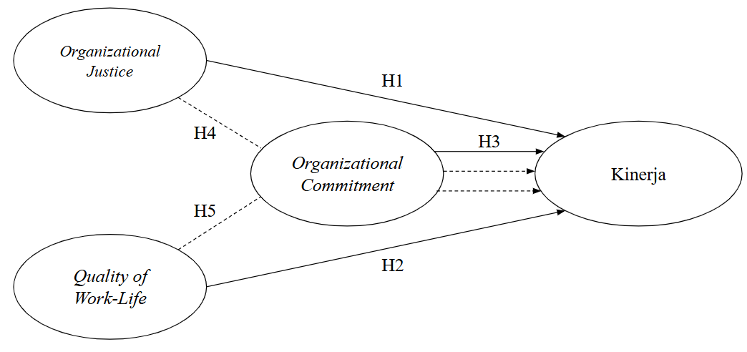
Figure 1 Frame of Mind

This research is expected to provide useful information in solving problems practically in the field. This research was carried out because there is a gap between the results of previous research and the phenomenon that occurs in the work environment. Therefore, the purpose of this study is to further analyze how the influence of organizational justice and quality of work-life on organizational citizenship behavior can be mediated by organizational commitment.

2.7 Research Methods

This study aims to make the findings widely applicable to population members, so that an accurate representation of population characteristics in the sample is needed (Scott, 2019). The total sample of 105 respondents was obtained using saturated sampling techniques. Saturated sampling

is a sampling technique where all members of the population are used as samples (Scott, 2019).

This research is a quantitative research. The data was obtained through a questionnaire that was distributed to all employees of the Ciamis Regency Education Office, except for the head of the Ciamis Regency Education Office, which amounted to 105 employees. The likert scale is used for measurement, which utilizes variable indicators presented in the form of statements or questions on questionnaire items (Scott, 2019).
The data analysis in this study involves statistical and descriptive analysis for PLS-SEM. Descriptive analysis is intended to describe respondents' responses and identify respondents' patterns. To test the system Structural Equation Modeling (SEM), used SmartPLS 4 testing program. SEM analysis was chosen for its ability to provide a direct representation of variable relationships and perform path analysis (Hair et al., 2017). The process requires two stages: the first stage is evaluating the assessment model Outer Model, while the second stage involves the evaluation of structural models (Inner Model) to test hypotheses and explain variable relationships. Convergent validity is confirmed with loading values exceeding 0.6 and AVE values above 0.5 (Ghozali, 2014). The discriminant validity was assessed to have cross-loading and Fornell-Larcker values, and the reliability of the indicators was validated with Cronbach's alpha and Composite Reliability values >0.70 (Hair et al., 2017).

3. Results and Discussion

3.1 Characteristics of Respondents

The first analysis in this study is the Demographic Analysis listed in Table 1. Demographic Analysis aims to provide additional information to future readers or researchers.

Table 1. Demographic Analysis
Source: Primary Data, 2024
No. | Category | Frequency | %
1. | Gender  Man  Woman  Total | 73  32  105 | 69,5%  30,5%  100%
2. | Age  < 20 years old  26 – 30 years old  31 – 35 years old  36 – 40 years old  > 40 years old  Total | 1  5  16  18  13  52  105 | 1,0%  4,8%  15,2%  17,1%  12,4%  49,5%  100%
3. | Marital Status  Marry  Not Married  Total | 97  8  105 | 92,4%  7,6%  100%
4. | Education  JUNIOR  SMA  Diploma  S1  S2  Total | 2  25  3  53  22  105 | 1,9%  23,8%  2,9%  50,5%  21,0%  100%
5. | Part  SecretariatManpower Development Division  Early Childhood Development Field  Field of Elementary School Development  Junior High School Coaching Field  Junior High School Supervision Field  Office Boy  Total | 37  11  14  13  13  11  6  105 | 35,2%  10,5%  13,3%  12,4%  12,4%  10,5%  5,7%  100%
6. | Long Time Working  < 1 year  1 – 3 years  4 – 5 years  6 – 7 years  8 – 10 years  > 10 years old  Total | 13  16  11  5  8  52  105 | 12,4%  15,2%  10,5%  4,8%  7,6%  49,5%  100%

Demographic analysis of respondents showed that the majority of respondents were male (69.5%), while female respondents were as many as (30.5%), with the dominant age group being more than 40 years old (49.5%). Most of the respondents had a S1 educational background (50.5%), and (49.5%) had more than 10 years of work experience, indicating that employees with high work experience and a high educational background were more involved in this study.

3.2 Outer Model Test

3.2.1 Outer Loading

In this outer loading test process, the researcher conducted three tests. In the first test, there were several variable statement items with a value of <0.60 so that values below 0.60 were corrected by removing the item from the model. Then in the second test, the researcher eliminated several variables that caused the AVE value to be below 0.5, so that when conducting the 3rd run test, the AVE value could meet the requirements above 0.5. Details can be seen in the picture of the outer loadings test results before the model and after being removed from the model.

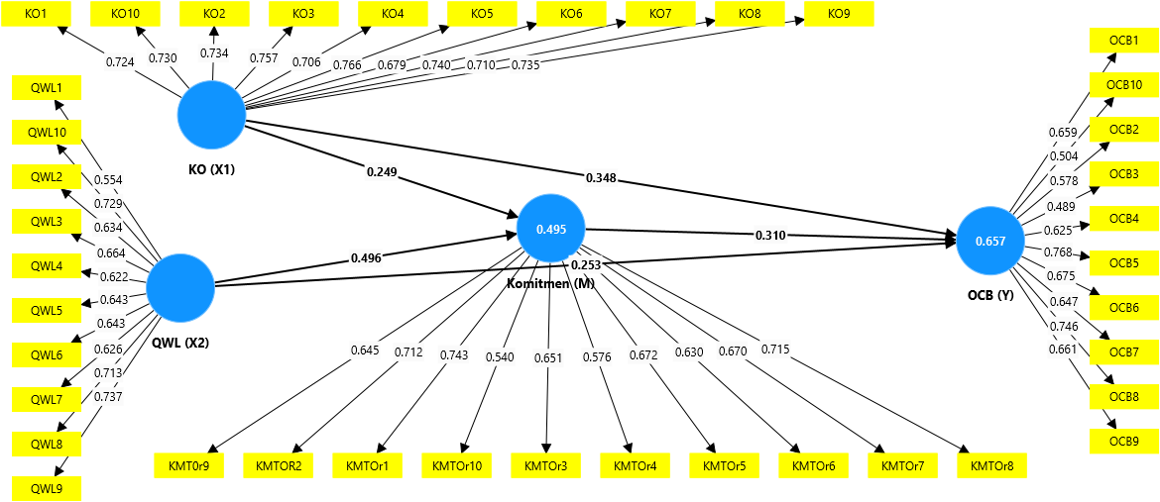
Figure 2 1st Outer Model Running
Source: Primary Data, 2025

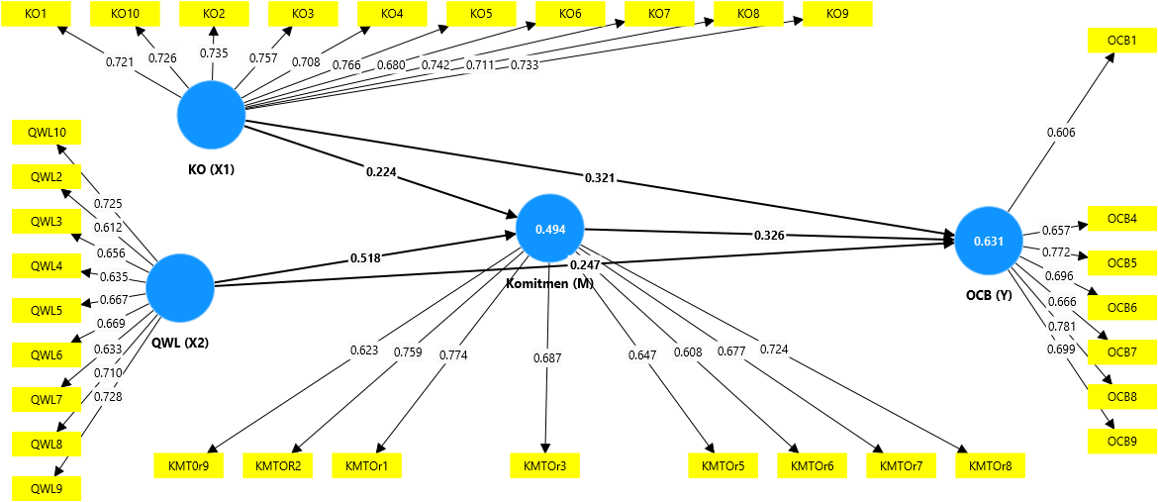
Figure 3 Outer Model After the 2nd Run
Source: Primary Data, 2025

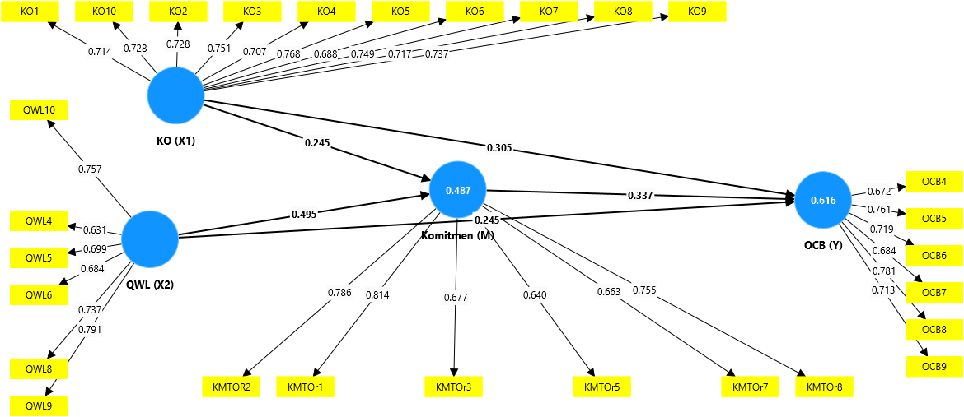
Figure 4 Outer Model After 3rd Run
Source: Primary Data, 2024

From the output of the outer loading, it can be seen that before it was repaired, there were several statement items that had an outer loading value of <0.60, namely items QWL 2 and OCB 2,3,10 which means invalid. Then in the 2nd run, there were several items that were deleted, namely QWL 1, Commitment 4, 10, and OCB 2.3 10. because the AVE value is <0.50. Then in the 3rd run there are several items that must be deleted again, namely, QWL 2,3,7 and Commitment 6,9 and OCB 1. From these results, all of the Outher Loading have an AVE value of >0.50 and can be considered that the statement of each of these variables is declared valid (Ghozali, 2014).

3.3 Measurement Model Analysis

This evaluation stage of the measurement model includes testing convergent validity, reliability, and discriminant validity. Table 2 shows the results of convergent validity and reliability.

Table 2 Validity and Reliability
Source: Primary Data, 2025
Variable | Cronbach's Alpha | Composite Reliability | Average Variance Extracted (AVE)
Organizational Justice | 0,902 | 0,919 | 0,531
Organizational Commitment | 0,819 | 0,869 | 0,526
Organizational Citizenship Behavior | 0,816 | 0,867 | 0,522
Quality of Work-Life | 0,811 | 0,864 | 0,516

Convergent validity is achieved with the value Loading Factor > 0.6 and AVE > 0.5 (Ghozali, 2014). After evaluating and sorting out a number of indicators that have a value Loading Factor <0.6, the rest of the indicator has a value of > 0.6 so that it can be declared valid. In addition, all Composite Reliability and Cronbach's alpha values are at > 0.70, indicating good reliability for each variable

Table 3 Discriminating Validity: Fornell-Larcker
Source: Primary Data, 2025
Variable | OJ | OC | OCB | QWL
Organizational Justice | 0,729
Organizational Commitment | 0,616 | 0,726
Organizational Citizenship Behavior | 0,696 | 0,690 | 0,723
Quality of Work-Life | 0,750 | 0,679 | 0,702 | 0,718

Table 3 shows that the Fornell-Larcker criteria have been well met, which is characterized by a higher value of the square root of AVE on the diagonal than with any other value for each variable.

3.4 Structural Model Analysis

The purpose of structural model evaluation is to analyze the relationships between variables, assess significance values, and determine the R-square value of the research model. The initial step in the evaluation of the structural model is to review the R-square value of each dependent variable, as described in Table 4.

Table 4 R-Square
Source: Primary Data, 2025
Variable | R-Square
Organizational Commitment | 0,487
Organizational Citizenship Behavior | 0,616

The R-square assessment in Table 4 shows good results. The R-square value of 0.616 for organizational citizenship behavior indicates that 61.6% of the variation in these variables can be explained by independent variables in this study, while others are influenced by other factors outside the study. This shows that the study has good predictions.

Table 5 Hypothesis Test
Source: Primary Data, 2025
Hypothesis |  | Path Coefficients (β) / Original Sample | T Statistic | P Values | Conclusion
I → OCB | H1 | 0,305 | 2,555 | 0,005 | Accepted
QWL → OCB | H2 | 0,245 | 2,254 | 0,012 | Accepted
OC → OCB | H3 | 0,337 | 3,355 | 0,000 | Accepted
I → OC → OCB | H4 | 0,082 | 1,634 | 0,051 | Rejected
QWL → OC → OCB | H5 | 0,167 | 3,141 | 0,001 | Accepted

Hypothesis testing assumes the influence of the independent variable on the bound variable if the statistical T value is > 1.960 and the P value is less than .05. The results of this test are shown in Table 5 which shows that all variable relationships have a positive path coefficient (β). However, hypothesis 4 in this study was rejected because it had a statistical T value and a P value that did not meet the requirements.
4. Discussion

4.1 The Influence of Organizational Justice on Organizational Citizenship Behavior

The findings of the study show that organizational justice has a positive and significant impact on organizational citizenship behavior or H1 acceptance. This means that the higher the level of fairness felt by employees in the organization, the more likely they are to exhibit OCB behavior, such as helping colleagues, working beyond formal responsibilities, and supporting the interests of the organization. This shows that the perception of fairness in the organization can increase employee motivation to contribute more than just their primary duties.
These findings are in line with Social Exchange Theory, which outlines that relationships between individuals and organizations are based on the principle of reciprocity. When employees feel they are treated fairly, they tend to reciprocate by exhibiting positive behavior that benefits the organization. The trust and loyalty formed through organizational justice encourage employees to participate voluntarily in activities that support the organization's goals. Therefore, organizational justice can be a key factor in creating extra engagement and contributions from employees.
The results of this study are also in line with the findings of the Bastyant et al., (2024), Kamil & Rivai (2021), Lim & Setyawan (2023), Romadhona & Prawitowati (2024), and Syafriyanti & Anisah (2021), which states that Organizational Justice play a role in increasing employee OCB. When employees feel transparency and fairness in decision-making and resource distribution, they tend to be more motivated to take actions that benefit the organization. This confirms that creating a fair system in the organization not only increases job satisfaction, but also forms a more collaborative and proactive work culture.

4.2 The Effect of Quality of Work-Life on Organizational Citizenship Behavior

The findings of the study show that quality of work-life has a positive and significant impact on organizational citizenship behavior or H2 acceptance. This shows that the better the quality of work life that employees feel, the more likely they are to show OCB behavior, such as helping colleagues, taking initiative at work, and showing loyalty to the organization. A high quality of work-life reflects comfortable working conditions, work-life balance, and organizational support, which ultimately improves OCB's behavior.
These findings are in line with Social Exchange Theory, which states that the relationship between employees and organizations is based on the principle of reciprocity. When the organization provides a supportive and well-being work environment for employees, employees tend to reciprocate by showing positive behaviors that benefit the organization. In other words, employees who feel valued and comfortable in their jobs will be more motivated to contribute more than just their main tasks.
The results of this study are also in line with the findings of the Purwanto et al., (2021, 2023), Rimatanti & Darmawan (2023), Sumarsi & Rizal (2020), and Widodo et al., (2023), which states that the quality of work-life plays a role in improving the OCB of employees. Employees who have a positive work experience, including a work-life balance, a conducive work environment, and a decent reward, are more likely to engage in voluntary organizational behavior. This reinforces that organizations that invest in improving the quality of their employees' working lives not only improve individual well-being, but also build a more collaborative and productive work culture.

4.3 The Influence of Organizational Commitment on Organizational Citizenship Behavior

The findings of the study revealed that organizational commitment has a positive and significant influence on organizational citizenship behavior or H3 received. These findings show that the higher the employee's commitment to the organization, the more likely they are to exhibit OCB behavior, such as helping colleagues, being loyal to the organization's policies, and contributing more than just their primary duties. Therefore, increasing organizational commitment can be an important strategy to build a more harmonious and productive work environment.
These findings are in line with Social Exchange Theory, which explains that the relationship between employees and organizations is reciprocal. When employees feel they have a strong bond with the organization and have a positive work experience, they tend to reciprocate by exhibiting behaviors that are beneficial to the organization. High commitment makes employees feel responsible to contribute more, including in the form of OCB.
The results of this study are also in line with the findings of the Firmansyah et al., (2022) Hermawanto et al., (2022), Nurjanah et al., (2020), Purwanto (2022), and Widodo et al., (2023), who found that organizational commitment play a role in increasing employee OCB. Employees who have a high level of commitment are more likely to exhibit extra-role behaviors because they feel like they are an important part of the organization. This indicates that organizations that are able to build and maintain employee commitment, whether through inspirational leadership, an inclusive work culture, or policies that support employee well-being, will find it easier to create a productive and team-oriented work environment.

4.4 Organizational Commitment mediates the Influence of Organizational Justice on Organizational Citizenship Behavior

The results of the study show that organizational commitment does not mediate the impact of organizational justice on organizational citizenship behavior or H4 is rejected. This shows that although organizational justice has a positive effect on OCB, the effect is not through the variable of organizational commitment as a mediator. In other words, employees who feel that there is justice in the organization do not necessarily increase their commitment first before showing OCB behavior. These findings indicate that organizational justice can directly encourage employees to behave positively without having to rely on their level of commitment to the organization.
These findings are not in line with the results of the study Kamil & Rivai (2021), Lim & Setyawan (2023), Romadhona & Prawitowati (2024), and Syafriyanti & Anisah (2021), which states that organizational commitment act as a mediator in the relationship between Organizational Justice and OCB. Employees who feel they are being treated fairly tend to increase their commitment first before finally showing OCB behavior (Lim & Setyawan, 2023). However, the results of this study show that at the Ciamis Regency Education Office, employees can directly respond Organizational Justice with positive behavior without going through the improvement stage organizational commitment. This can be due to other factors, such as work culture, reward systems, or social norms in the organization that are more influential in encouraging OCB.

4.5 Organizational Commitment mediates the Influence of Quality of Work-Life on Organizational Citizenship Behavior

The results of the study show that organizational commitment is able to mediate the relationship between quality of work-life and organizational citizenship behavior or H5 acceptance. This shows that a good quality of work-life not only directly increases OCB, but also plays a role in strengthening employees' commitment to the organization, which ultimately encourages them to contribute more voluntarily. With a comfortable work environment, work-life balance, and support from the organization, employees tend to develop a higher sense of attachment and loyalty. This strong commitment then encourages them to exhibit extra-role behaviors, such as helping colleagues and supporting organizational goals voluntarily.
These findings are in line with Social Exchange Theory, which states that the relationship between employees and organizations is reciprocal. When an organization provides a quality work environment, employees feel valued and more committed to the organization. This commitment then motivates them to demonstrate positive behaviors that benefit the organization, including OCB.
The results of this study are also in line with the findings of the Ulfa et al., (2021) and Ulum et al., (2024), which found that organizational commitment plays an important role in connecting quality of work-life with OCB. Employees who feel satisfied with their work environment tend to be more committed to the organization, which ultimately encourages them to behave positively at work. This indicates that the organization can improve OCB among employees, focused not only on creating a good quality of work life but also building employee commitment as a key factor in the process.

5. Conclusion And Suggestions

Based on the results of the study, it was found that organizational justice, quality of work-life, and organizational commitment have a positive and significant influence on organizational citizenship behavior (OCB). These results show that when employees feel they are treated fairly and have a good quality of work life, they tend to exhibit extra-role behaviors that are beneficial to the organization. In addition, organizational commitment has been proven to mediate the influence of quality of work-life on OCB, but it does not play a mediator in the relationship between organizational justice and OCB. Thus, this study emphasizes that to improve OCB, organizations need to pay attention to aspects of justice, work welfare, and strengthen employee commitment to the organization.
The implication of these findings is that organizations, especially in the government or public service sectors such as the Ciamis Regency Education Office, need to focus more on improving organizational justice and quality of work life to create a more conducive work environment. Improving the quality of work-life not only directly impacts OCB, but also strengthens employee commitment, which ultimately encourages them to contribute more to the organization. Therefore, organizations can implement policies that ensure fairness in decision-making, provide a better work-life balance, and build systems that encourage employee loyalty and attachment to the organization.
This research has a number of limitations that must be considered in the next research. This study did not consider the demographic aspect of the relationship in the research construct, so it did not explore in more depth a number of other factors such as age that may affect OCB through a qualitative approach. Second, the method aimed at is mainly quantitative-based, so it has not explored more deeply a number of other factors that may affect OCB through a qualitative approach. Finally, in this study, it was found that organizational commitment is not able to mediate organizational justice against OCB. Therefore, subsequent research can expand the scope of the sample to various sectors and combine quantitative and qualitative research methods to gain a more comprehensive understanding of the factors that affect OCB.

COMPETING INTERESTS DISCLAIMER:
Authors have declared that they have no known competing financial interests OR non-financial interests OR personal relationships that could have appeared to influence the work reported in this paper.

REFERENCES

Agustina, R., Yusuf, M., Sutiyan, O. S. J., Ardianto, R., & Norvadewi. (2022). Employee Performance Mediated Quality of Work Life Relationship Satisfaction on the Job and Organizational Commitment. Darma Agung Journal, 30(2), 589–605. https://doi.org/10.46930/ojsuda.v30i2.2278
As, E., Muhtar, E. A., & Wahyudi, H. (2024). The Influence of Communication and Work Environment on Employee Performance at the Education Office. Ganaya: Journal of Social Sciences and Humanities, 7(4), 162–169. https://doi.org/10.37329/ganaya.v7i4.3424
Asgari, A., Mezginejad, S., & Taherpour, F. (2020). The Role of Leadership Styles in Organizational Citizenship Behavior through The Mediation of Perceived Organizational Support and Job Satisfaction. Innovation, 30(75), 87–98. https://doi.org/10.15446/innovar.v30n75.83259
Asriani, N., Astaginy, N., & Ismanto, I. (2023). The Effect of Quality of Work Life on Commitment and Job Satisfaction with Organizational Culture Moderation (Study on Female Lecturers of USN Kolaka). Journal of Management and Business Economics Research (JEKOMBIS), 2(4), 197–214. https://doi.org/10.55606/jekombis.v2i4.2587
Bastyant, M. N., Sari, E. Y. D., & Bashori, K. (2024). Organizational Citizenship Behavior (OCB) Reviewed from Organizational Commitment and Organizational Justice. JIIP - Scientific Journal of Educational Sciences, 7(3), 2238–2244. https://doi.org/10.54371/jiip.v7i3.3536
Blau, P. M. (1964). Exchange and Power in Social Life. In John Wiley & Sons, Inc. https://doi.org/10.4324/9780203792643
Danisya Ira Asdi Putri ; Siti Nurmayanti. (2024). The Effect of Quality of Work Life and Organizational Justice on Organizational Citizenship Behavior (OCB) in Employees of PT. Eka Dana Cosultant. JPSDM (JOURNAL OF HUMAN RESOURCE RESEARCH), 3(3), 110–121.
Dimpu, A., Situmorang, R., Sihombing, D. R. W., Manurung, H., Economy, F., Economy, F., & Economy, F. (2024). The Effect of Employee Work Quality on Community Satisfaction in Lobu Siregar I Village, Siborongborong District, North Tapanuli Regency. EcoJournal, 3(1), 65–70.
Firmansyah, A., Junaedi, I. W. R., Kistyanto, A., & Azzuhri, M. (2022). The Effect of Perceived Organizational Support on Organizational Citizenship Behavior and Organizational Commitment in Public Health Center during COVID-19 Pandemic. Frontiers in Psychology, 13. https://doi.org/10.3389/fpsyg.2022.938815
Fitri, I. K., & Endratno, H. (2021). The Effect of Organizational Commitment and Job Satisfaction on Employee Performance with Organizational Citizenship Behavior as an Intervening Variable: A Study on Employees of Hotel Bahari, Tegal Regency. Derivatives: Journal of Management, 15(2), 276–293. https://doi.org/10.24127/jm.v15i2.663
Flint, D., Haley, L. M., & McNally, J. J. (2012). Dimensionality of Organizational Justice in a Call Center Context. Psychological Reports, 110(2), 677–693. https://doi.org/10.2466/01.07.21.PR0.110.2.677-693
Ghozali, I. (2014). Structural Equation Modeling Alternative Methods with Partial Least Square (PLS) Edition 4. Diponegoro University.
Hair, J. F., Hult, G. T. M., Ringle, C. M., & Sarstedt, M. (2017). A Primer on Partial Least Squares Structural Equation Modeling. In Long Range Planning (Vol. 46, Issues 1–2). SAGE Publications. https://doi.org/10.1016/j.lrp.2013.01.002
Handayani, H., Musdiani, M., & Novita, R. (2024). The Contribution of the Education and Culture Office in Overcoming the Shortage of Educators and Elementary Level Education Facilities in Pidie Regency. Domain Research: Journal of Multidisciplinary Research and Development, 6(5), 1403–1413. https://doi.org/10.38035/rrj.v6i5.986
Hermanto, Y. B., Srimulyani, V. A., & Pitoyo, D. J. (2024). The Mediating Role of Quality of Work Life and Organizational Commitment in The Link between Transformational Leadership and Organizational Citizenship Behavior. Heliyon, 10. https://doi.org/10.1016/j.heliyon.2024.e27664
Hermawan, F., Purnomo, H., Kusumastuti, D., Fitriana, R., Octaleny, E., Ie, M., & Sudadi. (2024). The Role of Transformational Leadership, Job Satisfaction and Organizational Commitment on Organizational Citizenship Behavior (OCB) of SMEs Employees in the Digital Era. Journal of Infrastructure, Policy and Development, 8(7), 1–16. https://doi.org/10.24294/jipd.v8i7.5194
Hermawanto, A. R., Ahman, E., & Supriadi, Y. N. (2022). Mediation Effects of Organizational Commitment between Organization Citizenship Behavior, Transformational Leadership, and Quality of Work Life. Quality - Access to Success, 23(189), 107–117. https://doi.org/10.47750/QAS/23.189.13
Hidayah, N., & Hendarsjah, H. (2021). The Impact of Quality of Work Life (QWL) and Work Motivation on The Organizational Citizenship Behavior (OCB) with Job Satisfaction as a Mediating variables. JPPI (Indonesian Journal of Education Research), 7(3), 499–506. https://doi.org/10.29210/020211247
Kamil, I., & Rivai, H. A. (2021). The Influence of Organizational Culture and Organizational Justice on Organizational Citizenship Behavior (OCB) with Organizational Commitment as a Mediation Variable. JMK (Journal of Management and Entrepreneurship), 6(3), 49–64. https://doi.org/10.32503/jmk.v6i3.1924
Liaquat, M., & Mehmood, K. (2017). Organization Citizenship Behavior: Notion of Social Exchange Theory. Journal of Business and Social Review in Emerging Economies, 3(2), 209–216. https://doi.org/10.26710/jbsee.v3i2.137
Lim, V. E., & Setyawan, A. (2023). Factors Influencing Organizational Citizenship Behavior are mediated by Organizational Commitmet at Beauty Clinics. Scientific Journal of Management, Economics, & Accounting (MEA), 7(3), 902–914. https://doi.org/10.31955/mea.v7i3.3454
Manihuruk, F. E. (2023). Analysis of the Influence of Organizational Justice, Job Satisfaction and Organizational Commitment on the Performance of BPJS Ketenagakerjaan Jambi City Employees. Journal of Applied Management and Finance (Mankeu), 12(1), 115–128. https://doi.org/10.22437/jmk.v12i01.16877
Mehra, R. (2023). A Study of Impact of Quality of Work Life on Organizational Commitment in Manufacturing Sector. International Journal of Research and Analytical Reviews (IJRAR), 10(1), 500–504. https://doi.org/10.1177/0258042X19851912
Meyer, J. P., & Allen, N. J. (1991). A Three-Component Conceptualization of Organizational Commitment. Human Resource Management Review, 1(1), 61–89. https://doi.org/10.1016/1053-4822(91)90011-Z
Novianti, K. R. (2021). Does Organizational Commitment Matter? Linking Transformational Leadership with Organizational Citizenship Behavior (OCB). Journal of Management Applications, 19(2), 335–345. https://doi.org/10.21776/ub.jam.2021.019.02.09
Nurhafni, I., Zefriyenni, & Very, J. (2022). Analysis of Transformational Leadership, Competence, and Organizational Justice on Employee Performance through Organizational Citizenship Behavior (OCB) as a Mediator. Journal of Business and Economics (JBE), 7(3), 279–289. https://doi.org/10.35134/jbeupiyptk.v7i3.175
Nurjanah, S., Pebianti, V., & Handaru, A. W. (2020). The Influence of Transformational Leadership, Job Satisfaction, and Organizational Commitments on Organizational Citizenship Behavior (OCB) in The Inspectorate General of The Ministry of Education and Culture. Cogent Business and Management, 7, 1–12. https://doi.org/10.1080/23311975.2020.1793521
Perdani, A. S., Busri, H., & Tabrani, A. (2024). The Journey of Education in Indonesia in the Philosophical Perspective of Ki Hajar Dewantara. Al Qalam: Scientific Journal of Religion and Society, 18(2), 1197–1205. http://dx.doi.org/10.35931/aq.v18i2.3124
Podsakoff, P. M., MacKenzie, S. B., Paine, J. B., & Bachrach, D. G. (2000). Organizational Citizenship Behaviors: A Critical Review of the Theoretical and Empirical Literature and Suggestions for Future Research. Journal of Management, 26(3), 513–563. https://doi.org/10.1177/014920630002600307
Purwanto, A. (2022). The Role of Transformational Leadership and Organizational Citizenship Behavior on SMEs Employee Performance. Journal of Industrial Engineering & Management Research, 3(5), 39–45.
Purwanto, A., Purba, J. T., Bernarto, I., & Sijabat, R. (2021). The Role of Transformational leadership, Leader Member Exchange, Digital Transformation on Organizational Citizenship Behaviour and Work Innovation Capabilities in during Covid-19 Pandemic. Antverpiensia Linguistics, 2, 2908–2932. https://doi.org/10.29210/020211163
Purwanto, A., Purba, J. T., Bernarto, I., & Sijabat, R. (2023). Investigating The Role Digital Transformation and Human Resource Management on the Performance of The Universities. International Journal of Data and Network Science, 7, 2013–2028. https://doi.org/10.5267/j.ijdns.2023.6.011
Rato, K. W., & Rahmat, A. (2020). The Influence of Organizational Justice on Organizational Commitment with Job Satisfaction as a Mediation Variable. Journal of Non-Formal Education, 6(3), 295. https://doi.org/10.37905/aksara.6.3.295-306.2020
Rimatanti, N. F., & Darmawan, A. (2023). Influence of Quality of Work Life (QWL), Organizational Commitment (OC) and Transformational Leadership on Organizational Citizenship Behavior (OCB). Journal of Economics, Social, and Humanities, 1(1), 12–26. https://doi.org/10.30595/jesh.v1i1.76
Romadhona, L. L., & Prawitowati, T. (2024). The Relationship between Organizational Justice and Organizational Citizenship Behavior of Generation Z Employees of East Java with Commitment Mediation. Dialectics: Journal of Economics and Social Sciences, 9(1), 115–125. https://doi.org/10.36636/dialektika.v9i1.3929
Sarah, M. A., Niha, S. S., & Manafe, H. A. (2023). The Effect of Job Satisfaction and Work Environment on Organizational Citizenship Behavior (OCB) through Employee Loyalty as a Mediation Variable. Journal of Science, 4(3), 403–411. https://doi.org/doi.org/10.31933/jimt.v4i3
Sirgy, M. J., Efraty, D., Siegel, P., & Lee, D.-J. (2001). A New Measure of Quality of Work Life (QWL) Based on Need Satisfaction and Spillover Theories. Social Indicators Research 2, 55(3), 241–302. https://doi.org/10.1023/A:1010986923468
Sugiyono. (2019). Quantitative, Qualitative, and R&D Research Methods. Alphabet.
Sumarsi, & Rizal, A. (2020). The Effect of Competence and Quality of Work Life on Organizational Citizenship Behavior (OCB) with Organizational Commitment Mediation. International Journal of Social and Management Studies (Ijosmas), 2(6), 69–88. https://doi.org/10.61707/ne843b17
Syafriyanti, & Anisah, H. U. (2021). Analysis of the Influence of Organizational Justice and Job Satisfaction on Organizational Citizenship Behavior (OCB) by Mediating Organizational Commitment at the Office of the National Defense Agency (BPN) of Banjarmasin City. Journal of Management Insights, 9(1), 51–61. https://doi.org/10.20527/jwmthemanagementinsightjournal.v9i1.31
Ulfa, M., Thoyib, A., & Ratnawati, K. (2021). Quality of Work Life and Organizational Citizenship Behavior: The Mediation Role of Organizational Commitment. South East Asia Journal of Contemporary Business, Economics and Law, 25(1), 100–109.
Ulum, R., Hermawati, A., & Mas, N. (2024). The Influence of Spiritual Leadership and QWL (Quality of Work Life) on OCB (Organizational Citizenship Behavior) Mediated by Organizational Commitment. Journal of Scientific Horizons, 4(1), 3899–3926.
Widodo, W., Gustari, I., & Permana, R. (2023). A Mediation Model of the Effect of Visionary Leadership on Teachers' Organizational Citizenship Behavior. International Journal of Learning, Teaching and Educational Research, 22(4), 104–123. https://doi.org/10.26803/IJLTER.22.4.7
Zahra, D., & Siregar, O. M. (2023). The Effect of Job Satisfaction and Organizational Commitment on Organizational Citizenship Behavior (OCB) (Study on Tea Processing Employees of PTPN IV Bah Butong). Indonesian Journal of Economics, Accounting, and Management, 2(1), 1–15.

