The Impact of Artificial Intelligence on FinTech Service Delivery: A Narrative Review of Customer Experience and Financial Performance
Abstract
Focusing on CX, OE, and FPL, this narrative research investigates the disruptive effects of artificial intelligence (AI) on the service provision of FinTech. We start by discussing the evolution of FinTech and the integration of AI, including robotic process automation, machine learning, and natural language processing. The report demonstrates how AI can automate simple processes, such as detecting fraud, KYC/AML compliance, and customer assistance, but also opens the door to extremely personalized financial services, from dynamic credit scoring to personalized investment and savings advice to product recommendations.
Empirical studies suggest that AI in FinTech enhances customer happiness by enhancing accessibility and resultant customization. But there are still a lot of problems with algorithmic transparency, data privacy, and the “black box” nature of AI decision-making. Illustrating the vital role of ethics when deploying AI, they include examples from businesses such as Wealthfront, Upstart and Kount that reveal how AI has brought about financial benefits, in the form of minimised fraud losses, reduced credit default rates, and operational cost reduction.
To ensure the ethical treatment of AI, this review ends by identifying key future research challenges and prospects. It illustrates the need for explainable AI, models that are a hybrid of AI and human expertise, and cross-industry boldness. As such, when used responsibly and ethically, AI can deliver more customer-centric, efficient, and profitable FinTech offerings.
I. Introduction
A. Context: The Emergence of FinTech and the Dominance of AI
Financial technology, or FinTech, has boomed in the recent decade as customer demand and digital innovation have converged. FinTech companies, innovative and customer-oriented providers of the alternative variety, have disrupted banking and financial services. At the heart of this change is Artificial Intelligence (AI), which is a major facilitator of automation, a vehicle for personalization, and a catalyst for data-driven decision-making within the financial sector [1].
B. The role of AI in the transformation of the financial services
Artificial intelligence is revolutionizing the financial services industry by enhancing service delivery mechanisms, streamlining business operations enabling real-time analytics. Machine learning models are able to sift through massive amounts of data, to identify trends, to mitigate risk, and to improve operating efficiency. AI and (NLP)-driven chatbots are transforming customer support, with intelligent, personalized help at scale and on demand. In addition, AI-fueled predictive analytics have given FinTech firms a new advantage in the industry, bearing new ways of credit scoring, fraud detection investment strategy[2].
C. Objective of this Review: Current Evidence Pooling
This narrative review seeks to summarize existing studies on the effect of AI on the provision of FinTech services, customer experience, and financial results. In this manuscript, we strive to get a full glimpse of how AI has been shaping the modern FinTech by summarizing relevant AI advances in the field of FinTech from industry, case studies, and academia.
D. Purpose and Goals of the Review
Three Review Sections The review has three main areas (1) Internal Operations and Service (i.e. Has AI increased operational efficiency and made it easier to provide a service?), (2) customer happiness (i.e. Does AI make fintech firms better at making their clients happy, by being customer centric and responsive to their needs?), and (3) the financial productivity (i.e. Does using AI give Fintech-Non-Fintech companies a bump in financial performance (i.e. better maximization of value)). In these ways, the paper also points out possible directions of future research and practice, and the merits and demerits of AI for FinTech.
II. Theoretical Background and Conceptual Framework
General Background on FinTech and Its Development
Financial technology, or FinTech, is the inventive use of technology to offer financial services in a faster and more cost-efficient process. FinTech was first coined in the early 2000s, before being swept up by an influx of new developments in data analytics, cloud computing, and mobile computing. The FinTech space, which was originally dominated by peer-to-peer lending and payments, has since expanded to include digital banking, robo-advisory, blockchain-based services, and insurtech, transforming how we earn, manage, save and spend[3].
B. Definition and Components of AI for FinTech
In FinTech, AI means using models to make decisions and replicate the human brain. Key components include:
• Machine Learning (ML): The use of ML allows systems to recognize patterns, learn from past information, and make predictions about future information. ML (machine Learning) is employed in FinTech to forecast investment, identify fraud, and estimate credit risk[4].
Natural language processing, or NLP, is what allows computers to understand and process human language. It is also what powers chatbots, voice assistants sentiment-analysis tools to improve customer communication and automate assistance in financial services.
• Robotic Process Automation (RPA): Through the use of software robots to automate repetitive rules-based tasks such as document validation and compliance checks, RPA can increase operational efficiency and decrease manual errors[5].
C. The Intersection of AI and Financial Services
FinTech companies now have the chance to provide more advanced and responsive products due to the confluence of AI and financial services. AI systems are able to provide real-time insights and personalize services by analyzing large, complicated data sets. By automating compliance and spotting new dangers, they also aid in risk management. AI-powered services provide consumers with more convenience, customization, and speedier decision-making. However, issues with algorithmic bias, data security, and regulatory compliance are brought up by this intersection[6].
D. Framework for Analysis: Service Delivery, Customer Experience, Financial Results
The focus of the conceptual framework used in this review is on three key dimensions:
Service Delivery: How AI improves the operational efficiency, decision cycle, and process automation of FinTech enterprises.
Customer Experience: How can AI-driven personalization, 24/7 support, and tailored financial advice drive customer happiness and retention?
Financial Performance: The impact of AI on financial performance, i.e., revenue, cost savings, and profits[7].
This framework offers an organized method for comprehending the complex effects of AI in FinTech. It draws attention to both the technological possibilities and the difficulties in guaranteeing the provision of moral, safe, and client-focused financial services. We created a conceptual framework that charts the relationship between important AI technologies and their functional consequences in order to organize our study of AI's influence on FinTech[8]. The framework illustrates how robotic process automation, machine learning, and natural language processing all work together to affect service delivery, customer satisfaction, and financial results, as seen in Figure 1. It also incorporates the more general ethical and legal issues that need to be resolved in order to guarantee the responsible and efficient application of AI.
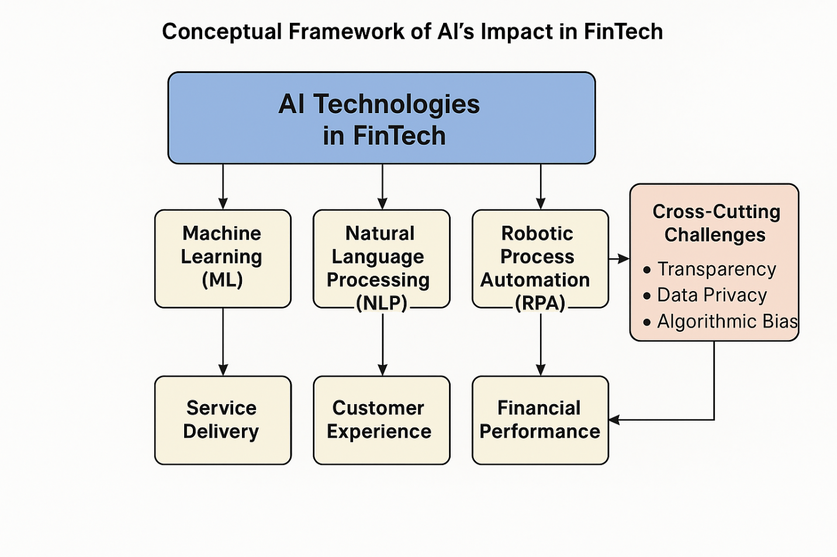
Figure 1: Conceptual Framework for FinTech's Use of AI. The conceptual framework that directs this review is shown in this diagram. It demonstrates how three crucial aspects of FinTech service delivery—financial success, customer experience, and operational efficiency—are improved by fundamental AI technologies, namely machine learning (ML), natural language processing (NLP), and robotic process automation (RPA). The paradigm also recognizes cross-cutting issues that affect AI's efficacy and sector-wide adoption, such as algorithmic bias, transparency, and data protection.
III. AI-Driven Innovations in FinTech Service Delivery
A. Personalization and Product Recommendations
One of the most pronounced impacts of AI will be its application in FinTech to deliver personalized financial advice and products. AI-driven platforms such as Wealthfront and Betterment parse customer preferences, risk appetite, and financial goals to create personalized portfolios. They are also using sophisticated algorithms to deliver automated investment advice_ and they make no secret that they are going to do an even better job helping people manage their finances as they learn more about their habits and behavior. Insurance carriers are also leveraging AI to customize their offerings, analyzing massive data sets -- from transactions to behavior -- to tailor their products. It also enables to make personalized pricing system, which ultimately results in enhanced client loyalty, service, and satisfaction. In lending, there are AI algorithms that are used to assess the creditworthiness and financial activity of a person, a solution for making more personalized loan offers in response to customer needs[9].
B. Mechanization vs. Operational Efficiency
By automating those activities, AI greatly improves productivity. Nonetheless, NLP-based bots/cognitive agents/ conversational agents and virtual assistants are key enablers of this transformation. Others, like Kasisto and Cleo, have taken an interest in conversational AI, whereby users interact with an AI bot to ask questions and receive instant financial advice. These tools contribute to service availability and response time reduction[10].
Tasks that don’t interact with the customer also make use of AI, such as risk management and fraud detection. Companies such as Kount and Zest AI employ a form of machine learning algorithm that can instantly recognize suspicious behavior by analyzing the patterns of transactions in a shopping system. These algorithms have the potential to improve over time as they are cycled using new data[11].
AI also enhances back-office operations, including compliance functions like KYC and AML. Automated AI systems can scan and authenticate identity documents more quickly and accurately than people; they can flag suspicious transactions and check for compliance with rules. This decreases the cost of operations while also minimizing the chances of human errors and legal issues[12].
C. Credit Scoring For Lending Decisions
Current credit scoring techniques are based on only a few data sources, and a large number of good credit risk prospects may be excluded. AI-backed models improve credit scores by taking in other data points such as utility bill payments, social media posts, and transaction records. Businesses, including Kabbage and Upstart, have built AI-powered systems that not only pull from these alternative data flows but also make credit determinations that are more equitable and well-informed. This has entrenched a risk-based system that expands credit for the less privileged[13].
Huge databases are processed by AI- AI-empowered credit scoring models, which can recognize some small cracks and value diamonds that usual methods won’t. This is ultimately beneficial for both lenders and borrowers because more precise risk valuations can be made, and the relevant default rates may be decreased[14].
D. Case Examples to Illustrate Successful AI Applications in FinTech
AI is changing the way FinTech is servicing the needs in real-life examples. For instance, Wealthfront and Betterment have successfully integrated AI-powered robo-advice to democratize access to investing advice and make wealth management accessible to the masses at a low cost. Kasisto's conversational AI technology is used by banks and credit unions, and reveals how virtual assistants could reduce support costs and enhance engagement with clients.
Upstart has also utilized AI in the lending field to allow borrowers with limited credit history to take loans and improve financial inclusion. In contrast, Zest AI helps lenders reduce losses and increment loan approval rates, ensuring strong risk controls with machine learning-based risk modeling[3].
Companies such as Kount apply AI to back office processes to detect fraud in e-commerce transactions, providing real-time decision-making that protects both customers and companies. Table 1 compiles key use cases in industries including Credit Scoring, Investment Advising, Fraud Detection, and Customer Service to emphasize how AI adoption in FinTech impacts practice. Whether it’s NLP-backed virtual assistants or machine learning-powered lending platforms, these instances demonstrate the range of AI use cases and deliver measurable outcomes such as reduced default rates, lower cost of operations, as well as higher consumer engagement. The comparative analysis identifies the strategic use of AI technologies in finance by several FinTech businesses to increase financial performance and service provision. AI-driven technologies can read papers and identify inconsistencies or indications of a red flag in the KYC/AML program, significantly reducing compliance costs.[15].

Table 1. Summary of AI Adoption in FinTech: Case Studies by Functionality and Outcomes
Company | AI Tool/Tech Used | Functionality | Outcome/Benefit
Upstart | ML | Credit Scoring | 27% lower default rates
Betterment | Robo-advisor (ML) | Investment Guidance | Increased AUM, higher retention
Kount | Predictive ML | Fraud Detection | Real-time alerts, reduced losses
Cleo | NLP Chatbot | Customer Support | 24/7 service, reduced human support
These examples reflect the rapid expansion of AI in various FinTech fields. AI is driving innovation that improves customer experience and financial performance: from customer-facing services to helping automate internal processes and build better credit models.
To summarize, FinTech implementation of AI is allowing businesses to offer more personalized and efficient services and addressing significant challenges in risk management and operating costs. With the further development of AI technologies, there will be more enhancements in the offerings made by the financial sector and driving competition in the FinTech Industry.[16].
IV. Impact on Customer Experience and Satisfaction
A. Enhanced Convenience and Accessibility
FinTech services are now much more accessible and convenient thanks to AI-driven platforms. AI-powered virtual assistants and chatbots are in service 24/7, meaning customers can contact financial services when they want to contact them, rather than being limited by office hours. For instance, AI chatbots are used by banks and FinTech companies to answer common questions, assist with transactions, and quickly update accounts.
And one more important reward of AI in customer experience is omnichannel engagement. When users move from voice to chat to app-based services, they aren’t losing context or breaking service. This consistent and unified experience across channels also drives user satisfaction and reinforces trust in FinTech services[17].
B. Improved Personalization and Financial Wellness
The ability to process massive amounts of data enables highly personalized financial services. For instance, robo-advisors use information about spending habits, risk tolerance, and financial goals when making investing and savings recommendations. AI-generated nudges, the short reminders or nudges, help alter consumer behavior in order to take better financial decisions and save more money or make debt repayments in due course.
These nudges, which leverage data insights for longer-term financial health, are informed by behavioral finance. AI serves a more educated and empowered user base, driving happiness and loyalty, proactively suggesting actions that align with users’ financial goals[18].
C. Trust and Transparency Concerns
Despite these benefits, trust and transparency concerns are raised by AI’s deployment within financial services. AI programs in general also often function as “black boxes,” where the process for reaching a decision is not easily understood by clients. This lack of clear communication could erode trust, which can be especially damaging when consumers are trying to make important decisions, for example, with regard to their investment plans or loan approvals.
Ethical and privacy concerns also muddy customers’ opinions of AI. It’s because AI applications demand a great deal of data collection and analysis, and the specter looms of potential abuses, data breaches, and algorithmic bias. FinTechs will have to carefully navigate these challenges by implementing robust privacy policies, ensuring that their algorithms are fair, and rationalizing decisions from AI systems for human interpretation.[19].
D. Empirical Evidence: Surveys and Studies on Customer Satisfaction
Several studies have discussed the impact of AI on customer satisfaction in FinTech. Based on survey data, consumers appreciate the responsiveness and simplicity of AI-driven technologies. For instance, 64 percent of respondents cited the ability to receive 24/7 responses to financial questions through AI chatbots in a 2023 Accenture survey. A Deloitte report reveals that 70% of FinTech clients consider AI-based financial advising to better meet their needs, as compared with traditional advising firms.
But these results also reflect long-running challenges around trust. According to a PwC report, 38% of FinTech users had concerns about voluntarily releasing personal information to computers for significant financial decisions, and 45% were anxious about the way in which AI applications managed their data.[20].
E. Challenges and Gaps: Where AI Falls Short in Customer Engagement
While AI mirrors the user experience in many ways, there remains a shortfall. Emotional intelligence is dumb or AI. Emotional intelligence might be great, but not when it comes to AI-powered interactions. While hotlines are there to provide advice, it is not particularly reassuring to wait on hold in order to talk to a stranger over the phone who is not empathic. Chatbots and virtual assistants work well for objective questions, but they often struggle to provide sympathetic support during sensitive financial discussions.
What’s more, over-relying on AI might alienate some types of customers who prefer human interaction, especially around complex financial matters. The effectiveness of AI-based platforms could also be limited by quirks and idiosyncrasies of language and culture, which can leave them confused or simply irritated[21].
There is also the "one-size-fits-all" risk - AI models are generalized, and the generalization might not be entirely suitable for a particular scenario. Closing these gaps and ensuring that AI will augment rather than replace personalised human aid also requires constant human supervision and open communication. With all said and done, AI has truly transformed the FinTech client journey, making it more accessible, streamlined, and personal. But there remain problems of empathy and trust in AI-mediated interactions. In the fast-moving world of FinTech, truly rewarding client experiences are caught between highly efficient AI and transparent processes, and the personal touch of human connection.[22].
V. Impact on Financial Performance and Business Outcomes
A. AI’s Role in Revenue Growth
AI represents a major new revenue stream for Fintech. By analyzing customer data and transaction history, AI enables extremely targeted cross-selling and upselling approaches. FinTech services can instantaneously anticipate the needs and desires of their customers and offer up-sellings of goods and services that improve revenues. tomers, for example, AI can suggest relevant credit products or investment products based on an individual’s shopping behavior, which in turn can help to improve conversion rate and solidify relationships with customers[23].
AI also improves scalability and facilitates the growth of digital channels. Large client bases can be served by AI-powered services like automated lending platforms and robo-advisors without corresponding increases in personnel or operating expenses. FinTech companies can swiftly expand their revenue streams and penetrate new markets thanks to this scalability while still providing high-quality services.
B. Cost Reduction through Automation
Automation-based cost reduction is one of AI's most important financial effects. AI significantly reduces operating costs by streamlining manual, repetitive operations throughout the FinTech business chain. Robotic process automation (RPA) solutions, for example, manage repetitive data input and compliance-related documentation, freeing up human resources to concentrate on higher-value tasks[24].
Additionally, by automating decision-making procedures that formerly depended on human judgment, AI reduces human error. AI can speed up and improve the accuracy of tasks like identification verification, transaction monitoring, and loan underwriting, which lowers compliance costs and operational inefficiencies.
C. Risk Management and Fraud Prevention as Financial Benefits
AI also improves risk management and fraud prevention, which improves financial performance. By spotting questionable transaction patterns, predictive AI algorithms help lower losses from fraud. Businesses such as Kount employ artificial intelligence (AI) to examine transaction data in real time and identify irregularities, so as to avert fraud before it happens.
To more precisely evaluate borrower risk in lending, AI-powered alternative credit scoring models incorporate a wider variety of data inputs, including cash flow and social media activity. In addition to increasing lending opportunities to underprivileged clients, this lowers loan default rates. FinTech companies can therefore improve the performance of their loan portfolios and reduce their overall credit risk[25].
D. Quantitative Data and Performance Metrics from Case Studies
Case studies illustrate how using the technology can make financial sense. For example, Upstart’s machine learning credit models have demonstrated to approve 58% more loans at a 27% lower default rate compared with traditional credit scoring. In a similar vein, robo-advisory firms like Betterment have seen a growth in assets under management and stickier customers as they deliver personalised services bolstered by AI[26].
There is also significant operating cost savings. AI-powered automation, for its part, could reduce financial services operating expenses by up to 25%, according to a McKinsey analysis. The savings can be attributed to faster processing times, fewer errors, and the ability to redirect human resources to more strategic tasks
E. Limitations and Cautionary Tales: Overinvestment, Reliance on Flawed AI Models
Notwithstanding these advantages, there are significant drawbacks and warning signs. Financial resources may be strained by overinvesting in AI solutions that don't yield the anticipated returns, especially for smaller FinTech companies[27]. AI projects could result in buried costs rather than productivity gains if implementation tactics and application cases are unclear.
Furthermore, there are serious financial risks associated with depending on faulty or biased AI algorithms. Inaccurate predictions made by AI algorithms based on skewed or inadequate data may lead to discriminatory practices, bad lending decisions, or inefficient fraud detection. Profitability and the company's reputation may suffer as a result[28].
There is also a lot of regulatory inspection. Financial services' AI-driven decision-making is coming under more scrutiny to guarantee equity and openness. The financial advantages of adopting AI can be countered by significant fines and reputational damage resulting from noncompliance with regulations pertaining to its use[29].
Adoption of AI in FinTech has resulted in quantifiable gains in risk management, cost reduction, and revenue growth, making it a key component of competitive advantage. Maximizing these financial gains, however, calls for cautious AI application, constant oversight for bias or mistakes, and a well-rounded investment plan that takes into consideration both possible advantages and disadvantages[30].

VII. Future Directions and Research Gaps
A. Need for Transparency and Explainability in AI Algorithms
With the progress of AI and the penetration into the financial service industry, transparent and understandable AI algorithms are in demand. Both consumers and regulators are demanding more precision about how AIs make decisions, particularly in lending and fraud detection. Future research efforts should focus on developing XAI-theory frameworks that balance interpretability and algorithmic complexity. Customer trust is bolstered, and new regulations for AI accountability and fairness are adhered to. For a strategic view of the complexity and impact of the applications and challenges of AI, the matrix of possibilities and challenges is indicated in Figure 2. In this model, specific use cases get identified based on business value and ease of code, such as chatbots, AI-generated loans, and personalization. It also highlights structural challenges such as algorithmic bias and trust, which will need more sophisticated, multi-year responses from FinTech players.”[31].

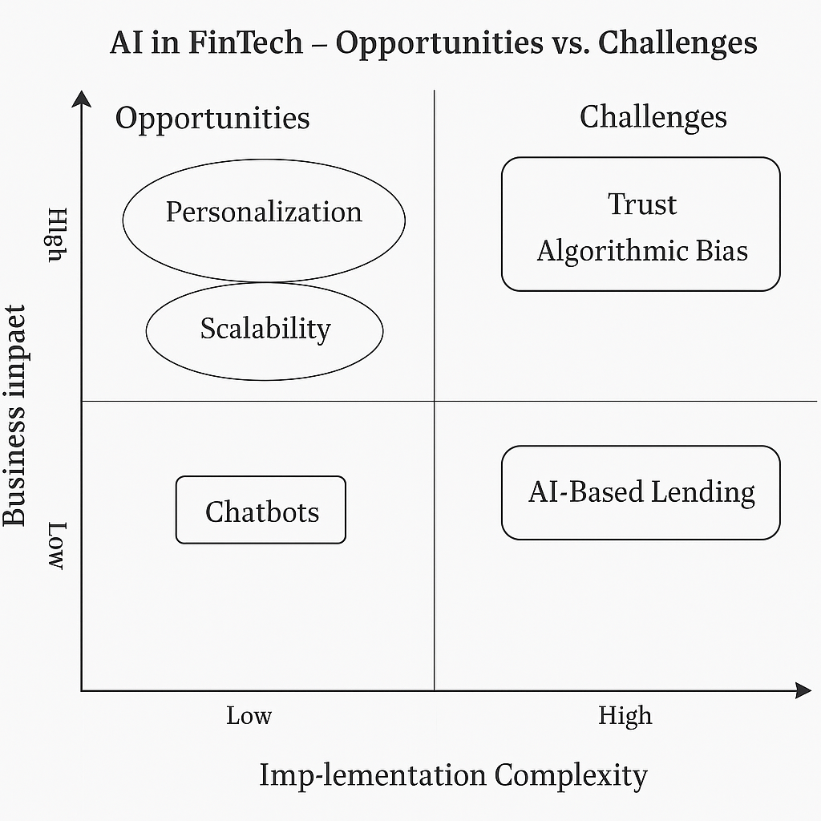
Figure 2: AI in FinTech: Prospects and Difficulties matrix. Based on two factors—business effect and implementation complexity—this 2x2 matrix classifies the main AI-related FinTech potential and difficulties. Low-complexity, high-impact applications, such as scalability and personalization, provide strategic advantages with few obstacles. On the other hand, high-complexity issues like algorithmic bias and trust demand careful consideration. The grid helps show where long-term investment and ethical scrutiny are required, as well as where FinTech companies can achieve fast successes.

B. Opportunities for Hybrid Models Combining AI and Human Expertise
Human experience is still crucial for complex decision-making and emotional intelligence, even though AI is excellent at data analysis and automating repetitive jobs. Future developments in FinTech should investigate hybrid models that combine human judgment with AI insights. These models ensure empathy and flexibility in client interactions while utilizing AI's speed and data processing skills. It will be crucial to research the most effective methods for incorporating human-in-the-loop techniques into FinTech operations[32].
C. Cross-Industry Collaboration for Responsible AI in FinTech
Collaboration outside of the FinTech industry is necessary for responsible AI development. Regulators, technology companies, and financial institutions must collaborate to create industry standards that put consumer protection, data security, and equity first. Future projects might involve shared repositories for AI risk assessment and bias reduction tools, as well as cross-industry guidelines for the ethical deployment of AI[33].
D. Suggested Areas for Further Research and Improvement
Several unanswered questions should be addressed in future studies: How might AI be applied without bias to help underprivileged groups that are financially disadvantaged? What effects will AI adoption have in the long run on brand reputation and consumer loyalty? In order to adjust to changing market conditions, how can FinTech companies guarantee ongoing AI model updates? By addressing these issues, we can ensure that the upcoming wave of AI-powered financial services is sustainable, inclusive, and innovative.
VIII. Conclusion
From enhanced client experience and personalization to higher operational efficiencies and superior financial performance, this exposition has discussed the transformation of FinTech service delivery by artificial intelligence. The likes of machine learning, natural language processing, and robotic process automation are causing a seismic shift in what new-age AI technologies can offer in the world of FinTech, such as more personalised, more accessible, and more secure financial services. Despite the transformative nature of AI on risk management, cost savings, and revenue generation, there are still challenges. Concerns over algorithmic transparency, privacy, and trust underscore the importance of responsible AI approaches. In addition, AI models will never completely replace the sensitivity and nuanced intuition of a human advisor, especially about intricate financial judgmentsFuture developments in FinTech AI will depend on striking a balance between automation and human supervision, as well as filling up the gaps in explainability and fairness. Unlocking AI's full potential while maintaining financial inclusivity and consumer pleasure will need cross-industry cooperation, research into hybrid models, and ethical AI practices.
At the end of the day, we cannot deny the revolutionary power of AI in FinTech, but it is a double-edged sword, providing us with the power to design and develop more profitable, efficient, and customer-centric financial services with great responsibility, only if it is used thoughtfully and ethically.

REFERENCES
1. Harsono I, Suprapti IAP. The Role of Fintech in Transforming Traditional Financial Services. Accounting Studies and Tax Journal (COUNT). 2024 Jan 22;1(1):81–91.
2. Perifanis NA, Kitsios F. Investigating the Influence of Artificial Intelligence on Business Value in the Digital Era of Strategy: A Literature Review. Information. 2023 Feb;14(2):85.
3. Suryono RR, Budi I, Purwandari B. Challenges and Trends of Financial Technology (Fintech): A Systematic Literature Review. Information. 2020 Dec;11(12):590.
4. Lawal O, Elechi K, Adekunle F, Farinde O, Kolapo T, Igbokwe C, et al. A Review on Artificial Intelligence and Point-of-Care Diagnostics to Combat Antimicrobial Resistance in Resource-Limited Healthcare Settings like Nigeria: Review Article. Journal of Pharma Insights and Research. 2025 Apr 5;3(2):166–75.
5. Collins C, Dennehy D, Conboy K, Mikalef P. Artificial intelligence in information systems research: A systematic literature review and research agenda. International Journal of Information Management. 2021 Oct 1;60:102383.
6. Harsono I, Suprapti IAP. The Role of Fintech in Transforming Traditional Financial Services. Accounting Studies and Tax Journal (COUNT). 2024 Jan 22;1(1):81–91.
7. Amoako G, Omari P, Kumi DK, Agbemabiase GC, Asamoah G. Conceptual Framework—Artificial Intelligence and Better Entrepreneurial Decision-Making: The Influence of Customer Preference, Industry Benchmark, and Employee Involvement in an Emerging Market. Journal of Risk and Financial Management. 2021 Dec;14(12):604.
8. Hidayat M, Defitri SY, Hilman H. The Impact of Artificial Intelligence (AI) on Financial Management. Management Studies and Business Journal (PRODUCTIVITY). 2024 Jan 30;1(1):123–9.
9. AI in the Financial Sector: The Line between Innovation, Regulation, and Ethical Responsibility [Internet]. [cited 2025 Jun 8]. Available from: https://www.mdpi.com/2078-2489/15/8/432
10. Chakraborty C, Pal S, Bhattacharya M, Dash S, Lee SS. Overview of Chatbots with special emphasis on artificial intelligence-enabled ChatGPT in medical science. Frontiers in Artificial Intelligence. 2023 Oct 31;6:1237704.
11. Islam T, Islam SAM, Sarkar A, Khan AJMOR, Paul R, Bari MS. Artificial Intelligence in Fraud Detection and Financial Risk Mitigation: Future Directions and Business Applications. IJFMR - International Journal For Multidisciplinary Research [Internet]. 2024 Oct 5 [cited 2025 Jun 8];6(5). Available from: https://www.ijfmr.com/research-paper.php?id=28496
12. (PDF) AI for Anti-Money Laundering (AML) and Know Your Customer (KYC) Compliance [Internet]. ResearchGate. 2025 [cited 2025 Jun 8]. Available from: https://www.researchgate.net/publication/389465811_AI_for_Anti-Money_Laundering_AML_and_Know_Your_Customer_KYC_Compliance
13. Hlongwane R, Ramaboa KKKM, Mongwe W. Enhancing credit scoring accuracy with a comprehensive evaluation of alternative data. PLOS ONE. 2024 May 21;19(5):e0303566.
14. Lawal OP, Egwuatu EC, Akanbi KO, Orobator ET, Eweje OZ, Omotayo EO, et al. Fighting Resistance With Data: Leveraging Digital Surveillance to Address Antibiotic Misuse in Nigeria. Path of Science. 2025 Mar 31;11(3):1009–17.
15. (PDF) AI in Financial Fraud Prevention: Opportunities and Obstacles. ResearchGate [Internet]. 2025 Jan 30 [cited 2025 Jun 8]; Available from: https://www.researchgate.net/publication/388361859_AI_in_Financial_Fraud_Prevention_Opportunities_and_Obstacles
16. Moro Visconti R. Artificial Intelligence-Driven FinTech Valuation: A Scalable Multilayer Network Approach. FinTech. 2024 Sep;3(3):479–95.
17. FinTech: a literature review of emerging financial technologies and applications | Financial Innovation | Full Text [Internet]. [cited 2025 Jun 8]. Available from: https://jfin-swufe.springeropen.com/articles/10.1186/s40854-024-00668-6
18. Yang Q, Lee YC. Enhancing Financial Advisory Services with GenAI: Consumer Perceptions and Attitudes Through Service-Dominant Logic and Artificial Intelligence Device Use Acceptance Perspectives. Journal of Risk and Financial Management. 2024 Oct;17(10):470.
19. Kiseleva A, Kotzinos D, De Hert P. Transparency of AI in Healthcare as a Multilayered System of Accountabilities: Between Legal Requirements and Technical Limitations. Front Artif Intell. 2022 May 30;5:879603.
20. El-Shihy D, Abdelraouf M, Hegazy M, Hassan N. The Influence of AI Chatbots in Fintech Services on Customer Loyalty within the Banking Industry. Future Bus Adm. 2024 Jun 24;3(1):16–28.
21. Lawal OP, Igwe EP, Olosunde A, Chisom EP, Okeh DU, Olowookere AK, et al. Integrating Real-Time Data and Machine Learning in Predicting Infectious Disease Outbreaks: Enhancing Response Strategies in Sub-Saharan Africa. Asian Journal of Microbiology and Biotechnology. 2025 May 28;10(1):147–63.
22. Rennie O. Navigating the uncommon: challenges in applying evidence-based medicine to rare diseases and the prospects of artificial intelligence solutions. Med Health Care and Philos. 2024 Sep 1;27(3):269–84.
23. Munira MSK, Juthi S, Begum A. Artificial Intelligence in Financial Customer Relationship Management: A Systematic Review of AI-Driven Strategies in Banking and FinTech. American Journal of Advanced Technology and Engineering Solutions. 2025 Feb 11;1(01):20–40.
24. Lawal OP, Taiye AF, Okafor CE, Elechi KW, Orobator ET, Kolapo TJ, et al. The Automated Insulin Delivery System in Nigeria: Advances, Challenges, And Future Prospects in Closed-Loop Insulin Delivery Systems. Journal of Medical Science, Biology, and Chemistry. 2025 Jun 30;2(1):64–74.
25. Adhikari P, Hamal P, Jnr FB, Adhikari P, Hamal P, Jnr FB. Artificial Intelligence in fraud detection: Revolutionizing financial security. International Journal of Science and Research Archive. 2024;13(1):1457–72.
26. (PDF) AI in Financial Services: Fraud Detection, Algorithmic Trading, and Risk Assessment [Internet]. ResearchGate. 2025 [cited 2025 Jun 8]. Available from: https://www.researchgate.net/publication/390557209_AI_in_Financial_Services_Fraud_Detection_Algorithmic_Trading_and_Risk_Assessment
27. Okafor CE, Egwuatu EC, Owosagba VA, Njei T, Adeyemi BI, Onuche PUO, et al. From Bench to Bedside: Medicinal Chemistry Strategies in the Development of Kinase Inhibitors for Cancer Therapy. Journal of Cancer and Tumor International. 2025 May 10;15(2):79–96.
28. Boukherouaa EB, AlAjmi K, Deodoro J, Farias A, Ravikumar R. Powering the Digital Economy: Opportunities and Risks of Artificial Intelligence in Finance. 2021 Oct 22 [cited 2025 Jun 8]; Available from: https://www.elibrary.imf.org/view/journals/087/2021/024/article-A001-en.xml
29. Elechi KW, Igboaka CD, Tiamiyu BB, Ugbor MJE, Arthur C, Ezeh OM, et al. Phytochemical Screening of Ficus globosa Latex (Moraceae) as a Source of Novel Antimicrobial Compounds. Path of Science. 2025 Mar 31;11(3):9001–10.
30. Mennella C, Maniscalco U, Pietro GD, Esposito M. Ethical and regulatory challenges of AI technologies in healthcare: A narrative review. Heliyon. 2024 Feb 15;10(4):e26297.
31. Vuković DB, Dekpo-Adza S, Matović S. AI integration in financial services: a systematic review of trends and regulatory challenges. Humanit Soc Sci Commun. 2025 Apr 22;12(1):1–29.
32. Lawal O, Oyebamiji HO, Kelenna IJ, Chioma FJ, Oyefeso E, Adeyemi BI, et al. A Review on Usage of Digital Health Literacy to Combat Antibiotic Misuse and Misinformation in Nigeria: Review Article. Journal of Pharma Insights and Research. 2025 Apr 5;3(2):258–69.
33. Vijayagopal P, Jain B, Ayinippully Viswanathan S. Regulations and Fintech: A Comparative Study of the Developed and Developing Countries. Journal of Risk and Financial Management. 2024 Aug;17(8):324.

