An Empirical Study of Seasonal Income and Sustainability among Private Water Suppliers in Kohima Town Nagaland

### ABSTRACT

This paper aims to examine the seasonality of household income and sustainability of private water suppliers in Kohima Town, which is the capital city of Nagaland. Due to the unreliability of the public water supply, many urban households depend on water delivered by private water suppliers, particularly in the dry season. Based on a sample of 30 private providers obtained through a structured questionnaire, the paper uses descriptive statistics, charts and the chi- square test in analysing income flows.

Results show that there is a pronounced seasonality in earnings during wet and dry periods, with people earning significantly more during the dry months and a quick descent of income during the monsoon. A chi-square test further tests and verifies the season and income level relationship as significant. Although majority of the respondents considered their income to be satisfactory, 87 percent are solely dependent on water vending as an income source. This highlights the sector’s importance in urban service delivery and its vulnerability to seasonal fluctuations.

The research suggests focused assistance, including improvements to infrastructure, seasonal financial aid, monitoring of water quality, and basic formalization using registration and coordination methods. Acknowledging and incorporating private water providers into local planning strategies can improve both the stability of livelihoods and the availability of water in semi-urban areas such as Kohima.

**Keywords:** Private water supply, informal economy, seasonal income, Kohima Town, Nagaland, urban services, sustainability, livelihood, infrastructure, water access

# Introduction

An assured drinking water supply is a basic requirement of any urban area, but in many Indian hill towns public infrastructure falls short of providing it. Kohima Town, the capital of Nagaland, is a testimony to this fact. As a result of the uneven landscape, rapid urban expansion and low municipal capacity, the city’s piped water supply is both erratic and insufficient, particularly during the dry season. In consequence, more and more families in the city turn to private suppliers for water that is taken to consumers in tankers or small vehicles. This ad hoc mechanism has filled an important gap in public provisioning, especially in areas with poor connectivity or irregular government supply.

Although private water suppliers are becoming increasingly important, they are predominantly unregulated, and there has been limited empirical research examining their economic situations, income trends, or sustainability practices. A significant portion of the current literature on informal water systems in India tends to focus on major metropolitan areas, often neglecting smaller and geographically diverse urban environments like those found in the Northeast region (Agarwal and Narain, 2010; Cervero, 2000; Chakrabarti and Bhatt, 2021). Furthermore, while seasonal water scarcity is a known issue in the region, the economic implications of such seasonality on private suppliers remain underexplored (Das, 2016).

That gap the study tries to fill in, that the income dynamics and livelihood sustainability of private water suppliers in Kohima will be studied. Using empirical data collected in the field, including surveys and statistical analysis, the study examines the impact of seasonality on income, on the extent to which suppliers rely on this income as well as considering what can be done to enhance the sustainability of the industry. The results are intended to contribute to urban water policy by documenting the informal yet vital role of the private sector in water provision in semi-urban and low-income hill towns.

# Review of Literature

The expansion of informal service sectors in Indian towns is known to be a response to the enduring infrastructural deprivation and growing urban demand. With regards to water supply, informal providers, like private tankers, hand-cart vendors and small suppliers, are usually the main source of water for households in underserved areas. Cervero (2000) describes this phenomenon as “informal infrastructure,” which adapts quickly to unmet needs in ways that formal systems cannot Cervero, 2000. This flexibility is particularly visible in peri-urban and hilly towns where public utilities struggle with terrain and capacity issues. Studies by Agarwal and Narain (2010) emphasize the regulatory challenges of informal transport and water delivery networks, which tend to operate without formal oversight yet play an essential role in urban functioning (Agarwal and Narain, 2010). Informal suppliers often face difficulties such as poor road access, high fuel costs, and inconsistent demand, all of which

influence income variability (Chattopadhyay, 2017; Roy and Arora, 2020). Chakrabarti and Bhatt (2021) further argue that self-employment in the informal sector is increasingly common in areas with limited formal employment, particularly among youth and semi-skilled workers (Chakrabarti and Bhatt, 2021). Seasonality is another critical but underexplored dimension. While seasonality is well- documented in agriculture, its impact on informal urban livelihoods—especially those tied to essential services like water—remains less studied. Ferrer and Zuniga (2020) explore this link by showing how fluctuations in urban demand create unstable income patterns in informal services (Ferrer and Zuniga, 2020).

Research specific to Northeast India is still emerging, though some scholars have examined the unique interplay of geography, infrastructure, and informal economies. Das (2016) underscores the limitations of water and transport access in the region due to rugged terrain and inadequate investment Das, 2016. Lama and Rai (2015) explains these concerns, highlighting the vulnerability of hill towns to monsoons, landslides, and seasonal disruption of daily commerce Lama and Rai, 2015. Baruah (2003) and Kikon and Karlsson (2019) also argue that informal systems often emerge as practical, community-driven responses to state failure in service delivery (Baruah, 2003; Kikon and Karlsson, 2019).

Gender aspects are significant as women and marginalized groups experience the brunt of water scarcity. Research by Mazumdar (2018) and Bhowmick and Ghosh (2022) indicates that while women are often overlooked in the management of informal water services, they are heavily reliant on these systems for maintaining their households (Bhowmick and Ghosh, 2022; Mazumdar, 2018).

Combined, these works demonstrate the necessary, adaptive function of informal water supply in spanning infrastructure deficits, as well as the insecurity of those who rely on these services. However, this research gap becomes substantial in emulsion of coverage of operation of such systems in small hill towns including Kohima under seasonal stresses. Our study aims to fill that gap with a statistical analysis of field-level data.

# Research Methodology

## Research Design

This study uses a quantitative and empirical approach aimed at exploring the seasonal variations in revenue and sustainability among private water suppliers in Kohima Town, Nagaland. The research is based on socio-economic data obtained directly from the suppliers through a standardized field survey and emphasizes how earnings fluctuate between the dry and mon- soon seasons. The methodology integrates both descriptive and inferential statistical methods to deliver a thorough insight into the trends and relationships found in the data.

## Study Area

Kohima, the capital city of Nagaland, is a mountainous area that experiences inconsistent public water supply systems. In various neighborhoods, residents depend significantly on private water vendors, particularly during the dry seasons. This scenario provides an insightful backdrop for examining informal service delivery in urbanizing areas that lack infrastructure.

## Sampling Method and Sample Size

A purposive sampling approach was used to select 30 active private water vendors from Kohima Town. This technique was deemed appropriate due to the small and informal nature of the supplier population, along with the absence of centralized registration records. Respondents were found through direct engagement in locations where water tankers are known to frequently deliver, encompassing both the central and peripheral areas of the town.

## Data Collection Procedure

Primary data was collected through a structured questionnaire administered in person. The survey instrument included close-ended questions covering:

* + - Daily income during dry and monsoon seasons
    - Dependency on water supply as the main livelihood
    - Perceived sufficiency of income
    - Service delivery challenges (road, traffic, fuel)
    - Seasonal changes in demand

Secondary data was obtained from local administrative reports, past research, and media sources that highlight water supply trends in Kohima.

## Variable Specification and Measurement

The key variables in this study are summarized in Table 1.

Table 1: Variable Definition and Measurement

|  |  |  |
| --- | --- | --- |
| **Variable** | **Type** | **Measurement Method** |
| Season | Categorical | Dry = 1, Monsoon = 0 |
| Daily Income | Continuous | INR (as reported by suppliers) |
| Income Sufficiency | Ordinal | 4-point scale (Very Sufficient to Not Sufficient) |
| Dependency on Job | Binary | Yes = 1, No = 0 |
| Road Accessibility | Categorical | Good, Average, Poor |

## Statistical and Graphical Method

Data was analyzed using Python 3.10 with the following libraries:

* + - pandas for data wrangling
    - seaborn and matplotlib for visualization
    - scipy.stats for the chi-square test

Descriptive statistics were utilized to provide an overview of income categories, adequacy levels, and dependency rates. A chi-square test was conducted to assess the association between seasonality and income level. Visual representations, such as bar charts and heatmaps, were used to emphasize trends and enhance understanding.

## Statistical Hypothesis Testing

The core statistical hypothesis evaluated was:

*H*0 : Season and income level are independent

*H*1 : Season and income level are dependent

This hypothesis was tested using a chi-square test of independence with a significance threshold of *α* = 0*.*05. Observed and expected values were derived from a contingency table based on high (6000) and low (<6000) daily income frequencies across two seasons.

## Ethical Considerations

All respondents participated voluntarily, and anonymity was maintained throughout the data collection and analysis phases. No personally identifiable information was recorded.

# Data Analysis and Interpretation

This section outlines the empirical results of the research derived from survey data gathered from 30 private water providers in Kohima Town. The analysis features descriptive summaries, frequency distributions, visual representations, and a chi-square statistical test to investigate the connection between seasonal variations and income levels. Each subsection below aligns with one of the primary research objectives.

## Income Distribution by Season

Income levels fluctuated greatly between the dry and monsoon seasons. In the dry season, the need for private water supply increases significantly due to shortages in public pipelines, leading to higher daily earnings for private vendors. Data from the dry season indicates that most suppliers earn between Rupees 7000 and Rupees 10000 daily, whereas in the monsoon season, this figure decreases considerably to under Rupees 5000.

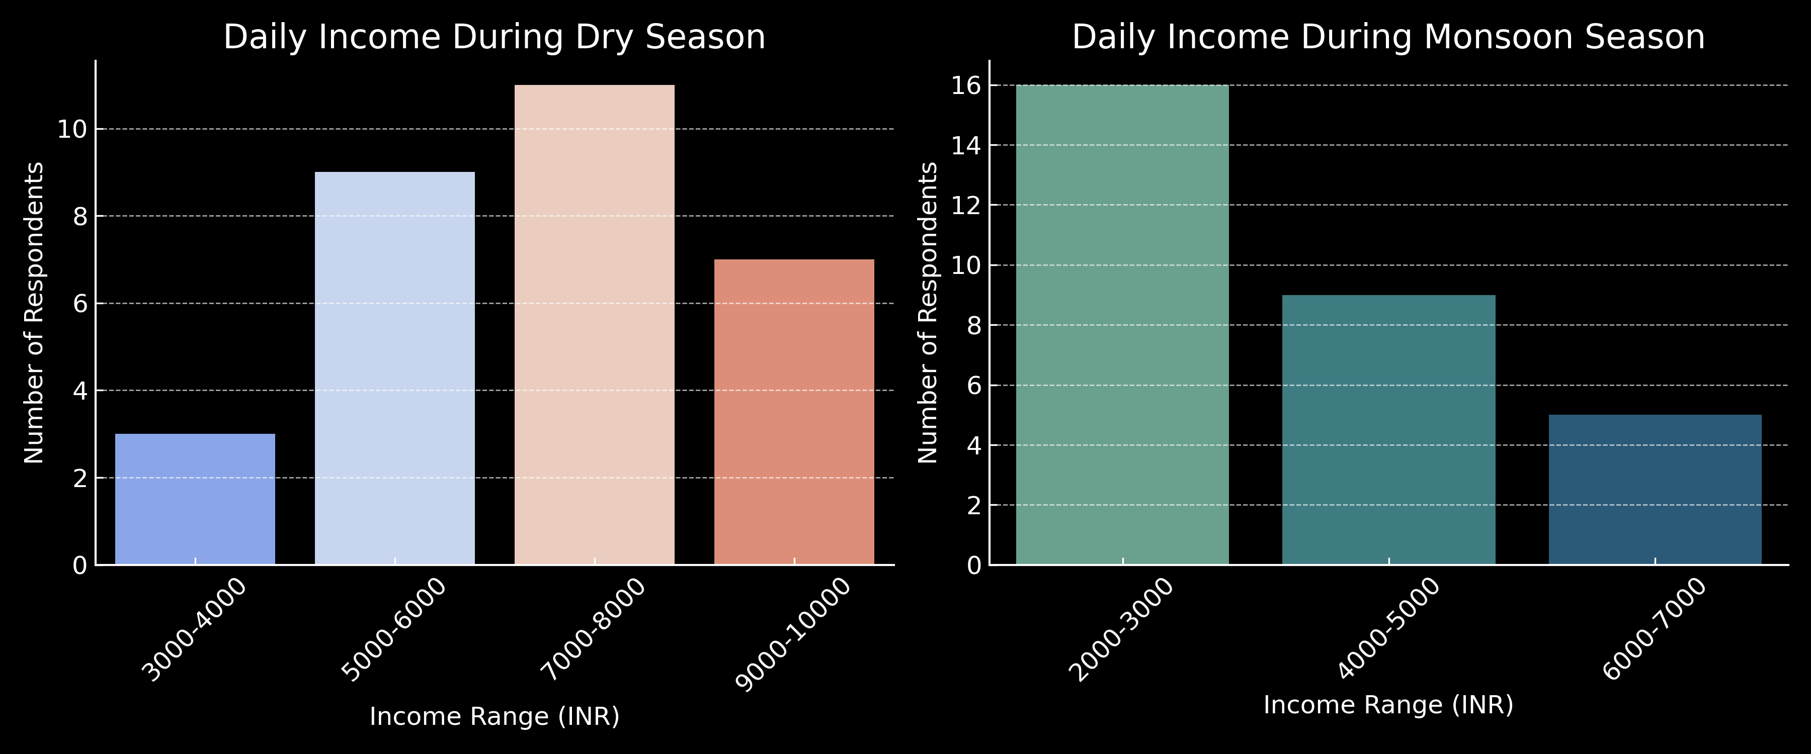

Figure 1: Daily Income Distribution in Dry vs Monsoon Seasons

As seen in Figure 1, the income distribution clearly shifts leftward during the monsoon, reflecting diminished demand and operational constraints such as road blockages and improved rainfall-fed alternatives.

## Income Sufficiency Perceptions

Respondents were asked to assess the sufficiency of their income from water vending. Figure 2 shows that:

* + - 34% rated their income as “Very Sufficient”
    - 53% said it was “Sufficient”
    - 10% felt it was “Partially Sufficient”
    - Only 3% found it “Not Sufficient”

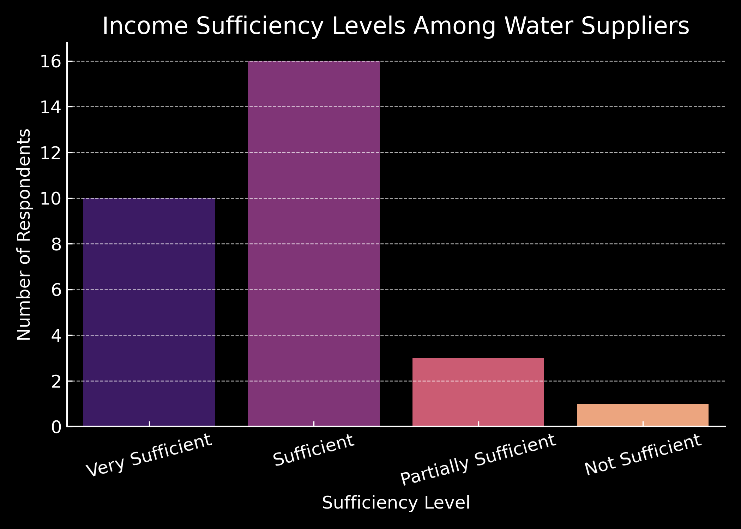

Figure 2: Income Sufficiency Levels Among Water Suppliers

The above suggests a generally optimistic outlook toward the livelihood, especially during high-demand seasons. However, income fluctuations present challenges to year round sustainability.

## Livelihood Dependency

An overwhelming 87% of respondents indicated that water vending is their sole occupation. This highlights the sector’s role as a primary livelihood generator in an informal urban economy.

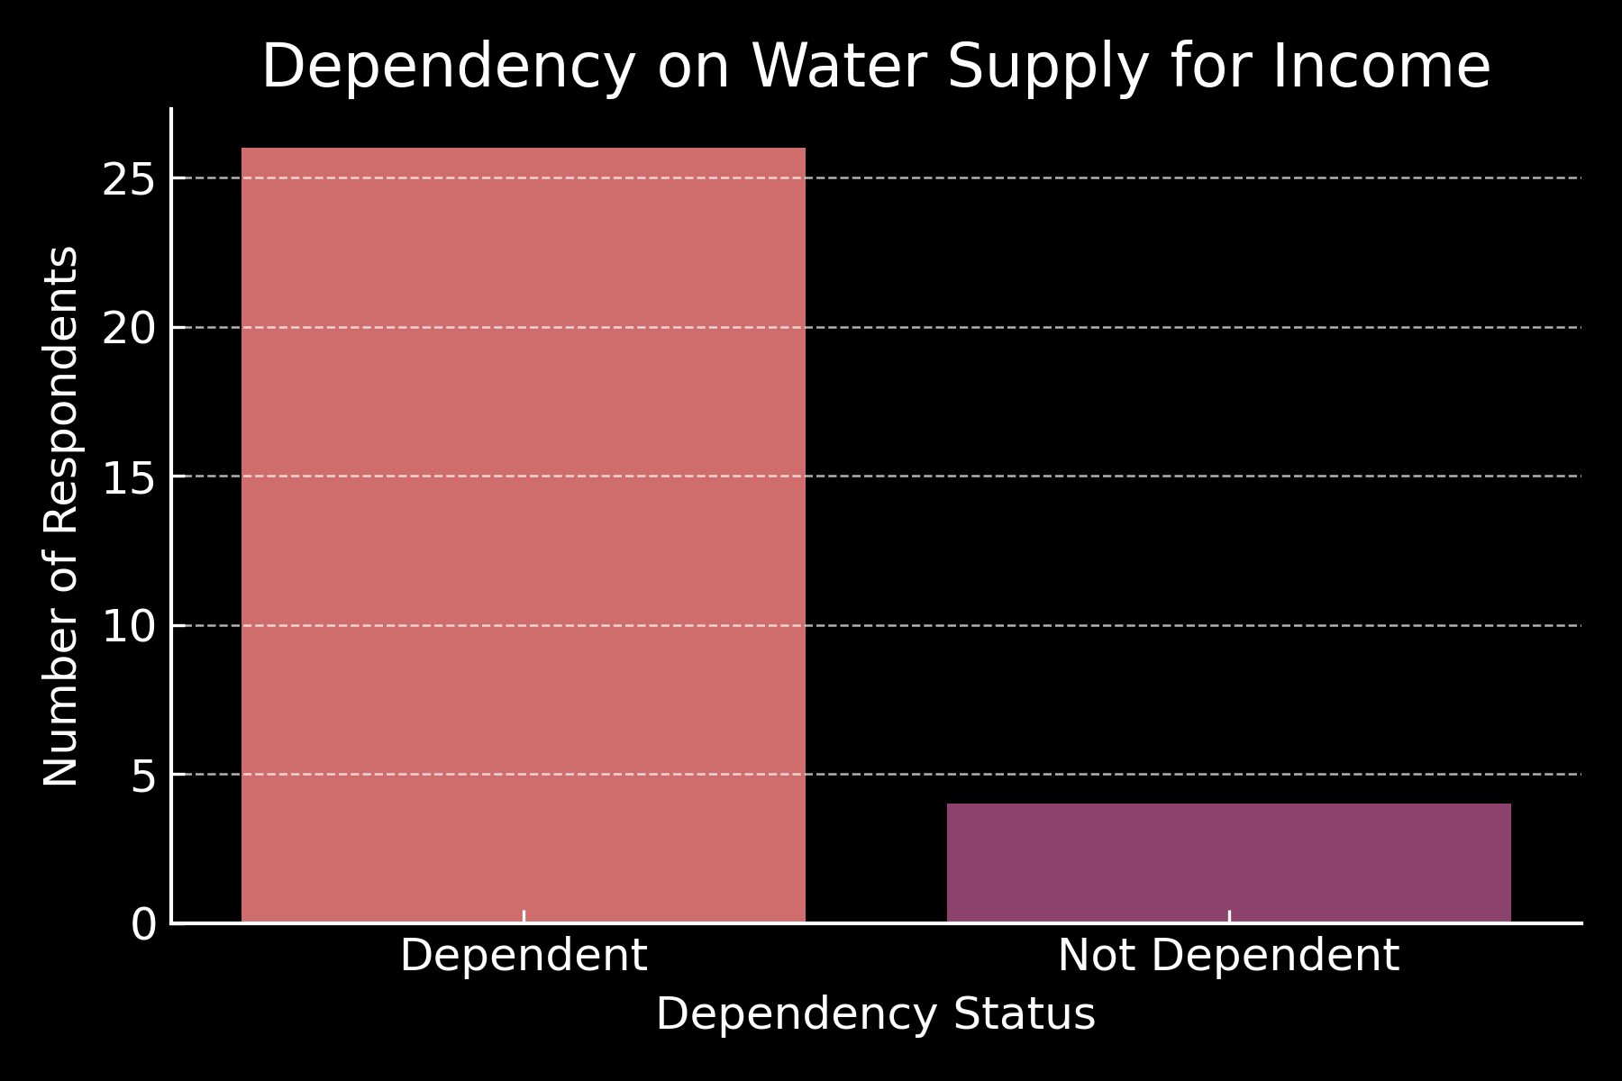

Figure 3: Dependency on Water Supply as Primary Livelihood

Such high dependency also signals vulnerability to seasonal shocks and economic disruptions, underscoring the need for policy attention to this sector.

## Chi-Square Test of Income and Season

To determine whether income level and season are statistically dependent, a chi-square test was conducted. The observed frequencies were grouped into high (Greater than Rs. 6000/day) and low (Less than Rs.6000/day) categories across two seasons.

Table 2: Contingency Table of Season and Income Level

### Season High Income (Greater than 6000) Low Income (Less than 6000)

Dry Season 18 12

Monsoon Season 5 25

The hypotheses were as follows:

*H*0 : Income level is independent of season

*H*1 : Income level is dependent on season

Using the chi-square test formula:

The computed test statistic was:

*χ*2 =

Σ (*Oij − Eij*)2

*Eij*

*χ*2 = 10*.*15 with *p* = 0*.*0014

Since *p <* 0*.*05, the result is statistically significant and the null hypothesis is rejected. There is a statistically significant relationship between season and income level, suggesting that private water suppliers earn substantially more during the dry season.

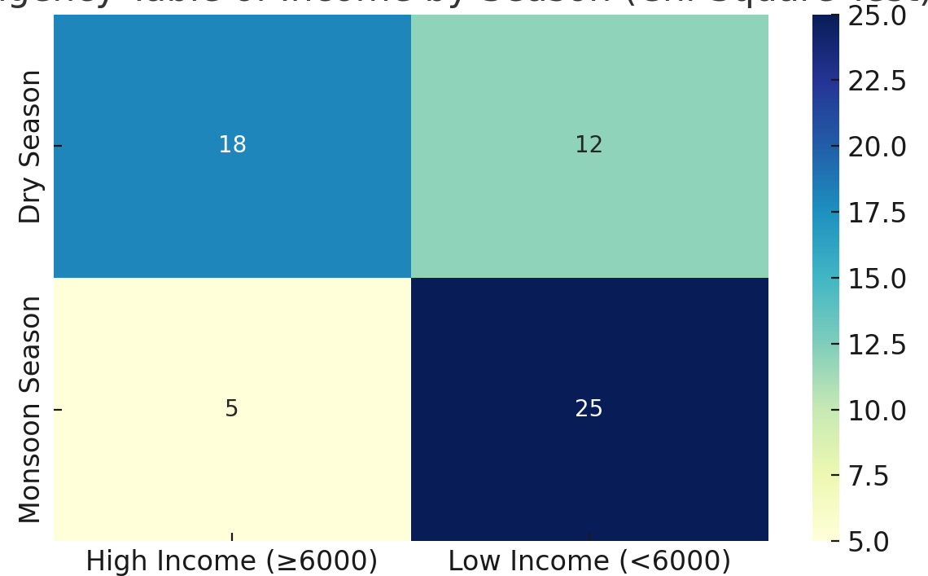

Figure 4: Heatmap of Chi-Square Test for Income vs Season

## Interpretation of Statistical Results

The results of the test confirm the seasonal variability identified in the descriptive data. Income shows a non-uniform distribution throughout the year and is significantly affected by external environmental factors. Most high-income reports originated during the dry season, reinforcing the idea that this time frame is the most profitable for private water suppliers.

To improve clarity on income distribution and seasonality, the box plot of daily income by season and the histogram of daily income distribution by season were also used.

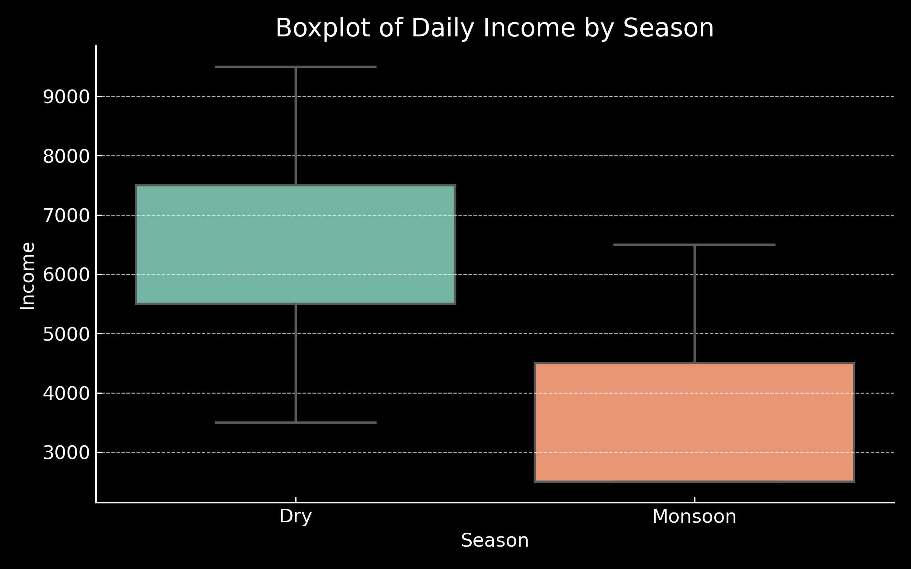

Figure 5: Boxplot of Daily Income by Season

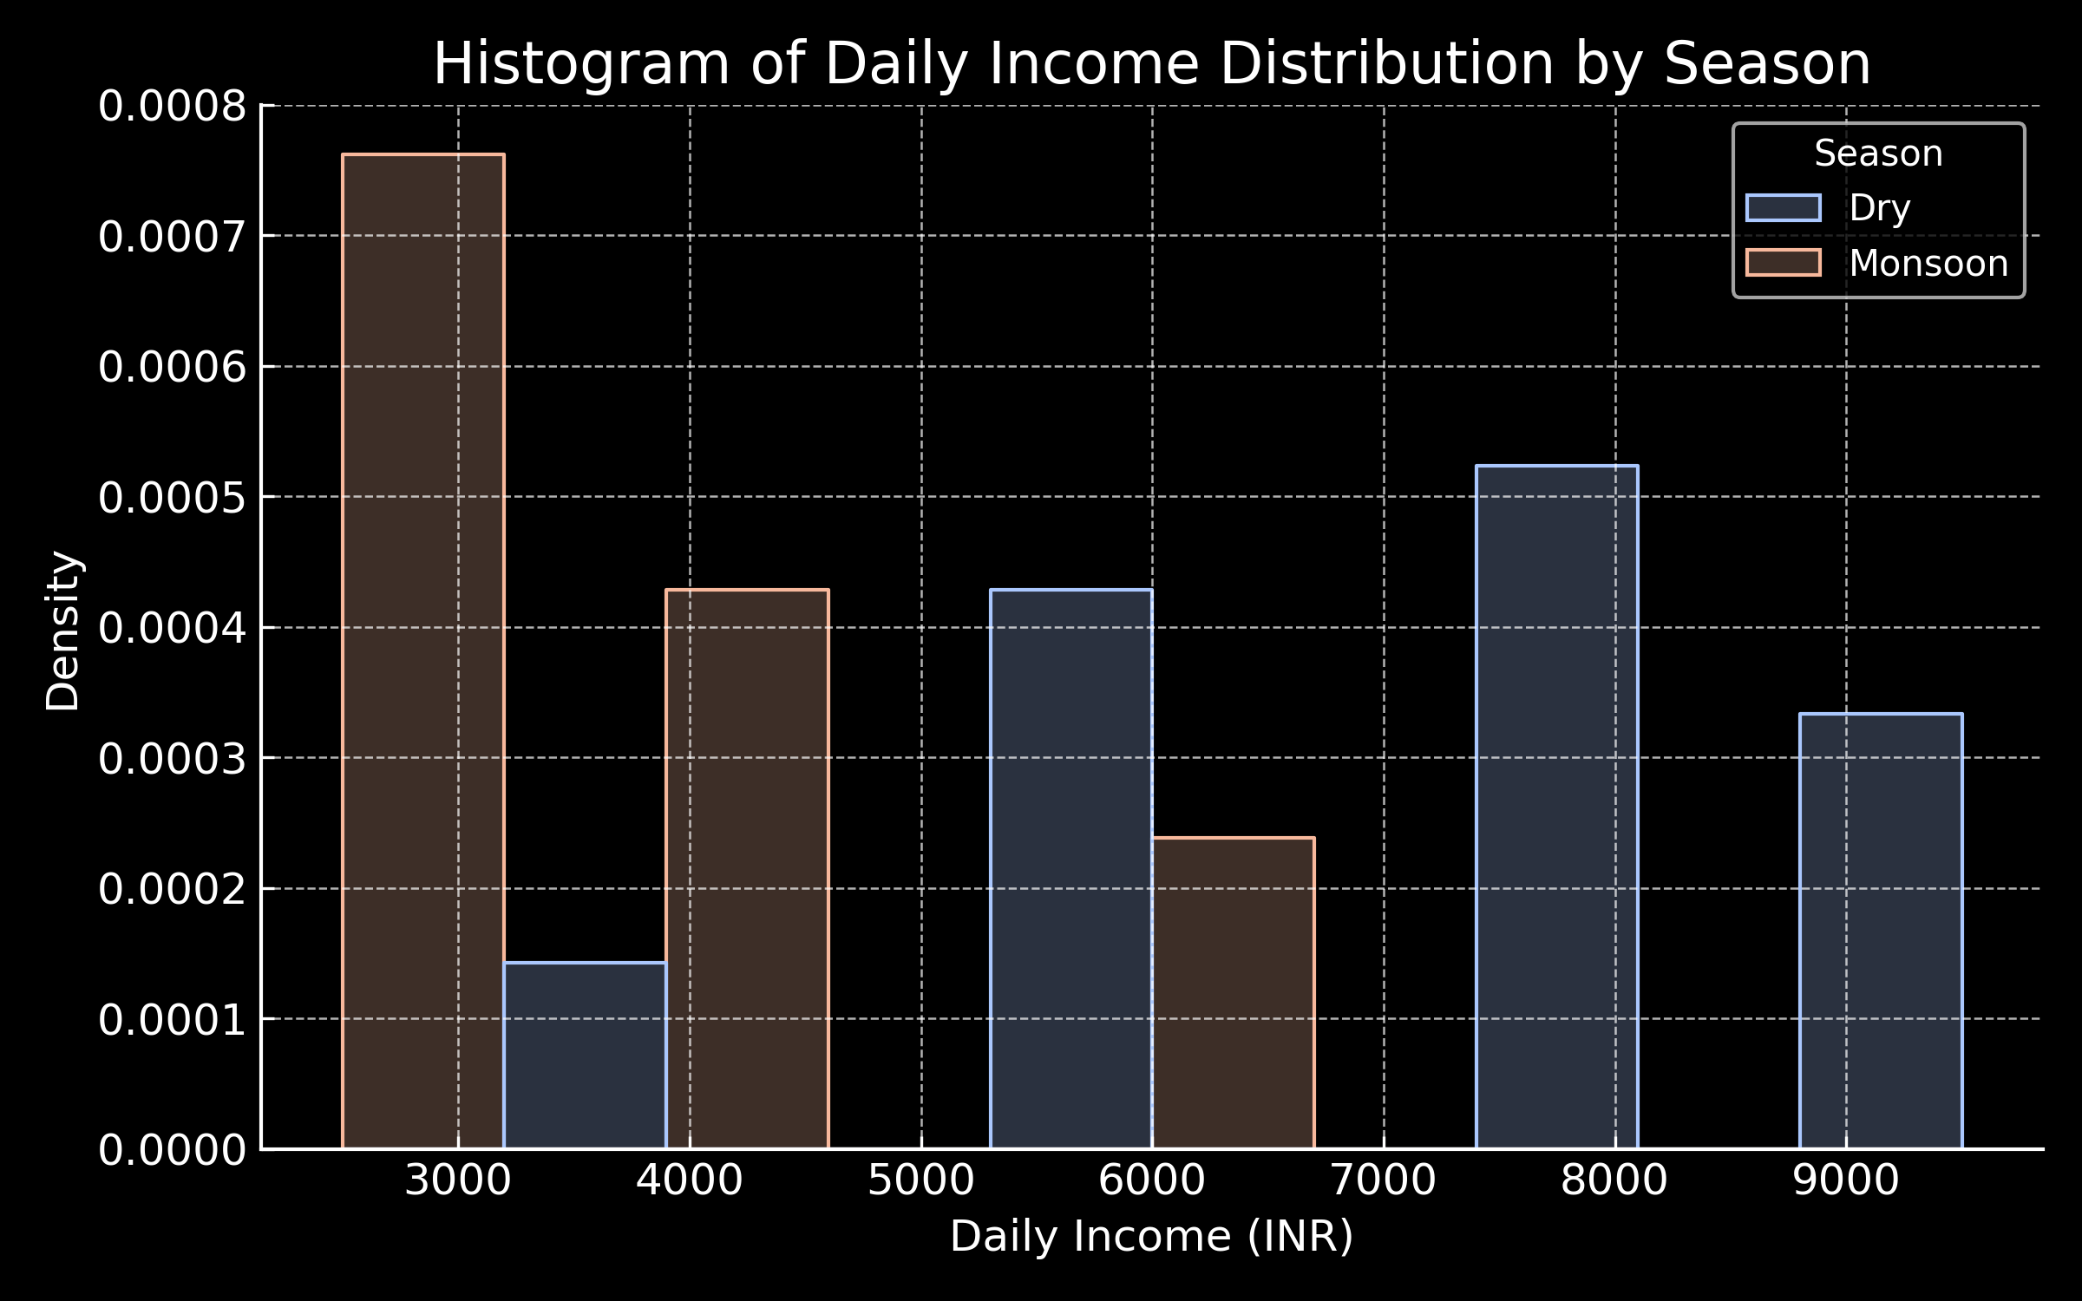

Figure 6: Histogram of Daily Income Distribution by Season

As shown in Figure 5, the dry season exhibits higher median income and wider dispersion, while the monsoon season reflects lower earnings with tighter variability. The histogram in

Figure 6 confirms a sharp leftward shift in income density during the monsoon, reinforcing the conclusions drawn from descriptive and statistical method.

# Discussion and Policy Implications

## Discussion of Key Findings

The results of this research indicate a distinct and statistically significant correlation between the season and income levels among private water suppliers in Kohima Town. The combination of descriptive analysis and chi-square testing shows that income levels are considerably higher during the dry season, when the public water supply is inadequate and demand for private deliveries increases. In contrast, earnings significantly decrease during the monsoon as natural water sources become more plentiful, and road conditions often impede mobility.

In spite of these seasonal income variations, the majority of suppliers reported being con- tent with their earnings, especially during times of high demand. A significant majority—87 percent—depend solely on this line of work for their sustenance, highlighting the importance of the informal private water supply sector in Kohima’s urban economy. However, the strong reliance on weather conditions for income creates a vulnerability, particularly for individuals who lack the means to diversify their income sources or save. The research also indicates that road infrastructure has a substantial impact on operational efficiency, with inadequate access in certain areas restricting service delivery and income stability.

## Policy Implications

The findings of this study have significant implications for local decision makers. There is an urgent need to support private water providers as providers of water services in the urban context. There may be an opportunity to invest in better local road status in serviced regions to ease delivery and lower supplier vehicle maintenance load. Seasonal subsidies and microfinance support could stabilize incomes during the off-season and sustain suppliers to cope with the costs of operating, i.e., fuel, repairs, etc. However, as a private water source could be used as a drinking water supply for many reasons, simple mechanisms of monitoring the water quality, such as low-cost test kits or a control by the municipality, could support the consumers’ security and the service level. What’s more, a light-touch registration framework for suppliers could help organize the industry without setting in stone stultifying bureaucratic controls. Participating vendors may have had access to refill points, tags, and support (where applicable) in price regulation during shortages. Digital services like SMS alerts or mobile apps could also make it simple for suppliers and municipal bodies to communicate, in case of a surge in demand or a disaster. Lastly, increasing the participation of these suppliers in local planning processes would underpin community-driven problem solving and ensure that the city

developmental agenda matches the reality lived by informal workers in essential activities.

## Scope for Further Research

Firstly, the data was analyzed in terms of water supply by the present study. Further study could systematically incorporate consumer interest to assess questions of satisfaction, pricing fairness and wellness. Further, data over time on delivery volumes or revenues would make it possible to apply regression or forecasting models that could assist in explaining sources of income variation in months or years. It would also be better if such studies could be compared with other towns in Nagaland or in the larger Northeast region to give a more complete picture of how unorganised water supply systems operate in such urban areas.

# Conclusion

Income dynamics and economic sustainability of private water vendors in Kohima Town, Nagaland have been investigated based on empirical analysis employing primary data. There is substantial evidence of a strong seasonal income pattern, such that damp-season income is significantly lower given low urban access to public water supply than in the dry season. A chi- square test verified that this seasonal variation is significant, adding support to the experience by respondents.

Even though working in the unorganized (and invisible) sphere, PWSPs provide significant inputs to the urban water services infrastructure of the town of Kohima. The vast majority of respondents are reliant on this work to survive, showing that this sector is both filling an important service void and providing vital work. But working seasonally, getting to work on bad roads, finding fuel, staying ahead of prices – they all add to the stress, and then sometimes leave them with an empty pocket at the end.

The results indicate that the targeted policy interventions such as strengthening of infrastructure, seasonal support policies, water quality monitoring and soft regulatory regimes would contribute to the resilience and sustainability of the sector. Such interventions would not only help to sustain the livelihoods of suppliers but would also enhance the ability to access water for thousands of urban residents who are dependent on them, particularly in peripheral and poor areas.

To conclude, this article highlights the actual need of acknowledging and taking into consideration informal service providers in urban planning and policy. Kohima’s illicit water sellers typify the kind of situational, site-specific response to infrastructure failure. Elevating their role through facilitation of governance can usher more inclusive and sustainable urban ecosystems - not only in Kohima but all other such hill towns in Northeast India, which face similar socio-economic and environmental issues.

# References

Agarwal, A., & Narain, S. (2010). Regulating india’s informal transport: The challenge ahead.

*Centre for Science and Environment*.

Bank, W. (2018). The state of the informal sector in india’s transport economy. *World Bank Policy Report*.

Baruah, S. (2003). Transport and trade in northeast india. *Economic and Political Weekly*, *38*(31), 3301–3307.

Bhowmick, P., & Ghosh, R. (2022). Gendered mobility and informal transit. *Urban India*, *42*(1), 99–117.

Cervero, R. (2000). *Informal transport in the developing world*. United Nations Centre for Human Settlements (UN-HABITAT).

Chakrabarti, S., & Bhatt, A. (2021). Self-employment and mobility in india’s informal sector.

*South Asia Economic Journal*, *22*(1), 43–65.

Chattopadhyay, B. (2017). Involvement of private sector in urban water supply: A case of nagaland. *International Journal of Social Sciences*, *5*(2).

Das, P. (2016). Road connectivity and development in the northeast. *Journal of Infrastructure*, *5*(2), 22–35.

Ferrer, C., & Zuniga, E. (2020). Informal work and economic inclusion in urban asia. *Cities*, *98*, 102570.

Kikon, D., & Karlsson, B. G. (2019). Beyond the developmental state: Infrastructure and iden- tity in northeast india. *Contemporary South Asia*, *27*(4), 505–519.

Kumar, A., Zimmerman, S., & Agarwal, O. P. (2012). *Approaches to urban transport planning in developing countries*. World Bank Discussion Paper.

Lama, K., & Rai, A. (2015). Transport infrastructure and hill area development. *Indian Journal of Regional Planning*, *45*(3), 77–89.

Mazumdar, S. (2018). Women’s safety and transport equity in india. *Gender and Development Review*, *10*(2), 40–51.

Mitlin, D., & Satterthwaite, D. (2013). Urban poverty in the global south. *Routledge*.

Pathak, P., & Bhan, R. (2022). Blurring boundaries: Informality and innovation in urban india.

*India City Monitor*, *12*(2), 111–123.

Pucher, J., Korattyswaroopam, N., & Ittyerah, N. (2007). The crisis of public transport in india: Overwhelming needs but limited resources. *Journal of Public Transportation*, *10*(4), 1–20.

Roy, R., & Arora, K. (2020). Informal urban transport and livelihood in india. *Asian Transport Review*, *7*(2), 45–60.

Sen, I. (2021). Employment patterns in the northeast: A field view. *Nagaland Social Research Journal*, *3*(1), 66–78.

Sharma, R., & Singh, P. (2020). Regulatory challenges of informal transport in indian cities.

*Journal of Urban Policy*, *9*(3), 55–72.

Singh, M. (2017). Transport and development in tribal regions of india. *Journal of Northeast Studies*, *6*(1), 14–25.