Design of Mini Tractor Operated Multipurpose Equipment for Groundnut Crop

ABSTRACT
A study was conducted in 2021 at the Department of Farm Machinery and Power Engineering, Dr. NTR College of Agricultural Engineering, Bapatla, Andhra Pradesh, to design, fabricate, and evaluate a cost-effective multipurpose agricultural implement. The equipment was developed in the departmental workshop and subsequently field-tested at the college research farm. Designed to address the needs of small and marginal farmers, the implement integrates sowing, spraying, and weeding functionalities into a single machine, significantly reducing the time, labor, and fuel requirements for row crop cultivation. The developed machine features a simple and robust design, with overall dimensions of 1800 × 600 × 1550 mm and a total weight of 150 kg. Tynes are mounted using nuts and bolts, allowing for easy adjustment of row spacing to suit various crops. The sowing unit ensures accurate seed placement at the desired depth, while the spraying and weeding units are configured for simultaneous operation. This makes the implement particularly suitable for narrow-row crops such as groundnut. Laboratory and field evaluations were conducted to assess the machine’s performance. The sowing unit delivered an average of 340 grams of seed per 20 ground wheel revolutions, corresponding to a seed rate of 120.2 kg ha⁻¹. The spraying unit, equipped with three adjustable nozzles, achieved a discharge rate ranging from 0.9 to 1.3 L min⁻¹ at operating pressures between 150 and 275 kPa. The swath width varied from 1.01 to 1.36 m, with nozzle overlap between 23% and 44%, increasing with pressure. Field results confirmed the implement’s effectiveness in reducing operational costs and fuel usage by enabling combined spraying and weeding operations in a single pass. The machine demonstrated strong potential as a practical and affordable solution for enhancing mechanization in smallholder farming systems, particularly for row crops requiring timely intercultural operations.
Keywords: Groundnut, drudgery, field capacity, field efficiency, sowing, weeding
1. INTRODUCTION
India ranks among the largest producers of groundnut (Arachis hypogaea L.), accounting for approximately 6.8 million tonnes from a cultivated area of 4.5 million hectares, with major production concentrated in states like Gujarat, Andhra Pradesh, Tamil Nadu, and Karnataka. Groundnut is a crucial oilseed crop for Indian agriculture, contributing significantly to farmers’ incomes and rural livelihoods. Traditional groundnut cultivation practices, involving separate manual or animal-drawn operations for sowing, intercultural, and digging, are labor-intensive, time-consuming, and physically strenuous, particularly for women and aged farmers. These conventional methods result in high drudgery, low field efficiency, and increased production costs, often affecting timely operations and ultimately yield.

In India, 67% holdings are less than 1 ha (Singh, 2015) accounting for 19% of the total operated area whereas; over 86% holdings are less than 2 ha accounting for nearly 47% of the operating area (Anonymous, 2013). Fragmentation of farm holdings is major concern in this respect and the average size of holdings has shrunk from 2.82 ha in 1970–71 to 1.1 ha in 2010–11 (Khandetod, 2019). This will also not satisfy need of energy requirement of farming as compared to other countries in the world (Mehta and Pajnoo, 2013).

Commercially there are various machines that are available for sowing, intercultural and spraying operations, however these machines have to be manually or power operated to perform the required operations and moreover separate machines are used for every function. Practically with such little ownership of land, it is not possible for small and marginal farmers to purchase each implement for specific operation. So, instead of developing implements and operational specific machines, multipurpose farm equipment which can perform sowing, weeding and spraying can reduce economic burden on small and marginal farmers.
To address the above challenges, a mini tractor operated multipurpose equipment was designed and developed specifically for small and marginal farmers cultivating groundnut.
2. MATERIALS AND METHODS
A multipurpose equipment was designed and fabricated in the Departmental Workshop of Farm Machinery and Power Engineering and evaluated at field of Dr. NTR College of Agricultural Engineering, Bapatla in the year of 2021.
2.1 Design Considerations
The seeding attachment furrow opener, frame, seed hopper, seed metering mechanism, chain and sprocket and ground wheel etc. The following sections describe the theoretical design process and fabrication involved.
2.1.1 Design of sowing unit
2.1.1.1. Size of the seed drill
Size of the seed drill usually depends on calculation of the total draft and number of furrow openers required based upon the power source available for operation of the seed drill (Ebrahim et al., 2008).
Accordingly, a trapezoidal cross section made by the furrow opener with a top width of 40 mm and bottom width of 25 mm and working at a depth of 35 mm respectively was assumed.
Cross section of furrow opener (A)=((a+b))/2 × h
Where,
a = Top width of furrow opener, mm
B = Bottom width of furrow, mm
h = Cutting depth of furrow opener, mm
Cross section of furrow opener (A)=13 cm²
The value for the average soil resistance is calculated by using the following formula
Average soil resistance (F_{x}) = A × Pk
Where,
A = Cross section of furrow, cm²
P_{k} = Specific soil resistance of heavy soil, kg cm⁻²
Specific soil resistance P_{k} of the soil when sowing to a depth of 15 cm for different soils is given as shown below (Allison, 1968);
Light soil: 0.12 kg cm⁻²
Medium soil: 0.15 kg cm⁻²
Heavy soil: 0.20 kg cm⁻²
Very Heavy soil: 0.35 kg cm⁻²
Therefore,
Average soil resistance (F_{x}) = 13 cm²×0.35 kg cm⁻²
Average soil resistance (F_{x}) = 4.55 kg
Assumed that the soil resistance to be 3–5 times higher than actual average soil resistance (F_{x}). (Shrivastava and Satyendra, 2011)
Draft at the tip of the tyne (Dt) = Fx×3(assumption)
= 4.55×3
Draft at the tip of the tyne (D_{t}) = 13.65 kgf
Since 1 kgf = 9.81 N
Total Draft (D) =13.65×9.81 N
Total Draft (D) =133.90 N
2.1.1.2. Furrow opener
Furrow openers are one of the most important components of any seed drill as they create a furrow to place the seed at required depth before dropping the seed. In case of direct seeding, the design of the furrow opener plays an important role as they affect the sowing depth and lateral scattering of the seeds.
Furrow openers of shovel type have been selected in the design of this equipment. The main aim is to open the furrow having 5 cm depth and 5 cm width so, that the seed can be placed at a depth of 2–5 cm and maintain row to row distance for groundnut crop is 30 cm (Reddy et al., 2015)
2.1.1.3. Design of furrow opener
In designing a furrow opener, the height of the furrow opener (H) plays an important role and it is calculated by using the following formula (Chaudhuri, 2001).
Height of the furrow opener, H=amax+H1+∆H
Where,
a_{max} = Depth of the tool, cm
H₁ = Length of the tyne, cm
∆H = Length of tyne used for fastening with the frame, cm
Here a_{max,} H₁, ∆H were considered as 5, 32 and 8 cm. Hence, the maximum height of furrow opener is calculated as 45 cm.
Distance (a) of the draft application on the furrow opener is said to be at a height of h/3 from the base of the opener.
Therefore, Distance of draft application,
A = h/3 = 45/3 = 15 cm
Moment arm length = h-a = 45-15 = 30 cm
Bending moment in tyne = D (h=a) = 13.65 (23.34) = 409.5 kg cm
= 409.5×9.81×10 N-mm = 40171.95 N-mm
By taking the value for factor of safety as 5, the maximum bending moment of tyne is given as
Maximum bending moment in tyne = Bending moment in tyne × Factor safety
= 40171.95×5 N-mm = 200859.75 N-mm
It is assumed that M.S flat tyne is used in the planter and f_{b} for mild steel is 56 N/mm²
Section modulus, Z = Mb/Fb = 200589.75/56 = 3586.78 mm³
From this section modulus of tyne, the minimum thickness of the plate is taken and is given by the following equation
Z = (1/6) × t (H)²
Where,
Z = Section modulus of tyne, mm³
t = Thickness of the flat piece, mm
H = Height of the furrow opener
2438.89 = (1/6) × t (45)²
t = 10.6 mm
t = 10.6 mm = 1.6 cm
Hence, for the design of the furrow opener of the planter a M.S flat having minimum length of 45 cm and thickness of 1.6 cm was selected.
2.1.1.4. Design of frame
The components of the seed sowing are mounted on the main frame (chassis) which is supported a stand attached to the frame. The machine is also connected to the rigid hitch point of the prime mover. The design was based on the stresses produced on the front of frame (Lal and Dutta, 1995). Frame was subjected to torsion and bending due to induced draft (Ramya et al., 2020).
The total draft acting on the tyne measured as 13.65 kg. As three tynes are to be fastened on the frame. Total draft in kg.f is given as
Draft (D) =13.65×5 kg.f = 68.25 kg.f
Total Draft (D) = Draft (D) × Factor of safety
Torque acting on the bar = Draft (kg) × Factor of safety × Ground clearance (cm)
Taking ground clearance available 45 cm and Factor of safety for mild steel 3,
Torque, T = 68.25 × 3 × 45 = 9213.75 kg cm
In addition to the torque, bending moment would also be produced. The bar was considered as simple supported beam on the frame in between the five furrow openers.
Maximum bending moment (kg cm) = D × L
Where,
D = Total draft on the frame, kg cm = 204.75 kg.f
L = Length of the frame, cm = 180 cm
Maximum bending moment (kg cm) = 204.75 × 180 =36,855 kg cm
Maximum bending moment (kg cm) = 36,855 kg cm.
Equivalent torque due to torsion and bending moment,
Te = (M_{max}²+T²)^{1/2}
Te = (36855²+9213.75²)^{1/2}
=37989.26 kg cm
2.1.1.5. Design of seed hopper
The capacity of hopper should be such that it gives minimum number of refilling per hectare area and does not cause high additional weight on the machine. The capacity of the hopper depends on the seed rate of different crops a 15 kg capacity hopper was designed.
Hopper capacity was calculated based on the quantity of the material to be filled in the box at a given bulk density (Varshney et al., 2004). The volume of the hopper is calculated as given below:
Let,
V = Volume of box, m³
ρ = Bulk density of material for groundnut = 286 kg/m³ (Reddy et al., 2015)
Q = Hopper capacity, kg= 15 kg
Then,
V = Q/ρ
= 15/283 = 0.065 m³ = 53000000 mm³
V = A×L
Where,
A = Area of cross section of box, mm²
L = Length of box (Assume 600 mm)
So,
A = V÷L
= 53000000 ÷ 700
= 75714.28 mm² ≈ 75714 mm²
Section X is rectangular, section Y is trapezoidal, and Z is rectangular.
Cross section area of section X = B×H
Where,
B = Width of rectangular section, mm = 260
H = Height of rectangular section, mm =140
So,
Area of X = 60×140 = 36400 mm²
Cross section area of section Z = b’ x h’
Where,
b’ = Width of rectangular section, mm = 65
h’ = Height of rectangular section, mm = 140
Cross section area of section Y = 1/2×(a + b)×h
Where,
H = Height of trapezoidal section, mm
a = Top width of trapezoidal section, mm=260
b = Base width of trapezoidal section, mm = 65
So, Area of Y = 75714–36400–9100 = 30214 mm²
Area of Y = 1/2×(260+65)×h = 30214 mm²
h =185.9≈186 mm
The seed hopper was divided in three sections as upper, middle and bottom. The upper section is rectangular in cross section having width of 260 mm, height of 140 mm and length of 300 mm length as dimensions. The middle section is trapezoidal in cross section provided with 45º slopes from two sides for free flow of seed. Its dimensions were 260 mm of top width, 65 mm of bottom width, 186 mm of height and 300 mm of length. The bottom section is rectangular in cross section having width of 65 mm, height of 140 mm and length of 300 mm. The schematic diagram as shown in Figure 1.
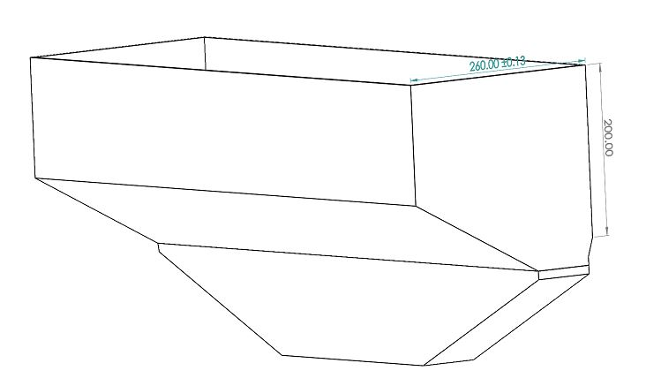
Fig. 1. Designed CAD view of seed box
2.1.2 Seed sowing metering mechanism
The required seed metering mechanism for ground nut was designed. The required seed rate for groundnut crop was 100–130 kg ha⁻¹ (Singh, 2017). As working width of developed equipment was 1.8 m, with ground wheel diameter 0.30 m, 7078 revolutions of drive wheel were required to cover area of one hectare.
Considering drive wheel to seed metering mechanism speed ratio as 1.5:1, the seed rate per revolution of metering mechanism was given by,
= 120/7078 = 0.0169 kg revolution⁻¹
= 16.9 g revolution⁻¹
Five furrow openers were provided on implement and hence seed rate per revolution per furrow opener was given by,
= 16.9/5 = 3.38 g revolution⁻¹
3.38 grevolution⁻¹ seed equivalence to seed of 11.8 cc revolution⁻¹ in terms of volume. To suit the requirement of 3.38 g revolution⁻¹ delivery of seed vertical rotor with cells on its periphery (Edge cell rotor) was chosen. Plastic metering rotor with 95 mm diameter, 12 mm width and 10 grooves on its periphery was selected based on its availability.
2.1.3 Chain and sprocket
A single strand bicycle chain was selected for transmitting power from ground wheel to metering shaft. The arrangement consisted one sprocket of 18 teeth and two sprockets of 12 teeth. The number chain links, length of chain and central distance between two sprockets were determined as discuss below.
The length of first chain (L) attached from ground wheel to 1st idler sprocket was calculated by using following formula (Khurmi and Gupta, 2011):
The number of links, m, where determined by following relationship.
m=(2C_{d}/P)+(T₁+T₂)/2+{(P(T₁-T₂)²)/(4π²×C_{d} )}
Where,
C_{d} = Centre distance, mm
P = Chain pitch, mm (12.5)
T₁ = Number teeth of 1st sprocket
T₂ = Number teeth of 2nd sprocket
On substituting the values of C_{d}, P, T₁ and T₂
m=(2×435/12.5)+(18+18/2)+{12.5(18-18)²)/(4π²×435)}=87.6 ≈88
The length of first chain (L₁) was calculated as number of links into chain pitch i.e. 1075 mm. Similarly, the number of links, center to center distance between sprockets and length of Second chain (L₂) measured to 388 mm.
Table 1. Specification of chains used for seed metering
S. No. | Placement | Centre to Centre distance, mm | Number of links | Length of chain, mm
L₁ | Chain on ground wheel shaft to intermediate shaft | 435 | 88 | 1075
L₂ | Chain on intermediate shaft to main shaft | 157 | 112 | 388

2.1.4 Design of pegged type ground wheel
Pegged wheel was suitable for use under wet or sticky soils, where plain, lugged or even pneumatic wheels fail to work hence pegged type ground wheel was used in the present study. The diameter of the wheel and the number of pegs depends on the size of wheel. Here, the diameter of the ground wheel was selected as 40 cm and number of pegs on the ground wheel was 12 (Verma, 1986). The pegs were made up of mild steel round bars or flat bars having pointed edge towards the ground surface. The motion at any given point on the wheel follows a cycloid path. The pegs enter the ground vertically and leave the surface upwards. Hence, soil coming in contact with the peg was pushed downward but not taken upwards. The diameter of ground wheel is calculated by using the following equation
Diameter of ground wheel, D = (n×p)/π
Where,
D = Diameter of drive wheel, cm
n = No. of seed dropped in one revolution
p = Plant to plant distance, cm
Ground wheel of 30 cm diameter, having width and thickness of 5 and 1 cm respectively was selected and provided at back side of the main frame of the drill. Twelve pegs (10×4.0×0.5 cm²) (Figure 2) were provided on the outer periphery of the wheel to get sufficient grip during rotation.
Power developed due to rotation of the wheel was transmitted to the seed metering shafts with the help of two sets of chain and sprocket arrangement. As the drive wheel enters in to the soil it is considered that the half of the peg is inserted in to the soil for better gripping and to avoid skidding of drive wheel. Hence, diameter of the drive wheel was measured from the tip of peg at one end to the base of the peg of opposite side.
2.1.5 Design of power transmission system from ground wheel to metering device
The power required for the seed metering device is generated from the ground wheel and is transmitted by using chain and sprocket. In order to reduce the loss of power during transmission, a dual set of chain and sprocket arrangement one for transmitting the power form ground wheel to an idler shaft on which the second set of sprocket was arranged, from that in turn a chain was arranged to the metering shaft of the drill. The speed ratio of ground wheel and seed metering device is given as a function of number of teeth on the sprockets and is calculated by the following formula.
Ng/Ns = Ts/Tg
Here,
Ng = Number of revolutions of the ground wheel, rpm
Ns = Number of revolutions of the seed metering device, rpm
Tg = Number of teeth on the sprocket of ground wheel (= 18)
Ts = Number of teeth on the sprocket of the seed metering device (=18)
Ng/Ns = 18/18 = 1
Fig. 2. Line diagram of ground wheel
Thus, the speed ratio of 1:1 was used in the present study. It implies that number of revolutions made by the ground wheel in a minute is same as the one made by the seed metering device.
2.1.6 Design of weeding blade
2.1.6.1. Functional requirements of weeding blade
Different components of weeding machine were designed for its functional and structural requirement. Following functional requirements were considered for design of the weeding blade:
- The weeding blade should cut and uproot weeds present on surface in a single run.
- The weeding should minimum invert the soil with minimum disturbance.
- Damage to crop during weeding operation should be as low as possible.
- The weeding tool should be simple in design and construction, and efficient in its performance.
The following design parameters were considered during the development of sweep type weeding tool for various spacing of crop (Sharma and Mukesh, 2010). CAD representation of prototype with weeding blade as shown in Figure 3.
2.1.6.2. Design of weeding blade
The cutting width of sweep type blade were found by using the formula,
Sc = Zf+Zp
W = Zf = Sc-Zp
Where,
Sc = Crop spacing, cm
Zf = Effective soil failure zone, cm
Zp = Protection zone, cm = 6 cm
W = Width of sweep, cm
[Protection zone multiplied by 2 since protection zone has to be provided on both sides of crop]
Zf = 30-(6×2) = 18 cm
Zf = W+2d tan Øs
Where.
Zf = Effective soil failure zone, cm
W = Cutting width of sweep, cm
D = Depth of weeding, cm
Øs = Angle of internal friction which ranges between 10 º to 30 º depending upon type of soil (Laxminarayana and Vikas, 2018) = 20º
18 = W+2(6) tan 20º
W = 13.6 cm ≈ 14 cm
2.1.7 Design of spraying unit
2.1.7.1. Design for tank capacity
The capacity of tank of tractor drawn sprayers depends upon location of water supply, area covered, hydraulic lift capacity of tractor and boom length of sprayer. Generally, 100–500 litre capacity of tank was taken (Sharma and Mukesh, 2010). It should be such that it can provided liquid for treatment of one hectare area. It can be estimated as under
Q_{t} = D_{b}×t
Where,
Q_{t} =Tank capacity, litres
D_{b} =Total discharge rate of all nozzles of the boom, l/min
t = Duration of use, min
Q_{t} = 2.25×60 = 135 lit
2.1.7.2. Design of sprayer tank size
The rectangular hollow frame was fabricated for mounting the sprayer tank in to the frame. The length, width and height of the frame were 440 mm, 240 mm and 310 mm respectively. The sprayer tank was designed to occupy solution 150 litres in one filling. Two PVC tanks of each 75-litre capacity were selected. Pump was arranged on the tractor with the help of frame and it was fixed on the top of the three-point linkage. Pump was to pressurise spray solution through and contributed through hose pipes to 3 nozzles.
2.1.8 Power requirement and drive arrangement of pump
Power requirement of spray pump was calculated by formula suggested by FAO 112/2 (Ramana and Jesudas, 2009)
Power requirement = (Output volume (Lpm) x pressure kPa ×0.746)/(44800×pump efficiency)
The power requirement of 0.71 kW is well within the tractor PTO power. Drive arrangement to pooled subtieady the HTP. The designated speed of 900 rpm of the HTP pump was attained by giving the pulley ratio which is mounted on the PTO splined shaft (540 rpm) and pump pulley. The V belt pulley used for transmitting power from PTO shaft to the HTP pump through A type belt.
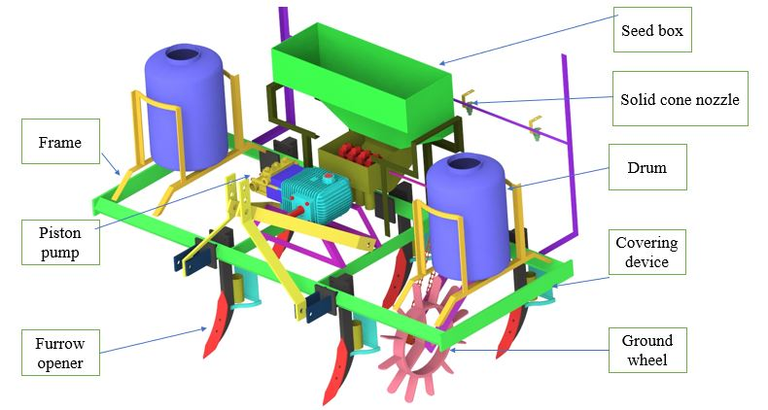
Fig. 3. CAD representation of prototype with reversible furrow opener

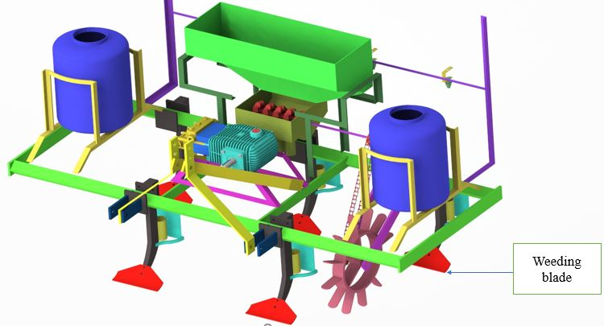
Fig. 4. CAD representation of prototype with weeding blade
3. RESULTS AND DISCUSSION
The developed multipurpose equipment effectively performed sowing, spraying, and weeding operations in groundnut crop. The integrated design included an edge cell seed metering system, a 150 L adjustable height spraying unit, and a cast iron blade weeder. Field evaluation showed that combining spraying and weeding in a single pass reduced fuel use and labor, resulting in lower cultivation costs and improved operational efficiency.
Table 2 : Study of Crop Parameter
S. No. | Groundnut crop parameters | Dimensions
1 | Average plant height, cm |  | 25.3
2 | Average plant width, cm |  | 10.1
3 | Row to row spacing, cm |  | 30
4 | Plant to plant spacing, cm |  | 10

Table 3 : Overall Specifications of Developed Equipment
S. No. | Particular | Specification
1 | Name of implement | Multipurpose equipment
2 | Make | ANGRAU
3 | Model | Prototype
4 | Type of power source | Mini tractor
5 | overall width of implement, cm | 60
6 | Overall length of implement, cm | 180
7 | Overall height of implement, cm | 170
8 | No of tynes | 5
9 | Tynes, cm | 45
10 | Tyne width, cm | 5
11 | Tyne thickness, cm | 1.6
12 | Furrow opener(L×W×T), cm | 32×3×3
13 | Weeding blade (L×W×T), cm | 14×10×0.5
14 | No of ball bearing | 2
15 | No of pulleys & belts | 2 &1
16 | No of nozzles | 3
17 | Type of pump | Horizontal triplex piston pump
18 | No of spray tanks | 2
19 | Each spray tank capacity, L | 75
20 | Type of nozzle | Solid cone
21 | Nozzle spacing, mm | 30
22 | Type of linkage system | 3- point linkage

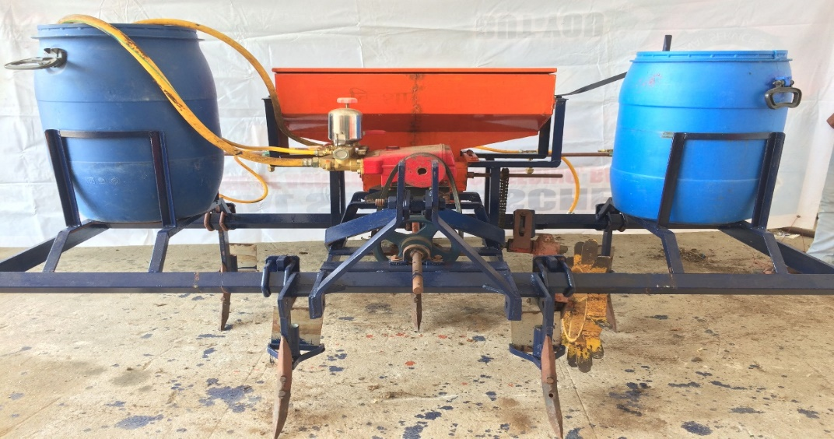
Fig. 5 Developed multipurpose equipment with reversible tyne
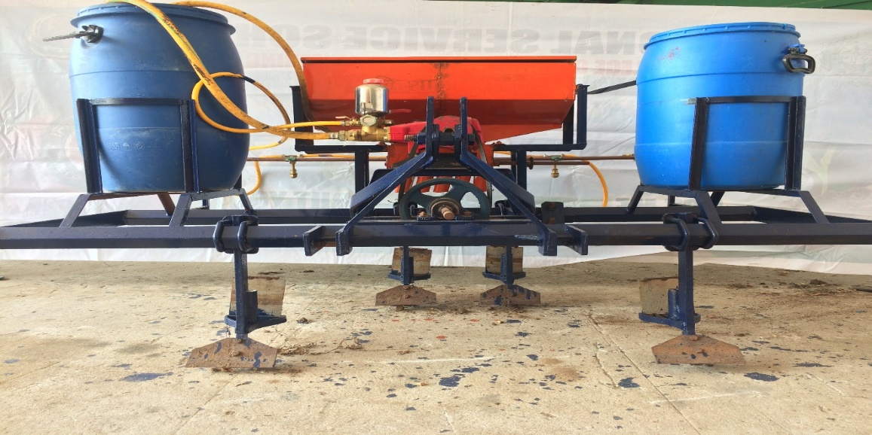
Fig. 6 Developed multipurpose equipment with weeding blade
3.3 Laboratory Evaluation For Multipurpose Equipment
Laboratory tests were performed after fabrication of multipurpose equipment. During these tests, key parameters such as seed rate, discharge rate, and swath width were measured and evaluated.
3.3.1 Laboratory Evaluation for Seeding Unit
The seeding unit calibration was performed in the laboratory before the field assessment. Results are presented in Table 4. The average weight of the seeds obtained from seeding unit delivery tube after 20 ground wheel revolutions was 340 gm. The quality of seed required to sow seeds in one hectare of area with developed seeding unit is noticed to be 120.2 kg ha⁻¹.
Table 4. Calculation of seed rate for developed seeding unit
S. No. | No of revaluation of ground wheel | Weight of seed collected (kg) | Seed rate (kg ha⁻¹)
1 | 20 | 0.34 | 120.3
2 | 20 | 0.33 | 120.1
3 | 20 | 0.34 | 120.3
4 | 20 | 0.34 | 120.3
3.3.2 Laboratory Evaluation of Spraying Attachment
3.3.2.1 Discharge rate of spraying attachment
Operating pressures of 150, 200 and 275 kPa was used for performance evaluation of boom sprayer set up as per recommended pressures (Robert et al, 2013). Discharge rate of spraying attachment varied from 0.9 to 1.3 L min⁻¹ as change in operating pressure of 150 to 275 kPa. Minimum discharge rate was obtained at 150 kPa and maximum at 275 kPa. Variations in discharge rate of nozzle were due to change in operating pressure. Fig. 7 shows the effect of operating pressure on discharge rate of all three nozzle.

Fig. 7 Effect of operating pressure on discharge rate of nozzle
3.3.2.2 Swath width of spraying attachment
Boom sprayer was tested at optimum working conditions such as 0.5 m height (Zhu et al.,2004) from target, operating pressures of 150, 200 and 275 kPa for solid cone nozzles. Swath width of spraying unit varied from 1.01 to 1.36 m and overlap with adjacent nozzle spray was varied from 23% to 44%. Maximum swath width and overlap was observed at operating pressure of 275 kPa. Mean values of swath width and overlap of sprayer was presented in Table 5.
Table 5 Mean values of swath width and overlap of spraying attachment
Operating pressure (kPa) | Swath width of boom sprayer (m) | Overlap (%) | Overall swath with (m)
150 | 1.7 | 23 | 1.01
200 | 2.07 | 33 | 1.13
275 | 2.42 | 44 | 1.36

4. CONCLUSION
The developed multipurpose equipment, integrating sowing, spraying, and weeding functions, was successfully fabricated and tested in groundnut fields. The spraying unit, with a 150 L capacity and three adjustable nozzles, effectively covered three crop rows, while the weeding unit, equipped with a cast iron horizontal blade, efficiently removed inter-row weeds. Field tests demonstrated that simultaneous spraying and weeding operations reduced both fuel consumption and overall cultivation costs compared to separate operations. Laboratory evaluations confirmed the equipment's performance. The average seed delivery from the seeding unit was 340 g per 20 revolutions of the ground wheel, corresponding to a seed rate of 120.2 kg ha⁻¹. The discharge rate of the spraying unit varied from 0.9 to 1.3 L min⁻¹ across operating pressures of 150 to 275 kPa, with swath widths ranging from 1.01 to 1.36 m and nozzle overlap between 23% and 44%. Maximum discharge rate, swath width, and overlap were observed at 275 kPa. These results highlight the effectiveness and efficiency of the developed equipment in reducing operational time and improving input utilization in row crop cultivation.
.
4. REFERENCES
Allison, F.E., 1968. Soil aggregation. Some facts and fallacies as seen by a microbiologist. Soil Science 106, 136–143.
Anonymous, 2013. State of Indian Agriculture 2012-13. Directorate of Economics and Statistics, Department of Agriculture and Cooperation, Ministry of Agriculture, New Delhihttp://164.100.47.132/paperlaidfiles/AGRICULTURE/State%20.
Chaudhuri, D., 2001. PM-power and machinery: performance evaluation of various types of furrow openers on seed drills-a review. Journal of Agricultural Engineering Research 79(2), 125–137.
Ebrahim A., Hamid Reza., Mohammad M and Kyeong U K. 2008. Development of a precision seed drill for oilseed rape. Turkish Journal of Agriculture and Forestry. 32. 451-458.
Khandetod, 2019. Mechanization in horticulture crops: present status and future scope. Advanced Agricultural Research & Technology 03, 92–103.
Khurmi, R.S., Gupta, J.K., 2011. Machine design. S. Chand publications. 120–180.
Lakshminarayana, S.V., Vikas, L., 2018. Development of bullock drawn three rowimproved intercultural hoe for groundnut. The Andhra Agriculture Journal 65, 83–86.
Lal, R., Dutta, A.C., 1995. Agricultural engineering (through worked examples), Saroj Prakasan, Allahabad.
Mehta, C.R., Pajnoo, R.K., 2013. Role of Japan in promotion of agricultural mechanization in India. Agricultural Mechanisation in Asia, America and Latin America 44(4), 15–17.
Ramana, C., Jesudas, M.D., 2009. Parasol sprayer for efficient chemical application in dwarf and semi dwarf mango orchards. Agricultural Mechanization in Asia, Africa, and Latin America 40(3), 9–14.
Ramya, K., Lokesh, M., Ravi, C.C.K., 2020. Design development of zero till cum fertilizer drill coulter type seed. Agrotechnology 09, 1–6.
Reddy, K.M., Kumar, D.V., Reddy, B.R., Reddy, B.S., Reddy, G.A., Munaswamy, V., 2015. Design and development of herbicide spraying technology while in sowing for groundnut. Progressive Agriculture 15(1), 21–27.
Robert, G., Pat, H., Shawn, D.A., Lloyd, H. and David, M. 2013. Nozzles: Selection and Sizing. Virginia Cooperative Extension. www.ext.vt.edu.
Sharma, D.N., Mukesh, S., 2010. Farm machinery design principles and problems (2nd edition). Jain brothers.
Shrivasta, A.K., Sathendra, J., 2011. Modification and performance evaluation of tractor drawn improved till plant machine under vertisol. Agricultural Engineering International: the CIGR 13, 1–11.
Singh, S., Singh, R.S., Singh, S.P., 2015. Farm power availability on Indian. Farms, Agricultural Engineering Today 38(4), 44–52.
Singh, T.P., 2017. Farm Machinery. PHI learning private limited. 110.
Varshney, A.C., Kumar, U., Naik, R.K., 2004. Agricultural machine design, CIAE/2004/01. 210–245.
Verma, S.R., 1986. Seed cum fertilizer drills in India. International Conference on Small Farm Equipment for Developing Countries. International Rice Research Institute. 2–6 September, Philippines, 255–285.
Zhu, H., Dorner, J.W., Rowland, D.L., Derkshen, R.C. and Ozkan, H.E. 2004. Spray penetration into peanut canopies with hydraulic nozzle tips. Biosystems Engineering. 87(3): 275-283.

