*Original Research Article*

Market Dynamics of Byadgi Chilli: Trends in Arrivals and Prices in Karnataka

ABSTRACT

|  |
| --- |
| **Byadgi chilli, a prominent variety of dried red chilli cultivated in Karnataka, is widely recognized for its deep red color, wrinkled appearance, and low pungency, making it highly desirable in the food and oleoresin industries. Given its Geographical Indication (GI) status and economic significance, this study aims to analyze the market growth rate, price trends, and arrival patterns of Byadgi chilli in three major markets—Bangalore, Hubballi, and Byadgi—over the period from 2000 to 2025. Using compound growth rate analysis, instability indices, and market integration methods, the study evaluates fluctuations and long-term trends in chilli arrivals and prices. The results indicate significant market instability, with varying degrees of growth across different markets. Byadgi market showed a higher instability in arrivals, while Hubballi experienced more price fluctuations. Despite an overall increasing trend in prices, the erratic arrival patterns suggest the need for improved storage, processing infrastructure, and government intervention. These findings offer insights for policymakers and stakeholders to enhance market efficiency, ensure better price realization for farmers, and strengthen the chilli value chain.** |

*Keywords: Byadagi chilli, Compound growth rate analysis, Market integration methods, Bangalore, Hubballi,*

1. INTRODUCTION

Byadgi chilli (*Capsicum Annuum)* is a popular variety of dried red chilli that originates from the town of Byadgi in the Haveri district of Karnataka, India. Known for its vibrant red color and unique wrinkled appearance, it is highly valued for its rich aroma and mild spiciness. Unlike other chilies, Byadgi chilli has a low pungency level and a high content of oleoresin, making it preferred choice in the spice industry for extracting natural color and flavor, Sudhir Sing *et al.,* (2024). It is widely used in traditional South Indian cuisine, especially in curries, pickles and spice blends. The chilli holds a Geographical Indication (GI) tag, ensuring its authenticity and preserving its heritage. India is the leading producer and exporter of chilli in the world with the production of over 1 million MT in 2018. It has the second-largest turnover among all chilli varieties of India. The chilli pods were harvested from January to May. There are two types of Byadgi chilli: Dabbi and Kaddi, Byadgi dabbi, which is small and plump, is more popular for its colour, flavour and taste. Though it has more seeds, it is less spicy compared to the kaddi variety. This variety is best suited for masala preparation and oleoresin extraction, Anil Kuruvila *et al.,* The quality of chilli varieties is measured in terms of the extractable red colour pigment- red hue is measured in ASTA colour value of 156.9 which is quite high. The high ASTA colour unit is a significant indicator of the quality of the chilli and hence, the high price accorded to it. The Byadgi market yard is the second largest red chilli market in the country catering to farmers from Dharwad, Haveri and Gadag districts in Karnataka and Kurnool district from neighbouring Andhra Pradesh. Besides the kaddi and dabbi chillies, Devanur Deluxe considered to be a hybrid of the traditional Byadgi chilli is in great demand in the markets for its attractive shiny deep red colour, big size and wrinkled surface.

An interesting aspect of oleoresin is that it is essentially an oil that is extracted from these chillies to be used in the preparation of nail polish and lipstick, and in food, confectionary and beverage industry. It is believed that about 50 litres of oleoresin can be extracted from 1 metric tonne of dried Byadgi chillies. Many companies have been setup in and around Byadgi to take up the task of extraction of oleoresin. And highlights its unique identity and significance, with increasing demand in both domestic and international markets, Tri Nang Huynh (2024). Byadgi chilli continues to be a valuable agricultural product, benefiting farmers and industries.

The market price of Byadgi chilli has shown significant fluctuations due to various factors such as climatic conditions, demand-supply dynamics, and export trends. Over the past few months, the price has ranged between ₹250 to ₹450 per kg, with occasional peaks during festival seasons and export surges. The increase in demand from the spice processing industries, particularly for oleoresin extraction, has played a crucial role in price determination.

Historical data indicates that Byadgi chilli prices are highly volatile, with peak prices occurring from January to April when fresh arrivals hit the market. Conversely, prices tend to decline during off-seasons due to lower demand and higher storage stocks. Additionally, external factors such as government policies, Minimum Support Price announcements, and international demand have influenced price variations, therefore this study was conducted to know the growth rate of chilli in each market.

2. material and methods

Export Facto Research was conducted for studying the market integration of Byadgi chilli. The study was purely based on secondary data of daily price and arrivals of various market were collected from Karnataka Krishimaratavahini for the period of 25 years from January 2000 till January 2025.

**2.1 Compound Growth rate analysis**

For computing compound growth rate of area, production and productivity of selected crops, the growth of market was calculated using the exponential function of the following form was used.

Y = a bt eUt ………………………………………………………………(1)

Where,

Y = Arrivals/price

a = Intercept

b = Regression coefficient

‘a’ and ‘b’ are the parameters to be estimated

t = time period

Ut = Disturbance term in year ‘t’

The equation (1) was transformed into log linear form and written as;

log Y = log a + t log b + Ut …………………………………………… (2)

Equation (2) was estimated by using Ordinary Least Squares (OLS) technique.

Compound growth rate (g) was then computed

g = (B – 1) 100 ………………………………………………………………… (3)

Where,

g: Compound growth rate in per cent per annum

B: Antilog of log b

The standard error of the growth rate was estimated and tested for its significance with ‘t’ statistic.

**2.2 Instability analysis**

The coefficient of variation was used as measure to study the variability in area, production and productivity of selected crops in each district. The co-efficient of variation or index of instability was computed by using the following formula

Standard deviation (σ)

CV = ——————————— x 100

Mean (X)

Linear trend was fitted to the original data of area, production, productivity of selected crops in district wise, for the period of 15 years from 1999-2000 to 2014-15. The trend coefficients were tested for their significance. Whenever the trend of series found to be significant; the variation around the trend rather than the variation around mean was used as an index of instability. The formula suggested by Cuddy and Della (1978) was used to compute the degree of variation around the trend. That is Co-efficient of variation was multiplied by the square root of the difference between the unity and coefficient of multiple determinations (R2) in the cases where R2 was significant to obtain the Instability Index.

Standard deviation (σ)

Instability index = ——————————— x 100 x √1-R²

Mean (X)

3. results and discussion

* 1. **Compound Growth Rate of Arrival and Price of Byadgi chilli in Bangalore**

The results revealed in Table 1 shows that the arrival and price trends of Byadgi Chilli in the Bangalore market exhibit notable fluctuations over the years, reflecting the dynamic nature of supply and demand. The Compound Annual Growth Rate (CAGR) of arrivals is 5.59 per cent, which was statistically significant at 1 per cent significance level, indicating a gradual increase in supply despite intermittent declines. The arrivals have varied considerably, peaking at 59,952 quintals in 2010 before experiencing a steady decline, reaching just 4,351 quintals in 2024. The Instability Index of 43.63 per cent highlights moderate volatility in arrivals, influenced by climate conditions, production shifts, and market demand variations. The decreasing trend in arrivals over the past decade suggests possible shifts in trade routes, market preferences, or reduced cultivation in response to price fluctuations.

The modal price of Byadgi Chilli has shown a stronger growth rate, with a CAGR of 6.63 per cent, statistically significant at 5 per cent level of significance. Prices have risen substantially from Rs. 15,075.47 per quintal in 2002 to Rs. 30,805.36 per quintal in 2024, with extreme volatility, as reflected in the high Instability Index of 115.83 per cent. This sharp price fluctuation indicates supply-demand imbalances, external market influences, and possible speculative trading. The price trend shows significant surges in 2012, 2020, 2022, and 2023, suggesting that lower arrivals often corresponded with sharp price increases, reinforcing the scarcity-driven price hikes.

Overall, while Byadgi Chilli remains in high demand, its supply in Bangalore has become increasingly unstable, leading to greater price fluctuations. The declining trend in arrivals alongside rising prices indicates potential supply chain constraints, which could be addressed through better market linkages, production incentives, and efficient logistics management. Ensuring stable supply chains and mitigating price volatility will be crucial for sustaining the market's growth in the coming years.

**Table1: Compound Growth Rate of Arrival and Price of Byadgi chilli in Bangalore**

|  |  |  |
| --- | --- | --- |
| **Year** | **Arrival (in quintal)** | **Modal Price (in Rupees/quintal)** |
| 2002 | 33682 | 15075.470 |
| 2003 | 58637 | 5978.180 |
| 2004 | 49869 | 7369.306 |
| 2005 | 43392 | 4056.970 |
| 2006 | 56729 | 6295.339 |
| 2007 | 54572 | 7877.647 |
| 2008 | 54662 | 7234.672 |
| 2009 | 58773 | 8519.273 |
| 2010 | 59952 | 9125.029 |
| 2011 | 56400 | 10140.880 |
| 2012 | 23244 | 19593.230 |
| 2013 | 20578 | 7698.464 |
| 2014 | 28068 | 11197.630 |
| 2015 | 25058 | 15520.000 |
| 2016 | 27830 | 15700.510 |
| 2017 | 37746 | 14870.880 |
| 2018 | 7976 | 16502.030 |
| 2019 | 12051 | 15243.830 |
| 2020 | 9763 | 27282.640 |
| 2021 | 4371 | 28718.380 |
| 2022 | 3346 | 42839.290 |
| 2023 | 3289 | 47235.990 |
| 2024 | 4351 | 30805.360 |
| **CAGR** | **5.59\*\*** | **6.63\*** |
| **Instability Index** | **43.63** | **115.83** |

** Significance at 1%, * Significance at 5%

**3.1.1 Compound Growth Rate of Arrival and Price of Byadgi chilli in Hubballi**

The arrival and price trends of Byadgi Chilli in the market show substantial growth over the years, with notable fluctuations as shown in table 2. The Compound Annual Growth Rate (CAGR) of arrivals is 7.22 per cent, which is statistically significant at 5 per cent significance level, indicating a steady increase in supply. The arrivals have grown from 22,713 quintals in 2002 to 353,102 quintals in 2024, reflecting a positive long-term trend. However, the Instability Index of 49.57 per cent suggests a relatively high degree of fluctuation in arrivals, influenced by climatic conditions, production variations, and changing market dynamics.

The modal price has increased at a higher CAGR of 8.26 per cent, also statistically significant at 5 per cent level of significance. Prices have surged from Rs. 2,922.01 per quintal in 2002 to Rs. 12,825.1 per quintal in 2024, demonstrating consistent price growth despite intermittent fluctuations. The Instability Index of 36.48 per cent suggests moderate price volatility, indicating that although prices have generally risen, they have been relatively more stable compared to arrivals. Significant price spikes were observed in 2011, 2013, 2020, and 2022, which may be attributed to supply shortages, rising demand, or external market factors.

The overall trend indicates a strong demand for Byadgi Chilli, with both arrivals and prices showing an upward trajectory. However, the fluctuations in supply highlight the challenges faced by farmers and traders in ensuring market stability. The relatively lower price instability compared to arrivals suggests that demand remains strong even with supply variations, but managing volatility in arrivals through better storage, improved market linkages, and policy interventions could help to stabilize the market further. The positive growth outlook reinforces the significance of Byadgi Chilli in the agricultural economy.

**Table 2: Compound Growth Rate of Arrival and Price of Byadgi chilli in Hubballi**

|  |  |  |
| --- | --- | --- |
| **Year** | **Arrival**  **(in quintal)** | **Modal Price**  **(in Rs/quintal)** |
| 2002 | 22713 | 2922.01 |
| 2003 | 47137 | 3778.50 |
| 2004 | 63208 | 4193.17 |
| 2005 | 99207 | 2680.28 |
| 2006 | 62457 | 3502.60 |
| 2007 | 66421 | 3937.50 |
| 2008 | 53153 | 3852.37 |
| 2009 | 58942 | 2315.66 |
| 2010 | 64747 | 3475.32 |
| 2011 | 83255.3 | 6582.87 |
| 2012 | 52668 | 5702.12 |
| 2013 | 24502 | 7387.71 |
| 2014 | 64219 | 4690.13 |
| 2015 | 94641 | 5750.01 |
| 2016 | 67638 | 8634.01 |
| 2017 | 112199 | 5416.79 |
| 2018 | 86960 | 6371.22 |
| 2019 | 134845 | 6482.35 |
| 2020 | 102968 | 13376.40 |
| 2021 | 132887 | 12001.50 |
| 2022 | 241025 | 22613.50 |
| 2023 | 167074 | 19362.30 |
| 2024 | 353102 | 12825.10 |
| CAGR | **7.22\*** | **8.26\*** |
| Instability Index | **49.57** | **36.48** |

** Significance at 1%, * Significance at 5%

**3.1.2. Compound Growth Rate of Arrival and Price of Byadgi chilli in Byadgi**

The arrival and price trends of Byadgi Chilli in the Byadgi market show significant growth over the years as shown in table 3. The Compound Annual Growth Rate (CAGR) of arrivals is 5.59 per cent, which is statistically significant at the 1 per cent level of significance, indicating a steady increase in supply. Despite fluctuations in individual years, overall arrivals have grown from 1,48,741 quintals in 2002 to 1,068,995 quintals in 2024. However, with an Instability Index of 43.63 per cent, there is moderate volatility in arrivals, which could be attributed to factors such as climatic variations, market demand, and government policies affecting supply patterns.

The modal price of Byadgi Chilli has increased at a higher CAGR of 6.63 per cent, statistically significant at 5 per cent significance level. Prices have risen sharply from Rs. 3,243.71 per quintal in 2002 to Rs. 27,631.9 per quintal in 2024, showing substantial fluctuations over the years. The Instability Index of 115.83 per cent indicates high price volatility, reflecting significant market fluctuations influenced by supply-demand imbalances, inflationary trends, and export demand. Notably, sharp price spikes were observed in 2006, 2007, 2012, and 2017, likely due to supply shortages or increased market demand. The relationship between supply and price is evident, as a decline in arrivals, such as in 2012, 2018, and 2020, corresponded with higher price levels, highlighting that lower supply tends to drive prices upward.

In recent years, while arrivals surged in 2022 and 2024, prices also remained high, indicating strong demand and market resilience. The high price fluctuations pose risks for farmers and traders, requiring measures such as better storage facilities, market interventions, and policy support to ensure greater price stability. Despite positive long-term growth, managing volatility remains a key challenge in the Byadgi Chilli market.

**Table 3: Compound Growth Rate of Arrival and Price of Byadgi chilli in Byadgi**

|  |  |  |
| --- | --- | --- |
| **Year** | **Arrival**  **(in quintal)** | **Modal Price**  **(Rs. /Quintal)** |
| 2002 | 148741 | 3243.71 |
| 2003 | 225377 | 4394.49 |
| 2004 | 351858 | 5331.02 |
| 2005 | 542763 | 3181.47 |
| 2006 | 370380 | 17339.10 |
| 2007 | 192439 | 71949.50 |
| 2008 | 353161 | 14734.30 |
| 2009 | 260338 | 5467.58 |
| 2010 | 250168 | 4842.69 |
| 2011 | 294341 | 6741.44 |
| 2012 | 88625.7 | 61184.60 |
| 2013 | 351342 | 6227.75 |
| 2014 | 501082 | 7763.92 |
| 2015 | 618176 | 7826.24 |
| 2016 | 715682 | 9708.91 |
| 2017 | 818758 | 111123.60 |
| 2018 | 572155 | 11123.60 |
| 2019 | 477472 | 9647.66 |
| 2020 | 361859 | 16012.70 |
| 2021 | 361859 | 12219.40 |
| 2022 | 948569 | 18836.30 |
| 2023 | 553384 | 35630.20 |
| 2024 | 1068995 | 27631.90 |
| **CAGR** | **5.59\*\*** | **6.63\*** |
| **Instability Index** | **43.63%** | **115.83%** |

** Significance at 1%, * Significance at 5%

**3.2. Byadgi Chilli arrival trends across key Karnataka markets**

The arrival trends of Byadgi Chilli across key Karnataka markets indicate varying growth and stability. TheCompound Annual Growth Rate (CAGR)is highest inHubballi (7.22%)**,** while Bangalore and Byadgihave a lower but identical CAGR of5.59 per cent**.** The Instability Indexis relatively moderate across all markets, withHubballi showing the highest fluctuation (49.57%)**,** whileBangalore and Byadgi have a lower instability (43.63%)**.** The t-statisticandp-values **c**onfirm statistical significance, withBangalore and Byadgi at 1 per cent level of significance**,** whileHubballi is significant at 5 per cent level of significance**.** These trends suggest that while arrivals are increasing across all markets, Hubballi experiences more volatility compared to Bangalore and Byadgi this study also in line with Patil and Yeledhalli (2016)

**Table 4: Byadgi Chilli arrival trends across key Karnataka markets**

|  |  |  |  |
| --- | --- | --- | --- |
| **Particulars** | **Bangalore** | **Hubli** | **Byadgi** |
| **CAGR** | 5.59** | 7.22* | 5.59** |
| **Instability Index (%)** | 43.63 | 49.57 | 43.63 |
| **t-statistic** | 3.6 | 5.21 | 3.6 |
| **p-Value** | 0.00167 | 0.0000362 | 0.00167 |

** Significance at 1%, * Significance at 5%

**3.3 Byadgi Chilli price trends across key Karnataka markets**

The price trends of Byadgi Chilli across key Karnataka markets show significant variations. The Compound Annual Growth Rate (CAGR)is highest in Hubballi (8.26%)**,** while Bangalore and Byadgihave a CAGR of 6.63%each. The Instability Indexis notably high in Bangalore and Byadgi (115.83%)**,** indicating significant price fluctuations, whereas Hubballihas much lower instability (36.48%). The t-statistic and p-values confirm statistical significance, with Hubballi showing the strongest significance at 1 per cent level of significance**,** while Bangalore and Byadgi are significant at 5 per cent level of significance. These trends suggest that Hubballi has the most stable prices, whereas Bangalore and Byadgi experience greater volatility (Patil 2022)

**Table 5: Byadgi Chilli price trends across key Karnataka markets**

|  |  |  |  |
| --- | --- | --- | --- |
| **Particulars** | **Bangalore** | **Hubli** | **Byadgi** |
| **CAGR** | 6.63* | 8.26* | 6.63* |
| **Instability Index** | 115.83 | 36.48 | 115.83% |
| **t-statistic** | 2.28 | 7.98 | 2.28 |
| **P-Value** | 0.0329 | 0.000000087 | 0.0329 |

** Significance at 1%, * Significance at 5%

**3.4 Bangalore market price and arrival of Byadgi Chilli**

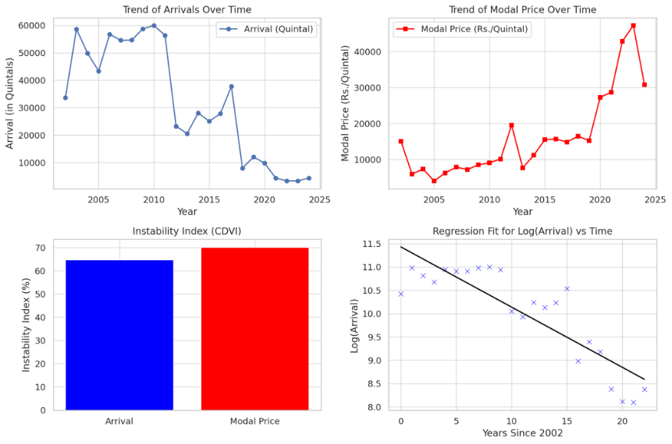

**Fig 1: Bangalore market price and arrival of Byadgi Chilli**

Figure 1 indicates the market price and arrival of Byadgi chilli of Bangalore market The arrival trends of Byadgi Chilli show a peak between 2005 and 2010, followed by a steady decline, with arrivals reaching historically low levels by 2025. This decline suggestsproduction constraints, policy changes, or market disruptionsaffecting supply. In contrast**,** modal prices have shownasteady upward trend**,** with sharp spikes observedbetween 2020 and 2025**,** likely driven bysupply shortages, increased demand, or inflationary factors**.** The instability index for both arrivals and prices remains high, reflecting market volatility and unpredictable production patterns**.** A negative regression trend inlog (Arrival) vs. Timeconfirms along-term decline in arrivals**,** indicating seriousstructural challenges in production and market supply chains**.** These trends highlight the need forpolicy interventions, improved production strategies, and better market stability measurestobalance supply and demand effectively.

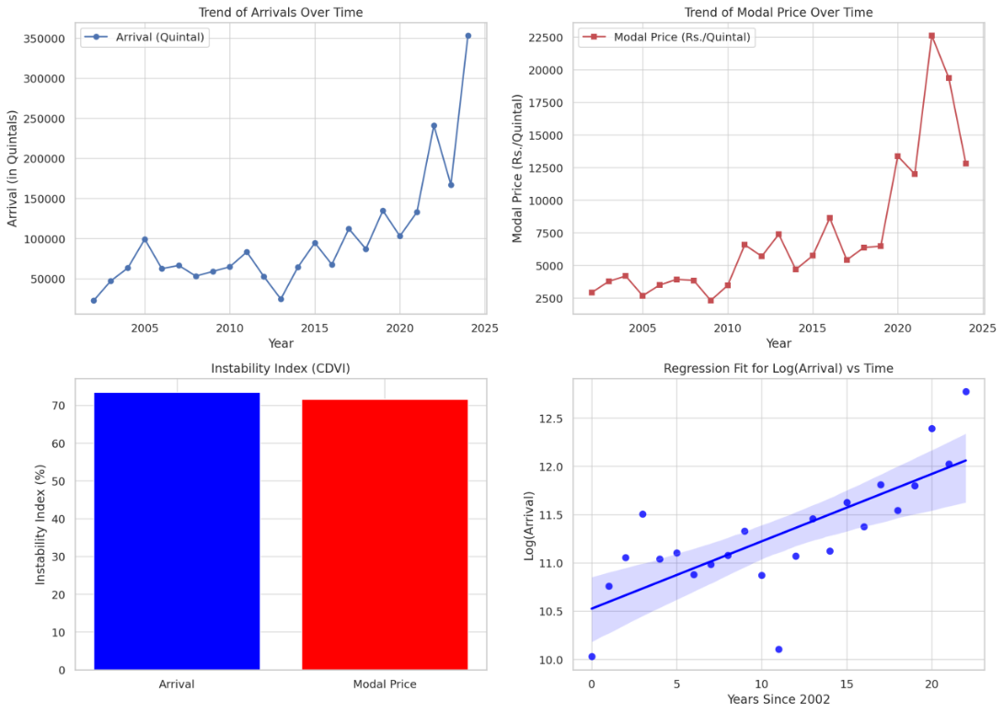

**Fig: 2 Hubballi market price and arrival of Byadgi Chilli**

Figure 2 indicates the market price and arrival of Byadgi chili at Hubli market. The arrival trends of Byadgi Chilli show a gradual increase over time, with some fluctuations before a sharp surge after 2020, indicating a significant boost in production or supply. These fluctuations before 2020 could be attributed to market variations, climatic conditions, or policy changes. In contrast, modal prices remained relatively stable and low until 2018–2020, after which a sharp price increase was observed. This surge suggests demand-supply imbalances, inflation, policy interventions, or external market shocks. Despite some corrections, prices remain significantly higher than previous years, indicating sustained demand or constrained supply. The instability index shows similar levels of fluctuation in both arrivals and prices, suggesting that supply variations have directly impacted market prices. The regression fit for log (Arrival) vs. Time shows a strong positive trend, confirming that arrivals have been increasing consistently over the years, likely due to improved agricultural practices, better market access, or increased production capacity. However, market volatility remains, highlighting the need for strategic planning to ensure price stability and sustained growth in production.

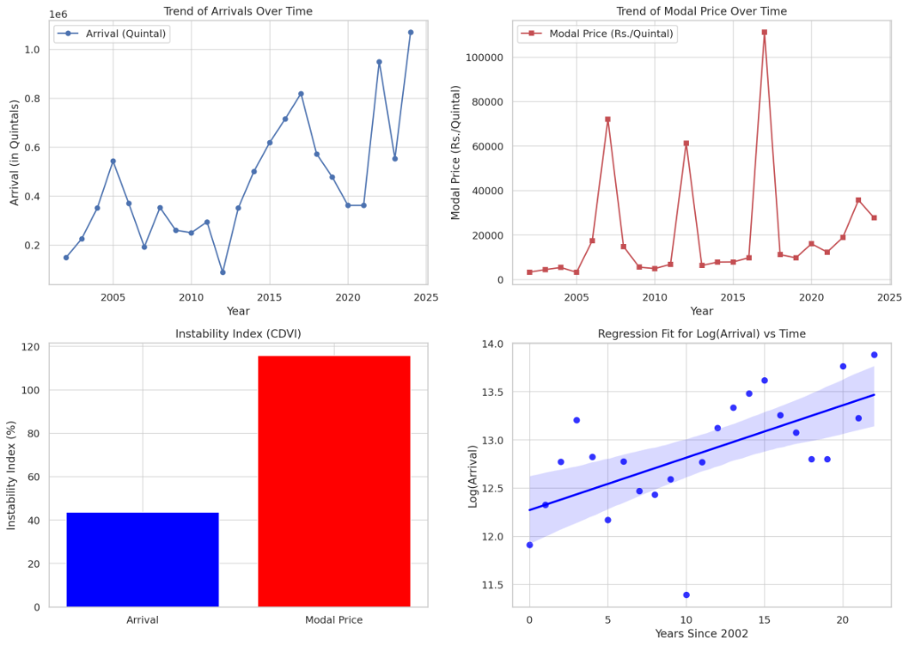

**Fig 3. Price and arrival of Byadgi Chilli in Byadgi market**

**3.5 Price and arrival of Byadgi Chilli in Byadgi market**

Figure 3 indicates the market price and arrival of Byadgi chilli at Hubli market. The arrival trends of Byadgi Chilli in the Byadgi market exhibit fluctuations over time, with periods of both increase and decline. However, a significant rise is observed between 2020 and 2025, suggesting potential factors such as market conditions, climate changes, government policies, or shifts in production influencing supply. The modal price trend, on the other hand, shows sharp spikes at multiple points, indicating high price volatility. While prices remain relatively low for most of the period, certain years’ experience extreme surges, which could be attributed to supply shocks, demand fluctuations, policy changes, or inflationary pressures. The instability index highlights that modal price instability is much higher than arrival instability, suggesting that while production may be somewhat stable, price fluctuations are largely influenced by external market factors. The regression fit for log(Arrival) vs. Time displays a positive slope, confirming a long-term increasing trend in arrivals, though with some variations as indicated by the confidence interval. Overall, arrivals have been increasing over time but with fluctuations, while prices have shown extreme volatility, possibly due to supply-demand imbalances or policy-driven price shocks. The higher price instability poses challenges for both farmers and policymakers, emphasizing the need for market interventions to stabilize prices while supporting production growth.

4. Conclusion

This study highlights the dynamic and somewhat unstable nature of the Byadagi chilli market in Karnataka. While price trends are generally upward, the inconsistent arrival patterns indicate supply chain inefficiencies. The compound annual growth rate (CAGR) of Byadagi chilli arrivals and prices in key Karnataka markets shows varying trends. Bangalore and Byadagi have identical arrival CAGRS of 5.59 per cent, while Hubballi exhibits the highest at 7.22 per cent, indicating a relatively stronger supply increase. However, instability in arrivals remains moderate, with Bangalore and Byadgi showing lower volatility than Hubballi. Price trends indicate higher growth, with Hubballi leading at 8.26 per cent, followed by Bangalore and Byadgi at 6.63 per cent. Price instability is significantly high in Bangalore and Byadgi, whereas Hubballi shows more stability. Addressing market volatility, improving supply chains, and implementing policy measures can help sustain long-term market stability and growth. Improved infrastructure, better warehousing facilities, and timely market information can help stabilize arrivals. Policy support in terms of minimum support prices and subsidies for cold storage units can also aid in mitigating price and arrival instability. Strengthening market integration can lead to better price transmission and equitable benefits for farmers across the region.

References

1. Preethi V.P., Jesy Thomas K. and Kuruvila Anil. (2018), Performance of coconut in India: A trend analysis, Journal of Tropical Agriculture 56 (2): 210-214.
2. Kavita Nitharwal, P.S. Raghuvanshi and Sudhir Singh (2024). Relationship between Prices and Market Arrivals of Gram in Madhya Pradesh, Journal of Scientist Research and Reports, 30(6);480-485 DOI:10.9734/jsrr/2024/v30i62064
3. Jyoti Chaudhary, H.P. Singh (2021). Market arrivals and price Behaviour of Potato: A study of Selected Markets of Uttar Pradesh, Indian Journal of Economics and Development, 17(3):519-526 DOI: [*https://doi.org/10.35716/ijed/20298*](https://doi.org/10.35716/ijed/20298)
4. Niyati Thakur, Shilpa Sharma and Ajit Sharma (2022). Dynamics of prices and arrivals of Major vegetables: A case study of North Indian Markets, Journal of Agro-Economist, 19(01)1-12 Doi:10.30954/2394-8159.01.2022.5
5. Mangala C. Devihosur, K. V. Ashalatha and Vasanatha Kumari J*.* (2024). Time Series Analysis of Dry chilli price Trends in Byadagi Market, Haveri District, Karnataka, India, Journal of Scientific Research and Reports, 30(11):552-561DOI:10.9734/jsrr/2024/v30i112583
6. Pathusha Nasurudeen, K. Thimmappa and Anil Kuruvila (2007). The Behaviour of Market Arrivals and prices of Paddy in Kanniakovil Regulated Market, DOI:10.13140/RG.2.2.13983.41124
7. Udhayan N., A. D. Naik and G. M. Hiremath (2023). Market Arrivals and Price Behaviour of Wheat in Major Markets of India, Asian Journal of Agricultural Extension Economics and Sociology, 41(10):378-386. DOI:10.9734/ajaees/2023/v41i102181
8. Patil Nethravathi Ashok and Yeledhalli R.A. (2016), Growth and instability in area, production and productivity of different crops in Bengaluru division, International Journal of Agriculture, Environment and Biotechnology, 9(**4**): 599-611. DOI Number: 10.5958/2230-732X.2016.00078.4
9. Patil Nethravathi Ashok, Yeledhalli R A and M. S. Ganapathy (2022), Growth, Instability Index and Structural Change of Different Crops in Bagalkot and Vijayapura District, J Krishi Vigyan 2022, 10 (**2**): 1-5.
10. Velayutham L.K., Damodaran K. (2015), Growth Rate of Chilli Production in Guntur District of Andhra Pradesh, International Journal of Research in Humanities and Social Studies, 2(11):1-5.