**Seed Dormancy in Mungbean: Implications for Pre-Harvest Sprouting Resistance**

**ABSTRACT**

Seed dormancy plays a critical role in mitigating pre-harvest sprouting (PHS) in mungbean (*Vigna radiata* L.), especially under conditions of untimely rainfall during harvest. This study was conducted over two consecutive cropping seasons, Kharif 2023 and Kharif 2024, to evaluate the extent of genetic variation in seed dormancy-related traits among 60 genetically diverse mungbean genotypes at the School of Agricultural Sciences, Malla Reddy University, Hyderabad. The primary objective was to identify genotypes with inherent resistance to PHS by assessing germination behaviour in intact pods, pod opening time (POT), and key agro-morphological characteristics. Based on germination percentage from intact pods, genotypes were categorized into three dormancy classes: highly dormant (<10%), moderately dormant (10–50%), and non-dormant (>50%). Notably, highly dormant genotypes exhibited delayed pod opening (ranging from 96 to 108 hours), thereby minimizing seed exposure to external moisture and significantly reducing the risk of PHS. Quantitative trait analysis revealed substantial variability in days to shattering, POT, and germination percentage, whereas days to flowering and maturity were relatively stable across genotypes. Among the tested entries, germination percentage ranged from 6.0% to 95.0%, with pooled mean GP of 75.63%. Genotypes GG53, GG50, and GG55 recorded the highest GP, while GG16, GG19, and GG20 recorded the lowest. For pod opening time, genotypes GG60, GG15, and GG47 exhibited rapid dehiscence. The genotypes GG16, GG19, and GG20 took over 100 hours to pod opening and low germination percentage. These findings highlight the importance of incorporating dormancy-associated traits into breeding strategies aimed at improving PHS resistance in mungbean, particularly for cultivation in rain-prone agro-ecological regions

*Key words: Domestication, Mung bean, Pre harvest sprouting, Seed dormancy*.

1. **INTRODUCTION**

Mungbean (*Vigna radiata* (L.) Wilczek), commonly known as green gram, is a vital legume crop cultivated extensively across Asia, particularly in India, China, Myanmar, Bangladesh, and Thailand. India is the largest producer and consumer, accounting for about 60% of global acreage and contributing around 2.5 million tonnes from 4.5 million hectares (Ministry of Agriculture & Farmers Welfare, 2022). Among Indian states, Rajasthan leads in production, followed by Maharashtra, Telangana, Andhra Pradesh, Karnataka, and Uttar Pradesh. Mungbean is cultivated during both kharif (monsoon) and rabi (post-monsoon) seasons, with increasing emphasis on rice-fallow systems in southern India during rabi. Its short duration (60–70 days), crop with ability to fix atmospheric nitrogen, and adaptability to diverse agro-ecological zones make it a crucial crop for sustainable agriculture. Furthermore, mungbean is rich in protein (20–25%), iron, folate, and essential amino acids, making it a significant dietary component in vegetarian and protein-deficient populations (Pandey et al., 2018). Despite its agronomic and nutritional importance, mungbean productivity is constrained by several abiotic and biotic factors, one of the most critical being pre-harvest sprouting (PHS). PHS is a major physiological disorder that results in significant losses in seed quality, viability, and overall yield. It occurs when mature seeds begin to germinate inside the pod before harvest, primarily due to unexpected rains or high humidity. This is especially problematic in rabi season crops, where crops reach maturity in cooler months with frequent dew and occasional showers (Singh et al., 2014). A natural defense against PHS is seed dormancy, which refers to the temporary inability of viable seeds to germinate under favourable conditions. Dormancy in mungbean may result from genetic factors such as seed coat hardness, hormonal control (e.g., ABA levels), and environmental traits like pod structure and humidity exposure.

Traits such as germination percentage (GP), pod opening time (POT), and days to shattering (DS) are indirect indicators of dormancy and pod integrity. Understanding the genetic variability of these traits is essential for developing PHS-resistant cultivars. Despite its relevance, limited research has explored the genetic control and variation of dormancy-related mechanisms in mungbean. Recent studies emphasize the importance of identifying genotypes with robust dormancy traits and incorporating these into breeding programs for climate-resilient, high-quality mungbean varieties.

Therefore, the present study aims to evaluate sixty diverse mungbean genotypes for dormancy associated traits, classify their resistance to PHS, and identify promising genotypes for future genetic improvement and breeding efforts. This will contribute to the development of stable, high-yielding, and sprouting-resistant mungbean cultivars, especially suited for cultivation under rainfed or unpredictable weather conditions.

1. **MATERIAL AND METHODS**

Field experiments were carried out during the Kharif 2023 and Kharif 2024 seasons at School of Agricultural Sciences, Malla Reddy University following a Randomized Complete Block Design (RCBD) with three replications. Each of the sixty mungbean genotypes was sown in a single-row plot measuring 4 meters in length, with an inter-row spacing of 30 cm and intra-row spacing of 10 cm. Standard agronomic practices, including timely irrigation, weeding, and pest management, were uniformly applied throughout the experimental area to minimize environmental variability and ensure the reliability of phenotypic data. For laboratory-based evaluations, a Randomized Complete Block Design (RCBD) with three replications was employed. Seeds were harvested at physiological maturity, air-dried, and used for further analyses related to seed dormancy and pod dehiscence.

These genotypes were obtained from NBPGR (Fig.1) representing a wide range of phenotypic and genetic diversity for traits associated with seed dormancy and pod dehiscence. Selection of genotypes was based on preliminary screening for morphological and agronomic variation. All genotypes were grown under uniform field conditions during both seasons to facilitate reliable comparison. The details of the genotypes used in the present investigation are presented in Table1.

At physiological maturity, seeds from each genotype were harvested, shade-dried, and subjected to laboratory evaluations arranged in a Randomized Complete Block Design (RCBD) with three replications. Seed germination / PHS was done by Germination test with pods intact These were used for the assessment of seed dormancy and pod dehiscence traits. Agro-morphological data were collected on five key traits: days to 50% flowering (D50%), days to maturity (DM), days to shattering (DS), germination percentage (GP%), and pod opening time (POT). Observations were taken from five representative plants per plot and averaged to obtain genotype-level values. The data were analysed using appropriate statistical tools to calculate mean, standard error (SE), and critical difference (CD) at the 1% significance level to determine the extent of genetic variation among genotypes.

### ****Germination Test****

Germination tests were conducted following the International Seed Testing Association (ISTA) guidelines using both the Top-of-Paper (TP) and Between-Paper (BP) methods. Seeds were placed in Petri dishes or germination trays lined with moist paper, and the setup was incubated at 25 ± 2°C under a 12-hour photoperiod. Observations were made every 6 hours over a period of 7 days to monitor the onset and extent of germination. To assess seed dormancy, intact pods were incubated under the same moist conditions, and the percentage of seeds germinating within the pods was recorded. Based on this, genotypes were classified into three categories: Dormant or resistant types with less than 10% germination, moderately dormant or intermediate types with 10–50% germination, and non-dormant or susceptible types showing more than 50% germination within the pod.

### ****Pod Opening Test****

For the evaluation of pod dehiscence and resistance to seed exposure under moist conditions, intact pods from each genotype were placed on moist germination paper inside closed chambers to simulate post-rainfall environments. The pods were observed at 6-hour intervals for a total of 120 hours to record the time taken for each pod to naturally open and expose its seeds. Based on the duration required for pod opening, genotypes were grouped as follows: Dormant or resistant genotypes took more than 96 hours to dehisce, moderate or intermediate types opened between 24 and 72 hours, while non-dormant or susceptible genotypes opened within 24 hours. This classification provided an indirect measure of resistance to pre-harvest sprouting (PHS) through delayed pod opening.

The collected data were subjected to statistical analysis to estimate mean, standard error (SE), and critical difference (CD) at the 1% level of significance, facilitating the assessment of genetic variability and identification of statistically significant differences among the genotypes.

1. **RESULTS AND DISCUSSION**

The analysis of variance (Table 2) indicatessignificant differences among sixty genotypes for all the characters studied. at the 1% level.

**I. Germination Percentage:** Substantial variation in seed dormancy was observed among the sixty mungbean (Vigna radiata L.) genotypes based on germination percentage in intact pods. The germination percentage ranged from as low as **6.0% to as high as 95.0%,** with a pooled mean of **75.63%,** indicating significant genotypic diversity in resistance to **pre-harvest sprouting (PHS).** Based on pod germination percentages, genotypes were classified into three dormancy categories and the images are depicted in Figure 2.

Genotypes **GG16, GG19, and GG20** exhibited strong PHS resistance, with pod germination percentages of 7.5%, 6.0%, and 6.75%, respectively. These genotypes maintained seed viability under moisture stress, suggesting effective pod-imposed dormancy. Similar resistance mechanisms have been documented in legumes like chickpea and cowpea, where delayed sprouting is attributed to pod structure and seed coat traits (Nadeem et al., 2018; Sankaranarayanan et al., 2017).

Genotypes such as **GG03, GG07, GG13, GG24, and GG45** displayed moderate dormancy (germination between 10% and 50%), offering partial protection under moderate rainfall during harvest. Mwaura et al. (2017) reported that intermediate dormancy can stabilize yield and seed quality in unpredictable weather conditions.

The majority of genotypes (52) recorded germination rates above 50%, indicating high susceptibility to PHS and are non dormant. These findings are consistent with Roy et al. (2016), who noted that most mungbean genotypes exhibit limited dormancy, highlighting the need for genetic improvement in this area. This distribution underscores a genetic predisposition towards weak dormancy in the existing mungbean gene pool, reinforcing the urgency for breeding programs targeting enhanced PHS resistance.

**II. Pod Opening Time (POT):**  a critical trait influencing seed exposure to moisture, showed strong correlation with germination behavior and dormancy classification. **Genotypes GG16, GG19, and GG20 demonstrated high levels of seed dormancy, characterized by delayed pod dehiscence with pod opening times (POT) ranging from 100.0 to 104.5 hours. This prolonged pod opening serves as a physical mechanism to prevent rain-induced pre-harvest sprouting (PHS). Similar findings were reported by Gupta et al. (2020) and Mwaura et al. (2018), who noted that genotypes with extended POT durations are less susceptible to PHS and can be classified as dormant (Figure 2).**

Genotypes like **GG03, GG07, GG13, GG24, and GG45** exhibited moderate levels of dormancy, with pod opening times (POT) ranging from 24 to 72 hours. This intermediate dehiscence provided partial protection against environmental moisture, thereby reducing the risk of pre-harvest sprouting while still facilitating seed dispersal. Such behavior is consistent with findings in pigeonpea and black gram, where similar POT ranges have been linked to moderate dormancy levels (Tewari et al., 2019).

Genotypes with rapid pod opening, occurring within 12 to 24 hours, such as GG15, GG47, and GG58, were found to be highly susceptible to pre-harvest sprouting. Early pod dehiscence exposes seeds to environmental moisture, particularly under high humidity conditions, significantly increasing the risk of sprouting, as also noted by Roy et al. (2016). These observations reinforce the importance of delayed pod opening as a critical trait for indirect selection in breeding programs aimed at developing PHS-resilient mungbean genotypes.

### ****III. Quantitative Analysis of Agro-Morphological Traits****

A comprehensive analysis of five key agro-morphological traits **Days to 50% Flowering (D50%), Days to Maturity (DM), Days to Shattering (DS), Germination Percentage (GP%),** and **Pod Opening Time (POT)** revealed significant variability among genotypes (Table 3). The **analysis of variance (ANOVA)** confirmed highly significant differences (p < 0.01) for all traits across genotypes and replications, indicating ample scope for genetic improvement.

#### The range, mean, and grand mean values for the five traits studied across mungbean genotypes encompassing various morphological and seed quality characteristics are presented in Table 3 and Table 4.

#### The performance of each trait, including its variability, statistical significance, and potential for selection, is discussed in detail below.

**Trait: D50%**

**The analysis of variance (ANOVA) for D50% revealed significant differences among replications and genotypes at the 1% level, indicating heterogeneity in blocks and genotypes. The mean value for D50% was 38.4875, with a range of 34.0 to 43.0. The standard error of the mean (SEm) was 0.3033, and the standard error of the difference (SEd) was 0.4290. The critical difference (CD) values were 0.8583 at the 5% level and 1.1418 at the 1% level, suggesting that differences greater than these values are statistically significant. Genotypes GG47 (42.25), GG58 (41.5), and GG46 (41.5) showed the highest values and were statistically at par, making them promising candidates for selection. On the other hand, GG16 (35.0) exhibited the lowest value, indicating poor performance for this trait. Similar findings regarding genetic variability in flowering time in mungbean were reported by Kumar and Sharma (2017) and Singh and Yadav (2019), emphasizing its importance in selecting early or late flowering genotypes.**

**Trait: DM**

**The ANOVA for DM showed significant differences among replications and genotypes at the 1% level, confirming heterogeneity in blocks and genotypes. The mean value for DM was 68.7792, with a range of 51.5 to 77.0. The standard error of the mean (SEm) was 0.3000, and the standard error of the difference (SEd) was 0.4243. The critical difference (CD) values were 0.8491 at the 5% level and 1.1294 at the 1% level, indicating that differences exceeding these thresholds are statistically significant. Genotypes GG57 (75.25), GG33 (75.25), and GG52 (74.75) demonstrated the highest values and were statistically at par, making them suitable for selection. Conversely, genotypes GG26 (53.75), GG39 (53.75), GG54 (53.25), and GG40 (53.25) showed the lowest values, indicating poor performance. These observations align with those of Sujatha and Reddy (2021) and Thakuria and Sarma (2018), who reported significant genotypic differences for maturity duration in mungbean.**

**Trait: DS**

**The ANOVA for DS revealed significant differences among replications and genotypes at the 1% level, indicating heterogeneity in blocks and genotypes. The mean value for DS was 79.5458, with a range of 62.5 to 88.0. The standard error of the mean (SEm) was 0.2734, and the standard error of the difference (SEd) was 0.3867. The critical difference (CD) values were 0.7738 at the 5% level and 1.0293 at the 1% level, suggesting that differences greater than these values are statistically significant. Genotypes GG43 (87.0) and GG46 (86.5) exhibited the highest values and were statistically at par, making them promising candidates for selection. In contrast, GG19 (64.25) showed the lowest value, indicating poor performance for this trait. Pod shattering resistance is a key trait in mungbean improvement, and similar variability was observed by Kavitha and Dharmaraj (2020) and Kumar and Singh (2014), who identified genotypes with delayed or reduced pod dehiscence.**

**Trait: GP (%)**

**The ANOVA for GP (%) showed significant differences among replications and genotypes at the 1% level, confirming heterogeneity in blocks and genotypes. The mean value for GP (%) was 75.6317, with a wide range of 5.0 to 95.0. The standard error of the mean (SEm) was 2.1829, and the standard error of the difference (SEd) was 3.0870. The critical difference (CD) values were 6.1771 at the 5% level and 8.2169 at the 1% level, indicating that differences exceeding these thresholds are statistically significant. Genotypes GG53 (94.25), GG50 (93.4), and GG55 (92.5) showed the highest values and were statistically at par, making them ideal for selection. On the other hand, genotypes GG16 (7.5), GG20 (6.75), and GG19 (6.0) exhibited the lowest values, indicating poor performance. Goswami and Singh (2021) and Sharma and Gupta (2018) also observed wide variability in germination percentage across mungbean genotypes, reflecting underlying differences in seed dormancy and vigor.**

**Trait: POT (hrs)**

**The ANOVA for POT (hrs) revealed significant differences among replications and genotypes at the 1% level, indicating heterogeneity in blocks and genotypes. The mean value for POT (hrs) was 29.4633, with a range of 9.5 to 109.0. The standard error of the mean (SEm) was 3.7584, and the standard error of the difference (SEd) was 5.3151. The critical difference (CD) values were 10.6355 at the 5% level and 14.1476 at the 1% level, suggesting that differences greater than these values are statistically significant. Genotypes GG19 (104.5), GG16 (100.5), and GG20 (100.0) demonstrated the highest values and were statistically at par, making them suitable for selection. Conversely, genotypes GG60 (12.25), GG15 (13.25), GG47 (13.0), and GG58 (13.0) showed the lowest values, indicating poor performance. Similar trends in pod opening time were documented by Kalariya and Parmar (2022) and Muthusamy and Senthil (2016), highlighting the significance of this trait in pre-harvest sprouting resistance.**

1. **CONCLUSION**

The study revealed significant variation among the genotypes for all traits, emphasizing the importance of identifying superior genotypes for selection and breeding. Genotypes with favorable values for traits such as days to 50% flowering (D50%), days to maturity (DM), days to shattering (DS), germination percentage (GP%), and pod opening time (POT) are promising candidates for future improvement programs, while those with consistently poor performance may require refinement or elimination. The consistent and significant genotypic differences observed across both years underscore the existence of substantial genetic diversity within the mungbean germplasm. In particular, traits like GP% and POT exhibited wide variability, making them critical targets for enhancing seed dormancy and resistance to pre-harvest sprouting (PHS). Notably, genotypes GG16, GG19, and GG20 demonstrated both low germination rates in intact pods and delayed pod opening, highlighting their potential as donor lines for developing PHS-resistant varieties. Incorporating these traits into high-yielding genotypes offers a strategic pathway to improve seed quality, resilience, and productivity in environments susceptible to untimely rainfall.

**REFERENCES**

1. Goswami, S. B., & Singh, B. (2021). Evaluation of mungbean genotypes for seed quality and dormancy under storage conditions. International Journal of Current Microbiology and Applied Sciences, 10(2), 1030–1038.
2. Gupta, N., Verma, A., & Singh, S. (2020). Evaluation of pod dehiscence and seed viability in pulses under high humidity. Indian Journal of Genetics and Plant Breeding, 80(4), 567–573.
3. Kalariya, K. A., & Parmar, D. J. (2022). Genetic evaluation of mungbean genotypes for pod dehiscence traits. Legume Research, 45(1), 142–146.
4. Kavitha, D. R., & Dharmaraj, P. S. (2020). Genetic analysis of pod shattering resistance in mungbean (Vigna radiata). Plant Archives, 20(2), 3852–3856.
5. Kumar, J., & Sharma, A. (2017). Genetic variability, heritability and genetic advance for yield and yield components in mungbean (Vigna radiata L. Wilczek). Legume Research, 40(3), 485–490.
6. Kumar, N., & Singh, B. B. (2014). Inheritance of pod shattering resistance and related traits in mungbean. Euphytica, 198, 373–382.
7. Ministry of Agriculture & Farmers Welfare. (2022). Agricultural Statistics at a Glance. Government of India.
8. Muthusamy, S., & Senthil, N. (2016). Screening mungbean genotypes for pod opening behavior under different environmental conditions. Journal of Food Legumes, 29(4), 320–324.
9. Mwaura, C., Achieng, J., & Odeny, D. (2017). Genetic variation in seed dormancy traits in mungbean (Vigna radiata). Journal of Agricultural Research, 12(2), 134–142.
10. Nadeem, M. A., Nawaz, M. A., & Qureshi, M. I. (2018). Role of pod morphology in resistance to pre-harvest sprouting in chickpea. Legume Research, 41(3), 429–436.
11. Nair, Ramakrishnan M., et al. "Biotic and abiotic constraints in mungbean production—progress in genetic improvement." *Frontiers in plant science* 10 (2019): 1340.
12. Pandey, A. K., Kumari, N., & Dubey, S. C. (2018). Nutritional and medicinal importance of mungbean: A review. International Journal of Chemical Studies, 6(3), 304–310.
13. Roy, D., Basu, M. S., & Kole, P. C. (2013). Studies on pre-harvest sprouting and seed dormancy in greengram (Vigna radiata L.). Legume Research, 36(5), 448–453.
14. Roy, S., Singh, A. K., & Sharma, R. (2016). Screening of mungbean genotypes for resistance to pre-harvest sprouting. Indian Journal of Agricultural Sciences, 86(11), 1430–1435.
15. Srividya, P. V., et al. "Studies on diversity of Sclerotium rolfsii causing collar rot in chickpea using morphological and molecular markers." *Legume Research-An International Journal* 45.1 (2022): 82-89.
16. Sharma, R., & Gupta, S. K. (2018). Seed dormancy and germination behavior in mungbean genotypes. Legume Research, 41(5), 783–787.
17. Singh, B., Dikshit, H. K., & Singh, D. (2014). Evaluation of mungbean germplasm for pre-harvest sprouting resistance and associated seed dormancy traits. Indian Journal of Genetics and Plant Breeding, 74(1), 60–65.
18. Singh, S. P., & Yadav, R. (2019). Genetic variability studies for flowering and maturity traits in mungbean (Vigna radiata). Journal of Pharmacognosy and Phytochemistry, 8(2), 2360–2364.
19. Sujatha, K., & Reddy, K. H. P. (2021). Variability and correlation studies for physiological maturity and yield traits in mungbean. International Journal of Chemical Studies, 9(2), 1403–1406.
20. Tewari, S. K., Yadav, R., & Meena, R. (2019). Influence of pod characteristics on seed dispersal and dormancy in pulses. Legume Research, 42(5), 695–700.
21. Thakuria, R. K., & Sarma, R. N. (2018). Estimation of genetic parameters for yield and maturity traits in mungbean. Legume Research, 41(6), 931–936.
22. Ullah, I., Ashraf, M., & Naeem, M. (2015). Inheritance of pod shattering and seed dormancy traits in mungbean (Vigna radiata L.). Pakistani Journal of Botany, 47(2), 633–639.

**Table 1.** The genotypes used in the present investigation

|  |  |  |  |  |  |  |  |
| --- | --- | --- | --- | --- | --- | --- | --- |
| **S.No.** | **Genotypes** | **S.No.** | **Genotypes** | **S.No.** | **Genotypes** | **S.No.** | **Genotypes** |
| 1 | GG1 | 16 | GG16 | 31 | GG31 | 46 | GG46 |
| 2 | GG2 | 17 | GG17 | 32 | GG32 | 47 | GG47 |
| 3 | GG3 | 18 | GG18 | 33 | GG33 | 48 | GG48 |
| 4 | GG4 | 19 | GG19 | 34 | GG34 | 49 | GG49 |
| 5 | GG5 | 20 | GG20 | 35 | GG35 | 50 | GG50 |
| 6 | GG6 | 21 | GG21 | 36 | GG36 | 51 | GG51 |
| 7 | GG7 | 22 | GG22 | 37 | GG37 | 52 | GG52 |
| 8 | GG8 | 23 | GG23 | 38 | GG38 | 53 | GG53 |
| 9 | GG9 | 24 | GG24 | 39 | GG39 | 54 | GG54 |
| 10 | GG10 | 25 | GG25 | 40 | GG40 | 55 | GG55 |
| 11 | GG11 | 26 | GG26 | 41 | GG41 | 56 | GG56 |
| 12 | GG12 | 27 | GG27 | 42 | GG42 | 57 | GG57 |
| 13 | GG13 | 28 | GG28 | 43 | GG43 | 58 | GG58 |
| 14 | GG14 | 29 | GG29 | 44 | GG44 | 59 | GG59 |
| 15 | GG15 | 30 | GG30 | 45 | GG45 | 60 | GG60 |

**Table 2:** Analysis of variance (ANOVA) for five agro-morphological in sixty mungbean genotypes, with pods produced under Randomized Complete Block Design (RCBD) across two seasons and pooled data

|  |  |  |  |  |  |  |  |
| --- | --- | --- | --- | --- | --- | --- | --- |
| **S. No.** | Trait | Year | Source of Variation | | | | |
| Rep.(DF=1) | Genotypes(DF=59) | Error  (DF=59) | |
| 1 | Days to 50% Flowering (D50%) | 2023 | 191.3 | 4.2** | | 0.2 | |
| 2024 | 171.4 | 4.8** | | 0.3 | |
| Pooled | 181.3 | 4.5** | | 0.2 | |
| 2 | Days to Maturity (DM) | 2023 | 201.5 | 58.4** | | 0.2 | |
| 2024 | 194.9 | 62.1** | | 0.5 | |
| Pooled | 198.2 | 60.2** | | 0.3 | |
| 3 | Days to Shattering (DS) | 2023 | 193.8 | 35.3** | | 0.1 | |
| 2024 | 198.1 | 32.7** | | 0.4 | |
| Pooled | 196.0 | 34.0** | | 0.3 | |
| 4 | Germination Percentage (GP%) | 2023 | 162.9 | 935.7** | | 9.5 | |
| 2024 | 174.9 | 818.3** | | 7.2 | |
| Pooled | 168.9 | 877.0** | | 8.4 | |
| 5 | Pod Opening Time (POT hrs) | 2023 | 355.0 | 785.7** | | 28.3 | |
| 2024 | 328.4 | 712.7** | | 22.4 | |
| Pooled | 341.7 | 749.2** | | 25.3 | |

* Significant at 5 percent and ** at 1 percent level

#### ****Table 3:**** Range, mean, and grand mean of genotypes for different characters in kharif 2023 and Kharif 2024 and pooled data in mungbean.

|  |  |  |  |  |  |  |  |  |  |
| --- | --- | --- | --- | --- | --- | --- | --- | --- | --- |
| Trait | GM | KH2023 | | | KH2024 | | | Pooled | |
| Mean | Range | Mean | | Range | Mean | | Range |
| D50% | 38.5 | 37.2 | 34.0-41.5 | 39.8 | | 36.0-43.0 | 38.5 | | 35.0-42.3 |
| DM | 68.8 | 67.5 | 51.5-74.0 | 70.1 | | 55.0-77.0 | 68.8 | | 53.3-73.3 |
| DS | 79.5 | 78.3 | 62.5-86.0 | 80.8 | | 66.0-88.0 | 79.5 | | 64.3-87.0 |
| GP (%) | 76.4 | 76.6 | 7.0-95.0 | 76.2 | | 8.0-95.0 | 76.4 | | 7.0-92.5 |
| POT (hrs) | 28.8 | 26.5 | 1.5-109.0 | 31.2 | | 12.0-104.0 | 28.8 | | 7.8-104.5 |

Table 4: Mean, Pooled mean of genotypes for different characters in kharif 2023 and kharif 2024 in mungbean



Figure 1: Sixty Mungbean genotypes used in the present study

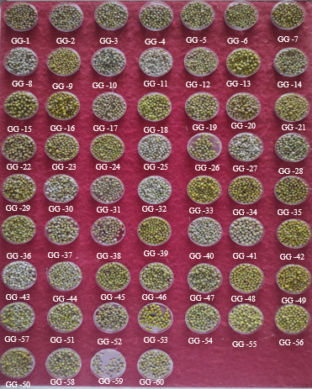

Figure 2: Germination of genotypes in lab condition

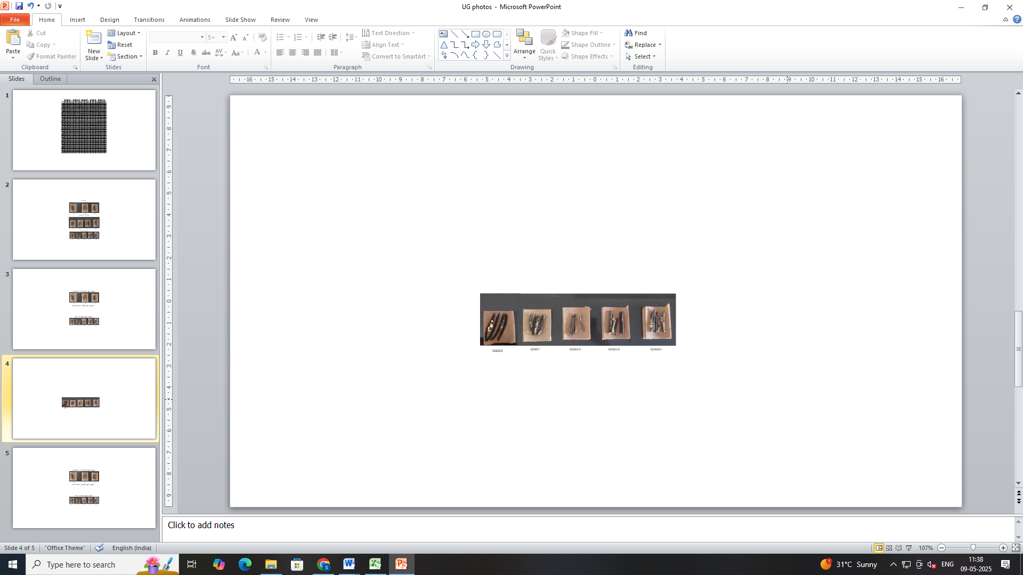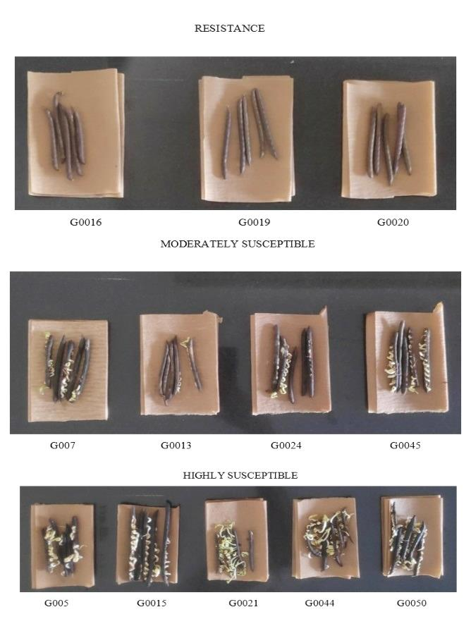

Dormant genotypes

GG16 GG19 GG20

Moderate dormant genotypes

GG3 GG7 GG13 GG24 GG45

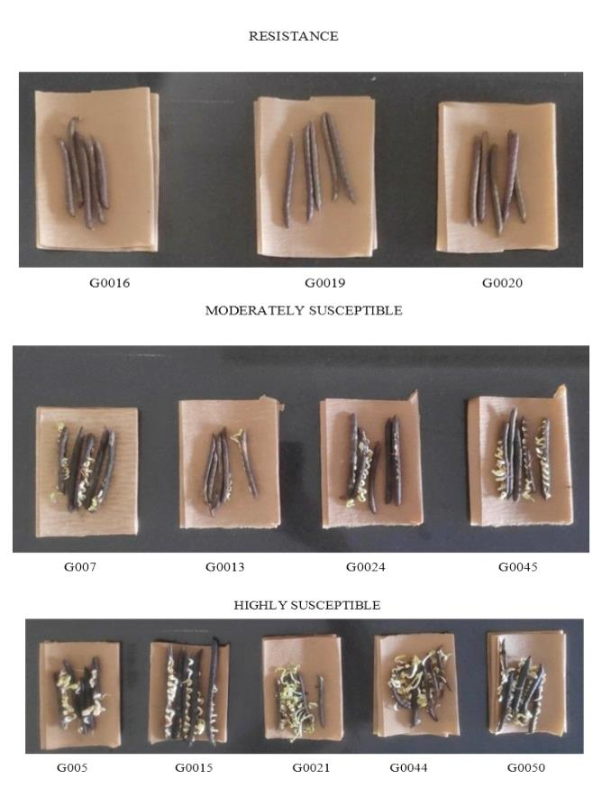

Non-dormant genotypes

GG5 GG15 GG21 GG44 GG50