**Constraints in production and marketing of soybean**

**Abstract**

The production pattern as well as the consumption pattern of India has dramatically changed in the recent past. Soybean, a miracle crop with 40 per cent protein and 20 per cent oil has gained demand for consumption as well as oil extraction leading to increased area under production. This paper has made an attempt to decode the constraints faced by farmers in the production and marketing of soybean in the study region. The data related to agricultural year 2021-22 was extracted for the present research and the primary data was collected by personal interview method with the pre-tested schedule. Garrett’s ranking technique was used to interpret the data. It was inferred from the results that among production constraints non-availability of required improved variety seeds in adequate quantities at the right time was the major constraint with highest mean Garrett score of 74.34 followed by scarcity of labour during peak periods (Garrett score 51.12). Among various marketing constraints encountered by farmer respondents in soybean marketing in the study region. It was inferred that high price fluctuation was the major constraint with highest mean Garrett score of 92.29 followed by untimely payment of sale proceeds (Garrett score 72.82).

**Introduction**

Soybean (*Glycine max*) is one of the major primary oilseed crops of India. It is a species of the legume native to East Asia, it is an imperative global crop widely grown for its edible bean, oil and has numerous utilities. Hence, Soybean is referred to as the “Golden bean” and “Miracle crop” etc. Soybean is the world’s most significant seed legume, which contributes to about 25 per cent of the global edible oil and two-thirds of the world’s total protein concentrate. it is used as cheapest source of protein for livestock feeding. The total soybean production in the world during 2018-19 was 348.71 million metric tonnes (Anonymous, 2020b). Among the countries growing soybean, Brazil ranked first with production of 125.89 million metric tonnes in 2018-19 trailed by United States of America (123.66 million metric tonnes), Argentina (37.79 million metric tonnes), China (14.19 million metric tonnes) and India (13.27 million metric tonnes) (Anonymous, 2020b). Besides soybean’s use as vegetable, it is also utilized in oil industries where it ranked first in the world oil production. Soybean based food products are also appropriate to diabetic patients as they contain less quantity of carbohydrates and low cholesterol content. Therefore, it is one of the most cost-effective protein sources in the world. It is a versatile crop with numerous possibilities of improving agriculture and supporting farming industry. Therefore, the cultivated area under soybean production is increasing substantially which has its own associated constraints in production and marketing.

**Indian Scenario**

The commencement of commercial exploitation of soybean in India was approximately four decades ago. Soybean has recognized itself as a major *kharif* season crop in the rainfed ecosystem of central and peninsular India. India has ranked fifth after USA, Brazil, Argentina and China both in terms of area (111.3 Lakh hectare) and production (132.7 lakh tonnes) of soybean in the world during 2018-19 with productivity of 1192 kg/ha. Among states of India, Madhya Pradesh was the top producer of soybean with production of 66.7 lakh tonnes trailed by Maharashtra (46.1 lakh tonnes), Rajasthan (11.7 lakh tonnes) and Karnataka (2.6 lakh tonnes). These states compositely contribute more than 90 per cent to the total country’s soybean production. Madhya Pradesh is popularly known as ‘Soya State of India’ since it occupies major portion (51.23 %) of area under soybean cultivation (Anonymous, 2020c). Soybean has achieved a prominent spot in India’s agro-economy. India had exported about 3.9 lakh tonnes of soybean meals / de-oiled cakes worth of Rs. 1434.03 crores in 2019-20 (April-August) which contributes significantly to overall agricultural export. Domestic consumption of soya meal in India stood at 5.80 million tonnes during 2019-2020 i.e., higher than 5.48 million tonnes during 2018-19 (Anonymous, 2020a)**.**

**Karnataka Scenario**

The area under soybean crop cultivation in Karnataka state in 2018-19 was 2.5 lakh hectares with production of 2.6 lakh tonnes and productivity of 1034 kgha-1. Among districts, Bidar was the principal producer of soybean with production of 1.03 lakh tonnes trailed by Belagavi (0.90 lakh tonnes), Kalaburagi (0.30 lakh tonnes) and Dharwad (0.27 lakh tonnes) during 2018-19. These districts collectively contribute to around 95 per cent of the total soybean production in Karnataka. Bidar district alone occupies around 47.8 per cent of area under soybean production in Karnataka state.

**Uses of Soybean**

Soybean comprises proteins, vitamins, calcium, phosphorous and iron and is perfectly suitable for human diet. Food uses of soybean include beverages, fermented foodstuffs like soya sauce and yoghurt. cheese equivalents like fried and roasted nuts, sprouts *etc*. Small amounts of soybean flour are already being used in baked products, primarily in biscuits and appetizers. The considerable amount of soya flour is also used in place of besan in confectionaries, pappads and similar consumable products. More demand for soya is in the pharmaceutical companies, farming, plywood glues, asphalt cements, detergent goods, paper boards, laminations and fibre panels.

The important soybean refined products are as follows:

1. **Soybean oil** is hauled out from its seeds and is used as vegetable oil. It is extensively used as cooking oil in India. In the course of manufacturing, the seeds are cracked and heated to 60 to 87o C.
2. **Oil meal** is byproduct of soybean oil processing and is used as cattle feedstuff.
3. **Soybean milk** is obtained by soaking, grinding and boiling soybean with water. It is one of the most vital nutritious drinks that can aid in keeping our health in a upright condition. It encompasses all the indispensable proteins, fibre, fatty acids, vitamins and minerals.
4. **Soybean flour** is obtained from roasted soybean that is grinded into a powder. The flour is considered to be good for human well-being and can be utilized as the supplement of wheat flour.
5. Soybean foodstuffs like **tofu** and **soya yogurt** are also rich source of proteins and vitamins.

**Health benefits of soybean**

1. It comprises low fat with practically no cholesterol.
2. It encompasses Omega – 3 fats which are considered to be good for the heart.
3. It is an exceptional source of Calcium and Vitamin B12.
4. It is a decent source of proteins comprising all of the amino acids.
5. It comprises crucial minerals like selenium, iron, calcium and magnesium.
6. It helps in plummeting diseases associated with the heart, cancers and osteoporosis.
7. It is universally used as livestock feedstuff, predominantly in the form of soybean meal.
8. About 85 per cent of the world's soybean crop is processed into soybean meal

and soybean oil, the residual is processed in other ways or eaten whole.

**Methodology**

The present study was conducted in 2021-22 to analyse the problems confronted by farmer respondents in production and marketing of soybean crop. The following analytical tools were used to carry out the research.

**Sampling procedure:**

A multistage purposive sampling technique was employed for choice of districts, taluks, villages and sample respondents. In the first phase, Belagavi and Dharwad districts were chosen intentionally for the analysis based on maximum area under soybean production. In the second phase, based on highest area under soybean production, two taluks, Bailhongal and Hukkeri from Belagavi district and two taluks, Kalghatagi and Hubballi from Dharwad district were chosen intentionally for the study. In the third phase, two villages from each of the taluks based on maximum area under soybean production were chosen intentionally. In the fourth stage, sixteen farmer respondents were chosen from each village encompassing eight sample farmer respondents who are growing University soybean cultivars and eight farmer respondents who are growing other soybean cultivars in UASD jurisdiction. Thus, total sample size of 128.

**Analytical Tools**

**Garrett’s Ranking Technique**

The constraints faced by the sample respondents during adoption of soybean technologies were ranked by using Garrett’s ranking technique. As per the method, farmer respondents were enquired of constraints that they confronted in adoption of soybean technologies. Depending upon intensity of constraints faced by them rankings were assigned individually to each of the constraints. Similarly, ranks were allocated to different frequency of various constraints. The results of such ranking were converted into score value by using the following formula.

Per cent position =100* (Rij-0.5) /Nj

Where,

Rij = Rank given for the ith constraint by jth farmer respondent.

Nj = Number of constraints ranked by the jth farmer respondent.

The per cent position of each rank was changed to scores by referring to tables given by Garret and Woodworth (1969). Then for each constraint, the scores of individual farmer respondents were summated and divided by the total number of farmer respondents for whom scores were assembled. The mean scores for all the constraints were ranked.

**Results and Discussion**

Table 1 indicate various production constraints faced by respondents in cultivation of soybean varieties in the study region. It is incidental from the table that non-availability of required improved variety seeds in adequate quantities at the right time was the major constraint with highest mean Garrett score of 74.34 followed by scarcity of labour during peak periods (Garrett score 51.12), high variability in labour wages (Garrett score 50.16), incidence of pest and diseases (Garrett score 49.69), inadequate germination of seeds (Garrett score 45.97), unawareness of recommended practices (Garrett score 45.75), unawareness of soybean variety (Garrett score 44.08) and difficulty in hiring required implements during peak period (Garrett score 37.90).

Table 2 specify various marketing constraints faced by respondents in soybean marketing in the study region. It is incidental from the table that high price fluctuation was the major constraint with highest mean Garrett score of 92.29 followed by untimely payment of sale proceeds (Garrett score 72.82), lack of market information (Garrett score 54.84), long distant market (Garrett score 48.50), lack of grading facilities (Garrett score 40.63), high cost of transportation (Garrett score 37.87), lack of storage facilities (Garrett score 28.34) and lack of marketing cooperative societies (Garrett score 23.70). These results were in line with study conducted by Jamanal (2017) and Yogananda (2016).

**Conclusion**

Non-availability of required quantity of Dsb-21 soybean variety seeds was the major constraint (Rank-I) in the study area thus, there is a need to increase the spread of improved soybean variety through its higher seed production by collaboration between university, seed producing agencies and National Seed Corporation (NSC) which is responsible for distributing required quantity of improved variety seeds at right time. The higher fluctuation in prices can be overcome by creating awareness among farmers regarding Minimum support price and marketing loans availed on production of warehouse receipt to avoid distress sale.

**References**

Anonymous. 2020a. Annual Report (2020-21), Ministry of Consumer Affairs, Food and Public Distribution, GOI, New Delhi.

Anonymous. 2020b. Annual Report (2020-21), Food and Agricultural Organisation, Rome, Italy.

Anonymous. 2020c. Agriculture Statistics at A Glance, Ministry of Agriculture and Farmer’s

Welfare, GOI, New Delhi.

Garrett, H. E. and Woodsworth, R.S., 1969, Statistics in Psychology and Education, Vakils, Feffer and Simons Pvt. Ltd. Bombay, pp. 329.

Jamanal, S. K. and Syed, S., 2017, Constraints faced by the soybean growers, *J. Pharmacog. Phytochem.*, 6 (6): 31-32.

### Yogananda, R. E., 2016, Production and marketing of soybean in Belagavi district of Karnataka - An Economic analysis. *M.Sc. (Agri.) Thesis*., Uni. Agric. Sci. Dharwad, Karnataka (India).

**``**

**Tables**

**Table 1: Constraints encountered by respondents in soybean production in study area**

**(n=128)**

|  |  |  |  |
| --- | --- | --- | --- |
| **SN.** | **Constraints** | **Mean Garrett score** | **Rank** |
| 1 | Non-availability of improved soybean (Dsb-21) variety seeds in required quantities | 74.34 | I |
| 2 | Scarcity of labour during peak periods | 51.12 | II |
| 3 | High variability in labour wages | 50.16 | III |
| 4 | I`ncidence of pest and diseases | 49.69 | IV |
| 5 | Inadequate germination of seeds | 45.97 | V |
| 6 | Unawareness of recommended practices | 45.75 | VI |
| 7 | Unawareness of soybean variety | 44.08 | VII |
| 8 | Difficulty in hiring implements during peak period | 37.90 | VIII |

**Table 2: Constraints encountered by respondents in soybean marketing in the study area**

**(n=128)**

|  |  |  |  |
| --- | --- | --- | --- |
| **SN.** | **Constraints** | **Mean Garrett score** | **Rank** |
| 1 | High price fluctuations | 92.29 | I |
| 2 | Untimely payment of sale proceeds | 72.82 | II |
| 3 | Lack of market information | 54.84 | III |
| 4 | Long distance to market | 48.50 | IV |
| 5 | Lack of grading facilities | 40.63 | V |
| 6 | High cost of transportation | 37.87 | VI |
| 7 | Lack of storage facilities | 28.34 | VII |
| 8 | Lack of marketing cooperative societies | 23.70 | VIII |

- **Northern Dry zone**

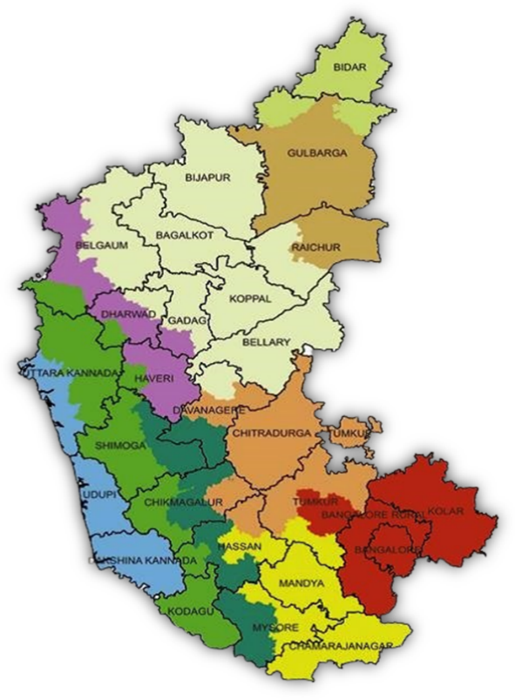

**KARNATAKA STATE**

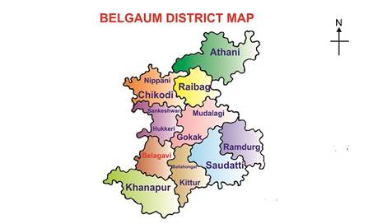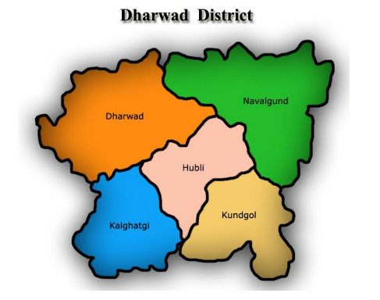

Study taluks

**Fig. 1. Map showing study area**

**Declaration**

We hereby declare that the article has neither been published or submitted for publication elsewhere.