***Original Research Article***

**Exploring Genetic Diversity for Economic Traits in Some Advanced Breeding Lines of Lowland Rice (*Oryza sativa* L.)**

**Abstract**

Diversity for economic traits like yield is crucial in rice breeding programmes. This study aimed to identify genetically divergent rice genotypes for hybridization programs, analysing eleven yield and yield-related traits across 35 advanced breeding lines and four check varieties. Employing Mahalanobis’ D2 analysis, we have identified six clusters indicating significant genetic diversity, with the widest divergence observed between clusters VI and IV (203.42) and the closest proximity between clusters III and I (69.25). Traits such as the grain number per panicle and L/B ratio significantly contributed to genetic divergence. Notably, certain breeding line combinations, including KMLT-4 × KPR-2-4-3-1-1, JGL-1798 × KPR-2-7-2-3-4, KMLT-4 × KPR-2-1-7-1-2, KMLT-4 × KPR-2-2-3-1-2-4, and KMLT-4 × KPR-2-2-2-8-2-1-1-2-3, exhibited superior mean yield performance compared to the check varieties under lowland conditions. These promising genotypes offer potential as parental candidates for future hybridization endeavours, aiming to build elite rice cultivars with broader genetic bases, ultimately enhancing agricultural productivity and resilience.Top of Form

**Key words:** Rice, Diversity, Advanced breeding lines

**1. INTRODUCTION**

Rice (*Oryza sativa* L.) is an annual cereal that belongs to the family Poaceae (*Graminae*). It is recognized as a "millennium crop" due to its pivotal role in feeding millions of people worldwide. Due to the population explosion, the necessity for rice will continue to increase soon. For this reason, rice breeders sought to increase rice productivity to meet food security needs Song [1]. In addition, it also contributes to the national economy. It is estimated that the need for rice is expected to be 125 to 130 million tonnes by 2025, which can be met only by enhancing productivity Mishra [2].

Rice production historically has been known to be influenced by a variety of environmental and socio-economic aspects that vary considerably from location to location. It is being grown under diversified ecosystems *viz.,* irrigated lowland and upland, rainfed lowland and upland and deep water / floating ecosystems. Rice crop receive their water mainly from rain; however, diverted water sources such as streams or swollen rivers are used in some places. For half of the growing season or longer, standing water covers rice fields to a depth of 50 cm Anonymous [3]. Another advantage is that it is easy to irrigate rice crop grown on wetlands. Furthermore, the soil on lowlands is more fertile than the soil on uplands. Therefore, it is advantageous to grow rice on wetlands where water can easily be collected.

Advanced breeding lines, comprising predominantly homozygous lines with some heterozygous ones, stem from crossing diverse parents to harness valuable gene combinations, offering breeders a selection pool for optimal lines. These lines serve as crucial repositories of genetic diversity, vital for developing high-yielding rice varieties and hybrids. Yield improvement stands as the central goal in rice breeding initiatives, underscoring the significance of these advanced breeding lines in achieving breeding objectives.

Top of Form

Genetic diversity is a crucial in crop improvement programme, as it aids in the development of superior recombinants Manonmani and Fazlullah Khan [4]. Genetic divergence amongst the genotypes plays an indispensable role in selecting parents having broader variability for different characters Nayak and Reddy [5]. Genetic divergence is the total number of genetic characteristics in the genetic makeup of a species. It serves as a base for various populations to adapt to changing environments. knowledge on the magnitude and nature of genetic divergence would assist plant breeder in choosing the right parents for the breeding program. The D2 technique based on multi-variate analysis developed by Mahalanobis [6] was a potent tool in quantifying degree of divergence in germplasm. The intent of this experiment is to explore the variability, heritability and diversity of rice advanced breeding lines in order to augment the utilization of rice genetic resources.

**2. MATERIAL AND METHODS**

The diversity studies on advanced breeding lines (ABLs) for yield and related traits in rice were conducted at the Zonal Agricultural and Horticultural Research Station (ZAHRS), Shivamogga, during *Kharif* season of 2021. The experimental site falls within the Southern Transition Agro-Climatic Zone of Karnataka (Zone-VII), situated at 13.9299° N latitude and 75.5681° E longitude, with an altitude of 569 meters above mean sea level (MSL). The experimental material comprised 35 ABLs of the F6 generation, involving four check varieties BPT-5204, JAYA, JYOTHI, and KPR-1 procured from the Department of Genetics and Plant Breeding, College of Agriculture, Shivamogga. The experiment was taken up in a puddled field using a Randomized Complete Block Design (RCBD) with two replications. Recommended agronomic practices were followed, including a sowing spacing of 20 x 15 cm. Eleven attributes related to advanced breeding lines of rice, such as days to 50 percent flowering, days to maturity, plant height, number of tillers per plant, number of productive tillers per plant, number of grains per panicle, panicle length, panicle fertility, test weight, L/B ratio, and grain yield, were measured.

Top of Form

**Statistical analysis:**

The mean values of all the traits were analysed for their variance following the RCBD as outlined by Cochran and Cox [7]. The descriptive statistics was conducted using WINDOSTAT version 9.2 software. Mahalanobis’ D2 analysis (as described by Mahalanobis [6]) was utilized to calculate the total genetic distance among the advanced breeding lines. Additionally, Tocher's method, as described by Rao [8], was employed to cluster the genotypes based on their similarities.

Top of Form

**3. RESULTS AND DISCUSSION**

**Genetic divergence among grain yield and yield-related attributes**

Germplasm genetic diversity plays a vital role in breeding and crop improvement programmes. It helps in analysing and establishing a genetic relationship in the collection, monitoring and identification of diverse parental combinations to produce segregating progenies with higher genetic variability Ramadan [9].

In order to exploit the existing genetic variation in the hybridization program, it is vital to evaluate the genetic divergence among the advanced breeding lines. Mahalanobis’ generalized distance (D2) analysis was studied for the 35 ABLs of rice with four checks.

Mahalanobis generalized distance estimated by D2 statistic Rao [8] is an exclusive tool for segregating populations built on a set of parameters instead of inferring from indices based on morphological similarities, phylogenetic relationship and eco-geographical diversity, among the various methods available.

In an effort to quantify the diversity in ABLs of rice, eleven quantitative characters were considered, and their fitness was assessed based on Mahalanobis' generalized distance concept (D2).

The Mahalanobis’ D2 analysis distributed the genotypes into six clusters, with cluster I being the largest, comprising 16 genotypes, followed by cluster II with nine genotypes, cluster VI comprising seven genotypes, cluster III with five genotypes, and cluster IV with two genotypes. Cluster V was the smallest, having only one genotype. These results align with findings from previous studies by Basavaraj and Dushyanthakumar [10], Amit [11], Partha [12], Ranjith [13], Dhakal [14] and Shivani [15].

Top of Form

*Clustering pattern of rice advanced breeding lines*

The advanced breeding lines of rice were sorted into six clusters based on the D2 statistic. These groups were formed in such a way that the advanced breeding lines within each cluster had smaller D2 statistic than those between the clusters. The pattern of clustering is represented in Table 1 and Fig.1.

Cluster pattern showed that cluster-I is the largest cluster consisting of sixteen advanced breeding lines followed by cluster-II with nine advanced breeding lines, cluster-VI with six advanced breeding lines, cluster-III with five advanced breeding lines and cluster-IV with two advanced breeding lines. Cluster-V was the smallest with one genotype.

*Intra and inter-cluster distance*

The assessment encompassed evaluating the distances of advanced breeding lines within clusters as well as the distances between any two clusters. Table 2 and Fig. 2 present the average D2 values of intra and inter-cluster distances.

Cluster VI exhibited the highest intra-cluster distance at 84.76, followed by clusters II at 58.83 and III at 58.09. Regarding inter-cluster distances, the utmost values were observed between cluster VI and cluster IV at 203.42, followed by cluster V and cluster IV at 155.49. Conversely, the lowest inter-cluster distance was observed between cluster III and cluster I at 69.25, followed by cluster V and cluster I at 72.76. Similar observations were made by Praveen [16] and Ranjith [13], who suggested that, selecting parents for hybridization from clusters with wider inter-cluster distances to maximize variability for economically important traits can be fruitful.

Top of Form

**Table 1: Clustering pattern of advanced breeding lines of rice-based on D2 values**

|  |  |  |
| --- | --- | --- |
| **Clusters** | **No. of Advanced Breeding Lines** | **Advanced Breeding Lines** |
| **I** | 16 | BPT-5204 × MM-2-4-1, BPT-5204 x MM-2-1-1, JGL-1798 x KPR-2-7-2-2-7-2, KPR-2 x Basu-2-1-6-2, KPR-2 × Basu-1-5-1-4, JGL-1798 × KPR-2-4-5-6-1, RNR-15048, JGL-1798 × KPR-2-2-4-1-1, JGL-1798 × KPR-2-2-6-5-2, KMLT-4 × MM-4-7-2-5, Basumati, KPR-2 × Jyothi-2-1-8-5-3, KMLT-4 × KPR-2-2-2-8-2-1-1-2-3, KPR-2 × Basu-1-4-1-1, BPT-5204 (Check) and Jaya (Check) |
| **II** | 9 | KMLT-4 × MM-4-2-2-5. KPR-1 × Jyothi 1-6-2-1-1-2, KMLT-4 × MM-4-3-1-1, JGL-1798 × KHP-2-2-6-3- 3, JGL-1798 × KPR-23-2-3-1-1-1, KPR-2 × Jyothi-2-1-4-1, KPR-2× Basu-1-4-2-1, KPR-2 × Basu-1-2-0 2-1 and Jyothi (Check) |
| **III** | 5 | JGL-1798 × KPR-2-3-7-4-1, KPR-2 × Basu-1-6-1-1, KPR-2, JGL-1798 × KPR-2-2-6-3-2 and KMLT-4 × KPR-2-4-3-1-1 |
| **IV** | 2 | KMLT-4 × KPR-2-2-3-1-2-4 and KMLT-4 × KPR-2-1-7-1-2 |
| **V** | 1 | JGL-1798 × KPR-2-7-2-3-4 |
| **VI** | 6 | KPR-2 × Jyothi-2-5-6-1, KMLT-4 × MM-4-9-2-4, KPR-2 × Basu-1-4-3-1, Jaya × MM-2-1-1-1, JGL-1798 × KPR-2-2-6-3-1 and KPR-1 (Check) |

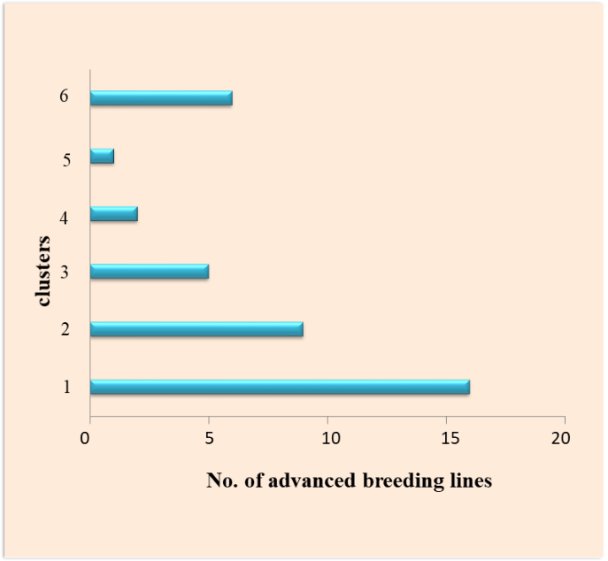

**Figure 1. Cluster pattern based on D2 values**

**Table 2: Inter and intra cluster distances for yield and its component characters in advanced breeding lines of rice**

|  |  |  |  |  |  |  |
| --- | --- | --- | --- | --- | --- | --- |
| **Clusters** | **I** | **II** | **III** | **IV** | **V** | **VI** |
| **I** | **36.09** | 81.47 | 69.25 | 150.29 | 72.76 | 88.66 |
| **II** |  | **58.83** | 126.55 | 110.21 | 100.78 | 102.97 |
| **III** |  |  | **58.09** | 128.45 | 144.83 | 140.14 |
| **IV** |  |  |  | **16.49** | 155.49 | 203.42 |
| **V** |  |  |  |  | **0.00** | 110.00 |
| **VI** |  |  |  |  |  | **84.76** |

* Diagonal values indicate intra cluster distances
* Above diagonal values indicate inter-cluster distances

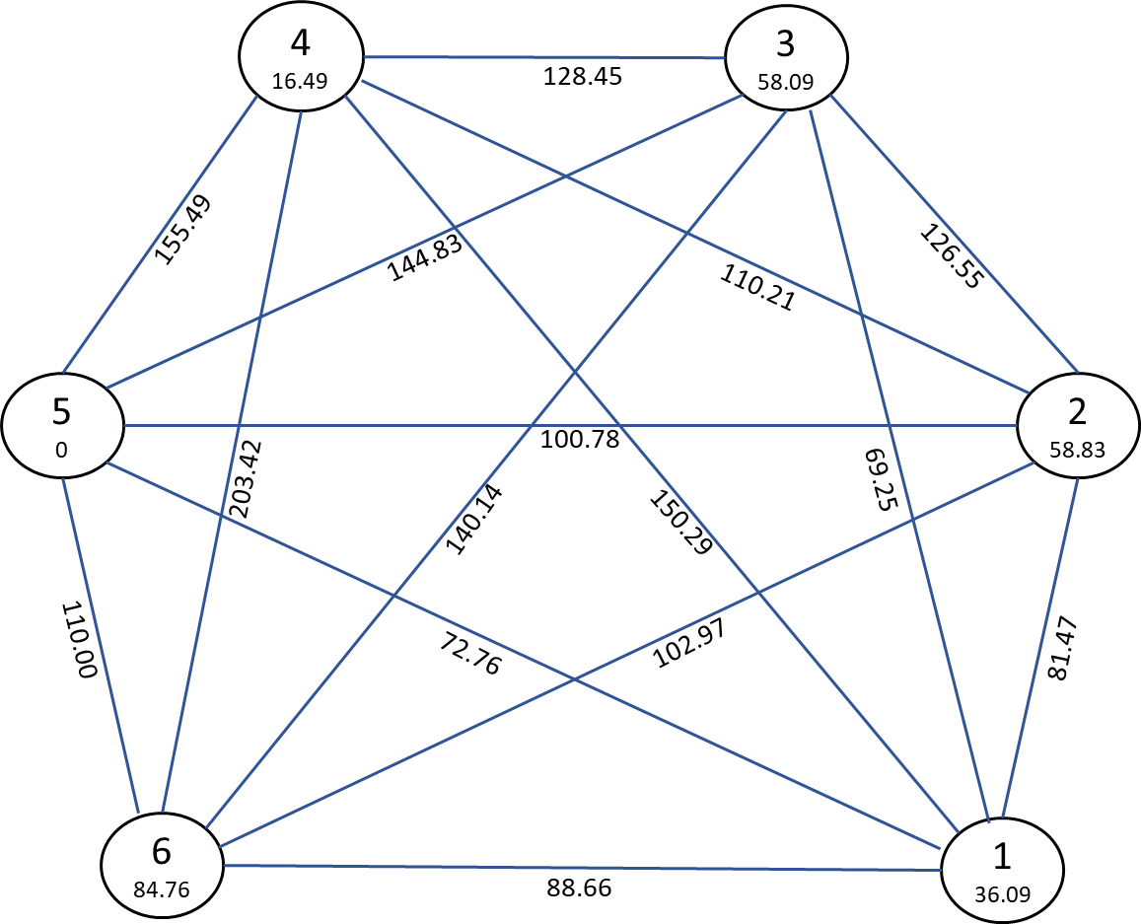

**Figure 2. Intra and inter cluster distances based on D2 statistics**

*Contribution of different traits towards divergence*

The traits that contributed most to the total divergence were number of grains per panicle, followed by the L/B ratio, test weight, panicle fertility, number of tillers per plant, plant height, days to 50 percent flowering, days to maturity, number of productive tillers per plant, panicle length, and grain yield (Fig. 3). Previous studies by Basavaraj and Dushyanthakumar [10], Chandramohan [17], Ranjit [13], and Solanki [18] have also emphasized the significant contribution of traits such as days to 50 percent flowering, number of grains per panicle, L/B ratio, and grain yield towards divergence in rice breeding.

**Figure 3. Percent contribution towards divergence**

Top of Form

**4. CONCLUSION**

According to the findings, considerable variation exists among the introgression lines considered for the current study. The emergence of different yield attribute clusters implies the possibility of divergence among the lines used. Recombination breeding for Cluster III introgression lines could increase the yield potential as they have the peak intra-cluster distance. Clusters III and IV, II and III, I and IV, and II and IV had the most significant inter-cluster distance. The introgression lines in these clusters can be employed in crosses, which will be fruitful due to favorable recombination throughout the selection process.

**REFERENCES**

1. Song, X. J., Huang, W., Shim, Z. M. and Lin, H. A QTL for rice grain width and weight encodes a previously unknown RING- type E3 Ubiquitin ligase. Nature Genetics. 2007; **3**(9): 623-630.
2. Mishra M. Rice in India. Agrolook, 2002; **3**: 10-15.
3. Anonymous. What are sustainable rice systems, Food and Agriculture Organization of the United Nations, 2021, pp.1. [*http://www.fao.org*](http://www.fao.org)
4. Manomani, S. and Fazlullah Khan, A. K. Analysis of genetic diversity for selection of parents in rice. Oryza. 2003; **40**: 54-56.
5. Nayak, A. R. and Reddy, J. N. Seasonal influence on quality characters in scented rice. Indian Journal of Genetics and Plant Breeding*.* 2004; **65**(2): 127-128.
6. Mahalanobis, P. C. On the generalized distance in statistics. Proceedings of the National Institute of Sciences of India.1936; **2**: 49-55.
7. Cochran, W. G. and Cox, G. M. Experimental designs. 1957;**1**: 127-131.
8. Rao, C. R. Advance statistical methods in biometric research. John Wiley Sons Inc.*,* New York. 1952.
9. Ramadan, E. A., Elmoghazy, A. M. and El-Mowafi, H. F. Molecular markers based genetic diversity analysis for drought tolerance in rice (*Oryza sativa* L.) using SSR markers. International Journal of Agricultural Science Research.2015; **2**(1): 137-146.
10. Basavaraj, K., and Dushyanthakumar, B. M. Genetic Diversity for Grain Yield and its Components in Local Rice (*Oryza sativa* L.) Genotypes under Submergence. Electronic Journal of Plant Breeding. 2014*;* **5**(1): 67-70.
11. Amit, K. M., Singh, P. K., Rishav, K., Pawan, K., Rahul, S., Anand, K. and Alok, K. Genetic divergence study in advance indica rice (*Oryza sativa* L.) lines for yield and quality attributes. International Journal of Current Microbiology and Applied Sciences*.* 2018;**7**: 2924-2933.
12. Partha, P. B., Singh, S. K., Singh, D. K., Reddy, Y. S., Sonali, H., Amrut, K. and Ashrutha, M. A. Genetic diversity analysis of rice (*Oryza sativa* L.) genotypes with high grain zinc content for yield and yield traits. Journal of Pharmacognosy and Phytochemistry*.* 2018;**7**(4): 1319-1323.
13. Ranjith, P., Sahu, S., Dash, K. S., Bastia, D. N. and Pradhan, B. D. Genetic diversity studies in rice (*Oryza sativa* L.). Journal of Pharmacognosy and Phytochemistry*.* 2018;**7**(2): 2529-2531.
14. Dhakal, A., Pokhrel, A., Sharma, S. and Poudel, A. Multivariate analysis of phenotypic diversity of rice (*Oryza sativa* L.) landraces from Lamjung and Tanahun Districts, Nepal*.*International Journal of Agronomy*.*2020: 1-8
15. Shivani, D., Jabeen, F., Chaithanya, K., Koushik, M. B. V. N., Dileep, G. D., Koti, E. P., Supriya, K., Sundaram, R. M., Kumar, J. A. and Abdul, R. Assessment of genetic diversity of rice germplasm using microsatellite markers. Journal of Pharmaceutical Innovation. 2021;**10**(5): 1393-1397
16. Praveen, K. U., Suresh, B. G., Ankit, K. and Swamy, M. Genetic divergence among advanced breeding lines of medium duration rice (*Oryza sativa* L.). International Journal of Science and Research.2015; **4**(7): 2585-2587.
17. Chandramohan, Y., Srinivas, B., Thippeswamy, S. and Padmaja, D. Diversity and variability analysis for yield parameters in rice (*Oryza sativa* L.) genotypes. Indian journal of agricultural research. 2016; **50**(6): 609-613.
18. Solanki, U. I., Parmar, M. B. and Gediya, L. N. Assessment of genetic divergence in rice genotypes under middle Gujarat condition. International Journal of Communication Systems, 2019; **7**(3): 2825-2828.