***Case report***

**Rare Synchronous Colonic and Ovarian Carcinomas in a 26-Year-Old Female Patient: A Case Report**

**Abstract**

Synchronous primary malignancies of the rectum and ovary are extremely rare, particularly in young individuals without known risk factors. Such cases pose diagnostic and therapeutic challenges, especially in low-resource settings. We report a 27-year-old Nigerian female with a confirmed recto-anal adenocarcinoma who subsequently developed a large left ovarian mass during neo-adjuvant chemotherapy. Histology revealed a FIGO Grade 2 endometrioid carcinoma. Both tumours were managed surgically and oncologically with a multidisciplinary approach. This case highlights the importance of clinical vigilance for synchronous tumours in young colorectal cancer patients and the need for integrated care and early genetic screening, especially in resource-limited environments.

**Keywords:** Early-onset colorectal cancer; Nigeria; Low-resource settings; Ovarian endometrioid carcinoma; Rectal-adenocarcinoma; Synchronous malignancy;

**Introduction**

Synchronous Primary Malignancies, defined as two or more primary tumours diagnosed simultaneously or within six months of each other, are rare, with an incidence ranging between 2% and 17% in cancer patients, depending on diagnostic intensity and population studied¹. The simultaneous occurrence of Colonic Adenocarcinoma and Ovarian Endometrioid Carcinoma is particularly uncommon, more so in young individuals under the age of 30. When such Dual Malignancies occur in young females, they often raise suspicion for hereditary cancer syndromes such as Lynch syndrome (hereditary non-polyposis colorectal cancer) or MUTYH (mutY DNA glycosylase)-associated polyposis².

Colorectal cancer (CRC) is the third most commonly diagnosed cancer globally, and although it predominantly affects older adults, a rising incidence in young adults has been reported in both high-income and low- and middle-income countries³. Young-onset CRC tends to present at advanced stages, with aggressive histologic features and a higher likelihood of synchronous or metachronous malignancies⁴. Similarly, Ovarian Carcinoma in young women is rare and is more frequently associated with Endometrioid and clear cell histologies, both of which may overlap molecularly and pathogenetically with Colorectal Adenocarcinomas⁵.

Synchronous Ovarian and Colorectal Carcinomas may present a diagnostic challenge due to overlapping clinical and radiologic features, particularly when metastatic disease cannot be reliably distinguished from Dual Primaries based solely on imaging or serum markers⁶. Immunohistochemistry and molecular profiling are critical in confirming distinct primaries, with markers such as CK7, CK20, PAX8, and mismatch repair (MMR) protein expression aiding in tissue origin determination⁷.

In Sub-Saharan Africa, Colorectal Cancer remains under-diagnosed and often presents late, with few reported cases of Synchronous Malignancies. A recent Nigerian study by Nwafor and Omenu in the South-South region described rising trends in young-onset Colorectal Cancer, with notable proportions of patients under 40 years of age⁸. However, there remains a paucity of data on Synchronous Primary Cancers in this demographic. Similarly, Ovarian Cancers in Nigerian and sub-Saharan populations often present at advanced stages and are less likely to be screened for synchronous pathology9,10

We present a rare case of Synchronous Colonic Adenocarcinoma and Ovarian Endometrioid Carcinoma in a 26-year-old Nigerian female, highlighting the diagnostic, pathological, and management considerations. A brief review of similar reports is included to contextualise this case within global and regional patterns.

**Case report**

A 27-year-old female who had 3 months of change in bowel habit, which was associated with passage of pencil-like faeces, haematochezia, tenesmus, anorexia and progressive weight loss. 4-days before the presentation, she developed colicky abdominal pains, absolute constipation and progressive abdominal distention. She has no known family member with similar complaints or any malignancy.

Physical findings revealed a young female in distress, to pain, not pale, anicteric, chronic ill-looking with a grossly distended abdomen, visible intestinal pattern and hyperactive bowel sounds. Rectal examination revealed a hard nodular circumferential rectal tumour 8cm from the anal verge with minimal contact bleeding.

She was optimised and had a Rectal Tumour Incision Biopsy and diverting sigmoid colostomy. The surgical pathology confirmed adenocarcinoma of the colon (Fig.1).

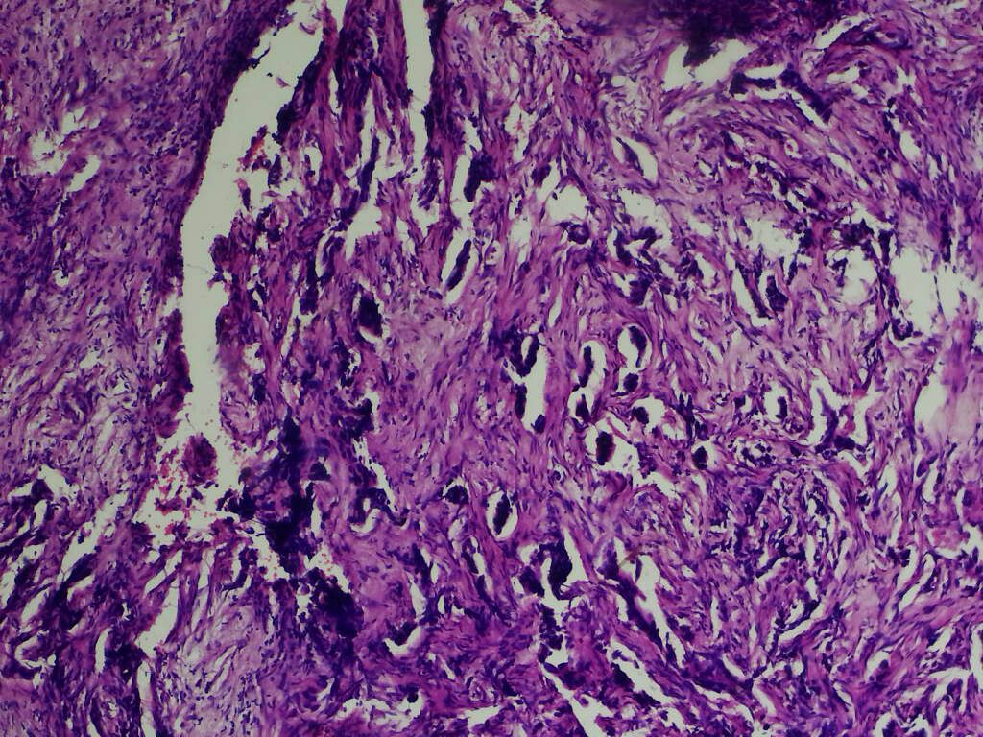

**Fig.1**.Histological sections of bowel lesion show sheets and nests of epithelial cells invading the lamina propria and muscularis muscle layers with associated desmoplasis of the stroma. These dysplastic epithelial cells show poorly formed glands. These cells have hyperchromatic nuclei, frequent abnormal mitosis. There are also signet ring cells seen in the stroma (H&E x40)

She had four courses of neo-adjuvant chemotherapy (Xerox Regimen). However, she presented within 2 months of commencing chemotherapy with a rapidly progressive abdominal distention but no constipation. Abdominal examination at presentation revealed a functioning sigmoid colostomy, Ultrasonography showed a complex solid mass with cystic pelvic component measuring 20x18cm in its greatest dimensions and minimal ascites.

She had an exploration, and intra-operative findings were a huge sessile left Ovarian Cyst tumour. Surgical pathology revealed Endometroid carcinoma, International Federation of Gynaecology and Obstetrics (FIGO) Grade 2 (Fig.2).

Post-operative was uneventful, and she is to commence adjuvant chemotherapy.

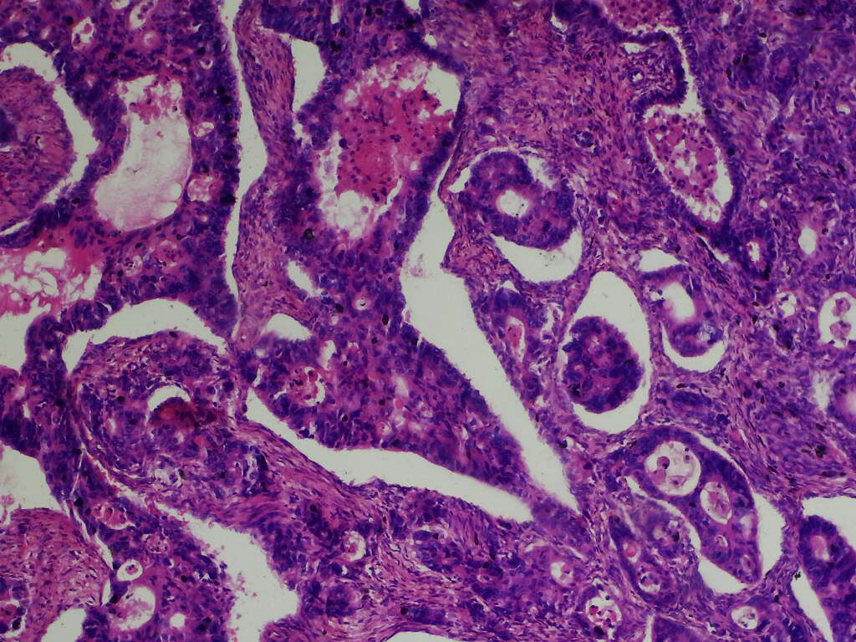

Fig.2. Histological section of the ovarian tumour shows a malignant neoplasm composed of neoplastic epithelial cells invading the stroma in sheets, poorly formed glands and singles. These epithelial cells are markedly pleomorphic both in nuclear and cellular morphology. Some of the nuclear of these dysplastic epithelial cells have coarse chromatin distribution while others are hyperchromatic. Some show prominent nucleoli while others have abnormal mitotic figures. In most foci are seen features of squamous metaplasia, with other foci having features of endometriosis. These are consistent with Endometrioid Carcinoma (FIGO - GRADE 2). (H&E x40).

**Discussion:**

This case highlights a rare and diagnostically challenging occurrence of Synchronous Primary Recto-anal Adenocarcinoma and Left Ovarian Endometrioid Carcinoma in a 27-year-old female. The rarity of this combination, particularly in such a young patient without a family history of malignancy, presents an opportunity to explore both the clinical and pathological implications in light of existing global and regional literature.

Globally, Synchronous Primary Malignancies involving the gastrointestinal and gynecologic tracts have been reported but remain uncommon. The ovary is a known site for metastatic spread from Colorectal Cancer, particularly in advanced-stage disease, with synchronous involvement seen in approximately 1–8% of female colorectal cancer cases11. However, true Synchronous Primary Malignancies—especially those involving Endometrioid Carcinoma of the Ovary and Rectoanal Adenocarcinoma—are exceedingly rare12. In high-income settings, early diagnosis is often facilitated by routine colorectal cancer screening, pelvic ultrasonography, and tumour marker evaluation13. Such mechanisms are not routinely accessible in many resource-limited environments, contributing to delayed presentation and advanced disease at diagnosis.

The patient’s age is also notable. Increasing attention has been given to Early-Onset Colorectal Cancer (EOCRC), which typically presents in patients less than 50 years old. This subset of Colorectal Cancer has been associated with distinct clinic-pathologic features, including aggressive histology and a predilection for distal tumours14. Recent epidemiological trends from North America and Europe suggest a rise in EOCRC incidence, frequently in the absence of identifiable hereditary cancer syndromes15. Our patient’s presentation with a distal rectal mass and absence of familial malignancy fits the clinical spectrum of EOCRC, though further genetic evaluation (e.g., mismatch repair status or Lynch syndrome screening) needs to be done.

In Sub-Saharan Africa, data on synchronous malignancies remain sparse, but isolated case reports and institutional series suggest that younger age at onset and advanced-stage disease are common among Colorectal Cancer patients16. A retrospective Kenyan study reported that synchronous gynecologic and gastrointestinal malignancies occurred in only 2.3% of cases, with endometrioid histology contributing marginally17. The scarcity of such dual presentations highlights both their rarity and the need for heightened clinical suspicion in similar settings.

In Nigeria, Colorectal Cancer is increasingly diagnosed, with rectal tumours constituting up to 40% of colorectal malignancies in tertiary institutions18. Synchronous Tumours are infrequently reported. For example, a study in Northern Nigeria found that fewer than 5% of Colorectal Cancer Patients had Synchronous Tumours, and none involved ovarian neoplasms19. Regarding ovarian malignancies, Endometrioid Carcinoma represents a minority of epithelial ovarian tumours, accounting for less than 10% in most Nigerian series20. Consequently, the coexistence of both tumours in this patient underscores a unique clinical phenomenon that may reflect either an underlying genetic predisposition or coincidental tumourigenesis.

This case also underscores the challenges of multidisciplinary management in low-resource environments. Initial management with biopsy, colostomy, and neo-adjuvant chemotherapy (XELOX regimen) was appropriate and consistent with global guidelines. The subsequent presentation with a rapidly enlarging ovarian mass during chemotherapy prompted surgical intervention, with histology confirming a FIGO Grade 2 Endometrioid Carcinoma. Postoperative recovery was uneventful, and the patient was planned for adjuvant chemotherapy, reflecting a commendable continuity of care despite systemic limitations.

**Conclusion:**

This case illustrates the critical importance of maintaining a broad differential diagnosis in young patients with gastrointestinal symptoms, especially females, and the need for coordinated diagnostic and therapeutic approaches. It also reinforces the relevance of investigating synchronous malignancies when new masses emerge during treatment and advocates for the integration of genetic screening services in oncologic practice across Sub-Saharan Africa and particularly in Nigeria.

**References:**

1. Vogt A, Schmid S, Heinimann K, Frick H, Herrmann C, Cerny T, et al. Multiple primary tumours: challenges and approaches, a review. ESMO Open. 2017;2(2): e000172.
2. Umar A, Boland CR, Terdiman JP, Syngal S, de la Chapelle A, Rüschoff J, et al. Revised Bethesda Guidelines for HNPCC. J Natl Cancer Inst. 2004;96(4):261–8.
3. Siegel RL, Miller KD, Wagle NS, Jemal A. Colorectal cancer statistics, 2023. CA Cancer J Clin. 2023;73(3):233–54.
4. Araghi M, Soerjomataram I, Bardot A, Ferlay J, Cabasag CJ, Morrison DS, et al. Changes in colorectal cancer incidence in seven high-income countries: a population-based study. Lancet Gastroenterol Hepatol. 2019;4(7):511–8.
5. Kurman RJ, Shih I-M. The origin and pathogenesis of epithelial ovarian cancer: a proposed unifying theory. Am J Surg Pathol. 2010;34(3):433–43.
6. Itam EH, Omonisi AE. Coexisting primary cancers of the ovary and colon in a Nigerian female: a diagnostic and therapeutic challenge. Niger J Clin Pract. 2021;24(7):1053–6.
7. Kim JY, Cho H, Park YM, Kim NK, Kim H. Usefulness of immunohistochemical markers for differential diagnosis of primary epithelial ovarian tumors and metastatic colorectal carcinomas. J Korean Med Sci. 2009;24(1):39–46.
8. Nwafor CC, Omenu TP. Histopathological profile of colorectal carcinoma in Uyo City, Nigeria. Niger J Clin Pract. 2020;23(9):1282–7.
9. Banjo AA, Anunobi CC, Okonkwo O, Abdulkareem FB, Salako O, Elesha SO. Clinicopathologic characteristics of ovarian cancers seen in Lagos University Teaching Hospital: a 10-year review. Niger J Clin Pract. 2016;19(6):747–52.
10. Makun K, Salami A, Orah N, Ibrahim O, Abdulrahman I, Olayemi E. Pattern of presentation and histologic spectrum of ovarian tumors in Zaria, Northern Nigeria: a 10-year review. Sub-Saharan Afr J Med. 2022;9(2):83–9.
11. Kube M, et al. Synchronous and metachronous ovarian metastases in colorectal cancer. *Int J Colorectal Dis*. 2010;25(6):681-686.
12. Lu B, et al. Synchronous endometrioid carcinoma of the ovary and rectum: Case report and literature review. *Int J Gynecol Pathol*. 2018;37(4):375-380.
13. Prat J. Ovarian carcinomas: five distinct diseases with different origins, genetic alterations, and clinicopathological features. *Virchows Arch*. 2012;460(3):237–249.
14. Siegel RL, et al. Colorectal cancer statistics, 2023. *CA Cancer J Clin*. 2023;73(4):233–254.
15. Chang DT, et al. Clinicopathologic and molecular features of early-onset colorectal carcinoma. *Cancer*. 2012;118(23):6310–6319.
16. Nzeako HC, et al. Colorectal carcinoma trends in Sub-Saharan Africa: A 10-year review. *Afr Health Sci*. 2020;20(4):1800–1809.
17. Ngu WN, et al. Synchronous and metachronous cancers in gynaecological oncology practice in Kenya: A 10-year retrospective study. *East Afr Med J*. 2017;94(12):933–937.
18. Irabor DO, et al. The changing pattern of colorectal cancer in Southwestern Nigeria. *Colorectal Dis*. 2014;16(4): O270–O274.
19. Abubakar AM, et al. A clinicopathological review of colorectal carcinoma in Northern Nigeria. *Niger J Clin Pract*. 2021;24(3):389–394.
20. Okonta PI, et al. Histopathological spectrum of ovarian tumours seen at the University of Benin Teaching Hospital, Nigeria: A 10-year review. *Niger J Surg Sci*. 2021;31(2):54–59.